**Temporal trends in pediatric mental health visits: Using longitudinal data to inform**

**ED health care planning**

Samina Ali MDCM1, Rhonda J. Rosychuk PhD1,2, Kathryn A. Dong MD3, Patrick J. McGrath PhD4, Amanda S. Newton PhD1*

1Department of Pediatrics, University of Alberta, Edmonton, Alberta.

2Women and Children’s Health Research Institute, Edmonton, Alberta.

3Department of Emergency Medicine, University of Alberta, Edmonton, Alberta.

4Departments of Psychology & Pediatrics, Dalhousie University, Halifax, Nova Scotia.

*denotes Corresponding Author:

Department of Pediatrics, Faculty of Medicine and Dentistry

#8213 Aberhart Centre One

11402 University Avenue

Edmonton, AB T6G 2J3

Tel: + 1 (780) 407-2018

Fax: + 1 (780) 407-1982

Email: [mandi.newton@ualberta.ca](mailto:mandi.newton@ualberta.ca)

**Abbreviations:** ACCS, *Ambulatory Care Classification System*; confidence interval, CI; CTAS, *Canadian Emergency Department Triage and Acuity Scale*; directly standardized visit rates; DSVRs; ED, emergency department; ICD-10-CA, *International Statistical Classification of Diseases and Related Health Problems, 10 edition, Canadian Version*.

**Keywords:** pediatric emergency, psychiatric emergency, mental health, temporal, presentation variation, seasonal

**Financial Disclosure:** The study reported in this paper was supported by a research grant from the Canadian Institutes of Health Research (200805KRS). Dr. Newton is supported by a Career Development Award from the Canadian Child Health Clinician Scientist Program in partnership with the SickKids Foundation, Child & Family Research Institute (British Columbia), Women & Children’s Health Research Institute (Alberta),

and Manitoba Institute of Child Health. Dr. Rosychuk is salary supported by the Alberta

Heritage Foundation for Medical Research (AHFMR) as a Health Scholar.

**Disclaimer:** This study is based in part on data provided by Alberta Health and Wellness. The interpretation and conclusions contained herein are those of the researchers and do not necessarily represent the views of the Government of Alberta. Neither the Government of Alberta nor Alberta Health and Wellness express any opinion in relation

to this study.

**ABSTRACT**

**Objective:** Understanding the temporality of mental health presentations to the emergency department (ED) during the 24-h cycle, day of the week, and month of the year may facilitate strategic planning of ED-based mental health services.

**Methods:** Data on 30,656 ED presentations for mental illness, substance use, or intentional self-harm by 20,956 patients (≤ 17 years) were examined. We studied patient demography, discharge diagnosis, and time and date of presentation.

**Results:** Most pediatric mental health ED visits (66.0%) occurred after the average work and school day (after 5pm). Presentations related to substance use and intentional self- harm steadily increased in the evening. ED visits related to substance use peaked on Friday through Sunday (4,723/7.475; 63.2%), while visits for mood disorders (4,127/

5,093; 81.0%), neurotic/stress-related disorders (5,960/ 7,989; 74.6%), and behavioral/emotional disorders (237/304; 78%) were highest during the work/school week (Monday to Friday). Visits for intentional self-harm peaked following the weekend (Monday: 771/4,676; 16.5%). Summer months had fewer visits (6,862/30,656; 22.4%), while March to May (2,752 to 2,912 visits) and October to November (2,751 to 2,701 visits) showed more steady peaks in volume. Most presentations by diagnostic group decreased in volume during the winter months (December to February) to increase again in the spring (March to May).

**Conclusions:** Peak times for pediatric mental health presentations to the ED are evenings throughout the week, suggesting that mental health services for children, adolescents, and their families should be available after work and school hours, 7 days a week.

**INTRODUCTION**

Increases in emergency department (ED) presentations for pediatric mental health services1,2 have placed EDs as a key system entry point for families hoping to access crisis care.3-6 EDs now function as a safety net7 in response to the lack of psychiatric service options in the mental health system.8,9 While 10% of North American children

and youth live with a major mental illness, as few as 1 in 6 receive necessary mental health services10-12 leaving those untreated vulnerable to acute crises and in need of ad hoc support. In the U.S., pediatric mental health accounts for 1.6% of all pediatric visits to the ED,1,13 and increases in these visits are considered disproportionate to increases in other emergency care presentations.13

The characterization of pediatric patients with mental health emergencies has been relatively recent. Pediatric patients with mood, anxiety, behavioral, and substance abuse-related disorders access the ED for emergency care2,14-16 more so than other

diagnostic groups, as do adolescent,1,15 non-white,1,13,17 and female1,15 patients. Pediatric

patients with mental health emergencies have also been shown to return to the ED for repeat care within short periods of time,3,15,17-18 with those most likely to return being adolescents,15 those with more chronic mental health needs,15 and those already receiving mental health services.17 ED visits for pediatric mental health occur throughout the 24-h daily cycle and all days of the week19 although there are notable trends in visit frequency, which may have significant implications for employing mental health care staff. Pediatric

mental health ED visits have been shown to occur more on school days than on weekends,19 and in the afternoon and early evening,19 while children with aggressive and

oppositional behaviours have been shown to access the ED more often on weekends and during school vacations, respectively.18

Effective ED management of pediatric mental health patients is endorsed by the American Academy of Pediatrics with the recommendation that pediatric patients presenting to EDs for mental health emergencies receive a prompt psychiatric

consultation.7 This recommendation, however, is far from being fully realized and criticism

exists regarding the lack of coordinated policies to address known system demand.2-6,15,20

While a lack of available psychiatric services in the ED may be part of the problem,21-22 another issue may be a disparity between the availability of psychiatric services and peak times of service need.21 Information regarding the temporality of mental health presentations may facilitate more strategic planning of ED-based mental health services. Using a historical six-year cohort (2002 to 2008), we studied patterns of presentation by children and adolescents for mental health emergencies to a large sample of rural and urban EDs according to time of day, day of the week, and month of the year. This included an exploration of temporal variations by patient sex, age, and diagnosis. **METHODS**

**Study Design and Population**

Data from six fiscal years (April 1, 2002 to March 31, 2008) were obtained from the Ambulatory Care Classification System (ACCS), a database established in 1997 by Alberta (Canada)’s provincial government as a flexible and integrated system for tracking the use of ambulatory care visits within government-funded facilities in the province. The database is linked with a provincial registry to provide patient demography. Data were abstracted for ED visits by children and adolescent (≤17 years) who presented with a

main ambulatory care diagnosis of mental illness, substance misuse/abuse, or intentional self-harm using the *International Statistical Classification of Diseases and Related Health Problems Canadian Version* (ICD-10-CA).23 This study was approved by the University of Alberta’s Health Research Ethics Board.

**Study Variables**

Patient demographic (age at each ED presentation and sex) and ED visit data were abstracted for analysis. ED visit data included patient-assigned main ambulatory

diagnoses based on the following ICD-10-CA codes: mental/behavioral disorders due to psychoactive substance abuse (F10–F19), schizophrenia and other psychotic disorders (F20–F25,F28–29), mood disorders (F30–F34,F38–F39), neurotic/stress-related disorders (F40–F43), behavioral/emotional disorders and syndromes (F50,F55,F59), disorders of adult personality and behaviour (F60–F69), behaviour/emotional disorders (F90–94), unspecified mental disorders (F99), and intentional self-harm (T71,X60–X84). Date and time of ED presentation were also abstracted. The start date was defined as the month and day of the year the ED service was started and end date was defined as the day of the year the ED service ended.

**Statistical Analyses**

Two types of rates were calculated to characterize the study population: age

group-specific rates per 100,000 population (≤17 years) for each sex and age group, and directly standardized visit rates (DSVRs)24 for each fiscal year. The 2002/03 Alberta population (≤17 years) stratified by age group and sex was used as the reference population in the DSVR calculations and 95% confidence intervals (CIs) were obtained. Frequencies and percentages summarized categorical data and line plots were used to

display data over time. Data were aggregated by hour of the day, day of the week, or month of the year. Five-year age groups were formed (0-4, 5-9, 10-14, 15-17 years). Data were analyzed using S-Plus software (S-Plus 8.0 for Windows, TIBCO Software Inc, Palo Alto, CA. 2007).

**RESULTS**

**Study Population**

Approximately 2.5 million ED visits were recorded for pediatric patients in Alberta between April 2002 and March 2008. These visits were reported by an average of 98 rural and urban EDs. Of these visits, 30,656 were for mental health-related complaints made by 20,956 distinct patients. The majority of children and adolescents (15,766; 75.2%) had only one ED visit during the six-year period; 24.8% of children and

adolescents had multiple mental health-related visits. Visits for mental health emergencies increased from 4,865 in 2002/03 to 5,208 in 2007/08, accounting for over 1% of the total visits to EDs by children and adolescents per year. ED visit rates were greater for males than females in the younger age groups (age 5 to 9 years): 70.4 per 100,000 for females *vs.* 141.6 per 100,000 for males in 2007/08, but were greater for females than for males in older age groups with the most noticeable gap in the 15 to 17 year age group (2,784.5 per 100,000 for females *vs.* 1,802.8 per 100,000 for males in 2007/08). DSVRs were relatively constant over time, 628.4 per 100,000 in 2002/03 (95%CI 605.7 to 651.1) compared to 654.9 per 100,000 in 2007/08 (95%CI 631.9 to 677.8).

Adolescents aged 15 to 17 years accounted for the majority of mental health patients seeking ED care (62.3%; 19,109 visits). Visits by females exceeded those by males overall, 58.5% *vs.* 41.5% (17,943 *vs.* 12,713) (see Table 1). During the study period, the number of ED visits by diagnostic groups remained relatively stable. The absolute numbers and proportion of ED visits for mental/behavioral disorders secondary to substance abuse and neurotic/stress-related disorders increased over time; in 2002/03, these diagnoses represented 19.8% and 24.9% (962/4,865 and 1,213/4,865) of ED mental health presentations, respectively, while in 2007/08 they represented 26.0% and

27.6% (1,354/5,208 and 1,440/5,208) of ED mental health presentations. Presentations for behavioral/emotional disorders and intentional self-harm decreased from 2003/03 to

2007/08 (see Table 1). In general, relatively few ED visits for schizophrenia and other psychotic-related disorders, behavioral syndromes, and disorders of adult personality were seen.

**Hour of Presentation**

During the six-year study period, the time of day was recorded for 30,485 ED

visits (99.4%). The number of children and adolescents presenting to the ED each hour

for mental health emergencies was consistent over the 6-year period with steady increases throughout the day beginning at 8am. The period with the highest rate was in the evening between 6pm and 1am (13,335/30,656; 43.5%); visits were less frequent during the early morning hours (between 1am and 8am; 4,779/30,656; 15.6%) (see Figure 1). The majority of ED visits for pediatric mental health emergencies occurred after the average work and school day. Thirty four percent of all pediatric mental health emergencies presented during

the day; from early to late evening (5pm to 1am) it was 48.4%, and between 1am and 9am it was 17.6%.

The hourly pattern of visits by diagnosis group was also examined (see Figures

2A and 2B). The distributions across the 24-h period were distinct for several diagnostic groups. The number of presentations related to substance abuse increased steadily after

8am and continued to increase until 12am. Between 8pm and 10pm, the number of ED visits for intentional self-harm continued to increase, while the number of ED visits for neurotic/stress-related disorders consistently increased from 8am until 8pm.

**Day of Presentation**

The date was recorded for all ED visits (n=30,656). The volume of ED visits for all pediatric mental health emergencies was distributed across days of the week with no noticeable peaks. A slightly higher volume of presentations occurred on Wednesdays (4,406/30,656; 14.4%), Fridays (4,476/30,656; 14.6%), and Saturdays (4,546/30,656;

14.8%) (see Table 2).

Figure 3 illustrates presentation by day of the week for each diagnostic group. ED visits related to substance abuse peaked on Friday through Sunday (4,723/7,475; 63.2%), while visits for mood disorders (4,127/5,093; 81.0%), neurotic/stress-related disorders (5,960/7,989; 74.6%), and behavioral/emotional disorders (237/304; 78.0%) were highest during the work/school week (Monday to Friday). Visits by children and adolescents for intentional self-harm peaked following the weekend (Monday: 771/4,676; 16.5%) with a steady decline in these presentations for the rest of the week.

**Month of Presentation**

ED visits for all pediatric mental health emergencies occurred across all 12 months of the year (see Table 2). Over the study period, the summer months (June to August) tended to have fewer visits (6,862/30,656; 22.4%), while March to May (2,752 to 2,912 visits) and October to November (2,751 to 2,701 visits) showed more steady peaks in volume.

The monthly pattern of visits by diagnosis group was also examined (see Figure

4). Most noticeably, the frequency of presentations for neurotic/stress-related disorders (718 to 568), mood disorders (497 to 224), and intentional self-harm (442 to 310) decreased from May to July and increased in the three months that followed. The number of presentations related to substance abuse (728 to 634) and behavioral/emotional disorders (377 to 248) also decreased from May to July with steady increases in the months that followed. Most presentations by diagnostic group decreased in volume

during the winter months (December to February) to increase again in the spring (March to May).

**DISCUSSION**

The results of this study have identified a daily pattern for pediatric mental health visits to the ED. Consistent with a study by Goldstein *et al.*23 most visits also occurred after the average work and school day (9am to 5pm). Possible reasons for this trend include parents recognizing the need for emergency support for their child while in their care at home,25-26 parents seeking ED care because they cannot manage on their own,26 parental availability to bring their child to the ED (i.e. after work), or an exacerbation of symptoms and behaviors in the home environment where structure is markedly different than that of the school milieu. It is often an adult in the child or adolescent’s life who labels his/her

behaviour as inappropriate/unmanageable and decides whether it justifies emergency intervention. A recent study documented parents’ main expectations for the ED visit as symptom management, support, and resources.25 This same study cites children and

youth’s top stresses preceding an ED visit as school, issues with parents and problems with

friends/peers.25 The main clinical implication of the pattern of presentations identified in this study is that pediatric mental health services in EDs need to be organized such that services are available throughout the week and particularly during evenings. While the frequency of pediatric mental health ED visits differed across days of the week, this variation was not large enough to warrant varying service availability on different days.

The finding that there were more presentations for pediatric mental health emergencies during school-based months (March to May, October to November) and fewer visits during summer months (June to August) provide direction for future service development, which may be better placed in school- and community-based settings. Schools have been identified by pediatric patients as a significant source of stress,25 and continued exposure to negative experiences throughout the week may explain the trend for more ED presentations during weekdays and the school year. This trend suggests that the school setting may exacerbate existing mental health conditions. The availability of regular mental health services for students, perhaps in the school setting, may decrease

the trend for crisis care in the ED.

Study findings also pointed to clear temporal trends for certain diagnostic groups. Many diagnostic groups saw the highest increase in presentations during the evening- early morning hours, and this was most pronounced for substance abuse-related and intentional self-harm related presentations. Further, patients with substance abuse-related

presentations were over-represented on weekends. Specialized services targeting

pediatric patients with these specific issues on weekends might be a cost-effective way to provide this programming, and may reduce patterns of repeat ED presentation for the same behaviors.15

While pediatric mental health visits have been identified as ‘resource

intensive’,5,13,27 a recent study has challenged this conclusion with findings that consistent and comprehensive clinical management of pediatric mental health presentations was lacking even in EDs that had pediatric and psychiatric resources.22 The authors suggest there is a need to move beyond this descriptor and towards defining what care is

necessary in EDs.22 A paucity of mental health resources remains a reality for most health centres, necessitating careful consideration in resource allocation; necessary guidance in such allocation can be inferred from this study. Ongoing use of temporal data will allow for more informed mental health service allocation and delivery, and improve the quality of care offered to pediatric mental health patients and their families.

**LIMITATIONS**

Individuals experiencing mental health crises may seek alternatives to ED care. Hence, our data do not capture all contacts with the health care system for mental

health crises. The patterns observed in this study could be related to differences in emergency service delivery and not simply systematic differences in illness distribution. However, our goal was to characterize those presentations that were made to the ED, and this would be captured within the dataset. We were also limited in our study by diagnostic reporting. Any diagnostic coding differences between reporting physicians’ main diagnoses or coding non-mental health diagnoses first, although the primary reason

for visit was mental health based, will have affected our ability to accurately report

trends. These reporting limitations are not unique to this study, but do point out important considerations for how mental health presentations are recorded.

This study is the largest study to date focused on the temporality of ED-based pediatric mental health care. We feel that the generalizability of our results to other Canadian cities is plausible. Data represented six years of reporting by approximately 100

EDs, with visits made to both urban and rural EDs throughout the province. Alberta is a province characterized by large rural areas, densely populated urban regions, and few pediatric health centres. Findings from this study can be considered relevant for similar geographical and health care resourced regions.

**CONCLUSIONS**

Our study examined the temporal variations in mental health-related visits to EDs across rural and urban areas in a Canadian province. The results of this study have clear implications for EDs when considering pediatric mental health programming issues. Peak times for pediatric mental health presentations to the ED are evenings throughout the week, suggesting that mental health services for children, adolescents, and their families should be available after work and school hours, 7 days a week.

**REFERENCES**

1. Sills MR, Bland SD. Summary statistics for pediatric psychiatric visits to US

emergency departments, 1993-1999. *Pediatrics*. 2002;110(4):e40.

2. Newton AS, Ali S, Johnson DW, et al. A 4-year review of pediatric mental health emergencies in Alberta. *CJEM*. 2009;11(5):447-454.

3. Christodulu KV, Lichenstein R, Weist MD, Shafer ME, Simone M. Psychiatric emergencies in children. *Pediatr Emerg Care*. 2002;18(4):268-270.

4. Goldstein AB, Horwitz SM. Child and adolescent psychiatric emergencies: The need for a clear research agenda. *Pediatr Emerg Care*. 2006;22(4):282.

5. Santiago LI, Tunik MG, Foltin GL, Mojica MA. Children requiring psychiatric consultation in the pediatric emergency department: Epidemiology, resource utilization, and complications. *Pediatr Emerg Care*. 2006;22(2):85-89.

6. Reder S, Quan L. Emergency mental health care for youth in Washington State: Qualitative research addressing hospital emergency departments' identification and referral of youth facing mental health issues. *Pediatr Emerg Care*. 2004;20(11):742-8.

7. American Academy of Pediatrics, American College of Emergency Physicians, Dolan MA, Mace SE. Pediatric mental health emergencies in the emergency medical services system. *Ann Emerg Med*. 2006;48(4):484-486.

8. Parker KCH, Roberts N, Williams C, Benjamin M, Cripps L, Woogh C. Urgent adolescent psychiatric consultation: From the accident and emergency department to inpatient adolescent psychiatry. *J Adolesc*. 2003;26(3):283-293.

9. Smith DH, Hadorn DC. Lining up for children's mental health services: A tool for prioritizing waiting lists. *J Am Acad Child Adolesc Psychiatry*. 2002;41(4):367-76; discussion 376-7.

10. US Department of Health and Human Services. *Mental health: A report of the*

*Surgeon General*. United States Public Health Service. 1999.

11. Offord DR, Boyle MH, Racine Y. Ontario child health study: Correlates of disorder. *J Am Acad Child Adolesc Psychiatry*. 1989;28(6):856-60.

12. Offord DR, Boyle MH, Szatmari P, et al. Ontario child health study II: six-month prevalence of disorder and rates of service utilization. *Arch Gen Psychiatry*.

1987;44(9):832-6.

13. Grupp-Phelan J, Mahajan P, Foltin GL, et al. Referral and resource use patterns for psychiatric-related visits to pediatric emergency departments. *Pediatr Emerg Care*.

2009;25(4):217-220.

14. Kennedy A, Cloutier P, Glennie JE, Gray C. Establishing best practice in pediatric emergency mental health: A prospective study examining clinical characteristics. *Pediatr Emerg Care*. 2009;25(6):380-386.

15. Newton AS, Ali S, Johnson DW, et al. Who comes back? Characteristics and predictors of return to emergency department services for pediatric mental health care. *Acad Emerg Med*. 2010;17(2):177-186.

16. Cole W, Turgay A, Mouldey G. Repeated use of psychiatric emergency services by children. *Can J Psychiatry*. 1991;36(10):739-742.

17. Goldstein AB, Frosch E, Davarya S, Leaf PJ. Factors associated with a six-month return to emergency services among child and adolescent psychiatric patients. *Psychiatr Serv*. 2007;58(11):1489-1492.

18. Peterson BS, Zhang H, Santa Lucia R, King RA, Lewis M. Risk factors for presenting problems in child psychiatric emergencies. *J Am Acad Child Adolesc Psychiatry*.

1996;35(9):1162-1173.

19. Goldstein AB, Silverman MA, Phillips S, Lichenstein R. Mental health visits in a pediatric emergency department and their relationship to the school calendar. *Pediatr Emerg Care*. 2005;21(10):653-657.

20. Kirby,M.J.L., Keon,W.J. *Overview of policies and programs in Canada*. Technical Report. Ottawa, Ontario: The Standing Senate Committee on Social Affairs, Science and Technology; 2004.

21. Cooper JL, Masi R. *Unclaimed children revisited (issue brief no. 1): Child and youth emergency mental health care: A national problem*. Columbia University, NY; 2007.

22. Newton AS, Ali S, Hamm MP, Haines C, Rosychuk RJ, Warron L, Johnson DW Klassen,T.P. Exploring differences in the clinical management of pediatric mental health in the emergency department. *Pediatric Emergency Care*. In press.

23. World Health Organization. International Statistical Classification of Diseases and Related Health Problems (10th Revision). Available:<http://www.who.int/classifications/icd/en/>(accessed 2011 March 16).

24. Carriere KC, Roos LL. Comparing standardized rates of events. *Am J Epidemiol*.

1994;140(5):472-482.

25. Cloutier P, Kennedy A, Maysenhoelder H, Glennie EJ, Cappelli M, Gray C. Pediatric mental health concerns in the emergency department: caregiver and youth perceptions

and expectations. *Pediatr Emerg Care*. 2010;26(2):99-106.

26. Sadka S. Psychiatric emergencies in children and adolescents. *New Dir Ment Health*

*Serv*. 1995:65-74.

27. Meunier-Sham J, Needham M. Increased volume/length of stay for pediatric mental

health patients: One ED’s response. *J Emerg Nurs*. 2003;29:229-39.

**FIGURE LEGEND:**

Figure 1: Pediatric mental health ED visits by hour of the day for each fiscal year.

Figure 2A: Pediatric mental health ED visits by diagnosis and hour of the day (all years,

2002 to 2008). (See Figure 2B for more detail regarding <50 visits per hour.)

Figure 2B: Pediatric mental health ED visits by diagnosis and hour of the day (all years,

2002 to 2008), visits < 50 per hour only.

Figure 3: Pediatric mental health ED visits by diagnosis and day of the week (all years,

2002 to 2008).

Figure 4: Pediatric mental health ED visits by diagnosis and month of the year (all years,

2002 to 2008).

**Table 1.** Demographic and diagnostic variables by pediatric mental health ED visit by fiscal year and all years combined, count (%)

|  |  |  |  |  |  |  |
| --- | --- | --- | --- | --- | --- | --- |
| **2002/03** | **2003/04** | **2004/05** | **2005/06** | **2006/07** | **2007/08** | **All Years** |

n 4,865 4,917 5,105 5,274 5,287 5,208 30,656

**Sex**

|  |  |  |  |  |  |  |  |
| --- | --- | --- | --- | --- | --- | --- | --- |
| Female | 2,867 (58.9) | 2,837 (57.7) | 2,968 (58.1) | 3,117 (59.1) | 3,114 (58.9) | 3,040 (58.4) | 17,943 (58.5) |

Male 1,998 (41.1) 2,080 (42.3) 2,137 (41.9) 2,157 (40.9) 2,173 (41.1) 2,168 (41.6) 12,713 (41.5)

|  |  |  |  |  |  |  |  |  |
| --- | --- | --- | --- | --- | --- | --- | --- | --- |
| **Age Group** |  | | | | | | | |
|  | 0-4 yrs | 58 (1.2) | 63 (1.3) | 52 (1.0) | 46 (0.9) | 49 (0.9) | 69 (1.3) | 337 (1.1) |
|  | 5-9 yrs | 229 (4.7) | 200 (4.1) | 228 (4.5) | 260 (4.9) | 231 (4.4) | 227 (4.4) | 1,375 (4.5) |
|  | 10-14 yrs | 1,560 (32.1) | 1,572 (32.0) | 1,648 (32.3) | 1,740 (33.0) | 1,720 (32.5) | 1,595 (30.6) | 9,835 (32.1) |

15-17 yrs 3,018 (62.0) 3,082 (62.7) 3,177 (62.2) 3,228 (61.2) 3,287 (62.2) 3,317 (63.7) 19,109 (62.3)

**Diagnosis**

Mental/behavioral disorder due to

|  |  |  |  |  |  |  |
| --- | --- | --- | --- | --- | --- | --- |
| 962 (19.8) | 1,121 (22.8) | 1,273 (24.9) | 1,356 (25.7) | 1,409 (26.7) | 1,354 (26.0) | 7,475 (24.4) |
| ― (3.2) | ― (2.6) | ― (2.3) | ― (2.4) | ― (2.3) | ― (2.1) | 759 (2.5) |
| 821 (16.9) | 806 (16.4) | 876 (17.2) | 838 (15.9) | 878 (16.6) | 874 (16.8) | 5,093 (16.6) |
| 1,213 (24.9) | 1,193 (24.3) | 1,306 (25.6) | 1,453 (27.6) | 1,384 (26.2) | 1,440 (27.6) | 7,989 (26.1) |
| ― (0.9) | ― (0.9) | ― (0.9) | ― (0.8) | ― (1.2) | ― (1.2) | 304 (1.0) |
| ― (1.9) | ― (2.2) | ― (2.1) | ― (2.1) | ― (1.7) | ― (1.7) | 593 (1.9) |
| 651 (13.4) | 672 (13.7) | 579 (11.3) | 618 (11.7) | 584 (11.0) | 599 (11.5) | 3,703 (12.1) |
| ― (0.2) | ― (0.0) | ― (0.3) | ― (0.3) | ― (0.2) | ― (0.2) | 64 (0.2) |

substance abuse Schizophrenia or other psychotic disorder

Mood disorders Neurotic/stress-related disorder Behavioral syndrome

Disorder of adult personality and behaviour Behavioral/Emotional disorder

Unspecified mental disorder

Intentional self-harm 915 (18.8) 845 (17.2) 790 (15.5) 714 (13.5) 739 (14.0) 673 (12.9) 4,676 (15.3)

‘―’ denote small counts suppressed for confidentiality

**Table 2.** Pediatric mental health ED visits by day of the week and month of the year,

count (%) (all years, 2002 to 2008).

**All Years**

**Day**

n 30,656

Sunday 4,278 (14.0) Monday 4,311 (14.1) Tuesday 4,368 (14.2) Wednesday 4,406 (14.4) Thursday 4,271 (13.9) Friday 4,476 (14.6)

Saturday 4,546 (14.8)

|  |  |  |
| --- | --- | --- |
| **Month** | April | 2,715 (8.9) |
|  | May | 2,921 (9.5) |
|  | June | 2,659 (8.7) |
|  | July | 2,111 (6.9) |
|  | August | 2,092 (6.8) |
|  | September | 2,358 (7.7) |
|  | October | 2,751 (9.0) |
|  | November | 2,701 (8.8) |
|  | December | 2,478 (8.1) |
|  | January | 2,637 (8.6) |
|  | February | 2,481 (8.1) |

March 2,752 (9.0)

**Figure 1.** Pediatric mental health ED visits by hour of the day for each fiscal year.

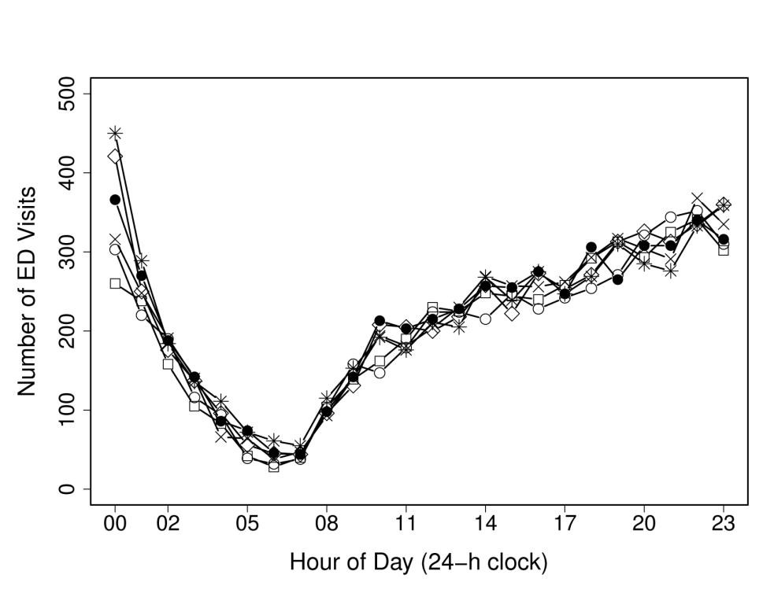

◊ 2005/2006; ● 2007/2008; ○ 2003/2004; □ 2002/2003; × 2004/2005; * 2006/2007

**Figure 2A.** Pediatric mental health ED visits by diagnosis and hour of the day (all years, 2002 to

2008). (See Figure 2B for more detail regarding <50 visits per hour.)

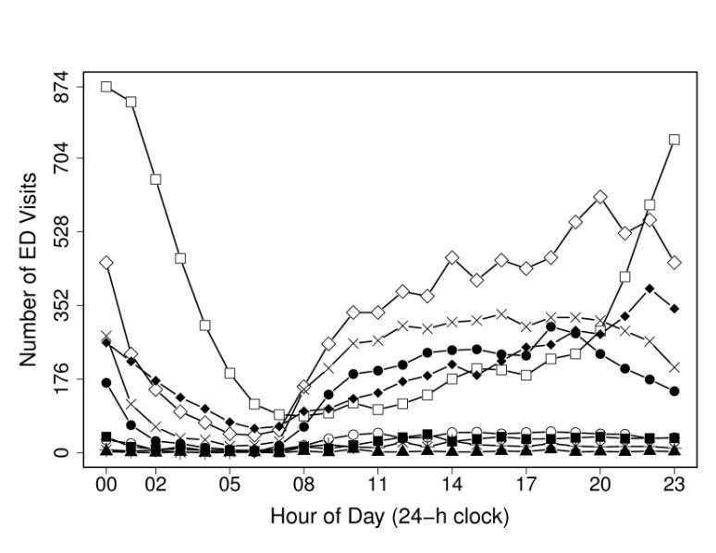

♦ Intentional self-harm; ■ Disorders of adult personality and behavior; ▲ Unspecified mental disorders; ◊ Neurotic/stress-related disorders; ● Behavioral/Emotional disorders; ○ Schizophrenia or other psychotic disorder; □ Mental/Behavioral disorders secondary to substance abuse; × Mood disorders; * Behavioral syndromes

**Figure 2B.** Pediatric mental health ED visits by diagnosis and hour of the day (all years, 2002 to

2008), visits < 50 per hour only.

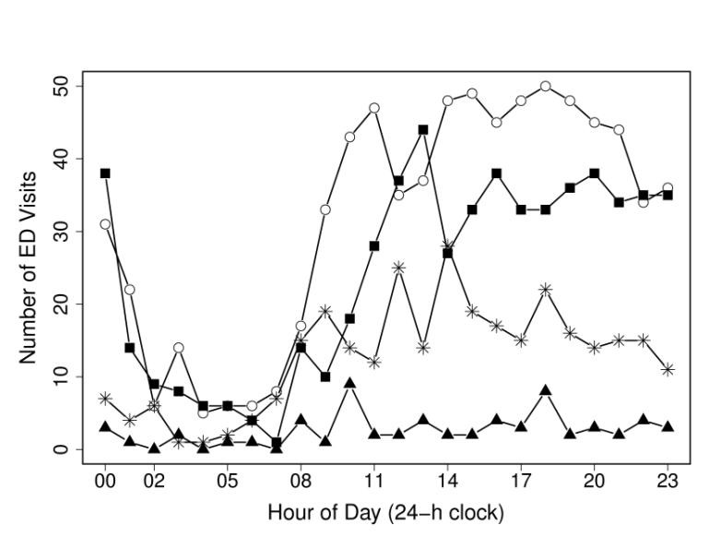

♦ Intentional self-harm; ■ Disorders of adult personality and behavior; ▲ Unspecified mental disorders; ◊ Neurotic/stress-related disorders; ● Behavioral/Emotional disorders; ○ Schizophrenia or other psychotic disorder; □ Mental/Behavioral disorders secondary to substance abuse; × Mood disorders; * Behavioral syndromes

**Figure 3.** Pediatric mental health ED visits by diagnosis and day of the week (all years, 2002 to

2008).

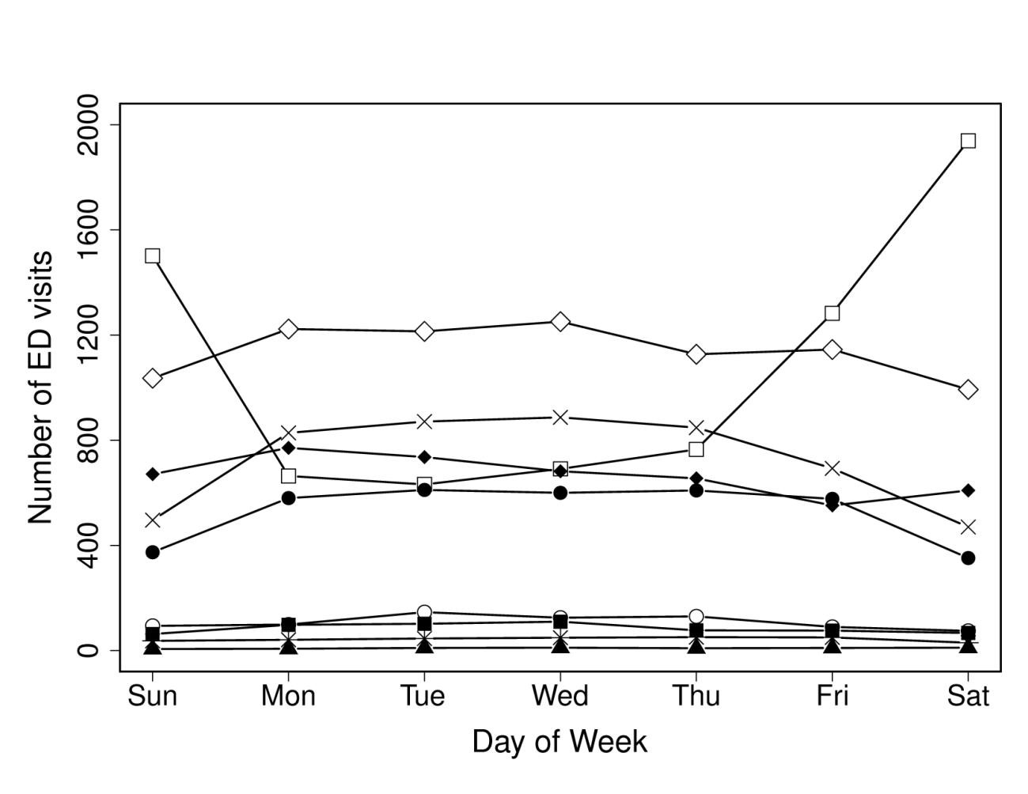

♦ Intentional self-harm; ■ Disorders of adult personality and behavior; ▲ Unspecified mental disorders; ◊ Neurotic/stress-related disorders; ● Behavioral/Emotional disorders; ○ Schizophrenia or other psychotic disorder; □ Mental/Behavioral disorders secondary to substance abuse; × Mood disorders; * Behavioral syndromes

**Figure 4.** Pediatric mental health ED visits by diagnosis and month of the year (all years, 2002 to 2008).

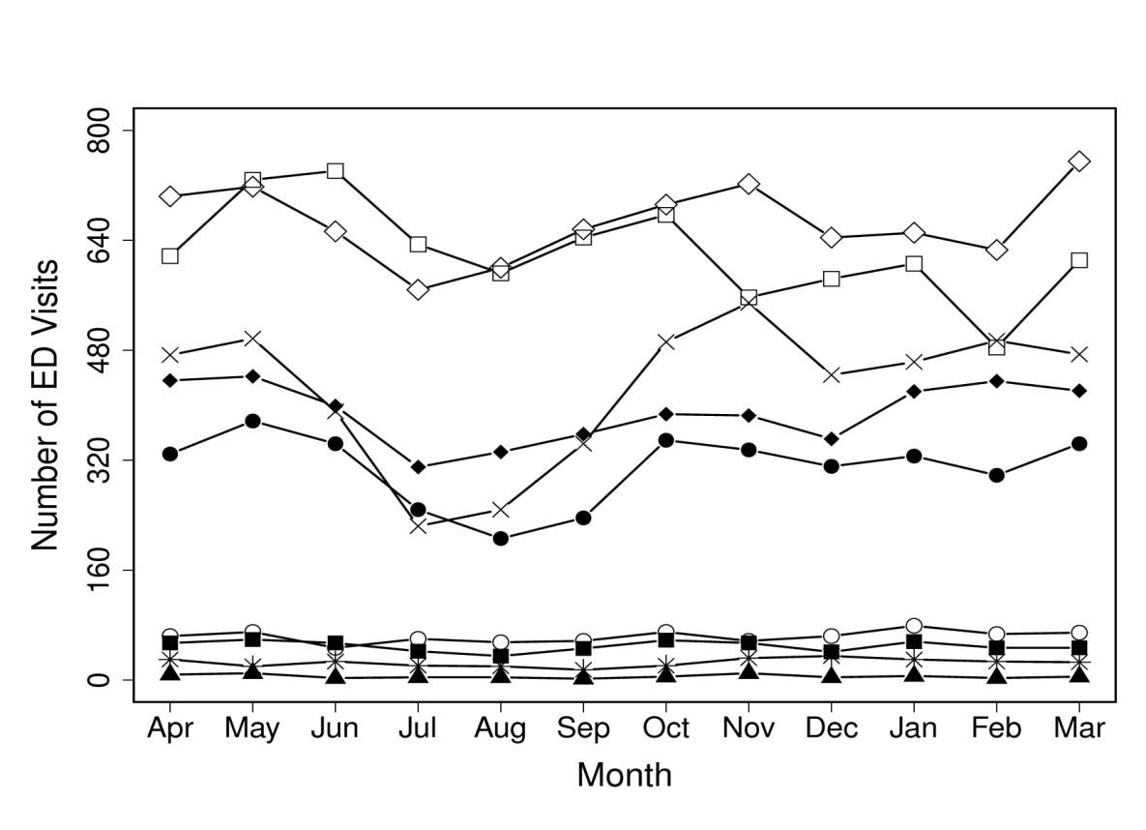

♦ Intentional self-harm; ■ Disorders of adult personality and behavior; ▲ Unspecified mental disorders; ◊ Neurotic/stress-related disorders; ● Behavioral/Emotional disorders; ○ Schizophrenia or other psychotic disorder; □ Mental/Behavioral disorders secondary to substance abuse; × Mood disorders; * Behavioral syndromes