Natural clinoptilolite composite coated stainless steel tubular membranes for water softening

Solmaz Adamaref, Weizhu An, Maria Ophelia Jarligo, Tetyana Kuznicki, Steven M. Kuznicki*

Department of Chemical and Materials Engineering, University of Alberta, Edmonton, AB, Canada T6G 2V4
*Corresponding author: E-mail: steve.kuznicki@ualberta.ca

Abstract

Disk membranes generated from high purity natural clinoptilolite mineral rock have shown promising water desalination and de-oiling performance. In order to scale-up production of these types of membranes for industrial wastewater treatment applications, a coating strategy was devised. A composite mixture of natural clinoptilolite from St. Cloud (Winston, NM, USA) and aluminum phosphate was deposited on the inner surface of porous stainless steel tubes by slip casting technique. The commercial porous stainless steel tubes were pre-coated with about 10 μm of TiO₂ layer. Phase composition and morphology of the coating materials were investigated using X-ray diffraction and scanning electron microscopy. Water softening performance of the fabricated membranes was evaluated using Edmonton (Alberta, Canada) municipal tap water as feed source. Preliminary experimental results show a high water flux of 7.7 kg/m² h and 75 % reduction of hardness and conductivity in a once-through membrane process at 95 °C and feed pressure of 780 kPa. These results show that natural zeolite coated, stainless steel tubular membranes have high potential for large-scale purification of oil sands steam-assisted gravity drainage water at high temperature and pressure requirements.

Keywords: hardness removal; natural zeolites; membranes; water purification.

Introduction

In the oil sands industry several steps are required to make sure that the recycled water meets the boiler feed water quality requirements (Heins and GE Water Technologies Process, 2009; Al-Asad and Husein, 2014). The very first methods for steam-assisted gravity drainage (SAGD) water purification technology were warm lime softening (WLS) for reducing the amount of silica and magnesium and weak acid cation (WAC) exchange for hardness (calcium) removal. In the last decade the use of evaporative methods for SAGD water treatment has been explored (Heins and GE Water Technologies Process 2009). Several facilities have been joined this process to improve the economics and reliability of SAGD water treatment process, including the boiler feed water quality (Heins and GE Water Technologies Process 2009).

Integration of polymeric or ceramic membranes in filtration systems has also been employed in SAGD water purification treatment (Heins and GE Water Technologies Process 2009). Although polymeric membranes show promise in ion separation and have found extensive industrial use, their applications for treatment of oily SAGD water at high temperatures poses a great chemical and thermal stability challenge to the membrane materials (Bader, 2007; Fakhru’l-Razi et al., 2009). Porous ceramic membranes are thermo-chemically stable at high temperatures. However, their separation mechanism is not applicable for water softening and desalination (Çakmakce et al., 2008; Luque et al., 2008).

Currently the most popular industrial zeolite membranes are synthetic zeolites coated on a porous substrate (Zhu et al., 2014). Zeolite layers of approximately several to one hundred micron thickness are grown on the surface of porous supports (Bernal et al., 2001; Lin, 2004; Pina et al., 2004; Yang et al., 2007). The substrates provide mechanical integrity to the thin membrane layer but they must be porous enough that flux resistance is negligible. This strict requirement for the support material increases the cost of the final synthetic zeolite membrane product. In addition, the tedious synthesis process often results in defects due to the thermal treatment required for the removal of organic templates (Zhao et al., 2004).

Recently membranes made of low-cost natural zeolites are shown to effectively remove cations and hydrocarbons from a simulated SAGD produced water stream (Swenson, 2012). The inherent chemical and thermal stability of natural zeolites makes them unique membrane material candidates for oil sands SAGD wastewater treatments.

One of the most common and promising natural zeolites is clinoptilolite, discovered in 1923 (Schaller and Geologi, 1923). The typical formula of clinoptilolite is (Na⁺,K⁺)₆[Al₆Si₃₀0₇₂]·20H₂O and its framework structure contains three sets of intersecting channels of 8 and 10 member rings. The dimension of the largest channel of clinoptilolite framework is 5.5 × 4.0 Å (Dong et al., 2008), which is smaller than most hydrated cations typically present in water. This characteristic confers the potential of natural clinoptilolite for water softening and desalination applications.

Previously we reported that natural clinoptilolite membranes directly sectioned from mineral deposits can be used for water desalination and de-oiling and have potential applications in SAGD water treatment (Swenson et al., 2012). Although effective removal of both cations and hydrocarbons from a simulated SAGD water stream has been achieved with these mineral membranes (Swenson et al., 2012), scaling-up to an industrial membrane technology for SAGD water treatment remains a challenge. In this study, low-cost commercial natural clinoptilolite powder has been used to prepare zeolite coated stainless steel tubular membranes for water treatment. The goal of this project is to develop a natural zeolite based membrane for treatment of SAGD water at operation temperatures, which are around 160 °C. Currently SAGD water is recovered and reused over and over again in an energy intensive process due to the necessary reheating of the purified feed water. This project aims to develop a membrane that can purify the processed water in-situ without having to change the operation temperature, thereby saving a lot of energy. To the best of our knowledge this is the first report of natural zeolite membrane integrated onto commercial porous stainless steel tubes used for water softening.

Methods

Materials

The composite membrane material is a mixture of natural zeolite clinoptilolite powder and a solvent binder of aluminum phosphate. Aluminum phosphate has been widely used as a binder for ceramic coating (Chen et al., 2003; Wagh, 2004). Silicate, which is the backbone structure of aluminosilicate zeolites, has similar chemical properties with phosphate, which suggests the possibility of a strong chemical bonding between the phosphate and zeolite (Wagh, 2004) making it a promising binder material for this particular application.

The natural zeolite clinoptilolite powder was from St. Cloud’s deposit (Winston, NM, USA) with particle size < 43 µm, and a bulk density of 1.39 g/cm³. Commercial aluminum phosphate based binder was purchased from Accumet Materials (Ossining, NY, USA). The weight ratio of P to Al in the binder solution was about 4.

Porous stainless steel (316L) tubes (Figure 1) provided by Graver Technologies (Glasgow, Delaware, USA) were used as metallic supports. The 316L stainless steel tube contains molybdenum, which increases the resistance of steel to corrosion. Another advantage of stainless steel is its good weldability to metallic industrial components. The as-received tubes were pre-coated with about 10 µm of porous TiO₂ layer. The average pore size of the titania layer was 0.02 µm. This was performed to increase the surface area contact between the metal porous substrate and the coating layers. The total porosity of the tubes was 13.4 % and the average pore size was about 1.7 µm as indicated by mercury intrusion measurements.

Figure 1. Stainless steel membrane support.

Municipal tap water from the City of Edmonton, Alberta Canada was used in evaluating the membrane performance for water softening. Composition of Edmonton tap water is listed in Table 1.

Table 1. Composition of Edmonton tap water (September’13 data, EPCOR 2013)
Parameters | Unit | Monthly Average | YTD* Min | YTD* Max
Bromate, dissolved | mg/L | <0.005 | <0.005 | <0.005
Chloride, dissolved | mg/L | 3.78 | 2.40 | 11.00
Conductivity | µS/cm | 343 | 301 | 485
Hardness, Calcium | mg CaCO₃/L | 110 | 84 | 258
Hardness, total | mg CaCO₃/L | 161 | 130 | 303
Nitrate (as N), dissolved | mg/L | 0.01 | <0.01 | 0.08
Nitrite (as N), dissolved | mg/L | <0.01 | <0.01 | <0.01
PH | N/A | 7.8 | 7.3 | 8.3
Potassium | mg/L | 0.83 | 0.60 | 2.82
Sodium | mg/L | 7.6 | 3.2 | 25.5
Sulphate, dissolved | mg/L | 47 | 39 | 131
Total organic carbon | mg/L C | 1.9 | 1.3 | 3.8
*YTD:Year-to-date

Preparation and characterization of membranes

The stainless steel tubes were washed by an alkaline detergent solution (Decon Labs, King of Prussia, PA, USA) and then rinsed thoroughly with distilled water in an ultrasonic bath for at least one hour to remove any mechanical grease during fabrication. They were then soaked in distilled water until an hour before coating deposition. Equal weight ratios of clinoptilolite powder, aluminum phosphate solution and distilled water were mixed together by planetary ball milling (Laval Labs, Laval, QC, Canada) at 300 rpm for 20 minutes. The resulting slurry was then used to coat the inner surface of the tubes by a process similar to slip casting. The coating slurry was injected into a vertically positioned porous stainless steel tube through a syringe pump rate of 3 mL/min. When the tube was completely filled with the coating slurry, the pump was stopped. The excess slurry was then drained out when the syringe was removed from the bottom of the tube. The coated tubes were then dried at room temperature overnight and then heat-treated in an electric furnace at 371 °C for 4 hours. Subsequent coating layers were deposited using the same procedure. The fabricated tubular membranes were soaked in distilled water until one hour before testing.

To investigate the phase composition of the composite membrane material by X-ray diffraction (XRD), the prepared coating slurry was poured into a flat plastic tray. After drying at room temperature overnight a flat hard sheet was formed and detached from the tray for similar heat treatment as with the coated tubes. XRD patterns were collected by 2009 Rigaku Ultima IV X-Ray Diffraction Unit (Rigaku Corporation, Tokyo, Japan) with a Co tube (wavelength K average = 1.790260 Å) operated at 38 kV and 38 mA. The samples were run in the 10 position sample changer from 20º to 90º on continuous scan rate of 2º per minute with a step size of 0.02.

Surface morphologies of the coated tubular membranes were observed by scanning electron microscopy (SEM, Hitachi S-3000N) to characterize the different morphological regions in the fabricated membranes.

Water softening tests

The water softening experiments were conducted using a laboratory-scale water purification testing setup for tubular membranes. Figure 2 shows the schematics of this setup. The pipeline between the heater and the membrane was insulated to reduce the amount of heat loss. The tank water temperature was controlled by an immersion heater with a temperature controller. An overhead stirrer was used to mix the tank water and keep the temperature uniform. Three thermocouples were used to monitor the temperatures of the tank, before and after the membrane cell. The membrane cell has a tube-shell configuration with feed water flowing through the tubular membrane and the permeate flowing through the glass shell which is exposed to ambient atmosphere. The flow rates of feed water were kept at 1 L/min for all the runs. The effective membrane area was about 20 cm². The permeation experiments were conducted at a temperature range of 25 to 95 °C and feed side pressure of 780 kPa. To prevent sample loss through evaporation permeate samples were collected in an ice-cold trap for the runs at temperatures above 75 °C. Samples collected at steady state were used for water flux calculations.

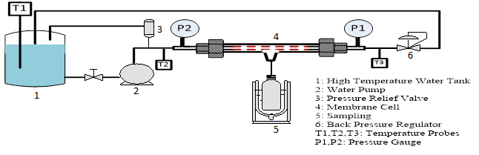
Figure 2. Schematic of the laboratory-scale water purification testing setup for tubular membranes.

The collected permeate samples were tested using a water hardness kit (Hach Cat. No. 1457-01) to determine the total hardness based on CaCO₃ as well as calcium hardness. This test was also performed for the tank water. Conductivity of both tank water and permeate samples were measured by a probe which was attached to a conductivity meter (Accumat XL 20).
The water permeate flux was calculated using equation 1:

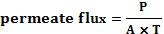 (1)

where P is the weight of the permeate sample in kg, A is the membrane’s effective area in m², and T is the sample collection time in hours. The hardness and conductivity reductions were calculated using equations 2 and 3:

(2)

(3)

where TTH is the total hardness of the tank’s water (ppm), PTH is the total hardness (ppm) of the permeate water, while TCH and PCH are the tank’s water Ca hardness (ppm) and permeate’s Ca hardness (ppm), respectively.

Results and Discussion

XRD patterns of the raw clinoptilolite powder and the composite mixture of clinoptilolite and aluminum phosphate binder are shown in Figure 3. The low intensity peaks of clinoptilolite in the composite mixture indicate that the particle size of the starting powder is significantly reduced by the milling process. The absence of aluminum and phosphate phases in the XRD profiles suggests that no crystal formation of aluminum phosphate occurred during the heat treatment. Clinoptilolite crystals detected on the surface of the sample suggest that zeolite channels are well exposed on the surface of the composite membrane allowing accessibility to the feed water stream.

Figure 3. XRD patterns of natural zeolite clinoptilolite powders (St. Cloud, Winston, NM, USA) and the composite coating material of clinoptilolite and aluminum phosphate.

The back-scattered electron image in Figure 4 shows a homogenously milled mixture of clinoptilolite and aluminum phosphate. The cross section of a tubular membrane after testing at 95 °C and 780 kPa is shown in Figure 5. The clinoptilolite composite coating covers uniformly the surface of the porous substrate, which was pre-coated with TiO₂. The thickness of the TiO₂ layer was about 10 µm, while the composite layer was ~60 µm. After testing, large cracks can be observed particularly at the interface of the ceramic membrane layers. The cracks could have propagated during the testing process where the membrane layers experience thermal and mechanical stress from heating and applied water pressure. These stresses are later released through formation of cracks at the interface of mechanically bonded ceramic membranes rather than through the rigid metallic support.

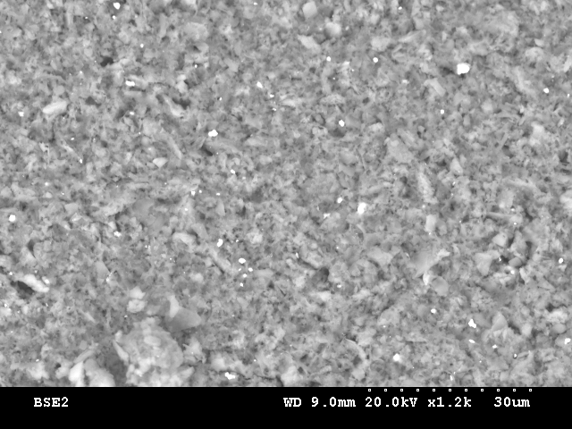

Figure 4. Surface morphology of the clinoptilolite and aluminum phosphate composite taken by SEM.

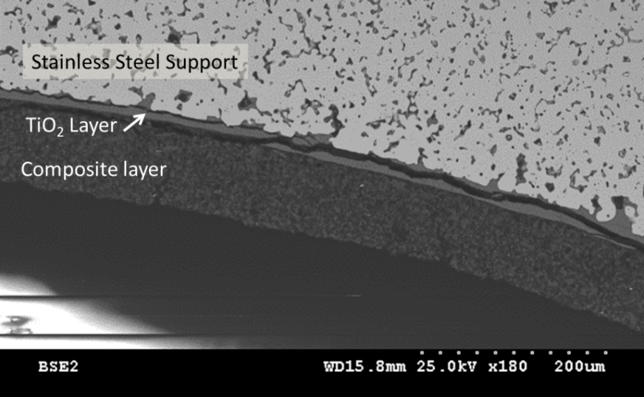

Figure 5. Cross-section of a porous stainless steel tube coated with TiO₂ layer and a composite layer of natural zeolite clinoptilolite in aluminum phosphate binder, after testing at 95 °C and 780 kPa.

The experimental results of water softening performed at 25 °C to 95 °C are presented in Figures 6 and 7. Figure 6 shows that water flux through the membrane increases with increasing temperature. The permeate flux obtained at 95 °C was about 4 times the flux at 25 °C. Temperature also has a significant effect on hardness removal and conductivity reduction of the feed water as shown in Figure 6. As temperature increased both water hardness and conductivity were dramatically reduced. Over 75 % of the total hardness removal was achieved at 95 °C. The reduction of conductivity is consistent with the removal of hardness reflected by the effective rejection of cations which occurs through clinoptilolite molecular/ion sieving - a strong temperature dependent diffusion process.

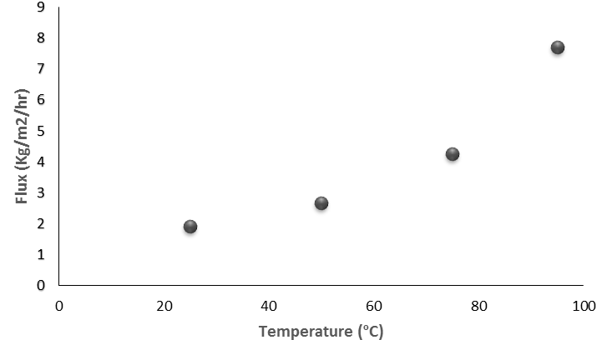

Figure 6. Water flux through the metal supported composite clinoptilolite-aluminum phosphate membrane at different temperatures and a pressure of 780 kPa.

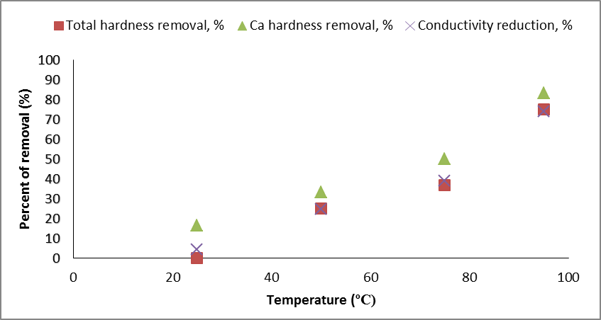

Figure 7. Hardness removal and conductivity reduction of water through clinoptilolite-ALP membranes on porous stainless steel support at 25-95 °C and 780 kPa.

Christidis et al. (2003) have found that heating can reduce surface area and microporosity. As temperature increases zeolitic pores/channels of the clinoptilolite framework contract (Bish, 1984; Doebelin and Armbruster, 2003) favouring the size exclusive molecular/ion sieving processes to occur. As the aperture of the zeolite channels decreases blocking of hydrated Ca and Mg ions by size exclusion increases. However, to further understand the mechanism of SAGD water softening through the natural clinoptilolite composite membranes described here investigation using actual industrial wastewater is necessary.

Lower cation rejection observed at room temperature suggests that some defects existed in the fabricated membranes. Further improvement of membrane integrity by optimizing the coating slurry composition and thermal treatment conditions are on-going. Nevertheless, the results reported here show promise that this low cost natural zeolite coated stainless steel tubular membrane technology is promising for large scale SAGD water purification.

Conclusions

Previously it has been shown that disk membranes generated from high purity mineral clinoptilolite have substantial promise in water desalination and de-oiling. In order to scale-up production of these zeolite-based membranes for industrial wastewater treatments a natural clinoptilolite composite was developed and used to coat a stainless steel tubular membrane. Water softening performance of the membrane has been evaluated in the temperature range of 25 °C to 95 °C and feed side pressure of 100 to 780 kPa. A high water flux of 7.7 kg/m² h and over 75 % of total hardness and conductivity removal were observed at 95 °C and 780 kPa. Further improvement on the membrane quality and performance can be expected by optimizing the coating composition and thermal treatment conditions. This study shows that natural zeolite coated stainless steel tubular membranes have great potential for large-scale purification of oil sands SAGD water at high temperature and high pressure requirements.

Acknowledgments:

Funding for this program was provided by the Helmholtz-Alberta Initiative. The authors also wish to thank Graver Technologies of the Marmon Water Group for supplying porous stainless substrates from their SCEPTER line of products, especially Scott Wittwer.

References

Al-Asad A. and Husein M. M. 2014 Treatment of steam-assisted gravity drainage water using low coagulant dose and Fenton oxidation. Environ. Technol., DOI:10.1080/09593330.2013.877086.

Bader M. S. H. 2007 Seawater versus produced water in oil-fields water injection operations. Desalination, 208 (1–3), 159–168.

Bernal M. P., Xomeritakis G. and Tsapatsis M. 2001 Tubular MFI zeolite membranes made by secondary (seeded) growth. Catal. Today, 67 (1–3), 101–107.

Bish D.L. 1984 Effects of exchangeable cation composition on the thermal expansion / contraction of clinoptilolite. Clays Clay Miner., 32(6), 444-452.

Çakmakce M., Kayaalp N. and Koyuncu I. 2008 Desalination of produced water from oil production fields by membrane processes. Desalination, 222 (1–3), 176–186.

Chen D., He L. and Shang S. 2003 Study on aluminum phosphate binder and related Al2O3-SiC ceramic coating. Mater. Sci. Eng. A, 348, 29–35.

Christidis G.E., Moraetis D., Keheyan E., Akhalbedashvili L., Kekelidze N., Gevorkyan R., Yeritsyan H. and Sargsyan H. 2003 Chemical and thermal modification of natural HEU-type zeolitic materials from Armenia, Georgia and Greece, Appl. Clay Sci., 24, 79–91.

Doebelin N. and Armbruster T. 2003 Stepwise dehydration and change of framework topology in Cd-exchanges heulandite. Micropor Mesopor Mat., 61, 85-103.

Dong J., Lin Y. S., Kanezashi M. and Tang Z. 2008 Microporous inorganic membranes for high temperature hydrogen purification. J. Appl. Phys., 104 (12), 121301-1-121301-17.

EPCOR. 2013 Water quality 2013: 2.1.2 Summary of major chemicals, microbiological, and physical parameters of Edmonton drinking water. Edmonton, Canada.

Fakhru’l-Razi A., Pendashteh A., Abdullah L. C., Biak D. R. A., Madaeni S. S. and Abidin Z. Z. 2009 Review of technologies for oil and gas produced water treatment. J. Hazard. Mater., 170 (2–3), 530–551.

Heins W. F. and GE Water Technologies Process. 2009 Technical advancements in SAGD evaporative produced water treatment. J. Can. Pet. Technol., 48 (11), 27–32.

Lin Z. 2004 Synthesis and characterisation of titanosilicate ETS-10 membranes. Microporous Mesoporous. Mater., 67 (1), 79–86.

Luque S., Gomez D. and Alvarez J. R. 2008 Industrial applications of porous ceramic membranes (pressure-driven processes). Membr. Sci. Technol., 13 (7), 177–216.

Pina M., Arruebo M., Felipe M., Fleta F., Bernal M., Coronas J., Menendez M. and Santamaria J. 2004 A semi-continuous method for the synthesis of NaA zeolite membranes on tubular supports. J. Membr. Sci., 244 (1–2), 141–150.

Schaller W. and Geologi U. S. 1923 The mordenite-ptilolite group; clinoptilolite, a new species. Mineralogical Society of America, 8, 128–134.

Swenson P. D. 2012 Natural zeolite membranes for gas and liquid separations. MSc thesis, University of Alberta, Edmonton, Alberta, Canada.

Swenson P., Tanchuk B., Bastida E., An W. and Kuznicki S. M. 2012 Water desalination and de-oiling with natural zeolite membranes — Potential application for purification of SAGD process water. Desalination, 286, 442–446.

Wagh A. S. 2004 Chemically Bonded Phosphate Ceramics. Elsevier, pp. 121–133.

Yang G., Zhang X., Liu S., Yeung K. L. and Wang J. 2007 A novel method for the assembly of nano-zeolite crystals on porous stainless steel microchannel and then zeolite film growth. J. Phys. Chem. Solids, 68 (1), 26–31.

Zhao L., Bram M., Buchkremer H., Stover D. and Li Z. 2004 Preparation of TiO composite microfiltration membranes by the wet powder spraying method. J. Membr. Sci., 244 (1–2), 107–115.

Zhu B., Hong Z., Milne N., Doherty C. M., Zou L., Lin Y. S., Hill A. J., Gu X. and Duke M. 2014 Desalination of seawater ion complexes by MFI-type zeolite membranes: Temperature and long term stability. J. Membr. Sci., 453, 126–135.

