**How can Principals Harvest Hope and Happiness in Schools?**

**Education Administration and Leadership 512**

Final Paper

**Professor: Dr. Noella Steinhauer**

Student: Anna Wilson

I.D.:0240309

Date: April 16, 4pm 2019

**How can Principals Harvest Hope and Happiness in Schools?**

**Introduction**

Public school principals are expected to lead teachers, students and communities into the realm of 21st Century learning with the “Four Cs of critical thinking, communication, collaboration, and creativity” (Roekel, 2012, p. 2). The violence, shootings, bullying, racism, poverty, suicides and declining achievement scores in North American schools has urged school leaders to look to other countries for inspiration.  Finland’s Programme for International Student Assessment (PISA) test scores are significantly higher than Canada and the United States (U.S.). Finland has a child poverty rate of five percent, and they often achieve high PISA scores year after year. Yet, unlike other countries, they focus more on collective learning and engaging students through the enjoyment of learning with minimal homework (McSpadden, 2017, para. 3). However, the United Nations International Children's Emergency Fund (UNICEF) estimates a third of American children live in poverty. UNICEF rated Canada 17th out of 29 wealthy countries due to the number of children living in poverty in Canada (Bradshaw & Chzhen, et. al., 2012, p. 3). When U.S. test scores are averaged with their middle-class and affluent peers, the U.S. test ranking declines (McSpadden, 2017, para. 4). Yet, Finland also scored high on the United Nations World Happiness Report (2017) which indicates a connection between happiness and academic achievement (Helliwell & Layard, et. al. 2019, p. 28). I believe Finland’s success can be attributed to their engagement in appreciative inquiry. Appreciative inquiry (AI) can be defined as collaborative search for people’s strengths, interests and the pursuits that gives them joy when they work together as an eco-system in symbiotic harmony with each other. AI involves the:

Art and practice of asking questions that strengthen a system’s capacity to heighten positive potential. It mobilizes inquiry through crafting an “unconditional positive question” often involving hundreds or sometimes thousands of people. AI is based on discovering what is working, what gives life, what is creating energy and excitement, and then determining how to create more of it.

(Cooperrider, & Whitney, 2005/2016, p. 334)

In order to strengthen the school systems across North America and more specifically, Canada, I must explore the answers to the questions of: How can principals harvest hope in their staff and students? How can principals teach their staff to harvest/nourish hope in their students and school community? This paper will prove how appreciative inquiry can harvest happiness and hope in schools through improving teachers' effectiveness which can improve students’ well-being and achievement. First, a closer analysis of the relationship between the World Happiness Report and the PISA student achievement test scores will be discussed. Second, Kathleen Absolon’s holistic Indigenous research framework of the petal flower will be woven into the theoretical framework of appreciative inquiry as I locate myself as a participant within my research. Third, Absolon’s theory and the theory of appreciative inquiry (AI) will be related to case studies in education leadership. Appreciative inquiry (AI) and Absolon’s theory challenges the neo-liberal theories driving individualism, and capitalism. Fourth, these theories and case studies will be synthesized into a pedagogical paradigm to support the development of happiness and hope in schools. Fifth, this pedagogical paradigm will be used as a lens to view implications for future education leadership practices to foster happiness and hope in schools.

**Relationship between the PISA Test Scores and the World Happiness Report**

PISA emphasizes functional skills that students have acquired as they near the end of compulsory schooling. PISA is coordinated by the Organization for Economic Cooperation and Development (OECD), an intergovernmental organization of industrialized countries, and is conducted in the United States. Data collection for the most recent assessment was completed in fall 2015. PISA assesses students' science, reading, and mathematics literacy in more than 70 countries and education systems. Science was the main subject of the 2015 data collection, as it was in 2006. PISA also included optional assessments of collaborative problem solving and financial literacy. In U.S. schools, 15-year-old students participated in both these optional assessments. The Program for International Student Assessment (PISA) is a worldwide study by OECD in 70 nations of 15-year-old students’ scholastic performance on mathematics, science and reading as indicated in the following figure #1:

**Figure #1 PISA Worldwide Ranking – Average Score of Math, Science and Reading (2015-2016)**

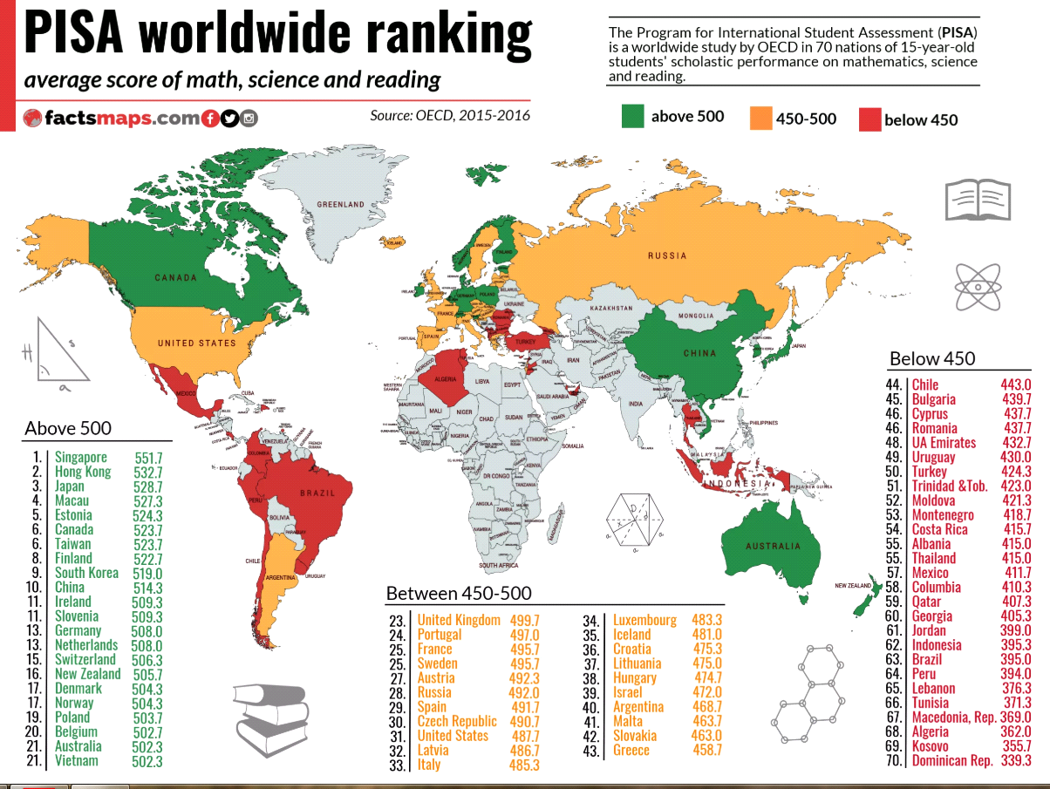

Organization for Economic Cooperation and Development (OECD), (2015-2016). PISA

Worldwide Ranking – average score of math, science and reading. FactsMap.com. Retrieved from <http://factsmaps.com/pisa-worldwide-ranking-average-score-of-math-science-reading/>

.

The Reading Literacy Items on the PISA test document contains 14 reading assessment objectives and 59 objectives associated with these units. These are learning objectives from the PISA 2000 and PISA 2009 (refer to appendix #1). As education researchers and leaders review these test scores, they may be wondering why Finland’s schools surpass many schools in North America. Lynnell Hancock is an education researcher for the Smithsonian Magazine and a Columbia University journalism professor who reports that many schools in Finland are small enough so that teachers can learn how each of their students learn so if one method fails, teachers have enough preparation time to collaborate with other teachers to integrate different class learning activities outdoors (2011, para.3). Approximately, 30 percent of Finnish children receive special assistance within their first nine years of school (Hancock, 2011, para. 6). Since Finnish teachers' work days are shorter, they have more time to write lesson plans and evaluate their students individually. This gives children more time to play outside which improves their health (para. 14).

Hancock reports that:

Finnish educators have a hard time understanding the United States’ fascination with standardized tests. “Americans like all these bars and graphs and colored charts,” Louhivuori [a teacher] teased. “Looks like we did better than average two years ago,” he said after he found the reports. “It’s nonsense. We know much more about the children than these tests can tell us.”

(2011, para.19)

Preschool is funded with free healthcare in all schools. Fruits and vegetables are grown in school gardens and freshly prepared for longer school lunch hours (Maensivu, & Uusiautti, et. al., 2019), (Compton & Ellis, et.al., 2011), (Moore, 2016). The relaxed lunch hour rationale is based on the fact that when children are rushed through their lunch, their nervous systems release more stress hormones which results in more behavior problems. The higher number of high school graduates in Finland is indicated in appendix #2 with the lower amount of money spent per Finnish high school student in appendix #3. Yet, the U.S. Government spends more per capita on prisons than students (Weber, 2010). The manner in which elementary and secondary education systems in Finland treat students is related to Finland’s ranking on the *World Happiness Report* which measures happiness yearly through the United Nations Sustainable Development Solutions Network. Finland ranks #1, Canada, #9 and the United States #19. The complex report measures well-being according to freedom to make life choices, corruption, generosity, and the economy. As indicated in the following figure #2:

**Figure # 2 The 25 Most and Least Happy Countries in the World (2017)**

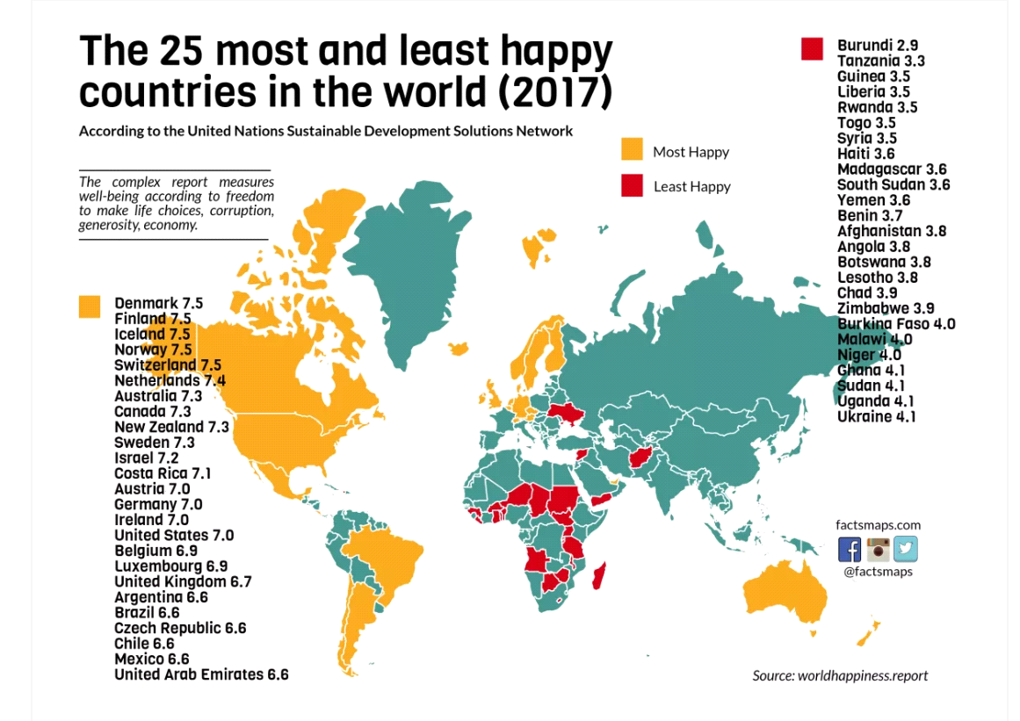

United Nations Sustainable Development Solutions Network (UNSDSN). (2017).The 25 Most and Least Happy Countries in the World. *FactsMap.com*. Retrieved from <http://factsmaps.com/most-and-least-happy-countries-in-the-world-2017/>

Longer paid maternity and paternity leave for parents in Finland are contributing factors to Finland's happiness as well as longer paid vacations and healthcare (Maensivu, & Uusiautti, et. al., 2019), ( Hancock, 2011, para. 9). The results in the United Nations (UN) of the Ranking of World Happiness explain national average life evaluations in terms of six key variables: GDP per capita, social support, healthy life expectancy, freedom to make life choices, generosity, and freedom from corruption. These six variables explain almost three-quarters of the variation in national annual average ladder scores among countries, using data from the years 2005 to 2018. Figure #2 and figure #3 uses the same six variables to estimate equations for national averages of positive and negative affect, where both are based on answers about past emotional experiences (Helliwell & Layard, et. al. 2019, p. 28).

According to international surveys, Finnish schools provide an equal quality of education to all students throughout the entire country. There are only minimal differences in learning results between areas of Finland (OECD, 2016). One factor explaining this may be the fact that the school system is the same throughout the whole country (Pollari & Salo, et. Al, 2018 p. 2). Finland has very few private schools, and most of them follow the national framework curricula (FNAE, 2014a; FNAE, 2015). One of the basic principles of Finnish education is that all pupils and students from all ethnicities, socio-economic income levels, and communities (urban and rural) must have the same educational opportunities. All schools follow a national core curriculum with the learning objectives for all core subjects (Pollari & Salo, et. Al, 2018 p. 2). School tuition in Finland is free from preschool to post secondary education. Finnish elementary and secondary schools provide free tuition, textbooks, transportation and daily hot meals for every student. All these measures enhance equality for students (Pollari & Salo, et. Al, 2018 p. 2) and foster hope and happiness reflected in figure #3.

.

**Figure # 3 United Nations of the Ranking of World Happiness for 2016 to 2018**

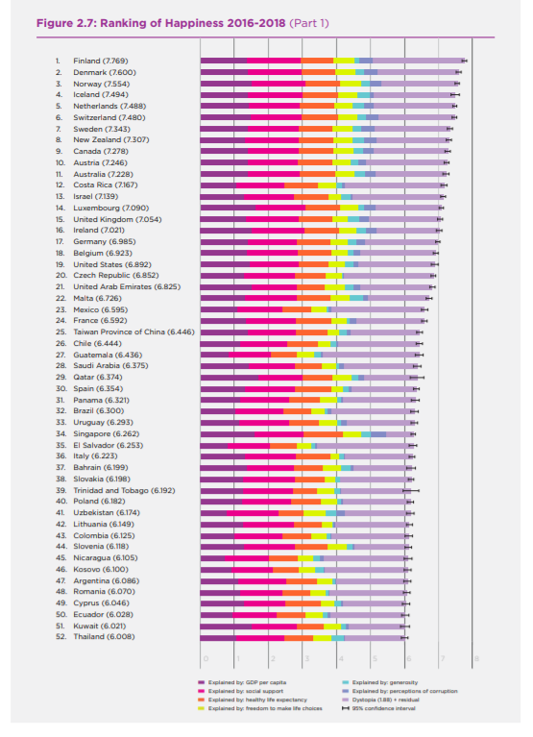

Helliwell, J.F., Layard, R. &. Sachs, J.D. (2019). *World Happiness Report 2019*, (p. 27). Retrieved from <https://s3.amazonaws.com/happiness-report/2019/WHR19.pdf>

**Locating Myself in the Context of my Research**

As an educational researcher I must remember that when I am ethically harvesting important data with research participants, I must also harvest hope during our experiences which is equally important. While some qualitative data may be measurable, measuring hope can be very difficult. Although my research methodology is based on the qualitative approach, I am worried that when I am defending my thesis I will be asked: “How do you ethically measure hope?” Indigenous researcher Dr. Kathleen Absolon developed the Petal Flower Model as a way teachers come to know themselves and their students. The flower’s survival is dependant on inner and outer elements (Absolon, 2011). The parts of the flower are interrelated and interdependent. The flower is earth centred and exists within a relationship with all of Creation (Absolon, 2011). The flower is also cyclical, as it changes constantly. Finally, it has a spirit and life that is impacted by the environment within which it exists (Absolon, 2011). The flower's roots are the grounding for Indigenous methods. The life and presence of the flower depends on its roots (Absolon, 2011). The centre of the flower represents self and self in relation to the research. Researchers must place themselves in the centre of the flower so they can know their location when researching relationships, Indigenous peoples, and communities. Indigenous researchers must dedicate themselves to recovering humanity and rehumanizing knowledge production (Absolon, 2011).

Within Kathleen Absolon’s holistic Indigenous research framework of the petal flower (2011, p. 51), I saw myself as a has-been teacher who was all washed up and eroding in the topsoil of life searching for meaningful roots. When masked burglars shattered my teacherage window in La Loche, Saskatchewan into shards of glass, I felt that I had lost my rapport with my students. I was so disillusioned with my teaching abilities, and my mental illness that I felt I should leave the teaching profession. I was shocked when I found out that my former student Marie Janvier, a teacher aide was killed by a gunman at Dene High. Marie was one of my hardest working students. I taught her how to read in a junior high  Language Arts class of fifty students with special needs ranging from pre-kindergarten reading levels, learning disabilities, and behaviour disorders, including students who are identified as at risk for dropping out of school. Marie’s parents were survivors of the Canadian Indian Residential School (IRS) system which resulted in their inability to communicate fluently in their Dene language because they were forbidden to speak it. Since the literacy instruction in the IRS was inadequate, Marie’s parents were also unable to communicate fluently in English.  In spite of these challenges, Marie’s desire to read to her unborn baby motivated her to persevere. As she wrote about her baby and experiences as a new mother in her journal, she blossomed with confidence. Marie’s perseverance grows in the centre of the flower which is cyclical like the seven generations of the IRS survivors renewing my resilience. The fact that she graduated and became a teacher aide re-germinated my roots of teaching with hope. Marie’s hope nourished my stem to grow into an Indigenous educator. My desire to share her memory and my experiences in La Loche sprouted a need to renew these rewarding experiences with teachers to inspire them to work in northern Indigenous communities and nourish their learning. The leaves are my hands branching out to the hands of teachers in hope of blossoming into resilient support systems. My hope is that my appreciation for my students' perseverance can encourage teachers to appreciate their students' perseverance.

**Examining the Conceptual Framework of Appreciative Inquiry (AI)**

David Cooperrider and Diana Whitney describe four steps in the appreciative inquiry cycle the four D's are Discovery, Dream, Design and Destiny. A typical Appreciative Inquiry design (called the 4D cycle of Appreciative Inquiry) would have four stages. 1. Discovery –Inquire into the best of the past and the present. Appreciative inquiry is anchored in the humanistic psychology and positive psychology research traditions (Calabrese & Hester, et. al, 2010, p. 252). Like humanistic psychology and positive psychology, AI focuses on human well-being, hope, optimism, joy, love, and a future orientation, and the study’s participants’ narratives that serve as the foundation for generative growth emanating from intentional cooperative action toward a desired end (Bushe and Kassam, 2005; Cooperrider and Srivastva, 1987b; Maslow, 1943; Seligman and Csikszentmihalyi, 2000; Thatchenkery, 1999, as cited in Calabrese & Hester, et. al, 2010, p. 253). AI is a form of action research emphasizing both action and reflection. There are several variations of the AI Summit for school improvement. In each variation, the AI 4-D cycle is the core of the AI process. The AI 4-D cycle:

1. Establishes a common set of protocols designed to generate collaborative inquiry to recognize successful past practices (***discovery)***;
2. Identifies themes from the successful experiences as the foundation for creating a strong vision (***dream***);
3. Builds a blueprint based on the dream (***design***);
4. Commits the blueprint to action (***destiny***) where participants act to initiate change.

(Whitney and Cooperrider, 2000, as cited in Calabrese & Hester, et. al, 2010, p. 253)

Participation in the AI 4-D cycle occurs through shared narratives. The participants’ shared narratives provide a collective experience of a positive core to sustain belief in ability to transform the future (Egan and Lancaster, 2005). AI focuses on what gives life to a system by reframing deficit-based language into asset-based language, which results in the conceptualization of a compelling image of a desired future (Ludema et al., 2003; Whitney and Cooperrider, 2000, as cited in Calabrese & Hester, et. al, 2010, p. 253). The application of AI is illustrated in the following figure 4:

**Figure # 4 AI Appreciative Inquiry Discovery, Dream, Design and Destiny**

Adapted from Calabrese, R., Hester, M., Friesen, S. & Burkhalter, K. (2010).Using appreciative inquiry to create a sustainable rural school district and community. *International Journal of Educational Management, (24)*3, pp.250-265, Retrieved from <https://doi.org/10.1108/09513541011031592>

Figure #4 is based on my reading of Calabrese’s, Hester’s, Friesen’s, and Burkhalter’s, case study from a rural school on the “Great Plains of the U.S. Daybreak Independent School District (DISD pseudonym, 2010, p. 251). The demographical changes in the town’s dwindling population revealed that the baby boomers (older people) who were retiring, had difficulty communicating with the younger generation because they did not understand each other. The older generation did not think the youth wanted to do anything productive with their lives and saw them as a burden on the social system. The youth saw the infrastructure of their town as out of touch with the advances in technology in the rest of the world and dreamed of moving to larger metropolitan cities. As a result, tensions rose and the youth engaged in drug and alcohol abuse and remained isolated from the older generation who descended further into isolation. The researchers interviewed the youth, the high school staff and the residents in the town individually and then together in a guided group discussion (this reflects appreciating teachers’ and students’ stories: hope is planted in petal two). Many of the youth shared their parents’ dreams for them which resonated with the dreams of the elderly residents. The older generation realized that if all the youth left the town, then they would not have anyone to operate their town as they descended into their senior years (This reflects 1.. Discovering students’ and teachers’ strengths while listening to their stories: hope germinates).

The youth in the high school did not want their parents to be left in an abandoned ghost town, so they worked with the school staff to create work experience programs to strengthen the infrastructure of their town which reflects number two when students are empowered with their dream of imagining how they can make their hopes for their families come true: 2. Dreams and empowerment. As the town stakeholders communicate with the school and the residents, they design a plan for expanding the infrastructure of the town: 3. Design: hope sprouts. The school, the youth, business stakeholders and the townspeople form community partnerships to transform their relationships into commitments to sustain their town from generation to generation reflecting number four destiny, community partnerships, and transformation projects: 4. Destiny, hope blossoms. Education leaders and principals must continue to bring town/corporate stakeholders, teachers, and students together to listen to each others’ stories for hope to pollinate and spread to more people to keep their community strong.

**Case Studies of Appreciative Inquiry in Education Leadership**

**John Jerome Paul was director of program services for Mi’kmaw Kina’matnewey, the education authority known as MK that provides financial and curriculum resources to its 12 member communities. At the time, the provincial government had threatened deep cuts to teacher education. Separately, public schools were under fire for underserving Mi’kmaq and African Nova Scotian students.**

**An early advocate of Mi’kmaq-controlled schools, John Jerome Paul director of program services for MK approached education faculties to build a community of Mi’kmaq teachers. “For student success, graduation and everything else, we need to get teachers from our communities, and we need students to see themselves in the curriculum,” he says. “Students have to see brown faces.”**

**Paul saw self-governance of education as a necessary first step for cultural and linguistic survival, followed by Mi’kmaw teacher training.**

**He challenged St. FX’s education faculty to adapt programs for aspiring teachers from MK member communities. “I told them, ‘You don’t just let us come in and drown in your pool. We want success,’” he says.**

**St. Francis Xavier education dean Jeff Orr, new to his post in the early days of MK, recalls the advice he received from Marie Battiste, a leading Indigenous scholar at the University of Saskatchewan and a native of Poklotek First Nation in Nova Scotia. “She told me, ‘Listen to what they want and partner.’”**

**Emphasizing flexible program delivery since 1997, the faculty has graduated 145 Mi’kmaq students with bachelor of education degrees and 42 with master of education degrees. One student is in a Ph.D. program. Some programs are offered full-time on campus, while others are offered part-time in the community on evenings or weekends to suit working parents, and there are new specialty certificates in teaching language and math to meet local demand.**

**Blaire Gould, acting executive director of MK, attributes Mi’kmaw student success to Mi’kmaq bands having “jurisdiction and autonomy over education, allowing communities to define what success looks like.”**

**But she also credits St. FX, “our earliest partners in education,” for working with local communities. “It’s not only how we trust St. FX to deliver what we want them to deliver for us, but they have a strong trust in us that we will bring the best students to them,” she says.**

**In Whycocomagh, a Mi’kmaq community on Cape Breton Island, a memorial to residential school survivors is located at We’koqma’q Mi’kmaw School, which enrols 200 students from kindergarten to Grade 12.**

**Tiffany Gould, a Grade 1 teacher at the school, earned her bachelor of education on the St. FX campus while pregnant with her fourth child. She currently works full-time, studies for a master of education delivered mostly online by St. FX, and collaborates on research projects with the university’s professors.**

A study from University of California, Berkeley, found that schools with high levels of integrity manage external pressures by integrating appreciative inquiry into their methods of communication (Mintrop, 2012). The researchers concluded that integrity comes directly from a school’s leader and the culture he or she builds. A high-integrity faculty culture is characterized by open communication, tolerance of dissent, and a learning orientation—values that listening leaders model in their interactions. (p. 19).  Listening helps us tune in to dominant narratives and shift them. Listening leaders are perceptive; they tune in to how people think and talk about the work of school improvement. They model a shift from

1. Discourse I (language that serves to maintain the status quo and reproduce inequity) to

2. Discourse II (language that explicitly names uncomfortable, unequal, and prejudicial conditions and relationships in schools) (Eubanks, Parish, & Smith, 1997).

See Figure #4 for the attributes of these two discourses.

**Figure #4 Two Discourses of Language Shifts Leading to Equity**

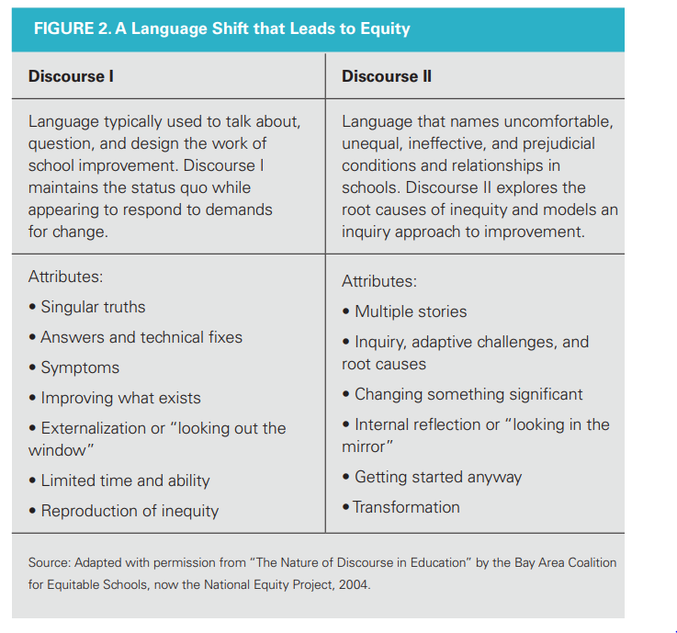

Safir, S. (2017). Learning to listen. (benefits of listening for school leaders). *Educational Leadership, (8)*16, (p. 19). Retrieved from https://search.ebscohost.com/login.aspx?direct=true&db=edscpi&AN=edscpi.A491893764&site=eds-live&scope=site

Listening leaders model this shift by facilitating brave conversations, asking hard questions, digging into the root causes of inequity, and ensuring that students, families, and colleagues from marginalized communities feel empowered to share their ideas and experiences.

At Oakland Technical High School Ross-Morrison and Diaz were teachers who listened carefully to the interwoven narratives in their school and found a story that elevated the status of programs perceived as more rigorous and desirable—programs serving a disproportionately white, middle class demographic. They also uncovered an overflow of students of color who were interested in, but couldn’t access, these programs. The co-principals set their sights on dismantling the old narrative, “that only ‘certain kids’ can handle advanced coursework,” (Safir, 2017, p. 18). They explored win-win options to increase access for all students. They redesigned the application process to reduce barriers to access (Safir, 2017, p. 19).

In a study of 464 principals and vice-principals, researchers found that the most effective leaders showed skill in the areas of empathy and relationship building (Stone, Parker, & Wood, 2005). Listening helps school leaders reconsider data to add students’ voices into the equation (Safir, 2017, p. 20). Listening helps principals strive to connect on data to the daily activities of the school. Listening leaders recognize that the data they need appears when they listen in lunchrooms, e-mails, and in their offices. Principals can find data in our close observations of students working on tasks and of teachers engaged in collaboration. These types of data can tell stories of transformation, and reveal where support is required. The principals realized how listening helped them to stay true to their values when they were under stress. Through effective listening principals and education, leaders became more aware of their styles of leadership and how they wanted to change their leadership methods as indicated in figure five:

**Figure # 5 Leadership Archetypes**

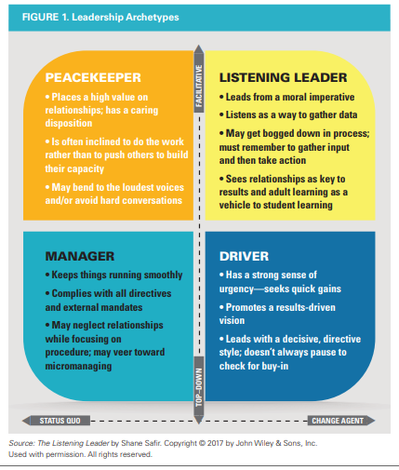

Safir, S. (2017). Learning to Listen. *Educational Leadership, 74(*8), p. 18.

Careful consideration of the leadership styles in Figure 5 also made me realize that my actions in my group work presentations for EDPS 512 were more like the manager and driver. I was so worried about citation analysis that my fears interfered with my desire to become an appreciative listener. My neo-liberal drive for achievement made me forget that I took this course to learn the leadership skills of the professors who helped me through university. I wanted my group members to feel heard, so I must aspire to be a good listener more than to achieve high grades. The leadership archetypes in figure #5 caution me not to neglect my relationships in my efforts to complete tasks with my classmates. I must not allow the stress of a presentation to interfere with my compassion for my classmates. Yet, the neo-liberal drive of competition for high grades and scholarships still resides in the back of my mind even though I want to be an agent of change instead of a keeper of the status quo.

Similarly, in 2011 the College of Allied Health Sciences was undergoing several leadership transitions which inspired Dean Elizabeth King to help her leadership team cope with these changes through Appreciative Inquiry (AI) with the help of Elaine Suess. The AI approach made many of the faculty supervisors realize that they had to ask their staff more questions to learn more about the challenges they endure. This involved the supervisors stopping themselves from telling their staff what to do and quoting policies during difficult times of the college semester. Their lessons learned included:

* Develop positive mindsets and shifting perspectives through awareness building to be intentional in shifting thinking toward the positive.
* Create habits that lead to *happiness* such as meditation, exercise, gratitude lists of what went right at the end of each day to lay the foundations for happiness and sustained, effective performance.

(Suess & Clark, 2014, p. 46, *italics added*)

The lessons learned reveals that achieving personal happiness is a process requiring personal affirmations when educators are evaluating their lessons daily. Daily affirmations of what worked well nourishes teachers’ learning spirit to learn from their mistakes and meet the challenges of the next day. In many of the schools I taught in, evaluations were deficit based instilling a fear of impending doom during my performance evaluations. Daily gratitude lists based on what teachers and students have done right is a great way to enhance happiness and hope for the next day.

Dr. Tali Heiman of the Department of Education and Psychology at the University of Israel and Dr. Dorit Olenik Shemesh, (2012) of the Hammill Institute on Disabilities conducted a research study on hope in which they analysed students’ patterns of use of collective postsecondary education courses. Their data was collected from the collective class discussions of 964 undergraduate students with and without learning disabilities (LD) at the Open University of Israel (OUI) (535 male and 429 female) studying with an age range from 17 to 57 years (Heinman & Shemesh, 2012, p. 312). Their academic responses and social perceptions in relation to their hope and well-being were measured. Students were asked to complete four questionnaires related to their patterns of using various assistive technologies. The questionnaires assessed Perceptions of Learning through collective Usage; Accessibility of Campus Computing; Hope Scale and Subjective Well-being Scale (Heinman & Shemesh, 2012, p. 308).

The Hope Scale was defined by Snyder (2002) as a positive motivational state that is based on an interactively derived sense of success and claimed that people typically think in terms of goals (Heinman & Shemesh, 2012, p. 311). The theory of hope, which is part of a cognitive model, involves two main components:

1. Agency: the motivation to pursue the goals

2. Pathways: strategies and planning to meet goals.

(Heinman & Shemesh, 2012, p. 311)

Agency thinking involves thoughts about one’s ability to endure his/her journey towards his/her goals, even when faced with challenges and obstacles. The lower hope scores of the students with learning disabilities (LD) were related to their long term frustration that students with LD remember from negative learning experiences in childhood (Lackaye, et. al., 2006, as cited in Heiman, & Shemesh, 2012, p. 311). The outcome of the students’ hope scale is indicated in the following figure 6 on the means, standard deviations and scores for hope and well being between student groups.

**Figure# 6 Means, Standard Deviations & Scores for Hope between Student Groups**

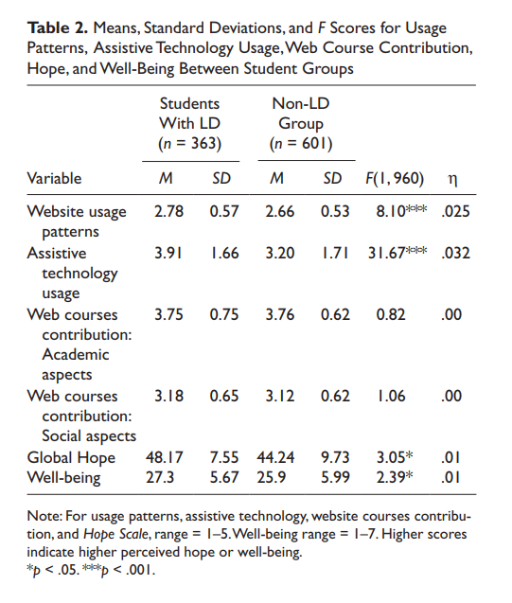

Heiman, T., & Shemesh, D. O. (2012.). Students With LD in Higher Education: Use and Contribution of Assistive Technology and Website Courses and Their Correlation to Students’ Hope and Well-Being. *Journal of Learning Disabilities, 45*(4), 308–318.

Their research revealed that compared to the control group, students with learning disabilities (LD) logged more often into the course sites, going into the forum more frequently and posted many more messages in the discussion forum than students without LD  (control group). The research indicated that students with LD are more familiar with assistive technology and use it more often than their classmates who do not have LD. Students with LD reported higher scores on the Hope scale because they were more motivated to find different methods (pathways) to reach their goals, and their subjective well-being was higher than their classmates without LD (control group) (Heinman & Shemesh, 2012, p. 315).

**Synthesis of Absolons’s Indigenous Flower Petal Model & Appreciative Inquiry (AI)**

The cycle of learning starts with my professor’s (Dr. Steinhauer’s) encouraging guided instruction which plants the seeds of hope with her discussion questions, classes, readings, and the nourishing discussions we have with the feasts of knowledge she prepares for us. There is a ceremonial class of feasting on the sharing of stories. This reflects Joanne Archibald’s idea that sometimes a good story is needed to sustain life more than food and water. At the beginning of the semester, Dr. Steinhauer gave each student in our class a handmade cloth feast bag to place a glass bowl, spoon and cloth napkin inside. The loving intent she put into these gifts made me feel as though I had a special responsibility in class to take care of my feast bag because this was an integral part of the ceremony of nourishing our learning spirit. I often talk too much in class and unintentionally interrupt others when I get excited or anxious over student injustices. As I ate my soup, I realized how enjoyable it was to really listen to my classmates. Nourishing my learning spirit (Battiste, 2013) requires me to be a more attentive listener. As I reach out to my classmates, we germinate empathy through sharing stories, discussing concepts, and questions. Our guided discussions grow hopeful roots in our relationships in our collective community. Throughout our collective classes, students initiate their own discussion questions on controversial issues and other topics reflecting our assigned readings**.** Through horizontal learning our friendships develop as we participate in group presentations making hope sprout. Horizontal learning grows into horizontal leadership nourishing our learning spirit as reflected in my pedagogical paradigm in figure seven for an appreciative leadership grows from the heart of leaders into the souls of schools:

**Figure #7 Pedagogical Paradigm for Harvesting Hope & Happiness in Schools**

Encouragement

Skill Practice

Hope is planted

Empathy, sharing stories, skill practice,

hope grows roots in community

Group work,

Friendships Hope sprouts

Skill + Concept=

Praxis

Hope Blooms

I can teach to classmates

Hope flourishes

As our class connects skills and concepts we develop praxis in developing collective learning tools and our hope blooms with creativity. Our collective responses progress from just answering assigned questions to responding to peers not merely for participation marks, but because we want to reciprocate in the collective relationships of reciprocity. Harvesting reciprocity is a multi-dimensional gift as the concepts and skills our classmates taught us in discussions become the lessons we teach to other classmates in our group presentation as hope flourishes we can pollinate or nourish other learning cycles. This reflects the concept ofcollective wisdom in collective learning environments as “dynamic ecosystems that interact, cross-fertilize, feed upon, and grow on each other (Gon & Zhu, 2007, p. 208). Harvesting hope in collective learning environments inspires intrinsic motivation in students with LD.

Many critics could claim that it is too difficult to quantify hope, especially in students with LD who have already had their IQ quantified empirically. Heinman and Shemesh discuss how their research study was based on a correlation with the students’ collective participation in their course activities with their classmates and the subjective reports of hope and well-being from students with LD. In empirical science, correlation studies often come with disclaimers of inconclusive results.However, although hope may be intangible, the collective interactions shared between students, teachers and principals are appreciative inquiry strategies that can enable marginalized students to experience the wealth of academic discourse communities of dynamic possibilities for social change: “to undergo a revolution to become "idea-centered" from "activity-centered," and to become collaborative learning from independent learning, so that learners can embark on a knowledge building” journey (Scardamalia, 2002, as cited in Gon & Zhu, 2007, p. 206).

**Critical Analysis**

Many principals may be discouraged from integrating AI into their school evaluation systems because many education-funding programs are based on the deficit model that attributes funding increments based on students’ weaknesses to secure funding initiatives that can be sustained over the fiscal school year. This deficit approach is also utilized in teachers’ performance evaluations to motivate teachers to work harder to ensure their students excel in their standardized achievement exams (Weber, 2010). Michelle Rhee of the Columbia School District supports “ capitalist-class interests through her educational reform proposals to offer merit pay to attract "good" teachers, while creating a flexible labor force through the abolition of tenure” (Oh, 2010, p. 163), (Beck, & Canada, et. al., 2010/2013). The Teacher Solidarity Research Group at UCLA conducted a close reading of dominant neoliberal educational reform discourses through an examination of the writings of Michelle Rhee and Wendy Kopp. Seven graduate education students and teachers of color organized their research along three dimensions of:

(1) experience as teachers;

(2) solidarity with teachers;

(3) analyses of racism

(Philip, & Martinez, et., al., 2016, p. 182).

While Thomas M. Philip, Danny C. Martinez, Eduardo Lopez and Antero Garcia admired Geoffrey Canada’s development of the charter schools (Beck, & Canada, et. al., 2010/2013), they cautioned that this solution does not address the systemic racism within the power structures of corporate institutions. Their analysis of the systemic racism embedded in public and private institutions is illustrated in figures 8 and 9 on the educational discourses from interlocutors without experience as teachers.

**Figure # 8 Educational Discourses from Interlocutors without Experience as Teachers**

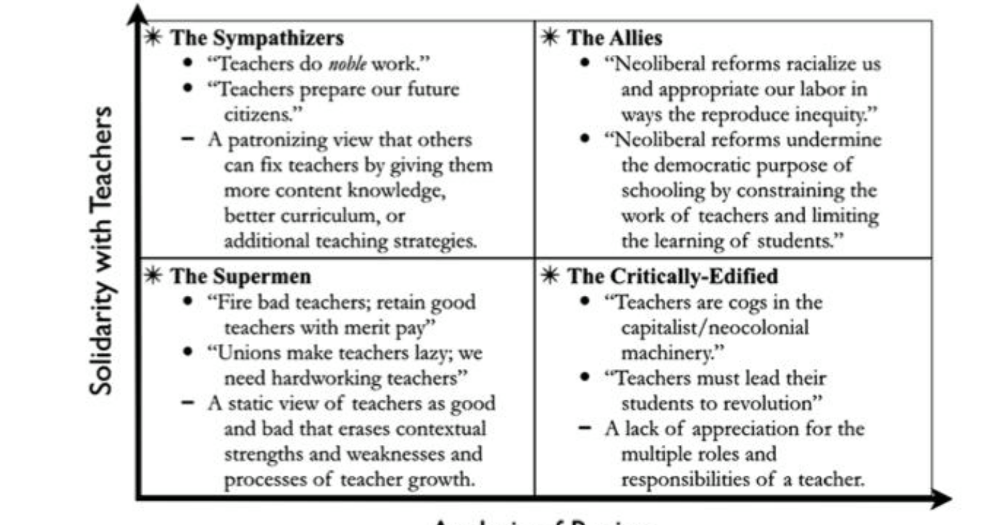

**Analysis of Racism**

Philip,T.M., Martinez,D.C., Lopez, E. & Garcia, A. (2016).Toward a teacher solidarity lens: former teachers of color (re)envisioning educational research,

*Race Ethnicity and Education, (19)*:1, p. 192.

The 8 discourses in Figures 8 and 9 serve the purposes of naming the perspectives which many critics perceive as the work of teachers; (2) to understand the relationship between these perspectives and the social positions of the interlocutors; and (3) to recognize and attempt to re-articulate these discourses in ourselves and others. I argue that appreciative inquiry (AI) and Absolon’s Indigenous methodology can challenge the racism within these discourses at the root. Principals need to build solidarity with teachers to harvest hope and happiness in schools.

**Figure #9 Educational Discourses from Interlocutors with Experience as Teachers**

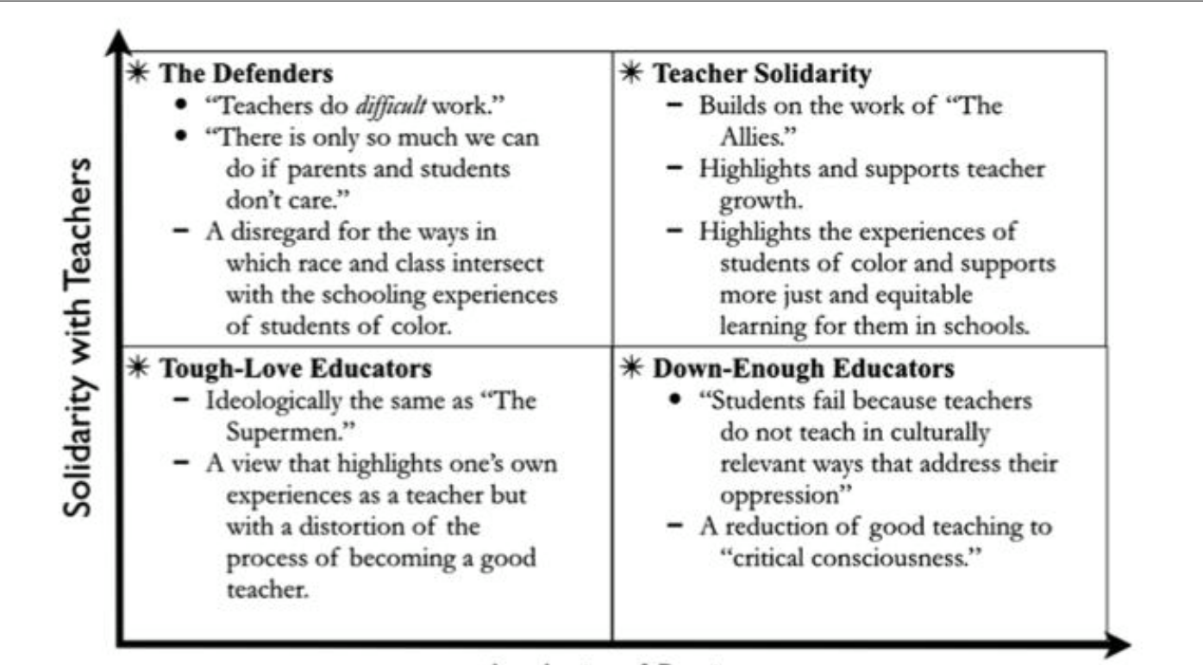

Philip, T.M., Martinez, D.C.,Lopez , E. & Antero Garcia, A. (2016). Toward a teacher solidarity lens: former teachers of color (re)envisioning educational research,

*Race Ethnicity and Education, (19)*:1, p. 193.

In the documentary *Waiting for Superman* (Guggenheim 2010), the metaphor of the paternal white hero Superman will save children from poverty by rescuing children from a bad school simplifies the civil right to an equal education with the belief that “educational equity can be attained without addressing fundamental issues of inequity and injustice in society [by] building on and extending market-based solutions for educational reform” (Philip, & Martinez, et.al., 2016, p.183). Veteran teachers from ethnic minorities identify how Rhee negates the process of becoming a teacher who teaches beyond critical consciousness into the heart and soul of each student. This reflects Kathleen Absolon’s Indigenous research methodology that positions students and education researchers into the centre of the flower to contemplate and pollinate where they are coming from. Through committing to researching our relationships with students through listening to their stories educators can teach to students instead of just teaching to the exams. This dedicates teachers to recovering the humanity through rehumanizing knowledge production (Absolon, 2011). Michelle Rhee’s focus is on the banking model of education where students merely digest knowledge and spit it out on standardized tests. In a neoliberal market driven economy this is what many businesses want. However, the rise of the Indigenous consciousness invites education leaders to teach students to engage in reciprocal learning where they are stewards of their school’s ecosystem where they can germinate the roots of justice and harvest hope and happiness. Injustice can be weeded out by the root so that radical hope can thrive (Lear, 2006).

**Conclusion and Implications for Future Practice**

Appreciative inquiry poses many advantages and disadvantages. For example, Martin et al. (2005) advocates for the questioning of assumptions over listening to students because some teachers may feel that listening to and acting on students' voices may result in giving into students’ demands. This occurred in Meadfield secondary school, where some of the teachers responded to AI inquiry as a “weakening of their authority from giving in to other staff and students’ proposals for change” (Willoughby, 2004, p. 113). This reveals how teachers’ hostility towards distributed leadership as a challenge with AI.Yet,Meadfieldschoolstill reported that AI resulted in increased engagement in schoolwork, improved performance and behaviour (p. 114).

Although empirical science may consider happiness and hope to be unmeasurable, the United Nations has ranked Finland as the number one happiest country with one of the highest high school PISA test scores globally. The relationship between academic achievement, happiness and hope is reflected in the value of appreciative inquiry, listening, and harvesting hope with reciprocal relationships. Principals can grow partnerships with community stakeholders by building a bridge of common ground to close the generation gap and open the channels of communication. As youth see their role in sustaining their community for the next generation, they can become stewards of their school's ecosystem. Principals can empower teachers through capitalizing on their strengths to cope with challenges in a positive way. Attentive listening enables attentive transformation across the chain of command into a chain of solidarity. Appreciative inquiry (AI) can involve members of the school community in decision-making. This creates a positive school climate of ethical democracy where leadership is distributed according to the strengths of the staff. As the entire school community becomes involved in a collaborative school review, teachers, support staff, students and parents can be engaged in the process of school improvement. This can catalyze their social capital in building the school’s capacity throughout the community, renewing the roots of hope to blossom into happy futures.

**References**

Absolon, K. E. (2011). *Kaandossiwin: How We Come to Know.* Halifax: Fernwood Pub.

Absolon, K. (2019). Indigenous holistic theory: A knowledge set for practice.*First Peoples Child & Family Review, 14*(1), 22-42. Retrieved from <http://login.ezproxy.library.ualberta.ca/login?url=https://search.ebscohost.com/login.aspx?direct=true&db=sih&AN=135787809&site=eds-live&scope=site>

Ail, Nik Mustafa Bin Mat, Taib, M. R. b., Jaafar, H. b., Salleh, Wan Aida Rohana, Mohamed, & Omar, M. N. b. (2015). Principals’ instructional leadership and teachers’ commitment in three junior science colleges (misc.) in Pahang, Malaysia.*Procedia - Social and Behavioral Sciences, 191*, 1848-1853. doi:10.1016/j.sbspro.2015.04.512

Barbezat, D. P., & Bush, M. (2014a). *Contemplative practices in higher education: Powerful methods to transform teaching and learning* San Francisco, California: Jossey-Bass, 2014]. Retrieved from <http://login.ezproxy.library.ualberta.ca/login?url=https://search.ebscohost.com/login.aspx?direct=true&db=cat03710a&AN=alb.7222886&site=eds-live&scope=site> <https://ebookcentral.proquest.com/lib/ualberta/detail.action?docID=1524285>

Barbezat, D. P., & Bush, M. (2014b). *Contemplative practices in higher education: Powerful methods to transform teaching and learning* San Francisco, California: Jossey-Bass, 2014].

Barnes, J. M., & Wane, N. N. (2000). *Equity in schools and society. [electronic resource]* Toronto Ont.] : Canadian Scholars' Press, 2000.

Battiste, M.(2013). *Decolonizing Education Nourishing the Learning Spirit*. Saskatoon: Purich Publishing Limited.

Beatriz Pont, a. (2017). *School leadership for equity: A comparative perspective* Emerald Publishing Limited. doi:10.1108/S1479-367920160000031007

Beck, C., Canada, G., Cassidy, J., Chilcott, L., Finton, G., Guggenheim, D., Kimball, B., Legend, J., Rhee, M., Richman, B., Roberts, K., Roland, E., Strickland, B., & Weingarten, R. (2010/2013). *Waiting for Superman.* Hollywood, California: Paramount Pictures.

Bell, D., & Anderson, K. D. (2011). *Sharing our success: Ten case studies in aboriginal schooling* Kelowna, B.C.: Society for the Advancement of Excellence in Education, ©2004.

Bellibas, M. S., & Liu, Y. (2017). Multilevel analysis of the relationship between principals’ perceived practices of instructional leadership and teachers’ self-efficacy perceptions.*Journal of Educational Administration, 55*(1), 49-69. doi:10.1108/JEA-12-2015-0116

Benson, J. (2017). When teacher self-care is not enough.*Educational Leadership, 75*(4), 38-42.

Berk, L. E., & Winsler, A. (1995). *Scaffolding children's learning: Vygotsky and early childhood education* Washington: National Association for the Education of Young Children, c1995.

Berkovich, I., & Eyal, O. (2017). The mediating role of principals’ transformational leadership behaviors in promoting teachers’ emotional wellness at work.*Educational Management Administration & Leadership, 45*(2), 316-335. doi:10.1177/1741143215617947

Bills, A., & Giles, D. (2016). Repositioning diagnostic school reviews using appreciative inquiry: A way of eliciting student voice for school improvement.*Journal of Educational Leadership, Policy & Practice, 31*(1), 165-179.

Boerema, A. J. (2011). Challenging and supporting new leader development.*Educational Management Administration & Leadership, 39*(5), 554-567. doi:10.1177/1741143211408451

Boone, R., & Higgins, K. (2007). The role of instructional design in assistive technology research and development.*Reading Research Quarterly, 42*(1), 135.

Bradshaw, J., Y. Chzhen, C. de Neubourg, G. Main, B. Martorano & L. Menchini (2012), ‘Relative Income Poverty among Children in Rich Countries’, Innocenti Working Paper 2012-01, *UNICEF Innocenti Research Centre, Florence*. Retrieved from www.unicef-irc.org/publications/pdf/iwp_2012_01.pdf

Brown, E. L., Phillippo, K. L., Weston, K., & Rodger, S. (2019). United States and Canada pre-service teacher certification standards for student mental health: A comparative case study. *Teaching & Teacher Education, 80*, 71-82. doi:10.1016/j.tate.2018.12.015

Buchanan, M. T. (2018). Sustaining school based religious education leadership.*Discourse and Communication for Sustainable Education, 9*(2), 68-78.

Byrne-Jiménez, M., & Orr, M. T. (2012). Thinking in three dimensions: Leadership for capacity building, sustainability, and succession.*Journal of Cases in Educational Leadership, 15*(3), 33-46. Doi: 10.1177/1555458912447842

Calabrese, R. (2015). A collaboration of school administrators and a university faculty to advance school administrator practices using appreciative inquiry.*International Journal of Educational Management, 29*(2), 213-221. doi:10.1108/IJEM-03-2014-0028

Calabrese, R., Hester, M., Friesen, S., & Burkhalter, K. (2010a). Using appreciative inquiry to create a sustainable rural school district and community.*International Journal of Educational Management,*(3), 250. doi:10.1108/09513541011031592

Calabrese, R., Hester, M., Friesen, S., & Burkhalter, K. (2010b). Using appreciative inquiry to create a sustainable rural school district and community.*International Journal of Educational Management,*(3), 250. doi:10.1108/09513541011031592

Calabrese, R., Hester, M., Friesen, S., & Burkhalter, K. (2010c). Using appreciative inquiry to create a sustainable rural school district and community.*International Journal of Educational Management, 24*(3), 250-265. doi:10.1108/09513541011031592

Cassidy, W., & Marsden, D. (2009). Aboriginal "ways of being": Educational leaders, students and traditional aboriginal knowledge.*Values and Ethics in Educational Administration, 7*(3) Retrieved from <http://login.ezproxy.library.ualberta.ca/login?url=https://search.ebscohost.com/login.aspx?direct=true&db=eric&AN=EJ1186402&site=eds-live&scope=site>

Clarkin, T. (2018). *Why We Can't Wait by Martin Luther King, Jr* Salem Press. Retrieved from <http://login.ezproxy.library.ualberta.ca/login?url=https://search.ebscohost.com/login.aspx?direct=true&db=ers&AN=89876602&site=eds-live&scope=site>

Cochrane, G. (2017). *Max weber's vision for bureaucracy*. Cham: Springer International Publishing. Retrieved from <http://link.springer.com/10.1007/978-3-319-62289-7>

Cole, R. A. (2000). *Issues in web-based pedagogy: A critical primer*. Westport, Conn: Greenwood Publishing Group. Retrieved from <http://login.ezproxy.library.ualberta.ca/login?url=https://search.ebscohost.com/login.aspx?direct=true&db=e000xna&AN=63659&site=eds-live&scope=site>

Compton, R. A., Ellis, B., Faust, S. T., & Woodard, A. (2011). *The Finland phenomenon. [videorecording] : inside the world’s most surprising school system*. Memphis, TN : New School Films, c2011. https://youtu.be/p9vYyRNlaM8

*Connected in isolation: A correlational study of students' sense of connectedness in an online course and their learning outcomes* (2016). Scholars Crossing 2016-11-01T07:00:00Z. Retrieved from <http://login.ezproxy.library.ualberta.ca/login?url=https://search.ebscohost.com/login.aspx?direct=true&db=edsoai&AN=edsoai.on1042812716&site=eds-live&scope=site>

Crozier-Durham, M. (2007). *Work/life balance: Personal and organisational strategies of school leaders* Retrieved from <http://login.ezproxy.library.ualberta.ca/login?url=https://search.ebscohost.com/login.aspx?direct=true&db=edsndl&AN=edsndl.oai.union.ndltd.org.ADTP.256785&site=eds-live&scope=site>

Csikszentmihalyi, M. (2014). *Flow and the foundations of positive psychology : The collected works of Mihaly Csikszentmihalyi* Dordrecht, Netherlands : Springer, 2014. Retrieved from <http://login.ezproxy.library.ualberta.ca/login?url=https://search.ebscohost.com/login.aspx?direct=true&db=cat03710a&AN=alb.6677292&site=eds-live&scope=site><http://dx.doi.org/10.1007/978-94-017-9088-8>

Cuéllar, M. (2017). Beyond weber: Law and leadership in an institutionally fragile world.*Stanford Law Review, 69*(6), 1781-1793. Retrieved from <http://login.ezproxy.library.ualberta.ca/login?url=https://search.ebscohost.com/login.aspx?direct=true&db=a9h&AN=124197357&site=eds-live&scope=site>

Damant, J., Knapp, M., Watters, S., Freddolino, P., Ellis, M., & King, D. (2013). The impact of ICT services on perceptions of the quality of life of older people.*Journal of Assistive Technologies,*(1), 5. doi:10.1108/17549451311313183

Dillon, J. (2012). *No place for bullying: Leadership for schools that care for every student*. Thousand Oaks, California, United States: Corwin Press. doi:10.4135/9781506335322 Retrieved from <http://login.ezproxy.library.ualberta.ca/login?url=https://search.ebscohost.com/login.aspx?direct=true&db=edsskl&AN=edsskl.9781506335322&site=eds-live&scope=site>

Ecarius, P. K. (2004). Educational leadership in the 21st century: Female elementary principals and appreciative leadership attributes.*Dissertation Abstracts International.Section A: Humanities & Social Sciences, 64*(12), 4284. Retrieved from <http://login.ezproxy.library.ualberta.ca/login?url=https://search.ebscohost.com/login.aspx?direct=true&db=fmh&AN=MRB-WRI0317498&site=eds-live&scope=site>

Ellis, G. W., Rudnitsky, A., McGinnis-Cavanaugh, B., Huff, I., & Ellis, S. K. (2015a). Designing a multimedia learning environment that engages children through narrative.*Proceedings of the ASEE Annual Conference & Exposition,*, 1-19. Retrieved from <http://login.ezproxy.library.ualberta.ca/login?url=https://search.ebscohost.com/login.aspx?direct=true&db=a9h&AN=116025262&site=eds-live&scope=site>

Ellis, G. W., Rudnitsky, A., McGinnis-Cavanaugh, B., Huff, I., & Ellis, S. K. (2015b). Designing a multimedia learning environment that engages children through narrative.*Proceedings of the ASEE Annual Conference & Exposition,*, 1-19. Retrieved from <http://login.ezproxy.library.ualberta.ca/login?url=https://search.ebscohost.com/login.aspx?direct=true&db=a9h&AN=116025262&site=eds-live&scope=site>

Endler, A., Rey, G. D., & Butz, M. V. (2012). Towards motivation-based adaptation of difficulty in e-learning programs.*Australasian Journal of Educational Technology, 28*(7), 1119-1135. doi:10.14742/ajet.792

Erben, T. (2006). In-service education mediated through curriculum development: An issues-based study of language learning and teaching.*Journal of in-Service Education, 32*(4), 451-476. doi:10.1080/13674580601024523

Faulkner, J. (2012). *Disrupting pedagogies in the knowledge society : Countering conservative norms with creative approaches* Hershey PA : Information Science Reference, c2012. Retrieved from <http://login.ezproxy.library.ualberta.ca/login?url=https://search.ebscohost.com/login.aspx?direct=true&db=cat03710a&AN=alb.5476865&site=eds-live&scope=site>

Fifield, J. (2014). An appreciative inquiry into the value of appreciative school leadership.*AI Practitioner, 16*(3), 47-52. doi:10.12781/978-1-907549-20-5-7

Fletcher, T., Ní Chróinín, D., & O'Sullivan, M. (2016). A layered approach to critical friendship as a means to support pedagogical innovation in pre-service teacher education.*Studying Teacher Education: Journal of Self-Study of Teacher Education Practices, 12*(3), 302-319. doi:10.1080/17425964.2016.1228049

Frauenholtz, S., Mendenhall, A. N., & Moon, J. (2017). Role of school employees' mental health knowledge in interdisciplinary collaborations to support the academic success of students experiencing mental health distress.*Children & Schools, 39*(2), 71-79. doi:10.1093/cs/cdx004

Fry, B. R., & Raadschelders, J. C. N. (2014). *Mastering public administration : From Max Weber to Dwight Waldo* (Third ed.). Los Angeles: Sage/CQ Press.

<http://ecx.sagepub.com/content/81/2/134.abstract.>

Gan, Y., & Zhu, Z. (2007). A learning framework for knowledge building and collective wisdom advancement in virtual learning communities.*Journal of Educational Technology & Society, 10*(1), 206-226. Retrieved from <http://login.ezproxy.library.ualberta.ca/login?url=https://search.ebscohost.com/login.aspx?direct=true&db=a9h&AN=26753354&site=eds-live&scope=site>

Ginsberg, R., & Multon, K. D. (2011). Leading through a fiscal nightmare the impact on principals and superintendents.*Phi Delta Kappan, 92*(8), 42. doi:10.1177/003172171109200809

Gordon, R. K., Akutsu, T., McDermott, J. C., & Lalas, J. W. (2017). *Challenges associated with cross-cultural and at-risk student engagement* Hershey, PA : IGI Global, 2017]. Retrieved from <http://login.ezproxy.library.ualberta.ca/login?url=https://search.ebscohost.com/login.aspx?direct=true&db=cat03710a&AN=alb.7905129&site=eds-live&scope=site>

Green, T. L. (2018). Enriching educational leadership through community equity literacy: A conceptual foundation.*Leadership and Policy in Schools, 17*(4), 487-515. doi:10.1080/15700763.2017.1326148

Grobler, B. (2014). Teachers’ perceptions of the utilization of emotional competence by their school leaders in Gauteng South Africa.*Educational Management Administration & Leadership, 42*(6), 868-888. doi:10.1177/1741143213513184

Guo-Liang Hsu, & Wu-Yuin Hwang. (2014a). The effect of intrapsychology learning before and after interpsychology activities with a web-based sharing mechanism.*Journal of Educational Technology & Society, 17*(1), 231-247. Retrieved from <http://login.ezproxy.library.ualberta.ca/login?url=https://search.ebscohost.com/login.aspx?direct=true&db=ehh&AN=94937814&site=eds-live&scope=site>

Guo-Liang Hsu, & Wu-Yuin Hwang. (2014b). The effect of intrapsychology learning before and after interpsychology activities with a web-based sharing mechanism.*Journal of Educational Technology & Society, 17*(1), 231-247. Retrieved from <http://login.ezproxy.library.ualberta.ca/login?url=https://search.ebscohost.com/login.aspx?direct=true&db=a9h&AN=94937814&site=eds-live&scope=site>

He, Y. & Oxendine, S. D. (2018). Leading positive change in higher education through appreciative inquiry: A phenomenological exploration of the strategic planning process. *Journal of Higher Education Policy and Management,*doi:10.1080/1360080X.2018.1558720

Heiman, T., & Shemesh, D. O. (2012). Students with LD in higher education: Use and contribution of assistive technology and website courses and their correlation to students' hope and well-being.*Journal of Learning Disabilities, 45*(4), 308-318. doi:10.1177/0022219410392047

Hess, F. M. (2013). Principals: Don't settle for rolling the boulder.*Phi Delta Kappan, 94*(8), 22. doi:10.1177/003172171309400806

Hoerr, T. R. (2018a). How to start on a high note plan now to make your teachers' return in august ultra-positive.*Educational Leadership, 75*(8), 88-89. Retrieved from <http://login.ezproxy.library.ualberta.ca/login?url=https://search.ebscohost.com/login.aspx?direct=true&db=edswss&AN=000436524200017&site=eds-live&scope=site>

Hoerr, T. R. (2018b). How to start on a high note: Plan now to make your teachers' return in august ultra-positive.*Educational Leadership, 75*(8), 88. Retrieved from <http://login.ezproxy.library.ualberta.ca/login?url=https://search.ebscohost.com/login.aspx?direct=true&db=ulh&AN=129418925&site=eds-live&scope=site>

Hydon, S., Wong, M., Langley, A. K., Stein, B. D., & Kataoka, S. H. (2015). Preventing secondary traumatic stress in educators.*Child and Adolescent Psychiatric Clinics of North America, 24*, 319-333. doi:10.1016/j.chc.2014.11.003

Kafele, B. K. (2017). Is your school better because YOU lead it?*Educational Leadership, 74*(8), 10. Retrieved from <http://login.ezproxy.library.ualberta.ca/login?url=https://search.ebscohost.com/login.aspx?direct=true&db=ulh&AN=122878843&site=eds-live&scope=site>

Kemp-Graham, K. (2015). Missed opportunities: Preparing aspiring school leaders for bold social justice school leadership needed for 21st century schools.*International Journal of Educational Leadership Preparation, 10*(1), 99-129. Retrieved from <http://login.ezproxy.library.ualberta.ca/login?url=https://search.ebscohost.com/login.aspx?direct=true&db=eric&AN=EJ1060976&site=eds-live&scope=site>

Kincheloe, J. L. (2008b). *Critical pedagogy primer*. New York: P. Lang.

Kumawat, D. (2017). Positive schooling: Challenges seen and met, as perceived by the principals, administrators and teachers in schools of Jaipur.*Indian Journal of Positive Psychology, 8*(4), 598-603. Retrieved from <http://login.ezproxy.library.ualberta.ca/login?url=https://search.ebscohost.com/login.aspx?direct=true&db=a9h&AN=127208570&site=eds-live&scope=site>

Lear, J. (2006). *Radical hope: ethics in the face of cultural devastation*. Cambridge, Mass.: Harvard University Press.

Larsen, D., Edey, W., & Lemay, L. (2007). Understanding the role of hope in counselling : Exploring the intentional uses of hope.*Counselling Psychology Quarterly (Print),*(4), 401. Retrieved from <http://login.ezproxy.library.ualberta.ca/login?url=https://search.ebscohost.com/login.aspx?direct=true&db=edscal&AN=edscal.19962737&site=eds-live&scope=site>

Lattimer, H. (2007). To help and not hinder.*Educational Leadership, 65*(1), 70. Retrieved from <http://login.ezproxy.library.ualberta.ca/login?url=https://search.ebscohost.com/login.aspx?direct=true&db=ulh&AN=27213659&site=eds-live&scope=site>

Leithwood, K., Louis, K. S., Anderson, S., Wahlstrom, K., Minnesota Univ, Minneapolis Center for Applied Research and,Educational Improvement, & Ontario Inst for Studies, in Education. (2004b). How leadership influences student learning. review of research.*The Wallace Foundation.*Retrieved from <http://login.ezproxy.library.ualberta.ca/login?url=https://search.ebscohost.com/login.aspx?direct=true&db=eric&AN=ED485932&site=eds-live&scope=site> [http://www.wallacefoundation.org](http://www.wallacefoundation.org/)

Lewallen, T. C., Hunt, H., Potts - Datema, W., Zaza, S., & Giles, W. (2015). The whole school, whole community, whole child model: A new approach for improving educational attainment and healthy development for students.*Journal of School Health, 85*(11), 729-739. doi:10.1111/josh.12310

Liang-Yi Li, & Gwo-Dong Chen. (2009). A coursework support system for offering challenges and assistance by analyzing students' web portfolios.*Journal of Educational Technology & Society, 12*(2), 205-221. Retrieved from <http://login.ezproxy.library.ualberta.ca/login?url=https://search.ebscohost.com/login.aspx?direct=true&db=a9h&AN=38422405&site=eds-live&scope=site>

Luckcock, T. (2010). Spirited leadership and the struggle for the soul of headteachers: Differentiating and balancing nine types of engagement.*Educational Management Administration & Leadership, 38*(4), 405-422. doi:10.1177/1741143210368302

Maensivu, K., Uusiautti, S. & Maatta, K. (2019). Special Needs Assistants: The Special Charcteristics and Strenght of the School System of Finland. *European Journal of Educational Research, (1),* 23. Retrieved from https://doi.org/10.12973/eu-jer.1.1.23

Mahfouz, J. (2018). Mindfulness training for school administrators: Effects on well-being and leadership.*Journal of Educational Administration, 56*(6), 602-619. doi:10.1108/JEA-12-2017-0171

Mayo, E. (2003a). *The human problems of an industrial civilization. [electronic resource]* London : Routledge, 2003. Retrieved from <http://login.ezproxy.library.ualberta.ca/login?url=https://search.ebscohost.com/login.aspx?direct=true&db=cat03710a&AN=alb.8250295&site=eds-live&scope=site><https://ebookcentral.proquest.com/lib/ualberta/detail.action?docID=182337>

Mayo, E. (2003b). *The human problems of an industrial civilization. [electronic resource]* London : Routledge, 2003. Retrieved from <http://login.ezproxy.library.ualberta.ca/login?url=https://search.ebscohost.com/login.aspx?direct=true&db=cat03710a&AN=alb.8402185&site=eds-live&scope=site> <https://www.taylorfrancis.com/books/9780203487273>

Mintrop, H. (2012). Bridging accountability obligations, professional values and student needs with integrity. *Journal of Education Administration, 50*(5), 695-726.

Moore, M. (2016). *Where to invade next.* [Place of publication not identified] : [Dog Eat Dog Productions], [2016]. Retrieved from https://search.ebscohost.com/login.aspx?direct=true&db=cat03710a&AN=alb.8053526&site=eds-live&scope=site

Mosia, P. A., & Phasha, N. (2017). Access to curriculum for students with disabilities at higher education institutions: How does the national university of Lesotho fare?*African Journal of Disability (Online),*(0), 1. doi:10.4102/ajod.v6i0.257

Myende, P. E., & Hlalele, D. (2018). Framing sustainable rural learning ecologies: A case for strength-based approaches.*Africa Education Review, 15*(3), 21-37. doi:10.1080/18146627.2016.1224598

Narain, S. (2017). Knowledge production, pedagogy and research in IR: Perspectives from india.*Journal of International & Global Studies, 8*(2), 18-33. Retrieved from <http://login.ezproxy.library.ualberta.ca/login?url=https://search.ebscohost.com/login.aspx?direct=true&db=a9h&AN=123321931&site=eds-live&scope=site>

Native American community academy: The power of embracing culture. (2013). *Principal Leadership, 13*(9), 46-52. Retrieved from <http://login.ezproxy.library.ualberta.ca/login?url=https://search.ebscohost.com/login.aspx?direct=true&db=eric&AN=EJ1016785&site=eds-live&scope=site> <http://www.nassp.org/tabid/3788/default.aspx?topic=The_Power_of_Embracing_Culture>

Naumova, T. A., Vytovtova, N. I., Mitiukov, N. W., & Zulfugarzade, T. E. (2017). Model of distant learning educational methods for the students with disabilities.*European Journal of Contemporary Education, 6*(3), 565-573. Retrieved from <http://login.ezproxy.library.ualberta.ca/login?url=https://search.ebscohost.com/login.aspx?direct=true&db=eric&AN=EJ1154723&site=eds-live&scope=site>.

Oh, D. C. (2010). Complementary Objectivity and Ideology: Reifying White Capitalist Hierarchies in Time Magazine’s Construction of Michelle Rhee. *Journal of Communication Inquiry, 34*(2), 151–167. Retrieved from https://search.ebscohost.com/login.aspx?direct=true&db=mzh&AN=2010641158&site=eds-live&scope=site

Patten, S. L. (2017). Principal leadership for teacher to parent communication in Ontario.*International Studies in Educational Administration (Commonwealth Council for Educational Administration & Management (CCEAM)), 45*(2), 73-90. Retrieved from <http://login.ezproxy.library.ualberta.ca/login?url=https://search.ebscohost.com/login.aspx?direct=true&db=a9h&AN=128211865&site=eds-live&scope=site>

Perlman, A. (2018). How to find happiness as a leader-focus on your why.*Explore (New York, N.Y.), 14*(4), 309-310. doi:10.1016/j.explore.2018.04.006

Pfeiffer, L. E. (2015). Which middle-level school should we choose? four common traits of schools demonstrating student growth.*Parenting for High Potential, 4*(7), 16-17. Retrieved from <http://login.ezproxy.library.ualberta.ca/login?url=https://search.ebscohost.com/login.aspx?direct=true&db=eric&AN=EJ1091765&site=eds-live&scope=site><http://www.nagc.org/resources-publications/nagc-publications/parenting-high-potential>.

Philip, T. M., Martinez, D. C., Lopez, E., & Garcia, A. (2016). Toward a teacher solidarity lens: former teachers of color (re) envisioning educational research. *Race Ethnicity and Education, 19(*1), 182–199. <https://doi.org/10.1080/13613324.2014.946494>.

Plutino, A. (2017). *Teachers as awakeners: A collaborative approach in language learning and social media.* ().Research-publishing.net. Retrieved from <http://login.ezproxy.library.ualberta.ca/login?url=https://search.ebscohost.com/login.aspx?direct=true&db=eric&AN=ED574258&site=eds-live&scope=site>

Pollari, P., Salo, O.-P., & Koski, K. (2018). In Teachers We Trust--The Finnish Way to Teach and Learn. I.e.: *Inquiry in Education, 10*(1). Retrieved from https://search.ebscohost.com/login.aspx?direct=true&db=eric&AN=EJ1180628&site=eds-live&scope=site

Pratt, Y. P., & Danyluk, P. J. (2017). Learning what schooling left out: Making an Indigenous case for critical service learning and reconciliatory pedagogy within teacher education. *Canadian Journal of Education, 40*(1), 1-29. Retrieved from <http://login.ezproxy.library.ualberta.ca/login?url=https://search.ebscohost.com/login.aspx?direct=true&db=ehh&AN=121859288&site=eds-live&scope=site>

Roekal, W. (2012).*Preparing 21st century students for a global society: An educator's guide to the "four cs"* (2012). Retrieved from <http://login.ezproxy.library.ualberta.ca/login?url=https://search.ebscohost.com/login.aspx?direct=true&db=lls&AN=99052875&site=eds-live&scope=site>

Reistad, S. (2018). Using happiness to enhance your leadership ability and your life.*AARC Times, 42*(3), 28-32. Retrieved from <http://login.ezproxy.library.ualberta.ca/login?url=https://search.ebscohost.com/login.aspx?direct=true&db=rzh&AN=131163639&site=eds-live&scope=site>

Rosenberg, L. R. (2010a). Transforming leadership: Reflective practice and the enhancement of happiness.*Reflective Practice, 11*(1), 9-18. Doi: 10.1080/14623940903525207

Rosenberg, L. R. (2010b). Transforming leadership: Reflective practice and the enhancement of happiness.*Reflective Practice, 11*(1), 9-18. doi:10.1080/14623940903525207

Sabre Cherkowski, A., & Walker, A.K. (2016). Purpose, passion and play : Exploring the construct of flourishing from the perspective of school principals.*Journal of Educational Administration,*(4), 378. doi:10.1108/JEA-10-2014-0124

Samuel McGuinness, a., Jessica Bates, a., Stephen Roulston, a., Una O’Connor, a., Catherine Quinn, a., & Brian Waring, a. (2018). *Empowering school principals to overcome turbulence in school partnerships through governance systems for equity, renewal and peace: Northern ireland* Emerald Publishing Limited. doi:10.1108/978-1-78754-675-220181008 Retrieved from <http://login.ezproxy.library.ualberta.ca/login?url=https://search.ebscohost.com/login.aspx?direct=true&db=edsemr&AN=edsemr.10.1108.978.1.78754.675.220181008&site=eds-live&scope=site>

San, T. L., & Calabrese, R. L. (2011). Empowering at-risk students through appreciative inquiry.*International Journal of Educational Management,*(2), 110. doi:10.1108/09513541111107542

Sax, C. L. (2002). Assistive technology education: An online model for rehabilitation professionals.*Disability and Rehabilitation, 24*(1-3), 144-151. Retrieved from <http://login.ezproxy.library.ualberta.ca/login?url=https://search.ebscohost.com/login.aspx?direct=true&db=cmedm&AN=11827148&site=eds-live&scope=site>

Smit, B. (2013). An ethnographic narrative of hope for school leadership in a rural educational setting.*Anthropologist, 15*(2), 137-143. Retrieved from <http://login.ezproxy.library.ualberta.ca/login?url=https://search.ebscohost.com/login.aspx?direct=true&db=edswsc&AN=000316936200003&site=eds-live&scope=site>

Smith, C., & Amushigamo, A. (2016). The perceived influence of school leadership on learner behaviour in a Namibian secondary school.*Educational Management Administration & Leadership, 44*(4), 650-667. doi:10.1177/1741143214559232

Soleimani, N., & Tebyanian, E. (2011). A study of the relationship between principals’ creativity and degree of environmental happiness in Semnan high schools.*Procedia - Social and Behavioral Sciences, 29*, 1869-1876. doi:10.1016/j.sbspro.2011.11.436

Somprach, K., Prasertcharoensuk, T., & Ngang, T. K. (2015). The impact of organizational culture on teacher learning.*Procedia - Social and Behavioral Sciences, 186*, 1038-1044. doi:10.1016/j.sbspro.2015.04.020

Steyn, G. M. (2012). Reframing professional development for South African schools: An appreciative inquiry approach.*Education & Urban Society, 44*(3), 318-341. doi:10.1177/0013124510392569

Suess, E., & Clark, J. (2014). Appreciative coaching for a new college leader.*AI Practitioner, 16*(2), 43-46. doi:10.12781/978-1-907549-19-9-7

Suh, R. (2018). *School dropout issues.* Great Neck Publishing. Retrieved from <http://login.ezproxy.library.ualberta.ca/login?url=https://search.ebscohost.com/login.aspx?direct=true&db=ers&AN=89164418&site=eds-live&scope=site>

Tan, C. Y. (2018). Examining school leadership effects on student achievement: The role of contextual challenges and constraints.*Cambridge Journal of Education, 48*(1), 21-45. doi:10.1080/0305764X.2016.1221885

*Technology in schools* (2012). . Thousand Oaks, California, United States: SAGE Publications, Inc. doi:10.4135/9781452218373

Tesfaw, T. A. (2014). The relationship between transformational leadership and job satisfaction: The case of government secondary school teachers in Ethiopia.*Educational Management Administration & Leadership, 42*(6), 903-918. doi:10.1177/1741143214551948

Waheed, Z., Hussin, S., & Bin Megat Daud, Megat,Ahmad Kamaluddin. (2018). The best practices for school transformation: A multiple-case study.*Journal of Educational Administration, 56*(1), 88-103. Retrieved from <http://login.ezproxy.library.ualberta.ca/login?url=https://search.ebscohost.com/login.aspx?direct=true&db=eric&AN=EJ1169267&site=eds-live&scope=site> <http://dx.doi.org/10.1108/JEA-11-2016-0136>

Wainwright, M. Co*llective leadership practices that assure high levels of student learning for all: High school implementation of response to intervention* Retrieved from <http://login.ezproxy.library.ualberta.ca/login?url=https://search.ebscohost.com/login.aspx?direct=true&db=edsndl&AN=edsndl.oai.union.ndltd.org.uky.edu.oai.uknowledge.uky.edu.edl.etds-1016&site=eds-live&scope=site>

Weber, K. (2010). *Waiting for "superman"* (2010). New York: PublicAffairs. Retrieved from <https://ebookcentral.proquest.com/lib/ualberta/detail.action?docID=589668>http://ebookcentral.proq

Waller, R. J. (2013). *Mental health promotion in schools: Foundations*. Oak Park, Ill: Bentham Science Publishers. Retrieved from <http://login.ezproxy.library.ualberta.ca/login?url=https://search.ebscohost.com/login.aspx?direct=true&db=nlebk&AN=538756&site=eds-live&scope=site>

Walters, J. E. (2014). From windshield to rearview mirror reflections on being an appreciative leader in higher education.*AI Practitioner, 16*(2), 32-37. doi:10.12781/978-1-907549-19-9-5

Watson, C. E., Johanson, M., & Dankiw, J. (2014). Effects of high-stakes testing on third through fifth grade students: Student voices and concerns for educational leaders.*E Journal of Organizational Learning & Leadership, 12*(1), 1-11. Retrieved from <http://login.ezproxy.library.ualberta.ca/login?url=https://search.ebscohost.com/login.aspx?direct=true&db=bth&AN=95784661&site=eds-live&scope=site>

Weber, M., & Andreski, S. (1983). *Max Weber on capitalism, bureaucracy, and religion: A selection of texts* [Works. Selections. English. 1983]. London; Boston: Allen & Unwin.

Wienclaw, R. A. (2017). *Public education reform* Great Neck Publishing. Retrieved from <http://login.ezproxy.library.ualberta.ca/login?url=https://search.ebscohost.com/login.aspx?direct=true&db=ers&AN=89185651&site=eds-live&scope=site>

Willoughby, G., & Tosey, P. (2007). Imagine 'meadfield': Appreciative inquiry as a process for leading school improvement.*Educational Management Administration & Leadership, 35*(4), 499-520. doi:10.1177/1741143207081059

Whitlock, J., & Hasking, P. (2017). Hurting from the inside out: Understanding self-injury. Educational Leadership, 75(4), 24-30. Retrieved from http://login.ezproxy.library.ualberta.ca/login?url=https://search.ebscohost.com/login.aspx?direct=true&db=rch&AN=128250330&site=eds-live&scope=site

Winkler, M. (2016). The tyranny of distance : Principal wellbeing in remote schools.*Independence,*(2), 56. Retrieved from <http://login.ezproxy.library.ualberta.ca/login?url=https://search.ebscohost.com/login.aspx?direct=true&db=edsaei&AN=edsaei.215868&site=eds-live&scope=site>

Yang, C. (2014). Does ethical leadership lead to happy workers? A study on the impact of ethical leadership, subjective well-being, and life happiness in the chinese culture.*Journal of Business Ethics, 123*(3), 513-525. doi:10.1007/s10551-013-1852-6

Yoder, D. M. (2003). *Organizational climate and emotional intelligence an appreciative inquiry into a "leaderful" community college /* Retrieved from <http://login.ezproxy.library.ualberta.ca/login?url=https://search.ebscohost.com/login.aspx?direct=true&db=edsndl&AN=edsndl.oai.union.ndltd.org.OCLC.oai.xtcat.oclc.org.OCLCNo.57192628&site=eds-live&scope=site>

Zareshahabadi, A. (2013). A survey of the relationship between job satisfaction and social happiness among high-schools teachers of Giroft city*. Informatica Economica*(4), 165. Retrieved from <http://login.ezproxy.library.ualberta.ca/login?url=https://search.ebscohost.com/login.aspx?direct=true&db=edsdoj&AN=edsdoj.3cb1f8001f4970b1c096c11297c880&site=eds-live&scope=site>

**Appendix #1**

**Key Features of the PISA 2015 Assessment Frameworks by Domain**

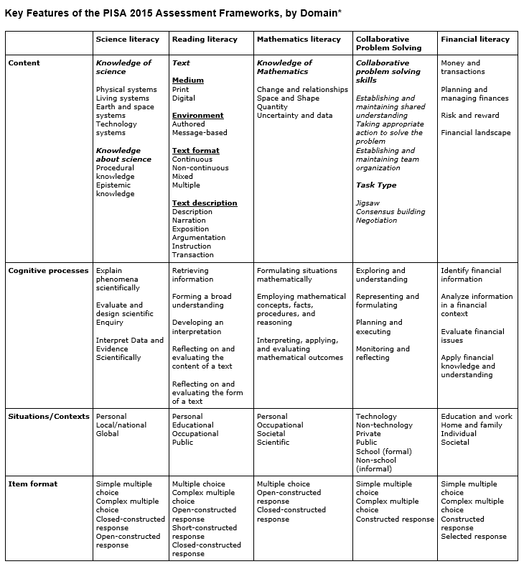(2015).PISA Reading Literacy Items. *PISA* *Programme of International Student Assessment*. Retrieved from https://nces.ed.gov/surveys/pisa/pdf/items_reading.pdf

**Appendix # 2**

**Percentage of High School Students Who Graduate in United States and Finland**

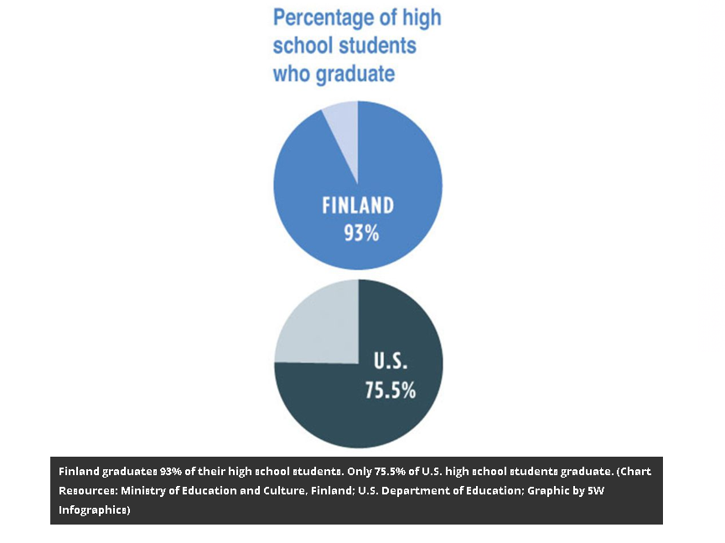

Hancock, L. (2011).Why Are Finland’s Schools Successful?. *Smithsonian Magazine*.

Retrieved from <https://www.smithsonianmag.com/innovation/why-are-finlands-schools-successful->

**Appendix #3**

**Annual Amount Spent Per Secondary School Student in the United States and Finland**

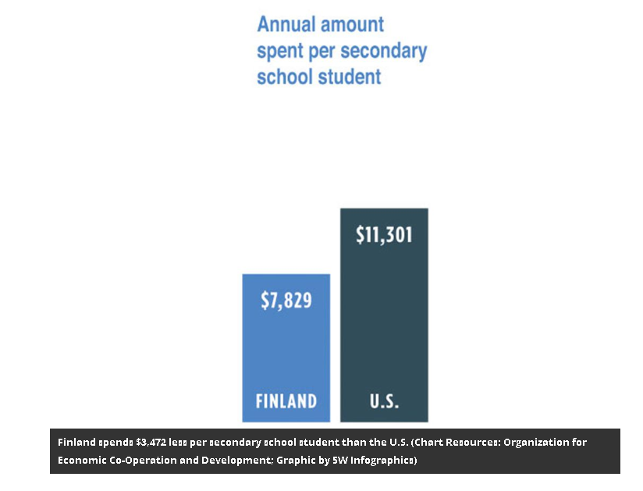

Hancock, L. (2011).Why Are Finland’s Schools Successful?. *Smithsonian Magazine*.

Retrieved from <https://www.smithsonianmag.com/innovation/why-are-finlands-schools-successful->

**Appendix # 4**

**Number of State Mandated Tests in the United States and Finland**

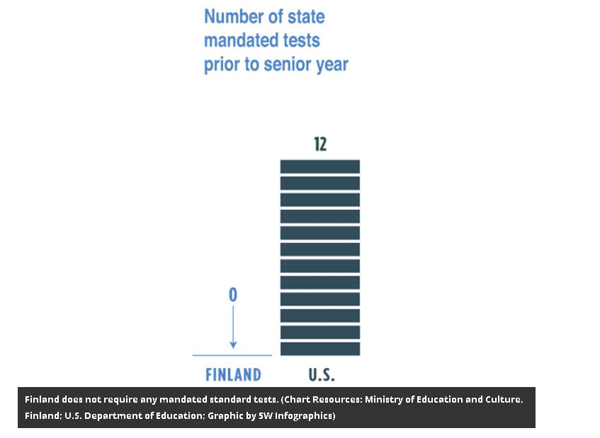

Hancock, L. (2011).Why Are Finland’s Schools Successful?. *Smithsonian Magazine*.

Retrieved from <https://www.smithsonianmag.com/innovation/why-are-finlands-schools-successful->

**Appendix #5**

**Rankings on 2009 International PISA Tests in the United States and Finland**

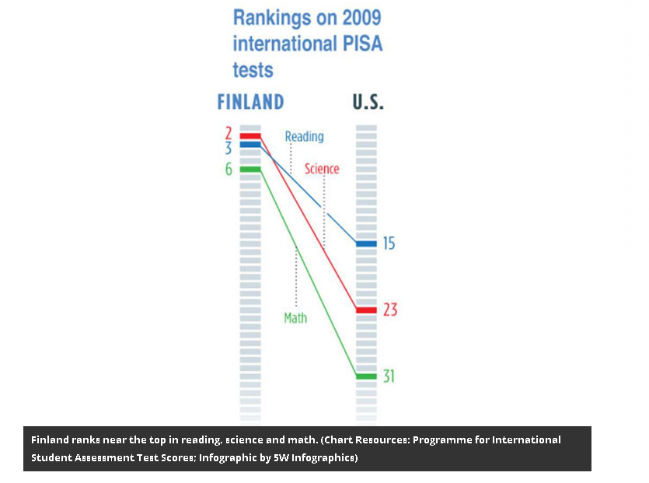

Hancock, L. (2011).Why Are Finland’s Schools Successful?. *Smithsonian Magazine*.

Retrieved from <https://www.smithsonianmag.com/innovation/why-are-finlands-schools-successful->

**Appendix #6 Education System in Finland**

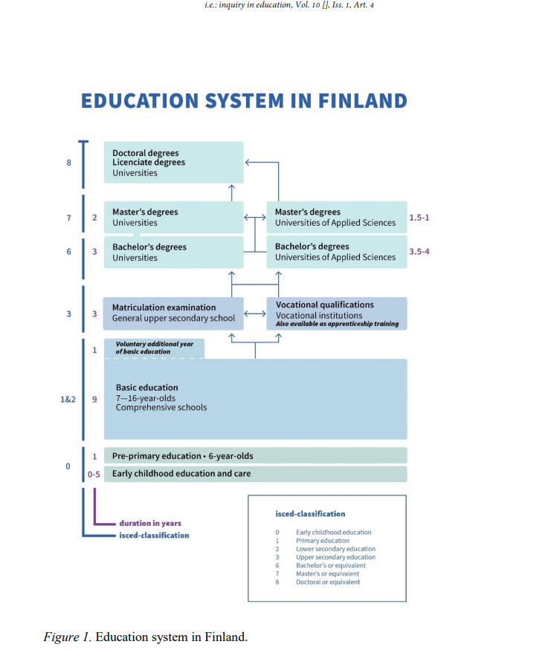

Pollari, P., Salo, O.-P., & Koski, K. (2018). In Teachers We Trust--The Finnish Way to Teach and Learn. I.e.: *Inquiry in Education, 10*(1).

**Appendix #7 Teacher Qualification Requirements for Teachers in Finland**

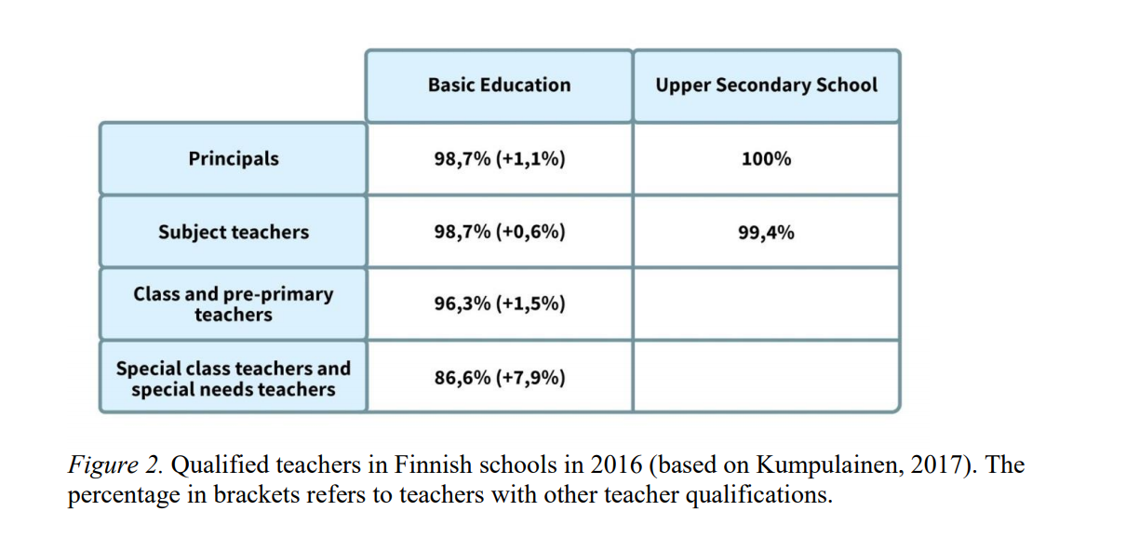

Pollari, P., Salo, O.-P., & Koski, K. (2018). In Teachers We Trust--The Finnish Way to Teach and Learn. I.e.: *Inquiry in Education, 10*(1).