Adsorptive Drying of CO₂ Using Low Grade Heat and Humid, Ambient Air
Brenden Tanchuk, James A. Sawada, Sabereh Rezaei, Steven M. Kuznicki*
Department of Chemical and Materials Engineering, University of Alberta, Edmonton, Alberta, T6G 2V4, Canada
*Corresponding author: Email: steve.kuznicki@ualberta.ca; Telephone: 1.780.492.8819; Facsimile: 1.780.492.8958

Abstract
Adsorptive separation of water from CO₂ is an appealing alternative to liquid absorbers for post-combustion capture systems. In all cases, the purified CO₂ stream from a PCC system will have a high moisture content and, due to equipment corrosion issues and the risk of hydrate formation, the CO₂ stream must be rigorously dried prior to being compressed. This work reports the first study on solid adsorbent selection for CO₂ drying using low grade heat and ambient air as a regeneration gas. Different types of adsorbents, chosen for their range of water adsorption characteristics, have been investigated for the desiccation of a pure CO₂ stream. When destined for sequestration the CO₂ product gas has little value and so the drying process should require no supporting process operations and should consume little additional energy. However, due to the costs and complexity of separating and purifying CO₂ from a flue gas stream, the drying process should return as much CO₂ as possible to the compression stage. An ideal desiccant for CO₂ drying should have a high moisture capacity and selectivity and should be regenerable using waste heat and ambient, humid air. The CO₂ drying performance of Na-, Ca-, and Ca/H- forms of ETS-10 were compared to that of commercial silica and 4A zeolite. Ca-ETS-10 was found to have the highest moisture capacity using a temperature swing of 30-70 °C and a CO₂ feed stream of 50–100% relative humidity. Due to the intrinsic selectivity for water over CO₂ on solid adsorbents, all desiccants tested had a CO₂ recovery greater than 95%.

Keywords: Carbon Dioxide; Gas Drying; Adsorption; ETS-10; Zeolites

1. Introduction
In the last decade there has been increased attention on the high levels of CO₂ emissions and their direct effect on global warming and climate change. The global production of CO₂ is projected to increase from 30 billion tons in 2008 to 43.2 billion tons by 2035 [1]. A number of designs have been proposed to mitigate the environmental effect of rising CO₂ emissions. One design which has received a significant amount of attention is post combustion capture (PCC). A PCC system uses an adsorptive separation process to selectively remove and concentrate CO₂ from the combustion gas stream. The concentrated CO₂ is then compressed and permanently sequestered preventing significant volumes of CO₂ from entering the atmosphere. To improve the efficiency of the separation the combustion process may be modified to run on pure oxygen and/or through a turbine in an integrated gasification combined (IGC) cycle [2-4]. IGC systems provide the benefit of generating a combustion stream with a high concentration of CO₂ although such advantages come at increased cost and added process complexity.
A number of different types of adsorbents with a high selectivity for CO₂ over other atmospheric gases have been investigated for recovering CO₂. These materials include zeolites [5-9], metal oxides [10-15], and solid-supported amines [16-20]. Each class of materials has different strengths and sensitivities but all will co-adsorb water to some extent which will be desorbed with the CO₂. Prior to compression this moisture needs to be reduced to trace levels to meet the requirements for underground carbon sequestration [21], and to avoid the formation of CO₂ hydrates [22].
An ideal desiccant for CO₂ drying would have a high water capacity at low partial pressure and would demonstrate a large difference in moisture capacity over a narrow temperature swing. The adsorbents’ selectivity toward water over CO₂ is likewise important because this property will drive the recovery of CO₂ from the drying step. The additional cost and complexity associated with improving CO₂ capture needs to be met with process efficiency at the drying stage, as losses at the drying stage will affect the overall efficiency of the PCC system.
Liquid absorption drying systems, while being a mature technology, are unsuitable for PCC/CO₂ sequestration due to the thermal input required in the reboiler and product gas losses due to the poor selectivity of the liquid. A triethyleneglycol (TEG) drying system, for example, is regenerated by heating the glycol to 200°C in order to remove the adsorbed moisture [23]. TEG also has a significant absorption capacity for CO₂ [24], which assists in the drying of the TEG fluid but simultaneously reduces the CO₂ recovery because the absorbed CO₂ is vented to the atmosphere during depressurization. TEG drying systems are also limited to generating gas streams having a dewpoint of about -40 °C which may not suit all compression and sequestration requirements.
Zeolite temperature swing adsorption (TSA) drying systems, used for drying natural gas, are capable of generating gas streams having very low dewpoints, but similar to TEG systems, zeolites require a regeneration step at temperatures greater than 200°C [25]. The moisture selectivity and capacity of zeolite molecular sieves are exceptionally high, and it would be expected that the CO₂ losses from a conventional TSA system would be minimal. However, generating high-grade heat to regenerate the zeolite desiccant through the combustion of fossil fuels is economically and environmentally unsound for PCC because the product gas has limited or no value.
Unlike zeolite molecular sieves, silica gel desiccants can be regenerated at temperatures as low as 100°C, which could allow the use of low-grade waste heat streams as a regeneration source. The water adsorption capacity of silica gel, however, decreases linearly with concentration [7] which lends the adsorbent little capacity at trace levels of moisture and reduces the amount of the bed used for adsorption.
Engelhard Titanosilicate 10 (ETS-10) is a large-pored, titanium silicate molecular sieve composed of a mixture of silicon oxide tetrahedra and titanium oxide octahedral [26, 27]. Its porous structure is composed of a network of connected 7.6 Å by 4.9 Å channels formed by 12 membered rings [26]. The channels are composed entirely of silica tetrahedra that gives the molecular sieve a chemical stability that is typically reserved for highly dealuminated zeolties. The titania chains that run orthogonally through the framework maintain a net negative charge that is offset by cationic counter ions. ETS-10 thus combines the chemically passive characteristics of silica gel with the ion exchange capability of zeolite molecular sieves. As a result of this combination of unique properties, ETS-10 has been explored as a template for precious metal nanodots [28, 29], quantum wires [30, 31], hydrocarbon separations [32, 33], as an additive to improve the conductivity of PEM fuel cell membranes [34, 35], and as a continuous membrane itself [36, 37, 38, 39] .
ETS-10 has previously been identified as a desiccant material for air [40], though its use for drying CO₂ streams has not been investigated. The adsorption behavior of ETS-10 is unique because it retains a high moisture capacity at low partial pressures at ambient temperatures, but rapidly loses moisture capacity as temperature increases [40].
This work describes the CO₂ drying performance of Na-, Ca- and Ca/H- ion exchanged forms of ETS-10 and compares them to commercial silica and zeolite 4A adsorbents. A wet CO₂ stream was dried using a single packed-bed column. The moisture capacity and the CO₂ recovery were calculated at trace moisture breakthrough for the ETS-10, silica, and zeolite 4A desiccants. The drying capacity of each adsorbent was compared at 50%, 75%, and 100% relative humidity (RH) using fixed bed regeneration time and temperature, air flow, and adsorption temperature.

2. Experimental
2.1 Materials
Grace Davison Grade 40 silica gel with a particle size range from 3.36 to 1.68 mm was used in this study. The zeolite 4A (Dessican Inc.) sample consisted of 4 to 2 mm beads. The Na-ETS-10 samples were synthesized hydrothermally using a previously published technique [27]. Synthesis gels were prepared by mixing 50 g sodium silicate solution (28.7% SiO₂, 8.9% Na₂O, Fisher), 3.2 g of sodium hydroxide beads (Fisher), 3.8 g of KF (anhydrous, Fisher), and 16.3 g of TiCl₃ solution (20%, Fisher). The pH of the mixture was adjusted from about pH 12 to 10.1 by adding hydrochloric acid (1M, Fisher). The mixture was then stirred for one hour and then reacted in a sealed, Teflon lined 125 mL autoclave (PARR Instruments) at 200°C for 72 hours. The post-reaction material was then washed with de-ionized water and filtered, then dried in an 80°C oven.
Samples of the synthesized Na-ETS-10 were ion exchanged to calcium and mixed calcium/hydrogen ion forms. The Ca²⁺ exchange was carried out by mixing the synthesized powder with a CaCl₂ solution. The ion exchange mixture was prepared by adding 30 g CaCl₂·2H₂O (Fisher) to 150 g of de-ionized water, stirring to dissolve the calcium chloride, then adding 15 g of Na-ETS-10 powder. The mixture was then agitated and placed in a sealed vessel in an oven at 80°C under static conditions for 4 hrs. After this the powder was again washed with de-ionized water and filtered, then dried at 80°C.
The mixed calcium hydrogen exchange was carried out by dissolving 4 g of CaCl₂·2H₂O in 150 g of de-ionized water and then adding 15 g of Na-ETS-10. The mixture was placed in an oven under static conditions at 80°C overnight in a sealed container. The sample was then filtered and dried at 80°C for two hours. The sample was then dispersed in 150 g of de-ionized water. The pH of the sample was lowered to 2 by adding HCl (1M, Fisher). The sample was stirred overnight at room temperature. It was then washed with deionized water, filtered, and dried in an oven at 80°C.
The ETS-10 powder was pressed into binderless dense pellets. These pellets, along with the zeolite 4A and silica beads were crushed and sieved with the 1.19 mm to 0.595 mm fraction for use in the CO₂ drying experiments.

2.2 Characterization
X-ray diffraction (XRD) was used to verify the identities of and to gain qualitative information on the crystal structures of the adsorbents used in this study. A Rigaku Ultima IV with Co tube (38kV, 38mA) with an average Kα wavelength of 1.7902 Å equipped with a D/Tex detector with a Fe filter was used for all XRD characterization. XRD patterns obtained were compared to data from the International Center for Diffraction Data-Powder Diffraction File (ICDD-PDF) using JADE 9.1, along with visual comparisons to existing standards and literature to verify sample identity and purity.
Gas adsorption isotherms, surface area, and pore volume measurements were carried out using a Micrometrics ASAP 2020C volumetric physisorption system. Nitrogen at -196°C was used as the probe molecule. Samples were outgassed at 200 °C overnight at a pressure of 0.4 Pa.

2.3 Experimental setup
Figure 1 shows the process flow diagram for the experimental setup. In order to control the input stream humidity, the inlet stream coming from the CO₂ cylinder (Praxair) was split and run through two mass flow controllers (MFC) (Alicat Scientific). The flow from MFC1 bubbled through a 300 mL liquid contactor partially filled with de-ionized water to a 50 mL accumulator, saturating it with moisture. The second stream from MFC2 went directly to the accumulator. The dry and moisture saturated gas streams were blended in the accumulator to achieve gas moisture contents from 0 to 100% RH. The liquid contactor was only partially filled to prevent liquid water from being carried over.
The CO₂ stream from the accumulator entered at the top of the adsorbent bed and flowed vertically downward. The adsorbent bed was a borosilicate glass tube with an inner diameter of 10.7 mm. The adsorbent was packed into the bed and kept in place by plugs of ~ 2 g of glass wool packed at both ends of the bed. The pressure at the inlet and exit of the bed was monitored by a pair of 0-15 psia pressure transducers (Omega Environmental). The temperature at the inlet and exit of the bed were measured using two K-type thermocouples (Omega Environmental). In order to maintain a stable temperature for humidification and to prevent condensation all equipment in contact with moist CO₂ was kept inside an oven maintained at 30°C.
The outlet of the desiccant bed was plumbed to a dewpoint meter, which assessed the amount of moisture remaining in the gas stream. The sensor used was a COSA Xentaur XDT transmitter with a high capacitance Al₂O₃ XTR-100 sensor element capable of measuring dewpoints from -100°C to 20°C (0.013 ppmv to 23080 ppmv).
The product flow rate was measured by an Alicat Scientific MC mass flow/backpressure controller. This allowed the column to be maintained at atmospheric pressure while simultaneously recording the product flow rate. A vacuum pump downstream could be used to create a pressure differential for smoother operation of the backpressure controller, however this was not typically required. To regenerate the bed, the three-way valves around the bed were actuated, shifting the system from adsorption to desorption mode. MFC 3 (Alicat Scientific) was used to control the flow of regeneration air. Either building-supplied compressed air or ambient air (compressed and delivered via a diaphragm pump KNF Neuberger) served as the regeneration air. The ambient air humidity was measured by a HH-314A portable temperature/humidity meter (Omega Environmental).
The regeneration air source was controlled by a three-way valve. The regeneration air flowed from MFC3 to the bottom of the adsorbent bed, counter current to the wet gas stream in the adsorption phase. The regeneration air was heated with heating cords (Omega Environmental). The regeneration air swept through the adsorbent bed and then past a HH-314A portable temperature/humidity meter (Omega Environmental) and was vented to the room.
After the regeneration step the bed was allowed to cool. During this time the dewpoint sensor was blown down with dry nitrogen supplied from a cylinder to remove moisture that had adsorbed. After the bed had cooled and the dewpoint sensor level had been reduced to below -65°C, another adsorption cycle would be run. The gas flow profiles for the adsorption, desorption, and cool-down phases of cycle operation are shown in Figures 7, 8 and 9 of Supplementary Data. Each cycle started with a desorption phase, followed by cool down phase, ending with an adsorption phase. The experiment was controlled and data collected through a Labview program constructed by the University of Alberta instrumentation services.

2.4 Breakthrough experiments procedure
Five different adsorbents were studied for CO₂ drying experiments: silica gel, zeolite 4A, Na-ETS-10, Ca-ETS-10, and Ca/H-ETS-10. The breakthrough experiments used a CO₂ flow rate of 500 sccm. The adsorption temperature was kept constant at 30°C to maintain a controllable, near-ambient condition. The bed regeneration conditions were set at a bed temperature of 70°C, with ambient room air used at a flow rate of 500 sccm. The regeneration time was set to one hour. The regeneration temperature was selected to compare the performance of the adsorbents using low-grade heat for regeneration, such as the waste heat available from the low-pressure steam of a power plant. The performance of each adsorbent was assessed using a CO₂ inlet feed having a moisture content of 50, 75, and 100 % RH. Data points were collected once every 5 sec throughout the experiments. These conditions were used for all adsorbents and all CO₂ stream humidities. Replicate runs were performed for each set of experimental conditions.
A breakthrough profile for Ca-ETS-10 is shown in Figure 2 as an example of the typical breakthrough profile which was seen in all experiments for all adsorbents. The spike in moisture level at the start of the experiment is due to moisture stranded in the piping between the top of the bed and the three-way switching valve. The moisture in this ~18 inches of 0.25” OD tubing is swept to the sensor as a slug at the start of the experiment and the downward trend in the dewpoint signal is due to the sensor drying out as it is exposed to the dry process gas. The breakthrough time was selected as the point at which the signal inflects upward coincident with the moisture front breaking through the bed.

3. Results and Discussion
3.1 Characterization
Figure 3 presents the XRD patterns for Na-, Ca-, and Ca/H-ETS-10. All major peaks were characteristic of ETS-10, except for the peak at 2θ = 35°. This peak was identified as being characteristic of ETS-4, a typical secondary phase which may be a by-product of ETS-10 synthesis. The peak shapes and locations match well in all three patterns, which indicate that, as expected, the ion exchange procedures had no significant impact on the ETS-10 crystal structure.
EDX analysis of the ion-exchanged ETS-10 desiccant samples was performed at three different points on the face of the sample. The five elements chosen for determination were Si, Ti, Na, Ca, and K. Si, Ti, and O comprise the ETS-10 structure, while Na⁺ and K⁺ are the typical cations which balance the net negative charge of the framework. Ca²⁺ was measured for the exchanged samples. This EDX data is shown in Table 1 as the relevant atomic ratios for each of the ETS-10 desiccant samples. The structure of the polymorph B of ETS-10, as reported by Anderson et al. has a theoretical Si:Ti ratio of 5 [41]. Though the experimentally gathered Si:Ti ratios do not match this theoretical value, the Si:Ti ratio for Na-ETS-10, Ca-ETS-10, and Ca/H-ETS agree within error with the range of Si:Ti ratios of 3.5-10 as reported by Kuznicki for ETS-10 [27]. Pavel et al. has reported ETS-4 with a Si:Ti ratio of 2.4 or lower [42]. It is likely based on the crystal morphology that these large clusters contained some particles of ETS-4. The presence of ETS-4 would also contribute to the lower Si:Ti ratio values obtained during EDX analysis. The presence of ETS-4 as an impurity phase was also verified by XRD.
The amount of Na+K dropped significantly after Ca and Ca/H exchanges, indicating that the Na⁺ and K⁺ ions are being displaced by the Ca²⁺ and H⁺ ions. The K⁺ ions are exchanged proportionally less than the Na⁺ which suggests that the K⁺ ions have a stronger affinity for their sites in the lattice compared to Na⁺. This result is typical of ETS-10 ion exchanges, and can be explained by the location of the Na⁺ and K⁺ ions within the framework. Anderson et al. propose that a portion of the K⁺ ions are locked within the cages of the structure and therefore unavailable for exchange, while the Na⁺ ions are more exposed and, thus, more easily displaced [41].
The cation to metal ratios (Na:Ti, Ca:Ti) can be examined to determine the degree of ion exchange. In the Ca-ETS-10 sample a significant decrease in the Na:Ti ratio is seen, and the presence of calcium is now observed. However, in order to balance the net negative charge of the TiO₆²⁻ octahedra, a net 2+ charge is necessary, which is not the case before or after the exchange, and the cation content of the Ca-ETS-10 appears to exceed that of the Na-ETS-10. This might be explained by the presence of H⁺ in addition to K⁺ and Na⁺ in the as-synthesized Na-ETS-10. These protons would have exchanged in during the washing of Na-ETS-10. The H:Ti ratio for the washed, as-synthesized Na/K-ETS-10 should be ~0.34. After calcium exchange, the H:Ti ratio becomes ~0.15, dropping along with the other monovalent cations as they are exchanged for Ca²⁺. For Ca/H-ETS-10, the H:Ti ratio rises to ~0.87. These results suggest that the ion affinity of ETS-10 follows the trend of Ca²⁺ > H⁺ > Na⁺ / K⁺. This trend is confirmed by literature reports that ETS-10 has a strong affinity for divalent cations and for protons [30, 43, 44].
Table 2 presents the results of N₂ adsorption isotherms that were used to determine the pore volume and surface areas for the various adsorbents. For the silica gel samples the BET method of calculating surface area was utilized, while for the ETS-10 samples the Langmuir method of calculating surface area was used. No data was obtained for zeolite 4A as it will not adsorb nitrogen at -196°C. To determine the pore volume, micropore and external surface areas the deBoer t-plots method was used. The surface areas and pore volumes of the various ETS-10 samples are fairly consistent since ion exchange is not expected to affect these properties.

3.2 Breakthrough capacities
Table 3 shows the breakthrough capacities on a gravimetric basis for silica gel, zeolite 4A, Na-ETS-10, Ca-ETS-10, and Ca/H-ETS-10 respectively. The values from not less than three experiments were used for the average and standard deviation. The values reported in Table 3 represent the average of the experimental breakthrough times and the 95% confidence interval (taken as 1.96 times the standard deviation, assuming a normal distribution).
The breakthrough capacity for the Ca-ETS-10 bed appears to have little dependence on the feed stream humidity. The zeolite 4A, Na-ETS-10, and Ca/H-ETS-10 beds show increasing moisture adsorption capacity as the humidity of the CO₂ stream increases. It was expected that the breakthrough capacity of zeolite 4A and the ETS-10 materials would remain constant as the feed stream moisture content increased, similar to Ca-ETS-10, since the water adsorption isotherms for these adsorbents show an essentially constant equilibrium water capacity at the humidity range investigated. The increased capacity would be expected as humidity rises if the feed stream moisture level was low enough to have moved out of the rectangular region of the adsorption isotherm. However, at 30°C the 50%-100% RH range corresponds to the rectangular region of these isotherms. This might be attributed to the fact that for zeolite 4A, Na-ETS-10, and Ca/H-ETS-10, the bed length is not long enough for the mass transfer front to fully develop, leading to the breakthrough before any portion of the bed is fully saturated. Additionally, defects in the packing of the adsorbent could result in gas channeling along the bed wall, which would similarly decrease the breakthrough time.
Table 3 presents the average breakthrough capacities with 95% confidence intervals. The size of these confidence intervals ranges from only a few percent up to about 35% for Na-ETS-10 at 50% RH feed stream. The variability can be as high as 20% for the Ca and Ca/H-ETS-10, 12% for the 4A sample, and up to 30% for the silica gel data. This variability is likely due to the change in the humidity of the ambient air used for the regeneration. The data sets with a larger variability in moisture capacity measurements also had a higher degree of variability in the recorded ambient air humidity. Increasing moisture in the regeneration air stream correlates to a decrease in bed moisture capacity, as shown for Ca-ETS-10 at 75% RH in Figure 4.
Figure 5 shows the effect that switching the regeneration gas from dry compressed air to ambient “wet” air has on bed moisture capacity for silica gel, zeolite 4A and Ca-ETS-10. The experiments were run using a feed stream humidity of 100% RH CO₂ and one hour regeneration time. The conditions for the experiments were kept the same with the exception of the regeneration air stream humidity. The building compressed air had a measured humidity of 46 ppmv while the ambient air humidity was between 3100 ppmv and 4100 ppmv. In all cases, the moisture capacity of the adsorbent bed was lower when using ambient air for regeneration. While the results for the Ca-ETS-10 may be within error, the results for silica gel demonstrate that this adsorbent is significantly affected by the regeneration stream humidity. The difference in the 4A bed loses is almost 50% of its capacity, which is well outside of the test-to-test variability for this sample.
During regeneration, the presence of moisture in the air stream limits the amount of water desorbed from the sieve by maintaining an elevated partial pressure of moisture. The difference in bed capacity under humid and dry regeneration can be understood by comparing the isotherms for the various materials. Figure 6 shows the water adsorption isotherms for silica gel, 4A, and Ca-ETS-10. Silica gel displays a linear response to moisture concentration across a range of temperatures and the adsorbent has little water capacity at low partial pressure. The capacity of the adsorbent at low partial pressure is limited by the presence of humidity in the regeneration gas stream. This residual moisture loading, coupled with the low capacity for moisture at low partial pressures, will significantly decrease the adsorption capacity of the silica gel (at low partial pressure) and explains the difference seen in the silica gel experiments. Unlike the linear response of silica gel, the 4A isotherms show a rectangular adsorption profile typical of aluminosilicate zeolites. 4A is saturated at relatively low levels of humidity and, without a dry gas to drive the loading on the sieve down, the adsorption capacity, over the range of temperatures selected, results in a much smaller swing capacity. The water adsorption isotherms for Ca-ETS-10 display a fundamentally different trend compared to the silica gel and 4A. The rectangularity of the isotherm at ambient temperature ensures a high moisture capacity at low partial pressure yet this rectangularity collapses at elevated temperatures. The fact that the adsorption profile for Ca-ETS-10 collapses as a function of temperature allows a larger swing capacity over a narrow temperature window even when humid air is used as the regeneration gas.
The breakthrough capacities can also be computed on a capacity per unit volume of adsorbent basis (g H₂O adsorbed per cc adsorbent). Comparing the breakthrough capacities in this manner is relevant because the adsorbent bed volume is a major factor in determining the capital cost of an adsorptive gas separation unit. On a capacity per unit volume basis Ca-ETS-10 has the highest capacity for both 50% RH (0.0582 g/cc) and 75% RH (0.0564 g/cc) CO₂ feed streams. For the 50% RH CO₂ feed this is noticeably higher than Na-ETS-10 (0.0335 g/cc), the second highest capacity adsorbent, and higher than the capacity of zeolite 4A (0.0311 g/cc). For the 75% RH CO₂ feed Ca/H-ETS-10 breakthrough capacity (0.0493 g/cc) is close to that of Ca-ETS-10. The capacity of zeolite 4A (0.0390 g/cc) is still noticeably lower than that of Ca-ETS-10 and Ca/H-ETS-10. At 100% RH in the CO₂ feed stream, Ca/H-ETS-10 (0.0671 g/cc) and Ca-ETS-10 (0.0666 g/cc) have approximately the same breakthrough capacity, higher than that of the other adsorbents.
The consistently low breakthrough capacity of silica gel is due to its relatively low affinity for moisture compared to the other adsorbents. This gives it a low equilibrium capacity at low inlet moisture levels, allowing ppm levels of moisture to easily breakthrough. The breakthrough capacity of zeolite 4A follows a similar trend to that of Na-ETS-10 and Ca/H-ETS-10. The breakthrough capacity of Ca/H-ETS-10 increased the most with the increasing feed stream humidity, followed by zeolite 4A and Na-ETS-10. This may imply that Na-ETS-10 is the closest material to fully developing a mass transfer front and thus is less affected by the increasing moisture content.

3.3 CO₂ Recovery
An important performance metric used to compare separations is the recovery of the product, or the amount of produced target gas divided by the amount of target gas fed to the system. In these breakthrough experiments the dry CO₂ exiting the system can be considered the product stream. The recoveries for the various breakthrough experiments are shown in Table 4. For all adsorbents, the recovery was greater than 95%. This result was expected due to the high selectivity these materials have for water over most other gases and vapour. CO₂ was lost as the initial gas flow moisture pulse was vented. The high selectivity of the adsorbents for water over CO₂ drives the process to high recovery.

Conclusions
The adsorptive removal of water vapour from a CO₂ gas stream is an attractive alternative to liquid solvent absorbers. This work has focused on drying a humid, concentrated CO₂ stream which would be generated from a PCC system. This study has shown ETS-10 is a promising desiccant for drying CO₂ to trace levels of moisture. The Ca- form of ETS-10 had the highest breakthrough capacity of the desiccants examined under the specified test conditions. The swing in water capacity is substantial using a regeneration temperature as low as 70°C and retains this capacity using humid, ambient air as a regeneration gas. The relative insensitivity of ETS-10 towards humidity in the regeneration stream eliminates the need for a separate regeneration air drying step which further reduces the energy requirements of the system. The ability to operate using humid, ambient air and low grade waste heat, coupled with the high recovery of CO₂, makes molecular sieve-based adsorptive drying an attractive alternative to solvent-based absorptive drying.

Acknowledgements
The authors thank Albana Zeko for assistance with manuscript preparation and Les Dean for his assistance building the experiment data acquisition program. The authors gratefully acknowledge the research funding provided by the Canada Research Chair (Tier I) and Helmholtz-Alberta Initiative (HAI).

References:

[1] J. Conti, P. Holtberg, International Energy Outlook 2011, DOE/EIA-0484(2011); U.S. Energy Information Administration, U.S. Government Printing Office, Washington, DC, 2011.
[2] C.-C. Cormos, A. Padurean, P.S. Agachi, Technical evaluations of carbon capture options for power generation from coal and biomass based on integrated gasification combined cycle scheme, Energy Procedia, 4 (2011) 1861-1868.
[3] Y. Hu, H. Li, J. Yan, Integration of evaporative gas turbine with oxy-fuel combustion for carbon dioxide capture, International Journal of Green Energy, 7 (2010) 615-631.
[4] A. Kather, S. Kownatzki, Assessment of the different parameters affecting the CO2 purity from coal fired oxyfuel process, International Journal of Greenhouse Gas Control, 55 (2011) 5204-5209.
[5] C.O. Arean, M.R. Delgado, Variable-temperature FT-IR studies on the thermodynamics of carbon dioxide adsorption on a faujasite-type zeolite, Applied Surface Science, 256 (2010) 5259-5262.
[6] Z. Liu, C.A. Grande, P. Li, J. Yu, A.E. Rodrigues, Adsorption and Desorption of Carbon Dioxide and Nitrogen on Zeolite 5A, Separation Science and Technology, 46 (2011) 434-451.
[7] Y. Wang, M.D. LeVan, Adsorption Equilibrium of Carbon Dioxide and Water Vapor on Zeolites 5A and 13X and Silica Gel: Pure Components, Journal of Chemical & Engineering Data, 54 (2009) 2839-2844.
[8] Z. Zhao, X. Cui, J. Ma, R. Li, Adsorption of carbon dioxide on alkali-modified zeolite 13X adsorbents, International Journal of Greenhouse Gas Control, I (2007) 355-359.
[9] A. Zukal, J. Mayerova, M. Kubu, Adsorption of Carbon Dioxide on High-Silica Zeolites with Different Framework Topology, Topics in Catalysis, 53 (2010) 1361-1366.
[10] J. Baltusaitis, J. Schuttlefield, E. Zeitler, V.H. Grassian, Carbon dioxide adsorption on oxide nanoparticle surfaces, Chemical Engineering Journal, 170 (2011) 471-481.
[11] P.-H. Chang, Y.-P. Chang, S.-Y. Chen, C.-T. Yu, Y.-P. Chyou, Ca-Rich Ca-Al-Oxide, High-Temperature-Stable Sorbents Prepared from Hydrotalcite Precursors: Synthesis, Characterization, and CO2 Capture Capacity, ChemSusChem, 4 (2011) 1844-1851.
[12] G.S. Grasa, J.C. Abanades, CO2 Capture Capacity of CaO in Long Seris of Carbonation/Calcination Cycles, Industrial & Engineering Chemistry Research, 45 (2006) 8846-8851.
[13] H. Lu, P.G. Smirniotis, F.O. Ernst, S.E. Pratsinis, Nanostructured Ca-based sorbents with high CO2 uptake efficiency, Chemical Engineering Science, 64 (2009) 1936-1943.
[14] G. Ramis, G. Busca, V. Lorenzelli, Low-temperature CO2 adsorption on metal oxides: spectroscopic characterization of some weakly adsorbed species, Materials Chemistry and Physics, 29 (1991) 425-435.
[15] S. Wang, S. Yan, X. Ma, J. Gong, Recent advances in capture of carbon dioxide using alkali-metal-based oxides, Energy & Environmental Science, 4 (2011) 3805-3819.
[16] B. Arstad, H. Fjellvag, K.O. Kongshaug, O. Swang, R. Blom, Amine functionalised metal organic frameworks (MOFs) as adsorbents for carbon dioxide, Adsorption, 14 (2008) 755-762.
[17] F.-Y. Chang, K.-J. Chao, H.-H. Cheng, C.-S. Tan, Adsorption of CO2 onto amine-grafted mesoporous silicas, Separation and Purification Technology, 70 (2009) 87-95.
[18] R. Chatti, A.K. Bansiwal, J.A. Thote, V. Kumar, P. Jadhav, S.K. Lokhande, R.B. Biniwale, N.K. Labhsetwar, S.S. Rayalu, Amine loaded zeolites for carbon dioxide capture: Amine loading and adsorption studies, Microporous and Mesoporous Materials, 121 (2009) 84-89.
[19] C. Knofel, J. Descarpentries, A. Benzaouia, V. Zelenak, S. Mornet, P.L. Llewellyn, V. Hornebecq, Functionalised micro-/mesoporous silica for the adsorption of carbon dioxide, Microporous and Mesoporous Materials, 99 (2007) 79-85.
[20] O.G. Nik, B. Nohair, S. Kaliaguine, Aminosilanes grafting on FAU/EMT zeolite: Effect on CO2 adsorptive properties, Microporous and Mesoporous Materials, 143 (2011) 221-229.
[21] L. Marini, Geological Sequestration of Carbon Dioxide: Thermodynamics, Kinetics, and Reaction Path Modeling, Elsevier, Amsterdam, 2006.
[22] A.Y. Manakov, Y.A. Dyadin, A.G. Ogienko, A.V. Kurnosov, E.Y. Aladko, E.G. Larionov, F.V. Zhurko, V.I. Voronin, I.F. Berger, S.V. Goryainov, A.Y. Lihacheva, A.I. Ancharov, Phase Diagram and High-Pressure Boundary of Hydrate Formation in the Carbon Dioxide-Water System, Journal of Physical Chemistry B, 113 (2009) 7257-7262.
[23] V.N. Hernandez-Valencia, M.W. Hlavinka, J.A. Bullin, Design Glycol Units for Maximum Efficiency, in: Proceedings of the Seventy-First GPA Annual Convention, Tulsa, OK: Gas Processores Association, 1992, pp. 310-317.
[24] O. Aschenbrenner, P. Styring, Comparative study of solvent properties for carbon dioxide absorption, Energy & Environmental Science, 3 (2010) 1106-1113.
[25] D.W. Breck, Zeolite Molecular Sieves, Wiley, New York, 1974.
[26] M.W. Anderson, O. Terasaki, T. Ohsuna, A. Philippou, S.P. MacKay, A. Ferreira, J. Rocha, S. Lidin, Structure of the microporous titanosilicate ETS-10, Nature, 367 (1994) 347-351.
[27] S.M. Kuznicki, LARGE-PORED CRYSTALLINE TITANIUM MOLECULAR SIEVE ZEOLITES, in, United States, 1989.
[28] C.C.H. Lin, M. Danaie, D. Mitlin, S.M. Kuznicki, Palladium nanoparticles formed on titanium silicate ETS-10, Journal of Nanoscience and Nanotechnology, 11 (2011) 2537-2539.
[29] M. Shi, C.C.H. Lin, L. Wu, C.M.B. Holt, D. Mitlin, S.M. Kuznicki, Nanosilver Particle Formation on a High Surface Area Titanate, Journal of Nanoscience and Nanotechnology, 10 (2010) 8448-8451.
[30] C.J. Nak, J.L. Young, J.-H. Park, H. Lim, C.-H. Shin, H. Cheong, B.Y. Kyung, New insights into ETS-10 and titanate quantum wire: A comprehensive characterization, Journal of the American Chemical Society, (2009) 13080-13092.
[31] B. Yilmaz, J. Warzywoda, A. Sacco Jr., Spectroscopic characterization of the quantum wires in titanosilicates ETS-4 and ETS-10, Nanotechnology, 17 (2006) 4092-4099.
[32] A. Anson, F. Yang, M. Shi, S.M. Kuznicki, Adsorption of ethane and ethylene on modified ETS-10, Chemical Engineering Science, 63 (2008) 4171-4175.
[33] M. Shi, C.C.H. Lin, T.M. Kuznicki, Z. Hashisho, S.M. Kuznicki, Separation of a binary mixture of ethylene and ethane by adsorption on Na-ETS-10, Chemical Engineering Science, 65 (2010) 3494-3498.
[34] A. Eguizabal, J. Lemus, M. Urbiztondo, O. Garrido, J. Soler, J.A. Blazquez, M.P. Pina, Novel hybrid membranes based on polybenzimidazole and ETS-10 titanosilicate type material for high temperature proton exchange membrane fuel cells: A comprehensive study on dense and porous systems, Journal of Power Sources, 196 (2011) 8994-9007.
[35] T. Sancho, J. Soler, M.P. Pina, Conductivity in zeolite-polymer composite membranes for PEMFCs, Jounal of Power Sources, 169 (2007) 92-97.
[36] Z. Lin, J. Rocha, A. Navajas, C. Tellez, J. Coronas, J. Santamaria, Synthesis and characterisation of titanosilicate ETS-10 membranes, Microporous and Mesoporous Materials, 67 (2004) 79-86.
[37] H.-K. Jeong, J. Krohn, K. Sujaoti, M. Tsapatsis, Oriented molecular sieve membranes by heteroepitaxial growth, Journal of the American Chemical Society, 124 (2002) 12966-12968
[38] I. Tiscornia, I. Kumakiri, R. Bredesen, C. Tellez, J. Coronas, Microporous titanosilicate ETS-10 membrane for high pressure CO2 separation, Separation and Purification Technology, 73 (2010) 8-12.
[39] A. Nalaparaju, Z. Q. Hu, X. S. Zhao, J. W. Jiang, Exchange of heavy metal ions in titanosilicate Na-ETS-10 membrane from molecular dynamics simulations, Journal of Membrane Science, 335 (2009) 89-95.
[40] S.M. Kuznicki, K.A. Thrush, H.M. Garfinkel, USE OF CRYSTALLINE MOLECULAR SIEVES CONTAINING CHARGED OCTAHEDRAL SITES IN CYCLIC DESICCATING PROCESSES, in, 1993.[41] M.W. Anderson, J.R. Agger, D.-P. Luigi, A.K. Baggaley, J. Rocha, Cation sites in ETS-10: 23Na 3Q MAS NMR and lattice energy minimization calculations, Physical Chemistry Chemical Physics, (1999) 2287-2292.
[42] C.C. Pavel, D. Vuono, L. Catanzaro, P. De Luca, N. Bilba, A. Nastro, J.B. Nagy, Synthesis and characterization of the microporous titanosilicates ETS-4 and ETS-10, Microporous and Mesoporous Materials, (2002) 227-239.
[43] E.D. Camarinha, P.F. Lito, B.M. Antunes, M. Otero, L. Zhi, J. Rocha, E. Pereira, A.C. Duarte, C.M. Silva, Cadmium (II) removal from aqueous solution using microporous titanosilicate ETS-10, Chemical Engineering Journal, (2009) 108-114.
[44] L. Lv, G. Tsoi, X.S. Zhao, Uptake Equilibria and Mechanisms of Heavy Metal Ions on Microporous Titanosilicate ETS-10, Industrial & Engineering Chemistry Research, (2004) 7900-7906.
[45] A. Gorbach, M. Stegmaier, G. Eigenberger, Measurement and Modeling of Water Vapor Adsorption on Zeolite 4A - Equilibria and Kinetics, Adsorption, 10 (2004) 29-46

Table 1. Relevant atomic ratios for various ETS-10 materials calculated from EDX results
Adsorbent | Atomic Ratios with 95% Confidence Intervals |  |  |  | Total Charge:Ti
 | Si:Ti | Na:Ti | Ca:Ti | K:Ti
Na-ETS-10 | 3.73±0.32 | 1.30±0.15 | - | 0.38±0.03 | 1.68±0.15
Na-ETS-10 | 3.75±0.32 | 1.22±0.15 | - | 0.42±0.03 | 1.64±0.15
Na-ETS-10 | 3.79±0.32 | 1.25±0.15 | - | 0.40±0.03 | 1.65±0.15
Ca-ETS-10 | 3.26±0.28 | 0.49±0.07 | 0.55±0.04 | 0.24±0.02 | 1.83±0.11
Ca-ETS-10 | 3.02±0.28 | 0.26±0.02 | 0.61±0.05 | 0.37±0.06 | 1.85±0.12
Ca-ETS-10 | 3.85±0.37 | 0.50±0.07 | 0.58±0.05 | 0.22±0.02 | 1.88±0.12
Ca/H-ETS-10 | 3.96±0.37 | 0.23±0.02 | 0.35±0.03 | 0.18±0.03 | 1.11±0.07
Ca/H-ETS-10 | 3.12±0.28 | 0.27±0.02 | 0.35±0.03 | 0.17±0.03 | 1.14±0.07
Ca/H-ETS-10 | 3.85±0.36 | 0.26±0.02 | 0.37±0.03 | 0.13±0.03 | 1.13±0.07

Table 2. Surface areas and pore volumes of adsorbent samples
Adsorbent | Total Surface Area  (m²/g) | Micropore Volume  (cc/g) | Micropore Area  (m²/g) | External Surface Area  (m²/g)
Silica Gel | 677.9±9.8 | 8.54E-02 | 171.5 | 506.4
Na-ETS-10 | 389.8±0.5 | 1.33E-01 | 341.6 | 48.9
Ca-ETS-10 | 380.1±0.1 | 1.21E-01 | 336.4 | 43.7
Ca/H-ETS-10 | 392.7±0.2 | 1.25E-01 | 348.2 | 44.4

Table 3. Average capacities for 5 tested adsorbents at various CO₂ feed stream humidity at 30 °C using ambient air as the regeneration gas
Adsorbent | Capacity (wt% H₂O)
 | 50% RH | 75% RH | 100 % RH
Ca-ETS-10 | 7.9±1.6 | 7.6±1.4 | 9.0±1.0
Ca/H-ETS-10 | 4.7±0.4 | 7.2±0.6 | 9.7±1.3
Na-ETS-10 | 4.5±1.6 | 4.5* | 6.2±0.2
Zeolite 4A | 3.8±0.2 | 4.8±0.6 | 6.7±0.8
Silica | 2.5±0.7 | 3.4±0.3 | 2.3±0.1
*multiple data points were not collected

Table 4. CO₂ percent recovery at moisture breakthrough for various adsorbents at 50, 75 and 100 % RH CO₂ feed streams
Adsorbent | Percent Recovery at CO₂ Feed Stream Humidities
 | 50% RH | 75% RH | 100 % RH
Ca-ETS-10 | 99.1±0.6 | 98.1±0.9 | 97.4±0.4
Ca/H-ETS-10 | 97.9±0.1 | 98.1±0.2 | 97.5±0.6
Na-ETS-10 | 98.2±1.3 | 96.9±1.2 | 96.1±0.5
Zeolite 4A | 97.4±0.2 | 98.5±2.5 | 96.6±0.6
Silica | 95.8±1.1 | 95.4±0.1 | 95.5±0.9

Figure Captions

Figure 1. Schematics of process flow diagram of experimental setup.
Figure 2. Breakthrough profile for Ca-ETS-10 at 30 °C and 75% RH.
Figure 3. Powder XRD patterns obtained for the ETS-10 samples.
Figure 4. Breakthrough capacity of Ca-ETS-10 at 30 °C as a function of regeneration air humidity.
Figure 5. Moisture breakthrough capacity for several adsorbents at 30 °C using different regeneration air sources with a 100% RH CO₂ feed stream.
Figure 6. Water adsorption isotherms for (a) Ca-ETS-10 [40], (b) Bayer 4A zeolite [45], and (c) Grade Davidson GD 40 silica gel [7].

Supplementary Material

Figure 7. Process flow diagram of the experimental setup showing gas flow during the adsorption phase.
Figure 8. Process flow diagram of the experimental setup showing gas flow during the regeneration phase.
Figure 9. Process flow diagram of the experimental setup showing gas flow during the cool down phase.
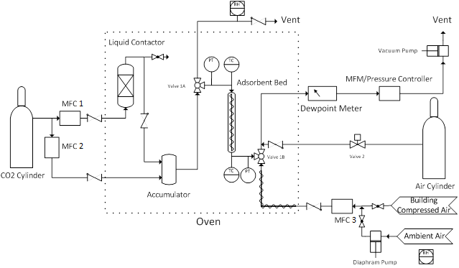
Figure 1.

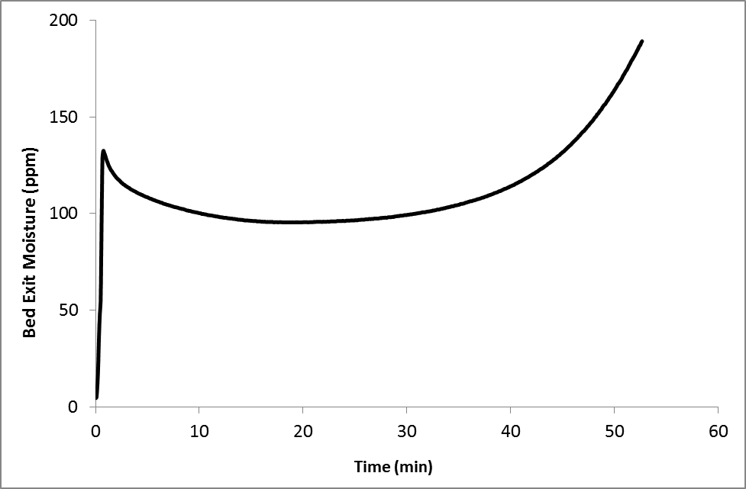
Figure 2.

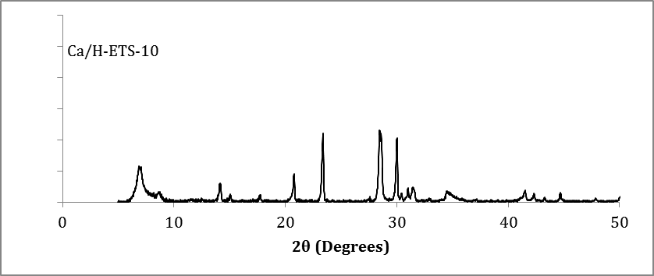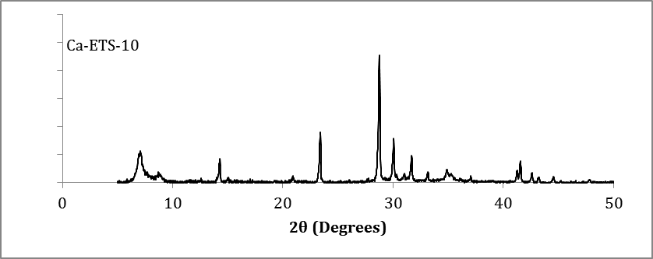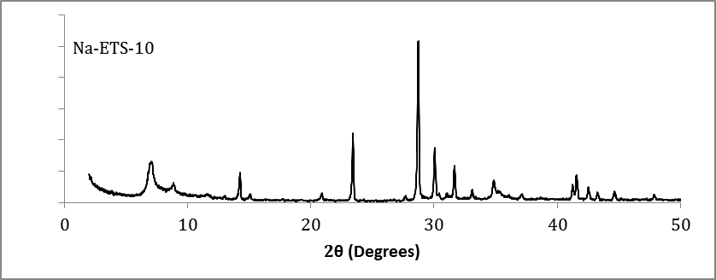

Figure 3.

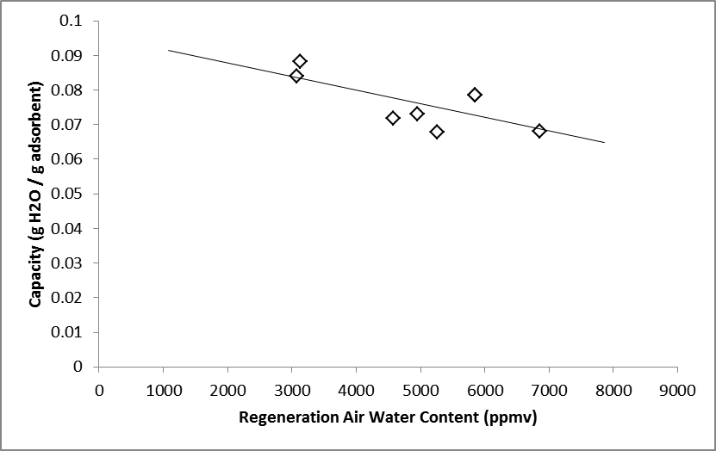

Figure 4.

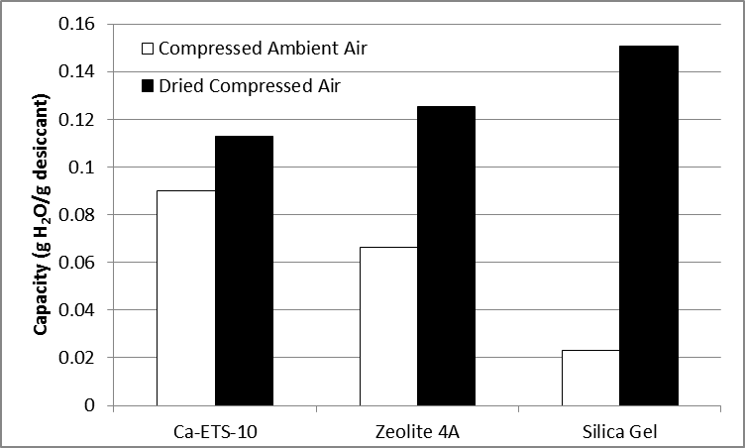
Figure 5.

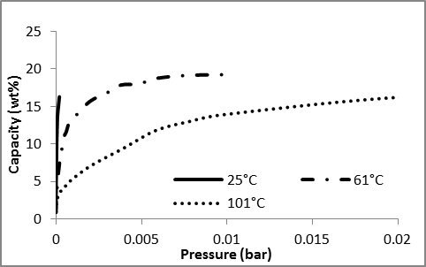
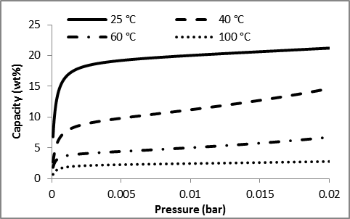
(b)
(a)

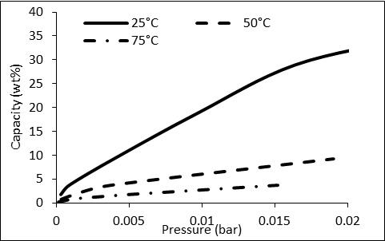
(c)

Figure 6.

Figure 6.

SUPPLEMENTARY MATERIAL:

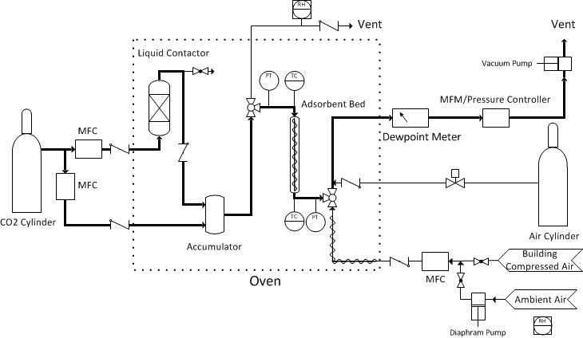

Figure 7.

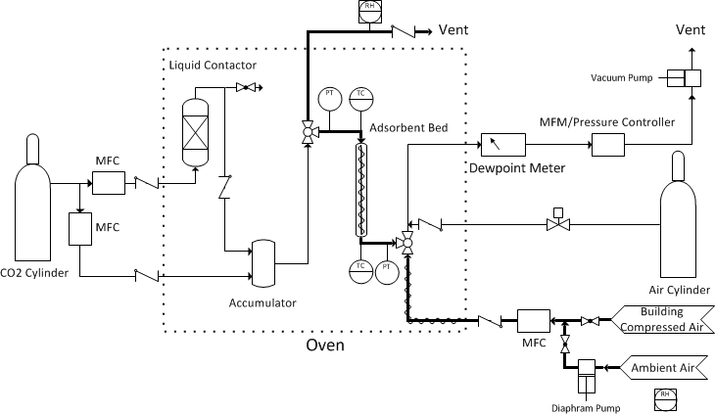
Figure 8.

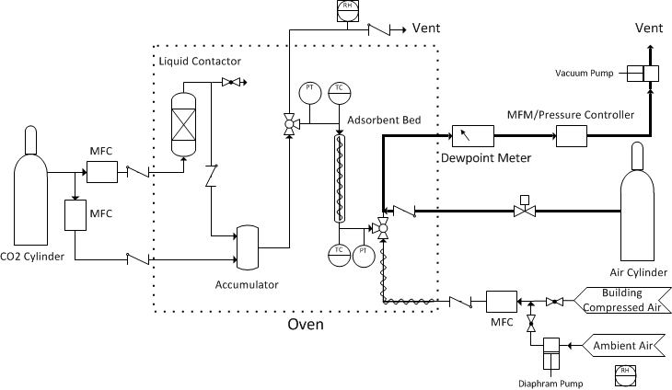
Figure 9.

