Settlement of juvenile glass sponges and other invertebrate cryptofauna on the Hecate Strait glass sponge reefs

Keenan C. Guillas1, Amanda S. Kahn1,3, Nathan Grant1, Stephanie K. Archer2, Anya Dunham2, Sally P. Leys1,4

1Department of Biological Sciences, University of Alberta, Edmonton, AB T6G 2E9, Canada.

2Fisheries and Oceans Canada, Pacific Biological Station, Nanaimo, BC V9T 6N7 Canada.

3Present address: Monterey Bay Aquarium Research Institute, Moss Landing, CA 95039 USA.

4Author for correspondence: sleys@ualberta.ca

**Running head:** Cryptic epifauna on sponge reefs

**KEYWORDS:** Hexactinellida, Porifera, recruitment, glass sponge reef, marine protected area

**ABSTRACT**

Glass sponge reefs are endemic to the continental shelf waters of British Columbia and Alaska where they form complex three-dimensional habitats used by a variety of commercially important fish and invertebrate species. The Hecate Strait and Queen Charlotte Sound Glass Sponge Reefs Marine Protected Area (HSQCS-MPA) was designated in February 2017 to protect 2410 km2 of reef habitat. Efforts to establish baseline information regarding reef-associated taxa in the new MPA have documented the diversity of megafauna in detail, but little is understood of the cryptic epifauna inhabiting hidden crevices within the reefs, and even less is understood of larval recruitment, the key reproductive process maintaining long-term reef health and stability. We collected specimens of areef-building glass sponge *Farrea occa* from the HSQCS-MPA and described the diversity of their epifauna. Four hundred eighty-nine organisms from six phyla were documented, including seventy-two sponges from three classes. We found several glass sponges: known juvenile reef-builders (two *Aphrocallistes vastus* and two *Heterochone calyx*); the lyssacine sponge *Leucopsacus scoliodocus*,previously known in Canadian waters only from Jervis Inlet; and an unidentified dictyonine sponge previously unknown to waters of British Columbia. Also present were the carnivorous sponge *Lycopodina occidentalis*, 11 *Desmacella austini*, and a calcareous sponge. The growth stages we observed suggest multiple settlement events by glass sponge larvae between February and early March. Of the 489 invertebrates, 454 were attached to dead sponge skeleton despite live tissue being much more available as substrate. This study highlights trends in recruitment at sponge reefs, explores factors that may affect larval settlement, describes new sponge associations, and provides the first description of the range of macrofauna found on glass sponges, acting as a baseline for continued monitoring of the MPA.

**1. INTRODUCTION**

Glass sponges (Porifera, Hexactinellida) are suspension feeders that form unusual deepwater reefs on the continental shelf of British Columbia, Canada and Alaska, USA (Conway, Barrie, Austin, & Luternauer, 1991; Stone, Conway, Csepp, & Barrie, 2013). The reefs cover hundreds of square kilometers of seafloor, are up to 9000 years old, and grow to heights of 19 m (Krautter, Conway, Barrie, & Neuweiler, 2001). This massive reef structure is made of the delicate silica skeletons of three species of sponge: *Farrea occa* Bowerbank 1862, *Heterochone calyx* (Schulze 1886), and *Aphrocallistes vastus* Schulze 1886, whose ability to fuse their spicule skeletons together forms the substrate for the settlement of other sponges. As such, sponge reefs are complex, dense, and fragile habitats whose framework supports a rich diversity of fish and invertebrates (Cook, Conway, & Burd, 2008; Chu & Leys, 2010; Dunham et al., 2018).

The reefs were first discovered in 1987 (Conway et al., 1991) but because most are too deep to be reached by SCUBA, much about them remains to be understood. While several studies have documented the megafauna (animals larger than 5 cm) of glass sponge reefs (Cook et al., 2008; Archer et al., 2018; Law, 2018) and the reefs are known to have a rich diversity of foraminifera (Guilbault, Krautter, & Conway, 2006), nothing is known of invertebrate cryptofauna, animals inhabiting crevices in the reefs. In particular, there is limited understanding of recruitment of new glass sponges, which is fundamental to understanding how the reefs regenerate themselves. While other glass sponges are known to produce larvae (Ijima, 1904; Okada, 1928; Boury-Esnault, Efremova, Bézac, &Vacelet, 1999; Leys, Cheung, & Boury-Esnault, 2006), larvae have not yet been found in reef-forming sponges.

In 2017 four reef complexes in Hecate Strait and Queen Charlotte Sound were designated as a Marine Protected Area (MPA) (Oceans Act, Hecate Strait and Queen Charlotte Sound Glass Sponge Reefs Marine Protected Areas Regulations, 2017). To determine how effective the MPAs are it has become important to gain a better understanding of the diversity and abundance of animals that inhabit the reefs, the trophic structure of those animals, and the additional roles of the reefs (Hannah et al., 2018). Therefore, to discover whether juvenile reef-forming sponges are common settlers on reef skeletons, and to better understand what other animals settle on glass sponge reefs, we collected and examined several adult individuals of *F. occa*, one of the primary reef-builders in the Hecate Strait and Queen Charlotte Sound Glass Sponge Reefs Marine Protected Area (HSQCS-MPA), and described the diversity and distribution of the creatures found on them.

**2. METHODS**

In May 2017 we explored the Hecate Strait and Queen Charlotte Sound Glass Sponge Reefs Marine Protected Area using the Canadian Coast Guard Ship *John P. Tully* and the remotely-operated vehicle (ROV) ROPOS (http://www.ropos.com). Samples were collected in the northern reef complex of the HSQCS-MPA from a site where there was an abundance of the species *Farrea occa* (53°11'34.3" N, 130°28'22.2" W; mean depth 170 m; Figure 1A-C)*.*  Five fragments (Figure 1D) and four whole small individuals (Figure 1E-H) of *F. occa* were placed into a collection box with a sealed lid on the ROV. The sponges are fragile and were collected by scooping the specimens up from below with dexterous ROV manipulator arms (Figure 1C) so that the delicate branches were not damaged. On the ship, sponges were removed from the collection box and air dried. All four whole specimens were roughly bush-shaped: the body form of *F. occa* consists of thin-walled tubes that branch mostly dichotomously and terminate in oscula (excurrent pumping units) so that the top of the sponge is wider than the base (Figure 1E-H). The base of each whole specimen was non-living skeleton. The fragments were portions of larger individuals and consisted of several interconnected living tubes that had small portions of nonliving skeleton at their bases (Figure 1D).

The underside of each *F. occa* specimen was studied with a Leica M50 microscope fitted with a Chameleon 1.3 MP Colour USB 2.0 camera. The two-dimensional areas of each specimen were determined using pixel ratios and scales in Adobe Photoshop CC 2019: 85.7 cm2, 148.3 cm2, 148.5 cm2, 156.7 cm2. All epibionts found on the sponges were removed and imaged with a QImaging Retiga 2000R camera on an Olympus SZX12 microscope. Identification, location, and substrate (sponge skeleton, sponge tissue, other epibiont) were recorded for all organisms. All sponges found on *F. occa* specimens were identified by making spicule preparations as described by Dinn (2018). Briefly, sponges were removed from their substrate and subsamples of each were placed into 1.5 mL cryotubes and digested in bleach overnight. Bleach was pipetted off the top of the solution and samples were rinsed in distilled water four times for 10 minutes each. The solution was agitated mildly at the start of each rinse and spicules were allowed to settle before water was removed. Spicule samples were rinsed for 10 minutes in 95% ethanol. Spicules were stored in fresh 95% ethanol until they were prepared for microscopy. Spicules were mounted on slides with DPX mounting media or filtered onto Millipore© 0.2 µm Isopore™ membrane filters and mounted on aluminum stubs for scanning electron microscopy. Slides were viewed with a Zeiss Axioskop 2 Plus and stubs were coated with gold and viewed with a Zeiss Sigma 300 VP-field emission SEM. Non-sponge invertebrates were identified using dichotomous keys in Kozloff (1996) and the World Register of Marine Species (WoRMS Editorial Board, 2019, www.marinespecies.org).

**3. RESULTS**

A total of 489 organisms were found on the four intact *Farrea occa* sponges and the five sponge fragments we collected. These included 315 invertebrates that could be identified to a taxonomic unit, 162 foraminifera, and 12 unidentified invertebrates and protists (Table 1). The number of organisms on each whole sponge ranged from 92 to 141, and 29 organisms from four taxonomic units were found on all five fragments combined.

**3.1 Distribution of epifauna**

Of the 489 organisms we documented, 454 (93%) were found on skeleton, 25 (5%) on tissue, and five (1%) on the bodies of other epibionts. Five were displaced during observation before substrate could be recorded (Table 1). The five organisms found on other epibionts, all foraminifera, used worm tubes, bryozoans, or sponges as substrate. If only considering the undersides of the four whole sponges as an estimate of area available for settlement (as in Figure 1E-H), skeleton comprised 43.4 ± 13.9 % of available substrate and tissue 56.6 ± 13.9 %. Thus, despite relatively even substrate type availability and the less physically accessible location of dead substrate on the underside of the sponge,skeleton was much more heavily recruited to by settling organisms than living tissue.

**3.2 Diversity of invertebrate epifauna**

The diversity of epifauna we observed on *F. occa* specimens spanned six phyla (Table 1). We also found diatoms, nematodes, and foraminifera in bleached spicule preparations but did not include them in diversity counts. Epifauna are noted below in the order they were studied.

Both gastropod molluscs and bivalves were found on the *F. occa* specimens (Figure 2A-C). These included juveniles of the gaper clam *Hiatella arctica* (Linnaeus 1767) (n=2) and scallop *Chlamys* sp. (n=2); the sponge-associated gastropod *Cerithiopsis stejnegeri* Dall 1884(n=1); and an unidentified gastropod with a minute pale blue shell (n=1).

Crustacea were often found loosely attached to the *F. occa* specimens (Figure 2I-K, N). These included isopods (n=18), several unidentified shrimp species from the suborder Pleocyemata (n=7), an amphipod (n=1), three unidentified euphasiid species, and a juvenile decorator crab, *Chorilia longipes* Dana 1851. The most common isopod species (n=13) was *Gnorimosphaeroma noblei* Menzies 1954. Six of the 18 isopods we collected were attached to tissue and five of these were *G. noblei*, which were always located on the sheltered undersides of the upper portions of the sponges. In contrast, the larger isopod *Lironeca* sp. (n=1) was found on the exposed lip of an osculum at the top of *F. occa*.

Annelids included six members of a single unidentified errant polychaete species (Figure 2L), which were found on both the tissue (‘previously live’) and dead regions of sponge, and a polychaete worm in the family Polynoidae (Figure 2M).

Bryozoans were the most abundant group (n=200) found in this study and consisted primarily of four species: *Disporella fimbriata* (Busk 1875), *Diaperoforma californica* (d’Orbigny 1853), *Dendrobeania laxa* (Robertson 1905), and *Stomacrustula sinuosa* (Busk 1860) (Figure 2E-H). Several other types were found but we were unable to identify them to species. Because of their high abundance, we calculated the extent of the skeleton they covered and found densities of up to 0.53 colonies cm-2. One *D. fimbriata* colony had a single isopod (*G. noblei*) attached to it, and another appeared to be overgrown by an unidentified encrusting demosponge. One *D. californica* bryozoan(Figure 3F) was found growing completely through the skeleton of an unidentified dictyonine glass sponge.

Although characterizing the diversity of extremely small-scale taxa was not the focus of this study, we found 162 foraminifera across all *F. occa* specimens and on other epifauna, and we identified two individuals of *Ammodiscus* sp. (Figure 2D).

**3.3 Diversity of sponge epifauna**

Seventy-two sponges were found from three classes: Hexactinellida (n=6), Demospongiae (n=65), and Calcarea (n=1) (Figure 3).

The hexactinellids included two of the three reef forming species: two individuals of *Aphrocallistes vastus* and two *Heterochone calyx* (Figure 3A,B). We also found the rossellid *Leucopsacus scoliodocus* Ijima 1903 and an unidentified dictyonine species (Figure 3C,F). The unidentified dictyonine sponge had pentactin dermalia as well as oxy- and discohexaster microscleres which are found in the third reef-forming taxon, *F. occa*, but the spicules did not form a single-layered farreoid framework (sensu Reiswig and Dohrmann, 2014). The smaller of the two *A. vastus* specimens (Figure 3A) was spherical, with an osculum about 1.5 mm in diameter that was flush with the body wall. The larger *A. vastus* specimen was more elongate and twice as large as the first specimen; the osculum was also flush with the surface of the body but was twice the diameter of the smaller sponge’s osculum (2.9 mm). The smaller of the two *H. calyx* was spherical in shape (Figure 3B), with an osculum about 1.5 mm in diameter that was raised as a lip. The larger *H. calyx* encrusted over several square centimeters of the *F. occa* and no osculum was visible. *L. scoliodocus* (Figure 3C) was a tiny transparent sphere with pentact spicules lying in the thin, still intact tissue. The unidentified dictyonine sponge (Figure 3F) was slightly smaller than the larger *H. calyx*, and more erect, but also without an identifiable osculum.

Demosponges found included 11 *Desmacella austini* Lehnert, Conway, Barrie, & Krautter 2005 (Figure 3D), the carnivorous sponge *Lycopodina occidentalis* (Lambe 1893)(n=1) (Figure 3E), and 53 demosponges of unknown affiliation (Figure 3G-J). The single unidentified calcareous sponge (Figure 3K) had triradiate megascleres.

**4. DISCUSSION**

The diversity of epifauna we found attached to the base of the *F. occa* skeletons spanned six phyla (Table 1). However, considering that the *F. occa* were collected from the middle of a sponge reef where three species of glass sponges cover at least half the available substrate (Law, 2018) there were surprisingly few glass sponge recruits. Understanding the diversity of cryptic fauna in the reefs, and especially the ability of sponges to recruit to the reefs is important for understanding the resilience of the reefs as marine protected areas.

**4.1 Diversity of invertebrate epifauna**

Bryozoans were the most abundant invertebrate epifauna we found on the reef sponges. Both Cook (2005) and Krautter et al. (2001) reported bryozoans encrusting on dead sponge skeleton from grab samples, yet neither study was able to identify bryozoans to species. Sponges are known to be able to outcompete bryozoans on shared surfaces (Barnes & Clarke, 1995), and both presumably require similar conditions for suspension feeding and settlement, so it might not be uncommon to find bryozoans associated with sponges as epifauna.

In contrast, polychaetes were not common on our samples. We did not find serpulid polychaetes, unlike Krautter et al. (2001) and Cook (2005), but this is almost certainly due to differences in sampling methodology—grabs by the former authors, and collection of single sponges by ROV here. Cook (2005) found polynoid scale worms in grab samples from the northern and southern reef complexes and identified 105 different polychaete species in 27 families from 643 grab sample specimens, while Krautter et al. (2001) noted the presence of serpulid polychaetes (genus *Terebella*) as semi-infaunal members of the reef community.

Cook (2005) also found both an unknown scallop and *Hiatella arctica* in grab samples of sediment and sponge skeletons from Hecate Strait; *H. arctica* is known from Haida Gwaii waters (Sloan, Bartier, & Austin, 2001) and was also seen in analysis of video from the northern reef complex (Jamieson & Chew, 2002). Law (2018) describes an abundance of clams (Order Venerida) from ROV imagery of the northern reef complex of the HSQCS-MPA, less than a quarter of which occurred on dead sponge skeleton. Most were found on bare substrate (i.e., mud or rock), which may explain the low numbers we found as juveniles here. It is nevertheless interesting that juveniles of these clams do seem to recruit to sponge skeletons.

Crustaceans such as shrimp, prawns, and euphasiids are abundant on glass sponge reefs, and amphipods have been found in grab samples from Hecate Strait (Krautter et al., 2001; Cook, 2005). *Chorilia longipes* is a common epibiont of glass sponges and is easily visible in ROV imagery from sponge reefs in both Hecate Strait and the Strait of Georgia (Cook, 2005; Chu & Leys, 2010; Archer et al., 2018; Law, 2018). The specimen of *C. longipes* we found was displaced from the glass sponge during collection and based on its size compared to oscula of *F. occa*, it is likely that it was using the upper portion of the sponge as a feeding platform. Although isopods are also often seen on glass sponge tissues, they are small and often overlooked in studies of biodiversity. To our knowledge, this is the first description of isopods inhabiting glass sponge reefs.

Foraminifera were abundant on *F. occa* specimens and finding multiple individuals of *Ammodiscus* sp. agrees with previous findings that suggest the composition of foraminifera on glass sponge reefs reflects that found in the deep sea (Guilbault et al., 2006).

There was a marked absence of some groups of soft-bodied organisms like flatworms and tunicates, but that may reflect a sampling artefact because the sponges were air-dried rather than preserved in formalin.

**4.2 Recruitment of glass sponges**

Our identification of juveniles of *Aphrocallistes vastus* and *Heterochone calyx* recruiting to skeletons of *F. occa* is an important addition to the two previous reports of dictyonine glass sponges settling on glass sponge skeletons (Leys et al., 2004; Kahn et al., 2016). Krautter et al (2001) also show nodules of dictyonine skeleton attached to the adult sponge skeletons, but they were unable to conclusively identify these as juvenile sponges because loose spicules were absent in their samples.

Reproduction and larval recruitment are perhaps the least understood aspects of glass sponge reefs, but they are an essential process for maintaining long-term reef health. We know that sperm are produced by *A. vastus* in Saanich Inlet in November (Kahn et al. 2016) and that embryos were found from a single November collection of *A. vastus* in 1995 (reported in Kahn et al. 2016). We also know from studies of the genetic diversity that larvae must disperse readily because each reef is a heterogeneous mixture of genotypes (Brown et al., 2017). The *A. vastus* and *H. calyx* juveniles we found are the smallest, and therefore likely the youngest, described from the reefs so far. The single individual of *Leucopsacus scoliodocus* has the size and shape of 6 week-old individuals of *Oopsacas minuta* (Leys et al. 2017), and looks very similar to the diagrams of juvenile *F. sollasii* described by Okada (1928).Based on body size and osculum diameter, we estimate that settlement for these juveniles occurred asynchronously around two months prior to their collection in May. Altogether therefore, we interpret that gametogenesis in the reef forming sponges occurs late in the year, larval development and release takes place in mid-winter (January-April), with recruitment happening between March and May. Until larvae or still younger juveniles are reported, the tiny individuals we found on the *F. occa* skeletons provide the closest estimate yet on the timing of settlement. Given the number of other demosponges we found on the skeletons, it is nevertheless surprising that so few glass sponge recruits were found.

The tiny juvenile of *Leucopsacus scoliodocus* is an interesting finding at the reefs because it was previously only known from collections at the entrance to Jervis Inlet, where it was described as attached to dead *H. calyx* and *A. vastus* (Reiswig, 2004). This is the first record of the species in Hecate Strait and anywhere in Canadian waters outside of Jervis Inlet. Another unusual finding was a dictyonine sponge which does not belong to any dictyonine glass sponge species known in British Columbia waters (HM Reiswig, personal communication); further study of its spicules and body structure will be necessary for identification.

**4.3 Other sponge epibionts on glass sponges**

Of the demosponge species we found, the small carnivorous sponge *Lycopodina occidentalis* is common in the NE Pacific (Riesgo, Taylor, & Leys, 2007), where it is found on fjord walls. Another common demosponge is *Desmacella* *austini* which was first described as encrusting the reef sponges. All 11 specimens we found here belonged to this species, with three sizes of sigmas, unlike a second species that has only two (Law, 2018; Law et al. in preparation). This suggests that *D. austini* is indeed the more common of the two species at the reef, however this is also the first report of the genus *Desmacella* encrusting *F. occa* skeletons (Lehnert et al., 2005; Law, 2018).

Finally, calcareous sponges are known from Hecate Strait (Sloan et al., 2001) but to our knowledge, the only previous record of class Calcarea on glass sponge reefs was later deemed a misidentification of what were glass sponges (Jamieson & Chew, 2002).

**4.4 Distribution of epifauna**

The vast majority of epibionts were found on the undersides of the sponges and towards their bases. In a reef, the boundary layer that would exist at the base of the sponges might allow greater larval settlement than on upper areas of skeleton, just as in subtidal invertebrate communities where downward-oriented substrates are often colonized before upward-oriented ones (Hanlon, Firth, & Knights, 2018). Because the base of a reef sponge is often hidden by the surrounding reef, it may also be less accessible to predators than upper regions (Knights, Firth, & Walters, 2012).

The existence of many motile species on upper portions of tissue and sessile species on lower, more hidden portions of skeleton indicates that different substrates foster very different communities. This has implications for reef ecology because the most diverse patches of sponge reef might then be a mixture of dead and live sponge. This observation is also useful for understanding whether *Desmacella austini*, which takes over the scaffold of reef sponges, settles on living tissue or dead skeletons. Our observations suggest the latter: all individuals of *D*. *austini* were on dead portions of *Farrea occa.* This suggests that for an encrusting epibiont, settling on live sponge tissue—which would require attachment to a dermal membrane near dynamic, pumping flagellated chambers—is not typical. Expectedly, those taxa that were found on live tissue (motile arthropods, errant polychaetes, foraminifera) were not attached permanently.

**4.5 Implications for monitoring reef diversity**

The range of epifauna we have described here demonstrates that a wider diversity of animals exists on glass sponge reefs than has previously been documented. Because of the physical complexity of reef habitat, relying on video surveys to chronicle diversity therefore may not be entirely accurate. Analysis of video imagery is the most common and economically viable technique for descriptions of reef diversity, but without physical sampling of reef sponges, the cryptofaunal diversity in this study would have remained completely overlooked.

Without physical sampling, there is also no way to document juvenile reef builders at ages that will allow estimates of reproductive timing. As demonstrated here, very minimal invasive sampling provides a large measure of diversity. Therefore, for future monitoring and assessment of sponge reef diversity, we suggest that pairing analysis of video imagery with in-depth analysis of a few specimens that are collected would be useful to provide as complete an account of the diversity of the reefs as is possible.

**Acknowledgements**

We thank the crew of the CCGS *J.P. Tully* and the CSSF ROPOS team for their careful work and expertise throughout the cruise and during sample collection. Henry M. Reiswig and Curtis Dinn assisted with identification of sponge species. This research was supported by the NSERC Canadian Healthy Oceans Network (CHONeII) and its partners: Department of Fisheries and Oceans Canada and INREST (representing the Port of Sept-Îles and City of Sept-Îles) (NETGP 468437-14, CHONe Project 2.2.3). Research was also supported by an NSERC Ship Time grant to SPL and Fisheries and Oceans Ship Time and National Conservation Plan funding to AD. The authors confirm that they have no conflict of interest.

**References**

Archer, S. K., Kahn, A. S., Leys, S. P., Norgard, T., Girard, F., Du Preez, C., & Dunham, A. (2018). Pyrosome consumption by benthic organisms during blooms in the northeast Pacific and Gulf of Mexico. *Ecology*, *98*, 1968–1969. https://doi.org/10.1002/ecy.2097

Barnes, D. K. A., & Clarke, A. (1995). Epibiotic communities on sublittoral macroinvertebrates at Signy Island, Antarctica. *Journal of the Marine Biological Association of the United Kingdom*, *75*, 689-703. https://doi.org/10.1017/S0025315400039102

Boury-Esnault, N., Efremova, S., Bézac, C., & Vacelet, J. (1999). Reproduction in a hexactinellid sponge: first description of gastrulation by cellular delamination in the Porifera. *Invertebrate Reproduction and Development*, *35*, 187-201. https://doi.org/﻿10.1080/07924259.1999.9652385

Brown, R. R., Davis, C. S., & Leys, S. P. (2017). Clones or clans: the genetic structure of a deep-sea sponge, *Aphrocallistes vastus*, in unique sponge reefs of British Columbia, Canada. *Molecular Ecology*, *26*, 1045–1059. https://doi.org/10.1111/mec.13982

Conway, K. W., Barrie, J. V., Austin, W. C., & Luternauer, J. L. (1991). Holocene sponge bioherms on the western Canadian continental shelf. *Continental Shelf Research*, *11*, 771–790. https://doi.org/10.1016/0278-4343(91)90079-L

Cook, S. E. (2005). Ecology of the hexactinellid sponge reefs on the western Canadian continental shelf. Master’s thesis, University of Victoria, Victoria, British Columbia, 127 pp.

Cook, S. E., Conway, K. W., & Burd, B. (2008). Status of the glass sponge reefs in the Georgia Basin. *Marine Environmental Research*, *66*, S80–S86. https://doi.org/10.1016/j.marenvres.2008.09.002

Chu, J. W. F., & Leys, S. P. (2010). High resolution mapping of community structure in three glass sponge reefs (Porifera, Hexactinellida). *Marine Ecology Progress Series*, *417*, 97–113. https://doi.org/10.3354/meps08794

Chu, J. W. F., Maldonado, M., Yahel, G., & Leys, S.P. (2011). Glass sponge reefs as a silicon sink. *Marine Ecology Progress Series*, *441*, 1-14. https://doi.org/10.3354/meps09381

Dinn, C. (2018). Sponge fauna of the eastern Canadian Arctic and Subarctic. Master’s thesis, University of Alberta, Edmonton, Alberta, 202 pp.

Dunham, A., Archer, S. K., Davies, S. C., Burke, L. A., Mossman, J., Pegg, J. R., & Archer, E. (2018). Assessing condition and ecological role of deep-water biogenic habitats: glass sponge reefs in the Salish Sea. *Marine Environmental Research*, *141*, 88–99. https://doi.org/10.1016/j.marenvres.2018.08.002

Government of Canada (2017). Hecate Strait and Queen Charlotte Sound Glass Sponge Reefs Marine Protected Areas Regulations SOR/2017-15. Retrieved from http://www.gazette.gc.ca/rp-pr/p2/2017/2017-02-22/html/sor-dors15-eng.html

Hannah, L., Thornborough, K., Thiess, M., Conway, K., Leys, S., Dunham, A., Archer, S., O, M., Chu, J., Dunham, J., Lemieux, J., & Lowe, C. (2018). Ecological risk assessment and selection of risk-based indicators for the Hecate Strait and Queen Charlotte Sound Glass Sponge Reefs Marine Protected Area. *Department of Fisheries and Oceans Canadian Science Advisory Secretariat Science Response 2018/040*. Retrieved from http://publications.gc.ca/collections/collection_2018/mpo-dfo/fs70-7/Fs70-7-2018-040-eng.pdf

Guilbault, J., Krautter, M., & Conway, K. (2006). Modern foraminifera attached to hexactinellid sponge meshwork on the west Canadian shelf: comparison with Jurassic counterparts from Europe. *Palaeontologia Electronica*, *9*, 48 pp.

Hanlon, N., Firth, L. B., & Knights, A. M. (2018). Time-dependent effects of orientation, heterogeneity and composition determines benthic biological community recruitment patterns on subtidal artificial structures. *Ecological Engineering*, *122*, 219–228. https://doi.org/10.1016/j.ecoleng.2018.08.013

Ijima, I (1904). Studies on the Hexactinellida. Contribution IV. (Rossellidae). *Journal of the College of Science of the Imperial University of Tokyo*, *28*, 13–307.

Jamieson, G. S., & Chew, L. (2002). Hexactinellid sponge reefs: Areas of Interest as Marine Protected Areas in the north and central coast areas. *Department of Fisheries and Oceans Canadian Science Advisory Secretariat Research Document 2002/122*, 78 pp.

Kahn, A. S., Yahel, G., Chu, J. W. F., Tunnicliffe, V., & Leys, S. P. (2015). Benthic grazing and carbon sequestration by deep-water glass sponge reefs. *Limnology and Oceanography*, *60*, 78–88. https://doi.org/10.1002/lno.10002

Kahn, A. S., Vehring, L. J., Brown, R. R., & Leys, S. P. (2016). Dynamic change, recruitment and resilience in reef-forming glass sponges. *Journal of the Marine Biological Association of the United Kingdom*, *96*, 429–436. https://doi.org/10.1017/S0025315415000466

Knights, A. M., Firth, L. B., & Walters, K. (2012). Interactions between multiple recruitment drivers: post-settlement predation mortality and flow-mediated recruitment. *PLoS ONE*, *7*, 1-8. https://doi.org/10.1371/journal.pone.0035096

Krautter, M., Conway, K. W., Barrie, J. V., & Neuweiler, M. (2001). Discovery of a “living dinosaur”: globally unique modern hexactinellid sponge reefs off British Columbia, Canada. *Facies*, *44*, 265–282. https://doi.org/10.1007/BF02668178

Law, L. K. (2018). Distribution, biodiversity, and function of glass sponge reefs in the Hecate Strait, British Columbia, Canada. Master’s thesis, University of Alberta, Edmonton, Alberta, 164 pp.

Lehnert, H., Conway, K. W., Barrie, J. V., & Krautter, M. (2005). *Desmacella austini* sp. nov. from sponge reefs off the Pacific coast of Canada. *Contributions to Zoology*, *74*, 265–270.

Leys, S. P., & Lauzon, N. R. J. (1998). Hexactinellid sponge ecology: growth rates and seasonality in deep water sponges. *Journal of Experimental Marine Biology and Ecology*, *230*, 111-129. https://doi.org/10.1016/S0022-0981(98)00088-4

Leys, S. P., Wilson, K., Holeton, C., Reiswig, H. M., Austin, W. C., & Tunnicliffe, V. (2004). Patterns of glass sponge (Porifera, Hexactinellida) distribution in coastal waters of British Columbia, Canada. *Marine Ecology Progress Series*, *283*, 133–149. https://doi.org/10.3354/meps283133

Leys, S. P., Mackie, G. O., & Reiswig, H. M. (2007). The biology of glass sponges. *Advances in Marine Biology*, *52*, 1–145. https://doi.org/10.1016/S0065-2881(06)52001-2

Leys, S. P., Kamarul Zaman, A., & Boury-Esnault, N. (2016). Three-dimensional fate mapping of larval tissues through metamorphosis in the glass sponge *Oopsacas minuta*. *Invertebrate Biology*, *135*, 259–272. https://doi.org/10.1111/ivb.12142

Okada, Y (1928). On the development of a hexactinellid sponge, *Farrea sollasii*. *Journal of the Faculty of Science, Tokyo University*, *4*, 1-27.

Reiswig, H. M. (2004). Hexactinellida after 132 years of study-what’s new? *Bollettino Dei Musei e Degli Istituti Biologici Dell’Università Di Genova*, *68*, 71–84.

Reiswig, H. M. and Dohrmann, M. (2014). Three new species of glass sponges (Porifera: Hexactinellida) from the West Indies, and molecular phylogenetics of Euretidae and Auloplacidae (Sceptrulophora). *Zoological Journal of the Linnean Society,* *171*, 233—253.

Riesgo, A., Taylor, C., & Leys, S. P. (2007). Reproduction in a carnivorous sponge: the significance of the absence of an aquiferous system to the sponge body plan. *Evolution and Development*, *9*, 618–631. https://doi.org/10.1111/j.1525-142X.2007.00200.x

Sloan, N. A., Bartier, P. M., & Austin, W. C. (2001). Living marine legacy of Gwaii Haanas I: marine invertebrate baseline to 2000 and invertebrate related management issues. *Parks Canada-Technical Reports in Ecosystem Science*, *35*, 1–331.

Stone, R. P., Conway, K. W., Csepp, D. J., & Barrie, J. V. (2013). The boundary reefs: glass sponge (Porifera: Hexactinellida) reefs on the international border between Canada and the United States. *United States Department of Commerce, National Oceanic and Atmospheric Administration Technical Memorandum. NMFS-AFSC-264*, 31 pp.

**Table 1.** Taxa found encrusting or preserved on dried *Farrea occa* glass sponges collected from the northern reef of the Hecate Strait and Queen Charlotte Sound Glass Sponge Reefs Marine Protected Area in May 2017.

|  |  |  |  |  |  |  |
| --- | --- | --- | --- | --- | --- | --- |
| **Phylum** | Taxon | No. Specimens by Substrate Type | | | | Total |
|  |  | Skeleton | Tissue | Epibiont | Displaced | Specimens |
| **Porifera** |  | **72** |  |  |  | **72** |
| Hexactinellida | *Aphrocallistes vastus* | 2 |  |  |  | 2 |
|  | *Heterochone calyx* | 2 |  |  |  | 2 |
|  | *Leucopsacus scoliodocus* | 1 |  |  |  | 1 |
|  | Subclass: Hexasterophora | 1 |  |  |  | 1 |
| Demospongiae | *Lycopodina occidentalis* | 1 |  |  |  | 1 |
|  | *Desmacella austini* | 11 |  |  |  | 11 |
|  | Unidentified Demospongiae | 53 |  |  |  | 53 |
| Calcarea | Unidentified Calcarea | 1 |  |  |  | 1 |
| **Bryozoa** |  | **200** |  |  |  | **200** |
| Stenolaemata | *Disporella fimbriata* | 86 |  |  |  | 86 |
|  | *Diaperoforma californica* | 43 |  |  |  | 43 |
| Gymnolaemata | *Dendrobeania laxa* | 50 |  |  |  | 50 |
|  | *Stomacrustula sinuosa* | 2 |  |  |  | 2 |
| Unidentified Bryozoa |  | 19 |  |  |  | 19 |
| **Arthropoda** |  | **21** | **6** |  | **3** | **30** |
| Malacostraca | *Gnorimosphaeroma noblei* | 8 | 5 |  |  | 13 |
|  | *Chorilia longipes* |  |  |  | 1 | 1 |
|  | *Lironeca* sp. |  | 1 |  |  | 1 |
|  | Suborder: Pleocyemata | 6 |  |  | 1 | 7 |
|  | Family: Euphasiidae | 3 |  |  |  | 3 |
|  | Order: Isopoda | 3 |  |  | 1 | 4 |
|  | Order: Amphipoda | 1 |  |  |  | 1 |
| **Annelida** |  | **4** | **2** |  | **1** | **7** |
| Polychaeta | Polynoidae | 1 |  |  |  | 1 |
|  | Unidentified Polychaeta | 3 | 2 |  | 1 | 6 |
| **Mollusca** |  | **6** |  |  |  | **6** |
| Bivalvia | *Hiatella arctica* | 2 |  |  |  | 2 |
|  | *Chlamys* sp. | 2 |  |  |  | 2 |
| Gastropoda | *Cerithiopsis stejnegeri* | 1 |  |  |  | 1 |
|  | Unidentified Gastropoda | 1 |  |  |  | 1 |
| **Foraminifera** |  | **143** | **13** | **5** | **1** | **162** |
| Tubothalamea | *Ammodiscus* sp. | 2 |  |  |  | 2 |
| Unidentified Foraminifera |  | 141 | 13 | 5 | 1 | 160 |
| **Unidentified species** |  | **10** | **2** |  |  | **12** |
| **Total** |  | **456** | **23** | **5** | **5** | **489** |

**Figure Legends**

**Figure 1.** (A) Location of the collection site within the northern reef of the Hecate Strait and Queen Charlotte Sound Glass Sponge Reefs Marine Protected Area. (B) Reef cover at a location where *Farrea occa* were collected in May 2017. (C) ROPOS collecting *F. occa* (arrow). (D) Fragments of *F. occa* sponges and (E-F) undersides of whole *F. occa* sponges, showing live sponge (white) and dead skeleton (brown), collected from the northern reef.

**Figure 2**. Organisms found on *Farrea occa* reef sponges collected from the northern reef of the Hecate Strait and Queen Charlotte Sound Glass Sponge Reefs Marine Protected Area in May 2017. (A) *Chlamys* sp.; (B) *Hiatella arctica*; (C) *Cerithiopsis stejnegeri*; (D) *Ammodiscus* sp.; (E) *Dendrobeania laxa*; (F) *Diaperoforma californica*; (G) *Stomacrustula sinuosa* colony and zooid morphology (inset); (H) *Disporella fimbriata* colony and zooid morphology (inset); (I) *Lironeca* sp.; (J) *Gnorimosphaeroma noblei*; (K) Pleocyemata; (L) an unidentified polychaete and chaetae morphology (inset); (M) Polynoidae and chaetae morphology (inset); and (N) *Chorilia longipes* and ventral view (inset). All scale bars = 1 mm.

**Figure 3.** Hexactinellids (A-C, F), demosponges (D-E, G-J), and a calcareous sponge (K) found on *Farrea occa* reef sponges collected from the northern reef of the Hecate Strait and Queen Charlotte Sound Glass Sponge Reefs Marine Protected Area in May 2017. (A) *Aphrocallistes vastus* body form (i) and spicules: pinnular hexactin (ii) with characteristic “spiky” pinnule (iii), hexactin (iv), scopule (v) and scopule detail (vi), oxyhexaster (vii), and discohexaster (viii). (B) *Heterochone calyx* body form (i) and spicules: pinnular hexactin (ii) with characteristic “scaly” pinnule (iii), scopule detail (iv) and scopule (v), and discohexaster (vi). (C) *Leucopsacus scoliodocus*:body form (i), dermal tissue with pentactin dermalia and discohexasters (ii), and discohexaster detail (iii). (D) *Desmacella austini* spicule brush (i) with tylostyle (ii) and three size classes (iii, iv, v) of sigma. (E) *Lycopodina occidentalis*:central body stalk (i), lateral body projection (ii), small palmate anisochela (iii), and head detail of style (iv), tylostyle (v), and subtylostyle (vi). (F) Portion of unidentified dictyonine sponge (Subclass Hexasterophora) (i) with fused dictyonal skeleton (ii), discohexaster (iii), and two types of oxyhexaster (iv, v). (G-J) Unidentified demosponges. (K) Unidentified calcareous sponge. Scale bars A, F, G approximate based on measured images of the same individuals.

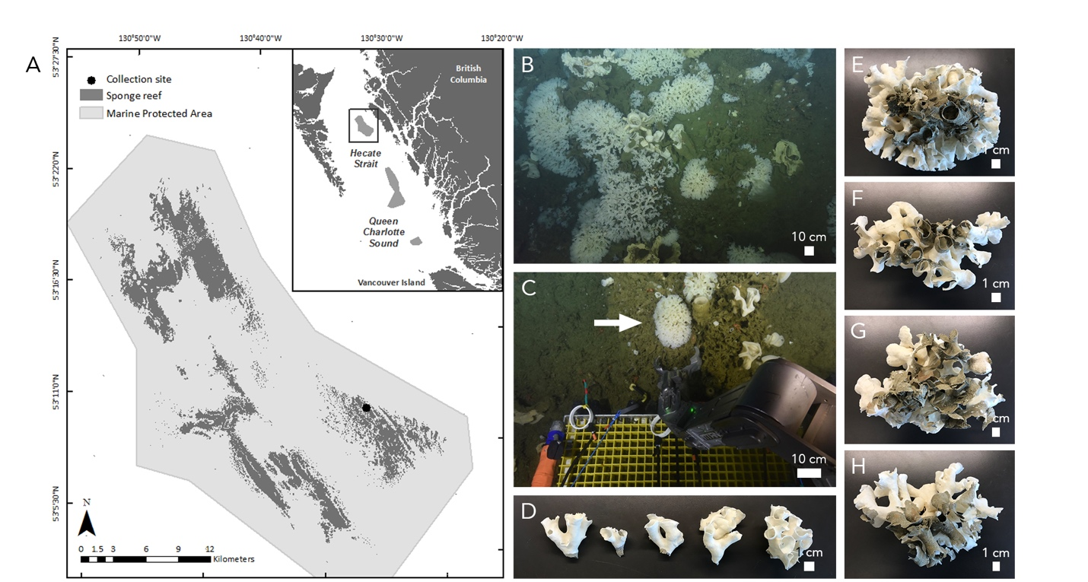

Figure 1.

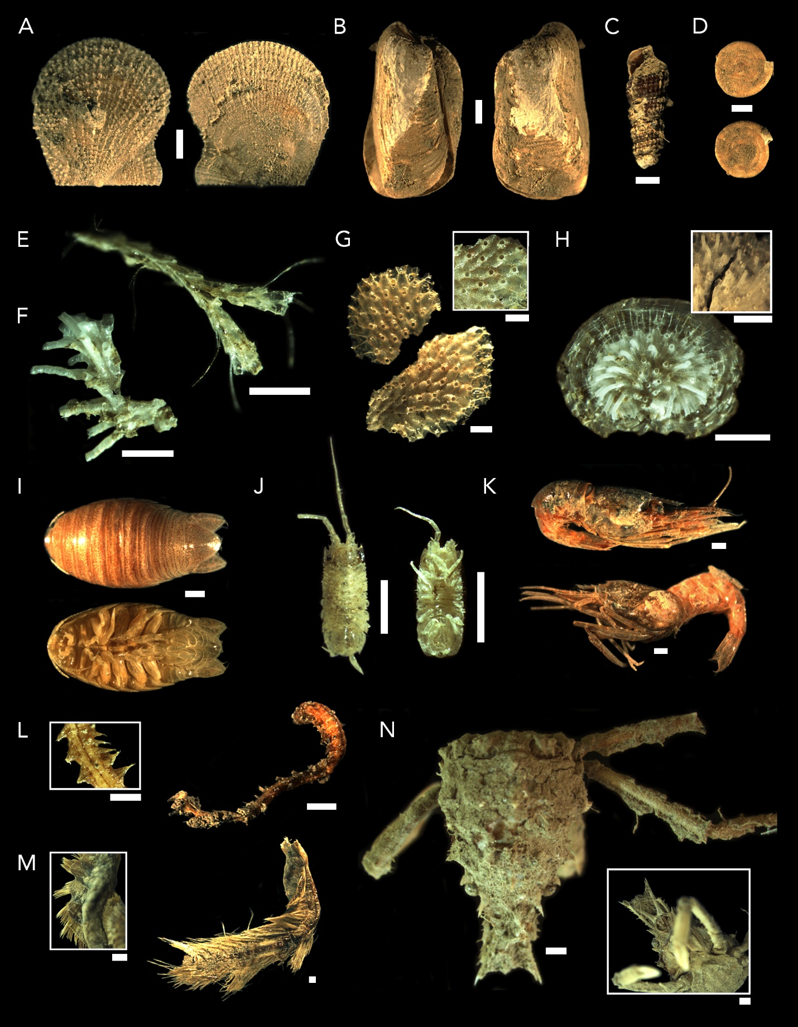

Figure 2.

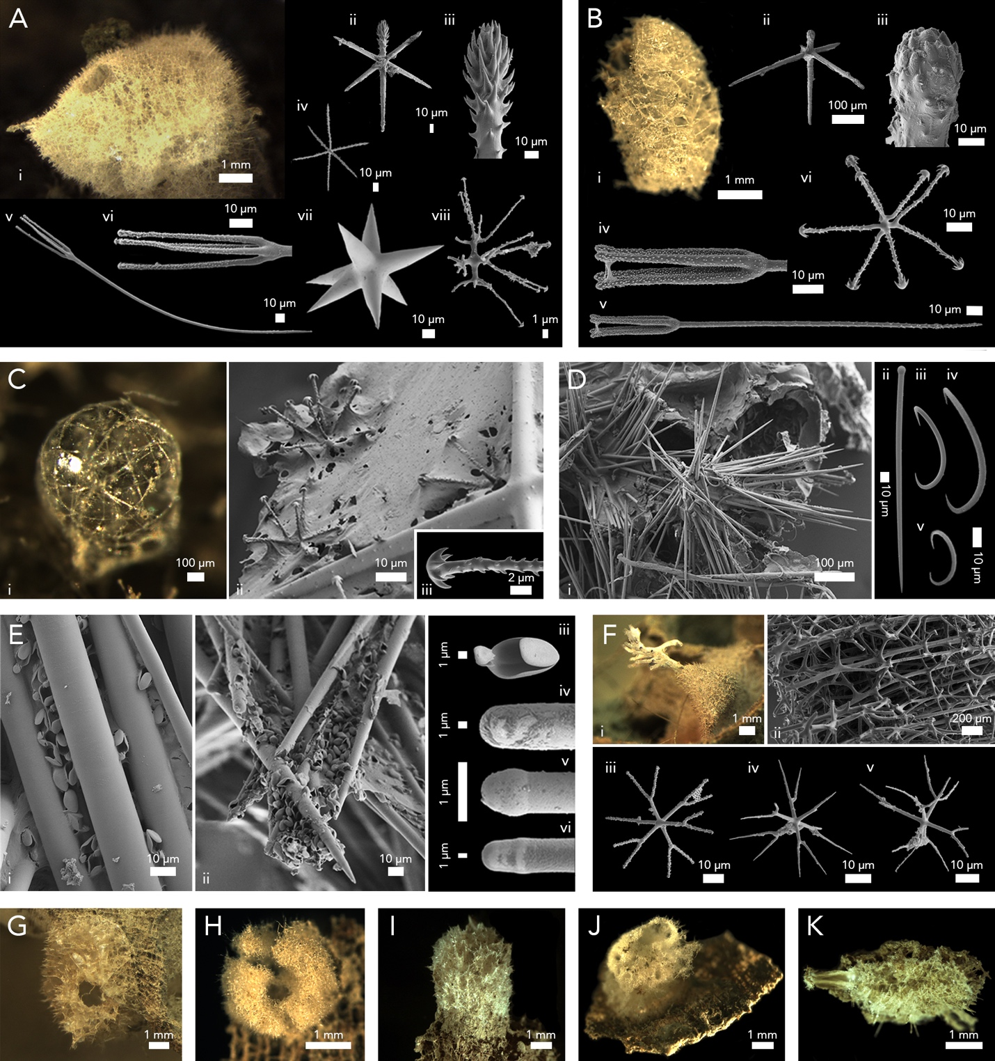

Figure 3.