Features of male- and female-produced song

in black-capped chickadees (*Poecile atricapillus*) change between seasons

Kimberley A. Campbell 1,3, Stephanie Thunberg 2,3, and Christopher B. Sturdy 1,3,4

1 Department of Psychology

2 Department of Biology

3 University of Alberta

4 Centre for Neuroscience, University of Alberta

1. Introduction

Of the 10 000 or so known avian species, nearly half belong to the clade Passeri[1]. Also called Oscines, or songbirds, birds in this group are unique in that they possess a morphologically complex vocal organ, the syrinx, which facilitates the production of complex and diverse vocalizations, including their song[2]. Songbird song is often learned and functions in both territory defense and mate attraction[3].

Though songbird song has been extensively studied, most research has focused on temperate species in which males tend to sing long, complex songs and females have been thought not to sing[4]. Recently, increasing accounts of female song in temperate species have been documented, suggesting that both males and females produce song[5]. Despite this, quantitative evaluations of the acoustic structure of female song, especially as compared to male song, are lacking (though see [6] - [8]).

The production and acoustic structure of female song was recently described in black-capped chickadees (*Poecile atricapillus*)[8]. These small, North American songbirds produce an acoustically simple song, the *fee-bee*, as compared to most other songbird species, consisting of only two notes[9] (see Figure 1). Though we now know that both sexes produce *fee-bee* song, the function of female song is not yet well understood. In this experiment, we sought to investigate how male- and female-produced black-capped chickadee *fee-bee* song changed in acoustic structure throughout the year.

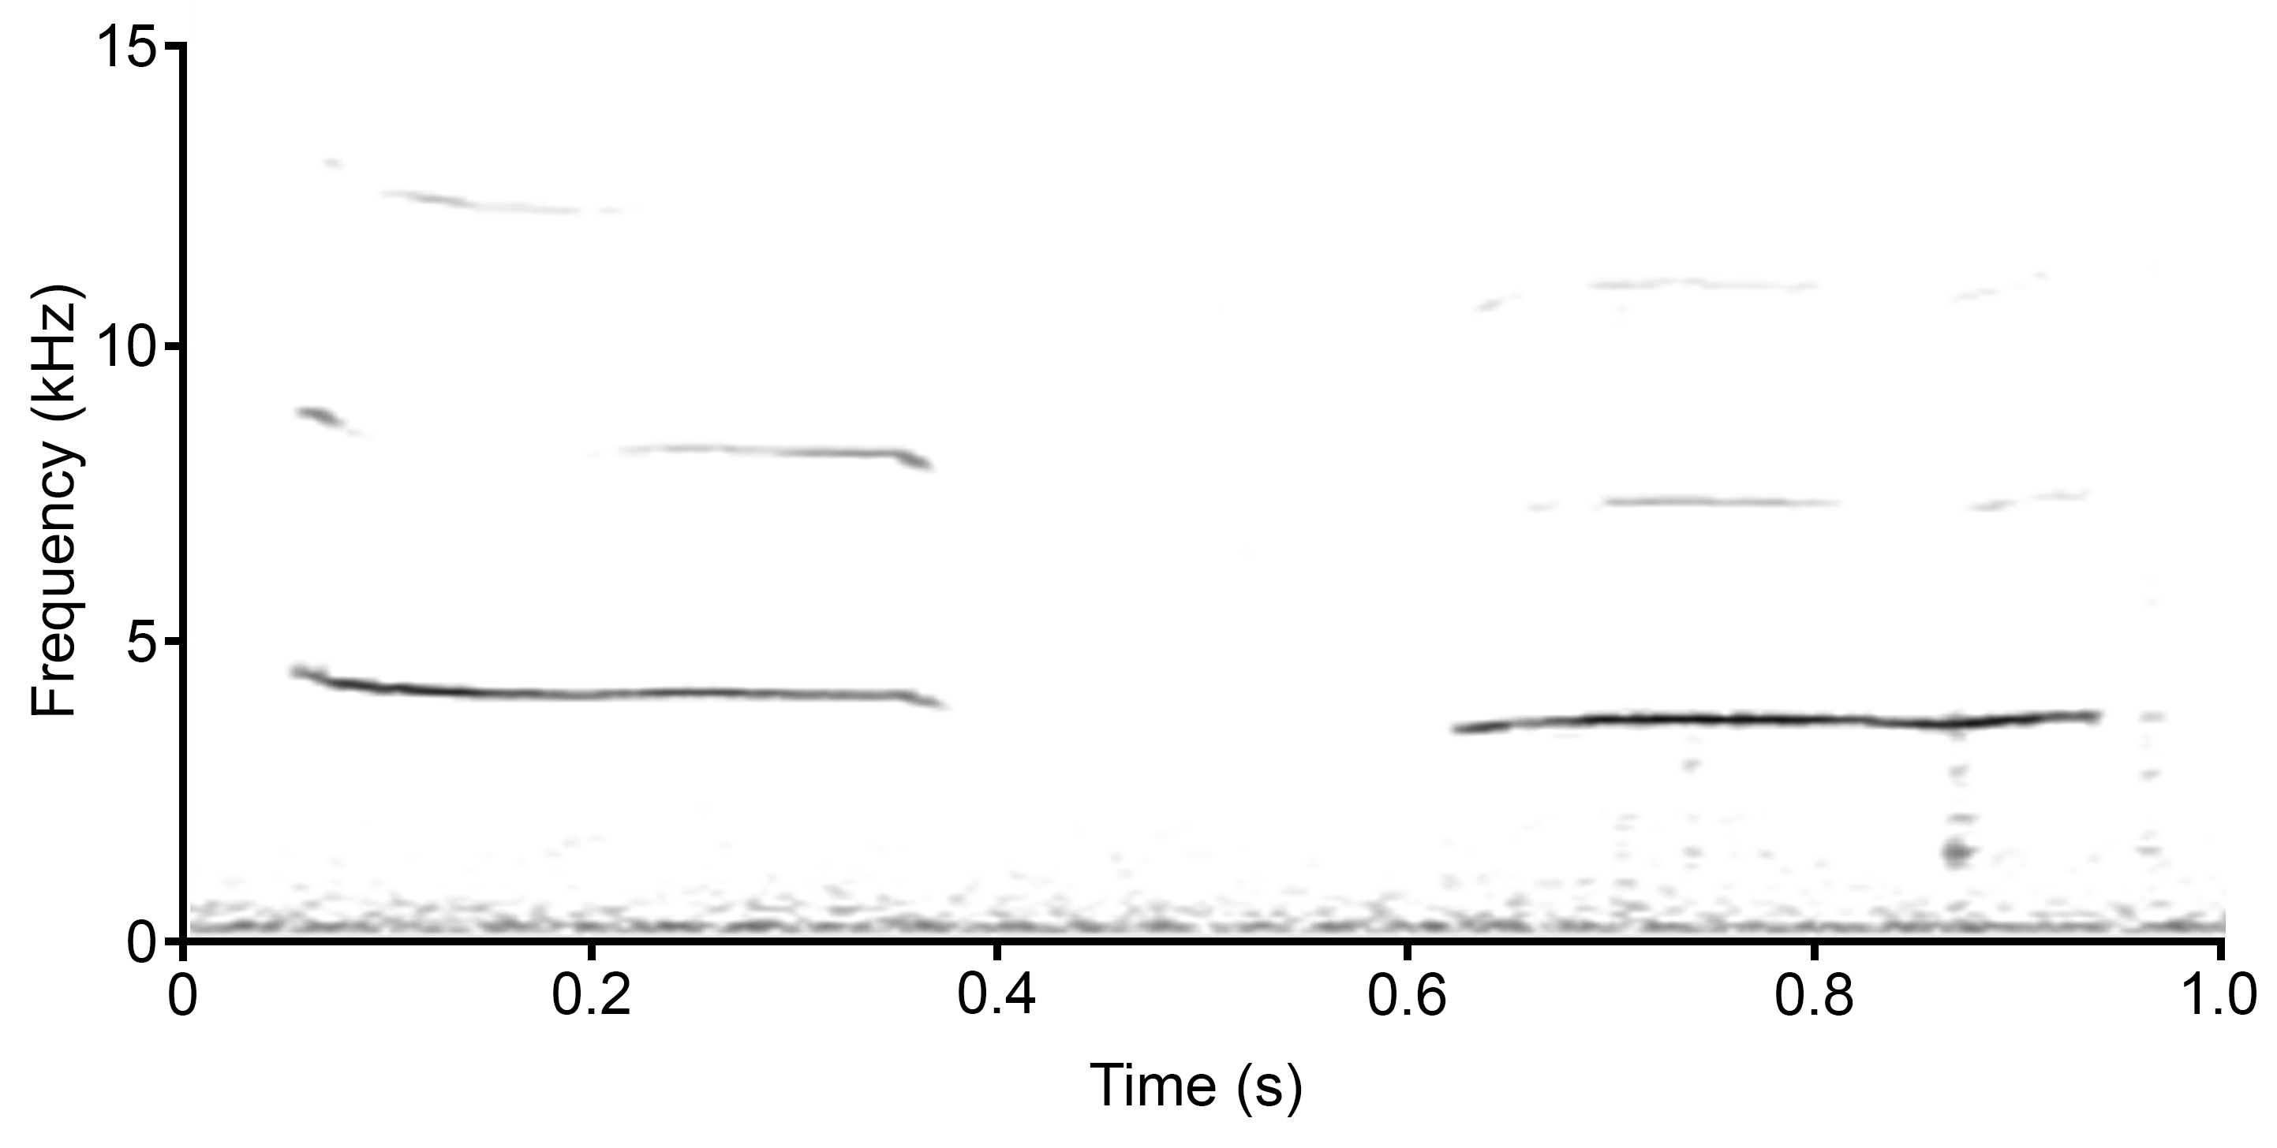

**Figure 1:** Sound spectrogram of a black-capped chickadee *fee-bee* song (window size = 256 points, time resolution = 5.8 ms).

|  |
| --- |
|  |
| ki6@ualberta.ca  sditlof@ualberta.ca  csturdy@ualberta.ca |
|  | |
|  | |
|  | |

1. Method
   1. Subjects

Recordings of *fee-bee* songs were used from eight adult black-capped chickadees (five male, three female). Birds were captured as adults in Edmonton, Alberta (53.53°N, 113.53°W) and Stony Plain, Alberta (53.45°N, 114.01°W) between 24 December 2010 and 20 February 2017. Sex was determined by deoxyribonucleic acid (DNA) analysis[10].

* 1. Recordings

Birds were recorded during two seasons, spring and fall, between March 20, 2012 and June 20, 2016. Each recording session lasted for one hour from 8:00 – 9:00. Birds were housed, transported, and recorded in individual 30 cm wide×40 cm high×40 cm deep Jupiter Parakeet cages (Rolf C. Hagen, Inc., Montreal, QC). Individual birds were recorded using a Marantz PMD670 (Marantz America, Mahwah, NJ) digital recorder set to a 16 bit, 44 100Hz sampling rate, and an AKG C 1000S (AKG Acoustics, Vienna, Austria) microphone set up in 1.7m×0.84m×0.58m sound attenuating chambers (Industrial Acoustics Company, Bronx, NY). The microphone was positioned 30 cm above the back center of the top of the cage.

* 1. Measures

Each bird produced at least one *fee-bee* song during each season of interest, spring and fall. Songs were chosen randomly from available songs.

A series of 13 frequency measures were obtained using the ‘specan’ function in the R package, warbleR[11] (mean frequency, standard deviation, frequency median, frequency of the 25th quartile, frequency interquartile range, frequency of the 75th quartile, mean dominant frequency, maximum dominant frequency, dominant frequency range, start of dominant frequency, end of dominant frequency, slope of dominant frequency, mean frequency peak). Similarly, three amplitude measures were obtained using the ‘analyzeFolder’ function in the R package, soundgen[12] (mean amplitude, amplitude median, standard deviation of amplitude).

* 1. Statistical Analyses

We conducted a principle components analysis (PCA) on frequency and amplitude measures in order to reduce them to a smaller subset of independent measures. Once these principle components were calculated, we conducted a repeated measures analysis of variance (ANOVA) with sex and season as independent variables and the principle components as dependent variables. All statistical analyses were conducted using R, version 3.3.2[13].

1. Results

The first principle component (PC1) explained 63.2% of the variance in frequency measures, while the second (PC2) explained an additional 20.7% of variance. Maximum dominant frequency and dominant frequency range contributed the most to PC1. Start of dominant frequency and dominant frequency slope contributed the most to PC2. We chose to continue with these two principle components as they explained a cumulative 83.9% of variance. The first two principle components for amplitude measures explained 95.3% and 4.6% of variance, respectively. Amplitude mean and amplitude median contributed the most to both PC1 and PC2. These two principle components explained a cumulative variance of 99.9%.

We conducted a repeated measures ANOVA to determine how the acoustic measures represented by the principle components differed between the sexes and the seasons. There was a significant main effect of PC1 for frequency measures such that songs produced in the spring had higher scores than those produced in the fall (*p* = 0.001, *F*1,6 = 37.191). All other main effects and interactions were not significant (*p* > 0.139).

1. Discussion

Variation in song structure has not yet been described in black-capped chickadees. This experiment was designed to evaluate acoustic differences in *fee-bee* song structure produced by males or females, as well as between two seasons, spring and fall.

We found that the structure of fee-bee songs changes between the seasons. This could be due to the critical biological functions, such as mate attraction, territory defense, and solicitation of extrapair copulations, which are more critical in spring, which corresponds to the black-capped chickadee breeding season, than they are in the fall[14]. This parallels our findings that songs produced by both sexes show less acoustic variation in spring-produced songs than in fall-produced songs.

1. Conclusion

Overall, our results have demonstrated that the songs of both sexes differ in acoustic structure between the fall and the spring. Future studies should further evaluate the nature of the acoustic change in songs across seasons, as well as evaluating whether the method or degree of change differs between the sexes. Learning more about the changes in acoustic structure of the *fee-bee* song may aid in better understanding the use and function of the vocalization, especially in female black-capped chickadees, whose use of the *fee-bee* song is not yet well studied.

Acknowledgments

The studies described here were conducted in accordance with the Canadian Council on Animal Care Guidelines and Policies with approval from the Animal Care and Use Committee for Biosciences for the University of Alberta (AUP 108). Capture occurred under Environment Canada Canadian Wildlife Service Scientific permit, Alberta Fish and Wildlife Capture and Research permits, and City of Edmonton Parks Permit. This research was supported by a Natural Sciences and Engineering Research Council of Canada Discovery Grant and Discovery Accelerator Supplement, an Alberta Ingenuity Fund New Faculty Grant, a Canada Foundation for Innovation New Opportunities Fund and Infrastructure Operating Fund grants along with start-up funding and CFI partner funding from the University of Alberta to CBS. KAC was supported by an Alexander Graham Bell Canada Graduate Scholarship.

References

[1] Sibley, C. G. & Monroe, B. L. (1990). Distribution and Taxonomy of Birds of the World. New Haven, CT: Yale University Press.

[2] Larsen, O. N., & Goller, F. (1999). Role of syringeal vibrations in bird vocalisations. Proceedings of the Royal Society B, 266, 1609-1615.

[3] Catchpole, C.K., & Slater, P.J.B., 2008. Bird Song: Biological Themes and Variations. Cambridge University Press, Cambridge, UK.

[4] Riebel, K., 2003. The “mute” sex revisited: vocal production and perception learning in female songbirds. Advances in the Study of Behavior, 33, 49-86.

[5] Garamszegi, L.Z., Pavlova, D.Z., Eens, M., & Møller, A.P., 2007. The evolution of song in female birds in Europe. Behavioral Ecology, 18, 86-96.

[6] Baptista, L.F., Trail, P.W., DeWolfe, B.B., & Morton, M.L., 1993. Singing and its functions in female white-crowned sparrows. Animal Behaviour, 46, 511-524.

[7] Pavlova, D., Pinxten, R., & Eens, M., 2005. Female song in European starlings: sex differences, complexity, and composition. Condor, 107, 559-569.

[8] Hahn, A. H., Krysler, A., & Sturdy, C. B. (2013). Female song in black-capped chickadees (*Poecile atricapillus*): acoustic song features that contain individual identity information and sex differences. Behavioural Processes, 98, 98-105.

[9] Ficken, M.S., Ficken, R.W., & Witkin, S.R., 1978. Vocal repertoire of the black-capped chickadee. Auk, 95, 34–48.

[10] Griffiths, R., Double, M. C., Orr, K., & Dawson, R. J. (1998). A DNA test to sex most birds. Molecular Ecolcology, 7, 1071-1075.

[11] Araya‐Salas, M., Smith‐Vidaurre, G., & Golding, N. (2017). warbleR: An r package to streamline analysis of animal acoustic signals. Methods in Ecology and Evolution, 8, 184-191.

[12] Anikin, A. (2018). Soundgen: an open-source tool for synthesizing nonverbal vocalizations. Behavior Research Methods, 1-15.

[13] R Core Team (2013). R: A language and environment for statistical computing. R Foundation for Statistical Computing, Vienna, Austria.

[14] Smith, S. M. (1991). The black-capped chickadee: Behavioral ecology and natural history. Ithaca, NY: Cornell University Press.