TENTATIVENESS IN THE MATHEMATICS CLASSROOM: TWO CASES OF THE HAND AS A LANDING SITE

Josh Markle
University of Alberta
jmarkle@ualberta.ca

Introduction
In this paper, I explore the notion of tentativeness in knowing and doing mathematics. In the context of experiencing the built environment, Barons (2008) describes tentativeness as a means of “complexifying one’s perceptual encounter with the environment” (p. 334).With respect to knowing and doing mathematics, it can also be interpreted as a both an instance of skillful know-how and as an affordance students may act on in their problem-solving (Markle, 2022). In the present study, I take up this idea of tentativeness by drawing onSamuel Todes’s (2001) work on perception and embodied cognition, on the one hand, and Gins and Arakawa’s (2002) notion of landing sites, on the other, to analyze two episodes of problem solving in the mathematics classroom. Through my analysis, I offer two provocations. One is that the notion of a landing site can be an interpretive aid in understanding how students come to know and do mathematics in the classroom. In this work, I choose to focus on the hand as a landing site. The second provocation involves the conceptualization of tentativeness as both a viable strategy for mathematical problem solving and as part of the affordance space, which educators can use to develop conceptual understanding. Conceptualizing the hand as a landing site, I describe some ways individuals use their hands to site tentativeness in their problem solving.
Theoretical and Philosophical Frameworks
I draw on the principles of enactivism, a theory which posits cognition as an emergent phenomenon arising out of interactions between organisms and the environment. Enactivism is one of several prominent theories of embodied cognition that push back on notions of representation-based models of perception and learning (e.g., cognitivism). I also draw on two additional sources of philosophical and methodological guidance. First, I incorporate the ideas of the philosopher Samuel Todes, in particular his notions of poise and sensuous abstraction (Todes, 2001). Second, I use Gins and Arakawa’s (2002) concept of landing sites to identify and describe moments of tentativeness in the mathematics classroom. I take up each of these ideas in turn in the remainder of this section.
In the last twenty years, theories of embodiment have become prominent in mathematics education research (e.g., Radford, 2014; Roth & Thom, 2009; Nemirovsky & Ferrara, 2009; de Freitas & Sinclair, 2014; Abrahamson, 2009). Moreover, enactivism, a theory of embodied cognition, has been a considerable source of insight and provocation in the teaching and learning of mathematics (e.g., Davis, 1996; Towers & Martin, 2015; Proulx, 2019; see Reid (2014) for one perspective on the history of enactive thought in mathematics education). Enactivism is a theory in which cognition emerges from interactions between organisms and the environment. In contrast to cognitivism, in which cognition is seen to reside in the brain, enactivism posits cognition to take place outside the boundaries of our skin and in the interactions between bodies and the environment. Our minds are thus an enmeshing of perception, cognition, and action in the environment. Below, I set out two sets of ideas—Samuel Todes’s notions of poise and sensuous abstraction, on the one hand, and Gins and Arakawa’s notion of landing sites—in the context of enactivist thinking. Throughout, I make connections back to the idea of tentativeness in knowing and doing mathematics.

Poise and Sensuous Abstraction
Enactivism is a prominent theoretical framework in mathematics education research (Reid & Mgombelo, 1996; Towers & Proulx, 2013; Davis, 1995). In this theoretical framework, the learner is viewed as an autonomous organism that exercises “skillful know-how in situated and embodied action” (Thompson, 2007, p. 13). What might this view have to offer in terms of understanding the phenomenon of tentativeness in the mathematics classroom? How might tentative action be understood as an active, participatory engagement in bringing forth a world? To think more about what it means to be actively engaged in the world in a tentative way, I present a sketch of Samuel Todes’ notions of poise and sensuous abstraction. Todes’s (2001) conception of poise offers a means of better understanding tentativeness in the mathematics classroom. For Todes (2001) poise plays a constitutive role in how we experience the world: poise is “sensuous proof that the perceptual experience of our immediate future conforms to that of our immediate past, and without poise no determinate perception is possible” (p. 79). This is not to say that our perceptual experience is predictable or consistent. Rather, for Todes (2001), perception is the process by which we acquire what we need to be in the world. That is, it is the “determination of an object through an effective response that forms skill in the percipient” (Todes, 2001, p. 78). Perception is determinate in the sense that it meets an anticipated need, and for Todes, only what is anticipated can be perceived. Poise is how our whole, active body opens up onto the world and how, as Merleau-Ponty (2012) wrote, the world “announces itself within us” (p. 19).
In Body and World (2001), Todes carefully and thoroughly distinguished this mode of being in the world from Enlightenment conceptions of bodily engagement. Hume, according to Todes (2001), saw the body as a “set of parts-outside-of-parts … no more than a curiously (inexplicably) animated corpse” (p. 46). But Todes argued that such a conception did not reflect the lived experience of the body. The active body is one that is felt as a unity, that is coordinated, and that can cope skillfully with the objects in its experience (Todes, 2001, p. 46). And to cope with those objects, “we must be able to anticipate them before we reach them, or they us” (Todes, 2001, p. 46). This sort of anticipation is characteristic of the tentative approaches to the mathematics problem described below. In bringing forth mathematical relationships through visualization, the participants in the cases discussed below enact a variety of strategies not necessarily to solve a problem, but to qualify it. In Todes’ (2001) sense, this skillful habit is poise, regardless of whether the problem is solved: “the success of poise is not in its execution, but in its very existence by which the body is, to begin with, knowingly in touch with the objects around it” (p. 66).
For Todes (2001), perception is the culmination of meeting an anticipated need, and we can only achieve perception in a state of poise. For example, we prepare ourselves to meet a need, say by orienting our body toward a coffee cup; we prepare the object to be perceived through our intentional attitude toward it; and our perception finds a determination in action, for example when we grasp the handle of the cup to drink from it. As Todes (2001) noted, “poise is lost as soon as anticipations cease being met as rapidly as they are made” (p. 72). But this is not an inexorable process. Indeed, Todes (2001) was clear that we are not enslaved to our anticipation or perception (p. 273). Todes (2001) thus introduced the notion of sensuous abstraction, what he called a “mild, incomplete, and delicately controlled inhibition [emphasis added] of the perception of the particular object having the abstracted sense quality” (p. 272). That is, sensuous abstraction is a forestalling of perception. One must still retain poise—that is, one must remain in touch with others and the surrounding environment—but is able to delay the foreclosure of anticipation. Todes (2001) wrote that sensuous abstraction occurs “when the normally transient stage of anticipatory presence is maintained” (p. 275). Lewis (2013) called this perceptual hesitation (p. 345). Perceptual hesitation, Lewis (2013) argued, can be seen as a “perception of the potentiality of perception itself” (p. 345). To put that in Todes’ terms, sensuous abstraction is a kind of skillful coping, a “skillfully inhibited perception … [in which] one becomes aware of qualities rather than things” (p. 274, original emphasis). In Markle (2022), I conceived of tentativeness as entailing this state of sensuous abstraction. In the following section, I propose a means of locating it in the doing of mathematics.

Landing Sites
In an attempt to focus on instances of tentativeness, I use Gins and Arakawa’s (2002) notion of landing sites as a means of characterizing how it emerges through situated action in a visualization exercise. A landing site is a heuristic. In fact, anything can be a landing site. In the classroom context, it could be the whiteboard at the front of the class, a manipulative, or a pen-and-paper math problem. In the discussion below, I designate the hand—through its pointing, grasping, touching and so on—as a landing site for foregrounding the role of tentativeness in problem solving. Landing sites are intimately tied to perception, and in fact align with Todes’s (2001) notion of poise: “in fielding her surroundings,” noted Gins and Arakawa (2002), the perceiver “makes use of cues from the environment to assign volume and a host of particulars to world and to body…her fielding of her surroundings never ceases, continuing even in sleep” (p. 7). Anything occasioned in this field has the potential for being a landing site.
Gins and Arakawa introduce different types of landing sites: perceptual, imaging, and dimensionalizing. Any landing site has the capacity to be any of the three. Consistent with an enactive view, perceptual landing sites are linked to sensation: they are any “designated areas of specified activity, [and include the] visual, aural, tactile, olfactory, proprioceptive, kinesthetic, [and] somaesthetic” (Gins & Arakawa, 2002, p. 10). When these kinds of landing sites come into being, they are recorded (e.g., I see a chair, the grass feels cool, etc.). Imaging landing sites bear a contrast in focus. While perceptual landing sites are concentrated as recorded phenomena, imaging landing sites are diffuse, manifesting as a “shifting-about patchwork of registerings and quasi-registerings” (Gins & Arakawa, 2002, p. 12). To put this in Todes’s (2001) terms, imaging sites are potential sites of sensuous abstraction, in which one notices the qualities of things. Finally, dimensionalizing landing sites are proposed as composites of perceptual and imaging landing sites. Again, to put this into Todes’s (2001) framework, dimensionalizing landing sites are akin to poise, states in which our anticipations and perceptions align.
In the present work, I use only the concept of imaging landing sites. I do this in part to circumvent what I perceive as a feature in Gins and Arakawa’s work that is potentially inconsistent with an enactivist framework. One example of this is in their discussion of dimensionalizing landing sites, in which they describe the perceptual as “direct perception” and imaging as “indirect or imitative perception” (Gins & Arakawa, 2002, p. 21). This description evokes, if not outright representational dualism, a distance between imaging and sensorimotor activity. In previous work, I have argued for the exactly the opposite: in an analysis of students’ embodied experiences in a spatial reasoning exercise, I interpreted their visualizations as sensorimotor, dependent on both the body’s movement (e.g., through gesture) and potential for movement (Markle, 2021). It is worth noting that Gins and Arakawa are not always obviously consistent in their own interpretations of imaging landing sites. In Architectural Body (2002), they make a point similar to that of Markle (2021) in their discussion of the blind mathematician, Karl Dahlke. Dahlke used visualization techniques to solve a complex pentomino tiling problem. As a blind person, Dahlke did not have the “direct access” characteristic of a perceptual landing site, which led Gins and Arakawa (2002) to suggest imaging as closely related to and enmeshed with direct perception (pp. 16-20). This view is more consistent with an enactive view of perception and action.
Also, consistent with enactive thinking, Gins and Arakawa (2002) emphasized the emergent nature of cognition and experience. As situated and embodied beings, our “surroundings invite, provoke, and entice [us] to perform actions, and the enacting motions of these actions not only serve up alternate vantage points but also inevitably shift sense organs about” (p. 1). Resonant in this description of perceptual experience are the ideas found in variedtheories of embodied cognition, such as ecological psychology (Gibson, 1979). In fact, several prominent ecological psychologists have taken up these ideas (e.g., Baron, 2013). Ecological psychology and enactivism do indeed share common ground, but there are also substantial differences, and these have implications for how we interpret the learning and doing of mathematics.
In Markle (2022), I suggested tentativeness as an affordance for students to act on in their problem posing and solving. The ontological nature of an affordance points to a key difference in the underlying principles of ecological psychology and enactivism. In the former, perceiving organisms are seen as directly involved in their environments via pre-existing affordances; that is, there is effectively no separation between organisms and the environment because affordances “point both ways” (Read & Szokolszky, 2020). In the latter, affordances emerge out of the coupling between organisms and the environment, and the autonomy of the organism determines the set of possible affordances.
This is a key distinction, in particular for interpreting classroom activity. One important implication is the need to view the affordance space as an emergent set of potentials, not only a feature of the environment which elicits student action. I argue that the idea of an imaging landing site is consistent with the enactive view. In fact, according to Baron (2013), Gins and Arakawa continued to develop their idea of imaging landing sites in ways that made it more amenable to an enactivist perspective. They did so in at least two ways: (1) they emphasized the ongoing and instantaneous coupling taking place between an individual and the environment during the imaging process; and (2) they made explicit the role of the body in imaging, noting that it is a multimodal phenomenon that enlists the senses, such as touch (Baron, 2013, n.p.).
As noted above, enactivism is predicated on the idea of autonomy, specifically that of autonomous agents, where autonomy describes a system that actively generates and sustains itself (Thompson, 2007). An autonomous system need not be a living one (as in an autopoietic system, for which the exemplar is a single-celled organism). Rather, for a system to be autonomous, its underlying processes must meet three criteria: they must be endogenous to the system, they must form a unity, and they must determine the sets of possible actions and affordances outside of the system (Thompson & Stapleton, 2009). This last point is a key one for how I have interpreted the idea of a landing site. In this paper, I parse out imaging landing sites as an expository device, not to acknowledge them as features of the environment that are independent of experience. In an enactive framework, organisms define all possible actions in an environment. There is no organism-independent affordance. In this sense, a landing site is simply a taking of note (Gins & Arakawa, 2022).

The Hand as a Landing Site: Two Cases of Siting Tentativeness
As noted in the discussion above, anything can be a landing site.For the present study, I have chosen to interpret how the hand is used as a landing site in the context of two case studies of students using spatial reasoning skills in mathematical problem solving. The human hand has long been an object of fascination. The poet Rainer Maria Rilke, in his treatise on the sculptor Auguste Rodin, wrote that the “hands are a complicated organism, a delta into which many divergent streams of life rush together in order to pour themselves into the great storm of action” (Rilke, 2014). In his book The Hand, the neurologist Frank Wilson asserted that any account of human intelligence that fails to acknowledge the critical role of the hand would be “grossly misleading and sterile” (Wilson, 1998, p. 7). Of relevance to the present study, the hand has also been taken up as a unit of analysis in mathematics education. Kaanta (2012), for example, analyzed the role of embodied actions, such as pointing, in classroom interactions. Davis et al. (2022) investigated the relationship between pointing and dominant metaphors for teaching and learning in the classroom. Here, I propose the hand as a landing site, and describe how students in the math classroom used their hands as sites of tentativeness.

Case One: The Hand in Motion
The first case focuses on a participant from agroup of undergraduate pre-service teacher candidates I worked with in a mathematics curriculum and instruction course at a small western Canadian university. I taught the class, which was an elective available to all students majoring in disciplines outside of mathematics. The data I present here was generated as part of a class activity focused on spatial visualization. Students listened to verbal instructions and used them tovisualize the construction of some conic sections—circles, ellipses, parabolas, and hyperbolas—using points, lines, and circles. The exercise was based off of J. L. Nicolet’s stop-motion animations and inspired by a similar exercise I took part in at the 2018 meeting of the Canadian Mathematics Educators Study Group (Chorney et al., 2018).
Although I intended to conduct the exercise in person, the class in which this exercise occurred was held virtually due to COVID-19. The exercise involved four rounds, one for each of the conic sections listed above. In each round, students attempted to visualize what I was saying as I read a script, responded in a particular way (e.g., through gesture, speech, or drawing) and submitted photos or short video recordings of their responses via an online platform, then watched a corresponding animation (Nicolet, 2007). After the fourth round of the exercise, students reflected on two prompts:
Prompt #1: Talk to me about your experience of imagining mathematics. What did you see? Was is it demanding or effortless? How did you feel during the process? Did you pay attention to your body? What was it doing?
Prompt #2: I asked you to communicate your imaginations in a variety of ways (e.g., gesture, speech, and drawing). What did you find most natural? Most difficult? Was there one means that helped you imagine "better" than others? That is, did communicating in a particular way help or hinder what you saw in your imagination?

Table 1 summarizes the details of the exercise. Of the 31 students in the class, 11 agreed to participate in a study focused on embodied ways of knowing in mathematics. Collected data included video, diagrams, and written reflections. I report on one of these participants below.

Table 1
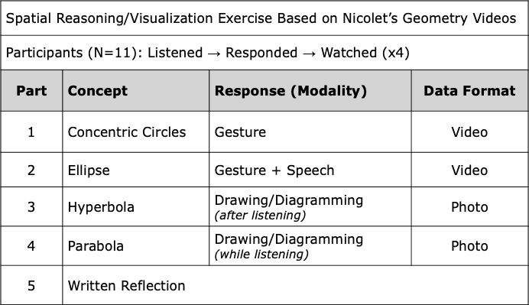

My objective in this paper is to reveal the ways in which the phenomenon of tentativeness emerged in the course of problem solving and posing in mathematics. To put those instances into high relief, I have chosen to interpret the ways in which the hand acted as a landing site for the participants. The visualization exercises conducted in this activity were challenging, and elicited feelings of hesitancy, uncertainty, and frustration from students. But the participants in this study often spoke to how their bodies, in particular their hands, enabled them to work through the problem. To speak to the way each participant initiated tentative action and used their body, Figure 1 depicts a stylized image captured from Participant 9’s video responses.

Figure 1
Gesturing Motion
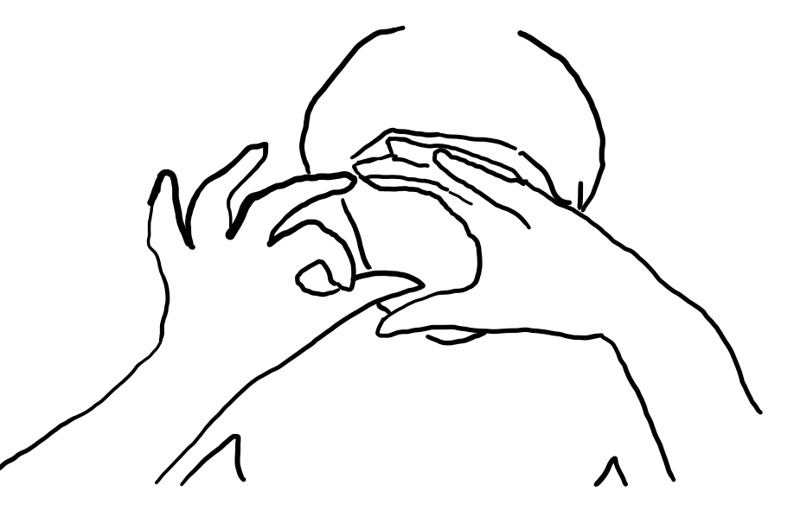
In this image, Participant 9 is using her hands to describe the relationship between two circles, one small circle tangent to the inside of a larger one, as the small circle moves along the inside of the other. Every participant in the study used an abundance of gesture to describe their visualizations (in fact, in the first round, students could only gesture to communicate). But what struck me was the way Participant 9 spoke of the role her hands played in her work. While other participants identified drawing as a favoured approach, Participant 9 eschewed drawing for gesture.
I decided to try to use my hands to visualize the movement instead of drawing a picture when I listened to it the second time. I had already tried to draw a diagram so I didn’t think I was doing it wrong. It really helped me to make a motion with my hands to ‘see’ it better in my mind. [Participant 9]
Indeed, this participant went on to identify the dynamic nature of the exercise as that which led her to favour bodily movement over drawing. She indicated that “drawing was extremely or rather the most helpful for a static idea but not when it came to a difficult spatial problem solving in motion.” For that, she required her hands, “which really helped me to make a motion…to ‘see’ it better in my mind.” How does this speak to the notion of the hand as a landing site for tentativeness? I argue it is in how Participant 9 took note of her body, in particular her hands, as she arrived at a provisional solution. During the activity, Participant 9 noted that she felt “there is probably a solution, but because I can’t picture it, this is the best I got for the moment.” Figure 1 depicts this tentative solution: Participant 9 uses her hands to hold a dynamic geometric relationship in place in order to draw out the potential qualities of a solution. I take up this idea of tentative, good-enough solutions in the next case, but end here by pointing to Participant 9’s acknowledgement of the role her hands played in taking note: “I felt much more engaged mentally and physically when I gestured with my hands. When I just sat there, I did not notice my body.”

Case Two: Discussing Parabolas
Markle (2022) conceptualizes tentativeness as “an emergent, participatory quality of problem solving and posing and an affordance that broadens the possibility for adaptive action in an environment” (p. 21). In that work, I focused on the collective, often gestural exchange between three participants as part of a larger study of embodied experiences in the secondary mathematics classroom. Through analysis of gesture, speech, and artifacts such as drawn diagrams, I characterized their mathematical understanding as emerging out of the “collective, tentative interactions between participants and the environment” (Markle, 2022, p. 23).
In the present work, I briefly return to some of that data under the interpretive lens of the hand as a landing site. Figure 2 depicts one participant’s description of the relationship between a line and a parabola. Specifically, the participant is responding to a graph showing a linear and a quadratic function, and describing what happens when the latter is divided by the former.

Figure 2
AQ describing her thinking with gesture
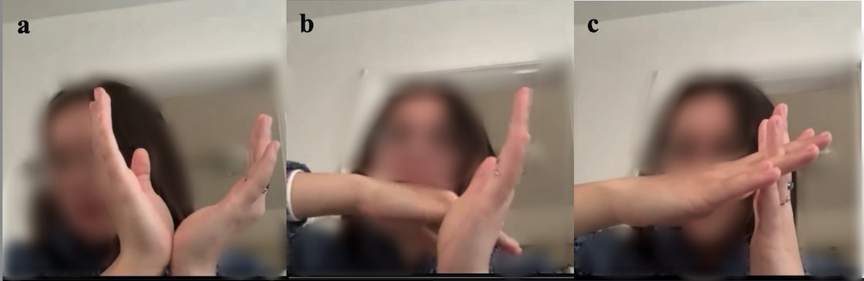
This participant verbally described here thinking as she gestured. I include her verbal description here:
Um, well when you divide … the parabola (a) by a linear line (b), it just becomes a linear line (c). So, since that linear line is negative and the parabola opens up, the other line has to have a negative slope.(Participant)
Two phenomena stood out to me during this sequence. The first was the way this participant positioned her hands between the camera and herself (this lesson also occurred virtually due to COVID-19). Of course, this was in part so we, the audience, could see her thinking. The point of interest, however, was the ways in which the participant gazed at her hands during her explanation. Her hands acted as a landing site, constructing, to quote Gins and Arakawa (2002), the mathematics to “exist in the tense of what if” (p. 29, original emphasis). That is, the hands acted as a landing site as the participant tentatively, provisionally offered a solution. This is elegantly captured in panel (c), in which the participant describes the resulting quotient as a linear function. Despite having “divided off” a linear function, the participant keeps both linear functions in play through hand gesture, depicted here with the hands crossed in an ‘X’. Again, we see the hand used as a means of holding in place; in this sense, the participant is not concerned so much with the precision of the solution as its qualities.

Concluding Remarks:Siting Tentativeness in the Mathematics Classroom
In Markle (2022), I drew on work in mathematics education (Proulx, 2019) and other areas, such as ecological psychology (Barons, 2008) and architectural theory (Gins & Arakawa, 2002), to characterize moments of tentativeness in the mathematics classroom. Specifically, I suggested tentativeness as both an emergent phenomenon arising out of problem solving and posing and an affordance in the environment to elicit student action. In the present study, I elaborate on this idea and suggest a focus on the hand as one means of siting tentativeness—that is, taking note of it—in the classroom. In both of the cases described above, the hand is a focal point. In one sense, the hand is an emergent quality of problem solving and posing, literally embodying solutions that are “felt to be posed, suggested, and not imposed as optimal and final” (Proulx, 2019, p. 14). In another sense, the hand becomes an affordance for action, as in the case of the participant from the first case study, who noted it was her hands that allowed her to visualize dynamic geometric relationships. In both instances, I argue, the hand was a site of awareness that, to paraphrase Gins and Arakawa (2002), allowed for the initiating of tentatives and the composing of provisional actions (p. 43). Looking at all the ways we might site tentativeness in the classroom has important implications for learning and doing mathematics.

Bibliography
Abrahamson, D. (2009). Embodied design: Constructing means for constructing meaning. Educational Studies in Mathematics, 70, 27–47.
Baron, R. (2013). Wayfinding through landing sites and architectural bodies: Exploring the roles of trajectoriness, affectivatoriness, and imaging along. Inflexions, 6, 270–285.
Baron, R. M. (2008). The Role of tentativeness in perceiving architecture and art: A far-from-equilibrium ecological perspective. Ecological Psychology, 20, 328–342.
Chorney, S., Sinclair, N., & Coles, A. (2018). Relation, ritual and romance: Rethinking interest in mathematics learning. Proceedings of the 42nd Conference of the Canadian Mathematics Education Study Group (CMESG), Squamish, Canada.
Davis, B. (1995). Why teach mathematics? Mathematics education and enactivist theory. For the Learning of Mathematics, 15(2), 2–9.
Davis, B. (1996). Teaching Mathematics. Garland.
Davis, B., Francis, K., Towers, J., & Markle, J. (2022). Speaking of learning: Exploring constraints of native languages on mathematics pedagogy. Manuscript in preparation.
de Freitas, E., & Sinclair, N. (2014). Mathematics and the Body: Material Entanglements in the Classroom. Cambridge University Press.
Gibson, J. J. (1979). The Ecological Approach to Visual Perception. Houghton-Mifflin.
Gins, M. & Arakawa. (2002). Architectural body. University of Alabama Press.
Kääntä, L. (2012). Teachers’ embodied allocations in instructional interaction. Classroom Discourse, 3(2), 166–186.
Lewis, T. E. (2013). Studied perception and a phenomenology of bodily gesturality. In C. Mayo (Ed.), Philosophy of education yearbook 2013 (pp. 341–349). University of Illinois at Urbana-Champaign/Philosophy of Education Society.
Markle, J. (2021). Enactive hermeneutics as an interpretive framework in the mathematics classroom. Philosophy of Mathematics Education Journal, 37(August), 1–27.
Markle, J. (2022). Tentativeness as strategy and affordance in visualization. For the Learning of Mathematics, 42(1), 20–24.
Merleau-Ponty, M. (2012). Phenomenology of perception (D. A. Landes, Trans.). Routledge.
Nemirovsky, R., & Ferrara, F. (2009). Mathematical imagination and embodied cognition. Educational Studies in Mathematics, 70, 159–174.
Nicolet, J. L. (2007). Animated geometry by J. L. Nicolet. Educational Explorers Film Company.
Proulx, J. (2019). Mental mathematics under the lens: Strategies, oral mathematics, enactments of meaning. The Journal of Mathematical Behaviour, 56, 1–16.
Radford, L. (2014). Towards an embodied, cultural, and material conception of mathematics cognition. ZDM: The International Journal of Mathematics Education, 46(3), 349–361.
Read, C., &Szokolszky, A. (n.d.). Ecological psychology and enactivism: Perceptually-guided action vs. Sensation-based enaction. Frontiers in Psychology, 11(Article 1270), 1–19.
Reid, D. (2014). The coherence of enactivism and mathematics education research: A case study. AVANT, 5(2).
Reid, D. A., & Mgombelo, J. (2015). Survey of key concepts in enactivist theory and methodology. ZDM: The International Journal of Mathematics Education, 47(2), 171–183.
Rilke, R. M. (2014). Auguste Rodin. Project Gutenberg. https://www.gutenberg.org/files/45605/45605-h/45605-h.htm
Roth, W.-M., & Thom, J. S. (2009). Bodily experience and mathematical conceptions: From classical views to a phenomenological reconceptualization. Educational Studies in Mathematics, 70(2), 175–189.
Thompson, E. (2007). Mind in life: Biology phenomenology, and the sciences of the mind. Harvard University Press.
Thompson, E., & Stapleton, M. (2009). Making sense of sense-making: Reflections on enactive and extended mind theories. Topoi, 28, 23–30.
Todes, S. (2001). Body and world. The MIT Press.
Towers, J., & Martin, L. C. (2015). Enactivism and the study of collectivity. ZDM: The International Journal of Mathematics Education, 47(2), 247–256.
Towers, J., & Proulx, J. (2013). An enactivist perspective on teaching mathematics: Reconceptualising and expanding teaching actions. Mathematics Teacher Education and Development, 15(1), 5–28.
Wilson, F. (1998). The Hand. Vintage Books.

