Pervaporative Desalination of Water Using Natural Zeolite Membranes
Paul Swenson, Brenden Tanchuk, Ankita Gupta, Weizhu An and Steven M. Kuznicki∗
Department of Chemical and Materials Engineering, University of Alberta
Edmonton, AB, T6G 2V4, Canada
Abstract
Several deposits of dense natural clinoptilolite, including one from British Columbia, Canada, have been identified which exhibit both high zeolite content and essentially no macroporosity or intercrystalline voids. Sections of zeolite mineral from the British Columbia deposit were machined into thin membranes and used in the pervaporative desalination of water samples with varying salinity levels, including synthetic seawater. Essentially complete rejection of Mg²⁺ and Ca²⁺ (99.99% and 98.52%) and high levels of rejection of Na⁺ and K⁺ (over 97.5%) were observed when using a synthetic seawater feed at 75ºC and 1 atm feed-side pressure. Water flux through the natural zeolite membranes was dependent on the ion concentration in the feed, the operating temperature and the feed salinity. At 93ºC, water fluxes of 2.5 kg/m²·h and 0.39 kg/m²·h were obtained for feed concentrations of 100 mg/L Na⁺ and 5500 mg/L Na⁺, respectively. The high ion rejection and water flux observed for these rugged and economical natural clinoptilolite membranes indicates their potential utility for desalination applications.

Keywords: Desalination, zeolite, pervaporation, membrane, molecular sieve
1. Introduction
Water is a vital resource for life. It is currently estimated that the annual water volume used by industry will increase to 50% above 1995 levels by 2025 [1]. As access to fresh water becomes increasingly limited in many areas of the world, the ability to desalinate seawater or reuse process water for industrial applications is expected to take on greater significance.
Desalination by reverse osmosis through polymeric membranes is a well-established and well-recognized technology [2-5]. Unfortunately, the inherently poor chemical and physical stability of the polymeric materials when exposed to organic-rich water limits their application [6-8]. Since polymeric membranes are not suited to these conditions, other, more stable, materials must be developed. Zeolites, crystalline aluminosilicates with a well-defined pore/channel structure [9], have gained significant research attention as potential materials for desalination processes, because they could theoretically provide perfect separation of molecules of different sizes and adsorptive properties, [2]. In fact, it has been predicted that 100% Na⁺ rejection could be achieved with reverse osmosis using a perfect zeolite A crystal lattice [10]. In addition, unlike polymeric membranes, molecular sieve zeolite membranes offer high thermal and chemical stability.
Pervaporation is a well-established approach to alcohol dehydration and this type of membrane separation is now being considered for desalination [11-14]. Cho et al. have achieved ion rejection of over 99.9% combined with a water flux of 1.9 kg/m² h at 69ºC for synthetic seawater tested using a NaA zeolite membrane [15]. Ultrapure water has also been produced from North Sea water using a hydroxy sodalite pervaporation membrane with ion rejection of greater than 99.99% [16]. Although the mechanism of transport and ion rejection remains controversial, several research groups have established that pervaporation through zeolite membranes shows great promise for desalination applications [15-20].
Currently, the most popular zeolite membranes for pervaporation applications are synthetic thin-film zeolite membranes supported on porous substrates [11-20]. Several major factors restrict their application to industrial desalination, however, including strict requirements for the structural properties of the support materials. Poor chemical and physical compatibility between the available support materials and the zeolite layer increases the cost of production and the presence of defects formed during membrane preparation. Other concerns, including fragile thin surface layers and tedious synthesis procedures, also reduce the feasibility of applying thin-film membranes on an industrial scale.
Recently, very dense clinoptilolites have been identified which have been compressed by time and nature to form masses with essentially no macroporosity. These geomorphic natural zeolites do not have the fragile crystal grain boundaries found in synthetic zeolite analogs and, therefore, have the mechanical robustness to be considered for large-scale industrial processes. Natural zeolite membranes are already showing promise in the separation of hydrogen from syngas at elevated temperatures [20].
Clinoptilolite is one of the most abundant naturally occurring zeolites; excavatable deposits have been identified in 16 countries [21]. The clinoptilolite framework is composed of a 10-membered ring with 8-membered ring cross channels. The dimensions of the largest channel of the clinoptilolite framework are 0.44 × 0.72 nm [9], which is smaller than most hydrated cations, an indication that clinoptilolite has potential for desalination applications. Although water desalination by supported synthetic zeolite membranes has been investigated [15-19], there are no reports of the application of natural zeolite membranes to water desalination. In this study, a dense natural zeolite from British Columbia, Canada, consisting primarily of clinoptilolite and its aluminum-rich structural analog heulandite, was used to demonstrate the desalination of water samples, including synthetic seawater. Efficient ion rejection by the zeolite, and its strong chemical stability in an organic-rich, saline environment, suggests great potential for desalination applications under severe, high temperature conditions that would be unfavorable to polymeric membranes.
2. Experimental
2. 1 Materials
The natural zeolite minerals were obtained from the Mt. Kobau and Manery Creek area of British Columbia, Canada. The minerals were received as large, as-mined pieces and only those with no visible fractures or cracks, which may have propagated through the rock during excavation, were tested.
City of Edmonton municipal water was used as a base for all ionic mixtures. The ionic content of City of Edmonton municipal water was analyzed using atomic absorption. City of Edmonton municipal water was used without the addition of salts to establish a baseline flux and to analyze temperature dependence. The sodium chloride used to make ionic water for single compound experiments was provided by Sigma-Aldrich Canada and was of ≥99.0% purity. Synthetic seawater was prepared using Sea Salts, also provided by Sigma-Aldrich Canada. Synthetic seawater was prepared using the directions provided by Sigma Aldrich (3.8g/L).
2.2 Preparation of Natural Zeolite Membranes
Membranes were sliced as sheets from the as-mined material after a visual inspection checking for obvious impurities or fractures. Fractures most commonly occur during the excavation process and can propagate throughout the rock. The rocks were sliced using a Rock Rascal Model TM Combination Trim Saw/Grinder equipped with a MK USA MK-303 diamond lapidary saw blade. The sliced membranes were polished to a thickness of 2.4 to 2.6 mm using a 180-grit rotating diamond lapidary disc, washed with deionized water, and dried at ambient temperature and pressure prior to testing.
2.3 Characterization
The membranes were characterized using x-ray diffraction (XRD), scanning electron microscopy (SEM) and energy-dispersive x-ray spectroscopy (EDX). XRD was performed using a Rigaku Giegerflex 2173 with a Co tube and a vertical goniometer equipped with a graphite monochromator using Kα wavelengths for filtration. EDX was conducted at an accelerating voltage of 20 kV using a liquid nitrogen-cooled, lithium-drifted silicon detector equipped with a Norvac window (Princeton Gamma-Tech), attached to a JEOL 6301F field emission scanning electron microscope.
2.4 Membrane Desalination Measurements
Figure 1 is a flow diagram of the experimental set-up for the permeation experiments. The purpose-designed membrane cell was machined out of Plexiglas and the membranes were sealed into place using Permatex Ultra Copper instant gasket sealant. The effective cross-flow area of the membrane was approximately 6 cm². The water tank operated at a constant volumetric flow rate of 1 L/min at all temperatures and salinities. The hot saline water was circulated across the surface of the membrane in a cross-flow pattern. The temperature of the feed water was maintained by a temperature controller (H). The tank water and the outlet retentate stream temperatures were monitored by two J-type thermocouples. The temperature drop from the tank water to the retentate stream never exceeded 2ºC, even at a tank temperature of 95ºC. Pervaporation experiments were run at membrane cell temperatures ranging from 25ºC to 93ºC. A dry ice/ethanol cold trap, which maintained a temperature of approximately -70ºC was employed to collect permeates. The ionic contents of both feed and permeate streams were analyzed using a Varian 220FS Atomic Absorption Spectrometer. An air-C₂H₂ flame was used for analyzing Na⁺, K⁺, and Mg²⁺, and an N₂O-C₂H₂ flame was used for Ca²⁺.
3. Results and Discussion
Figure 2 shows SEM images of a typical raw, unpolished zeolite membrane (2.4 mm thick) at different levels of magnification. A solid sample was used for SEM, since a micrograph of the powder would not have been representative of the membrane surface. No major impurities, fractures or defects were detected. Fractures commonly occur during excavation and can generally be detected by visual examination before testing. Igneous minerals, such as natural clinoptilolite and heulandite deposits, commonly have porphyritic textures with phenocrysts (larger crystals embedded in a finer crystal matrix). No phenocrysts were detected in the zeolite samples used for desalination experiments by visual examination or by scanning electron microscopy.
It is apparent at all levels of magnification that the raw membrane surface cannot be viewed as a single continuous layer, and that there are gaps in the upper surface. These gaps, which are less than ~1 µm wide, do not traverse the membranes. The low flux and high selectivity observed in subsequent permeation experiments indicate a lack of intercrystalline gaps penetrating the membrane. Unlike membranes synthesized on a porous support, where the zeolitic layer is only several microns thick, this material is predominantly zeolitic.
EDX results for the sample in Figure 2 are presented in Table 1. Sodium was not detected at the two locations tested, indicating that the predominant cation species in the as-mined zeolite are potassium and calcium. Cations which were not included in the analysis may also be present in the structure. The Si/Al ratio of the mineral surface is shown in the last row of Table 1. The Si/Al ratio varies from slightly above to slightly below 3.5 in the locations tested. This observation correlates with XRD results (below) that indicate that the Si/Al ratio for the zeolitic framework in these samples is at the boundary between clinoptilolite and heulandite.
XRD patterns for two zeolite samples used in the permeation experiments are shown in Figure 3. These two samples are taken from different locations within the same deposit in British Columbia. X-ray diffraction (XRD) phased analysis showed the mineral is mainly composed of clinoptilolite and heulandite with trace impurities. Clinoptilolite and heulandite share the same HEU framework but differ in their silica-to-aluminum ratio. The silica-rich form (Si/Al>3.5) is referred to as clinoptilolite and the aluminum-rich form (Si/Al<3.5) as heulandite. In both XRD patterns, strong peaks for the HEU framework can be seen, along with some impurities, as is typical for a natural zeolite deposit. The two significant impurities detected in these samples were identified as albite and microcline, which are both feldspars. Both XRD patterns exhibit similar trends, indicating that samples mined from different areas of this deposit are comparable but not identical.
The specific surface area of the untreated natural zeolite was determined to be 14m²/g. Depending on purity, cations located in the pore and Si/Al ratio of the framework the surface area can vary. Due to the larger cations naturally found in the natural zeolite pores low specific surface areas are common with untreated samples. In a study done by Korkuna et al. studying the structural and physiochemical properties of a natural clinoptilolite deposit form the Ukraine a specific area of 14m²/g was also [22]. This fell into the range of specific surface areas for deposits found worldwide, which is approximately 11-27m²/g [22-24].
Figure 4 presents the results from pervaporation experiments with water samples of increasing salinity. Initially City of Edmonton municipal water, hereafter referred to as baseline water, was used to obtain a baseline flux over the temperature range of 27ºC to 93ºC and to qualitatively determine the effect that increasing temperature has on flux. The fluxes shown are averages of three runs at each temperature and salinity. When exposed to baseline water, the flux is heavily dependent on the temperature. With increasing salinity, the strong dependence on temperature decreases significantly. At all temperatures measured, the flux across the membrane decreases substantially as the salinity increases. A comparison of XRD patterns of the fresh membrane surface and the feedside of a membrane that has been exposed to synthetic seawater at all temperatures is shown in Figure 5. No significant changes to the clinoptilolite/heulandites crystal structure can be seen in the XRD patterns after permeation experiments.
In pervaporation experiments performed by Dotrement et al. [25], separating chlorinated hydrocarbons with varying NaCl concentrations using silicalite, a similar trend of decreasing flux with increasing sodium ion concentration was observed. However, in a study of the reverse osmosis desalination of seawater using a hydroxy sodalite membrane, Khajavi et al. [16] showed that seawater had higher flux than pure water. Khajavi et al. also found that increasing NaCl concentration increased flux, while increasing NaNO₃ decreased flux. Both these studies show that the effect of salinity and the counter ions can affect flux differently and the exact mechanism(s) at work are still being investigated.
Figures 5 and 6 show the atomic adsorption results for pervaporative desalination of synthetic seawater using a natural zeolite membrane. Figure 5 shows the results for Na⁺ rejection at temperatures ranging from 27ºC to 93ºC and Figure 6 shows the ion rejection results for Na⁺, Ca²⁺, Mg²⁺ and K⁺ at 75 ºC. Na⁺ rejection was highest at 27ºC, 99.7%, decreasing with increasing temperature to 95.8% at 93 ºC. For synthetic seawater at 75ºC, near-complete rejection of Mg²⁺ and Ca²⁺ (99.99% and 98.52%) was observed, along with rejections of over 97.5% for Na⁺ and K⁺.
When the baseline water was desalinated using the zeolite membrane, calcium and magnesium ion rejections across all temperatures remained above 90%. As sample salinity increased, the percentage of ion rejection increased for all four ions. In all tests to date, the percent rejection for all four ions increases in the same order as their hydrated radii [26-28].
4. Conclusions
Desalination by natural zeolite membranes offers a robust alternative to the thin-film membranes currently used in the desalination industry. In this study, natural zeolite membranes showed high flux and efficient ion rejection for synthetic seawater in pervaporative desalination experiments. Ion rejection values remained high over a wide range of temperatures. Future effort will address the effects of membrane modification in order to increase the flux values for desalination by natural zeolite membranes. With improvements in flux rates and an increased understanding of the relatively temperature-independent ion rejection mechanism, this natural mineral could prove to be a viable technology for desalination.
Acknowledgements
The authors thank Albana Zeko and Dr. Amy Dambrowitz for assistance with manuscript development. The authors gratefully acknowledge the research funding provided for this program by the Alberta Energy Research Institute and the Alberta Water Research Institute. This work was also supported by the Natural Sciences and Engineering Research Council Industrial Research Chair in Molecular Sieve Separations Technology (S.M.K.).

References
[1] G. Clout, Review of CSD-13 Water and Sanitation Decisions, in: Statement of the
United Nations Industrial Development Organization, UNIDO, New York, 2008. [2] K.P. Lee, T.C. Arnot, D. Mattia, A review of reverse osmosis membrane materials for
desalination - Development to date and future potential, Journal of Membrane Science, 370 (2011) 1-22.
[3] V. Polasek, S. Talo, T. Sharif, Conversion from hollow fiber to spiral technology in large seawater RO systems - process design and economics, Desalination, 156 (2003) 239-247.
[4] H.B. Park, B.D. Freeman, Z.B. Zhang, J.E. McGrath, Highly chlorine-tolerant polymers for desalination, Angewandte Chemie International Edition, 47 (2008) 2019-6024.
[5] G. Pearce, Water and wastewater filtration: Membrane module format, Filtration & Separation, 44 (2007) 31-33.
[6] H. Ahn, H. Lee, S. Lee, Y. Lee, Pervaporation of an aqueous ethanol solution through hydrophilic zeolite membranes, Desalination, 193 (2006) 244-251.
[7] L. Li, J. Dong, T.M. Nenoff, R. Lee, Reverse osmosis of ionic aqueous solutions on a MFI zeolite membrane, Desalination, 170 (2004) 309-316.
[8] A. Malekpour, M.R. Millani, M. Kheirkhah, Synthesis and characterization of a NaA zeolite membrane and its application for desalination of radioactive solutions, Desalination, 225 (2008) 199-208.
[9] D.W. Breck, Zeolite Molecular Sieves, Wiley—Interscience, New York, 1974.
[10] J. Lin, S. Murad, A computer simulation study of the separation of acqueous
solutions using thin zeolite membranes, Molecular Physics, 99 (2001) 1175-
1181.
[11] S. Wee, C.T. Tye, S. Bhatia, Membrane separation process - Pervaporation through zeolite membrane, Separation and Purification Technology, 63 (2008) 500-516.
[12] Q. Liu, R.D. Noble, J.L. Falconer, H.H. Funke, Organics/water separation by pervaporation with a zeolite membrane, Journal of Membrane Science, 117 (1996) 163-174.
[13] H. Ahn, Y. Lee, Pervaporation of dichlorinated organic compounds through silicate-1 zeolite membrane, Journal of Membrane Science, 279 (2006) 459-465.
[14] X. Chen, X. Lin, P. Chen, H. Kita, Pervaporation of ketone/water mixtures through silicalite membrane, Desalination, 234 (2008) 286-292.
[15] C.H. Cho, K.Y. Oh, S.K. Kim, J.G. Yeo, P. Sharma, Pervaporative seawater desalination using NaA zeolite membrane: Mechanisms of high water flux and high salt rejection, Journal of Membrane Science, 371 (2011) 226-238.
[16] S. Khajavi, J.C. Jansen, F. Kapteijn, Production of ultra pure water by desalination of seawater using hydroxy sodalite membrane, Journal of Membrane Science, 356 (2010) 52-57.
[17] S. Khajavi, J.C. Jansen, F. Kapteijn, Performance of hydroxy sodalite membranes as absolute water selective materials under acidic basic conditions, Journal of Membrane Science, 356 (2010) 1-6.
[18] M.C. Duke, J. O`Briend-Abraha, N. Milne, B. Zhu, J.Y.S. Lin, J.C.D. Costa, Seawater desalination performance of MFI type membranes made by secondary growth, Separation and Purification Technology, 68 (2009) 343-350.
[19] M. Kazemimoghadam, T. Mohammadi, Synthesis of MFI zeolite membranes for
water desalination, Desalination, 206 (2007) 547-553.
[20] W. An, P. Swenson, L. Wu, T. Waller, A. Ku, S.M. Kuznicki, Selective separation of
hydrogen from C1/C2 hydrocarbons and CO2 through dense natural zeolite membranes, Journal of Membrane Science, 369 (2011) 414-419.
[21] D. Zhao, K. Cleare, C. Oliver, C. Ingram, D. Cook, R. Szotak, L. Kevan, Characteristics of the synthetic heulandite-clinoptilolite family of zeolites, Microporous and mesoporous Materials, 21 (1998).
[22] O. Korkuna, R. Leboda, J. Skubiszewska-Zie¸ba, T. Vrublevs’ka, V.M. Gun’ko, J.
Ryczkowski, Structural and physicochemical properties of natural zeolites: clinoptilolite and mordenite, Microporous and Mesoporous Materials. 87 (2006) 243-254.
[23] L.M. Camacho, S. Deng, R.R. Parra, Uranium removal from groundwater by natural
clinoptilolite zeolite: Effects of pH and initial feed concentration, J.Hazard.Mater. 175 (2010) 393-398.
[24] V. Tomečková, M. Reháková, G. Mojžišová, J. Magura, T. Wadsten, K.
Zelenáková, Modified natural clinoptilolite with quercetin and quercetin dihydrate and the study of their anticancer activity, Microporous and Mesoporous Materials. In Press, Corrected Proof.
[25] C. Dotrement, S. Van der Ende, H. Vandemmele,C.Vandecsteele, Concentration Polarization and other Boundary Layyer Effects in the Pervaporation of Chlorinated Hydrocarbons. Desalination. (1994) 91-113.
[26] M.Y. Kiriukhin, K.D. Collins, Dynamic hydration numbers for biologically important ions, Biophys.Chem. 99 (2002) 155-168
[27] A.G. Volkov, S. Paula, D.W. Deamer, Two mechanisms of permeation of small neutral molecules and hydrated ions across phospholipid bilayers, Bioelectrochem.Bioenerget. 42 (1997) 153-160
[28] J. Zhou, X. Lu, Y. Wang, J. Shi, Molecular dynamics study on ionic hydration, Fluid Phase Equilib. 194-197 (2002) 257-270

Table 1. EDX results for the elemental analysis of an untreated natural zeolite membrane at two locations on the membrane surface.
 | Atomic Percent
Element | Location 1 | Location 2
Si | 23.46 | 23.71
Al | 6.95 | 7.21
Fe | 1.75 | 1.19
Ca | 2.7 | 2.82
Na | 0 | 0
K | 1.69 | 1.36
Cs | 0 | 0
Ti | 0.26 | 0.26
Mn | 0.01 | 0
Si/Al | 3.51 | 3.42

Figure Captions:
Figure1. Flow diagram of the apparatus for natural zeolite membrane permeation experiments.
Figure 2. Scanning electron micrographs of an untreated zeolite sample after planning at (a) 500x, (b) 5,000x, (c) 15,000x and (d) 20,000x magnification.
Figure 3. X-ray diffraction data for two natural clinoptilolite samples mined from two separate areas of the deposit in British Columbia with (a) dominantly clinoptilolite and (b) dominantly heulandite character.
Figure 4. Permeation flux for clinoptilolite membranes exposed to different salinities of experimental water.
Figure 5. Comparison of the XRD patterns on the natural zeolite membrane surface before and after being exposed to permeation experiments with synthetic seawater at all temperatures.
Figure 6. Sodium ion concentrations in the feed and permeate streams from persorptive deionization of synthetic seawater by a natural zeolite membrane at 27ºC to 93 ºC.
Figure 7. Ion concentrations in the feed and permeate streams from persorptive deionization of synthetic seawater by a natural zeolite membrane at 75 ºC.

Figure1

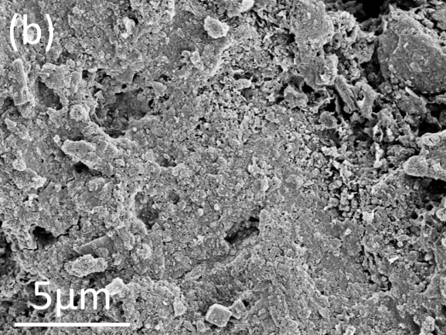
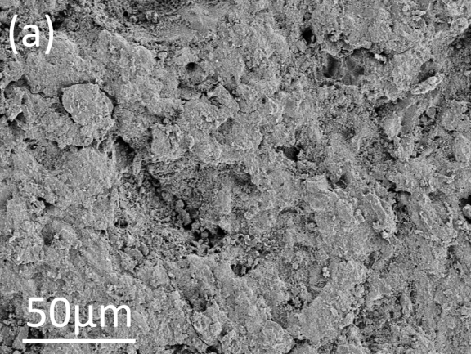
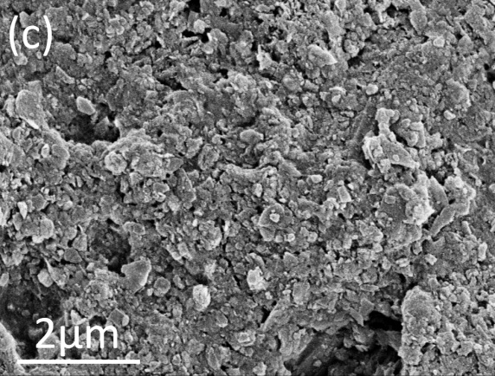
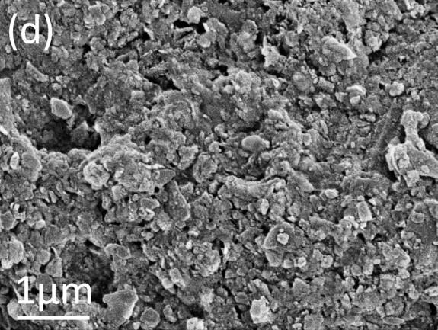

Figure 2
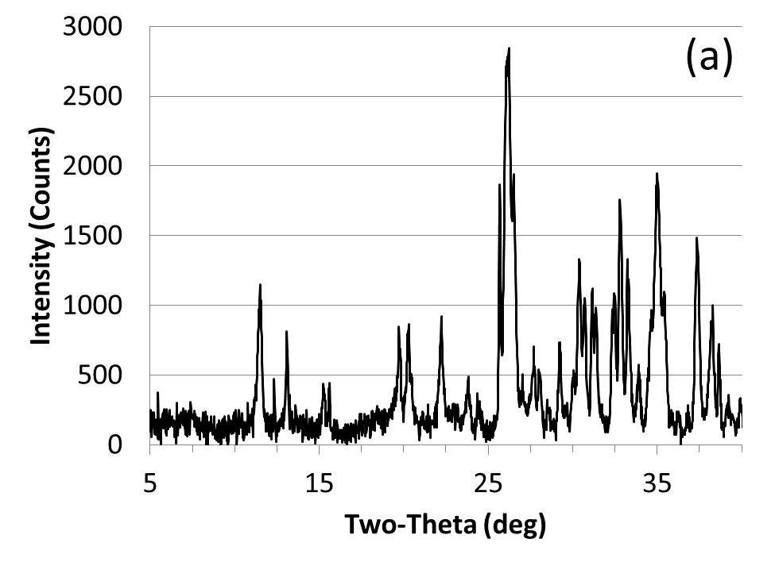
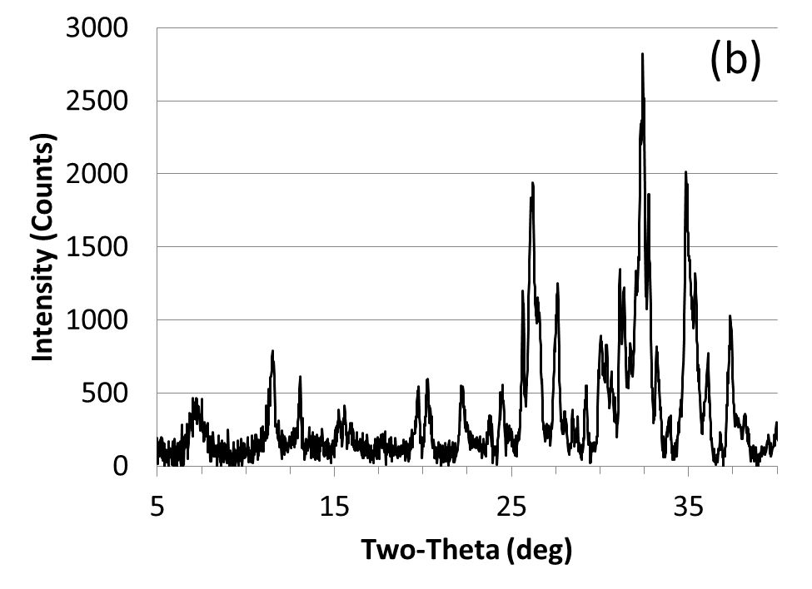
Figure 3

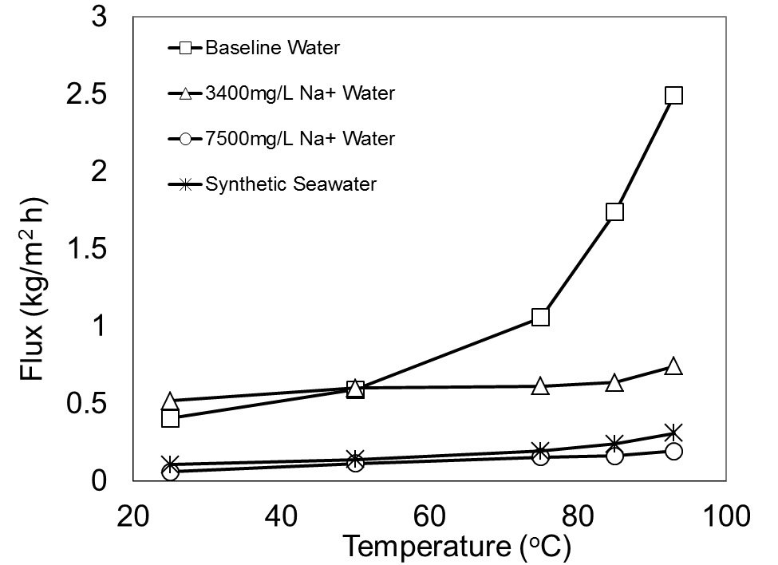
Figure 4

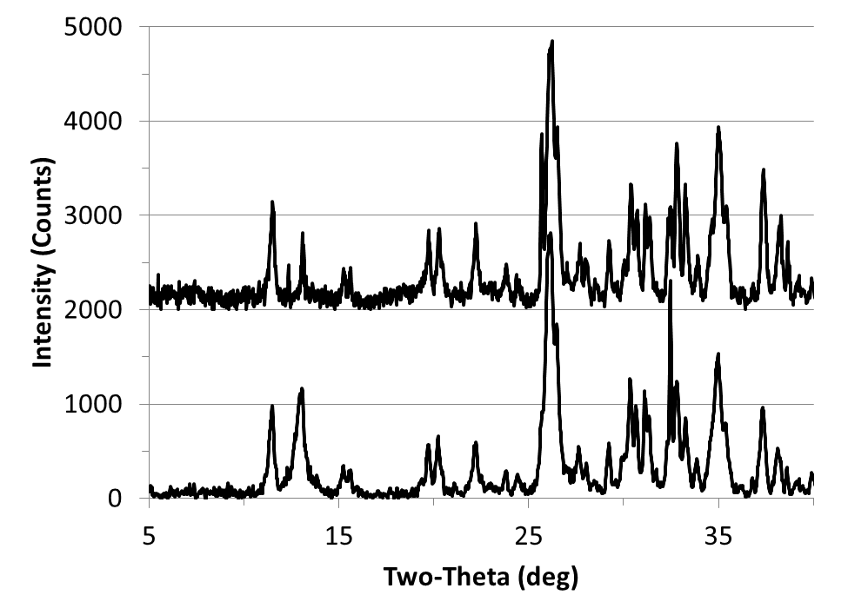
Before

After
After
Figure 5

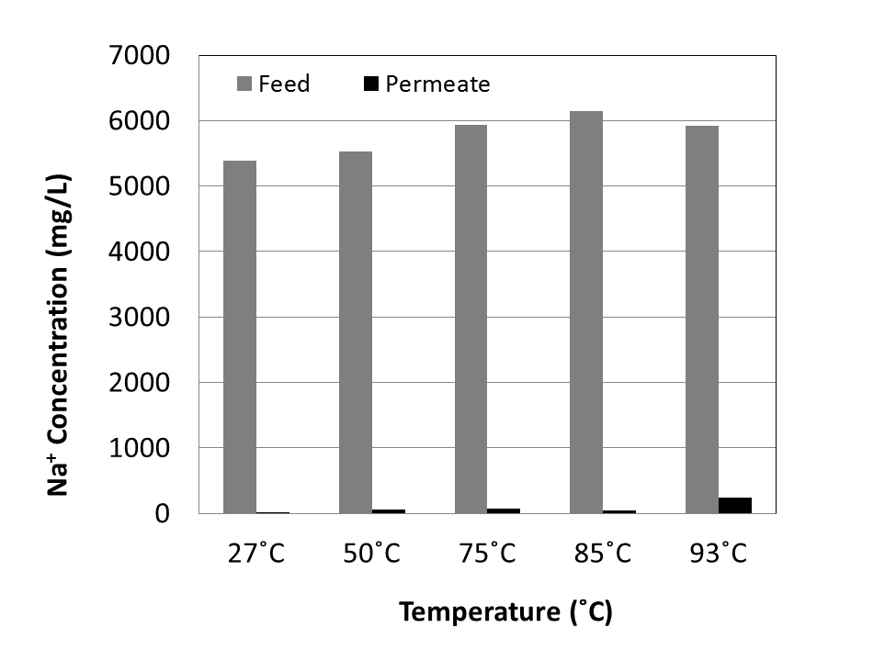
Figure 6

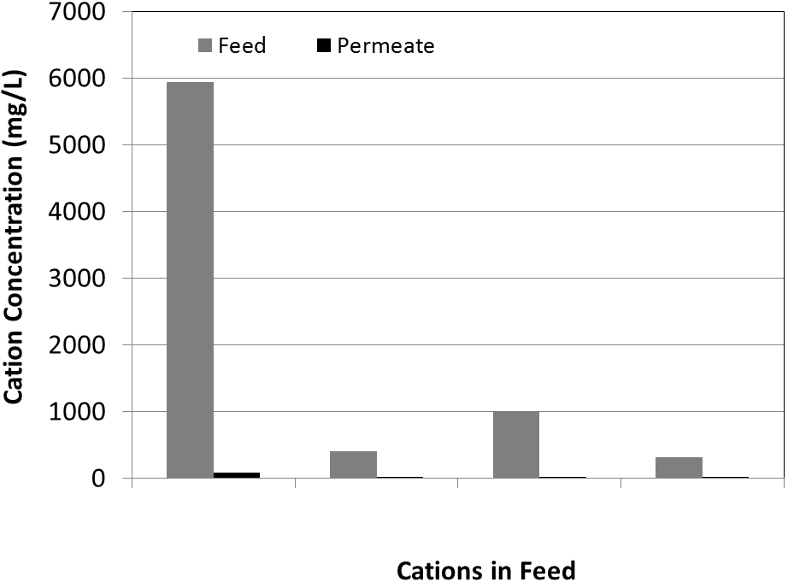
Na⁺ Ca²⁺ Mg²⁺ K⁺
Hydrated Radius*: 0.278nm 0.356nm 0.364nm 0.269nm

*Hydrated radii are averages from references 26-28

Figure 7

 To whom all correspondence should be addressed. Tel: (780) 492-8819; Fax: (780) 492-8958; E-mail: steve.kuznicki@ualberta.ca.

