Nanotechnology & Medical Devices: Risk, Regulation and ‘Meta’ Registration
SIMON GRANGE, Kris Chettiar, Mateen Arestu, Peter Smitham, Patrick Pilarski, Marilena Loizidou, GAVIN JELL
Word Count: 3512
Simon Grange
7/21/2012

Integrating data services across the life science spectrum illustrates the design and development of novel therapies in terms of Translational Research (TR) paths. The aim is to build an ‘open’ registry from multiple centres by allowing for open archiving of key characteristics of materials used in the preparation of implantable devices.

Nanotechnology & Medical Devices: Risk, Regulation and ‘Meta’ Registration
Simon Grange¹, Kris Chettiar², Mateen Arestu², Patrick Pilarski³, Peter Smitham⁴, Marilena Loizidou⁶, Gavin Jell⁶
¹Alberta Bone and Joint Health Institute, Suite 400, 3820, Hospital Drive NW, Calgary, Canada
²Dept of Surgery, University of Calgary, Canada
³Dept. Computer Science, University of Alberta, Canada
⁴Institute of Orthopaedics and Musculoskeletal Science (IOMS), Stanmore, UK
⁵Dept. of Surgery, UCL, Royal Free Campus, London, UK

Introduction: The standardisation of risk assessment and the subsequent management of this information, challenges the development of new biomedical devices, especially those incorporating nanotechnology (1). At the nanoscale, electromagnetic forces become much more important, conferring unique properties to a material of this scale. Nanomaterials not only have different thermal, optical and magnetic properties compared to their bulk counterparts, but also have dramatically different biological interactions. Size will influence the ability of a particle to penetrate biological barriers (skin, tissue and cell membranes) and due to the massive increase in ratio of surface area to mass; nanomaterials will have markedly different reactivity rates.
It is for precisely these unique properties at the nanoscale (e.g. optical, thermal properties, reaction rates and dissemination within the body) that nanomaterials could revolutionize modern medicine and are of increasing interest to scientists, clinicians and manufacturers. Nanomaterials are already being used in medical diagnosis and treatment, and commercially for cosmetics, sunscreens and stain-resistant clothing etc. Indeed the vast array of nanomaterials being developed (Table 1) presents one of the hurdles to effective risk management i.e. precise definitions of what nanomaterials are. Materials which have unique properties and biological interactions may require new assessments of risk and standardisation of regulation, without which translation and development of these promising medical devices could be jeopardised.
Biological interactions with nano-sized materials are just beginning to be investigated and understood, but some lessons can be learnt from existing human-nanomaterial interactions, namely from inhaled industrial by-products or orthopaedic implant wear debris. Clearly the mode of entry into the body has important consequences on the dissemination of the particles within the body and clearance rates. For example sophisticated biological barriers (skin, mucus membranes) already exist to prevent environmental nanoparticles entering the circulatory system. These protection mechanisms are by-passed by implanted devices (fig. 1).
Man-made |  | Natural
Engineered | Industrial  by-products | Biological | Atmosphere  / inorganic
Drug delivery systems: liposomes, micelles, inorganic particles, carbon annotates | Mining | Viruses | Volcanic emissions
Enhanced imaging systems: quantum dots | Combustion (soot) | Prions | Dust
Biosensors: gold nanoparticles | Industrial by-products | Pollen | Sea spray - salts
Biofunctional-ised materials: nanoscale engineered topography & chemistry | Diesel emission particulates
Biomaterial Wear Debris
Table 1 Common types of nanomaterials which interact with biological systems. Nanomaterials can be generated through various mechanisms; nano-sized drug delivery systems, nano-grooved substrates, bio-functionalised implants or their wear and degradation products (1)
The biological interactions with nano sized debris (e.g. from orthopaedic implants) will be different to larger sized breakdown products. The toxic potential can also relate to in vivo sites of particle accumulation and resulting tissue injury is often correlated with surface area, rather than mass (1). The issue of potential adverse effects of nano debris from implants therefore depends on their ‘through life cycle’ (2;3) and the characteristics of the particles.
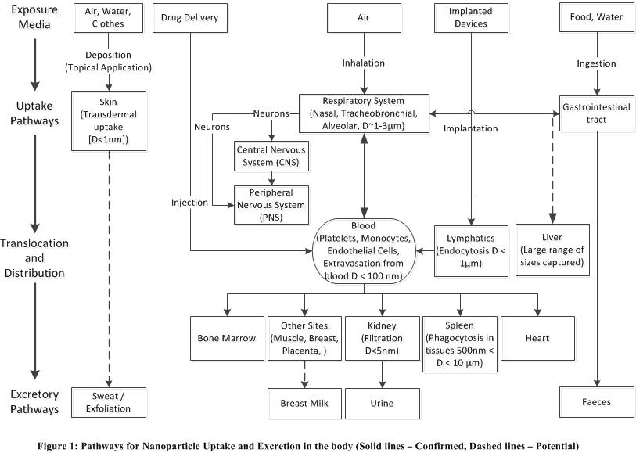
Aims: Integrating data services across the spectrum of the life sciences can inform the design and development of novel therapies in terms of Translational Research (TR) paths. The aim is to build a registry that can draw from established resources, such as the Swedish Hip Registry (4). A ‘Creative Commons’ (5) registry model can be constructed from multiple centres, by allowing for open archiving of key characteristics of materials used in the preparation and implementation of implantable devices, building upon established resources.
Figure 1 Pathways for Nanoparticle Uptake and Excretion in the body (Solid Lines - Confirmed, Dashed Lines - Potential)
This should potentially identify pitfalls associated with the use of certain materials for specific biomedical applications, alerting the community to the potential risks before they occur. There is a perceived clinical need for better ‘upstream’ understanding of factors that may lead to clinical problems. This relates to orthopaedic implants in particular, whose nanoscale issues may have unanticipated clinical consequences (5). It is, however, relevant to all implant types (1). Potential assays that may be used to evaluate cellular in vitro impact at the nanoscale are listed in Table 2 below.
We aim to present a set of relevant variables for which parameters can be defined and collected from different body sites, and to collate the potential values and risks associated with novel nanomaterials and devices, which produce these nanoscale interactions. We should consider all available knowledge of their ‘through life cycle’, minimizing the risk of developing undesirable biological interactions.
Initially we will focus on implantable orthopaedic devices, and the opportunity to build on shared collaborative datasets, such as the Orthopaedic Implant (Joint) Registries. In the broader context, such a process can be applied to all implantable devices that may interact on the nanoscale (6).
Assay type | Process probed | Assay
Viability | Metabolic activity  Proliferation  Necrosis  Apoptosis | MTT, Alamar Blue  Total DNA  Membrane permeability  Annexin-V, TUNEL
Mechanistic | Oxidative stress  DNA damage | ROS detection  TUNEL
Functional/  Behavioral | Differentiation  Inflammatory response  ECM formation  Cell mobility and recruitment | RT-PCR,  Western blotting  ELISA  A Red and Collagen  Trans well cultures, scratch test
Cellular uptake | Endocytosis  Phagocytosis | FRAP  TEM  QD microscopy
Table 2 List of some tests currently used to analyse nanotoxicity (7)
With new materials and their associated manufacturing processes (e.g. machining of the bearing surfaces), there are a myriad of variables that need to be considered. A proposed map consisting of the uptake of nanoparticles and affected biological systems (Fig. 1) is therefore presented to illustrate the complexity. The optimum end result is measured in terms of safety and effectiveness through ‘longevity’ of implantable devices. There are some materials which are completely inappropriate, such as compounds containing heavy metals (e.g. Mercury - Hg), which should be ‘red flagged’ as unusable. Then there are those which are currently in use which are controversial (‘amber flag’), such as carbon nano tubes (CNT), which have been described to cause both desirable and undesirable cellular interactions. Even tried and ‘in vivo’ tested materials, such as Ultrahigh Molecular Weight Cross-linked Polyethylene (UHMWPE), have been shown to promote inflammation when wear particles are produced and thereby contribute to the aseptic loosening of orthopaedic implants.
Clearly material chemistry is not the only consideration; material wear rates, particle size, particle shape and importantly particle concentration have all been shown to be important in determining biological response.
Governance: In orthopaedic implants, material wear debris has been shown to induce inflammation locally and at distal sites due to dissemination through the lymphatic and vascular system (7). Long term failure rates as high as 50% in orthopaedic implants (Table 3) suggest that existing pre-clinical and clinical trials are insufficient in determining long-term risk. These are real issues because of the duration of interaction, but the risk has to be set in the context of the massive benefit to the quality of life that such implants offer. New guidelines that consider the entire component ‘life cycle’ are required for existing as well as new technologies. Despite an increased understanding of the biological-material interface, we are still faced with a disjointed picture on how new nano technologies impact biologically and what can be done to make the best of their potential.
The aforementioned in vitro assay modes are relevant (Table 2). Both these and the in vivo tests therefore need to be linked to clinical outcome. Currently many of the cellular assays routinely used to determine nanomaterial interactions, group a number of “negative” outcomes under the umbrella term of cytotoxicity or nanotoxicity. Cell death, and the mechanisms of cell death, are not the only cellular parameters that may demonstrate undesirable cell interactions. The interactions which increase cell proliferation may be equally as harmful in altering tissue functionality as cell death. Any changes in cell behavior from their normal role (e.g. inflammatory responses, angiogenic responses, cell differentiation etc.,) may lead to impairment of tissue functionality.

Governance approaches must support innovation, yet protect individuals and society at large. The optimum approach is not yet known, since there are presently no preclinical testing methods that can reliably predict outcomes; or affordably and systematically investigate all possible negative interactions. There is therefore still a need for empirical data to be analysed and registries provide the best approach. As expectations arise within society for an improved longer term quality of life, greater pressure is placed upon healthcare providers and industry to deliver potential new solutions.

Type of implant | No. of patients | % With osteo-lysis | % With revision surgery | Follow up period
Porous-coated titanium stem. *1 | 185 | 27 | Not recorded | Evident after 6mths-5yrs
Cemented titanium alloy stems.*2 | 132 | 30 | 12 had or needed revision | Mean of 6.6yrs
Harris-Galante. *3 | 82 | 23 | 7.5 | Mean of 7.5yrs
Ceramic femoral *4 | 96 | 22 | 10 | Mean of 8.5yrs
Porous coated acetabular component with and without cement. *5 | 137 | With 12% Without 32% | Not recorded | Mean of 9yrs
Charnley, polyethylene cup, stainless steel alloy stem. *6 | 62 | 57 | 23% total 18% due to aseptic loosening | 25yrs
Table 3 Example follow-up studies of total hip arthroplasty*
*Follow up studies show increasing osteolysis and aseptic loosening with age of implant for a number of different implants. However, various evaluation methods, different surgical techniques, the vast variety of implant materials make comparisons between implant success difficult. This table also highlights the slow process of human biocompatibility evaluation (~25 years). *1 Wan 1996. *2 Scholl 2000. *3 Soto 2000. *4 Yoon 1998. *5 Zicat 1995. *6 Callaghan 2000

Our knowledge base can therefore be categorised according to the "Rumsfeld Paradigm" (table 4 below), which refers to what the professions recognise and what other potentially available information could add value.

 | Known  By Community | Unknown  By Community
Known  by User | Known Knowns (KK)  Information that we all have access to  e.g. published in vitro and in vivo studies  (tables 1 & 3) | Unknown Knowns  (UK)  Information that we all do not yet have access to but could seek permission for  e.g. Aggregated data from Secured Intellectual Property
Unknown  by User | Known Unknowns (KU)  Information that we have access to, but not yet collacted  e.g. table 2 (implant retrieval data) | Unknown Unknowns (UU)  Information that may be very relevant but which is not ‘on the horizon’  e.g. data mined ‘gap analysis’
Table 4 ‘Rumsfeld's’ Paradigm
Known Knowns: Broadly speaking this relationship between local and remote (other centres’) perspectives on information about the materials, can distinguish what we ‘know’ as a community from what we ‘need to know’ that may presently be inaccessible. This may be obtained from empirical processes, i.e. results of current tests and registries that have been evaluated (2). These published results represent ‘Known Knowns’.
Unknown Knowns: What we don't know that others know, i.e. information that is ‘out there’ from different sources including proprietary databases, that securely hold intellectual property in industry, could be anonymously reported, possibly as aggregated data. This represents things that are known by certain groups, but not by the community i.e. ‘Unknown Knowns’ (UK). These can be reported directly once they are not censored. The latter includes the information that some registries could provide us with.
Known Unknowns: There is information that the community identifies as potentially available, i.e. that we ‘know’ is ‘unknown’ (KU). Sources include unpublished case series, and this will potentially drive further registry development, integrated with failed device ‘Retrieval’ information. Since serum ion levels from orthopaedic implants do not clearly correlate with failure of implants, whilst the wear particle concentration in the periprosthetic tissue does correlate with implant failure and the subsequent need for revision surgery (either through aseptic loosening or perceived potential risk (9)), the data based on ‘retrieved’ specimens represents the ‘known unknowns’.
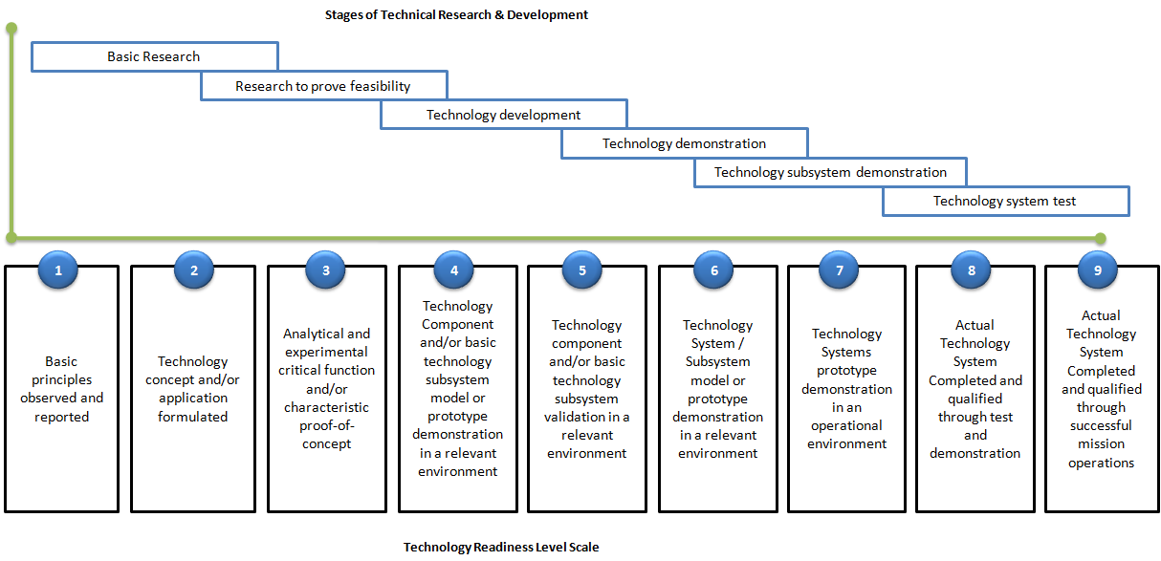
Unknown Unknowns: The last category is the "Unknown Unknowns" (UU), where there may be future tests. These do not presently exist. The clinical outcomes will ultimately provide information needed to reach sound conclusions. These may relate to the consequences of higher serum ion levels or to clinical examination through modalities such as Magnetic Resonance Imaging (MRI) or Ultrasound Scanning (USS) or even multimodal imaging. Whatever the technology or technique, the question arises as to how to inform the process of future implant design. The process is similar to patent mining or the identification of “patent vacuums”, employing a software infrastructure in the database that identifies possible tests and agents based on the surrounding data landscape (8).
Figure 2 Applying Technology Readiness Levels to the design of a new device
Since there are no long-term evaluations at this stage, the question is also one of whether there are reliable and robust short-term (post-implantation) surrogate measures, which can predict failure, as has successfully be seen with Radiostereometry (RSA), which can demonstrate significant wear in some implanted prostheses, when using bearings such as ultrahigh molecular weight polyethylene (UHMWE).
Acceptable Risk: None of these approaches actually answer the critical question; ‘Collectively, are these reliable indications of risk?’ This illuminates the fact that there is presently no thorough way of predicting implant success ex-vivo. The adaptation for a ‘Creative Commons’ approach could rapidly progress this process, ensuring legal protection through appropriate licensing (3). Using the Technology Readiness Level (TRL) Scale to ensure a clear non-repudiable ‘chain-of-evidence’, the trend should always be a logical transition from one stage to the next. For such technological transfer, it should be possible to demonstrate this provenance. The aim is to ensure ease of governance by transition from Good Laboratory Practice (GLP) to Good Clinical Practice (GCP) and to Good Manufacturing Practice (GMP).
To achieve this, it is necessary to demonstrate that the sequential steps have been satisfactorily completed. In addition, to become confident in the process, it is necessary to report adverse events as well as positive findings since there is usually a 2:1 reporting bias in favor of the positive findings (10).
Technology Readiness: By building the structure around the Technology Readiness Level (TRL) scale, and when technologies are bundled together, the System Readiness Level (SRL), it is possible to establish the general principle of how to demonstrate that the appropriate design review and safety testing has been completed, justifying progression. The aim is to visualise this in multiple dimensions, including any potential biohazard and also the cost of development of each stage. The general workflow, transitioning across programmes and jurisdictions, means that the system would require acceptance of parameters to meet those of an International Standards Organisation, such as ISO. This means that there will be an established process for developing Standard Operating Procedures (SOP) that can transcend the jurisdictions of the different organisations and be acceptable to the governing bodies, who ultimately oversee the differing stages of technology transfer.
The key to this is the ability to model across steps of technology development and to compare the differing datasets reasonably, i.e. through processes of verification and validation (Figure 2 above). The progression is also dependent across different stages, where the user can also establish associations across differing technologies. In effect this links to the conventional processes for Serious Unexpected Suspected Adverse event Reporting (SUSAR), which is intended to report short term adverse events from pharmaceutical products and act as a broad net after Clinical Trials of Investigational Medicinal Products (CTIMPs). Agreement of the academic profession to report such findings and to develop a voluntary registry for the purpose would be required.
Discussion: By agreement to participate, users will potentially benefit from useful information to justify their contribution, with altering public perceptions regarding reported issues such as Metal-on-Metal (MoM) implant. This will challenge the development of new devices through failure to disaggregate information regarding known ‘failing’ implants from others that use similar materials. Whilst history advises caution with respect to new prostheses, some MoM devices have raised concerns, though it is apparently only certain types of bearing that precipitate the problems. It is therefore population groups, providing epidemiological data through registries in countries such as Australia and the UK that will offer usable results for specific devices. Attempting to extrapolate directly from one registry to another is however potentially logically flawed as parameters differ.
Ideally if rigorous in-vitro analysis could offer new and reliable tests, these would be of value, though they are unlikely to predict the local biological environment, including the synovial (natural joint lining) cells and their interaction with the prostheses.
Since we are aware that certain metal debris is shed from the modular hips, it is realistic to assume that this relates only to specific reported devices that have been seen to have higher wear and thus failure rates. Examples such as the ‘Duron’ cup and ASR hips, have already been withdrawn from the market in 2010. The question then arises; what new paradigms, with associated controls, can be employed to improve our evaluation of potential new materials for biomedical applications? Through developing validated proxy measures, nanotechnologists can assist society by preventing vulnerable designs from being implanted early in the process, without having to go through extensive, expensive and risky clinical trials. Registries will therefore be of value, helping to avoid the design of future implants, which may steer down a ‘cul-de-sac’.
Clearly it is reasonable for regulatory agencies such as the USA’s Food and Drugs Administration (FDA) and European Medical Authority (EMA) to step in if there is irrefutable evidence of a disproportionately high failure rate of novel technologies. Fortunately however, across the spectrum of implantable devices these are rare, and the majority of devices have both an acceptable functional life expectancy and a safe ‘through life cycle’ profile. At the other end of the spectrum, as successful as some technologies are, even they are seldom bio inert (11;12).
The issue is therefore the ‘middle ground’, where we must first address issues of how we analyse complexity to ensure that salient features are recorded simply within databases. Those features, which have been demonstrated to be identified as ‘not fit for purpose’, can be quarantined from future design processes. In addition to recording characteristics in simple terms, it is also possible to extract key features in vulnerable designs before they reach critical mass. Automatic detection of anomalies has been achieved in bio-outbreak identification from hospital, pharmacy, and related data logs; where pathogen detection and localization within an urban centre can be identified before human regulators can make sense of the emerging anomaly. As nanotechnologies develop, this negative aspect will need to be addressed so as to avoid the ‘taint by association’ of a potentially very valuable industry, by a few dysfunctional designs.
Solutions: The proposed method would be to consider the ‘chain of evidence’ in a similar way to, but the inverse of, considering a ‘chain of error’. This positive aspect considers the data collected across the life-science spectrum. This derives from different areas of basic science, right through to the process of design, development and clinical testing, industrialization and commercialisation, in terms of technology transfer.
It is not unreasonable to consider that such an evidence path is demonstrable when seeking future regulatory approval. However it still has to be recognised that this only accounts for the ‘known knowns’ (KK). As stated above, ‘Unknown Unknowns’ (UU) may be accessible through data mining. For example, computational technologies akin to those used in patent vacuum identification (8) anomaly detection, and disease outbreak detection (13) can assist in identifying both future assays and future failure or success modes from early data in the TRL pipeline. Specifically, active learning based on existing data in an evidence path can form a powerful source of new knowledge by suggesting tests to reduce the space of ‘Unknown Unknowns’ (14;15). Data-driven foresight of this kind can positively direct technological exploration and regulation. To develop a predictive loop for future realisation; both the ‘Unknown Knowns’ (UK), the ‘Known Unknowns’ (KU), from the ‘meta’ registry information, will have to plug this information gap and hopefully diminish the ‘Unknown Unknowns’ (UU), which may jeopardise future technological progress.
Conclusions: Through machine learning, there are techniques available to identify salient features in data, and predict the relative value and ascribed certainty of these variables. These methods should be applied to the registries, using specific evidence models, which can be primed by data from industry. At the same time, dissemination of established information should minimise the risk of future harm through rapid communication of validated results.
Existing pre-clinical and clinical trials are insufficient in determining risk. New guidelines are required for both new and existing technologies. The development of a non-repudiable robust Translational Research (TR) approach (16) should therefore precede the clinical implementation of future materials. A hurdle to voluntary registration of data is researcher participation or industry bias. This bias reflects inclusion of only positive data e.g. Carbon Nano Tube (CNT) researchers publish that CNT are not toxic - whilst toxicologists would normally argue otherwise.
Ultimately peer pressure encourages ‘reluctants’ to participate, though after 50 years of Joint Registries there is still limited data and disagreement on orthopaedic failure rates, with the notable exception of Swedish National data. As professions, we must aim to establish this clearly measurable causal links between pre-clinical design and actual clinical outcomes. More complicated data registration is going to be difficult, but is ultimately necessary as we progress toward the introduction of bio inspired nano scale products such as synthetic cartilage substitution in vivo (17).
At present, research efforts in nanotoxicology are just beginning. Less than 4% of all current U.S. governmental research expenditure on nanotechnology is targeted at studying the effects on human health and the environment (18). At this level of technology readiness, increasing this investment will ultimately strengthen a proposed global business of $9 Billion per annum assisting in the creation of a sustainable industry.

References:

(1) Maynard & Kuempel. Airborne Nanostructured Particles and Occupational Health. J.NANOPARTICLE RES. 7, 587-588. 2005.

(2) Alison J Smith et al, on behalf of the National Joint Registry of England and Wales. Failure rates of stemmed metal-on-metal hip replacements: analysis of data from the National Joint Registry of England and Wales. Lancet 379, 1199-1204. 13-3-2012.

(3) Art Sedrakyan. Metal-on-metal failures—in science, regulation, and policy. Lancet 2012 Mar 13;379(1174):1176.

(4) Swedish Hip Registry Study. http://www.ncbi.nlm.nih.gov/pmc/articles/PMC2856196/ . 2012.

(5) P.A.Revell. The biological effects of nanoparticles. Nanotechnology Perceptions 2006;2:283-98.

(6) Leticia E. Development of Inhalable Nanoparticles. 2004 p. 193-5.

(7) Jell G et al. Lymphangiogenesis in the bone-implant interface of orthopedic implants: importance and consequence. J Biomed Mater Res A 2006 Apr;77(1):119-27.

(8) Changho Son et al., “Development of a GTM-based patent map foridentifying patent vacuums”, Expert Systems with Applications, Volume 39, Issue 3, 15 February 2012, Pages 2489-2500

(9) Daniel J et al. The validity of serum levels as a surrogate measure of systemic exposure to metal ions in hip replacement. J Bone Joint Surg Br 89-B[6], 736-742. 2007.

(10) Natalie McGauran* . Reporting bias in medical research - a narrative review. Trials 2010;11(37):1-15.

(11) J Vander Sloten et al. Applications of computer modelling for the design of orthopaedic, dental and cardiovascular biomaterials. 1998 p. 212-489.

(12) L.L.Hench. Prosthetic Implant Materials. Annual Review Material Science 5, 279-300. 1975.

(13) Buckeridge, D.L., et al., Algorithms for rapid outbreak detection: a research synthesis. Journal of Biomedical Informatics, 2005. 38(2): p.99-113..

(14) Y. Zhang, “Multi-Task Active Learning with Output Constraints, ”Proceedings of the Twenty-Fourth AAAI Conference on Artificial Intelligence (AAAI-10), pp. 667-672, 2010.

(15) C. Chao, M. Cakmak, and A. Thomaz, “Transparent active learning for robots,” HRI '10: Proceeding of the 5th ACM/IEEE international conference on Human-robot interaction, 2010.

(16) Miles-Board et al. Extending the role of a healthcare digital library environment to support orthopaedic research. Health Informatics Journal, 2006;12(2):93-105.

(17) Coburn JM, Gibson M, Monagle S, Patterson Z, Elisseeff JH. Bioinspired nanofibers support chondrogenesis for articular cartilage repair. Proceedings of the National Academy of Sciences 2012 Jun 19;109(25):10012-7.

(18) Robert F. Service. Nanotechnology Grows Up. Science 2004;304:1732-4.

