**Demulsifier Performance in Diluted Bitumen De-watering:   
Effects of Mixing and Demulsifier Dosage**

**Jeng Yi Chong1, Marcio B Machado1, Nitin Arora1, Sujit Bhattacharya2, Samson Ng2, Suzanne M Kresta1\***

1. Department of Chemical and Materials Engineering, University of Alberta, Edmonton, AB T6G 1H9, Canada

2. Syncrude Canada Ltd., Edmonton, AB T6N 1H4, Canada

* Author to whom correspondence may be addressed. E-mail address: kresta@ualberta.ca

Abstract:

Mixing conditions were explored as a possible avenue for improvement of demulsifier performance in solvent diluted bitumen de-watering process. The effects of demulsifier bulk concentration, demulsifier injection concentration and mixing energy on water and solids removal from the oil phase were tested. All of the experiments were carried out in a confined impeller stirred tank (CIST), which provides well characterized mixing conditions and relatively uniform flow and turbulence. Results showed that lowering the injection concentration and increasing the mixing energy both improve demulsifier performance, allowing a 50% drop in the bulk concentration of demulsifier. This result agrees well with an earlier study by Laplante, et al. 1 where a different demulsifier was investigated. In that study, it was shown that the product of mixing time and energy dissipation rate at the feed point (the mixing energy = J) provides an alternate mixing variable.

Keywords: diluted bitumen, demulsifier, mixing energy, meso-mixing, de-watering, CIST.

# Introduction

Crude oils and water have a tendency to form stable water-in-oil emulsions.2 These emulsions are stabilized due to the presence of naturally occurring surface active agents and solids in the crude oil.3, 4 The presence of emulsified saline water in bitumen is a major problem in bitumen refining operations due to corrosion. Stabilized solids can also cause problems by erosion and depositing fouling layers in pipelines and refineries.5

The removal of water and solids from bitumen is a key step in bitumen recovery from oil sands. It is usually done in two stages. The first stage is done through a hot-water extraction where most of the water and solids are removed to tailings. After the first stage of extraction, the froth has roughly 30% water and 10% solids by weight. In the second stage of separation, froth is diluted with naphtha. The diluted bitumen product must contain a total water and solids content of less than 3% to avoid problems in the upgrading and refining processes. A chemical demulsifier is frequently used to break the stability of the water in oil emulsion.1, 3, 5-12

The formulation, characterization and selection of demulsifiers has been studied by many research groups.13-22 Several chemical and operational factors affect the demulsifier performance: chemical composition and structure, temperature of operation, pH, salinity, HLB (hydrophilic-lipophilic balance), ethylene oxide number, and demulsifier concentration. 1, 19-27

In spite of a large volume of work on the composition and operating conditions related to the demulsifier and surface thermodynamics,11, 28-30 the addition and dispersion conditions of the demulsifier are often neglected or not properly characterized.1 Two commonly used mixing devices for demulsifier dispersion at bench scale are bottle tests and shaker tables. These devices provide very low mixing energy and the flow is often not turbulent.31-35 At the industrial scale, the demulsifier is injected and dispersed in pipelines where the flow is fully turbulent but local mixing conditions can vary significantly due to large variations on the amount of water present in the bitumen36 or dropwise injection into the boundary layer at the pipe wall (flush mounted injection), which can significantly retard mixing.37

Any bench scale experiment that intends to replicate fully turbulent industrial scale conditions must also run in fully turbulent flow.38, 39 As bottle tests, shaker tables34, 35, 40 and stirred tanks41, 42 can all have regions where the flow falls into transitional flow, and the viscosity of diluted bitumen is significantly higher than the viscosity of water, other options for test vessels need to be considered. Several new mixing devices have been developed to provide better test conditions. These designs are based on two principles: confining the flow and miniaturizing the vessel. These design features allow better control of mixing conditions, more uniform flow and more homogenous turbulence and energy dissipation throughout the entire volume of the vessel.31

This study uses a mixing test geometry called the confined impeller stirred tank (CIST) with a volume of 1L of working fluid.43 The CIST is a tall, slender vessel (H=3T) filled with 5 or 6 impellers. It provides high levels of turbulence and active circulation over more than 95% of its volume. The CIST was designed to overcome many of the weaknesses of the bench scale stirred tank and is 10x more homogeneous in its turbulence levels than the conventional stirred tank. The CIST provides fully turbulent flow at low Re, which is difficult to achieve in other test geometries.31, 41 The CIST height to diameter ratio (H = 3T) is ideal to study the sedimentation of water and solids after addition and dispersion of the demulsifier.

Laplante, et al. 1 proposed a standardized protocol for testing demulsifier performance in diluted bitumen systems using a CIST and discussed the importance of a standardized mixing protocol to compare the performance of these chemicals. When each research group uses its own procedure, the effects of mixing on the demulsifier performance are often overshadowed by other parameters, most especially by the bulk demulsifier concentration.

Using the CIST, Laplante, et al. 1 showed that when the mixing conditions are well chosen, the initial settling is much faster and more of the water and solids are removed. This happens because the water droplets or aggregates have a larger equivalent diameter compared to the ones formed when non-ideal mixing conditions are used.36 These large water droplets or aggregates of small drops coalesce and settle more easily. Laplante, et al. 1 also found that some of the solids tend to leave with the water.

Laplante, et al. 1 and Chong, et al. 36 both showed that reducing the injection concentration (% of active ingredient in the demulsifier solution) improves demulsifier performance, and that mixing depends on both the rate of energy dissipation and the mixing time. These two variables can be combined to give a single scaling variable, the mixing energy (J=ε*tmix).44-46 The mixing energy (J) can be estimated and/or directly measured for various vessels, mixers, pipes, and pumps.47 It allows a translation of mixing conditions from batch (mixing time * energy dissipation rate) to continuous (residence time x energy dissipation rate) processes.

Laplante, et al. 1 tested only one demulsifier and sample of diluted bitumen. This paper expands the investigation to a different commercial demulsifier. The objective of this work is to validate the results presented by Laplante, et al. 1 for a second demulsifier, assessing the effects of mixing intensity (ε), mixing time (tmix), demulsifier bulk concentration (BC) and injection concentration (IC) to see if the conclusions are more generally applicable.

Two experimental campaigns were carried out. In the first one the variables ε, tmix, BC and IC were run at three different levels to check for non-linear effects. The second campaign merged mixing intensity and mixing time onto the mixing energy (J), and tested the effects of J, BC and IC at two levels. The amount of solids removed was measured and correlated to water removal. The mixing protocol reported by Laplante, et al. 1 was used in all experiments.

# Methodology

In any additive study, the bulk concentration will have a major effect and is an important part of the experimental design. Mixing is characterized by mixing intensity (sometimes characterized as the power per unit mass, but more accurately the local rate of dissipation of turbulent kinetic energy per unit mass at the point of injection) and mixing time (how long the mixer runs). The effects of mixing can be masked if a plume of high local concentration of additive forms close to the feed point, leading to a situation where the demulsifier may be locally overdosed.48 The formation of a dispersion plume with high local concentrations is known as a meso-mixing effect.49-51 If the concentration is reduced at the point of injection, and the injection rate is controlled, plume formation can be reduced or eliminated. The injection concentration is defined as a third key mixing variable, and the injection rate is controlled. Since mixing is often an interacting variable, it is necessary to run experiments using factorial designs, which allow changes to more than one variable at a time.

The first experimental campaign assessed the effects of four variables at three levels:

* Bulk concentration of demulsifier (BC, ppm): the amount of active ingredient injected into the diluted bitumen by weight. BC was varied from 5 ppm to 95 ppm, which covers a range from close to absence of demulsifier to the expected ideal dosage. The bulk concentration of demulsifier was calculated in terms of the weight of the diluted bitumen (froth bitumen + naphtha). The BC values in terms of the weight of the bitumen froth were varied from 8.5 ppm to 161.5 ppm.
* Mixing intensity (εimp, W/kg): the total power consumed per unit mass scaled with the impeller swept volume. It was varied from 1 to 40 W/kg, which covers a range of energy dissipation levels from an empty pipe to a high pressure drop static mixer installed in the same pipe.50, 52
* Mixing time (tmix, min): the time during which impellers are run after the injection of demulsifier. The mixing time was varied from 2 to 10 minutes.
* Injection concentration of demulsifier (IC, wt%): the amount of active demulsifier ingredient (wt%) in the xylene solution. The demulsifier was supplied at 39 wt% solution and was diluted with xylene to obtain the desired injection concentration (3 to 39 wt%).

In order to detect any quadratic effects, all of the variables were tested at three levels using a Box-Behnken full factorial design.53 The level intervals were equally spaced and coded using the relationship:

|  |  |  |
| --- | --- | --- |
|  | $${\text{X}}_{\text{A}}\text{=2}\left(\frac{\text{A-}{\text{A}}_{\text{min}}}{{\text{A}}_{\text{max}}\text{-}{\text{A}}_{\text{min}}}\right)\text{-1}$$ | (1) |

where Amin and Amax are minimum and maximum values of the variable respectively. Equation 1 gives coded levels -1, 0 and +1 for each variable as shown in Table 1. A three level factorial design was used, giving a set of 30 experiments including 6 central repeat experiments. The full design details are included with the results.

The second experimental campaign was designed based on the results from the first experimental campaign. The ranges of BC and IC were narrowed to allow for a closer focus on mixing effects. The effects of three variables at two levels were assessed:

* Bulk demulsifier concentration (BC, ppm): BC was set to 27 ppm or 50 ppm. The concentration of demulsifier was calculated in terms of the weight of diluted bitumen (bitumen froth + naphtha). The BC values in terms of weight of bitumen froth were 45.9 ppm and 85 ppm.
* Mixing energy (J, J/kg): mixing time (tmix) and mixing intensity (εimp) were combined into a single variable called mixing energy (J= εimp **\*** tmix). The mixing energy was set to either 120 or 24000 J/kg. The mixing energy of 120 J/kg was obtained through a combination of εimp = 1 W/kg and tmix = 120 s = 2 min and the mixing energy of 24000 J/kg through a combination of εimp = 40 W/kg and tmix = 600 s = 10 min.
* Injection concentration of demulsifier (IC, wt%): IC was varied from 3 to 12 wt%.

In Campaign 2, a two-level factorial design was conducted in which the variables XBC, XJ and XIC had two values: -1 and +1, giving a full factorial design of 8 experiments. The details are summarized in Table 1.

## 2.1. Experimental procedure

The diluted bitumen with a naphtha/bitumen ratio (N/B) of 0.7 was used as supplied by Syncrude Research with the properties given in Table 2. Due to the high variability of the oil, water and solids contents that are natural in bitumen,54 it is important to measure the composition and physical properties of the diluted bitumen as supplied for each experimental campaign. The composition of the diluted bitumen was determined using Dean Stark OWS analysis55 and Karl Fischer titration. Dean Stark OWS analysis is a solvent extraction procedure that separates oil, water and solids in a sample to give the mass of each component. The viscosity was measured using a Fenske viscometer at 80ºC. The density was measured using a pycnometer. The diluted bitumen was stored in 4 L paint cans in a refrigerator at 5°C to preserve the emulsion until use.

A commercial demulsifier different from the one used by Laplante, et al. 1 was used in this study. This demulsifier has a formulation known to be successful for bitumen de-watering. It belongs to a class of demulsifier that contains ethylene oxide-propylene oxide block copolymer. The carrier fluid is mainly composed of xylenes. As the main objective of this study is to assess the effects of mixing variables, the formulation of the demulsifier, the naphtha to bitumen ratio and the temperature were all kept constant.

Each experimental run can be divided into three steps, according to the protocol proposed by Laplante, et al. 1:

1. Sample preparation (pre-mixing protocol)
2. Demulsifier injection and dispersion (mixing protocol)
3. Batch gravity settling

Figure 1 shows the experimental set up. The left-hand side of figure is the stirred vessel where the sample was heated and pre-mixed. The right-hand side shows the two CIST’s run in parallel where the demulsifier was added and dispersed, followed by a period of gravity settling.

### Pre-mixing for redispersion

The pre-mixing step is carried out to fully re-disperse the free water and solids present in the diluted bitumen. A 2.7 L sample in a 4 L container was first hand shaken and then heated in an ethylene glycol bath at 60 °C for 30 min. Then, a 45° down-pumping pitched blade turbine (PBTD) (D = T/2) with four T/10 baffles was installed in the can and run at 1000 rpm for 15 min while heating to 76.5 °C. At the end of premixing, ~100 mL of diluted bitumen was taken for OWS analysis, out of which ~1 mL was retained for Karl Fischer titration. A Kam controls Karl Fischer analyzer was used.

### Demulsifier mixing and gravity settling

After pre-mixing, the diluted bitumen was transferred to two CISTs (shown on the right-hand side of Figure 1) using a Masterflex pump and disposable tubing. The CIST is a 1 L tank with H/T ratio of 3, fitted with four T/12 baffles which prevent solid body rotation of the fluid by converting tangential flow to axial flow along the walls of tank. The CIST is fitted either with 5 A310, 6 Intermig or 5 Rushton impellers. Different impeller geometries are used to get a broad range of turbulent energy dissipations (εimp, Table 3).56 The impellers are mounted on 6 mm shaft with an off bottom clearance of C = D/3 for the lowest impeller and a submergence of S = D for the highest impeller. The remaining impellers are evenly spaced over the shaft. The detailed mixing specification of the CIST for all three impeller types has been summarized in Table 3. Machado and Kresta 43 measured the power number (NP) for the impellers used in this study using the methodology described by Chapple, et al. 57. Machado and Kresta 43selected tri-ethylene glycol at 25°C as one of the fluids for power number measurement since its viscosity (6 μm2 /s) is similar to the viscosity of diluted bitumen at 80 °C.

During the run, the temperature was held constant at 76.5 °C by circulating ethylene glycol through the jacketed CISTs. 9.5 mm stainless injection ports and steel sampling and were installed on the tank lid at radial positions of r/R = 0.5 and r/R = 0.9 respectively. The demulsifier injection volume was calculated based on the specified IC and BC. Demulsifier was injected 1 min after starting the impellers using a syringe or 3 mm tubing (connected to syringe pump) guided through a sampling port installed on the lid of CIST. The injection was done at the top of the uppermost impeller at a radial position r/R = 0.5 to promote high initial dispersion of demulsifier. For any demulsifier volume larger than 1 mL, a syringe pump was used to inject at a flow rate QI.

QI was adjusted to minimize the chance of forming a localized plume of high demulsifier concentration (mesomixing effect) which can inhibit demulsifier performance51, 58-60. The adjustment of the feed rate was done to ensure that the demulsifier was mixed in a molecular level (micromixing) considerably faster than the time required to form a dispersion plume (mesomixing). A summary of the derivation of the feed rate calculation is shown next and full details can be found at Chong 61.

Mesomixing time (tmeso) can be expressed as:

|  |  |  |
| --- | --- | --- |
|  | $$t_{meso}\text{=0.1}\frac{Q_{I}ε}{U*0.1k^{2}}$$ | (2) |

where U is the mean velocity of surrounding fluid at the feed point, k is the turbulent kinetic energy and ε is the energy dissipation.

Micromixing time (tmicro) can be expressed as:

|  |  |  |
| --- | --- | --- |
|  | $$t_{micro}\text{=12}{\left(\frac{ν}{ε}\right)}^{0.5}≅\text{17.24}{\left(\frac{ν}{ε}\right)}^{0.5}$$ | (3) |

where ν is the kinematic viscosity. Equation 3 has two possible coefficients: 12 is from the engulfment-deformation-diffusion (EDD) model62, 63 and 17.24 is from the engulfment rate model. 64 The smaller coefficient was considered for a more conservative design, since the micromixing will be smaller and achieved faster.

Mesomixing plays an important role in the process if it is larger than 0.2 * tmicro.65-67 As the goal is to avoid mesomixing during the demulsifier injection, tmeso < 0.2 tmicro. So it is assumed that tmeso = 0.2 tmicro..

(4)

The turbulent kinetic energy is given by Equation 5. The flow is considered isotropic, so all fluctuating velocities have the same order of magnitude.

$k=\frac{1}{2}(v_{z}^{'2}+v_{r}^{'2}+v_{θ}^{'2})$ = $\frac{3}{2}v_{z}^{'2}$ (5)

As the flow is considered isotropic at the feed point, the energy dissipation can be approximated by Equation 6.

$ε=A\frac{v_{z}^{'3}}{L}$ (6)

where A is the turbulence proportionality constant (≈1 for locally isotropic turbulence68) and L is the turbulence integral length scale.

There are three possible length scales that can be used in Equation 6: L = dp, L = dimp/10 and L = T/5, where dp is the feed pipe diameter, dimp is the impeller diameter and T is the tank diameter. As the diameter of the feed pipe will affect the size of the droplet during the demulsifier injection, it was chosen as the length scale. The most important component of the mean velocity at the surface is the axial component.43

The feed rate required to avoid mesomixing effects is given by Equation 7.

|  |  |  |
| --- | --- | --- |
|  | $${\text{Q}}_{\text{I}}\text{=0.54}\frac{{\text{ν}}^{\text{0.5}}\text{∙}{\text{U}}_{\text{z}}{\text{∙}{\text{d}}_{\text{p}}}^{\text{1.5}}}{{v_{z}^{'}}^{\text{0.5}}}$$ | (7) |

In Equation 7, $ν$ is the kinematic viscosity, $U_{z}$ is the mean velocity of the surrounding fluid at the injection point, dp is the injection pipe diameter and v'z is the local fluctuating velocity. Uz and v'z were obtained from measurements by Machado and Kresta 43.

During demulsifier dispersion (while the impellers were running), samples were taken 60 s after demulsifier injection and 30 s before the end of the mixing time (tmix). These samples were taken 3.2 cm (z/H = 0.14) below the liquid surface at a radial position r/R = 0.9 using 6 mm diameter polyethylene tubing attached to an auto-pipette. These samples were used for water content measurement through Karl Fischer titration.

After the impellers stopped, the diluted bitumen was allowed to settle for 60 min in the CIST. Samples were taken at 3.2 cm (z/H=0.14) below the liquid surface at 1, 3, 5, 7, 10, 30 and 60 min and the water content was measured through Karl Fischer titration. After 60 min of batch settling, three 100 mL samples were obtained for OWS analysis55 at submergences of z/H=0.1, 0.5 and 0.9 using 6 mm tubing connected to a glass syringe. The z/H ratio was measured from the height of the liquid surface at the end of the run, z/H=0.

# Results

The performance of demulsifier is determined by monitoring the water content in the top layer throughout the settling time. The solids content and OWS analysis was done at three heights at the end of the run. An early sharp decline in water content with respect to time is an indication of ideal operating conditions as this produces the shortest settling time and tends to lead to the lowest final water content. Based on the results from Campaign 1, a second campaign was carried out where the demulsifier dosage and injection concentration were adjusted and the mixing variables, mixing intensity and mixing time were lumped together as the mixing energy. The Campaign 1 water and solids results are discussed first.

## Campaign 1

A set of 30 experiments was conducted to evaluate the effects of four variables at three levels: BC, IC, εimp and tmix on water and solids removal. In these experiments, the initial water content varied from 2.2 wt% to 2.82 wt% and the final water content (after 60 minutes of settling) varied from 0.13 wt% to 1.78 wt%. Table 4 shows the combination of variables for all runs along with the initial water content, the water content after a settling time of 60 min and the percentage of water removed. 5 runs had more than 80% of the water removed from the top product layer. These runs are shown in bold letters in Table 4.

The main findings, taken one block at a time from Table 4, are as follows:

1. When BC and ε were varied at constant tmix and IC, a combination of high BC and high ε had the highest water removal. Improving ε at high BC improved water removal by 9%.
2. When BC and tmix were varied at constant ε and IC, the combination of high BC and high tmix had the best performance. Increasing tmix at high BC improved the water removal by 21%.
3. When BC and IC were varied and the mixing conditions were kept at the central levels, a combination of high BC and low IC gave the best result. Dropping IC at high BC improved the water removal by 43%. This combination of variables (**+1**, 0, 0, **-1**) gave, in fact, the best result of all the runs.
4. When the mixing variables ε and tmix were both varied, the combination of high ε and high tmix gave the best result. Increasing tmix at high ε improves the water removal by 32%, while increasing ε at high tmix improved the water removal by 24%.
5. When IC was varied with ε and BC and tmix were kept constant, the two runs where IC was at the lowest level presented good performances regardless of the level of ε. Dropping IC improves the water removal by 45% at high ε and by 56% at low ε.
6. Similar trends appeared when IC was varied with tmix. The runs where IC was at the lowest level presented good performances regardless of the level of tmix. Dropping IC improves the water removal by 51% at high tmix and by 28% at low tmix.

The water settling rate is an important parameter for de-watering of diluted bitumen because shorter settling times impact the process time and the vessel size. The water content profiles over settling time are presented in Figure 2a and b. In order to better illustrate the trends, only the best and worst performances of the 30 runs are shown in these figures. The full set of results can be found in Chong 61. The runs with final water content less than 0.5 wt% were classified as favorable operating conditions and the ones with final water content greater than 1.5 wt% were classified as poor operating conditions.

Figure 2a shows the runs with favorable operating conditions. All these runs had low IC (3 wt%) and medium (50 ppm) or high bulk concentration (95 ppm). Note that because this is a fractional design, there is only one run with low IC and high BC (see Table 4). The rate of water removal is fast in the first 10 min followed by a slower rate from 10 min to 60 min. The rapid action of demulsifier in the first 10 min is critical for the most successful application. This also suggests that if operating conditions are favorable, the settler size or the settling time may be decreased.

Figure 2b shows the runs with poor operating conditions. For these runs, even a medium BC (50 ppm) has a slow de-watering rate due to either low εimp (1 W/kg) or low tmix (2 min) or high IC (39 wt%). All four variables have to work synergistically for efficient water removal. A BC of 5 ppm is too low for effective water separation and presented poor performance for all runs. Pre-dilution of the demulsifier (reduction of injection concentration) has a positive effect on the demulsifier performance.

To evaluate the relative impact of each of the four variables on water removal, the Box-Benken experimental results were analysed using the method of contrast coefficients to find the main (βi) and two factor (βij) interactions at each time step, giving the model form in Equation 3.

|  |  |
| --- | --- |
| $C\left(t\right)=β_{0}+β_{BC}x_{BC}+β_{ε}x_{ε}+β_{t}x_{t}+β_{IC}x_{IC}$ + $β_{BC*BC}{x_{BC}}^{2}+β_{ε*ε}{x_{ε}}^{2}+β_{t*t}{x_{t}}^{2}+β_{IC*IC}{x_{IC}}^{2}$ + $+β_{BC*ϵ}x_{BC}x_{ε}+β_{BC*t}x_{BC}x_{t}+β_{BC*IC}x_{BC}x_{IC}+β_{ε*t}x_{ϵ}x_{t}+β_{ε*IC}x_{ε}x_{IC}+β_{t*IC}x_{t}x_{IC}$ | (3) |

where C (t) is the water content (wt%) as a function of time and xi are the variable levels (-1, 0 or +1). The statistically significant resulting coefficients (β) are shown in Figure 3 with their associated 95% confidence intervals. 14 effects were calculated but only 4 were statistically significant over the settling time.

A negative value of a regression coefficient (β) implies that higher values of x (+1) in Equation 3 are favorable for reduction in water content. Hence, IC is favorable at -1. BC, εimp and tmix are favorable at +1. IC is the dominant variable with twice the impact of the other variables. BC is the second most important variable after 5 min as evidenced from a lower absolute value of coefficient in comparison to IC. The effects of εimp and tmix were statistically insignificant in this campaign which we hypothesized could be due to overshadowing of these effects by the broad range of IC and BC.

βIC*IC and βIC*BC were the only significant interaction terms. βIC*IC was negative throughout the settling time which indicates that the effect of dilution from 21 to 3 wt% was higher than dilution from 39 to 21 wt%. βIC*BC is the measure of interaction between IC and BC and this variable had a positive value from 5 min till the end of settling.

Under low IC (XIC = -1) conditions, the final water content of diluted bitumen was less than 0.5 wt% even at the intermediate bulk concentration (BC=50 ppm, XBC = 0). A bulk concentration of 5 ppm was too low for water removal. These results indicate that the intermediate BC may be sufficient to achieve a good performance as long as the demulsifier is pre-diluted before injection.

An analysis of variance (ANOVA) was performed to assess the statistical significance of each effect using the F-distribution.69, 70 The results were assessed both in terms of water content(C,wt%) and normalized water content (C/C0) and were consistent with the conclusions obtained from the fractional factorial design and the plotted effect coefficients. The main results were:

* The effect of IC was the most significant at all settling times. Quadratic effects of IC were also significant at all settling times;
* The BC was significant at all settling times except for 3 min, but a BC at the 0 level was deemed sufficient as only one of the 5 good runs has a +1 level of BC;
* The interaction BC*IC was significant at 5, 7, 10 and 30 min;
* tmix was significant only at 10 min and only when the absolute water content was considered;
* The interaction effect εimp*tmix was significant only at 60 min and only when the absolute water content was considered. This interaction effect can also be specified as the mixing energy per unit mass (J, J/kg).

Along with the water removal, the removal of solids is also required for pipeline transportation and downstream upgrading plants.9 100 mL of diluted bitumen samples were collected at z/H=0.1, 0.5 and 0.9 after 60 min of settling to determine the solids content using OWS analysis.55 We note that the water remained dispersed in a continuous oil phase at the bottom of the tank.

There was no correlation between initial water and solid contents in diluted bitumen as shown in Figure 4a. The initial solids content varied from 0.33-0.56 wt%. The lowest final solid content after 60 min of settling was 0.08 wt% (z/H=0.1 at conditions (0, 0, +1,-1)). The oil wetting nature of some solids may inhibit their removal.71

The final solids content at the top (z/H=0.1) and middle (z/H=0.5) section of CIST were correlated with final water content. Reduction of solid at the top of CIST (z/H=0.1) is plotted against reduction of water content (z/H=0.14) in Figure 4b for 30 runs. There is a linear correlation between the solids and water reduction if the absolute water reduction is more than 1.5 wt%. There is no correlation when the water reduction is below 1.5 wt%. The solids are removed with the water in runs where the addition of demulsifier is effective for water reduction. This suggests that water and solid aggregates form which settle together. Of the seven points with a water reduction greater than 1.5 wt% in Figure 4, 5 are at low IC and 2 are at the mid-point IC. Note that a total of 6 low IC runs were done, and the only poor performing low IC run also had a low BC. Low IC (XIC = -1) –significantly decreases the water, which also helps in solids reduction. These results are in agreement with previous results published by Laplante, et al. 1. Results for samples taken at z/H =0.5 can be found in Chong 61.

Runs with lower water content at the top corresponded to high solids at the bottom (z/H=0.9) as shown in Figure 5. The runs where most of the water was removed from the top product layer where also the runs were the highest solids content was measured at the bottom.

The analysis of the results of Campaign 1 suggests that IC and BC are the dominant effects on the demulsifier performance. These results agree with Laplante, et al. 1. On the other hand, the mixing variables (tmix and εimp) were not statistically significant, which is contrary to Laplante, et al. 1. The broad range of the levels of IC and BC could have overshadowed the effects of the mixing variables.

The results also indicate that the intermediate BC (50 ppm) may be sufficient for good performance if the injection concentration is decreased. This means that the demulsifier dosage can be reduced by almost half if other conditions are adjusted accordingly. These results prompted a second experimental campaign, where the ranges of BC and IC were adjusted to test the effects of mixing when the bulk concentration (BC) of the demulsifier is closer to the minimum requirement.

## Campaign 2

The second experimental campaign narrowed the ranges of BC and IC based on the results of Campaign 1, as shown in Table 1. The range for BC was reduced from 5-95 ppm to 27-50 ppm. The range of IC was reduced from 3-39 wt% to 3-12 wt%. εimp and tmix were lumped into a single parameter, the mixing energy J (=εimp**.**tmix).44, 47

Instead of repeating the complete Box-Behnken factorial design, a two-level factorial design was conducted in which the variables XBC, XIC and XJ had two values: -1 and +1, as shown in Table 1. A full factorial design of 8 experiments was conducted.

The diluted bitumen samples used in this campaign had an initial water content of 1.04-1.44 wt% in comparison to 2.2-2.82 wt% water in the previous campaign. Due to the wider variation in initial water content among the eight runs (30% in Campaign 2 instead of 20% in Campaign 1), the water content was normalized with initial water content. All of the results are shown in Figure 6. The lowest final water content was achieved in run (**+1**, **+1**, **-1**), where more than 60% of the water was removed. This combination of variables provides the most favorable mixing conditions because the demulsifier is already pre-diluted, which limits the maximum local concentration, and the high mixing energy allows for rapid dispersion of the additive. Due to the low IC and high J, the formation of a demulsifier dispersion plume is avoided and no meso-mixing effect is observed.36

This agrees with the results presented by Laplante, et al. 1and by Chong, et al. 36 that high BC, high mixing energy J and low IC are the most favorable condition for diluted bitumen dewatering. The worst performance was seen for the exact opposite conditions (-1, -1, +1) where less than 20% of the water was removed. For more than 50% water reduction, two out of three parameters should be favorable. The demulsifier performance was better in case of (-1, **+1**, **-1**) than (-1, -1, **-1**) indicating that the effect of low BC can be overcome by high mixing energy J.

In both runs with high BC and high J, most of the water was removed in the first ten minutes.

The main and two factor effect coefficients (β) were plotted as a function of time in Figure 7. In this campaign, BC and J are equally significant variables. The effect of IC is not statistically significant, meaning that the demulsifier performance is nearly the same at 12 wt% and 3 wt% injection concentration. By combining this observation with the previous campaign, it can be concluded that the effect of dilution from 39 to 12 wt% is beneficial for water reduction whereas further dilution to 3 wt% does not improve the results. The effect of the interaction variable, βBC*J is significant during first 10 min of settling.

By combining the results from Campaigns 1 and 2, we concluded that BC can be reduced from 95 ppm to 50 ppm as long as the IC and J are within the range of 12 wt% and 24000 J/kg respectively.

As a final step in the analysis, the coefficients were plotted on normal probability plots, which is a graphical technique to assess if the data is approximately normally distributed72. The data were plotted against a theoretical normal distribution. The points that do not do not fall on a straight line are not normally distributed and are therefore significant. This technique is used because there are no replicates in Campaign 2.

Figure 8 shows the normal probability plot of the coefficients of normalized water content at a settling time of 60 min. The horizontal axis shows the ordered (from the minimum to the maximum values) coefficients and the vertical axis distributes the 7 coefficients evenly across a normal distribution using Z-scores. The same conclusions observed in the regression coefficient analysis emerge. The significant effects are BC and J, since the points clearly did not followed the straight line.

The initial solids content was in the range of 0.34 to 0.44 wt%. Figure 9 shows the linear relationship between the final solids content in the top section (z/H=0.1) of the CIST and the final water content (z/H=0.14) after 60 min of settling. The lowest solid content of 0.1 wt% (z/H=0.1) was obtained with a combination of high BC, high J and low IC, which was also the run with the maximum water removal. This corroborates the observation that settling of water aids solids removal. There was a similar linear relationship between solids content in the middle section (z/H=0.5) of the CIST and water content in the top section (z/H=0.14). However, no correlation was seen between the solids content in the bottom section (z/H=0.9) of the CIST and the water content in the top section. These observations align with the observations from the previous campaign. The full set of results is given in Chong 61.

# Conclusions

Bulk demulsifier concentration, injection concentration and mixing energy are variables that play an important role in the de-watering of diluted bitumen. Using high bulk concentrations of demulsifier may overshadow the effects of the mixing variables.

In the first experimental campaign, the injection concentration (IC) of demulsifier was the dominant variable followed by bulk concentration (BC) of demulsifier. The wide range of IC and BC overshadowed any effects of mixing time and energy dissipation.

In the second experimental campaign, the range of IC and BC was reduced and it was found that BC and J (mixing energy) are equally important parameters. This provides further evidence that increased mixing energy can improve de-watering results. The effect of IC was negligible in Campaign 2, which implies that the dilution of demulsifier from 39 to 12 wt% resulted in significant performance enhancement but further dilution from 12 to 3 wt% did not yield any additional benefits.

As a result of this study, it is concluded that a bulk demulsifier concentration of 50 ppm can guarantee a high water and solids removal as long as the injection concentration and mixing energy are within a recommended range. In fact, the demulsifier dosage can be cut by half when the mixing conditions are favorable. Also, there is a linear relationship between high water removal and high solids removal when the water reduction is above 1.5 wt%.

The results presented in this paper confirm all of the trends published by Laplante, et al. 1 and Chong, et al. 36. It can be concluded that the effects of bulk demulsifier concentration, injection concentration and mixing energy are consistent between the two chemical additives used in these studies.

# Acknowledgment

The authors would like to thank NSERC (NSERC CRDPJ395170-09) and Syncrude Canada Limited (SCL 4600100599) for financial support and Syncrude Canada Limited for the permission to publish the results.

# Nomenclature

|  |  |
| --- | --- |
| A | variable in the Box-Behnken design |
| A | turbulence length scale (m) |
| BC | demulsifier bulk concentration (ppm) |
| C | impeller off-bottom clearance (m) |
| D | impeller diameter (m) |
| dP | demulsifier injection pipe diameter (m) |
| H | liquid height (m) |
| IC | demulsifier injection concentration (wt%) |
| J | mixing energy (J/kg) |
| k | turbulent kinetic energy (m2/s2) |
| L | turbulence integral length scale (m) |
| N | impeller rotational speed (rpm) |
| Np | power number |
| P | power consumed by impeller (W) |
| QI | injection flow rate (m3/s) |
| r | radial coordinate (m) |
| R | CIST radius (m) |
| Re | Reynolds number |
| S | upper impeller submergence (m) |
| T | tank diameter (m) |
| tmeso | mesomixing time (s) |
| tmicro | micromixing time (s) |
| tmix | mixing time(min) |
| U | mean velocity of surrounding fluid at demulsifier injection point (m/s) |
| Uz | mean axial velocity of surrounding fluid at demulsifier injection point (m/s) |
| Vimp | impeller swept volume (m3) |
| v'r | local radial fluctuating velocity at demulsifier injection point (m/s) |
| Vtank | stirred tank volume (m3) |
| v'z | local axial fluctuating velocity at demulsifier injection point (m/s) |
| v'θ | local tangential fluctuating velocity at demulsifier injection point (m/s) |
| X | variable coding Box-Behnken |
| z | sampling height measured from the liquid surface (m) |
| Greek Letters | |
| β | coefficient factorial design |
| ε | energy dissipation (W/kg) |
| εave | average energy dissipation (W/kg) |
| εimp | energy dissipation in the impeller swept volume(W/kg) |
| ν | kinematic viscosity (m2/s) |
| ρ | density (kg/m3) |

# References

1. Laplante, P.; Machado, M. B.; Bhattacharya, S.; Ng, S.; Kresta, S. M., Demulsifier Performance in Froth Treatment: Untangling the Effects of Mixing, Bulk Concentration and Injection Concentration using a Standardized Mixing Test Cell (CIST). *Fuel Processing Technology* **2015,** 138, 361-367.

2. Canevari, G. P., The formulation of an effective demulsifier for oil spill emulsions. *Marine Pollution Bulletin* **1982,** 13, (2), 49-54.

3. Feng, X.; Behles, J. A., Understanding the Demulsification of Water-in-Diluted Bitumen Froth Emulsions. *Energy & Fuels* **2015,** 29, (7), 4616-4623.

4. Canevari, G. P., Some Basic Concepts Regarding the Separation of Oily Water Mixtures. *A S L E Transactions* **1969,** 12, (3), 190-198.

5. Gray, M.; Xu, Z. H.; Masliyah, J., Physics in the oil sands of Alberta. *Physics Today* **2009,** 62, (3), 31-35.

6. Liu, J. J.; Xu, Z. H.; Masliyah, J., Processability of oil sand ores in Alberta. *Energy & Fuels* **2005,** 19, (5), 2056-2063.

7. Masliyah, J.; Zhou, Z. J.; Xu, Z. H.; Czarnecki, J.; Hamza, H., Understanding water-based bitumen extraction from Athabasca oil sands. *The Canadian Journal of Chemical Engineering* **2004,** 82, (4), 628-654.

8. Long, Y. C.; Dabros, T.; Hamza, H., Stability and settling characteristics of solvent-diluted bitumen emulsions. *Fuel* **2002,** 81, (15), 1945-1952.

9. Rao, F.; Liu, Q., Froth Treatment in Athabasca Oil Sands Bitumen Recovery Process: A Review. *Energy & Fuels* **2013,** 27, (12), 7199-7207.

10. Xu, Y. M.; Wu, J. Y.; Dabros, T.; Hamza, H.; Wang, S. Y.; Bidal, M.; Venter, J.; Tran, T., Breaking water-in-bitumen emulsions using polyoxyalkylated DETA demulsifier. *Canadian Journal of Chemical Engineering* **2004,** 82, (4), 829-835.

11. Zolfaghari, R.; Fakhru’l-Razi, A.; Abdullah, L. C.; Elnashaie, S. S. E. H.; Pendashteh, A., Demulsification techniques of water-in-oil and oil-in-water emulsions in petroleum industry. *Separation and Purification Technology* **2016,** 170, 377-407.

12. Kailey, I.; Behles, J., Evaluation of the Performance of Newly Developed Demulsifiers on Dilbit Dehydration, Demineralization, and Hydrocarbon Losses to Tailings. *Industrial & Engineering Chemistry Research* **2015,** 54, (17), 4839-4850.

13. Carneiro, G. F.; Silva, R. C.; Barbosa, L. L.; Freitas, J. C. C.; Sad, C. M. S.; Tose, L. V.; Vaz, B. G.; Romão, W.; de Castro, E. V. R.; Neto, A. C.; Lacerda, V., Characterisation and selection of demulsifiers for water-in-crude oil emulsions using low-field 1H NMR and ESI–FT-ICR MS. *Fuel* **2015,** 140, 762-769.

14. Kailey, I.; Blackwell, C.; Behles, J., Effects of crosslinking in demulsifiers on their performance. *The Canadian Journal of Chemical Engineering* **2013,** 91, (8), 1433-1438.

15. Razi, M.; Rahimpour, M. R.; Jahanmiri, A.; Azad, F., Effect of a Different Formulation of Demulsifiers on the Efficiency of Chemical Demulsification of Heavy Crude Oil. *Journal of Chemical & Engineering Data* **2011,** 56, (6), 2936-2945.

16. Kailey, I. K., Study the properties and performance of newly developed demulsifiers in oil sands froth treatment. *Energy & Fuels* **2016,** DOI: 10.1021/acs.energyfuels.6b01940.

17. Borges, B.; Rondón, M.; Sereno, O.; Asuaje, J., Breaking of Water-in-Crude-Oil Emulsions. 3. Influence of Salinity and Water-Oil Ratio on Demulsifier Action. *Energy & Fuels* **2009,** 23, (3), 1568-1574.

18. Kailey, I.; Feng, X., Influence of Structural Variations of Demulsifiers on their Performance. *Industrial & Engineering Chemistry Research* **2013,** 52, (2), 785-793.

19. Hajivand, P.; Vaziri, A., Optimization of Demulsifier Formulation for Separation of Water from Crude Oil Emulsions. *Brazilian Journal of Chemical Engineering* **2015,** 32, (1), 107-118.

20. Pacheco, V. F.; Spinelli, L.; Lucas, E. F.; Mansur, C. R. E., Destabilization of Petroleum Emulsions: Evaluation of the Influence of the Solvent on Additives. *Energy & Fuels* **2011,** 25, (4), 1659-1666.

21. Kokal, S.; Al-Ghamdi, A., Oil/water separation experience from a large oil field. *SPE Production & Operations* **2006,** 21, (3), 365-371.

22. Kokal, S. L., Crude Oil Emulsions: A State-Of-The-Art Review. *SPE Production & Facilities* **2013,** 20, (01), 5-13.

23. Goldszal, A.; Bourrel, M., Demulsification of Crude Oil Emulsions: Correlation to Microemulsion Phase Behavior. *Industrial & Engineering Chemistry Research* **2000,** 39, (8), 2746-2751.

24. Wu, J.; Xu, Y.; Dabros, T.; Hamza, H., Effect of EO and PO positions in nonionic surfactants on surfactant properties and demulsification performance. *Colloids and Surfaces A: Physicochemical and Engineering Aspects* **2005,** 252, (1), 79-85.

25. Wu, J.; Xu, Y.; Dabros, T.; Hamza, H., Effect of Demulsifier Properties on Destabilization of Water-in-Oil Emulsion. *Energy & Fuels* **2003,** 17, (6), 1554-1559.

26. Atta, A. M.; Allohedan, H. A.; El-Mahdy, G. A., Dewatering of petroleum crude oil emulsions using modified Schiff base polymeric surfactants. *Journal of Petroleum Science and Engineering* **2014,** 122, 719-728.

27. Hernández, E. I.; Castro-Sotelo, L. V.; Avendaño-Gómez, J. R.; Flores, C. A.; Alvarez-Ramírez, F.; Vázquez, F., Synthesis, Characterization, and Evaluation of Petroleum Demulsifiers of Multibranched Block Copolymers. *Energy & Fuels* **2016,** 30, (7), 5363-5378.

28. Rondón, M.; Bouriat, P.; Lachaise, J.; Salager, J.-L., Breaking of Water-in-Crude Oil Emulsions. 1. Physicochemical Phenomenology of Demulsifier Action. *Energy & Fuels* **2006,** 20, (4), 1600-1604.

29. Chen, Z.; Peng, J.; Ge, L.; Xu, Z., Demulsifying water-in-oil emulsions by ethyl cellulose demulsifiers studied using focused beam reflectance measurement. *Chemical Engineering Science* **2015,** 130, 254-263.

30. Al-Sabagh, A. M.; Kandile, N. G.; Noor El-Din, M. R., Functions of Demulsifiers in the Petroleum Industry. *Separation Science and Technology* **2011,** 46, (7), 1144-1163.

31. Machado, M. B.; Kresta, S. M., Update to Turbulence in Mixing Applications. In *Advances in Industrial Mixing: A Companion to the Handbook of Industrial Mixing*, Kresta, S. M.; Etchells, A. W.; Dickey, D. S.; Atiemo-Obeng, V. A., Eds. John Wiley & Sons, Inc.: 2015.

32. Mancilla, E.; Palacios-Morales, C. A.; Córdova-Aguilar, M. S.; Trujillo-Roldán, M. A.; Ascanio, G.; Zenit, R., A hydrodynamic description of the flow behavior in shaken flasks. *Biochemical Engineering Journal* **2015,** 99, 61-66.

33. Rodriguez, G.; Anderlei, T.; Micheletti, M.; Yianneskis, M.; Ducci, A., On the measurement and scaling of mixing time in orbitally shaken bioreactors. *Biochemical Engineering Journal* **2014,** 82, 10-21.

34. Weheliye, W.; Yianneskis, M.; Ducci, A., On the fluid dynamics of shaken bioreactors- flow characterization and transition. *AIChE Journal* **2013,** 59, (1), 334-344.

35. Rodriguez, G.; Weheliye, W.; Anderlei, T.; Micheletti, M.; Yianneskis, M.; Ducci, A., Mixing time and kinetic energy measurements in a shaken cylindrical bioreactor. *Chemical Engineering Research and Design* **2013,** 91, (11), 2084-2097.

36. Chong, J. Y.; Machado, M. B.; Bhattacharya, S.; Ng, S.; Kresta, S. M., Reduce Overdosing Effects in Chemical Demulsifier Applications by Increasing Mixing Energy and Decreasing Injection Concentration. *Energy & Fuels* **2016,** 30, (6), 5183-5189.

37. Ger, A. M.; Holley, E. R., Comparison of single-point injections in pipe flow. *ASCE J Hydraul Div* **1976,** 102, (6), 731-746.

38. Machado, M. B.; Kresta, S. M., Scaling-Down Local Mixing Effects for Biotechnology Applications. *American Pharmaceutical Review* **2016,** 19, (5), 47-51.

39. Donati, G.; Paludetto, R., Scale up of chemical reactors. *Catalysis Today* **1997,** 34, (3-4), 483-533.

40. Palacios-Morales, C.; Aguayo-Vallejo, J. P.; Trujillo-Roldán, M. A.; Zenit, R.; Ascanio, G.; Córdova-Aguilar, M. S., The flow inside shaking flasks and its implication for mycelial cultures. *Chemical Engineering Science* **2016,** 152, 163-171.

41. Machado, M. B.; Bittorf, K. J.; Roussinova, V. T.; Kresta, S. M., Transition from turbulent to transitional flow in the top half of a stirred tank. *Chemical Engineering Science* **2013,** 98, 218-230.

42. Bittorf, K. J.; Kresta, S. M., Active volume of mean circulation for stirred tanks agitated with axial impellers. *Chemical Engineering Science* **2000,** 55, (7), 1325-1335.

43. Machado, M. B.; Kresta, S. M., The confined impeller stirred tank (CIST): A bench scale testing device for specification of local mixing conditions required in large scale vessels. *Chemical Engineering Research & Design* **2013,** 91, (11), 2209-2224.

44. Liné, A., Energy consumption to achieve macromixing revisited. *Chemical Engineering Research and Design* **2016,** 108, 81-87.

45. Demoz, A., Scaling inline static mixers for flocculation of oil sand mature fine tailings. *AIChE Journal* **2015,** 61, (12), 4402-4411.

46. Senda, S. P.; Renanto, R.; Roesyadi, A.; Sumaryono, W.; Bindar, Y., The Power Consumption Performance of an Orbiting Screw Solid-Solid Mixer. *ITB Journal of Engineering Science* **2012,** 44, (3), 287-302.

47. Machado, M. B.; Kresta, S. M., When Mixing Matters: Choose Impellers Based on Process Requirements. *Chemical Engineering Progress* **2015,** 111, (7), 27-33.

48. Czarnecki, J.; Moran, K.; Yang, X. L., On the "rag layer" and diluted bitumen froth dewatering. *Canadian Journal of Chemical Engineering* **2007,** 85, (5), 748-755.

49. Baldyga, J.; Makowski, L.; Orciuch, W., Interaction between Mixing, Chemical Reactions, and Precipitations. *Ind. Eng. Chem. Res.* **2005,** 44, 5342-5352.

50. Bourne, J. R., Mixing and the Selectivity of Chemical Reactions. *Organic Process Research & Development* **2003,** 7, (4), 471-508.

51. Baldyga, J.; Bourne, J. R.; Hearn, S. J., Interaction between chemical reactions and mixing on various scales. *Chemical Engineering Science* **1997,** 52, (4), 457-466.

52. Davies, J. T., A Physical Interpretation of Drop Sizes in Homogenizers and Agitated Tanks, Including the Dispersion of Viscous Oils. *Chemical Engineering Science* **1987,** 42, (7), 1671-1676.

53. Box, G. E.; Behnken, D. W., Some New Three Level Designs for the Study of Quantitative Variables. *Technometrics* **1960,** 2, (4), 455-475.

54. Czarnecki, J.; Radoev, B.; Schramm, L. L.; Slavchev, R., On the nature of Athabasca Oil Sands. *Adv Colloid Interface Sci* **2005,** 114-115, 53-60.

55. Starr, J.; Bulmer, J. T.; Research, S., *Syncrude Analytical Methods for Oil Sand and Bitumen Processing*. Alberta Oil Sands Technology and Research Authority: 1979.

56. Machado, M. B.; Nunhez, J. R.; Nobes, D.; Kresta, S. M., Impeller characterization and selection: Balancing efficient hydrodynamics with process mixing requirements. *AIChE Journal* **2012,** 58, (8), 2573-2588.

57. Chapple, D.; Kresta, S. M.; Wall, A.; Afacan, A., The effect of impeller and tank geometry on power number for a pitched blade turbine. *Chemical Engineering Research & Design* **2002,** 80, (A4), 364-372.

58. Patterson, G., Modeling and Scale-Up of Mixing- and Temperature-Sensitive Chemical Reactions. *Industrial & Engineering Chemistry Research* **2005,** 44, (14), 5325-5341.

59. Baldyga, J.; Pohorecki, R., Turbulent micromixing in chemical reactors - a review. *The Chemical Engineering Journal* **1995,** 58, 183-195.

60. Baldyga, J.; Bourne, J. R., Interactions between mixing on various scales in stirred tank reactors. *Chemical Engineering Science* **1992,** 47, (8), 1839-1848.

61. Chong, J. Y. Mixing Effects on Chemical Demulsifier Performance in Diluted Bitumen and Froth. University of Alberta, Edmonton, AB, Canada, 2013.

62. Baldyga, J.; Bourne, J. R., A Fluid Mechanical Approach to Turbulent Mixing and Chemical Reaction Part III Computational and Experimental Results for the New Micromixing Model. *Chemical Engineering Communications* **1984,** 28, (4-6), 259-281.

63. Baldyga, J.; Bourne, J. R., A Fluid Mechanical Approach to Turbulent Mixing and Chemical Reaction Part II Micromixing in the Light of Turbulence Theory. *Chemical Engineering Communications* **1984,** 28, (4-6), 243-258.

64. Baldyga, J.; Bourne, J. R., Simplification of micromixing calculations. I. Derivation and application of new model. *The Chemical Engineering Journal* **1989,** 42, (2), 83-92.

65. Baldyga, J.; Bourne, J. R.; Yang, Y., Influence of feed pipe diameter on mesomixing in stirred tank reactors. *Chemical Engineering Science* **1993,** 48, (19), 3383-3390.

66. Bourne, J. R.; Yu, S. Y., Investigation of Micromixing in Stirred-Tank Reactors Using Parallel Reactions. *Industrial & Engineering Chemistry Research* **1994,** 33, (1), 41-55.

67. Baldyga, J.; Bourne, J. R., *Turbulent Mixing and Chemical Reactions*. Chichester, UK, 1999.

68. Wu, H.; Patterson, G. K., Laser-Doppler Measurements of Turbulent-Flow Parameters in a Stirred Mixer. *Chemical Engineering Science* **1989,** 44, (10), 2207-2221.

69. Ferreira, S. L.; Bruns, R. E.; da Silva, E. G.; Dos Santos, W. N.; Quintella, C. M.; David, J. M.; de Andrade, J. B.; Breitkreitz, M. C.; Jardim, I. C.; Neto, B. B., Statistical designs and response surface techniques for the optimization of chromatographic systems. *J Chromatogr A* **2007,** 1158, (1-2), 2-14.

70. Bezerra, M. A.; Santelli, R. E.; Oliveira, E. P.; Villar, L. S.; Escaleira, L. A., Response surface methodology (RSM) as a tool for optimization in analytical chemistry. *Talanta* **2008,** 76, (5), 965-77.

71. Bensebaa, F.; Kotlyar, L. S.; Sparks, B. D.; Chung, K. H., Organic coated solids in Athabasca bitumen: Characterization and process implications. *The Canadian Journal of Chemical Engineering* **2000,** 78, (4), 610-616.

72. Chambers, J.; Cleveland, W.; Kreiner, B.; Tukey, P., *Graphical Methods for Data Analysis* Springer: 1983.

Table 1: Variable coding for the factorial designs.

|  |  |  |  |  |
| --- | --- | --- | --- | --- |
| Campaign 1 (3-level Box-Behnken factorial design) | | | | |
| Variable level | BC (ppm)* | IC (wt%) | εimp (W/kg) | tmix (min) |
| -1 | 5 | 3 | 1 | 2 |
| 0 | 50 | 21 | 21 | 6 |
| 1 | 95 | 39 | 40 | 10 |
| Campaign 2 (2-level full factorial design) | | | | |
| Variable level | BC (ppm)* | IC (wt%) | J (J/kg) | |
| -1 | 27 | 3 | 120 | |
| 1 | 50 | 12 | 24000 | |

*BC values were set in terms of the weight of the diluted bitumen.

Table 2: Composition and properties of diluted bitumen.

|  |  |
| --- | --- |
| Average water content (wt%) | 2.3 – 2.7 |
| Average solids content (wt%) | 0.3 – 0.6 |
| Average hydrocarbons content (wt%) | 96.7 – 97.4 |
| Naphtha/bitumen ratio | 0.7 |
| Density, 80 °C (kg/m3) | 860 |
| Viscosity, 80 °C (μm2/s) | 6.1 |

Table 3: CIST geometry and mixing specifications.

|  |  |  |  |
| --- | --- | --- | --- |
| **Tank Geometry** | | | |
| T (m) | 0.075 | | |
| Vtank(L) | 0.994 | | |
| H (m) | 0.225 | | |
| **Impeller Geometry** | | | |
| **Impeller Type** | **Intermig** | **A310** | **Rushton** |
| Number of impellers | 6 | 5 | 5 |
| D (m) | 0.05 | 0.038 | 0.038 |
| C (m) | 0.017 | 0.013 | 0.013 |
| S (m) | 0.05 | 0.038 | 0.038 |
| Vimp(m3) | 1.68E-04 | 5.23E-05 | 4.31E-05 |
| N (rpm) | **250** | **1000** | **600** |
| NP per impeller | 1.3 | 0.65 | 4.6 |
| εave= P/ρVtank (W/kg) | 0.18 | 1.13 | 1.71 |
| εimp~ P/ρVimp (W/kg) | **1.08** | **21.45** | **39.48** |
| Re | 1715 | 3858 | 2315 |

Table : Initial water content, final water content and percentage of water removal for all runs in the Box-Behnken factorial design (Campaign 1). The runs that have the best performance (water removal > 80%) are in bold letters.

|  |  |  |  |  |  |  |  |
| --- | --- | --- | --- | --- | --- | --- | --- |
| Block / Variable | Bulk concentration | Mixing intensity | Mixing time | Injection concentration | Initial water content  (C0, wt%) | Water content at settling time = 60 min  (Cf, wt%) | Water removal (%) |
| XBC, Xε | -1 | -1 | 0 | 0 | 2.37 | 1.69 | 29 |
| -1 | +1 | 0 | 0 | 2.38 | 1.69 | 29 |
| +1 | -1 | 0 | 0 | 2.61 | 1.39 | 47 |
| +1 | +1 | 0 | 0 | 2.43 | 1.07 | 56 |
| XBC, Xtmix | -1 | 0 | -1 | 0 | 2.47 | 1.42 | 43 |
| -1 | 0 | +1 | 0 | 2.58 | 1.54 | 40 |
| +1 | 0 | -1 | 0 | 2.36 | 1.10 | 53 |
| +1 | 0 | +1 | 0 | 2.56 | 0.66 | 74 |
| XBC, XIC | -1 | 0 | 0 | -1 | 2.20 | 1.33 | 40 |
| -1 | 0 | 0 | +1 | 2.42 | 1.58 | 35 |
| **+1** | **0** | **0** | **-1** | **2.27** | **0.13** | **94** |
| +1 | 0 | 0 | +1 | 2.45 | 1.20 | 51 |
| Xε, Xtmix | 0 | -1 | -1 | 0 | 2.47 | 1.63 | 34 |
| 0 | -1 | +1 | 0 | 2.54 | 1.61 | 37 |
| 0 | +1 | -1 | 0 | 2.49 | 1.78 | 29 |
| 0 | +1 | +1 | 0 | 2.54 | 0.98 | 61 |
| Xε, XIC | **0** | **-1** | **0** | **-1** | **2.49** | **0.39** | **84** |
| 0 | -1 | 0 | +1 | 2.43 | 1.76 | 28 |
| **0** | **+1** | **0** | **-1** | **2.40** | **0.43** | **82** |
| 0 | +1 | 0 | +1 | 2.50 | 1.57 | 37 |
| Xtmix, XIC | **0** | **0** | **-1** | **-1** | **2.54** | **0.36** | **86** |
| 0 | 0 | -1 | +1 | 2.82 | 1.19 | 58 |
| **0** | **0** | **+1** | **-1** | **2.65** | **0.24** | **91** |
| 0 | 0 | +1 | +1 | 2.57 | 1.53 | 40 |
| Central Design Points | 0 | 0 | 0 | 0 | 2.43 | 1.37 | 44 |
| 0 | 0 | 0 | 0 | 2.71 | 1.30 | 52 |
| 0 | 0 | 0 | 0 | 2.63 | 1.29 | 51 |
| 0 | 0 | 0 | 0 | 2.49 | 1.29 | 48 |
| 0 | 0 | 0 | 0 | 2.41 | 1.32 | 45 |
| 0 | 0 | 0 | 0 | 2.41 | 1.42 | 41 |



Figure 1: Experimental set up. The stirred tank on the left-hand side is for pre-mixing of a 2L sample. The two-1L CIST’s on the right-hand side are where the mixing and settling steps are carried out as two parallel experiments. The CIST’s are shown with Rushton turbines, but A310 and Intermig impellers were also used as specified in Table 3. Source: Laplante, et al. 1

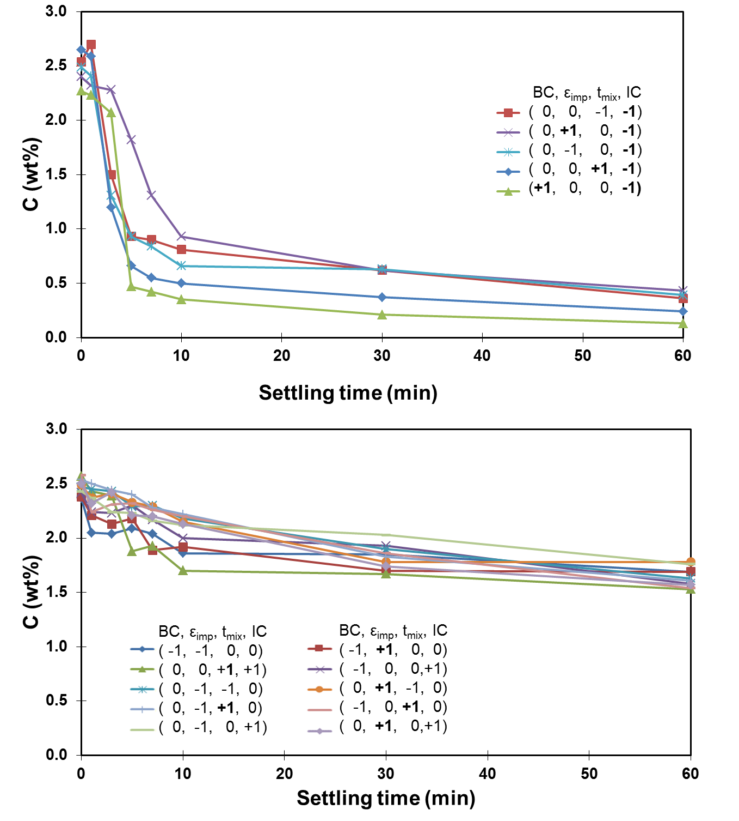

Figure 2: Decrease in water content at z/H = 0.14 over 60 minutes of settling time for Campaign 1: (a) favorable mixing conditions; and (b) poor mixing conditions. Bolded symbols in the legends indicate favorable variable levels.



Figure 3: Effects, or model coefficients, calculated from the factorial design results from Campaign 1. Only the model coefficients that were statistically significant are plotted.



Figure 4: a) Initial solids content versus initial water content. There is no correlation between the variables. b) Reduction in solids content at z/H=0.1 as a function of water content reduction at z/H=0.14 for Campaign 1. The blue diamonds in Figure 4b represent runs where the water removal was higher than 1.5 wt% and the red triangles represent runs where the water removal was lower than 1.5 wt%. A linear relationship between water and solids removal was found when the water removal was higher than 1.5 wt%.



Figure : Final solids content at z/H = 0.9 versus final water content at z/H=0.14. When the final water content in the surface layer drops below 0.5%, more solids are found at the bottom of the CIST. The solids settle all the way to the bottom of the vessel rather than staying suspended at an intermediate height.

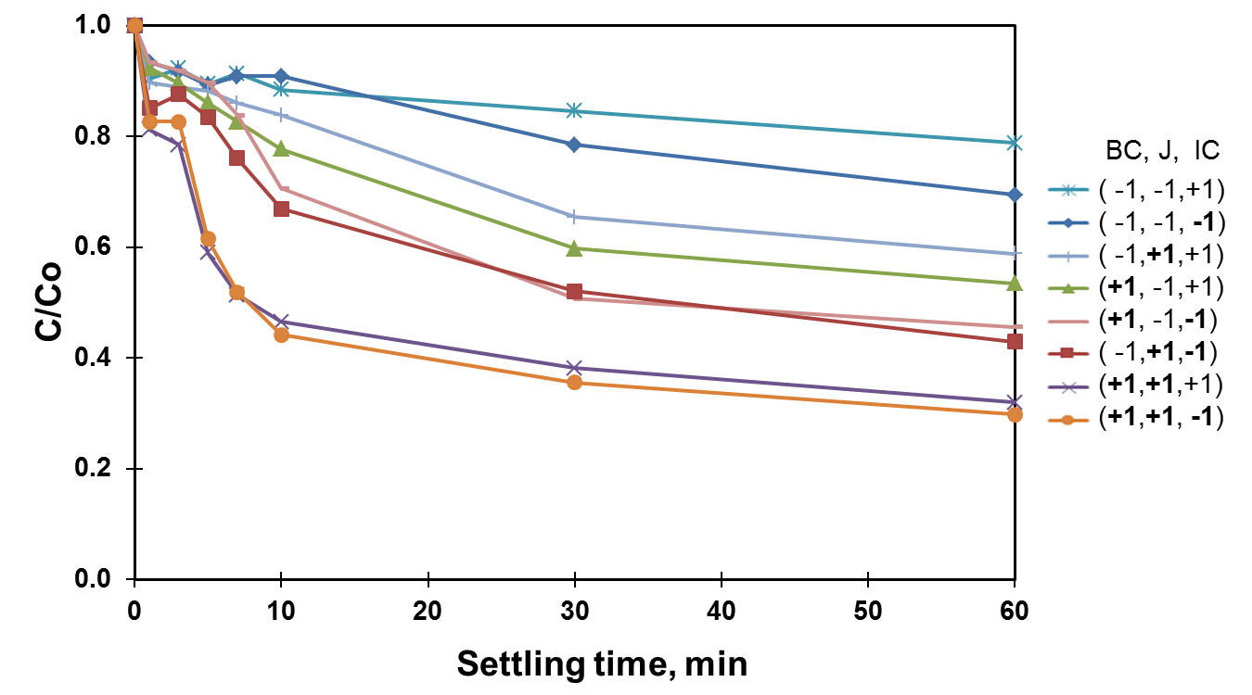

Figure 6: Decrease in normalized water content over time at z/H=0.14 for Campaign 2. The variables in bold letters indicate favorable dosage or mixing conditions. The best performance was obtained with a combination of high BC, high J and low IC. The worst performance was obtained with a combination of low BC, low J and high IC.

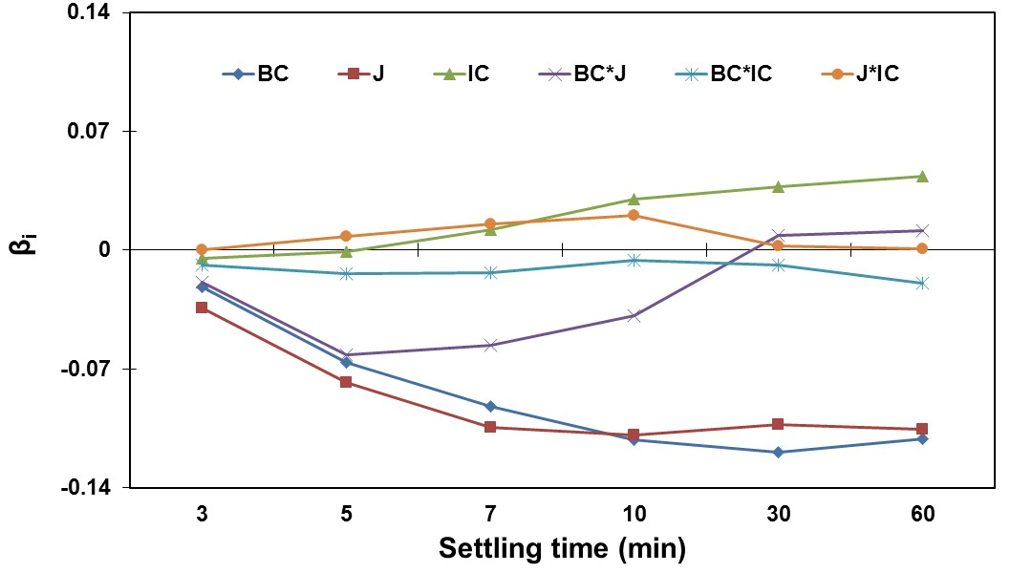

Figure 7: Effects, or model coefficients, calculated from the factorial design results from Campaign 2. The most significant effects are bulk concentration (BC) and mixing energy (J).



Figure 8: Normal probability plot of all effects after 60 min of settling for Campaign 2. The red circles identify the statistically significant effects (BC and J).

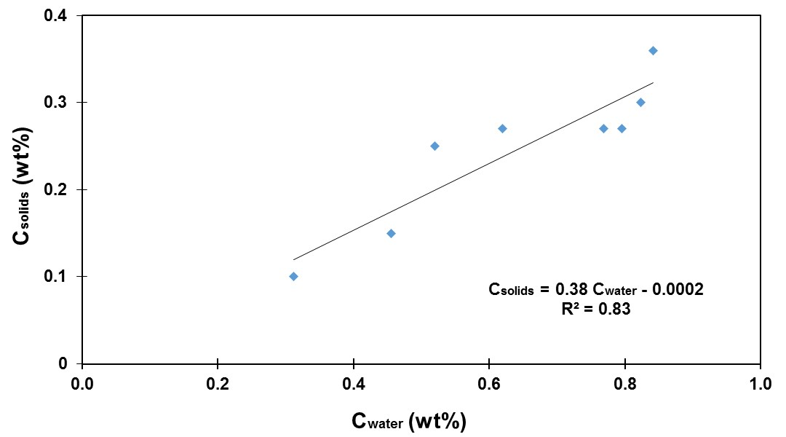

Figure 9: Product solids content as a function of final water content for Campaign 2. The solids content varies linearly with water content.