Copper exchanged nanotitanate for high temperature H₂S adsorption
Farzad Yazdanbakhsh¹, Marc Bläsing², James A. Sawada¹, Sabereh Rezaei¹, Michael Müller², Stefan Baumann², Steven M. Kuznicki¹*
¹Department of Chemical and Materials Engineering, University of Alberta, Edmonton, Alberta T6G 2V4, Canada
²Institute for Energy and Climate Research (IEK-2), Forschungszentrum Jülich GmbH, Leo-Brandt-Straße 1, 52425Jülich, Germany
*Corresponding author: Email: steve.kuznicki@ualberta.ca; Telephone: 1.780.492.8819

ABSTRACT:
The H₂S breakthrough capacity of copper-exchanged Engelhard TitanoSilicate-2 (ETS-2) was measured at temperatures up to 950 °C and it was found that the adsorbent efficiency remains unchanged across the entire temperature range. Below 750 °C, the adsorption capacity at breakthrough is 0.7 moles of H₂S per mole of copper while above 750 °C the capacity of the adsorbent is halved. The change in H₂S capacity is due to Cu²⁺ reduction by the H₂ which is formed through the thermal dissociation of H₂S. The adsorbent shows good potential for use over a wide range of operating temperatures in H₂S scrubbing processes.
Keywords: H₂S, ETS-2, High temperature, Desulfurization, Copper oxide, Adsorption

1. Introduction
Hydrogen sulfide (H₂S) is a highly odorous and toxic gas, which can be found in the majority of coal gasification plants, petrochemical industries and wastewater treatment plants.¹ H₂S is known to severely poison catalytic systems. It takes ppm quantities of sulfur contaminants to reduce the lifetime of a supported metal catalyst to a few months or even a few weeks.²
Depending on the origin, coal can have between 0.1- 6 wt% sulfur content, which is released in the form of H₂S during coal gasification processes and production of syngas for power generation using IGCC process.^{3, 4} In IGCC syngas is produced by gasification of coal and it is later used as a fuel for the gas turbine and electricity generation. Syngas is also used to produce hydrogen in a process called water-gas shift reaction at temperatures between 250 °C and 350 °C. However, to prevent serious poisoning of the water-gas shift catalyst and corrosion of the pipelines and equipment in IGCC, syngas should be free of H₂S.⁵
Several commercial treatment techniques are commonly used to remove H₂S, such as absorption in liquids (alkaloamines, ammonia solution, and alkaline salt solution), biological processes,⁶ adsorption on activated carbon⁷ and metal oxides,⁸ and separation by molecular sieves.⁹ The disadvantage of most of these processes is the low operating temperatures which necessitates the cooling down and subsequent reheating of the hot gas produced from coal gasification. The system efficiency increases when high temperature desulfurization is used.^{10,11}
Among different methods for H₂S removal, adsorption on metal oxides has shown good potential for use at temperatures as high as 1500 ⁰C. Oxides of many metals such as Fe, Cu, Zn, Co, W, Mo, Ca, Ba, and Sr are reported to be efficient adsorbents at high temperatures.¹²
Iron oxide is one of the first metal oxides to be used for H₂S removal since 19th century.¹³ Iron oxide when exposed to H₂S forms iron sulfide which can be regenerated by air; the resulting SO₂ can be used in the Claus process to produce elemental sulfur.¹⁴ After several regeneration cycles, the reactor will clog and has to be shut down for sulfur removal. Another disadvantage of using iron oxide adsorbents is that they are not capable of removing H₂S to an absolute concentration below few hundreds parts per million and therefore, they have to be used in combination with another adsorbent to reach a level of less than 10 ppm.¹⁵
Copper oxides have also been reported to reduce H₂S from several thousand ppm to sub ppm levels. However the disadvantage of copper oxide is that in the presence of a reducing agent (like H₂ and CO) in the gas stream Cu²⁺ reduces to metallic copper lowering the sulfidation efficiency.^{16,17}
In order to improve the adsorptive performance of metal oxides, strategies such as doping with other metals have been used. Recently a Ca-Ba -based sorbent was used to reach H₂S concentration below 0.5 ppm at 800-900 °C.¹⁸ Zinc ferrite was used as an adsorbent for H₂S in coal gases at 538 °C.¹⁹
Mixed oxides of copper together with Cr, Ce, Al, Mg, Mn and Ti have also been investigated with CuCr₂O₄ (CuO-Cr₂O₃) and CuCeO₂ found to be the most efficient adsorbents at temperatures as high as 850 ⁰C.²⁰
Li et al.²¹ tested an CuO-CeO₂ adsorbent and reported an H₂S reduction down to 5-10 ppm from a gas stream containing several thousand ppm at temperatures between 650-850 ⁰C.
In order to enhance the utilization of the adsorbents and their H₂S breakthrough capacities, the number of active sites has to increase. This can be achieved by substituting the metal oxide on the surface of different supports such as Al₂O₃, TiO₂, SiO₂ and zeolites. Ko et al.¹⁰ compared the H₂S adsorption capacity of Mn, Fe, Cu, Co, Ce and Zn when substituted on Al₂O₃ in syngas at 500-700 ⁰C. They reported 100% utilization for Mn-Al₂O₃. A result of substitution is the increased mechanical strength of the adsorbent, as reported by Gasper-Galvin et al.²² when Cu, Mo and Mn were supported on SP-115 zeolite.
In this paper improvements were made to the support material using a high surface area nanotitanate Engelhard TitanoSilicate-2 (ETS-2) as the support and copper oxide as the active species. ETS-2 was first introduced by Kuznicki²³ and is a high surface area sodium nano-titanate with superior ion-exchange capabilities formed by the alkaline digestion of TiO₂. The caustic digestion converts the surface of the TiO₂ particles into sodium titanate, which is an effective ion-exchanger; particularly for transition metals.²⁴ The material has no measurable microporosity which makes it immune to pore blockage or capillary condensation.^{23,24} Having no measurable microporosity, its surface area can be as high as 250 m²/g due to the nano-scale platelets. ETS-2 particles are on the order of 50 - 100 nanometers long. The core of these particles is presumed to be TiO₂ while the surface titania species carry a net negative charge which is offset by sodium ions.
ETS-2 has been demonstrated to be an effective support for transition metals and for removing trace levels of H₂S at ambient temperature. In our previous study,²⁴ copper was exchanged onto the surface of ETS-2 and the H₂S removal efficiency was measured at ambient temperature using a dynamic breakthrough system. Samples were pre-conditioned at various temperatures before testing and it was determined that at pre-treatment temperatures beyond 500 °C, the material underwent a structural change and lost the majority of its H₂S capacity. The adsorption capacity of the samples, however, was always measured at ambient temperature. In the present study, the adsorption capacity of Cu-ETS-2 was measured at temperatures between 250 and 950 °C to understand whether the structural changes that occur as the adsorbent is heated beyond 500 °C limit the H₂S capacity of the adsorbent. Another goal was to understand the stability and the performance of Cu-ETS-2 as high temperature H₂S adsorbent in a non-reductive environment at temperatures ranging from 250 to 950 °C.

2. Experimental

2.1 Materials preparation
ETS-2 was hydrothermally synthesized according to a procedure published elsewhere²³ and was used as-made. ETS-2 is typically synthesized by addition of sources of titanium, silica, alkalinity and water. Solid TiO₂ is used as the source of titanium and sodium silicate (29% SiO₂, 9% NaOH) as the source of silica.
Cu-ETS-2 was prepared by mixing the as-made ETS-2 with a copper nitrate solution. The weight proportion of adsorbent to copper salt and water was 1:2:100. The copper salt was first dissolved in water and ETS-2 was added afterwards. The amount of water used in our preparation is higher than the amount cited by Rezaei et al.²⁴ so that the suspension could be more easily stirred. The mixture was kept mixing at 80 °C for approximately 1 day. In the next step, the ion-exchanged sample was filtered and washed extensively with deionized water and dried in a vacuum oven at 60 °C overnight. Prior to sulfidation experiments, a 10 g sample of the adsorbent was activated by heating to 500 °C under a static airflow in a furnace at 10 °C /min with an isothermal dwell of 2 hours.

2.2 Characterization
The crystal structure of the powders was analyzed by powder X-ray diffraction (XRD) using a BRUKER D4 Endeavor diffractometer (Bruker-AXS, Karlsruhe, Germany). The measurements were carried out with Cu K_{a} radiation, a step size of 0.05° and a step time of 5 s. The acceleration voltage was 40 kV and the emission current was 40 mA. The computer program HighScore Plus (PANalytical, 2004) was used for phase identification of the samples.
The microstructure of the adsorbents was investigated by Scanning Electron Microscopy (SEM) using a Zeiss Ultra 55 device (Carl Zeiss NTS GmbH, Oberkochem, Germany).
High resolution TEM images were collected using Zeiss Libra (Fa. Carl Zeiss Microscopy, Oberkochen, Germany) 200 Cs (200 KeV) combined with an objective Cs corrector. The elemental analysis was carried out by energy-dispersive X-ray spectroscopy (EDX) using an INCA energy-dispersive X-ray analysis system (Oxford Instruments, Uedem, Germany). Point specific elemental analysis by the EDX detector attached to the SEM instrument was used to estimate the amount of copper atoms exchanged on the surface of ETS-2. Three separate spots (measuring a few hundred nm in size) were analyzed. Data was collected for the elements Na, Ti, Si, Cu, and O and the copper loading was calculated as the weight fraction of this combination of elements. The measured copper loading was identical within the sensitivity of the instrument for all the spots measured.
For the mass spectrometry measurements a standard ABB Extrel mass spectrometer (Questor QGP) capable of detecting down to 100 ppb concentrations was used.

2.3 Experimental setup
The experimental setup consists of a gas mixing unit, an electrical heated tube reactor furnace and mass spectrometer. To ensure the temperature uniformity, the furnace has 3 temperature zones with a total length of 600 mm. 1g of adsorbent was packed between plugs of quartz wool inside a heat resistant alumina tube with internal diameter of 6 mm. The tube was then placed inside the furnace and was fed by a continuous flow of 500 mL/min of He/ H₂S mixture. The H₂S concentration in the feed gas stream was 500 ppmv. The flow rates were controlled by electronic mass flow controllers.
The mass spectrometer was used to determine the H₂S concentration at the exit of the adsorbent bed. The H₂S concentration was monitored continuously during the experiment at 1 minute intervals. The breakthrough point was determined when the H₂S concentration exceeded 5 ppmv and the adsorption experiments were stopped at exit concentration of 50 ppmv.

3. Results and discussion
Figure 1 presents the electron microscopy graphs of ETS-2. It shows that the particles tend to forms clusters. SEM analysis presented in Figure 1 a) shows that each cluster is almost 1 micron in size. TEM analysis presented in Fig. 1 b) shows each particle is typically between 50-100 nm long and almost 20 nm wide. The results of point specific EDX analysis (Table 1) indicated presence of about 7.5 atomic% (equivalent to 17 wt%) of copper on the sample.
Figure 2 shows the XRD patterns of ETS-2 and Cu-ETS-2. ETS-2 pattern consists of broad peaks, which are characteristic of nano-scale particles of anatase.²⁵ The presence of these reflections is to be expected as only the surface of the particles have been converted to sodium titanate and the bulk of the particles is TiO₂.
The adsorbent was tested for H₂S capacity at temperatures between 250 °C to 950 °C at 100 °C intervals. Figure 3 shows a typical adsorption breakthrough curve for Cu-ETS-2 at 550 °C. The inlet concentration of 500 ppmv H₂S is effectively removed by the adsorbent as the concentration of H₂S in the outlet is maintained below the detection limit of the instrument (100 ppbv) for a significant period of time. As time passes, the H₂S concentration rises above baseline and the curve inflects as H₂S “breaks through”. The concentration rises rapidly after breakthrough as a result of the adsorbent becoming saturated and having fewer sites with which to react with H₂S. The capacity of the adsorbent is calculated by multiplying the mass flow rate of H₂S into the bed by the time it takes for the outlet to show a concentration of 5 ppmv H₂S. Figure 4 shows the breakthrough curves for different adsorption experiments carried out at varying temperatures to understand how this variable affects the capacity of the adsorbent.
The capacity of the adsorbent for H₂S at different temperatures is presented in Figure 5. The H₂S adsorption capacity is largely equivalent between 250 °C to 650 °C. As the temperature is increased to 750 °C, the adsorption capacity undergoes a step change and the adsorbent loses about half of its capacity. The capacity stays at nearly the same level up to 950 °C. In order to understand the reason for the sudden change, the adsorbent was characterized by XRD analysis after adsorption. The results are presented in Figure 6.
The analysis results show that titania in the adsorbent becomes more crystalline at higher temperatures as evidenced by the growing intensity of the peaks and the sharpness of the reflections. At 350 and 550°C, TiO₂ is present in the form of tetragonal anatase while at 750 °C TiO₂ peaks are sharper still, and indicate a phase transformation to rutile.
The XRD results indicate the presence of predominantly CuS crystals at 350 °C and Cu₂S at 750 °C. At 550 °C, new crystal morphology is also observed which indicates copper to sulfur ratios between 9:5 and 2:1 called digenite. According to literature,²⁶ digenite can be formed during copper sulfidations from temperatures as low as 80 °C (low digenite) up to 775 °C (high digenite). In our study digenite is presumed to have formed due to partial reduction of Cu²⁺ at the same temperature range.
The change in copper sulfide species seen in the XRD patterns can be explained by a change in the oxidation state of copper and change in the adsorption mechanism due to the presence of hydrogen introduced by thermal dissociation of H₂S. It has been established that at higher temperatures, H₂S is dissociated into hydrogen and sulfur as indicated by reaction (1)²⁷:

xH₂S→xH₂+S_{x} (1)

where S_{x} indicates different allotropes of sulfur. On the basis of thermodynamic data, Barin and Knacke²⁸ suggested that at temperatures above 627 °C the reaction (1) can be written as:

2H₂S→2H₂+S₂ (2)
According to Table 2, at temperatures up to 627°C, just a small amount of H₂S is dissociated to form H₂. In this region CuO is the predominant active species and adsorption is governed by the following reaction:

CuO + H₂S CuS + H₂O (3)

As the temperature increases, the amount of hydrogen generated increases significantly (estimated to be 7 mol%) which, with an incoming stream of 500 ppmv H₂S, must be enough to effectively reduce CuO to Cu as per Eq. (4)²⁹:

CuO+ H₂Cu+H₂O (4)

Once in its metallic form, the copper sulfidation reaction proceeds as per Eq. (5):

2Cu+H₂SCu₂S+H₂ (5)

The copper to sulfur stoichiometry in Eq. (5) is half that compared to Eq. (3). Thus, while the metal utilization may remain unchanged, the amount of sulfur that will be adsorbed scales with the oxidation state of the metal.
The observation that the adsorption capacity of Cu-ETS-2 does not change dramatically as a function of temperature is likely the result of a shift in the adsorption mechanism. The XRD patterns suggest a continual sintering process, evidenced by the increasing intensity of the titania peaks (Figure 6) compared to the starting material which might be expected to have a negative effect on the adsorption capacity. The SEM images in Figure 7, however, clearly show a growth in the size of the copper sulfide crystals as the sulfiding temperature is increased. The growth of these crystals as a function of temperature suggests that the copper sulfide crystals behave as an active adsorption site. While Cu-ETS-2 may progressively sinter, which could lead to a loss of copper adsorption sites, this loss is compensated for by the growth of the copper sulfide crystals. The two effects apparently counter each other and provide for a relatively constant adsorption capacity under our test conditions.

Conclusions
Cu-ETS-2 is found to be an efficient H₂S adsorbent at temperatures suitable for direct desulfurization of gas streams. Under our test conditions, the H₂S capacity for Cu-ETS-2 remains unchanged up to 650 °C after which a change in the oxidation state of copper causes a reduction in capacity. At breakthrough, 99% of the H₂S has been removed and almost 0.7 moles of H₂S per Cu is adsorbed below 750 °C, while above this temperature close to 0.35 mole H₂S is adsorbed per mole Cu. The reduction in H₂S adsorption capacity is due to the reduction of Cu²⁺ in the presence of H₂ generated from thermally dissociated H₂S.

Acknowledgments
We thank Albana Zeko for her helpful comments on the manuscript, Dr. Egbert Wessel, Dr. D. Grüner, and Mr. M. Ziegner from Forschungszentrum Jülich GmbH for help in TEM, SEM, EDX, and XRD analyses. Financial support from the Initiative and Networking Fund of the Helmholtz Association (HGF) through the Helmholtz-Alberta Initiative is kindly acknowledged.

References
(1) Gupta, R. P.; Turk, B. S.; Portzer, J. W.; Cicero, B. C. Desulfurization of Syngas in a Transport Reactor. Environ. Prog. 2001, 20, 187.
(2) Bartholomew, C. H.; Agrawal, P. K.; Katzer, J. R. Sulfur Poisoning of Metals. Adv. Catal. 1982, 31, 135-242.
(3) Stirling, D.; Clark, J. H.; Braithwaite, M. J. Sulfur Problem - Cleaning up Industrial Feedstocks; The Royal Chemical Society: Cambridge, 2000.
(4) Bläsing, M., Müller, M. Release of Alkali Metal, Sulphur, and Chlorine Species from High Temperature Gasification of High- And Low-Rank Coals. Fuel Process. Technol. 2013, 106, 289.
(5) Koryabkina, N. A.; Phatak, A. A.; Ruettinger, W. F.; Farrauto, R. J.; Ribeiro, F. H. Determination of Kinetic Parameters for the Water-Gas Shift Reaction on Copper Catalysts under Realistic Conditions for Fuel Cell Applications. J. Catal. 2003, 217, 233.
(6) Jensen, A. B.; Webb, C. Treatment of H₂S-Containing Gases: A Review of Microbiological Alternatives. Enzyme Microb. Technol. 1995, 17, 2.
(7) Klein, J.; Henning, K. D. Catalytic Oxidation of Hydrogen Sulfide on Activated Carbons. Fuel 1984, 63, 1064.
(8) Elseviers, W. F.; Verelst, H. Transition Metal Oxides for Hot Gas Desulphurization. Fuel 1999, 78, 601.
(9) Melo, D. M. A.; De Souza, J. R.; Melo, M. A. F.; Martinelli, A. E.; Cachima, G. H. B.; Cunha, J. D. Evaluation of the Zinox and Zeolite Materials as Adsorbents to Remove H₂S from Natural Gas. Colloids Surf., A: Physicochemical and Engineering Aspects. 2006, 272, 32.
(10) Ko T. H.; Chu, H.; Chaung, L. K. The Sorption of Hydrogen Sulfide from Hot Syngas by Metal Oxides over Supports. Chemosphere 2005, 58, 467.
(11) Müller, M. Integration of Hot Gas Cleaning at Temperatures above the Ash Melting Point in IGCC. Fuel 2013, 108, 37.
(12) Westmoreland, P. R.; Harrison, D. P. Evaluation of Candidate Solids for High-Temperature Desulfurization of Low-Btu Gases. Environ. Sci. Technol. 1976, 10, 659.
(13) Crynes, B. L. Chemical Reactions as a Means of Separation: Sulfur Removal; Marcel Dekker: New York, 1977.
(14) Gollmer, H. A. in Chemistry of Coal Utilization; Lowry, H.H., Eds.; John Wiley & Sons: New York, 1945; pp 947-1007.
(15) Swisher, J. H.; Swerdtfeger, K.; Review of Metals and Binary Oxides as Sorbents for Removing Sulfur from Coal-Derived Gases. JMEPEG 1992, 1, 399.
(16) Kyotani, T.; Kawashima, H.; Tomita, A. High Temperature Desulfurization with Copper-Containing Sorbents. Environ. Sci. Technol. 1989, 23 (2), 218-223.
(17) Patrick, V.; Gavalas, G. R. Structure and Reduction of Mixed Copper- Aluminum Oxide. J. Am. Ceram. Soc. 1990, 73 (2), 358-369.
(18) Stemmler, M.; Tamburro, A.; Müller, M. Laboratory Investigations on Chemical Hot Gas Cleaning of Inorganic Trace Elements for the “UNIQUE” Process. Fuel 2013, 108, 31.
(19) Ayala, R. E.; Marsh, D. W. Characterization and Long-Range Reactivity of Zinc Ferrite in High-Temperature Desulfurization Processes. Ind. Eng. Chem. Res. 1991, 30, 55.
(20) Abbasian, J.; Hill, A. H.; Wangerow, J. R.; Flytzani-Stephanopoulos, M.; Bo, L.; Patel, C.; Chang, D. Development of Novel Copper-Based Sorbents for Hot-Gas Cleanup. IGT-Final technical report to CRSC; IGT project No. 40330, 1992.
(21) Li, Z.; Flytzani-Stephanopoulos, M. Cu-Cr-O and Cu-Ce-O Regenerable Oxide Sorbents for Hot Gas Desulfurization. Ind. Eng. Chem. Res. 1997, 36, 187.
(22) Gasper-Galvin, L.; Atimtay, A. T.; Gupta, R. P. Zeolite-Supported Metal Oxide Sorbents for Hot-Gas Desulfurization. Ind. Eng. Chem. Res. 1998, 37, 4157.
(23) Kuznicki, S. M. Large-Pored Crystalline Titanium Molecular Sieve Zeolites; Patent US 4,853,202, 1989.
(24) Rezaei, S.; Tavana, A.; Sawada, J.; Junaid, A.; Kuznicki, S. M. Novel Copper-Exchanged Titanosilicate Adsorbent for Low Temperature H₂S Removal. Ind. Eng. Chem. Res. 2012, 51, 12430.
(25) Yogamalar, R.; Srinivasan, R.; Vinu, A.; Ariga, K. X-ray Peak Broadening Analysis in ZnO Nanoparticles. Solid State Commun. 2009, 149, 1919–1923.
(26) Donnay, G.; Donnay, J. D. H.; Kullerud, G. Crystal Structure of Digenite, Cu₉S₅. Am. Mineral. 1958, 43, 228-242.
(27) Fukuda, K.; Dokiya, M.; Kameyana, T.; Kotera, Y. Catalytic Decomposition of Hydrogen Sulfide. Ind. Eng. Chem. Res. 1978, 17, 243-248.
(28) Barin, I.; Knacke, O. Thermochemical Properties of Inorganic Substances; Springer-Verlag: Berlin, 1973.
(29) Patrick, V.; Gavalas, G. R.; Flytzani-Stephanopoulos, M.; Jothimurugesan, K. High Temperature Sulfidation-Regeneration of Cuo-Al₂O₃ Sorbents. Ind. Eng. Chem. Res. 1989, 28, 931-940.

Table 1. Point-specific EDX analysis of Cu-ETS-2 for 3 randomly selected points on the sample (values are in atomic%).
Elements  Point number | Si | Ti | Cu | O
1 | 1.7 | 26.6 | 7.5 | 64.2
2 | 2.2 | 26.1 | 7.5 | 64.2
3 | 2 | 26.4 | 7.5 | 64.2

Table 2. Equilibrium concentration of hydrogen in decomposition of hydrogen sulfide under 1 atm (calculated).²⁷

Temperature, ºC | Equilibrium concentration, mol%
127 | 1.3×10⁻³
227 | 6.1×10⁻³
327 | 2.0×10⁻²
427 | 4.8×10⁻²
627 | 1.9
927 | 13.1
1127 | 25.6

List of figure captions:

Figure 1. a) TEM and b) SEM images of nanotitanate ETS-2 showing the particle size and cluster structure.

Figure 2. XRD patterns of ETS-2 and Cu-ETS-2.
Figure 3. Breakthrough curve for H₂S adsorption by Cu-ETS-2 at 550 °C.
Figure 4. Breakthrough curves for Cu-ETS-2.

Figure 5. Breakthrough capacities of Cu-ETS-2 at different temperatures.

Figure 6. XRD patterns of Cu-ETS-2 after H₂S adsorption at 350 ⁰C, 550 ⁰C and 750 ⁰C.
Figure 7. SEM images of Cu-ETS-2 after adsorption at: a) 350 ⁰C, b) 550 ⁰C, c) 750 ⁰C and d) 950 ⁰C.

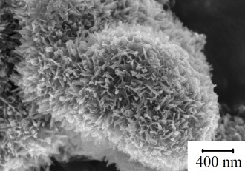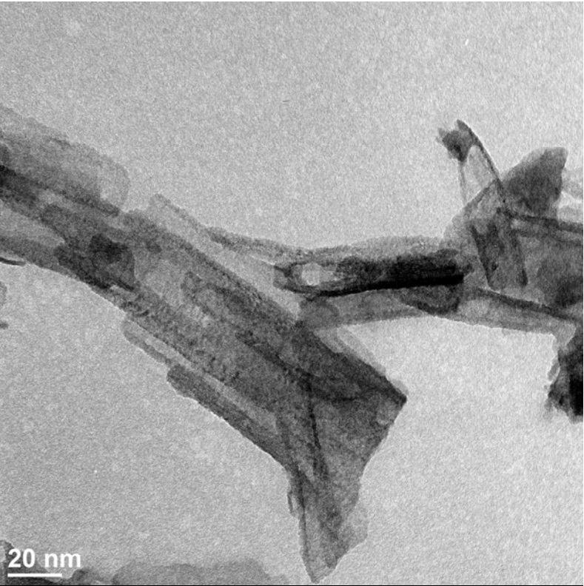
a) b)
Figure 1.

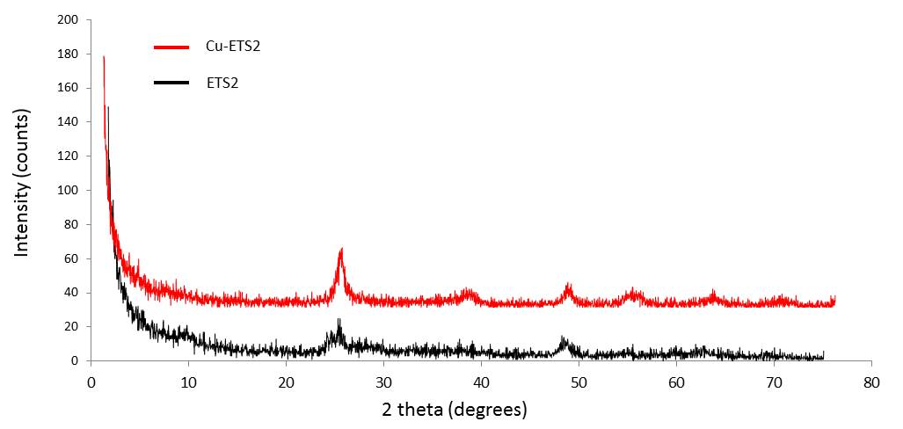

Figure 2.

Figure 3.

Figure 4.

Figure 5.

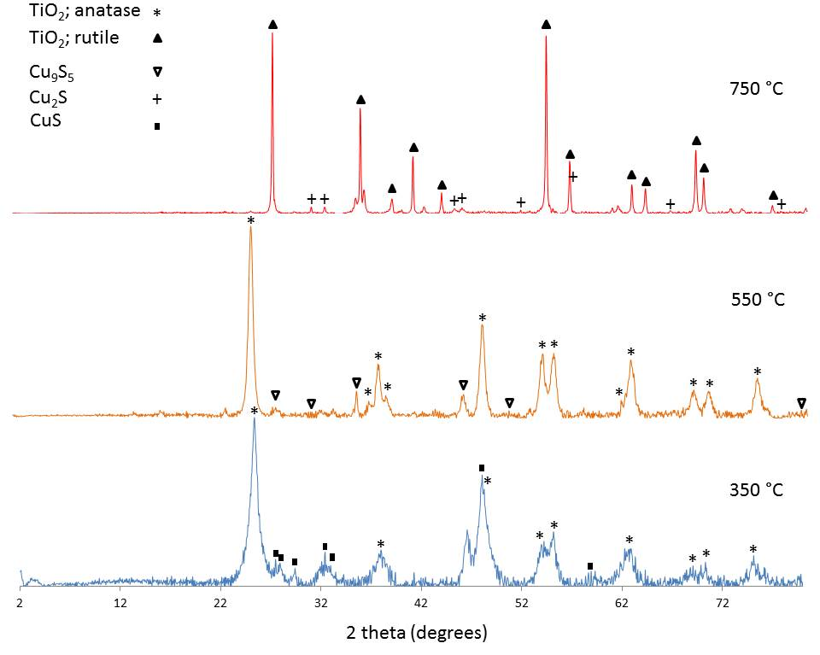

Figure 6.

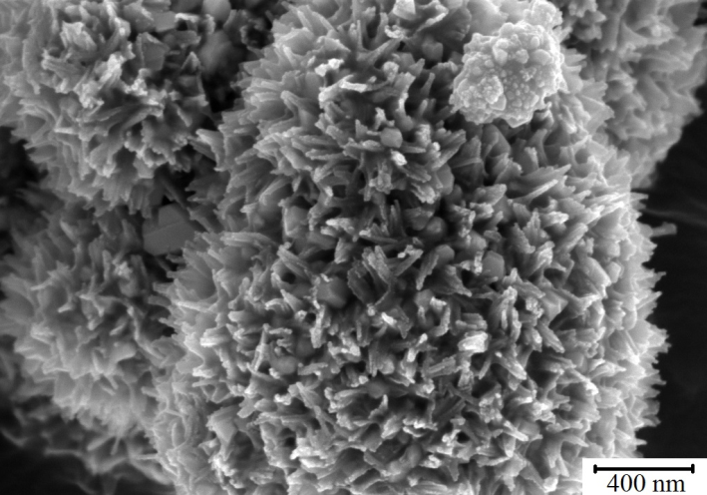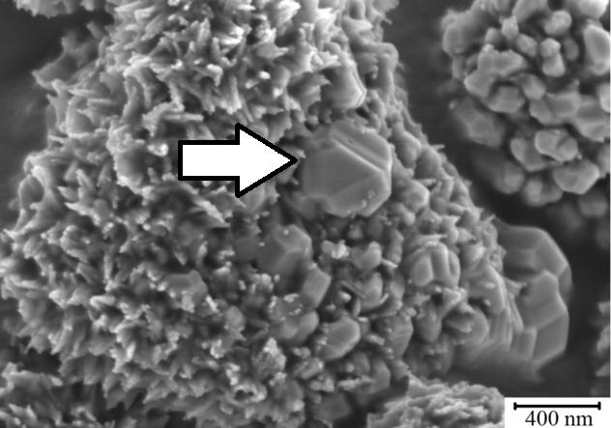
a) b)
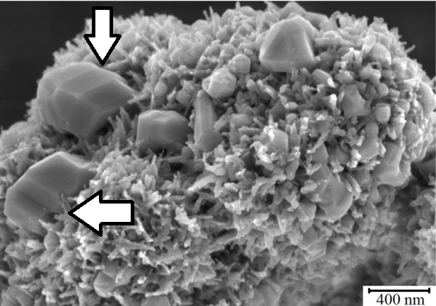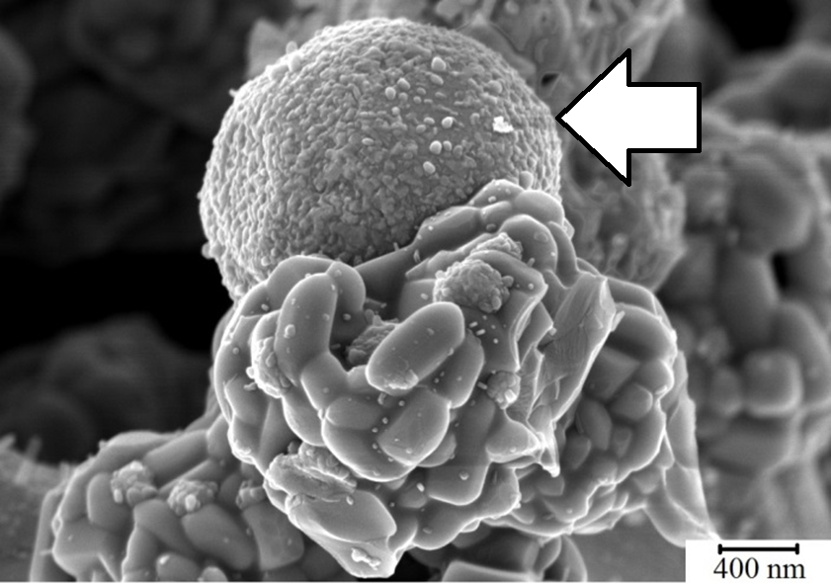
c) d)
Figure 7.

