Improvement of H₂/CO₂ selectivity of the natural clinoptilolite membranes by cation exchange modification
Weizhu An, Paul Swenson, Ankita Gupta, Lan Wu, Tetyana M. Kuznicki, Steven M. Kuznicki*
Department of Chemical & Materials Engineering, University of Alberta, Edmonton, AB T6G 2V4 Canada
*Corresponding author: Email: steve.kuznicki@ualberta.ca; Tel: 1.780.492.8819; Fax: 1.780.492.8958
Abstract
The dense geomorphic clinoptilolite membranes reported in our previous work [1] were chemically modified by cation exchange with group’s IA (Li⁺, Na⁺ and K⁺) and IIA (Ca^{2+,} Sr²⁺ and Ba²⁺) metal ions. It was found that hydrogen and CO₂ permeances through the modified membranes were very sensitive to the types, size and charge of the extra-framework cations. H₂ permeance through the clinoptilolite membranes decreased as the exchanged cation size increased and was correlated to the channel blockage by the exchanged cations. CO₂ permeance was more related to the chemical properties of the exchanged cations than their sizes. Significant improvement of H₂/CO₂ selectivity from 5.8 to 34 and 5.8 to 13 for the Li and Ca exchanged forms of geomorphic clinoptilolite membranes respectively were obtained at the high temperature of 300C. Strong temperature dependence of H₂ and CO₂ permeances observed with these two ion-exchanged membranes suggests activated diffusion of H₂ and CO₂ through the membrane. The higher H₂/CO₂ selectivity for Ca and Li ion-exchanged membranes might be predominantly attributed to the suppression of CO₂ adsorption and the clinoptilolite framework structure changes due to the high ionic potential of the extra framework cations (Li and Ca) during the thermal dehydration process.

Keywords: Natural clinoptilolite; Membranes; Cation exchange; High temperature; H₂/CO₂ separation
1. Introduction

Previously we reported that geomorphic zeolite sheets machined from dense natural clinoptilolite rocks showed high hydrogen permeance and promising H₂/CO₂ selectivity well above Knudsen diffusion, at temperatures up to 500ºC [1]. Hydrogen is a clean fuel with zero pollution emission and a valuable feedstock for petroleum industries and various other chemical processes [2-3]. In contrast, CO₂ is linked to global warming and ecosystem deterioration [4-5]. One of the advantages of the new integrated gasification combined cycle (IGCC) power plants is the possibility for CO₂ capture from the pre-combustion syngas resulting in production of the desirable H₂ and the removal of the ‘greenhouse gas’ CO₂ [6-7]. However, the high-temperature hydrogen separation from the pre-combustion syngas needs to be energy efficient in order for the IGCC technology to be both economically and environmentally appealing [8].
Zeolites are the crystalline aluminosilicates with well-defined molecular level micropore/channel sizes and are considered the most promising inorganic membrane materials for high temperature gas separations and have attracted increasing research attention from both academia and industry [8-11]. One of the unique characteristics of the zeolite materials is their ion exchangeability. The effects of cation exchange on adsorption behaviour and separation selectivity, catalytic activity and other important physical properties [12-13] of the zeolite materials have been taken advantage of in various applications [14-25].
Natural zeolite, clinoptilolite-heulandite is one of the most abundant zeolite resources in the world [12-13, 26-27]. The large deposits were formed mostly as a result of volcanic lava combined with saline water under tremendous natural pressure [26]. Clinoptilolite-heulandite sediments are usually of high quality and the crystal size can be as large as 2 cm [26]. Recently, we explored the hydrogen separation performance of the natural clinoptilolite-heulandite from two different resources, British Columbia, Canada, and New South Wales, Australia [1]. Our studies showed that zeolite membranes made directly from natural zeolite rocks are highly gas permeable and hydrogen selective. Hydrogen permeance of approximately 5×10⁻⁷ mol m⁻² s⁻¹ Pa⁻¹ with a H₂/CO₂ selectivity higher than that of Knudsen diffusion were achieved. In addition, these membranes are rather stable at high temperatures up to 500ºC [1].
Clinoptilolite has a two-dimensional (2D) micropore/channel structure. The framework of clinoptilolite contains three sets of intersecting channels. Two of the channels are parallel to the c-axis: the A channels, which are formed by strongly compressed ten-membered rings (aperture 4.4 x 7.6 Å), and the B channels, which are confined by eight-membered rings (aperture 4.7 x 4.1 Å). The C channels are parallel to the a-axis and are also formed by eight-membered rings (aperture 5.5 x 4.0 Å) [5-13, 26-27]. There are four designated cation sites [20] in the framework of the clinoptilolite. Cation locations in the clinoptilolite and their interactions with adsorbates have been an active research topic aiming at potential commercial gas separations using these natural zeolite materials. Significant variation of gas uptake rates due to the channel blockage induced by different cation exchanges of clinoptilolites has been reported [13, 24-25, 28-29]. The manipulation of cation exchange on the channel aperture can be as large as 1.5 to 5.5 Å [13]. Different cations have their preferential locations in the channel framework of the clinoptilolite and some are located near the openings of the pores/channels [12] which will have the strongest effect on changing the effective pore size. It is therefore possibility to manipulate the separation performance of a clinoptilolite membrane by changing the cation balance in the zeolite. It is apparent that channel blockage is essential for a successful membrane separation based on molecular sieving. Cation exchanges also alter the potential energy of the pore surface of the zeolite materials, and therefore, change the interactions between the diffusing molecules and the pore surface. If the opening is not the restricting barrier, the change of the potential energy of the channel surface would also work to retard or speed certain types of gases, therefore, to improve the separation. Gas molecule permeation through a zeolite membrane channel occurs through a combination of adsorption and diffusion. It is expected that any alteration of the surface’s energetic fields and pore dimensions could interfere with gas permeation and selectivity. Since the location of the cation controls the effective aperture size and the charge density of the cation influences the interaction energy between the gas and the zeolite the gas separation performance of zeolite membranes can be modified by simple cation exchange.
Although synthetic zeolite membranes have been studied intensively for their application in gas separations [14-17] and the cation exchange is not a new technique for modification of the performance of zeolite materials, there are essentially no reports on the effect of cation exchange on gas separation performance of natural clinoptilolite membranes. In this study, natural clinoptilolite membranes were modified by cation exchange using IA and IIA group metal ions. For the first time, the effect of cation exchange modifications of the natural zeolite membranes on single gas H₂ and CO₂ permeations and the H₂/CO₂ selectivity of the natural clinoptilolite membranes was evaluated. The roles of cation types, sizes, and their preferred locations in the clinoptilolite channel/pores and their chemical properties in the H₂/CO₂ separations through the modified membranes are discussed.

2. Experimental
2.1 Materials
The membrane material used in this study was from natural zeolite rocks from Castle Mountain Zeolites (Quirindi, NSW, Australia). The samples were obtained as reddish rocks with a high bulk density of ~ 2.3 g/cm³. The composition of the rocks provided by the supplier is shown in Table 1. It contains ~ 85% clinoptilolite and 15% mordenite. The XRD pattern of this material shown in Figure 1 confirmed that clinoptilolite is the dominated phase and the major impurity is quartz. All chemicals used in the cation exchange experiments were from Fisher Scientific, Canada, while all the gases from Praxair, Canada.

2.2 Membrane preparation and modification
The membrane disks used in this study were prepared by sectioning the rocks with a diamond cutting saw. The raw membrane slices were ground and polished with a 180 grid diamond lapidary polisher to form a disk ~2.5 cm in diameter and 1.5 mm thick. The ion exchange procedures were performed in aqueous solutions of the chloride forms of the corresponding ions. For Li, Na, K, Sr and Ba exchanges, the raw membrane disks were treated with the corresponding 28wt% aqueous solutions at 100°C for 3 days, respectively. For Na exchange, the raw clinoptilolite membrane was treated twice in the aqueous solution of 28wt% NaCl at 100°C for 3 days. After ion-exchange, membranes were washed thoroughly with deionised water and dried at 80°C overnight. For comparative study, raw clinoptilolite membranes were first washed with an ultrasonic deionised water bath to remove the cutting debris and then followed the same washing and pre-drying procedures as cation exchanged membrane samples.

2.3 Characterization and Surface Analysis of Raw and Modified Membranes
X-ray Diffraction (XRD) patterns of raw and cation-exchanged membranes were collected by Rigaku Geigerflex Model 2173 diffractometer with a Co tube and a graphite monochromator. Surface elemental composition of the raw and cation exchanged membranes were analyzed by energy dispersive X-ray spectroscopy (EDX) integrated in the SEM (JEOL 6301 F field emission scanning electron microscope) and XPS (Kratos AXIS-165 XPS Sepctrometer using mono Al-Kα as radiation source and pass energy of 160eV). The extent of cation exchange was calculated by the atomic ratio of exchanged cation multiplied by corresponding charge number to the sum of atomic aluminum and iron presented on the surface.
CO₂ isotherms of both raw and cation exchanged membrane materials were obtained at 25 ºC and 300 ºC by ASAP 2020, Micromeritics. The membrane material powder samples were ion-exchanged using the same salt solution and exchange procedures as cation exchanged membrane for gas permeation tests. In order to closely match CO₂ adsorption behaviors under gas permeation conditions, all powder samples were treated under glass sealant curing temperature programs. Before CO₂ isotherm measurements all samples were activated again in situ at 300 ºC.

2.4 Gas permeation measurements
Single gas H2 and CO2 permeations were measured in a cross flow membrane test system described in [1]. Briefly, the membrane disk was sealed on one end of the ceramic tube (1/2” diameter) with a commercial glass sealant (SG-683 K; Heraeus GmbH, Germany). The membrane sealed tube was inserted into a 1” quartz glass tube. The two chambers, feed side and permeate side separated by the membrane both had tube-shell configuration, with gas in through the tube and out through the shells. Argon was used as sweeping gas. For all the permeation tests a constant feed gas flow of 100 mL/min (STP) and sweeping gas flow of 200 mL/min (STP) were used. An on-line GC (Shimadzu 14B) equipped with a HayeSep D packed column and TCD was used for analyzing the outlet composition. The steady state gas concentration data (see supplementary material) was used to calculate permeance and selectivity.

3. Results and Discussion
3.1 XRD and cation exchange results
XRD patterns of raw and cation exchanged membrane samples are shown in Figure 2. The intensities and positions of the reflections did not change significantly from sample to sample indicating a comparable degree of crystallinity for each sample and demonstrates that the ion exchange process did not have a deleterious effect on the geomorphic zeolite.
Surface cation concentrations of clinoptilolite membranes before and after cation exchange were measured by EDX and XPS (for Li only) and the results are listed in Table 2. Despite the high concentrations of the chloride salt solution used for the ion exchange, some samples were not completely exchanged. Compared to the raw clinoptilolite membrane the extent of the exchange varied for different extra-framework cations. Low levels of exchange were observed for the two univalent cations, Li and Na where the balance was the original, Ca, Mg and K cations. Clinoptilolite appears to prefer the original extra framework cations resulting in incomplete cation exchange products, especially for Na [19] which is substantiated by the EDX analysis results presented in Table 2. Even after performing twice the Na-exchange, K and Ca ions were still present in the zeolite membrane. It is also interesting to note that Ca- exchanged sample still contained the original potassium cations. The highest extent of ion exchange was observed for K-exchanged samples. The cation exchange results reflected the trend of cation exchange selectivity of clinoptilolite and, thus, the affinity of the cation with the negative charged zeolite framework structure [30]. This complex cation co-existence in Na- and Li-exchanged membrane samples brought about different gas permeation and separation performances, which will be shown below. The high-field strength cations, like Li⁺ and Ca²⁺ tend to interact strongly with polar molecules, therefore will be loosely attached to the framework structures [30]. However, it has also been reported that similar distortion of the framework structure of thermally treated Ca²⁺-exchanged clinoptilolite occur due to the interaction between cation and framework oxygen during the dehydration process [31-32]. The distinct chemical properties of these two cations and the observed H₂ and CO₂ separation performance with their respective cation exchanged membranes will be discussed below.

3.2 Gas permeation and H₂/CO₂ separation through the raw and monovalant cation exchanged natural clinoptilolite membranes
Figures 2 and 3 show the H₂ and CO₂ permeances through the monovalent cation exchanged clinoptilolite membranes. Distinct differences in H₂ and CO₂ permeation behavior were observed amongst the different monovalent cation exchanged clinoptilolite membranes. H₂ and CO₂ permeances decreased with the exchanged cations in the order of raw>Na>K. It should be noted that H₂ and CO₂ gas permeances through the Li-exchanged membrane displayed a completely different temperature dependence compared to other monovalent cations of Group IA. A strong temperature dependence and high H₂/CO₂ selectivities of 34 and 14 were observed with the Li-exchanged membranes at temperatures of 300 °C and 500 °C respectively, while raw, Na- and K-exchanged membranes showed weak temperature dependence and lower H₂/CO₂ selectivities at the same temperatures (Figure 4). Gas adsorption and diffusion on and through the clinoptilolite are strongly influenced by the type, size and location of the exchangeable extra framework cations in the three main channels (A, B and C) [19, 30]. There are four energy favourable cation sites designated to four naturally occurring cations, i.e. Ca²⁺/Na⁺ (M1 and M2) in channel A and B; K⁺ (M3) in channel C and Mg²⁺ (M4) in channel A [ 25, 28, 30]. Partial or complete blockage of the clinoptilolite channels by suitable cations is possible depending on the cation size, type and location relative to the channel size [13, 19]. For Li-, Na- and K-exchanged clinoptilolite membranes used in this study, H₂ permeances seemed to follow the size effect and decreased as the cation sizes increased from Na to K. This was not the case, however, for Li-exchanged membranes, especially at lower temperatures (below 200 °C). A correlation between the cation size and H₂ and CO₂ permeance through these monovalent cation exchanged clinoptilolite membranes was plotted in Figures 5 and 6. The permeation data from 300 °C and 500°C were selected because of the potential application of these membrane materials for pre-combustion H₂/CO₂ separations at temperatures above 250 °C. A clear correlation between the cation radii and H₂ permeances was observed at both 300 °C and 500 °C indicating molecular sieving or channel blockage by the larger cations, Na and K. However, the correlation between the cation radii and CO₂ permeances showed a distinctinly different trend. Instead of a decrease of permeances with increase of cation size, CO₂ permeances from the Li-exchanged membrane were much lower than the larger cations, Na- and K-exchanged clinoptilolite membranes. Hashigawa et al. [18] studied CO₂/N₂ separation through the alkali cation exchanged Y-zeolite membranes. The correlation of N₂ and CO₂ diffusivity with the alkali cation size showed a similar trend as H₂ and CO₂ permeances in this study. Philip et al. [23] reported that the bonding distances between the exchanged alkali cations and the oxygen in CO₂ molecules increased in the order of Li<Na<K<Cs. The shorter distance between CO₂ and Li in the zeolite implies strong chemical interactions. The strong electrostatic field of the compact Li⁺ ion generates a strong interaction between CO₂ and Li-exchanged clinoptilolite leading to reduced diffusivity and, therefore decreased CO₂ permeance and enhanced H₂/CO₂ selectivity [18]. This can be further explained by the correlation of CO₂ permeance with monovalent cation size at 500 °C as shown in Figure 6. Since diffusion through the membrane is an activated process, the diffusivity resistance through the membrane will be finally overcome by the increased temperature. It appears that the mechanism of channel blockage gradually becomes dominant around 500 °C (Figure 6).

3.3 Gas permeation and H₂/CO₂ separations through the divalent cation exchanged natural clinoptilolite membranes
Figures 7 and 8 show the H₂ and CO₂ permeance through the divalent cations (Ca, Sr, and Ba) - exchanged clinoptilolite membranes. Both H₂ and CO₂ permeances through the clinoptilolite membranes were influenced by the divalent cation type, size and their location in the framework. Ca-exchanged clinoptilolite membranes showed a distinct temperature dependence for H₂ and CO₂ permeances and high H₂/CO₂ selectivities of 19 and 15 at 300 °C and 500 °C, respectively (Figure 4). By correlating the divalent cation size with H₂ and CO₂ permeances (Figures 9 and 10) a similar trend as in the case of monovalent exchanged membranes (Figure 5) is observed. H₂ permeance decreased with the increase of divalent cation sizes. However, there was one exception from the trend as CO₂ permeances for Ca-exchanged clinoptilolite membrane were lower even at 500 °C. For the energy favourable locations [25, 30], Ca²⁺ are normally located in channels A and B, (i.e. M1 or M2 sites) and considering their relative size compared to the channel’s openings Ca²⁺ ions are not capable of a complete channel blockage like the larger cations (Sr²⁺ and Ba²⁺). Therefore, the strong temperature dependency of gas permeances and the suppressed CO₂ permeances seems to suggest a strong chemical interaction between Ca-exchanged sites and CO₂ resulting in a reduced CO₂ diffusivity through the Ca-exchanged membranes. For zeolite membranes channel size and channel surface affinity to the gas molecules are a determining factor for a desirable gas permeance and a successful separation. For Ba-exchanged clinoptilolite membranes the decrease of both H₂ and CO₂ permeances (Figures 7 and 8) indicates a possible channel blockage by larger Ba cations. Since the size of Ba²⁺ is close to that of K⁺, it is possible that Ba affected channel size in a similar manner as K. Finally, Sr-exchanged clinoptilolite showed similar H₂ and CO₂ permeances and H₂/CO₂ selectivity at 300 °C compared to the raw clinoptilolite.
In order to understand the role of CO₂ adsorption in CO₂ permeance/selectivity through the cation-exchanged membranes, CO₂ isotherms at 25 ºC and 300 ºC for both raw and cation-exchanged membrane materials were obtained (Figures 11 and 12). CO₂ adsorption increases with increased cation sizes at both low and high temperatures except for raw membrane material. Li- and Ca-exchanged clinoptilolite showed distinctly low CO₂ adsorption. These CO₂ isotherms seemed not to favour the proposed mechanism of restricted CO₂ diffusion due to the strong interactions between CO₂ and the compact cations Li and Ca. It appears that theory of interactions only between CO₂ and the exchanged cations cannot explain the high H₂/CO₂ selectivity observed for Li- and Ca- exchanged membranes. Doebelin et al. [31] studied dehydration process of cation exchanged clinoptilolites and reported that clinoptilolite framework structure change is a function of charge and size of extra framework cations during the high temperature dehydration. Bish [32] reported the effects of exchangeable cation composition on the thermal expansion/contraction of clinoptilolite. Significant cell volume decrease was observed during high temperature dehydration, and this unit cell contraction and distortion at high temperatures was cation charge and size dependent. Therefore, the unit cell or channel dimension change induced by high temperature treatment and high ionic potential cations (Li and Ca) might be responsible for the low CO₂ adsorption and improved selectivity obtained for these two outstanding cation exchanged membrane samples. Further research on the possible framework structure changes of cation exchanged clinoptilolite membrane materials during high temperature dehydration and their impact on gas separation application will be a focus of the future study.

Conclusions
H₂ and CO₂ permeances through group’s IA and IIA cation-exchanged clinoptilolite membranes were substantially influenced by the type, size and charge of the extra-framework cations. H₂ permeance through the clinoptilolite membranes was correlated, primarily, to the channel blockage by the exchanged cations. CO₂ permeance was also influenced by the chemical properties of the exchanged cations. The higher H₂/CO₂ selectivity for Ca- and Li- exchanged membranes might predominantly be attributed to the suppression of CO₂ adsorption and the clinoptilolite framework structure changes due to the high ionic potential of the extra framework cations (Li and Ca) during the thermal dehydration process.

Acknowledgements
The authors thank Albana Zeko and Dr. James Sawada for assistance with manuscript development. The authors gratefully acknowledge the research funding provided for this program by Climate Change and Emissions Management (CCEMC) Corporation (“CCEMC”), General Electric (GE) and Helmholtz-Alberta Initiative. We would like to especially acknowledge the contributions of Drs. Anthony Ku and Hrishikesh Keshavan of GE.

References

- W.Z. An, P. Swenson, L. Wu, T. Waller, A. Ku, S. M. Kuznicki, Selective separation of hydrogen from C₁/C₂ hydrocarbons and CO₂ through dense natural zeolite membranes, J. Membr. Sci. 369 (2011) 414-419.
- W. Dougherty, S. Kartha, C. rajan, M. Lazarus, A. Bailie, B. Runkle, A. Fencl. Greenhouse
gas reduction benefits and costs of a large-scale transition to hydrogen in the USA., Energy
Policy, 37 (2009) 56-67.
- J.A. Ritter, A.D. Ebner, State-of-the-art adsorption and membrane separation processes for
hydrogen production in the chemical and petrochemical Industries, Sep. Sci. Technol. 42 (2007) 1123-1193.
- M. Wang, A. Lawal, P. Stephenson, J. Sidders, C. Ramshaw, Post-combustion CO₂ capture with chemical absorption: A state-of-the-art review, Chem. Eng. Res. Des., 89 (2011) 1609-1624.
- R. Shukla, P. Ranjith, A. Haque, X. Choi, A review of studies on CO₂ sequestration and
caprock integrity, Fuel 89 (2010) 2651-2664.
6. C. Kunze, H. Spliethoff, Assessment of oxy-fuel, pre- and post-combustion-based carbon
capture for future IGCC plants, Appl. Energy 94 (2012) 109-116.
- R. Bredesen, K. Jordal, O. Bolland, High-temperature membranes in power generation with CO₂ capture, Chem. Eng. Process. 43 (2004) 1129-1158.
- S.A. Hosseinzadeh Hejazi, A.M. Avila, T.M. Kuznicki, A. Weizhu, S.M. Kuznicki, Characterization of natural zeolite membranes for H2/CO2 separations by single gas permeation, Ind. Eng. Chem. Res. 2011, 50(22) 12712-12726.
- S.J. Doong, Advanced hydrogen (H₂) gas separation membrane development for power plants, in: D. Roddy (Editor), Advanced Power Plant Materials, Design and Technology, Woodhead Publishing Lt., 2010, 111-142.
- J. Caro, M. Noack, P. Kolsch, R. Schafer, Zeolite membranes-state of their development and perspective, Microporous Mesoporous Mater., 38(1) (2000), 3-24.
- L. Cot, A. Ayral, J. Durand, C. Guizard, N. Hovnanian, A. Julbe, A. Larbot, Inorganic membranes and solid state sciences, Solid State Sci., 2(3), (2000) 313-334.
- D.W. Breck, Zeolite Molecular Sieves - Structure, Chemistry, and Use, John Wiley & Sons, Ltd. New York, 1974.
- M.W. Ackley, R.F. Giese, R.T. Yang, Clinoptilolite: untapped potential for kinetic gas separations, Zeolites 12 (1992) 780.
- K. Aoki, R.D. Noble, Gas permeation properties of ion-exchanged ZSM-5 zeolite membranes, Microporous Mesoporous Mater., 39 (2000) 485-492.
- M. Hong, R. D. Noble, Ion-exchanged SAPO-34 membranes for light gas separations, Microporous Mesoporous Mater., 106 (2007) 140-146.
- J. Lindmark, J. Hedlund, Separation of CO₂ and H₂ with modified MFI membranes, in: R. Xu, Z. Cao, J. Chen, W. Yan (Eds.), Stud. Surf. Sci. Catal., 170A, Elsevier, 2007, pp. 975.
- K. Kusakabe, T. Kuroda, S. Morooka, Separation of Carbon dioxide from nitrogen using ion-exchanged faujasite-type zeolite membranes formed on porous support tubes, J. Membr. Sci., 148 (1998) 13-23.
- Y. Hasegawa, K. Watanabe, K. Kusakabe, S. Morooka, The separation of CO₂ using Y-type zeolite membranes ion-exhanged with alkali metal cations, Sep. Purif. Technol., 22/23 (2001) 319-325.
- T. Armbruster, Clinoptilolite-heulandite: applications and basic research, in: A. Galarneau, F. Di Renzo, F. Fajula, J. Vedrine (Eds.) Stud. Surf. Sci. Catal. 135, Elsevier, 2001, pp. 13.
- A. Dyer, Ion-exchange properties of zeolites and related materials, in: J. Cejka, H. Van Bekkum, A. Corma, F. Schuih, (Eds.), Stud. Surf. Sci. Catal.168, 2007, Elsevier, pp. 525-553.
- A. F. Masters, Zeolite-from curiosity to cornerstone, Microporous Mesoporous Mater., 142 (2011) 423-438.
- Y.M. Channon, C.R.A. Catlow, R.A. Jackson, S.L. Owens, A Computational investigation into the effect of extra framework cations on the structural composition of heulandites-type zeolites, Microporous Mesoporous Mater., 24 (1998) 153-161
- L. L. Philip, G. Maurin, Gas adsorption in zeolites and related materials, in: J. Cejka, H. Van Bekkum, A. Corma, F. Shuih, (Eds.), Stud. Surf. Sci. Catal. 168, 2007, Elsevier, pp. 555-610.
- M. W. Ackley, R.T. Yang, Adsorption characteristics of high-exchange clinoptilolite, Ind. Eng. Chem. Res., 30 (1991) 2523-2530
- M. W. Ackley, R.T. Yang, Diffusion in ion-exchanged clinoptilolite, AIChE J., 37(11) (1991) 1645-1656.
- D.L. Bish, J.M. Boak, Clinoptilolite-heulandite nomenclature, Natural Zeolite: Occurrence, Properties and Applications, Rev. Mineral Geochem., 45 (2001), 207-216.
- L.B. Sand, F.A. Mumpton, Natural Zeolites, Occurrence, Properties, Use, Pergamon Press, 1978.
- A. Jayaraman, R.T. Yang, Tailored Clinoptilolites for nitrogen/methane separation, Ind. Eng. Chem. Res., 44 (2005) 5184-5192.
- C. A. Armenta, G. H. Ramirez, E. F. Loyola, A. U. Castaned, R. S. Gonzalez, C. T. Munoz, A. J. Lopez, E. R. Castellon, Adsorption kinetics of CO₂, O₂, N₂ and CH₄ in cation-exchanged clinoptilolite, J. Phys. Chem. B, 105 (2001) 1313-1319.
- K. Koyama, Y. Takeuchi, Clinoptilolite: the distribution of potassium atoms and its role in thermal stability, Z. Kristallogr., 145 (1977) 216-239.
- N. Doebelin, T. Armbruster, Stepwise dehydration and change of framework topology in Cd-exchanged heulandites, Microporous and Mesoporous Mater., 61 (2003) 85-103.
- D. L. Bish, Effects of exchangeable cation composition on the thermal expansion/contraction of clinoptilolite, Clay and Clay Minerals. 32 (1984) 444-452.

Table 1. Chemical composition of Castle Mountain zeolite*

Mineral content | wt.% | Atom. Of metal %
SiO₂ | 71.81 | 33.57
Al₂O₃ | 12.10 | 6.40
Fe₂O₃ | 1.14 | 0.8
Na₂O | 2.33 | 1.72
K₂O | 0.90 | 0.75
CaO | 2.60 | 1.86
MgO | 0.65 | 0.39
TiO₂ | 0.22 | 0.13
MnO | 0.03 | 0.023
P₂O₅ | <0.01 | <0.004
SrO | 0.22 | 0.19
Loss on Ignition | 7.77

* Information provided by the supplier

Table 2. Surface elemental composition of raw and cation exchanged membranes
Sample Name | EDX Data
Sample Name | Atomic %
Sample Name | Na | K | Ca | Mg | Fe | Al | Ti | Si | O | Ba | Sr | Li | Exchange Extent % | Si/Al
Rawª Clinoptilolite | 1.36 | 0.469 | 1.29 | 0.653 | 0.48 | 5.17 | 0.075 | 22.87 | 67.58 |  |  |  | - | 4.42
Li-Clinpotilolite^{c} |  | 0.38 | 0.24 | 0.57 | 0.61 | 4.83 |  | 26.94 | 63.04 |  |  | 3.39 | 62.12 | 5.57
Na-Clinoptilolite | 3.33 | 0.59 | 1.18 |  | 0.14 | 5.80 |  | 25.63 | 63.32 |  |  |  | 57.4 | 4.42
K-Clinoptilolite |  | 5.95 |  |  | 0.45 | 4.87 |  | 25.76 | 62.78 |  |  |  | 108 | 5.29
Ca-Clinoptilolite |  | 0.48 | 2.68 |  | 0.78 | 4.86 |  | 26.16 | 64.28 |  |  |  | 95 | 5.39
Sr-Clinoptilolite |  | 0.62 |  | 0.35 | 0.84 | 4.36 |  | 26.81 | 64.47 |  | 2.54 |  | 97.7 | 5.04
Ba-Clinoptilolite |  |  | 0.41 |  | 0.38 | 5.64 |  | 25.92 | 64.23 | 2.51 |  |  | 83.39 | 4.60
Raw^{b} | 1.72 | 0.75 | 1.86 | 0.39 | 0.8 | 6.4 | 0.13 | 33.57 | 54.19 |  | 0.19 |  |  | 5.25
- SEM-EDX
- Supplier’s data
- Surface XPS

Figure captions:
Figure 1. XRD patterns of raw and cation exchanged clinoptilolite membranes.
Figure 2. H₂ permeances through raw and monovalent ion-exchanged clinoptilolite membranes.
Figure 3. CO₂ permeances through raw and monovalent ion-exchanged clinoptilolite membranes.
Figure 4. High temeprature H₂/CO₂ selectivity on various cation exchanged membranes.
Figure 5. Correlation of hydrogen permeances with monovalent ion sizes.
Figure 6. Correlation of CO₂ permeances with monovalent ion sizes.
Figure 7. H₂ permeances through raw and divalent ion-exchanged clinoptilolite membranes.
Figure 8. CO₂ permeances through raw and divalent ion-exchanged clinoptilolite membranes.
Figure 9. Correlation of hydrogen permeances with divalent ion sizes.
Figure 10. Correlation of CO₂ permeances with divalent ion sizes.
Figure 11. CO₂ adsorption isotherms at 25 ºC for cation-exchanged membrane materials.
Figure 12. CO₂ adsorption isotherms at 300 ºC for cation-exchanged membrane materials.

Figure 1.

Figure 2.

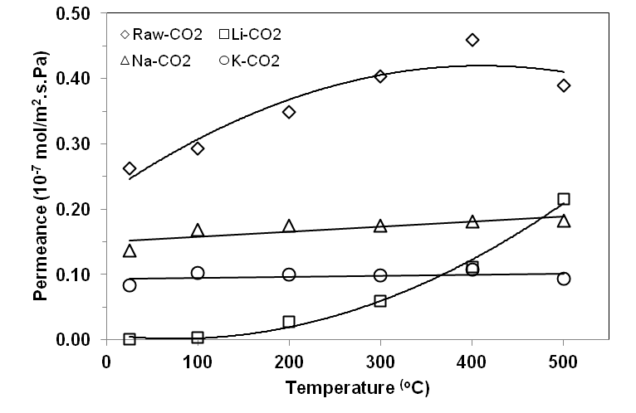

Figure 3.

Figure 4.

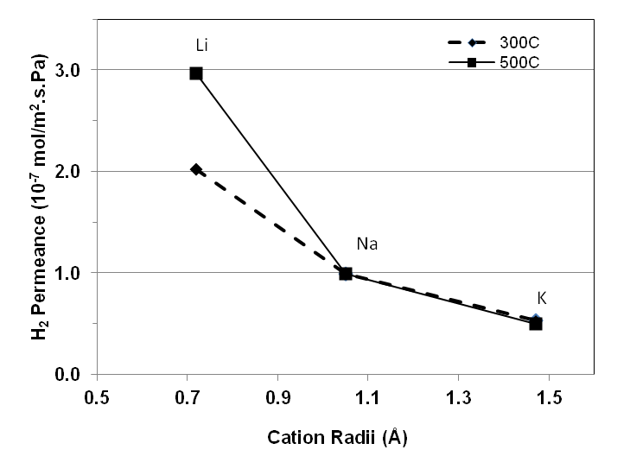

Figure 5.

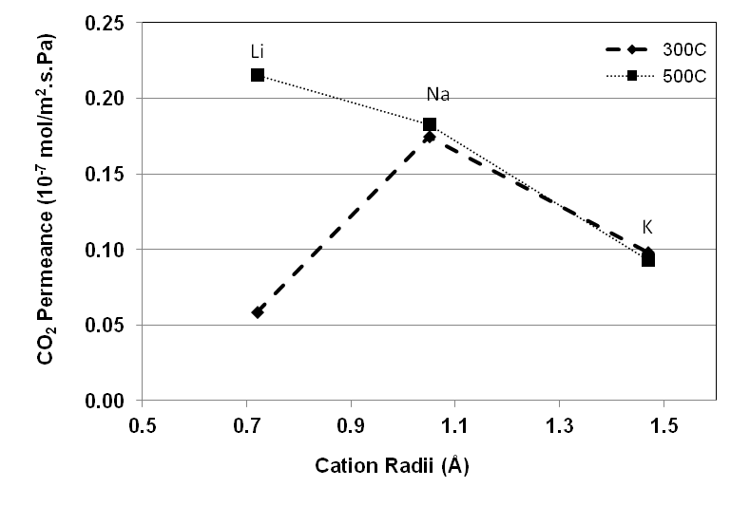

Figure 6.

Figure 7.

Figure 8

Figure 9

Figure 10

Figure 11

Figure 12

