natural zeolite-based cement Composite membranes FOr H₂/CO₂ SEPARATION
Amir Hossein Shafie, Weizhu An, Seyed Alireza Hosseinzade Hejazi, James A. Sawada, Steven M. Kuznicki∗
Department of Chemical and Materials Engineering, University of Alberta,

Edmonton, AB, Canada T6G 2V4

Abstract
Natural zeolite-based membranes have shown promise in the separation of H₂ from CO₂ and hydrocarbons. However, these highly dense, naturally monolithic materials can suffer defects, which disrupt the continuity of the zeolite micropores and create leak paths through the membrane. Cement materials were explored as a component to generate natural zeolite-based cement composite membranes because of their ability to intergrow between the zeolite particles. The influence of operating pressures and temperatures on the performance of the natural zeolite-based cement composite membranes was examined. Gas permeation tests indicated that permeation through the membrane (thickness of 1.8 to 2.2mm) was an activated diffusion process and the experiments measured a hydrogen permeance of 4.1 × 10⁻⁸ mol m⁻² s⁻¹ Pa⁻¹ and a H₂/CO₂ single gas selectivity of 25 at 25ºC and 100 kPa.
Keywords: zeolite, membrane, clinoptilolite, gas separations, hydrogen.

- Introduction
Hydrogen is a clean, environmental-friendly fuel and an important feedstock in petroleum chemical industries [1]. Hydrogen is often produced as a high temperature mixture with CO₂ (syngas), hydrocarbons and other impurities (H₂S, CO etc.), therefore, production of pure hydrogen almost always involves separation of hydrogen from syngas and/or hydrocarbons [2].
Zeolite molecular sieve membranes possess high thermal and chemical resistance compared to polymeric membranes and have well defined pores/channels of molecular size. Therefore they offer an alternative to selectively separate molecules based on their shape/size differences and adsorption properties [3]. The most popular approach to preparing zeolite membranes is to grow a thin selective zeolite layer on a porous support, usually alumina or in some cases stainless steel [3]. The synthesis of supported thin zeolite membranes for large-scale hydrogen separations, however, needs to overcome technical and material challenges including restrictive requirements for support properties, tedious synthesis processes and the formation of fatal membrane defects due to poor materials compatibility between the support and the zeolite [4].
Zeolite membranes have also been made by embedding the separation reagent into a continuous matrix material to keep the selective separation property of the reagent while providing the integrity of the membrane. It has been reported that a matrix membrane of zeolite nano/meso particles embedded in polymeric membranes showed improved thermal stability, mechanical strength and separation performance as compared to pure polymeric membranes and synthetic supported zeolite membranes [5]. However, polymer-based matrix zeolite membranes have limited applications in harsh chemical environments and at high temperatures due to the inherent properties of the matrix polymer [6].
Recently An et al. reported selective separation of hydrogen from light hydrocarbons and CO₂ using natural zeolite clinoptilolite membranes [7]. The results of that study demonstrated the unique separation properties of the natural zeolite crystals as compared to conventional supported synthetic thin zeolite membranes. In this study, a clinoptilolite-based cement composite membrane was prepared and its performance in H₂/CO₂ separation was examined.
The objective of this study is to take advantage of the low cost and high separation qualities of natural zeolite materials and further explore the potential of natural zeolite based membranes in the separation of hydrogen from CO₂. Cement was used as the composite material because it possesses similar properties and chemical components to zeolites. The continuous, multidirectional nature of cement crystal intergrowth under proper conditions provides close binding to zeolite particles. This special bond between zeolite and cement crystals could potentially eliminate interparticle voids or gaps formed in the interface between zeolite particles and cement matrix and result in a membrane with high separation integrity. To date, there have been no reports on natural zeolite-based cement composite membrane use for gas separations. The results presented here show that the natural zeolite-based cement composite membranes combine the mechanical strength of cement and the selective separation properties of the zeolite, and have great potential for selective hydrogen separation at high temperature and in harsh chemical environments.

2. Experimental

2.1 Materials and Membrane Preparation
The natural zeolite clinoptilolite was obtained from Zeolite Global Solutions LLC (Las Vegas, NV, United States). Table 1 lists the chemical and physical properties of clinoptilolite provided by the supplier. Portland Cement (Type I, Lafarge North American) was used as purchased for matrix material. All the gases used in this study were obtained from Praxair, Canada.
Clinoptilolite powder from Zeolite Global Solutions LLC (designated as GSC) was well mixed with Portland cement by dry-grinding. The weight ratio of zeolite to cement ranged from 75:25 to 87:13. Zeolite cement composite membranes were prepared by dry pressing. Depending on the desired final membrane thickness (1.8 to 2.2 mm) the measured amount of powder mixture was dry-pressed into a disc with a manual hydraulic press and a 19.05 mm diameter die under a pressure of 210 MPa. After pressing, the obtained green membrane discs were cured overnight by high temperature steam in a 500 mL teflon lined stainless steel autoclave. Steam temperatures were varied from 120 ^{º}C to 250 ^{º}C to find the optimal curing conditions. Before gas permeation tests, all composite membrane samples were dried at 300ºC in a temperature programmable muffle furnace at atmospheric pressure. The temperature controller of the furnace was set to ramp at 1ºC/min from room temperature to 300ºC and hold at 300ºC overnight.

2.2 Characterization of Matrix Membranes and Materials by X-ray diffraction (XRD) and Scanning Electron Microscopy (SEM)
Phase identification of zeolite materials and prepared zeolite cement composite membranes were characterized by X-ray diffraction with a Kα average wavelength of 1.79 Å (Rigaku Geigerflex Power Diffractometer , Co tube, graphite monochromator ). Membrane surface morphology and surface composition were examined by SEM with energy dispersive x-ray spectroscopy (JEOL 6301F).

2.3 Gas permeation measurements
Gas permeation through the zeolite cement composite membranes were measured in a stainless steel membrane testing system shown in Figure 1. Membranes were sealed in a stainless flanged cell with two graphite gaskets. The two chambers (feed and permeate sides) separated by the membrane were each attached to a stainless steel tube (OD=12.7 mm) where feed and sweeping gases (Ar) entering through tube sides, while permeate and retentate exited through the shell sides. The flanged membrane cell was placed into a tube furnace with a multipoint programmable temperature controller. For permeation tests at higher temperatures, a heating rate of 5ºC/min was used in each temperature interval. Transmembrane pressure was controlled by a back pressure regulator located at the feed side outlet. The feed and sweeping gas flow rates were controlled by two mass flow controllers (Sierra Instrument Inc.). The flow rates of the feed and sweeping gas were constant at 100 mL/min (STP) and 200 mL/min (STP) respectively, for all gas permeation tests. The flow rate of outlet streams was measured using bubble flowmeters. An on-line Shimadzu Gas Chromatograph GC-14B (GC) equipped with TCD and packed column (HaySep Q, 80~100mesh) was used to analyze the outlet gas concentrations. Helium and argon were used as GC carrier gases for CO₂ and H₂ analysis respectively.

3. Results and discussion

3.1 Physical and Chemical Characterization

3.1.1 X-Ray Diffraction
Figure 2 shows XRD patterns for both raw zeolite powder and the composite membrane. These XRDs show very similar patterns except for several new peaks in the composite membrane sample. The similarity between the XRD patterns indicates that the clinoptilolite embedded in the Portland cement matrix still preserves its crystalline structure, even after steam induced hydration. The new peaks at 2θ=34.5º and approximately 40º indicate that cement hydration has occurred, as they indicate the presence of C-S-H (CaO-SiO₂-H₂O) phases [8, 9]. In samples with higher cement content, we also observed calcite formation, which may be attributed to the presence of atmospheric carbon dioxide and the highly reactive agents in Portland cement.

3.1.2 Formation of homogeneous, dense and networked cement-zeolite membranes
High temperature steam curing of cement usually produces dense and homogeneous cement paste with characteristic closed network crystals. These crystalline products of cement hydration can heal or fill gap and crack defects in the cement matrix and enhance cohesion between fillers and cement paste [10]. This enhanced cohesion, and the binding characteristics of clinoptilolite cement particles, are critical for the formation of a high quality zeolite cement composite membrane. Figure 3 a and b show SEM images of the surface and a cross-section of the cement composite membrane. Corresponding EDX analysis of selected points (1 and 2 and 3) is presented in Figure 4. The images show that zeolite particles on the surface are surrounded by a homogeneous, dense and cementitious matrix as indicated by the higher calcium content at point 2. The high temperature steam curing process produced a very dense layer composed of clinoptilolite and the products of the cement hydration matrix (Figure 3 a and b). The thickness of this layer was estimated to be approximately 1 to 2µm (Figure 3b). The new phases (new peaks in the XRD spectrum) and the increased density of the surface layer suggest that the crystal products from the hydration of cement under high temperature steam have resulted in significant intergrowth of the cement with the zeolite crystals, creating close bonds between them.

3.2 Single gas permeation measurements
Single gas permeation results (H₂ and CO₂) over a composite membrane with a clinoptilolite/cement weight ratio of 87:13 are shown in Figure 5. Hydrogen permeance of 4.1 × 10⁻⁸ mol m⁻² s⁻¹ Pa⁻¹ and CO₂ permeance of 1.6 × 10⁻⁹ mol m⁻² s⁻¹ Pa⁻¹ were obtained at 25ºC and feed pressure of 100 kPa. Both the hydrogen and CO₂ permeances were temperature dependent within the temperature range tested and both gas permeances increased with increasing temperature. The temperature dependence of the gas permeance is an indication that permeation through the zeolite clinoptilolite cement composite membranes is an activated diffusion process.
The ideal selectivities for hydrogen over CO₂ through the zeolite cement composite membrane were higher than that predicted by Knudsen diffusion (4.74 for H₂/CO₂). The selectivity for H₂/CO₂ decreased with increasing temperature. At lower temperature (25ºC), H₂/CO₂ selectivities of 25 and 12 were achieved at feed pressures of 100 kPa and 200 kPa, respectively, indicating that permeation through the clinoptilolite zeolite pore/channel was dominant.
In general, the accepted permeation mechanism for a gas molecule with a size close to that of the pore/channel of the zeolite is adsorption on the surface of the pore/channel, followed by diffusion through the pore/channel and desorption from the surface of the opposite side of the membrane [11,12]. At lower temperatures (25ºC), higher selectivity for hydrogen over CO₂ can be attributed to the much stronger adsorption of CO₂ than hydrogen on the surface of the clinoptilolite pore, which restricts the diffusion of CO₂. At higher temperatures, CO₂ adsorption on the surface of the zeolite pore is weakened and the mobility/diffusion of CO₂ is increased, resulting in lower H₂/CO₂ selectivity [13].

3.3 Zeolite Concentration Effect
To investigate the effect of the zeolite content on composite membrane properties and gas separation performance, membrane samples with different ratios of natural zeolite to cement were prepared and tested. Figure 6 shows the effect of the weight ratio of clinoptilolite to Portland cement on hydrogen permeance at 25ºC and various trans-membrane pressures. The pure cement membrane showed essentially no hydrogen permeation under the experimental conditions tested. Hydrogen permeance increased with increasing clinoptilolite zeolite content in the cement composite membrane, indicating that efficient gas permeation was through the zeolite.
Although clinoptilolite is valued for its high permeance and selectivity, an optimal weight ratio of zeolite to cement in the composite membrane must be determined. A ratio is considered optimal if it achieves mechanical strength and membrane integrity plus optimal permeance and selectivity performance. The best ratio that we have found to date for clinoptilolite to Portland cement is 7:1. Future work will optimize both the synthesis conditions (to improve gas permeation and hydrogen selectivity) and the zeolite/cement ratio.

4. Conclusions
Natural zeolite (clinoptilolite)-based Portland cement composite membranes with a thickness of 1.8 to 2.2mm were prepared and their performance in the selective separation of hydrogen from CO₂ was examined. SEM and XRD results for the zeolite cement composite membrane confirm the hydration of the cement under high temperature steaming conditions and the formation of a denser layer on the surface due to the intergrowth of the cement hydration product with the clinoptilolite particles. Hydrogen permeance of 4.1×10⁻⁸ mol m⁻² s⁻¹ Pa⁻¹ with H₂/CO₂ selectivity of 25 was obtained at 25ºC and a feed pressure of 100 kPa. The gas permeance through the clinoptilolite cement composite membrane was dependent on operating temperature, indicating that permeation through the membrane was an activated diffusion process. This study demonstrates a new low-cost and high selectivity approach to hydrogen separation using zeolite membranes. These composite membranes are suitable for high temperature applications and for use under conditions where chemical and physical stability are required. Development of these zeolite/cement composites could potentially result in the development of practical, robust H₂ separation membranes showing strong molecular sieving behavior under industrially relevant conditions.

Acknowledgements
The authors thank Dr. Amy Dambrowitz and Albana Zeko for assistance with manuscript development and GE Global Research for their support throughout the project. The authors gratefully acknowledge the research funding provided for this program by Canada Research Chair and Helmholtz-Alberta Initiative (S.M. Kuznicki).

References

[1] T. M. Nenoff, R. J. Spontak, C. M. Aberg, Membranes for hydrogen purification: An important step toward a hydrogen-based economy, MRS Bull. 31 (2006) 735-741.
[2] Kirk-Othmer encyclopedia of chemical technology, Wiley, New York, DOI: 10.1002/0471238961.
[3] J. Caro, M. Noack, Zeolite membranes – Recent developments and progress, Micropor. Mesopor. Mater. 115 (2008) 215-233.
[4] J. Caro, M. Noack, P. Kölsch, R. Schäfer, Zeolite membranes – state of their development and perspective, Micropor. Mesopor. Mater. 38 (2000) 3-24.
[5] M. G. Süer, N. Baç, L. Yilmaz, Gas permeation characteristics of polymer-zeolite mixed matrix membranes, J. Membr. Sci. 91 (1994) 77-86.
[6] S. J. Miller, W. J. Koros, D. Q. Vu, Mixed matrix membrane technology: enhancing gas separations with polymer/molecular sieve composites, Stud. Surf. Sci. and Catal. 170 (2007) 1590-1596.
[7] W. An, P. Swenson, L. Wu, T. Waller, A. Ku, S. M. Kuznicki, Selective separation of hydrogen from C1/C2 hydrocarbons and CO2 through dense natural zeolite membranes, J. Membr. Sci. 369 (2011) 414-419.
[8] I. Janotka, L. Krajci, M. Dzivak, Properties and utilization of zeolite-blended portland cements, Clays Clay Miner. 51 (2003) 616-624.
[9] M.Grutzeck, S. Kwan, M. DiCola, Zeolite formation in alkali-activated cementitious systems, Cem. Concr. Res. 34 (2004) 949-955.
[10] C. Lehmann, P. Fontana, U. Müller, Evolution of Phases and Micro Structure in Hydrothermally Cured Ultra-High Performance Concrete (UHPC), in: Z. Bittnar, P. J. M. Bartos, J. Nemecek, V. Smilauer, J. Zeman (Eds.), Nanotechnology in construction 3- Proceedings of the NICOM3, Springer, Berlin, 2009, pp. 287-293.
[11] P. F. Lito, C. F. Zhou, A. S. Santiago, A. E. Rodrigues, J. Rocha, Z. Lin, C. M. Silva, Modelling gas permeation through new microporous titanosilicate AM-3 membranes, Chem. Eng. J. 165 (2010) 395-404.
[12] M. P. Bernal, J. Coronas, M. Menéndez, J. Santamaría, Characterization of zeolite membranes by temperature programmed permeation and step desorption, J. Membr. Sci. 195 (2002) 125-138.
[13] Y. S. Lin, I. Kumakiri, B. N. Nair, H. Alsyouri, Microporous inorganic membranes. Sep. Purif. Methods. 31 (2002) 229-279.

Table 1. Clinoptilolite specifications provided by the Zeolite Global Solutions LLC.

Particle size | 325 Mesh
Clinoptilolite content | 75-85 %
Bulk density | 689-752 kg/m³
Si/Al molar ratio | 4.9
Thermal stability | 650 ^{º}C
pH stability | 0-13
Cation exchange capacity (CEC) | 0.8-1.2 meq/g

Figure Captions

Figure 1. Schematic diagram of permeation tests.
Figure 2. XRD patterns for clinoptilolite and the zeolite composite membrane.
Figure 3. SEM images of the zeolite composite membrane: a) surface and b) cross-section. Labels 1 and 2 and 3 indicate the points selected for EDX analysis.
Figure 4. EDX analysis of the a) point 1 and b) point 2 and c) point 3 from the SEM image shown in Figure 3 b.
Figure 5. H₂/CO₂ permeation vs temperature through the zeolite composite membrane, ΔP=100 kPa.
Figure 6. The effect of matrix concentration on H₂ permeation through the zeolite composite membrane at 25 ^{º}C.

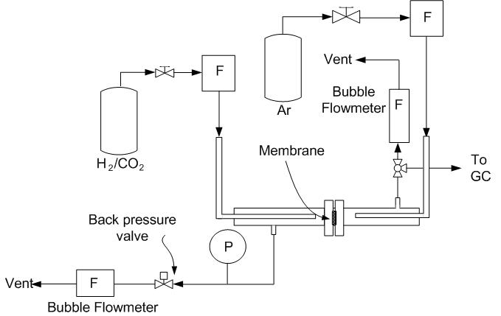

Figure 1
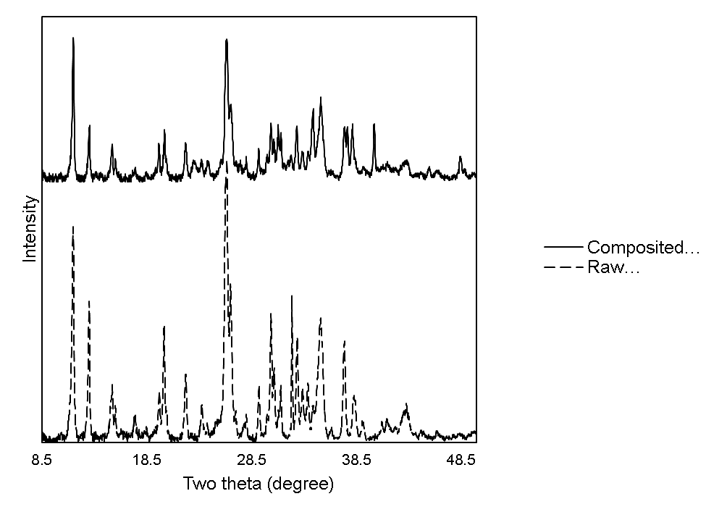

Figure 2
C
C
H
H
C: Clinoptilolite
H: Hydration product

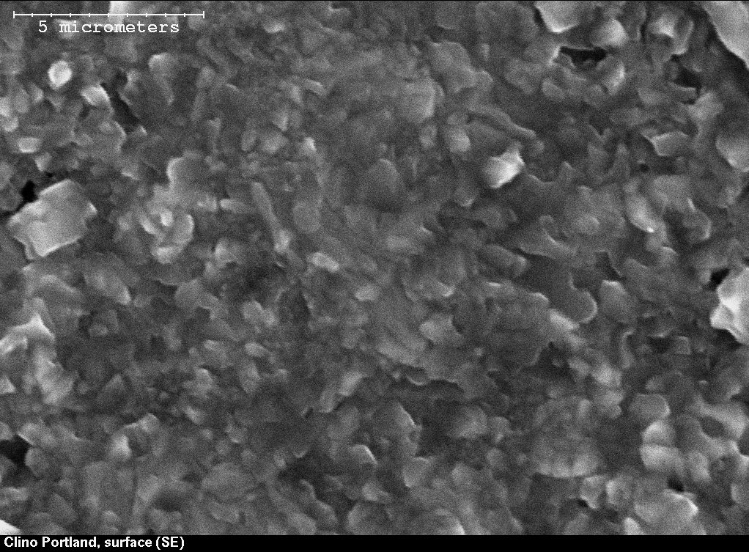
a)

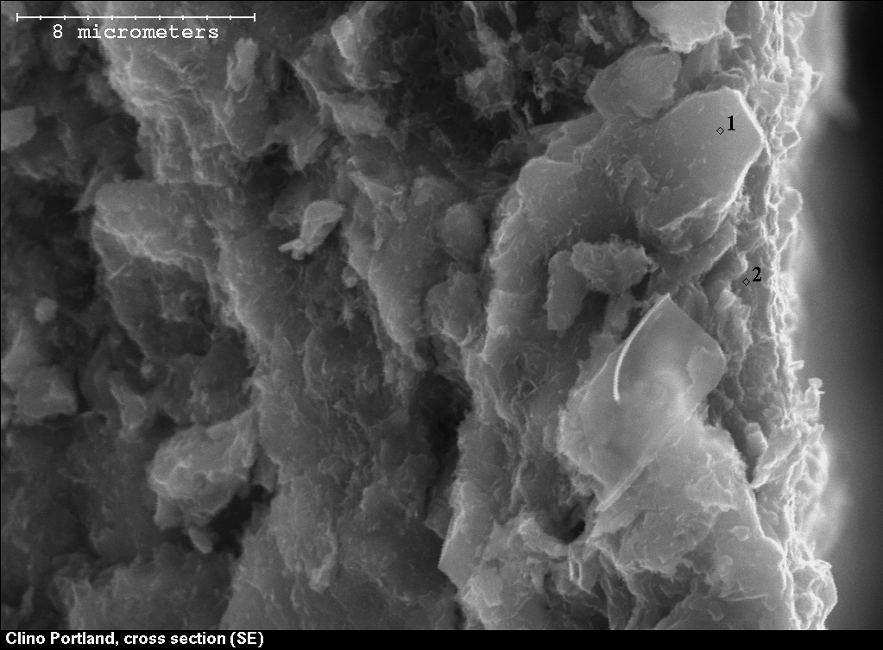
b)

Figure 3

a)
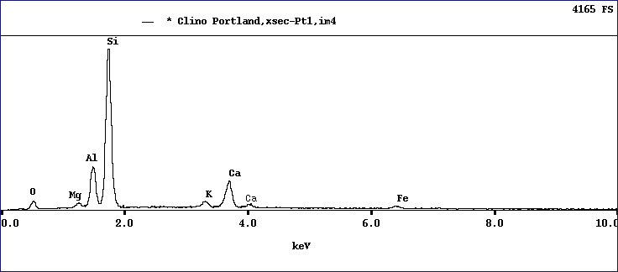
b)
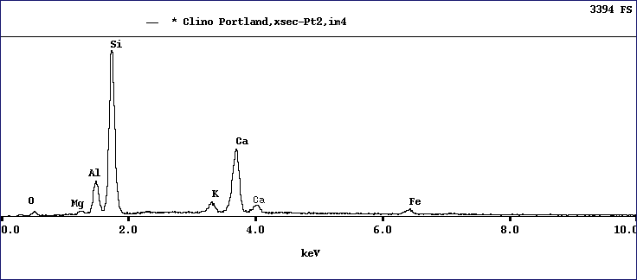

Figure 4
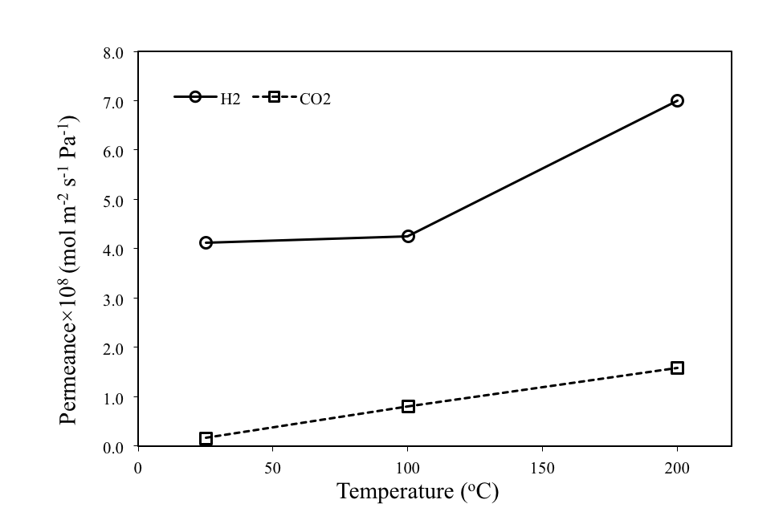

Figure 5

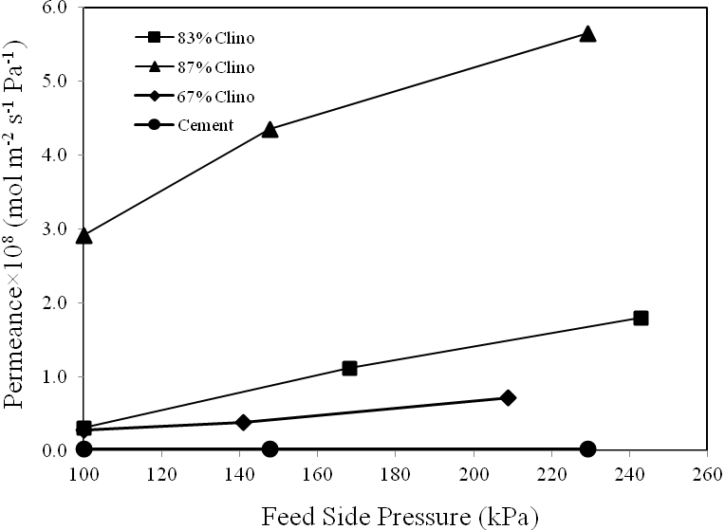
Figure 6

 To whom all correspondence should be addressed (Email: steve.kuznicki@ualberta.ca; Telephone: 1.780.492.8819; Facsimile: 1.780.492.8958).

