University of the Arctic Digital Library: Update 2012

By Sandy Campbell  
John W. Scott Health Sciences Library  
University of Alberta, Edmonton, Alberta, Canada

Abstract

The University of the Arctic Digital Library project is an ongoing project in which PLC takes an interest. Some Digital Library functions are now operational at a level, integrated into the Arctic Virtual Learning Tools environment. This session will report on the 2011 meeting in Tornio/Kemi and Rovaniemi, Finland and review the developments to date and the future expectations for the library. A proposal has been developed for the June 2012 Council Meeting to establish a lead institution that would be responsible for the Digital Library. Developments in the University of the Arctic, itself, will also be discussed.

Background

The University of the Arctic (UArctic) is a virtual university which began in 2001 and currently has more than 120 members from around the Arctic region. Many members of the Polar Libraries Colloquy work in post-secondary institutions that are members of the University of the Arctic. PLC joined the UArctic in 2005 and has continued since that time to work in an advisory capacity with UArctic on information issues, most notably the development of a Digital Library. The Digital Library project was first discussed at the 2006 Colloquy in Rome(Campbell & Snellman, 2008) and explored further with representatives of the UArctic instructors during the joint PLC/UArctic meeting in Edmonton in 2008(Dana, 2010).The ongoing work on the project has been reported in the Polar Libraries Bulletin(Campbell, 2007; Campbell, 2009a; Campbell, 2009b) and at the last PLC meeting(Campbell, 2011).

University of the Arctic Council Meeting 2011 – Kemi/Tornio and Rovaniemi, Finland

In June 2011, I represented PLC at the 10th Anniversary UArctic Council Meeting which took place initially at Tornio/Kemi, Finland and then moved to Rovaniemi, Finland. The UArctic Digital Library has been developed as a facet of the Arctic Virtual Learning Tools (VLT) environment developed by the UArctic VLT teamwith funding from The Council of Nordic Ministers. In Tornio, I attended the VLT team meeting, where we discussed some of the technical details of how the Digital Library would work within the VLT. The VLT, including the library, is housed on the Arctic Portal servers at the University of Akureryi in northern Iceland. In addition to supplying a search interface, Arctic Portal also supplies a digital repository service.

At the subsequent Council Meeting at Rovaniemi, it became apparent that further discussions about a Digital Library at the Council level would be inappropriate without a UArctic member university volunteering to take the lead in developing the library. Because there was no lead institution in place at the time, there was no break-out session for the discussion of the Digital Library. Leena-Kaisa Viitanen (Arctic Portal) included the Digital Library in her presentation to the Council about the accomplishments of the VLTproject.

Subsequent Discussions and Developments

Since the Council Meeting, the VLT group has met numerous times through Skype to continue to work on defining what an institutional lead for the Digital Library might be asked to undertake. The goal of this work was to place a call for volunteers before the 2012 Council Meeting, to find member institution that would take the lead on the Digital Library project. Members of the VLT team have made a further presentation on the project, including the Digital Library at the IPY Conference in Montreal in April, 2012.

In the interim two events impacted the progress and direction of our work on the Digital Library. First, the Canadian government severely reduced its funding to UArctic(Foreign Affairs and International Trade Canada, 2011), preferring to direct that funding to the three “northern colleges”. This precluded any Canadian university member from seeking funding to undertake leadership on the project.

Second, on a more positive note, PLC members will have been aware of the launch by The University of Tromsø (UTromsø) Library of the High North Research Documents service(University of Tromsø Library, 2012). Following the launch in January, 2011, discussions took place between UArctic and UTromsø about how UArctic might make use of this service. While High North is primarily a metadata harvester, UTromsø Library expressed an interest in integrating High North with the UArctic Digital Library. A small pilot project is now underway in which UTromsø Library is testing the adding of content and metadata to the digitial library and repository housed by the Arctic Portal. The test will serve to document processes and determine costs.

The 2012 UArctic Council Meeting is was held at UTromsø, (simultaneously with the 2012 PLC meeting). More study needs to be done to determine whether or not UTromsø Library would be able to take the lead on the UArctic Digital Library. UTromsø Library received permission to seek funding a UArctic-specific fund at UTromsø to support an ongoing project. If UTromsø Library is able to take on the lead role for the Digital Library, a proposal to that effect would be put before the UArctic Council at its 2013 meeting, for approval by the membership.

Any plan for a member university to take the lead with the Digital Library would include an advisory board, which would include librarians from member institutions and a PLC representative.

The UArctic Digital Library

[www.vlt.is](file:///\\samba.srv.ualberta.ca\scampbel\DATA\DATA\OFFICE\PapersandPresentations\2012\Conferences\PLC\UArctic%20Digital%20Library\www.vlt.is)

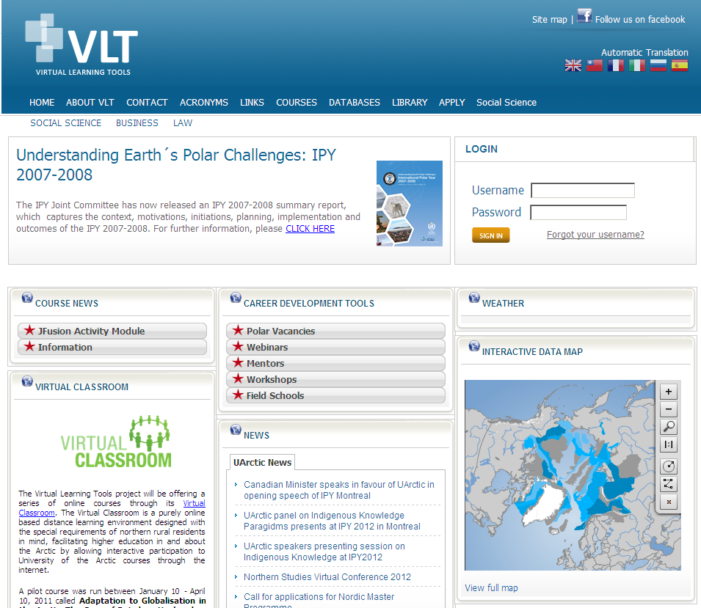

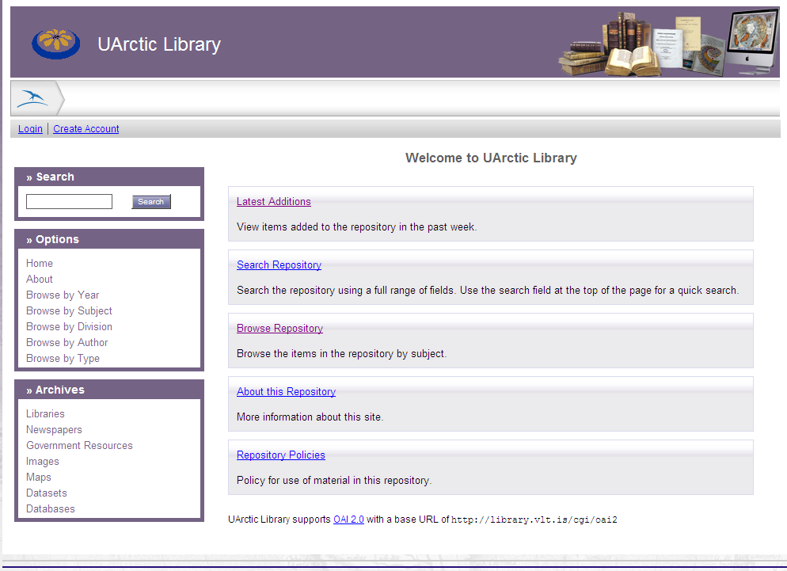

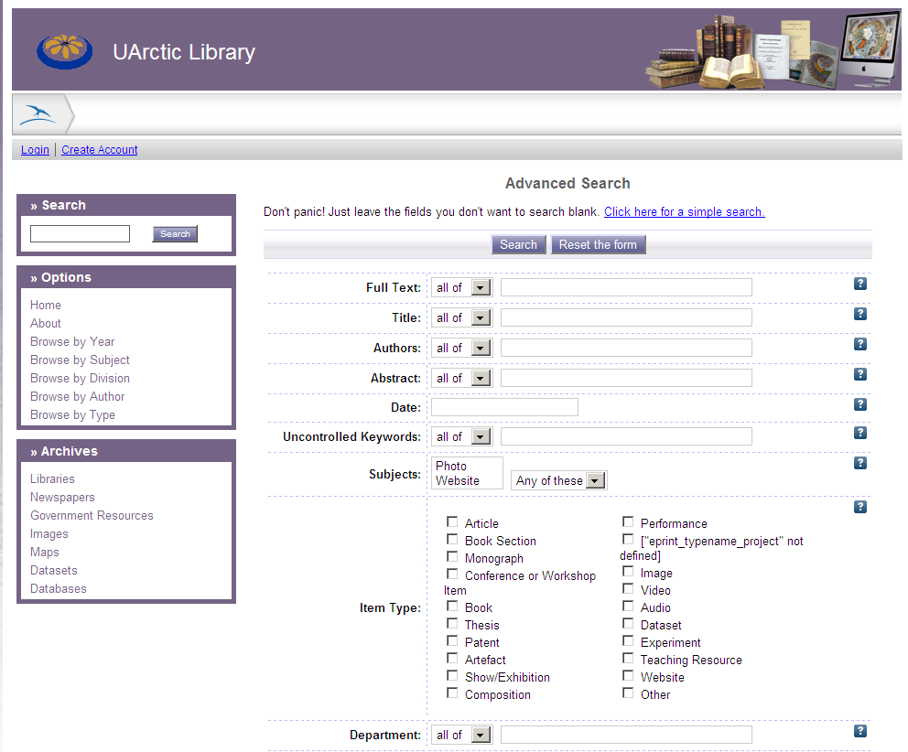

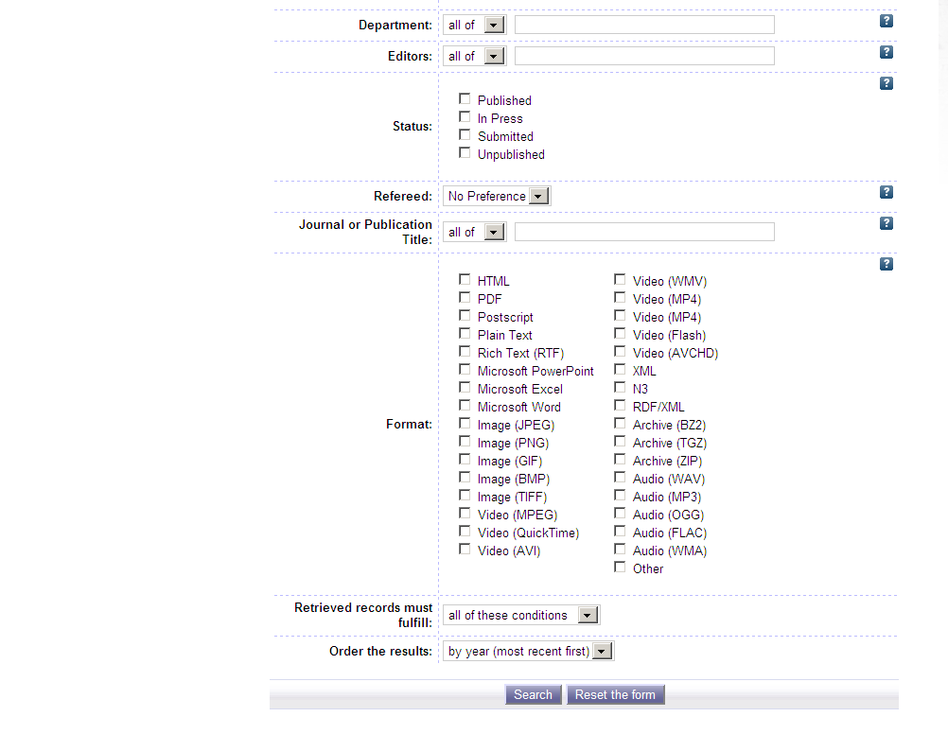

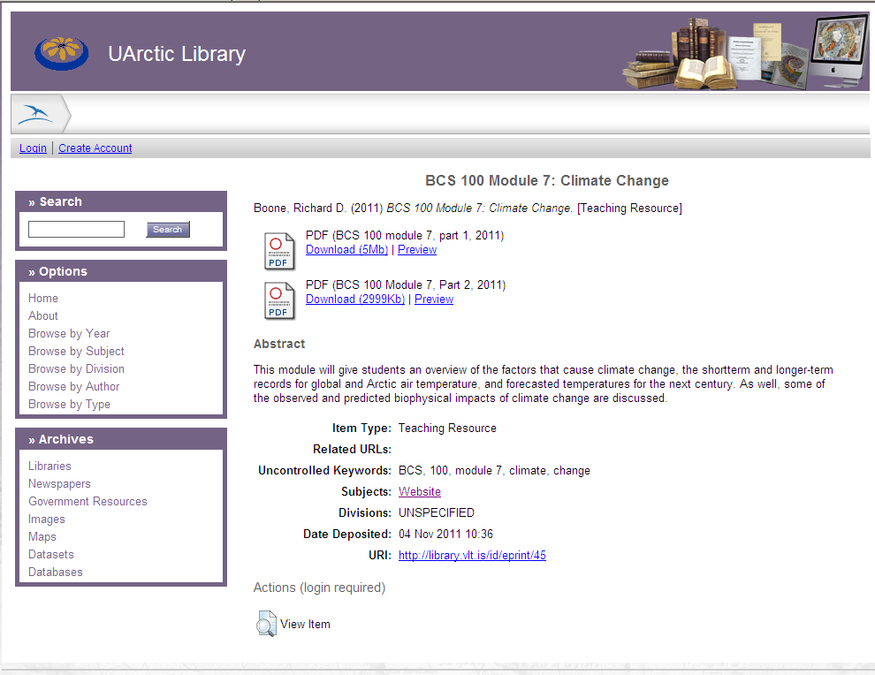

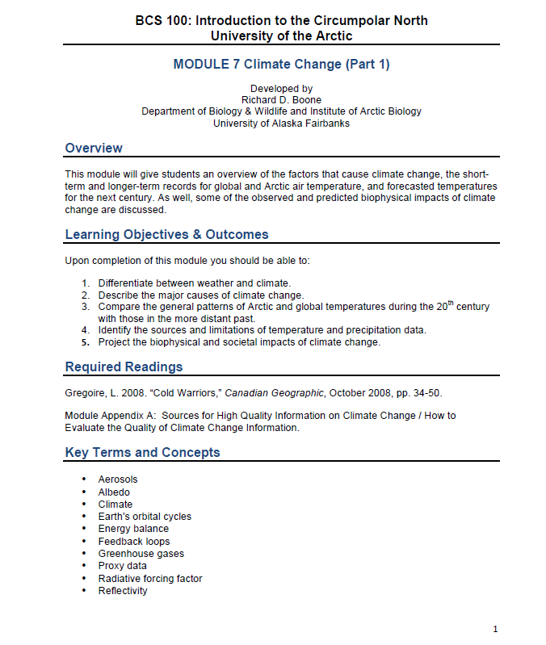

References

Campbell, S. (2007). University of the Arctic Council Meeting Report, *Polar Libraries Bulletin, 59*(Fall), 7-8.

Campbell, S. (2009a). Report from the University of the Arctic Council Meeting, Kiruna, Sweden August 11-14, 2009 *Polar Libraries Bulletin,* (63), 2-4.

Campbell, S. (2009b). UArctic Digital Library project update. *Polar Libraries Bulletin,* (62), 6.

Campbell, S. (2011). University of the Arctic Digital Library: Progress and Update. *Cool Libraries in a Melting World : Proceedings of the 23rd Polar Libraries Colloquy 2010,* Bremerhaven, Germany. 125.

Campbell, S., & Snellman, O. (2008). UArctic Librarians Open Forum. *Building Polar Networks, a Strategy for the Future/ 21st Polar Libraries Colloquy,* Rome, Italy. 64-65.

Dana, K. O. (2010). Virtual UArctic Library: proposal on behalf of UArctic Teachers. *Currents of Change: The Future of Polar Information/22nd Polar Libraries Colloquy Proceedings,* Edmonton, Alberta, Canada. 131-132.

Foreign Affairs and International Trade Canada. (2011). *Summative Evaluation of the Northern Dimension of Canada's Foreigh Policy.* Retrieved April/26, 2012, from <http://tiny.cc/b03ddw>

University of Tromsø Library. (2012). *High North Research Documents*. Retrieved April/26, 2012, from <http://highnorth.uit.no/>