**SPEED TALK SPEAKERS**

**Teamwork: improved patient experience, patient care and patient safety**

This talk will explore the concept of team in community practices, and how to increase their efficiency and effectiveness.

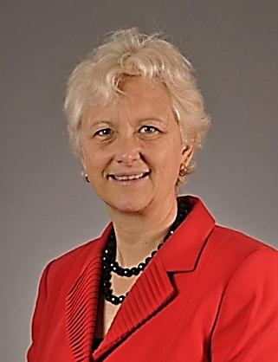

**Maeve O’Beirne** is the Director of the Patient Medical Home and Quality in the Department of Family Medicine at the University of Calgary.  She is a family physician at the Sheldon Chumir Family Medicine Teaching clinic and at the Low Risk Maternity Clinic in Calgary.  Her research interests are patient safety, quality improvement and teams in primary care.

**The Impact of History on Traditional Asian Medicine**

Several traditional systems of Asian medicine have globalized since the mid-twentieth century. Amongst the most successful are Traditional Chinese Medicine, Ayurveda, and Yoga.  Both China and India have long-established traditions of scholarly medicine with deep historical

roots. This rich history is often invoked as part of the supporting narrative for the potential of these medical systems in the modern world. By contrast, Modern Establishment Medicine has radically severed its connection with ancient and medieval European medicine. The modern doctor would never invoke Galen or Hippocrates as good reasons for taking the medicines he prescribes. What is going on here? Does history and tradition really matter when we are choosing a therapy? Or not? Or only sometimes? Where medicine is concerned, what

is the relationship between history and trust?

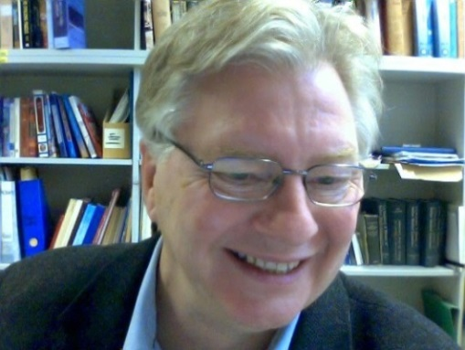**Dr. Dominik Wujastyk** is a Professor and Singhmar Chair in Ancient Indian Society and Polity in the Department of History and Classics, Faculty of Arts. His research and teaching interests include the history of Indian medicine (Ayurveda) and Yoga philosophy, Sanskrit and Pali literatures, formal Indian linguistics, and the cultural history of premodern India. He is the founder of INDOLOGY ([indology.info](http://indology.info/)), an online forum for professional scholars of early India, and the founder and chief editor of the Open Access journal *History of Science in South Asia.*

**Changing the Way We Think About Indigenous Health**  
Dr. Tailfeathers is the Medical Lead for the Population, Public and Indigenous Health Strategic Clinical Network (Alberta Health Services). She will address necessary changes in health services for Indigenous people in Alberta.

**Esther Tailfeathers** was born and raised on the Blood Reserve or Kainai First Nation which is located in Southern Alberta. Esther has lived in many Indigenous communities including the Northern Sami community in Northern Norway. She received her MD and completed her Family Medicine Residency from the University of North Dakota. Since then she has served communities such as the Blackfeet Indian Hospital in Montana, the Blood Reserve, and the Cardston hospital and emergency room. More recently she served in the remote northernmost community of Fort Chipewyan. She is currently the Medical Lead for the Population, Public and Indigenous Health Strategic Care Network.

**Regulating traditional medicine (be careful what you wish for)**

This talk will explore the experience of regulating Traditional Chinese Medicine in Ontario where everyone had the best intentions (theoretically) but there have been a number of challenges.

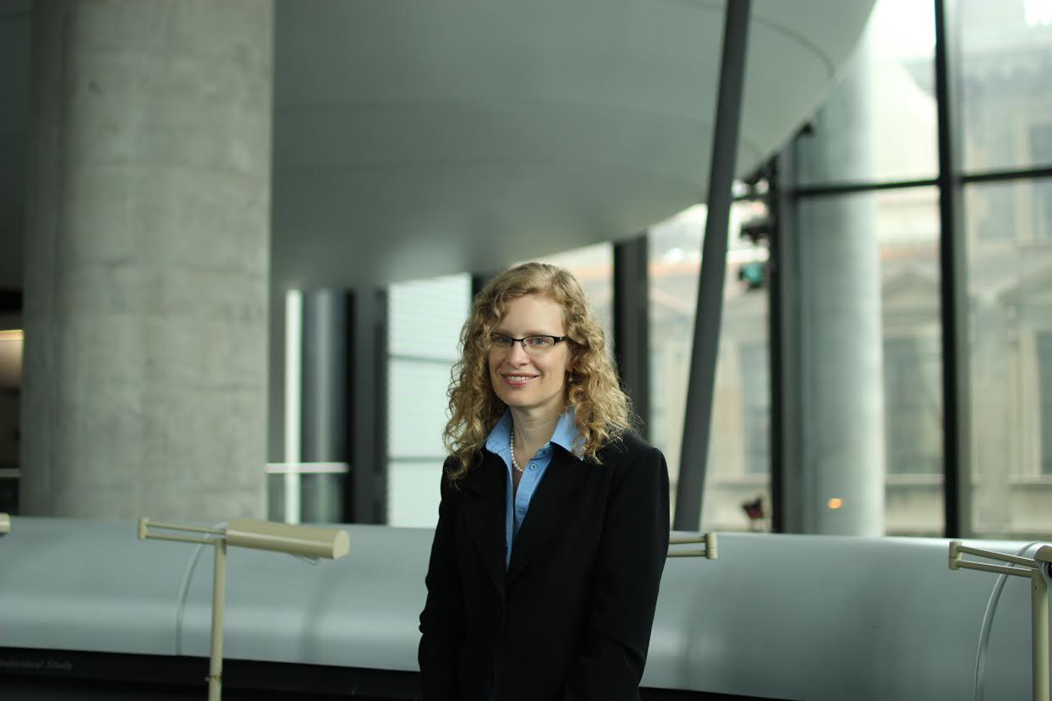**Dr. Heather Boon** is a Professor and the Dean of the Leslie Dan Faculty of Pharmacy, University of Toronto.  She is one of the founding Directors of the Canadian Interdisciplinary Network for Complementary and Alternative Medicine research and is the current President of the International Society of Complementary Medicine.  Her primary research interests are the safety and efficacy of natural health products as well as complementary/alternative medicine regulation and policy issues. She is the author of a textbook on natural health products and over 130 academic publications in the area.