Exclusion as Political:
Rebuilding the American Masculine Identity Through High School History Textbooks

By
Sarah J. Clifford

A thesis submitted in partial fulfillment of the requirements for the degree of

Bachelor of Arts (Honors)
In
Political Science

Department of Political Science
University of Alberta

© Sarah Joan Clifford, 2020
Abstract

This thesis examines how high school history textbooks’ depictions of the War on Terror reinforce the construction of an American masculine identity. Using a critical discourse analysis, it charts how textbooks mobilize the American identity around the tools of linking, differentiation, and hierarchization to legitimize its foreign policy through the construction of the “Other”. In identifying how textbooks are simply an “arm of the state”, this study displays how, through discursively enacting narratives that rely upon the construction of a “Self” and an “Other”, textbooks act as a site that helps reconstitute and rebuild the American masculine identity. In sum, this thesis demonstrates how not only is the state gendered, but so too are textbooks.

Tables of Contents

Chapter 1 Masculinities and Politics: Can Exclusion Be Political?………………...….…..…1
Introduction……………………………………………..……………………….….………...1
Literature Review and Theoretical Background….……..………………...…………..….…..5
Education Policy…………………………………………..………………..………….........11
Subsequent Chapter Outlines ……………………………..……………………………...…15

Chapter 2 Foreign Policy: The Forgotten Facet of the American History Curriculum…...18
Introduction ……………………………..…………………………………………........…..18
Textbooks………………………………..…………………………………………......…....21
Methodology……………………………..……………………………………….....…..…..26
Conclusion………………………………..………………...…………………........…….…33

Chapter 3 Militarizing a National Identity………….…………………….…………..….…...34
Introduction ………………………………………..……………………………....….….…34
National Identity as Discursive………………..…………………………………….…....…34
Militarization.……………………………...………………………………………...…...…40
Education as Controlling Identity ……..……………………………………………….…...42
Conclusion ……..……….…………………………………………………....…...…..….…45

Chapter 4 The Shaping of Historical Discourses......................................................................46
Introduction…………………………………………..…………………………………..….46
The Common Narrative…………………………………..……………….....……..…….....47
Critical Discourse Analysis: America’s Unmanning………..…….………....……….…..…56
The American Rebuilding Project....……….…………………..………….……...….…..…65
California Versus Texas: Diverging National Narratives? …….…....…....………………...76
Conclusion…………………………..…….……………………………...……………....…78

Chapter 5 Conclusion: Why Does This Matter?..…………………………………………….80
Introduction.……………………………..………………………………….…………....….80
Findings: America’s Project of “Manning Up”….………………………….…………....….80
Implications of this Analysis………………..……………..….…………….…………….....83
Areas of Future Research………….……………...………………………...………..……...85
Conclusion………….………………………………...……………………………………..87

Bibliography……………………………………………………………………………..….......88

Chapter 1 Masculinities and Politics: Can Exclusion Be Political?
Introduction
By many accounts, 9/11 was a transformative experience – one forever ingrained in the American psyche and the nation’s identity (e.g. Sylvester 2013; Mann 2008; Sturken 2002). However, what is important to note is not how 9/11 enmeshed itself in the American identity, but instead, how 9/11 altered it. As Bonnie Mann notes, 9/11 was an occasion of America’s “unmanning,” a figurative dethroning of the nation that challenged its purported invulnerability and status as the global hegemon (2006, 153). To denounce its physical emasculation, the United States embarked on a process of rebuilding that not only transformed the American political landscape but also witnessed the reconstruction of the American masculine identity. To call attention toward this process of rebuilding, this study challenges how the War on Terror helped reconstruct the American masculine identity and how this reconstruction not only pervades the United States’ military but also unknowingly infiltrates other sites, such as history textbooks.

Further underpinning this study is Maria Grever and Tina van der Vlies’ (2017) assertion of the connection between textbooks and state influence. Grever and van der Vlies note that “[h]istorical scholarship and history teaching are both deeply rooted in the making of a national identity” (2017, 287). As the American rebuilding project relies on reconstructing its nation’s identity to reflect a more idyllic, masculine persona, history textbooks are at the forefront of this effort because of their ability to control what students learn, and how they view the state. Following this framework, Elie Podeh notes how textbooks act as an “arm of the state, agents of memory” because they contain “[s]tate sanctioned histories of the nation” (2000, 66; Montgomery 2005, 314). Histories that are moulded to better align with a state’s mandated values and masculine identity through a government’s control over the education system. Making textbooks a tool the state can utilize to perpetuate its masculine identity by shaping the information students receive and learn about. Building on this conceptualization of the masculine identity, curriculum scholar Yiting Chu (2017) notes how the ideological intonations embedded in state-sanctioned textbooks influence student’s perception of the state and their national identity. Chu describes this shaping of a nation’s identity by stating how “school knowledge is frequently constructed, selected, organized, and presented according to the interests and values of dominant groups in society while ignoring or distorting those of marginalized groups” (ibid., 230). In drawing attention toward the usage of “dominant” and “marginalized” groups throughout the text, Chu exemplifies how each state utilizes the concept of differentiation to make sense of who does and does not belong to a nation’s identity.

Although Chu is correct in discerning that a state constructs its identity through the process of differentiation, an action I will expand on in Chapter 3, he neglects to discuss how a hierarchization within identities also occurs - one that determines who epitomizes the purported national identity, and who is not allowed to fully embody it. Illustrating the pervasiveness of hierarchies in the American identity are both McGraw-Hill and Pearson Education’s portrayal of the history of slavery in their recent Texas edition high school history textbooks. For instance, the McGraw-Hill text depicts “the slave trade in terms of immigration” through utilizing the language of “worker” instead of “slave” to inaccurately represent the experiences of all African-Americans in 18th and 19th century America (Fernandez and Hauser 2016). Resulting in one Texan teacher positing that this inaccurate use of language is “what erasure looks like” (ibid.). By actively silencing and re-writing slavery’s historical narratives to lessen the negative stigma engrained in this portion of American history, McGraw-Hill and Pearson’s revisionist standpoint removes all narratives that challenge the legitimacy and interests of the state. Showcasing how textbooks can hierarchize and emphasize certain people’s lived experiences (e.g. white slave owners) over that of others (e.g. African Americans) to construct a version of history that best serves the interests of the state. By relating my study to this disjoint between historical accuracy and a text’s sanitized portrayal of history, I question whether this shaping of ‘historical’ content by the state not only pervades contentious subjects, such as slavery, but also permeates discourses surrounding less publicly contested events, such as American wars.

As the textbooks’ inaccurate portrayals of slavery exemplify, textbooks can influence the information students receive by both emphasizing and removing certain bodies and voices from their content who either contribute to, or challenge, what many feminist scholars refer to as the United States’ masculine identity. To help make sense of this identity, I rely on feminist theory to challenge and unsilence how the United States sees itself and what institutions, such as the education system, help perpetuate this identity. As Ackerly, Stern, and True detail,

the researcher has to rely on methods of deconstruction to study texts and discourses. […] That is, the scholar must look for and study what is not contained within the text but rather what is written between the lines or expressed as symbols or in practices (2006, 12).

Thus, a feminist lens aids in deconstructing and questioning the silences around who controls the United States’ history, who serves to benefit from these particular constructions, and why certain bodies, voices, and events are highlighted while others are subordinated and excluded from these narratives.
Through applying a feminist lens, I posit that textbooks’ shaping of historical narratives occurs because of the American gendering of the state. As such, not only is the United States influenced by its desire to emit a masculine identity, but the content in each state’s education system is also gendered. To call attention toward this gendering of the state, I conduct a case study of textbook coverage of the Bush administration's foreign policy by questioning how history textbooks reinforce the construction of an American masculine identity through their framing of the War on Terror. I hypothesize that, because the gendering of the American state is intrinsically tied to its performance militarily, the topics each textbook emphasizes or excludes throughout their discussions of the War on Terror are therefore gendered as well. Hence, by using textbooks as my locus of analysis, I delineate a connection between the War on Terror’s gendered intonations and how the United States constructs its own identity to make sense of what narratives the state propagates throughout each textbook, and why. In sum, utilizing feminist theory to unsilence the embedded gendered discourses in each textbook illustrates how textbooks frame, rebuild, and legitimize the American masculine identity through their depictions of the War on Terror.

To conclude, utilizing the War on Terror as my case study allows for a critical examination of how the United States frames its “unmanning” during 9/11, and how it reclaims its masculine identity in the post-9/11 space. Coupling these two events with historical discourses that surround these topics in textbooks allows me to distill, through a feminist lens, how the United States views these events and more importantly, how textbooks help the state reclaim its status as the global hegemonic power. This introductory chapter serves as the theoretical foundation of my study to question how textbooks reinforce the construction of an American masculine identity through their framing of the War on Terror. To begin, I ground my study in a literature review of feminist theorizations of the masculine state and education studies. I then demonstrate how my study fills a gap in both education and political science research. As I discuss, employing textbooks as my locus of analysis is not only rare in the fields of political science and history but is even more rare to use when analyzing the American masculine state. Thus, my chapter also briefly questions the validity of utilizing textbooks as a tool of analysis in political science research to deconstruct a state’s perceived identity.

Literature Review and Theoretical Background
I begin my literature review and theoretical background by highlighting a few monumental pieces by feminist IR scholars in the field of masculinity and the state. I then discuss recent education studies that focus on the American history curriculum. Both feminist IR and education theory inform my analysis by calling attention toward how textbooks’ depiction of the War on Terror help to reconstitute and rebuild the American masculine state.

The Masculine State
Feminist theorists such as Cynthia Enloe (1990), J. Ann Tickner (2001), and Laura Sjoberg (2013) provide comprehensive analyses of the role and implications that constructions of gender play in our society. To begin, Laura Sjoberg (2011; 2013) explains how governments rely on the construction of gender and the interplay between masculinities and femininities to formulate how each state interacts on the world stage. She argues that a states’ gendered attributes and language it espouses showcase how the international system is structured in a hierarchical, and gendered manner. For example, Sjoberg notes how “gender norms are a crucial part of competition between states” as each state uses conflict to overpower one another and prove its absolute authority. Resulting in each state’s position as the potential masculine hegemon depending on its performance amongst other states on the international stage (2011, 86). To illustrate this concept, Sjoberg details that if a state ‘wins’, its masculinity “is implicitly or often explicitly affirmed” (ibid.). The loser’s masculinity, in comparison, “is subordinated or doubted” to that of the winner (ibid.). Thus, conflict is a series of competitions for superiority for a state to display its ultimate masculinity in relation to the dominated and subjugated Other.

Masculinity, as Charlotte Hooper defines, is “in opposition to femininity in the dichotomous pair masculine/feminine”, where masculine traits are everything that the feminine is not: rational, active, competitive, emotionless (1998, 34). It is important to note that the construction of masculinity does not refer explicitly to the male sex but instead, encapsulates both men and women who display or conform to inherently masculine traits and values (Sjoberg and Gentry 2007, 10). Hence, society derives these traits and stereotypes from discourses on gender, which “can set, change, enforce, and represent meaning on the basis of perceived membership in or relation to sex categories” (ibid., 6-7). When paralleling Hooper’s conceptualization of masculinity with Sjoberg and Gentry’s description of gender, it is evident that masculinity is not “strictly descriptive to men”, but rather acts on accepted values and norms associated with the masculine (ibid., 10).

Hegemonic Masculinity
This is not to say that there is one, singular type of masculinity that subordinates the feminine. In reality, a hierarchy and multiplicity of masculinities exist, with hegemonic masculinity being the ultimate masculinity that dominates all others. Hegemonic masculinity juxtaposes that of the subordinated masculinit(ies) and is in opposition to femininity, which all men are subjected to and measured against (Connell 2005). To expand on this conceptualization, Connell asserts that:

[h]egemonic masculinity can be defined as the configuration of gender practice which embodies the currently accepted answer to the problem of the legitimacy of patriarchy, which guarantees (or is taken to guarantee) the dominant position of men and the subordination of women (2005, 77).

When performed, hegemonic masculinity is “a practice of manhood among white, straight males who claim authority in the most powerful positions” - men who often live in countries such as the United States (Jones 2016, 21). Although this definition of hegemonic masculinity alludes to an inaccurate belief that only individuals can uphold this masculine imagery, states also strive for this illusionary and powerful ideal. The United States’, because of its current desire to maintain its global hegemonic domination, centres many of its military endeavours around maintaining its position as the world’s protector and only ‘superpower.’ Hooper observes that many of the United States’ actions revolve around the need to “meet the requirements of retaining power and privilege for [its] elite (usually white, middle- or upper class, heterosexual) men under changing circumstances” (2001, 86). Following this logic, to solidify many American’s conformity toward the ideals of the hegemonic masculine figure, the United States must protect these ideals alongside its authority in the international system to maintain both its citizens and the state’s position as the hegemon (Jones 2016, 21).

Building on Connell’s conceptualization of hegemonic masculinity, Bonnie Mann (2006) analyzes how masculinities and femininities play differing roles in aesthetically framing American interventions. Mann asserts that “winning is the telos of the masculine nation, and losing is its unmanning” (ibid., 153). Winning then becomes an aesthetically pleasing, manly affair that is “a linchpin of American national style” (ibid.). By curating the American military around the necessity of winning and performing its manliness, Mann demonstrates how the gendering of wars requires a state to constantly reframe its foreign policy to aesthetically portray itself as the masculine victor - even in times that it is not. Thus, identifying an intersection between the construction and perpetuation of the American masculine identity and the United States’ performance militarily – an intersection I will further discuss in Chapters 3 and 4.

Exclusion in American History
To control how the United States’ populace aesthetically view their nation’s masculine identity, the state also has to control how its society remembers this identity. Following this logic, Cynthia Enloe (2000) sees memory as masculinized, through “masculinized humiliation and masculinized hope” (ibid., 44). She notes that, by selecting what pieces of memory the state historicizes, slowly, a masculine homogenization of memory occurs where citizens are forced to adopt the state-sanctioned way of remembering that reinforces and perpetuates the furtherance of the American masculine identity. Resulting in what Diane Ravitch refers to as the “collective loss of American memory” that transcends all other forms of knowledge through replacing a citizen’s memory with one singular historical way of thinking (2004, 5). Thus, because of history textbooks’ role in constructing the collective memory of the state, textbooks become implicated in perpetuating the state’s masculine identity through controlling and excluding narratives that contradict the ongoing masculinist homogenization of memory.

To summarize, the United States is in a constant struggle over memory, with textbooks being on the figurative ‘front lines’ of this struggle. The conflict over what is remembered, who is remembered, and more importantly, who is forgotten, symbolizes the United States’ attempt to solidify its control over not only all other states but also over those within its populace who might challenge the role of the hegemon and seek to dismantle the current system of power the U.S. has established. To solidify this current system of power that revolves around the exclusion and alteration of collective memory, the state looks toward its collective memory as a site to help reconstruct and shape its national identity. Collective memory, according to Duncan Bell, refers to

widely shared perceptions of the past. It shapes the story that groups of people tell about themselves, linking past, present and future in a simplified narrative. It is what keeps the past - or at least a highly selective image of it - alive in the present (2006, 2).

Collective memory’s ability to shape how people see themselves contributes to how I see national identity as fluid, constantly changing, and reconstructed. Similarly, Bell views identity as “malleable, negotiable and open to challenge” because of collective memory’s direct connection to influencing how people act and see themselves in the state (2006, 5). Through utilizing this collective memory, a state can construct its national identity around how it wants both its citizens and the outside world to see it. Hence, not only does the state constantly (re)formulate its image on the international stage to match its purported identity, but it also moulds its history to fit this image.

Ted Hopf and Bentley Allan’s (2016) study on the United States’ identity puts this conversation into practice by discussing what discourses, ideas, and memories help construct the American national identity. Hopf and Allan’s piece attempts to discover the linkages between American national narratives and the exclusion of historical events from the United States’ collective memory by pointing to certain themes and concepts they believe help construct the American identity. Such themes include “freedom,” “independence,” and “democracy” (ibid., 2). Although their literary contribution helps identify the intersection between national narratives and themes represented in textbooks, their study does not discursively explore why Americans emphasize these themes in their identity, how the United States curates this national identity, and what the state excludes from its national narratives. Leading to a gap in education and identity studies literature that my analysis helps to fill.

Building on Hopf and Allan’s discussion, national narratives are “(often canonized) stories about a state’s origin and achievements, and the perceived characteristics of a national community, produced to make sense of past events and to create cohesion in the present with a view to the future” (Grever and van der Vlies 2017, 287). Grever and van der Vlies’s study also attempts to discover the linkages between national narratives and their permeation throughout public opinion. To back this assertion, they analyze how state-adopted textbooks act as “agents of the nation” by functioning both as a tool to promote an administration’s political agenda, but also by aiding in the concealment and erasure of sensitive topics from a state’s collective memory (ibid., 288). To prove this erasure, Grever and van der Vlies highlight history textbooks’ contribution to “structural amnesia” as a way for a populace to forget sensitive events (ibid., 291). In excluding certain aspects of a state’s history from the textbooks, textbooks can influence a populace and centre each citizen’s opinions toward that of the state by simultaneously magnifying and erasing portions of a state’s version of history. Together, allowing the concept of “structural amnesia” to work in chorus with a state’s assertion of its masculine identity by memorializing certain events that both textually and visually depict one overarching version of American history that the state approves of (ibid.).

As Grever and van der Vlies explain, what is particularly telling of textbooks’ impact on a populace is how their exclusion of certain foreign policy narratives help to maintain civic complacency toward America’s military interventions abroad. Yet, when discussing the motivations behind this exclusion, Grever and van der Vlies do not acknowledge the inherent gendering of foreign policy and ignore why certain events are erased and suppressed from national narratives. By considering both Hopf and Allan’s recent study alongside that of Grever and van der Vlies, my study looks to bridge the gap between the two while also incorporating a gendered analysis. In connecting Hopf and Bentley’s question of what aspects constitute the American national identity with Grever and van der Vlies’ concept of “structural amnesia,” I uncover how textbooks help perpetuate the gendering of the American identity. Prompting the notion that, through shifting the narratives in textbooks to memorialize certain events, while simultaneously promoting a “structural amnesia” of others, textbooks become implicated in the state’s assertions of its masculine identity.

Education Policy
Disseminating the United States’ pre-approved values and beliefs can occur in many forms, such as through presidential addresses, and military recruitment advertisements. However, as I discuss earlier, one way the state can rebuild its masculine identity is also through utilizing the education system and history textbooks to disseminate its pre-approved knowledge and value system. Textbooks are an interesting site of analysis because not only do they illustrate the nation’s identity and how it wants its students to see it, but it also highlights what information, bodies, and voices the state deems important enough to memorialize and teach students about. Explicitly displaying who is involved in helping to construct the American identity, and who is seemingly excluded from this rebuilding exercise. To analyze this, I focus on history textbooks’ discourses to delineate a connection between the United States’ continued affliction with perpetuating a masculine identity and how the education system acts as a platform to disseminate state-sanctioned information onto a populace.

California and Texas Textbooks
Analyzing education in the United States does not come without its challenges. As I detail in Chapter 2, individual state governments control their education curriculum, not the federal government. Leading to the federal government having no responsibility over what each state’s Department of Education deems necessary for students to learn. As analyzing all 50 state’s education systems is not feasible in the constraints of this project, I focus on two states: California and Texas. I do this for four reasons:

1. California and Texas are the two most populous states in the U.S. and, assumedly, have the largest number of students enrolled in their education systems. As my main claim in this study surrounds the United States’ national narratives and masculine identity, it is imperative that I analyze texts that impact the largest number of Americans to soundly draw a connection to how national narratives are constructed and perpetuated amongst a populace. In comparison, if I chose to analyze the discourses in textbooks curated for Alaska and Rhode Island, this would prove difficult to deduce a connection between these narratives and how they shape the American identity solely because of the small subset of the population these texts impact.

2. As both California and Texas require students to obtain a minimum of 12 years of schooling, or the equivalent of grade 11, analyzing history textbooks intended for students in grades 9-12 allows my study to account for students who drop out of school before their high school graduation. Ensuring the largest sample size possible to better understand how the state aligns itself with the narratives textbooks promote.

3. Both states have notoriously dichotomous politics, with California often voting Democrat and Texas as Republican. As both states consistently elect the same party in their state legislator, the education system remains relatively unhampered by each changing administration as the state’s elected officials maintain similar positions to that of the previous administration. If the education system is consistent over several years, it is easier to infer what the majority of young Californians and Texans are taught in their education system because the curriculum would not change greatly under differing administrations due to partisan affiliation. My hypothesis in this study also assumes that the United States’ education system perpetuates one singular national narrative throughout its textbooks. Although I do anticipate the texts to diverge on particular topics, I assert that when analyzing the War on Terror, the content will remain similar regardless of which state’s education system it is intended for. Thus, by using texts from two states with divergent politics, I can implement a comparative analysis to deduce whether the narratives surrounding the War on Terror shift in each state’s textbooks to better delineate if there is an overarching national narrative that pervades state-adopted textbooks.

4. Many Departments of Education in the United States do not require schools to utilize certain textbooks and instead, allow the districts, school boards, and sometimes even individual teachers to select what textbook(s) each class uses. For instance, Texas adopts the same three textbooks state-wide that each main American publishing house adapts for its curriculum. California does not adopt textbooks on the state-level and instead, allows school-districts to adopt textbooks. Nevertheless, the Department of Education in California maintains a list of all publishers involved in the state - allowing me to contact all the publishing houses responsible for textbook sales in each state to find their top-selling textbooks.

Moreover, my decision to utilize textbooks as the primary data source for my project is twofold. According to Scott Roberts, history textbooks are often the “primary sources of knowledge and understanding” for students as they create the basis for how students perceive the political world outside of the classroom (2002, 52). To highlight textbooks’ importance in knowledge dissemination, Roberts points to how students do not gain an introduction to the history and political nature of a nation until they take a course on American history. Displaying the sheer importance textbooks play in disseminating knowledge and shaping student’s understandings of the state. Secondly, textbooks act as an “arm of the state, agents of memory” as they diffuse the state’s ideologies in an accessible manner toward its populace (Podeh 2000, 66). Once again, demonstrating how the state implicates textbooks in disseminating pre-approved information that corresponds with a government’s purported values and masculine identity. Hence, making textbooks the perfect site to analyze how the United States sees itself and how it attempts to perpetuate its identity onto the next generation.

Gaps in Education
Surprisingly, although these connections between identity, gender, and education may seem apparent, scholars tend to overlook these intersections in their analyses. For example, Diane Ravitch (2004), Richard Neumann (2012), Ted Hopf and Bentley Allan (2016), and Maria Grever and Tina Van der Vlies (2017), six prominent scholars in textual analysis, all have diverging analyses that focus on topics such as identity, national narratives, and American ideals and norms in textbooks. However, what these scholars do not implement is a feminist lens. Highlighting how my study contributes to the overall scholarship in political science and education studies. In addition, as feminist analyses of war and identity often focus on other loci of analysis, such as presidential speeches, incorporating textbooks as my site of analysis also contributes to the growing and diverging scholarship surrounding the American masculine state. Therefore, this study uniquely brings together the intersecting disciplines of education and gender studies to help better understand the field of international relations.

Conclusion
Textbooks are a powerful tool in the American political system that feminist analyses should not overlook when studying American wars and identity. Not only do textbooks help shape their citizens’ ideals and values toward the state’s dominant narratives but they help reveal the gendered nuances in American society. This past chapter serves to lay a strong foundation for my future analysis surrounding the American masculine state and identity construction. I highlight several diverging points that surround feminist theory, education policy, and identity theory to demonstrate the complex nature of this study. But what I also display is the intrinsic connection between these three diverging topics. Thus, the rest of my paper seeks to further extrapolate these connections by using textbooks as my locus of analysis.

Chapter 2, “Foreign Policy: The Forgotten Facet of the American History Curriculum,” restates the importance of textbooks in the education system and discusses the methodological portion of my study. Chapter 3, “Militarizing a National Identity,” begins my analysis by discussing what a national identity is. It also lays the foundation for understanding how the American masculine identity impacts the state’s pursuit of certain foreign policies, and how the education system reproduces this identity. Lastly, this chapter’s theoretical discussion surrounding identity construction lays the foundation for Chapter 4, “The Shaping of Historical Discourses”. This chapter details the findings from my critical discourse analysis that consists of an evaluation of the gendered discourses and binaries present in the texts that help reconstitute the American masculine identity after its unmanning from 9/11. It also contrasts the Californian textbooks with those from Texas to question whether textbooks perpetuate one, resounding masculine national narrative. Chapter 5, “Conclusion: Why Does This Matter?” expands on my analysis from the subsequent chapter and addresses why this thesis is important for understanding the inherent gendering of American wars. Lastly, it points to future areas of research that can build off of the findings from this study.

Notes
Before conducting my analysis, it is important to comment on my positionality in the subject
matter and how it impacts the aforementioned study. As a scholar who discusses the exclusion of bodies and experiences who are most often of people of colour, it is of detrimental importance to recognize my positionality as a white, educated woman studying those with different lived experiences than myself. Harel-Shalev and Daphna-Tekoah note that “acknowledging the subjective element in one’s analysis, which exists in all social science research, actually increases the objectivity of the research”, which I hope to do through emphasizing my positionality in my research (2016, 327).

Furthermore, growing up as a Canadian who did not attend an educational institute in the United States, I lack a lived experience to further my analysis of the domestic implications that the American education system has on the populace and how it impacts someone’s worldview. Thus, I acquire all of my base knowledge on the subject of the United States’ education system from both discussions with American colleagues who experience firsthand the flaws in this system, while also through reading secondary literature on the United States education policies. However, writing as a non-American allows me to approach this project with no prior knowledge or experience with American textbooks that could impact my study. Enabling me to conduct a more fruitful and unbiased analysis.

Chapter 2 Foreign Policy: The Forgotten Facet of the American History Curriculum
Introduction
When thinking about American history textbooks and the content they possess, one may imagine a book that depicts topics such as slavery, the Industrial Revolution, the Civil Rights Movement, and maybe most prominently, American wars. Surprisingly, while reviewing the abundant literature on history textbook analyses, prominent scholars such as Hopf and Allan (2016), Neumann (2012), and Ravitch (2004) pay little attention to how textbooks depict the American military and its foreign policy initiatives. Drawing on these observations, this chapter begins by questioning why existing scholarship on textbooks often excludes American wars? Furthermore, this chapter briefly investigates whether this exclusion in scholarly literature is solely evident in American textbook analyses, or if this theme also emerges as a larger international pattern.

As I discuss in Chapter 1, the American military plays an evidentiary role in constructing and perpetuating the United States’ national identity. However, when scholars seek to examine this identity in textbooks, they often frame their studies around topics such as American values, nationalism, and racism - instead of foreign policy. For instance, scholars such as Hopf and Allan (2016), Hur (2010), and Ravitch (2004) utilize high school history textbooks to analyze the themes of independence, patriotism, and American Liberal Idealism (Hopf and Allan 2016, 1). Although Hopf and Allan’s study accurately depicts the many themes related to the United States’ national identity, such analyses lack a critical gendered lens to further question why these themes emerge in the literature and for whose benefit they serve. By reducing textbook studies to quantitative thematic analyses and excluding a critical analysis of the United States’ military history, the field of education studies often leaves the history of American wars uncontested and ignored. Thus, this chapter challenges representations of American ‘history’ by examining how the American state reproduces a particular gendered and militarized version of history through its education system.

To inform this discussion on the American masculine identity present in textbooks, I relate my study to the ongoing academic and public discussion of Japan and South Korea’s recent textbook controversy to highlight how a state can control and sanitize its history to bolster its legitimacy and purported national identity. Bilateral relations between Japan and South Korea are a site of controversy ever since the turn of the 20th century. With Japan’s refusal to recognize its colonialist and violent actions alongside its inability to cope with its wartime failure and guilt, Japan has since co-opted its education system to help reshape its problematic history into one more nationalistic and honorable. This co-optation has not gone without its criticisms. Throughout the 1960s and continuing into Shinzō Abe’s presidency, Japanese textbooks have witnessed the erasure of events such as the Nanjing Massacre, the Comfort Women issue, and the Japanese massacre on Okinawa island (Nozaki 2008). These textbooks, through the exclusion of sensitive events, act as memorials for the Japanese war effort - helping to “inscribe the national myth” of success, masculinity, and heroism (Edkins 2003, 17). Japan’s collective memory surrounding its defeat, as Edkins argues, “can be seen as ways of forgetting: ways of recovering from trauma by putting its lessons to one side, refusing to acknowledge that anything has changed, restoring the pretence” (ibid, 16). By shaping how Japanese citizens remember (and subsequently forget) its wartime defeat, Japan’s textbooks produce “linear time, the time of the state” (ibid., 16). One which not only prevents a state from healing from its past trauma but also forces a populace to conform toward its nationalistic belief system and political agenda – effectively erasing parts of a state’s history.

As recent studies by Rumiko et al. (2018), Puja and Akane (2018), Sang-Jin (2012), and Shin and Sneider (2011) acknowledge Japan’s history textbook’s fictitious portrayal of the Second World War, researchers have flocked to analyze its education system. However, researchers do not turn toward the American education system as a site to analyze the intersections between the United States’ national identity and its military history. This is what my study does. By highlighting the ongoing textbook controversy in Japan, this chapter demonstrates how history, even that present in textbooks, is not wholly factual and should not be taken as a ‘given’. In briefly noting this controversy, it is evident that a state can alter its education system and textbook content, even in a democratic and capitalist system where private companies, not state agencies, produce educational textbooks.

This chapter points to a multiplicity of textbook analyses in the Japanese and Korean contexts to also highlight the lack of textbook analyses that incorporate a gendered lens. For example, Shin and Sneider (2011), Nozaki (2008), and Bukh (2007) all accurately portray how a state alters its history but are reluctant to answer why this manipulation occurs and what effect it creates. I posit that this manipulation occurs because of the gendering of the state and Japan’s desire to rebuild its masculine identity after its unmanning from its loss of World War II. Hence, by incorporating a gendered analysis in my own study, I not only identify how the state shapes narratives surrounding the War on Terror, but I also illustrate why this shaping occurs.

Analyzing textbooks in the United States also poses an interesting opportunity. For one, there is minimal scholarly literature on studying history textbooks, particularly studies that analyze the American military. Second, this research presents a challenge because of the lack of discussion toward the methodology one should employ when conducting a textual analysis of history textbooks. Nonetheless, this research also highlights an exciting gap in textbook and identity literature. Feminist and identity scholars have long theorized the intrinsic connection between foreign policy and identity (e.g., see Hooper 1998; Hansen 2006; Mann 2006) through using tools such as cartoons, images, presidential speeches, twitter feeds, and media coverage to delineate these connections. To add to the burgeoning field of feminist research on national identity, gender, and foreign policy, my contribution entails utilizing textbooks as my locus of analysis. Thus, textbooks are simply one tool I use to better understand how a state constructs its identity and the gendered nuances this construction entails.

To conclude, this chapter serves three tasks. First, it encompasses an overview of the connection between textbooks and state ideology. Second, it prompts a discussion toward why textbooks are a useful tool for studying American wars. Lastly, the chapter ends with a description of the methodology I employ for my critical discourse analysis (CDA). Overall, the purpose of this section is to form a basis for my upcoming textbook analysis as well as promote a discussion toward the validity of studying textbooks as a figurative arm of the state.

Textbooks
As I detail in Chapter 1, textbooks are often the “primary sources of knowledge and understanding” for students (Roberts 2002, 52). Building on this statement, Roberts contends that textbooks become arms of the state, diffusing a government’s approved ideologies and constructing official knowledge claims of state history. Textbooks, often crafted by experts in the chosen discipline, work to synthesize a state’s purported historical narrative, while acting as an authority on the subject because of the author’s scholarly insights and “legitimate knowledge” (Altbach et al. 1991, 243). Resulting in textbooks going unchallenged in the classroom and wielding unlimited power to shape the forms of knowledge students receive. Hence, opening a figurative door to allow publishing houses and the state to construct narratives in textbooks that go unchallenged even by the educator in the classroom.

Textbook Selection
Textbooks, because of their legitimated control over knowledge, are utilized by the state to shape historical narratives to align with its approved values and identity. However, this approval is not direct. Because of the American Constitution’s imposition of federalism, each state has certain powers that the federal government holds no jurisdiction over. One of these powers is over education, resulting in each state holding autonomy over its education system and specifically, textbook selection. For example, Texas adopts textbooks on the state-level where California’s State Board of Education allows school boards to choose which textbooks they select (Scudella 2013; California Department of Education 2017). With textbook selection occurring on the state level instead of the federal level, this poses a predicament (Education Commission of the States 2013). I previously claim that the federal government can shape education and textbook requirements – not the state. As a result, when analyzing which textbooks each state uses, it is evident that almost all 50 states use the same texts across the country. This is because of two reasons. First, due to publishing house’s consolidation, only three main companies remain in the United States: McGraw-Hill, Pearson, and Houghton Mifflin Harcourt (Crawford and Foster 2008). Second, as Crawford and Foster (2008) explain, the textbook industry is largely based on capital accumulation. As California, Florida, and Texas represent over a third of the education market, “publishers consciously develop texts that will be attractive to these states” (ibid., 127-128). As textbooks comprise 16% of all printed materials in the United States and gross over 4.3 billion USD in sales, publishing houses devote a large quantity of their attention to ensure that their texts are adopted in the three most populous states: California, Texas, and Florida (ibid). According to Crawford and Foster, this means that “American students are routinely presented with history textbooks that are heavily influenced by the preferences of a few key states” (ibid.). Resulting in the creation of one overarching, but inconspicuous, American education curriculum. What the history education system then creates is a platform for the construction of one resounding American identity that is left unchallenged by the three main publishing houses because they all cater to the same three states with the same political stances. By shaping the content in these textbooks, it is therefore easy for the three dominant states to formulate a singular, dominant narrative and overarching American identity that students are subjected to. Demonstrating how publishing houses can shape the content of their textbooks to align with a state’s purported identity and value system.

Secondly, it is important to note how each state does not control textbooks directly. As I previously exhibit, publishing companies are motivated by supply and demand. With the state representing one of each publishing companies’ largest buyers, a potential sale from the Texas Board of Education, for example, could amount to hundreds of thousands of dollars in revenue annually. Importantly, although the publishing company’s independence allows them to publish textbooks containing any material they choose, a state’s education board can relinquish their purchase if textbooks do not conform toward certain ideological expectations. To demonstrate, in 1974 the Random House division, Pantheon, published a textbook designed for Mississippi’s new 9th grade curriculum. This text “discussed racial conflict frankly and pointed out the contributions that black people had made to the state” (FitzGerald 1979, 29). Pantheon published the text, but the Mississippi State Textbook Purchasing Board refused to purchase the textbook because of its content. Immediately, Pantheon adopted new content to continue sales with the Mississippi State Education Board. Although one may argue that because of the publishing house’s freedom of speech and ability to publish material that they approve of, the state theoretically has no control over what material is present in textbooks. However, because of the sheer purchasing power most states possess, they can control the market to ensure that only ideologically approved content is present in their textbooks. Therefore, even though publishing companies are supposedly independent of government influence, Mississippi could shift its textbooks’ content toward its preferred ideology by revoking its purchase.

As evident by each state’s control over their textbook’s content, textbooks can reflect a state’s values and beliefs. Particularly, they display “what is valued and given priority and what is devalued and excluded” (Cherryholmes 1988, 66). To continue using the 1974 Mississippi case study, the rejected textbook showcases how the state of Mississippi devalues the lived experiences of African Americans and seeks to exclude their history from that of the state. By analyzing both what textbooks include and exclude alongside how they frame events to erase those who do not conform to the dominant American identity, textbooks illustrate how the government can use the education system as a tool of oppression to maintain the construction of its dominant, masculine identity. Additionally, this erasure also eliminates contradictory opinions and facts that limit students’ ability to expand their knowledge base on certain subjects. Douglas Cameron Brown details that “[b]y failing to acknowledge contradiction or difference, a text effectively silences alternative knowledge claims, creating a potential crisis in legitimation” (1996, 8). In making it difficult for students to access an array of opinions, coupled with the erasure of specific bodies and voices the state deems as threatening toward its identity, textbooks aid in the state’s ability to alter and sometimes erase histories that it may disapprove of.

Past Textbook Analysis: What Have We Learned?
This paper is not complete without noting the broader whole of education studies and that analyzing textbooks only contribute toward a partial understanding of how education shapes national narratives around American foreign policy. Scholars, such as Frances FitzGerald (1979), and John Wills (1990) critically examine three components of the American education system to show how, although textbooks are integral in disseminating knowledge, other facets of the education system are also important in this knowledge dissemination. These include, 1) how universities educate prospective teachers about American history, 2) pedagogical and curriculum standards created by each state, and 3) what literature and information teachers rely on when educating students. Because of the limited scope of my paper, I only focus my study on how textbooks shape narratives. Still, I remain aware that textbooks are only one tool in how the state uses its education system to influence its populace.

Methodology
Analyses centred around studying history textbook’s involvement in constructing and disseminating a national identity are sparse. Methodologically speaking, because of the general lack of studies conducted, scholars have not developed a dominant approach toward what method(s) one should employ when analyzing textbooks. As a result, most studies broadly implement some type of qualitative analysis, while neglect to discuss the analytical and epistemological roots of their methodology (e.g. see Brown 1996; Neumann 2012). As a case in point, when discussing his methodological stance, Neumann (2012) states that “relevant sections of the textbooks were investigated regarding their presentation of socialism” but never explains how he constructed the investigation. In comparison, Ted Hopf and Bentley Allan (2016) are in the minority where their study on identity in American history textbooks is quantitative in nature through coding and counting all thematic depictions of the American identity. However, a discussion toward why these scholars make these methodological choices and why a quantitative analysis supersedes a qualitative analysis, in Hopf and Allan’s case, is never done. Displaying the lack of discussion toward methodological practices in history textbook analyses and signalling the need for a more rigorous conversation toward how to administer a textbook analysis.

As I discuss in Chapter 3, Lene Hansen argues that researchers can employ a discourse analysis, coupled with post-structuralist theory “to theorize the constitutive relationship between representations of identity and foreign policies” (2006, xiv). For foreign policies to live on and be memorialized, the state must continually retell the story of the initiative through objects such as memorials, textbooks, or other forms of public commemoration. This historicization is indicative of how the state views itself and its policies - demonstrating how the United States sees its own identity in comparison to the rest of the world. Therefore, I implement a critical discourse analysis to both deconstruct the American identity and analyze the subjugation and silencing of voices within it.

Critical Discourse Analysis
According to James Paul Gee and Michael Handford, discourse is “language in use” (2012, 1). Discourse analysis then involves “the study of the meanings we give language and the actions we carry out when we use language in specific contexts” (ibid.). Yet, Gee and Handford’s conceptual definition neglects to discuss some of Foucault’s foundational ideas surrounding discourse that are integral when conducting a discourse analysis. Foucault argues that to understand discourses, one must also “rediscover the silent murmuring, the inexhaustible speech that animates from within the voice one hears, re-establish the tiny, invisible text that runs between and sometimes collides with them” (1972, 30). To expand on Foucault’s ideas, discourse analysis frames its understanding around the power which language holds in politics by analyzing how texts shape the reality that we live in.

To further build on Foucault’s conceptualization of discourse, critical discourse analysis (CDA) “is an instrument whose purpose is precisely to expose power structures and ‘disorders of discourse’” (Wodak 1997, 6). Fairclough similarly sees CDA as a tool that “brings the critical tradition of social analysis into language studies and contributes to critical social analysis a particular focus on discourse and on relations between discourse and other social elements (power relations, ideologies, institutions, social identities, and so forth)” (2012, 9). Through these two conceptualizations, I see critical discourse analysis as the study of the relationship between language and power. In particular, I utilize CDA to analyze how language holds power to construct particular identities, legitimize foreign policy, and give the state meaning through textbooks’ ability to “control language” (Wodak 2012, 528). This involves deconstructing how language creates identities through the mobilization of linking, differentiation, and hierarchization that gives identities, through their connection to language, the power to legitimize a state’s foreign policy and military initiatives. By focusing on how language in textbooks shapes student’s understandings of their identity, nationhood, and foreign policy, critical discourse analysis helps highlight how language works as a tool to both legitimize and deconstruct student’s notions to align with the state-sanctioned knowledge presented in a text. Hence, CDA allows me to dissect how textbooks contribute to reconstructing the American masculine identity through using language and the gendered structures of power that pervade the international system.

Additionally, I detail in Chapter 1 that previous textbook analyses lack a gendered understanding of the textbook’s content. To absolve my study of this same dilemma, I also implement a critical discourse analysis because of the method’s predisposition to analyzing the relationship between language and gender. CDA aids in unsilencing the “discursive construction of dominance” in textbooks through “overturning the oppositional logic that mystifies categories like woman/man, domestic/international, and peace/war” (Coates 2012, 91; Kronsell 2006, 110). Thus, when deconstructing textbook’s depiction of the American masculine identity through their discursive enactment of linking, differentiation, and hierarchization, CDA highlights how gender becomes differentiated and silenced within this discursive construction of identity through questioning how language helps to marginalize or erase certain voices from American national narratives while highlighting others (ibid.). Thus, I utilize CDA to focus on the production of knowledge and power in textbooks that surround foreign policies and the American identity, while simultaneously deconstructing the gendered silences in each discursive fragment.

To delineate a connection between gender, war, and ideology, I conduct a critical discourse analysis (CDA) on textbooks approved by the California and Texas Departments of Education to identify how textbooks construct student’s understandings of the Bush administration’s War on Terror. I base my methodology on Maria Grever and Tina van der Vlies (2017), Valentina Bartolucci (2012) and Douglas Cameron Brown (1996) analyses but further incorporate a gendered analysis that draws from scholars such as Bonnie Mann (2008).

Analytical Questions
I borrow similar methodological practices from Douglas Cameron Brown (1996) and Maria Grever and Tina van der Vlies’ (2017), while also draw on feminist thought in international relations literature to make sense of each textbook’s nuanced and gendered content (e.g., see Mann 2006). Importantly, a feminist lens helps question the forms of knowledge the textbooks are predicated on and challenges whose history the books represent. I contend that the state-centric knowledge positioned in the textbooks on American wars and military practices focus almost explicitly on white, cis-gendered men’s lived experiences. These experiences rely upon the oppression and subjugation of the less masculine and often feminized other, which is then dispelled to the entire populace as given ‘truths’ and ‘facts.’ To inform this analysis of given truths and deconstruct the gendered narratives in textbooks, I ask the following analytical questions listed below. These questions help inform my analysis of the state (actor), what the texts discuss (subject and the War on Terror), how the text frames each foreign policy initiative (action and result), and what techniques the text uses to bolster its content and assertions (discursive comparisons). My four topics are:

- Subject: How is the U.S. military framed?
- Actors: Who are the actors (Self versus Other)? What bodies are included or excluded and is there a connection between the Self and Other with these exclusions? Does the Self possess certain ‘values’ that the Other does not?
- Action and result(s): How does the text frame each military engagement? Are there some military engagements that are excluded from the textbooks? If so, what do these policies have in common?
- Discursive comparisons: What common binaries or dichotomies are present? If so, do the authors utilize superlatives, or pejorative terms to bolster these discursive comparisons? Ex. East versus West, male versus female, threatening versus peaceful.

Feminist scholars such as Christine Sylvester (2019), Annick T.R. Wibben (2016), Charlotte Hooper (2001), and Ann J. Tickner (2001) discuss the intrinsic connection between power, the construction of binaries that include an ‘us’ versus ‘them/Other’ component, and the United States’ hegemonic masculinity. The American masculine state is predicated on both its access to power, but also how it constructs its identity in relation to what it believes it is not. As one essential component of my analysis is analyzing the construction of an American masculine identity, asking “who are the actors” and how the texts represent these actors helps to inform my analysis of how the United States sees itself, but also, who it both includes and excludes from the “Self”.

Lastly, my methodology focuses on discourses from textbooks in both the discursive and extra-discursive sense. Not only do I analyze how a text uses words and phrases to frame its content, but I also analyze other properties in textbooks, such as how a text’s usage of images come together to build meaning and subsequently impact how one views the War on Terror. I share Brown’s view that discourse is “representative of not only printed textual material, but of all underwriting and generated properties resulting from symbolic transference of the idea or concept” (ibid., 2). Analyzing discourses shed light on how “discourse constructs particularized textual understandings” and how it “harbour[s] currents of power, inequality hierarchy and singularity” within a text (ibid., 7). Thus, my study takes on a holistic approach to analyzing textbooks “as a whole” that involves reading both textually and visually (Grever and van der Vlies 2017, 286).

Temporal Categories
In my analysis, I separate the text temporally to allow for a holistic view of the changing American identity throughout the War on Terror years. My analysis contains two sections: (1) the September 11, 2001 attacks, and (2) the American invasions of Afghanistan, 2001, and Iraq, 2003. I begin my analysis with the attacks of 9/11 because, as Bonnie Mann asserts, the “underside of the post-9/11 project of national manhood was the suspicion that the nation and its men had gone soft” from the attacks (2014, 4). To analyze the construction of the American masculine identity, 9/11 allows my study to witness how the United States challenged its purported emasculation and its likening to the feminized “Other” subsequently after the attacks. The invasion of Afghanistan in 2001, and Iraq in 2003 also represent interesting comparative case studies as the United States conducted both operations under the auspice of the War on Terror - with both resulting in dramatically different outcomes. For example, the military operation in Afghanistan is often hailed as a success for overthrowing the Taliban and imposing a democratically elected government under the rule of Hamid Karzai. Iraq, in comparison, was an utter failure: the American troops never identified any Iraqi Weapons of Mass Destruction (WMD), stabilized Iraq’s oil production, nor instilled peace in the region (Frum 2019). Yet, unlike the Vietnam War that is often cited as a poor military choice and regrettable operation, Iraq does not have the same reputation. Although I am interested in how the text frames successful military engagements, I believe that I can delineate more from military operations deemed as a failure because they represent a direct attack against the purported American masculine identity. Thus, what is important to analyze is not how each military act is labelled as a failure, but instead, how they are shifted into being labelled as a success.

To add a second dimension to my analysis, I contrast the text’s temporal frames with textbooks published in different states. As I argue above, I believe there is one overarching national narrative and identity in American textbooks. Displaying how state politics and ideology do not interfere with the content of the textbooks that surrounds U.S. foreign policy initiatives. By separating the texts both temporally and geographically, it demonstrates how although each state has the power and capacity to shape its curriculum, there is still one underlying American masculine identity that is present throughout all American history textbooks.

Conclusion
This chapter serves to provoke our understanding of the connection between the state and education, alongside how information in textbooks is often constructed for a purpose. It also discusses how conducting a critical discourse analysis helps to unpack and dissect not only the gendered intonations in textbooks, but to also gain a better understanding of why certain narratives and bodies are included, and why others are excluded. Moreover, implementing a critical discourse analysis allows me to question what purpose this exclusion serves, and how it impacts students’ understandings of the War on Terror. Moving toward a broader theoretical discussion of the American masculine identity, the next chapter acts as a basis to question if the construction of an American masculine identity occurs in textbooks, and if so, where is it visible and for what purpose it serves?

Chapter 3 Militarizing a National Identity
“Whose experiences and memories of these wars qualify for public viewing and whose war is out of the picture at these sites?”
(Sylvester 2019, 5).

Introduction
This chapter is inspired by Christine Sylvester’s (2019) discussion of who constitutes the national ‘Self’ and whose memories are allowed to constitute the nation’s. Sylvester’s quote, excerpted in the epigraph, prompts us to think about who determines what memories and experiences are available for public viewing and where this viewing occurs. Hence, this chapter asks what values help to construct “the American national identity” and what tools does the state utilize to perpetuate this identity. Specifically, I question how the American national identity informs U.S. foreign policy and security narratives due to the American identity’s dependence on the military to help sustain its inherently masculine character. Lastly, I aim to deconstruct the normative notions surrounding the motivations of the United States’ foreign policy in the 21st century. This allows me to demonstrate how not only are these motivations integral to our understanding of international relations but also how they unknowingly pervade our everyday lives - such as in education.

National Identity as Discursive
Before discussing how the American national identity is (re)constituted and performed throughout textbooks and how this performance impacts student’s knowledge of the United States’ foreign policy, it is important to first grasp what is a “national identity”. As it is beyond the purview of this study, I do not attempt to wholly synthesize what constitutes the American national identity. Instead, I draw attention toward the process of constructing a national identity and how this process depends on the American identity’s performance in militarized narratives and foreign policies to legitimize its existence.

What is Identity?
Identity, as Neil Renwick defines, is “a human or anthropomorphized sense of sameness differentiated from others[.] [It] is constructed and thus the object of power and open to being contested” (2000, 2). Important here are two key concepts that Renwick discusses: differentiation and the object of power. To start, differentiation means that an identity depends on juxtaposing itself against what it is not. This delineation helps create a “Self” and an “Other”, where the Self is everything that the Other is not. Identity is then constructed around this juxtaposed Other in many ways. In the American context, this juxtaposition occurs in two forms: geographical and temporal Othering. Geographical Othering, as rather evident from its name, is constructed strictly based on a person or state’s perceived belonging to one region of the globe. As a case in point, the post-9/11 space saw an upsurge in rhetoric that sought to delineate a clear distinction between the “American” nation, and that of the “Arab” world to create a homogenous identity that separated the “victims” from the “perpetrators” of 9/11. When describing the September 11 attacks, the Houghton Mifflin Harcourt textbook The Americans: United States History Since 1877 labels the perpetrators of 9/11 as solely “Arab terrorists” - displaying a reluctance to explain their backgrounds, motivations, and specific national identities (Danzer et al. 2016, 894). Instead, by only using “Arab” as an identifier, the textbook plays on previously invoked stereotypes of the Orient that construct “all Muslims as Arabs and all Arabs as terrorists” (Merskin 2004, 158). Allowing the text to homogenize and reduce all Arab bodies to the complicit and terrorizing “Other” that the American state should fear and control. In essence, by creating a juxtaposition that focuses on the geographical space that these men belong to, the text helps the United States to constitute its “Self” as those who, in contrast, do not belong to the “Arab World” and who are not “terrorists”.

In comparison, the ‘temporal’ Other is more challenging to understand because of its often nuanced usage throughout identity discourses. To again contextualize this discursive juxtaposition in the American case study, the United States frames its professed identity around preventing its return to the periods of its “unmanning” that it experienced during both its military loss in Vietnam and the attack of September 11, 2001. To illustrate this, Ronald Reagan’s address to the Veterans of Foreign Wars Convention in Chicago, 1980, displays a stark contrast between the temporal Other that is Vietnam, with present-day American military strategy. His speech notes that,

[t]here is a lesson for all of us in Vietnam. If we are forced to fight, we must have the means and the determination to prevail or we will not have what it takes to secure the peace. And while we are at it, let us tell those who fought in that war that we will never again ask young men to fight and possibly die in a war our government is afraid to let them win (Reagan 1980).

Here emerges a discussion of “never again” shall the United States embark on a military cause that is both unnecessary and unwinnable. Although after Vietnam the United States fought many wars that were both unnecessary, and unwinnable, the American military still frames many of its operations around its fear of turning a recent war into the next “Vietnam” (Bercuson 2019). The fear of losing and inevitably, becoming “unmanned” again permeates militarized discourses and further, the military identity. Thus, marking the temporal Other as the event that the United States must not, under any circumstance, return to.

Secondly, Renwick’s definition also points to how identities become an “object of power” by shaping how both the state and its citizens view themselves and their role in society (2000, 2). A national identity, as Hopf and Allen (2016) describe, is dictated by certain values and behaviours the state condones to create a shared sense of community and mutual understanding amongst a populace. In essence, this identity is implicated in the process of nation building, where prominent American values such as “freedom”, “liberty”, and “equality” help define how the United States sees itself and subsequently, how it responds to certain events. Giving the American identity the power to incorporate these desirable ideas of “freedom”, “liberty”, and “equality” into its national discourses to then mobilize its populace around a certain policy that represents these values.

We see this concept of identities as objects of power through Laura Bush’s 2001 address on the “State of Afghan Women” (Gerstenzang and Getter 2001). For the United States to garner greater international support for its “War on Terror”, Laura Bush sought to not only justify the war on the basis of defeating terrorism but also to promote the notion of gender equality around the world. To Bush, Afghanistan represented a patriarchal, repressive, and backward state that hindered women and girls’ agency and independence in society. In comparison, the United States and other liberal democracies framed themselves as model states of equality for both sexes - states which fight “for the rights and dignity of women” (ibid.). By situating the United States as the exemplary state that has a responsibility to share these values of equality with other more illiberal states, Bush justifies the War on Terror as a fight against the “brutal oppression of women” that all nations who believe in gender equality must also join (Stout 2001). Through this framing, the United States did not invade Afghanistan simply in a desire to fight against terrorism, but instead, to also protect its Western liberal values, the American way of life, and all women and girls who are subjugated by the brutish Other. Thus, drawing attention toward the perceived dichotomy between the United States’ values, with that of the Other, to justify the American invasion on the grounds of its national identity instead of merely the perceived “Arab” threat to American sovereignty.

Identity and the Masculine State
Bush’s staging of the War on Terror as a mission to grant women’s equality in illiberal states afflicted by terrorism also exemplifies the notion that foreign policy, much like identities, is discursive. As Lene Hansen discusses,

[t]he conceptualization of foreign policy as a discursive practice implies that policy and identity are seen as ontologically interlinked: it is only through the discursive enactment of foreign policy, or in Judith Butler’s terms ‘performances’, that identity comes into being, but this identity is at the same time constructed as the legitimization for the policy proposed” (2006, 19)

Here, Hansen demonstrates that to create and perpetuate the American identity, it relies on the state to continually perform it for both its citizens and the world to view and make sense of. In turn, as Laura Bush exemplifies through her desire to “save” all Afghan women and girls’ from Taliban oppression, the conceptualization of an American identity also helps legitimize a state’s foreign policy and mobilize its populace behind it. In recognizing how identity and foreign policy are intrinsically linked, one can then make sense of why the state conducts certain policies, what purpose they serve, and who they benefit.

However, what Laura Bush’s speech about Afghani women also displays is the innate gendering of foreign policy - which, as Hansen explicates, also relies on the gendering of the American identity. After the attacks of September 11th, many feminist scholars were quick to note the pervasive gendered intonations that both the attack and the subsequent American invasion of Afghanistan entail. For example, Bonnie Mann points to the plane's symbolic “penetration” of the Twin Towers and the subsequent “castration” the towers evoked by their collapse. Leading directly to a physical emasculation and “unmanning of America” where the penetrated and castrated towers symbolize a direct assault on the nation (Mann 2008, 187). Bush’s subsequent declaration of the War on Terror comparatively represents a resurrection of the “pierced and porous” American body of the nation - with the penetration of Afghanistan’s borders by U.S. troops emblematically depicting a reclamation of the American masculine superiority (Freccero 2002, 453).

Through mobilizing around not only aggressive tactics such as the physical invasion of Afghanistan but also behind more nuanced policies, such as Bush’s request to save the oppressed female souls of Afghanistan, the United States quickly turned itself from the weak, wounded, and feminized state after 9/11, into the masculine, saviour state. Enabling the trauma of 9/11 to help reclaim the American masculine identity through justified displays of force, violence, and military prowess. Thus, as Judith Butler (1988) discusses, war and international relations can be simplified to that of a performative display of a state’s symbolic gendering. As much as the War on Terror was a way to seek vindictive justice for the attacks of September 11th, the United States also pursued this war to showcase its bravado and domination on the world stage to reclaim its recently injured masculine identity. Showcasing how intrinsically connected the performance of identity is to the gendering of international relations, but moreover, how this gendering relies heavily on the military for its legitimacy.

Militarization
Discovering the innate connection between masculinity and militarization is something feminist theorists have challenged for decades. For instance, Cynthia Enloe contends that because the United States military demands its troops to exemplify prowess, domination, and bravado over the enemy, it represents the “fullest expression of masculinity” (in Hooper 2001, 81). A masculinity that works in chorus alongside other institutionalized military values such as physical violence, aggression, heterosexism, and misogyny. Likewise, J. Ann Tickner notes how “engaging in war is often deemed to be the clearest expression of men’s enduring natural ‘aggression’ as well as their manly urge to serve their country and ‘protect’ their female kin” (ibid.). Building on the similarities between performative masculinity and military practices, Cynthia Enloe defines militarization as “a step-by-step process which a person or a thing gradually comes to be controlled by the military or comes to depend for its well-being on militaristic ideas” (ibid, 3). Further, she argues that

[t]he more militarization transforms an individual or society, the more that individual or society comes to imagine military needs and militaristic presumptions be not only valuable but also normal. Militarization, that is, involves cultural as well as institutional, ideological and economic transformations (ibid., 3).

Thus, both masculinity and militarization work in tandem to describe how the American military necessitates its citizens’ conformity toward its dominant and masculine national identity to help retain the United States’ position as global hegemon.

Following this logic, the United States’ masculine identity is based on how power is distributed through each state’s success abroad - accordingly viewed and defined in association with certain sex-based characteristics. The United States, possessing ultimate authority, physical force, and perceived control over the globe militarily, represents the masculine “Self”. Where those it comes to dominate represent that of the less desirable, feminized Other. The affirmation of each state’s masculinity thus depends on its performance amongst other states, where, if a state ‘wins’ its masculinity “is implicitly or often explicitly affirmed” (Sjoberg and Gentry 2011, 86). But if it loses, its “masculinity is subordinated or doubted” (ibid.). Therefore, war becomes a series of competitions for superiority where a state displays its utmost masculinity in relation to the dominated and subjugated others. Demonstrating how militarization becomes one performative aspect of how the American masculine identity is constructed and rebuilt through both enacting the concepts of differentiation and power to constitute the American identity against everything it is not.

However, to maintain this masculine identity alongside its position as the global hegemon, it is not only necessary to performatively exert the state’s domination abroad, but it is as equally important for its citizens to understand and perform this masculine identity domestically. As I discuss in Chapter 1, textbooks are important sites of memory-making because they selectively control what a populace remembers and forgets. In the context of foreign policy, this process of memory-making becomes important as the gendered “visual and narrative dimensions of war”, located in textbooks, “delimit public discourse” through defining what a state’s populace should know about each foreign policy and what it should forget (Butler 2012, 109). This selective framing of foreign policy again impacts how a populace views themselves and their state abroad. In situating textbooks at the forefront of this identity construction and the state’s project of “manning up”, how a text frames a foreign policy has direct implications on how students view and understand their national identity (Mann 2008, 179). Demonstrating how textbooks are important sites where national narratives are constructed and then disseminated to help constitute and perpetuate a masculinized American identity through their depictions of foreign policy.

Education as Controlling Identity
Whose Bodies Qualify for Public ‘Viewing’
The collective American identity frames itself through a process of differentiation that then informs how the state views itself and its actions on the world stage. Thus, it is also important to note how this collective American identity is not homogenous and inclusive. Rather, this identity is formulated around a multiplicity of internalized identities with only some of those identities being allowed to constitute and represent the “American” identity.

As I discuss previously, an identity is “a human or anthropomorphized sense of sameness” (Renwick 2000, 2). Hence, anyone who possesses this “sense of sameness” with that of other Americans can subscribe to the American identity. While American citizenship is often the precursor to this identity, there are varying levels of belonging held in that identity with that of the heterosexual, white male espousing the epitome of what an “American” should be. Above all, this desirable identity is then reflected in what narratives the state chooses to promote and memorialize. As Sara Ahmed notes, after 9/11 the United States rushed to memorialize its national trauma by not only seeking to “replace an absence with a presence, but also [...] to represent the absence through some losses and not others” (2014, 156). The selectivity of lives that the state deems as valuable to remember and memorialize is perfectly encapsulated in Marita Sturken’s discussion of the “hierarchy of the dead” that pervades discourses surrounding 9/11’s first responders (2002, 384). Sturken points to how the image of America’s collective trauma is perfectly centered around those that society deems to embody the collective nation and epitomizes what it means to be an “American” (ibid.). This includes privileging the lives of the fallen first responders during 9/11 as the bodies who personify the collective loss of the nation, over other bodies such as office workers, custodians, and security guards. As first responders often exemplify the characteristics of the dominant, white, masculine American, the choice of the American state to memorialize these bodies showcases who the state deems worthy of being historicized and what characteristics it seems as representative of its own identity. In comparison, those possessing less admirable contributions to the state’s image, such as office workers, are viewed as unworthy of remembering.

Analyzing who the state chooses to memorialize and who it chooses to exclude in its national discourses demonstrates how the state sees itself and its masculine identity, alongside who belongs to this identity and who is subsequently Othered. Through this narrative, the heroic, selfless, masculine body prevails, compared to the helpless, weak, feminized bodies who are seemingly written out of the national trauma. Although this is one stark example of a state simultaneously including and excluding the bodies of Americans who either aid or hinder the development of the American masculine identity, this process of exclusion placates American history. Going back to my opening discussion of how American history textbooks attempt to reshape the history of slavery in the U.S., we can now identify that this rewriting is an intentional maneuver to remove all bodies of those who threaten the purported American identity from being commemorated. As the United States historically prides itself on being conceived at the hands of the white, European settler, this narrative of the “white subject as sovereign in the nation” continues to permeate American national narratives to this day. In this framework, those who do not align themselves with this white settler narrative seemingly become “bodies out of place” in their own nation (Ahmed 2014, 2). Contributing to the notion that, although everyone with American citizenship is allowed to belong to the American “national identity”, a hierarchy in that identity exists. Privileging certain bodies and voices over those who threaten the white, heterosexual, and masculine national “Self”.

Who Qualifies for Public ‘Viewing’ in Textbooks?
Situated at the crux of this study is a discussion surrounding the nexus between who is the American “Self” and how textbooks reinforce this “Self” through their construction of the American masculine identity. When looking at how textbooks impact students’ conceptions of the American identity, students already bring with them preconceived notions of what it means to be “American”, who belongs to this nation, and what historical events have brought the United States into ‘being’. Therefore, it would be inaccurate to claim that textbooks solely “produce” this American national identity. Instead, through the information textbooks disseminate, they help “reproduce” student’s already formulated notions of their identity by simply bolstering this conception further. A textbook’s purpose then becomes to discursively control what does and does not belong to this American identity. As identities are continually constructed and reconstituted, the textbook’s role in the system of American identity consolidation is to limit the number of competing discourses that students are exposed to. As Hansen contends, the construction of an identity is only successful if “it is continuously rearticulated and uncontested by competing discourses” (2006, 5). Thus, requiring the state, and as an extension - textbooks - to solidify the one American identity that it approves of to further perpetuate society’s dependence on the state to understand both their individual identity and that of the nation’s.
Conclusion
To summarize, this chapter deconstructs our understanding of what is the American national identity and what effect this identity has on foreign policy. I note that, to perpetuate the American masculine identity and solidify the state’s position as the global hegemon, the American state carefully selects whose memories, bodies, and voices can belong to the national “Self” and subsequently, who is excluded from this national identity. Moreover, this chapter shows how history textbooks are a crucial element in enmeshing this identity in the American psyche. Building into Chapter 4, this chapter serves as a precursor to understanding, and identifying, textbooks’ nuanced role in reconstructing the American masculine identity. Importantly, this chapter prompts us to question who textbooks’ depiction of the War on Terror represent, what purpose this representation serves, and how this representation impacts student’s self-understandings of the American state.

Chapter 4 The Shaping of Historical Discourses
“Today, our fellow citizens, our way of life, and our very freedom came under attack in a series of deliberate and deadly terrorist acts…. Thousands of lives were suddenly ended by evil, despicable acts of terror… These acts of mass murder were intended to frighten our nation into chaos and retreat. But they have failed. Terrorist attacks can shake the foundations of our biggest buildings, but they cannot touch the foundation of America. These acts shatter steel, but they cannot dent the steel of American resolve.” (Lapsansky-Werner et al. 2016, 693-694).

Introduction
President Bush’s “Address to the Nation”, detailed in the epigraph, perfectly embodies how the six textbooks I analyze for this study similarly view and help perpetuate the post-9/11 American masculine identity. It represents a narrative of a newly frustrated nation who, for reasons unbeknownst to it, was attacked and emasculated. More importantly, it also represents a narrative of a nation that will persevere. A nation that will emerge stronger than ever through framing the attack not as a loss, but instead, as a symbol of “American resolve” (ibid., 694). Not only does the attack of 9/11 become a traumatic event memorialized in the annals of American history, but it signals the start of the new American nation-building enterprise; an enterprise that permeates, albeit in nuanced ways, all high school history textbooks present in this study. As I discuss in this chapter, each text uses the attacks of September 11th to explain why the United States’ embarks on the War on Terror, but more importantly, how 9/11 symbolizes a shift in the American psyche. After 9/11, the American nation looked to itself as the victim, the undesirable, and the feminized loser in this theoretical game of foreign policy – a narrative that Bush provoked and used to mobilize the American populace toward a war that is still ongoing today.

Commencing with the attacks of 9/11 and Bush’s move toward using this trauma as a foundation for his future foreign policy initiatives, this chapter attempts to understand the role textbooks play in shaping and perpetuating the American masculine identity. To showcase this, I separate my analysis into three sections. The first offers an overview of all the textbooks I use in my study and details the common narrative(s) in each book’s cover. The second section focuses on a deeper analysis of each textbook to deconstruct some of the embedded meanings in their narratives. Moving toward a comparative analysis, the third section separates the texts based on state affiliation to delineate any differences between each state’s curriculum regarding American foreign policy.

The Common Narrative(s)
For my analysis, I use 6 textbooks from the three most dominant publishing houses in the United States: Houghton Mifflin Harcourt (HMH), McGraw-Hill, and Pearson. Each company caters to both Texas and California’s history education systems, often being the only three textbook options for students. Pictured below are the six textbooks I analyze in my study. Each image and excerpt detail the book’s textual information, such as author, title, and date of publication - but more significantly, depict the symbolism and importance that each textbook evokes. Textbook covers are important sites of analysis for two reasons: 1) The cover often reflects the dominant narrative in each textbook, or what image the author(s) want to emphasize. 2) The cover is the first aspect of the textbook that the student will see. Displaying how, similar to the text inside each book, the cover has an integral role in disseminating information and meaning.

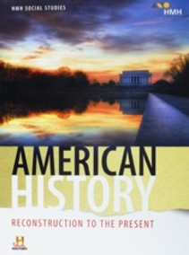
Houghton-Mifflin Harcourt
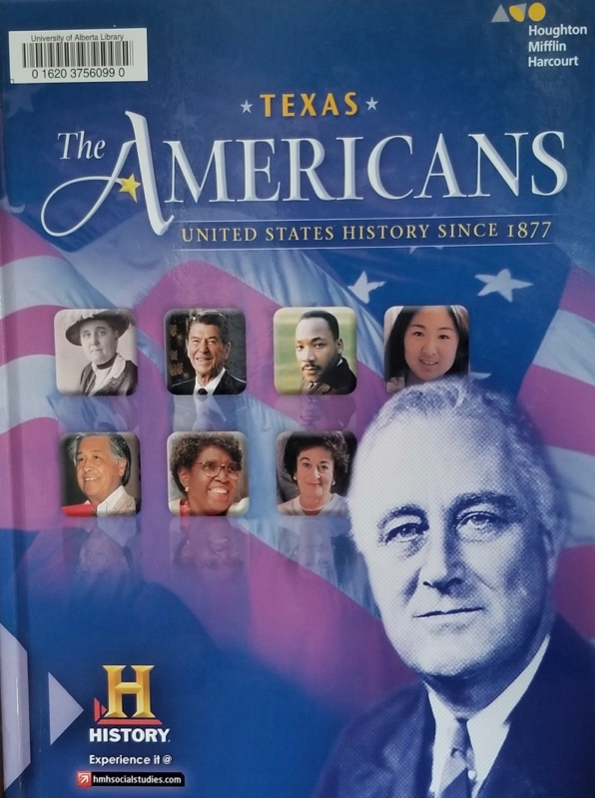
Figure 1b. The Americans: United States History Since 1877.
Gerald A. Danzer, J. Jorge Klor de Alva, Larry S. Krieger, Louis E. Wilson, and Nancy Woloch. 2016.
Figure 1a. American History: Reconstruction to the Present.
Gerald A. Danzer, J. Jorge Klor de Alva, Larry S. Krieger, Louis E. Wilson, and Nancy Woloch. 2018.

Danzer et al’s (2018) American History (California), present in Figure 1a, picturesquely depicts the Washington Mall. For many Americans, the Washington Mall symbolizes ‘the nation’ through its plethora of monuments and memorials that showcase both America’s heroes and its mainly victorious wars. Composed of the infinity pool and the Lincoln Memorial, both sites evoke strong notions of the American identity, with the Lincoln Memorial particularly conveying a sense of national success, “freedom” and “equality”. In turn, simultaneously speaking to the bravado and size of the nation through referencing the monuments’ grandeur nature. Danzer et al’s California cover, unlike those I discuss below, also attempts to remove itself from referencing the militarization of American society. By utilizing the Washington Mall as the image of ‘America’, the cover creates the illusion that the American nation-building project was a peaceful experience - not one filled with wars, oppression, and occupation. Although those familiar with the Washington Mall will note that the cover, albeit in a nuanced manner, does position the obtainment of the American values of “freedom” and “equality” in reference to the many military memorials that scatter this Mall, these monuments do not foreground the cover. Rather, they are hidden away from eyesight to detract from their involvement in the nation’s identity. Following this logic, I contend that by not positioning these memorials at the foreground of the cover, the cover depicts a concerted effort to hide the American military’s involvement in constructing the United States’ national identity. Hence, shifting the reader's gaze to view America’s domestic accomplishments instead of its military ‘successes’. In sum, the cover portrays the United States as a peaceful, idyllic nation – one whose history and values it continues to exemplify today through sites such as the Washington Mall.

Comparatively, Danzer et al’s Texas edition cover in Figure 1b evokes a less nuanced approach to dispelling a patriotic, American essence. Protruding the photo is Franklin D. Roosevelt, the 32nd President of the United States. The choice to foreground Roosevelt on the cover, overtop of the American flag, is highly tied to the militarization of American society. Rather than choose an image that depicts a President known for fostering technological innovation, such as John F. Kennedy, or the first African American President, such as Barack Obama, Danzer et al. (2016) depicts a President directly tied to America at war. Evoking memories of Pearl Harbour, emasculation, Japanese military defeat, American triumph over adversity, and the United States’ masculine ascendency as an economic and political superpower after World War II. More intriguing however are the parallels this cover draws between the national trauma of Pearl Harbour and the national trauma 9/11 invokes. Although the cover never directly points to 9/11, it highlights how the trauma of Pearl Harbour holds direct connections to the trauma of 9/11 and the process of “manning up” the nation underwent subsequently after these two attacks (Mann 2006, 179). Displaying how not only does the trauma of a nation’s emasculation and subsequent “manning up” pervade textbooks in nuanced ways, but its gendered and patriotic intonations also influence how we view these two attacks and the legitimacy of the nation’s leaders at the time (ibid.).

Roosevelt’s image also intersects with seven other figures on the cover who had all faced some type of societal ostracization or difficulties in their lives because of race, disability, or religious beliefs. As a reminder, textbook covers are never chosen simply for style and are meticulously crafted to evoke a specific meaning. Danzer et al’s (2016) cover, for instance, specifically dispels American inclusivity, success, and the American dream. One we can easily identify through the cover’s equal distribution of both women and men, who all represent a diverse set of ethnic backgrounds and experiences. Figures such as Jane Addams, César Chávez, Barbara Jordan, Gerda Weissmann Klein, Maya Lin, Martin Luther King, and Ronald Reagan (ibid., R61). American citizens who all contributed to civil or human rights-related activities, or in Lin’s case, built a sobering memorial that drew attention toward the magnitude of the American war effort in Vietnam. However, when analyzing these images together, they all tell one story. A story not of a white-settler nation or that of the Founding Fathers, but how America is truly a “melting pot” society that was built out of hard-working people from all ethnicities and cultural backgrounds. According to the cover, America is a truly accepting and equal nation - one that is premised not on discrimination and oppression, but one built on acceptance, community, and nationhood.

McGraw-Hill
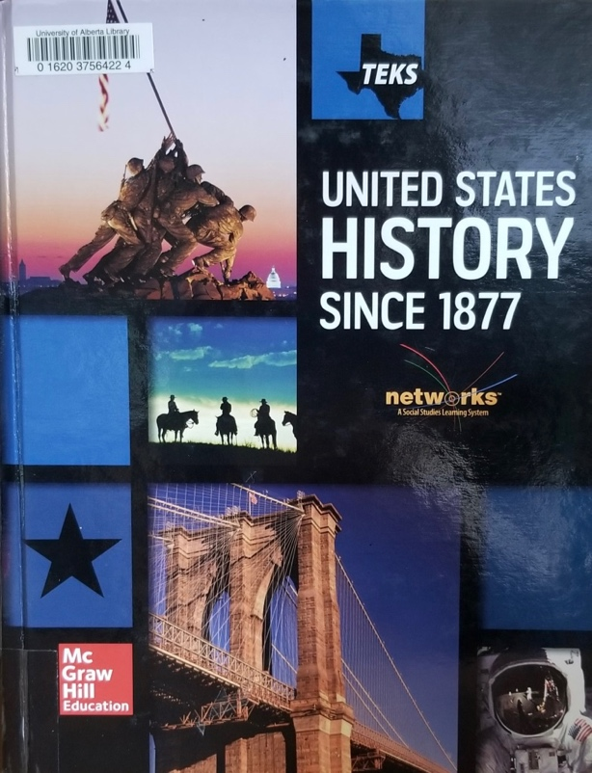
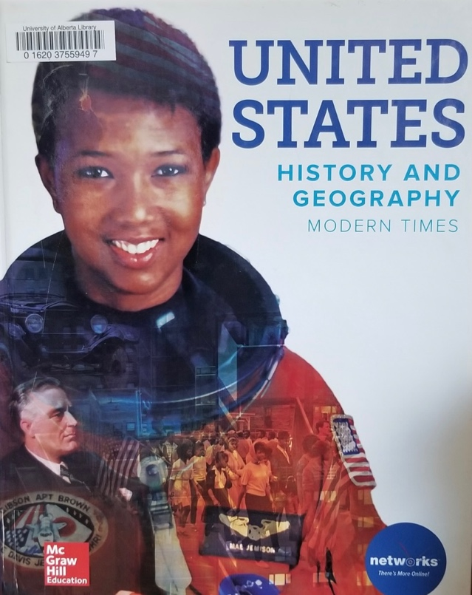
Figure 2b. United States History Since 1877.
Joyce Appleby, Alan Brinkley, Albert S. Broussard, James M. McPherson, and Donald A. Ritchie. 2016.
Figure 2a. United States History: and Geography: Modern Times. Joyce Appleby, Alan Brinkley, Albert S. Broussard, James M. McPherson, and Donald A. Ritchie. 2018.

Appleby et al’s United States History and Geography: Modern Times (California) and United States History Since 1877 (Texas), prides themselves on communal American achievements. The Californian text, Figure 2a, depicts Mae Carol Jemison, the United States’ first African American female astronaut. Still, this cover neglects to contextualize Jemison’s actions and mention who she is. Rather, what the authors expect students to take away from this photo is both the United States’ technological innovation, exemplified through both its space program and the existence of equal opportunities for men and women, coloured and non-coloured. This assertion is made more evident upon a closer examination of the image. Embedded in Jemison’s portrait are more images, containing Franklin D. Roosevelt, an unmarked civil rights march, a classic 1900s Ford model, and a young child holding the American flag. These images together demonstrate not only American successes and sacrifices, but also how these photos, actions, and ideas have built a foundation to allow Mae Carol Jemison to succeed. Jemison’s success is now, albeit exceptional, built and contingent on the successes of the male Americans before her who are responsible for these previous innovations. Showcasing how the women of the state, even when demonstrating grand accomplishments, are not responsible for these accomplishments. Hence, the cover effectively works to strip Jemison of her agency and autonomy while labelling her success as an extension of the state’s.

The Texas cover, Figure 2b, moves away from almost all notions of overt racial ‘equality’ and gendered opportunity through including images of the Marine Corps Memorial, the Brooklyn Bridge, an astronaut on the Moon, and ‘cowboys’ presumably in the Midwest. The cover emphasizes how America is built on its success in the development of technology (the space race), innovation (the Brooklyn Bridge), and importantly, expansionism (the Marine Corps and the Midwest). Nonetheless, I find myself questioning the selection of these images more than any other textbook I mention. Particularly, including an image of the Iwo Jima memorial is a curious choice. By now, it is well known that this image, taken by Joe Rosenthal, was staged by Rosenthal to imbue the viewer with a sense of patriotic fervor after a successful American conquest. A photo now known to be stylistically constructed to evoke a narrative of America’s reclamation of its emasculation after Pearl Harbour. Building on this logic, I see the author’s inclusion of a photo taken at Iwo Jima as a continuous attempt to reconstruct the American identity around the United States’ military successes. Iwo Jima, memorialized in American history narratives particularly because of the aforementioned photo, embodies American resolve, tenacity, and bravery after overcoming the throes of Pearl Harbour. The inclusion of the memorial not only juxtaposes America’s military might with Japan’s defeat but more importantly, it speaks to the continual process of reclaiming the “unmann[ed]” American masculine identity after the United States’ in Pearl Harbour (Mann 2006, 159). To summarize, this cover conveys many meanings: expansionism, technological development, and the United States’ remasculinization that accompanied the successful Pacific War. All three ideas come together to dispel the notion of American accomplishments, but also how American superiority pervades all facets of life.

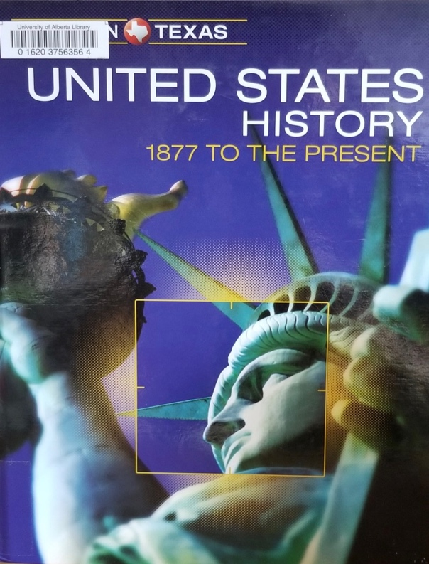
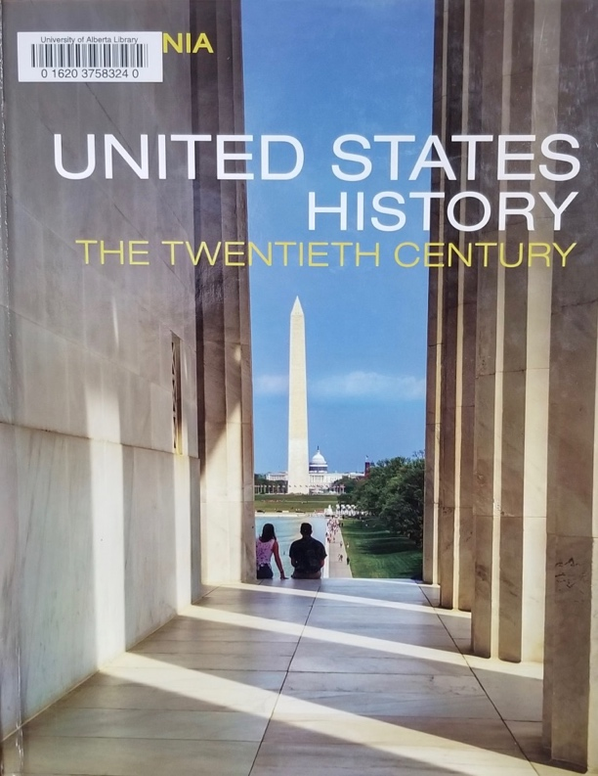
Pearson

Figure 3b. United States History: 1877 to Present.
Emma J. Lapsansky-Werner, Peter B. Levy, Randy Roberts, and Alan Taylor. 2016.
Figure 3a. United States History: The Twentieth Century, California.
Emma J. Lapsansky-Werner, Peter B. Levy, Randy Roberts, and Alan Taylor. 2019.

Lastly, Lapsansky-Werner et al’s United States History: The Twentieth Century, California, evokes a very similar message to that of Danzer et al’s California edition. In a less romanticized sense, Figure 3a once again alludes to the American national identity - one premised on key misconceptions that surround the United States’ nation-building project such as peace, equality, and freedom for all. Still, the viewer is left with a numbed understanding of American history: one that praises the Founding Fathers of America through the symbolism of the Washington Monument while detracting from the plethora of war memorials strewn throughout the Mall that emblematize America’s imperialistic presence around the globe. Leaving the viewer with a sanitized and peaceful vision of the United States, while concurrently drawing attention toward the grandeur and success of the nation that the Washington Memorial once again, evokes.

Another overtly nationalistic theme is that of Figure 3b’s Lapsansky-Werner et al’s United States History: 1877 to Present (Texas), with the Statue of Liberty foregrounding the photo. The Statue of Liberty overtly represents the American values of freedom, independence, and above all, a feminized liberty. For a country that prides itself on its settler history, using the Statue of Liberty as the singular photo on the cover dispels a prominent characterization of the American identity - one conceived and born out of European ingenuity, settlement, and the myth of equality. Through the Statue of Liberty’s close position to Ellis Island - a former immigration centre outside of New York City - the statue effectively acts as a gateway to obtaining the American Dream. Evoking the so-called melting pot rationale that prides itself on diversity and the ability for anyone to become successful, regardless of their gender, race, nationality, or religious association. The Statue of Liberty further promotes the question of gender as, although the statue itself depicts a female body with maternalistic characteristics that figuratively help care for the nation, this gender is seemingly erased. For many when looking at the Statue of Liberty, the monument does not represent that of a woman, but rather is degendered and takes on the image of the nation. One that does not symbolize the feminine, but instead, solely embodies characteristics such as liberty and freedom. Pointing to how, even though the statue epitomizes the notions of equality that the American state is purportedly premised on, the de-gendering of the Statue of Liberty showcases how the feminine aspects of the state are not accepted as equal and are seemingly forgotten or overlooked.

Together, these textbook covers draw on many of the prominent aspects of the American identity. I discuss notions of race, power, success, and sacrifice, alongside how the texts paint a picture of American exceptionalism – one displayed by the state’s technological innovation, military superiority, and diverse citizenry. However, what these covers also point toward is the inherent gendering of the state. To come back to Cynthia Enloe’s question of “where are the women”, these texts demonstrate a stark removal and co-optation of women that results in the covers depicting women only when they serve the interests of the state (1990, 1). Here, we see two examples of “feminine” covers with Jemison and the Statue of Liberty foregrounding the two textbook designs. For Jemison, because she espouses not only the masculine characteristics of an astronaut coupled with her being the first African American astronaut, McGraw-Hill deems her accomplishments acceptable enough to be on the cover. Moreover, although Jemison foregrounds the cover, the visual narrative that the cover evokes deeply within her image attempts to remove Jemison of her success and agency. Posing the state as responsible for her success - not Jemison herself. The Statue of Liberty, in comparison, is allowed on the cover because of the simultaneous de-gendering the statue faces. Focusing not on the statue’s purported gender but instead the values that it represents. Displaying how gender is only made visible by the textbooks when it serves certain interests, such as through the promotion of gender equality. But, when this gendering does not serve the textbooks’ interests, it is made invisible and silenced. Demonstrating one aspect of how textbook covers dispel the notion of the American masculine identity through their seeming erasure and silencing of all narratives that do not contribute to or help perpetuate its masculine identity.

In sum, textbook covers often embody the author’s view of “the nation” - with all six covers depicting a very masculine, and successful image of what constitutes the United States. Moving into my analysis of the content present within textbooks’ depiction of the War on Terror, I begin discussing America’s emasculation in the immediate post-9/11 space, then move toward an analysis of how the American state uses this emasculation as a means to legitimize its adjacent foreign policy endeavours. Thus, questioning how history textbooks reinforce the construction of the American masculine state through their depictions of the War on Terror.

Critical Discourse Analysis: America’s Unmanning
As I discuss in Chapter 3, the attacks of September 11th witnessed America’s “unmanning” with the emblematic physical penetration of the World Trade Center’s porous body representing a direct assault on the national body - an injury the American government attempted to refute. Drawing on the post-9/11 space as the focal point of my case study, this analysis demonstrates how the United States overcame its “unmanning” through utilizing textbooks as one tool to shift portrayals of its emasculation to be depicted as a heroic display of American “resolve”, self-determination, and reconstituted American masculinity (Mann 2006, 159; Lapsansky-Werner et al. 2019, 694). Following this logic, this section questions how the trauma of 9/11 not only serves as a legitimizing tool for future American military invasions but also helps shift the American identity toward one that embodies the vision of the American masculine state.
America’s Unmanning
Figures 4a, 4b, and 4c depict each textbook’s visual aids that accompany its discussion of 9/11. Similar here is how all three images demonstrate some form of destruction that followed the attacks - whether that was through the explosion of the towers or the rubble left in the wake of the towers’ collapse. This visual display of destruction is meant to evoke memories of trauma, anger, and defencelessness - memories that depict the American nation as the innocents in this cruel, unjustified, and warless act. More importantly, however, is how each textbook cultivates these emotions to emblematically represent America’s perseverance, resilience, and refusal to lose in this theoretical game of war. A show of defiance that is intrinsically connected with each textbooks’ choice to exclude all visual imagery of the towers collapsing. Rather, each text points to the tower’s unwillingness to fall - with Danzer et al. alluding to how the “weakened” towers persevered and withheld for “two hours after the attacks” before “crumbl[ing] to the ground” (2018, 892). The photo of President Bush at Ground Zero, standing in the figurative ashes of the nation, further symbolizes these “assurances of American manhood” through his embodiment of the nation’s fearless display of strength, “resolve”, and above all, manliness (Mann 2008, 187; Lapsansky-Werner et al. 2019, 694). By extracting the notion of “resolve” that permeates the American nation’s reaction to the attack, both the visual and discursive dimensions of the texts show how the nation refuses “to transform its vulnerability and wounds […] into an affective response of fear” (Ahmed 2014, 73). In turn, also refusing to accept the nation’s physical emasculation and unmanning that 9/11 caused through demonstrating the failure of the attack to “destroy the nation”, the American “way of life” and undermine the American masculine identity (ibid.; Lapsansky-Werner et al. 2019, 733).

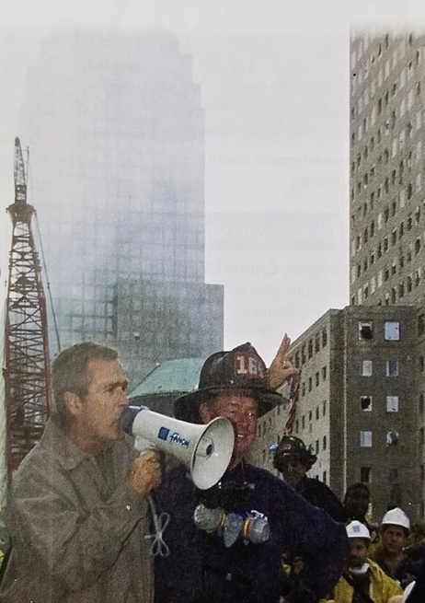
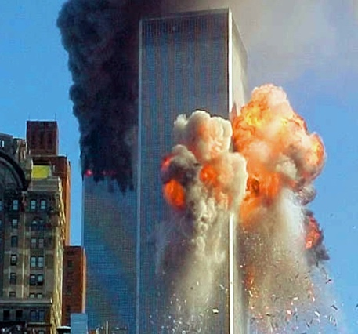
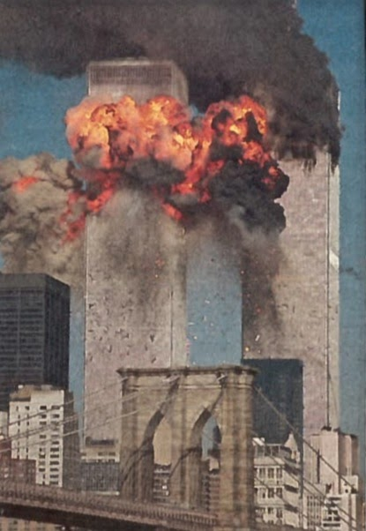
Figure 4c.
Appleby et al. 2018, 624.
Figure 4a.
Danzer et al. 2016, 895.
Figure 4b.
Lapsansky-Werner et al. 2016, 692.

9/11 as Shifting the American Identity
Despite Bush’s early attempts to label the attacks of September 11th as having failed to undermine the American psyche and “destroy the nation”, many Americans were left “deeply shaken”, vulnerable, and “shocked” at the notion that unknown, benevolent terrorists had succeeded in undermining their nation’s sovereignty (Lapsansky-Werner et al. 2016, 694; Appleby et al. 2016, 624). Drawing on these emotions, 9/11 concurrently triggers the American naval-gazing project - one that looks inward toward its national identity as a site that it must rebuild and reconstitute to prove its nation’s legitimacy in times of great vulnerability and weakness. As I highlight in Chapter 3, the reconstruction of a nation’s identity is premised on its ability to differentiate itself from the Other. A process of identity construction that textbooks also employ to bolster the United States’ process of “manning up” and reconstitute its masculine identity. Most prominent throughout the texts is how each constructs the notion of the American identity by juxtaposing it against the “Other”. This “Other” arises through each textbook’s ability to discursively link the bodies of Arab and Muslim men with the concepts of ‘terrorism’ and ‘threat’. For instance, Lapsansky-Werner et al. describe the attackers, al-Qaeda, as a deadly and ruthless “Islamist terrorist” group whose goal “was to end all American involvement in Muslim countries” and punish the U.S. for its “economic and military power” (2019, 733). Appleby et al. similarly sees the attack strictly as “Muslim hostility” for America sending aid to Israel (2016, 625). Danzer et al. conversely remove all mention of al-Qaeda from the text and solely blame the “Nineteen Arab terrorists” and “Islamic radicals” for the attack (2016, 894). Through homogenizing and likening the perpetrators to that of “Arab”, “Islamic”, or “Muslim hostility”, the figure of the “terrorist” becomes the faceless enemy “associated with some bodies (and not others)” (Appleby et al. 2016, 625; Ahmed 2014, 15). Cultivating an “economy of fear” that Ahmed notes “becomes contained in an object” - with this object being the brown body that fear manifests itself in (ibid., 67). The Muslim, Islamic, and Arab bodies then become envisioned as a “possibility of future injury” that the American body must defend itself from. Once again, delineating the American body (“Us”), to that of the Muslim, Islamic, and Arab bodies (“Them”), to promote a unified American force against the future terror that the “Other” possesses.

Furthermore, not only do textbooks construct the American identity through differentiating it from the geographically linked “Muslim”, “Arab” and “Islamic” bodies, but it also constitutes itself through the process of linking certain values to the American identity that the Other does not possess. Throughout all six texts, each depicts the American nation in a state of performativity where its citizens embody, and display, what it means to be American. Discursively permeating this American identity are the ideals of “resolve”, “unit[y]”, and “justice” - values that each textbook sees as enmeshed in the notion of the American identity (Lapsansky-Werner et al. 2016, 734). In comparison, this “positive process of linking” that connects the concept of “American” with identifiers such as “resolve” leads to the “negative process of differentiation” where those who are not American cannot possess these identifiers (Hansen 2006, 17). Drawing on this conceptualization, the United States then positions itself not only as geographically different but as innately more sophisticated and superior through defining itself as everything that the Other is not. Grounding the American response to 9/11 not as one embroiled in trauma and mourning, but as a show of the United States’ masculinity, superiority, and ability to overcome any egregious attack because of its “internal strength” that the Other does not possess (Ahmed 2014, 78).

This notion of internal strength, alongside other values each textbook deems inherent to the American nation, not only permeates the discursive conceptualization of the American masculine identity through the textbook’s narratives, but it also arises through their visual aids. Figures 5a, and 5b are two photos that correspond with Lapsansky-Werner et al’s section of “Americans Unite in Troubling Times” that attempts to connect the new nation-building project after 9/11 with that of American nationalism (2019, 734). Similar to the United States’ narrative shift that frames 9/11 as a collective display of unity, these photos selectively depict 9/11 not as a traumatic loss, but as a moral triumph over hate. With the American flag in Figure 5b evoking a narrative of “never forget 9-11-01”, these images not only imbue the reader with feelings such as “survival”, “freedom”, and “independence” that American society valorizes, but they also work in tandem to shift what a populace remembers, and forgets, in association with the attack (Lapsansky-Werner et al. 2016, 694). A shift to selectively manage how a population remembers 9/11 - one not laden with trauma and vulnerability, but instead, one where the American populace “rallied to defend the nation” (ibid. 2016a, 734). Marking again the textbook's gendered role in “delimit[ing] public discourse” to revolve around one masculine narrative not of failure, but of triumph against the Other (Butler 2012, 109).
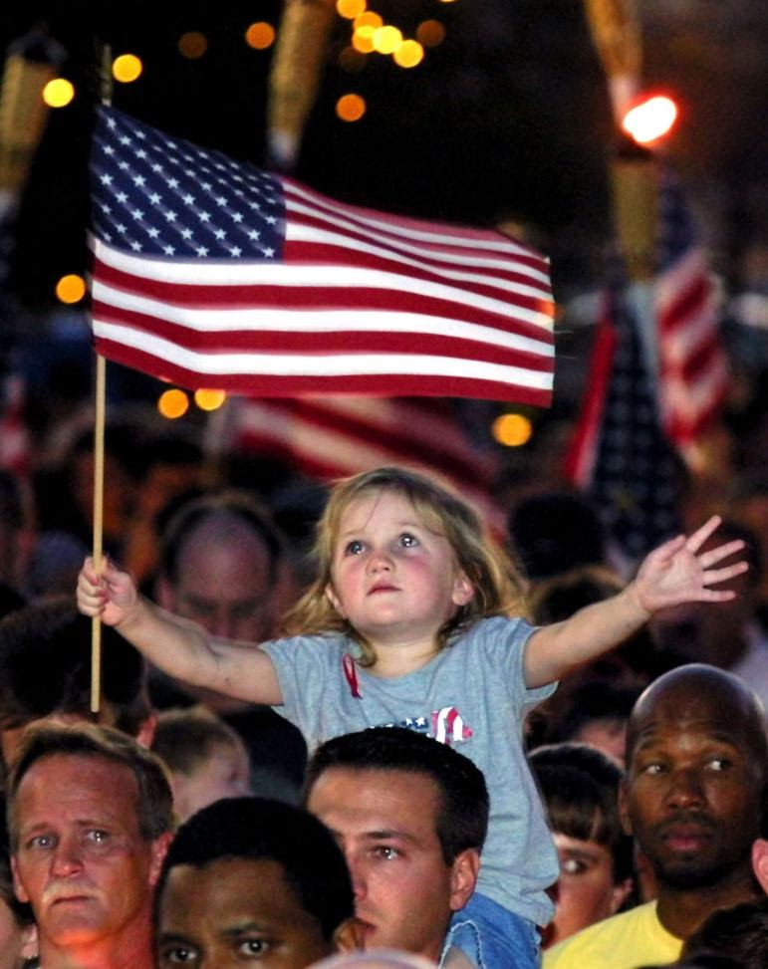
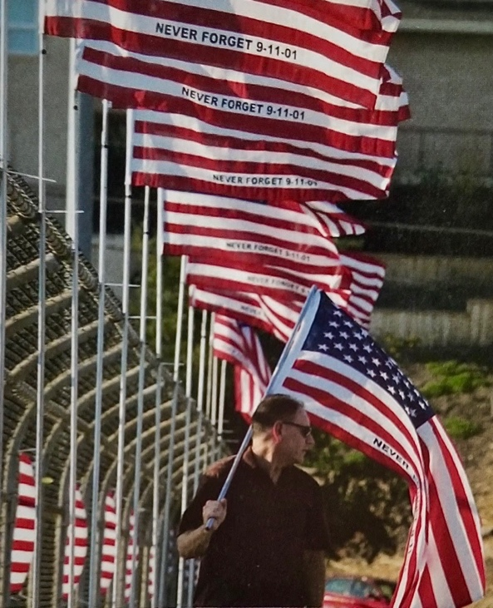

Figure 5b.
Lapsansky-Werner et al. 2016, 694.
Figure 5a.
Appleby et al. 2016, 626.

Hierarchization of Trauma
Identities function as applicators to discursively understand who does and does not belong to the American nation through using the tool of differentiation. Following this logic, not only do textbooks delineate who does and does not belong to this identity, but they also help depict what values constitute this identity and whose bodies are allowed to represent it. Resulting in a hierarchization ingrained in each textbook’s depiction of the trauma itself with specific bodies memorialized in the text’s narratives while others are seemingly forgotten. Embedded in the trauma of 9/11 are two hierarchizations of American bodies, with the first occurring with those affected in New York City over those in both Washington D.C. and Pennsylvania. In all six texts, the destruction of the World Trade Center overtakes any discussion of the other two hijacked planes - often with the plane crashes in Pennsylvania and the Pentagon described in a singular sentence at the end of a paragraph. Although this description, to a certain extent, is valid because of the higher death toll and magnitude of destruction in New York compared to the other two incidents, this description also highlights what the American state prioritizes in its trauma narratives: attacks against capitalism and financial mobility. As many texts describe the World Trade Center as the “center of American finance”, 9/11 gained new meaning through not only being an attack on the American state but also an attack on its way of life (Appleby et al. 2018, 892). Allowing textbooks to shift the narratives of 9/11 from any notions of failure or national culpability to instead frame the attack as inevitable because of America’s formidable success financially and democratically. In comparison, although the falling towers represent the emasculation of the state, the attack on the Pentagon further symbolizes a more harmful attack on the masculinity of the nation - with the military representing the epitome of its masculinity. Choosing to focus the nation’s trauma around that incurred in New York also works in tandem to hide the United States’ military defeat and loss from the attack on the Pentagon. Hence, in hierarchizing the trauma endured in New York, the text shapes the narratives of 9/11 to exclude almost all notions of the American military defeat while simultaneously emphasizing the failed attack against America’s values.

Secondly, not only does a hierarchization exist in what events the textbooks memorialize, but it also exists in who textbooks decide belong and do not belong to the American identity. As I discuss in Chapter 3, narratives surrounding the loss of 9/11 demonstrate how the state favours memorializing those who represent the fullest expression of the American masculine identity. Relating to this gendered memorialization is how all six textbooks exclude a precise death toll of 9/11 from their descriptions by detailing how “[a]bout 3,000 people were killed” (Danzer et al. 2016, 894). With the exact death toll for 9/11 amounting to 2,977 people, it is surprising that no text felt it necessary to precisely account for all of the lives lost during these attacks (CNN 2020). Instead, each textbook’s simplification of the collective loss demonstrates how the bodies of those killed are only articulated as “a measure of war intensity” and used to display the trauma of the nation. Through summarizing Judith Butler’s Precarious Life (2004), Christine Sylvester notes that “some war deaths are counted and grieved and many others are ignored” (2019, 1). Leading again to the determination that only the bodies that matter to the state are accurately counted and acknowledged.

To explain this homogenization of the United States’ collective loss, Marita Sturken develops the concept of “the hierarchy of the dead” (2002, 384). Similar to Butler’s assertion, Sturken notes how, not only are some lives grieved while others are not, but in that grief also exists a hierarchy - with some deaths warranting more grief from the state than others. For instance, after shortly describing the collective loss of life from the attacks of 9/11, Danzer et al. speak valiantly of those involved in New York’s rescue operations:

Amidst the brutal destruction at the World Trade Center, the courage, selflessness, and noble actions of New York City’s firefighters, police officers, and rescue workers stood as a testament to the human spirit. Many of the first firefighters at the scene disappeared into the burning buildings to help those inside and never came out again. Entire squads were lost. Rescuers worked around the clock trying to find survivors in the wreckage. They had to contend with shifting rubble and smoky, ash-filled air. Medical workers from the area rushed to staff the city’s trauma centers. But after the first wave of injured were rescued, there were few survivors to treat, only bodies to recover (2018, 892).

Here, Danzer et al. directly equate the human spirit to the qualities many, assumedly male Americans possess - with displays of “courage”, “selflessness”, and “noble actions” legitimizing the first responder’s suffering and loss because they embody these desirable qualities (ibid.). Where those who do not possess these qualities are seemingly silenced and forgotten by being equated to “only bodies” that lack physical attributes and characteristics (ibid.). This excerpt also displays what bodies and characteristics are allowed to belong to the national identity with the defenceless, feminized civilians in the World Trade Center allowed no connection to the state. Where those of the masculine saviors are allowed to embody the loss of the nation as the “iconic victims” of 9/11 (Sturken 2002, 381).

This quote also works to tie the performativity of the American masculine identity to the bodies of New York’s first responders. Here, the first responder embodies that of the nation - with both the first responder and the nation falling courageously together in the line of duty. Additionally, the quote also displays how, although the attack briefly defeats the state, the state does not fall in vain. Instead, it falls as a courageous, selfless, and noble nation - not a feminized and weak nation. Following this logic, this excerpt attempts to disagree with Bonnie Mann’s earlier assertion that “winning is the telos of the masculine nation, and losing is its unmanning”. As this text highlights, through New York’s first responders embodying and performing certain masculine characteristics as the towers emblematically fall to the ground, this “unmanning” does not persist as the first responders’ masculine performativity continues even in the wake of the tower’s collapse (Mann 2006, 159). Indicating that the United States did not lose its masculine identity but instead chose to embody it in more nuanced ways. Leading to textbooks framing 9/11 not as the nation’s “unmanning”, but as a way to reconstitute, reconstruct, and perform its masculine identity through the bodies of New York’s first responders.

Textbooks Role in Reframing America’s Unmanning
By linking the American identity to certain values and ideals that help prove its nation’s masculinity, while conversely differentiating that identity through comparing it to the Arab, Muslim, and Islamic Other, textbooks help to construct and disseminate the American masculine identity. As identities require their continued perpetuation and re-articulation for sustenance, constructing a nation that persevered in a time of great trauma, while simultaneously embodying that of the masculine first responder, allows textbooks to create a selective depiction of history. Through discursively shifting the narratives around 9/11 to reflect a positive image of the nation persevering rather than ‘falling’ after the attacks of 9/11, textbooks help legitimize both the construction of this masculine identity, while further promoting the attacks of 9/11 as a legitimizing tool for future American invasions.

The American Rebuilding Project
Identities help make sense of foreign policy. They ascribe meaning, legitimize, or delegitimize
an action, and mobilize a nation’s populace around a certain ideal. Identities also come into being through foreign policy. They visually display a nation’s thoughts, insights, and self-understandings through their performance on the world stage. Thus, for the newly rearticulated American masculine identity to come into being after its “unmanning” from 9/11, this identity also necessitates its performative enactment for others to make sense of, understand, and visualize. An enactment that, because of the intersections between a state’s masculinity and its performance through the military, is embodied and showcased during the War on Terror. Building on the previous section that discusses the United States’ “unmanning”, this section analyzes how textbooks view the American rebuilding project through the case studies of the invasions of Afghanistan (2001), and Iraq (2003). These two cases, albeit both under the auspice of the War on Terror, serve two different purposes within this singular military campaign. For instance, the invasion of Afghanistan is premised as the beginning of the American rebuilding project. The first display of force after the attacks of September 11th that meant to depict America’s re-entrance onto the world stage. Conversely, Iraq embodied the performative enactment of the United States’ newly rebuilt identity. Thus, leading to both invasions dispelling two very different notions of what is the American identity, how the identity is performed, and what purpose the identity serves. However, what these case studies also help signify together is the continual reassertion of the nation. Reassertions that are also evident in textbooks.

Identity as Legitimation: Operation Enduring Freedom
As Charlotte Hooper notes, the military is “the fullest expression of masculinity” as it epitomizes and performs numerous characteristics innately tied with society’s conceptualization of masculinity (2001, 81). Characteristics such as “natural aggression”, domination, and physical force that, when enacted in a militarized setting, help demonstrate a nation’s superiority in contrast to the feminized Other the state is fighting against (ibid.) In turn, war is simply an affirmation of a state’s masculinity, where if a state “wins” its masculinity is proven by demonstrating its ultimate authority internationally. Thus, as winning acts to legitimize a state’s authority through displays of physical force and perceived control over the feminized ‘loser’, the United States similarly sought to utilize its military capacity to performatively reclaim its position as the global hegemon and masculine state. Effectively undoing its previous “unmanning” through acts of retribution that seek to feminize the Other while simultaneously recovering its “national manhood” after 9/11 (Mann 2006, 149).

Following this logic, it should be no surprise that textbooks also view the military’s occupation of Afghanistan in a similar, masculine light. To all six textbooks, the invasion of Afghanistan is a display of sheer, militarized force. Immediately after invading Afghanistan, the American forces “shattered the Taliban’s defenses”, “launched massive attacks”, and physically bombarded the state (Appleby et al. 2018, 628). When submitted to the American military might, the Taliban government, “fell”, “fled to the mountains” and was “dr[iven]... from power” (ibid., 628; Danzer et al. 2016, 896). Rhetoric that both imbues the reader with an overwhelming sense of American muscle and superiority while also drawing parallels to the American “refusal” to lose during the attacks of 9/11. A refusal that, comparatively, the Taliban could not muster because of its inability to match the fortitude and mental strength of the American nation. Thus, drawing distinctions to the United States’ previous “unmanning” that, although represented as a loss of sovereignty and national prestige, demonstrates American resolve and perseverance that the Taliban forces simply do not have. Leading to the distinction that, not only does the United States possess superior military might against the innately weak Taliban forces, but moreover, the values that the American nation holds and performs throughout the invasion also display its superior masculinity.

Albeit in different and nuanced ways, all six textbooks describe the declaration of the War on Terror and the subsequent invasion of Afghanistan as “a war the nation had to fight” (Appleby et al. 2018, 626). A war that was not against a certain country, but rather, a war to defend the American masculine identity and its purported values that each textbook reflected its discursive usage of the American values of ‘freedom’ and ‘justice’ to rationalize the invasion. In Bush’s declaration of war, a narrative of America retaking its position as a global leader, policeman, and “peacekeeper” by promoting the notions of freedom and justice quickly saturate much of the textual discourses surrounding the invasion (Appleby et al. 2018, 627). Here, narratives portray the United States as the world’s protector - most overtly displayed through its naming of the invasion of Afghanistan as “Operation Enduring Freedom” (Danzer et al. 2018, 893). Hence, helping to rearticulate the United States as a protector nation that is “pursuing the attackers” through holding both terrorists, and states who harbored them as “accountable” for their wrongdoing and misconduct (Lapsansky-Werner et al. 2019, 734). Following this logic, the United States quickly transforms itself from the attacked nation seeking vindictive justice to now, a selfless nation seeking peace, prosperity, and the promotion of universal values to help save oppressed people around the world. By framing the United States as promoting a set of principles that belong to the American identity and not that of the Arab, Muslim, and Islamic Other, each textbook sees the War on Terror not as a brute show of military force, but rather as a display of paternalistic notions of protection that attempt to save the “Other” from harm.

Here again, the United States reasserts its masculine identity by placing responsibility on itself for ensuring the success and prosperity of other nations, such as Afghanistan. Appleby et al., for instance, labels the American intervention as an attempt to “help stabilize the [Afghan] country”, “maintain peace”, and “create a stable Afghan-led nation” (2016, 628-629). Quickly, textbooks forget the destruction and penetration of Afghanistan’s sovereign borders by American troops, and instead, herald the United States for bringing peace, democracy, and universal principles to rescue the Afghani people from the Taliban’s oppressive rule. For example, all six textbooks highlight the commencement of Afghanistan’s first democratic election in 2004 as a turning point in Afghanistan’s democratization. Importantly, all textbooks highlight the gendered composition of Hamid Karzai’s government, with Appleby et al. praising Karzai for “appoint[ing] several women to his cabinet” (2018, 629). The construction of a democratically elected government that includes multiple female representatives exemplifies how the authors view certain values, such as democracy and gender equality, as indicators of a state’s legitimization and transformation to align more closely with the preferred values of the idealized American nation. Demonstrating how the textbooks utilize the ideals of democracy and women’s representation as tools to measure both Afghanistan’s “success” as a nation and the United States’ involvement in that success (Appleby et al. 2018, 628).

To summarize, the invasion of Afghanistan helped reconstruct and embed the American masculine identity into the nation’s psyche in a multitude of ways. Through both the American military’s brute show of force alongside its portrayal of many masculine characteristics that saturate each textbook’s narration of the invasion, the war in Afghanistan reframes the United States’ “quest for invulnerability” and project of “manning up” as a reassertion of America’s global leadership and rightful position as hegemon (Mann 2008, 179). Leading to a nuanced reclamation and performative display of its masculine identity through spreading these values worldwide.

Identity as Legitimization: Operation Iraqi Freedom
The invasion of Iraq, similar to Afghanistan, “was an occasion for [the American identity’s] performative constitution” (Mann 2006, 155). However, unlike Afghanistan, Iraq did not serve to reassert the United States’ masculinity on the world stage. Conversely, the infiltration of Iraq was intended to performatively maintain the United States’ newly constituted masculine identity that it had previously rebuilt and asserted through its occupation of Afghanistan. As Bonnie Mann notes, “the superpower identity can only be maintained and expressed through repetition, through a staging and restaging of its own omnipotence” (Mann 2006, 155). Hence, the invasion of Iraq worked to stage and restage the American military’s performative ability to solidify the nation’s masculine identity on the international stage.

Much like the American invasion of Afghanistan, militarized rhetoric infiltrates the textual narratives surrounding the invasion of Iraq to depict the American forces as unchallenged and militarily superior when facing the Iraqi Other. Here, the United States “stormed into Iraq” and launched “massive air raids” - forcing the government of Saddam Hussein to “dissolve” and “collapse almost immediately” (Danzer et al. 2016, 896; ibid. 899; Appleby et al. 2018, 630; Lapsansky-Werner et al. 2016, 695). In a parallel vein to that of the Taliban government in Afghanistan, the American forces witnessed “Saddam and other Iraqi leaders [go] into hiding” (ibid., 734). Depicting a similar feminization of the enemy that saw both the Iraqi and Afghani military forces cowardly fall under the immense pressure of America’s military might. Acting as the textbook’s first demonstration of the American’s attempt to re-solidify its identity as the global hegemon.

Similar to that in Afghanistan, underpinning the invasion of Iraq is the United States’ paternalistic notions of protection it exudes throughout the entirety of the War on Terror. Figure 6 exemplifies the American infantilization of Iraq, with Iraq embodying that of the child and the United States that of the soldier and father figure. Depicting the American military forces not as the aggressor in this invasion, but instead as a paternalistic leader helping Iraq grow as a nation from adolescence into adulthood. As in Afghanistan, these notions portray the United States military forces as the global protector, policeman, and peacekeeper that is responsible for the world’s safety. In this context, Appleby et al. discuss how Bush had to “deal with Iraq” – once again equating the United States to the ‘big brother’ or father figure who needs to share its ideals of “freedom and liberty” to help the “oppressed Iraqi people” (2016, 630; Hansen 2006, 25). In utilizing the notion of the protector that must again, “deal with Iraq”, Bush not only legitimizes the invasion of Iraq to protect the world from the imminent threat of biological and chemical weapons but he also discursively differentiates the American values of “freedom” and “liberty” with that of the Other’s (Appleby et al. 2016, 630; ibid.). Enacting paternalistic notions of protection that help validate the invasion on the premise that the Iraqi way of life must be moulded to better conform to that of the United States’ to help Iraq ‘grow up’ and improve its society through enacting certain individual liberties and universal principles.
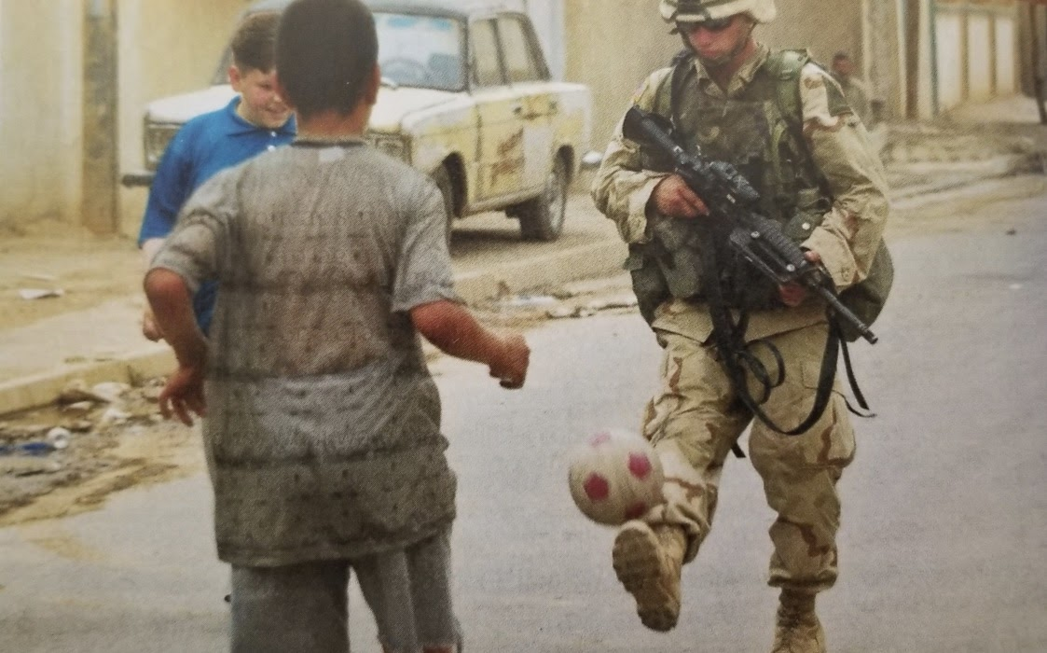

Figure 6.
Appleby et al. 2018, 632.

One tool the United States enacts to push Iraq from its theoretical ‘adolescence’ into ‘adulthood’ is the visual “unmanning” of Hussein. A shift that allows for the imposition of democracy and greater gender equality across the nation while simultaneously paving the way for Iraq’s emergence as a new, democratic nation in the mainly “evil” Middle East (Appleby et al. 2016, 629). Yet, the unmanning of Hussein also holds greater symbolism, with the physical toppling of Hussein’s statue paralleling the collapse of the World Trade Centre. Figure 7a, and 7b display Danzer et al. and Lapsansky-Werner et al’s visual demonstrations of the “fall of Hussein” (Danzer et al. 2016, 899). These photos both emblematize the emasculation of the nation and the physical “unmanning” of Hussein and his regime. In a similar vein to 9/11, the images display the crumbling of the nation. However, diverging from the images of 9/11 with those of Hussein’s fallen statue is how the Americans, unlike al-Qaeda, remain to stake their claim and refuse to “cut and run” (Appelby et al. 2018, 632). Following this logic, the paralleled nature of both the fall of Hussein with that of the crumbling World Trade Centre dispels the notion of American retribution. Labelling the War on Terror as a successful enterprise because of its similar emasculation of the enemy that fully proves its re-emergence onto the world stage.
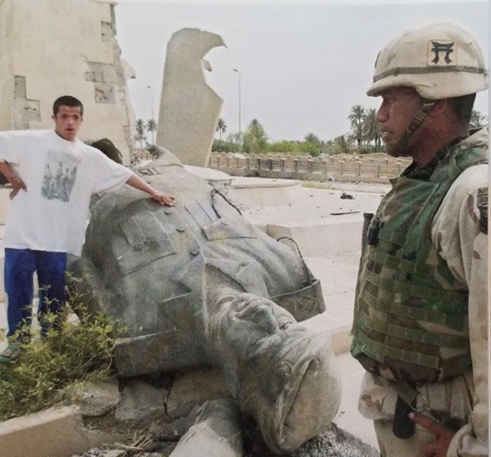
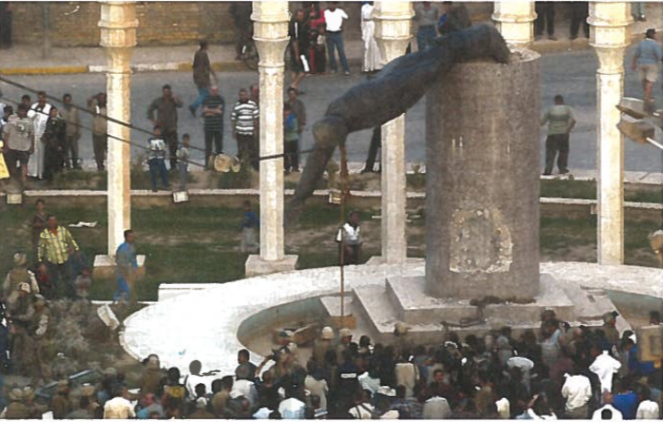
Figure 7a.
Danzer et al. 2016, 899.
Figure 7b.
Lapsansky-Werner et al. 2016, 695.
As many of the textual narratives surrounding both the American invasions of Afghanistan and Iraq remain similar, the diverging points in these narratives revolve around how the textbooks measure the success of each invasion. Throughout their depictions of American foreign policy in the 20th and 21st centuries, textbooks are reluctant to note any American failure or flaw. Surrounding their portrayal of 9/11 for instance, all six textbooks avoid discussing the American support for the mujahideen that helped garner al-Qaeda much of its power in the 1980s. Textbooks’ illustration of Afghanistan runs in a similar vein, with each text refusing to discuss any notion of an Afghani death toll or failure of the American forces to bring peace to the region after its destabilizing invasion. This is mainly because of the United States’ success in removing the Taliban from power and installing a democratic government in Afghanistan, at the time the texts were written. Allowing textbooks, because of these accomplishments, to label the invasion of Afghanistan as mainly a success.

In comparison to Afghanistan, Iraq’s portrayal in each textbook holds greater controversy. Under President Bush’s decision to invade, he cited Hussein’s capacity to utilize his purported Weapons of Mass Destruction (WMD) as “a grave threat” to world peace and American sovereignty (Lapsansky-Werner 2016, 629). Under this premonition, Bush alongside a small coalition of forces invades Iraq. Yet, what remained contentious throughout the whole occupation was the American “failure to find any WMD” - an irregularity that most texts note and criticize (Appleby et al. 2018, 631). Therefore, the texts’ discussion of the United States’ failure in Iraq is jarring. However, for the United States, the invasion’s success in Iraq did not derive from its ability to quell dissent in the region, but rather, is premised on the American’s ability to invade in the first place. Important to the American people is the aesthetics of war - the continual reassertion of the United States’ masculinity on the world stage that once again displays its superpower status and reclamation of its title as global hegemon after its unmanning of 9/11. As Bonnie Mann notes, “aesthetics is the linchpin of American national style” – an ideal that enables the United States to “displace the need for good reasons altogether” to invade. Thus, allowing the United States to premise the Iraq war on aesthetics over justification.

Secondly, in highlighting the war’s failure, textbooks demonstrate the United States’ ability to attack a sovereign nation when an invasion of such magnitude is not justified nor legitimated by an international committee. Drawing on this conceptualization, textbooks’ disagreement toward the legitimacy of the American invasion of Iraq does not work to contradict the American masculine identity as one may assume. Instead, these disagreements help bolster this masculine identity because it reasserts the American nation’s position as the global protector and leader. Displaying how, even when the United States lacks justification for an action, it can proceed with any invasion because of its status as the masculine hegemon and unchallenged control globally.

In sum, placating all six textbook’s discursive representations of the War on Terror is both the American military’s expressive show of strength and capability and its portrayal of the invasion as a protective intention to increase the welfare and independence of both the Afghani and Iraqi people. However, embedded in these narratives of the American saviour complex also highlights a discursive shift in the American masculine identity. One that looks toward foreign policy as an opportunity to reconstitute its identity rather than looking inward toward itself after 9/11 as a site to reconstruct and perpetuate its identity. Through each textbook’s discursive and visual narrations, they display how the United States sees itself during these invasions but moreover, how it legitimizes these invasions through utilizing its identity.

Before ending this chapter, I briefly turn to a short discussion on “where are the women” in these textbooks. As I have spent a great deal of time documenting the American masculinist enterprise, it only seems natural to also question where the women fall in this enterprise and how textbooks depict, or do not depict, women.

“Where are the Women” Now?

Following Cynthia Enloe’s famous adage of “where are the women”, my analysis falls into a similar peculiarity where all of the textbooks I use in this study seemingly exclude all mention of women from their texts (1990, 1). To highlight this exclusion, Figure 8 depicts the sole photo of a woman present in all six textbooks’ discussion of the War on Terror. Additionally, not only are women visually absent from the texts - with Appleby et al. (2016; 2018) posing as the only exception, but women are also discursively absent - with Appleby et al. (2016; 2018) again being the only authors that mention women even once in their texts. This poses the question of, if the invasions of Afghanistan and Iraq were so heavily premised on the gendered tropes of stopping the “brutal oppression of women” and spreading the values of gender equality across the illiberal world that Laura Bush advocated for, then why are these narratives excluded from the textbooks (Stout 2001). Important to note in this discussion is the context of the image below. Figure 8, taken in 2004, depicts an Iraqi woman after voting. Here, the image is meant to exhibit the United States’ success in spreading both the values of democracy and gender equality throughout Iraq. Marking the state’s shift from adolescence to adulthood. However, this image also draws our attention toward how women, when appearing in a textbook, often do so as a way for a text to measure the success of a policy, such as how advanced a nation’s democratic and gendered freedoms are. Highlighting how the presence of women is only valid and useful in a textbook if they serve to promote an ostensive American value. In sum, textbooks push all women to the periphery of the “core narrative” as they are only introduced into a text if their gender helps to bolster the image of the American masculine state (Clark 2005).
Figure 8.
Appleby et al. 2016, 631.

California Versus Texas: Diverging National Narratives?
To end my analysis, one facet of my study questions if textbooks dispel one, resounding national narrative of past American foreign policy endeavours. Analyses of state textbooks, such as Goldstein (2020), note the diverging narratives that textbooks from California and Texas evoke. Goldstein’s study highlights the stark political divide between California and Texas as a problematic influencer in the content of the books. Yet, this study only analyzes domestic history - with that of each state’s discussion of slavery situated as the focal point of Goldstein’s analysis. My analysis, in comparison, situates itself solely around the topic of American foreign policy, where I find no prominent, diverging narratives to exist between the textbooks from California and Texas, unlike Goldstein’s study.

Important to note is how each of the three main publishing houses utilize the same authors for both their California and Texas textbooks – making it easy to distill what changes each state’s board of education made to the textbooks. With no prominent distinctions arising between the Californian and Texan textbook’s depiction of the War on Terror, this demonstrates how there is one overarching American narrative surrounding these wars. Signifying that, if all textbooks portrayals of the War on Terror remain consistent across state lines, so too does each text’s depiction of the American masculine identity. Allowing textbooks to become implicated in constructing and perpetuating one national identity that is not affected by state politics or interests. Secondly, as neither California nor Texas’s boards of education change the content within their textbooks, it also demonstrates how the state plays an almost non-existent role in influencing the textbook’s content around American foreign policy. Signifying that, even though each state is responsible for its education system, few changes are visible between the different state editions. Additionally, it is important to note the lack of contention in state politics that foreign policy garners. Although the House of Representatives still holds authority over foreign policy, the Commander in Chief often determines foreign policy. Leading to state politics rarely impacting the decisions that surround the American military and thus making it an unimportant topic for each state to attempt to influence. Hence, although each state controls their education and textbook selection, what results is the representation of one overarching American identity that is almost identical across all six textbooks.

Conclusion
During this analysis, I demonstrate how textbooks are implicated in dispelling a masculine identity through their discussion of the War on Terror. First, embedded in each cover’s imagery of ‘the nation’ emerges a narrative of the nation’s masculinist success. A success grounded in its technological innovation, melting pot rationale, and military superiority. Secondly, in conducting a critical discourse analysis, textbooks similarly depict gendered and militarized discourses around the War on Terror. Through their portrayal of 9/11, textbooks work to shift the narratives surrounding the United States emasculation and loss of sovereignty from one of an inherent failure, to one dispelling the event as a show of American resolve and internal strength. Building on this narrative shift, each textbook simultaneously deconstructs its understanding of the American identity to evoke both a differentiation and hierarchization within that narrative to help reconstruct the identity against the “Muslim”, “Arab”, and “Islamic” Other. Further legitimizing this identity for the state to later employ under the auspice of the War on Terror. During the invasion of Afghanistan and Iraq, each textbook utilizes this newly reconstructed identity to illustrate America’s rebuilding project. A project premised on both the nation’s military might while simultaneously relying on the American identity as a tool to dispel a plethora of liberal values and ideals to further legitimize the American presence as the world’s protector and leader. Hence, both the textbooks’ portrayals of 9/11 alongside the invasions of Afghanistan and Iraq work to demonstrate the United States’ perceived retaking of its masculine identity - with the fall of Hussein’s regime symbolically representing the United States’ return as the global hegemon.

Lastly, as my analysis serves to deconstruct textbooks’ portrayal of the American masculinist enterprise through their depiction of the War on Terror, this chapter also briefly discusses the exclusion of women from both the textual and visual dimensions of the textbooks. After noting in Chapter 3 how the Bush administration consistently cited the importance of saving the ‘oppressed women and girls’ from Taliban occupation during its invasion, it is surprising that this narrative only emerges in one publishing house’s text. Drawing attention toward the pervasiveness of gendered discourses in the textbooks through the seeming erasure of almost all women’s involvement in 9/11 and the occupations of Afghanistan and Iraq. Demonstrating how textbooks, in both shifting and excluding certain narratives, help rebuild and reconstitute the American identity to legitimize the reprisal of its role as global hegemon.

Moving toward the concluding chapter, Chapter 5 serves to answer the question of “why does this analysis matter?” I briefly summarize my findings from my study, then move toward addressing why these findings are important, what research gap this study fills, what implications they hold for our understanding of history education, and how state-oversight in textbooks poses problems for student’s future understandings of the state and their own identity. Lastly, I point to future areas of research and how this study can add to larger studies that look at forms of public remembrance and memorialization around the United States foreign policy.

Chapter 5 Conclusion: Why does this matter?

Introduction
In this study, I question how history textbooks reinforce the construction of the American masculine identity through the Bush administration's War on Terror. To answer this question, I ground my study in feminist analyses of the masculine state to deconstruct the values and notions present in textbooks that underpin the American identity. Through exploring the discursive construction of the United States’ identity in six high school history textbooks’ depictions of the War on Terror, this study reveals how textbooks employ the methods of linking, differentiation, and hierarchization to help rebuild and reconstitute the American masculine identity. In sum, my analysis shows how textbooks impose one overarching, national narrative that seeks to shift the discourses surrounding the War on Terror and American military interventions to reflect an image of protection, masculinity, and hegemony. A narrative shift that, as a result, also works to exclude the bodies and voices that go against this idyllic image of the state - such as women.

This concluding chapter serves three goals. First, it summarizes the study’s findings from Chapter 4’s critical discourse analysis. Second, it questions why this research matters, and what implications these findings present for the future of education studies. Third, it identifies areas of future research before concluding the study.

Findings: America’s Project of “Manning Up”
To many feminist theorists, 9/11 represents the United States’ physical “unmanning”. However, when discussing 9/11, what each text exhibits is not a depiction of America’s unmanning but instead, a narrative of how the United States’ triumphed over hate and “evil” (Lapsansky-Werner et al. 2016, 693). In shifting the narratives around 9/11 from reflecting a traumatic loss to one representing the United States’ “internal strength”, textbooks effectively dispel “assurances of American manhood” that signal the beginning of the United States’ reconstruction of its masculine identity (Ahmed 2014, 78; Mann 2008, 187). In doing so, textbooks highlight two important facets involved in reconstructing the American identity immediately after 9/11. First, each textbook differentiates the American nation from the “Other” to, in turn, make sense of why the nation was attacked. Second, after differentiating between who belongs to the nation (“Self”) and who does not (“Other”), each textbook additionally constructs a hierarchy within the American identity. One that equates the loss of New York City’s first responders to the loss of the nation. Demonstrating that, because of New York’s first responders’ physical enactment of certain masculine traits during 9/11, they are allowed to embody the trauma of the nation. In comparison, office workers and janitors who also perished in the World Trade Centre are seemingly forgotten because of their feminized deaths. Leading to what Marita Sturken calls the “hierarchy of the dead” where some bodies are grievable and others are not (2002, 384). Thus, illustrating who the American nation deems as important to remember and therefore, how the nation continues to perform its masculine identity in nuanced ways even during the trauma of 9/11.

Unlike America’s unmanning after 9/11, the invasion of Afghanistan symbolizes the United States’ rebuilding project and reassertion of its masculinity on the world stage. The invasion of Iraq, as an extension of the American invasion of Afghanistan, helps to solidify this identity. Hence, working in tandem together to propel the United States to its rightful position as global hegemon and protector that it was seemingly stripped of after 9/11. To do this, all six textbooks depict the two invasions as a sheer display of American muscle that caused both Afghanistan and Iraq to immediately fall. Secondly, after the United States’ masculine triumph over the feminized Afghani and Iraqi Other, all six textbooks shift to discussing the “success[es]” of the American occupations (Appleby et al. 2018, 628). Successes that the texts define as the United States’ ability to disseminate its purported values of democracy and gender equality amongst the oppressed people of Afghanistan and Iraq. Quickly, textbooks’ depictions of the War on Terror shift from an initiative premised on redemption to one framed as a civilizing mission to help the infantilized states of Afghanistan and Iraq ‘grow up’. In turn, legitimizing the United States’ reclaimed position as the global policeman and protector because of its role in disseminating the ostensive values of the American identity to help save the innocent Afghani and Iraqi civilians.

Lastly, this analysis not only notes the masculinized rhetoric that infiltrates all six textbooks, but it also notes the lack of women present in both the narrative and visual dimensions of all of the textbooks. As each text only mentions women when referencing the United States’ perceived success in spreading its values throughout both Afghanistan and Iraq, such as the values of democracy and gender equality, women instantaneously become tools to measure each invasion’s success. Highlighting how each textbook, and by extension the American state, only display and utilize women when they serve a particular interest and help bolster the masculinity of the state.

To summarize, textbooks are implicated in the dissemination of the United States’ masculine identity through their depictions of American foreign policy. This implication occurs because of textbooks’ ability to discursively shift how they frame the attacks of 9/11 alongside the invasions of Afghanistan and Iraq to dispel an image of American success, perseverance, and the nation’s return as the global hegemon and policeman. Hence, through each textbook’s masculine depiction of these events, coupled with their subsequent exclusion of women, textbooks help to reconstruct and perpetuate the American masculine identity through their discussion of the War on Terror.

Implications of this Analysis
First and foremost, this study challenges our understandings of textbooks’ role in nation-building and identity construction. By drawing on the intersections of gender, foreign policy, education, and identity, this study highlights the disjoints between how we see the American identity, how this identity is inherently gendered, and how textbooks promote this gendering through their ability to shape and exclude both narratives and bodies of those who go against this masculine state. Hence, this study fills a research gap in both international relations studies on identity construction, and education studies on militarization and historicization, by challenging who controls education, and how a state uses this control as a tool to legitimize its foreign policy.

During this study, I note how history textbooks are often the “primary sources of knowledge and understanding” for students as they create the foundation for their perceptions of the political world outside of the classroom (Roberts 2002, 52). As education is intrinsically tied to student’s self-understandings of the state, this study demonstrates how textbooks act as an “arm of the state, agents of memory” to disseminate a state’s pre-approved information to shape how students think and learn about their society (Podeh 2000, 66). Displaying how state oversight and control over textbooks pose drastic implications for student’s ability to think critically about their state when the government controls the narratives students learn about. Therefore, by working to limit the number of “competing discourses” that students are exposed to, textbooks ensure that a state’s identity is “continuously rearticulated and uncontested by competing discourses” (Hansen 2006, 5). In sum, textbooks’ involvement in reconstructing and perpetuating the American masculine identity through inculcating students with certain beliefs and values has drastic implications for student’s self-understandings and ability to learn uncensored and uninhibited by their government’s political agenda.

Secondly, implicating textbooks in the state’s masculinist rebuilding project not only poses numerous ramifications for student’s critical understanding of their state, but it also impacts student’s perception of their national identity. As I discuss in Chapter 4, understanding the gendering of the state shows how identities can privilege certain bodies over others because of who the state allows to belong to the national “Self” and who the state excludes from that “Self”. Through textbooks’ constant re-articulation of the masculinist ideals that American students should aspire to, while feminizing those the state deems as unfit for its identity, students develop understandings toward how the state and those belonging to it should act and look like. Concurrently, through textbooks’ almost complete exclusion of women from the text, they subconsciously teach students how women are the less desirable and less successful in comparison to their male, American counterparts – helping further the gendered inequality that already pervades the United States. Hence, not only do textbooks limit their student’s ability to think critically about their government, but they also help perpetuate existing inequalities.

To summarize, in calling attention toward the gendering of the state, present in textbooks, this study demonstrates how the state utilizes its education system to shape the information students learn and think critically about. Resulting in textbooks helping to construct and perpetuate one resounding American masculine identity through including and excluding certain narratives
that help bolster this identity.
Areas of Future Research
As this study’s research question concisely looks at textbooks’ involvement in disseminating the American rebuilding project through their textual and visual narratives of the War on Terror, future areas of research could encompass expanding this study to involve other rebuilding narratives. This may include questioning how history textbooks’ depictions of Pearl Harbour, the Cold War, and the Vietnam War help construct or deconstruct the American masculine identity pre-9/11. This question would also help to discern whether the masculinist narratives present in textbooks’ discussion of the War on Terror pervade topics before 9/11 and whether the state’s process of rebuilding its identity differed depending on the temporal frame, military operation, and who the American identity chose to Other.

A second area of future research revolves around textbooks’ involvement in public remembrance. To further analyze how this masculinist rebuilding project pervades American society, creating a study that analyzes diverse sites of public commemoration controlled by the state will generate a broader understanding of how the state sees its own identity and how the military is implicated in this identity construction. Hence, looking at how a state shapes its national memory to alter student’s self-understandings of the nation and its past. This study, as an extension of my current study, would call attention toward how the state limits competing discourses surrounding its identity and how that limitation is created to ensure the continued perpetuation of its militarized, masculine identity. However, this study would not simply use textbooks as a locus of analysis but would instead look at how American society as a whole is implicated in this process of memorialization. This includes analyzing sites such as memorials and museums that are generally viewed by a larger audience – including many non-American citizens. Thus, this research topic would also question not only how these sites of public commemoration help to construct the American masculine identity for domestic, American citizens to see and understand but it would also question how this construction has the potential to impact how the United States is perceived internationally by non-Americans alongside what the implications of this perception are.

Lastly, a more practical question might address how we can help to limit and prevent textbooks from perpetuating this masculine identity in the future. Although my study identifies how this construction of a masculine identity occurs and what the implications of this construction are, it does not discuss how textbooks can limit this construction. Thus, a broader examination is warranted to help identify ways to lessen state control over textbooks in the future and what mechanisms can be put into place to ensure academic continuity and accurate historical portrayal throughout the textbooks.

Conclusion
To conclude, this study analyzes the construction of the American masculine identity through the site of California and Texas’s high school history textbooks. By employing textbooks as my locus of analysis, I discern how “[s]tate sanctioned histories of the nation” influence not only how students learn and think critically about their history, but how it also influences the way they see their nation’s identity. Through conducting a critical discourse analysis of six high school history textbooks, this study demonstrates how textbooks employ the tools of linking, differentiation, and hierarchization to influence who belongs to the nation’s identity and how this identity is then mobilized to legitimize its future military operations. Thus, by including and excluding certain narratives and bodies from the text, this analysis highlights how textbooks help reinforce the construction of the American masculine identity and challenge our understanding of how this masculine identity not only infiltrates aspects of society, such as the military, but how textbooks are also implicated in this perpetuation and construction. Leading to the reassertion that history textbooks, albeit in nuanced ways, are gendered.

Bibliography
Ackerly, Brooke A., Maria Stern, and Jacqui True, eds. 2006. Feminist Methodologies for International Relations. Cambridge: Cambridge University Press.
Ahmed, Sara. 2014. The Cultural Politics of Emotion. Edinburgh: Edinburgh University Press.
Altbach, Philip G., Gail P. Kelly, Hugh G. Petrie, and Lois Weis, eds. 1991. Textbooks in American Society: Politics, Policy, and Pedagogy. Albany: State University of New York.
Appleby, Joyce, Alan Brinkley, Albert S. Broussard, James M. McPherson and Donald A. Ritchie, eds. 2016. United States History Since 1877. Columbus, OH: McGraw-Hill Education.
Appleby, Joyce, Alan Brinkley, Albert S. Broussard, James M. McPherson and Donald A. Ritchie, eds. 2018. United States History and Geography Modern Times. Columbus, OH: McGraw-Hill Education.
Attiah, Karen. 2015. “So much for the West ‘saving’ women from terrorism.” The Washington Post. November 18, 2015. www.washingtonpost.com/blogs/post-partisan/wp/2015/11/18/so-much-for-the-west-saving-muslim-women-from-terrorism/.
Bartolucci, Valentina. 2012. “Terrorism Rhetoric Under the Bush Administration.” Journal of Language and Politics 11 (4): 562-582.
Bell, Duncan, eds. 2006. Memory, Trauma and World Politics: Reflections on the Relationship Between Past and Present. New York, NY: Palgrave Macmillan.
Bercuson, David J. 2019. “Why Afghanistan is America’s Next Vietnam.” The National Post. August 22, 2019. https://nationalpost.com/opinion/david-j-bercuson-why-afghanistan-is-americas-new-vietnam.
Brown, Douglas Cameron. 1996. Text as Discourse: A Discourse Analysis of Alberta Grade Twelve Social Studies Textbooks. Edmonton: University of Alberta.
Bukh, A. 2007. Japan’s History Textbooks Debate: National Identity in Narratives of Victimhood and Victimization. Asian Survey 47 (5): 683-704.
Butler, Judith. 1988. “Performative Acts and Gender Constitution: An Essay in Phenomenology and Feminist Theory.” Theatre Journal 40 (4): 519-531.
Butler, Judith. 2004. Precarious Life: The Powers of Mourning and Violence. London: Verso.
Butler, Judith. 2012. “The Discourse of Terror.” In Weapons of the Strong: Conversations on US State Terrorism, edited by Jon Bailes and Cihan Aksan, 109-117. London: Pluto Press.
California Department of Education. 2017. “2017 HSS Publisher Contact Information.” https://www.cde.ca.gov/ci/hs/im/hsspubcontact.asp.
Cherryholmes, Cleo H. 1988. Power and Criticism. New York: Teachers College, Columbia University.
Chu, Yiting. 2017. “Twenty Years of Social Studies Textbook Content Analysis: Still “Decidedly Disappointing”?” The Social Studies 108 (6): 229-241.
Clark, Penney. 2005. ““A Nice Little Wife To Make Things Pleasant:” Portrayals of Women in Canadian History Textbooks Approved in British Columbia.” McGill Journal of Education 40 (2): 241-266.
Coates, Jennifer. 2012. “Gender and discourse analysis.” In The Routledge Handbook of Discourse Analysis, edited by James Paul Gee and Michael Handford, 90-103. New York: Routledge.
Connell, R.W. 2005. Masculinities. 2nd ed. Berkeley: University of California Press.
Crawford, Keith A., and Stuart J. Foster. 2008. War, Nation and Memory: International Perspectives on World War II in School History Textbooks. Charlotte, NC: Information Age Publishing, INC.
Danzer, Gerald A., J. Jorge Klor de Alva, Larry S. Krieger, Louis E. Wilson, and Nancy Woloch, eds. 2018. American History: Reconstruction to the Present. Orlando, FL: Houghton Mifflin Harcourt.
Danzer, Gerald A., J. Jorge Klor de Alva, Larry S. Krieger, Louis E. Wilson, and Nancy Woloch, eds. 2016. The Americans United States History Since 1877. Orlando, FL: Houghton Mifflin Harcourt.
Edkins, Jenny. 2003. Trauma and the Memory of Politics. Cambridge: Cambridge University Press.
Education Commission of the States. 2013. State Textbook Adoption. www.ecs.org.
Enloe, Cynthia. 1990. Bananas, Beaches & Bases. Berkeley: University of California Press.
Enloe, Cynthia. 2000. Maneuvers: the International Politics of Militarizing Women’s Lives. Berkeley: University of California Press.
Enloe, Cynthia. 2010. Nimo’s War, Emma’s War: Making Feminist Sense of the Iraq War. Berkeley: University of California Press.
Fairclough, Norman. 2012. “Critical Discourse Analysis.” In The Routledge Handbook of Discourse Analysis, edited by James Paul Gee and Michael Handford, 9-20. New York: Routledge.
Fernandez, Manny and Christine Hauser. (2015) “Texas Mother Teaches Textbook Company a Lesson on Accuracy.” The New York Times. October 5, 2015. https://www.nytimes.com/2015/10/06/us/publisher-promises-revisions-after-textbook-refers-to-african-slaves-as-workers.html.
FitzGerald, Frances. 1979. America Revised: History Schoolbooks in the Twentieth Century.
Foucault, Michel. 1972. The Archaeology of Knowledge. Trans. by A.M. Sheridan Smith. New York: Pantheon.
Freccero, Carla. 2002. “They are all sodomites!” Signs: Journal of Women in Culture and Society 28 (1): 453-455.
Frum, David. 2019. “Take it from an Iraq War Supporter – War with Iran Would be a Disaster.” The Atlantic. May 15, 2019. https://www.theatlantic.com/ideas/archive/2019/05/the-iraq-war-was-a-failurewar-with-iran-would-be-worse/589534/.
Gee, James Paul and Michael Handford. 2012. The Routledge Handbook of Discourse Analysis. New York: Routledge.
Gerstenzang, James and Lisa Getter. 2001. “Laura Bush Addresses State of Afghan Women.” Los Angeles Times. November 18, 2001. https://www.latimes.com/archives/la-xpm-2001-nov-18-mn-5602-story.html.
Goldstein, Dana. 2020. “Two States. Eight Textbooks. Two American Stories.” New York Times. January 12, 2020. https://www.nytimes.com/interactive/2020/01/12/us/texas-vs-california-history-textbooks.html.
Grever, Maria and Tina van der Vlies. 2017. “Why National Narratives are Perpetuated: A Literature Review on New Insights From History Textbook Research.” London Review of Education 15 (2): 286-301.
Hansen, Lene. 2006. Security as Practice: Discourse Analysis and the Bosnian War. New York: Routledge.
Harel-Shalev, Ayelet and Shir Daphna-Tekoah. 2016. “The “Double Battle”: Women Combatants and Their Embodied Experiences in War Zones.” Critical Studies on Terrorism 9 (2): 312-333.
Hooper, Charlotte. 1998. “Masculinist Practices and Gender Politics: The Operation of Multiple Identities in IR.” In Marysia Zalewski and Jane Parpart, eds. The Man Question in International Relations. Boulder, Colo: Westview Press.
Hooper, Charlotte. 2001. Manly States: Masculinities, International Relations, and Gender Politics. New York: Columbia University Press.
Hopf, Ted and Bentley B. Allan. 2016. “Making Identities Count: Building a National Identity Database.” New York, NY: Oxford University Press.
Hur, Ki Hoon Michael. 2016. “A Country upon a Hill? American National Identity in 2010.” In Making Identity Count: Building a National Database, edited by Ted Hopf and Bentley Allan, 183-200. New York: Oxford University Press.
Jones, Leigh Ann. 2016. From Boys to Men: Rhetorics of Emergent American Masculinity. Urbana, IL: Conference on College Composition and Communication of the National Council of Teachers of English.
Kronsell, Annica. 2006. “Methods for studying silences: gender analysis in institutions of hegemonic masculinity.” In Feminist Methodologies for International Relations, edited by Brooke A. Ackerly, Maria Stern, and Jacqui True, 108-128. New York: Cambridge University Press.
Lammy, David. 2018. “Crude, Racist Textbooks Have No Place in Today’s Education System.” The Guardian. October 10, 2018. https://www.theguardian.com/commentisfree/2018/oct/10/racist-textbooks-education-textbook-caribbean-fathers-absent.
Lapsansky-Werner, Emma J., Peter B. Levy, Randy Roberts and Alan Taylor, eds. 2019. United States History: The Twentieth Century, California. Upper Saddle River, NJ: Pearson Education.
Lapsansky-Werner, Emma J., Peter B. Levy, Randy Roberts and Alan Taylor, eds. 2016. United States History 1877 to the Present. Upper Saddle River, NJ: Pearson Education.
Mann, Bonnie. 2014. Sovereign Masculinity: Gender Lessons from the War on Terror. New York: Oxford University Press.
Mann, Bonnie. 2008. “Manhood, Sexuality, and Nation in Post-9/11 United States.” In Security Disarmed, edited by Barbara Sutton, Sandra Morgen, and Julie Novkov, 179-197. New Jersey: Rutgers University Press.
Mann, Bonnie. 2006. “How America Justifies its War: A Modern/Postmodern Aesthetics of Masculinity and Sovereignty.” Hypatia 21 (4): 147-163.
Mead, Sara. 2008. “Forgetting Our History.” New America. February 17, 2008. https://www.newamerica.org/education-policy/early-elementary-education-policy/early-ed-watch/forgetting-our-history/.
Merskin, Debra. 2004. “The Construction of Arabs as Enemies: Post-September 11 Discourse of George W. Bush.” Mass Communication and Society 7 (2): 157-175.
Montgomery, Ken. 2005. “Banal Race-Thinking: Ties of Blood, Canadian History Textbooks, and Ethnic Nationalism.” Paedagogica Historica: International Journal of the History of Education 40 (3): 315-38.
Neumann, Richard. 2012. “Socialism in High School Social Studies Textbooks.” The Social Studies 103 (1): 31-38.
Nozaki, Yoshiko. 2008. War Memory, Nationalism and Education in Postwar Japan, 1945-2007. New York: Routledge.
Podeh, Elie. 2000. “History and memory in the Israel educational system: The portrayal of the Arab-Israeli conflict in history textbooks (1948-2000).” History and Memory 12 (1): 65-100.
Ravitch, Diane. 2004. A Consumer’s Guide to High School History Textbooks. Washington: Thomas B. Fordham Institute.
Renwick, Neil. 2000. America’s World Identity: The Politics of Exclusion. New York: St. Martin’s Press.
Roberts, Scott L. 2002. “A Review of Social Studies Textbook Content Analysis Since 2002.”
Reagan, Ronald. 1980. “Veterans of Foreign Wars Convention, Chicago, Illinois, Peace: Restoring the Margin of Safety.” The National Archives. August 18, 1980. https://www.reaganlibrary.gov/8-18-80.
Rumiko, Nishino, Kim Puja and Onozawa Akane, eds. 2018. Denying the Comfort Women: the Japanese State’s Assault on Historical Truth. New York: Routledge.
Sang-Jin, Han. 2012. Divided Nations and Transitional Justice: What Germany, Japan, and South Korea Can Teach the World. Boulder, CO: Paradigm Publishers.
Saunders, Elizabeth N. 2016. “Will foreign policy be a major issue in the 2016 election? Here’s what we know.” Washington Post. January 26, 2016. https://www.washingtonpost.com/news/monkey-cage/wp/2016/01/26/will-foreign-policy-be-a-major-issue-in-the-2016-election-heres-what-we-know/.
Scudella. 2013. “State Textbook Adoption.” Education Commission of the States. September 2013. https://www.ecs.org/clearinghouse/01/09/23/10923.pdf.
Shin, Gi-Wook, and Daniel C. Sneider, eds. 2011. History Textbooks and the Wars in Asia: Divided memories. New York: Routledge.
Sjoberg, Laura. 2013. Gendering Global Conflict: Towards a Feminist Theory of War. New York, NY: Columbia University Press.
Sjoberg, Laura, and Caron E. Gentry. 2011. Women, Gender, and Terrorism. Athens, Georgia: The University of Georgia Press.
Sjoberg, Laura, and Caron E. Gentry. 2007. Mothers, Monsters, and Whores: Women’s Violence in Global Politics. London: Zed Books.
Stout, David. 2001. “A NATION CHALLENGED: THE FIRST LADY; Mrs. Bush Cites Women’s Plight under Taliban.” The New York Times. November 18, 2001. https://www.nytimes.com/2001/11/18/us/a-nation-challenged-the-first-lady-mrs-bush-cites-women-s-plight-under-taliban.html.
Sturken, Marita. 2002. "Memorializing absence." In Understanding September 11, edited by Craig Calhoun, Paul Price, and Ashley Timmer, 374-384. The New Press: New York
Sylvester, Christine. 2019. Curating and Re-curating the American Wars in Vietnam and Iraq. Oxford: Oxford University Press.
Sylvester, Christine. 2013. War as Experience: Contributions from International Relations and Feminist Analyses. New York: Routledge.
Thomas B. Fordham Institute. 2018. “Research.” Accessed March 1, 2020. https://fordhaminstitute.org/national/research.
Tickner, J. Ann. 2001. Gendering World Politics. New York: Columbia University Press.
Timsit, Annabelle and Annalisa Merelli. 2018. “For 10 Years, Students in Texas Have Used a History Textbook That Says Not All Slaves Were Unhappy.” Quartz, May 11, 2018. https://qz.com/1273998/for-10-years-students-from-texas-have-been-using-a-history-textbook-that-says-not-all-slaves-were-unhappy/.
Wibben, Annick T.R., eds. 2016. Researching War: Feminist Methods, Ethics and Politics. New York: Routledge.
Wiggins, Sally. 2017. “An introduction to discourse analysis.” London: SAGE Publications Ltd.
Wills, John. 1990. "Public Education and Political Discourse: Classroom Histories of the Cold War". PhD Diss. U of California, San Diego.
Wodak, Ruth. 2012. “Politics as usual: investigating political discourse in action.” In The Routledge Handbook of Discourse Analysis, edited by James Paul Gee and Michael Handford, 525-540. New York: Routledge.
Wodak, Ruth, eds. 1997. Gender and Discourse. London: SAGE Publications Ltd.

For a more detailed discussion surrounding the Texas textbook controversy, please additionally see Lammy (2018), and Timsit and Merelli (2018).
Each main publishing house in the United States lists what states they cater toward and what edition each state requests. Allowing me to identity how each publishing house only provides about 4 different editions of its history textbook: 1 for California, 1 for Texas, and two other editions that are split between the remaining states. Displaying a stark similarity between the textual material each state receives even though each state’s mandated curriculum differs from one another.
For more information, see the Thomas B. Fordham Institute (2018) and New America (2020). These think tanks, based in Washington D.C., are two of the most prominent in education policy, with the Fordham Institute typically more right-leaning and New America more left-leaning. Both conduct textbook reviews, publish books, articles and blog posts yearly. For example, a focal point of the Fordham Institute’s platform is its list of state standards and common core requirements for each state. These are centered around mathematics and English, but do not evaluate

