Comparative Adsorption Study of EVS-10 and ETS-10
Farnaz Mani, James A. Sawada, Steven M. Kuznicki*
Department of Chemical and Materials Engineering, University of Alberta, Edmonton, Alberta, Canada T6G 2V4
*Corresponding author: Tel: 1.780.492.8819; Fax: 1.780.492.8958; E-mail address: steve.kuznicki@ualberta.ca

Abstract
Vanadium silicate EVS-10 is analogous to ETS-10 except that vanadium completely substitutes for titanium in the structure. This study compares the structural and adsorptive characteristics of EVS-10 with ETS-10. The structures were characterized by powder XRD, EDX, argon physisorption, and SEM/TEM. The Henry Law constants and heats of adsorption were calculated for both adsorbents from low pressure adsorption data using CH₄, C₂H₆, C₂H₄, N₂, O₂, and CO₂ for pressures up to 100 kPa and temperatures of 303, 323, and 343 K. The adsorption data were fit using Langmuir, Toth, and Redlich-Peterson isotherms. The best model was selected based on the quality of fit to the data and how closely the model predicted the saturation concentration compared to the value calculated from the measured pore volume data. The structural properties for EVS-10 are almost indistinguishable from ETS-10. The adsorption data reflects this similarity in that both adsorbents have similar heats of adsorption and selectivities for a wide range of gases. These results suggest that heteroatom substitution in ETS-10 does not necessarily affect its adsorption properties if the framework dimensions and composition remain similar.
Keywords: Vanadium silicate, AM-6, ETS-10, adsorption selectivity, Toth
- Introduction
Molecular sieves have been used in many different areas such as separation [1,2], drying [3], adsorption [4-6], purification [7] and catalysis[8]. Vanadium silicate similar to titanium silicate belongs to the category of mixed coordination molecular sieves. Due to its wide-pore size and thermal stability, Engelhard Titanium Silicate (ETS-10) is the-state-of-the-art in tetrahedral/octahedral framework microporous materials. It was ﬁrst synthesized in 1990 by Kuznicki et al. [9]. ETS-10’s structure has been solved by Anderson et al.[10,11]. The most fascinating aspect of ETS-10 structure is the infinite chains of titanium and oxygen atoms surrounded by a silicate ring structure. As a result a rod forms; it is the rod nature that imparts some of the fascinating properties of ETS-10 [12]. Because of its unique structure among other octahedral/tetrahedral framework molecular sieves, ETS-10 has been the subject of extensive research. Scientists have attempted to synthesize comparable materials by heteroatom substitution in the framework atoms. Such substitutions can lead to the formation of new molecular sieves; i.e, titanium can be replaced by vanadium [13], zirconium [14,15] or niobium [16] while silicon can be replaced by aluminum, copper or iron[17]. Kuznicki et al. was the ﬁrst to demonstrate that ETS-10 structure allows the incorporation of octahedral framework atoms such as cerium, zirconium, niobium and tetrahedral framework atoms such as aluminum, copper and iron into the framework dubbed as EXS [17,18].
Vanadium silicate, EVS-10, is the analogue of titanium silicate, ETS-10 where titanium is entirely substituted by vanadium in the framework. Rocha et al. [12,13] was the first to report complete incorporation of vanadium into an ETS-10 structure through the use of ETS-10 seeds. Previously, we have demonstrated a simpliﬁed method to synthesize vanadium-substituted ETS-10 without the use of templates, reducing agents, or ETS-10 seeds. We dubbed our micro-porous vanadium silicate EVS-10 [19]. Studies have been conducted on the adsorptive behaviour of ETS-10 for light hydrocarbons such as methane, ethane, ethylene, and carbon dioxide [1,2,4,6,20-24] as well as oxygen and nitrogen [5,25,26]. These gases are particularly important due to their individual commercial applications.
While the adsorption properties of ETS-10 have been established, the adsorptive properties of the vanadium analogue, EVS-10, have yet to be investigated. The purpose of this paper is to explore the adsorptive characteristics of this new sorbent, EVS-10. The adsorption isotherm data obtained for each of the above-mentioned gases are fitted to Toth, Langmuir, Redlich and Peterson by the unconstrained optimization technique. The Henry constants are calculated from a restricted range of the isotherm data using the Langmuir model of adsorption. The ideal selectivity is calculated in the Henry’s law region to identify and exploit the adsorption characteristics of EVS-10 for different gas separation processes.

- Theoretical Background
The experimental isotherms of methane, ethane, ethylene, carbon dioxide, nitrogen, and oxygen are fitted to the Langmuir adsorption isotherm:
$$q=q_{s}\frac{\text{bp}}{1+\text{bp}} (1)$$

Toth model [27]: $q=q_{s}\frac{p}{(b+p^{t})^{1t}} (2)$
Redlich Peterson [28]: $q=q_{s}\frac{\text{bp}}{1+{\text{bp}}^{β}} (3)$
where q for a given adsorbent is the amount of gas adsorbed on the solid, p is the corresponding partial pressure in the gas phase, q_{s} represents the saturation or maximum adsorption capacity, b is the adsorption equilibrium constant. Parameters t and β are dimensionless and range between 0-1 and represent the heterogeneity of the adsorbent.
As reported by Al-Baghli et al [20] and Breck [29], the theoretical value for the maximum loading can be calculated for microporous zeolites. This definition is used to cross-check with the saturation concentration predicted by the models:
$$q_{s}=\frac{ε}{ν^{}} (4)$$
where ε (cc.g⁻¹) and ν* (cc.mmol⁻¹) are defined as the adsorbent pore volume and molar volume of the adsorbate at a given temperature, respectively. According to Dubinin [30] the molar volume is calculated from:
$$ν^{}=ν_{b}+\frac{T−T_{b}}{T_{c}−T_{b}}(b−ν_{b}) (5)$$
where T_{c} and T_{b} (K) are the symbols of critical and boiling temperatures respectively. T(K) is the system’s temperature. ν_{b} (cc.mol⁻¹ ) is the molar volume at boiling point temperature and b (cc.mol⁻¹) is the van der Waal’s volume. Above the critical temperature where no liquid can form by increasing the pressure, ν* is considered equal to the van der waal’s volume. As stated by Al-Baghli et al.[20], in the calculation of theoretical saturation concentration adsorbate molecules are presumed to be in a state similar to a highly compressed liquid .
The Henry constant for each model is calculated from
$$\begin{aligned}H=\text{lim}\frac{q}{p} (6) \\ p→0 \end{aligned}$$
The isosteric heat of adsorption (ΔH^{iso}) is deﬁned as the standard enthalphy of adsorption at a fixed surface coverage. It is calculated from Van’t Hoﬀ equation. At low coverage, i.e. low pressure, where all models collapse to a common point, the equilibrium constant is equivalent to Henry’s law constant.
$$\frac{d\text{ln}K}{\text{dT}}=\frac{{ΔH}^{\text{iso}}}{{\text{RT}}^{2}} (7)$$
where K is the equilibrium constant, R is the gas constant and T is the temperature in Kelvin.
An average value of isosteric heat of adsorption is obtained from the slope of a plot LnK versus1/T.
The ideal selectivity in the Henry’s law region is calculated from the high-resolution isotherm data in this region by using Langmuir equation.
$$α_{1}^{2} = \frac{K_{2}}{K_{1}} (8)$$
- Experimental
Hydrothermal synthesis of vanadium silicate, EVS-10, was carried out as previously described [19]. A mixture of 32 g sodium silicate (28.8% SiO2, 9.14% Na2O, Fisher), 12 g deionised water, 0.5 g sodium hydroxide, 2 g potassium chloride, 1 g sodium floride and 4.1 g sodium chloride was added to a mixture of 3.06 g vanadium sulfate and 12g of water. The resulting low viscosity gel was left aging for 3 days then transferred to a stainless steel autoclave and reacted for 7 days at 503 K. The final product was purple in color and was washed with deionised water and dried at 353 K.
Hydrothermal synthesis of ETS-10 was conducted as previously described [9]. In order to prepare the ETS-10 gel, 50 g sodium silicate (28.8% SiO₂, 9.14% Na₂O, Fisher), 3.8 g of KF (anhydrous, Fisher), 3.2 g of sodium hydroxide (97% NaOH, Fisher), 16.3 g of TiCl₃ solution (Fisher), and 4 g of HCl (1M, Fisher) was stirred for 1 h. The synthesis was carried out in a Teflon-lined autoclave for 64 h at 488 K. The final product with white color was washed with deionised water and dried at 373 K. No binder was added to the vanadium silicate or titanium silicate crystals for the adsorption studies.
A static volumetric adsorption instrument was used to generate high resolution, low-pressure equilibrium adsorption data. Ethane, methane, ethylene, carbon dioxide, nitrogen, and oxygen adsorption isotherms for EVS-10 and ETS-10 were obtained at 303, 323, 343 K and pressures up to 100 kPa on Micromeritics (ASAP 2020C). This instrument is equipped with low-pressure range transducers that permit measurements of the equilibrium data with high resolution at the Henry‘s law region. The samples were run on the instrument configured in its chemisorption configuration and 200 mg samples were loaded into quartz U-tubes. Samples were activated under a N₂ flow of approximately 200 mL/min by heating the sample at 10 °C/min up to 523K. The sample was held isothermally and under flow for 15 min before the N₂ flow was shut off and the sample subjected to vacuum. The sample was evacuated at a pressure of <0.5 Pa for 60 min and cooled to the analysis temperature under vacuum. Once the temperature in the furnace was stable at the analysis temperature the isotherm data collection was started.
Surface area and pore volume measurements were carried out on the same instrument but configured for micropore analysis under cryogenic conditions. Samples were outgassed overnight under vacuum at 0.5 Pa and 523K. Argon was used as the probe gas and liquid argon was used as the cryogen bath. This choice was made to overcome the limitation associated with localized adsorption of N₂ on cationic sites within the zeolite framework. The helium that was introduced at the end of the out-gassing step was removed by mounting the sample on the analysis port and evacuating the sample, backfilling it with argon, and evacuating the sample again. This cycle was carried out 5 times before the analysis was started. Adsorption data was collected by introducing fixed doses into the sample and allowing the system to reach equilibrium. The dosing was continued until the fractional pressure reached 0.03 P/P_{o}. The free-space of the sample was measured after the argon physisorption experiment was completed and the adsorption data was corrected with the measured freespace data. The surface area of the samples was calculated using the Langmuir model and all but the first 10 experimental points were used for the analysis of the surface area. The pore size distribution and pore volume were calculated using the Horvath-Kawazoe data reduction and the cylindrical Saito-Foley pore geometry with interaction parameter 3.49e-43 erg.cm⁴. The instrument allows the precise dosing of very low partial pressures of the adsorbent which results in isotherm data in the micropore region.

- Results and Discussion
  - Characterization
The XRD patterns in figure 1 for ETS-10 and EVS-10 are virtually identical in d-spacing and reflection intensity ratios even though the EVS-10 sample does not show the peaks characteristic of the ETS-4 impurity that tends to co-crystallize in small amounts with ETS-10. The XRD patterns suggest the crystalline morphologies of the two materials are indistinguishable. The images obtained from the field emission scanning electron microscope (FE-SEM) reveals similar morphology but different crystal size between EVS-10 and ETS-10. EVS-10 has a crystal size of about 100-200 nm whereas ETS-10 has a crystal size of about 8µm (Figure 2).
To better image the EVS-10 crystallites, transmission electron microscopy (TEM) images were collected [31,32]. The crystalline habits seen in Figure 3 are similar to those seen for ETS-10 in the FE-SEM images and confirm a comparable morphology between EVS-10 and ETS-10.
The surface area and porosity data calculated for ETS-10 and EVS-10 are summarized in Table 1. It can be seen that the EVS 10 sample has an incrementally higher specific surface area which could be due to differences in phase purity; the XRD suggests some measurable fraction of ETS-4 in the ETS-10 sample. The pore volumes calculated are similarly comparable to the surface area results and show only a 3% difference between samples. Again, the presence of a minor impurity phase in ETS-10 is expected to be the cause of this difference.
An interesting difference between the materials lies in their pore size distributions (Figure 4). The pore size distribution for EVS-10 is unimodal and relatively discreet compared to ETS 10. While the two materials share the same value for the peak pore size, the profile for ETS-10 is asymmetric and shows a shoulder to higher pore diameter that is not evident in EVS-10. This shoulder is the cause of the difference in calculated average pore size seen in Table 1, and could be related to the scale of the crystallites. The ETS-10 crystal structure is actually composed of a series of polymorphs which stack sequentially and create disorder within the crystal structure [33]. The ETS-10 crystals, being two orders of magnitude larger than the EVS-10 crystallites, could be expected to have more defects introduced into the crystals due to the commensurately larger number of polymorph combinations. EVS-10, by nature of its nanoscale particles, could be expected to suffer from fewer crystalline defects as a result of polymorph stacking faults.
The composition of the molecular sieves was assessed using energy-dispersive X-ray spectroscopy (EDX). The results in Table 2 indicate a strong similarity in the elemental composition of the two materials; particularly in cation (mol%) and cation equivalence ratios. The cation equivalents in both cases fall short of the expected value of 2 to fully balance the divalent charge on the titanium, though sodium is a light elements and the uncertainty in its measurement is thus relatively high. The Si/Ti ratio is somewhat different between the two materials though this difference may not be as significant as it appears from the EDX data as large changes in the Ti/Si ratio should have an effect on the crystal structure yet no significant differences are seen in the powder x-ray diffraction patterns. Within the limit of the accuracy of the method we consider the composition, and particularly the cation composition, to be equivalent.

  - Single component adsorption isotherms
A single isotherm model cannot be used to fit the full range of isotherm profiles for methane, ethane, ethylene, carbon dioxide, nitrogen and oxygen. Adsorption isotherms are fitted to Toth, Langmuir and Redlich Peterson model by the unconstrained optimization technique. A large number of isotherm models exist. Some are thermodynamically consistent while others are empirical. The best isotherm model was selected to be the one with both a good SSE and which predicts a q_{s} which is consistent with values calculated from Eq (4).
Different parameters need to be examined to choose the best isotherm model. One parameter is the sum of squares due to error (SSE) which measures the total response values deviation from the fit to the response values. A value close to zero is an indication of a good fit. The other factor is the predicted saturation concentration by the model, which should not vary significantly with isotherm temperatures and should be in good agreement with the theoretical saturation concentration calculated from Eq (4). Toth model best fits to rectangular isotherms and Langmuir model best fits to linear isotherms. Redlich Peterson model is an empirical equation which provides a good fit to both rectangular and linear isotherms. It provides the smallest SSE value when fit to the experimental isotherm data of all the above-mentioned gases compared to the other two models. However, it underestimates the saturation concentration compared to the theoretical values. We picked the isotherm model which has the closest saturation concentration prediction within the factor of 2 difference. In cases such as oxygen and nitrogen Redlich Peterson underestimates the saturation concentration by the order of 7 compared to the theoretical saturation concentration calculated from Eq. 4, which makes it unacceptable. The micropore volume for our as-synthesized ETS-10 (0.120257 cc.g⁻¹) is higher than the one reported by Al-Baghli et al. [20], which is 0.1195 cc.g⁻¹. Therefore, our reported values for the theoretical saturation limit are slightly higher than the ones reported by Al-Baghli et al. [20] on ETS-10. These values are summerized in Table 3. The theoretical saturation concentrations reported for EVS-10 are slightly higher than the values on ETS-10 for similar gases due to slightly higher micropore volume of EVS-10 compared to ETS-10 (see Table 1). As shown in figure 5, ethylene, ethane, and carbon dioxide best fit to Toth model and methane best fits to Langmuir model on both EVS-10 and ETS-10. These results are in agreement with the results reported by Al baghli et al. [20]. Similar to methane, nitrogen and oxygen best fit to Langmuir model on both EVS-10 and ETS-10 (Figure 6). The parameters for the best fitting models for each of the above mentioned gases on EVS-10 and ETS-10 are reported in the supplementary material.

  - Henry constant, heat of adsorption
The shape of the isotherm reveals the strength of the adsorption on the adsorbent surface. The more rectangular the isotherm is, the higher the heat of adsorption. The heat of adsorption provides a quantitative measurement for the strength of the bonding between sorbate and adsorbent surface. Ethylene, ethane and carbon dioxide on both ETS-10 and EVS-10 have rectangular isotherms while methane, nitrogen and oxygen have more linear isotherms. Likewise, the more rectangular the isotherm the higher the Henry constant.
The Henry constants are calculated by fitting the Langmuir form of adsorption to a restricted range of the isotherm data. This choice was made to allow for the Henry’s Law constant to be extracted directly from the Langmuir equation. By restricting the pressure range to provide a good fit to the Langmuir equation we were able to achieve the best assessment of the Henry constant for all isotherms at all temperatures. The Henry constant and the heat of adsorption values are reported in Table 4. The Henry constant data can be used to calculate the isosteric heat of adsorption of a pure gas using the Van`t Hoff equation.
Heats of adsorption values for the various gases are comparable for EVS-10 and ETS-10, which suggests similar bonding strengths of all the above-mentioned gases to both EVS-10 and ETS-10. There are modest differences in the heat of adsorption for C₂H₄, N₂, and O_{2,} which could imply a subtle difference in how strongly these gases interact with the cations in the framework. The differences, however, are not consistent for a single material. The similarity of Van’t Hoff plots (Figure 7) for all species (r-square varies between 0.9935-1.0) on both adsorbents indicate that the differences in the heats of adsorption could simply be due to experimental error; especially with weakly adsorbing gases, such as O₂. The differences seen are more likely caused by the uncertainty in the measurement of the sample temperature than by any fundamental difference in adsorption mechanism. The chemical and structural information for the two materials are so comparable that a difference in adsorption mechanism is unlikely.

  - Ideal/Henry Selectivity
The ideal selectivity for a selected series of separations was calculated for both adsorbents and the ratios are presented in Table 5. As expected from the calculation of the heats of adsorptions, both adsorbents display similar preferences for a range of gas pairs. Small differences between the two adsorbents manifest in certain cases, though the single-component selectivities for both materials are of the same order of magnitude for each gas pair. These results suggest that EVS-10 will have equivalent adsorptive properties compared to ETS-10, albeit with the framework consisting of vanadate chains instead of titanate chains.

- Conclusions
As-synthesized EVS-10 has a composition and structure almost indistinguishable from as-synthesized ETS-10, except for its crystallite size. Similar heats of adsorption on both EVS-10 and ETS-10 confirm comparable bonding strength for all the measured gases. The similarities in the structure and composition of EVS-10 and ETS-10 suggest that the two materials should have comparable adsorption properties. The structural data combined with the adsorption data suggest that, for ETS-10 structure types, analogous materials formed through isomorphic heteroatom substitution of titanium will have similar adsorption properties.

Acknowledgements
The authors would like to thank Albana Zeko for help in preparing the manuscript and Tong Qiu for collecting all of the isotherms data. Support from the Natural Sciences and Engineering Research Council Industrial Research Chair in New Molecular Sieves, Canada Research Chair in Molecular Sieve Nanomaterials, and Helmholtz-Alberta Initiative are gratefully acknowledged.

References
[1] M. Shi, C.C.H. Lin, T.M. Kuznicki, Z. Hashisho, S.M. Kuznicki, Chem. Eng. Sci. 65 (2010) 3494-3498.
[2] A. Anson, C.C.H. Lin, T.M. Kuznicki, S.M. Kuznicki, Chem. Eng. Sci. 65 (2010) 807-811.
[3] A. Kapoor, R.T. Yang, Chem. Eng. Sci. 44 (1989) 1723-1733.
[4] A. Anson, Y. Wang, C.C.H. Lin, T.M. Kuznicki, S.M. Kuznicki, Chem. Eng. Sci. 63 (2008) 4171-4175.
[5] A. Anson, S.M. Kuznicki, T. Kuznicki, T. Haastrup, Y. Wang, C.C.H. Lin, J.A. Sawada, E.M. Eyring, D. Hunter, Micropor. Mesopor. Mat. 109 (2008) 577-580.
[6] A. Anson, C.C.H. Lin, S.M. Kuznicki, J.A. Sawada, Chem. Eng. Sci. 64 (2009) 3683-3687.
[7] M.W. Ackley, S.U. Rege, H. Saxena, Micropor. Mesopor. Mat. 61 (2003) 25-42.
[8] A. Corma, Chem. Rev. 97 (1997) 2373-2419.
[9] S.M. Kuznicki, (1991).
[10] M.W. Anderson, O. Terasaki, T. Ohsuna, A. Philippou, S.P. MacKay, A. Ferreira, J. Rocha, S. Lidin, Stud. Surf. Sci. Catal. 98 (1995) 258-259.
[11] M.W. Anderson, O. Terasaki, T. Ohsuna, A. Philippou, S.P. MacKay, A. Ferreira, J. Rocha, S. Lidin, Nature. 367 (1994) 347-351.
[12] J. Rocha, M.W. Anderson, Inorg. Chem. (2000) 801-818.
[13] J. Rocha, P. BrandÃƒÂ£o, Z. Lin, M.W. Anderson, V. Alfredsson, O. Terasaki, Angew. Chem. Int. Edit. Engl. 36 (1997) 100-102.
[14] J. Rocha, P. Ferreira, Z. Lin, J. R. Agger, M. W. Anderson, Chem. Commun. (1998) 1269-1270.
[15] Z. Lin, J. Rocha, P. Ferreira, A. Thursfield, J.R. Agger, M.W. Anderson, Journal of Physicl Chemical B. 103 (1999) 957-957.
[16] J. Rocha, P. Brandao, A. Phillippou, M.W. Anderson, J. Chem. Communication. (1998) 2687-2687.
[17] S.M. Kuznicki, K.A. Thrush, (2002).
[18] S.M. Kuznicki, K.A. Thrush, (1991).
[19] F. Mani, L. Wu, S.M. Kuznicki, Micropor. Mesopor. Mat. 177 (2013) 91-96.
[20] N.A. Al-Baghli, K.F. Loughlin, J. Chem. Eng. Data. 50 (2005) 843-848.
[21] N.A. Al-Baghli, K.F. Loughlin, J. Chem. Eng. Data. 51 (2006) 248-254.
[22] S.M. Kuznicki, A. Anson, T. Segin, C.C.H. Lin, (2011).
[23] N.B.K. Magnowski, A.M. Avila, C.C.H. Lin, M. Shi, S.M. Kuznicki, Chem. Eng. Sci. 66 (2011) 1697-1701.
[24] M. Shi, A.M. Avila, F. Yang, T.M. Kuznicki, S.M. Kuznicki, Chem. Eng. Sci. 66 (2011) 2817-2822.
[25] A. Anson, S.M. Kuznicki, T. Kuznicki, B.C. Dunn, E.M. Eyring, D.B. Hunter, Separ. Sci. Technol. 44 (2009) 1604-1620.
[26] M. Shi, J. Kim, J.A. Sawada, J. Lam, S. Sarabadan, T.M. Kuznicki, S.M. Kuznicki, AICHE J. 59 (2013) 982-987.
[27] J. Toth, Acta. Chim. Acad. Sci. Hung. 69 (1971) 311-328.
[28] F. Wu, B. Liu, K. Wu, R. Tseng, Chem. Eng. J. 162 (2010) 21-27.
[29] D.W. Breck, Zeolite Molecular Sieves: Structure, Chemistry, and Use, John Wiley & Sons, Inc., 1974.
[30] M.M. Dubinin, Izv. Akad. Nauk, Ser. Khim. (1961) 1183-1191.
[31] F.X.L.I. Xamena, P. Calza, C. Lamberti, C. Prestipino, A. Damin, S. Bordiga, E. Pelizzetti, A. Zecchina, J. Am. Chem. Soc. 125 (2003) 2264-2271.
[32] K.N. Bozhilov, V.P. Valtchev, Mater. Res. Bull. 28 (1993) 1209-1214.
[33] M.W. Anderson, O. Terasaki, T. Ohsuna, A. Philippou, S.P. MacKay, A. Ferreira, J. Rocha, S. Lidin, Nature. 367 (1994) 347-351.
[34] C. Casado, Z. Amghouz, J.R. García, K. Boulahya, J.M. González-Calbet, C. Téllez, J. Coronas, Mater. Res. Bull. 44 (2009) 1225-1231.

Table Captions:
Table 1: Micropore analysis under cryogenic conditions for EVS-10 and ETS-10. Samples were outgassed overnight under vacuum at 0.5 Pa and 523 K. Argon was used as the probe gas and liquid argon was used as the cryogen bath.
Table 2: Mol equivalents of each element in the molecular structure of EVS-10 and ETS-10 from EDX analysis.
Table 3: Theoretical saturation concentrations calculated from Eq. 4 at 303K and predicted saturation concentrations from the fit of the best models on the isotherm data at 303K.

Table 4: Comparison of Henry’s constants (mol kg⁻¹ kPa⁻¹) and heats of sdsorption (kJ mol⁻¹) from Langmuir isotherm at 298K.
Table 5: Comparison of Ideal/Henry’s selectivities (α) at 298 K.
Supplementary-Table 1: Values of unconstrained optimization parameters for the best models on ETS-10.
Supplementary-Table 1: Values of unconstrained optimization parameters for the best models on EVS-10.

Table 1
Parameter | EVS-10 | ETS-10
Pore size (Å) | 8.27 | 8.65
Micropore volume (cm³/g) | 0.123876 | 0.120257
Langmuir Surface area (m²/g) | 367.96 | 361.57

Table 2

Adsorbent | Mol%
 | Na | K | V | Ti | Si | (Na+K)/V |  | (Na+K)/Ti
EVS-10 | 1.15 | 0.44 | 1 |  | 3.21 | 1.59
ETS-10 | 1.08 | 0.46 |  | 1 | 3.96 |  | 1.54
Table 3:
Theoretical Saturation Concentration (mmol g⁻¹) | CH₄ | C₂H₄ | C₂H₆ | CO₂ | N₂ | O₂
EVS-10 | 2.87 | 2.13 | 1.88 | 2.90 | 3.20 | 3.88
ETS-10 | 2.79 | 2.07 | 1.83 | 2.81 | 3.11 | 3.77
Predicted Saturation concentration (mmol g⁻¹)
EVS-10 | 2.09 | 2.14 | 1.96 | 3.09 | 1.64 | 1.9
ETS-10 | 2.12 | 2.31 | 2.05 | 3.21 | 1.80 | 1.99
Table 4

- Henry Cte | EVS-10 | ETS-10
C₂H₄ | 19.0 | 17.0
C₂H₆ | 1.5 | 1.3
CH₄ | 2.5e-02 | 2.4e-02
CO₂ | 6.0 | 8.0
N₂ | 7e-03 | 8e-03
O₂ | 2.58e-03 | 2.85e-03
- ∆H
C₂H₄ | 45.0 | 42.0
C₂H₆ | 33.0 | 32.5
CH₄ | 22.0 | 22.0
CO₂ | 37.0 | 37.5
N₂ | 18.0 | 19.7
O₂ | 13.0 | 17.0
Table 5
Selectivity (α) | EVS-10 | ETS-10
α (C₂H₄/C₂H₆) | 13 | 13
α (C₂H₆/CH₄) | 60 | 55
α (CO₂/CH₄) | 364 | 357
α (CH₄/ N₂) | 3.50 | 3.0
α ( C₂H₄/ CH₄) | 755 | 703
α (CO₂/N₂) | 1271 | 1047
α (CO₂/O₂) | 3303 | 2987
Figure Captions:
Figure 1: XRD patterns of EVS-10 synthesised at 503K (solid line) and ETS-10 synthesized at 488K (dashed line) [9].
Figure 2: Right: SEM image of the seedless, template-free and reducing agent free vanadium silicate EVS-10. Left: SEM image of ETS-10.
Figure 3: Left: TEM image on the seedless, template-free, reducing agent-free vanadium silicate crystals. The microporous structure of the new material, EVS-10, is clearly shown. Right: TEM image of ETS-10 crystal adopted from [34].
Figure 4: Horvath-Kawazoe differential pore volume plot: solid line represents EVS-10 and dashed line - ETS-10.
Figure 5: Fit of (a) Langmuir model to methane isotherm, (b) Toth model to ethylene isotherm, (c) Toth model to ethane isotherm and (d) Fit Toth model to CO₂ isotherm. All the adsorption data are on vanadosilicate EVS-10: ▲ - 303K, ▼ - 323K and ● - 343K.

Figure 6: Fit of Langmuir model to the isotherms of (a) N₂ and (b) O₂ on ETS-10; (c) N₂ and (d) O₂ on EVS-10 at: ▲ - 303K, ▼ - 323K and ● - 343K.
Figure 7: Van Hoﬀ ’s plot of Henry’s constant values from experimental data at 303, 323, and 343K: For EVS-10: ○ - C₂H₄, □ - C₂H₆, - CH₄, ∆ - CO₂; ⊳ - N₂, ⊲ - O₂. For ETS-10: ● - C₂H₄ ; - C₂H₆; ▼ - CH₄; ▲ - CO₂; - N₂; - O₂. The solid lines represent the regression lines.
Supplementary figure: Fit of (a) Langmuir model to methane isotherm, (b) Toth model to ethylene isotherm, (c) Toth model to ethane isotherm and (d) Fit Toth model to CO₂ isotherm. All the adsorption data are on titanosilicate ETS-10 at: ▲ - 303K, ▼- 323K and ● - 343K.

Figure 1:

Figure 2:

Figure 3:
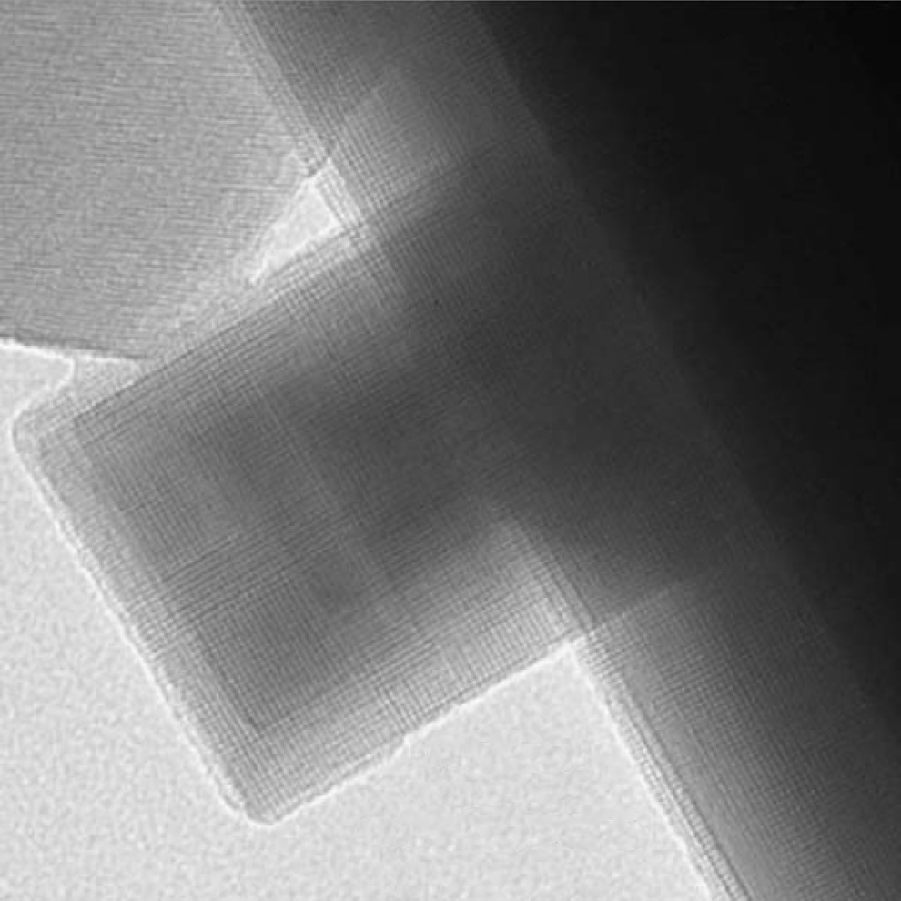
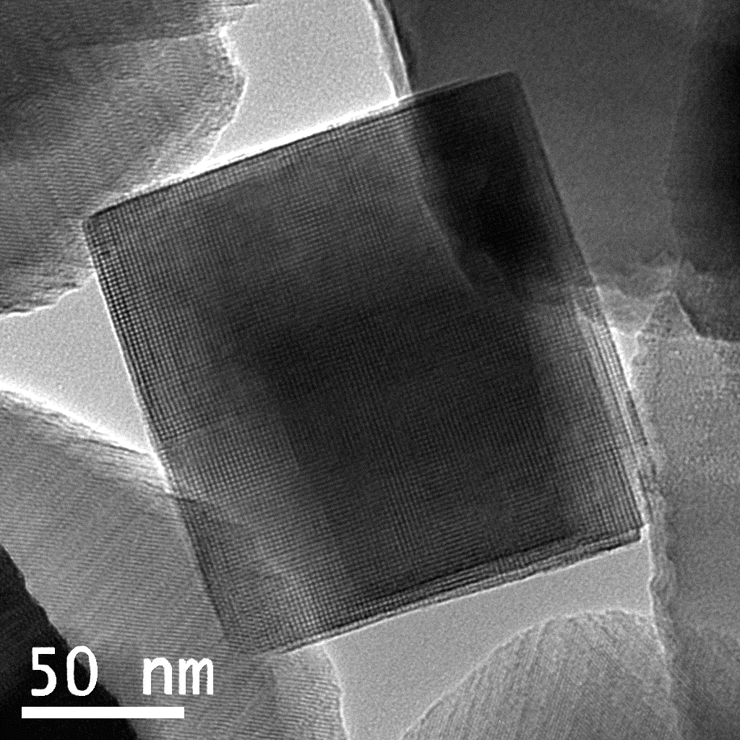
50 nm

Figure 4:

Figure 5:
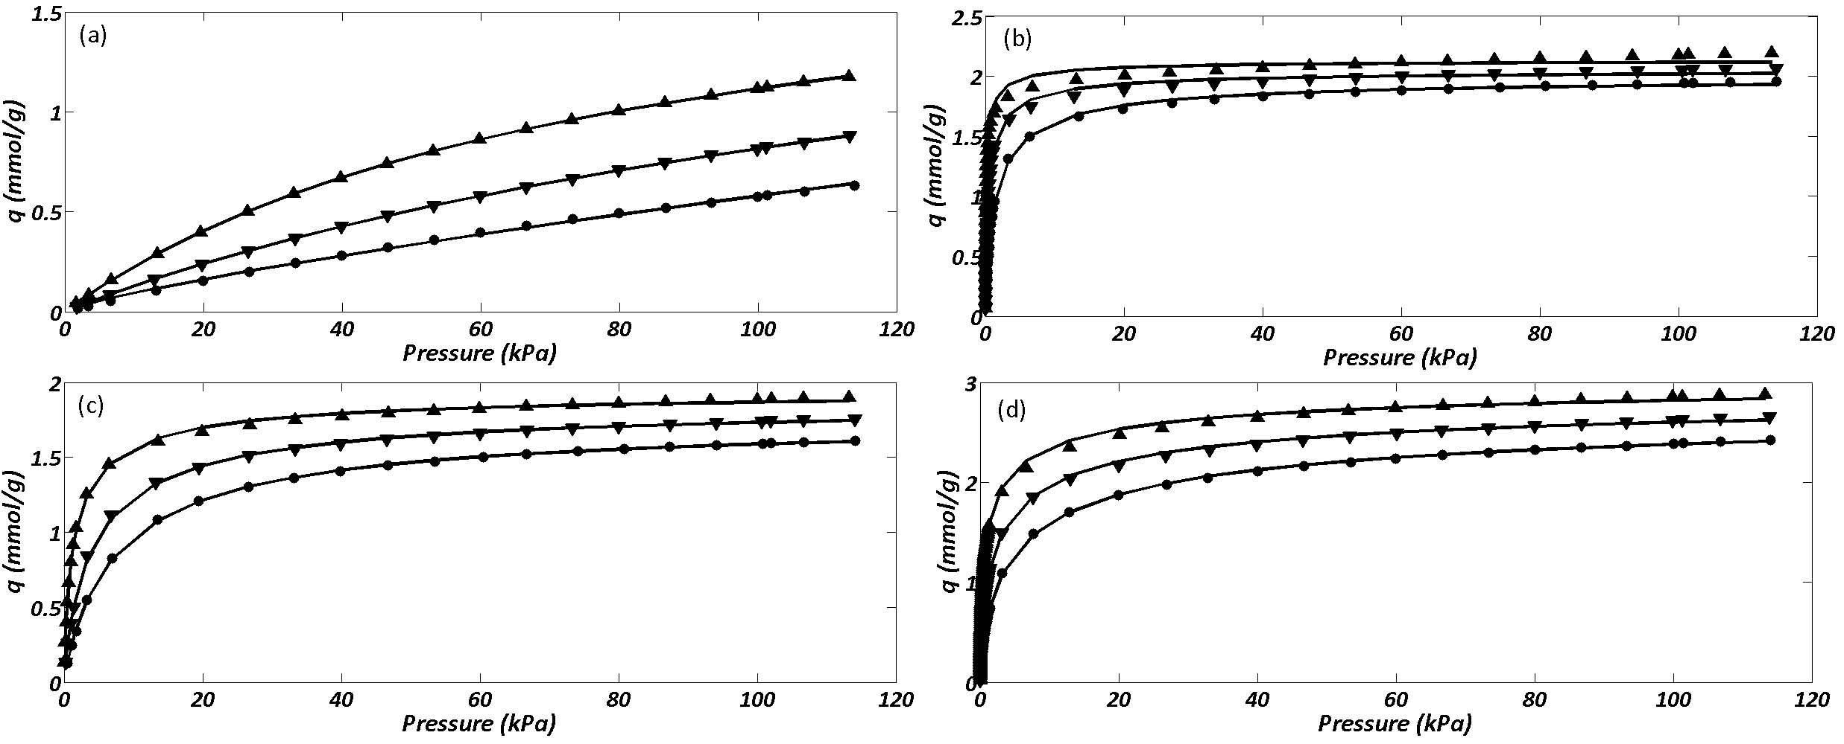
Figure 6:
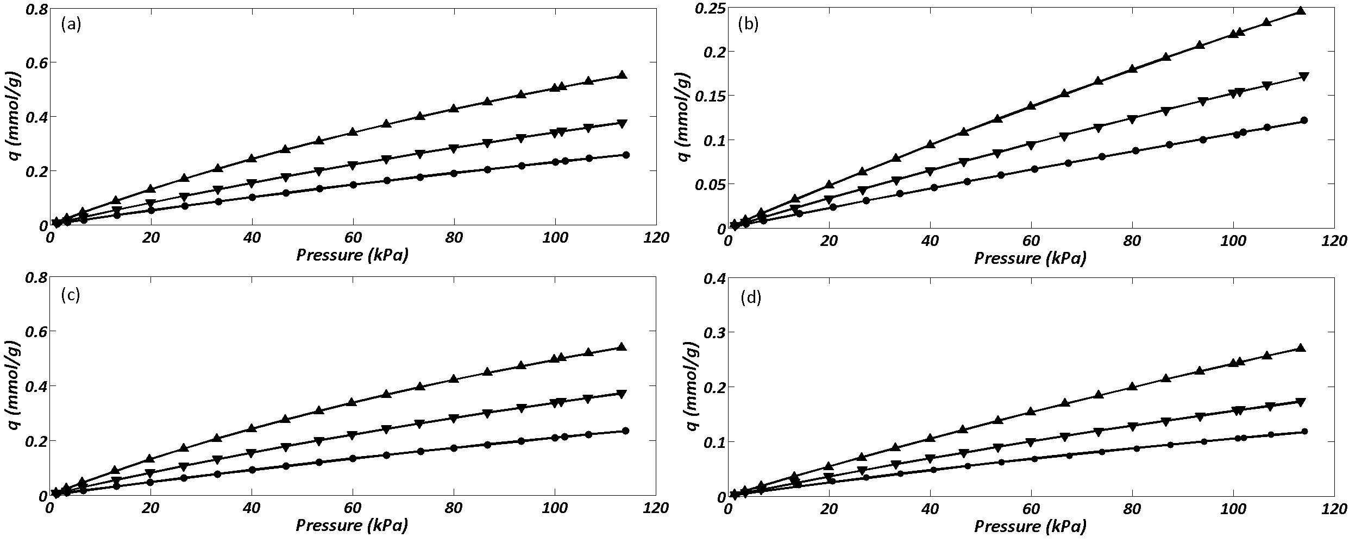

Figure 7:

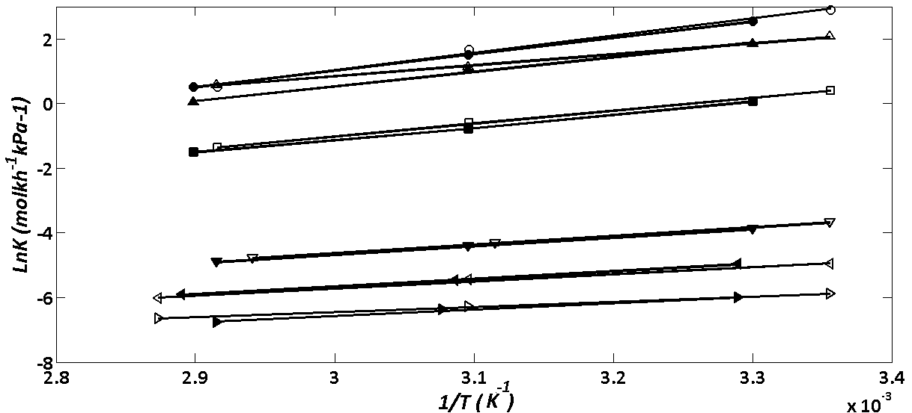
Supplementary Table 1:

C₂H₆ CO₂
Toth Model Toth Model
T/K | 303 |  | 323 | 343 | T/K | 303 | 323 | 343
SSE | 1.050e-02 |  | 3.314e-03 | 1.308e-03 | SSE | 5.499e-02 | 1.538e-02 | 3.752e-03
q_{s}/mmol.g⁻¹ | 2.047 |  | 1.968 | 1.888 | q_{s}/mmol.g⁻¹ | 3.207 | 3.142 | 3.000
b/kPa | 1.273 |  | 2.694 | 5.734 | b/kPa | 5.565e-01 | 9.806e-01 | 1.71
β | 7.231e-01 |  | 7.801e-01 | 8.392e-01 | β | 4.931e-01 | 5.071e-01 | 5.471e-01
H/mmol.g⁻¹.kpa⁻¹ | 1.4660 |  | 5.5246e-01 | 2.3562e-01 | H/mmol.g⁻¹.kpa⁻¹ | 1.0527e+01 | 3.2657 | 1.1252
C₂H₄ CH₄
Toth Model Langmuir Model
T/K | 303 |  | 323 | 343 | T/K | 303 | 323 | 343
SSE | 1.337e-01 |  | 4.308e-02 | 2.720e-02 | SSE | 1.389e-05 | 1.561e-05 | 2.320e-05
q_{s}/mmol.g⁻¹ | 2.305 |  | 2.226 | 2.138 | q_{s}/mmol.g⁻¹ | 2.115 | 2.078 | 1.949
b/kPa | 2.325e-01 |  | 4.599e-01 | 1.005 | b/kPa | 9.733e-03 | 5.835e-03 | 3.827e-03
β | 6.348e-01 |  | 6.652e-01 | 7.502e-01 | H/mmol.g⁻¹.kpa⁻¹ | 2.0585e-02 | 1.2125e-02 | 7.459e-03
H/mmol.g⁻¹.kpa⁻¹ | 2.2948e+01 |  | 7.1556 | 2.1238
N₂ O₂
Langmuir Model Langmuir Model
T/K | 303 | 323 |  | 343 | T/K | 303 | 323 | 343
SSE | 4.653e-06 | 7.271e-07 |  | 4.029e-06 | SSE | 2.742e-06 | 6.082e-06 | 8.244e-06
q_{s}/mmol.g⁻¹ | 1.798 | 1.719 |  | 1.553 | q_{s}/mmol.g⁻¹ | 1.994 | 1.466 | 1.355
b/kPa | 3.889e-03 | 2.475e-03 |  | 1.749e-03 | b/kPa | 1.232e-03 | 1.158e-03 | 8.545e-04
H/mmol.g⁻¹.kpa⁻¹ | 6.992e-03 | 4.255e-03 |  | 2.716e-03 | H/mmol.g⁻¹.kpa⁻¹ | 2.457e-03 | 1.698e-03 | 1.158e-03

Supplementary Table 2:

C₂H₆ CO₂
Toth Model Toth Model
T/K | 303 | 323 | 343 | T/K | 303 | 323 | 343
SSE | 1.034e-02 | 1.710e-03 | 4.733e-04 | SSE | 5e-02 | 1.5e-02 | 2e-03
q_{s}/mmol.g⁻¹ | 1.956 | 1.877 | 1.771 | q_{s}/mmol.g⁻¹ | 3.094 | 2.984 | 2.891
b/kPa | 9.151e-01 | 2.319 | 4.651 | b/kPa | 4.560e-01 | 7.780e-01 | 1.292
t | 7.172e-01 | 7.774e-01 | 8.412e-01 | t | 4.930e-01 | 5.130e-01 | 5.350e-01
H/mmol.g⁻¹.kpa⁻¹ | 2.213572 | 6.361e-01 | 2.849e-01 | H/mmol.g⁻¹.kpa⁻¹ | 1.519e+01 | 4.866 | 1.791
C₂H₄ CH₄
Toth Model Langmuir Model
T/K | 303 | 323 | 343 | T/K | 303 | 323 | 343
SSE | 1.216e-01 | 3.220e-02 | 9.372e-03 | SSE | 7.940e-06 | 2.671e-05 | 2.379e-05
q_{s}/mmol.g⁻¹ | 2.139 | 2.058 | 2.004 | q_{s}/mmol.g⁻¹ | 2.087 | 1.994 | 1.831
b/kPa | 1.657e-01 | 3.901e-01 | 9.655e-01 | b/kPa | 1.267e-02 | 6.420e-03 | 4.587e-03
t | 6.785e-01 | 7.230e-01 | 7.477e-01 | H/mmol.g⁻¹.kpa⁻¹ | 2.644e-02 | 1.280e-02 | 8.400e-03
H/mmol.g⁻¹.kpa⁻¹ | 3.025e+01 | 8.788e-01 | 1.93386
N₂ O₂
Langmuir Model Langmuir Model
T/K | 303 | 323 | 343 | T/K | 303 | 323 | 343
SSE | 5.286e-06 | 2.113e-06 | 3.748e-06 | SSE | 1.881e-06 | 7.71e-06 | 2.861e-05
q_{s}/mmol.g⁻¹ | 1.643 | 1.574 | 1.483 | q_{s}/mmol.g⁻¹ | 1.895 | 0.9432 | 0.5686
b/kPa | 4.310e-03 | 2.729e-03 | 1.644e-03 | b/kPa | 1.465e-03 | 1.978e-03 | 2.268e-03
H/mmol.g⁻¹.kpa⁻¹ | 7.081e-03 | 4.295e-03 | 2.438e-03 | H/mmol.g⁻¹.kpa⁻¹ | 2.776e-03 | 1.866e-03 | 1.290e-03

Supplementary figure
