A Rational Treatment for an Irrational Fear
Capstone Report
Submitted by
Amanda McIvor
April 7th 2015

A Growing Concern
In America, 18% – around 57 million people – suffer from anxiety disorders ². Anxiety is a response to an unknown threat, often associated with feelings of uneasiness. These anxiety disorders are derived from fear of what might or could happen and that is when problems arise. Fear on the other hand is the emotional response to a known threat. Fear is “a brilliant internal guardian that warns you of hazards and helps guide you through risky situations”². Although fear can act as a guide, it also has the potential to be problematic. Although fear can be a protective mechanism in the moment it can become consuming and lead to extreme cases of fear, known as phobias. Phobias are irrational fears that can become unhealthy affecting quality of life through factors such as avoidance. They can cause both intense physical and psychological reactions such as distress, anxiety, sleep deficiency and nausea.
The Fifth Edition of the Diagnostic and Statistical Manual of Mental Disorders (DSM-5) defines five types of specific phobias:
- Animal Type: including dogs, cats, spiders, bugs, mice, birds, fish, and snakes.
- Natural Environment Type: including heights, storms, and water related.
- Blood-Injection-Injury Type: including blood, injections, watching medical procedures on television, and for some, just talking about medical procedures.
- Situational Type: including driving, flying, elevators, and enclosed places.
- Other Type: including other specific fears such as choking or vomiting, balloons breaking or other loud sounds, or clowns ⁵.

This report analyzes and compares four of the most promising techniques used to date on treating these specific phobias namely flooding, modeling and desensitization (both systematic and in vivo). These techniques are analyzed through five selected and thoroughly examined case studies. Each of the four treatments has promise in the scientific community but has not yet been classified as fully efficient. This report also analyzes the results obtained from experiments utilizing the abovementioned procedures in order to judge effectiveness. In order to be deemed effective, these processes need to be able to not only eradicate the fear response but also maintain participant safety and comfort in treatment and produce longevity, as to not result in redevelopment of the phobia.
Meeting the Methods
Flooding is a form of behavior therapy based on the principles of respondent conditioning. It involves treating phobias through direct, rapid exposure to the feared object or situation. Maximum tolerable anxiety is maintained until fear begins to diminish, and then exposure is continued until the patient is comfortable in the situation. It is sometimes referred to as exposure therapy or prolonged exposure therapy. Basically flooding is the overcoming of one’s fears by facing them head on ³. The rationale behind this treatment is that avoidance behavior is most effectively extinguished by preventing escape during treatment sessions ⁸.
Modeling uses the aid of demonstration by a therapist or other individual, to help a participant make steady progressions in overcoming a feared object or situation ⁴. This treatment is also known as participant modeling and requires a few steps. First the participant is given information about the procedure and concerns are addressed. Then the model handles the feared object working to show that the participants fear is irrational or unfounded. After this the participant is encouraged to join in interaction with the fear object. Starting with situations involving little anxiety and ending with overall accomplishment of the feared activity. Finally the participant is encouraged to practice the new skills on his or her own to ensure that the participant does not attribute success to the model ⁴.
Systematic desensitization is a type of behavioral therapy based on the principle of classical conditioning. This form of desensitization works to substitute a relaxation response in place of a previously aversive stimulus. This is done by forming a hierarchy of fear ranked from least to most fearful. Through the hierarchy it aims to remove the fear response of a phobia, exposing the participant to imagery from the hierarchy one image at a time. The participant then works their way up the hierarchy while practicing relaxation techniques ⁹. As it is staged on classical conditioning this treatment does not involve actual stimulation, instead it works in vitro, through imagined exposure.
In vivo is a Latin phrase meaning in life. In vivo desensitization has the participant actually exposed to the feared stimulus, rather than imagining it. This technique also involves a hierarchy of fear to work up and thus differs from flooding techniques as it involves gradual exposure, not immediate exposure. In vivo desensitization works to expose the participant to the stimulus while maintaining a minimal amount of distress. The treatment is based on the theory that the fear response has been conditioned and that avoidance of the fear maintains the fear ⁶.
Selected Studies
The scope of this report does not permit the use of all available case studies. Of the investigations reviewed five were chosen for further analysis and representation in this report. The five case studies were chosen based on relevance and utilization of the treatments in question as well as credibility.
1: Situational and Systematic
The first case study involved a situational type specific phobia restricted to driving on the Interstate 95 (I-95). The participant was a 59-year-old Caucasian male, self- employed as a jeweler. He had a specialty in home sales, had appointments all over the county and depended on I-95 for travel. He developed discomfort after hearing of a family that died in a collision on the highway. Over time he became unable to drive at all on the interstate highway, alternatively relying on city roads, which proved to be more time-consuming ⁵. His treatment consisted of systematic desensitization combined with hypnosis and followed with in vivo desensitization. The participant was asked to construct a hierarchy starting from least upsetting thoughts associated with the phobia increasing to most upsetting. Figure 1 shows the resulting list.
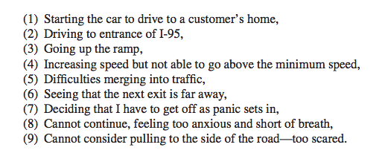Figure 1: The Constructed Hierarchy⁵.
Hypnotic aided systematic desensitization was successful and allowed for the second phase of treatment: in vivo rehearsal. In addition to six office visits consisting of an assessment, four hypnosis sessions, and a summary session, the patient completed 130 miles in 14 days of in vivo desensitization. An important question that cannot be answered by this case report is how much of the success can be attributed to hypnosis, systematic desensitization, in vivo desensitization, or a combination of the three ⁵.
2: Noah’s Ark
The second study utilized flooding as the treatment for various different animal type specific phobias. Participants were told that the phobia persisted due to avoidance and if they could maintain contact for a long enough period of time, they would become comfortable with it ³. The promise was made and kept that participants would know beforehand everything that was going to happen and would not be forced to progress faster than they could tolerate. However they would be constantly urged to push themselves to the limit, maintaining anxiety at the maximum tolerable level ³.
Table 1: Clinical Data on Participants Treated by Flooding ³.
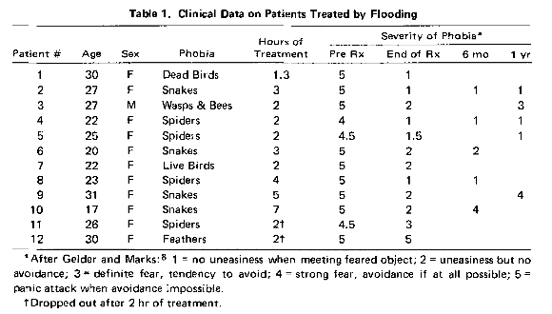
Severity of Phobia Marking Scheme: 1 = no uneasiness when meeting feared object; 2 = uneasiness but no avoidance; 3 = definite fear, tendency to avoid; 4 = strong fear, avoidance if at all possible; 5 = panic attack when avoidance impossible. ⬆ dropped out after 2 hours of treatment ³.
The demographics of each participant as well as treatment results are laid out in Table 1. In this investigation modeling was also regularly employed, meaning that the therapist demonstrated holding and handling the phobic object, but control was quickly transferred to the participant ³.
3: Dogged Determination
A third case study also involved flooding as the treatment of an animal type specific phobia regarding dogs. A girl of 11 years with a severe phobia of dogs was treated with flooding after systematic desensitization failed. Her phobia towards dogs consisted of almost constant worry of coming across a dog as well as panic upon presence of a dog involving screaming and crying ⁸. For treatment the girl was placed in a trailer along with some other staff and a small dog. At first she was extremely apprehensive towards the dog and jumped on her chair crying and pleading for the dog to be removed. However, after six, one-hour long trials she appeared to be completely free of her phobia ⁸. The decrease in her anxiety during treatment can be seen in Figure 2.
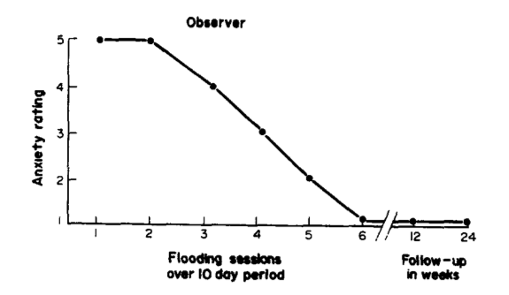
Figure 2: Therapist’s rating of the participant’s anxiety during six treatment sessions and at the follow up sessions ⁸.
Nineteen months after flooding the girl remained free of the phobia and any sort of tension state regarding the animal. Some other effects included loss of a mild fear of cats as well as an enhanced social life and academic achievements ⁸.
4: Needing a Needle
In a fourth case study participant modeling was used to desensitize a participant with a blood-injection-injury type phobia, an extreme fear of needles. This treatment was necessary so that she could undergo a needed surgery. Prior to undergoing treatment the 23-year-old participant would cry, scream and pull away when approached by anyone with a needle. The treatment consisted of the participant being asked to touch and experiment with some of the medical equipment such as syringes and needles ⁴. The therapist first did each task and then the participant was asked to repeat the process. The entire procedure ranged from the participant touching the packaged equipment up to actually having a needle and catheter inserted into the participant. In approximately an hour the entire modeling procedure was completed and was deemed successful. There was no suggestion of recurrence of her fears and she was able to go through with the operation ⁴. At a follow-up two months after the operation the participant had maintained her results and did not appear to have any signs of relapse ⁴.
5: The Elevator Incident
The fifth, and final, case study was based on a situational type specific phobia of elevators. The treatment used was in vivo desensitization. An 11-year-old girl refused to ride in elevators after receiving an injury to her hand involving an elevator door. Both the child and the therapist helped derive a behavioral anarchy and in vivo desensitization proceeded ¹⁰. Both a heart rate monitor and self-reported fear responses by the child were used to signify distress. The hierarchy as well as self-reported fear responses for each level can be seen in Figure 3.
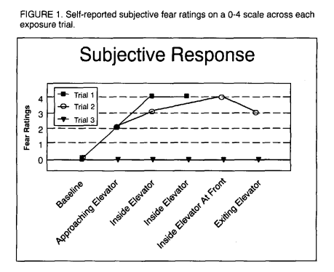
Figure 3: Self-reported subjective fear ratings on a 0-4 scale across each exposure trail ¹⁰.
After treatment the child was able to resume elevator use without detectable fear. In addition, a follow-up test one year later showed that there was no reoccurrence in the child’s fear ¹⁰.

Synthesis: Effectively Eradicating Fear
Fear Be Gone
In order to be considered effective, the treatment doesn’t just need to work once, but it needs to also provide consistent positive results. As previously mentioned, every single case study on each treatment cannot be included within the scope of this report. But a few case studies can provide some insight on a treatments ability to extinguish fear. Although evidence of success can be seen for each treatment, some did not solely achieve this success. As seen in the second and third case studies, flooding can be used alone as well as in conjunction with both modeling and a hierarchical system. Thus proposing that flooding, as a treatment, can be successful both independently and when used in a combination.
It proved difficult to find case studies consisting of systematic desensitization alone as a treatment. More often it is paired with another treatment such as in vivo or modeling. Also it was found to often include hypnosis in the procedure. Although this does not prove that the treatment is ineffective it does suggest that it cannot stand on its own. It was also mentioned in case study three that flooding was used only after systematic desensitization had failed, creating some doubt in its ability as a treatment. Many case studies were found to have different treatments used together to produce results. This makes it difficult to determine which treatment is responsible for the success or if it can truly be attributed to a combination of techniques. That being said, case study five solely used in vivo desensitization and was able to produce desired results.
Although consistency is key it was also difficult to fully cover in this report. Instead the analyzed treatments were compared on their exclusive ability to produce results within the analyzed case studies. This comparison brought attention to systematic desensitization as potentially unable to work independent of other treatments. However this comparison alone is not enough to determine which treatment is most effective and therefore more factors need to be taken into account.

Putting the Participant First
When considering safety the first thing that comes to mind is whether or not direct exposure to the phobic stimulus would be physically safe. To address this concern one must realize that the treatment of phobias stems off the fact that they are irrational. This means that the participant does not actually have reason to fear what it is they are afraid of. That being said any exposure would not put the participant in physical harm, yet it could result in psychological harm through the extreme anxiety-inducing situations.
Another important factor that needs to be taken into account when determining treatment effectiveness is how it makes the participant feel. It is important that the participant both is and feels safe when undergoing treatment. Out of the four techniques outlined in this paper, flooding causes the most concern for participant psychological safety. Disapproval of this type of direct exposure stems from the fact that it evokes distress, although temporary, which can be seen as cruel. There are concerns about safety, tolerability and humaneness of such an extreme exposure therapy approach and this wariness is not unjustified ¹.
Table 1 shows the different participants varying treatment lengths in the second case study. The main cause of concern lies on the last two participants and how they dropped out of treatment two hours into their session. Within this cases study it also mentions that anxiety is usually both pronounced and dramatic during the course of this treatment. Signs of alarm include screaming, weeping, running from the room, teeth chattering, and hyperventilation ³. There then lies concern that if a participant were to drop out after such exposure they would be left in a condition worse than when they began treatment.
Available evidence regarding the concern of flooding treatment safety was found in a paper entitled The Cruelest Cure ¹. This paper ultimately concluded that flooding treatment is safe, tolerable and carries minimal risk of harming patients. That being said, there is some risk associated with this type of treatment, which can be reduced through careful considerations by clinicians when conducting exposure.
When dealing with phobias it can be expected that a participant will endure discomfort during treatment. The main goal should be to minimize this discomfort and not produce unnecessary anxiety that could result in an undesired effect. Although rendered safe, it can be argued that flooding induces unnecessary anxiety in participants that can result in eradication of treatment and ultimately could do more harm than good.
Going the Distance
Treatment is of no use if the participant ends up redeveloping the fear response. If this occurs then the used technique cannot be deemed successful in effectively eradicating the phobia. Analysis of this factor is constantly ongoing and once treatment is administered the participant can receive follow-ups for an undetermined amount of time. The first follow-up often occurs between 6-months and a year after treatments end, as was the case with many of the abovementioned case studies.
The first case study failed to provide any evidence of a follow-up with the participant so any signs of relapse cannot be determined. Both case studies three and five showed maintained results over a year after treatment. Case study four also maintains results but in a follow-up only two-months later. Comparisons are easily done through Table 1 for the second case study. Not every participant is included in follow-up testing but of those that were some evidence of relapse can be seen. Not every participant appears to relapse, but the few that do cause doubt in the effectiveness of flooding treatment. This doubt is not eased, as the reasoning behind certain participant’s reoccurrence is not able to be determined.
Another concern involves the modeling technique. Occasionally the participant may attribute their bravery or success to the model ⁴. This can result in the participant not being able to maintain results independently from the model or the therapeutic situation. A similar issue can be seen with systematic desensitization. Since it involves the participant imagining the situation and not being exposed to a real life situation, it can be difficult for the participant to maintain advancements when introduced to a real life scenario. The reality being that at some point the participant will have to be exposed to the actual stimulus in order to determine eradication of the fear.
The Summary of All Fears
Just because a treatment produces the desired result does not necessarily mean that it is effective. Effectiveness also entails that it produces long lasting results and is both safe and efficient in producing those results. After analyzing and comparing different case studies utilizing each technique I would consider in vivo desensitization as the most effective method. Reasoning includes that it does not induce unnecessary anxiety and participant discomfort as much as the flooding treatment does. Also there is evidence that it can be effective as the sole treatment for a participant and does not require additional treatments as well.
Treatments such as systematic desensitization and modeling often also use in vivo desensitization either after or during their procedures. This can aid in the effectiveness of in vivo desensitization as it can then also be paired with other treatments, such as a model, making it adaptable. In vivo desensitization is also adaptable for different cases and scenarios as it uses a hierarchy that can be suited to each individual’s specific needs. Another factor is that in vivo desensitization actually utilizes the phobic stimulus instead of just an imagination, and therefore does not rely on the participant’s ability to create a vivid image, which may not be effective when faced with a real life situation.
In order to improve upon this analysis more investigations can be done where each technique is the sole component used for treatment. This would provide more evidence on each treatment’s individual ability to eradicate the fear response. Also follow-up testing should be continued to watch for any reoccurrence that may result after treatment. Although limitations to this report are recognized, based on the evidence provided and criteria outlined for effectiveness, in vivo desensitization can be determined as the most effective technique for the treatment of specific phobias.

References
- Abramowitz JS, Deacon BJ, Olatunji BO. The Cruelest Cure? Cognitive and Behavioral Practice 16. Ethical Issues In the Implementation of Exposure-Based Treatments. 2009; 172-180.

- Bell C. Can Fear be Cured? The Telegraph. 2013. Available online at: http://www.telegraph.co.uk/news/science/10219393/Can-fear-be-cured.html

- Buxton M, Curtis G, Lippman D, Nesse R, Wright J. Flooding In Vivo as Research Tool and Treatment Method for Phobias: A Preliminary Report. Comprehensive Psychiatry. 1976; 17(1): 153-160.

- Ferguson JM, Taylor CB, Wermuth BM. Rapid Desensitization of a Needle Phobia by Participant Modeling. West J Med. 1976; 124: 174-176.

- Iglesias A, Iglesias A. I-95 Phobia Treated With Hypnotic Systematic Desensitization: A Case Report. American Journal of Clinical Hypnosis. 2013; 56(2): 143-151.

- Johnson T. In Vivo Desensitization to Treat Anxiety. 2012. Available online at: http://www.anxietysocialnet.com/anxiety-blog/item/566-in-vivo-desensitization-to-treat-anxiety.

- Kunkel R. Can Positive Reinforcement Overcome Fear? An Investigation of Competing Contingencies. 2011. Available online at: http://digital.library.unt.edu/ark:/67531/metadc84232/m1/1/

- Manocha SN, Jain VK, Sreenivasan U. Treatment of Severe Dog Phobia in Childhood by Flooding: A Case Report. Child Psychology. 1979; 20: 255-260.

- McLeod SA. Systematic Desensitization. 2008. Available online at: http://www.simplypsychology.org/Systematic-Desensitisation.html

- Sturges JW, Sturges LV. In Vivo Systematic Desensitization in a Single-Session Treatment of an 11-Year Old Girl's Elevator Phobia. Child & Family Behavior Therapy. 1998; 20(4): 55-62.

