A novel copper-exchanged titanosilicate adsorbent for low temperature H₂S removal
Aida Tavana, Sabereh Rezaei, Lan Wu, Abu S.M. Junaid, James A. Sawada, Steven M. Kuznicki*
Department of Chemical and Materials Engineering, University of Alberta, Edmonton, Alberta, Canada T6G 2V4
*E-mail: steve.kuznicki@ualberta.ca
ABSTRACT
The H₂S removal capacity of copper loaded on a number of titanosilicate supports was investigated. Copper supported on Engelhard Titanosilicate-2 (Cu-ETS-2) has been found to be a superior H₂S scavenger for maintaining H₂S levels below 0.5 ppm because of its high cation exchange capacity and copper dispersion. Cu-ETS-2 demonstrated higher utilization at room temperature when compared to fully developed commercial H₂S adsorbents. In addition it was found that the adsorption capacity of Cu-ETS-2 is maintained over a wide range of activation temperatures.

1. Introduction
Hydrogen sulfide (H₂S) is a common contaminant in hydrocarbon process streams. In addition to being found in the process streams of coal gasification plants, wastewater treatment plants and petrochemical plants, it is present in natural sources such as hot springs, volcano gases and natural gas. This odorous, colorless, toxic gas is corrosive and poisonous, and has a negative impact on pipelines and catalysis, and ceramic membranes used in syngas separations. Even at levels as low as 3 ppm, severe pipeline corrosion is predicted in the presence of H₂S.¹ Nickel or alumina catalysts, used in steam reforming processes are poisoned by the trace amounts of H₂S in natural gas. PEM fuel cells have anode Pt catalysts that are susceptible to H₂S at even lower levels (0.1-1 ppm), which requires the incoming hydrogen gas to be essentially free of H₂S.²
Conventional techniques for H₂S removal are absorption in liquids (alkaloamines, ammonia solutions, and alkaline salt solutions), the Claus Process, and by reaction on activated carbon or metal oxides. Reactive removal of H₂S is common when the gas stream must be polished down to sub-ppm levels.
Much of the previously reported work on reactive sequestration of H₂S has focused on using different forms of supported and unsupported metal oxides and mixed metal oxides, in efforts to improve the adsorbents capacity, thermal stability, and utilization.
Westmoreland et al. have conducted a thermodynamic survey of 28 elements of the periodic table and found that Fe, Zn, Mo, Mn, V, Ca, Sr, Ba, Co, Cu and W oxides are all possible candidates for high temperature desulfurization.³ The study was focused on selecting materials that would be functional at temperatures between 360°C and 1560°C.
A great deal of effort has been applied to enhancing the adsorptive performance of metal oxides through heteroatom doping. Ayala et al. used zinc ferrite for the desulfurization of coal gases at 538°C.⁴ Mixed oxides of copper with Cr, Ce, Al, Mg, Mn, Ti and Fe were also investigated and it was found that CuO-Cr₂O₃ and Cu-CeO₂ were the most efficient desulfurization adsorbents at 650°C.⁵
In order to further enhance the utilization of the active metals, a higher degree of metal dispersion is required. Active chemicals (metals/metal oxides) can be loaded on different supports such as Al₂O₃, TiO₂, SiO₂, and zeolites in order to gain more surface areas and improve structural stability.
Tzu-Hsing Ko et al. compared adsorption capacities of Mn, Fe, Cu, Co, Ce and Zn supported on γ-Al₂O₃ for H₂S removal in syngas at 500°C-700 °C and found that 100% utilization was achieved using copper and manganese.⁶ Gasper-Galvin et al. studied copper, molybdenum and manganese supported on SP-115 zeolite for desulfurization purposes and observed an increase in the mechanical strength of the adsorbents.⁷ Copper supported on SiO₂ and natural zeolite (major phases consisting of mordenite and clinoptilolite) was also investigated and compared to pure copper oxide by Kyotani et al. This study showed almost the same breakthrough capacities for copper supported on SiO₂ (15 wt.% copper) and zeolite (20 wt.% copper) as of that for pure copper oxide.⁸
Less attention has been paid to H₂S removal from gas streams at room temperature. H₂S removal at room temperature is useful when the gas stream’s temperature is low and in applications such as on-board fuel processing of proton exchange membrane fuel cells.
A comparative study of different metal oxides (Ag, Cu, Zn, Co,Ni, Ca, Mn and Sn) has been conducted by Mei Xue et al. which showed that the hydrous CuO has the highest H₂S uptake capacity using 10 ppm H₂S in N₂ at room temperature.⁹ Yang et al. doped ZnO/SiO₂ with eight different transition metals and compared the H₂S capacities with ZnO/SiO₂ at room temperature. It was shown that copper doped ZnO/SiO₂ had the highest H₂S capacity which was double that of ZnO/SiO₂.¹⁰ Baird et al. also demonstrated that copper and cobalt dopants enhance the sulfur removal capacity of ZnO at room temperature.¹
At low temperatures H₂S can only react with the first monolayer of metal oxides¹, thus selecting the most reactive metals and applying them to supports that yield the highest surface areas can significantly enhance utilization at these temperatures. However, low temperature gas streams can also contain a high moisture content, which can be disadvantageous for microporous supports. At high relative humidity porous materials will undergo capillary condensation, the pore structure will fill up with water and the adsorbent will be unable to react with H₂S directly from the gas stream.
Based on the superior H₂S adsorption performance of Cu-based compounds at room temperature, a novel Cu-based adsorbent was prepared using a non-porous, high surface area titanosilicate as the support (Cu-ETS-2). This novel adsorbent was tested for the adsorption of low concentrations of H₂S at room temperature and the copper utilization was compared to commercial, low temperature H₂S adsorbents as well as copper-exchanged Engelhard Titanosilicate-4 (ETS-4) and Engelhard Titanosilicate-10 (ETS-10). The effect of activation temperature on the H₂S capacity of Cu-ETS-2 was also investigated.

2. Materials and Methods
2.1 Adsorbent preparation
ETS-2, ETS-4 and ETS-10 were hydrothermally synthesized as cited in the literature.¹¹ The method for ETS synthesis includes the addition of sources of silica, sources of titanium, and sources of alkalinity such as sodium and/or potassium hydroxide and water. Sources of potassium fluoride can be used optionally to improve the solubility of a solid titanium source. Sodium silicate (28.7% SiO₂, 8.9% Na₂O) was the source of silica in ETS-2, ETS-4 and ETS-10.
The source of titanium for ETS-2 was solid Ti₂O₃, while solubilized TiCl₃ was used in ETS-4 and ETS-10 synthesis.
For the ion exchange experiments a quantity of the as-synthesized powdered material was mixed with a copper nitrate salt solution. The weight proportion of adsorbent (ETS-2/4/10) to salt and water was 1:2:10. The salt was first dissolved in the quantity of water then the adsorbent was added and the mixture agitated to create a slurry. The vessel containing the slurry was then placed in an oven at 80°C for approximately 18 hours. Afterward, the exchanged samples were filtered and washed with de-ionized water and dried at 80°C overnight. Adsorbent granules were generated by mixing the Cu-exchanged powder with Ludox HS-40 colloidal silica (40 wt. % suspension in H₂O). The relatively dry mixture was placed in a cylindrical mold (2.54 cm diameter) and compressed in an axial press to a pressure of 6 metric tons for about 1 minute. The disk formed at this step was crushed and sieved to obtain 20-50 mesh particles.
Prior to analysis, samples were activated in air by heating them in a muffle furnace at a rate of ~4° /min and an isothermal dwell of 2 hrs.
Commercial samples of R3-11G (36 wt.% CuO), R3-12 (40 wt.% ZnO and 40 wt.% CuO), Zinc Oxide (100 wt.% ZnO) were provided by BASF Chemical Company and were sieved to 20-50 mesh particles and used as received.

2.2 Adsorption experiments
A sample of 50 mg of the pelletized adsorbent was packed between plugs of glass wool in a stainless steel column of 4 cm length and 0.38 cm inside diameter. The adsorbent was exposed to a continuous flow of 100 ml/min of the 10 ppm H₂S (balance N₂) mixture. The flow rate was controlled by needle valves and was measured using a bubble flow meter. The outlet of the bed was connected to a Gas Chromatograph (GC) equipped with MXT-1 column (60 m length, 0.53 mm ID) provided by Restek and a FPD detector. The H₂S concentration was monitored continuously during the experiments at 4 minute intervals. The breakthrough point was determined when an H₂S concentration of 0.5 ppm was measured at the outlet of the bed.

2.3 Characterization tests
2.3.1 Surface area measurements
The specific surface area of the samples was determined by N₂ adsorption using an Autosorb-1 volumetric system from Quantachrome Instruments. The surface area of the adsorbent was calculated using the BET method.

2.3.2 Powder X-ray diffraction (XRD) analysis
The crystalline structures of the adsorbents were examined by XRD measurements using a Rigaku Geigerﬂex Model 2173 diffractometer equipped with a cobalt (λ=1.79021Å) rotating anode source and a graphite monochromator for filtering the K-beta wavelengths.

2.3.3 Transmission electron microscopy (TEM)
The image and selected area electron diffraction (SAED) of Cu-ETS-2 particles were investigated by a JEOL 2010 transmission electron microscope (TEM). Samples in powder form were dispersed in methanol in an ultrasonic bath for 10 minutes. One or two drops of each of these suspensions were then placed on a Carbon Type B, Au grid (300 mesh) and dried prior to analysis.

2.3.4 Energy dispersive X-ray spectroscopy (EDX)
The point specific elemental analysis of Cu-ETS-2 particles was done with EDX which was attached to TEM instrument used in this study.

2.3.5 Atomic absorption spectrophotometry (AAS)
Atomic absorption spectrophotometry was performed for investigating the copper content (wt. %) in Cu-ETS-2, Cu-ETS-4 and Cu-ETS-10. A quantity of material was weighed using a balance with 0.1 mg resolution. Nitric acid was then added to the sample to extract the copper species and build-up 10 millilitres of solution. The copper concentration in the solution was measured with VARIAN 220FS atomic absorption spectrophotometer afterward.

3. Results and discussion
3.1 Characterization of Cu-ETS-2 before H₂S exposure
TEM analysis of the Cu-ETS-2 particles shows the presence of three distinct components with different morphologies and diffraction patterns (Figure 1). EDX analysis also shows different compositions in each of these components (Table 1).

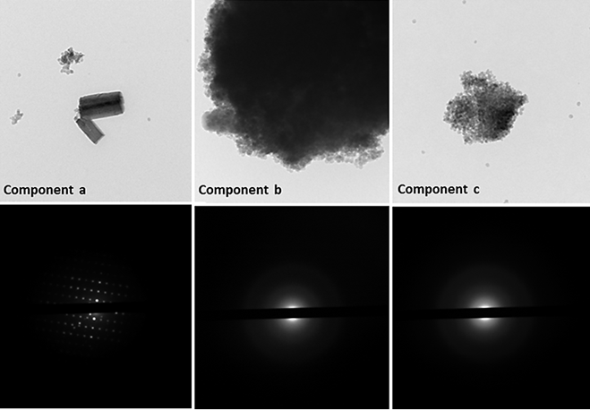
Figure 1. TEM images and SAED patterns of Cu-ETS-2

Table 1. Point specific elemental analysis of Cu-ETS-2 as determined by EDX
Element | Component a | Component b | Component c
Element | wt. % | wt.% | wt. %
Na | 0.09 | 0.02 | 0.00
Si | 0.32 | 0.52 | 1.00
Ti | 0.58 | 0.39 | 0.00
Cu | 0.01 | 0.08 | 0.00

The TEM results indicate that ETS-2 is not homogeneous and contains both crystalline and amorphous components. The crystalline component of Cu-ETS-2 (Component a, Figure 1), does not contain a significant amount of copper, and EDX analysis shows 0.09 wt. % of sodium ions still remained un-exchanged in this component (Table 1). Due to the low copper content, this component is not likely the active phase for H₂S adsorption.
A second component (Component b, Figure 1), is non-crystalline and has the highest copper content compared to the other components (Table 1) and is expected to be the phase principally responsible for H₂S adsorption.
A second, spherical amorphous component (Component c, Figure 1) has no measureable copper content (Table 1) and therefore no H₂S adsorption potential is anticipated in this phase. The existence of this component is likely due to the addition of Ludox, a colloidal silica suspension, used in making the adsorbent granules.
Powder XRD patterns were collected for ETS-2, as-prepared Cu-ETS-2 and Cu-ETS-2 at different activation temperatures. Figure 2 depicts the XRD patterns of ETS-2 and as-prepared Cu-ETS-2.

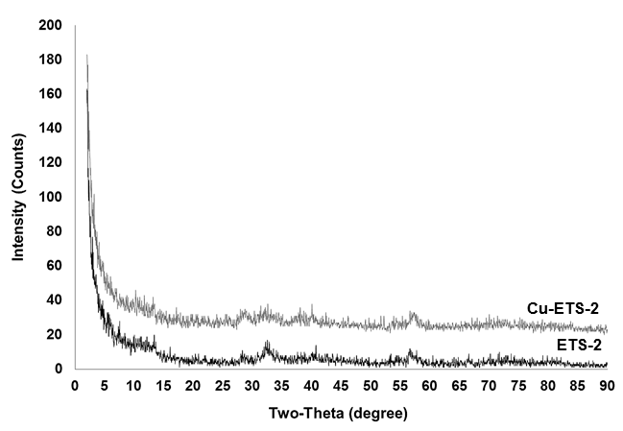
Figure 2. XRD patterns of ETS-2 and as-prepared Cu-ETS-2
The XRD pattern for ETS-2 indicates that the sample is semi-crystalline. The powder pattern suggests that the crystalline component detected in the TEM experiments (Component a, Figure 1) is a minor phase compared to the two amorphous fractions (Components b and c, Figure 1).
The XRD data of Cu-ETS-2 shows that the ion exchange with copper does not introduce any significant changes in the ETS-2 structure. It also confirms the high atomic dispersion of copper ions in the ETS-2 structure, since no diffraction peaks for copper compounds are detected.
The XRD patterns for samples of Cu-ETS-2 exposed to different activation temperatures are shown in Figure 3.
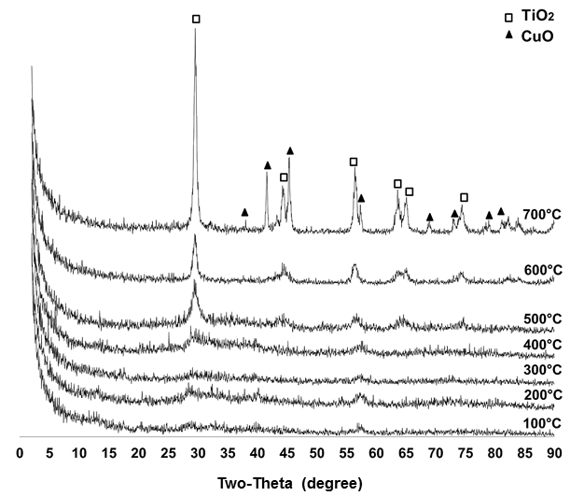
Figure 3. XRD patterns of Cu-ETS-2 activated at different temperatures
The patterns in Figure 3 show that Cu-ETS-2 undergoes a phase change at higher activation temperatures. The XRD pattern of Cu-ETS-2 activated at 700°C shows reflections for anatase (TiO₂) and copper oxide (CuO). The emergence of these crystalline phases suggests that the amorphous phases in Cu-ETS-2 are converted to crystalline forms above 400°C.
Surface area measurements were collected for ETS-2, as-prepared Cu-ETS-2, and the commercial H₂S adsorbent samples (Table 2). Given that Cu-ETS-2 is predominately non-crystalline, its surface area must be derived from the external surface of very finely divided platelets that make up the material.

Table 2. Specific surface area of ETS-2, Cu-ETS-2 and commercial samples
Sample | Specific surface area (m²/g)
ETS-2 | 229.7
Cu-ETS-2 | 186.6
R3-11Gª | 151.2
R3-12^{b} | 117.8
ZnO | 27.9
ª 36 wt.% CuO. ^{b} 40 wt.% CuO + 40 wt.% ZnO.

3.2 Adsorption tests
3.2.1 H₂S breakthrough capacities of Cu-ETS-2 versus Cu-ETS-4 and Cu-ETS-10
Comparison of the H₂S breakthrough capacities on the range of supports (Cu-ETS-2, Cu-ETS-4 and Cu-ETS-10) is given in Table 3. All breakthrough experiments were carried out on an equivalent mass of adsorbent under the same test conditions. The H₂S capacity was defined as the time it took to measure an outlet concentration of 0.5 ppm H₂S. The copper utilization was calculated by converting the breakthrough time to moles of H₂S, and then dividing that value by the moles of copper on the adsorbent sample, as measured by atomic adsorption.

Table 3. Cu-ETS-2, Cu-ETS-4 and Cu-ETS-10 breakthrough capacities and copper utilizations
Adsorbentª | H₂S breakthrough capacity  (mg H₂S/g of adsorbent) | Copper loading  wt.% | % Copper utilization
Cu-ETS-2 | 47 | 12.5 | 71
Cu-ETS-4 | 11 | 4.8 | 44
Cu-ETS-10 | 45 | 8.4 | 98
ª All adsorbents were activated at 100°C.

The low copper utilization in Cu-ETS-4 can be explained by a pore blockage effect. In crystalline materials with very small pores and channels in their structure the copper sites nearest the external surface of the crystals react first. When the H₂S reacts to form copper sulfide the occluded sulfur partially blocks the pore openings, impeding gas access to the rest of the crystal.⁸ The high copper utilization of Cu-ETS-10 was anticipated since ETS-10 has a larger pore diameter that will allow the gas passage even if the channel is partially blocked. The atomic dispersion of copper in the microporous framework allows for complete utilization of the metal.
However, the existence of pores and channels in Cu-ETS-10 structure creates a problem in humid gas streams, as the pore system will fill up with liquid water due to capillary condensation and renders the adsorbent inactive toward H₂S adsorption.
Unlike Cu-ETS-4 and Cu-ETS-10, which have crystalline frameworks, Cu-ETS-2 is composed of finely divided platelets. The nano-sized platelets provide the material with its relatively high external surface area. The substantial, but incomplete, copper utilization for Cu-ETS-2 may be due to inconsistencies in the sample structure that may not allow some of the exchanged copper ions to react with H₂S, or may be the result of active copper sites being blinded due to copper sulfide formation on the surface of the particles.
3.2.2 H₂S breakthrough capacity of Cu-ETS-2 versus commercial adsorbents
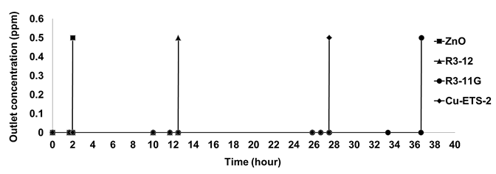
Figure 4. Comparison of the breakthrough times for 50 mg of Cu-ETS-2 and commercial H₂S adsorbents
Cu-ETS-2, activated at 100°C, demonstrated superior H₂S breakthrough capacity per gram compared to the ZnO and R3-12 (40 wt.% ZnO + 40 wt.% CuO) commercial adsorbents. The breakthrough times presented in Figure 4 show that, under the specified test conditions, Cu-ETS-2 is capable of maintaining a column outlet concentration of H₂S of less than 0.5 ppm for ~27 hours. The only commercial sample with longer breakthrough time is R3-11G sample (36 wt.% CuO).
Table 4 shows that, despite having the highest capacity, R3-11G suffers from low utilization of copper species (41 wt.%). This is likely due to the dense copper sulfide phase formed during the sulfidation, which blinds the particle to further reaction with H₂S.⁸ The data also shows that Cu-ETS-2 has the highest utilization amongst all the samples. The significant improvement in Cu utilization in Cu-ETS-2 compared to the rest of the samples is caused by an increase in the degree of dispersion of active species on the ETS-2 support via ion-exchange.

Table 4. Cu-ETS-2 versus commercial samples
Adsorbent | Loading  wt.% |  | % Utilization
Adsorbent | Copper | Zinc | % Utilization
Cu-ETS-2 | 12.5 | - | 71
R3-11Gª | 29 | - | 41
R3-12^{b} | 32 | 32 | 6.5
ZnO | - | 80 | 0.8
ª 36 wt.% CuO. ^{b} 40 wt.% CuO + 40 wt.% ZnO.

3.2.3 Effect of activation temperature on H₂S capacity of Cu-ETS-2
In order to investigate the effect of activation temperature on H₂S breakthrough capacity of Cu-ETS-2, H₂S adsorption tests were conducted for samples activated at different temperatures.
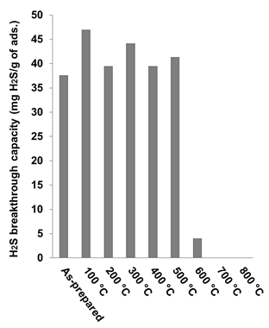
Figure 5. Breakthrough capacity of Cu-ETS-2 activated at different temperatures
Figure 5 shows that the H₂S capacity of Cu-ETS-2 remains relatively unchanged after the material has been exposed to temperatures of up to 500°C. The decrease in capacity after 500 °C correlates with an increase in the intensity of anatase reflections seen in the XRD patterns (Figure 3) and is assigned to a re-crystallization event which renders Cu-ETS-2 inactive toward H₂S.

4. Conclusions
The data collected demonstrates that, at room temperature, Cu-ETS-2 is an H₂S adsorbent with a high gravimetric H₂S capacity and high copper utilization. This adsorbent maintains its capacity over a wide range of activation temperatures. The copper utilization in Cu-ETS-2 is higher than that of highly developed commercial samples due to its high surface area and the degree of copper dispersion in ETS-2. The non-porous nature of the ETS-2 structure takes advantage of the ion exchange characteristics of microporous frameworks without the risk of the pore blockage and capillary condensation effects inherent in these structures.
Acknowledgements
We thank Albana Zeko for helpful comments on the manuscript and Weizhu An for her support on preparing the experiment’s set-up. The authors also thank R. Eslahpazir for TEM analysis. Financial support from the Canada Research Chair and Helmholtz-Alberta Initiative (S.M.K.) is gratefully acknowledged.

References
(1) Baird, T.; Denny, P. J.; Hoyle, R.; Mcmonagle, F.; Stirling, D.; Tweedy, J. Modified Zinc-Oxide Absorbents for Low-Temperature Gas Desulfurization. J. Chem. Soc., Faraday Trans. 1992, 22, 3375-3382.
(2) Gangwal, S. K. Desulfurization for Fuel Cells. In Fuel Cells: Technologies for Fuel Processing; Shekhawat, D.; Spivey, J. J. and Berry D. A. Ed.; Elsevier: Amsterdam 2011, 317-360.
(3) Westmoreland, P. R.; Harrison, D. P. Evaluation of candidate solids for high-temperature desulfurization of low-Btu gases. Environ. Sci. Technol. 1976, 7, 659-661.
(4) Ayala, R. E.; Marsh, D. W. Characterization and Long-Range Reactivity of Zinc Ferrite in High-Temperature Desulfurization Processes. Ind. Eng. Chem. Res. 1991, 1, 55-60.
(5) Abbasian, J.; Hill, A. H.; Wangerow, J. R. ; Flytzani-Stephanopoulos, M.; Bo, L.; Patel, C.; Chang, D. ; Development of Novel Copper-Based Sorbents for Hot-Gas Cleanup; IGT-Final Technical Report to CRSC, IGT Project No. 40330 , Aug 1992.
(6) Ko, T.; Chu, H.; Chaung, L. The sorption of hydrogen sulfide from hot syngas by metal oxides over supports. Chemosphere 2005, 4, 467-474.
(7) Gasper-Galvin, L.; Atimtay, A. T.; Gupta, R. P. Zeolite-supported metal oxide sorbents for hot-gas desulfurization. Ind. Eng. Chem. Res. 1998, 10, 4157-4166.
(8) Kyotani, T.; Kawashima, H.; Tomita, A.; Palmer, A.; Furimsky, E. Removal of H₂S from Hot Gas in the Presence of Cu-Containing Sorbents. Fuel 1989, 1, 74-80.
(9) Xue, M.; Chitrakar, R.; Sakane, K.; Ooi, K. Screening of adsorbents for removal of H₂S at room temperature. Green Chem. 2003, 529-534.
(10) Yang, H. Y.; Tatarchuk, B. Novel-Doped Zinc Oxide Sorbents for Low Temperature Regenerable Desulfurization Applications. AIChE J 2010, 11, 2898-2904.
(11) Kuznicki, S.M. Large-pored crystalline titanium molecular sieve zeolites. U.S. Patent 4,853,202, 1989.

Figure Captions:
Figure 1: TEM images and SAED patterns of Cu-ETS-2
Figure 2: XRD patterns of ETS-2 and as-prepared Cu-ETS-2
Figure 3: XRD patterns of Cu-ETS-2 activated at different temperatures
Figure 4: Comparison of the breakthrough times for 50 mg of Cu-ETS-2 and commercial H₂S adsorbents
Figure 5: Breakthrough capacity of Cu-ETS-2 activated at different temperatures

Table 1. Point specific elemental analysis of Cu-ETS-2 as determined by EDX
Element | Component a | Component b | Component c
Element | wt. % | wt. % | wt. %
Na | 0.09 | 0.00 | 0.02
Si | 0.32 | 1.00 | 0.52
Ti | 0.58 | 0.00 | 0.39
Cu | 0.01 | 0.00 | 0.08

Table 2. Specific surface area of ETS-2, Cu-ETS-2 and commercial samples
Sample | Specific surface area (m²/g)
ETS-2 | 229.7
Cu-ETS-2 | 186.6
R3-11Ga | 151.2
R3-12b | 117.8
ZnO | 27.9
ª 36 wt.% CuO. ^{b} 40 wt.% CuO + 40 wt.% ZnO.

Table 3. Cu-ETS-2, Cu-ETS-4 and Cu-ETS-10 breakthrough capacities and copper utilizations
Adsorbentª | H₂S breakthrough capacity  (mg H₂S/g of adsorbent) | Copper loading  wt.% | % Copper utilization
Cu-ETS-2 | 47 | 12.5 | 71
Cu-ETS-4 | 11 | 4.8 | 44
Cu-ETS-10 | 45 | 8.4 | 98
ª All adsorbents were activated at 100°C

Table 4. Cu-ETS-2 versus commercial samples
Adsorbent | Loading  wt.% |  | % Utilization
Adsorbent | Copper | Zinc | % Utilization
Cu-ETS-2 | 12.5 | - | 71
R3-11Gª | 80 | - | 15
R3-12^{b} | 32 | 32 | 6.5
ZnO | - | 80 | 0.5
ª 36 wt.% CuO. ^{b} 40 wt.% CuO + 40 wt.% ZnO.

