REAL MEDICINE FOUNDATION (PAKISTAN)

April 20, 2016

FORMATIVE Menstrual Hygiene Management Research: Adolescent Girls in Baluchistan

Zubia Mumtaz, PhD. University of Alberta, Canada
Marni Sommer, Columbia University, USA
Afshan Bhatti, Real Medicine Foundation, Pakistan

Acknowledgements…………………………………………………………………..3

Summary ……………………………………………………………………………….4

Acronyms……………………………………………………………………………….6

Introduction and Background……………………………………………………….7

Methods………………………………………………………………………………….8

Preliminary Results…………………………………………………………………..13
Recommendations……………………………………………………………………22

References……………………………………………………………………………..24

Contents

Copyright © 2016. Zubia Mumtaz. University of Alberta, School of Public Health, Edmonton, Alberta, Canada. This document is archived within the University of Alberta’s Education and Research Archive available from
This work is subject to copyright. All rights reserved, whether the whole or part of the material is concerned.

Acknowledgments:

The Formative Menstrual Hygiene management research has benefitted from the support of many institutions and individuals. We are taking this opportunity to thank them. First of all we would like to thank UNICEF Pakistan for providing us this opportunity funded by Global Affairs Canada. Here we would also like to thank the continuous support of UNICEF Pakistan staff members specially Ms. Saadia Yaqoob and Ms. Asiya Ashraf Chaudhry.

On behalf of UNICEF Pakistan we would also like to thank WASH in Schools for Girls: Advocacy and Capacity Building for MHM through WASH in Schools Programmes’ (WinS4Girls Project), funded by the Government of Canada, UNICEF Headquarters and the Advisory Group (UNGEI and UNICEF Sections: Gender; Adolescent Development and Participation; and Education) for their continuous support and guidance to UNICEF Pakistan.

We would also like to express our sincere gratitude to Ministry of Education, Ministry of Health and Department of Local Government Balochistan for their cooperation and support during the course of study and also look forward to their support in the utilization of study findings.

Here we would also like to thank UNICEF Provincial office Balochistan, Balochistan Rural Support Program, National Rural Support Program and all the members of MHM working group Pakistan for their kind cooperation and encouragement which helped us to complete this study in time.

Summary

Menarche is the onset of menstruation, and is part of the complex physical changes that occur during girls’ transition from childhood into young adulthood. These changes relate to lifestyle, behavior, growth and development. While menarche is a physiologically normal process, in many countries it is embedded within a host of cultural beliefs, values and practices. In Pakistan, these include dietary restrictions including eating eggs, beef and fish, hygienic practices that forbid bathing, religious practices that restrict prayer and contact with the Quran.

A small body of literature suggests a key element of cultural practices surrounding reproductive health in Pakistan, including menstruation, is the ‘culture of silence’. Part of a larger value system that is embedded within the gender order of society, information around menstruation is actively withheld until after the onset of menstruation. A number of studies have suggested girls’ knowledge around menstruation and hygiene practices may be inadequate. Lack of knowledge about menstruation is associated with profound psychological and emotional problems.

Alongside growing attention to the MHM needs of girls in schools that lack adequate WASH facilities, a growing body of literature recommends menstrual health and hygiene education in order to improve health and education-related outcomes of adolescent females. Dr. Marni Sommer at the Mailman School of Public Health, Columbia University, has addressed this gap by developing girls’ puberty books that provide essential, culturally sensitive information on puberty and menstrual hygiene management (MHM) for 10-14 year old girls in Tanzania, Ghana, Ethiopia and Cambodia⁸. Her project is now expanding into Pakistan with a plan to develop a culturally contextual puberty book for girls.

As a first step in development of the puberty book, qualitative data were collected to understand girls’ experiences of menarche, explore cultural values, beliefs and practices surrounding menstruation, and how the lack of water, sanitation and disposal infrastructure may be negatively impacting girl’s management of menstruation in schools, and their ability to participate in the classroom. The original project was conducted in the province of Punjab, Pakistan. UNICEF commissioned the researchers to expand the research site to the province of Baluchistan to ensure the book captures the cultural beliefs and values of an additional key province of the country. This report focuses on the findings from Baluchistan only.

Methods
A comparative case study (rural vs. urban) was conducted from September to December 2015 in rural and urban Baluchistan. Urban data were collected from Kuchlaak, a neighborhood in Quetta City, District Quetta and rural data from village Sakuran Goth, Tehsil Hub, in Lasbela District. Both sites were selected by UNICEF, Pakistan. In each site, data were collected from both in-school and out-of-school girls.

Three methods of data collection were utilized: 1) Participatory activities were conducted with groups of adolescent girls (n= 177); 2) observations were conducted of school water, sanitation and disposal facilities; and 3) in-depth interviews were conducted with key informants such as parents, teachers, and health workers.

Preliminary Results
Overall, our data identified six key themes:
- Menarche is generally experienced by girls as a traumatic event characterized by fear, distress and worry.
- Prior knowledge of menarche normalized the process, leading to positive experiences of the first menstrual period.
- Currently, girls’ knowledge of puberty and menstrual practices was rooted in local, cultural epistemology. However, they were skeptical of this knowledge and questioned it.
- There are significant information needs, specifically around physiology of puberty and menstruation; recognition and relief of menstrual symptoms; appropriate menstrual hygiene and management practices; and social, physical, religious and dietary restrictions.
- Water, sanitation and hygiene facilities in schools are inadequate to meet menstruating girls’ needs.
- Participants identified a range of WASH and menstrual management resources to develop Girl-Friendly school facilities.

Recommendations
Based on the research findings, we recommend:
- Development of an information resource to provide girls knowledge of puberty, menarche and menstrual hygiene management. This could be a book, pamphlet, an animated video or a web-based resource.
- Development of a MHM health education module that should be taught as part of girls’ school curriculum.
- Train teachers to deliver MHM information in a sensitive and objective manner.
- Develop school WASH facilities, including availability of clean washrooms, running water and disposal facilities, located in safe spaces.
- Create positions for cleaners to clean the washroom facilities through advocacy with provincial government.
- Develop menstruation support facilities such as availability of sanitary supplies in schools.
- Conduct further research to understand why teachers are reluctant to engage students around MHM issues, why is there a blindness to dirty toilet facilities, why there is reluctance to clean toilet facilities, what are appropriate mechanisms for menstrual waste disposal and if there are opportunities to manufacture sanitary pads using local, cheap materials.

Acronyms and Abbreviations

UNICEF United Nations Children's Emergency Fund
KPK Khyber Pakhtunkhwa
MHM Menstrual Hygiene Management
NGO Non-Governmental Organization
WASH Water, Sanitation and Hygiene
AB Afshan Bhatti, National Research Manager, Real Medicine Foundation, Pakistan

Introduction and Background

Menarche is the onset of menstruation, and is part of the complex physical changes that occur during girls’ transitions from childhood into young adulthood. These changes relate to lifestyle, behavior, growth and development. While menarche is a physiologically normal process, in many countries it is embedded within a host of cultural beliefs, values and practices. In Pakistan, these are reported to include dietary restrictions including eating eggs, beef and fish, hygienic practices that forbid bathing, religious practices that restrict prayer and contact with the Quran.^{1, 2}

A small body of literature suggests a key element of cultural practices surrounding reproductive health in Pakistan, including menstruation, is a ‘culture of silence’¹. Part of a larger value system that is embedded within the gender order of society, information around menstruation is actively withheld until after the onset of menstruation.³ The gender order in Pakistan is highly patriarchal, with clearly demarcated gender roles and large sex differentials in access to resources of all types, including knowledge.⁴ Women’s seclusion is a defining element of this gender order. Besides limited mobility, seclusion encompasses withholding knowledge of every kind.⁵ Within this context, sexuality and reproduction are regarded as shameful topics, and discussions are actively avoided^{1, 3}. Although educating girls’ about reproductive health is understood as a mother’s responsibility, mothers are often shy and reluctant to discuss sex, sexuality and menstruation with their daughters^{3, 6}. Furthermore, the lack of discussion on reproductive health throughout recent generations has left mothers experience-less on the conveyance of menstrual-related information and support³. Even when information is shared, it is limited to practices around the management of bleeding, religious restrictions and the continued maintenance of the silence^{1, 3}. One reason for the withholding of information may be an effort to ‘raise innocent daughters’ described as girls who are unaware of all knowledge related to reproduction, including knowledge of menstruation, sex and sexuality. It is believed that lack of such knowledge indicates the girls’ minds are pure of shameful knowledge and their innocence is equated to chastity³.

A number of studies from a range of countries, including small studies from Pakistan, have suggested girls’ knowledge levels around menstruation and hygiene practices may be inadequate ^{1, 2,7,8,9}. Lack of knowledge about menstruation is associated with profound psychological and emotional problems^{9, 10}. There is some emerging evidence that poor knowledge is associated with poor management of menstrual pain, development of urinal infections and even possibly infertility (as a result of unsanitary management of post-partum bleeding), although further research is needed to determine causality ^{11,12,13, 14}.

Current trends in educational attainment indicate Pakistan is under-performing in reducing the gender parity in education, with the country having the highest number of female out-of-school children in South Asia¹⁵. Marked disparities based on wealth and regional differences were also found.^{15, 16} Poor girls in rural areas were sixteen times less likely to attend school compared to boys from the wealthiest households in urban areas.¹⁷ Although the specific interaction between menarche and female educational attainment has yet to be explored empirically in Pakistan, current literature documents harsher restrictions in the mobility of girls in Pakistan once they reach sexual maturity¹⁶. Given these social restrictions, distance to schools, safety concerns while travelling, lack of secure school infrastructure including boundary walls, basic toilet facilities and drinking water, and presence of female teachers are all factors which affect girls’ educational attainment.^{15, 16} In some areas, the absence of segregated all-girl government schools, which have toilet facilities, has emerged as a significant constraint on girls’ attending schools¹⁵. Literature from Kenya, Tanzania, Uganda and Zimbabwe have reported on the lack of WASH facilities at schools, unaffordability of sanitary pads, the risk of embarrassment of a menstrual leak, and the school absenteeism of girls when they are managing their menses as every-day challenges associated with menses.^{9, 10, 18, 19, 20, 21} Similar challenges maybe reflected in the experience of Pakistani girls attending schools.

Alongside the growing attention to the MHM needs of girls in schools that lack adequate WASH facilities, there is also a growing body of literature recommending the need for improved menstrual health and hygiene education in order to improve health and education-related outcomes of adolescent females ^{1,2,7,12,22}. Dr. Marni Sommer at the Mailman School of Public Health, Columbia University, has addressed this need by developing girls’ puberty books that provide essential, culturally sensitive information on puberty and menstrual hygiene management (MHM) for 10-14 year old girls in Tanzania, Ghana, Ethiopia and Cambodia¹⁰. Her project is now expanding into Pakistan with a plan to develop a culturally contextual puberty book for girls. In partnership with UNICEF, University of Alberta and Real Medicine Foundation, Pakistan, the project was launched by first collecting qualitative data around girls’ experiences of menarche, deeper exploration of cultural values, beliefs and practices surrounding menstruation, and how the lack of water, sanitation and disposal infrastructure may negatively impact girl’s management of menstruation in schools, and ability to participate in the classroom. Additional collaboration and information was sought from a range of key stakeholders working with adolescent girls in Pakistan, and the approval of the Ministry of Education.

The original project was conducted in the province of Punjab, Pakistan between February– August 2015, with additional qualitative data collected by a small number of NGOs working in other provinces of Pakistan. UNICEF commissioned the researchers to expand the research site to the province of Baluchistan to ensure the book captures the cultural beliefs and values of an additional key province of the country. This report will focus on the findings from the province of Baluchistan only.

Methods
A comparative case study (rural vs. urban) was conducted from September to December 2015 in rural and urban Baluchistan. Urban data were collected from Kuchlaak, a neighborhood in Quetta City, District Quetta and rural data from village Sakuran Goth, Tehsil Hub, in Lasbela District. Both sites were selected by UNICEF, Pakistan. In each site, data were collected from both in-school and out-of-school girls. In-school girls were recruited from one high school in each site after obtaining permission from the Provincial Educational Directorate, respective District Education officers and School administration. Out-of-school girls were identified with the help of a local social worker in Kuchlak and a Lady Health Worker in Sakuran Goth, who gathered them in their homes. See Table 1 for details of numbers of respondents in each site. Older adolescent girls, aged 16-19 years,(both in and out-of-school girls) were intentionally sampled in this study, as they would be more comfortable disclosing their menarche experiences, and sharing advice for girls yet to reach puberty openly, as compared to younger girls.

Table 1: Participant Information
Site | In-school or Out-of-school Girls | Class | Number of Participants | Key Informant Interviews
Urban site: Kuchlak Neighbourhood of Quetta City | In-school Girls | 7 | 24 | 25
 |  | 8 | 16
 |  | 9 | 23
 |  | 10 | 12
 | Out-of-school girls | Not applicable | 9
Rural site: Sakuran Goth and Tehsil Hub in Lasbela district | In-school Girls | 7 | 19 | 26
 |  | 8 | 22
 |  | 9 | 16
 |  | 10 | 21
 | Out-of-school girls | Not applicable | 15
Other stakeholders (Provincial ministries of education and health, and UNICEF implementing partners) |  |  |  | 6
Total Number of In-school and Out of school- girls |  |  |  |  | 177
Total Number of Participants |  |  |  |  | 234

Three methods of data collection were utilized: 1) Participatory activities were conducted with groups of adolescent girls, both in and out-of-school (n= 177); 2) observations were conducted of school water, sanitation and disposal facilities; and 3) in-depth interviews were conducted with key informants such as parents, teachers, health workers (N=57). Participatory approaches were used because as our respondents were adolescent girls, which is a particularly sequestered group of the population in Pakistan. Participatory methods allowed for an equalizing and dynamic exchange between researchers and participants, which in turn enables development of a relationship of trust.²³ It further enables collection of sensitive information from young girls.²³ The same research methodologies have been used by Dr. Sommer to collect data on MHM for developing the girl’s puberty book in four other countries.

The research team, consisting of Afshan Bhatti (AB) and a research assistant, collected the data. In each site the team met with each group of respondents daily, over 7-8 days. Multiple participatory activities were conducted with girls, such as the writing of menstrual stories, girls’ brainstorming on the improvement of WASH facilities in schools; and the development of a proposed puberty curriculum for girls aged 10-14.

To assess if school infrastructure met girls menstrual hygiene needs, WASH facilities in both schools were observed utilizing school focused checklists used in Dr. Sommer’s previous studies. Observation is a useful method of data collection as it enables documentation of the on-ground reality. In addition, 12 key informant interviews were completed in both sites to capture adults’ perspectives and understandings of girl’s experiences of menstruation and schooling and to contextualize the cultural practices and beliefs identified by the girls. These informants included mothers, teachers, school administrators, community health workers and religious leaders. All key informants were women as culturally menstruation is a female domain from which men are excluded. Not only is male involvement considered a taboo, involving men might have created issues that potentially could have terminated the research.

All data were collected in textual form in the local languages, mostly Urdu, but also Pushto and Lassi. The data in Pushto and Lassi was first translated into Urdu. All data was then transcribed in Urdu and then translated and transcribed into English. Data were analyzed using a latent content analysis approach. Using Quirkos, a qualitative data management program, the data was first coded inductively. The codes were then categorized to identify broader themes to abstract deeper meaning and to build an explanation for the findings.

Participatory Activities with school girls

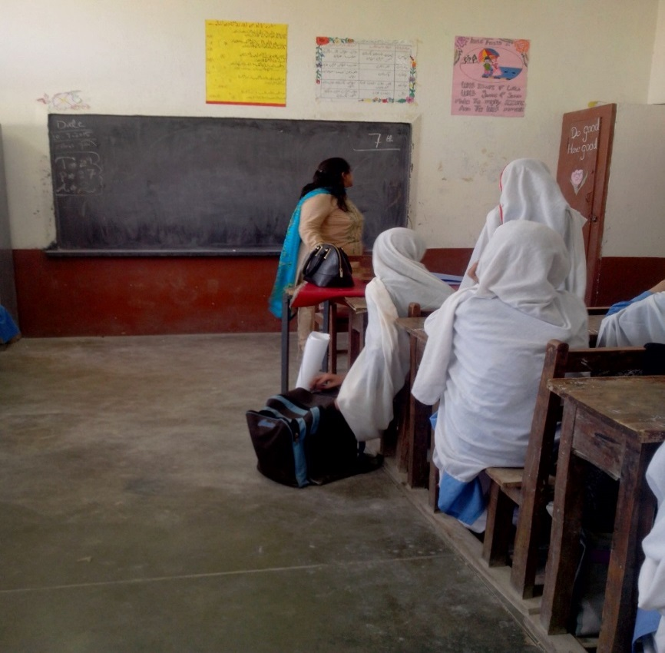

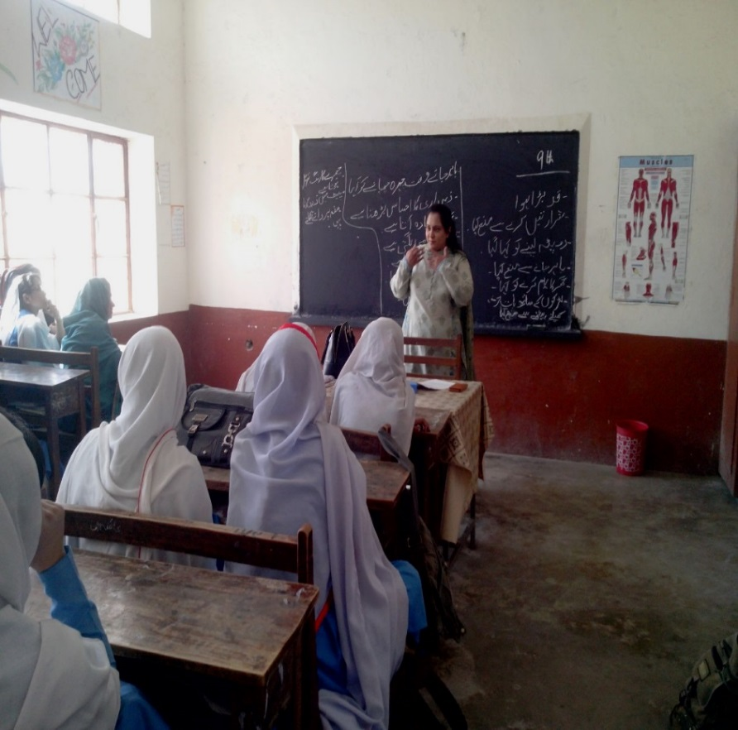

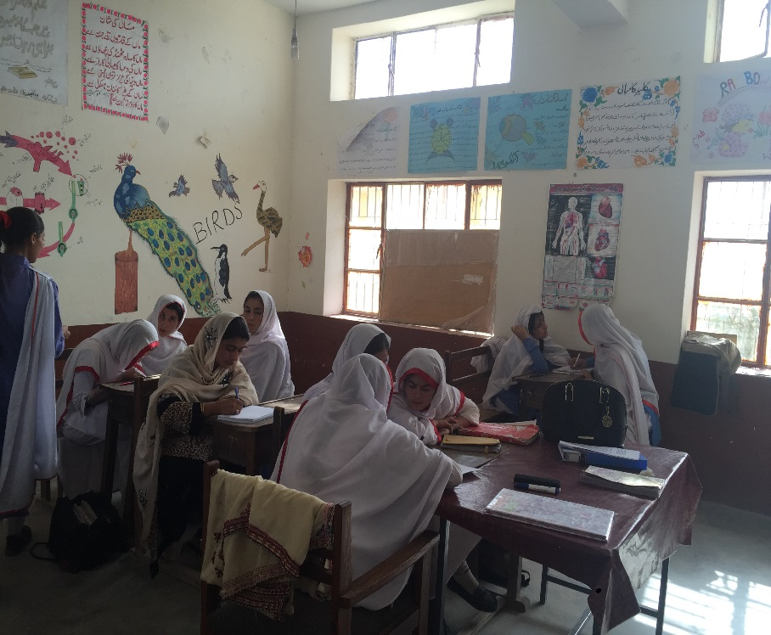

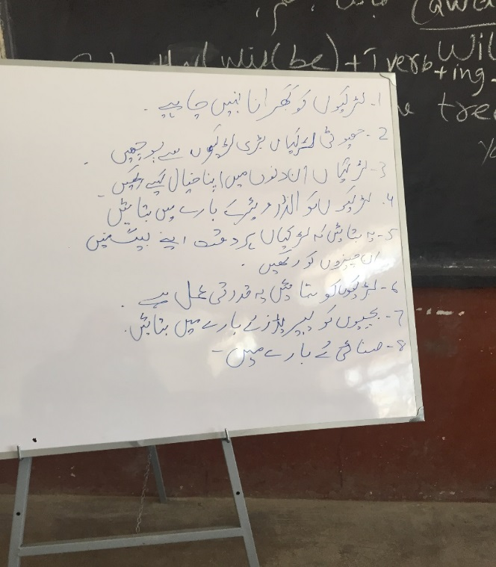

Preliminary Results

Overall, our data identified six key themes that could broadly be understood as:
- Menarche a traumatic event: It was often associated with fear, worry and distress as the girls did not understand why they were bleeding.
- Knowledge and normalization of pubertal changes: Girls’ who had previous knowledge about pubertal changes resulted in a positive experience which normalized menarche. These girls’ were also able to ask for assistance with menstrual hygiene management more easily.
- Cultural Information: Skeptical Acceptance: A large part of the understanding of puberty and pubertal changes stemmed from cultural information. However girls’ actively questioned the validity of cultural customs associated puberty, pointing to inconsistencies.
- Information Needs and Concerns: The girls’ expressed questions and concerns around the physiology of puberty and menstruation, recognition and relief of menstrual symptoms, appropriate menstrual hygiene and management practices; and social, physical, religious and dietary restrictions.
- Quality of WASH facilities do not meet girls menstrual hygiene needs: Poor quality of WASH facilities, including dirty toilets, lack of waste disposal mechanisms, and lack of running water, served as barriers for girls’ in maintaining their menstrual hygiene in school settings.
- Request for Girl-friendly School and WASH Facilities: In order to meet their menstrual hygiene needs, the girls requested clean washroom facilities which are equipped with a working toilet, water, hand soap, towels and dustbins to dispose their soiled pads. Apart from these, the girls requested health education to be provided in schools to manage their menstruation with confidence as well infrastructural improvements including water tanks, and school transportation.

1) Menarche a traumatic event
A key theme emerging from the data was that our respondents’ experience of menarche had been a traumatic event characterized by fear, distress and worry. The vast majority of the girls’ reported they had been scared when they first saw the blood. Most did not understand what was happening to them and a few girls even thought they had developed a disease such as cancer or were dying.

“When I had my first period, I did not know anything about it. I was at home at that time. I was getting ready for school one morning when I felt my shalwar (pants) was wet. I was surprised because I had not sat in water or anything. I went to the washroom and checked my shalwar. I got very scared and I thought that I had developed cancer.” (Lasbela, Girl in 9th grade)

While some girls informed their mothers, elder sisters, cousins or friends about the bleeding, most were too shy or did not know how to communicate that they were bleeding. In the end, some “mustered up the courage” to tell a family member. However a number of them continued to keep their bleeding a secret that was discovered when a family member questioned their suspicious behavior or noticed spotting on their clothing.

“I was in class five when I had my periods. I found stains on my clothes when I came back from school; I was very scared. I was unable to understand anything. I went to the bathroom immediately and took a shower. I didn’t tell anyone because I thought that my mother would scold me if I told her about it. Later, I went in the kitchen and sat on a seat. It was stained when I stood up. My mother saw those stains.” (Lasbela, Girl in 10th grade)

The girls’ worries were only calmed after the family member, often mother, an elder sister, aunt or cousin informed them the bleeding was due to menses and that it was a natural process associated with growing up.

2) Knowledge and normalization of pubertal changes.
While the majority of girls reflected on their first menstruation experiences through a negative light, a small minority (three) recalled it without any fear or stress. All three girls had been previously informed about menarche and bleeding by their sisters. As a result, they were easily able to tell their sisters and mothers when the bleeding started or they were able to obtain supplies such as pads, cloths and underwear to manage their menstruation themselves.

“I was staying at my sister's house when I had my first periods. I told my sister when I started bleeding. My sisters had already told me about it already so I was somewhat mentally prepared. I wasn’t worried. I told my sister that I saw blood when I went to washroom and she gave me supplies to manage the bleeding.” (Kuchlaak, Girl in 10th grade)

A comparison between the menstrual experiences of girls with and without menarche information indicated the former had a positive experience compared to the trauma of the latter. Prior knowledge had normalized the process of menarche. Even the girls themselves recognized the importance of this knowledge, most of them recommended that all girls should have knowledge of what to expect at menarche to avoid unnecessary worry and stress.

I think that we should tell girls about periods when they reach the age of 11 or 12, at least, we should give them a hint. This way, they will be able to manage themselves without getting confused or worried. I don’t think that we should hide this thing from young girls. (Lasbella, Girl in 7th grade)

3) Cultural Information: Skeptical Acceptance
A third important theme emerging from our data was that girls’ knowledge of puberty and menstrual practices was rooted in local, cultural epistemology. Cultural information around puberty appeared to be more available and more predominant for girls, and to play a larger role in their understandings of puberty. While the girls did describe pubertal changes in terms of onset of menstruation, increases in height, development of breasts, growth of pubic hair, appearance of acne, and emotional aggressiveness, they placed a greater emphasis on the social changes they had to undergo. These included, amongst others, practicing pardah (seclusion) which greatly restricted their movements outside the house, and adhering to a long list of practices including avoidance of water and bathing, eating or avoiding certain ‘hot’ and ‘cold’ foods as classified through traditional humoural understanding, and not lifting weights.

However, the girls, especially urban girls, actively questioned the validity of this information. This emerged most apparently in the questions they asked:

Why can't we take a bath during menstruation? (Kuchlaak, Girl in 8th grade)
Why can we not play during menstruation? It is a natural process. Don’t sportswomen play during this time of month? (Kuchlaak, Girl in 9th grade)
Why can't we lift weights during our periods? What happens if we do? (Kuchlaak, Girl in 8th grade)

One reason for this questioning may be the inconsistency of the information they received. For example, the girls noted the inconsistency in advice regarding ‘hot and cold’ foods, bathing, pain relief and even amount of bleeding.
My mother doesn’t allow me to eat certain things during periods e.g., onions, meat, buttermilk, yoghurt etc. What is the reason behind this? (Lasbela, Girl in 7th grade)
Is it true that our stomach enlarges if we use water to wash ourselves and eat beef during periods? (Kuchlaak, Girl in 9th grade)
Can we take any medicine to relief the pain? Some people say that we shouldn’t take medicines during periods. Why is that? (Kuchlaak, Girl in 10th grade)
“Some people say it is good to bleed a lot during periods, while others say it is not’ (Kuchlak, out-of-school girl).

Clearly, while it is important to acknowledge cultural information, our data suggests that it is not meeting the girls’ information needs. It has, however, identified the girls’ precise information needs, which are discussed in detail below.

4) Information Needs and Concerns
The girls’ information needs can be grouped into four categories: Knowledge of physiology of puberty and menstruation; recognition and relief of menstrual symptoms; appropriate menstrual hygiene and management practices; and social, physical, religious and dietary restrictions.

4.1 Physiology of puberty and menstruation
Our data suggests girls’ need information on the physiology of menstruation and its associated physical and emotional changes. Some girls wanted to know why women menstruate, why they developed breasts and grow pubic hair, why only women menstruated and not men, why don’t very young girls or older women menstruate, or why do girls start menstruating at different ages. While girls recognized menstruation as a change that occurs during puberty, they were unaware of the physiological reasons behind the development changes they were experiencing.

Why do we get periods? (Lasbela, Girl in 8th grade)

Why do periods start at a young age and end when we are old? (Lasbela, Girl in 8th grade)

Females don’t normally get periods before the age of 9 and after the age of 55. What do we call if they bleed before or after these ages? (Lasbela, Girl in 8th grade)

Why can't a girl become mother if she doesn’t get her periods? (Kuchlaak, Girl in 10th grade)

The girls also had many concerns around variations in frequency of bleeding and amount of bleeding. They were not aware of the occurrence of biologically normal variation in the length of cycles, or the amount of bleeding. Fluctuations in the length of the menstrual cycle were regarded as a sign of abnormality, as was ‘little’ bleeding and ‘blood clots’. Some girls were also unclear about the ‘color’ of menstrual blood, expressing concerns that their bodies were somehow not normal.

My second and biggest problem is that my periods are irregular. Sometimes, I don’t get them for months while, occasionally, I get them within twenty days of first cycle. Please tell me a solution to this problem. I am worried. Also, I bleed very little when I get my periods. Normally, I bleed for only two days and nothing happens after that. However, the pain continues even when I get the whitish discharge. (Kuchlaak, Girl in 10th grade)

The respondents recommended that all prepubescent (‘before onset of menarche’) girls should be informed about menstruation and the processes underlying the bleeding. They recommend the girls should be informed that menstruation is a natural process, that all women undergo puberty and menstruate and be reassured that there is nothing to worry about with the onset of menstruation.

4.2 Recognition and relief of menstrual symptoms
Our data indicate girls’ need information on recognizing normal menstrual symptoms, the reasons underlying them and how to obtain relief. The most common concerns the girls identified included leg pain, headaches, backaches and stomachaches. The participants also wanted to know why they felt irritable, angry and aggressive while menstruating. Other questions related to overall concerns regarding acne, body pain, nausea, bloating, fatigue, weakness and overall discomfort.

In addition, a need for information on pain management and remedies was identified. Of particular concern was the girls’ poor understanding of and inconsistent use of pain medication. Many girls reported that they were restricted from using any medication to relieve pain while menstruating, although a few girls did report that they were allowed to use medicines and one had even sought medical attention for unbearable pain.
Why do people take tablet during periods? Is it all right to take tablets? If yes, then which tablet should we take? (Lasbela, Girl in 9th grade)
‘Some people say that it is okay to take medicine for pain during periods, while others say that it is dangerous. (Kuchlak, Girl in 9th grade)

4.3 Appropriate Menstrual Hygiene and Management Practices
Another information need identified was around suitable menstrual hygiene and management practices. A common cultural practice identified in the data is the avoidance of water and bathing during menstruation. Local understanding of menstruation, located within Yunani humoral beliefs of health and disease, situate bleeding as an impure process. A menstruating woman is understood as being impure. This leads to a number of restrictions on menstruating girls including prohibitions on coming in contact with water and bathing. Bathing was understood to cause abdominal swelling and intensification ‘of menstrual pain.

Our data, however, suggests these restrictions were questioned by the girls. They want to know if they really have to follow these restrictions and if yes, what are the reasons underlying them.

‘During periods we are not allowed to take a bath for 7 days. What is the reason behind that? (Kuchlak, Girl 8th grade)

Should we clean ourselves with water during this time (Kucklak, grade 9th)

Although the girls followed these practices, our data suggest a need to provide knowledge around hygienic menstrual management and practices. In addition, the girls specifically suggested that the puberty book should provide information on how to use pads and underwear, frequency of changing pads, and the importance of keeping these with them at all time, including school.

“Girls should bring their pads and other important stuff to school in order to avoid any problems if they get periods in school.” (Kuchlaak, Girl in 7th grade)

4.4 Social, Physical, Religious and Dietary Restrictions
When girls were asked to list what information should be included in the puberty book, the list, paradoxically, included all cultural practices they also questioned. They suggested the following information should be covered in the book:
- Religious restrictions such as avoiding praying, fasting, sitting on the prayer mat, as well as touching or reciting the Quran.
- Physical restrictions including avoiding lifting heavy objects, not playing or dancing as well as riding bikes.
- Social restrictions such as not sitting with men and boys when menstruating, following the norms of pardah (seclusion) including not leaving the home and conducting themselves in a ‘proper’ manner.
- In terms of dietary restrictions, the girls wanted the book to contain information on what specific foods to eat and avoid.

5) Quality of WASH facilities do not meet girls menstrual hygiene needs

Water, sanitation and hygiene facilities were observed in three high schools, two in the data collection sites and one in Hub, a semi-rural area. Observations in additional schools were not possible due to security reasons. All three schools were girls-only schools. Additional useful data related to the color of girls’ uniforms that consisted of blue kameez, white shalwar and a white Dupatta, which might readily show menstrual stains if girls are not able to change their menstrual materials adequately in school.

Table 2 lists the total number of students and toilets in each site. In all schools, one toilet was reserved for the headmistress and one for the teachers.

Table 2

Site | No of girls | No. of toilets | Ratio of girls : toilets
Kuchlak (urban) | 385 | 3 | 128:1
Hub (semi-urban) | 1214 | 4 | 303.1
Sakuran | 232 | 2 | 116:1

The urban and semi-urban school’s had flush toilets and clean water, either piped or collected from a well. Where running water was not available in a toilet or sink, water in a bucket or a portable tank with a tap was available. In both cases the toilets were located at a relatively safe location from the classrooms for easy access for the girls. However the facilities were all very dirty, with one school reporting its toilets were cleaned only once per year. There was no mechanism for waste disposal, which was consequently scattered around the toilets. None of the schools has regular cleaners. There was no post for a school cleaner and the service was provided, very irregularly, by nearby village’s traditional cleaners. Consequently the girls, specifically the younger ones in classes 2-4, were assigned to clean the toilets. In the urban school the girls not only cleaned the principal and teachers toilets, but the entire school.

The rural school toilet was a pit-latrine, with no water. The toilets were located at a significant distance, behind the classrooms. The girls never used the toilets and the toilets were locked. In fact the girls reported that they were scared to go anywhere near the toilets because of stories that ‘jinns’ (spirits) lived there.

The poor quality of the WASH infrastructures, the dirty toilets and their location all acted as a barrier for girls to access the facilities. While this is a severe impediment on a day-to-today basis, it was further exacerbated when girls were menstruating and needed to maintain menstrual hygiene. The lack of running water meant that the girls could not wash up. The lack of a concealed disposal mechanism for their menstrual hygiene products (such as a closed dustbin) led to girls not changing their pads for the duration of a school day. Not only is this uncomfortable, it has health consequences such as increased rashes.

As a result of this inaccessibility to WASH facilities in school, these girls had permission to go home to use toilets, and those who lived further tended to go to their friends’ homes. We observed girls freely walking out of the school at all times and not returning for up to an hour at a time. Such behaviors have implications for girls’ absences from school during school-hours and its potential impact on their education. The photographs below capture the situation graphically.

Toilet facility (urban site)

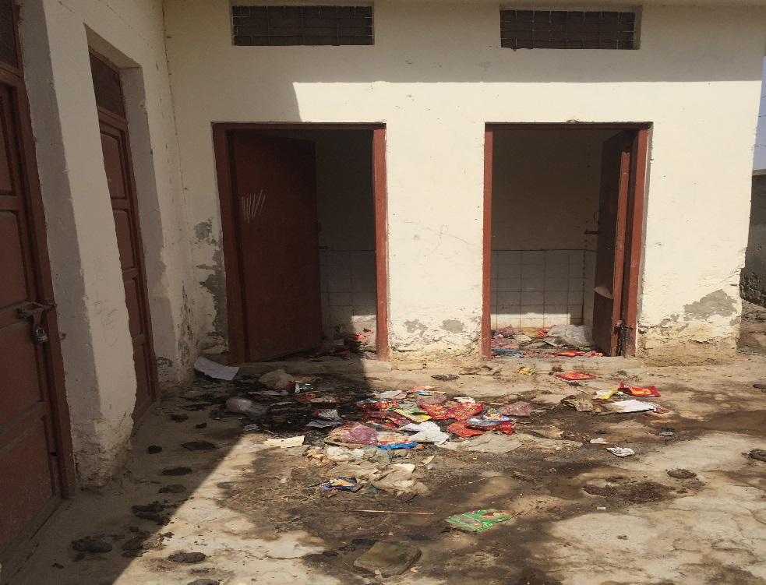

A locked toilet in rural site

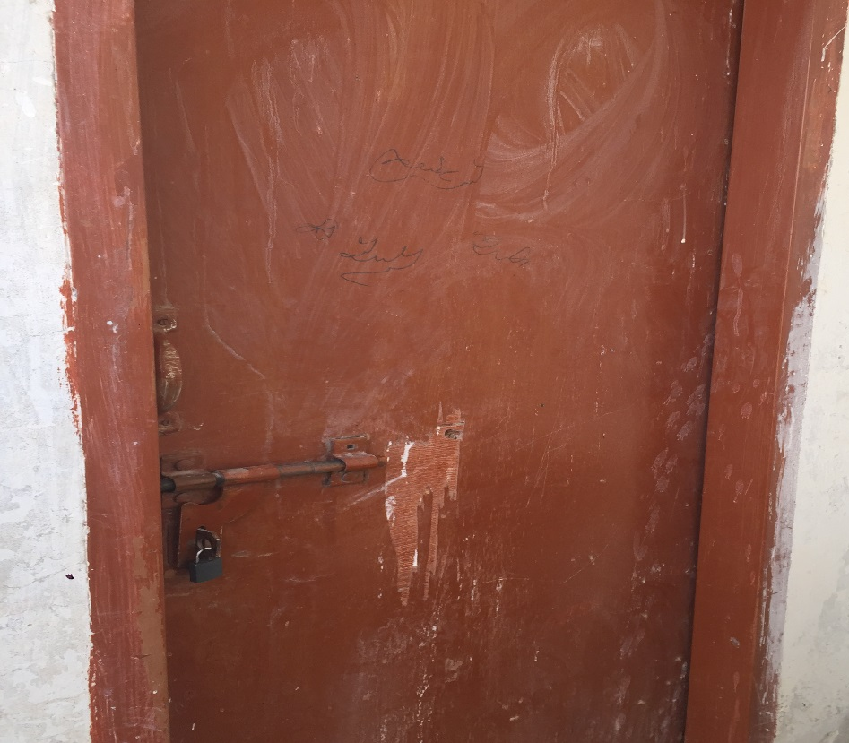

Water source available, but no water in the tap in this urban school

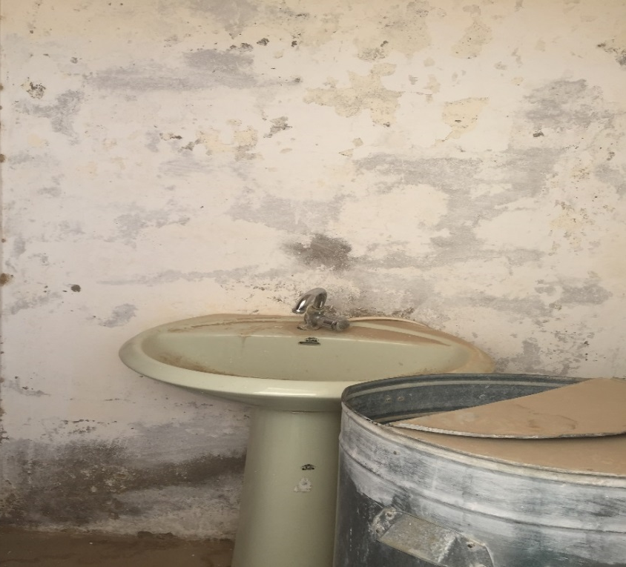
School waste disposal system: burning in a lane

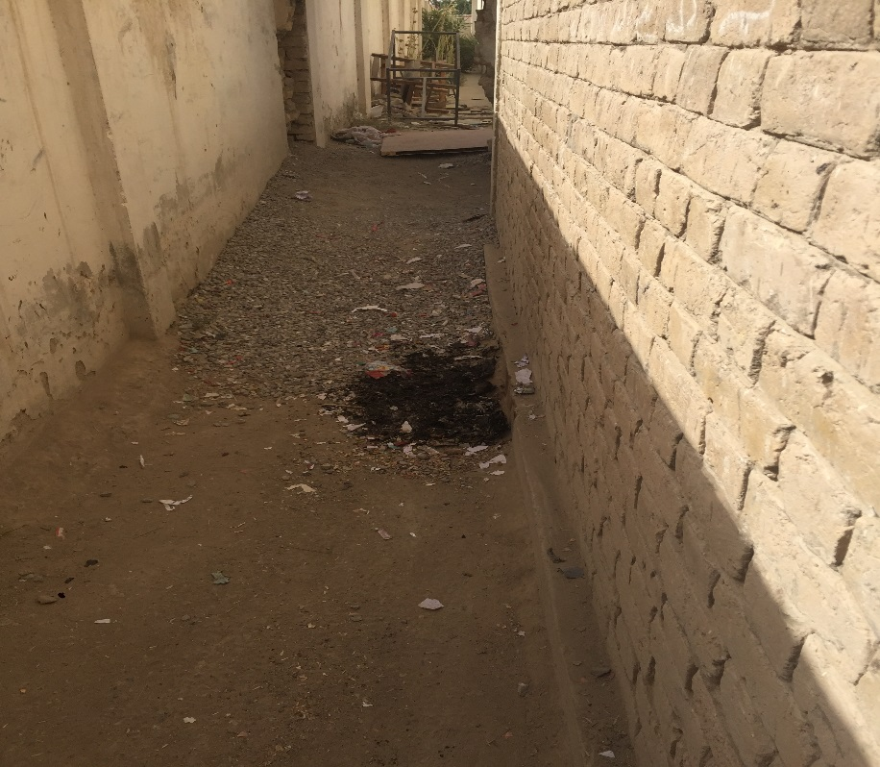

6) Request for Girl-friendly School and WASH Facilities
In order to create more girl-friendly schools, the participants identified the following areas of need for themselves and other adolescent girls:

6.1 Resources for Menstrual Management
The following resources were listed:

    - Washrooms. Identifying a lack of washrooms in school as problematic, the girls recommended that each school should have, at least, two to three clean washroom facilities, which are equipped with toilet, water, hand soap, towels as well as dustbins or other methods to dispose soiled pads.

“There is no washroom that’s why we go home to relieve ourselves.” (Lasbela, Girl in 7th grade)

“There is a washroom building, but it’s locked. The reason for keeping the washroom under lock and key is that there is no cleaner in the school” (Observations notes, Lasbella)

In order to ensure the washrooms and school facilities remained clean, the girls recommended hiring cleaning personnel, as otherwise students often had to clean themselves, something the girls felt was not their task to perform.

“We mop the floors ourselves because there is no cleaner in our school.” (Lasbela, Student in 7th grade)

    - Menstrual management facilities: To assist with menstrual management in schools, the girls recommended the need to have emergency pads, underwear, extra clothing including shawls and pain medication, be available for girls who do not have the MHM-related materials they need. They suggested a room be assigned where these materials could be stored. This room could also be used for resting when the girls suffered from menstrual pain. They suggested a few minutes be slotted between classes so girls have time to change their pads.

    - Health Education in Schools: In order to assist girls to feel supported during the experience of menarche and to understand how to manage their menstruation with confidence, there is a need for special health education in schools, led by specially trained teachers.

6.2 Addressing Infrastructural and Utility Gaps
Our respondents identified a long list of infrastructural needs they would address if they had a million rupees (the “million rupee” activity was one of the participatory activities used to solicit girls’ ideas). These included:

6.2.1) Improvements in schools infrastructure, including the need for functioning washrooms. The participants keenly felt their school should be kept clean. The participants stated they would invest in providing clean water to their school facilities, along with water tanks, water motors and filters to provide fresh clean water. They also specified the need for electricity, a gas supply and generators.
6.2.2) Transportation: The final change advocated by the student was the need for transportation to and from the schools. The student stated this would help them get to school regularly but also assist in times of need such as when girls had severe menstrual stomachaches.
“We will arrange a vehicle so that it is easy to send girls home if they are not feeling well.” (Lasbela, Girl in 10th grade)

Recommendations
The objective of the present research was to understand girls’ in Baluchistan experiences of menarche, explore cultural values, beliefs and practices surrounding menstruation, and how the lack of water, sanitation and disposal infrastructure may negatively impact their management of menstruation in schools, and ability to participate in schools. Similar data were collected from Punjab by the same team and in KPK by International Rescue Committee. The Punjab data is currently being analyzed. Overall, the findings from Baluchistan, preliminary findings from Punjab and a small study from KPK show a high degree of similarity, suggesting a commonality of experiences, cultural beliefs and practices across the country.

Based on this research, we recommend:

- Develop an information resource to provide girls knowledge of puberty, menarche and menstrual hygiene management. This information can be presented in a written form, as a book, or a pamphlet. It can also be presented as an animation video. At a later stage, a web-based resource can be developed for use by girls who have access to the internet.

- Develop a MHM health education module that should be taught as part of their school curriculum.

- Train teachers to deliver this health education module in a sensitive and objective manner.

- Develop school WASH facilities. This includes making available clean washrooms with clean running water and disposal facilities. More importantly these washrooms should be located in safe spaces and be open and available for use by the girls.

- There is also a need to create positions for cleaners to clean the washroom facilities. Moreover, these positions should be filled by people who will clean the facilities, which traditionally have been low-caste cleaners. Our previous research has shown that such posts are often filled by relatives of either the teachers, senior managements or even the local powerful elite. Such people draw the salary but do not perform their duties.

- Develop menstruation support facilities. This includes making available sanitary supplies (at a cost), and a room for menstruating girls to rest in case of pain.

- Conduct further research on following areas:
  - Obtain a deeper understanding of meanings of menstruation and how these impact menstrual management including use of absorbent materials and their disposal. This information is important to understand further
    - Need and potential to develop a local, economically feasible mechanism to manufacture sanitary pads using local, cheap materials
    - Development of a culturally-acceptable mechanism for menstrual waste disposal.
  - How men and boys understand menstruation and the impact of these on menstrual management resources.
  - Why teachers remain reluctant to engage students around MHM issues?
  - Why are toilet facilities in school so dirty? Why is there a social and cultural blindness to a dirty toilet? Why is there reluctance to clean toilet facilities?

References
- Ali, T. S., Ali, P. A., Waheed, H., & Memon, A. A. (2006). Understanding of puberty and related health problems among female adolescents in Karachi, Pakistan. Journal-Pakistan Medical Association, 56(2), 68.
- Ali, T. S., & Rizvi, S. N. (2010). Menstrual knowledge and practices of female adolescents in urban Karachi, Pakistan. Journal of Adolescence, 33(4), 531-541.
- Hamid, S., Johansson, E., & Rubenson, B. (2011). Good parents’ strive to raise ‘innocent daughters. Culture, health & sexuality, 13(7), 841-851.
- Mumtaz, Z*. and S. Salway (2007). Gender, pregnancy and uptake of antenatal care services in Pakistan. Sociology of Health and Illness. 29(1): 1-26.
- Mumtaz, Z. and S. Salway. (2005). ‘I never go anywhere’: Extricating the links between women’s mobility and uptake of reproductive health services in Pakistan. Social Science and Medicine 60(7): 1767-1779.
- Hennink, M., Rana, I., & Iqbal, R. (2005). Knowledge of personal and sexual development amongst young people in Pakistan. Culture, health & sexuality,7(4), 319-332.
- Chothe, V., Khubchandani, J., Seabert, D., Asalkar, M., Rakshe, S., Firke, A., ... & Simmons, R. (2014). Students’ Perceptions and Doubts About Menstruation in Developing Countries A Case Study From India. Health promotion practice, 15(3), 319-326.
- Khan, A., & Pine, P. (2003). Adolescent reproductive health in Pakistan: Status, policies, programs, and issues. Policy Project, Pakistan.
- McMahon, S. A., Winch, P. J., Caruso, B. A., Obure, A. F., Ogutu, E. A., Ochari, I. A., & Rheingans, R. D. (2011). 'The girl with her period is the one to hang her head' Reflections on menstrual management among schoolgirls in rural Kenya. BMC international health and human rights, 11(1), 7.
- Sommer, M. (2010). Where the education system and women's bodies collide: The social and health impact of girls' experiences of menstruation and schooling in Tanzania. Journal of adolescence, 33(4), 521-529.
- Ali, T. S., Sami, N., & Khuwaja, A. K. (2007). Are unhygienic practices during the menstrual, partum and postpartum periods risk factors for secondary infertility?. Journal of Health, Population and Nutrition, 189-194.
- Aniebue, U. U., Aniebue, P. N., & Nwankwo, T. O. (2009). The impact of pre-menarcheal training on menstrual practices and hygiene of Nigerian school girls. Pan African Medical Journal, 2(1).
- Deo, D. S., & Ghattargi, C. H. (2005). Perceptions and practices regarding menstruation: a comparative study in urban and rural adolescent girls. Indian J Community Med, 30(1).
- Ahmed, R. and K. Yesmin (2008) ‘Menstrual hygiene: breaking the silence’, in J. Wicken, J. Verhagen, C. Sijbesma, C. da Silva and P. Ryan (eds.) Beyond Construction Use by All,: IRC International Water and Sanitation Centre and WaterAid
- UNICEF, P. (2012). Situation Analysis of children and women in Pakistan.
- UNICEF, P. (2013). Global initiative on out-of-school children.
- UNICEF. (2014). Pakistan Annual Report 2013.
- Binka, C. (2003). Tell our daughters about sex and periods. Africawoman (13)(October 2003), 7-8.
- Kirumira, E. K., & Stewart, J. E. (Eds.). (2003). Life skills, sexual maturation and sanitation: what's (not) happening in our schools?: an exploratory study from Uganda. Weaver Press.
- National Union of Eritrean Women (NUEW), & Catholic Relief Services (CRS). (2002). Baseline survey for the practice of high school students on reproductive health and personal hygiene. [Internal report]. Asmara: CRS.
- Stewart, J. (2004). Life skills, maturation, and sanitation: What’s (not) happening in our schools? An exploratory study from Zimbabwe. Zimbabwe:Women’s Law Center Weaver Press.
- UNICEF. (2012). Progress for Children: A report card for adolescents, number 10. New York, NY: UNICEF Division of Communication.
- Sommer, M. (2011). An Early Window of Opportunity for Promoting Girls Health: Policy Implications of the Girls Puberty Book Project in Tanzania.Global Journal of Health Education and Promotion, 14(1).

