Asthma Action Plans

Methods
In June 2014, searches were conducted by an expert searcher-librarian (SC) in the following databases: Ovid MEDLINE, Ovid EMBASE, Ovid Health and Psychosocial Instruments, Cochrane Library CINAHL, SCOPUS, LILACS, PROSPERO, and Proquest Dissertations and Theses Full Text. The databases were searched using controlled vocabulary (eg: MeSH , EMTREE, etc.) and text words to represent the concepts of "asthma action plans" and "emergency department" and "clinical trials". No limits were applied. Full text of the search strategies can be found in Appendix A

Appendix A

1
Database: Ovid MEDLINE(R) In-Process & Other Non-Indexed Citations, Ovid MEDLINE(R) Daily and Ovid MEDLINE(R) <1946 to
Present>
Search Strategy:
--------------------------------------------------------------------------------
1 exp Patient Education as Topic/ or exp Self Care/ or exp Patient Care Planning/ (151860)
2 asthma action plan.mp. (150)
3 *"Asthma"/th [Therapy] (8896)
4 (plan or plans).ti,ab. (105379)
5 3 and 4 (501)
6 Emergency Treatment/ or Emergency Medicine/ or emergency medical services/ or emergency service, hospital/ or
trauma centers/ or triage/ or exp Evidence-Based Emergency Medicine/ or exp Emergency Nursing/ or Emergencies/ or
emergicent*.mp. or ((emergenc* or ED) adj1 (room* or accident or ward or wards or unit or units or department* or
physician* or doctor* or nurs* or treatment*or visit*)).mp. or (triage or critical care or (trauma adj1 (cent* or
care))).mp. [mp=title, abstract, original title, name of substance word, subject heading word, keyword heading word,
protocol supplementary concept word, rare disease supplementary concept word, unique identifier] (201293)
7 5 and 6 (155)
8 limit 7 to clinical trial, all (41)

2
EMBASE
Database: Embase <1974 to 2014 June 02>
Search Strategy:
--------------------------------------------------------------------------------
1 (plan or plans).ti,ab. (139836)
2 Emergency Treatment/ or Emergency Medicine/ or emergency medical services/ or emergency service, hospital/ or
trauma centers/ or triage/ or exp Evidence-Based Emergency Medicine/ or exp Emergency Nursing/ or Emergencies/ or
emergicent*.mp. or ((emergenc* or ED) adj1 (room* or accident or ward or wards or unit or units or department* or
physician* or doctor* or nurs* or treatment*or visit*)).mp. or (triage or critical care or (trauma adj1 (cent* or
care))).mp. [mp=title, abstract, subject headings, heading word, drug trade name, original title, device manufacturer,
drug manufacturer, device trade name, keyword] (255697)
3 *asthma/ (112138)
4 1 and 2 and 3 (447)
5 limit 4 to (clinical trial or randomized controlled trial or controlled clinical trial or multicenter study or
phase 1 clinical trial or phase 2 clinical trial or phase 3 clinical trial or phase 4 clinical trial) (62)

3.
Database: Health and Psychosocial Instruments <1985 to April 2014>
Search Strategy:
--------------------------------------------------------------------------------
1 asthma.mp. [mp=title, acronym, descriptors, measure descriptors, sample descriptors, abstract, source] (1267)
2 "Asthma".sd. (826)
3 1 or 2 (1267)
4 (plan or plans).ti,ab. (442)
5 3 and 4 (14)
6 asthma action plan*.mp. [mp=title, acronym, descriptors, measure descriptors, sample descriptors, abstract,
source] (1)
7 5 or 6 (14)

4

CINAHL June 2, 2014
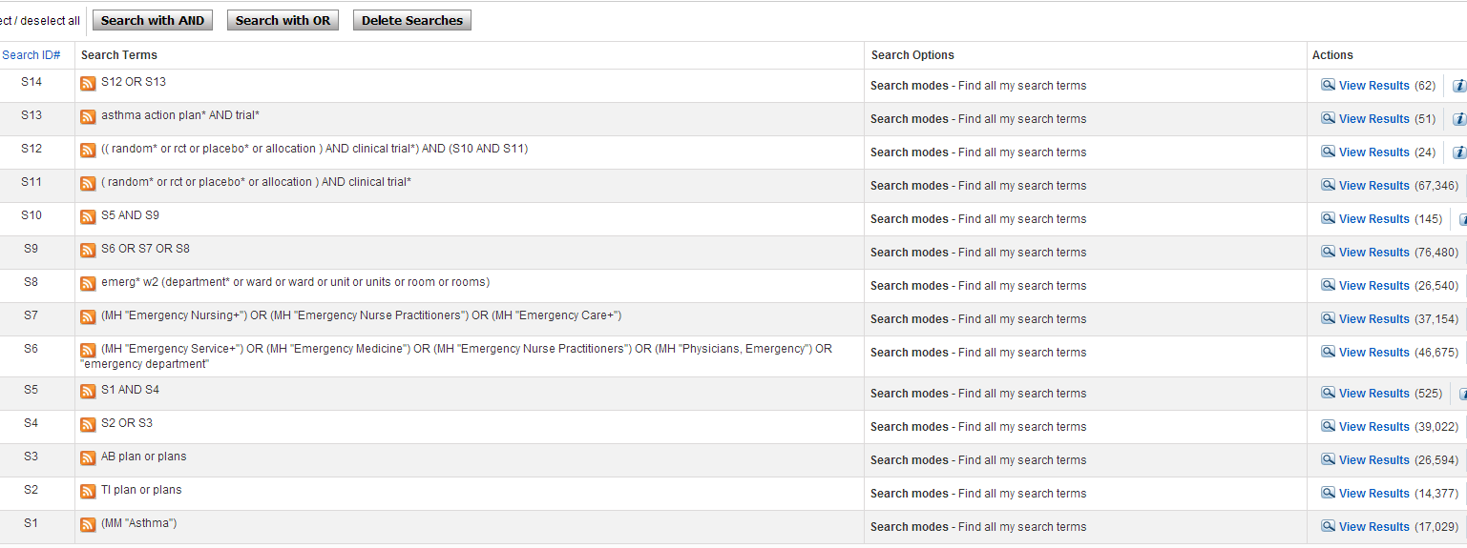
5
Cochrane Library Searched June 2, 2012
Cochrane Reviews (11) Oher Reviews (3) Trials (122) Methods Studies (0) Technology Assessments (0) Economic

asthma action plan*

6
Proquest Dissertations and Theses Full Text June 2, 2014
all((asthma AND (plan OR plans) AND (emergenc* OR ed) AND (random* OR rct OR placebo* OR trial OR trials OR allocation)))

7
SCOPUS June 2, 2014
TITLE-ABS-KEY(asthma AND (plan OR plans) AND (emergenc* OR ed) AND (random* OR rct OR placebo* OR trial OR trials OR allocation))

8
LILACS
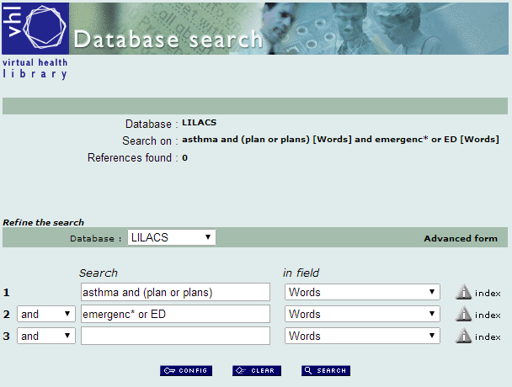

9
PROSPERO
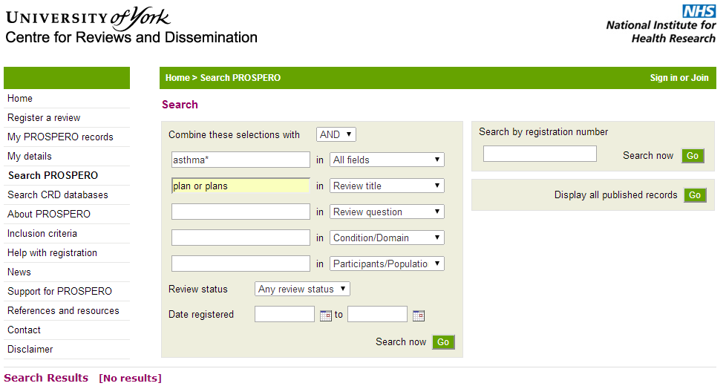

Author Note:
Sandy Campbell is an expert searcher and Medical Librarian at the John W. Scott Health Sciences Library, University of Alberta.

