**Estimation of the age of a weathered mixture of volatile organic compounds**

By:

Brianne M. Zorzetti1, 2, and James J. Harynuk1*

1Department of Chemistry, University of Alberta, Edmonton, AB, T6G 2G2, Canada

2Eigenvector Research Inc., Wenatchee, WA, 98801, United States

Submitted To:

Analytica Chimica Acta

*\*Corresponding author: Department of Chemistry, University of Alberta, Edmonton, AB, T6G 2G2, Canada. Tel.: +1 780 492 8303; Fax: +1 780 492 8231.*

*E-mail address: james.harynuk@ualberta.ca (J.J. Harynuk).*

**Abstract**

The ability to predict the amount of time that a light petroleum mixture has been weathered could have many applications, such as aiding forensic investigators in determining the cause and intent of a fire. In our study, an evaporation chamber that permits control of airflow and temperature was constructed and used to weather a model nine-component hydrocarbon mixture. The composition of the mixture was monitored over time by gas chromatography and a variety of chemometric models were explored, including partial least squares (PLS), nonlinear PLS (PolyPLS) and locally weighted regression (LWR or loess). A hierarchical application of multivariate techniques was able to predict the time for which a sample had been exposed to evaporative weathering. A classification model based on partial least squares discriminant analysis (PLS-DA) could predict whether a sample was relatively fresh (< 12 h exposure time) or highly weathered (>20 h exposure time). Subsequent regression models for these individual classes were evaluated for accuracy using the root mean square error of prediction (RMSEP). Prior to regression model calculation, y-gradient generalized least squares weighting (GLSW) was used to preprocess the data by removing variance from the X-block, which was orthogonal to the Y-block. LWR was found to be the most successful regression method, whereby fresh samples could be predicted to within 40 min of exposure and highly weathered samples predicted to within 5.6 h. These results suggest that our hierarchical chemometric approach may also allow us to estimate the age of more complicated light petroleum mixtures, such as gasoline.

*Keywords:* Gas chromatography; Y-gradient generalized least squares weighting; Weathering; Partial least squares discriminant analysis; Locally weighted regression

1. **Introduction**

Hydrocarbon pollution causing environmental damage occurs frequently due to accidental and intentional release from sources such as production platforms, tanker accidents or operational discharge, municipal wastes, and natural seepage. Petroleum input into the marine environment has previously been estimated at 1.7-8.8 million metric tons per year [[1]]. As a result, the ability to characterize and observe petroleum spill behaviour is important in evaluating its impact on the ecosystem, making accurate risk assessments, and determining the efficacy of remediation strategies implemented to mitigate damage.

Petroleum released into the environment is subjected to weathering, which encompasses the physical, chemical and biological processes responsible for hydrocarbon degradation. Extensive research has been conducted to improve our understanding of the compositional changes that occur during heavy petroleum weathering, which is essential to determining the fate and behaviour of oil spills in the environment [[2], [3], [4], [5], [6], [7]]. Previous studies have also focused on the weathering of heavy petroleum samples in more extreme environments. Brandvic and Faksness [[8]] studied Arctic oil spills and the effect of ice conditions on oil weathering, Barakat et al. [[9]] investigated biomarker stability in oil exposed to the arid terrestrial environment of Egypt and Wang et al. [[10]] collected data on a 25-year-old oil spill in the wetlands of northern Alberta to determine if clean-up was successful and to assess vegetative recovery. Toxicity during weathering has also been studied to understand the consequences of oil spills for the ecosystem and marine life. Neff et al. [[11]] studied the toxicity of crude oil and diesel fuel weathering on six tropical and temperate marine animals. Similarly, Carls et al. [[12]] have studied crude oil toxicity on pacific herring eggs and Heintz et al. [[13]] on pink salmon embryos.

Liability associated with petroleum release in the environment requires reliable characterization and source identification, which can be complicated by weathering. However, understanding this process can aid in determining which criteria are necessary for characterization. Biomarkers are distinctive compounds found in crude oil that are resistant to degradation, making them ideal for predicting efficiency of remedial action, monitoring spill behaviour and identifying oil sources. As a result, biomarkers have become the focus of many petroleum weathering studies [[14], [15], [16], [17]].

Another successful approach to petroleum fingerprinting is the application of chemometrics. Mudge [[18]] reassessed the sources of hydrocarbon background found in the Gulf of Alaska and Prince William Sound with PLS analysis. Stout et al. [[19]] have studied petroleum biomarkers using principal component analysis (PCA) to correlate spilled oil to possible sources. Gaines et al. [[20]] reduced the number of biomarker ratios needed to differentiate between diesel fuels using PCA, while Malmquist et al. [[21]] distinguished between the effects of evaporation and dissolution on oil spill composition. Borges et al. [[22]] compared PCA, Kohonen self-organizing maps and PLS-DA methods to classify oil samples by geographical origin. Similarly, parallel factor analysis (PARAFAC) has been applied as a screening technique for source matching [[23]], and soft independent modelling of class analogy (SIMCA) has successfully classified heavy petroleum based on biomarker data [[24], [25], [26]]

Unfortunately, few studies have focused on light petroleum weathering with the aim to estimate the time of exposure based on the observed composition of a weathered sample at a given time, and assuming a prior composition. Previous studies aimed at estimating the age of petroleum contamination have already proven important in litigation due to the high costs associated with spill cleanup. Oukijk [[27]] estimated the age of heating-oil leaks from underground storage tanks with an error of ±2 years. Similarly, Christensen and Larsen [[28]] studied degradation ratios between alkanes and isoprenoids from which they could estimate the age of diesel oil spills in a subsurface soil environment with an error ± 2 years for oil exposed between 5-20 years. Here we focus on modeling the weathering of a model light petroleum mixture to estimate its exposure time. This could have many applications, for example in the estimation of the age of spilled ignitable liquids (ILs) during the course of an arson investigation. In the United States, annual property damage from intentional fires is estimated at over one billion dollars [[29]]. As forensic investigators seek to determine the cause of a fire, identifying the presence of an IL is the primary question, though it is desirable to identify the class and origin of the IL as well if possible. Many studies have focused on tracing the origin of an IL [[30], [31], [32], [33]]. However, knowing the length of time for which an IL has been exposed to weathering effects prior to a fire would also be a useful tool for forensic investigators. In this study we apply chemometrics to the chromatographic profiles of our weathered samples to obtain a predictive model that can estimate, with reasonable accuracy, the age of a model mixture.

1. **Experimental**

An enclosed chamber was built to control and adjust the major weathering parameters of temperature and airflow (Fig. 1). The chamber measured 51×25×34 cm (length×width×height). Access to the chamber was provided by a sliding front panel. The chamber contained three perforated-metal shelves, two of which were removable, and six feed-through ports in the chamber roof for thermocouples. The chamber was insulated on all sides by a 2.5 cm thick Styrofoam™ layer and it sat on a 3 mm thick rubber mat. The chamber temperature was regulated by a recirculating water bath that pumped heated water through a serpentine segment of 1/4 inch copper tubing that rested on the chamber floor. After passing through the chamber, the water entered the core of a 2 L cylindrical water jacket before returning to the water bath. High-pressure laboratory air was passed through a hydrocarbon trap and then counter-currently (to the water flow) through a coil of 1/4 inch copper tube that was soldered around the outside of the water jacket to ensure good thermal contact before flowing into the chamber floor where it was dispersed evenly through the chamber by a series of perforations in a second serpentine segment of 1/4 inch tubing. Air that entered the chamber was vented through a segment of 2-inch pipe connected to the top of the chamber and into a fume hood. The water jacket and all copper tubing were insulated with foam insulation.

Nine compounds were chosen to represent characteristic components of gasoline [[34], [35]]. The nine-compound mixture was made by combining 10 g of naphthalene (Caledon, ON, Canada) and 30 mL each of the following hydrocarbon compounds: benzene (Caledon), heptane (Caledon), 2,2,4-trimethylpentane (Chemical Samples Co., OH, United States), toluene (Fisher Scientific, ON, Canada), m-xylene (Sigma-Aldrich, ON, Canada), nonane (Sigma-Aldrich), decane (Sigma-Aldrich) and 1,2,3,5-tetramethylbenzene (Sigma-Aldrich).

For weathering, 50 mL aliquots of the sample solution were poured into circular Pyrex® dishes (80×40 mm) and placed on a shelf in the weathering chamber. Samples of the weathered solution were collected at varying times during the course of the five-day weathering study. Samples were collected every half-hour within the first two hours of weathering, followed by hourly increments until six hours (total time) had elapsed, then two-hour increments until 12 hours had elapsed. At this time, eight-hour increments were implemented until 36 hours had elapsed, then twelve-hour intervals until 84 hours had elapsed. A final sample was taken at 108 hours total elapsed time. A total of twenty samples were collected from each dish and stored at -4°C in sealed 1.8 mL GC sample vials. Prior to analysis, weathered samples were brought to room temperature and diluted 200× using pentane (Fisher Scientific) containing 3,6-dimethyloctane (Chemical Samples Co.) as an internal standard at a concentration of 0.5 μL·mL-1.

* 1. *GC-MS analysis*

Samples were analyzed using an Agilent 7890 gas chromatograph coupled to an Agilent 5975 mass spectrometer (Agilent Technologies, ON, Canada). A 30 m×0.25 mm×0.25 µm HP-5 column (Agilent Technologies) with helium carrier gas at a constant pressure of 9.5 psi was used. The total run time was 10.7 minutes with an oven program of 35 °C (hold 3 min) to 120 °C at 15 °C·min-1, then to 180 °C at 30 °C·min-1. The front inlet temperature was held at 250 °C and the transfer line temperature was held at 185 °C. The sample injection volume was 1 µL, using a 500:1 split ratio. Electron impact ionization (70 eV) was used with a quadrupole mass analyzer in full scan mode (35 to 250 amu).

* 1. *Data analysis*

All compound peak areas were integrated using ChemStation™ software (Agilent Technologies). Data were then analyzed using MATLAB 7.9 (The MathWorks™, MA, United States) and PLS Toolbox 5.8.2 (Eigenvector Research Inc. WA, United States).

1. **Results and Discussion**

Two weathering studies were conducted in which two dishes each were placed on the top (Dishes A and B) and bottom (Dishes C and D) shelves of the evaporation chamber. A sample was collected from each dish at the designated time using a Pasteur pipette. Temperature was monitored with five evenly spaced thermocouples. For the first study in September 2009, the chamber was held at 25 ± 1 °C with a constant flow rate of 11.8 L·min-1 (16 chamber volumes per hour). The second study, held in October 2009, was conducted under conditions that were identical to the prior study, with the one change being a more precise thermocouple meter which provided measurements to 0.1 °C. During this study, the chamber was held at a constant temperature of 26.7 ± 0.5 °C.

During these studies we noticed that the dishes on the bottom shelf (C and D) experienced a faster weathering rate than the top shelf (A and B). This may be due in part to the temperature being slightly higher and/or the air flow on the bottom shelf being slightly more turbulent. Either of these effects could potentially speed evaporation on the bottom shelf. Saturation of clean air that entered from the bottom of the chamber with compounds from the bottoms shelf, thus slowing evaporation on the top shelf was not deemed to be a likely explanation. This is due to the fact that data for the top shelf in both of the September and October studies were collected with samples on both shelves, and the top-shelf data from these two trials were indistinguishable from data from an initial pilot study which only had dishes on the top shelf (data not shown). This pilot was used to determine suitable solvent volumes, injection conditions, and the length of weathering times to use in gathering the full data set. Samples from either shelf can be modeled successfully, but they cannot be easily combined. For simplification, we have arbitrarily chosen the data collected from the top shelf for our model studies. Integrated peak areas, normalized to the internal standard and total analyte peak areas for all samples from both shelves are included as a tab-delimited text file in the supplementary material. Future studies will be aimed at identifying the source of the discrepancy between the behaviour of samples on the two shelves.

All samples were analyzed in triplicate by GC-MS, resulting in a total of sixty data points from each dish. Before applying the chemometric models, the integrated area of each peak was normalized to the area of the internal standard (to account for variations in GC injection volume) then divided by the normalized total peak area. Our data were then autoscaled, and a GLSW [[36], [37], [38], [39], [40]] technique was used to down-weight the differences between replicate measurements.

GLSW uses the eigenvectors and eigenvalues of a covariance matrix to down-weight signal identified as being from known interferences or differences between samples which should otherwise be the same. In this work, X-block variance which is approximately orthogonal to the property of interest is identified for down-weighting using a sorted list of the reference values. To a first approximation, the reference values (known individually as the y values and collectively as the Y-block) can be considered a description of the similarity between samples. Samples with similar y values would be expected to have similar responses (rows of the X-block). In order to identify the differences between samples with similar y values, the rows of both the X- and Y-blocks are simultaneously sorted in order of increasing y value. This puts samples with similar y values near each other in both blocks. Next, the difference between proximate samples is determined by calculating the derivative down each column (response variable) of the X-block. These derivatives are calculated using a 5-point, first-order, Savitzky-Golay first derivative (equivalent to a derivative with a 5-point moving boxcar smoothing). This derivative yields a matrix, **X**d, in which each sample (row) is an average of the difference between it and the four samples most similar to it. A similar derivative is calculated for the sorted Y-block, yielding vector **y**d, a measure of how different the y values are for each group of 5 samples.

At this point, **X**d could be used to calculate the covariance matrix for down-weighting. However, some of the calculated differences (rows) may have been performed on groups of samples with significantly different y values. These rows contain features which are more correlated to the Y-block and should not be removed by GLSW. To avoid this, the individual rows of **X**d need to be re-weighted by converting the sorted Y-block differences into a diagonal re-weighting matrix, **W**, in which the *i*th diagonal element, *w*i, is calculated from the rearranged equation:

$\log_{2}\left(w_{i}\right)={-y}_{d,i}s_{yd}$ (1)

The value **y**d,i is the *i*th element of the **y**d vector, and **s**yd is the standard deviation of y-value differences:

$s_{yd}=\sqrt{\sum_{i=1}^{m}{\frac{{\left(y_{d,i}-{\overline{y}}_{d}\right)}^{2}}{m-1}}}$ (2)

The re-weighting matrix is then used along with **X**d to form the covariance matrix

$C=X_{d}^{T}W^{2}X_{d}$ (3)

and followed by the singular-value decomposition of the matrix, which produces the left eigenvectors, **V**, and the diagonal matrix of singular values, **S**:

$C=VS^{2}V^{T}$ (4)

Next, a weighted, ridged version of the singular values is calculated

$D=$ $\sqrt{\frac{S^{2}}{α}+I_{D}}$ (5)

where ***I***D is a diagonal matrix of ones of appropriate size and α is the weighting parameter. A value of α is chosen, usually between 1 and 0.0001, to define the level of influence the filter has on the X-block. At large values (α >1), the filter has less effect and its influence increases as α decreases. Finally, the inverse of these weighted eigenvalues are used to calculate the filtering matrix, ***G***:

$G=VD^{-1}V^{T}$ (6)

This filtering matrix can be used by simply projecting a sample into the matrix. The result of this projection is that correlations present in the original covariance matrix are down-weighted (as defined by α) while other variances pass. The filtering matrix is used both on the original training data prior to model calculation and any future new data prior to application of the regression model.

* 1. *PLS-DA*

Though only nine variables are used, the weathering time profiles of individual compounds are collectively complex (see supplementary electronic material). Multiple linear regresstion (MLR) and PLS were initially investigated for modeling weathering across the entire time range, but the results were unsatisfactory. This is likely due to the fact that the weathering patterns for the different compounds do not vary linearly with time (or ln(time)) as shown in the supplementary material. After trying to linearize the data, we decided to split the data into a “fresh” and “old” regime. Within each of these two regimes, the data were found to be somewhat linear, and PLS-DA was used as a classification tool to determine the regime to which samples belonged. PLS-DA seeks to find factors, or latent variables (LV), in multivariate space that discriminate between classes in the calibration set by using a PLS model and by calculating a Bayesian threshold, where the number of false positives/negatives is minimized for the prediction of new data.

The weathered samples were divided into two classes. Class 1 was designated for samples weathered 0-12 hours (Samples A & B, 1 through 12), and Class 2 was 20-100 hours (Samples A & B, 13 through 20). Each replicate measurement taken was treated individually, resulting in a 120 (sample) by 9 (variable) X-block matrix for each of the individual weathering studies and a 240 by 9 X-block for the combined studies. Six different training/test sets were created from the original data matrices by randomly removing samples to use for model validation (test set). Of the 120 samples from each weathering study, 80 were randomly chosen to form the training set and 40 were chosen as a test set. Similarly, of the 240 samples from the combined weathering studies, two-thirds formed the training set and one-third formed the test set. The training sets were cross-validated using random subsets during model calculation. All training sets for the September data were optimized with 3 LV, October training sets optimized with 2 LV and the combined training sets optimized with 2 LV. All models successfully separated the classes and correctly classified the test samples in all six training/test sets (Fig. 2 to 4). These results indicate that PLS-DA is capable of separating classes whose individual samples originated from weathering studies held weeks apart and at slightly different temperatures.

* 1. *PLS, PolyPLS and LWR*

PLS seeks to find the LV which captures the greatest variance in the independent variables (X-block) that is also relevant to predicting the dependent variables (Y-block), while assuming a linear inner relation between the X and Y-blocks. This is accomplished by decomposing the X-block into scores and loadings pairs, where loadings relate to the variables and scores relate to the samples; each pair being represented by a LV. Cross-validation of the training data using random subsets was used to estimate the optimum number of LVs for the model by reserving a fraction of the training set for internal validation.

From the original 120 by 9 X-block used for PLS-DA on the October and September studies, Class 1 samples (<12 h exposure) reduced to a 72-sample matrix and the 240 by 9 matrix for the combined studies reduced to a 144-sample matrix. Class 2 (20-100 h exposure) data sets reduced to a 48-sample matrix for the individual studies and a 96-sample matrix for the combined study. From each matrix, two-thirds of the samples were randomly chosen to form a training set for model calculation and the remaining samples formed a test set for model validation. This process was repeated to produce six different training/test sets for each matrix on which to build/validate a model. The corresponding time data were assigned to the Y-block. The X and Y matrices were preprocessed by autoscaling and performing GLSW with α = 0.01.

The root mean square error of prediction (RMSEP) was used to gauge how well the models could predict new data [41]. Given by Equation 7, *yi* is the true y value for sample *i, ŷi* is the y value predicted for sample *i* with the model under evaluation, and *n* is the number of samples for which a prediction is obtained.

$RMSEP=\sqrt{\frac{\sum_{i=1}^{n}{{\left(y_{i}-\hat{y_{i}}\right)}^{2}}}{n}}$ (7)

For the September, October and combined Class 1 data, cross-validation resulted in an optimized PLS model with two LV, across all training/test sets. Both the September models and the combined studies models captured over 85 % and 97 % variance in the X and Y blocks respectively, while the October model captured over 93 % and 98 % variance. PLS was also applied to the Class 2 data, resulting in models optimized with three LV for the September, October and combined data (across all training sets) that captured over 92 % and 96 % variance in the X and Y blocks of the individual studies, and over 89 % and 97 % variance in the combined studies.

PolyPLS is similar to PLS; however, the algorithm builds nonlinear models by using polynomial inner relations rather than assuming linearity as with PLS. The number of LVs found for the optimized PLS models were also used in building the nonlinear models, and both second- and third-order polynomials models were calculated. A second nonlinear regression technique explored was LWR. LWR is a smoothing procedure that uses local fitting to estimate a regression surface; it is particularly useful when the dependent variables have a nonlinear relationship with the independent variables [42,43]. For LWR, a subset of the training set is chosen to create the local model for an observed sample. The samples in each subset are chosen based on their proximity to the observed sample and are inversely weighted accordingly, with closer samples having more influence on the placement of the local regression line. This process is repeated for each sample. Models are calculated using a defined number of LVs, a smoothing parameter and a y-distance parameter. The smoothing parameter determines the fraction of total samples used in the local regression window. As the fraction of local points approaches one, the noise becomes less influential, but the variance described by the regression surface decreases. Ideally, the number of local points chosen for the regression window should minimize the influence of noise without losing the pattern in the data [44]. The y-distance parameter determines the method with which local points are chosen for the regression window. A y-distance of zero only considers samples that lie close in LV space, while values approaching one will also account for samples with similar Y-block values. A value of 0.8 was chosen for the y-distance parameter in all models, while the smoothing parameter varied between 0.2-0.8 for each training set. For both classes, the number of LVs alternated between two and three, depending on the training set.

The results for all training/test sets were combined to provide a RMSEP range for each regression method as shown in Table 1. In general, we see that increasing the number of samples used to calculate a model by combining the September and October studies has a stabilizing effect, as seen by a narrowing of the RMSEP range. Moreover, we see a positive effect on the Class 2 models with the reduction in overall prediction error. A second-order polynomial model appears to more accurately predict Class 1 data than linear PLS; however, the model is less stable in its Class 2 predictions, as seen by the larger window of error. Similarly, we find that model performance is further hindered when a third-order polynomial is used. Finally, LWR (Fig. 5 and 6) outperforms both PLS and PolyPLS regression methods, which becomes more apparent with the noticeably smaller and narrower RMSEP for Class 2.

1. **Conclusions**

We have found that estimating the age of a simple hydrocarbon mixture is feasible by first applying a classification model based on PLS-DA that can predict whether a sample is relatively fresh or highly weathered. A LWR method can then be used to predict the age of a sample with reasonable accuracy; Class 1 samples (< 12 h exposure time) estimated to within 40 minutes for all data sets and Class 2 samples (20-100 h exposure time) to within 5.6 hours. We have also demonstrated the use of y-gradient GLSW for smoothing of replicate measurements of samples and removing X-block variance.

**Acknowledgements**

This project was financially supported by contributions from the Natural Sciences and Engineering Research Council of Canada (NSERC) and Alberta Ingenuity, as well as the University of Alberta through their Master’s Scholarship, Centennial Award and the Walter H. Johns Graduate Fellowship. The authors also wish to thank P.M.L. Sandercock with the Edmonton RCMP, as well as the University of Alberta’s Mass Spectrometry Laboratory and Technical Shops and Services, for their assistance.

**References**

**Figures:**

Fig. 1. Schematic of the evaporation chamber constructed to control temperature and airflow during a weathering study.

C:\Users\Harynuk Group\Downloads\Fig.1 b&w.tif

Fig. 2. PLS-DA of a September training/test set shows both classes are clearly separated by the class threshold and all test samples correctly classified; (Δ) class 1 training set; (□) class 2 training set; (♦) validation test set. The samples are identified by weathering study, dish and sampling time (ex: SB-13 is the thirteenth sample taken from dish B for the September study).

C:\Users\Harynuk Group\Downloads\Fig.2 b&w.tif

Fig. 3. PLS-DA of an October training/test set shows both classes are clearly separated by the class threshold and all test samples are correctly classified; (Δ) class 1 training set; (□) class 2 training set; (♦) validation test set. The samples are identified by weathering study, dish and sampling time (ex: OA-20 is the last sample collected from dish A for the October study).

C:\Users\Harynuk Group\Downloads\Fig.3 b&w.tif

Fig. 4. PLS-DA of a combined September and October training/test set shows clear separation between the classes and correct classification of the test samples; (Δ) class 1 training set; (□) class 2 training set; (♦) validation test set. The samples are identified by weathering study, dish and sampling time (ex: OB-1 is from the October study, dish B and the first sample collected; SA-9 is the ninth sample collected from dish A in September).

C:\Users\Harynuk Group\Downloads\Fig.4 b&w.tif

Fig. 5. LWR calibration for a class 1 combined September and October training/test set; (○) training set; (♦) validation test set. Samples are identified by weathering study, dish and sampling time.

C:\Users\Harynuk Group\Downloads\Fig.5 b&w2.tif

Fig. 6. LWR calibration for a class 2 combined September and October training/test set; (○) training set; (♦) validation test set. Samples are identified by weathering study, dish and sampling time.

C:\Users\Harynuk Group\Downloads\Fig.6 b&w.tif

**Table 1**

RMSEP (minutes) for all regression methods

|  |  |  |  |  |  |  |  |  |
| --- | --- | --- | --- | --- | --- | --- | --- | --- |
|  | **Class 1** | | | | **Class 2** | | | |
|  | **PLS** | **2nd order**  **PolyPLS** | **3rd order**  **PolyPLS** | **LWR** | **PLS** | **2nd order**  **PolyPLS** | **3rd order**  **PolyPLS** | **LWR** |
| **September** | 27-44 | 27-38 | 31-39 | 26-40 | 219-282 | 172-322 | 244-447 | 106-219 |
| **October** | 24-35 | 23-33 | 25-37 | 22-32 | 259-400 | 264-428 | 279-512 | 200-335 |
| **Combined** | 38-48 | 36-43 | 35-48 | 28-39 | 233-277 | 229-300 | 238-343 | 216-250 |

**Supplementary Material - 1**

Accompanying “Estimation of the age of a weathered mixture of volatile organic compounds”

by B.M. Zorzetti, J.M. Shaver, and J.J. Harynuk

Plots of weathering profiles for each compound in the model mixture (September and October studies combined). X-axis represents the natural log of time (min) for each sample taken during weathering. Y-axis represents the normalized peak areas divided by the normalized total peak area.

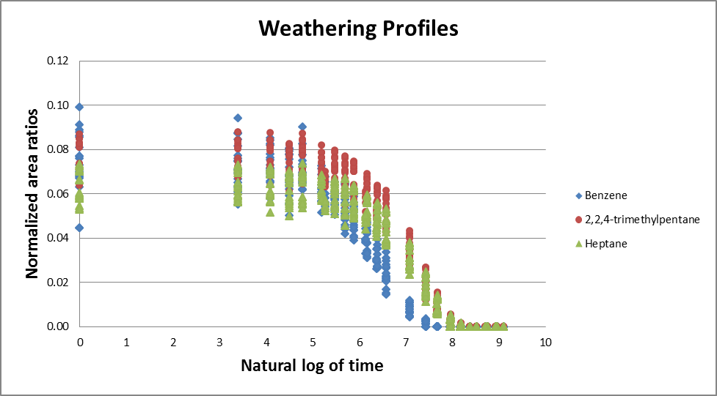

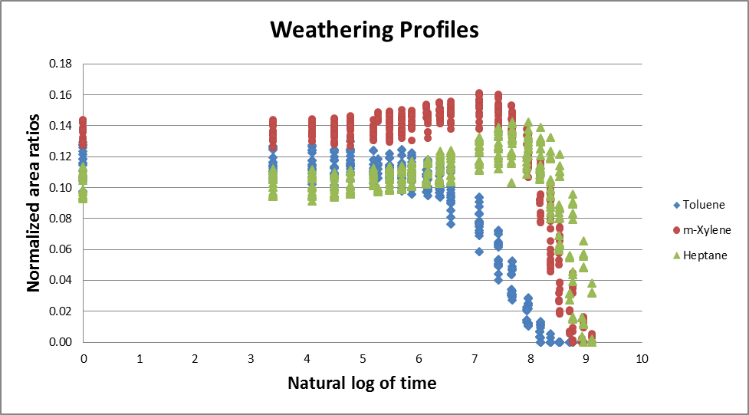

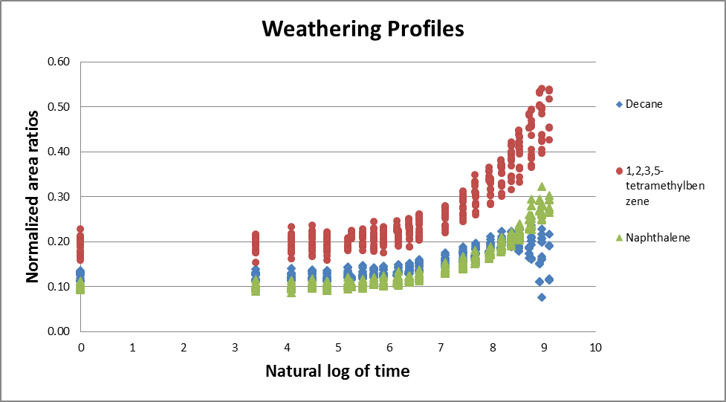

1. [] C.B. Koons, Mar. Technol. Soc. 18 (1984) 4-10.
2. [] Z. Wang, M. Fingas, J. Microcolumn Sep. 7 (1995) 617-639.
3. [] M.F. Fingas, J. Hazard. Mater. 56 (1997) 227-236.
4. [] R.K. Nelson, B.M. Kile, D.L. Plata, S.P. Sylva, L. Xu, C.M. Reddy, R.B. Gaines, G.S. Frysinger, S.E. Reichenbach, Environ. Forensics 7 (2006) 33-44.
5. [] W. Stiver, D. Mackay, Environ. Sci. Technol. 18 (1984) 834-840.
6. [] G.D. Wardlaw, J.S. Arey, C.M. Reddy, R.K. Nelson, G.T. Ventura, D.L. Valentine, Environ. Sci. Technol. 42 (2008)7166-7173.
7. [] D.E. Nicodem, C.L.B. Guedes, R.J. Correa, Mar. Chem. 63 (1998) 93-104.
8. [] P.J. Brandvik, L.G. Faksness, Cold Reg. Sci. Technol. 55 (2009) 160-166.
9. [] A.O. Barakat, Y. Qian, M. Kim, M.C. Kennicutt, Environ. Int. 27 (2001) 291-310.
10. [] Z. Wang, M. Fingas, S. Blenkinsopp, G. Sergy, M. Landriault, L. Sigouin, P. Lambert, Environ. Sci. Technol. 32 (1998) 2222-2232.
11. [] J.M. Neff, S. Ostazeski, W. Gardiner, I. Stejskal, Environ. Toxicol. Chem. 19 (2000) 1809-1821.
12. [] M.G. Carls, S.D. Rice, J.E. Hose, Environ. Toxicol. Chem. 18 (1999) 481-493.
13. [] R.A. Heintz, J.W. Short, S.D. Rice, Environ. Toxicol. Chem. 18 (1999) 494-503.
14. [] Z. Wang, C. Yang, M. Fingas, B. Hollebone, X. Peng, A.B. Hansen, J.H. Christensen, Environ. Sci. Technol. 39 (2005) 8700-8707.
15. [] Z. Wang, M. Fingas, G. Sergy, Environ. Sci. Technol. 28 (1994) 1733-1746.
16. [] G.S. Douglas, A.E. Bence, R.C. Prince, S.J. McMillen, E.L. Butler, Environ. Sci. Technol. 30 (1996) 2332-2339.
17. [] R. Fernández-Varela, J.M. Andrade, S. Muniategui, D. Prada, F. Ramírez-Villalobos, Water Res. 43 (2009) 1015-1026.
18. [] S.M. Mudge, Environ. Sci. Technol. 36 (2002) 2354-2360.
19. [] S.A. Stout, A.D. Uhler, K.J. McCarthy, Environ. Forensics 2 (2001) 87-98.
20. [] R.B. Gaines, G.J. Hall, G.S. Frysinger, W.R. Gronlund, K.L. Juaire, Environ. Forensics, 7 (2006) 77-87.
21. [] L.M.V. Malmquist, R.R. Olsen, A.B. Hansen, O. Andersen, J.H. Christensen, J. Chromatogr. A 1164 (2007) 262-270.
22. [] C. Borges, M.P. Gómez-Carracedo, J.M. Andrade, M.F. Duarte, J.L. Biscaya, J. Aires-de-Sousa, Chemom. Intell. Lab. Syst. 101 (2010) 43-55.
23. [] J.H. Christensen, A.B. Hansen, J. Mortensen, O. Andersen, Anal. Chem. 77 (2005) 2210-2217.
24. [] K. Øygard, O. Grahl-Nielsen, S. Ulvøen, Org. Geochem. 6 (1984) 561-567.
25. [] N. Telnaes, B. Dahl, Org. Geochem. 10 (1986) 425-432.
26. [] K. Urdal, N.B. Vogt, S.P. Sporstøl, R.G. Lichtenthaler, H. Mostad, K. Kolset, S. Nordenson, K. Esbensen, Mar. Pollut. Bull. 17 (1986) 366-373.
27. [] G. Oudijk, Environ. Forensics 10 (2009) 120-131.
28. [] L.B. Christensen, T.H. Larsen, Ground Water Monit. Remediat. 13 (1993) 142-149.
29. [] United States Fire Administration Home Page, Topical Fire Report Series, http://www.usfa.dhs.gov/downloads/pdf/tfrs/v9i5.pdf (June 2010).
30. [] D.C. Mann, J. Forensic Sci. 32 (1987) 606-615.
31. [] P.M.L. Sandercock, E. Du Pasquier, Forensic Sci. Int. 134 (2003) 1-10.
32. [] P.M.L. Sandercock, E. Du Pasquier, Forensic Sci. Int. 140 (2004) 43-59.
33. [] M. Ichikawa, N. Nonaka, I. Takada, S. Ishimori, Anal. Sci. 9 (1993) 261-266.
34. [] R.O. Keto, P.L. Wineman, Anal. Chem. 63 (1991) 1964-1971.
35. [] ASTM method: E1618-06, Standard test method for ignitable liquid residues in extracts from fire debris samples by gas chromatography-mass spectrometry.
36. [] B.M. Wise, N.B. Gallagher, R. Bro, J.M. Shaver, W. Windig, R.S. Koch, PLS Toolbox Version 4.0 for use with MATLAB™, Eigenvector Research, Inc. Washington, 2006.
37. [ ] H. Martens, M. Høy, B.M. Wise, R. Bro, P.B. Brockhoff, J. Chemom. 17 (2003) 153-165.
38. [] N.B. Gallagher, P.L. Gassman, T.A. Blake, Environ. Sci. Technol. 42 (2008) 5700-5705.
39. [] T. Burr, N. Hengartner, Sensors 6 (2006) 1721-1750.
40. [] T.A. Blake, J.F. Kelly, N.B. Gallagher, P.L. Gassman, T.J. Johnson, Anal. Bioanal. Chem. 395 (2009) 337-348.