If it ain’t broke don’t fix it: breeding success affects nest-building decisions

Andrés Camacho-Alpízar¹, Tristan Eckersley¹, Connor T. Lambert¹, Gopika B. Balasubramanian¹ & Lauren M. Guillette^{1,2*}
¹ Department of Psychology, University of Alberta, Edmonton, Canada AB
²School of Biology, University of St Andrews, St Andrews, UK

*Corresponding author: L.M. Guillette
Address: Department of Psychology, University of Alberta, Edmonton, Canada AB T6G 2R3
Email: guillett@ualberta.ca
Phone: +1(780) 492-5302

Acknowledgements

We would like to thank Sarah Collard, Toni Bayans and all the members of Science Animal Support Services. We would also like to thank Briana Kroeker for help with bird care. This work was supported by the Natural Sciences and Engineering Council of Canada (NSERC), the University of Alberta Faculty of Science Start-Up grant program and the Department of Psychology at the University of Alberta.

ABSTRACT

Observational studies in the wild suggest that birds select material to build their nests based on functional aspects of material that promote reproductive success. How birds select material for nest building from the variety of materials available in their environment is unclear. In the current laboratory experiment we manipulated breeding success of zebra finch (Taeniopygia guttata) pairs (i.e., raising fledglings) to test if this affects the subsequent selection of nest material between a familiar versus a novel material, that differ in structural properties. All birds experienced one breeding attempt using coconut fiber as nest material during which their breeding success was manipulated: half of the breeding pairs fledged their nestlings while the remaining pairs had their eggs removed to simulate nest failure. In a second nest-building attempt, all pairs were given access to both familiar nesting material (coconut fiber) and a novel nesting material (white cotton string). Pairs that were successful in their first breeding attempt built their second nest with significantly more familiar material compared to novel material. Pairs that were unsuccessful, however, incorporated similar amounts of familiar and novel material in their second attempt. Our results show that experiencing either a successful or an unsuccessful breeding attempt influences how birds select between familiar and novel material with different structural properties (e.g. flexibility, thickness) to build a second nest. Moreover, our experiment shows that leaarning from experience plays an important role for decision making in future structure-building endeavors.

KEYWORDS

Decision making, Learning, Material selection, Nest building, Reproductive success, Zebra finch

INTRODUCTION

Many animals use a wide array of materials from their environment to build structures for shelter and reproduction (Barber, 2013; Cornelissen et al., 2016; Hansell, 2000; Stewart et al., 2011). For instance, bagworm moth larvae (Lepidoptera, Psychidae) build a protective shelter over their bodies after emerging from the egg using silk they produce and incorporate pieces of tree bark and/or other foliage, which has been shown to be key for the survival of these larvae as those individuals that failed to build this shelter usually die within a few days (Kaufmann, 1968). Three-spined stickleback (Gasterosteus aculeatus) males incorporate algae and substrate pieces to build a nest to use as receptacle for fertilized eggs and protection from water currents and predators (Wootton, 1976). Tree and shrub stems from different species are used by beavers (Castor canadensis) to build their dams (Barnes and Mallik, 1996). A taxonomically widespread example of animal architecture is nest building by birds. As in the examples above, building a nest requires selecting material and manipulating that material to obtain the desired product which, in the case of avian nests, is a structure in which eggs are laid, young of many species are raised, and/or adults can take shelter (Hansell, 2000). Selection of material, therefore, is a crucial step in nest building and potentially has direct consequences on the reproductive success of an individual (Deeming and Mainwaring, 2015).

In the wild, nest-building birds have a variety of material with which they can build their nest. Field observations and experiments both in captivity and the wild suggest that individual birds select different types of material corresponding to different functional aspects of the nest that promote nestling survival - by providing protection against predators and ectoparasites (Hansell, 2000) or by providing a safe micro-environment for development (Deeming and Mainwaring, 2015; Mainwaring et al., 2014). For instance, camouflaging a nest relative to the background environment may make detection by predators more difficult (Bailey et al., 2014b; Hansell, 1996). Accordingly, both long-tailed tits (Aegithalos caudatus) and blue-grey gnatcatchers (Polioptila caerulea) incorporate lichen flakes in the outer layer of their nests, reducing their nests’ visual detectability (Hansell, 1996). Nest material may also alert birds of approaching predators, as in the case of some ground-nesting birds that construct a rampart of stones exclusively at the nest entrance (e.g. blackstarts, Cercomela melanura; Leader & Yom-Tov, 1998, Hansell 2000). Additionally, nest material may also serve as a predator deterrent, and may explain why blue grosbeaks (Passerina caerulea) and great crested flycatchers (Myarchus crinitus) incorporate snake skin on the outside of their nests (Hansell, 2000). Birds also incorporate materials that reduce ectoparasite load and bacterial density on infected nestlings, such as the incorporation of cigarette butts in response to ectoparasites in the nest by house finches (Carpodacus mexicanus; Suárez-Rodríguez & Garcia, 2017; Suárez-Rodríguez, López-Rull, & Garcia, 2013), and the incorporation of aromatic plants in the nest by blue tits (Cyanistes careuleus; Mennerat et al., 2009). The structural properties (e.g. rigidity) of different materials also seem to influence material selection for nest building. Common blackbirds (Turdus merula) and bullfinches (Pyrrhula pyrrhula) use thicker and more rigid material for the nest outer wall compared to the inner wall and the nest lining (Biddle et al., 2017, 2015). Field observations suggest that different individuals from the same species use different proportions of material in correlation with the ambient temperature where the nest is built: great tits (Parus major), blue tits, European robins (Erithacus rubecula) and yellow warblers (Setophaga petechia), use more materials with insulating properties (e.g. feathers, animal fur) in colder compared to warmer areas of their range distribution (i.e. higher altitudes and latitudes; Cerezo & Deeming, 2016; Crossman, Rohwer, & Martin, 2011; Mainwaring et al., 2012; but see Sonnenberg, Branch, Benedict, Pitera, & Pravosudov, 2020). Despite this large amount of observational data on the various functional aspects of different materials, how birds ‘know’ which material is best to use to build their nest remains largely unknown.

Experimental data on captive zebra finches (Taeniopygia guttata) show that individual birds base their material selection decisions, in part, on their experience. The early socio-ecological environment, for example, was found to affect material selection in first-time nest builders, who preferred material they had interacted with as juveniles while being in the presence of an adult bird (Breen et al., 2020). Zebra finches also learn the structural properties of material and select the most efficient (i.e. more rigid) material to build their nest (Bailey et al., 2014a). Zebra finches, moreover, associate nest material with breeding success, but not failure: on the one hand, individuals that successfully raised nestlings with the material colour they did not like in an initial colour preference test, reversed their material colour preference after the successful breeding experience. On the other hand, nest failure did not affect subsequent nest material selection as unsuccessful pairs continued to select their initially preferred colour (Muth and Healy, 2011). The lack of effect of a failed breeding attempt on material choice could owe to the fact that birds had previously interacted with both material options, which allowed them to discover that both material options differed only in their colour without either material offering potential structural advantage over the other (Bailey et al., 2014a). Having been given a novel material option (i.e. material the bird has not interacted with previously) with different structural properties after failing a breeding attempt, zebra finches might have opted to select the structurally-different novel material over their previously used material. Understanding how birds respond to novel materials after manipulating nest success has not previously been addressed but is relevant for species that breed at different locations and also to better understand how species respond to changing environments (e.g. increasing urbanization – Wang, Chen, Blair, Jiang, & Ding, 2009) with respect to nest-building decisions. Moreover, during the second colour-preference test in Muth and Healy (2011), pairs were not given enough material to complete a nest, and their final preference was assessed by counting the first ten deposits. Therefore, we do not know the extent to which birds will use or reject material to build a subsequent nest to completion, which we aim to explore in the present experiment.

Encountering novel material to build a nest is likely common in the wild, especially in nomadic species such as the zebra finch which, according to Zann (1996), exhibits variation in the materials used to build their nests among colonies in the Australian outback. Given the zebra finches’ ability to associate the nest-building material they use with their breeding success, it is plausible that the nesting success experienced with a specific material will influence whether these birds use novel material or not in subsequent nesting attempts. In the current experiment we ask whether nesting success or failure affects selection of familiar versus novel material that differ in their structural properties to complete a subsequent nest. To answer our question, male-female zebra finch pairs, in the laboratory, experienced one breeding attempt, all using the same nesting material (coconut fiber), and their breeding success was experimentally manipulated by allowing them to either raise fledgelings (successful pairs) or removing their eggs (unsuccessful pairs). Egg removal has been used in various experiments to simulate nest failure (Arnold, 1992; Erikstad & Bustnes, 1994; Muth & Healy 2011; Williams, Jeffs, Murray, & Choudhury, 1996). During a second breeding attempt, we provided birds with familiar (coconut fiber) and a novel material (white cotton string). If nesting success affects how birds respond to novel nest material, then (1) successful birds will build with the familiar material over the novel material; and/or (2) unsuccessful birds will avoid the familiar material and incorporate novel material. By conducting this experiment, we aim understand how experience shapes birds’ response to novel nesting material, which is likely to be encountered in the wild.

METHODS

Subjects and Housing

Fifty-four zebra finches (27 male, 27 female) were obtained from a breeder in Quebec, Canada (Eastern bird supplies) as juveniles and were housed in same-sex colony cages (165 x 66 x 184 cm) on a 14:10 light:dark cycle (full spectrum lights - Standard, 32W, T8 Daylight). Room temperature ranged from 20°C to 23.5°C and humidity from 35% - 50%. Birds had ad libitum food (mixed seeds, Hagen Canada), water and supplements (Pacific Pear Oyster Shell and Hartz Grit ‘n Gravel’ cuttlefish bone, Canadian Lab Diet). Birds were provided with greens (e.g., parsley, spinach) and vitamin mix water (Hagen Canada) three times per week and spray millet (Hagen Canada) once per week.

Apparatus

Each breeding cage (100 x 50 x 50 cm) contained six perches, two food bowls and two water bowls, and was lined with brown paper (U-line Kraft paper; Figure 1A). In the experimental rooms, which were kept under the same lighting, temperature and humidity conditions as the colony room, breeding pairs had auditory, but not visual contact with one another. Males and females were paired randomly, making sure not to pair siblings with each other. During nest building each pair was provided egg mix daily (CeDe-Finches) to supplement nutrition. No birds had previous experience with nest building at the start of the experiment.
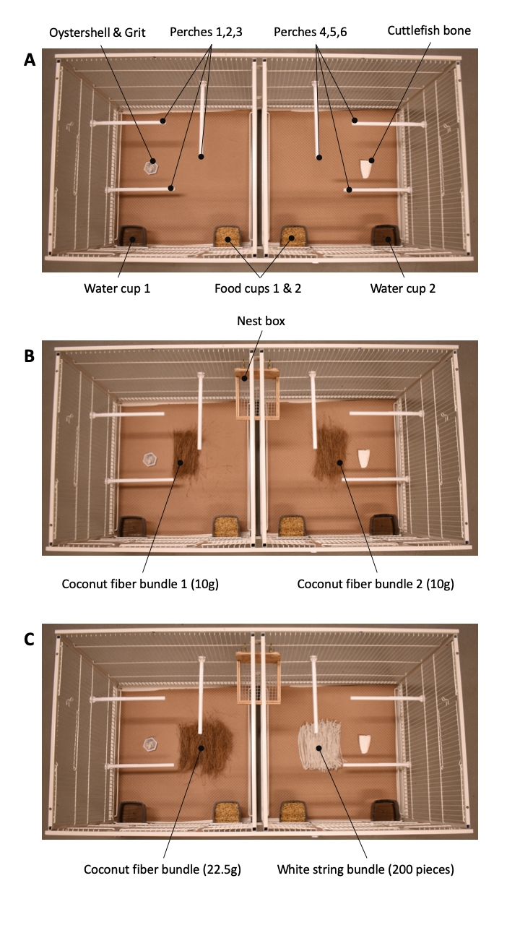
Figure 1. Top down photos of the breeding cage layout during three periods of the experiment. (A) Pair bonding period. (B) First nest-building experience which includes a nest cup and two bundles of coconut fiber (10g each). (C) Second nest-building experience which includes a nest cup and one bundle of 22.5 grams of coconut fiber (familiar material) and one bundle of 200 pieces of white string (novel material).

First Breeding Experience

Each breeding pair was moved into a breeding cage and after four days of pair bonding, given a nest cup (Figure 1B, 12.5 x 12 x 12 cm) placed in middle of the back 100cm side of the cage and 20g of coconut fiber (Aves Canada) to use as nest-building material (Figure 1B). Nests were monitored each day to check for eggs. If no eggs were present and the available nest material was depleted the pair was provided an additional 20g of coconut fiber. A nest was considered complete when the female laid an egg inside the nest, at which point we removed and weighed the remaining coconut fiber that was not deposited in the nest. Each pair was pseudo-randomly assigned to an experimental group at nest completion. The pseudorandom assignment was set up in such a way that the first pair to finish building a nest was assigned to the successful group and the next pair to finish building a nest was assigned to the unsuccessful group. Each pair’s breeding success was manipulated by either allowing them to raise fledglings until nutritional independence (successful pairs, n = 14) or by removing their eggs seven days post-incubation onset (unsuccessful pairs, n = 13). Any additional eggs found in the unsuccessful pairs’ nest in the subsequent days were removed. Each nest was removed from a successful pair five days after the last chick had fledged (~23 days post-hatch). To ensure successful and unsuccessful pairs were exposed to their nest for the same amount of time, each unsuccessful pair was yoked to (i.e. coupled with) a successful pair with regards to the number of days the nest was kept in their cage, meaning that successful and unsuccessful birds would have spent the same number of days with their nest in their cage. Due to the uneven number of our sample (27 male-female pairs), we had one successful pair with no unsuccessful pair yoked to it.

Once the fledglings of a successful pair reached nutritional independence (~35 days post-hatch), that successful pair and the unsuccessful pair that was yoked to that successful pair had their nests removed and went on to participate in a different experiment for approximately seven days. During this time subjects interacted with orange and pink-colored jute string and deposited 25 pieces of each colour into a nest cup (Baker’s Twine, James Lever Co., London, UK), after which, each pair was moved into a breeding cage for a second breeding attempt.

Second Breeding Experience – Nesting Material Selection

During the second breeding attempt, each pair was provided with a nest cup and 22.5 grams of coconut fiber, hereafter referred to as familiar material because they built their first nest with this material. Each pair was also given 200 pieces of white cotton string, hereafter referred to as novel material, as they had not previously encountered this material (Figure 1C). The string was cut to 15 cm lengths. We currently lack data on individual preference for coconut fiber versus cotton string, and therefore do not know if zebra finches show preference for coconut fiber or cotton string. However experiments show that zebra finches use both types of material to build nests in captivity (Bailey, Morgan, et al., 2014, Muth & Healy 2011). The amount of coconut fiber corresponds to half of the average plus one standard deviation [(average + 1 SD)/2] amount of coconut fiber used by 14 zebra finch pairs to build a coconut fiber nest (eight pairs taking part in this experiment that had already built their first nest; and six pairs from a different experiment). The amount of white string corresponds to half of the amount of white string pieces used by zebra finches from a previous experiment (Bailey et al., 2014a) to build a species-typical dome-shaped nest (Figure 2). Therefore, the total amount of material given on the first day should be enough for zebra finch males to build a nest using both kinds of material. One material type (familiar or novel) was randomly placed on one side of the cage and the other material type was placed on the opposite side of the cage in order to control for possible location bias that could result in birds selecting one material because of where it was located.

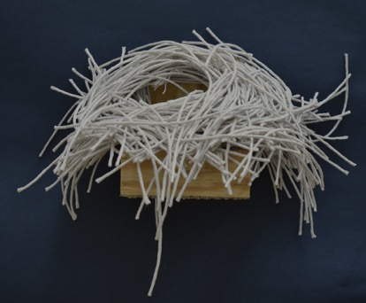
Figure 2. Example of a dome-shaped nest built by a zebra finch male using 400 pieces of white string.

Each pair was monitored daily to check for eggs and material availability. If a pair had used most of either kind of material before the first egg was laid in the nest, we provided them with an extra 22.5g of coconut fiber or 200 pieces of white string, as much as each male needed to complete his second nest. Nests were considered complete when the female laid one egg inside the nest. Once the nest was completed, we removed any remaining material not in the nest from the cage, weighed the coconut fiber and counted the pieces of white string. Birds were then returned to the colony room.

Data Analysis

The experiment ran continuously from June 2019 to March 2020 during which birds remained on a 14:10 light:dark schedule. To quantify the total amount of material used by each pair to build their first and second nest, we subtracted the amount of material that remained in the cage after the nest was completed from the total amount of material that was provided. To determine which kind of material was preferred by successful and unsuccessful birds in their second breeding attempt, we compared the proportion of material used, only out of the first amount of material we provided (coconut fiber: 22.5g; white string: 200 pieces) in order to avoid inflating the proportion of material used by those pairs that did not require a second batch of material. Refills only occurred as material was depleted: 7 of 14 (50%) successful and 3 of 13 (23%) unsuccessful pairs did not get a refill. Therefore, pairs that received a refill and ended up using more material than the initial provided amount had a score of 1.0 in the proportion of material used (i.e. the birds used all of the initial provided amount of material).

The proportion of familiar (coconut fiber) versus novel (white string) material use within just successful and then again within just unsuccessful birds was compared using Wilcoxon signed-rank tests (within-subject analysis). We compared the proportion of familiar material use between successful and unsuccessful birds and also the proportion of novel material use between successful and unsuccessful birds using Wilcoxon rank-sum tests (between-subject analysis). We also compared the total amount of familiar (one analysis) and novel material (a second analysis) used in the second breeding attempt between successful and unsuccessful birds using two-tailed t-tests; and compared the total amount of familiar material used by successful and unsuccessful pairs in their first and second breeding attempt (keeping in mind that no breeding-success manipulation had occurred when the first nest was completed). We used a t-test to compare material use between birds that required a refill of material and birds who did not require a refill to determine whether requiring a refill of one material correlated with higher use of the alternate material. We performed this analysis in order to rule out the alternative explanation that birds used one material only because the other had been depleted. Finally, comparing the time taken to complete first and second nests could provide further evidence for the role that experience plays in nest-building endeavors, therefore, we compared the time in days taken to complete the first versus the second nest using a repeated measures Analysis of Covariance, with breeding success in the first nesting attempt as the covariate. All statistical tests were carried out in R (R Core Team, 2018).

Ethical Note

All of the procedures were conducted in accordance with the Canadian Council on Animal Care (CCAC) Guidelines and Policies and the ABS Guidelines for the Use of Animals in Research. The present experiment had the approval from the Animal Care and Use Committee for Biosciences for the University of Alberta (AUP 2923), which is consistent with the Animal Care Committee Guidelines for the Use of Animals in Research. Birds had access to food, water and supplements at all times during the experiment and remained healthy throughout. All birds were returned to the colony room after participating in the experiment.

RESULTS

First Breeding Attempt

All pairs in the successful experimental group (N = 14) raised nestlings to fledglings, and all nests in our experiment were built by the males. The amount of material (coconut fiber) used during the first breeding experience (before any breeding success manipulation was carried out) did not differ between successful (M ± SD = 38.33 ± 13.22 g, N = 14) and unsuccessful pairs (M ± SD = 39.72 ± 14.98 g, N = 13; t₂₄ = -0.25, P = 0.80, d = -0.10, 95% CI[-0.89, 0.70]).

Nesting Material Selection in Second Breeding Experience

In their second breeding experience, successful pairs used a higher proportion of familiar material (median = 1.00) compared to novel material (median = 0.43; Wilcoxon signed-ranks test: V = 66, N = 14, P < 0.01, r = 0.79, 95% CI[0.67, 0.88]), while unsuccessful pairs used comparable proportions of familiar (median = 0.72) and novel material types (median = 0.46; Wilcoxon signed-ranks test: V = 69, N = 13, P = 0.10, r = 0.42, 95% CI[-0.15, 0.85]; Figure 3, Table 1). When comparing material use between successful and unsuccessful pairs, we found that successful pairs used a much higher proportion of the initial amount of familiar material than unsuccessful pairs (Wilcoxon rank-sum test: W = 143, N₁ = 14, N₂ = 13, P < 0.01, r = 0.51, 95% CI[0.20, 0.78]). The proportion of novel material used did not differ between successful and unsuccessful pairs (Wilcoxon rank-sum test: W = 78.50, N₁ = 14, N₂ = 13, P = 0.56, r = -0.12, 95% CI[-0.48, 0.28]).

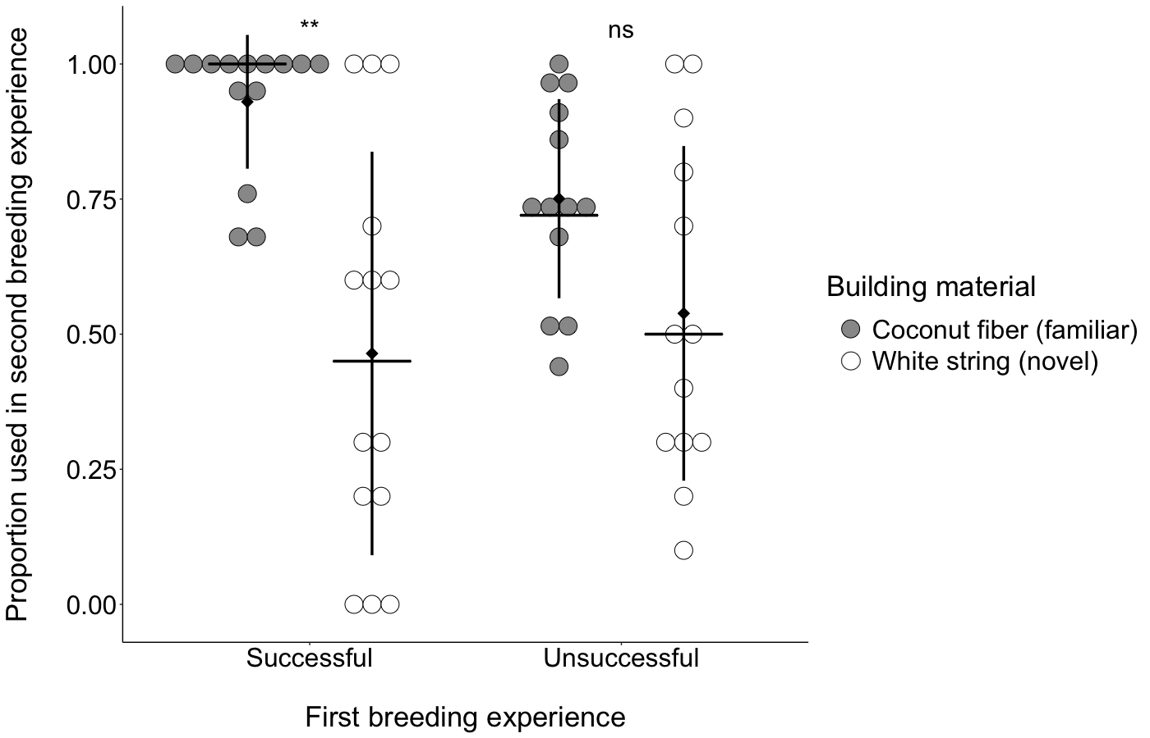
Figure 3. The proportion of familiar and novel building material used by treatment group (successful vs unsuccessful breeding experience). On the y-axis the proportion of coconut fiber (familiar material) and white string (novel material) used by zebra finch males to build their second nest. The treatments groups are on the x-axis, in their first breeding attempt pairs were either successful in raising fledglings, or had their eggs removed part way through incubation (unsuccessful). Each pair is represented by two circles, one filled circle indicating the proportion of familiar material used and one open circle indicating the proportion of novel material used. Black horizontal lines indicate the median. Diamonds and vertical lines indicate M ± SD respectively. **p < 0.05, ns = p > 0.05.

Successful pairs used in total more familiar material (M ± SD = 22.86 ± 5.17 g, N = 14) than unsuccessful pairs (M ± SD = 17.51 ± 5.48 g, N = 13) in their second breeding experience (t₂₄ = 2.61, P = 0.01, d = 1.01, 95% CI[0.16, 1.85]; Figure 4A, Table 1). The amount of novel material used did not differ between successful (90.36 ± 73.51, N = 14) and unsuccessful pairs (103.46 ± 60.38, N = 13; t₂₄ = 0.50, P = 0.62, d = -0.19, 95% CI[-0.99, 0.60]; Figure 4B, Table 1).

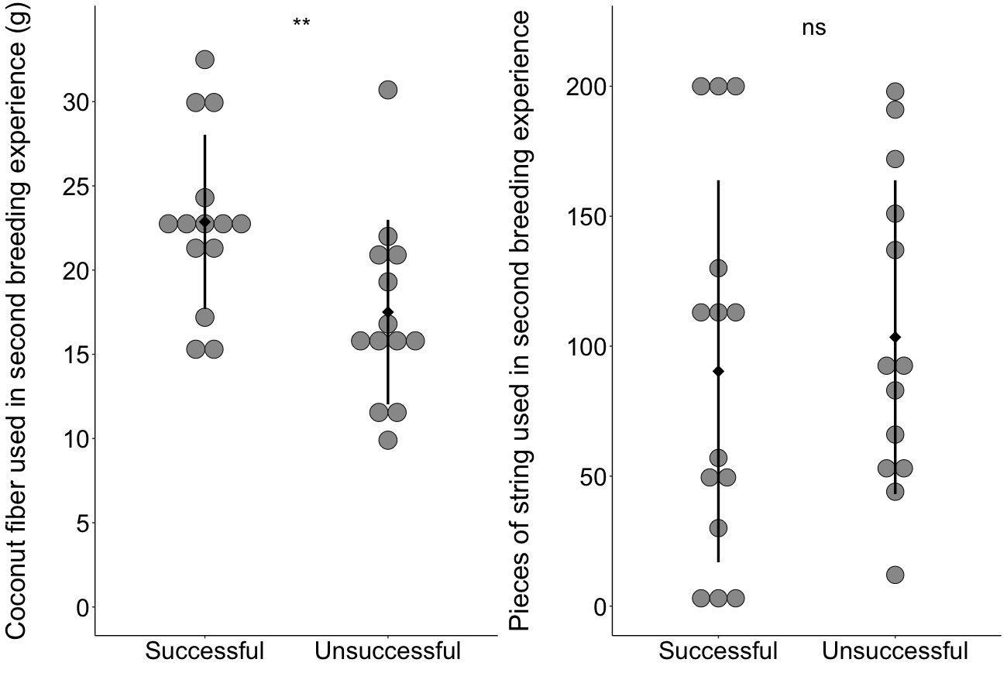
Figure 4. Total amount of familiar and novel building material used by treatment group (successful vs unsuccessful breeding experience). Left panel: Total amount of coconut fiber (familiar material) in grams used (y-axis) by zebra finch males in the different treatment groups (x-axis) to build their second nest. Right panel: y-axis is the total number of string pieces (novel material) used by zebra finch males in the different treatment groups (x-axis) to build their second nest. In their first breeding attempt pairs were either successful in raising fledglings (successful), or had their eggs removed part way through incubation (unsuccessful). Diamonds and vertical lines indicate M ± SD respectively. **p < 0.05, ns = p > 0.05.

The familiar material (coconut fiber) was the only material that required refilling for some birds (n = 7 of 14 successful pairs, n = 3 of 13 unsuccessful pairs). We did not find any evidence that using up all or most the familiar material caused birds to then use the novel material (white string) more so than birds that did not require a refill. On the contrary, we found that birds who required a refill of familiar material used on average less novel material (119.94 ± 66.64 pieces) than birds who did not require a refill (57.10 ± 46.22 pieces; t = 2.88, df = 24.15, p < 0.01, d = 1.05, 95% CI[0.17, 1.92]).

Time Taken to Complete Nests

Birds took fewer days to finish their nests in their second (M ± SD = 4.52 ± 1.89, N = 27) compared to their first (M ± SD = 6.48 ± 2.91, N = 27) breeding attempt (F_{1, 49} = 8.19, P < 0.01, d = 0.80, 95% CI[0.23, 1.37]; Figure 5). Breeding success in the first breeding attempt did not have any effect on the time taken to complete the nest in the second breeding attempt (F_{1, 49} = 0.01, P = 0.92, d = -0.03, 95% CI[-0.57, 0.52]).

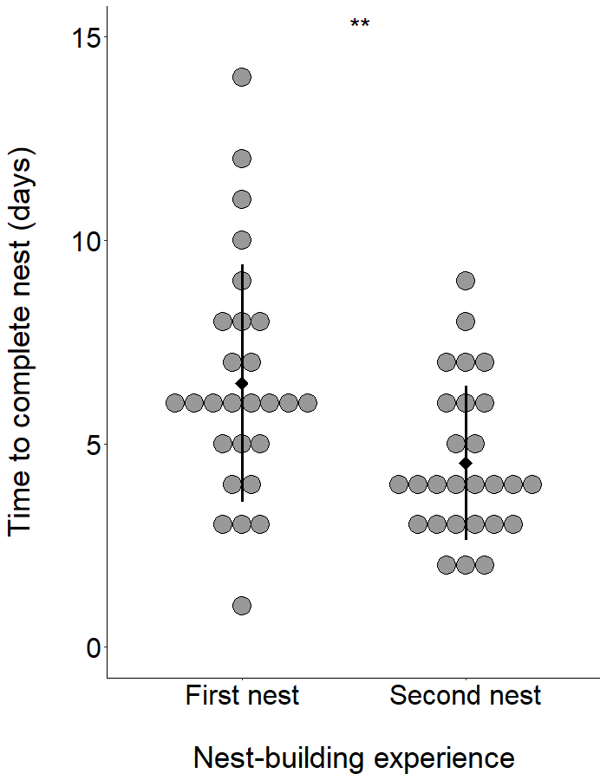
Figure 5. Days taken by zebra finch males to build their first and second nest. Diamonds and vertical lines indicate M ± SD respectively. **p < 0.05

DISCUSSION

Our study found that zebra finches take into account breeding success when selecting between familiar and novel material with different structural properties. Birds that experienced a successful first breeding attempt used more familiar compared to novel material and used more familiar material compared to previously unsuccessful birds in their second breeding attempt. These data support our prediction that successful birds would prefer familiar over novel material. Birds that were unsuccessful in raising fledglings, on the other hand, added similar amounts of familiar and novel material in their second nest, which does not support our prediction that unsuccessful birds would reject the material with which they failed to raise fledglings and rather use novel material with different structural properties. Novel material use did not differ between successful and unsuccessful birds, suggesting that previous breeding experience does not affect whether birds incorporate novel material to build a subsequent nest.

The finding that zebra finches preferred to build a nest using the same kind of material used in a successful breeding attempt mirrors the results obtained by Muth and Healy (2011), which showed that zebra finches change their material colour preference after a successful breeding experience. Furthermore, our results extend the previous results of Muth and Healy (2011) and provide evidence that successful birds prefer to build a nest using mostly familiar material even in the presence of novel material with different structural properties. Although we acknowledge that laboratory conditions greatly differ from the natural habitat of the zebra finch, such learning from previous breeding experiences could allow nomadic species like the zebra finch to make informed decisions on material selection when moving into a new breeding site (Zann, 1996).

Besides material selection, breeding success also has been found to affect breeding site selection (Fisher and Wiebe, 2006; Hoover, 2003; Styrsky, 2005) and nest design (Edwards et al., 2020). Migratory protonothary warblers (Protonotaria citrea), for example, were more likely to return to the same breeding site the more broods they produced in their previous breeding season (Hoover, 2003). Similarly, spotted antbirds (Hylophylax naevioides) were more likely to reuse a nest structure within and between breeding seasons if they had a successful breeding experience in that structure (Styrsky, 2005). With respect to nest design, an experiment carried out on captive zebra finches showed that breeding success affected the amount of material that birds incorporated into their subsequent nest, regardless of the ambient temperature (Edwards et al., 2020). More specifically, zebra finches that successfully produced young included the same amount of material in their second nest, while birds that failed to produce young incorporated more material than in their previous attempt. All of the above examples, together with our results present correlational and causational evidence that previous breeding experience affects future nest building decisions.

The fact that failing to raise fledglings did not cause birds to completely reject the familiar material, even when given the option to select novel material with different structural properties, could be due to a couple of factors. One possible explanation is that, even if failing to raise fledglings, it is still preferable for a bird to build a subsequent nest using material it has previous experience with, rather than building a nest using entirely novel material, because the bird will have acquired practice in how to use the familiar material to build a nest. In fact, we found that all birds took fewer days to finish their second nest compared to their first nest. This result suggests an effect of nest building experience on building speed. The second possibility that explains why unsuccessful birds did not reject familiar material completely is that, despite having different structural properties, no material offered any significant structural advantage, which birds could realize after interacting with both kinds of material (Bailey et al., 2014a). Another possible explanation for our results is that the birds did not associate the risk of predation with the type of nest material they had used, however we consider this unlikely because unsuccessful birds did use less familiar material than successful birds in their second breeding attempt.

In their second breeding attempt, successful birds incorporated more familiar material than unsuccessful birds while incorporating similar amounts of novel material, indicating that successful birds built larger nests than unsuccessful birds. In the first breeding attempt however, before any experimental manipulation on breeding success was carried out, both successful and unsuccessful birds, built nests of similar size. These results seem to contradict those of Edwards et al. (2020), who found that unsuccessful, but not successful, zebra finches built larger subsequent nests compared to their previous nests in which they failed to raise fledglings. Nest failure in Edwards et al. (2020) was not experimentally manipulated and occurred naturally (thus excluding nest predation as the cause of nest failure as breeding pairs were kept in separate cages), whereas in our experiment, we manipulated the birds’ breeding success by removing their eggs, which was meant to simulate nest predation. Therefore, it is possible that how birds respond to nest failure varies depending on the cause of the nest failure, and that failing to raise fledglings due to predation will affect subsequent nest building differently than failing to raise fledglings due to other factors (e.g. temperature). Nest predation has been found to affect mostly the choice of breeding location (reviewed in Lima, 2009), however our experimental data suggest that there might be an effect of nest predation on subsequent nest size as well, with birds building smaller nests at higher predation risk.

Selectivity of material has also been documented in the context of tool manufacture and use. New Caledonian crows (Corvus monudeloides), similarly to zebra finches, show among-site variation in material selection for hook-tool manufacture, and are able to identify their preferred plant species as material to craft their hook-tools (Klump et al., 2019; St Clair et al., 2016). Moreover, this selectivity on specific plant species has consequences for tool shape and efficiency (Sugasawa et al., 2017). Bearded capuchin monkeys (Cebus libidinosus) have also been found to be selective with regards to the stones they use to break open seeds and show preference for bigger stones (Fragaszy et al., 2010).

Our experiment shows that nest-building birds are also selective when choosing between familiar versus novel material with different structural properties, and that such preference is prevalent until nest completion. Moreover, our results add support to the idea that individual learning plays a significant role in nest building decisions, by showing that captive zebra finches take into account their previous breeding experience when selecting between novel and familiar nest material.

ETHICAL NOTE

All of the procedures were conducted in accordance with the Canadian Council on Animal Care (CCAC) Guidelines and Policies and the ABS Guidelines for the Use of Animals in Research. The present experiment had the approval from the Animal Care and Use Committee for Biosciences for the University of Alberta (AUP 2923), which is consistent with the Animal Care Committee Guidelines for the Use of Animals in Research. Birds had access to food, water and supplements at all times during the experiment and remained healthy throughout. All birds were returned to the colony room after participating in the experiment.

REFERENCES

Arnold, T., 1992. Continuous laying by american coots in response to partial clutch removal and total clutch loss. Auk 109, 407–421. https://doi.org/10.2307/4088356
Bailey, I.E., Morgan, K. V., Bertin, M., Meddle, S.L., Healy, S.D., 2014a. Physical cognition: birds learn the structural efficacy of nest material. Proc. R. Soc. B Biol. Sci. 281, 20133225. https://doi.org/10.1098/rspb.2013.3225
Bailey, I.E., Muth, F., Morgan, K., Meddle, S.L., Healy, S.D., 2014b. Birds build camouflaged nests. Auk 132, 11–15. https://doi.org/10.1642/auk-14-77.1
Barber, I., 2013. The evolutionary ecology of nest construction: Insight from recent fish studies. Avian Biol. Res. 6, 83–98. https://doi.org/10.3184/175815513X13609538379947
Barnes, D.M., Mallik, A.U., 1996. Use of woody plants in construction of beaver dams in northern Ontario. Can. J. Zool. 74, 1781–1786. https://doi.org/10.1139/z96-197
Biddle, L.E., Deeming, D.C., Goodman, A.M., 2015. Morphology and biomechanics of the nests of the Common Blackbird Turdus merula. Bird Study 62, 87–95. https://doi.org/10.1080/00063657.2014.988119
Biddle, L.E., Goodman, A.M., Deeming, D.C., 2017. Construction patterns of birds’ nests provide insight into nest-building behaviours. PeerJ 5, e3010. https://doi.org/10.7717/peerj.3010
Breen, A.J., Lovie, K.E., Guerard, C., Edwards, S.C., Cooper, J., Healy, S.D., Guillette, L.M., 2020. Juvenile socio-ecological environment shapes material technology in nest-building birds. Behav. Ecol. 31, 892–901. https://doi.org/10.1093/beheco/araa027
Cerezo, A.T., Deeming, D.C., 2016. Nest insulation in the European Robin (Erithacus rubecula): effects of latitude and construction materials. Avian Biol. Res. 9, 96–102. https://doi.org/10.3184/175815516X14551263654405
Cornelissen, T., Cintra, F., Santos, J.C., 2016. Shelter-Building Insects and Their Role as Ecosystem Engineers. Neotrop. Entomol. 45, 1–12. https://doi.org/10.1007/s13744-015-0348-8
Crossman, C.A., Rohwer, V.G., Martin, P.R., 2011. Variation in the structure of bird nests between northern Manitoba and Southeastern Ontario. PLoS One 6. https://doi.org/10.1371/journal.pone.0019086
Deeming, D.C., Mainwaring, M.C., 2015. Functional properties of nests, in: Nests, Eggs and Incubation: New Ideas about Avian Reproduction. Oxford University Press, Oxford, pp. 29–49.
Edwards, S.C., Shoot, T.T., Martin, R.J., Sherry, D.F., Healy, S.D., 2020. It’s not all about temperature: breeding success also affects nest design. Behav. Ecol. 31, 1065–1072. https://doi.org/10.1093/beheco/araa052
Erikstad, K.E., Bustnes, J.O., 1994. Clutch Size Determination in Common Eiders: An Egg Removal and Egg Addition Experiment. J. Avian Biol. 25, 215–218. https://doi.org/10.2307/3677077
Fisher, R.J., Wiebe, K.L., 2006. Nest Site Attributes and Temporal Patterns of Northern Flicker Nest Loss: Effects of Predation and Competition. Oecologia 147, 744–753.
Fragaszy, D.M., Greenberg, R., Visalberghi, E., Ottoni, E.B., Izar, P., Liu, Q., 2010. How wild bearded capuchin monkeys select stones and nuts to minimize the number of strikes per nut cracked. Anim. Behav. 80, 205–214. https://doi.org/10.1016/j.anbehav.2010.04.018
Hansell, M.H., 2000. Bird nests and construction behaviour. Cambridge University Press.
Hansell, M.H., 1996. The function of lichen flakes and white spider cocoons on the outer surface of birds’ nests. J. Nat. Hist. 30, 303–311. https://doi.org/10.1080/00222939600771181
Hoover, J.P., 2003. Decision rules for site fidelity in a migratory bird, the Prothonotary Warbler. Ecology 84, 416–430. https://doi.org/10.1890/0012-9658(2003)084[0416:DRFSFI]2.0.CO;2
Kaufmann, T., 1968. Observations on the Biology and Behavior of the Evergreen Bagworm Moth, Thyridopteryx ephemeraeformis (Lepidoptera: Psychidae). Ann. Entomol. Soc. Am. 61, 38–44. https://doi.org/10.1093/aesa/61.1.38
Klump, B.C., Cantat, M., Rutz, C., 2019. Raw-material selectivity in hook-tool-crafting New Caledonian crows. Biol. Lett. 15, 20180836. https://doi.org/10.1098/rsbl.2018.0836
Leader, N., Yom-Tov, Y., 1998. The possible function of stone ramparts at the nest entrance of the blackstart. Anim. Behav. 56, 207–217. https://doi.org/10.1006/anbe.1998.0766
Lima, S.L., 2009. Predators and the breeding bird: behavioral and reproductive flexibility under the risk of predation. Biol. Rev. 84, 485–513. https://doi.org/10.1111/j.1469-185X.2009.00085.x
Mainwaring, M.C., Hartley, I.R., Bearhop, S., Brulez, K., du Feu, C.R., Murphy, G., Plummer, K.E., Webber, S.L., James Reynolds, S., Deeming, D.C., 2012. Latitudinal variation in blue tit and great tit nest characteristics indicates environmental adjustment. J. Biogeogr. 39, 1669–1677. https://doi.org/10.1111/j.1365-2699.2012.02724.x
Mainwaring, M.C., Hartley, I.R., Lambrechts, M.M., Deeming, D.C., 2014. The design and function of birds’ nests. Ecol. Evol. 4, 3909–3928. https://doi.org/10.1002/ece3.1054
Mennerat, A., Mirleau, P., Blondel, J., Perret, P., Lambrechts, M.M., Heeb, P., 2009. Aromatic plants in nests of the blue tit Cyanistes caeruleus protect chicks from bacteria. Oecologia 161, 849–855. https://doi.org/10.1007/s00442-009-1418-6
Muth, F., Healy, S.D., 2011. The role of adult experience in nest building in the zebra finch, Taeniopygia guttata. Anim. Behav. 82, 185–189. https://doi.org/10.1016/j.anbehav.2011.04.021
R Core Team, 2018. R: A Language and Environment for Statistical Computing.
Sonnenberg, B.R., Branch, C.L., Benedict, L.M., Pitera, A.M., Pravosudov, V.V., 2020. Nest construction, ambient temperature and reproductive success in a cavity-nesting bird. Anim. Behav. 165, 43–58. https://doi.org/10.1016/j.anbehav.2020.04.011
St Clair, J.J.H., Klump, B.C., van der Wal, J.E.M., Sugasawa, S., Rutz, C., 2016. Strong between-site variation in New Caledonian crows’ use of hook-tool-making materials. Biol. J. Linn. Soc. 118, 226–232. https://doi.org/10.1111/bij.12757
Stewart, F.A., Piel, A.K., McGrew, W.C., 2011. Living archaeology: Artefacts of specific nest site fidelity in wild chimpanzees. J. Hum. Evol. 61, 388–395. https://doi.org/10.1016/j.jhevol.2011.05.005
Styrsky, J.N., 2005. Influence of Predation on Nest-Site Reuse by an Open-Cup Nesting Neotropical Passerine. Condor 107, 133–137. https://doi.org/10.1093/condor/107.1.133
Suárez-Rodríguez, M., Garcia, C.M., 2017. An experimental demonstration that house finches add cigarette butts in response to ectoparasites. J. Avian Biol. 48, 1316–1321. https://doi.org/10.1111/jav.01324
Suárez-Rodríguez, M., López-Rull, I., Garcia, C.M.Í., 2013. Incorporation of cigarette butts into nests reduces nest ectoparasite load in urban birds: New ingredients for an old recipe? Biol. Lett. 9, 10–12. https://doi.org/10.1098/rsbl.2012.0931
Sugasawa, S., Klump, B.C., St Clair, J.J.H., Rutz, C., 2017. Causes and Consequences of Tool Shape Variation in New Caledonian Crows. Curr. Biol. 27, 3885-3890.e4. https://doi.org/10.1016/j.cub.2017.11.028
Wang, Y., Chen, S., Blair, R.B., Jiang, P., Ding, P., 2009. Nest composition adjustments by Chinese Bulbuls Pycnonotus sinensis in an urbanized landscape of Hangzhou (E China). Acta Ornithol. 44, 185–192. https://doi.org/10.3161/000164509X482768
Williams, T.D., Jeffs, C., Murray, K.A., Choudhury, S., 1996. Intraclutch egg-size variation in the Barnacle Goose Branta leucopsis: an egg-removal experiment. Ibis (Lond. 1859). 138, 499–505. https://doi.org/10.1111/j.1474-919X.1996.tb08070.x
Wootton, R.J., 1976. The biology of the sticklebacks. Academic Press.
Zann, R.A., 1996. The Zebra Finch A Synthesis of field and Laboratory Studies. Oxford University Press, Oxford.

