**Workshops**

**2:00 – 3:30 p.m.**

**Addictions and Mental Health in Indigenous Communities**

**Mazankowski Shaw 3i Auditorium (0A8.60)**This workshop will cover the current state of a community in crisis, the Blood Tribe, and the fentanyl crisis. How did this happen and how do we respond? Examine how the health care system and government policy contributed to the crisis.

**Speaker:** Dr. Esther Tailfeathers

Dr. Esther Tailfeathers was born and raised on the Blood Reserve or Kainai First Nation which is located in Southern Alberta. Esther has lived in many Indigenous communities including the Northern Sami community in northern Norway. She received her MD and completed her Family Medicine Residency at the University of North Dakota. Since then she has served communities such as the Blackfeet Indian Hospital in Montana, the Blood Reserve, and the Cardston hospital and emergency room. More recently she served in the remote northernmost community of Fort Chipewyan. She is currently the Medical Lead for the Population, Public and Indigenous Health Strategic Care Network.

**How to Build a Non-Pharmacologic Management Plan for Chronic Pain Patients**

**Classroom D (2F1.04)**Learn how to work with your chronic pain patients to create a non-pharmacologic management strategy that is an efficient use of the physician's time and works with or without adjuvant prescription medication. Understand how to personalize the plan for your patient's needs, build a sense of self efficacy, and identify barriers in order to enhance implementation.

**Speaker: Dr. Ann Crabtree**

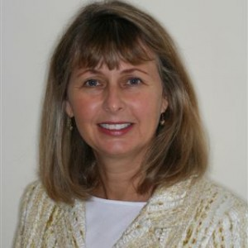Dr. Ann E. Crabtree is a Clinical Associate Professor at the Cumming School of Medicine, University of Calgary and an elected member of the Governing Council of the College of Physicians & Surgeons of Alberta. She is a consulting physician at the Alberta Health Services Chronic Pain Center specializing in prescription drug misuse, health, and well-being. Dr. Crabtree is passionate about good governance, creating community among physicians, and adding non-pharmacologic management strategies to the physician’s armamentarium to create health, prevent illness and treat disease.

**Research in Integrative Approaches to Chronic Pain and Mental Health**

**Bernard Snell Hall Auditorium**This symposium will showcase the research of Faculty in the area of integrative health approaches to chronic pain management and mental health. This will be followed by a panel discussion.

**Facilitator: Dr. Jerome Yager**

**The Placebo Effect and Child Health**

**Speaker:** Dr. Tim Overlander

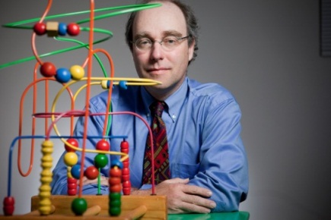Dr.  Oberlander is a physician-scientist whose work “bridges” developmental neurosciences and community child health. As a clinician, he is the medical lead for the Complex Pain Service at BC Children’s Hospital. He has particular interest in managing pain in children with developmental disabilities. As a researcher, Dr Oberlander’s work focuses on understanding how early life experiences, related to in utero exposure to antidepressants, shape stress reactivity, cognition and attention during childhood that contribute to the early origins of self-regulation. Building on this work, he is currently studying the developmental character of the placebo effect in children and youth and its therapeutic potential. His work shows that the developing brain has a remarkable capacity for plasticity and recovery. Even in the face of adversity, some children do very well and the goal of his work is to figure out how and why this happens.

**Novel and Integrative Approaches to Managing Chronic Pain Across the Lifespan**

**Speaker:** Dr. Bruce Dick

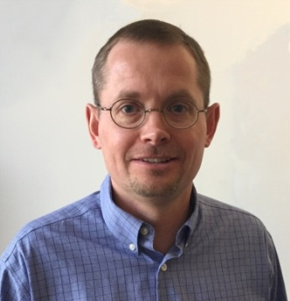

Dr. Dick is a Professor at the University of Alberta in the Department of Anesthesiology and Pain Medicine, and a clinical psychologist providing services in the Pediatric Chronic Pain Clinic at the Stollery Children’s Hospital and the Multidisciplinary Pain Centre at the University of Alberta Hospital. His research interests include the effects of chronic pain on cognitive function, sleep, mood, and quality of life. He also has an interest in novel treatment approaches including technology for distance treatment.

**New Discoveries About Spinal Stiffness and Back Pain**

**Speaker:** Greg Kawchuk

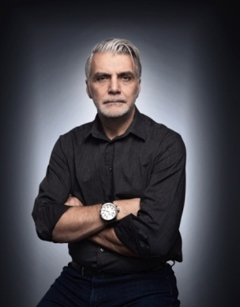Dr. Greg Kawchuk BSc, DC, MSc, PhD is a Professor in the Faculty of Rehabilitation Medicine at the University of Alberta. He is a CMCC graduate (1990) who practiced chiropractic for 15 years in multidisciplinary settings before becoming a full-time researcher. He was the recipient of the first chiropractic research chair in Canada and in 2004, was recruited to the University of Alberta as the Canada Research Chair in Spinal Function. Dr. Kawchuk’s research interests are focused on creating meaningful strategies to prevent and treat spinal disorders. His work spans basic science, clinical trials and recently, healthcare reform. A major component of his research is developing novel technologies to measure spinal function and then employing those technologies to evaluate clinical interventions. Competitive awards from major provincial, national and international funding agencies support Dr. Kawchuk’s work and include AIHS, AITF, CIHR, NSERC, and NIH. To date, his work has resulted in over 100 papers, the most recent of which have been published in The Spine Journal, Pain, Scientific Reports and PLOS One. Dr. Kawchuk is currently the Research Council Chair of the World Federation of Chiropractic.