**Selective separation of hydrogen from C1/C2 hydrocarbons and CO2 through DENSE natural zeolite Membranes**

Weizhu An,1 Paul Swenson, 1 Lan Wu, 1 Terri Waller, 1 Anthony Ku,2 and Steven M. Kuznicki1,[1]*

1Department of Chemical and Materials Engineering, University of Alberta

Edmonton, AB, T6G 2V4, Canada

2GE Global Research, 1 Research Circle, Niskayuna, NY 12148, USA

**Abstract**

Zeolite membranes have been studied for decades, but are not sufficiently robust for widespread practical application. We examine an unusual natural clinoptilolite material which has been compacted over time into crystalline blocks containing essentially no macroporosity. When sectioned, this material behaves as a solid, continuous molecular sieve membrane. Untreated membranes sliced from this dense material were found to have as much as two times higher ideal selectivity for H2 over CO2 and C1/C2 hydrocarbons than would be predicted by Knudsen diffusion. 1.2 mm-thick membrane sections modified by simple hydrothermal treatments and applied to the separation of hydrogen from CO2, CH4, C2H4, and C2H6 demonstrated H2 permeance as high as 5.2×10-7 mol m-2 s-1 Pa-1 combined with ideal selectivities of 57 (H2/CO2), 22 (H2/CH4), 98 (H2/C2H4) and 78 (H2/C2H6) at 25 °C; and 13 (H2/CO2), 6 (H2/CH4), 26 (H2/C2H4) and 12 (H2/C2H6) at 500 °C. These modified natural zeolite membranes were thermally and chemically stable, and their hydrogen permeance was reproducible after multiple temperature cycles. These unique natural zeolite membranes have the potential to be engineered for high-temperature, energy-efficient industrial separation and purification applications including hydrogen separation, and to serve as a model for the development of robust synthetic zeolite membranes with superior separation characteristics.

Key words: zeolite, membrane, high temperature, hydrogen separation, CO2, H2.

**1. Introduction**

Hydrogen is in high demand as a feedstock for petroleum refining and upgrading, as a key reagent in metallurgical, food processing and chemical manufacturing reactions, and as a clean, zero-emission fuel [1-3]. The petrochemical industry, in particular, consumes large amounts of hydrogen in multiple upgrading and refining processes, including hydrocracking, hydrodesulfurization and hydrodenitrogenation [1]. Hydrogen is manufactured either from fossil fuel (oil, natural gas and coal) as a secondary energy resource or from hydrogen-containing resources such as water. Currently, 41 MM tons of H2 is produced annually worldwide, predominantly (80 %) through energy-intensive steam reforming of natural gas [1]. A key component of any steam reforming process is H2 separation and purification by adsorption-based separation units. It is estimated that a 20 % improvement in separation/purification efficiency could reduce worldwide energy consumption for H2 production by 450 trillion Btu per annum [1]. An alternative to steam reforming is the emerging concept of co-generation of hydrogen and power from fossil fuels, particularly coal. Energy-efficient co-generation of H2, like current reforming processes, will be dependent on efficient separation of hydrogen from synthetic gas (syngas) [2-3].

Membrane separation is the most energy-efficient separation technology currently available because it is a single-pass process, with no need for sorbent regeneration or desorption by temperature/pressure variation. Hydrogen-selective membranes that are sulfur- and steam-resistant, and temperature stable (>400 °C), would be ideal for H2 production applications. Zeolite membranes have been of particular interest because they have a unique molecular sieving mechanism and relatively high tolerance to sulfur and steam at high temperatures [4-7]. Synthetic molecular sieve membranes for hydrogen separation have been studied intensively; however, their applications have been limited by high production costs and technical challenges including cracks or defects in the membranes, and poor physical and chemical compatibility between thin synthetic membranes and the obligatory porous supports [8, 9]. In addition, despite active research and development in hydrogen separation by synthetic molecular membranes [10-12], very little attention has been paid to the hydrogen gas permeance and selectivity of natural zeolite-based membranes and their potential applications in the hydrogen separation industry.

Clinoptilolite is one of the most common naturally occurring natural zeolites, but the clinoptilolite from Castle Mountain in Australia appears to be a unique deposit. The material has been compressed by its environment to the point that it has essentially no macroporosity. With a bulk density approaching 2.7 g/cm3, approximating the value expected for a single clinoptilolite crystal, this material may be regarded as a solid zeolite block. In this report, we describe hydrogen separation though both raw and surface-modified, clinoptilolite-rich natural zeolite membranes. These rugged and economical natural zeolite membranes selectively separate hydrogen from CO2, CH4, C2H4, and C2H6, and the surface-modified membrane is thermally and chemically stable after multiple heating-cooling cycles, indicating that it may be suitable for industrial hydrogen separations. Compressed Castle Mountain clinoptilolite may also serve as a model for the development of synthetic membranes that combine improved separation properties with increased mechanical strength.

**2. Experimental**

*2.1 Materials*

The natural zeolite rocks purchased from Castle Mountain Zeolites (Quirindi, NSW, Australia) are clinoptilolite-rich minerals composed of clinoptilolite (~85 wt.%) and mordenite (~15 wt.%) with trace amounts of quartz. The nominal mineralogical composition of Castle Mountain zeolite is listed in Table 1 and the Si/Al molar ratio calculated from the composition data is 5.03.

*2.2 Membrane preparation*

The rocks were sectioned by a diamond saw into thin discs approximately 1.25 cm in diameter and 1.0 - 1.5 mm thick. The discs were polished with a diamond polishing lap (180mesh, Fac-Ette Manufacturing Inc.) followed by washing in an ultrasonic bath for 30 min. Clean discs were dried in an oven at 120 °C for at least 2 h.

*2.3 Surface modification*

A dried, clean membrane was supported on the top of a glass vial, which was placed in the center of a Teflon-lined autoclave. A few drops of deionized water were added into the support vial and some water was also added to the area surrounding the vial; the membrane did not directly contact the water. Two drops of surface modification solution were added to the top surface of the membrane and the autoclave was immediately sealed. The surface modification solution was a thoroughly mixed solution of sodium silicalite, sodium hydroxide and deionized water with a weight ratio of 5:1:14. Surface modification took place in an oven at 150 °C for three days. The modified membrane was then washed with deionized water, gently polished with a silicon carbide sand paper (400mesh) and washed again, and finally dried at 120°C for at least 2 hours.

*2.4 X-ray diffraction (XRD) and scanning electron microscopy (SEM) of raw and surface-modified membranes*

Data for phase identification of raw and surface-modified membranes was collected by XRD using a Rigaku Geigerflex Model 2173 diffractometer with a Co tube and a graphite monochromator. The surface morphology of the membranes was examined by SEM using a JEOL 6301F field emission scanning electron microscope supplemented with energy dispersive x-ray spectroscopy (EDX).

*2.5 Gas permeation measurement*

A schematic diagram of the experimental setup for gas permeation measurements is shown in Figure 1. Briefly, the membrane was sealed on the top of an inner ceramic tube (OD=1/2”) with a glass sealant (SG-683 K; Heraeus GmbH, Germany). The feed side was a quartz tube. The permeation side consisted of two ceramic tubes arranged in a tube-shell structure with a 1/4" ceramic tube for sweeping gas in and a 1/2” ceramic tube shell for sweeping gas-carried permeate out. During gas permeation measurements, the flow rate of the feed side was maintained at 100 mL/min (STP), while the flow rate of the sweeping gas (Ar) was maintained at 200 mL/min (STP). The entire permeation system was placed into a tube furnace and the temperature was controlled by a multipoint programmed temperature controller.

Gas permeation of each pure gas (supplied by Praxair Canada, Inc.) was measured at temperatures ranging from 25 °C to 500 °C with a partial pressure difference across the membrane of approximately 100 kPa. An on-line gas chromatograph (GC; Shimadzu GC-14B) equipped with a HayeSep Q packed column and a thermal conductivity detector was used to analyze the outlet gas composition from both the feed and permeation sides.

**3. Results and Discussion**

*3.1 Characterization of raw and surface-modified natural zeolite membranes*

XRD analysis of raw and surface-modified natural zeolite membranes confirmed that the major phases of the natural zeolite membrane material are clinoptilolite and mordenite, with minor quartz impurities [13]. Although some authors have reported that hydrothermal treatment of clinoptilolite-rich natural zeolites with a concentrated solution of either sodium hydroxide or alkali sodium silicate results in structural changes [14-18], the XRD patterns of these clinoptilolite-rich raw and surface-modified samples were very similar (Figure 2). Some changes were observed in the 2θ range of 15 to 40° following surface modification: the peaks observed at 22.08° and 27.59°in the raw sample decreased in height, while the intensity of the peaks located at 2θ =15.83° and 2θ=32.32° increased.

The overall Si/Al ratio of the surface of the modified membrane was determined to be 7.49 by EDX, much lower than that of the raw membrane (9.17), which may be a result of the dissolution of Si impurities in the strong caustic modification solution during the hydrothermal modification process. In addition, the Si/Al ratios for both the raw and surface-modified samples, based on overall EDX surface analysis, were higher than the calculated value of 5.03. EDX point analysis confirmed that most of the membrane surface after modification consisted of clinoptilolite, which has a reported Si/Al ratio of 4.25 to 5.25 [13]. EDX point examination of the surfaces also revealed that the surface composition of the membranes varies from point to point, especially for the raw membrane, a result which is consistent with the composite nature of natural zeolite minerals. Overall, the surface morphology of the modified membranes appears to include larger crystals than the surface of the raw membranes (Figure 3a and 3b).

*3.2 Gas separation performance*

The following equations were used to calculate the permeance and selectivity:

 ,

where Pi is the permeance (mol/m2·s·Pa), Ni is molar flux (mol/s m2)of component i, Δpi is the partial pressure difference (Pa) of component i across the membrane; and

,

Sij is the ideal selectivity of i over j.

The permeance results for seven raw membrane samples for H2 and four raw membrane samples for CO2 are shown in Figure 4. For all the permeance tests at temperatures above 100 °C the standard deviation was less than 20%, presumably due to very low concentration of gas components in the samples. As expected, both higher and lower than average hydrogen permeances and unstable permeances of CO2 (Figure 4) were observed in some as-mined samples. This is possibly due to the presence of impurities, or the potential phase transformation of unstable zeolite crystals at temperatures exceeding 400 °C [14]. The gas permeance and H2 ideal selectivity of raw natural zeolite membranes are shown in Figure 5. An average hydrogen permeance approaching 2.5×10-7 mol m-2 s-1 Pa-1, and selectivity for hydrogen over CO2 and C1/C2 hydrocarbons close to or slightly higher than that predicted by Knudsen selectivity (, Mi, Mj – molecular weights of i and j species) were observed at all temperatures tested using raw sections of this natural clinoptilolite material. This is consistent with the dense and compacted natural characteristics of this zeolite mineral. The permeance and the hydrogen selectivities of the raw membranes used in this study indicate that these materials contain essentially no macroporous defects. The absence of macroporosity suggests that this compacted natural clinoptilolite may be a good candidate membrane material for hydrogen separations.

The gas permeation and ideal selectivity characteristics of surface-modified natural zeolite membranes are shown in Figure 6. At all temperatures tested, the surface modified membranes demonstrated significantly improved selectivity for H2 over CO2 and C1/C2 hydrocarbons, while their hydrogen permeance was essentially unchanged. The hydrogen permeance of the modified natural zeolite membranes increased with operating temperature, doubling from to ~2.5×10-7 mol.m-2.s-1Pa-1 at 25 °C to ~5×10-7 mol.m-2.s-1Pa-1 at 500 °C. It is noteworthy that the approximately 1.2 mm thick membranes used for these experiments had permeance values that are comparable to the permeation results reported in the literature for thin supported synthetic membranes (thickness of 3~60 µm) [19-23].

The experimental results show that the permeance of CH4 (kinetic diameter: 0.38 nm) was higher than that of the smaller CO2 (kinetic diameter: 0.33 nm). Also, the permeances of all gases tested increased with the operating temperature (Figures 5a and 6a). Because of the increasing trend with temperature observed for the permeation results (opposite to the decreasing trend with temperature associated with Knudsen diffusion [24, 25]), the zeolite flux contribution is probably the prevailing transport mechanism at these experimental conditions. Thus, at room temperature, a higher adsorption strength may well lead to a lower diffusivity value for CO2. For instance, CO2 was predicted to diffuse slower than CH4 in MFI zeolites at 300K using molecular dynamics [26]. At higher temperatures, with a weak adsorption affinity, molecules are expected to permeate based on an activated gaseous diffusion regime [27 - 29]. The strong temperature dependence of gas permeance for both raw and modified membranes indicates that diffusion through the natural zeolite membranes is an activated diffusion process [27, 28].

The selectivity for hydrogen over CO2 and C1/C2 hydrocarbons was significantly higher than that predicted by Knudsen diffusion for the modified membranes. For the surface-modified membranes, the ideal selectivity for hydrogen over CO2 was 57 at 25 °C and 13 at 500 °C. The ideal selectivities for hydrogen over CH4, C2H4 and C2H6 were 22, 98 and 78 at 25 °C and 6, 26 and 12 at 500 °C, respectively (Figure 6b). The corresponding Knudsen separation factors are 4.69 (H2/CO2), 2.83 (H2/CH4), 3.74(H2/C2H4), and 3.87(H2/C2H6). High H2 selectivity indicates that gas separation through the modified natural zeolite membrane is dominated by molecular sieving and adsorption/diffusion mechanisms. The higher selectivity observed for hydrogen over C2H4, even at temperatures as high as 500°C, may be attributed to the strong adsorption behavior of C2H4 on the zeolite surface. A study to elucidate the correlation between the adsorption/diffusion behaviour of the gases and their membrane separation characteristics is in progress.

*3.3 Thermal and Chemical Stability*

The hydrogen permeance of raw and upgraded (surface-modified) membranes was examined both before and after three heating/cooling cycles (Figure 7). The H2 permeance of the raw membrane was significantly reduced after repeated heating-cooling-permeation test cycles (Figure 7a). In contrast, the surface-modified membrane showed higher thermal and chemical stability, as evidenced by reproducible hydrogen permeance after 3 cycles of heating-cooling combined with hydrocarbon permeation tests at 500 °C (Figure 7b). Consistent with the results of XRD, SEM and EDX analysis, the improved thermal stability of the surface-treated membrane suggests that the hydrothermal modification process may remove or transform less stable impurities or phases within the natural zeolite. Pretreating natural zeolite clinoptilolite with sodium hydroxide also has been reported to improve the NH4 adsorption capacity of clinoptilolite through the hydrothermal transformation of clinoptilolite[16,17].

Based on the results of this work, we propose that the improved H2 selectivity of natural zeolite membranes observed following hydrothermal modification may be a result of several simultaneous processes, including in-situ transformation of the crystalline structure within the zeolite, removal of Si impurities from the surface and healing of the nanoscale defects inherent to the mined mineral. Further characterization and quantification of the properties of both the raw and surface-modified natural zeolite membranes will be required to provide a conclusive explanation for the properties of surface-modified natural zeolite membranes.

**4. Conclusions**

Compacted, metamorphosed zeolite clinoptilolite films can act as natural molecular sieve membranes. High hydrogen permeance (as high as 6×10-7 mol m-2 s-1 Pa-1) and ideal selectivity for hydrogen over CO2, CH4, C2H4, and C2H6 up to two times better than predicted by Knudsen diffusion can be achieved using raw sections of this material. Further improvements to stability and selectivity can be achieved by chemical surface modification. Simple hydrothermal surface modification of slices of raw, clinoptilolite-rich natural zeolite results in 1.2 mm-thick membranes with hydrogen permeance as high as 5.2×10-7 mol m-2 s-1 Pa-1 at 500 °C, and selectivities of 57 (H2/CO2), 22 (H2/CH4), 98 (H2/C2H4) and 78 (H2/C2H6) at 25 °C; and 13 (H2/CO2), 6 (H2/CH4), 26 (H2/C2H4) and 12 (H2/C2H6) at 500 °C. The modified membranes also exhibit high thermal and chemical stability after several heating-cooling temperature cycles. This study demonstrates that zeolite membranes made directly from this unique, compacted natural zeolite may have potential for selective separation of hydrogen from other industrial gases in high-temperature applications. In addition, this rugged natural zeolite may provide a model for the development of rugged new synthetic zeolite membranes with superior separation properties.

**Acknowledgements**

The authors thank Dr. Amy Dambrowitz for assistance with manuscript development. The authors gratefully acknowledge the research funding provided for this program by Nova Chemicals Corporation and the Alberta Energy Research Institute. This work was also supported by the Alberta Ingenuity Fund through the Scholar in Separation Technology for Oilsands Extraction and Upgrading (S.M.K.), and the Natural Sciences and Engineering Research Council Industrial Research Chair in Molecular Sieve Separations Technology (S.M.K.).

**References**

1. J.A. Ritter, A.D. Ebner, State-of-the-Art Adsorption and Membrane Separation Processes for Hydrogen Production in the Chemical and Petrochemical Industries, Sep. Sci. Technol. 42 (2007) 1123-1193.
2. A. Perna, Combined Power and Hydrogen Production from Coal. Part A-Analysis of IGHP Plants, Int. J. Hydrogen Energy. 33 (2008) 2957-2964.
3. F. Starr, E. Tzimas, S. Peteves, Critical Factors in the Design, Operation and Economics of Coal Gasification Plants: The Case of the Flexible Co-Production of Hydrogen and Electricity, Int. J. Hydrogen Energy. 32 (2007) 1477-1485.
4. J. Caro, M. Noack, Zeolite Membranes - from Barrer’s Vision to Technical Applications: New Concepts in Zeolite Membrane R&D, Stud. Surf. Sci. Catal. 170 (2007) 96-109.
5. A. Julbe, Zeolite Membranes-Synthesis, Characterization and Application, Surf. Sci. Catal. 168 (2007) 181-219.
6. X. Yin, G. Zhu, Z. Wang, N. Yue and S. Qiu, Zeolite P/NaX Composite Membrane for Gas Separation, Micropor. Mesopor. Mater. 105 (2007) 156-162.
7. X.Gu, Z. Tang, J. Dong, On-Stream Modification of MFI Zeolite Membranes for Enhancing Hydrogen, Separation at High Temperature, Micropor. Mesopor. Mater. 111 (2008) 441-448.
8. G.R. Gavalas, Zeolite Membranes for Gas and Liquid Separations, in: Y.Yampolskii, I. Pinnau, B.D. Freeman (Eds.), Materials Science of Membranes for Gas and Vapor Separation, John Wiley & Sons, Ltd., New York, 2006, pp. 307-336.
9. J. Caro, M. Noack, Zeolite Membranes - Recent Developments and Progress, Micropor. Mesopor. Mater. 115 (2008) 215-233.
10. J.C. White, P.K. Dutta,, K. Shqau, and H. Verweij, Synthesis of Ultrathin Zeolite Y Membranes and their Application for Separation of Carbon Dioxide and Nitrogen Gases, Langmuir, 26 (2010) 10287-10293.
11. M. Tsapatsis, M.A. Snyder, Hierarchical Nanomanufacturing: From shaped Zeolite Nanoparticles to High-performance Separation Membranes, Angew. Chem. Int. Edit. 46 (2007) 7560-7573.
12. Y.S. Lin, I. Kumakiri, B.N. Nair, H. Alsyouri, Microporous Inorganic Membranes, Separ. Purif. Method. 31 (2002) 229-379.
13. D.W. Breck, Zeolite Molecular Sieves - Structure, Chemistry, and Use, John Wiley & Sons, Ltd. New York, 1974.
14. M.W. Ackley, S.U. Rege, H. Saxena, Application of Natural Zeolites in the Purification and Separation of Gases, Micropor. Mesopor. Mater. 61 (2003) 25-42.
15. G. Rodriguez-Fuentes, Design and Development of New Zeolitic Materials Based on Natural Clinoptilolite, Stud. Surf. Sci. Catal. 170 (2007) 2074-2079.

[16] S.-J. Kang, K. Egashira, Modification of Different Grades of Korean Natural Zeolites for Increasing Cation Exchange Capacity, Appl.Clay Sci. 12 (1997) 131-144.

[17] J.R. Klieve, M.J. Semmens, An Evaluation of Pretreated Natural Zeolites for Ammonium Removal, Water Res. 14 (1980) 161-168.

[18] M.J. Semmens, W.P. Martin, The influence of Pretreatment on the Capacity and Selectivity of Clinoptilolite for Metal Ions, Water Res. 22 (1988) 537-542.

[19] B.S. Liu, C.T. Au, A, La2NiO4-Zeolite Membrane Reactor for the CO2 Reforming of CH4 to Syngas, Catal. Lett. 77 (2001) 67-74.

[20] F. Bonhomme, M.E. Welk, T.M. Nenoff, CO2 Selectivity and Lifetimes of High Silica ZSM-5 Membranes, Micropor. Mesopor. Mater. 66 (2003) 181-188.

[21] M. Kanezashi, J. O’Brien, Y.S. Lin, Template-Free Synthesis of MFI-Type Zeolite Membranes: Permeation Characteristics and Thermal Stability Improvement of Membrane Structure, J. Membrane Sci. 286 (2006) 213-222.

[22] M.E. Welk, T.M. Nenoff, F. Bonhomme, Defect-Free Zeolite Thin Film Membranes for H2 Purification and CO2 Separation, Stud. Surf. Sci. Catal. 154 (2004) 690-694.

[23] R. Lai, G.R. Gavalas, ZSM-5 Membrane Synthesis with Organic-Free Mixtures Micropor. Mesopor. Mater. 38 (2000) 239-245.

[24] A.M. Tarditi, E.A. Lombardo and A.M. Avila, Xylene Permeation Transport through Composite Ba-ZSM-5/SS Tubular Membranes: Modeling the Steady-State Permeation, Ind. Eng. Chem. Res. 47 (2008) 2377-2385.

[25] M. Kanezashi and Y.S. Lin, Gas Permeation and Diffusion Characteristics of MFI-Type Zeolite Membranes at High Temperatures, J. Phys. Chem. C113 (2009) 3767-3774.

[26] R. Krishna, Describing the Diffusion of Guest Molecules Inside Porous Structures. J. Phys. Chem. C 113 (2009)19756-19781.

[27] J.R. Xiao and J. Wei, Diffusion mechanism of hydrocarbons in zeolites. I. Theory. Chem. Eng. Sci. 47 (1992) 1123-1141.

[28] J.R. Xiao and J. Wei, Diffusion mechanism of hydrocarbons in zeolites—II. Analysis of experimental observations, Chem. Eng. Sci. 47 (1992) 1143-1159.

[29] M. Kanezashi, J. O’Brien-Abraham, Y. S. Lin, K. Suzuki, Gas Permeation Through DDR-Type Zeolite Membranes at High Temperatures, AIChE J. 54 (2008) 1478-1486.

Table 1. Chemical composition of Castle Mountain zeolite*

|  |  |
| --- | --- |
| Mineral content | wt.% |
| SiO2 | 71.81 |
| Al2O3 | 12.10 |
| Fe2O3 | 1.14 |
| Na2O | 2.33 |
| K2O | 0.90 |
| CaO | 2.60 |
| MgO | 0.65 |
| TiO2 | 0.22 |
| MnO | 0.03 |
| P2O5 | <0.01 |
| SrO | 0.22 |
| Loss on Ignition | 7.77 |

* Information provided by the supplier

**Figure Captions**

Figure 1. Schematic of the set-up for gas permeation measurements.

Figure 2. XRD Patterns of raw and surface-treated zeolite membranes.

Figure 3. SEM images of the surfaces of raw (a) and surface-modified (b) natural zeolite membranes.

Figure 4. Permeances of H2 and CO2 through membranes from different natural zeolite rocks.

Figure 5. Gas permeation (a) and selectivity for H2 over CO2, CH4, C2H4, and C2H6 (b) on a raw natural zeolite membrane.

Figure 6. Gas permeation (a) and selectivity for H2 over CO2, CH4, C2H4, and C2H6 (b) on a surface-modified natural zeolite membrane.

Figure 7. The stability of H2 permeance after 3 heating/cooling cycles for raw (a) and upgraded (b) natural zeolite membranes.



Figure 1.



Figure 2.

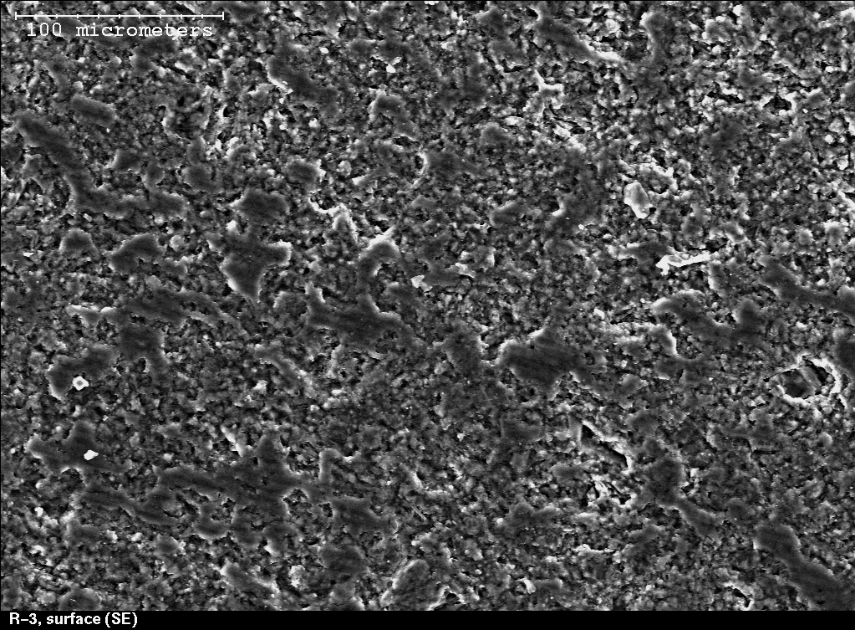**a.**

**b.**

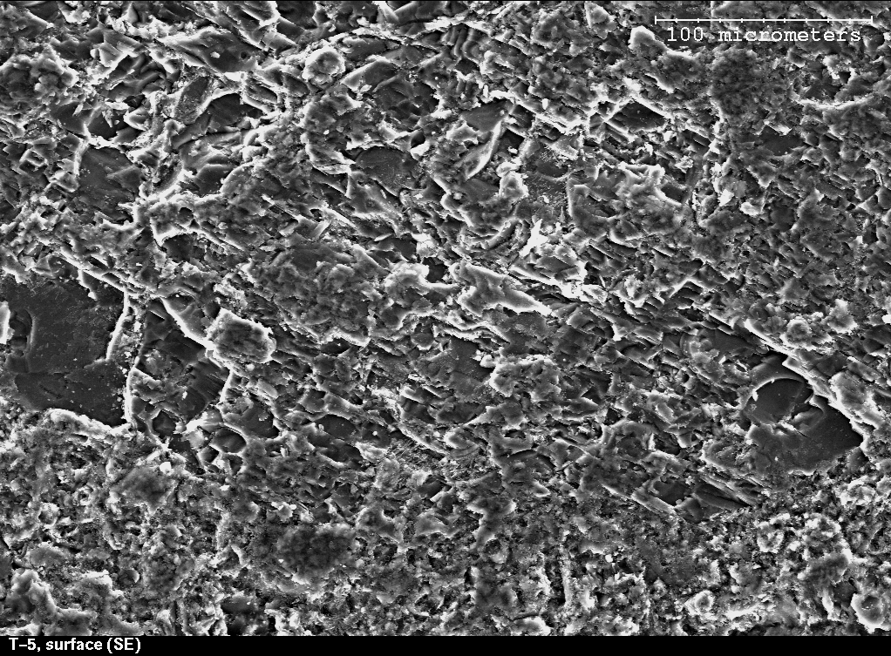

Figure 3.



Figure 4.

a.

b.Figure 5.

a.



b.

 Figure 6.

a.



b.



Figure 7.

1. * To whom all correspondence should be addressed (Email: [steve.kuznicki@ualberta.ca](mailto:steve.kuznicki@ualberta.ca); Telephone: 1.780.492.8819; Facsimile: 1.780.492.8958).