Establishing Translational Research Pipelines for Smart Devices
  - Using EMG Analysis to validate the stages to technological maturation of a
  - Manual Wheelchair lightweight sensing hand rim

Simon Grange^{1,2,3,5}, Liping Qi¹, Cy Frank², Martin Ferguson-Pell¹, Peter Smitham³, Catherine Holloway⁴, Stephen Taylor⁴, Gary Wills⁵, Nick Tyler⁴

¹Faculty of Rehabilitation Medicine, University of Alberta, Edmonton, Alberta, Canada, T6G 2G4
²Alberta Bone and Joint Health Institute, Calgary, Alberta, Canada
³Institute of Orthopaedics and Musculoskeletal Science, UCL, UK
⁴Civil Environmental, Geomatic Engineering, UCL, UK
⁵Electronics & Computer Science, University of Southampton, UK
Abstract
The development of a translational research path has traditionally been a haphazard approach, filtering technologies so that the ‘best of breed’ may ultimately succeed. The conversion ratio of brilliant ideas to useful devices remains suboptimal, as many ‘fail to progress’. The reality of developing biotechnology transfer and Knowledge Transfer (KT) generally, is that the ability of multidisciplinary teams (MDT) to assimilate and then act upon information is becoming the rate limiting step for the building of complex projects. The model proposed here considers both the biological aspects of Life Sciences (LS) and the establishment of Technology Readiness for its implementation.
By offering a sustainable generic structure for the assimilation and transfer of technologies, at a rate supported by the individual teams, the potential is for a standalone system able to accommodate clinical research and governance needs. The construction of a "signature", which reflects the current state of development, and through the rate progress of translation, and development of these technologies, potentially allows us to draw comparisons across different multidisciplinary environments, so as to ensure that adequate resources are allocated to assure their interoperability within agreed timescales.
A case example applying this process to the development of a ‘force sensing’ lightweight hand rim for manual wheelchairs allowed for the kinematic data to be compared with Electromyographic (EMG muscle patterning) data. This demonstrates that this strategic approach can be operationalized. By mapping the EMG signals from the basic science experiments through to clinical evaluation, the groundwork for assuring rapid integration of approaches for the afferent arm of novel ‘autosensing’ FES technologies. This integrates with work practices across disciplines, so as to create a potential ‘template’ for integration into Standard Operating Procedures (SOPs). These accommodate established ‘Good Laboratory Practice’ (GLP) and also can meet the requirements for governance of the translational research framework.

Keywords: Industrialization, Knowledge Transfer, Electromyography, Wavelet analysis, Biomechanics, Muscle synergy, Rehabilitation, Principal Component Analysis, Governance

Introduction

‘Reinventing the wheel’ is a relatively simple task for modern engineering. Certain obvious characteristics are evident and have stood the test of time, but as sensing technologies develop, so does our potential to harness the Human Machine Interface (HMI). By near-real-time analysis of data that it generates, we can create novel opportunities for technologies to play a key role by providing insight into how we may optimise our environment, through adaptation to our human performance and its limitations. Spinal cord injured manual wheelchair users suffer significant shoulder problems(1) since they are over dependent on their arms for propulsion. Instrumentation of their activity is therefore aimed at developing protective strategies.
For the purpose of establishing a rapid prototyping and testing system for mapping EMG patterns to kinetic activity, the Translational Research approach was applied to ensure rapid translation within a short time frame for optimal development of approaches for ‘afferent limb’ activity modelling in the upper limb. A kinematic sensing system was thus developed for manual wheelchair users (MWUs) which is both lightweight and can provide the data that can be multiplexed with other ‘streams’, including 16 channel EMG, to ensure interoperability with modular assistive technologies. It is possible to initiate a technology transfer pipeline with Knowledge Transfer (KT) from multidisciplinary academic teams, through development teams to potential industrial partners, in anticipation of future productisation and commercialisation.
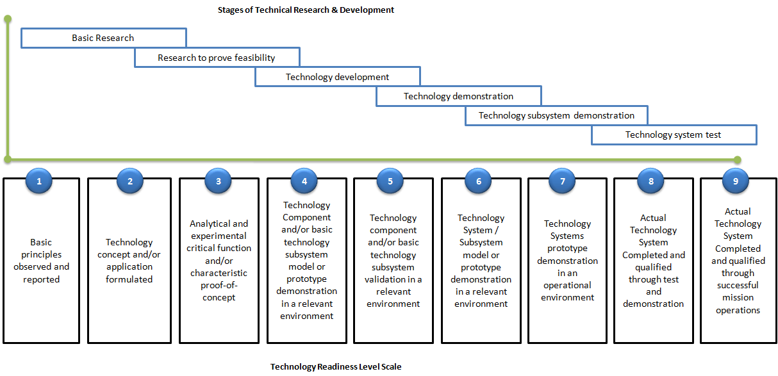
This traditional engineering process of "design and build” has been modified to "co-design" and "co-build" in order to accommodate multidiscipliniarity, methods of validation and testing. This demonstrates the potential to adopt open and flexible models for the development of large complex systems as a way of streamlining the knowledge transfer from academic research to development projects.
Figure 1 Mapping the Technology Readiness Level (TRL) on to the Stages of technical research and development
The widespread adoption of the Technology Readiness Level (TRL) scale (Figure 1) demystifies technological maturity and helps to operationalize roadmaps that strategically direct research themes.
This reflects the traditional technology transfer "cascade", but identifies nine clear (discrete) stages. This only reveals part of the story. With development of increasingly complex systems, multiple systems and subsystems may interact, so interoperability is vital. For this reason, it is necessary to consider the system readiness, invoking different evaluation approaches, which are equally valid, and yet often refer to different parameters. It is therefore not possible to compare these directly. Instead it is practical to represent progress in terms of a "signature", reflecting the relative progress of the different subsystems.
Ultimately we need to ensure adequate interoperability for entire systems to be deployed, especially in a clinical environment where risk of adverse events necessitates clear governance and risk mitigation.

Governance
It is essential that we are able to integrate clinical, research and governance information. This must comply with the necessary standards of information required ‘downstream’ for appropriate Foods and Drugs Administration (FDA) and European Medicines Agency (EMA) approvals for the North American and European markets respectively.
By developing the appropriate technology transfer environment, it is possible to accelerate the process, ensuring that for example; Good Laboratory Practice (GLP) is managed within the University environment, and then translated according to the criteria for Good Clinical Practice (GCP), to ensure compliance for clinical trials. Following successful completion of these validation studies, it is necessary to consider aspects of Good Manufacturing Practice (GMP) and to recognise the special importance in the medical arena of a ‘safe mode to failure’. In cases where failure is anticipated, it is necessary to extend this to consider the appropriate surveillance, which is metered in proportion to the risk.
By adopting a translational research path where the provenance of technologies can be demonstrated in terms of an empirical methodology, each ‘column’ has as its foundation the data which is analysed by the investigators at each stage. This is synthesised and evaluated so as to create clearer understanding that allows the team to progress to the next stage.
Broadly speaking, the first three stages (TRL1-3) occur in the University environment. They lead from initial idea to design and testing for the initial ‘Proof of Concept’ (POC) development. This creates many potential opportunities that can be taken forward, ultimately with a view to potential productisation. The next three technology readiness levels (TRL4-6) take the initial proof of concept; build demonstrations, for testing and validation using appropriate scenarios and environments. In the case of biologically interactive technologies (Clinical Trials of Investigational Medicinal Products - CTIMP and Advanced Therapeutic Medicinal Products - ATMP), the ‘pipe’ has clearly defined animal models followed by Phase I (first in humans), Phase II (safety and efficiency) and Phase III (clinical effectiveness) trials. A similar approach for implantable devices is inevitable in the future, even if presently not regulated for.
This process will therefore go from the theoretical methodological preparation stage of protocol generation through to a practical application evaluation stage, such as the clinical study or formal testing, as is the case with software development.
Transitioning from TRL6 to 7 ensures that new system components are integratable into a ‘real-world’ working environment, and again through TRL8, there is likely to be a formal evaluation stage. This may be through Health Technology Assessment which is usually managed within each jurisdiction, or some type of later Phase IV (implementation oriented) clinical trial, which will extend beyond the initial indications of the formal validation in the case of the Clinical Trials of Investigational Medicinal Products (CTIMP).
Ultimately the real ‘test’ for any system is its potential to impact upon the market, and thus success is indicated by evaluation of its impact at the TRL9 stage. Identifying design flaws at this stage is clearly ‘too late’ for correction.
Cross-cutting this technology assessment tool, is the realistic appraisal as to which biological scales are relevant. At the beginning of the spectrum (10⁻⁸m), aspects of the technology that impact at the genetic level will be communicated biologically through gene expression to the proteomic level, which drives the metabolome and hence influences the metabolic level. These physiological systems work on sub cellular and cellular systems, which clearly impact upon the ability of tissues to perform their functions, to withstand stresses which challenge homoeostatic mechanisms. As tissues are specialised within organs, so the organs combine to represent the systems such as the peripheral nervous system or musculoskeletal system. There is of course a significant relationship between these subsystems of the body, such as the coordinated actions of the neuromusculoskeletal axis, to affect the wishes of an individual.
Extending beyond this scale, is the relationship that individual has with their local, family group or individuals who may be clustered with respect to certain clinical conditions. Either way, these individuals and groups contribute to their relevant community, whose expertise in living with clinical conditions and feedback, drive research teams. This is broadly termed ‘public and patient involvement’ (PPI). This ultimately has an impact at the political level, where there is the need to apply the strategic thinking necessary to address epidemiological challenges. Whilst this Life Science (LS) scale effectively considers research issues in isolation, for the purposes of biotechnology transfer, this provides a simple matrix that relates one level to another and one step to the next. This process may require demonstration of correlation, with experimental (empirical) data, or it may represent a transition across levels, which may be of scientific or administrative value.

Validation & Verification
Development of "soft" and "hard" gates is relevant to how we are building different translational research pipelines. These may alternately represent protocol development and testing, acting as a coordinating force to ensure that subsystems are brought "online" at an appropriate rate for their integration and ultimate interoperability. These “soft” gates warrant internal peer review only, compared with external peer review at the “hard” gates such as requesting ethical opinion or sponsor approvals.
Tempered with these approaches, is the need to build in risk assessment at various stages in accordance with the criteria to meet necessary governance regulations. Progressing to the stage where modular systems design and development is normal, simple systems become complex, so too, the complex systems on which these depend, become complicated, as they rely on interactions with other components.
Indeed there are some situations which are so complicated that the only rational approach to this chaotic environment, such as the global ‘race’ to meet the next ‘grand challenge’, is to run parallel paths of development - to ultimately support the best of breed, which ultimately appears as a clear leader.
This is the approach adopted by funding agencies, i.e. no single group can work in isolated academic splendour. It is therefore the ability to convene multidisciplinary teams with the minimum resource at short notice, and for them to be able to work in a shared real or Virtual Research Environment (VRE) (2)(see figure 2 below), which will ultimately gives them the competitive edge.

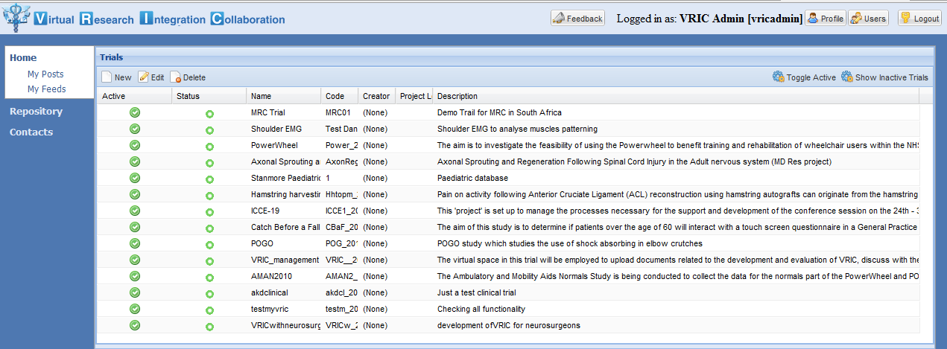
Figure 2 Virtual research integration and collaboration environment

This represents a degree of optimisation of the ‘systems’ approach, with gating procedures to ensure appropriate regulation for the protection of subjects (such as the necessary institutional review board – IRB reviews) and also to ensure that pre-productised devices are ready for progressing to their next stage of development.
Ultimately the value to institutions is the ability to discretely categorise stages of progress to either offer support or to ‘cull’ research and development efforts that are clearly not going to be productive. Precautions should be taken to avoid the ‘culling’ process too early, since history clearly demonstrates that the ultimate true value of potential new technologies e.g. the laser, may take at least two decades to be realised, and often for previously unanticipated applications.
This ensures that the groups and teams are assured that their intellectual property is adequately protected, supporting the interests sponsors and institutions.

Ensuring Technical Knowledge Transfer
The aim of the ‘PowerWheel’ project was to ensure a validated sensing wheel that could be ‘rolled out’ prior to the Paralympics in London in 2012. This is a clear deadline which focuses the world’s attention and offers an opportunity to find a commercial partner for the next phase of development. Success of the validation process depended on the transfer of expertise from the basic science laboratory to the test environments. This was exemplified by analysis of the EMG data that was synchronized with the kinematic data.
This technique was validated in a wheelchair propulsion laboratory (TRL2) in Canada, and then applied in the study of a population of 30 healthy able bodied individuals (UCL PAMELA laboratory, UK) representing validation in a relevant environment (TRL5). Finally the system was evaluated in an operational environment (TRL7) at the Stanmore Clinical Research Facility, involving 7 spinal cord injured patients from the London Spinal Cord Injury Centre.

Wavelet analysis of the EMG signal
EMG data were normalized to percentage of cycle time and synchronized with kinetic data. All signal processing was performed using custom programs, written using Mathematica (version 6.0, Wolfram Inc., Champaign, IL, USA). The EMG signals were resolved into intensities in time-frequency space using wavelet techniques(3). The intensity is a close approximation to the power of the signal contained within a given frequency band, and the intensity spectrum is equivalent to the power spectrum from the signals. A filter bank of 10 non-linearly scaled wavelets was used, index by k, with center frequency, fc, ranging from 7 Hz (wavelet 0) to 350 Hz (wavelet 9). The first wavelet of EMG covered a frequency band of 0-10 Hz, which is typically associated with movement artifacts.
The effects of movement due to dynamic contractions were reduced by removing the first wavelet from the spectra. Total intensity was given by summing the intensities over the selected wavelets (10-350 Hz, k = 1-9). Total intensity is a measure of the time-varying power within the signal and is equivalent to twice the square of the root-mean-square (2rms²). This technique was uniformly applied across the three studies, at stages TRL2, 5 and 7.

EMG activities
EMG signals represent the activity of an organ (muscle) and collectively the patterning represents an anatomical system, in this case the shoulder joint musculature. Wheelchair propulsion involves 2 phases, the push and the recovery phase (4;5). Anterior deltoid, pectoralis major, biceps, and triceps have primary activity during the push phase for the forward push. The general pattern of push phase muscles was characterized by the onset of activity in the late recovery phase during the arm return and push preparation phases. The EMG intensity of these muscles was higher in sprint than in straight push, which indicates that fast speed wheelchair propulsion places higher load on these shoulder muscles and hence requires higher muscle activation levels. Similar patterns of activity were seen at all three validation stages.
After the follow-through of the push phase, the shoulder motions reversed direction in the recovery phase. The recovery muscles, middle deltoid, supraspinatus, latissimus dorsi, and subscapularis, contracted eccentrically to restrain shoulder flexion and then contracted concentrically to return the arm to its starting position. The EMG intensities of these muscles were significantly higher for sprint than for straight push, which may be associated with rapid movement in the recovery phase. Participants executed the propulsion cycle faster to maintain increased speed.
Compared to forward push, the tested muscles displayed different patterns in backward push. The push muscles were active during the mid-push and mid-recovery phase, whereas the recovery muscles were active during the late-recovery and early push phases. The EMG intensity of push muscles was lower in backward push than in forward push, while the recovery muscles showed a higher EMG activity in backward push than in forward push. It has been reported that long term use of the manual wheelchair leads to muscle imbalance, overdevelopment, strengthening and shortening of the anterior deltoid and pectoralis with weakening and lengthening of the opposing muscle groups (6-10). Backward push would therefore be a good exercise for manual wheelchair users to strengthen posterior musculature.

Conclusions
At different stages of the translational research pipe, demonstration of the consistency of EMG patterning across the validation steps, coordinated with consistent kinematic data collection, suggests that the wheel could transition to its next step for development, with confidence that it effectively adds value. This demonstration supported real collaboration across multidisciplinary teams representing Neurophysiology, Engineering, Rehabilitation Medicine and Orthopaedics. It covered initial University research and development (TRL1-3) plus engineering and evaluation in a healthy population, (TRL4-6) development stages. Rapid transition through to a nationally supported (UK NIHR i4i FDP1) clinical trial of spinal cord injured patients (TRL7), demonstrates the potential for this approach to develop a truly competitive edge in a global research and development environment.
As Darwin stated(11); "In the struggle for survival, the fittest win out at the expense of their rivals because they succeed in adapting themselves best to their environment." The reality is that major scientific endeavour is now a global exercise. It is the ability to rapidly configure groups to focus on challenges and complete stages effectively that will ensure their long term survival. VREs are likely to play a central role in this in the future.
This means that the teams need to respect the logical transition and the consistent extrapolation of an argument from one step to the next. It is the provenance of data which ultimately secures the foundation of clinical intervention in a sound basic science evidence base. We must all adapt our technologies to ensure rapid, reliable and robust transfer through the progressive levels of readiness to the point that they can be implemented safely and securely for the benefit of all.

References
(1) Curtis KA et al. Shoulder pain in wheelchair users with tetraplegia and paraplegia. Arch Phys Med Rehabil 80[4], 453-457. 1-1-1999.
(2) Wills G, Grange S. Virtual Research Integration and Collaboration (VRIC). ECS 2010Available from: URL: www.voeu.ecs.soton.ac.uk
(3) von Tscharner V. Intensity analysis in time-frequency space of surface myoelectric signals by wavelets of specified resolution. J Electromyogr Kinesiol, 10[6], 433-445. 2000.
(4) Kulig Keal. Shoulder joint kinetics during the push phase of wheelchair propulsion. Clin Orthop Relat Res, [354], 132-143. 1998.
(5) Veeger et al. Load on the shoulder in low intensity wheelchair propulsion. Clin Biomech (Bristol, Avon), 17[3], 211-218. 2002.
(6) Lin HTeal. Muscle forces analysis in the shoulder mechanism during wheelchair propulsion. Proc Inst Mech Eng H, 218[4], 213-221. 2004.
(7) Mulroy SJ et al. Electromyographic activity of shoulder muscles during wheelchair propulsion by paraplegic persons. Arch Phys Med Rehabil, 77[2], 187-193. 1996.
(8) Mulroy SJ et al. Effects of spinal cord injury level on the activity of shoulder muscles during wheelchair propulsion: an electromyographic study. Arch Phys Med Rehabil, 85[6], 925-934. 2004.
(9) Richter WMealS. Stroke pattern and handrim biomechanics for level and uphill wheelchair propulsion at self-selected speeds. Arch Phys Med Rehabil, 88[1], 81-87. 2007.
(10) Sabick et al. A new method to quantify demand on the upper extremity during manual wheelchair propulsion. Arch Phys Med Rehabil, 85[7], 1151-1159. 2004.
(11) Darwin Quote. 2012. http://www.darwin-literature.com/l_quotes.html

Author’s Address
Simon AW Grange
Adj. Assoc. Prof. Faculty of Rehabilitation Medicine
grange@ualberta.ca

