Redliner: A device for monitoring wheelchair users’ over-exertion events during functional mobility activities.
Zohreh Salimi, Martin Ferguson-Pell, Kenton Hamaluik, Adam Pinkoski
Faculty of Rehabilitation Medicine, University of Alberta, Edmonton, Alberta, Canada, T6G 2G4.
Presenter’s e-mail address: zsalimi@ualberta.ca

Purpose:
There are about 65 million wheelchair users around the world¹. Many suffer from shoulder injuries due to over-use of the structures of the upper extremities during wheelchair propulsion and transfers. Over-exertion injuries, result in chronic pain, reduced quality of life, increase the dependence of wheelchair on care-givers and lead to further loss of function. Being active and performing regular exercises is important for wheelchair users to prevent joint degenereation², to maintain cardiovascular health³, and to enhance upper extremity muscle strength.
A number of products have become very popular recently to provide an indication for able bodied persons of everyday levels of activity (Fitbit, Garmin, Polar and many others). Mainly designed to record walking activity and coupled in some cases to heart rate monitoring, these devices are not intended to be accurate measures of phyiological energy consumption. Instead they provide a simple means to record and sustain daily levels of activity. Similar devices have not been produced for wheelchair users where the relationship between ambulation and cardiovascular challenge is complex.
The PCI (Physiological Cost Index) is a simple, easy to measure indicator of the physiological cost associated with walking⁴. It is an indicator of energy cost⁵ during walking for a self-selected speed⁶. We have investigated its potentail for the remote monitoring of wheelchair user levels of activity.. However, in a recent study⁷ that we undertaken under carefully controlled conditions we have found that PCI is not a valid measure of the physiological cost of wheelchair ambulation.
A review of studies that have considered the use of activity monitors for measuring meaningful wheelchair activities suggests that they are not reliable. Activity monitors such as Actiwatch⁸, CSA⁹, and PAMS&GWRM¹⁰ have been studied. The Actiwatch⁸ and CSA⁹ (Computer Science and Applications Inc.) were shown to have an intermediate correlation (~ 50 to 60%) with self-reported activity level and energy expenditure, respectively. They do not provide measures like push counts that are informative and beneficial for wheelchair users. PAMS&GWRM¹⁰ looks promising, but provides very limited information for wheelchair users, and is not commercially available. Instead of measuring acitivity we have broadened the specifications for such a device so that it measures both the level of activity and also the frequency with which the wheelchair user over-uses his/her upper exteremities during wheelchair propulsion in every day activities.
Method:
A low cost device using a proprietary design has been developed and mounted on the wheelchair’s wheels. A series of tests has been performed in real world settings: on grass, linoleum, cobblestones, and asphalt. On each of these surfaces a set of four tests was completed: straight-line pushing, maneuvering, maximal push, and coast down. The maximum acceleration obtained from maximal test in each setting (e.g. asphalt) was used to estimate the maximum force the participant could apply in that setting. Then, all the instances that the participant exceeded 80% (according a study¹¹ conducted by Hills, 2011) of his maximal force was considered to be “red-lining”, or over-exertion. A threshold of 80% of maximum capacity is a widely used in physiological studies as an indicator of over exertion..
Results:
In Figure 1 the Redliner’s results for the task of propelling wheelchair in a straight line on cobblestone is shown. A cobble stone surface represents a particularly challenging task both for the wheelchair user and for Redliner’s sensors. The result for one participant is shown in Figure 1.
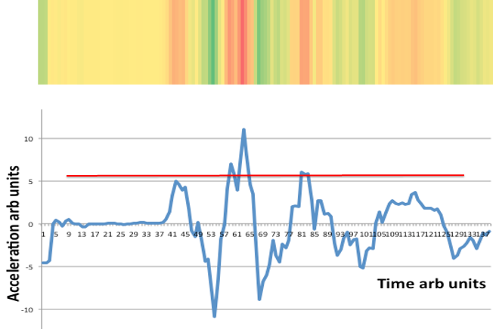
Figure 1. Redliner’s results for straightline wheelchair propulsion on a cobblestone surface.

Conclusions:
Redliner is both an activity monitor and a means to detect the frequency and circumstances of over exertion events during wheelchair propulsion. Further studies are planned that will validate the information obtained from Redliner using an instrumented wheelchair wheel (Smartwheel). An opportunity assessment for the potential commercialization of Redliner is being planned.
References:
1. Guidelines on the provision of manual wheelchairs in less resourced settings. Physiotherapy. 1999;85(4):227.
2. Wylie EJ, Chakera TM. Degenerative joint abnormalities in patients with paraplegia of duration greater than 20 years. Paraplegia. 1988;26(2):101–6.
3. Jacobs PL, Nash MS. Exercise recommendations for individuals with spinal cord injury. Sports medicine (Auckland, N.Z.). 2004;34(11):727–51.
4. Reliability of Physiological Cost Index Measurements in Walking Normal Subjects Using Steady-state , Non-steady-state and Post-exercise Heart Rate Recording. 1978.
5. Chin T, Sawamura S, Fujita H, Nakajima S, Ojima I, Oyabu H, Nagakura Y, Otsuka H, Nakagawa a. The efficacy of physiological cost index (PCI) measurement of a subject walking with an Intelligent Prosthesis. Prosthetics and orthotics international. 1999;23(1):45–9.
6. Graham RC, Smith NM, White CM, Rc AG, Nm S, The WCM. The reliability and validity of the physiological cost index in healthy subjects while walking on 2 different tracks. Archives of physical medicine and rehabilitation. 2005 [accessed 2014 Mar 26];86(10):2041–6. http://www.ncbi.nlm.nih.gov/pubmed/16213251
7. Salimi Z, Ferguson-Pell MW, Ramadi A, Haennel R, Mohammadi F, Qi L. Investigating validation of physiological cost index for wheelchair users. In: 15th Biomedical Engineering conference (BME) Program and Proceedings. ; p. 73.
8. Warms CA, Belza BL. Actigraphy as a measure of physical activity for wheelchair users with spinal cord injury. Nursing Research. 2004;53(2):136–143.
9. Washburn RA, Copay AG. Assessing physical activity during wheelchair pushing: validity of a portable accelerometer. Adapted Physicl Activity Quarterly. 1999;16(3):290–299.
10. Wongsirikul N. Field-based usability study of physicL activity monitoring and sharing systems for manual wheelchair users with spinal cord injudt. University of Pittsburgh; 2014.
11. Hills L. Every push matters. University College London; 2011. 1-141 p.

