Calibration of Redliner

The following calibration was performed by rotating the wheel through increments of 90 degrees as the data was captured from Redliner. In order to get an indication of the response from the z axis the wheel was removed and placed on its side. In the case of the x and y axes the difference in output for the maximum and minium readings represents 2g or 2*9.8m/s/s. In the case of the z axis the difference between the neutral reading and the reading lying on size = 1g.

The x axis is aligned radially relative to the wheel and the y axis tangentially.

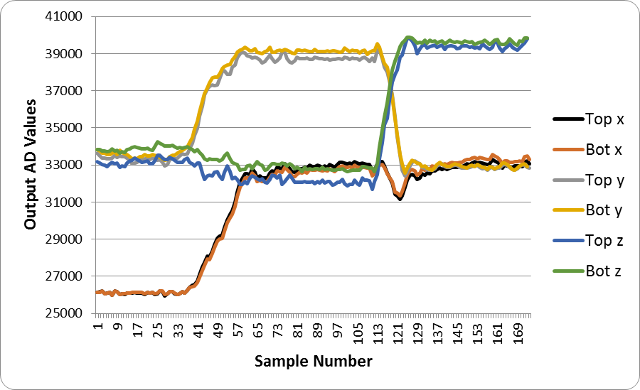

Using this data the following calibration constants were determined for this formula:

Calibrated α = A × α + B

 | Wheel attached to wheelchair, Redliner placed vertical | Wheel attached to wheelchair, Redliner placed horizontal | Wheel removed from wheelchairand lain on side | A | B
Top x | 26105.4242 | 32818.5 | 32915.5366 | 0.00146133 | -47.958566
Bot x | 26117.0606 | 32611.087 | 33167.0976 | 0.00151062 | -49.26293
Top y | 33323.8571 | 38729.0217 | 32877.7317 | 0.00181493 | -60.480497
Bot y | 33536.0357 | 39140.8913 | 32924.4634 | 0.00175027 | -58.697054
Top z | 32565.8919 | 32133.3043 | 39369.4634 | 0.00144189 | -46.956426
Bot z | 33302.045 | 32854.8261 | 39622 | 0.00155223 | -51.692309

