Framework For An ‘Open Laboratory’ Sandbox
Ensuring International Collaboration with Data Protection

Simon Grange, Liping Qi
grange@ualberta.ca
Rehabilitation Robotics Sandbox
University of Alberta, Edmonton
Alberta, Canada
Yin Zhifu, Helin Zou
zouhl@dlut.edu.cn
Dalian University of Technology, Liaoning, China
Dalian, China

Abstract—Rapid and effective collaboration across jurisdictions requires respect for collaborators’ data and the assurance that it will be shared for mutual benefit, whilst protecting intellectual property of the individuals, their groups and institutions. This paper outlines a principle for sharing, whilst protecting discrete datasets, yet ensures that their data streams may be integrated in a way that will progressively encourage the ‘creative commons’ approach to data management for the benefit of a wider community.
Through the integration of different data streams for processing raw data, according to agreed algorithms in this common secure ‘Sandbox’, it is possible for the digital ‘virtual’ environment to emulate and reflect collaboration in the physical ‘real world’ environment.
Keywords-component; Data Management, Matlab, LabView, International Collaboration

Introduction
Library services traditionally offer support for the academic processes that by virtue of increasing complexity, can no longer occur in isolated splendor (1). It is necessary to view the modern role of laboratories in the context of dynamic centres, focusing activity at differing stages of the research and development process. These facilities should act as part of a syncitium.
It is vital to maintain secure development of ‘Intellectual Property’ (IP), yet share it, to create new knowledge and ultimately integrate and assimilate this with others. To this end, universities are adopting the policy of ‘open archives’ (2-4). As individuals and their devices become more mobile, jurisdictions must still be respected and the challenge is to balance differing competing forces, such as Freedom of Information (FOI), where publicly funded sources are concerned, and the required ‘know how’ held by private institutions.

Methods
Collaboration across the two teams in China and Canada, plus shared projects with centres in Europe, necessitate the development of an evolving network that ensures security, whilst maintaining ease of access to collaborative resources. The system’s data repository should, where possible, ‘run itself’ i.e. be autonomous.

Technology Readiness:

By building the structure around the Technology Readiness Level (TRL) scale, it is easier to manage governance (5) and when technologies are bundled together, the System Readiness Level (SRL) can be adopted. It should be possible to establish the general principles of how to demonstrate the appropriate design, review it and ensure that adequate safety and efficiency testing has been completed, to justify progression to the next stage. The aim is to visualise this in multiple dimensions, supporting conventional project management strategies, including awareness of any potential biohazard and also the associated cost of development of each stage.

The general workflow, transitioning across programmes and jurisdictions, means that the system components would require acceptance of parameters to meet those of an International Standards Organisation. This means that there will be an established process for developing Standard Operating Procedures (SOP) that transcends the jurisdictions of the different organisations that will be acceptable to the governing bodies, who ultimately oversee the differing stages of technology transfer.
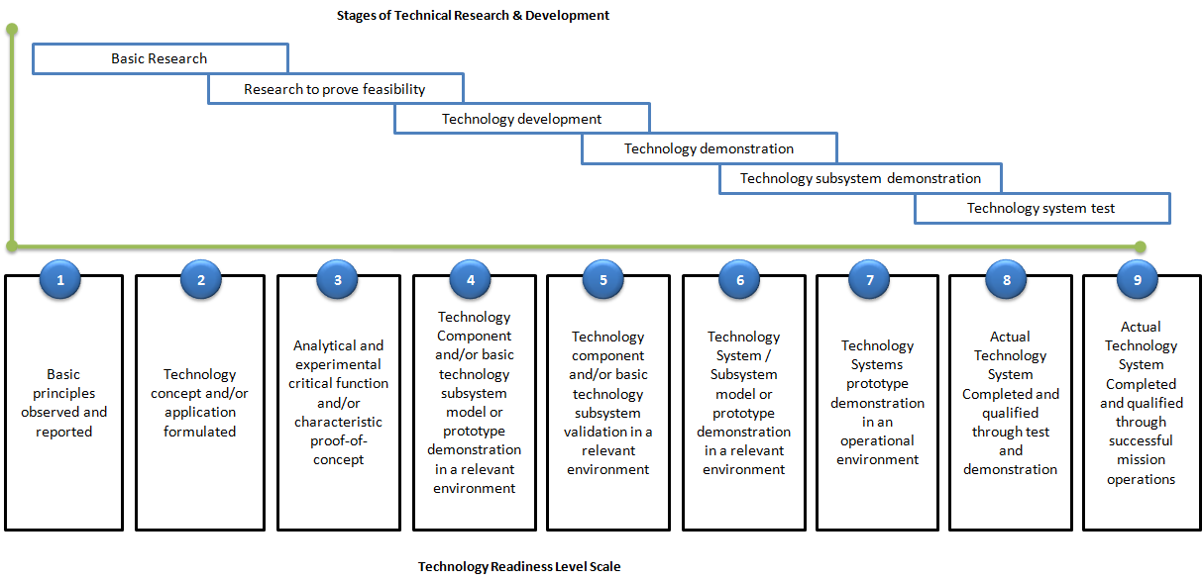
The key to this is the ability to model across steps of technology development and to compare the differing datasets reasonably, i.e. through processes of verification and validation (Figure 1 above). The progression is also dependent across different stages, where the user can also establish associations across differing technologies. The first stage of this process, once adopted, is the acceptance of a collection of synchronized data from different sources and a common approach to ensure their coordinated analysis. This transfers the work from TRL1 via such experimental protocols to TRL3 in a basic science laboratory, and then on to TRL5 in a translational research laboratory such as the Rehabilitation Robotics Sandbox (6) in this example.
Figure 1 Applying Technology Readiness Levels to the design of a new device
Here a kinematic measuring device (Wheelchair Ergometer) and an Electromyographic (electrical) signal capture (EMG) device are coordinated. This is to ensure the principles of muscle patterning activity can be recorded and synchronized with the physical demands that individuals are subjected to.

Flow Chart
Figure 2 Flow chart of the real-time system
The context of this is seen in the flowchart (Figure 2 above). A data acquisition system with real-time signal processing and communication capability is developed with commercial off-the-shelf components and LabVIEW CompactRIO (National Instruments Inc., Austin, Texas, USA). This operating system is capable of dealing with large scale data acquisition, signal processing and feedback. In the study, the ergometer and EMG signals were collected by the DAQ (data acquisition) module. The signals from both systems are processed on a ‘Fully Programmable Gate Array’ (FPGA) in real-time to provide the required performance feedback. A performance report (Figure 3 below) is generated to give feedback to the wheelchair user during wheelchair propulsion on the ergometer.
Figure 3. 4 EMG Muscle activity reports of 10 propulsion cycles

Hybrid Programming of MATLAB and LabVIEW
Because the graphical programming language is a visual programming language, it is easy to design measurement and control systems with LabVIEW; combining this with the equally well established MATLAB software (MathWorks Inc., MA, USA), which offers the potential for the ease of data analysis. MATLAB provides a good range of arithmetic libraries and supports complex matrix operations. By combining LabVIEW with MATLAB, they complement each other, significantly improving programming efficiency.

Remote Control & Data Transfer
Having established the process underlying the workflow, the aim is to establish and maintain communications through different remote terminals. In order to control all the systems with one computer and synchronize different DAQ systems, a system that allows one master computer to control and transfer data simultaneously to/from multiple DAQ systems was developed (Figure 4 below).
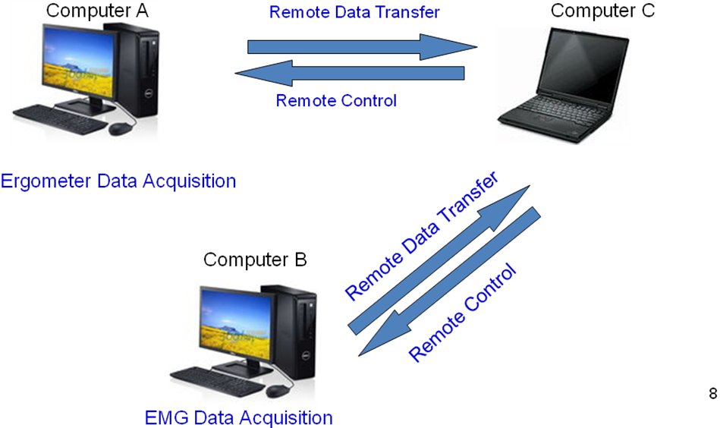
Figure 4 Foundation of a network

To achieve remote control and monitoring, the Web Publishing Tool of LabVIEW is used to publish the ‘Human Machine Interface’ (HMI) to the internet as a website. The collaborators only need to type the address of the HMI into a Windows Explorer™ (Microsoft, WA, USA) web browser. The client computer will gain access to the server via the internet and security can be managed via conventional web site access privileges. Thus, the client computer, which is connected to the server can control and acquire data remotely. This provides a ‘door’ into the ‘Walled Garden’ where the owners can easily control who has the ‘keys’ through alignment with conventional human resource (HR) management approaches.

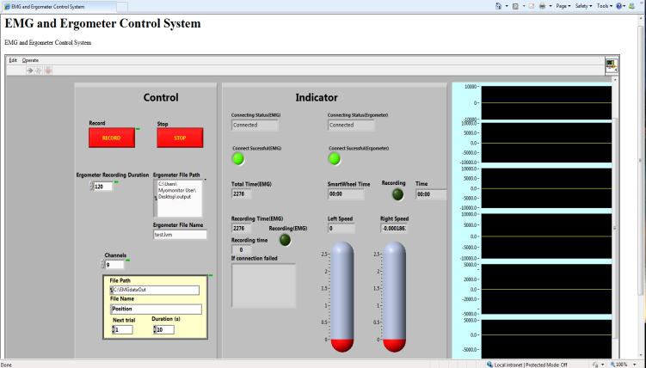
Figure 5. The website of published HMI, where the client computer can get access to the server through internet

Governance
Governance approaches must support innovation, yet protect individuals and our society at large. The optimum approach to sharing this data, when managing data from remote sites is not yet known. There are presently no preclinical testing methods that can reliably predict outcomes; or affordably and systematically investigate all possible negative interactions. The need therefore still exists for empirical data to be analysed and open source data potentially offers one such approach. As expectations arise within society for an improved long-term quality of life, greater pressure is placed upon healthcare providers and industry to deliver potential new solutions and to translate the potential solutions that Basic Sciencemay offer healthcare into operational systems. We may find that through the various jurisdictional ‘Freedom of Information’ acts (FOI), that appropriate data becomes available.
Our knowledge base can therefore be categorised according to the "Rumsfeld Paradigm" (Table 1 below), which refers to what the professions recognise and what value other potentially available information could add.

Known Knowns:
Broadly speaking, this relationship between local and remote (other centres’) perspectives on information, can distinguish what we ‘know’ as a community from what we ‘need to know’ that may presently be inaccessible. This may be obtained from empirical processes, i.e. results of current tests and registries (e.g. the Canadian Institute for Health Information - CIHI) that have been evaluated (7). These published results represent ‘Known Knowns’.

 | Known By Community | Unknown By Community
Known by User | Known Knowns (KK)  Information that we all have access to  e.g. Published in vitro and in vivo studies such as CIHI | Unknown Knowns  (UK)  Information that we all do not yet have access to but could seek permission for  e.g. Aggregated data from Secured Intellectual Property
Unknown by User | Known Unknowns (KU)  Information that we have access to, but not yet collected  e.g. Censored in registries | Unknown Unknowns (UU)  Information that may be very relevant but which is not ‘on the horizon’  e.g. Data mined ‘gap analysis’
Table 1 ‘Rumsfeld's’ Paradigm

Unknown Knowns:
What we don't know that others know, i.e. information that is ‘out there’ from different sources including proprietary or nationally supported databases, that securely holding intellectual property, could be anonymously reported, possibly as aggregated data. This represents things that are known by certain groups, but not by the community i.e. ‘Unknown Knowns’ (UK). These can be reported directly if they are not censored. The latter includes the information that some registries could provide us with.

Known Unknowns:
There is information that the community identifies as potentially available, i.e. that we ‘know’ is ‘unknown’ (KU). Sources include unpublished clinical case series, and this will potentially drive further data registry development.

Unknown Unknowns:
The last category is the "Unknown Unknowns" (UU), where there may be future tests and trials. Presently these do not exist. The clinical outcomes will ultimately provide information needed to reach sound conclusions and ‘close the loop’ with basic science results by validating or refuting findings. These may relate to pre-clinical and clinical examination through modalities such as Magnetic Resonance Imaging (MRI), Ultrasound Scanning (USS) or even multimodal imaging. Whatever the technology or technique, the question arises from this example as to how to inform the process of future ‘smart’ implant design. The process is similar to ‘patent mining’ by the identification of ‘patent vacuums’, employing a software infrastructure in the database that identifies possible tests and agents based on the surrounding data landscape (8).

Discussion

Acceptable Risk:
None of these approaches actually answer the critical question; ‘Collectively, can we build open autonomous data transfer systems?’ The adaptation for a ‘Creative Commons’ approach could rapidly progress this process, ensuring legal protection through appropriate licensing (9). Using the Technology Readiness Level (TRL) Scale ensures a clear non-repudiable ‘chain-of-evidence’. The trend should always be a logical transition from one stage to the next. For such technological transfer, it should be possible to demonstrate provenance. The aim is therefore to ensure ease of governance by transition from Good Laboratory Practice (GLP) to Good Clinical Practice (GCP) and to Good Manufacturing Practice (GMP).
To achieve this, it is necessary to demonstrate that the sequential steps have been satisfactorily completed. To become confident in the process, it is necessary to report adverse events as well as positive findings, since there is usually a 2:1 reporting bias in favor of the positive findings (10).

Trust, yet Verify
Having established the mechanism for shared data acquisition, storage and presentation, it is necessary to demonstrate the potential for long-term evaluations of the processes. The question is also one of whether there are reliable and robust short-term strategies, which can evolve along the lines of ‘trust yet verify’.
This positive aspect considers the interrelationship of data collected across the life-science spectrum. This derives from different areas of basic science, right through to the process of design, development and clinical testing, industrialization and commercialisation, in terms of technology transfer.
This example focused on an approach for adoption of hybrid programming using established software toolkits, as part of a broader approach for consistent rapid collaborator integration. It focuses on the data management paths, which are at the heart of reliable analyses and the subsequent non-repudiation of results. When seeking future regulatory approval however, it still has to be recognised that this only accounts for the ‘known knowns’ (KK).

Data Mining
‘Unknown Unknowns’ (UU) may be accessible through data mining. For example, computational technologies akin to those used in patent vacuum identification (8), anomaly detection, and disease outbreak detection (11) can assist in identifying both future assays and future success or failure modes from early data in the TRL pipeline. Specifically, active learning based on existing data in an evidence path can form a powerful source of new knowledge by suggesting tests to reduce the space of ‘Unknown Unknowns’ (12;13).

Data-driven foresight of this kind can positively direct technological exploration and regulation but it necessitates cooperation. To develop a predictive loop for future realisation; both the ‘Unknown Knowns’ (UK), the ‘Known Unknowns’ (KU), from the ‘meta’ registry information, will have to plug this information gap to hopefully diminish the ‘Unknown Unknowns’ (UU), which may otherwise jeopardise future technological progress.

Conclusions
Through machine learning, coupled to a ‘creative commons’ approach to data integration, there are techniques available to identify salient features in data, predicting the relative value and ascribed certainty of these variables. These methods should be applied to the data registries as a safeguard, using specific evidence (data) capture models, which can be primed by data from industry. Dissemination of established information should also minimise the risk of future harm through rapid communication of validated results.
Existing pre-clinical and clinical trials are insufficient in determining all risks. New guidelines are therefore required for both new and existing technologies. The development of a non-repudiable robust Translational Research (TR) approach (1;13) should therefore precede the clinical implementation of future biologically interactive materials. A hurdle to the voluntary registration of data is researcher participation or industry bias, which reflects inclusion of only positive data.
As professions, we must aim to establish these clearly measurable causal links between pre-clinical design and actual clinical outcomes and such data integration approaches may support this. More complicated data registration is ultimately necessary as we progress toward the introduction of more sophisticated datasets related to bio-inspired stem cell or nano scale products such as synthetic cartilage substitution in vivo (14) or smart implantable devices (15).
The early development of Virtual Research Environment infrastructures still employed a monolithic structure (16-19), which means that laboratories now need to be established with ‘virtual’ as well as ‘real’ facilities being integrated into multimodal multidisciplinary dynamic structures, as our circulation of academic minds becomes more fluid, so functionality is increased and progress of scientific advancement accelerated. The intellectual property ‘know how’, including expertise of analysis and interpretation of novel approaches still needs to be protected.

Acknowledgment
The assistance of Prof. Martin Fergusson Pell is greatly appreciated in the initial Set-up of the Robotics Sandbox laboratory along with Expert Guidance from the Curators of the University of Alberta Library services; Leah Vanderjagt and Chuck Humphrey for documents and data respectively.

References

