Figure 1

a

b

R

Va-R

Va-b

Vb-R

A

a

b

R1

R2

Va-R1

Vb-R2

VR1-R2

Va-b

B

Figure 2

B

Ocean

Forest

City

Mountain

(0, 0)

A

Ocean

Forest

City

Mountain

(0, 0)

r = 50 [vm]

D

(0, 0)

C

Ocean

Forest

City

Mountain

(0, 0)

Figure 3

A

B

Figure 4

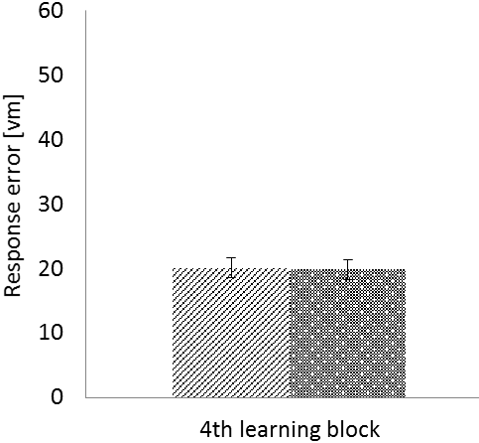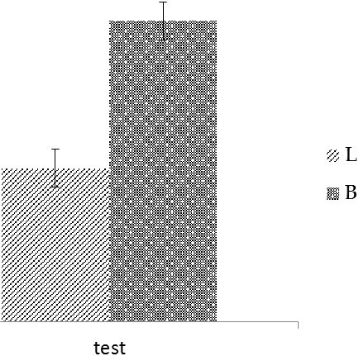

**\***

A

B

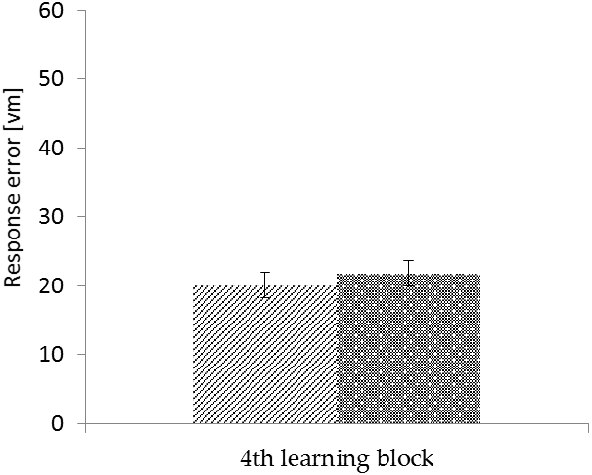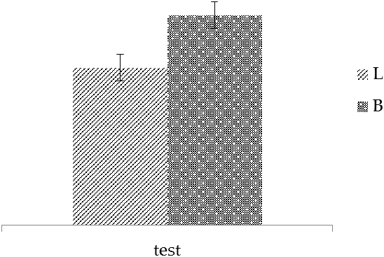

**\***

Figure 5

A



B

