The influence of temperature on the pyrolysis of household products
Xiao Qin Lee ª • P. Mark L. Sandercock ^{b} • James J. Harynuk ^{a ,*}
X.Q. Lee • J.J. Harynuk*
Department of Chemistry, University of Alberta, Edmonton, AB T6G 2G2, Canada
* Corresponding author. tel.: +1 780 492 8303; fax: +1 780 492 8231.
e-mail address: james.harynuk@ualberta.ca

P.M.L. Sandercock
Trace Evidence Services, National Forensic Laboratory Services - Edmonton, Royal Canadian Mounted Police, Edmonton, AB, T5V 1B7, Canada

Abstract
We have previously demonstrated the successful application of multivariate statistical(i.e. chemometric) techniques to the classification of casework fire debris based on gasoline content, with the objective to expedite the data interpretation process for the forensic analysis of fire debris. We have also shown thatit is possible to classify simulated fire debris based on gasoline content using simulated fire debris; however, models trained on simulated debris are not applicable to casework samples without a significant loss in model accuracy.Apreviously developed simulation protocolthat works wellfor generating debris to train human analysts was inadequate for training either partial least-squares discriminant analysis (PLS-DA) or soft independent modelling by class analogy (SIMCA) models to identify casework debris due mainly to its inability to generate a sufficient amount of benzene, toluene, ethylbenzene, and xylenes (BTEX) and non-aromatic hydrocarbon compounds. This method relied on pyrolyzing materials at 400 ◦C. Here we examine the effects of pyrolysis conditions on household materials, including spruce plywood, vinyl sheet flooring, polyethylene terephthalate (PET) carpet, Nylon 6 carpet, polyurethane (PU) foam carpet underlay, asphalt shingle, medium-density fireboard (MDF) shelving, and spruce timber at temperatures above 400 ◦C, in an attempt to generate additional BTEX and non-aromatic hydrocarbon compounds for the realistic simulation of fire debris. The work presented here showed that C3- to C5-alkylbenzenes, which are abundant in gasoline, were generally absent from the pyrolysates of all materials studied and at all temperatures studied (400, 700 and 900 ◦C), only appearing in trace amounts on rare occasions. Based on our results, we propose that accurate simulation of fire debris could be achieved with a mixture of carpets, carpet underlay, and vinyl flooring pyrolyzed at 700 ◦C; spruce plywood pyrolyzed at 900 ◦C, and asphalt shingles pyrolyzed at 400 and 700 ◦C. These conditions generated a substantial amount of BTEX and non-aromatic hydrocarbons in the debris matrix background. The testing of this “recipe” for generating simulated debris for training chemometric models that can classify casework debris is left for future experimentation.
Keywords:
Fire debris • Pyrolysis • Gas chromatography-mass spectrometry

Introduction
Combustion and pyrolysis reactions are the dominant processes that occur in a fire, with combustion being described by two processes: flaming combustion and smouldering combustion [1, 2]. Flaming combustion is the most common type of combustion with characteristic flames for which it is named. This process involves a reaction between oxygen and fuel in the gas phase. Smouldering combustion is a flameless process involving the reaction of atmospheric oxygen directly with the surface of a solid fuel in an environment with limited ventilation [1–3]. Since flaming combustion is an entirely gas-phase process, solid and liquid fuels must undergo a phase change or a chemical change to enter the gas phase. For some fuels this is achieved by simple evaporation; however, for the vast majority of substrates, pyrolysis is required to support flaming combustion.
Pyrolysis is the process whereby (typically large) organic compounds undergo thermal decomposition at elevated temperature. Strictly speaking, the pyrolysis reaction occurs in the absence of oxygen; however, in the context of fires where oxygen may still be present, pyrolysis refers to thermal decomposition due to heat without involving oxygen [1,4,5]. Pyrolysis products (pyrolysates) are generated via multiple mechanisms and are smaller, more volatile compounds than the parent molecules. Thus pyrolysates are better able to support flaming combustion. Common pyrolysis products include alkanes, alkenes, alkadienes (e.g. from pyrolysis of polyethylene) [4], and aromatic compounds such as benzene, toluene, ethylbenzene, and xylenes (BTEX), as well as styrene and naphthalene (e.g. from polyvinylchloride) [4]. The wide variety of materials used in building construction, coupled with the different temperature zones and atmospheric compositions present during a structural fire will generate a complex and unpredictable background matrix of pyrolysis products. During forensic fire investigations, the presence of pyrolysis products is the main factor complicating the identification of ignitable liquids in fire debris.
Much work has been devoted to understanding the combustion and pyrolysis behaviour of flooring materials and the interference potential of pyrolysis products with the detection of ILs. Smith [6] characterized the volatiles generated by charred carpet obtained from fire scenes and observed styrene and BTEX. Howard and McKague [7] demonstrated the pyrolysis of styrene-butadiene copolymer material in a test tube with a Bunsen burner to compare the volatiles generated from this polymer with those from charred carpet volatiles collected at fire scenes. Later, DeHaan and Bonarius [8] performed a full scale simulation of a structural fire for the identification of volatiles produced from pyrolysis of a few different types of flooring products, including nylon carpet, polyethylene/polypropylene carpet and polyurethane foam underlay. The goal was to investigate whether the volatile products from these materials could be distinguished from those found from common petroleum distillates (ILs) or synthetic blends. Bertsch [9] pyrolyzed carpet and carpet underlay in one-gallon paint cans over a Bunsen burner. In this study, styrene, methylstyrene, ethylbenzene, naphthalene and methylnaphthalenes were identified as pyrolysis products. Chasteen et al. [10] burned building materials under four different sets of conditions and constructed a library of pyrolysis products based on their results. Fernandes et al. [11] burned three types of carpet(polypropylene, nylon, and wool) with sponge rubber underlay using a Bunsen burner. All three samples generated toluene, and polypropylene carpet also generated styrene and limonene.
Over the last few decades, research has also been conducted to investigate the pyrolysis products formed from various types of natural and synthetic polymers [12–19], the results of which may be useful for deducing the behaviour of polymers containing household products in fires (for example: poly(ethylene terephthalate) (PET) containers and textiles, nylon carpets, polyurethane (PU) foam underlay, and polyvinyl chloride (PVC) sheet flooring). Smith [15] established a library of pyrolysis products generated from different types of synthetic polymers including polystyrene, polyethylene and nylon. The characteristic pyrolysis products used to identify each polymer were also listed. Bednas et al. [20] studied the pyrolysis of PET fabrics at 700 ◦C and 900 ◦C using flash pyrolysis-gas chromatography/mass spectrometry (Py-GC/MS). Benzene, vinyl benzoate, benzoic acid, and biphenyl were observed as the main pyrolysis products. Dziecioł and Trzeszczynski ́ [21–23] conducted several studies on the influence of temperature and atmosphere on the pyrolysis of PET granulate. They pyrolyzed samples at constant temperatures from 200 to 700 ◦C in constant nitrogen or air flow. Moltó et al. [24] also heated used polyester fabrics isothermally under these two atmospheres to temperatures of 650–1050 ◦C. McNeill and Memetea [14] identified 60 products from the pyrolysis of PVC under helium atmosphere up to 1000 ◦C. The pyrolysis products of PVC were found to contain aromatics and polycyclic aromatic hydrocarbons (PAHs) such as BTEX, naphthalene, biphenyl and their substituted products [12–14]. Alajbeg characterized the pyrolysis products of PVC window blinds [13], rigid polyurethane foam [18], and commercial phenol-formaldehyde resin foam [25] in a flow reactor with a mixture of oxygen and nitrogen atmosphere (1:1) at three different temperatures: 550, 750, and 950 ◦C. Nylon 6 and Nylon 6,6 are two types of polyamide fibres commonly used to produce carpets. The former produces caprolactam as the major pyrolysis product [15,16], while Nylon 6,6 pyrolysates exhibit a characteristic cyclopentanone peak [15–17]. PU is a polymer frequently used in the production of carpet underlay,the pyrolysis of which was found to generate considerable amounts of benzene,toluene, styrene, aniline, benzonitrile, 1-propenyl-bezene and naphthalene [18,19].
Wood is the primary structural material used in residential construction and is also found in flooring and furniture. Wood consists mainly of cellulose (approximately 50%), hemicellulose (approximately 25%) and lignin (approximately 25%) [2]. Pyrolysis of wood generally produces guaiacols and phenols which originate from lignin, as well as levoglucosan which originates from cellulose [26–30]. Asphalt shingles are another combustible material, commonly used as a roofing material in North America, fabricated from the residual bottoms remaining after the vacuum distillation of crude oil. This petroleum-based product yields pyrolysates comprising primarily n-alkanes, alkenes, aromatics and PAHs [31,32].
Pyrolysis products such as BTEX (benzene, toluene, ethylbenzene, xylenes), alkanes, and PAHs will often be present in fire debris collected from residential structural fires. In particular, the C2-alkylbenzenes are an important group of diagnostic compounds for many petroleum products [1] and so interference from pyrolysis products can make the interpretation of data from forensic samples more challenging. Currently, the interpretation of chromatographic data from samples of fire debris is a laborious manual process requiring one experienced analyst to interpret the data, and a second experienced analyst to confirm the results. Data interpretation can take anywhere from 20–60 min per analyst, per sample. With the goal of speeding up the data interpretation workflow, our group has previously demonstrated the application of partial least-squares discriminant analysis (PLS-DA) and soft independent modelling by class analogy (SIMCA) to the detection of gasoline in simulated [33] and casework arson debris [34]. While the individual models for simulated and casework debris were successful, models trained by debris simulated in a laboratory were not able to classify casework debris samples based on gasoline content without introducing an unacceptable number of false positives and false negatives [35]. It was shown that while C2-alkylbenzenes and aliphatic alkanes are typically abundant in real (casework) fire debris, the debris simulation method [36] did not produce a sufficient concentration of these compounds to cause the model optimization algorithm to ignore these features when identifying which peaks to retain for modeling. Consequently, C2-alkylbenzenes and aliphatic alkanes were chosen by the model as marker compounds for indicating the presence of gasoline. This, in turn, resulted in a model which would frequently misclassify casework debris samples where these compounds appear frequently in the matrix. Thus a refinement of the simulation protocol is required to generate simulated debris that is adequate for the automated construction of a chemometric model for classifying casework debris samples.

Pyrolysis temperature and atmospheric composition can affect the chemical profiles of the resultant pyrolysates of household materials. During a fire, the temperature of a room within a structure will change over time as the fire develops. Although several studies have been conducted to investigate the influence of temperature on pyrolysis products, to our knowledge there has been no research using ramped-temperature profiles that mimic temperature rise in a real fire. Additionally, to our knowledge there has been no comprehensive study of the pyrolysis of a broad range of building materials under identical conditions. In this research, we evaluate the influence of temperature and heating profile on the pyrolysis products of eight types of household materials commonly submitted for arson analysis, and use this information as a step toward developing a lab-scale fire debris simulation protocol that will likely result in more realistic debris samples suitable for training chemometric models.

Experimental
Materials and reagents
Eight different types of household materials were obtained locally and used in this study: spruce plywood (0.1 g/sample), vinyl sheet flooring (0.1 g/sample), polyethylene terephthalate (PET) carpet (0.2 g/sample), Nylon 6 carpet (0.2 g/sample), polyurethane (PU) foam carpet underlay (0.1 g/sample), asphalt shingle (0.8 g/sample), medium-density fireboard (MDF) shelving (0.2 g/sample), and spruce timber (0.3 g/sample). Chemical reference standards used for peak identification were obtained originally from a variety of vendors and acquired by us through the University of Alberta Chemical Recycling Program. The identities and purities of compounds were verified by GC–MS and, where necessary NMR. A full list of reference standards is given in Table 1.
Pyrolysis of materials
Substrates were weighed to the specified weight ± 0.0005 g and loaded into pyrolysis tubes. Two types of tubes with similar dimensions were used in this research to accommodate different target temperatures: glass culture tubes (13 × 100 mm borosilicate glass; Kimble Chase, Vineland, NJ) and quartz tubes (12 x 110 mm fused quartz) manufactured in-house. To prevent over-pressurization and possible explosion, the caps were modified for some samples by drilling 0.25” and 0.358” diameter holes through the centres of the caps for the glass and quartz tubes, respectively, into which a polytetrafluoethylene-faced silicone septum (12 mm × 2 mm; Chemglass Life Sciences) was placed. A fused silica capillary (1 m × 100 μm; Agilent Technologies) was inserted through the septum in the cap, protruding approximately 0.5 cm into the tube. The outlet of the capillary was passed through the septum of a 2 mL GC vial (Chromatographic Specialties, Brockville, ON) containing 1 mL of CS₂ (ACS reagent grade; Fisher Chemical, Edmonton, AB) and submerged in the solvent (CS₂ volatiles trap). A needle also pierced the septum of the GC vial to allow venting as needed.
Pyrolysis was performed in a Carbolite MTF 10/15 mini-tube furnace fitted with a Eurotherm 818 electronic temperature controller (Carbolite, Hope Valley, U.K.). With the sample at the bottom of the pyrolysis tube, the tube was inserted into the preheated tube furnace such that the sample was located in the centre ofthe furnace to ensure the consistency of heating. Each sample was pyrolysed for specific period of time and with a specific temperature-time profile (Fig. 1). Once the desired pyrolysis time was reached, the capillary vent tube was removed (if present) and the tube was removed from the furnace and inserted into a room-temperature water-jacketed copper tube to cool to room temperature [36]. After cooling, the cap on the tube was unscrewed, 0.5 mL CS2 was quickly added, the tube recapped and shaken for 30 s. The extracted solution in the tube was removed by Pasteur pipette and filtered through a glass wool plug in another glass pipette. Another 0.5 mL of CS2 was then used to rinse the glass wool into the final extract. Volatiles trapped in the CS2 volatiles trap were also retained for analysis.
Temperature profiles
The temperature profiles were based on temperature profiles observed in experiments involving fires in full-scale wood-frame structure [37]. Fifteen different heating profiles were explored in our work, including both isothermal and ramped temperatures. The three target temperatures were 400, 700, and 900 ◦C. For the isothermal heating profiles, each sample was inserted into a preheated furnace for 30 or 60 min at each target temperature. For the ramped temperature profiles, the initial temperature was 50 ◦C. This temperature was chosen because it was the lowest stable temperature that the furnace could reach within a reasonable cooling period. Samples were heated to the target temperature in 30 min and held at the final temperatures for 10, 30, or 60 min. The ramping profiles used for each experiment are described in Fig. 1.

GC-MS analysis
Extracts and CS₂ volatiles traps (if used) were analysed using an Agilent 7890A GC with 5975C quadrupole mass spectrometer and 7683 auto sampler (Agilent Technologies, Mississauga, ON). The column was a 28 m × 250 µm; 0.25 µm d_{f} ZB-5MS column (5%-phenyl-arylene/95%-dimethylpolysiloxane; Phenomenex, Torrence, CA). Helium (5.0 grade; Praxair, Edmonton, AB) carrier gas at a flow rate of 1 mL min⁻¹ was used. Data acquisition and automation were performed by MassHunter Workstation (Agilent). The oven temperature program was set at 40 °C (3 min hold) to 320 °C (3 min hold) at 20 °C min⁻¹. Samples were injected in split mode (50:1) with the injector held at 280 °C and transfer line temperature was 200 °C.

Peak identification
Compounds listed in Table 1 were positively identified by mass spectral matching with the NIST 08 library (NIST, Gaithersburg,MD) and retention index matching with the reference standard analysed using the same experimental conditions. Compounds listed in Table 2 were tentatively identified by comparison to NIST 08 library mass spectra (NIST, Gaithersburg, MD) and by retention index matching with the library hit. Experimental retention indices were calculated from the retention time of known n-alkane standard solution (n-C7 to n-C40; Sigma–Aldrich, Edmonton, AB) [38]. Compounds were considered identified if the mass spectral match factors were above 750 [39] and retention indices were within ±40 units. The exact isomeric structures of the C3-alkylbenzenes could not be deduced, but their spectra were clearly C3-alkylbenzene spectra. A list of positively and tentatively identified compounds generated from each material is shown in electronic Supplementary materials (ESM) Table S1.

Results and Discussion

Reproducibility of the simulation method
Reproducibility of the pyrolysis experiment was evaluated using asphalt shingles and MDF shelving material. For these materials, each experiment was repeated three times. The specific reproducibility conditions herein being separate pyrolysis experiments on separate samples of each material performed on different days by one of two operators, with the remainder of experimental conditions remaining nominally the same. Visual comparison of the normalized chromatograms showed good reproducibility in terms of the product identities, intensities, and peak ratios (see ESM Fig. S1 as an example).

Comparison of isothermal and temperature-programmed pyrolysis at each target temperature
For the isothermal pyrolysis experiments, each material was heated for 30 min and 60 min at each target temperature. The general pattern in each chromatogram for a given substrate at different heating periods is similar in terms of the peak identities and their relative intensities (see ESM Fig. S2). Thus the heating period does not significantly affect the pyrolysis products generated.
Comparison of the pyrolysates produced isothermally and with temperature ramping to temperatures of 400 °C showed very few differences in the compounds produced and their relative peak ratios. The temperature ramping and different heating times had no influence on the results for any of the substrates at 400 °C (see ESM Fig. S3). This lack of change with heating rates/times did not always hold true for the pyrolysis reactions at 700 and 900 °C. When heating to 700 or 900 °C, some compounds generated by isothermal pyrolysis were not observed during the temperature-programmed pyrolysis, or vice versa. Additionally, the temperature-programmed pyrolysis with a 10 minute hold did not produce the same chemical profile as pyrolysis with longer hold times.

Comparison of pyrolysate profiles of substrates under different conditions

Asphalt roofing materials
Asphalt shingles are manufactured from the residue derived from the vacuum distillation of crude oil, and are composed of saturated hydrocarbons, polycyclic aromatics, polar aromatics and heterocyclic compounds. Within the context of fire investigations, liquids such as gasoline. The chromatograms of pyrolysates generated from asphalt shingle at three different temperatures are shown in ESM Fig. S4. Asphalt shingle is the only material we studied that generated an extensive series of alkanes and alkenes in significant abundance. Its pyrolysis at 400 ◦C generated mainly alkenes and alkanes (both straight chain and branched). n-Alkenes and n-alkanes appeared as a pattern of couplets over the range of C7–C30; however, only the n-alkenes and n-alkanes from C7 to C15 could be confirmed by mass spectral comparison. These isomers presumably originated from the combination of radicals produced during the thermal degradation of hydrocarbons present in the petroleum-based materials [32]. BTEX were not produced from any of the 400 ◦C pyrolysis experiments on asphalt shingles but appeared as major products at 700 ◦C. Of all the materials investigated, the largest quantities of ethylbenzene and xylenes were generated from the pyrolysis of asphalt shingles. Except for BTEX, the pyrolysates of asphalt shingles at 700 ◦C also contained alkanes, alkenes and several aromatic compounds (naphthalene, methylnaphthalenes and biphenyl). Traces of C3-alkylbenzenes were also generated when asphalt shingle was pyrolyzed at 700 ◦C and had similar relative ratios as those in petroleum-based ILs. When pyrolysis was conducted at 900 ◦C, BTEX were also observed but the quantity of ethylbenzene and xylenes generated was <5% of the tallest peak. The pyrolysis products mainly consisted of polyclyclic aromatic compounds (PAHs) such as acenapthylene, acenaphthene, 9H-fluorene, phenanthrene, anthracene, phenylnaphthalenes, fluoranthene, and pyrene, although pyrene was only observed from the temperature-programmed 900 ◦C pyrolysis with a hold time of 60 min. Here we report for the first time to the best of our knowledge the presence of acenaphthylene, acenaphthene, and 9H-fluorene from the pyrolysis of asphalt shingle in addition to other compounds known to originate from hot asphalt roofing tar [40]. Please note that throughout this discussion, when referring to “identified” compounds, we are referring both to positively identified compounds (Table 1) and tentatively identified compounds (Table 2).
Carpets
Nylon and PET are two materials commonly used in carpet production. Fig. 2 presents a summary of BTEX and C3-alkylbenzene production relative to the dominant peak in the chromatogram for materials pyrolyzed at differenttemperatures. Neither benzene nor xylenes were observed when the carpets were pyrolyzed at 400 ◦C. BTEX was only generated at either 700 or 900 ◦C, but the relative intensity of ethylbenzene and xylenes were much lower at 900 ◦C. It was also observed that larger amounts of ethylbenzene were produced compared to xylenes. This result is consistent with results reported in the literature [9], and the pattern differs from the usual pattern observed for the C2-alkylbenzenes in gasoline [1]. Two C3-alkylbenzenes were identified from the pyrolysis of PET, and one identified frompyrolysis of Nylon 6 carpet, but neither in significant amounts.
The intensities of propylbenzene, benzaldehyde and methylstyrene were highest when PET carpet was pyrolysed at 400 ◦C and reduced with increasing temperature. At 900 ◦C, these three compounds were absent while acenaphthylene, 9H-fluorene, anthracene, 1-phenylnaphthalene, 2-phenylnaphthalene, and fluoranthene were positively identified. These PAHs were observed in all pyrolysates of PET carpet at 900 ◦C, except for acenaphthylene, which was only detected from the pyrolysates of isothermal but not temperature-programmed pyrolysis.
Naphthalene, biphenyl, indene, 2-methylnaphthalene, and 1-methylnaphthalene were absent from the 400 ◦C pyrolysis of Nylon 6 carpet, but were observed at 700 ◦C and their intensities increased with temperature. Although naphthalene and biphenyl were both observed from the pyrolysis of PET carpet at 400 ◦C, their intensities were also observed to increase with temperature, similar to Nylon 6 carpet. 2-Methylbiphenyl, similar to acenaphthylene from PET carpet, was only observed from the isothermal pyrolysis of Nylon 6 carpet at 900 ◦C but not temperature-programmed pyrolysis. Also, styrene was observed as the dominant peak when Nylon 6 was pyrolysed with temperature ramping to 700 ◦C whereas caprolactam was observed as the dominant peak in isothermal pyrolysis at the same target temperature.
Interestingly, two isothiocyanates and three nitriles were tentatively identified in the pyrolysates of Nylon 6 carpet. As listed in Table 3, n-pentyl isothiocyanates were detected at both 400 and 700 ◦C while cyclohexyl isothiocyanate was only observed at 700 ◦C. These compounds have not been previously reported in the pyrolysis of Nylon 6. Nylon has been previously reported to produce acetonitrile at 770 ◦C [41], however this was not observed in our study. Instead, pentanenitrile, hexanenitrile and benzonitrile were observed in the pyrolysates of Nylon 6 carpet; these have not been reported previously. Benzonitrile was observed only when Nylon 6 was pyrolyzed at 900 ◦C, while pentanenitrile was observed across all temperatures. Although hexanenitrile has been previously shown to be produced from Nylon 8 when it was pyrolyzed at temperatures up to 700 ◦C and not observed in Nylon 6 pyrolysates, it was observed in all pyrolysates of Nylon 6 in our study [41].
Carpet underlay
The pyrolysis behaviour of carpet underlay is similar to carpets. Although it only generated benzene and xylenes when pyrolyzed at temperatures above 700 ◦C,toluene and ethylbenzene were formed at all three temperatures (Table 3). Overall, BTEX had a higher relative intensity at 700 ◦C (ESM Fig. S6) compared with other temperatures, although the relative intensity of ethylbenzene was similar at both400 and700 ◦C. Traces of propylbenzene and another C3-alkylbenzene isomer were also identified at 400 and 700 ◦C, but only in trace amounts.
The isothermal pyrolysis of PU carpet underlay generated slightly different chromatographic patterns compared to the temperature-programmed pyrolysis at 700 and 900 ◦C. At 700 ◦C, the isothermal pyrolysis generated styrene as the tallest peak whilst the dominant peak from temperature-programmed pyrolysis was phenyl isothiocyanate. The relative intensity of ethylbenzene was similar in both isothermal and temperature-programmed pyrolysis, but the relative intensity of benzene, toluene and xylenes were much higher in the isothermal pyrolysis. At 900 ◦C, although naphthalene and benzenebutanenitrile were, respectively,the tallest peaks inisothermal and temperature-programmed pyrolysis, the relative intensity of BTEX remained similar. Although the volatiles trap solution collected at 900 ◦C exhibited a high relative intensity of BTEX, the relative intensity of toluene, ethylbenzene and xylenes were lower than that at 700 ◦C.
Phenanthrene, pyrene, biphenyl, fluoranthene and acenaphthylene were only observed when PU was pyrolysed at 900 ◦C but not at the lower temperatures. Phenanthrene and pyrene were positively identified from all pyrolysis of PU at 900 ◦C, regardless isothermal or temperature-programmed. The temperature ramping program and the hold period at target temperature of pyrolysis of PU carpet underlay had influences on the production of biphenyl, benzonitrile, fluoranthene and acenaphthylene at 900 ◦C. Biphenyl was only positively identified at isothermal but not temperature-programmed pyrolysis. The other three compounds were positively identified from the isothermal pyrolysis at 900 ◦C but absent from the temperature-programmed pyrolysis with 10-min hold time. Benzonitrile and fluoranthene were observed from temperature-programmed pyrolysis with 30- and 60-min hold time but acenaphthylene was only detected at 60-min-hold-time temperature-programmed pyrolysis of PU.
The pyrolysis of PU carpet underlay generated six previously unreported compounds: triphenyl phosphate, benzenebutanitrile, 1,3-diphenylpropane, 3,3-diaminodiphenylmethane, phenylisothiocyanate and thianaphthene. The presence of triphenyl phosphate in pyrolysates at all temperatures was most likely due to its presence as a flame retardant added to the carpet padding [42–44]. Benzenebutanitrile, 1,3-diphenylpropane and phenyl isothiocyanate were also tentatively identified from all pyrolysis of PU. 3,3-Diaminodiphenylmethane was identified only when PU carpet underlay was pyrolysed at 400 ◦C whereas thianaphthene waspositively identifiedonly atthe 900 ◦C temperature-programmed pyrolysis with 30- and 60-min hold time. The two sulphur-containing compounds have not been previously reported in the pyrolysates of PU, whereas pyrolysis of PU typically generates isocyanates because they are the precursors in the manufacture of polyurethanes [18,19,45,46]. Their presence could be attributed to the addition of sulphur to the manufacturing process of carpet underlay as a curing agent or flame retardant element [47–49].
Vinyl flooring
Among all the materials investigated, PVC flooring is the only one that generated BTEX in all pyrolysis experiments, and this was the only material tested that generated benzene at 400 ◦C. When heatedabove 200 ◦C, PVCpolymersundergo stepwisedehydrochlorination and produce conjugated unsaturated chains, which then lead to cyclization and the formation of benzene and other highly conjugated hydrocarbons [50,51]. Similar to carpets, the intensities of ethylbenzene and xylenes relative to dioctyl terephthalate (DOTP) (the tallest peak) were highest at 700 ◦C (ESM Fig. S7). BTEX were also observed from the volatiles trap solution collected at 900 ◦C, with slightly lower relative intensities as compared to 700 ◦C. Three C3-alkylbenzene isomers were observed in insignificant amounts from vinyl flooring pyrolyzed at 700 and 900 ◦C.
The effect of different hold times for temperature-programmed pyrolysis of PVC is notable at 700 and 900 ◦C, for the generation and intensity of naphthalene, 3-methylindene, phenanthrene and anthracene and styrene. The relative intensity of naphthalene generally increased with pyrolysis temperature; however, its relative intensity from temperature-programmed pyrolysis at 900 ◦C with 10 min hold time was as low as that from pyrolysis at 400 ◦C. The same effect of hold time was observed for the generation of 3-methylindene, phenanthrene, and anthracene. They were identified from the pyrolysis of PVC at 700 and 900 ◦C except for the temperature-programmed pyrolysis at these two temperatures with 10 min hold time. Styrene appeared in low relative intensity in all 400 ◦C and temperature-programmed 900 ◦C pyrolysis experiments with 30 min and 60 min hold time.
Apart from the hold time, temperature and temperature ramping program affected the intensities of several PAHs in vinyl flooring pyrolysis. Indene, methylnaphthalenes, biphenyl, phenanthrene, and anthracene were formed via intramolecular cyclization or intermolecular mechanisms from the dehydrochlorinated polymer. These compounds were not observed until PVC was pyrolysed at 700 ◦C with increased abundance at 900 ◦C. Other PAHs, which were observed only when PVC was pyrolysed at 700 and 900 ◦C, included C3-alkylbenzenes, indane, 3-methylindene, acenaphthylene, 4-methylbiphenyl, 9H-fluorene, phenylnaphthalenes, and fluoranthene. Pyrene and triphenylene were positively identified only at 900 ◦C but not at the two lower temperatures. Also fluoranthene and 1-phenylnaphthalene were generated from the isothermal 700 and 900 ◦C pyrolysis but not the temperature-programmed pyrolysis reaching the same final temperatures.
All of the above-mentioned PAHs were previously reported as pyrolysis products of PVC [12–14]; however, here we report for the first time the production of triphenylene from PVC pyrolysis at 900 ◦C (Table 3). Also, 2-chloroethyl benzoate, which has not been previously reported in pyrolysates of PVC, was tentatively identified from the 400 ◦C pyrolysis of PVC. Its presence is likely due to secondary reactions of HCl with non-chlorinated chemical species (impurities) in the PVC. Contrary to the literature [13,50], vinyl chloride and chlorobenzene, two common products generated from PVC pyrolysis, were not observed in our study.
Cellulosic materials
Wood is composed of lignin, cellulose and hemicellulose. Lignin accounts for approximately 25–35% of the organic matter in spruce, and contributes to the majority of the pyrolysis products observed [52–54]. Guaiacol, and its substituted products 4-ethylguaiacol, 4-vinylguaiacol, eugenol, 4-propylguiacol, cis- and trans-isoeugenol, apocynin, and guaiacylacetone, were observed as pyrolysis products for all three types of cellulose material tested at all temperatures, and they appeared as major products during pyrolysis at 400 ◦C and 700 ◦C. Vanillin is another related pyrolysis product generated by both spruce lumber and plywood; however, it was not found in any pyrolysis experiments of MDF shelving. Spruce plywood generated phenols at all temperatures while spruce lumber and MDF only generated phenols at 700 and 900 ◦C. In addition, furfural, 2-furanmethanol and 5-methyl-2-furancarboxaldehyde, which are the products due to the pyrolysis of the cellulose component [26], were also characteristically observed. Spruce lumber and plywood generated furfural, furanmethanol and 5-methyl-2-furancarboxaldehyde, while MDF generated only 2-furanmethanol.
Each of the cellulosic materials investigated generated BTEX in a slightly different manner. As shown in Table 3, benzene, toluene, and ethylbenzene were generated from spruce lumber pyrolyzed at 700 ◦C and 900 ◦C, but xylenes were never observed. The pyrolysis of spruce plywood generated benzene, toluene and ethylbenzenes at 700 ◦C and 900 ◦C, but xylenes were only observed at 900 ◦C. In contrast to the pyrolysis of spruce wood, MDF generated BTEX when it was pyrolyzed at 700 ◦C, while benzene and C2-alkylbenzenes were absent from the pyrolysis products at 400 and 900 ◦C, respectively. The relative intensities of BTEX were low compared to the results obtained from other materials pyrolyzed at 700 ◦C.
Similar to other materials, the temperature program influenced the generation of several compounds in the pyrolysis of cellulosic materials. For the pyrolysis of spruce plywood, acenaphthylene, 9H-fluorene, phenanthrene, and anthracene were all positively identified at 900 ◦C exceptfor the temperature-programmed 900 ◦C pyrolysis with 10 min hold time. Naphthalene was positively identified from all isothermal and temperature-programmed pyrolysis with 30- and 60-min hold time at 900 ◦C. However, it was absent from the temperature-programmed pyrolysis with 10-min hold time, as well as all pyrolysis at 400 ◦C. The temperature-programmed pyrolysis of MDF shelving at 900 ◦C generated five compounds that were not observed in the isothermal pyrolysis at the same temperature (3-methyl-1,2-cyclopentanedione, 4-vinylguaiacol, eugenol, 4-propylguaiacol and apocynin).
Summary of results vis-à-vis the laboratory simulation of fire debris
For the simulation of fire debris in the laboratory, a mixture of materials is proposed. The goal is to ensure that the mixture generates some generic hydrocarbon background, as well as an abundance of BTEX, as these pyrolysis products can be found in fire debris and are not necessarily indicative of gasoline or other ignitable liquids. A mixture of asphalt shingles pyrolyzed at both 400 and 700 ◦C will contribute hydrocarbon background and BTEX. This BTEX content can be augmented with 700 ◦C pyrolysates of one or more of the following substrates: PET, Nylon 6 carpet, PU carpet underlay, PVC, or spruce plywood.

Conclusions
In this research each of the eight investigated household materials were pyrolyzed using 15 temperature profiles. The heating periods and ramped temperatures did not generally affect the pyrolysis results when the target temperature was 400 °C. At 700 and 900 °C; however, the pyrolysis behaviours of the materials differed, depending on the temperature program used. Temperature-programmed pyrolysis with longer hold times behaved similarly to isothermal pyrolysis with the same target temperature, while those with short (30 min or less) hold times often failed to generate compounds that were found in other pyrolysis experiments at the same target temperature with longer hold times. The relative peak ratios of different compounds also differed between isothermal and temperature-programmed pyrolysis at the higher temperatures.
For the majority of the materials investigated, benzene and toluene were observed. The relative intensities of ethylbenzene and the xylenes are generally not as high as benzene and toluene and were especially low for cellulosic materials. Overall, pyrolysis of carpets, carpet underlay, and vinyl flooring at 700 °C and spruce plywood at 900 °C generated a reasonable amount of BTEX. Pyrolysis of asphalt at 400 and 700 °C also generated significant amounts of both BTEX and non-aromatic hydrocarbons. These pyrolysis conditions may be suitable for generating more realistic simulated debris samples for chemometric modelling.
Several new compounds were also identified in our study, which, to our knowledge, have not been previously reported in the pyrolysis literature. These include: acenaphthylene, acenaphene, and fluorene from asphalt shingle; pentanenitrile, hexanitrile, n-pentyl isothicyanate, cyclohexyl isothiocyanate, and benzenitrile from nylon carpet; phenyl isothiocyanate, benzenbutanitrile, toluenediamine, 1,3-diphenylpropane, diaminodiphenylmethane, toly isothiocyanate, triphenylphosphate, and thianaphthene from polyurethane foam carpet underlay; and, chloro-C₂-alkylbenzene and 2-chloroethyl benzoate from vinyl flooring. The identification of these compounds enhances our knowledge about the pyrolysis products generated by the burning of household materials.
The presence of BTEX and non-aromatic hydrocarbons in simulated fire debris will improve the construction of a chemometric classification model. These compounds are commonly found in gasoline and fire debris and so are not reliable markers for gasoline. Their presence in simulated debris, as in real casework debris, may allow the chemometric model to ignore them and select only the features that are characteristic to gasoline (C3- to C5-alkylbenzenes). Although C3-alkylbenzenes were also generated from the pyrolysis of some of the materials investigated, usually only one to three of the more than six isomers in gasoline were present and in very low relative abundance. In addition, C4- and C5-alkylbenzenes were not found in any of the experiments indicating that C3-, C4- and C5-alkylbenzenes (which were selected as variables indicative of gasoline in casework debris-trained models [34]) are reliable markers for the identification of gasoline.
These results increase our understanding how temperature will affect the pyrolysis of household materials and will contribute to the development of a method to simulate fire debris that is closer to that observed in casework debris so that it may be used for training chemometric models for the identification of ILs in casework samples. Further research is required to investigate other factors, including atmospheric composition and the interaction of different substrates when pyrolyzed simultaneously.

Acknowledgements
The authors wish to thank the Department of Chemistry at the University of Alberta, and the Natural Sciences and Engineering Research Council (NSERC) Canada, as well as Genome Canada / Genome Alberta for their support of this research.

References

[1] E. Stauffer, J.A. Dolan, R. Newman, Fire Debris Analysis, Elsevier Inc., Amsterderm, 2008.
[2] J.D. DeHaan, D.J. Icove, Kirk’s Fire Investigation, seventh ed., Pearson, New Jersey, 2012.
[3] T.J. Ohlemiller, Smoldering combustion, in: C.L. Beyler (Ed.), SFPE Handbook of Fire Protection Engineering, third ed., National Fire Protection Association, Quincy, Massachusetts, 2002, pp. 200–210.
[4] E. Stauffer, Concept of pyrolysis for fire debris analysts, Sci. Justice 43 (2003) 29–40.
[5] É. Stauffer, Identification and Characterization of Interfering Products in Fire Debris Analysis, Florida International University, 2001.
[6] R.M. Smith, Arson analysis by mass chromatography, Anal. Chem. 54 (1982) 1399A–1409A.
[7] J. Howard, A.B. McKague, A fire investigation involving combustion of carpet material, J. Forensic Sci. 29 (1984) 919–922.
[8] J.D. DeHaan, K. Bonarius, Pyrolysis products of structure fires, J. Forensic Sci. Soc. 28 (1988) 299–309.
[9] W. Bertsch, Volatiles from carpet: a source of frequent misinterpretation in arson analysis, J. Chromatogr. A 674 (1994) 329–333.
[10] C.E. Chasteen, R.R. Hurchins, M.L. Render, Preparation of pyrolysis standards to approximate pyrolysis products observed in fire scenes, in: Proceedings of the International Symposium on the Forensic Aspects of Arson Investigations, Havana, FL, 1995, pp. 331–334.
[11] M.S. Fernandes, C.M. Lau, W.C. Wong, The effect of volatile residues in burnt household items on the detection of fire accelerants, Sci. Justice 42 (2002) 7–15.
[12] A. Alajbeg, P. Arpino, Ð. Deur-Siftar, ˇ G. Guiochon, Investigation of some vinyl polymers by pyrolysis-gas chromatography–mass spectrometry, J. Anal. Appl. Pyrolysis 1 (1980) 203–212.
[13] A. Alajbeg, Products of non-flaming of poly(vinyl chloride) combustion, J. Anal. Appl. Pyrolysis 12 (1987) 275–291.
[14] I.C. McNeill, L. Memetea, Pyrolysis products of poly(vinyl chloride), dioctyl phthalate and their mixture, Polym. Degrad. Stab. 43 (1994) 9–25.
[15] C.G. Smith, Library of pyrolysis-gas chromatography data for synthetic polymers, J. Anal. Appl. Pyrolysis 15 (1989) 209–216.
[16] H. Ohtani, T. Nagaya, Y. Sugimura, S. Tsuge, Studies on thermal degradation of aliphatic polyamides by pyrolysis-glass capillary gas chromatography, J. Anal. Appl. Pyrolysis 4 (1982) 117–131.
[17] L.H. Peebles Jr., M.W. Huffman, Thermal degradation of nylon 66, J. Polym. Sci. 9 (1971) 1807–1822.
[18] A. Alajbeg, Products of non-flaming combustion of rigid polyurethane foam, J. Anal. Appl. Pyrolysis 10 (1987) 215–224.
[19] R. Font, A. Fullana, J.A. Caballero, J. Candela, A. Garcı, Pyrolysis study of polyurethane, J. Anal. Appl. Pyrolysis 59 (2001) 63–77.
[20] M.E. Bednas, M. Day, R. Sander, D.M. Wiles, Combustion and pyrolysis of poly(ethylene terephthalate). I. The role of flame retardants on products of pyrolysis, J. Appl. Polym. Sci. 26 (1981) 277–289.
[21] M. Dzie ̧cioł, J. Trzeszczynski, ́ Studies of temperature influence on volatile thermal degradation products of poly(ethylene terephthalate), J. Appl. Polym. Sci. 69 (1998) 2377–2381.
[22] M. Dzie ̧cioł, J. Trzeszczynski, ́ Volatile products of poly(ethylene terephthalate) thermal degradation in nitrogen atmosphere, J. Appl. Polym. Sci. 77 (2000) 1894–1901.
[23] M. Dzie ̧cioł, J. Trzeszczynski, ́ Temperature and atmosphere influences on smoke composition during thermal degradation of poly(ethyleneterephthalate), J. Appl. Polym. Sci. 81 (2001) 3064–3068.
[24] J. Moltó, R. Font, J.A. Conesa, Study of the organic compounds produced in the pyrolysis and combustion of used polyester fabrics, Energy Fuels 20 (2006) 1951–1958.
[25] A. Alajbeg, Products of non-flaming combustion of phenol-formaldehyde resin foam, J. Anal. Appl. Pyrolysis 9 (1986) 255–263.
[26] Y. Tsuchiya, K. Sumi, Thermal decomposition products of cellulose, J. Appl. Polym. Sci. 14 (1970) 2003–2013.
[27] K. Kato, Pyrolysis of cellulose. Part III. Comparative studies of the volatile compounds from pyrolysates of cellulose and its related compounds, Agric. Biol. Chem. 31 (1967) 657–663.
[28] F. Shafizadeh, Introduction to pyrolysis of biomass, J. Anal. Appl. Pyrolysis 3 (1982) 283–305.
[29] T. Hosoya, H. Kawamoto, S. Saka, Pyrolysis behaviors of wood and its constituent polymers at gasification temperature, J. Anal. Appl. Pyrolysis 78 (2007) 328–336.
[30] T. Hosoya, H. Kawamoto, S. Saka, Cellulose–hemicellulose and cellulose–lignin interactions in wood pyrolysis at gasification temperature, J. Anal. Appl. Pyrolysis 80 (2007) 118–125.
[31] L. Schlepp, M. Elie, P. Landais, M. Romero, Pyrolysis of asphalt in the presence and absence of water, Fuel Process. Technol. 74 (2001) 107–123.
[32] C. Roy, A. Chaala, Preliminary investigation of the vacuum pyrolysis of bituminous roofing waste materials, J. Environ. Eng. Sci. 2 (2003) 119–126.
[33] N.A. Sinkov, B.M. Johnston, P.M.L. Sandercock, J.J. Harynuk, Automated optimization and construction of chemometric models based on highly variable raw chromatographic data, Anal. Chim. Acta 697 (2011) 8–15.
[34] N.A. Sinkov, P.M.L. Sandercock, J.J. Harynuk, Chemometric classification of casework arson samples based on gasoline content, Forensic Sci. Int. 235 (2013) 24–31.
[35] X.Q. Lee, P.M.L. Sandercock, L.A. Adutwum, J.J. Harynuk, Comparison of simulated and casework arson debris for the training of chemometric ignitable liquid detection models (submitted for publication).
[36] P.M.L. Sandercock, Preparation of pyrolysis reference samples: evaluation of a standard method using a tube furnace, J. Forensic Sci. 57 (2012) 738–743.
[37] T. Lennon, M.J. Bullock, V. Enjily, The fire resistance of medium-rise timber frame buildings, Proceedings of the World Conference on Timber Engineering (2000) http://timber.ce.wsu.edu/resources/papers/4-5-4.pdf.
[38] H. Vandendool, P.D. Kratz, A generalization of the retention index system including linear temperature programmed gas-liquid partition chromatography, J. Chromatogr. 11 (1963) 463–471.
[39] S.E. Stein, NIST Standard Reference Database 1A, 2008, http://www.nist.gov/srd/.
[40] W.F. Rogge, L.M. Hildemann, M.A. Mazurek, G.R. Cass, B.R.T. Simoneit, Sources of fine organic aerosol. 7. Hot asphalt roofing tar pot fumes, Environ. Sci. Technol. 31 (1997) 2726–2730.
[41] E. Braun, B.C. Levin, Nylons: a review of the literature on products of combustion and toxicity, Fire Mater. 11 (1987) 71–88.
[42] A.I. Balabanovich, Poly(butylene terephthalate) fire retarded by bisphenol A bis(diphenyl phosphate), J. Anal. Appl. Pyrolysis 72 (2004) 229–233.
[43] J. Green, A review of phosphorus-containing flame retardants, J. Fire Sci. 14 (1996) 353–366.
[44] S.V. Levchik, A review of recent progress in phosphorus-based flame retardants, J. Fire Sci. 24 (2006) 345–364.
[45] H. Ohtani, T. Kimura, K. Okamoto, S. Tsuge, Y. Nagataki, K. Miyata, Characterization of polyurethanes by high-resolution pyrolysis-capillary gas chromatography, J. Anal. Appl. Pyrolysis 12 (1987) 115–133.
[46] S. Li, Z. Jiang, K. Yuan, S. Yu, W.K. Chow, Studies on the thermal behavior of polyurethanes, Polym. Plast. Technol. Eng. 45 (2006) 95–108.
[47] M. Al-Tabaqchall, L. Wesch, E. Weiss, Flame protection composition comprising aluminum trihydrate organic binder, and a sulfur compound and a polyurethane foam provided with such flame-protection, U.S. Patent 4455396, 1980.
[48] P.E. Feinberg, Underlay for rugs and carpets, U.S. Patent 3031325, 1976.
[49] J. Bogdany, Composite open-cell foam structure, U.S. Patent 4957798, 1979.
[50] R.P. Lattimer, W.J. Kroenke, The formation of volatile pyrolyzates from poly(vinyl chloride), J. Appl. Polym. Sci. 25 (1980) 101–110.
[51] C. Huggett, B.C. Levin, Toxicity of the pyrolysis and combustion products of poly(vinyl chlorides): a literature assessment, Fire Mater. 11 (1987) 131–142.
[52] M. Kleinert, T. Barth, Phenols from lignin, Chem. Eng. Technol. 31 (2008) 736–745.
[53] J. Zakzeski, P.C.A. Bruijnincx, A.L. Jongerius, B.M. Weckhuysen, The catalytic valorization of lignin for the production of renewable chemicals, Chem. Rev. 110 (2010) 3552–3599.
[54] E. Sjöström, Wood Chemistry: Fundamentals and Applications, second ed., Gulf Professional Publishing, Houston, 1993.

Figure Captions

Fig. 1 Pyrolysis ramped-temperature profiles for (a) 400 °C, (b) 700 °C and (c) 900 °C
Fig. 2 Bar charts for peak heights of BTEX and C₃-alkylbenzenes relative to dominant peak of chromatogram of (a) Nylon 6 carpet, (b) PET carpet, (c) carpet underlay, (d) vinyl flooring, and (e) spruce plywood at different pyrolysis temperatures

Figure

Fig. 1a

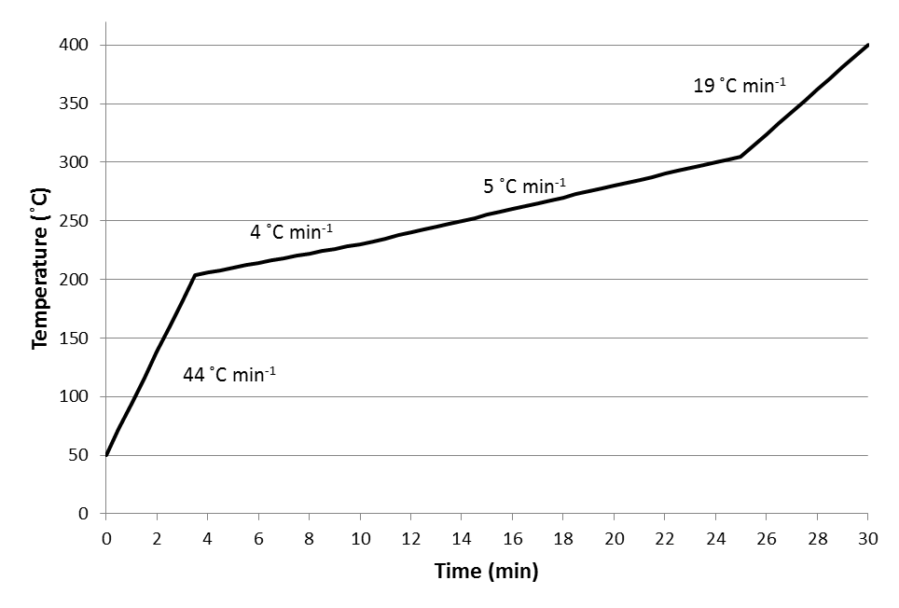

Fig. 1b

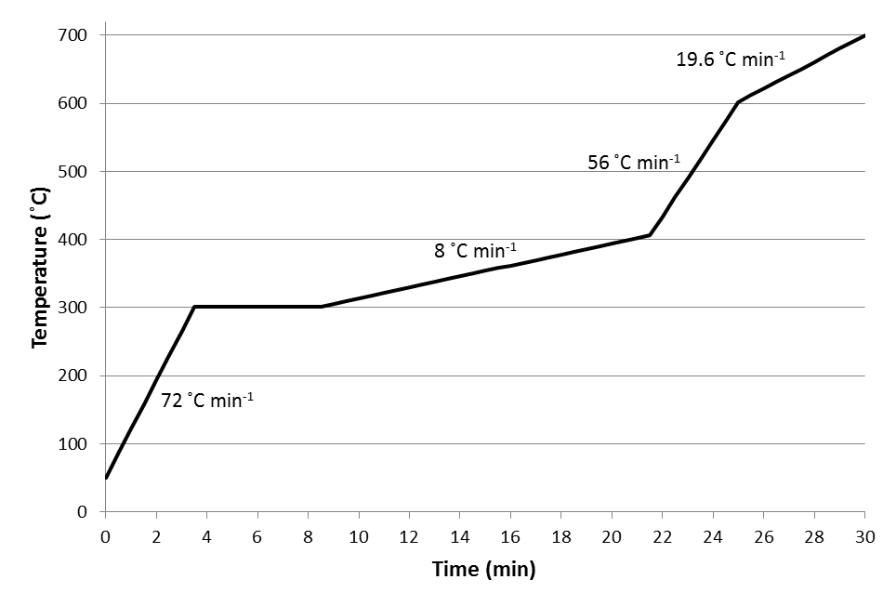

Fig. 1c

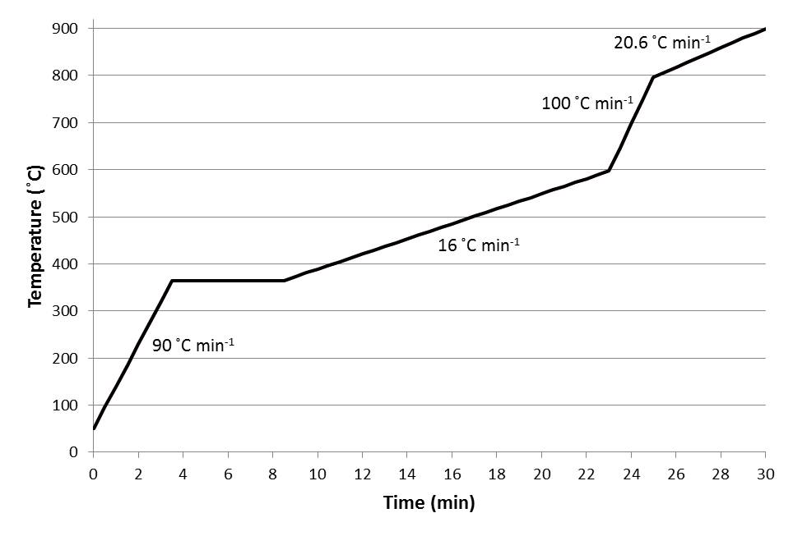

Fig. 2
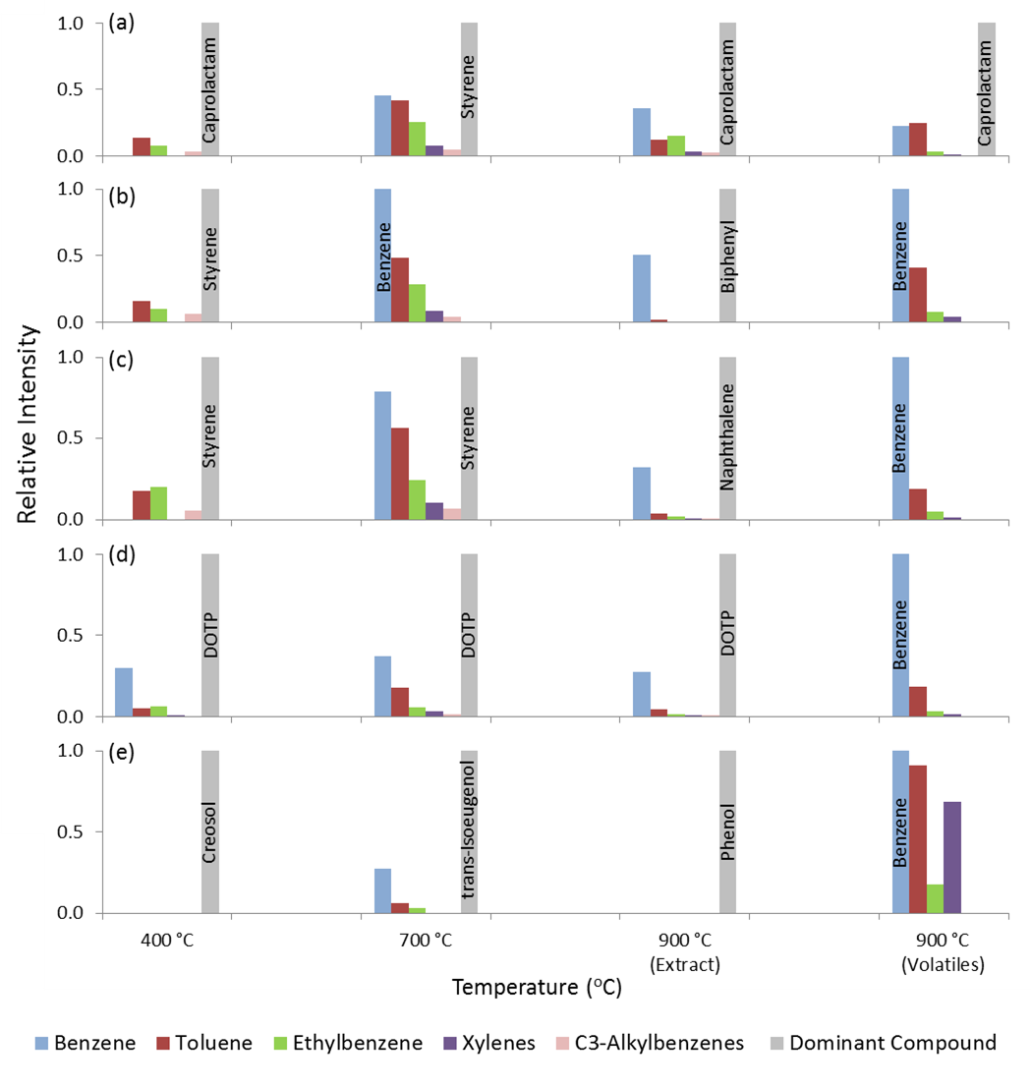

Table Captions

Table 1 List of positively identified compounds.
Table 2 List of tentatively identified compounds.
Table 3 Pyrolysis products of interest formed by each material by different temperature experiments. ISO and TP represent isothermal and temperature-programmed pyrolysis, respectively. The number after ISO and TP represents the target temperature and the second part of number for temperature-programmed pyrolysis indicates the hold time. “X” indicates the presence of compound of interest. New compounds that have not been previously reported in the pyrolysis are marked by asterisk (“*”).

Table 1

Peak Label | Compounds | Experimental Retention Indices | MS Matching Factor
A | Benzene | 675 | 965
B | Heptane | 700 | 807
C | Toluene | 769 | 967
D | Octane | 800 | 877
E | Furfural | 837 | 861
F | Ethylbenzene | 865 | 961
G | m-Xylene | 874 | 953
H | p-Xylene | 875 | 929
I | o-Xylene | 893 | 958
J | Nonane | 900 | 885
K | Benzonitrile | 988 | 912
L | Decane | 1000 | 909
M | p-Toluidine | 1079 | 914
N | Guaiacol (2-Methoxyphenol) | 1089 | 948
O | Undecane | 1100 | 875
P | Naphthalene | 1197 | 975
Q | Dodecane | 1200 | 873
R | Thianaphthene | 1208 | 888
S | 2,4,6-Trimethylphenol | 1209 | 865
T | p-Methylbenzoic acid | 1282 | 914
U | Tridecane | 1300 | 823
V | 1-Methylnaphthalene | 1328 | 931
W | Biphenyl | 1395 | 974
X | Tetradecane | 1400 | 865
Y | 2,6-Dimethylnaphthalene | 1426 | 841
Z | 2,3-Dimethylnaphthalene | 1464 | 792
AA | 1,5-Dimethylnaphthalene | 1469 | 778
BB | Acenaphthylene | 1473 | 932
CC | Pentadecane | 1500 | 789
DD | Acenaphthene | 1507 | 941
EE | 4-Methylbiphenyl | 1516 | 903
FF | Fluorene | 1610 | 881
GG | 9H-fluoren-9-one | 1778 | 872
HH | Phenanthrene | 1818 | 955
II | Anthracene | 1829 | 902
JJ | 1-Phenylnaphthalene | 1885 | 843
KK | 2-Methylphenanthrene | 1945 | 766
LL | 1-Methyphenanthrene | 1972 | 798
MM | 2-Phenylnaphthalene | 2007 | 936
NN | Fluoranthene | 2118 | 936
OO | Pyrene | 2168 | 919
PP | Triphenyl phosphate | 2438 | 811
QQ | Triphenylene | 2505 | 764

Table 2
Peak Label | Compounds | Experimental Retention Indices | Library Retention Indices | Differences in Retention Indices | MS  Match Factor
1 | 2,5-Dimethylfuran | 704 | 696 | 8 | 860
2 | C₈-Alkene | 710 |  |  | > 806
3 | 1-Methylpyrrole | 735 | 722 | 13 | 880
4 | Pyrrole | 751 | 733 | 18 | 820
5 | 2-Methylheptane | 768 | 767 | 1 | 841
6 | Pentanenitrile | 782 | 764 | 18 | 753
7 | 2-Ethyl-4-methyl-1,3-dioxolane | 786 | 773 | 13 | 924
8 | Cyclopentanone | 795 | 766 | 29 | 863
9 | 1-Octene | 798 | 785 | 13 | 844
10 | 1-Isopropoxy-2-propanol | 803 | 814 | 11 | 893
11 | Methyl-2-cyclopenten-1-one | 838 |  |  | >898
12 | C₉-Alkene | 843 |  |  | > 776
13 | Trimethylcyclohexane | 845 |  |  | > 750
14 | C₉-Alkene | 849 |  |  | > 791
15 | Furanmethanol | 859 | 826 | 33 | 915
16 | 1-(Acetyloxy)-2-propanone | 871 | 839 | 32 | 820
17 | Hexanenitrile | 882 | 851 | 31 | 899
18 | Styrene | 893 | 914 | 21 | 900
19 | Methyl-2-cyclopenten-1-one | 900 |  |  | > 791
20 | Dimethylpyrazine | 914 |  |  | > 750
21 | 2-Hydroxy-2-cyclopenten-1-one | 921 | 919 | 2 | 862
22 | Propenylbenzene | 950 | 950 | 0 | 911
23 | Propylbenzene | 958 | 944 | 14 | 915
24 | 5-Methyl-2-furancarboxaldehyde | 963 | 924 | 39 | 852
25 | Benzaldehyde | 965 | 928 | 37 | 945
26 | C₃-Alkylbenzene | 966 |  |  | > 780
27 | C₃-Alkylbenzene | 973 |  |  | > 750
28 | Aniline | 981 | 946 | 35 | 957
29 | α-Methylstyrene | 983 | 980 | 3 | 880
30 | C₃-Alkylbenzene | 987 |  |  | > 767
31 | Phenol | 989 | 960 | 29 | 944
32 | 1-Decene | 992 | 987 | 5 | 901
33 | C₃-Alkylbenzene | 998 |  |  | > 810
34 | 3-Methyl-1,2-cyclopentanedione | 1025 | 1043 | 18 | 918
35 | C₃-Alkylbenzene | 1029 |  |  | > 832
36 | Indane | 1045 | 1030 | 15 | 880
37 | 3-Butenylbenzene | 1049 | 1039 | 10
38 | Indene | 1050 | 1037 | 13 | 936
39 | Methylphenol | 1054 |  |  | > 861
40 | Chloro-C₂-alkylbenzene | 1070 |  |  | > 800
41 | Acetophenone | 1073 | 1052 | 21 | 966
42 | Methylphenol | 1075 |  |  | > 877
43 | 1-Undecene | 1092 | 1088 | 4 | 821
44 | n-Pentyl isothiocyanate | 1102 | 1112 | 10 | 909
45 | Dimethylphenol | 1110 | 1112 |  | > 823
46 | Dimethylphenol | 1113 |  |  | > 767
47 | 3-Ethyl-2-hydroxy-2-cyclopenten-1-one | 1117 | 1100 | 17 | 882
48 | Vinyl benzoate | 1143 | 1150 | 7 | 938
49 | C₂-Alkylphenol | 1149 |  |  | > 812
50 | C₂-Alkylphenol | 1151 |  |  | > 827
51 | 3-Methylindene | 1163 | 1155 | 8 | 818
52 | Benzoic acid | 1177 | 1170 | 7 | 903
53 | Creosol | 1193 | 1165 | 28 | 961
54 | 1-Dodecene | 1192 | 1187 | 5 | 856
55 | Phenyl isothiocyante | 1203 | 1163 | 40 | 870
56 | C₃-Alkylphenol | 1238 |  |  | >750
57 | 4-Ethylguaiacol | 1278 | 1250 | 28 | 920
58 | Cyclohexyl isothiocyanate | 1248 | 1260 | 12 | 811
59 | Caprolactam | 1291 | 1260 | 31 | 931
60 | 2-Methylnapthalene | 1312 | 1298 | 14 | 919
61 | 4-Vinylguaiacol | 1315 | 1293 | 22 | 908
62 | Tolyl isothiocyanate | 1340 |  |  | > 798
63 | Benzenebutanenitrile | 1348 | 1337 | 11 | 915
64 | Eugenol | 1358 | 1337 | 21 | 922
65 | 4-Propylguaiacol | 1369 | 1345 | 24 | 903
66 | C₂-Alkylbenzoic acid | 1376 |  |  | > 765
67 | 1-Tetradecene | 1392 | 1385 | 7 | 787
68 | Toluenediamine | 1398 |  |  | > 841
69 | Toluenediamine | 1401 |  |  | > 785
70 | Vanillin | 1403 | 1403 | 0 | 901
71 | cis-Isoeugenol | 1409 | 1410 | 1 | 909
72 | 2-Chloroethyl benzoate | 1413 | 1373 | 40 | 958
73 | C₂-Alkylnaphthalene | 1443 |  |  | > 750
74 | Methylbiphenyl OR Diphenylmethane | 1452 |  |  | > 840
75 | trans-Isoeugenol | 1455 | 1429 | 26 | 948
76 | p-Diacetylbenzene | 1467 | 1470 | 3 | 845
77 | Apocynin | 1490 | 1503 | 13 | 849
78 | 1-Pentadecene | 1492 | 1486 | 6 | 743
79 | Methylbiphenyl | 1507 |  |  | > 814
80 | 1-Isopropenylnaphthalene | 1516 | 1500 | 16 | 825
81 | Guaiacylacetone | 1532 | 1538 | 6 | 861
82 | 2,2,4-Trimethyl-1,3-pentanediol diisobutyrate | 1592 | 1591 | 1 | 835
83 | 1,3-Diphenylpropane | 1677 | 1665 | 12 | 901
84 | C₇-Alkylbenzoate | 1717 |  |  | > 775
85 | 2-Propenal, 3-(4-hydroxy-3-methoxyphenyl)-  OR Coniferaldehyde | 1743 | 1741 | 2 | 844
86 | Diaminodiphenylmethane | 2102 |  |  | > 891
87 | 1,3-Propanediol dibenzoate | 2173 | 2199 | 26 | 840
88 | Terphenyl | 2237 |  |  | > 825
89 | dioctyl terephthalate | 2752 | 2730 | 22 | 973

Table 3
Asphalt Shingle
Compounds of  Interest | ISO 400  TP 400 | ISO 700 | TP 700-10 | TP 700-30  TP 700-60 | ISO 900 | TP 900-10 | TP 900-30  TP 900-60
Benzene |  | X | X | X | X | X | X
Toluene |  | X | X | X | X | X | X
Ethylbenzene |  | X | X | X | X | X | X
Xylenes |  | X | X | X | X | X | X
C₃-Alkylbenzene |  | X | X | X
Alkanes (C₇-C₁₁) | X
Alkanes (C₁₁-C₃₀) | X | X | X | X
Alkenes | X | X
*Acenaphthylene |  |  |  |  | X | X | X
*Acenaphthene |  |  |  |  | X | X | X
*Fluorene |  |  |  |  | X | X | X
PET Carpet
Compounds of  Interest | ISO 400  TP 400 | ISO 700 | TP 700-10 | TP 700-30  TP 700-60 | ISO 900 | TP 900-10 | TP 900-30  TP 900-60
Benzene |  | X | X | X | X | X | X
Toluene | X | X | X | X | X | X | X
Ethylbenzene | X | X | X | X | X | X | X
Xylenes |  | X | X | X | X | X | X
C₃-Alkylbenzenes | X | X | X | X
Alkanes (C₇-C₁₁) | C7
Alkanes (C₁₁-C₃₀)
Alkenes | C9
Nylon 6 Carpet
Compounds of  Interest | ISO 400  TP 400 | ISO 700 | TP 700-10 | TP 700-30  TP 700-60 | ISO 900 | TP 900-10 | TP 900-30  TP 900-60
Benzene |  | X | X | X | X | X | X
Toluene | X | X | X | X | X | X | X
Ethylbenzene | X | X | X | X | X | X | X
Xylenes |  | X | X | X | X | X | X
C₃-Alkylbenzenes | X | X | X | X | 30 min | X
Alkanes (C₇-C₁₁)
Alkanes (C₁₁-C₃₀)
Alkenes | C9 | C9 | C9 | C9 | C9 | C9 | C9
*Pentanenitrile | X | X | X | X | X | X | X
*Hexanenitrile | X | X | X | X | X | X | X
*n-Pentyl isothiocyanate | X | X | X | X
*Cyclohexyl isothiocyanate |  | X | X | X
*Benzonitrile |  |  |  |  | X | X | X
PU Carpet Underlay
Compounds of  Interest | ISO 400  TP 400 | ISO 700 | TP 700-10 | TP 700-30  TP 700-60 | ISO 900 | TP 900-10 | TP 900-30  TP 900-60
Benzene |  | X | X | X | X | X | X
Toluene | X | X | X | X | X | X | X
Ethylbenzene | X | X | X | X | X | X | X
Xylenes |  | X | X | X | X | X | X
C₃-Alkylbenzenes | X | X | X | X
Alkanes (C₇-C₁₁)
Alkanes (C₁₁-C₃₀)
Alkenes
*Phenyl isothiocyanate | X | X | X | X | X | X | X
*Benzenebutanenitrile | X | X | X | X | X | X | X
*Toluediamine | X | X | X | X
*1,3-Diphenylpropane | X |  |  |  |  | X | X
*Diaminodiphenylmethane | X
*Toly isothiocyanate | X | X | X | X | X | X | X
*Triphenyl phosphate | X | X | X | X | X | X | X
*Thianaphthene |  |  |  |  |  |  | X
PVC Sheet Flooring
Compounds of  Interest | ISO 400  TP 400 | ISO 700 | TP 700-10 | TP 700-30  TP 700-60 | ISO 900 | TP 900-10 | TP 900-30  TP 900-60
Benzene | X | X | X | X | X | X | X
Toluene | X | X | X | X | X | X | X
Ethylbenzene | X | X | X | X | X | X | X
Xylenes | X | X | X | X | X | X | X
C₃-Alkylbenzenes |  | X | X | X | X | X | X
Alkanes (C₇-C₁₁)
Alkanes (C₁₁-C₃₀)
Alkenes
*Chloro-C₂-alkylbenzene |  | X | X | X | X
*2-Chloroethyl benzoate | X | X | X | X | X | X | X
Spruce Lumber
Compounds of  Interest | ISO 400  TP 400 | ISO 700 | TP 700-10 | TP 700-30  TP 700-60 | ISO 900 | TP 900-10 | TP 900-30  TP 900-60
Benzene |  | X | X | X | X | X | X
Toluene |  | X | X | X | X | X | X
Ethylbenzene |  | X | X | X | X | X | X
Xylenes
Alkanes (C₇-C₁₁)
Alkanes (C₁₁-C₃₀)
Alkenes
Spruce Plywood
Compounds of  Interest | ISO 400  TP 400 | ISO 700 | TP 700-10 | TP 700-30  TP 700-60 | ISO 900 | TP 900-10 | TP 900-30  TP 900-60
Benzene |  | X | X | X | X | X | X
Toluene |  | X | X | X | X | X | X
Ethylbenzene |  |  |  |  | X | X | X
Xylenes
Alkanes (C₇-C₁₁)
Alkanes (C₁₁-C₃₀)
Alkenes
MDF Shelving
Compounds of  Interest | ISO 400  TP 400 | ISO 700 | TP 700-10 | TP 700-30  TP 700-60 | ISO 900 | TP 900-10 | TP 900-30  TP 900-60
Benzene |  | X | X | X | X | X | X
Toluene | X | X | X | X
Ethylbenzene | X | X | X | X
Xylenes | X | X | X | X
Alkanes (C₇-C₁₁)
Alkanes (C₁₁-C₃₀)
Alkenes

Electronic Supplementary Materials

The influence of temperature on the pyrolysis of household materials

Xiao Qin Lee ª, P. Mark L. Sandercock ^{b}, James J. Harynuk ^{a ,*}

Published in
Journal of Analytical and Applied Pyrolysis

ª Department of Chemistry, University of Alberta, Edmonton, AB T6G 2G2, Canada
* Corresponding author. Tel.: +1 780 492 8303; fax: +1 780 492 8231.
e-mail address: james.harynuk@ualberta.ca

^{b} Trace Evidence Services, National Forensic Laboratory Services - Edmonton, Royal Canadian Mounted Police, Edmonton, AB, T5V 1B7, Canada

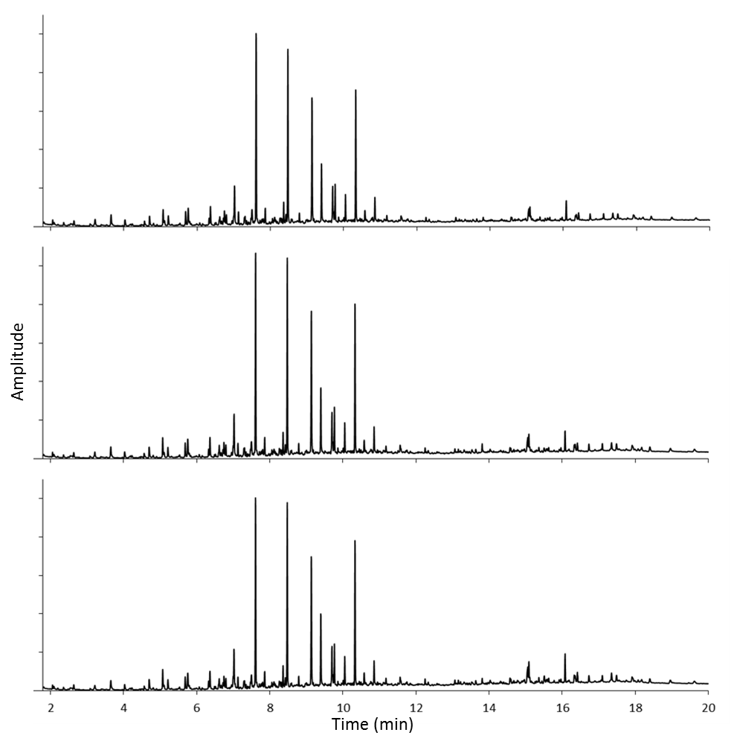
Fig. S1: Plot of total ion chromatographic data from three replicate samples of MDF shelving each pyrolyzed at 400 °C for 30 min as an example of reproducibility of pyrolysis.

(a)
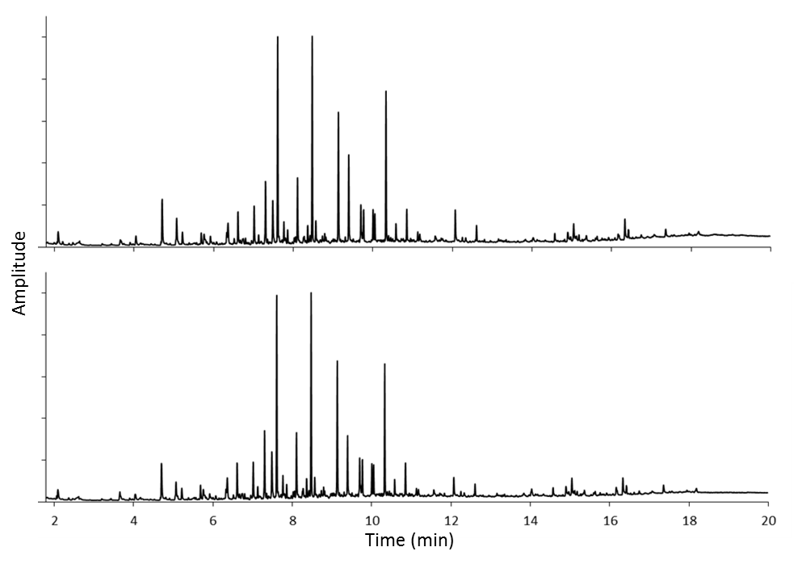

(b)
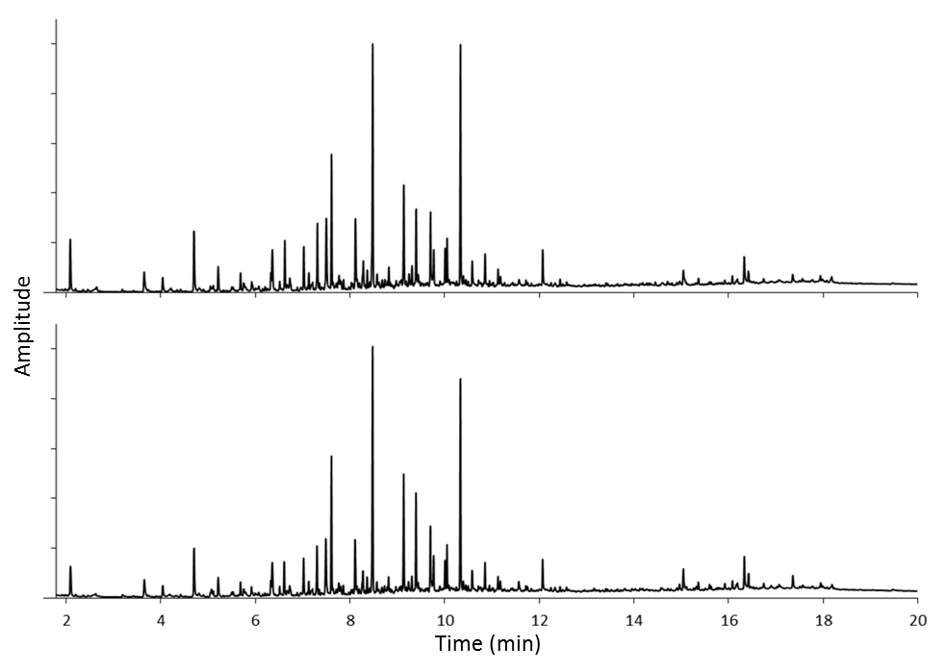

(c)
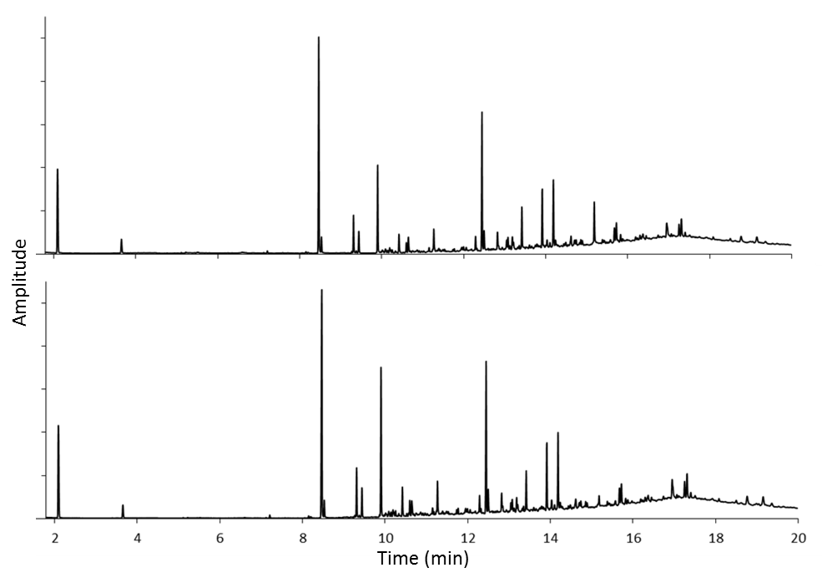
Fig. S2: Total ion chromatographic data of (A) spruce plywood pyrolyzed at 400 °C for 30 (top) and 60 min (bottom), (B) spruce lumber pyrolyzed at 700 °C for 30 (top) and 60 min (bottom) and (C) asphalt shingle pyrolyzed at 900 °C for 30 (top) and 60 min (bottom)

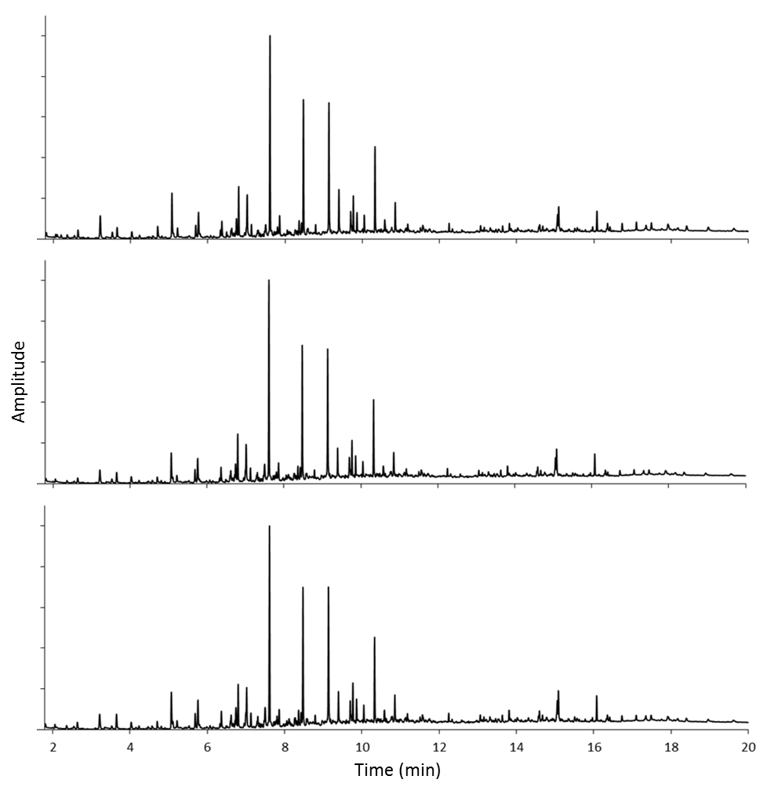
Fig. S3: Total ion chromatographic data of MDF shelving pyrolyzed with temperature program from 50 °C to 400 °C with a hold time 10 (top), 30 (middle) and 60 min (bottom)

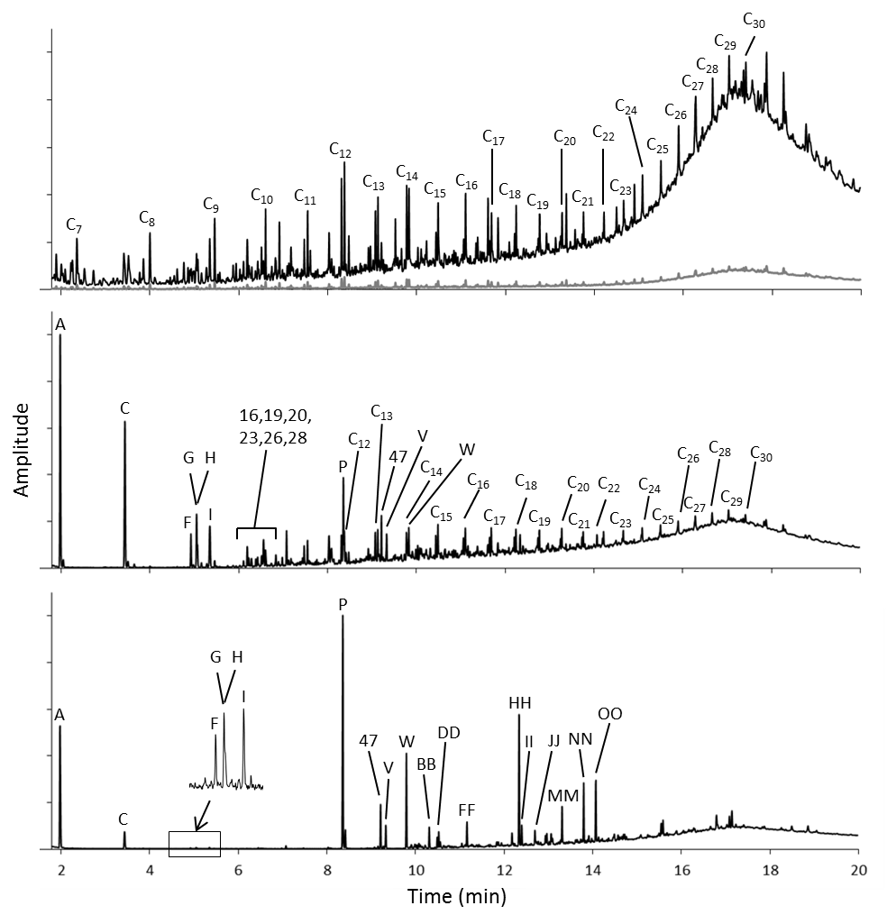
Fig. S4: Comparison of chromatographic profiles obtained from isothermally pyrolyzed asphalt shingle at 400 °C (top), 700 °C (middle) and 900 °C (bottom). Peak assignments may be found in Tables 1 and 2 in the main article. Letters indicate positively identified compounds (Table 1), and numbers indicate tentatively identified compounds (Table 2).

(a)
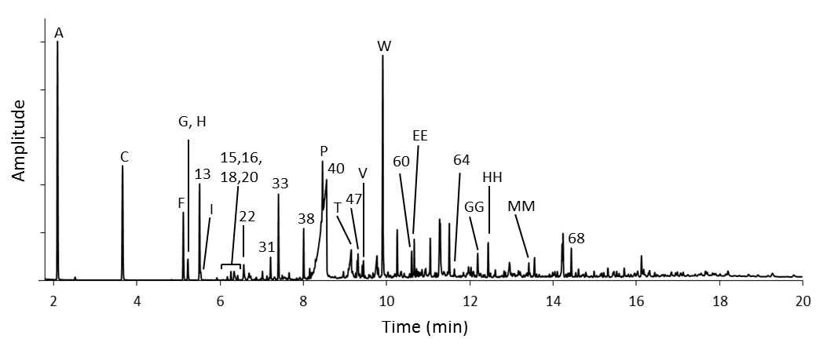

(b)
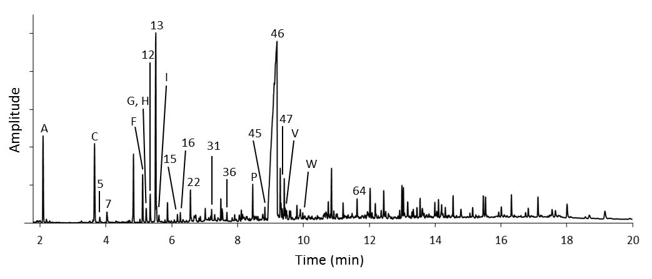
Fig. S5: Total ion chromatographic data of (a) PET and (b) Nylon 6 carpet pyrolyzed at 700 °C for 30 min. Note that peak heights are normalized to 100% for the tallest peak in each chromatogram. Peak assignments may be found in Tables 1 and 2 of the main article. Letters indicate positively identified compounds (Table 1), and numbers indicate tentatively identified compounds (Table 2).

\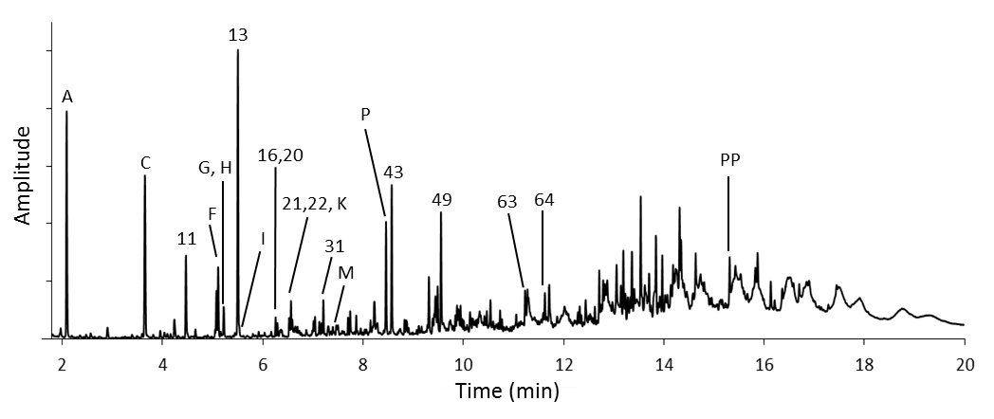
Fig. S6: Total ion chromatographic data of carpet underlay pyrolyzed at 700 °C for 30 min. Note that peak heights are normalized to 100% for the tallest peak in each chromatogram. Peak assignments may be found in Tables 1 and 2 of the main article. Letters indicate positively identified compounds (Table 1), and numbers indicate tentatively identified compounds (Table 2)

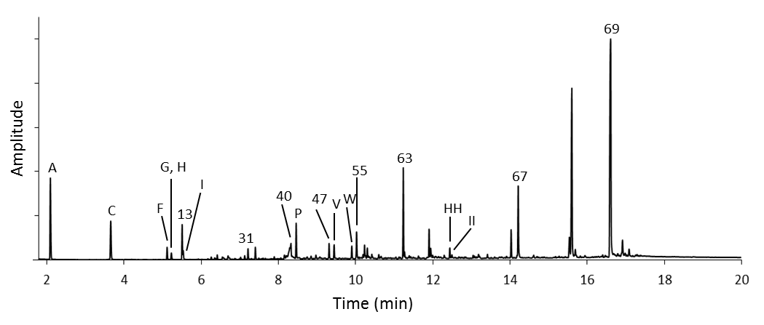
68
Fig. S7: Total ion chromatographic data of vinyl sheet flooring pyrolyzed at 700 °C for 30 min. Note that peak heights are normalized to 100% for the tallest peak in each chromatogram. Peak assignments may be found in Tables 1 and 2 of the main article. Letters indicate positively identified compounds (Table 1), and numbers indicate tentatively identified (Table 2)

Table S1. List of positively and tentatively identified compounds for each material (see text of main article for compound codes)

Material | Target  Temperature | Temperature  Profiles | Positively and tentatively identified compounds
Asphalt  Shingle | 400 | ISO 400-30 | B, 4, 8, D, J, 25, L, 35, O, 42, Q, U, 52, X, 59, CC
 |  | ISO 400-60 | B, 4, 8, D, J, 25, L, 35, O, 42, Q, U, 52, X, 59, CC
 |  | TP 400-10 | B, 4, 8, D, J, 25, L, 35, O, 42, Q, U, 52, X, 59, CC
 |  | TP 400-30 | B, 4, 8, D, J, 25, L, 35, O, 42, Q, U, 52, X, 59, CC
 |  | TP 400-60 | B, 4, 8, D, J, 25, L, 35, O, 42, Q, U, 52, X, 59, CC
 | 700 | ISO 700-30 | A, C, F-I, 16, 19, 20, 23, 26, 28, P, 42, Q, U, 47, V, W, 52, X, 59, CC, 60
 |  | ISO 700-60 | A, C, F-I, 16, 19, 20, 23, 26, 28, P, 42, Q, U, 47, V, W, 52, X, 59, CC, 60
 |  | TP 700-10 | A, C, F-I, 16, 19, 20, 23, 26, 28, P, 42, Q, U, 47, V, 52, X, 59, CC, 60
 |  | TP 700-30 | A, C, F-I, 16, 19, 20, 23, 26, 28, P, 42, Q, U, 47, V, 52, X, 59, CC, 60
 |  | TP 700-60 | A, C, F-I, 16, 19, 20, 23, 26, 28, P, 42, Q, U, 47, V, 52, X, 59, CC, 60
 | 900 | ISO 900-30 | A, C, F-I, P, 47, V, W, BB, DD, FF, HH, II, JJ, MM, NN, OO
 |  | ISO 900-60 | A, C, F-I, P, 47, V, W, BB, DD, FF, HH, II, JJ, MM, NN, OO
 |  | TP 900-10 | A, C, F-I, P, 47, V, W, BB, DD, FF, HH, II, JJ
 |  | TP 900-30 | A, C, F-I, P, 47, V, W, BB, DD, FF, HH, II, JJ, MM, NN, OO
 |  | TP 900-60 | A, C, F-I, P, 47, V, W, BB, DD, FF, HH, II, JJ, MM, NN, OO
PET Carpet | 400 | ISO 400-30 | B, C, F, 13, 15, 16, 18, 22, 30, 33, 38, 40, T, W, 64
 |  | ISO 400-60 | B, C, F, 13, 15, 16, 18, 22, 30, 33, 38, 40, T, W, 64
 |  | TP 400-10 | B, C, F, 13, 15, 16, 18, 22, 30, 33, 38, 40, T, W, 64
 |  | TP 400-30 | B, C, F, 13, 15, 16, 18, 22, 30, 33, 38, 40, T, W, 64
 |  | TP 400-60 | B, C, F, 13, 15, 16, 18, 22, 30, 33, 38, 40, T, W, 64
 | 700 | ISO 700-30 | A, C, F-H, 13, I, 15, 16, 18, 20, 22, 31, 33, 38, 40, P, T, 47, V, W, 60, EE, 64, GG, HH, MM
 |  | ISO 700-60 | A, C, F-H, 13, I, 15, 16, 18, 20, 22, 31, 33, 38, 40, P, T, 47, V, W, 60, EE, 64, GG, HH, MM
 |  | TP 700-10 | A, C, F-H, 13, I, 15, 16, 18, 20, 22, 31, 33, 38, 40, P, T, 47, V, W, 60, EE, 64, GG, HH, MM
 |  | TP 700-30 | A, C, F-H, 13, I, 15, 16, 18, 20, 22, 31, 33, 38, 40, P, T, 47, V, W, 60, EE, 64, GG, HH, MM
 |  | TP 700-60 | A, C, F-H, 13, I, 15, 16, 18, 20, 22, 31, 33, 38, 40, P, T, 47, V, W, 60, EE, 64, GG, HH, MM
 | 900 | ISO 900-30 | A, C, F-H, 13, I, 21, 31, 33, 38, 40, P, T, 47, V, W, 57, BB, 60, EE, FF, 64, GG, HH, JJ, MM, NN
 |  | ISO 900-60 | A, C, F-H, 13, I, 21, 31, 33, 38, 40, P, T, 47, V, W, 57, BB, 60, EE, FF, 64, GG, HH, JJ, MM, NN
 |  | TP 900-10 | A, C, F-H, 13, I, 21, 31, 33, 38, 40, P, T, 47, V, W, 60, EE, FF, 64, GG, HH, JJ, MM, NN
 |  | TP 900-30 | A, C, F-H, 13, I, 21, 31, 33, 38, 40, P, T, 47, V, W, 60, EE, FF, 64, GG, HH, JJ, MM, NN
 |  | TP 900-60 | A, C, F-H, 13, I, 21, 31, 33, 38, 40, P, T, 47, V, W, 60, EE, FF, 64, GG, HH, JJ, MM, NN
Nylon 6  Carpet | 400 | ISO 400-30 | C, 5, 7, F, 12, 13, 15, 16, 22, 36, 45, 46, 64
 |  | ISO 400-60 | C, 5, 7, F, 12, 13, 15, 16, 22, 36, 45, 46, 64
 |  | TP 400-10 | C, 5, 7, F, 12, 13, 15, 16, 22, 36, 45, 46, 64
 |  | TP 400-30 | C, 5, 7, F, 12, 13, 15, 16, 22, 36, 45, 46, 64
 |  | TP 400-60 | C, 5, 7, F, 12, 13, 15, 16, 22, 36, 45, 46, 64
 | 700 | ISO 700-30 | A, C, 5, 7, F-H, 12, 13, I, 15, 16, 22, 31, 36, P, 45, 46, 47, V, W, 64
 |  | ISO 700-60 | A, C, 5, 7, F-H, 12, 13, I, 15, 16, 22, 31, 36, P, 45, 46, 47, V, W, 64
 |  | TP 700-10 | A, C, 5, 7, F-H, 12, 13, I, 15, 16, 22, 31, 36, P, 45, 46, 47, V, W, 64
 |  | TP 700-30 | A, C, 5, 7, F-H, 12, 13, I, 15, 16, 22, 31, 36, P, 45, 46, 47, V, W, 64
 |  | TP 700-60 | A, C, 5, 7, F-H, 12, 13, I, 15, 16, 22, 31, 36, P, 45, 46, 47, V, W, 64
 | 900 | ISO 900-30 | A, C, 5, 7, F-H, 12, 13, I, 15, 16, 22, K, 31, P, 45, 46, 47, V, W, BB, 60, FF, HH, II
 |  | ISO 900-60 | A, C, 5, 7, F-H, 12, 13, I, 15, 22, K, 28, P, 46, 47, V, W, BB, 60, FF, HH, II
 |  | TP 900-10 | A, C, 5, 7, F-H, 12, 13, I, 15, 16, 22, K, 31, P, 45, 46, 47, V, W, BB, FF, HH, II
 |  | TP 900-30 | A, C, 5, 7, F-H, 12, 13, I, 15, 22, K, 31, P, 46, 47, V, W, BB, FF, HH, II
 |  | TP 900-60 | A, C, 5, 7, F-H, 12, 13, I, 15, 22, K, 31, P, 46, 47, V, W, BB, FF, HH, II
PVC Sheet  Flooring | 400 | ISO 400-30 | A, C, F-H, 13, I, 16, 40, P, 63, 67, 68
 |  | ISO 400-60 | A, C, F-H, 13, I, 16, 40, P, 63, 67, 68
 |  | TP 400-10 | A, C, F-H, 13, I, 16, 40, P, 63, 67, 68
 |  | TP 400-30 | A, C, F-H, 13, I, 16, 40, P, 63, 67, 68
 |  | TP 400-60 | A, C, F-H, 13, I, 16, 40, P, 63, 67, 68
 | 700 | ISO 700-30 | A, C, F-H, 13, I, 16, 19, 20, 23, 29, 31, 39, 40, P, 47, V, W, Y, Z, AA, BB, EE, 61, FF, 63, HH, II, JJ, KK, LL, MM, NN, 67, 68
 |  | ISO 700-60 | A, C, F-H, 13, I, 16, 19, 20, 23, 29, 31, 39, 40, P, 47, V, W, Y, Z, AA, BB, EE, 61, FF, 63, HH, II, JJ, KK, LL, MM, NN, 67, 68
 |  | TP 700-10 | A, C, F-H, 13, I, 16, 19, 20, 23, 29, 31, 40, P, 47, V, W, Y, Z, AA, BB, EE, 61, FF, 63, KK, LL, MM, 67, 68
 |  | TP 700-30 | A, C, F-H, 13, I, 16, 19, 20, 23, 29, 31, 39, 40, P, 47, V, W, Y, Z, AA, BB, EE, 61, FF, 63, HH, II, KK, LL, MM, 67, 68
 |  | TP 700-60 | A, C, F-H, 13, I, 16, 19, 20, 23, 29, 31, 39, 40, P, 47, V, W, Y, Z, AA, BB, EE, 61, FF, 63, HH, II, KK, LL, MM, 67, 68
 | 900 | ISO 900-30 | A, C, F-H, 13, I, 16, 19, 20, 23, 29, 31, 39, 40, P, 47, V, W, Y, Z, AA, BB, EE, 61, FF, 63, HH, II, JJ, KK, LL, MM, NN, OO, 67, QQ, 68
 |  | ISO 900-60 | A, C, F-H, 13, I, 16, 19, 20, 23, 29, 31, 39, 40, P, 47, V, W, Y, Z, AA, BB, EE, 61, FF, 63, HH, II, JJ, KK, LL, MM, NN, OO, 67, QQ, 68
 |  | TP 900-10 | A, C, F-H, 13, I, 16, 19, 20, 23, 29, 31, 40, P, 47, V, Y, Z, AA, BB, EE, 61, FF, 63, 64, KK, LL, MM, OO, 67, QQ, 68
 |  | TP 900-30 | A, C, F-H, 13, I, 16, 19, 20, 23, 29, 31, 39, 40 P, 47, V, W, Y, Z, AA, BB, EE, 61, FF, 63, 64, HH, II, KK, LL, MM, OO, 67, QQ, 68
 |  | TP 900-60 | A, C, F-H, 13, I, 16, 19, 20, 23, 29, 31, 39, 40 P, 47, V, W, Y, Z, AA, BB, EE, 61, FF, 63, 64, HH, II, KK, LL, MM, OO, 67, QQ, 68

Material | Target  Temperature | Temperature  Profiles | Positively and tentatively identified compounds
PU Carpet Underlay | 400 | ISO 400-30 | C, 7, F, 13, 16, 20-22, 31, M, 43, 49, 63, 64, 65, PP
 |  | ISO 400-60 | C, 7, F, 13, 16, 20-22, 31, M, 43, 49, 63, 64, 65, PP
 |  | TP 400-10 | C, 7, F, 13, 16, 20-22, 31, M, 43, 49, 63, 64, 65, PP
 |  | TP 400-30 | C, 7, F, 13, 16, 20-22, 31, M, 43, 49, 63, 64, 65, PP
 |  | TP 400-60 | C, 7, F, 13, 16, 20-22, 31, M, 43, 49, 63, 64, 65, PP
 | 700 | ISO 700-30 | A, C, F-H, 13, I, 16, 20-22, K, 31, M, P, 43, 49, 63, 64, PP
 |  | ISO 700-60 | A, C, F-H, 13, I, 16, 20-22, K, 31, M, P, 43, 49, 63, 64, PP
 |  | TP 700-10 | A, C, F-H, 13, I, 16, 20-22, K, 31, M, P, 43, 49, 63, 64, PP
 |  | TP 700-30 | A, C, F-H, 13, I, 16, 20-22, K, 31, M, P, 43, 49, 63, 64, PP
 |  | TP 700-60 | A, C, F-H, 13, I, 16, 20-22, K, 31, M, P, 43, 49, 63, 64, PP
 | 900 | ISO 900-30 | A, C, F-H, 13, I, 21, 22, K, 31, M, P, 43, 49, W, BB, HH, 63, 64, NN, OO, PP
 |  | ISO 900-60 | A, C, F-H, 13, I, 21, 22, K, 31, M, P, 43, 49, W, BB, HH, 63, 64, NN, OO, PP
 |  | TP 900-10 | A, C, F-H, 13, I, 21, 22, 31, M, P, 43, 49, HH, 63, 64, OO, PP
 |  | TP 900-30 | A, C, F-H, 13, I, 21, 22, K, 31, M, R, P, 43, 49, HH, 63, 64, NN, OO, PP
 |  | TP 900-60 | A, C, F-H, 13, I, 21, 22, K, 31, M, R, P, 43, 49, BB, HH, 63, 64, NN, OO, PP
Spruce Lumber | 400 | ISO 400-30 | E, 10, 17, 27, N, 41, 50, 51, 54, 56, 58, 62, 65
 |  | ISO 400-60 | E, 10, 17, 27, N, 41, 50, 51, 54, 56, 58, 62, 65
 |  | TP 400-10 | E, 10, 17, 27, N, 41, 50, 51, 54, 56, 58, 62, 65
 |  | TP 400-30 | E, 10, 17, 27, N, 41, 50, 51, 54, 56, 58, 62, 65
 |  | TP 400-60 | E, 10, 17, 27, N, 41, 50, 51, 54, 56, 58, 62, 65
 | 700 | ISO 700-30 | A, C, E, F, 10, 17, 24, 27, 32, 34, N, 41, P, 44, 48, 50, 51, 53, 54, 56, 58, 62, 65
 |  | ISO 700-60 | A, C, E, F, 10, 17, 24, 27, 32, 34, N, 41, P, 44, 48, 50, 51, 53, 54, 56, 58, 62, 65
 |  | TP 700-10 | A, C, E, F, 10, 17, 24, 27, 32, 34, N, 41, P, 44, 48, 50, 51, 53, 54, 56, 58, 62, 65
 |  | TP 700-30 | A, C, E, F, 10, 17, 24, 27, 32, 34, N, 41, P, 44, 48, 50, 51, 53, 54, 56, 58, 62, 65
 |  | TP 700-60 | A, C, E, F, 10, 17, 24, 27, 32, 34, N, 41, P, 44, 48, 50, 51, 53, 54, 56, 58, 62, 65
 | 900 | ISO 900-30 | A, C, E, F, 17, 24, 27, 32, 34, N, 41, P, 44, 47, 48, V, 50, 51, W, 53, 54, 56, BB, 58, 62, FF, 65, HH, II, NN, OO
 |  | ISO 900-60 | A, C, E, F, 17, 24, 27, 32, 34, N, 41, P, 44, 47, 48, V, 50, 51, W, 53, 54, 56, BB, 58, 62, FF, 65, HH, II, NN, OO
 |  | TP 900-10 | A, C, E, F, 17, 24, 27, 32, 34, N, 41, P, 44, 47, 48, V, 50, 51, W, 53, 54, 56, BB, 58, 62, FF, 65, HH, II, NN, OO
 |  | TP 900-30 | A, C, E, F, 17, 24, 27, 32, 34, N, 41, P, 44, 47, 48, V, 50, 51, W, 53, 54, 56, BB, 58, 62, FF, 65, HH, II, NN, OO
 |  | TP 900-60 | A, C, E, F, 17, 24, 27, 32, 34, N, 41, P, 44, 47, 48, V, 50, 51, W, 53, 54, 56, BB, 58, 62, FF, 65, HH, II, NN, OO

Material | Target  Temperature | Temperature  Profiles | Positively and tentatively identified compounds
Spruce Plywood | 400 | ISO 400-30 | E, 10, 17, 24, 27, 32, 34, N, 37, 41, S, 44, 48, 50, 51, 53, 54, 56, 58, 62, 65
 |  | ISO 400-60 | E, 10, 17, 24, 27, 32, 34, N, 37, 41, S, 44, 48, 50, 51, 53, 54, 56, 58, 62, 65
 |  | TP 400-10 | E, 10, 17, 24, 27, 32, 34, N, 37, 41, S, 44, 48, 50, 51, 53, 54, 56, 58, 62, 65
 |  | TP 400-30 | E, 10, 17, 24, 27, 32, 34, N, 37, 41, S, 44, 48, 50, 51, 53, 54, 56, 58, 62, 65
 |  | TP 400-60 | E, 10, 17, 24, 27, 32, 34, N, 37, 41, S, 44, 48, 50, 51, 53, 54, 56, 58, 62, 65
 | 700 | ISO 700-30 | A, B, C, E, 10, 13, 17, 19, 24, 27, 32, 34, N, 37, 41, P, S, 44, 48, 50, 51, 53, 54, 56, 58, 62, 65
 |  | ISO 700-60 | A, B, C, E, 10, 13, 17, 19, 24, 27, 32, 34, N, 37, 41, P, S, 44, 48, 50, 51, 53, 54, 56, 58, 62, 65
 |  | TP 700-10 | A, C, E, 10, 17, 24, 27, 32, 34, N, 37, 41, P, S, 44, 48, 50, 51, 53, 54, 56, 58, 62, 65
 |  | TP 700-30 | A, C, E, 10, 17, 24, 27, 32, 34, N, 37, 41, P, S, 44, 48, 50, 51, 53, 54, 56, 58, 62, 65
 |  | TP 700-60 | A, C, E, 10, 17, 24, 27, 32, 34, N, 37, 41, P, S, 44, 48, 50, 51, 53, 54, 56, 58, 62, 65
 | 900 | ISO 900-30 | A, B, C, E, F, G, H, 3, I, 17, 20, 24, 27, 32, 34, N, 37, 41, P, S, 44, 48, 50, 51, 53, 54, 56, BB, 58, 62, FF, 65, HH, II
 |  | ISO 900-60 | A, B, C, E, F, G, H, 3, I, 17, 20, 24, 27, 32, 34, N, 37, 41, P, S, 44, 48, 50, 51, 53, 54, 56, BB, 58, 62, FF, 65, HH, II
 |  | TP 900-10 | A, B, C, E, 10, F, G, H, 13, I, 17, 20, 24, 27, 32, 34, N, 37, 41, P, S, 50, 51, 53, 54, 56, 58, 62, 65
 |  | TP 900-30 | A, B, C, E, 10, F, G, H, 13, I, 17, 20, 24, 27, 32, 34, N, 37, 41, P, S, 44, 48, 50, 51, 53, 54, 56, BB, 58, 62, FF, 65, HH, II
 |  | TP 900-60 | A, B, C, E, 10, F, G, H, 13, I, 17, 20, 24, 27, 32, 34, N, 37, 41, P, S, 44, 48, 50, 51, 53, 54, 56, BB, 58, 62, FF, 65, HH, II
MDF Shelving | 400 | ISO 400-30 | 1, 2, 3, C, 7, 10, G-I, 27, 32, 34, N, 41, 44, 48, 50, 51, 54, 56, 59, 62
 |  | ISO 400-60 | 1, 2, 3, C, 7, 10, G-I, 27, 32, 34, N, 41, 44, 48, 50, 51, 54, 56, 59, 62
 |  | TP 400-10 | 1, 2, 3, C, 7, 10, G-I, 27, 32, 34, N, 41, 44, 48, 50, 51, 54, 56, 59, 62
 |  | TP 400-30 | 1, 2, 3, C, 7, 10, G-I, 27, 32, 34, N, 41, 44, 48, 50, 51, 54, 56, 59, 62
 |  | TP 400-60 | 1, 2, 3, C, 7, 10, G-I, 27, 32, 34, N, 41, 44, 48, 50, 51, 54, 56, 59, 62
 | 700 | ISO 700-30 | A, C, 10, G-I, 24, 27, 32, 34, N, 41, P, 44, 48, 50, 51, 54, 56, 58, 62
 |  | ISO 700-60 | A, C, 10, G-I, 24, 27, 32, 34, N, 41, P, 44, 48, 50, 51, 54, 56, 58, 62
 |  | TP 700-10 | A, C, 10, G-I, 24, 27, 32, 34, N, 41, P, 44, 48, 50, 51, 54, 56, 58, 62
 |  | TP 700-30 | A, C, 10, G-I, 24, 27, 32, 34, N, 41, P, 44, 48, 50, 51, 54, 56, 58, 62
 |  | TP 700-60 | A, C, 10, G-I, 24, 27, 32, 34, N, 41, P, 44, 48, 50, 51, 54, 56, 58, 62
 | 900 | ISO 900-30 | A, C, 24, 32, 34, N, 41, P, 44, W, 54, 56, HH, OO
 |  | ISO 900-60 | A, C, 24, 32, 34, N, 41, P, 44, W, 54, 56, HH, OO
 |  | TP 900-10 | A, C, 10, 24, 27, 32, 34, N, 41, P, 44, 48, 50, 51, W, 54, 56, 58, 62, HH, OO
 |  | TP 900-30 | A, C, 10, 24, 27, 32, 34, N, 41, P, 44, 48, 50, 51, W, 54, 56, 58, 62, HH, OO
 |  | TP 900-60 | A, C, 24, 27, 32, 34, N, 41, P, 44, 48, 50, 51, W, 54, 56, 58, 62, HH, OO

