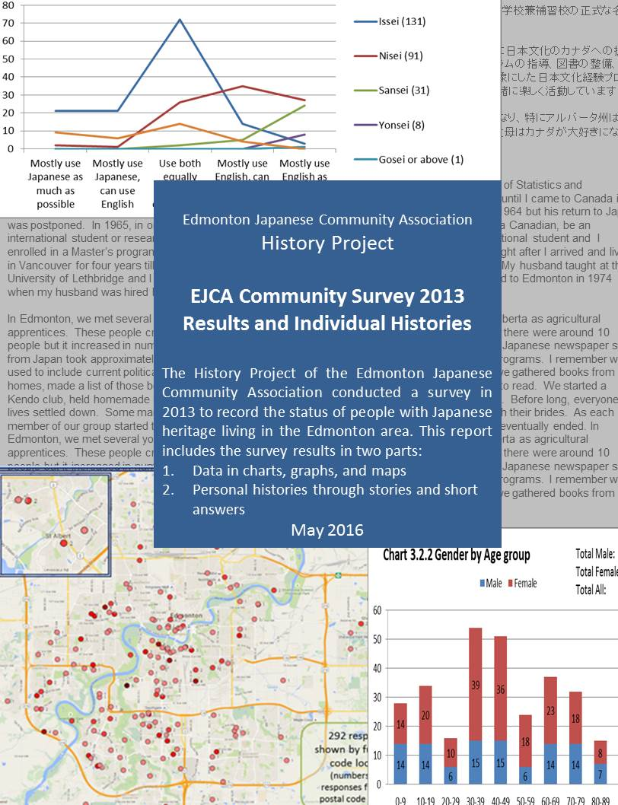
Editors: Sanae Ohki (Part 1), David Sulz (Part 2)

Publisher: Edmonton Japanese Community Association (EJCA). History Project Phase 3 Committee

Date: May 2016

History Project Phase 3 Committee members:
Cathy Tennant, Daiyo Sawada, David Sulz, Jim Hoyano, Sanae Ohki (chair)

Contact:
Edmonton Japanese Community Association
c/o EJCA/Argyll Community Centre, 6750 - 88 Street, Edmonton, Alberta, Canada T6E 5H6
E-mail: office@ejca.org

Copyright: Edmonton Japanese Community Association. All rights reserved.
No part of this book may be reproduced without permission from the EJCA except in the case of brief quotations or insubstantial portions which must be properly credited.

Electronic version:
This document is also available through the University of Alberta’s Education & Research Archive (ERA) and can be downloaded from: https://era.library.ualberta.ca/files/gh93h222
Note: the electronic version includes screen-shots of all 4 survey instruments and intermittent updates.
Date of this version: 29 July 2016 - EHC acknowledgement added (this page)

Important notes:
Due to the nature of historical data collection, there are undoubtedly many gaps, missing information, and the accuracy of some facts may be disputed. The committee members disclaim any responsibility for errors, omissions and incomplete information but are pleased to receive corrections, suggestions, additions, etc. that may be used (or not) at the committee's discretion.
Additional information (or corrections or clarifications) received after May 2016 may* be added to a separate document named EJCA Community Survey 2013 Results and Individual Histories Addendum. If this occurs, likely places to look will be the EJCA website, University of Alberta’s Education & Research Archive, or the EJCA library. It may also be added to the electronic version of this report hosted on ERA – with an update currency note.
* note: we can’t be sure what will happen as time passes and the History Committee disbands or members change.

The History Committee of the EJCA gratefully acknowledges the advice and support received from the Edmonton Heritage Council (EHC) of the City of Edmonton for the production and distribution of print copies of this report. Sufficient funds were provided under the Project Grants Program of the EHC to produce both soft cover and hard cover copies of the report and to distribute them to interested individuals as well as to noted libraries, museums and depositories here in Edmonton, in Canada and in Japan, including the National Archive of Japan and the Japanese Overseas Migration Museum in Yokohama.

Edmonton Japanese Community Association
History Project – EJCA Community Survey 2013 Results and Individual Histories

Table of contents
- Project Scope
  - Scope 2
  - Timelines 3
  - Funding and finance 3
  - Committee members and translators 3

- The Survey
  - Conceptualizing the Survey 4
  - Designing the Survey 4
  - Formatting the Survey 6
  - Conducting the Survey 6
  - Analysis and Reporting Methods 7
  - Quantitative Summary of Overall Responses to the Survey: Part One and Part Two 7

- Part 1 – “Snapshots” of our community in 2013
  - Charts and graphs of responses to each question 8
  - Cross classification of multiple questions 25

- Part 2 – Individual Life
  - Background to the contents of this document 34
  - Individual Responses to Part 2 of EJCA History Project Survey 36

Appendix A: Survey Instruments (exclusive to electronic version of this report)
Online, English Survey 235
Online, Japanese Survey 248
Print (hard copy) English survey 261
Print (hard copy) Japanese survey 273

- Project Scope
  - Scope
In January 2010, the Edmonton Japanese Community Association (EJCA) established a History Project Committee. The purpose of the project was to gather information about Japanese-Canadians (and people with Japanese heritage) in Edmonton and the surrounding area. Phase 1 of the History Project started in March 2010. It conducted interviews, collected old documents and established a method to archive materials that were gathered. Phase 2 started in September 2012 and collected more detailed information. A report of the interviews and data collected in Phases 1 and 2 was published in July 2014.
During Phase 1, we found a document, ”Nakayama Shiro, the Comprehensive List of Japanese-Canadians, July 1921“ that included a list of Japanese living in Edmonton in 1921 and the biographies of key individuals. There were 25 people listed.
Another document, “ Tairiku Nippo, Japanese Name List, September 1941 “ was a list of Japanese and Japanese Canadians living in Canada in 1941. The total number listed was about 23,000 including 13,000 born in Canada (i.e. second generation or nisei), 2,500 Japanese-Canadians, and 7,500 Japanese.
1912 was the first year when a few Japanese were recorded formally as residents in Edmonton although there had been Japanese people living in the Edmonton area on a temporary basis before 1912. So, 2012 was the 100th anniversary of the history of Japanese Canadians in Edmonton.
According to the Statistics Canada’s census, the number of Canadians or permanent residents with Japanese ancestry was as follow:
 | 1941 | 1951 | 1961 | 1971 | 1981 | 1991 | 1996 | 2001 | 2006 | 2011
Canada | 23,149 | 21,663 | 29,179 | 37,255 | 40,990 | 65,965 | 68,135 | 85,225 | 98,990 | 109,740
Alberta | 578 | 3,336 | 3,721 | 4,460 | 5,225 | 8,745 | 8,275 | 11,945 | 13,465 | 15,650
Lethbridge | 2 | 314 | 838 | 920 | n/a | n/a | n/a | 1,365 | 1,705 | 2,120
Calgary | 82 | 137 | 456 | 935 | n/a | 2,855 | 3,875 | 4,710 | 5,820 | 6,605
Edmonton | 35 | 124 | 230 | 610 | n/a | 1,820 | 1,910 | 2,235 | 2,835 | 3,650

During the Phase 1 and 2 activities, it was noticed that there was no recent data about the lives of Japanese and Japanese-Canadians so the History Committee decided to capture a snapshot of Japanese, Japanese Canadian, and other people of Japanese ancestry, living in the Edmonton area, as of June 2013. This became known as Phase 3. It was felt that the data would provide valuable and interesting information for future generations.
Working definitions for the survey:
During initial discussions, it was realized that “the Japanese in Edmonton” could have a few interpretations so it was decided to use the following guidelines.

Japanese: Japanese citizens, especially those likely leave Edmonton within five years (i.e. temporary residents of Edmonton area)

Japanese-Canadian:
- Canadian with Japanese ancestor(s), including those with dual citizenship.
- Canadian born in Japan, including dual citizens.
- Japanese with Canadian landed immigrant status.
- Japanese without Canadian landed immigrant status but planning to live in Canada over next 5 years.

Others with Japanese heritage: Neither Canadian nor Japanese nationality; e.g. second generation Japanese American, Japanese married to a French person and living in the Edmonton area.
  - Timelines

January 2013 Decision to conduct a survey collecting information about Japanese and Japanese Canadians living in the Edmonton area.
May 2013 Survey questionnaire finalized
June-August 2013 Survey conducted (online and paper versions)
August 2013 Paper responses combined with online responses
Aug 2013 - 2015 Responses in Japanese translated to English
September 2015 Collection of missing photos and personal histories completed
September 2015 Draft survey report completed and presented at EJCA Annual General Meeting
March 2016 Collection of seniors’ histories completed
April 2016 Report ready for printing
June 2016 Phase 3 project completed

  - Funding and finance
History Project – Phase 3 Finances to April 30, 2016

Funding Sources
Casino Fund 973.95
EJCA General Fund 1,096.93
EJCA Fund for printing 2,915.00
Heritage Council Grant 2,915.00
Total 7,900.88
Expenses
Survey and printing expenses 1,258.72
Materials, gift certificates 437.16
Translation 375.00
Total 2,070.88

Expected expense for the completion of Phase 3
Publishing of report 5,830.00
Total expenses 7,900.88
  - Committee members and translators
Committee members: Cathy Tennant, David Sulz, Daiyo Sawada, Jim Hoyano, Sanae Ohki (Chair)
Translators (Japanese survey responses to English): Akiko Ogata, Kyoko Watanabe, Mineko Koto, Natsuko Cyr, Sanae Ohki, Takashi Ohki, Urara Kobayashi

- The Survey
  - Conceptualizing the Survey
Survey as “Community Portrait”
As indicated in Section 1.1 above, the 2011 Statistics Canada Census revealed there were approximately 3,650 people residing in the Edmonton area who claimed some Japanese ancestry. The 2014 EJCA membership list shows 656 members including children. Approximately half of these have Japanese ancestry. Who then are the remaining 3,300? The History Committee tried to answer this question by
- Designing a survey instrument,
- Promoting the survey (and the importance of participating) to the Japanese community in the Edmonton area using multiple modes of communication (e.g., the EJCA Newsletter, contacting users of the EJCA Centre, word of mouth, etc.)
In undertaking the survey, the Committee guided its activity by conceptualizing the survey as a process of taking “snapshots” of all the community members who participated and then aggregating these individual snapshots into a “Community Portrait.” This metaphor “Survey as Portrait” made us realize that using the survey to take snapshots of 3,650 people when the whereabouts of 3,000 of them was pretty much unknown was quite a daunting task! However, in trying to understand what we were doing, the Committee realized that the metaphor “Survey as Portrait” allowed us to see that the Survey was a vital component in the larger and more meaningful process of understanding, building and enhancing the Japanese community. In particular, we saw our task as:
- Obtaining a “Portrait” of the Japanese Community living in the Edmonton area circa 2013, by composing it from multiple snapshots of the individual members of the community who participated;
- Using that “Community Portrait” as a baseline for informed decision making within the Japanese community as a component of the community of Edmonton;
- Conceptualizing the 2013 edition of the survey as just the first survey; hopefully, further surveys will be done on a systematic basis (every other decade or so) to provide a chronological trajectory to guide decision making of the community as it enacts its history.
Said again, by conducting similar surveys on an ongoing basis, our community will have an ongoing way to constitute and assess its historic journey as it lives through it. Metaphorically speaking, by taking periodic “selfies” on a regular basis, the community will have a standardized method of informing its progress – past, present and future – thus providing us with:
- An historic appreciation of where we came from,
- An understanding of how we are doing in the present, and
- A longitudinal baseline to help our planning for the future.

  - Designing the Survey
Metaphorically, the survey was designed so that an ‘Overall Portrait’ of the Japanese community could be composed by aggregating the overall portrait from several component snapshots. Each item in the survey questionnaire was designed to provide a snapshot of basic components of community living. What are these basic components?
Statistics Canada is charged with a similar task and is responsible for the Canadian Census which has two parts: a brief “short form” with only a few questions and a more detailed section formerly called the “long form” but changed to the “National Household Survey” for the 2011 census.
The History Committee used the 2011 National Household Survey as a conceptual model with the main difference being a much more modest scope, texture and depth. The components of our Community Portrait were specified in two parts:
Part One: Community Profile items (including several “required” questions)
Part 1 requested general background information that would be useful for constructing aggregated “snapshots” of our community. Many of these items were modeled on those used in the National Household Survey (2011). The snapshots created from these items were captured as graphs, tables, and charts. Part 1 did not ask for, nor require, participants to provide information revealing their personal identity. For example, some items asked for postal codes but not addresses; others asked for the area in Japan where their ancestors resided but not the particular location.
In brief, we tried to collect information on:
- General identity
  - Sex
  - Age
  - Generation (1st or Issei, 2nd or Nisei, 3rd or Sansei, etc.)
- Japanese ancestry
  - Location of ancestral “home” in Japan
  - Ancestral and personal arrival in Canada/Edmonton
- Residence in Edmonton
  - Length of residence in Edmonton
  - Location of residence
  - Type of dwelling
  - Number of residents in household
- Japanese language competence
  - Speaking
  - Writing
  - Reading
- Education
  - Level of schooling (junior high, high school, university)
  - Technical school
- Employment
  - Occupation(s)
  - Current employer
- Involvement in Japanese culture and events
  - Participation in EJCA events or clubs
  - Japanese hobbies, arts, past-times
  - Ways to enhance involvement

Part Two: Personal History (optional section)
Part 2 probed deeper and asked participants to share personal events that were meaningful or significant in their life. Of particular interest were events that depicted what it was like to be “Japanese” living in the Edmonton area. Such responses were collated into “personal historical portraits,” each portrait identified with a person or a family as was common practice in composing “community histories.” Together, these biographical “selfies” will provide a glimpse into the history of the Japanese community in the Edmonton area as lived and shared by the members themselves. Because Part 2 required personal identification, it was optional and later separated from Part 1 responses.
- Name (given and family)
- Year of birth
- Ancestral history
- Why and when came to Edmonton area
- Major occupation(s) or employers
- Ways that being Japanese affected the course of your life or family history
- Additional history not included above
- Availability of family photos or other documents
- Contact information

  - Formatting the Survey
The survey questionnaire was produced in four versions:
- A Japanese online version
- A Japanese paper version
- An English online version
- An English paper version

  - Conducting the Survey
Voluntary Participation
Unlike the Census of Canada which is mandatory for Canadians (notwithstanding the complication that a part of it was made voluntary in 2011), our survey was completely voluntary and thus required multiple modes of promotion/advertising/cajoling to encourage participation including:
- Announcements
  - written in the EJCA newsletter, Moshi Moshi
  - sent to EJCA clubs
  - made at EJCA events
  - written in the Metro Edmonton Japanese Community School newsletter
  - made at the Consular services held in Edmonton
  - sent to Japanese-related associations at the University of Alberta
  - through posters at various Japanese restaurants
- Participation Lottery: gift certificates from local Japanese restaurants awarded by draw
- Word of mouth encouragement

  - Analysis and reporting methods
Part One
Because Part 1 produced data that could be classified, listed and/or counted, standard statistical methods such as charts, graphs, and lists were used to portray the data. Section 3.1 portrayals are single-dimensional (one variable only) while those in section 3.2 are cross-dimensional (two or more variables in interaction)
Part Two
Part 2 produced qualitative data through written responses in Japanese or English. These responses were entered verbatim into a spreadsheet then converted to an MSWord document through a mailmerge function. This latter document was then edited and added to as more information was gathered.
  - Quantitative Summary of Overall Responses to the Survey: Part One and Part Two

The following responses were received.
Part 1 (Questions 1 – 30) did not require any personal identification (no name required)
Part 2 (Questions 31 – 40) were personal history questions and required name identification (although some were entered as “anonymous”). This section was separated from Part 1 responses to avoid personal identification of part 1 responses.
Language used | Part 1 and Part2 | Part 1 only | Part 2 only | Total
English | 67 | 31 | 8 | 106
Japanese | 139 | 58 | 5 | 202
Total | 206 | 89 | 13 | 308

Responses to Part 1 | 206 + 89 | 295
Responses to Part 2 | 206 + 13 | 219

- Part 1 – “Snapshots” of our community in 2013
  - Charts and graphs of responses to each question
    - Reponses using English form or Japanese form

    - Responses to each question

Question 1: Do you have any Japanese heritage in your ancestry?
Yes | 295
No | 0

Question2: Are you currently living in the Edmonton area?
Yes | 278
Blank | 17
Total | 295

Question 3: Sex
Male | 107
Female | 188
Total | 295

Question 4: Year of birth
Year | # | Year | # | Year | # | Year | # | Year | #
1919 | 1 | 1942 | 2 | 1960 | 2 | 1978 | 6 | 1999 | 2
1921 | 2 | 1943 | 5 | 1961 | 2 | 1979 | 4 | 2000 | 5
1922 | 1 | 1944 | 3 | 1962 | 4 | 1980 | 6 | 2001 | 5
1924 | 1 | 1945 | 4 | 1963 | 4 | 1982 | 7 | 2002 | 3
1926 | 1 | 1946 | 4 | 1964 | 5 | 1983 | 4 | 2003 | 6
1927 | 2 | 1947 | 7 | 1965 | 2 | 1984 | 1 | 2004 | 5
1928 | 2 | 1948 | 3 | 1966 | 3 | 1985 | 2 | 2005 | 3
1930 | 2 | 1949 | 3 | 1967 | 1 | 1986 | 1 | 2006 | 2
1931 | 3 | 1950 | 4 | 1968 | 3 | 1987 | 3 | 2007 | 3
1932 | 3 | 1951 | 3 | 1969 | 4 | 1989 | 3 | 2008 | 3
1933 | 3 | 1952 | 1 | 1970 | 9 | 1990 | 1 | 2009 | 3
1934 | 4 | 1953 | 1 | 1971 | 3 | 1991 | 1 | 2010 | 4
1935 | 2 | 1954 | 4 | 1972 | 10 | 1992 | 2 | 2011 | 3
1936 | 3 | 1955 | 3 | 1973 | 11 | 1994 | 2 | 2013 | 1
1937 | 3 | 1956 | 2 | 1974 | 6 | 1995 | 1 | Rats | 1
1938 | 3 | 1957 | 2 | 1975 | 7 | 1996 | 2 | (blank) | 4
1940 | 2 | 1958 | 1 | 1976 | 8 | 1997 | 3
1941 | 8 | 1959 | 2 | 1977 | 3 | 1998 | 6 | Total | 295

Question 5: Age groups
Age group | #
0-9 | 28
10-19 | 34
20-29 | 16
30-39 | 54
40-49 | 51
50-59 | 24
60-69 | 37
70-79 | 32
80-89 | 15
90+ | 4
Total | 295

Question 6: Generations
Generation | #
Japanese temporarily in Canada | 33
Issei | 131
Nisei | 91
Sansei | 31
Yonsei | 8
Gosei or above | 1
Total | 295

Note: There was considerable discussion regarding the definition of the generations: Issei, Nisei, Sansei, Yonsei and Gosei. Any number of situations may occur which make it difficult to make an “accurate” choice. For example, what is the child if the mother is Issei and the father is Nisei? Most other cultures refer to the “first generation” as the first generation to be born in a country rather than the first generation that immigrated; whereas, from a Japanese viewpoint, this person would be a Nisei (second generation). We also suspected that when a child was born in Japan but moved when a baby and grew up outside of Japan, they may have referred to themselves as Nisei in the survey, even though the child and parents were born in Japan.

Question 7 and 8: Japanese Ancestry: Which of your father’s and mother’s grand-parents were Japanese?
Father’s grandpa 1, Father’s grandma 1, Father’s grandpa 2, Father’s grandma 2
Mother’s grandpa 1, Mother’s grandma 1, Mother’s grandpa 2, Mother’s grandma 2
Japanese fraction - Question asked if a person’s great grand-parents (eight of them) were Japanese or non-Japanese. Fraction = number of Japanese/8

Fraction | Meaning | #
0 | All great grandparents non-Japanese | 1
0.125 | One out of eight was Japanese | 2
0.25 | Two out of eight were Japanese | 13
0.375 | Three out of eight were Japanese | 3
0.5 | Four out of eight were Japanese | 68
0.625 | Five out of eight were Japanese | 0
0.75 | Six out of eight were Japanese | 1
0.875 | Seven of eight were Japanese | 0
1 | All eight were Japanese | 207
Total |  | 295
Note: “Japanese fraction = 0” – possible error in a response
Question 9. What area(s) of Japan is considered your ancestral home?
Column Headings:
# = Number of respondents whose ancestral area is the prefecture
Population = recent (2000) population of each prefecture, in 10,000s
Index = Survey respondents / population (multiplied by 100,000 to make them easily comparable)
: Top 3 prefectures by total number of respondents

: Top 3 prefectures by index

Prefecture | # | Population (10,000) | Index |  | Prefecture | # | Population (10,000) | Index
Aichi-ken | 12 | 691 | 1.74 |  | Miyazaki-ken | 1 | 119 | 0.84
Akita-ken | 5 | 120 | 4.17 |  | Nagano-Ken | 6 | 220 | 2.73
Aomori-ken | 1 | 150 | 0.67 |  | Nagasaki-ken | 2 | 153 | 1.31
central japan | 1 | - |  |  | Nara-Ken | 5 | 145 | 3.45
Chiba-ken | 5 | 589 | 0.85 |  | Niigata-ken | 8 | 248 | 3.23
Ehime-ken | 6 | 151 | 3.97 |  | Oita-ken | 0 | 124 | 0
Fukui-ken | 3 | 83 | 3.61 |  | Okayama-ken | 1 | 196 | 0.51
Fukuoka-ken | 9 | 497 | 1.81 |  | Okinawa-ken | 4 | 132 | 3.03
Fukushima-ken | 3 | 214 | 1.40 |  | Osaka-fu | 17 | 863 | 1.97
Gifu-ken | 2 | 211 | 0.95 |  | Saga-ken | 2 | 88 | 2.27
Gunma-ken | 3 | 202 | 1.49 |  | Saitama-ken | 5 | 687 | 0.73
Hiroshima-ken | 8 | 287 | 2.79 |  | Shiga-ken | 13 | 133 | 9.77
Hokkaido | 27 | 568 | 4.75 |  | Shimane-ken | 4 | 76 | 5.26
Hyogo-ken | 12 | 552 | 2.17 |  | Shizuoka-ken | 7 | 376 | 1.86
Ibaragi-ken | 6 | 299 | 2.01 |  | Tochigi-ken | 2 | 200 | 1.00
Ishikawa-ken | 0 | 118 | 0 |  | Tokushima-ken | 1 | 83 | 1.20
Iwate-ken | 0 | 143 | 0 |  | Tokyo-to | 34 | 1174 | 2.90
Kagawa-ken | 4 | 103 | 3.88 |  | Tottori-ken | 5 | 62 | 8.06
Kagoshima-ken | 13 | 179 | 7.26 |  | Toyama-ken | 1 | 113 | 0.88
Kanagawa-ken | 13 | 837 | 1.55 |  | Wakayama-ken | 3 | 109 | 2.75
Kochi-ken | 1 | 82 | 1.22 |  | Yamagata-ken | 0 | 124 | 0
Kumamoto-ken | 5 | 187 | 2.67 |  | Yamaguchi-ken | 6 | 153 | 3.92
Kyoto-fu | 4 | 256 | 1.56 |  | Yamanashi-ken | 0 | 89 | 0
Mie-ken | 4 | 186 | 2.15 |  | (blank) | 16 | - | 0
Miyagi-ken | 5 | 234 | 2.14 |  | Total | 295 | 12606 | 2.34

Sorted by descending order of actual numbers Sorted by descending order of rate
 | Prefecture | Number of people | Population of area (unit 1 million) | Index |  | Prefecture | Number of people | Population of area (unit 1 million) | Index
1 | Tokyo-to | 34 | 11.74 | 2.90 | 1 | Shiga-ken | 13 | 1.33 | 9.77
2 | Hokkaido | 27 | 5.68 | 4.75 | 2 | Tottori-ken | 5 | 0.62 | 8.06
3 | Osaka-fu | 17 | 8.63 | 1.97 | 3 | Kagoshima-ken | 13 | 1.79 | 7.26
4 | Kagoshima-ken | 13 | 1.79 | 7.26 | 4 | Shimane-ken | 4 | 0.76 | 5.26
5 | Kanagawa-ken | 13 | 8.37 | 1.55 | 5 | Hokkaido | 27 | 5.68 | 4.75
6 | Shiga-ken | 13 | 1.33 | 9.77 | 6 | Akita-ken | 5 | 1.20 | 4.17
7 | Aichi-ken | 12 | 6.91 | 1.74 | 7 | Ehime-ken | 6 | 1.51 | 3.97
8 | Hyogo-ken | 12 | 5.52 | 2.17 | 8 | Yamaguchi-ken | 6 | 1.53 | 3.92
9 | Fukuoka-ken | 9 | 4.97 | 1.81 | 9 | Kagawa-ken | 4 | 1.03 | 3.88
10 | Hiroshima-ken | 8 | 2.87 | 2.79 | 10 | Fukui-ken | 3 | 0.83 | 3.61
11 | Niigata-ken | 8 | 2.48 | 3.23 | 11 | Nara-Ken | 5 | 1.45 | 3.45
12 | Shizuoka-ken | 7 | 3.76 | 1.86 | 12 | Niigata-ken | 8 | 2.48 | 3.23
13 | Ehime-ken | 6 | 1.51 | 3.97 | 13 | Okinawa-ken | 4 | 1.32 | 3.03
14 | Ibaragi-ken | 6 | 2.99 | 2.01 | 14 | Tokyo-to | 34 | 11.74 | 2.90
15 | Nagano-Ken | 6 | 2.20 | 2.73 | 15 | Hiroshima-ken | 8 | 2.87 | 2.79
16 | Yamaguchi-ken | 6 | 1.53 | 3.92 | 16 | Wakayama-ken | 3 | 1.09 | 2.75
17 | Akita-ken | 5 | 1.20 | 4.17 | 17 | Nagano-Ken | 6 | 2.20 | 2.73
18 | Chiba-ken | 5 | 5.89 | 0.85 | 18 | Kumamoto-ken | 5 | 1.87 | 2.67
19 | Kumamoto-ken | 5 | 1.87 | 2.67 | 19 | Saga-ken | 2 | 0.88 | 2.27
20 | Miyagi-ken | 5 | 2.34 | 2.14 | 20 | Hyogo-ken | 12 | 5.52 | 2.17
21 | Nara-Ken | 5 | 1.45 | 3.45 | 21 | Mie-ken | 4 | 1.86 | 2.15
22 | Saitama-ken | 5 | 6.87 | 0.73 | 22 | Miyagi-ken | 5 | 2.34 | 2.14
23 | Tottori-ken | 5 | 0.62 | 8.06 | 23 | Ibaragi-ken | 6 | 2.99 | 2.01
24 | Kagawa-ken | 4 | 1.03 | 3.88 | 24 | Osaka-fu | 17 | 8.63 | 1.97
25 | Kyoto-fu | 4 | 2.56 | 1.56 | 25 | Shizuoka-ken | 7 | 3.76 | 1.86
26 | Mie-ken | 4 | 1.86 | 2.15 | 26 | Fukuoka-ken | 9 | 4.97 | 1.81
27 | Okinawa-ken | 4 | 1.32 | 3.03 | 27 | Aichi-ken | 12 | 6.91 | 1.74
28 | Shimane-ken | 4 | 0.76 | 5.26 | 28 | Kyoto-fu | 4 | 2.56 | 1.56
29 | Fukui-ken | 3 | 0.83 | 3.61 | 29 | Kanagawa-ken | 13 | 8.37 | 1.55
30 | Fukushima-ken | 3 | 2.14 | 1.40 | 30 | Gunma-ken | 3 | 2.02 | 1.49
31 | Gunma-ken | 3 | 2.02 | 1.49 | 31 | Fukushima-ken | 3 | 2.14 | 1.40
32 | Wakayama-ken | 3 | 1.09 | 2.75 | 32 | Nagasaki-ken | 2 | 1.53 | 1.31
33 | Gifu-ken | 2 | 2.11 | 0.95 | 33 | Kochi-ken | 1 | 0.82 | 1.22
34 | Nagasaki-ken | 2 | 1.53 | 1.31 | 34 | Tokushima-ken | 1 | 0.83 | 1.20
35 | Saga-ken | 2 | 0.88 | 2.27 | 35 | Tochigi-ken | 2 | 2.00 | 1.00
36 | Tochigi-ken | 2 | 2.00 | 1.00 | 36 | Gifu-ken | 2 | 2.11 | 0.95
37 | Aomori-ken | 1 | 1.50 | 0.67 | 37 | Toyama-ken | 1 | 1.13 | 0.88
38 | Kochi-ken | 1 | 0.82 | 1.22 | 38 | Chiba-ken | 5 | 5.89 | 0.85
39 | Miyazaki-ken | 1 | 1.19 | 0.84 | 39 | Miyazaki-ken | 1 | 1.19 | 0.84
40 | Okayama-ken | 1 | 1.96 | 0.51 | 40 | Saitama-ken | 5 | 6.87 | 0.73
41 | Tokushima-ken | 1 | 0.83 | 1.20 | 41 | Aomori-ken | 1 | 1.50 | 0.67
42 | Toyama-ken | 1 | 1.13 | 0.88 | 42 | Okayama-ken | 1 | 1.96 | 0.51
43 | Ishikawa-ken | 0 | 1.18 | - | 43 | Ishikawa-ken | 0 | 1.18 | -
44 | Iwate-ken | 0 | 1.43 | - | 44 | Iwate-ken | 0 | 1.43 | -
45 | Oita-ken | 0 | 1.24 | - | 45 | Oita-ken | 0 | 1.24 | -
46 | Yamagata-ken | 0 | 1.24 | - | 46 | Yamagata-ken | 0 | 1.24 | -
47 | Yamanashi-ken | 0 | 0.89 | - | 47 | Yamanashi-ken | 0 | 0.89 | -
 | central Japan | 1 | - | - |  | central Japan | 1 | - | -
 | (blank) | 16 | - | - |  | (blank) | 16 | - | -
 | Total | 295 | 126.06 | 2.34 |  | Total | 295 | 126.06 | 2.34

Question 10. Year you first moved to Canada

Year | # | Year | # | Year | # | Year | #
1933 | 1 | 1972 | 6 | 1990 | 3 | 2004 | 9
1937 | 1 | 1973 | 5 | 1991 | 3 | 2005 | 6
1955 | 1 | 1974 | 2 | 1992 | 4 | 2006 | 9
1961 | 1 | 1975 | 2 | 1993 | 4 | 2007 | 10
1962 | 3 | 1976 | 1 | 1994 | 2 | 2008 | 2
1963 | 1 | 1978 | 4 | 1995 | 1 | 2009 | 10
1964 | 1 | 1979 | 3 | 1996 | 1 | 2010 | 10
1965 | 2 | 1980 | 2 | 1997 | 5 | 2011 | 7
1966 | 1 | 1981 | 6 | 1998 | 6 | 2012 | 10
1967 | 2 | 1983 | 1 | 1999 | 5 | 2013 | 8
1968 | 1 | 1984 | 1 | 2000 | 8 | Born in Canada | 84
1969 | 3 | 1985 | 2 | 2001 | 11 | Left blank | 1
1970 | 6 | 1986 | 3 | 2002 | 5
1971 | 3 | 1989 | 1 | 2003 | 5 | Total | 295

Question 11. Where were you from before moving to Edmonton area?
Country | Prefecture | # | Total |  | Country | Province | # | Total
Japan |  |  | 102 |  | Canada |  |  | 120
 | Aichi-ken | 4 |  |  |  | Alberta (see below) | 69
 | Akita-ken | 1 |  |  |  | British Columbia | 21
 | Aomori-ken | 1 |  |  |  | Manitoba | 5
 | Chiba-ken | 1 |  |  |  | Northwest Territories | 2
 | Fukuoka-ken | 1 |  |  |  | Nova Scotia | 3
 | Fukushima-ken | 1 |  |  |  | Ontario | 11
 | Hiroshima-ken | 1 |  |  |  | Quebec | 5
 | Hokkaido | 10 |  |  |  | Saskatchewan | 3
 | Hyogo-ken | 4 |  |  |  | Yukon | 1
 | Ibaraki-ken | 1 |  |  | Other country |  |  | 22
 | Japan | 13 |  |  |  | Australia | 3
 | Kanagawa-ken | 6 |  |  |  | China | 2
 | Kyoto-fu | 3 |  |  |  | Germany | 1
 | Nagano-ken | 2 |  |  |  | New Zealand | 2
 | Nara-ken | 2 |  |  |  | Peru | 2
 | Niigata-ken | 2 |  |  |  | Thailand | 1
 | Okinawa-ken | 1 |  |  |  | USA | 11
 | Osaka-fu | 10 |  |  | Born in Edmonton area |  |  | 51
 | Saitama-ken | 6 |  |  |  | Born here | 27
 | Shizuoka-ken | 5 |  |  |  | blank | 24
 | Tokyo | 27 |  |  | Grand total |  |  | 295

Alberta details: There were 69 people who came from other areas of Alberta.
City in Alberta | # | City in Alberta | # | City in Alberta | #
Calgary | 21 | Jasper | 3 | Lloydminster | 1
Lethbridge | 16 | Taber | 3 | Opal | 1
Edmonton | 4 | Barnwell | 2 | Pincher Creek | 1
Picture Butte | 4 | Redcliff | 2 | Rimbey | 1
Raymond | 4 | Coaldale | 1 | Vauxhall | 1
Cold Lake | 3 | Grande Cache | 1
Question 12. What year did you (or your family) move to Edmonton area?

Year | # | Year | # | Year | # | Year | #
1945 | 3 | 1967 | 1 | 1986 | 2 | 2004 | 6
1946 | 3 | 1969 | 2 | 1987 | 2 | 2005 | 4
1948 | 1 | 1970 | 4 | 1988 | 1 | 2006 | 14
1949 | 2 | 1971 | 5 | 1990 | 2 | 2007 | 4
1950 | 2 | 1972 | 9 | 1991 | 2 | 2008 | 9
1952 | 1 | 1973 | 8 | 1992 | 6 | 2009 | 9
1956 | 2 | 1974 | 6 | 1993 | 1 | 2010 | 15
1958 | 1 | 1975 | 6 | 1994 | 4 | 2011 | 13
1959 | 1 | 1976 | 5 | 1996 | 1 | 2012 | 18
1960 | 1 | 1978 | 5 | 1997 | 3 | 2013 | 13
1961 | 1 | 1979 | 2 | 1998 | 5 | born in Edmonton | 11
1962 | 1 | 1980 | 2 | 1999 | 1 | no response | 14
1963 | 2 | 1981 | 8 | 2000 | 6 | Total | 295
1964 | 3 | 1982 | 1 | 2001 | 11
1965 | 3 | 1983 | 5 | 2002 | 8
1966 | 5 | 1985 | 5 | 2003 | 4
Question 13. How long have you lived in Edmonton area?
Description | #
Less than 5 and only here temporarily (e.g. studying) | 24
Less than 5 years and plan to stay longer | 47
5 to 9 years | 46
10 to 19 years | 52
20 to 29 years | 25
More than 30 years | 101
Total | 295
Question 14. What is your postal code?
6 digit postal code: respondents’ locations were mapped in Edmonton, St. Albert and Sherwood Park areas (some respondents lived outside the map area). 6 digit postal codes can narrow location to a small area so this map is sized to not show that level of precision.
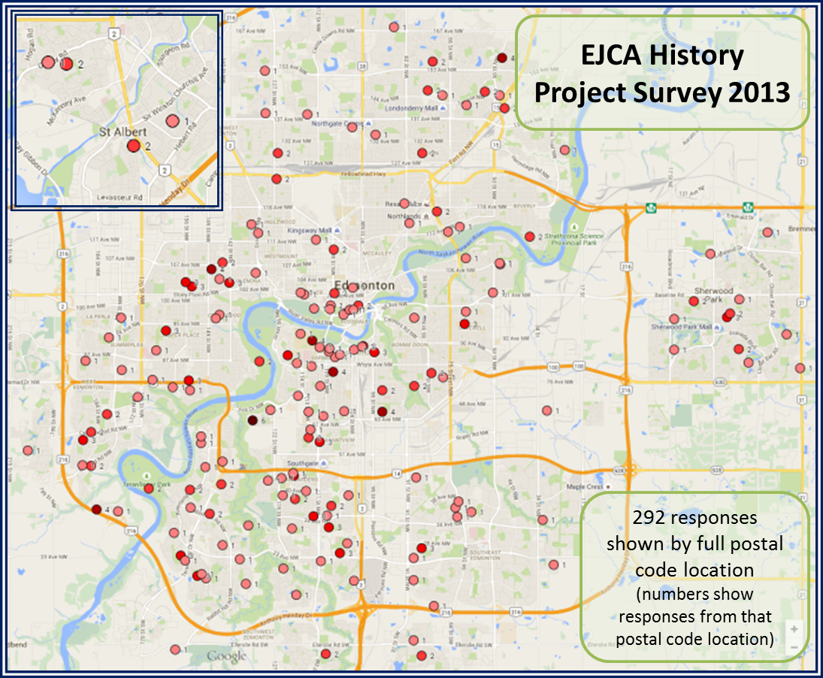
1: One response per one postal code

2: Two responses per one postal code

3: Three responses per postal code

4: Four responses per one postal code

5: Five responses per postal code

6: Six responses per one postal code

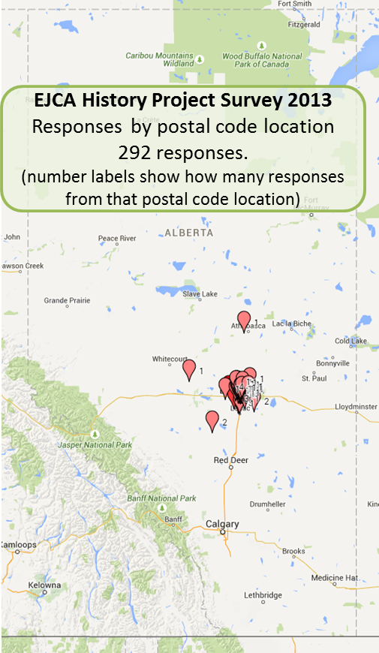
Question 15. Type of dwelling
 | Rent | Own | Guest/Others | Total
house | 24 | 181 | 17 | 222
apartment | 24 | 0 | 0 | 24
condo | 4 | 19 | 0 | 23
seniors' residence | 1 | 2 | 0 | 3
dormitory | 5 | 0 | 2 | 7
other | 8 | 3 | 9 | 20
Total | 66 | 205 | 28 | 299
Note: There were four entries that had multiple responses.
Question 16. Japanese Language Use
Responses | #
Mostly use Japanese as much as possible | 32
Mostly use Japanese, can use English | 28
Use both equally depending on situation | 114
Mostly use English, can use Japanese | 58
Mostly use English as much as possible | 63
Total | 295

Question 17. How many people live in your household?
How many? | #
1 | 34
2 | 88
3 | 61
4 | 63
5 | 33
More than 5 | 16
Total | 295

Question 18. Japanese writing skill
Writing skill level | #
Level 1. None | 68
Level 2. Hiragana and Katakana | 27
Level 3. Some Kanji memorised (e.g. write personal letter or diary) | 40
Level 4. Explanatory sentences, business letters or essay using a dictionary | 48
Level 5. Can write a newspaper article or academic essay | 112
Total | 295

Question 19. Japanese reading skill
Reading skill level | #
Level 1. None | 74
Level 2. Children’s books or manga | 40
Level 3. Easy essays using dictionary | 16
Level 4. Novels or non-fiction using dictionary | 16
Level 5. Newspapers, novels, academic writing with minimal reference to dictionary | 149
Total | 295

Question 20. Japanese speaking skill
Speaking skill | #
Level 1. None | 45
Level 2. Greetings, simple shopping | 33
Level 3. Daily life conversation | 53
Level 4. Explain details of things, give and follow complicated instructions | 32
Level 5. Business, academic, philosophical conversation | 132
Total | 295

Question 21. Education experience - this table shows final education experience; many respondents will have multiple levels.
Final Education Experience | Responses
Currently before elementary school age | 12
Currently elementary or junior high students | 44
Junior/Senior high school | 37
Technical school or equivalent | 85
Bachelor | 69
Master | 31
Doctorate | 16
Blank | 1
Total | 295

Question 22. Current employer or organization
Summary by grouping:
Education Institution
· University | 13
· Technical/Community college | 1
· Kindergarten to Grade 12 | 2
· Metro Edmonton Japanese Community School | 3
Government
· Office | 8
· Police office | 2
Service (food, sales, technical, social, business) | 47
Professional
· Law Enforcement | 1
· Health | 16
· Others | 2
Self Employed | 14
None (including students, home makers, retirees) | 144
Blank | 42
Total | 295

Details:
Current employer or organization | # |  | Current employer or organization | #
None: includes students, homemakers, retired | 144 |  | Compass Canada | 1
Blank | 42 |  | Dental lab | 1
Self employed | 14 |  | Edmonton Eskimos Football Club | 1
Alberta Health Services | 12 |  | GE finance | 1
University of Alberta | 12 |  | General Motors Canada Ltd | 1
Japanese restaurant | 11 |  | Grant MacEwan University | 1
Government of Alberta | 5 |  | GREEN LEAF ENTERPRISES INC. | 1
Metro Edmonton Japanese Community School | 3 |  | Health care - Capilano Rehab Centre | 1
Doctor | 2 |  | law office | 1
Edmonton Police Services | 2 |  | LEXUS OF EDMONTON | 1
Missionary | 2 |  | NAV CANADA | 1
High school | 2 |  | Newspaper company, | 1
Restaurant | 2 |  | NorQuest College | 1
Accountant office. | 1 |  | Office (Edmonton) | 1
Airport | 1 |  | OHGIYA ltd | 1
Alberta Government | 1 |  | Oil company | 1
AltaGas Utilities Inc. | 1 |  | Capilano Rehab Centre | 1
Architecture ATB | 1 |  | Printing shop | 1
Bakery | 1 |  | Private House Ownership | 1
Beauty Salon | 1 |  | Prometric Test Center | 1
Business - Accompli Kitchen Inc | 1 |  | Rhythmicana Gymnastics | 1
Business - Aecon | 1 |  | Rogers Broadcasting Ltd. | 1
Business - arrange homestay programs | 1 |  | Running Room Canada Inc. | 1
Cameron Canada Corporation | 1 |  | SOHO | 1
Canadian Trillinium School Group | 1 |  | Strathcona County | 1
Car rental | 1 |  | The Family Centre | 1
Caregiver | 1 |  | Worker's Compensation Board of Alberta | 1
Citytv | 1 |  | Total | 295

Question 23. Current occupation (not employer)
The questionnaire allowed free-form responses so they were categorized as accurately as possible using the Occupational Categories used in the 2011 National Household Survey (Statistics Canada)
[Occupational Categories as Listed by Statistics Canada - 2011 NHS] |  |  | Responses
 | 0 | Management occupations | 6
 | 1 | Business, finance and administration occupations | 16
 | 2 | Natural and applied sciences and related occupations | 8
 | 3 | Health occupations | 18
 | 4 | Occupations in education, law and social, community and government services | 28
 | 5 | Occupations in art, culture, recreation and sport | 11
 | 6 | Sales and service occupations | 20
 | 7 | Trades, transport and equipment operators and related occupations | 4
 | 8 | Natural resources, agriculture and related production occupations | 3
 | 9 | Occupations in manufacturing and utilities | 3
Additional Categories [not listed in the Occupational Categories by Statistics Canada]
 | 10 | Student | 47
 | 11 | Volunteer | 8
 | 12 | Homemaker | 12
 | 13 | Unemployed | 5
 | 14 | Retired | 47
 | 15 | None or blank | 59
Total |  |  | 295

Question 24. Japanese community involvement (multiple choices)
227 responded with at least one involvement, 68 responded with “None”
Community activity | #
EJCA (Edmonton Japanese Community Association) member | 137
Attend EJCA events | 100
EJCA active Club and Committee members | 61
Former EJCA member | 22
Japanese Christian Church member | 22
Metro Edmonton Japanese Community School member | 48
National Association of Japanese Canadian individual member | 0
Other | 30

Question 25. What other Japanese community involvement do you have?
- Former MEJCS (Metro Edmonton Japanese Community School) student
- Teaching at MEJCS
- Host and producer of Radio Wasabi, a Japanese music radio show
- Japanese language instructor at Faculty of Extension, U of A
- Japanese Language instructor
- Edmonton Japanese Golf Club
- Japanese Garden (Devonian Botanic Garden)
- EJCA Language class instructor
- JAGSA (Japanese Association of Graduate Students at U of A)
- Prince Takamado Japan Centre, U of A
- Taking karate lessons
- Taking Taiko lessons
- Doing exercises for EJCA Seniors
- Doing presentation of Japanese culture in primary school
- Member of SNS “My Japan”
- Member of Noble House Kenjutsu

Question 26. How often have you visited Japan?
Frequency | #
Never been to Japan | 33
A few short visits | 46
A few long visits | 18
Many short visits | 22
Many long visits | 15
Many short and long visits | 24
Regularly (every 1-3 years) | 136
(blank) | 1
Total | 295

Question 27. What Japan-related hobbies and past-times do you have? (Multiple choices)
231 responses had at least one Japan-related hobby.
Japan-related Hobbies | #
Cooking | 117
Movie | 92
Anime/manga | 69
Martial Arts | 53
Calligraphy | 48
Japanese Craft | 39
Karaoke | 39
Ikebana | 29
Tea ceremony | 22
Games (Go, Shogi) | 17
Japanese Dance | 14
Taiko | 15
Koto | 2
Other | 1

Question 28. Do you identify yourself with any particular religion(s) or philosophy? (optional)
Religion or Philosophy | Number | Total
Agnostic | 1 | 1
Buddhism |  | 15
Buddhism | 8
JODO SHINSHU BUDDHIST | 1
Jodo-shinshu Otani-ha | 1
No particular religion although events like funerals and weddings will be conducted in a Buddhist manner | 3
Raised Buddhist but not practicing. Philosophical leaning towards Buddhist thought. | 1
Zen | 1
Shinto and Buddhism | 1 | 1
Christianity |  | 38
Christian | 23
Baptist | 3
Catholic | 5
Church of Jesus Christ of Latter Day Saints (Mormon) | 2
Protestant | 4
"First of all, continue to seek the Kingdom of God and God's xxx" from the Bible. | 1
Islam | 1 | 1
“I accept religions except the heretical religions and should lay emphasis on all character building in the childhood.” | 1 | 1
Yes | 1 | 1
No or none | 62 | 62
Space or N/A | 175 | 175
Total | 295 | 295

Question 29. Is there anything EJCA could offer to encourage you to become more involved in the Japanese-Canadian community? (free-form responses)
Wish list to EJCA | Responses
Already doing a good/great job | 10
Nothing/not sure | 28
Maintenance of
· Art club | 1
· Japanese language (classes, materials) | 2
Promotion of:
· Bazaar | 1
· Calendar of events (electronic) | 5
· Camellia | 1
· Casual get together in Japanese dress | 1
· Cuisine/Food | 4
· Generational issues, communication | 1
· Information: immigration, social assistance, seniors | 1
· Japanese “festivals” (Powell St.) | 1
· Japanese Christian Church | 2
· Japanese culture | 2
· Japanese language (classes, materials, contacts) | 5
· Learn about the Japanese people/community | 2
· Researching Japanese heritage | 1
· sns.mynippon.jp | 1
· Undo-kai | 1
· Volunteering opportunities | 2
Blank | 223
Total | 295

Question 30. Who filled out this form?
Family member | 81
Friend | 1
Myself | 213
Total | 295

  - Cross classification of multiple questions
    - Language response by generation
The graphs show the number of Japanese or English forms used for the survey responses, by each generational group (e.g. 53 of 91 nisei responded in English.)
Note: Some cases reflect Issei parents using Japanese form for their Nisei children

 | English | Japanese | Total
Japanese temporarily in Canada | 3 | 30 | 33
Issei | 5 | 126 | 131
Nisei | 53 | 38 | 91
Sansei | 28 | 3 | 31
Yonsei | 8 |  | 8
Gosei or above | 1 |  | 1
Total | 98 | 197 | 295

    - Gender by age group
The graphs show the number of male or female who responded to the survey, by each age group (e.g. 36 of 51 responded in age group 40 - 49 are female.)

Age group | Male | Female | Grand Total
0-9 | 14 | 14 | 28
10-19 | 14 | 20 | 34
20-29 | 6 | 10 | 16
30-39 | 15 | 39 | 54
40-49 | 15 | 36 | 51
50-59 | 6 | 18 | 24
60-69 | 14 | 23 | 37
70-79 | 14 | 18 | 32
80-89 | 7 | 8 | 15
90+ | 2 | 2 | 4
Grand Total | 107 | 188 | 295

    - Generations – by age groups

Age Generation | 0-9 | 10-19 | 20-29 | 30-39 | 40-49 | 50-59 | 60-69 | 70-79 | 80-89 | 90+ | Grand Total
Gosei or above | 1 |  |  |  |  |  |  |  |  |  | 1
Yonsei | 5 |  |  | 3 |  |  |  |  |  |  | 8
Sansei | 3 | 1 |  | 6 | 7 | 6 | 7 | 1 |  |  | 31
Nisei | 14 | 23 | 5 | 6 | 9 | 2 | 7 | 9 | 12 | 4 | 91
Issei | 3 | 7 | 5 | 23 | 31 | 15 | 23 | 21 | 3 |  | 131
Japanese temporarily in Canada | 2 | 3 | 6 | 16 | 4 | 1 |  | 1 |  |  | 33
Grand Total | 28 | 34 | 16 | 54 | 51 | 24 | 37 | 32 | 15 | 4 | 295

    - The year when they came to Canada or Born in Canada by age group
Age Year | 0-9 | 10-19 | 20-29 | 30-39 | 40-49 | 50-59 | 60-69 | 70-79 | 80-89 | 90+ | Grand Total
Before 1944 |  |  |  |  |  |  |  | 2 |  |  | 2
1944-1953
1954-1963 |  |  |  |  |  |  |  | 5 | 1 |  | 6
1964-1973 |  |  |  |  | 4 |  | 9 | 15 | 2 |  | 30
1974-1983 |  |  |  | 3 | 1 | 4 | 12 | 1 |  |  | 21
1984-1993 |  |  | 1 |  | 12 | 6 | 1 | 1 |  |  | 21
1994-2003 |  | 19 | 1 | 10 | 15 | 3 | 1 |  |  |  | 49
2004-2013 | 21 | 11 | 10 | 29 | 7 | 3 |  |  |  |  | 81
Born in Canada | 7 | 4 | 4 | 12 | 12 | 8 | 14 | 8 | 11 | 4 | 84
Left blank |  |  |  |  |  |  |  |  | 1 |  | 1
Grand Total | 28 | 34 | 16 | 54 | 51 | 24 | 37 | 32 | 15 | 4 | 295
    - The year when respondents came to Canada or Born in Canada by generation

 | Japanese temporarily in Canada | Issei | Nisei | Sansei | Yonsei | Gosei or above | Grand Total
Before 1944 |  | 1 | 1 |  |  |  | 2
1944 - 1953 |  |  |  |  |  |  | 0
1954 - 1963 |  | 6 |  |  |  |  | 6
1964 - 1973 |  | 26 | 4 |  |  |  | 30
1974 - 1983 | 1 | 18 | 2 |  |  |  | 21
1984 - 1993 | 2 | 18 | 1 |  |  |  | 21
1994 - 2003 | 2 | 29 | 16 | 2 |  |  | 49
2004 - 2013 | 28 | 33 | 18 | 2 |  |  | 81
Born in Canada |  |  | 48 | 27 | 8 | 1 | 84
Left blank |  |  | 1 |  |  |  | 1
Grand Total | 33 | 131 | 91 | 31 | 8 | 1 | 295

    - How many years living in Edmonton by sex

    - Language use by generation

    - Final education completed by age group
Age group | age < 6 | Student | Junior/Senior high school | Technical school or equivalent | Bachelor | Master | Doctorate | (blank) | Grand Total
0-9 | 12 | 16 |  |  |  |  |  |  | 28
10-19 |  | 28 | 4 | 1 |  |  |  | 1 | 34
20-29 |  |  | 1 | 7 | 7 | 1 |  |  | 16
30-39 |  |  | 5 | 15 | 20 | 12 | 2 |  | 54
40-49 |  |  | 3 | 17 | 18 | 9 | 4 |  | 51
50-59 |  |  | 3 | 8 | 9 | 4 |  |  | 24
60-69 |  |  | 5 | 18 | 10 | 3 | 1 |  | 37
70-79 |  |  | 7 | 13 | 2 | 2 | 8 |  | 32
80-89 |  |  | 5 | 6 | 3 |  | 1 |  | 15
90+ |  |  | 4 |  |  |  |  |  | 4
Total | 12 | 44 | 37 | 85 | 69 | 31 | 16 | 1 | 295
Percentage | 4% | 15% | 13% | 29% | 23% | 11% | 5%

    - Language skill level by generations

Level 1 : None
Velel 2: Hiragana and Katakana
Level 3: Some Kanji memorised (e.g. write personal letter or diary)
Level 4: Explanatory sentences, business letters, or essay using a dictionary
Level 5: can write a newspaper article or academic essay

    - Japanese reading skill by generation

Level 1 : None
Level 2: Children’s book or manga
Level 3: Easy essay using dictionary
Level 4: Novels or non-fiction using dictionary
Level 5: Newspapers, novels, academic writing with minimal referemce to dictionary
    - Japanese Speaking skill by generation

Level 1: None
Level 2: Greetings, simple shopping
Level 3: Daily life conversation
Level 4: Explain details of things, give and follow complicated instructions.
Level 5: Business, academic, philosophical conversation.

    - What area(s) of Japan is considered your ancestral home – by respondent’s language. In some cases, we assumed that English responses were from second, third, fourth generation.
: Top 3 prefectures within each group.

Prefecture | Responded in English | Responded in Japanese | Grand Total
Aichi-ken |  | 12 | 12
Akita-ken |  | 5 | 5
Aomori-ken | 1 |  | 1
Central japan | 1 |  | 1
Chiba-ken |  | 5 | 5
Ehime-ken | 2 | 4 | 6
Fukui-ken |  | 3 | 3
Fukuoka-ken | 8 | 1 | 9
Fukushima-ken | 1 | 2 | 3
Gifu-ken | 1 | 1 | 2
Gunma-ken |  | 3 | 3
Hiroshima-ken | 5 | 3 | 8
Hokkaido | 3 | 24 | 27
Hyogo-ken | 2 | 10 | 12
Ibaragi-ken |  | 6 | 6
Kagawa-ken | 1 | 3 | 4
Kagoshima-ken | 8 | 5 | 13
Kanagawa-ken | 4 | 9 | 13
Kochi-ken | 1 |  | 1
Kumamoto-ken | 4 | 1 | 5
Kyoto-fu | 2 | 2 | 4
Mie-ken | 1 | 3 | 4
Miyagi-ken | 3 | 2 | 5
Miyazaki-ken |  | 1 | 1
Nagano-Ken | 1 | 5 | 6
Nagasaki-ken |  | 2 | 2
Nara-Ken | 1 | 4 | 5
Niigata-ken | 2 | 5 | 7
Niigata-ken |  | 1 | 1
Okayama-ken |  | 1 | 1
Okinawa-ken | 1 | 3 | 4
Osaka-fu | 2 | 15 | 17
Saga-ken |  | 2 | 2
Saitama-ken |  | 5 | 5
Shiga-ken | 12 | 1 | 13
Shimane-ken |  | 4 | 4
Shizuoka-ken | 3 | 4 | 7
Tochigi-ken |  | 2 | 2
Tokushima-ken |  | 1 | 1
Tokyo-to | 5 | 29 | 34
Tottori-ken | 3 | 2 | 5
Toyama-ken | 1 |  | 1
Wakayama-ken | 3 |  | 3
Yamaguchi-ken | 3 | 3 | 6
(blank) | 13 | 3 | 16
Grand Total | 98 | 197 | 295

4. Part 2 – Individual Life

4.1 Background to the contents of this document
This core of this collection of brief individual biographies was compiled from responses to part II of the EJCA History Project Survey that was conducted from June to September 2013. Additional information for some entries was submitted by individuals after (or in addition to) the survey and/or added by members of the EJCA history committee upon further collection or interviewing.

Disclaimer: This document undoubtably contains inconsistencies and errors in formatting, translations, and “fact.” It is the result of a large project spanning several years and involving many people who volunteered their memories and stories as well as their translation and editing abilities. Please be generous in your reading and please feel welcome to build upon this work in any way you can.

Part II of the survey consisted of the following questions:

English Language Survey Form | Japanese language Survey Form
31. First name (given name) | 32. 名前 (First Name) １漢字・カタカナ・ひらがな. ２．カタカナ. ３.英語（アルファベット. 例：１．譲二 ２．ジョージ ３．George
32. Surname (family name) | 31. 苗字 (家族名) １.漢字またはカタカナ.２.カタカナ. ３．英語（アルファベット）  例:１.田中 ２.タナカ ３.Tanaka
33. Year of birth  Community and family histories usually include individual birth years for future generations and researchers. | 33. 生年 (西暦年号)  コミュニティや家族史には将来皆様の子孫があなたを知るためや研究者のために通常生年が必要です。
34. Ancestral history  Where is your family from, especially in Japan but also including places before coming to Edmonton? | 34. 先代やあなたは日本のどこから来ましたか？  先代の方やあなたは日本のどこから来ましたか？またエドモントンに来る前はどこに住んでいましたか？
35. When and why did you or your family come to Edmonton area?  Sometimes we're drawn to an area (e.g. to study, for a job, for farming, etc.) and sometimes pushed (e.g. relocation from coast, conditions in Japan or elsewhere). What things led you here? | 35. いつ、どうしてエドモントンへ来ましたか？  勉学・仕事・家族のために自分の意思で 動くこともあるし、また強制移動や地域の事情で仕方なく動くこともあります。何が動機でエドモントンに住むようになりましたか？詳しくお知らせください。
36. What were your major occupations in the past and major employers (up to 5)? | 36. あなたの仕事はなんですか？雇用主はどこですか？
37. In what ways has having Japanese heritage affected the course of your life or family history? | 37. あなたが日本人または日系人であることは、人生にどのような影響があったと思いますか？
38. Additional history  Do you have other personal or family history that you would like to share? For example, how you came to live in the Edmonton area, connections to Japan, why you visit Japan, why your ancestors came to Canada, etc. | 38. 個人史・家族史  そのほか個人や家族の話をお伝えください。例えば、どのようにエドモントンに来て住むようになったか、日本との関係はどのように保たれているか、どうして日本へ行くのか、 どうしてあなたの先代に人がカナダへ来たのか、そのほか、いろいろ書いてください。 お願い：もし長い個人史・家族史を書いていただく場合は別紙に書いて歴史委員へお届けください。
The entries for each individual are arranged according to the answers to the questions above. Blank sections indicate a question was not answered on the survey. Japanese answers were translated into English and are marked by [translation] to indicate they weren’t the respondents’ actual words.

(Surname / family name / 苗字 / 家族名):
From question 32.

(First name / given name / 名前):
From question 31.
Year of birth / 生年:
From question 33 (or other evidence in response or additional information added later)

Ancestral History? 先代やあなたは日本のどこから来ましたか？
From question 34
When and why did you or your family come to Edmonton area? いつ、どうしてエドモントンへ来ましたか？
From question 35

What were your major occupations in the past and major employers? あなたの仕事はなんですか？雇用主はどこですか？
From question 36.

In what ways has having Japanese heritage affected the course of your life or family history? あなたが日本人または日系人であることは、人生にどのような影響があったと思いますか？
From question 37.

Additional history? 個人史・家族史
From question 38.

Information submitted in lieu of survey responses or
More detail submitted in addition to survey responses.
Additional information submitted to the history committee in addition to survey responses. Where there was no original survey reponse, the Surname, First name, and Year of birth information was added based on the information given.

4.2 Individual Responses to Part 2 of EJCA History Project Survey
Allport, オルポート (Surname / family name / 苗字 / 家族名)
Keiko, 恵子, ケイコ (First name / given name / 名前)
Year of birth / 生年: 1947

Ancestral History? 先代やあなたは日本のどこから来ましたか？
父は和歌山県, 母は北海道, 私は東京
[Translation] Father - Wakayama-ken. Mother – Hokkaido. Me – Tokyo.

When and why did you or your family come to Edmonton? いつ、どうしてエドモントンへ来ましたか？
カナダ人男性と結婚し、仕事がエドモントンだったので この地に住むことになった。
[Translation] I married a Canadian and because his job was in Edmonton, we ended up living here.

In what ways has having Japanese heritage affected the course of your life or family history? あなたが日本人または日系人であることは、人生にどのような影響があったと思いますか？
誇りである。子供にも伝えたい。
[Translation] I am proud of being Japanese and I want to hand down my pride to my children.

Additional history? 個人史・家族史
カナダ人と結婚のためカナダに移住。日本には年に一度帰日している。親、兄弟、そして友人に会うために日本へいく。
[Translation] I moved to Canada to marry a Canadian. I visit Japan once a year to meet my parents, brothers, and friends.

Asai, 朝居, アサイ (Surname / family name / 苗字 / 家族名)
Yukiko, 由紀子, ユキコ (First name / given name / 名前)
Year of birth / 生年: 1968

Ancestral History? 先代やあなたは日本のどこから来ましたか？
広島県と山口県 [Translation] Hiroshima-ken and Yamaguchi-ken

When and why did you or your family come to Edmonton area? いつ、どうしてエドモントンへ来ましたか？
結婚したため [Translation] Because of marriage.

What were your major occupations in the past and major employers? あなたの仕事はなんですか？雇用主はどこですか？
ランチスーパーバイザー
ジャパニーズレストランのウエイトレス/ジャパニーズビレッジ
マネージャー/イタリアンれすとらん（日本）
[Translation] Lunch supervisor; Waitress at Japanese Village restaurant; Manager of Italian Restaurant (in Japan).

In what ways has having Japanese heritage affected the course of your life or family history? あなたが日本人または日系人であることは、人生にどのような影響があったと思いますか？
まだ分かりません。[Translation] Do not know yet.

Additional history? 個人史・家族史
ワーキングホリデイ・ビザを取りカナダに来ました。
そして、カナダに住みたくて、すしシェフとして移民権を取り、結婚してエドモントンに住んでいます。
[Translation] I first came to Canada on a working holiday visa. I wanted to keep living in Canada so I got immigrant status as a sushi chef, got married, and have been living in Edmonton since.

Asai, 朝居, アサイ (Surname / family name / 苗字 / 家族名)
Joh, 貞, ジョー (First name / given name / 名前)
Year of birth / 生年: 2004

Ancestral History? 先代やあなたは日本のどこから来ましたか？
広島県、山口県 [Translation] Hiroshima-ken and Yamaguchi-ken

In what ways has having Japanese heritage affected the course of your life or family history? あなたが日本人または日系人であることは、人生にどのような影響があったと思いますか？
わからない. [Translation] Don't know.

Additional history? 個人史・家族史
父は、仕事を見つけたのでカナダに移住。
母は、ワーキングホリデイ・ビザで来て、移民権を取り、結婚してエドモントンに住んでいる。
[Translation] My father came to Canada because he found a job here. My mother came to Canada on a working holiday visa first, then got immigrant status. They married and live in Canada.

Azumaya, 東谷, アズマヤ (Surname / family name / 苗字 / 家族名)
Yoko, 陽子, ヨウコ (First name / given name / 名前)
Year of birth / 生年: 1972

Ancestral History? 先代やあなたは日本のどこから来ましたか？
先代は三重県松阪市。私はエドモントンに来る前は７年ほど広島県東広島市に在住（大学のため。
[Translation] My ancestors are from Matsuzaka-shi in Mie-ken. Before coming to Edmonton, I lived for about 7 years in Higashi Hiroshima-shi in Hiroshima prefecture (attending university).

When and why did you or your family come to Edmonton? いつ、どうしてエドモントンへ来ましたか？
勉強のため（博士課程をするため）。たまたまUofAの教授と知り合いになって誘われたから。
[Translation] To study (for a PhD). I got to know a professor at the U of A who invited me to come.

What were your major occupations in the past and major employers? あなたの仕事はなんですか？雇用主はどこですか？
弁護士
現在は Barr Picard という事務所
その前は Sharek & Co.
その前は Ackroyd LLP
その前は学生
[Translation] Lawyer. Currently at a firm called Barr Picard; previously at Sharek & Co.; before that at Ackroyd LLP; before that I was a student.

In what ways has having Japanese heritage affected the course of your life or family history? あなたが日本人または日系人であることは、人生にどのような影響があったと思いますか？
英語に訛りがあるので、就職には苦労した。でもそのために特色がでた。ほかの人に、日本人だからおとなしいだろうと思われた。
[Translation] Since I have an accent when speaking English, I have had some trouble finding employment; however, it did help me differentiate myself. People sometimes think I must be quiet and reserved because I am Japanese.

Additional history? 個人史・家族史
エドモントンには勉強をするために一人で来た。来てから１０年ほどは日本人との接触を極力避けてきた。日本には数年に一度家族や友人に会いにいく程度。EJCAをとおして日本文化を広めていきたいとは思うが、日本に帰りたいとは思わない。
[Translation] I came to Edmonton on my own to study. For about 10 years, I avoided contact with other Japanese people. I go back to Japan once every few years to see my family and friends. Even though I want to help introduce Japanese culture through EJCA, I don’t really have a desire to go back to Japan to live.

Chatrand,シャトラン (Surname / family name / 苗字 / 家族名)
Ritsuko, 律子、リツコ (First name / given name / 名前)
Year of birth / 生年: 1955

Ancestral History? 先代やあなたは日本のどこから来ましたか？
Hokkaido (Sapporo)

When and why did you or your family come to Edmonton? いつ、どうしてエドモントンへ来ましたか？
数年前に短期でEdmonton に住み、ここで現在の主人に出会いました。子供たちは日本で育ち両国を子供たちに伝える義務もあり、移住しました。
[Translation] I was living in Edmonton for a short time a few years ago when I met my current husband. Because our children were growing up in Japan and I thought it was our reponsibility to teach them about both their countries, we immigrated to Canada.

What were your major occupations in the past and major employers? あなたの仕事はなんですか？雇用主はどこですか？
食品製造、店舗経営
[Translation] Food industry, Store management

In what ways has having Japanese heritage affected the course of your life or family history? あなたが日本人または日系人であることは、人生にどのような影響があったと思いますか？
幸運なことに国外に出ても日本人としてイヤな思いをした経験もなくて、誇りを持って日本人として生きることが出来ました。
[Translation] I am fortunate because I have had no negative experiences as a Japanese living abroad. I live proudly as a Japanese.

Additional history? 個人史・家族史
30年前に仕事でEdmontonと訪ね、後日本で家族が出来、主人と出会ったのも当地であるため、子供たちにカナダを知らせる大きな目的と古い友達たちの強い誘いも手伝い、ふたたびEdmonton へ。日本には母姉兄家族がいるため、チャンスがあれば会いに行く予定です。
[Translation] I visited Canada 30 years ago for business. Later, after having a family in Japan, we returned to Edmonton because I met my husband here, I wanted my children to learn about Canada, and my old friends encouraged and helped us a lot to come back here. Because my mother, my sister's family, and my brother’s family are all in Japan, I plan to take any opporunity to go visit them.

Currie, クーリー (Surname / family name / 苗字 / 家族名)
Hiroko, 洋子, ヒロコ (First name / given name / 名前)
Year of birth / 生年: 1939

Ancestral History? 先代やあなたは日本のどこから来ましたか？
私自身は東京からきましたが、両親は満州
[Translation] I came from Tokyo-to. My parents were from what was known as Manchuria.

When and why did you or your family come to Edmonton? いつ、どうしてエドモントンへ来ましたか？
主人はカナダ人の軍人でペタワワ・オンタリオから転勤でエドモントンへきました。
[Translation] My husband was a member of the Canadian army and we moved to Edmonton from Petawawa, Ontario.

What were your major occupations in the past and major employers? あなたの仕事はなんですか？雇用主はどこですか？
1980年ー2005年 （25年） カナダ国防省に勤めていました。軍のテイラー
2005年ー2008年 学生（美術）
1960年ー1968年 古河電工、子会社 万世興業 一般事務
1966年ー1969年 日本青年海外協力隊、タンザニアで洋裁教師
[Translation] 1980-2205 (25 years) - worked for the Canadian Department of National Defence as an army tailor. 2005-2008 – student (fine arts). 1960-1968 – office clerk at Mansei Kogyo, a subsidiary of Furukawa Denko company. 1966-1969 volunteer sewing teacher with Japan Overseas Cooperation Volunteers (JOCV) in Tanzania

Cyr (Surname / family name / 苗字 / 家族名)
Natsuko (First name / given name / 名前)
Year of birth / 生年: 1937

Ancestral History? 先代やあなたは日本のどこから来ましたか？
I lived in the Kansai area, specifically in Nishinomiya, Hyogo.

When and why did you or your family come to Edmonton? いつ、どうしてエドモントンへ来ましたか？
To work for the Alberta Research Council as a chemist.

What were your major occupations in the past and major employers? あなたの仕事はなんですか？雇用主はどこですか？
Government of Alberta. University of Calgary. Union Carbide. McGill University. Nottingham University in England.

In what ways has having Japanese heritage affected the course of your life or family history? あなたが日本人または日系人であることは、人生にどのような影響があったと思いますか？
I learned that previous Japanese immigrants had to experience sad life. I didn't know anything at all about this.

Davis (Serizawa) (Surname / family name / 苗字 / 家族名)
Ruriko (First name / given name / 名前)
Year of birth / 生年: 1944

When and why did you or your family come to Edmonton? いつ、どうしてエドモントンへ来ましたか？
I came to Edmonton in 1970 after I was married. Prior to that I lived in Calgary and prior to that I lived in Coquitlam, B.C. with my parents.

What were your major occupations in the past and major employers? あなたの仕事はなんですか？雇用主はどこですか？
Good Samaritan Society. U of A Hospital. Aberhart Centre. Eric Cormack Centre

In what ways has having Japanese heritage affected the course of your life or family history? あなたが日本人または日系人であることは、人生にどのような影響があったと思いますか？
The biggest impact of having Japanese heritage was emotional and economic affects of the internment.

Davis, デイビス (Surname / family name / 苗字 / 家族名)
Junko, 淳子, ジュンコ (First name / given name / 名前)
Year of birth / 生年: 1974

Ancestral History? 先代やあなたは日本のどこから来ましたか？
・香川県香川郡直島町出身
・エドモントンに来る前は、アメリカ、オレゴン州ポートランドに１年間住んでいた。
[Translation] Naoshima-cho [village] in Kagawa-gun [county] in Kagawa-ken. I lived for one year in Portland, Oregon before moving to Edmonton

When and why did you or your family come to Edmonton? いつ、どうしてエドモントンへ来ましたか？
夫がアルバータ大学に就職することになったため。
[Translation] My husband found employment at U of A

What were your major occupations in the past and major employers? あなたの仕事はなんですか？雇用主はどこですか？
アルバータ大学日本語教師
エドモントン補習校教師
ウィスコンシン大学付属研究補助員
オハイオ州立大学修士課程大学院生
[Translation] Japanese Language Instructor at the Univ. of Alberta. Teacher at the Metro Edmonton Japanese Community School. Research Assistant affiliated with University of Wisconsin. Master’s level graduate student at Ohio State University.

In what ways has having Japanese heritage affected the course of your life or family history? あなたが日本人または日系人であることは、人生にどのような影響があったと思いますか？
カナダではどうしても少数派になるので、少数派として肩身の狭い思いをすることはまれにあるが、異文化に対する受容能力に富んでいるカナダでは逆にそれが強みになることもあるように思う。日本の文化が全般的に好意的に受け入れられていることもあり、日本人であるということは、カナダで生活する上では総じてプラスとして作用しているのではないかと感じている。
[Translation] Being a minority in Canada, I very occassionally feel some awkwardness; however, in Canada there is a great ability to accept foreign cultures so being a minority can coversely also be an advantage or strength. In general, Japanese culture is viewed quite favourably in Canada, which is quite a plus for living in Canada as a Japanese individual I believe.

Additional history? 個人史・家族史
・出身地がカナダのティミンズ市と姉妹提携をしていて、役場にカナダの国旗が飾ってあるが、まさか自分がカナダに住む事になろうとは思っていなかった。
・アメリカ人の夫がアルバータ大学に就職したため、2007年に一家３人でエドモントンに越して来た。
・2008年に娘が生まれた。一家で唯一のカナダ人。
・家での言語状況は父が英語、母は日本語で子供達と会話。子供2人、これまでは日本語と英語のどちらでもネイティブで通用する程度の言語力を保持している。
・日本には毎年行くようにしている。日本に住んでいる父と妹に会うため。子供達を日本の学校に短期間だけでも毎年送り、日本人として日本の学校生活を経験させ、多くの事を学んでもらいたいため。
[Translation] My home town in Japan has a sister city relationship with Timmins, Ontario so I was used to seeing a Canadian flag on display at our city hall; however, I never really imagined that someday I would be living in Canada. When my husband (who is American) found a job at U of A in 2007, our family of three moved to Edmonton. Our younger daughter born in 2008 is the only Canadian citizen in our family. The language situation in our household is that their father (my husband) speaks English and their mother (me) speaks Japanese to the children. We have been working to make sure our two children maintain and increase their abilities to use both Japanese and English as native speakers. We put our effort in going back to Japan every year in order to see my father and my younger sister. We send our children to school in Japan for a short time every year where they experience Japanese school culture as a Japanese child would and they learn many interesting things.

Eder (Surname / family name / 苗字 / 家族名)
Carole (First name / given name / 名前)
Year of birth / 生年: 1951

Ancestral History? 先代やあなたは日本のどこから来ましたか？
My father was a nisei born in Revelstoke BC in 1922. He returned to Japan in 1930 to Hiroshima where his family is from. His father, sensing war was pending, sent him back to Canada (B.C.) in 1938. He was interned during WWII, in Kapuskasing, Ontario, moved to Ontario after the war and settled in Toronto. Moved to Edmonton in 1982.
Mother was Nisei born in Vancouver, BC in 1922. Family from Shimane-ken. Interned during WWII in Lemon Creek (Kootenays, BC). First family to move east to Ontario after the war; settled in Toronto. Moved to Edmonton in 1982 to be with daughter's family and granddaughter born in 1982.

When and why did you or your family come to Edmonton? いつ、どうしてエドモントンへ来ましたか？
I came to Edmonton in 1976 with my husband. We were both modern dancers and had lived in Vancouver for 3 years previously. I am from Toronto and my husband was from France. We were offered 2 teaching positions to cover sabbaticals in the Dance Dept at Grant MacEwan Community College and Drama Dept. at U of A.
We also published an arts magazine, Interface, from 1977-1981, with editions in Edmonton, Calgary and Vancouver.
My daughter was born in 1982. We started a restaurant, bed and breakfast, La Boehme, that same year.
My parents moved to Edmonton end of 1982.

What were your major occupations in the past and major employers? あなたの仕事はなんですか？雇用主はどこですか？
Modern Dancer - Tournesol Dance Experience
Arts Magazine Editor - Interface Magazine
Co-Owner La Boehme Restaurant, Bed & Breakfast
Registered Massage Therapist, Royal Glenora Club
Yoga Instructor, Family Yoga Centre

In what ways has having Japanese heritage affected the course of your life or family history? あなたが日本人または日系人であることは、人生にどのような影響があったと思いますか？
I grew up in Toronto after WWII with the entire JC community having been uprooted from their homes, property in the Vancouver area and interned in the BC interior.
It was a unique situation growing up with a large family and community that had to rebuild from scratch and assimilate into Canadian society. It was an amazing effort, full of love, discipline, resilience, commitment and unwavering loyalty to family and friends.
I studied Japanese language and literature in university and visited Japan 3 times in the 70s and 80s for months at a time. My Japanese heritage was a very important part of my upbringing and continues to be an essential part of my life.

Eder (Surname / family name / 苗字 / 家族名)
Chantal (First name / given name / 名前)
Year of birth / 生年: 1982

Ancestral History? 先代やあなたは日本のどこから来ましたか？
Mother is sansei [third generation]; grandparents born in BC; great grandfathers from Hiroshima and Kuromatsu. Father is from Alsace, France.

When and why did you or your family come to Edmonton? いつ、どうしてエドモントンへ来ましたか？
I was born in Edmonton.
My parents were dancers and came to Edmonton to teach dance at Grant MacEwan Community College and University of Alberta.
In 1982 they opened a French restaurant, La Boehme.

What were your major occupations in the past and major employers? あなたの仕事はなんですか？雇用主はどこですか？
Graduated NAIT, Radio & Television Arts, Diploma
Presently a senior producer at Speakeasy, London, England. Work in new media, producing videos, communications projects for corporations.

In what ways has having Japanese heritage affected the course of your life or family history? あなたが日本人または日系人であることは、人生にどのような影響があったと思いますか？
Japanese heritage is a very important part of my upbringing. My JC grandparents lived across the street and were a part of my everyday life. I learned Japanese cooking from my grandmother.
I visited my father's family in Hiroshima in 1985 and 27 years later, 2012, reconnected with my Hiroshima family. I was able to spend the day with them and ask them questions about the day the bomb fell on Hiroshima - most of them were in the city centre - and how they survived.
I also visited the family gravesite where some of my grandfather's ashes are placed.

Fedrau (Surname / family name / 苗字 / 家族名)
Mieko, 美恵子 (First name / given name / 名前)
Year of birth / 生年: 1961

Ancestral History? 先代やあなたは日本のどこから来ましたか？
新潟県新潟市 [Translation] Niigata-ken, Niigata-shi.

When and why did you or your family come to Edmonton? いつ、どうしてエドモントンへ来ましたか？
エドモントン在住者との結婚. [Translation] Married to a person living in Edmonton.

What were your major occupations in the past and major employers? あなたの仕事はなんですか？雇用主はどこですか？
教師（Edmonton Public Schools)
事務員（日本国総領事館）
日本語教師（University of Alberta)
通訳•翻訳家 (Government of Alberta)
[Translation] Teacher (Edmonton Public Schools). Office worker (Japanese Consulate General). Japanese language teacher (Univ. of Alberta). Interpreter and Translator (Government of Alberta).

In what ways has having Japanese heritage affected the course of your life or family history? あなたが日本人または日系人であることは、人生にどのような影響があったと思いますか？
日本語の習得、日本人的価値観の理解、日本語を話す人々とのネットワークを糧に、カナダに来てから現在に至るまでに携わった仕事が得られた。
[Translation] My abilities in Japanese language learning, understanding Japanese values, and networking with Japanese speakers, have helped me find jobs in Canada since I first arrived.

Additional history? 個人史・家族史
カナダ人との結婚を機にエドモントンに住むようになった。両親や友人が日本に住んでいるので、訪問が理由で帰国している。娘にもルーツを理解してもらうために、頻繁に訪日するよう心がけている。
[Translation] I starting living in Edmonton when I married a Canadian. Since my parents and friends are in Japan, I have a reason to go home and visit them. Also, since I want my daughter to understand her roots, it is important to visit Japan frequently.

Fedrau (Surname / family name / 苗字 / 家族名)
Yuko Anna (First name / given name / 名前)
Year of birth / 生年: 1997

Ancestral History? 先代やあなたは日本のどこから来ましたか？
Mother was born in Niigata, Japan. I was born in Edmonton.

When and why did you or your family come to Edmonton? いつ、どうしてエドモントンへ来ましたか？
My mother was married to a Canadian (i.e. my father). I was born in Edmonton.

What were your major occupations in the past and major employers? あなたの仕事はなんですか？雇用主はどこですか？
none

In what ways has having Japanese heritage affected the course of your life or family history? あなたが日本人または日系人であることは、人生にどのような影響があったと思いますか？
I learned Japanese language and culture through my mother and attending MEJCS for 13 years. I have made friends who have similar background in Edmonton. My non-Japanese friends started to learn Japanese at high school because of my influence. I make frequent visits to Japan to see my family and friends there.

Froment, フロメント (Surname / family name / 苗字 / 家族名)
Junko, 順子 (First name / given name / 名前)
Year of birth / 生年: 1971

Ancestral History? 先代やあなたは日本のどこから来ましたか？
福岡県 [Translation] Fukuoka-ken

When and why did you or your family come to Edmonton? いつ、どうしてエドモントンへ来ましたか？
２０００年カナダ人夫と結婚。日本に住む。
２００７年エドモントンに不動産購入
２０１０年不動産の件で問題あり、これがきっかけでエドモントンに住む事を決意し渡加。
その他の理由；夫がカナダ人であるということ。
3人の娘を、できればカナダで学生時代を過ごしてほしかった事、など。
[Translation] 2000 - married my Canadian husband, lived in Japan. 2007 – bought some real-estate in Edmonton. 2010 - because of some trouble regarding the aforementioned real-estate, we had the impetus to decide to move to Canada and live in Edmonton. Other reasons for coming to Edmonton were that my husband is Canadian and we wanted our three daughters to spend their school years in Canada.

What were your major occupations in the past and major employers? あなたの仕事はなんですか？雇用主はどこですか？
看護婦3年間（藤井医院）
自営業10年間（ロジャーズイングリッシュスクール）
日本語講師3年目（エドモントン補習校）
[Translation] Worked for 3 years as a nurse at the Fujii Hospital. Independent business for 10 years (Rogers English School). In my 3rd year as a Japanese instructor at the Metro Edmonton Japanese Community school.

Additional history? 個人史・家族史
1995年；カナダへホームステイに行く
2000年；カナダ人夫と結婚、一緒に日本へ行く。長女出産
2001年；夫インターナショナルスクールに勤めながら自営業を少しずつはじめる
2004年；双子女子出産、本格的に自営業一本で、英会話スクールをはじめる
2007年；エドモントンで不動産購入
2010年4月；自営業を売却しエドモントンへ家族で移住
2010年12月；夫がやっと希望のオイル関係の仕事につく
2013年；生活もやっと慣れてきた
[Translation] 1995 - visited Canada and stayed with a host family. 2000 - married a Canadian and went back to Japan together where our first daughter was born. 2001 - my husband started to run his own business while also working an international school. 2004 - twin girls were born, seriously worked on building our private business - an English conversation school. 2007 - bought real-estate in Edmonton. April 2010 - sold our business and moved to Edmonton. December 2010 - my husband found a job in a petroleum related field. 2013 – we feel settled in and at home here.

Fujino. (Surname / family name / 苗字 / 家族名)
Akira (Aki) (First name / given name / 名前)
Year of birth / 生年: 1929

Information submitted in lieu of survey responses.

I was born in Vancouver, Kitsilano District in 1929. I resided there until people of Japanese ancestry, regardless of citizenship or whether or not they were born in Canada, were forced to evacuate to at least 100 miles inland from the west coast after the outbreak of World War II.
Any male adult who refused to obey the order was forced into a POW camp. Some camps were in Ontario where Tom Sando was subjected to go. We were initially moved into the Hastings Park Exhibition Grounds for several weeks and housed in the horse stalls or the livestock buildings within the Park. Our family was slated for the Lemon Creek Relocation Camp, one of the largest and without indoor plumbing and electricity.
After the war was over, we were given the choice of going east of the Rockies or so-called “repatriation” to Japan. Our parents chose Japan and we children had no choice but to follow. We left for Japan in the summer of 1946. Like other Nisei, I found with the US occupation, life there was very hard because they had nothing after the war.
In 1950, the Korean War started and Canada took part in the conflict as part of the UN Force. The Canadian army established a Canadian Re-enforcement Group Camp in Hiro, Japan. One of our fellow Nisei who was in the same situation as myself by the name of Bob Kawanami, said “Hey, we got our citizenship back in 1948—I am going to see if I can join the Canadian Forces” and proceeded to Hiro, Japan. He was accepted. Word got around to other Nisei and I was one that followed on November 5, 1952. A special series of Regiment Numbers was created for our group. Bob Kawanami was given SX501 and I was SX520.
After Basic Training at the Canadian Battle School outside the main camp, my group shipped out to Korea the first week of January 1953. I was fortunate to get transferred back to Japan in July 1953, right after the ceasefire. I served in Japan until July 1955 and in the meantime, I met Noriko and got married in January 1955.
I got posted to Toronto on returning to Canada in July 1955. In September of 1960, I got to the Gaza Strip in the Middle East as part of the Peace Keeping Force of the Canadian Army for one year. During this time, Noriko and our children (Grace and Raymond) enjoyed one year in Japan.
Upon returning, I was posted to North Bay, Ontario (“God’s Country”) until 1961. Then I got posted to the Canadian Army in Germany as part of the NATO forces. Our family spent three wonderful years there. My last posting in the army was to Edmonton. I returned in November 1978 with 26 years of service. I then joined the Correctional Service of Canada here in Edmonton for 13 years. Then I completely retired in 1991.
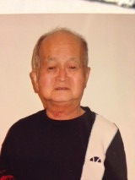
Aki Fujino

Fujino. 藤野 (Surname / family name / 苗字 / 家族名)
Noriko, 則子 (First name / given name / 名前)
Year of birth / 生年: 1931

Ancestral History? 先代やあなたは日本のどこから来ましたか？
島根県. 日本、トロント、日本、ノースベイ、オンタリオ、ドイツ
[Translation] Shimane-ken. Japan, Toronto; Japan; North Bay, Ontario; Germany

When and why did you or your family come to Edmonton? いつ、どうしてエドモントンへ来ましたか？
Jan 1971 - 主人の転勤のために
[Translation] January 1971 – my husband was transferred by his company.

Guimond (Surname / family name / 苗字 / 家族名)
Sola (First name / given name / 名前)
Year of birth / 生年: 2008

Ancestral History? 先代やあなたは日本のどこから来ましたか？
Hyogo, Japan; Quebec, Canada

When and why did you or your family come to Edmonton? いつ、どうしてエドモントンへ来ましたか？
2006 for parents' jobs.

Additional history? 個人史・家族史
I visit Japan because my grand parents are in Japan.

Guimond (Surname / family name / 苗字 / 家族名)
Taiyo (First name / given name / 名前)
Year of birth / 生年: 2004

Ancestral History? 先代やあなたは日本のどこから来ましたか？
Hyogo, Japan; Quebec, Canada

When and why did you or your family come to Edmonton? いつ、どうしてエドモントンへ来ましたか？
2006 for parent's job

Additional history? 個人史・家族史
I visit Japan because my grandparents are in Japan.

Gyoba (Surname / family name / 苗字 / 家族名)
Dan (First name / given name / 名前)
Year of birth / 生年: 1970

Ancestral History? 先代やあなたは日本のどこから来ましたか？
Unsure, however the name is uncommon enough, I'd like to trace it.

When and why did you or your family come to Edmonton? いつ、どうしてエドモントンへ来ましたか？
While I was very young, my father's job brought us to the prairies.

What were your major occupations in the past and major employers? あなたの仕事はなんですか？雇用主はどこですか？
Currently self employed. My former employer retired, and sold the business to out of province interests. Many of my clients did not get along well with the new company, so I decided to take on the work myself.

In what ways has having Japanese heritage affected the course of your life or family history? あなたが日本人または日系人であることは、人生にどのような影響があったと思いますか？
I don't believe that anything was specific to being Japanese. It is perhaps of import to note that my father was born in an internment camp during the second world war, and that has had an impact on his family dynamics as a child.
In my own life, I am of course interested in my Japanese heritage, as I am with my European and western heritage. I want my children to have a good understanding of their heritage as well.

Additional history? 個人史・家族史
As I understand, my great-grandfather's family came to Canada sometime in the early 20s. My grandmother came later in 1933, as her marriage to my grandfather had been arranged earlier. I know that they owned and operated a boarding house in Vancouver at the onset of the second world war, and a large amount of land in the lower mainland. They lost both when the family with 3 children were sent to an internment camp, first to New Denver, then to Tashme. This is where my aunt and father were born.
After the war, the family relocated to Spuzzum, BC. My grandfather worked for a sawmill there, and built a house. He lived out the rest of his life there, passing away in 1974. I spent many summers there, and enjoyed the Japanese bath my grandfather built, as well as the gardens. My grandmother stayed there until she had to stay with my uncle in Ashcroft, BC because of her health. She passed away in 1986. The family still nominally owns the house, but the building is no longer serviceable.
After finishing school in Vancouver, where my father met my mother, he worked in Ashcroft for Bethlehem copper mine. After I was born, he took a more lucrative job as a land surveyor in Edmonton. We moved first to a condominium on the east side of Edmonton, then to a house in Sherwood Park.
I attended elementary school and 7th grade in Sherwood park, then from 8th grade to graduation in St. Albert when my father started a construction business with a partner there. I moved into Edmonton itself when I began my post-secondary education, and have been here since.

Hakii, 波木井 (Surname / family name / 苗字 / 家族名)
[Moriyuki?] 壮幸 (First name / given name / 名前)
Year of birth / 生年: 1989

Ancestral History? 先代やあなたは日本のどこから来ましたか？
鎌倉市 [Translation] Kanagawa-ken, Kamakura-shi.

When and why did you or your family come to Edmonton? いつ、どうしてエドモントンへ来ましたか？
勉学（2004） [Translation] To study

Hashimoto (Surname / family name / 苗字 / 家族名)
Taro (First name / given name / 名前)

Ancestral History? 先代やあなたは日本のどこから来ましたか？
Vancouver, BC

When and why did you or your family come to Edmonton? いつ、どうしてエドモントンへ来ましたか？
Father's job situation.

What were your major occupations in the past and major employers? あなたの仕事はなんですか？雇用主はどこですか？
Edmonton Schools.
YouCan.
Edmonton Catholic Social Services.

In what ways has having Japanese heritage affected the course of your life or family history? あなたが日本人または日系人であることは、人生にどのような影響があったと思いますか？
Much wider view to the eastern culture.
Japanese cultural background has become important part of backbone of life.

Additional history? 個人史・家族史
Have been related to Japanese families in Osaka and Tokyo area at parents' generations. Have actual work experience in the Ikeda City which is a suburb of Osaka and I went through numerous difficulties to live and work with social rules and customary ideas.

Hashimoto (Surname / family name / 苗字 / 家族名)
Junichi (First name / given name / 名前)
Year of birth / 生年: n/a

Ancestral History? 先代やあなたは日本のどこから来ましたか？
City of Osaka, Osaka Prefecture, Japan

When and why did you or your family come to Edmonton? いつ、どうしてエドモントンへ来ましたか？
1977 for work = job opportunity. From Vancouver BC.

What were your major occupations in the past and major employers? あなたの仕事はなんですか？雇用主はどこですか？
Architect - Registered Member of the Alberta Association of Architects.

In what ways has having Japanese heritage affected the course of your life or family history? あなたが日本人または日系人であることは、人生にどのような影響があったと思いますか？
Japan Architect Association had a program called for sending Young Architects to Abroad in 1965. I passed the selection process by this program committee. When I applied for this opportunity in Canada, my life changed. I wanted and desired to study the western culture in Canada.
My curiosity originated from being a Japanese who was educated and trained in this field.
And, after my experience for a few years in Canadian cities, I decided to stay in Canada to pursue my profession.

Additional history? 個人史・家族史
My journey from Winnipeg, Toronto, Vancouver and Edmonton was caused by professional career seeking and opportunities.
U of Alberta started construction of a Japanese garden in Devonian Botanic Garden, I was selected as Project Architect for the University. I was given the opportunity to guide the university in order to achieve their goal. This made me more interested in travelling between two countries. In later years I had more project-related and frequent trips between the two countries. This experience created closer relationship for my family in Japan and local Canadians.

Hashimoto, 橋本 (Surname / family name / 苗字 / 家族名)
Atsumi, あつみ (First name / given name / 名前)
Year of birth / 生年: 1941

Ancestral History? 先代やあなたは日本のどこから来ましたか？
東京から来ました。エドモントンに来る前は、ヴァンクーヴァー市、その前はトロント市、その前はウィニペック市にいました。
[Translation] Came from Tokyo. Before coming to Edmonton, I lived in Vancouver, and Toronto before that, and Winnipeg before that.

When and why did you or your family come to Edmonton? いつ、どうしてエドモントンへ来ましたか？
主人の仕事の関係で動きました。 [Translation] Moved because of my husband's work.

What were your major occupations in the past and major employers? あなたの仕事はなんですか？雇用主はどこですか？
Lab technician, at University of Alberta: worked in Departments of Microbiology, Biological Science, Agriculture and finally in Biological Science.

In what ways has having Japanese heritage affected the course of your life or family history? あなたが日本人または日系人であることは、人生にどのような影響があったと思いますか？
カナダに移住する事に依って、日本の生活習慣、教育などから始まって、日本文化の面白さが年と共に判って来ました。
子供が成長するに連れて、又、新聞ラジオTV等のニュースが充分に判る様になって、興味のある本が読める様な英語力と時間が出来てから、社会的な平等というものが、性別、年齢、人種、文化的な背景、姿形（肌の色だけではなく）を超えて平等であるということが、いかに大切であるかということに、理論でなく身じかな生活の中で理解できるようになりました。これと同時に、自分自身の個人的な感性の中にある、差別と言う物を見届けることができ、いかに総ての人が（即ち自分が）平等であるということが、法的に守られる事の大事さを理解しました。
しかし、自分の考えを社会的な組織の中で表現する時間は作れませんでした。
[Translation] Because of moving to Canada, but having had my early life in a Japanese lifestyle, culture, and education, I am realizing the interesting side of Japanese culture as I get older. As my children grew, my understanding of media such as newspapers, radio programs, and TV grew along with my English skills (and free time) that allowed me to read more interesting books. I started to understand the importance of social equality that transcends sex, age, race, cultural background, and appearances (not only the skin colour) not just theoretically but in my daily life. At the same time, I was able to see discrimination within my own experience that conviced me of the importance of equality for everyone (including me) to be protected under the law. Unfortunately, I haven’t been able to make time to express my ideas through any social organization.

Additional history? 個人史・家族史
ある時点で、日本文化を知りたくて、お茶を始めました。充分に指導される先生がいらっしゃいませんでしたが、あべこべに、しきたりの枠から解放されて茶文化を問い続けられたのが幸いでした。
わたくしは、お茶を通して、他人と競うのでなく自分と向かい合うという形で学べた事が幸いだったと思います。
[Translation] At some point awhile ago, I wanted to learn about Japanese culture and took up tea ceremony. Although there weren’t teachers who could give enough instruction, I think I have been fortunate to learn and explore the tea ceremony in a way not necessarily bound by conventional practice. Through tea ceremony, I think I have been fortunate to learn that is not about competing with or emulating others, but learning together.

Hashimoto, 橋本, ハシモト (Surname / family name / 苗字 / 家族名)
Masao, 正男, マサオ (First name / given name / 名前)
Year of birth / 生年: 1995

Ancestral History? 先代やあなたは日本のどこから来ましたか？
埼玉県 戸田市 [Translation] Saitama-ken, Toda-shi.

When and why did you or your family come to Edmonton? いつ、どうしてエドモントンへ来ましたか？
勉学 [Translation] I came to Edmonton to study

What were your major occupations in the past and major employers? あなたの仕事はなんですか？雇用主はどこですか？
学生 [Translation] Student

Higa (Surname / family name / 苗字 / 家族名)
Kevin (First name / given name / 名前)

Higuchi (Surname / family name / 苗字 / 家族名)
Jean (First name / given name / 名前)
Year of birth / 生年: 1974

Ancestral History? 先代やあなたは日本のどこから来ましたか？
I am a third generation Japanese born in Peru. Immigrated to Canada back in 2003, even though I was here before as a student.

When and why did you or your family come to Edmonton? いつ、どうしてエドモントンへ来ましたか？
For school and for the opportunities this country offers.

What were your major occupations in the past and major employers? あなたの仕事はなんですか？雇用主はどこですか？
I have been working in the IT industry since 1998, and currently I am the supervisor of Network Architecture for a Utility Company.

In what ways has having Japanese heritage affected the course of your life or family history? あなたが日本人または日系人であることは、人生にどのような影響があったと思いますか？
I feel proud to have Japanese blood in myself. I do follow some of the Japanese customs and traditions. I love the people from Japan due to the fact that everybody respects everyone, no matter what color you have or where you come from.

Additional history? 個人史・家族史
I lived in Japan for one year. I played baseball for SHIDAX by signing a 1 year contract. It was just an amazing experience which I will never forget. I do have family in Japan still such as aunts and uncles, grand aunts, etc.

Hill (Surname / family name / 苗字 / 家族名)
Keita (First name / given name / 名前)
Year of birth / 生年: 1992

Ancestral History? 先代やあなたは日本のどこから来ましたか？
Yosano (Iwataki), Kyoto, Japan

Hirata (Surname / family name / 苗字 / 家族名)
Yoshiaki (First name / given name / 名前)
Year of birth / 生年: 1949

Ancestral History? 先代やあなたは日本のどこから来ましたか？
福岡県久留米市山川町。 [Translation] Fukuoka-ken, Kurume-shi, Yamakawa-cho [town].

When and why did you or your family come to Edmonton? いつ、どうしてエドモントンへ来ましたか？
１９７３年１０月にエドモントンに来ました。仕事のため。
[Translation] In October 1973, I moved to Edmonton because of my work.

What were your major occupations in the past and major employers? あなたの仕事はなんですか？雇用主はどこですか？
歯科技工士。Crown Dental Lab, Ltd.
[Translation] Dental Technician at Crown Dental Lab Ltd.

In what ways has having Japanese heritage affected the course of your life or family history? あなたが日本人または日系人であることは、人生にどのような影響があったと思いますか？
仕事の面で非常に有利でした。[Translation] It had numerous advantages in terms of my work

Additional history? 個人史・家族史
エドモントンへ来た時は独身でしたがバンクーバーで妻と出会い結婚し
子供ふたりともエドモントンで生まれ育ちました。
[Translation] I was single when I came to Edmonton but I met my wife in Vancouver where we got married. Both of our children were born and grew up in Edmonton.

Hirata, 平田 (Surname / family name / 苗字 / 家族名)
Kazuko, かず子 (First name / given name / 名前)
Year of birth / 生年: 1949

Ancestral History? 先代やあなたは日本のどこから来ましたか？
広島県呉市出身。エドモントンに来る前はバンクーバーに住んでいました。
[Translation] Born in Hiroshima-ken, Kure-shi. Before coming to Edmonton, I lived in Vancouver.

When and why did you or your family come to Edmonton? いつ、どうしてエドモントンへ来ましたか？
バンクーバーで主人と知り合い結婚して主人の仕事の転勤のため
エドモントンへ引越してきました。
[Translation] I met my husband in Vancouver where we got married. Then we moved to Edmonton because of my husband's work.

What were your major occupations in the past and major employers? あなたの仕事はなんですか？雇用主はどこですか？
主婦。１９８０年から２０１０年まで会社の経理部勤務。Crown Dental Lab, Ltd.
[Translation] Homemaker. Worked in the accounting department of Crown Dental Lab, Ltd from 1980 to 2010.

Hiratsuka, 平塚、ヒラツカ (Surname / family name / 苗字 / 家族名)
Yasuyuki, 保之、ヤスユキ (First name / given name / 名前)
Year of birth / 生年: 1933

Ancestral History? 先代やあなたは日本のどこから来ましたか？
Tokyo

What were your major occupations in the past and major employers? あなたの仕事はなんですか？雇用主はどこですか？
Canada Northern Forest Institute, University of Alberta

Hiruki (Surname / family name / 苗字 / 家族名)
Tadaaki (First name / given name / 名前)
Year of birth / 生年: 1962

Ancestral History? 先代やあなたは日本のどこから来ましたか？
Father - Fukue-shi, Nagasaki-ken
Mother - Tokyo
Me - Sagami-ohno, Kanagawa-ken
Sister - Madison, WI, USA
Wife - Tokyo
Son - Kingston, Ontario

When and why did you or your family come to Edmonton? いつ、どうしてエドモントンへ来ましたか？
Brought by my father in 1966, who got a faculty appointment at the University of Alberta during that institution's hiring boom in the mid 1960s.
Left Edmonton in 1986 to complete professional training. In the meantime, Klein-era cuts gutted my field (medical diagnostic laboratories), making it impossible to return to Alberta to pursue my career.
Moved back to Edmonton in 2006 for what seemed to be a promising professional opportunity for me, and to be able to support my parents from closer proximity than where we were (Kingston, ON). Brought my wife and son because I wanted them to have access to Japanese community resources (Japanese language school in particular) that were not available where we were (Kingston, ON).

What were your major occupations in the past and major employers? あなたの仕事はなんですか？雇用主はどこですか？
Edmonton Public Library, Southgate Branch - Page (book shelver, odd jobs)
Woodward's Food Floor, Southgate Mall - Bagger (bag groceries), then Stocker (stock shelves)
Alberta Research Council, Toshi Kaneda Laboratory - Summer Student
University of Alberta, Mike Longenecker Laboratory - Summer Student
Alberta Cancer Board, Cross Cancer Institute - Pathologist

In what ways has having Japanese heritage affected the course of your life or family history? あなたが日本人または日系人であることは、人生にどのような影響があったと思いますか？
As a Japanese (or Asian for that matter) one certainly stood out in 1960s/70s/80s Edmonton, such that even though there was no tight-knit Nikkei community, there was a sense that one had to behave and be a good example of Japanese people.
That didn't stop me, however, from getting involved in the odd schoolyard fight over racial taunts. I am generally not a fighter and doubt that would have happened had I not been Japanese.
That sort of thing was limited to my first few years of elementary school (Richard Secord School, the current home of MEJLS on Friday evenings). Perhaps I have been extraordinarily lucky, but in school beyond that and in my various workplaces, I have never perceived that overt discrimination was an issue. Everything has been respectful and merit based.
The biggest effect was on my choice of a person to marry -- somebody who values Japanese language and culture, can up the quotient of the same in our family, and who wants to be in Canada yet still maintain ties with Japan. It took a long time for me to find such a person, but eventually I did -- again, lucky!
Wanting access to Japanese community resources for my wife and child (and me!) factored into my choice to move back to Edmonton from small-town Ontario.
Since the birth of my child, we have chosen to spend one family vacation every year in Japan, meaning it will take longer for us to get through our list of other places we want to go.
As the only son of an oldest son, the matter of inheritance of ancestral property in Japan will eventually come up. It remains to be seen how this will affect the course of my life.

Additional history? 個人史・家族史
I remember getting Japanese mandarin oranges from Woodward's and Safeway at Christmastime. The boxes were bigger back in the 60s/70s/80s. A store in the 60s/70s, possibly in Parkallen, sold Glico caramels in the red box with the picture of a runner and separate small box on top that contained a toy.
Sapporo Ichiban ramen was only available in the original flavor (red package). We would receive occasional care packages by sea mail from Japan that included senbei.
There were only 2 Japanese restaurants in Edmonton in the 60s/70s: Japanese Village (still in the same place today) and Mikado (then across from the pyramid-shaped church). Later came Furusato on Whyte and Wasabi in the former Prudham's Lumber space south of Whyte; later they moved to Lendrum shopping mall.
Much of the little Japanese culture that I learned in Edmonton in the 1960s/70 was from non-Japanese people: my raku pottery teacher, my karate sensei, Erickson Datsun, Daruma Datsun.
I was in the first cohort of students in the Metro Edmonton Japanese Community School at Sherbrooke School (Ohki-sensei's class), the oldest by several years (age 16) and probably the first one to quit (after just 1 year) so I could go to work part-time at Woodward's on Friday evenings. Several years later (age 19) I would return to Japanese for one undergraduate course (only one Arts option course was allowed in my Science program) at the University of Alberta (Kawashima-sensei's class), and then much later (age 33) at Toronto Japanese Language School (Takahashi-sensei's class) after I had started full-time work.
We lived outside the city limits at that time (now the Windermere subdivision) and I thought maybe that was why my parents didn't involve our family in EJCA activities. But today when I see the dedication and effort of the people coming in from as far away as Stony Plain, Wetaskiwin, Canmore and Pigeon Lake, I realize it was not about physical distance, just a lack of desire.
We are the only branch of my mother and father's families outside of Japan. Long-distance telephone calls were expensive in the 1960s/70s/80s and thus infrequent, but my parents aren't particularly close to their families anyway, communicating mainly by blue aerograms. Only a few relatives (1 grandfather, 2 grandmothers, 2 aunts, 1 uncle, 1 cousin) ever came to Canada, all for just one short visit.
We tended to socialize only with other post-war immigrant families, usually with university connections, and sojourners from Japan. But I remember one evening going with my father to visit Dr. Henry Shimizu for some reason I don't recall. They talked in the kitchen, but I was young and shy and spent the whole time waiting in the foyer! I regret never getting to talk with Dr. Shimizu, who was a real community force, I would learn many years later.
Although I didn't know it at the time, Dr. Shimizu had a big role in bringing the taiko group Ondekoza to Edmonton for a concert at the SUB Theatre. This was a huge watershed event for Japanese Canadians to see such powerful and vital Japanese culture performed live. I also remember a show by the Kazenoko children's theatre company, also at the SUB Theatre.
As post-war immigrants, we didn't get involved in the redress movement. At the time, I thought it wasn't our fight. I was young, but now I realize it was all of ours as well as future generations.

Hiruki, 比留木 (Surname / family name / 苗字 / 家族名)
Chuji, 忠治 (First name / given name / 名前)
Year of birth / 生年: 1931

Ancestral History? 先代やあなたは日本のどこから来ましたか？
長崎県. エドモントンに来る前の住所Madison, Wisconsin, USA
[Translation] Nagasaki-ken. And then Madison, Wisconsin, USA before moving to Edmonton.

When and why did you or your family come to Edmonton? いつ、どうしてエドモントンへ来ましたか？
アルバータ大学で大学院に植物ウイルス学の研究室を創設のためにウイスコンシン大学から赴任してきました。
[Translation] I moved from the University of Wisconsin to the University of Alberta in order to establish the Plant Virology Research Laboratory.

What were your major occupations in the past and major employers? あなたの仕事はなんですか？雇用主はどこですか？
1954-65 研究員（植物病理学）日本専売公社
1963-64 Visiting Plant Pathologist University of California, Berkeley;
1964-66 Honorary Follow University of Wisconsin, Madison;
1966-1996 Distinguished University Professor, University of Alberta, Edmonton

[Translation] 1954-65: Researcher (in plant pathology) at Japan Senbai Corporation

In what ways has having Japanese heritage affected the course of your life or family history? あなたが日本人または日系人であることは、人生にどのような影響があったと思いますか？
現在小生は８２才ですが、一生は困難の連続でした。しかし、それは日本人であるからではなく、個人と個人のレベルで考慮すべき問題であるように思われます。周りの人々が心が広いか狭いかでお互いの関係はまったく違ったものになるものとおもわれます。しかし、運命論者になるべきではなく、こちらの対応次第で相手の反応も変わってくることを信じて努力を重ねるべきでしょう。
[Translation] I am 82 years old and I have had my share of difficulties. However, I believe these were not due to being Japanese in general but because of issues on a person-to-person and case-by-case basis. I believe that our relationships with others around us are completely dependant on how open- or closed-hearted we are with each other. However, rather than allowing fate to rule my life, I shall keep working hard on relationships since I believe people’s reactions would change according to my attitude about how I interact with them.

Additional history? 個人史・家族史
小生は１０年前から自分史の執筆にとりかかり、A4で約８０ページの原稿ですが、ながすぎるので、ご希望があればPDFでお送りいたします。
[Translation] For the last 10 years, I have been writing my personal history which now comprises about 80 pages.

More detail submitted in addition to survey responses.

第二の故郷カナダに生活して (比留木忠治)

エドモントンでの家族生活
家庭生活では結婚以来研究優先で貫いてやってきましたので、妻の靖子には普通の家庭以上の負担をかけてきました。１９５８年からのフルブライト資金によるウィスコンシン大学での最初の留学から元の職場日本専売公社秦野たばこ試験場に復帰しましたが、本格的な研究に打ち込むにはどうしてももう一度本場米国での研究室で思い切り研究したいとの願望が日ごとに強くなってきました。当時は出張命令があればともかく本人の意思で留学することは全く認められず、再度留学するには退職するしかなかったのです。靖子は文句ひとつ言わず、快適な社宅や家財を放棄して、スーツケースひとつで明日もわからぬ初めての土地に、当時一才の忠明を抱いてついてきてくれたのです。

真知子はウイスコンシン大学に二度目の留学中に生まれ、１９６６年エドモントン市に移住したとき、やっと１才半でした。小さいときから無鉄砲なのか４才の夏の休暇中にバンフのUpper Hot springsのプールで高いほうの飛び込み台(約３ｍの高さ)から飛び込む様子が偶々居合わせたエドモントンの競泳グループの監督の目にとまり、勧誘をうけて毎日の訓練に参加することになりました。小学校に通うようになってからは登校前に２時間、放課後２時間の市のプールでの猛訓練の甲斐があってか、中学校時代にはアルバータ州代表の一人として選ばれ、英国ロンドン市で開催された国際競技に出場して好成績をおさめて当時の州首相から表彰されたこともあります。

靖子はカナダでは子供たちが幼稚園に通う間は家庭で育児に専念し、小学校に入学とともに図書館の司書として市立図書館と大学図書館で数年ずつ働き、のちにアルバータ大学文学部東方学科で日本語講師として定年まで勤務しました。市の南端の建売り住宅で地下室が未完成の二階建てを購入し、９年住んでいる間に建材会社で組織した「Do it yourself seminar」に通って見よう見まねで地下室を完成させました。前庭に芝生を入れ裏庭の１/3を和風の庭園、2/3を家庭菜園としていままでは小説でしか読んだことのない西洋野菜とか草花を栽培して心行くまで楽しみました。庭園にはシラカバやヤナギを植え、池には噴水をつけたところ、近所中の評判となり珍客とともに参観を頼まれたこともありました。その一隅に造成したコンクリートのパチオは夏の夕暮れなどにバーベキューで家庭団欒のひとときを過ごす場所を提供してくれました。私の３０代の中頃から４０代中頃まで、ちょうど子供たちが幼稚園から高校前期までの、家族が比較的まとまって生活する時期を彩ってくれた思い出すたびに懐かしい人生の一齣でした。

１９７３年ヨーロッパでの一年の在外研究を終わって帰ったところで、市内での生活を切り上げ、郊外の郡部（Strathcona County）に移住する計画を立てました。１エーカーの原野を購入し、市立図書館に通って住宅建築について必要な技術と法律の情報を集め、独力で設計図を完成後、市役所の専門家の承認を得て、カナダ人の大工の棟梁とその配下３名に依頼して新居が完成したのは六ケ月後でした。敷地の１/３を芝生と庭園、１/３を住宅建設、残りの１/３を家庭菜園として利用しました。

郊外に移住してもっとも不便だったのは飲料水でした。水道設備がないので自分で井戸を掘るか配水トラックによる飲料水の配達を契約するしかないのです。このため住宅建築に際して容量２，８００ガロン（約１２，５００Ｌ）のコンクリート製地下タンクを２個建設し、ひとつを飲料水、他の一つを天水を集めて生活用水として利用することにしました。本来のアルバータ大学での教育と研究も多忙ではあったのですが、一日のうち半分は夏の間は広い荒地を耕し、秋から冬は暖房用に敷地内の雑木を伐採する文字通り開拓者の生活を数年にわたって味わいました。住居を建設して今年で４０年になりますが、敷地が郡部から市内に編入され、やっと市内の水道が引けるように準備をする段階にたどりついたところです。

アルバータ州は冬の寒さが厳しいので、利用できる果樹類も限られています。リンゴのような寒地向きの果樹でも耐寒性の早生種をえらばねばならず、栽培管理にはいろいろと困難がともないます。しかし、数年におよぶ試行錯誤の結果、一時は２０数本のリンゴが枝もたわわに立派な実をつけるほどになりましたが、年ごとに激しくなる都市近郊化の影響で生活圏を奪われた野生動物による被害もおおきくなり、折角成功したリンゴ栽培もヤマアラシによる突然の被害で全滅してしまいました。野菜類はショッピングセンターで簡単にできるものは避けて、アスパラガスのような高級野菜とか、ゴボウやネブカネギのような日本食に必須のものを栽培することにしました。戸外では夏でも夜温が８度Ｃくらいまで降下するので、ナスやピーマンなどは温室栽培の方が良い結果が得られます。このため手造りの半地下太陽熱温室を利用して好結果を得ました。アルバータの夏は短く、６，７，８月の３カ月間に満足な収穫を確保するためには、品種の選択、土性の検討、細心の肥培管理などが要求されます。最近では有機栽培に関する興味が一般化して、農薬や化学肥料を極力利用しない有機農業に関する関心も深くなってきました。我が家でも毎年有機質資材や野菜くず、刈り草、落ち葉などを集めて堆肥造りを続けています。

家庭における教育目標と日本語補習校通学・その成果
若い時から植物を対象とした生活をおくっているうちに、生物として植物も動物も人間もある意味では同じような反応をすることに気づきました。もっとも大事なことは対象となる相手に細心の注意を払って何が必要であるかを理解する努力が必要なことではないでしょうか。

我が家の庭には４０年前に植えたマツの苗を日本の盆栽仕立てにしたものと、カナダ式に自由に伸び伸びと育てたものがあります。日本式に丁寧に手をかけて管理したものは今なお約３メートルの高さでくねくねとしていますが、カナダ式に育てたものは樹高約２０メートルで豪壮な感じです。人によって好みは変わると思いますが、私は教育とは外から規制するのではなく、本来生得のよい特徴を注意深く見守って教師はそれを１００％ひきだすのが本来の役目であると信じています。知識は努力によって豊富になりますが、その量を誇るのではなく、賢明な判断をなす勇気の源泉でなければならないと常々考えております。したがって家庭でも基本方針としては、なるべく誤らない判断力をつけるために極力自主性を尊重し、学校の成績を上げるための手伝いは控えるように留意しました。

エドモントン地区の日本人コミユニテイスクールは１９７７年当時の少数の日本人有志者の熱心な努力によってその基礎が築かれ、多くの人たちが今なおその恩恵を受けていますが、我が家では２人の子供たちが、１9７７年から数年にわたってお世話になり、この間に培った級友との友情は成人していまは別々の社会生活を送るようになっても、今だに続いています。要は在学中に得た知識の量よりも、学習の興味を持ち続け生涯学習による持続的進歩の大切なことを自覚することではないかと思うのです。この困難な事業を始めるための基礎を築かれた勇気に敬意を表するとともに、その後４０年にわたってこの事業を続けてこられた並みならぬ努力は心からの賞賛に値すると深く信じるものです。おかげで長男忠明はアルバータ大学医学部を卒業後、カナダ東部の諸州でインターンとしての訓練後にクイーン大学医学部助教授を経て、米国オレゴン州の大学医学部やビクトリア大学医学部に勤務後、エドモントン市に帰ってCross Cancer Institute に大腸がん専門医として勤務していましたが、東京出身の女性と結婚して小学校５年の長男と３人でバンクーバー市で暮らしています。

真知子はアルバータ大学では理学部でコンピュタ・サイエンスを専攻して卒業したのですが、その後大学院で動物学を勉強した後、米国シアトル市の国立海洋生物研究所で絶滅に瀕する生物の研究にとりくみました。太平洋のアザラシの生態を観察したり、南極のペンギンや北極のシロクマを調査したりした後、現在は広報担当係りとして情報教育主任をつとめていますが、同研究所は「Silent Spring (沈黙の春）」で有名なRachel Carsonがかつて勤務したところです。同じ研究所でアメリカ人と職場結婚をして１３才の男児と９才の女児に恵まれ、シアトルに暮らしています。

エドモントンでの研究と教育生活
私は今年８４才になりますが、若いころウイスコンシン大学とカリフォルニア大学でウイルス学とバイオテクノロジーを学びました。これが機縁となって１９６６年にカナダのアルバータ大学の大学院に当時未発達であった植物ウイルス学研究室を開設することになり、その後３０年間教授として勤務しました。大学院では研究内容を公開して国際的に大学院生を募集するため、各国からの優秀な候補者を選抜することが可能です。３０年間の在職中に北米はもとよりヨーロッパ、アジア、アフリカの各国からの留学生を迎え、また各大学や研究所からの訪問研究者も多く、研究室は常に活気にあふれていました。当時の卒業生や研究生の中にはその後、大学学長や有名大学の学部長や教授職などの地位について活躍した人びともいて、その後の本人独自の努力もさることながら、優秀な若者同士が互いに切磋琢磨する重要性も痛感させられます。

１９６６年の夏着任したとき、当時の農学部長は学内の広報雑誌に新任の紹介をしてくれたのですが、その内容は「せっかく立派なpositionを我々は努力してつくったのに、カナダの学生が勉強をしてくれないので、外国人を採用になければならなかった」というもので歓迎とは程遠いものでした。募集は英国の科学雑誌Natureの広告を通じてなされたため、２００人以上の応募者があり、大変な就職難だったのです。着任第一の仕事は、園芸学の教授を通じて依頼を受けたカルガリーの園芸農家が栽培している１エーカーの温室栽培トマト１万本に発生した原因不明の生育被害調査でした。実地に調査をしてみると、原因は私が日本の大学で卒業論文のテーマとし、学位論文にとりあげたタバコモザイク病ウイルス（ＴＭＶ）による被害であることがわかりました。幸いこの研究で無毒系統のＴＭＶを選抜保有していましたので、それを提供し当時新しい概念の免疫現象を利用して次のシーズンには問題を解決することができました。この農家は大変喜んで御礼に近くのマクドナルドでハンバーガーをご馳走してくれました。あとで知人はこういうときは最初に契約を結んで仕事をはじめるべきであったと注意してくれましたが、あとの祭りでした。

おなじころエドモントンの国際空港の付近で栽培中の鑑賞植物ケマンソウ１．５エーカーの１万本が何年栽培しても花が咲かなくなったので、原因を調査して欲しいと言ってきました。これはちょうどそのころ東京大学で研究中の新病原（Phytoplasma)によるものであることが翌年わかったのですが、もちろん当時はそれとは知らず、電子顕微鏡による同じ結論の結果を米国の専門誌Phytopathologyに発表したときには、東大での研究が１９６８年の第１回国際植物病理学会議で発表されて世紀の大発見と騒がれたあとでした。しかし、その後も同じような病害がアルバータ北西部(Peace River)の牧草種子生産地に大発生し、１９９０年に我が研究室で世界初めてバイオテクノロジーの手法（ＰＣＲ）を利用した診断法を開発する機縁となりました。当時この研究で大活躍してくれた中国からの留学生Deng博士はこの研究で学位を獲得しましたが、Ottawaの連邦生物工学研究所でインフルエンザウイルスの新迅速抗血清生産法を考案して米国の医薬会社研究所に転じ、現在では上海に設立した同会社新研究所の部長として活躍しています。

カナダは寒冷な気候のためウイルス媒介昆虫が少ないので種子ジャガイモの生産に好適で特にＰＥＩ（Prince Edward Island州）はオランダについで国際的にも有名です。１９６６年に着任のとき以来アルバータの気候的ならびに地理的条件を活かして無病種子ジャガイモ生産のシステム構築に努力し、この研究で１９９４年Alberta Science and Technology Leadership Awards に指名されました。ジャガイモＭウイルスの新生物検定法や電子顕微鏡によるその抗ウイルス機作の研究が認められ、ノールウエー学術会議とトロムソー大学やポーランド農務省の招待による国際シンポジウムに出席したこともあります。この研究はその内容がカリフォルニア大学で学位論文のテーマとして取り上げられ、その結果は教科書に採用されるほどに発展しました。１９９０年にはこれらの業績を評価され、王立学士院（The Royal Society of Canada)の終身会員として認証されました。

Peace Riverの牧草種子生産地帯はカナダの主要牧草生産地としてだけでなく、ハチミツ生産地としても農業上に重要な地位をしめています。１９６６年着任以来、夏は牧草生産の重要な時期であるため、ほとんどの時間をこの地域での研究に費やし、１９８１年には新ウイルスsweet clover necrotic mosaic virusを発見しました。このウイルスは高感度のmonoclonal antibodyを作成してその後３０年以上全世界の各地で発生したウイルスと注意深く比較検定を続けていますが、いまだに同種ののウイルスは発見されず、Peace River を中心とするアルバータ州の北西部から中部に及ぶ農業地帯だけに特異的に発生するものです。１９９６年カナダ植物病理学会では牧草のウイルスに関するシンポジウムを開催し、国際植物病理学会長Hamilton博士に講演を依頼しました。その講演のなかで、博士は過去２０年の統計をとってみると、全カナダで発表された牧草ウイルスに関する研究論文の約４７％は比留木研究室からのものであり、この記録は将来も破られることはないであろうと言明されました。

これらの業績はその年の学会特別賞（グランプリ）の対象となり、晩餐会に際して発表されました。アルバータ大学からは１９８８年にArthur Gilbert Maｃcalla professorshipを，１９９１年に Distinguished University Professorshipを、１９９４年には Kaplan研究賞を受賞しました。また１９９７年にはパリ大学から博士号審査委員として招聘を受け、その審議のためパリに赴きました。着任当初のアルバータ大学との契約は大学院での教育と研究だったのですが、学部で園芸植物病理学も担当してくれないかと依頼され、以後３０年楽しんでこのコースを教えました。このコースは園芸学専攻のためのものでしたが、私の講義に出席した専攻生の中から幾人かの植物病害のdiagnostician が生まれ、なかにはもっと専門的な勉強を続けたいと大学院専攻に切り替えて２人の植物病理学の博士と１人の修士がでました。また大学院を終了後現在大学教授として活躍している卒業生が４人おります。

アルバータ大学にはカナダ産植物を主体とした日本庭園が附置されており、大学初の日本人卒業生栗本雄一博士に因んで、栗本日本庭園とよばれております。その一隅に元厚生大臣小沢辰雄氏の寄付による本格的な茶亭があり、この設備を利用して松風会（元代表橋本あつみさん）が、茶の湯グループとして茶の湯文化紹介のボランテイア活動に熱心に従事し、週末に市内の各地やときには国外から来られる多数の来園者によろこばれておりました。たまたま私がツバキ事業に関係しているところから、このグループに茶の湯に欠かせない茶花のツバキがカナダでは手に入らないので何とかならないだろうかと相談を受けました。幸い研究に関連して植物の輸入には経験がありましたので、早速カナダ政府から植物輸入許可証の交付を受け、五島のわが家の庭木の中で生育の良いツバキの切り枝を挿し木することから始めました。その後の育成には大学の温室を利用して各人が交代で灌水などをおこなっているので、ツバキ技術もめきめきと進み、ツバキに対する興味と知識が深くなるにしたがって、カナダでツバキ愛好会を結成する機運も次第に出てきたようです。

松風会には８人のボランテイア活動に熱心な会員がおり、週末には市外にある栗本日本庭園を訪れる多数の市民の皆様に茶室の畳の上で茶の湯の作法により日本のお茶を提供しています。寒冷な気候では、一般の市民はツバキを一度も見たこともなく、冬に咲くバラのような花ということでツバキに対する興味が集まり、実物を展示して解説を交えた講演会を何度も開きました。春の終わりになると小学校から低学年の学童たちが一斉に見学旅行にやってきます。ツバキに対する好奇心も強く、様ざまな質問がよせられます。そこで、解説用にツバキに関する情報をまとめたポスターを作成したところ、判りやすいと皆さんに喜ばれました。

定年後の生活と今後
６５歳の誕生日をすぎて２週間後に定年退職を控えて勤務先の有志の方たちが私のために退職記念パーテイを開いてくれました。旧知の人々に通知を出したところ、驚いたことに数千キロも離れた遠隔の地からまで、中には家族をつれて参加してくれた教え子たちもふくめ、公私にわたって多数の方々が集まってくださり、ヨーロッパやアジアの国々からも真心のこもった退職の祝意と激励のお手紙をいただきました。その中に１冊の「Ferry Tales」と題する小型の本がありました。「ここにノヴァ・スコシアの一漁村で育った私の少年時代のことを記した小冊を同封します。貴方と私が育った文化環境は違っても、田舎に育った少年時代の経験にはおそらく似たものがあることでしょう。貴方がこの本を楽しまれることを祈ります。（後略）」と添え書きがありました。著者はブレア・マックニール博士。トロント大学を首席で卒業した秀才で、グエルフ大学の教授を私より数年前に定年退職後、自分史の執筆に取り掛かり、出来上がった本には１３４ページのなかに７３の興味深い挿話がおさめてありましたが、いずれも彼の郷里ロング・アイランド島での生活に関する思い出を綴ったものです。

私は長崎県五島列島にある五島市で農家の長男として生まれ、小学校の頃から歴史が好きで、将来は歴史学者になることを夢にみていましたが、高校で進学指導の先生に「農家の息子は農学部に行け」と諭されて、農学部で植物病理学を専攻しました。いわば植物医者です。定年後、本来の興味を活かして日本歴史学会に入会し、約１０年間五島の郷土史を研究して、「ある偶然」と題する史話にまとめて東京の文芸社から上梓しました。１０００部初版として印刷したものは約２年で売り切れました。続いて２年後に「南の風・北の風」と題した随筆集を同じく文芸社から発刊したところ、思いがけず今回現代日本文芸作家大賞を受賞の栄に浴しました。約８年前から自分史「蒼海の道」の執筆に取り掛かっています。まだ完成には程遠い感じですが、米寿まで生き延びることができれば、その頃には出来上がるだろうと楽しみにしています。

定年後全世界５８ケ国約３万人の会員を擁する国際植物病理学会の財務・企画担当の役員(Treasurer)に選出され、１２年にわたって国際事業に関与しました。この間ヨーロッパ・北米・南米・アジア・アフリカ・大洋州など各国の人たちと幅の広い交流があり、持続的な人間関係を築くことができました。２００８年にはイタリーのトリノ市で開催された弟９回国際植物病理学会議において国際植物病理学会の名誉会員として表彰されました。これは学会最高の名誉とされているものです。
続いて２７ケ国から２千人の会員によって構成される国際ツバキ協会の副会長に２００７年に選出され、６年にわたる任期を終えたところです。

私が現職時代に五島で採取した種子から育成した約５０本のツバキの成木と観賞用品種の苗約５０本は、アルバータ大学の温室に保存されていました。維持の費用はすべて 大学の規定に従って私の口座から支払っていたのです。２０１２年大学当局からその整理の申し入れがありましたので、急きょ大学当局者と相談のうえすべてを三分して、栗本日本庭園附属温室、エドモントン市観賞植物温室、および最新の設備のホールズ温室（昔の教え子が社長として経営）に引き受けてもらえました。 伸びすぎたツバキの枝をきりとり、トラックによる運搬を容易にするために主幹を２メートルに切り縮め、エレベーターで温室の荷物積み込み口まで運ぶ間も、まるでわが子を嫁におくりだすような気持を味わいました。手分けをして送りだしたツバキはそれぞれの落ち着き場所を得てすくすくと育っており、将来が楽しみです。

松風会元代表の橋本さんは、ご主人とともに長い間エドモントンにお住まいで、大学の理学部で研究補助員として勤務されていましたが、定年退職後バンクーバー市に引退されることになり、これを機会に前に栗本日本庭園温室に寄贈したヤブツバキの一部がバンクーバー市にあるブリテイッシュ・コロンビア大学植物園に寄付され、大学構内にある新渡戸記念庭園に植栽されることになりました。これについては受け入れ側として、園長のパトリック・ルイス博士と副園長のダグラス・ジャステイス博士、および所員スギヤマ・リョウさんの熱心な協力の賜物といわねばなりません。エドモントン市と違い、太平洋に接するバンクーバー市は温暖な気候に恵まれているので、ツバキはバンクーバー市内の個人庭園にはあちこちに植栽されているもののまだ珍しく、公立の植物園にはまとまったコレクションとしては収集されていないため貴重な植物として受け入れられ、これから来園者を喜ばせることは疑いないとのことでした。エドモントンの三カ所に移されたツバキを訪ね、お世話してくださる方々にもお目にかかって、今後の取り扱い方についても詳しく話し会いました。今後ツバキを通じて相互の交流が一層盛んになることを祈っております。

世界的な傾向として、今ツバキ産業界には新しい風が吹き始めたようです。ヨーロッパ各国の中でも、スペイン、イタリー、スイスでは挿し木によるツバキ苗の増産にますます拍車がかかってきました。ツバキ苗を室内植物として装飾用の鉢物や切り花として利用する需要が年々伸びてきているそうです。日本では庭園木として観賞してきたツバキをせいぜい盆栽にするのが普通ですが、冬の厳しいヨーロッパの国々では本来戸外の多年性植物であるツバキを、冬の室内植物として鉢植えにして楽しむ習慣が根付いてきました。日本では伝統的に梅雨期の庭園植物として取り扱ってきたアジサイを、カナダでは鉢植え植物として一般にクリスマスの室内植物として用いるようになったことを考えると、厳寒のため戸外で栽培できないツバキでも、今後室内植物として観賞する可能性は極めて高いと言わざるをえません。近年ではツバキの野生種との交配により、周年咲きの新品種も入手できるようになりました。花の色、形、豪華さからいえば、ツバキは室内植物としての理想的条件を備えています。我が家でも８年前に始め、自宅の室内で育てた実生苗に２年前から美しい花が咲くようになりました。 世界的に大都市集中の傾向はますます増大し、これからアパートやマンションなどの集合住宅で生活する若い家族がふえるにつれ、ツバキはこれまで以上に人々に愛され、新しい生活形態の中で豊かに利用されていくのではないでしょうか。

[English translation]
Living in my Second Home Town by Chuji Hiruki
Family life in Edmonton
In 1958, I studied abroad on a Fulbright scholarship at the University of Wisconsin. When I went back to Japan, I was reposted to my former research job at Hadano Tobacco Experimental Station at Nippon Senbai-kosha (Japan Monopoly Corporation). Though I knew my job was taking a priority in my life and I was imposing a heavy burden on my wife, Yasuko, compared to other households, I wanted to immerse myself in research. In order to do this I realized I had to go back to the United States. I quit my job and Yasuko gave up a comfortable living in a company-owned house. I moved my faithful wife and one year old son, Tadaaki, to a new country, not knowing what our future held.
Our daughter, Machiko, was born while I was studying at the University of Wisconsin for the second time. When we moved to Edmonton in 1966, she was only a year and half. I must say she has been an adventurous child since she was little. One day, when she was four years old, she was jumping off from the higher jumping board (approximately 3 meters high) into the Upper Hot Springs pool in Banff during the summer break. The coach of a competitive swimming group in Edmonton just happened to be there and she caught his attention. She was scouted and joined their morning practices every day. Once she became elementary school age, she practiced two hours each before and after school in a public pool. When she was in a junior high, she was chosen for the Alberta provincial team and participated in an international competition held in London, England. She did well there and received an award from the premier of Alberta.
Yasuko concentrated entirely on raising our children until they started elementary school. Then she began working as a librarian at a city library and later, a university library for several years. From there, she made the transition to teaching at the University of Alberta, as a lecturer in Japanese language in the Department of Eastern Studies.
We purchased a ready-built house with an undeveloped basement in the south side of Edmonton and lived there for 9 years. During that time, I attended a “do it yourself” seminar organized by builders and was able to finish our basement by watching others and following their examples. I installed new sod in the front yard and started a Japanese garden in 1/3 and vegetable garden in 2/3 of the backyard. We thoroughly enjoyed growing western vegetables and flowers which we only read about in books before. We also planted white birch and willow trees. When I added a fountain in the garden, it became the talk of the neighbourhood and we received some unexpected visitors. In the corner of our yard, we built a concrete patio which provided us a place to enjoy family time and BBQs in the summer. During my mid-30s to 40s, our children went through kindergarten to high school, so we were able to spend quality time together as a family. I still miss those good old days with my family.
In 1973, when I came back from my one-year overseas research trip in Europe, Yasuko and I decided to start a new chapter in our lives and move to the outskirts of city in Strathcona County. We bought one acre of uncultivated field and gathered all necessary information on building techniques and county bylaws for residential buildings by frequenting public libraries. After completing a blueprint myself, I obtained approval from a specialist at the county office. Then, we contracted a Canadian master carpenter and three of his workers and our new house was built six months later. We divided our land into 1/3 for lawn and garden, 1/3 for the house, and 1/3 for a vegetable garden.
The biggest inconvenience in establishing our new home was the lack of available drinking water. There was no plumbing system in our area and we had no choice but to either dig our own well or contract a water delivery truck for our drinking water. We ended up deciding to build two 800 gallon (12,500 litres) underground tanks, and used one for drinking water and other for domestic use from collected rain water.
Even though I was very busy teaching and researching at the University of Alberta, I spent half of my days cultivating our large land in the summer and cutting and collecting fire-wood for the fall and winter. I literally experienced a pioneer’s life for several years. It has been 40 years since we built our house. Our land has been incorporated into the city from the county, and finally, a plumbing system is being prepared to be extended to our house from the city of Edmonton.
Winter in Alberta is very harsh, so the selection of fruit trees is very limited. Apple trees are suitable for cold regions but we had to specifically choose an early maturing variety. There is considerable difficulty in cultivation management here. However, after several years of trial and error, we were able to grow over twenty trees full of apples. Unfortunately, we have started to see increased damage to our trees caused by wild animals, like porcupines, which have lost their habitat because of the results of intensified urbanization activities. One year, we had our apples completely destroyed by porcupines. In our garden, we planted expensive vegetables like asparagus and vegetables for Japanese cooking such as burdock roots and Welsh onions, and have avoided planting vegetables we can easily buy from local grocery stores. Because the temperature goes down to 8 degrees Celsius even during the summer, growing eggplants and green peppers in a greenhouse produce better results. I made a semi-underground solar greenhouse with good harvesting results. Alberta’s summer is very short; therefore, in order to get a sufficient harvest within three months: June, July and August, appropriate soil selection and prudent fertilization management are required. Recently, there has been an increased interest in organic cultivation without the use of agrichemical or chemical fertilizers. Our family has been making compost by collecting organic materials, vegetable scraps, mowed grass, and fallen leaves.

Educational goal at home and attending the Japanese language supplementary school and its result
As I have spent my life growing plants since young age, I have realized that, in a certain sense, all plants, animals, and humans have many things in common. The most important thing is that one needs to pay utmost attention to figure out what is necessary for the specific subject.
In our garden, we planted pine seedlings 40 years ago. One grew in the Japanese Bonsai style and the others grew freely. The Japanese style receives a lot of meticulous care and is still 3 meters tall with its twisting branches. On the other hand, the free growing trees are now around 20 meters tall and looks magnificent.
I understand everyone has a different preference for education. I think education should not be restricted externally. A child’s original and self-acquired characteristics should be observed carefully and a teacher’s primary role is to bring out 100% of the child’s own characteristics. Knowledge becomes richer with one’s own effort. However, I believe knowledge should be the source for courage to make wise decisions instead of boasting about one’s volume of knowledge. Therefore, as a fundamental guidance at home, we made every effort to respect our children’s independence, so that they can make decision for themselves, and paid extra attention to refrain from helping our children with their studies as much as possible so they would appear good in their grades at school.
In 1977, the Japanese Community School in Edmonton was founded and built by a handful of volunteers’ studious efforts, and today still, many people continue benefitting from their efforts. Our two children studied there for several years from 1977. Friendships with their classmates grew during those years, and still continue even though they are older with different social lives.
My point is that I think maintaining one’s interest in learning and realizing the importance of continuous development through lifelong learning are more important than the volume of knowledge acquired while in school. I would like to express my admiration for the courage of those who started and built up the foundation, and I deeply believe their extraordinary effort to continue this project for 40 years, should be commended. Thanks to their efforts, our eldest son, Tadaaki graduated from the Faculty of Medicine and worked as a resident doctor in several provinces in eastern Canada. After his residency, he became an assistant professor in the Faculty of Medicine at Queens University. After working in the Faculties of Medicine at the University of Oregon and the University of Victoria, he came back to Edmonton. He was working as a doctor specializing in colorectal cancer at the Cross Cancer Institute. After marrying a Japanese woman from Tokyo, they moved to Vancouver and live there with their son who is now in the grade five.
Machiko majored in computer science in the Faculty of Science at the University of Alberta. After studying zoology in graduate school, she engaged in the research of animals facing extinction with the U.S. Fish and Wildlife Services. After observing the ecology of seals in the Pacific Ocean and studying penguins in South Pole and Polar bears in the North Pole, she now is a manger of information technology education and in charge of public relations. Dr. Rachel Carson, the author of “Silent Spring”, used to work at this office. Machiko married an American man who worked at the same institute and they are blessed with two children; a 13- year old boy and 9- year old girl and currently live in Seattle.

Life with Research and Education in Edmonton
I turned 84 years old this year. I studied virology and biotechnology at the University of Wisconsin and the University of California. The plant virology research laboratory was opened at the University of Alberta, Canada in 1966. Because of my background education, I worked there as a professor for 30 years. In graduate school, we are able to choose excellent candidates from different countries because they recruit prospective students by unveiling research contents. During my 30 years of tenure, I welcomed many international students from North America, Europe, Asia, and African countries, and also had visiting researchers from many universities and institutes. Our research laboratory was filled with a vibrant atmosphere. Some of the graduates and researchers I worked with are now university presidents, deans or professors of famous universities. I admire their individual efforts in their accomplishments. However, even more than that, I keenly feel the importance of friendly competition among excellent young people.
When I arrived at my post in the summer of 1966, the dean of agriculture wrote an introduction of me as the newly appointed post in the university PR magazine. He said, “Despite the fact that we put in an effort to create a respectable position, we had to hire a foreigner because Canadian students don't study hard enough.” This fell far short of a welcoming notice. They had advertised internationally for this position in the science magazine called Nature in the United Kingdom and there were over 200 applicants. I must say, it was highly competitive. My first work, requested by a horticultural science professor, was to investigate unknown growth damage that had occurred on 10,000 tomato plants which were grown in a one acre greenhouse by a horticultural farmer in Calgary. When I arrived at the location, I realized that the damage was caused by the tobacco mosaic virus (TMV) which my doctoral thesis happened to be on. Fortunately, I still possessed a specially selected non-virulent strain of TMV through my research. I was able to utilize the immune phenomenon, which was a new concept around that time, and solve the problem by next season. The farmer was very pleased and bought me a hamburger at nearby MacDonald’s. It was not until after the fact that my friend suggested that I should have had a contract before starting my investigation.
At just about the same time, I was also approached and asked to investigate why 10,000 bleeding heart plants on 1.5 acres of land near the Edmonton International Airport had never bloomed, even though they had been growing for many years. The University of Tokyo was in the middle of researching a new pathogen called Phytoplasma. Coincidentally, one year later, I also found that a new pathogen called Phytoplasma was causing the damage to the Bleeding Hearts. By the time my results on Phytoplasma were published in the American journal, “Phytopathology”, the researchers at the University of Tokyo had released their findings at the first International Congress of Plant Pathology in 1968 and it was considered to be the scientific breakthrough of the century. Similar large outbreaks of the disease had occurred on pasture seed production areas in Alberta’s Peace River district. This triggered the development of a biotechnology diagnosis method in my laboratory by utilizing the polymerase chain reaction (PCR), which was considered to be the first in the world. Dr. Deng, a student from China, played a very active role and received his doctoral degree through this research. He designed a new rapid antiserum production of the influenza virus at the Federal Biotechnology Institute in Ottawa and moved to the research institute of an American pharmaceutical company. Now, he is playing an active role as the director of a new research institute established in Shanghai by the same company.
There are few virus-transmitting insects in Canada because of its cool climate. Therefore, growing conditions are suitable for the production of seed potatoes. Seed potato production in province of Prince Edward Island is especially well known and is ranked as the second highest in the world after Holland. Since my post in 1966, I have put in my best effort to build a production system for disease-free seed potatoes by utilizing Alberta’s climate and geographical advantages. Through this research, I was nominated for the Alberta Science and Technology Leadership Awards in 1994. My research for the new bioassay method for potato virus M and its anti-virus mechanism using the electron microscope was recognized and I have been invited to attend international symposia by the Science Council of Norway, the University of Tromso, as well as the Ministry of Agriculture and Rural Development of the Republic of Poland. The concept of this research was used for academic dissertation at the University of California, and as a result, it began to be incorporated into textbooks. In 1990, I was recognized for these achievements and inducted into the Royal Society of Canada as a fellow (permanent member).
Forage seed production area in the Peace River region is recognized as a key production area for the forage production as well as the honey production from the agricultural point of view. Since my post in 1966, I spent most of my researching time in this area because the summer is an important season for forage production. In 1981, I discovered a new sweet clover necrotic mosaic virus. Using this virus, I and my associates produced a highly sensitive monoclonal antibody. Since then, I conducted careful comparative testing on viruses emerging all over the world for over 30 years, but I and others haven’t yet found the congeneric virus species. Therefore, this specific virus is only found in the agricultural areas in northwest and central Alberta centering on Peace River. In 1996, the Canadian Phytopathological Society held a symposium regarding forage viruses and asked Dr. Hamilton, the president of the International Society for Plant Pathology, to present a lecture. In his lecture he declared that 47% of all forage virus research papers submitted from all over Canada for the last 20 years came from the Hiruki lab, and this record would likely not be broken in the future.
These achievements were nominated for the Society’s grand prize, and the announcement was made at the dinner party. I received the Arthur Gilbert McCalla Professorship in 1988, the Distinguished University Professorship in 1991, and the J. Gordin Kaplan Award in 1994 from the University of Alberta. In 1997, I was invited to sit as a committee member for doctoral examination by the University of Paris and traveled to Paris for its deliberation. Initially, my contract with the University of Alberta consisted of educational and research activities.in the Faculty of Graduate Studies. However, as I became established within the lab, I was asked to teach horticultural plant pathology for the Faculty of Agriculture, and I did so joyfully for 30 years. This course was mainly offered for students who were majoring in horticulture; however, some of students who took my course, became plant disease diagnosticians. Some of them chose to continue their study in a more specialized area in plant pathology and switched to graduate school. Two of them received PhD in plant pathology and another received a Master of Science degree. In addition, there are four graduates who are currently playing active rolls as professors at the universities after graduating from graduate school.
The University of Alberta has an annexed Japanese garden utilizing Canadian native plant species. The garden is called Kurimoto Garden, named after Dr. Yuichi Kurimoto, who was the first Japanese national to graduate from the University of Alberta. In one corner of that garden, there is an authentic pavilion donated by the Honourable Tatsuo Ozawa, the past minister of the ministry of Health, Labour and Welfare of Japan. Matsukaze Chanoyu Association (past representative Mrs. Atsumi Hashimoto) has been passionately engaged in introducing the Chanoyu culture to visitors to this facility. Tea offerings held on weekends have enjoyed by many visitors to the garden from all over Edmonton as well as foreign countries. Because I was involved in the camellia tree project, this group sought my advice on how they could obtain camellia flowers because there weren’t any in Canada. The camellia flowers were essential to Chanoyu/tea ceremony. Fortunately, because of my experience importing plants for my research, I quickly received a permit from the Government of Canada to import camellia. I started by using the healthy cuttings from trees in my garden in Goto, Japan. I cultivated them in the university greenhouse and each member took turns to water these cuttings and their skills in taking caring for the camellia seedlings. As their interest and knowledge in the trees grew deeper, the idea of forming a camellia society amongst themselves started to gather momentum.
There are 8 enthusiastic members who are devoted volunteers in our Matsukaze Society. They offer weekend visitors to the Kurimoto Japanese Garden, Japanese tea in the style of a traditional Japanese tea ceremony on tatami-mats. The general public has never seen camellia flowers because of the local cool climate. People have started to show an interest because these flowers are like roses that bloom during the winter. We held many lecture presentations which exhibited fresh branches and explanations. Around the end of every spring, elementary school students visit the garden on school trips. They show deep curiosity and ask various questions; so, for them, we made a poster of information on the camellia and they were delighted because it was easy to understand.

Life after retirement and hereafter
Two weeks after my 65th birthday, as I was awaiting my retirement and volunteers at my work held a retirement party for me. When they invited my old friends, surprisingly, many came to my party. Some came from several thousand kilometers away and some former students came with their families. I also received sincere letters of well-wishing and encouragement from Europe and Asia. Among those letters, there was a small size book titled, “Ferry Tales”. With it was a note saying, “I have enclosed a booklet which I recorded my childhood memories as a boy growing up in a Nova Scotia fishing village. You and I grew up in different cultural backgrounds; however, I believe we must have shared similar boyhood experiences as we both grew up in the country side. I hope you enjoy reading this book (the rest omitted).” The writer was Dr. Blair McNeill. He was a brilliant student and graduated as a top student from the University of Toronto. After retiring from the University of Guelph, several years before my own retirement, he began writing his story- a 134 page book of 73 very interesting episodes of memories of his life in Long Island.
I was born as the eldest son in a farming family in Goto city, Goto Islands, Nagasaki prefecture. I have always liked history ever since I was in a grade school and dreamt of becoming a historian. However, during my academic and career counseling meeting in high school, my teacher persuaded me to enter into the agricultural field because I was a son of a farmer. Therefore, I majored in plant pathology in the Faculty of Agriculture at the university. Basically, I was a plant doctor. After retiring, I joined the Society of Japanese History to pursue my original interest in history, and researched the local history of Goto Islands for 10 years. I wrote a historical anecdote titled, “Historical Anecdote, Synchronicity” which was published by Bungeisha Co. Ltd. in Tokyo. One thousand copies of the first edition were sold out in two years. Subsequently, two years later, as my collection of essays entitled, “South Wind, North Wind” came off the press, I had the honour of unexpectedly receiving a Modern Japanese Literary Writers Grand Prize. I started my personal autobiography called, “A Path of Blue Ocean” eight years ago. It feels like it is a long way from completion; however, I do look forward to completing it if I live to celebrate my “Beiju (eighty‐eighth)” birthday.
After retiring, I was elected to be a Treasurer in charge of finance and planning at the International Society for Plant Pathology, which has approximately 30,000 members from 57 countries, and has been involved in international projects for 12 years. During that time, I met with people from Europe, North America, South America, Asia, Africa and Oceania and was able to continue the close relationships. In 2008, I was recognized at the 9th International Congress for Plant Pathology in Torino, Italy, as an honorary member of the International Society for Plant Pathology, the highest honour of the society. Subsequently, in 2007, I was elected as vice president of the International Camellia Society which has 2000 members from 27 countries and I have fulfilled my 6 year term.
50 adult camellia trees grown from seeds as well as approximately 50 varieties of seedlings I collected in Goto while I was working there, were kept in the green house at the University of Alberta. The costs of maintaining these seedlings have been paid from my fund. Unfortunately, in 2012, I was notified by authorities of the university to clear those plants. In haste, but in mutual agreement with the authorities of the university, all the seedlings were divided into three parts and were donated one to a greenhouse in the Kurimoto Japanese Garden, the second to the Edmonton Muttart Conservatory and the last to the Hole’s Greenhouse facility. We had to cut the long camellia branches and shorten the trunks down to 2 meters in order to facilitate easier to transport by a truck. It felt like I was sending off my daughter while we moved them to the loading entrance of the greenhouse by the elevator. The trees have settled at each place and are growing well. I’m excited for their future.
Our past representative of Matsukaze Chanoyu Association, Mrs. Hashimoto lived in Edmonton with her husband and worked as a research assistant in the Faculty of Science. When she moved to Vancouver, B.C. after her retirement, and by taking this occasion, part of the Camellia japonica that were donated to the Kurimoto Japanese Garden, were further shared with the UBC Botanical Garden and Centre for Plant Research in Vancouver. They will be cultivated in the Nitobe Memorial Garden which is located at the university. It was wonderful news! It is because of the combined efforts of the director of Botanic Garden, Dr. Patrick Lewis; the associate director, Dr. Douglas Justice; and curator, Mr. Ryo Sugiyama that this was able to come to pass.
The city of Vancouver is on the pacific coast and its warm climate is different from that of Edmonton. Though camellia trees were grown in several private gardens in Vancouver, they were rare. Public botanical gardens still did not have large collections of camellia, and so they were welcomed as valuable plants and will, without a doubt, be pleasing to visitors in the future.

I also visited the three places where three groups of camellia were moved. I met with the caretakers and discussed their future care in detail. I hope our relationship through the camellia will become more active in the future.
It seems like a global trend is starting to spread in the camellia world; especially among European countries such as Spain, Italy, and Switzerland that have expedited the increased production of camellia seedlings. It seems the demand for the seedlings grown in ornamental indoor pots or as cut flowers is growing every year. In Japan, people have enjoyed the ornamental plants in the garden or for Bonsai. However, in European countries with colder winter climates, the custom of converting perennial plants into potted plants for indoor pleasure has found deep roots. Hydrangea, too, were traditionally treated as garden plants during rainy season in Japan, but are now used as potted indoor plants during the Christmas season in Canada. I must say that the possibility of the camellia being appreciated as indoor plants is extremely high because they possess the ideal qualities of flower colour, shape, and splendor. Recently, year around blooming camellias were bred by crossing with a wild version of the species. I started growing camellias from seeds, in pots, eight years ago and they started to broom two years ago. As society continues to trend toward urban centralization and number of young families living in apartments or condominiums increases, I think camellia will be loved by people more than ever and richly utilized in their new lifestyle.

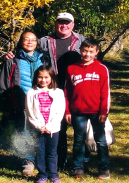
Daughter, Machiko and her family in Seattle. 娘の真智子さん家族、シアトル

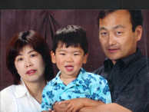
Son, Tadaaki and his family in Vancouver. 息子の忠明さん家族、バンクーバー

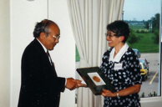
カナダ植物病理学会特別賞受賞の筆者

Hoya, 保谷、ホヤ (Surname / family name / 苗字 / 家族名)
Natsumi, 夏未,ナツミ (First name / given name / 名前)
Year of birth / 生年: 1987

Ancestral History? 先代やあなたは日本のどこから来ましたか？
Tokyo, Nishi-Tokyo-shi [West Tokyo]

When and why did you or your family come to Edmonton? いつ、どうしてエドモントンへ来ましたか？
Studying English

What were your major occupations in the past and major employers? あなたの仕事はなんですか？雇用主はどこですか？
Restaurant server

Hoyano (Surname / family name / 苗字 / 家族名)
Jim (First name / given name / 名前)
Year of birth / 生年: 1943

Stories of Our Seniors 3: Jim Hoyano by Jim Hoyano
My parents were born and raised in Hammond (in the Maple Ridge area), British Columbia. Along with over 2,000 other Japanese, they chose to come to the sugar beet fields in southern Alberta so that the family could stay together on Smith Farm (other Japanese families on Smith Farm included the Matsune family) during the evacuation of Japanese-Canadians from the B.C coast.
When my family was still on Smith Farm, I was born in Lethbridge, Alberta in 1943 at Saint Michael’s Hospital. I don’t remember anything about our stay on the farm, only from photos.
After the war ended in 1945, the family moved to a farm near Taber, but after 6 months decided farming was not for them, so we moved to Coaldale, a town 10 miles east of Lethbridge on Highway #3 in 1946. That was where I grew up and lived until I left home to go to the University of Alberta in Edmonton in 1963.
I grew up in Coaldale playing baseball, hockey, basketball, golf and curling, and going to school in my spare time. When I started Grade 1, I only spoke Japanese because I was brought up by my maternal grandmother while my mother went to work. My Grade 1 teacher was Sophie Ito who married one of the Iwabuchi brothers and now lives in Edmonton. And my Grade 2 teacher was Diane Nagata, now Diane Nawata, Aki Nawata’s wife. After 12 years of school in Coaldale, I graduated from high school in 1962, more than 50 years ago. My brothers Ken and Allan and sister Joy were all born in Coaldale and lived there until they finished high school.
After taking my first year of university in Lethbridge, I came to Edmonton in the fall of 1963. I had never been to Edmonton before I came up in August of that year to look for a place to live. Edmonton in those days had very few high rise buildings and the tallest building on campus was the newly built Education Building. The University of Alberta had a student population of about six thousand, compared to more than thirty-five thousand now.
I lived in Edmonton from the fall of 1963 to September 1971, and during that time the following took place:
- Attended the University of Alberta for 8 years and received 2 degrees in1966 & 1971 in chemistry.
- Married Yumiko in 1969 after our first meeting in the chemistry department in late 1964.- First trip to Japan in July 1971: Hokkaido, Tokyo and Kyoto

In September 1971, we went to California for a little over 2 years on a postdoctoral fellowship from the National Research Council of Canada. I was at Stanford University which is about 30 miles south of San Francisco on the peninsula. So for two years we never saw any snow. We lived in the city of Mountain View before computers and the internet became common people’s daily fife. But the area around there was already known as Silicon Valley because of all the high tech companies in the area starting in 1956. Hewlett-Packard was the big company there. I think Steve Jobs, the founder of Apple was still a high school student there. Now Mountain View is the headquarters for many IT companies such as Google.
When we left Edmonton in 1971, there were no Japanese restaurants in the city. I think Mikado opened during the period we were away. Mountain View even had a Japanese restaurant within walking distance from our apartment, and San Jose, the city beside Mountain View, had a Japan Town. There was a Japanese supermarket about a 5 minute drive from our place. There was a nice authentic Japanese garden in Saratoga, another city adjoining Mountain View. In the whole Bay area you didn’t have to go far to find a Japanese restaurant or a Japan Town. You have to remember that up the peninsula from San Jose to San Francisco a distance of about 50 miles, is like one continuous city.
We enjoyed the great climate there, but if it got too hot, we could always go to the City as the locals called San Francisco where it was always cool all year round. Golden Gate Park, Japan Town and Fishermen’s Wharf were places we visited regularly. The modernization of Japan Town was just beginning in the early 1970s. Tourism from Japan was still 10-15 years away.
During our 2 year stay in California, we had many visits from people we knew from Alberta and Japan: my relatives, Mr. and Mrs. Shimizu, Yumiko’s parents, friends returning to Japan, and a friend from Japan, whom we met in Edmonton, came on his honeymoon and stayed with us!
In late 1973 we moved to Vancouver and stayed for 3 and a half years. During this time I was at the Chemistry Departments at UBC and Simon Fraser University. Our daughter Dee was born in Vancouver in 1974. We really enjoyed our stay in Vancouver with all the great events, parks and restaurants. In the first year it seemed like it rained continuously for 6 months. But after the first year we hardly noticed if it was raining; we just went ahead with our plans for the day whether it was raining or not.
Then we spent one year between 1977 and 78 in London, Ontario before coming back to Edmonton in August 1978, and have been here ever since. I was at the Chemistry Department at the University of Alberta and retired in 2005. I have been involved with EJCA off and on, more on than off since the early 1980’s, so it’s been over 30 years being involved with EJCA. I won’t go into any details, but it has been a fun and rewarding experience. Our daughter Dee now lives in Victoria with her husband Carlos and 2 daughters. I have been to Japan about 15 times and each visit is like going to a Japanese immersion school.

[Japanese translation]
私の両親はブリティッシュ・コロンビア州のハモンド（現在のメープル リッジのあたりです）で生まれ、育ちました。太平洋戦争中にブリティッシュ・コロンビアでは日系人が海岸線地域から内陸に強制退去させられた時に、両親は他の日系人２０００人余りと一緒に南アルバータの甘藷農家で働くことにしました。両親が入った甘藷農家はスミス農場です。ここにはマツネ一家もいました。
私はまだ両親がスミス農場にいた１９４３年にレスブリッジのセイント・マイケル病院で生まれました。私はこの農場のことは全く覚えていません。ただ写真を持っているだけです。１９４５年終戦の年に私たち一家はテーバー近くの農場に移りました。しかし六ヶ月後に、農業は一家に向いていないと決断して、１９４６年にコールデールに移りました。コールデールはレスブリッジから東に１０マイルの所にあり、ハイウェイ３号線が通っています。１９６３年にアルバータ大学に入るためにエドモントンに移るまで、わたしはこの町で育ちました。
コールデールでは、野球、アイスホッケー、バスケットボール、ゴルフ、カーリング、などで毎日大変忙しく、この間、学校にも通っていました。私は小学一年で学校に行くまで、日本語しか話せませんでした。母は仕事で忙しく、私は主に母方の祖母に育てられていたからです。小学一年の時に先生はソフィー・イトー（後にイワブチ兄弟の一人と結婚しました。現在、エドモントンに住んでいます）でした。そして小学二年の先生はダイアン・ナガタ（現在ミセス・アキ・ナワタです）でした。私は１９６２年にコールデールで高校を卒業しました。思えばもう５０年以上も前のことです。私の弟、ケンとアラン、妹ジョイも皆コールデールで生まれ、高校卒業まで住んでいました。
私は大学の最初の一年をレスブリッジ大学で過ごしてから、１９６３年にエドモントンのアルバータ大学に入りました。それまでエドモントンに来たことはありませんでした。この年の８月に先ずは住むところを見つけるためにエドモントンに来ました。当時のエドモントンには髙いビルは少なく、大学では建設が終わったばかりの教育学部のビルが一番高かったのです。大学の学生数も六千人あまりで、現在の三万五千人に比べると雲泥の差です。
私はエドモントンに１９６３年の秋から１９７１年の９月までいました。この間に私がしたことは（１）アルバータ大学に８年間通い、化学の学位を二つ取る、（２）１９６９年にユミコと結婚する（１９６４年に化学学部で出会いました）、（３）１９７１年７月に初めて日本を訪問する（北海道、東京、京都）です。
１９７１年に私はカナダ研究評議会からポスト・ドックの奨学金を貰い、スタンフォード大学に２年間行きました。スタンフォード大学はサンフランシスコから南に３０マイルの所にあります。この２年間雪をみることはありませんでした。私たちはマウンテン・ビュー市に住んでいました。ここはいまでこそＩＴ企業の集うシリコン・バリーの中心ですが、当時はまだコンピュータ、インターネット時代の前でした。ヒューレッドパッカードは既にここに本社を構えていましたが、アップルのスティーブ・ジョブはまだ高校生でした。現在のマウンテン・ビュー市には数多のＩＴ企業が集まっています。グーグルの本社もあります。
私たちがエドモントンからカリフォルニアに移った１９７１年には、エドモントンには日本料理店が一軒もありませんでした。ミカドが店を開いたのは、私がカリフォルニアにいる間です。マウンテン・ビュー市では私たちのアパートから歩いて行けるところに日本料理店がありました。そして隣接するサン・ホセ市にはジャパンタウンまでありました。日本食品を扱うスーパーもアパートから車で五分で行けました。
これもマウンテン・ビュー市に隣接するサラトガ市には本式の日本庭園までありました。サンフランシスコからサンホセまで５０マイルは連続した町で、ここには日本料理店、食料店、ジャパンタウン、日本庭園と日本に関する施設がたくさんありました。
このような便利な施設の利用だけでなく、ここの気候も最適でした。マウンテン・ビューが暑いと思ったときはサンフランシスコまで出かけました（地元では単にシティを呼んでいました）。マウンテン・ビュー市よりシティーの方が涼しいのです。サンフランシスコではゴールデンゲート公園、ジャパンタウン、フィシャーマンズワーフなどがお気に入りの場所でした。この当時のサンフランシスコはまだ日本からの旅行者は少なかったです。日本の旅行者が大挙して訪れるようになるのはこれから１５～２０年たってからです。
カリフォルニアに滞在した二年間に、私たちのところに大勢の人が来ました。アルバータと日本の友人、シミズ夫妻、私の家族、ユミコの両親等々です。日本人でエドモントンで知り合いになった人などは新婚旅行で私たちの所に泊まっていきました。
１９７３年にバンクーバーに引っ越し、そこで三年半暮らしました。私はＵＢＣとサイモンフレーザー大学の科学学部で働きました。娘のディーはバンクーバー滞在中の１９７４年に生まれました。私たちはいろいろな行事があり公園やレストランの多いバンクーバーの生活を満喫しました。最初の年は六ヶ月も降り続くようの思われる雨に辟易しましたが、二年目からは雨は全く気にならず、晴れても降っても天気のことを気にせずに生活するようになりました。
１９７７年から７８までオンタリオ州ロンドンで生活して、１９７８年夏にエドモントンに引っ越して来ました。私がアルバータ大学の化学学部で働くようになったからです。それ以来ずっとエドモントンで暮らしています。私は２００５年にアルバータ大学の仕事から引退しました。私はこの３０年間いろいろな形でＥＪＣＡと関係してきました。とても楽しいそして実りの多い関係でした。ディーは夫のカルロスと二人の娘と一緒にビクトリアにいます。わたしは全部で１５回日本に行きましたが、毎回日本に帰ると、日本語イマージョンコースに入った学生のような気分になります。
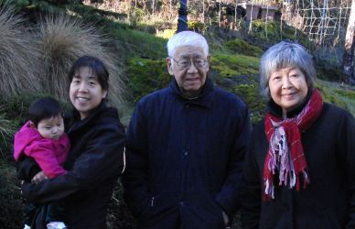
Jim and Yumiko Hoyano with a daughter Dee and a granddaughter Isabel in 2011.

Ide, 井出, イデ (Surname / family name / 苗字 / 家族名)
Yoshiaki, 吉昭, ヨシアキ (First name / given name / 名前)
Year of birth / 生年: 1976

Ancestral History? 先代やあなたは日本のどこから来ましたか？
埼玉県 [Translation] Saitama-ken

When and why did you or your family come to Edmonton? いつ、どうしてエドモントンへ来ましたか？
研究のため [Translation] For research.

What were your major occupations in the past and major employers? あなたの仕事はなんですか？雇用主はどこですか？
仕事：研究
雇用主：日本の日本医科大学
過去から現在までの歯科研究、教育、臨床
[Translation] My occupation is researcher. Employer: Nihon Ika Daigaku (Japan Dentistry University). Over my career, I’ve been involved in dentistry research, education, and clinical practice.

In what ways has having Japanese heritage affected the course of your life or family history? あなたが日本人または日系人であることは、人生にどのような影響があったと思いますか？
今のところ感じない
[Translation] I haven’t felt any impact yet.

Inagaki, 稲垣, イナガキ (Surname / family name / 苗字 / 家族名)
Sawako, 佐和子, サワコ (First name / given name / 名前)
Year of birth / 生年: 1976

Ancestral History? 先代やあなたは日本のどこから来ましたか？
兵庫県. Quebec. [Translation] Hyogo-ken.

When and why did you or your family come to Edmonton? いつ、どうしてエドモントンへ来ましたか？
2006 - 自分自身の英語圏での就職
[Translation] 2006 – to find my own employment in the English-speaking world.

What were your major occupations in the past and major employers? あなたの仕事はなんですか？雇用主はどこですか？
Nursing Attendant, Alberta Health Services

Additional history? 個人史・家族史
両親が日本に住んでいる為
[Translation] Because my parents live in Japan.

Ingham (nee Urano) (Surname / family name / 苗字 / 家族名)
Florence Sakae (First name / given name / 名前)
Year of birth / 生年: 1926

Ancestral History? 先代やあなたは日本のどこから来ましたか？
Wakayama ken / Osaka

When and why did you or your family come to Edmonton? いつ、どうしてエドモントンへ来ましたか？
Further education

What were your major occupations in the past and major employers? あなたの仕事はなんですか？雇用主はどこですか？
Administrator

More detail submitted in addition to survey responses.

Obituary from Edmonton Journal: January 16, 2016 (by Madeleine Cummings, Edmonton Journal Writer)

Florence Sakae Ingham, 1926 – 2015
Florence Ingham, a long-time University of Alberta administrative assistant who helped start a mobile dental clinic for northern communities, died Dec. 24 at age 89.
Ingham never trained as a dentist, but served as the program administrator for the faculty of dentistry's outreach clinic, which emerged in the early1970s and exists to this day. The program placed dentistry students in remote northern communities, where they treated patients and gained hands­ on experience.
Until the clinic came along, many people in communities such as Manning and La Crete had either never seen a dentist or feared the only one available. Some children, dental officers discovered, were, struggling to concentrate in school because their tooth decay was so painful. Ingham matched dental students with communities and supervisors, and made sure the program ran smoothly. "She had this remarkable organizing capability," said Geoffrey Sperber, a professor emeritus in the dentistry faculty.
In addition to orchestrating the placements, Ingham helped integrate the program with the curriculum and served as an intermediary between Alberta Health Care, which provided the funding, and, the dentistry students and staff. She met with doctors, students, and elders in communities, did damage control over the phone when the students slipped up, and helped persuade some dentists to open permanent practices in the rural posts.
"Very seldom did people say no to her," said her daughter, Gail. Ingham was organized, efficient, and a keen judge of character. People wanted to be on her good side. If they weren't, she was not shy about letting them know. Marga Galac, who worked with Ingham during the ‘60s, ‘70s and '80s, described her as "an extremely competent worker" whose energy and problem-solving skills were highly valued by everyone in the office. "She was the go-to girl for everything," Galac said. "If you had something going on in your life, Flo was the first one to be there to help. She always had an answer and a solution."
Over the years, the outreach clinic expanded and attracted student dentists from outside the province and the country. In 2003, for her work in the field, Ingham received an honorary membership to the Alberta Dental Association and College - a rare achievement for a non-dentist. But it took Ingham time to find the career for which she was so well suited.
She was born Florence Sakae Urano, to Japanese immigrant parents, in 1926. After the Japanese attack on Pearl Harbor on Dec. 7, 1941, the Canadian government started moving anyone of Japanese origin to ghost towns in BC's interior.
Florence's family was forced to either repatriate from Vancouver to Japan or move to an internment camp. One family member returned to Japan, but Florence ended up in a camp in the Salmon Arm region. Like thousands of other Japanese-Canadians, she and her family lost voting rights, land, possessions and access to education and nutritious food. One of her uncles died in the camps. Another relative refused to speak English for the rest of his life. "They lost absolutely everything," her daughter Gail said.
As a teenager, Ingham moved to Edmonton to look after another family's children in exchange for room and board. She did this for two years before moving to work for another and attend Alberta College.
Ingham spent a decade as a stay at-home mother before re-entering the work force. She eventually found her way to the faculty of dentistry in the mid-l960s and stayed there until 1997, working to organize not only the mobile clinic but also continuing education courses and industry conferences. In1995, she challenged her mandatory retirement in order to keep working for two more years.
After retiring, she threw herself into volunteering. She cooked for Meals on Wheels and for seniors at the Edmonton Japanese Community Association. She also volunteered for the Christmas Bureau. These commitments, her daughter said, demanded more of her time than her full-time job had.
Giving back was always important to Ingham. Though she was quick to judge and blunt if you didn't meet her high standards, she felt compelled to reach out to anyone who needed her help. She welcomed unexpected guests regularly into to her home. It didn't matter if you were a runaway teen, a struggling alcoholic, or a Nigerian prince visiting the university as a dignitary. "She'd welcome anybody and anyone, "Gail said, "They were all equal in her eyes."
In her free time, she read endlessly, usually murder mysteries or Danielle Steele novels, but also played video games. She found them entertaining and helpful for maintaining her dexterity. Cooking was another love. She impressed colleagues with her cinnamon buns, ribs, lemon pie and prize-winning pork and beans. She often provided dishes for work events and was insisted any left-overs from these functions go to charities.
Ingham is survived by seven children, seven grandchildren and four great-grandchildren. A celebration of her life will be held at a later date at the Edmonton Japanese Community Centre.
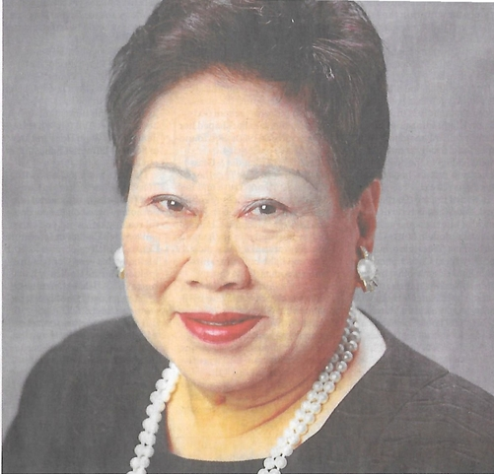
Florence Sakae Ingham (nee Urano, [unknown date]

Ito (Surname / family name / 苗字 / 家族名)
Cathy (First name / given name / 名前)
Year of birth / 生年: 1970

Ancestral History? 先代やあなたは日本のどこから来ましたか？
My father, John Ito was born in Surrey, B.C. He was interned at Lemon Creek during the war and after the war his family moved to Mie-ken, Japan when he was 12 years old. My grandmother was born in Canada but had married a cousin from Japan. He decided that after the war the family would move to his hometown in Mie-ken after the war. My father returned to Canada at the age of 21 and married my mother from Osaka after he had started working as a radio operator for the federal government. After doing some work up in the Northwest Territories with the federal government, my father got transferred to Edmonton in the early 70s. My father and mother had 3 children and I was the youngest. We grew up in Sherwood Park.

When and why did you or your family come to Edmonton? いつ、どうしてエドモントンへ来ましたか？
I was born and raised in Edmonton due to my father's work with the federal government.

What were your major occupations in the past and major employers? あなたの仕事はなんですか？雇用主はどこですか？
I worked as an occupational therapist in Edmonton and Vancouver. I then worked 4 years as a therapist in Sudan with The Leprosy Mission Canada. I'm currently working as a Grants Manager with another charity called Mission of Mercy Canada, which works for impoverished children and adults in north-east India.

In what ways has having Japanese heritage affected the course of your life or family history? あなたが日本人または日系人であることは、人生にどのような影響があったと思いますか？
I grew up going to the Edmonton Japanese Christian Church. Worshipping and having fellowship together with other Japanese has been an important part of my life. Through the church I've been able to keep up some of my Japanese language. Also, I grew up attending the Metro Edmonton Japanese Community School. Attending the school has helped in developing my Japanese language skills but it has also been a wonderful place where I developed and nurtured long term friendships.

Ito, 伊藤 (Surname / family name / 苗字 / 家族名)
Akiko, 晶子 (First name / given name / 名前)
Year of birth / 生年: 1962

Ancestral History? 先代やあなたは日本のどこから来ましたか？
Northwest Territories

When and why did you or your family come to Edmonton? いつ、どうしてエドモントンへ来ましたか？
主人の転勤 [Translation] Transferred with my husband's job.

Additional history? 個人史・家族史
私事、伊藤晶子、一世です。故主人ジョン国太郎伊藤、彼は日系三世です。彼の祖父、祖母が日本愛知県出身。戦前1900年初頭カナダに移住してきました。彼の母親、叔父、叔母は三世です。
私たちの子供三人は、四世です。孫七人は五世です。いずれも日本語が話せます。日本語学校で三人は中卒です。目下、一人は年長組で学んでいます。いずれ、三歳児もその中、お世話になることと思います。
[Translation] My name is Akiko Ito and I am issei [1st generation). My late husband, John Kunitaro Ito, was a sansei [third-generation Japanese]. His grandfather and grandmother were from Aichi-ken and moved to Canada before the war, in the early 1900s. His mother, uncle and aunt are nisei [2nd generation]. Our three children are yonsei [4th generation]. Our seven grandchildren are gosei [5th generation]. All of them can speak Japanese. Three of my grandchildren finished the Metro Edmonton Japanese Community School junior high programme. At present, one of them is attending kindergarten at MEJCS and, sooner or later, my three-year-old grandchild will attend MEJCS also.

Ito, 伊藤, イトウ (Surname / family name / 苗字 / 家族名)
Kieko, きえ子, キエコ (First name / given name / 名前)
Year of birth / 生年: 1946

Ancestral History? 先代やあなたは日本のどこから来ましたか？
東京 [Translation] Tokyo-to.

When and why did you or your family come to Edmonton? いつ、どうしてエドモントンへ来ましたか？
1972年に友人がカナダに来ていたのでたづねてきた。
1973年に移住権を取り住んでいる。
[Translation] In 1972, I came to Edmonton to visit a friend who had moved to Canada. In 1973, I got landed immigrant status and have been living here ever since

What were your major occupations in the past and major employers? あなたの仕事はなんですか？雇用主はどこですか？
1. Book keeper, 2. Lab helper, 3. Kitchen worker in a nursing home

In what ways has having Japanese heritage affected the course of your life or family history? あなたが日本人または日系人であることは、人生にどのような影響があったと思いますか？
日本での教育慣習がカナダでの生活の支えになっていると思う。
[Translation] I believe that the education and customs that I got in Japan contribute positively to the way I live in Canada

Additional history? 個人史・家族史
夫婦と子ども２人の他の家族は日本なので、親のいる頃は親に、そして兄姉に会いに、又友人に会う為に日本に行きます。
[Translation] Except for my husband and two children, all my family lives in Japan so I go back to Japan to visit my parents, siblings, and friends.

Ito, 伊藤, イトウ (Surname / family name / 苗字 / 家族名)
Wataru, 渉, ワタル (First name / given name / 名前)
Year of birth / 生年: 1949

Ancestral History? 先代やあなたは日本のどこから来ましたか？
千葉県 又は 東京都.
[Translation] Chiba-ken, Tokyo-to

When and why did you or your family come to Edmonton? いつ、どうしてエドモントンへ来ましたか？
1973 技工士としてキャルガリーのlabから転勤してきた
[Translation] In 1973, I was working as a dental technician in a lab in Calgary and was transferred to Edmonton.

What were your major occupations in the past and major employers? あなたの仕事はなんですか？雇用主はどこですか？
技工士（自営) [Translation] Dental technician (self-employed)

In what ways has having Japanese heritage affected the course of your life or family history? あなたが日本人または日系人であることは、人生にどのような影響があったと思いますか？
日本での教育がここでの生活の基盤になっていると思う
[Translation] I believe that the education I received in Japan has formed a good foundation for my life here.

Additional history? 個人史・家族史
親（既に死亡）や兄姉に会う為又、友人に会う為に日本に行く。
[Translation] I go to Japan to see my family (parents and siblings) and friends – my parents, however, are now deceased.

Iwabuchi (Surname / family name / 苗字 / 家族名)
Jack Koi (First name / given name / 名前)
Year of birth / 生年: 1927

Ancestral History? 先代やあなたは日本のどこから来ましたか？
Miyagi-ken: McLeod, AB; Brandon, MB; Taber, AB; Edmonton

When and why did you or your family come to Edmonton? いつ、どうしてエドモントンへ来ましたか？
To start a business

What were your major occupations in the past and major employers? あなたの仕事はなんですか？雇用主はどこですか？
Encouraged to create your own job.

Iwamoto, 岩元, イワモト (Surname / family name / 苗字 / 家族名)
Hiroko, 浩子, ヒロコ (First name / given name / 名前)
Year of birth / 生年: 1970

Ancestral History? 先代やあなたは日本のどこから来ましたか？
兵庫県神戸市. [Translation] Hyogo-ken, Kobe-shi.

When and why did you or your family come to Edmonton? いつ、どうしてエドモントンへ来ましたか？
リブインケアギバープログラムに参加するため。
[Translation] To attend a live-in caregiver programme.

What were your major occupations in the past and major employers? あなたの仕事はなんですか？雇用主はどこですか？
ケアギバー、シャーウッドパーク. [Translation] Caregiver in Sherwood Park.

Additional history? 個人史・家族史
カナダが好きで、カナダに移民したいので。 [Translation] I like Canada so I want to immigrate to Canada.

Iwamoto, 岩本 (Surname / family name / 苗字 / 家族名)
Chihiro, 千空 (First name / given name / 名前)
Year of birth / 生年: 1982

When and why did you or your family come to Edmonton? いつ、どうしてエドモントンへ来ましたか？
留学のため、2006年エドモントンに来て、今の主人に会い、移住しました。
[Translation] I came to Canada as a foreign student. In 2006, I came to Edmonton where I met my husband, and immigrated.

What were your major occupations in the past and major employers? あなたの仕事はなんですか？雇用主はどこですか？
主人の知り合いに紹介され、テストセンターで働きはじめました。
[Translation] I have started working in a testing centre thanks to an introduction from an acquaintance of my husband.

Kabata, 下野, カバタ (Surname / family name / 苗字 / 家族名)
Kaori, 香織 (First name / given name / 名前)
Year of birth / 生年: 1963

Ancestral History? 先代やあなたは日本のどこから来ましたか？
京都府宮津市. 京都府綾部市. [Translation] Kyoto-fu, Miyazu-shi. Kyoto-fu, Ayabe-shi.

When and why did you or your family come to Edmonton? いつ、どうしてエドモントンへ来ましたか？
１９９２年に修士号（言語学）取得目的でアルバータ大学大学院に入学。
[Translation] 1992 – enrolled in University of Alberta graduate studies to obtain an MA in linguistics.

What were your major occupations in the past and major employers? あなたの仕事はなんですか？雇用主はどこですか？
アルバータ大学教授. [Translation] Professor at the University of Alberta.

In what ways has having Japanese heritage affected the course of your life or family history? あなたが日本人または日系人であることは、人生にどのような影響があったと思いますか？
日本人の気質やまじめさ、忍耐強さには非常に感心するとともに日本人であることは誇りに思っている。
[Translation] I believe that taking pride in Japanese characteristics such as earnestness and perserverance bring credit to Japanese people.

Additional history? 個人史・家族史
私が国際ロータリー奨学生として訪加するまで、私の家族はカナダを含む外国とは全く無縁でいました。今も、私以外は家族は全員日本です。
[Translation] Until I came to Canada as a recipient of the Rotary International student scholarship, my family had absolutely no connections with any foreign country. Even today, all of my family members are in Japan.

Kadonaga (Surname / family name / 苗字 / 家族名)
Betty Tsukiko (First name / given name / 名前)
Year of birth / 生年: 1928

When and why did you or your family come to Edmonton? いつ、どうしてエドモントンへ来ましたか？
Japan; British Columbia

What were your major occupations in the past and major employers? あなたの仕事はなんですか？雇用主はどこですか？
Job

In what ways has having Japanese heritage affected the course of your life or family history? あなたが日本人または日系人であることは、人生にどのような影響があったと思いますか？
Employed by J&S Produce

Kadonaga (Surname / family name / 苗字 / 家族名)
Donald (First name / given name / 名前)
Year of birth / 生年: 1948

Ancestral History? 先代やあなたは日本のどこから来ましたか？
Grandparents are from Japan and immigrated to Canada. Parents were born in B.C. They moved to Alberta because of W.W. II. I was born in Lethbridge. The family moved to Vauxhall. The family moved to Edmonton.

When and why did you or your family come to Edmonton? いつ、どうしてエドモントンへ来ましたか？
Parents with the family moved to Edmonton for a job opportunity for both my parents. I understand that one of the motivations for the move was for at least some of the children, including myself, was the potential to attend post secondary educational institutions and be able to stay at home.

What were your major occupations in the past and major employers? あなたの仕事はなんですか？雇用主はどこですか？
Systems Programmer for Workers' Compensation of Alberta and prior to the WCB I was also a Systems Programmer for ACT Computer Services. However, I started at ACT as a programmer.

In what ways has having Japanese heritage affected the course of your life or family history? あなたが日本人または日系人であることは、人生にどのような影響があったと思いますか？
My parents have friends and relatives that I expect helped to establish opportunities for our move from Lethbridge to Vauxhall and then again from Vauxhall to Edmonton.

Kagawa, 賀川, かがわ (Surname / family name / 苗字 / 家族名)
Toshihiro, 敏弘, としひろ (First name / given name / 名前)

Ancestral History? 先代やあなたは日本のどこから来ましたか？
兵庫県西宮市満池谷町. [Translation] Hyogo-ken, Nishinomiya-shi, Manchidani-cho [town].

When and why did you or your family come to Edmonton? いつ、どうしてエドモントンへ来ましたか？
移住. [Translation] Immigrated.

What were your major occupations in the past and major employers? あなたの仕事はなんですか？雇用主はどこですか？
今は定年退職後コンピュータやネットワークのインストールや修理をしている。その前はHPでサーバー、ネットワーク、ワークステイションのインストールや修理をしていた。その前はアルバータ州の政府内で上と同様。その前はワング・コンピュータで上と同様。その前は日本の高千穂交易(株)でさまざまなコンピュータやその周辺機器のインストールや修理をしていた。
[Translation] Currently, after reaching retirement age, I am working at installing and repairing computers and networks. Before that, I worked for HP installing and repairing servers, networks, and workstations. Before that, I did the same sort of job as above within the Government of Alberta. Before that, I did the same as above for Wang Computer company. And before that, I worked for
Takachiho Koheki Co., Ltd. in Japan installing and repairing a variety of computers and peripheral equipment.

In what ways has having Japanese heritage affected the course of your life or family history? あなたが日本人または日系人であることは、人生にどのような影響があったと思いますか？
影響というより、私自身今でも日本人として誇りを持って生きている。
[Translation] Instead of saying how it has affected my life, I would rather say I have been living as a Japanese individual with pride.

Additional history? 個人史・家族史
３５歳に人生の半分を過ぎて、後半分をカナダか米国に住もうと思ってきた。母と妹と友達に会いに時々帰国します。
[Translation] At the age of 35, which I felt was the midpoint of my life, I decided to spend the second half of my life living in Canada or the USA. I occasionally go back to Japan to see my mother, my younger sister, and friends.

Kai, 甲斐, カイ (Surname / family name / 苗字 / 家族名)
Yasushi, 靖, ヤスシ (First name / given name / 名前)
Year of birth / 生年: 1970

Ancestral History? 先代やあなたは日本のどこから来ましたか？
島根県. [Translation] Shimane-ken

When and why did you or your family come to Edmonton? いつ、どうしてエドモントンへ来ましたか？
仕事. [Translation] For a job.

What were your major occupations in the past and major employers? あなたの仕事はなんですか？雇用主はどこですか？
調理師. [Translation] Chef.

In what ways has having Japanese heritage affected the course of your life or family history? あなたが日本人または日系人であることは、人生にどのような影響があったと思いますか？
仕事（すし調理)を選ぶきっかけになった。
他のアジアの国の人々やアメリカ、カナダの人々と話す機会があると戦争を含め歴史的な出来事に関心を持つことになった。
[Translation] I became a sushi chef because of my Japanese heritage. Through opportunities to talk with people from other Asian countries as well as Canadians and Americans, I have become more aware of historical Japanese events and incidents including what happened during the war [WW II].

Additional history? 個人史・家族史
インターネットの求人欄でエドモントンの今の仕事を知り、来た。
[Translation] I found my current job in Edmonton through the job ads on the internet.

Kaneda, 金田, カネダ (Surname / family name / 苗字 / 家族名)
Yoshie, 芳枝, ヨシエYoshie, 芳枝, ヨシエ (First name / given name / 名前)
Year of birth / 生年: 1947

Ancestral History? 先代やあなたは日本のどこから来ましたか？
佐賀県. [Translation] Saga-ken

When and why did you or your family come to Edmonton? いつ、どうしてエドモントンへ来ましたか？
2007年11月末. [Translation] Late November of 2007

In what ways has having Japanese heritage affected the course of your life or family history? あなたが日本人または日系人であることは、人生にどのような影響があったと思いますか？
日本語を話し、食事、文化、生活に影響を受けた。
[Translation] It has affected my life in terms of speaking Japanese, types of food, culture, and my daily lifestyle.

Additional history? 個人史・家族史
子供たちがエドモントン大学に入学、卒業後もエドモントンにし就職、結婚などで永住しているため、（私達）親も来ることにした。
[Translation] Because our children entered and then graduated from university, found jobs, and got married in Edmonton, we, as parents, decided to move permanently to Edmonton.
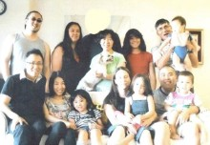

Kaneda family:
From back left: Kenneth (son), Margaret (daughter), Yoshie Kaneda, Julianna (Margaret's daughter), Susumu Kaneda, Keishin (Edward's son).
From front left: Edward (son), Naomi (Edward's wife), Hiyono (Edward's daughter), Tanya (John's wife, Miya (John's son), John (son), Maddox (John's son)

Kaneda, 金田, カネダ (Surname / family name / 苗字 / 家族名)
Takako, 貴子, タカコ (First name / given name / 名前)
Year of birth / 生年: 1974

Ancestral History? 先代やあなたは日本のどこから来ましたか？
佐賀（母）, 東京（父） [Translation] Saga-ken (mother), Tokyo-to (Father)

When and why did you or your family come to Edmonton? いつ、どうしてエドモントンへ来ましたか？
仕事 [Translation] For a job.

What were your major occupations in the past and major employers? あなたの仕事はなんですか？雇用主はどこですか？
看護婦 [Translation] Nurse

In what ways has having Japanese heritage affected the course of your life or family history? あなたが日本人または日系人であることは、人生にどのような影響があったと思いますか？
日本語を少し分かるようになった. [Translation] I have learned to understand Japanese language a little.

Additional history? 個人史・家族史
仕事のためにエドモントンへきた。 [Translation] Moved to Edmonton for a job.

Kaneda, 金田, カネダ (Surname / family name / 苗字 / 家族名)
Hiroshi, 寛, ヒロシ (First name / given name / 名前)
Year of birth / 生年: 1978

Ancestral History? 先代やあなたは日本のどこから来ましたか？
佐賀（母）、東京（父）, Lethbridge, Alberta.
[Translation] Saga-ken (mother). Tokyo-to (Father).

When and why did you or your family come to Edmonton? いつ、どうしてエドモントンへ来ましたか？
1996年、アルバータ大学入学. [Translation] 1996 – to attend the University of Alberta.

What were your major occupations in the past and major employers? あなたの仕事はなんですか？雇用主はどこですか？
ボンバルビア ファイナンス [ボンバルディア?]
ＧＥ ファイナンス
[Translation] Bombardier finance. GE finance

In what ways has having Japanese heritage affected the course of your life or family history? あなたが日本人または日系人であることは、人生にどのような影響があったと思いますか？
日本人とカナダ人の違いなどを知った。
[Translation] Understand the difference between Japanese and Canadians.

Additional history? 個人史・家族史
大学へ入るため、エドモントンに来た。
[Translation] Moved to Edmonton to attend university.

Kaneda, 金田, カネダ (Surname / family name / 苗字 / 家族名)
Sunao, 直, スナオ (First name / given name / 名前)
Year of birth / 生年: 1973

Ancestral History? 先代やあなたは日本のどこから来ましたか？
親は佐賀（母）、東京（父）, 私は、Barnwell, Alberta
[Translation] Saga-ken (mother). Tokyo-to (Father). Barnwell, AB (Myself).

When and why did you or your family come to Edmonton area? いつ、どうしてエドモントンへ来ましたか？
エドモントン代価区 [大学？] へ入学のため. [Translation] To attend university in Edmonton.

What were your major occupations in the past and major employers? あなたの仕事はなんですか？雇用主はどこですか？
エドモントン総領事館でアルバイト
Telus
石油関連会社
[Translation] Part-time job with the Consulate General of Japan in Edmonton. Telus. Oil-field related company

In what ways has having Japanese heritage affected the course of your life or family history? あなたが日本人または日系人であることは、人生にどのような影響があったと思いますか？
親が英語が出なくて困ったが、兄弟でやってこられた。
[Translation] There was some concern about my parents’ English ability but the siblings helped out.

Additional history? 個人史・家族史
親が日本から来て、土台を築き、自分たちは教育を受け、カナダ社会で自立している。
[Translation] My parents came from Japan, established a home-base here, educated themselves, and are self-reliant members of Canadian society.

Kaneda, 金田, カネダKaneda, 金田, カネダ (Surname / family name / 苗字 / 家族名)
Susumu, 進, ススム (First name / given name / 名前)
Year of birth / 生年: 1941

Ancestral History? 先代やあなたは日本のどこから来ましたか？
東京. [Translation] Tokyo-to

When and why did you or your family come to Edmonton? いつ、どうしてエドモントンへ来ましたか？
子供、孫達がエドモントンに住んでいる為
[Translation] Because my children and grandchildren live in Edmonton.

What were your major occupations in the past and major employers? あなたの仕事はなんですか？雇用主はどこですか？
退職
ポテト農場
オイル、ナチュラルガス関係の工場
オフィス、クリニックなどのせいそう会社経営
[Translation] Retired (current). Potato farming. Oil and natural gas industry related factory. Office and clinic company management.

Kawagoe (Surname / family name / 苗字 / 家族名)
Kurumi (First name / given name / 名前)
Year of birth / 生年: 1985

Ancestral History? 先代やあなたは日本のどこから来ましたか？
Kuramoto, Japan

When and why did you or your family come to Edmonton? いつ、どうしてエドモントンへ来ましたか？
To study and work (Live-in Caregiver Program).

What were your major occupations in the past and major employers? あなたの仕事はなんですか？雇用主はどこですか？
Nifco, Japan (Quality Check)

Kawai-Woodard, 河合, カワイ・ウッダード (Surname / family name / 苗字 / 家族名)
Tamiko, 多美子, タミコ (First name / given name / 名前)
Year of birth / 生年: 1959

Ancestral History? 先代やあなたは日本のどこから来ましたか？
静岡県浜松市. [Translation] Shizuoka-ken, Hamamatsu-shi

When and why did you or your family come to Edmonton? いつ、どうしてエドモントンへ来ましたか？
１９７９年、ボストンの語学学校に行った帰りに兄の住むエドモントンに寄り、４ヶ月ほど滞在し気に入ったので翌年移民の申請をし１９８１年にエドモントンに住むようになりました。
[Translation] In 1979, on my way home from studying at a langage school in Boston, I stopped in Edmonton where my brother lived. During my 4 month visit, I came to like Edmonton so much that I applied for the next year and then have been living in Edmonton since 1981.

What were your major occupations in the past and major employers? あなたの仕事はなんですか？雇用主はどこですか？
事務職. [Translation] office clerk.
Alberta Health Services
Canadian Engineering Surveys
Japanese Village
Westin Hotel事務職 [Translation] office clerk

In what ways has having Japanese heritage affected the course of your life or family history? あなたが日本人または日系人であることは、人生にどのような影響があったと思いますか？
相手の立場に立って考える、辛抱する、またチームワークなどを子供の頃から自然に日本の文化の中で学んで来たと思う。
[Translation] I think that since childhood I’ve learned naturally about Japanese culture as well as ideas around teamwork, perseverance, and learning how to see things from another’s point of view.

Additional history? 個人史・家族史
私の兄は料理人としてカナダに移民をしました。日本では自分の目指す道にかなり時間がかかるだろうと思い海外協力事業団を通してジャパニーズヴィレッジに就職。ウェスティンホテルで働くようになりその後ヨーロッパに渡りスウェーデン、スイス、フランスで働き、再びカナダに戻り、後にアメリカのサンフランシスコのパンパシフィックホテルの総料理長そして日本に帰国、横浜のパンパシフィックホテルの総料理長を経て現在は日航ホテルの顧問をしています。
[Translation] My brother immigrated to Canada as a chef. As he thought it would take too long to reach his goals in Japan, he went through the Japan International Cooperation Agency (JICA) and got a job at the Japanese Village [restaurant]. Later, he worked for the Westin Hotel and then went to Europe where he worked for awhile in Sweden, Switzerland, and France before returning to Canada. Then he moved to the USA and worked for Pan Pacific Hotel in San Francisco as an executive chef before going back to Japan to the Pan Pacific Hotel in Yokohama. Currently, he is working as an advisor for the Nikko Hotel.

Kawasaki (Surname / family name / 苗字 / 家族名)
Sanae (First name / given name / 名前)
Year of birth / 生年: 1938

Ancestral History? 先代やあなたは日本のどこから来ましたか？
東京都江戸川区. [Translation] Tokyo-to, Edogawa-ku.

When and why did you or your family come to Edmonton? いつ、どうしてエドモントンへ来ましたか？
主人の転勤. [Translation] My husband was transferred here for his job.

What were your major occupations in the past and major employers? あなたの仕事はなんですか？雇用主はどこですか？
- ノン・アカデミックスタッフーUniversity of Manitoba、事務職
- マニトバ州北部、Leaf Rapids公立校で校長の秘書
- U of A 大学でnon-academicスタッフとして、Student Programs Officerとして勤務
- 日本語教師として U of A Extension に勤務
- 日本語教師として Grant MacEwan に勤務
- 現在も家で日本語の個人レッスンを続けている
[Translation] 1. University of Manitoba, non-academic staff, office staff. 2. Principal’s secretary in a public school in the northern Manitoba town of Leaf Rapids. 3. Worked as Student Programs Officer at University of Alberta (non-academic staff). 4. Japanese language instructor at Univ. of Alberta. 5. Japanese Language instructor at Grant MacEwan. 6. Currently giving individual Japanese language lessons out of my home.

In what ways has having Japanese heritage affected the course of your life or family history? あなたが日本人または日系人であることは、人生にどのような影響があったと思いますか？
先人が足跡として残してくれた日本人の勤勉さ、高い精神性を含む生き方は私達の血の中に脈々と受け継がれていて、その御蔭で自分に誇りと自信を与え続けてくれている。
[Translation] I am proud to follow in the footsteps of our Japanese ancestors and have their spirits of diligence and spiritual strength flowing in our veins. Thanks to this, I feel have a great resevoir of pride and confidence to accomplish much.

Additional history? 個人史・家族史
母親が１０１歳でいまだ健在なので、毎年会いに行く。そのお蔭で毎年旧友に会い、旧交を温め合い、旅行をしたりするチャンスがあるのは幸せだと思っている。
戦争中に母方の叔父夫婦が和歌山県に住んででいたので、戦争が終るまで私は和歌山県で生活した。当時親戚、縁者の中に渡米（カナダを含む）している人たちがたくさんいた。そのほとんどが漁師や農民。彼らが国を離れた大きな理由の一つは日本が貧しかったからだと思う。
[Translation] Because my mother is still alive and well at the age of 101, I go to visit her every year. Thanks to this, I also have opportunity to meet with old friends and warmly renew our friendships; I am so happy to have these chances to travel.
During the war, my relatives on my mother's side lived in Wakayama-ken so I stayed there until the war ended. Back then, many of my relatives had immigrated to North America (including Canada). Most of them were fishermen or farmers. I think the main reason for them to leave Japan was that times were really hard and they were poverty-stricken.

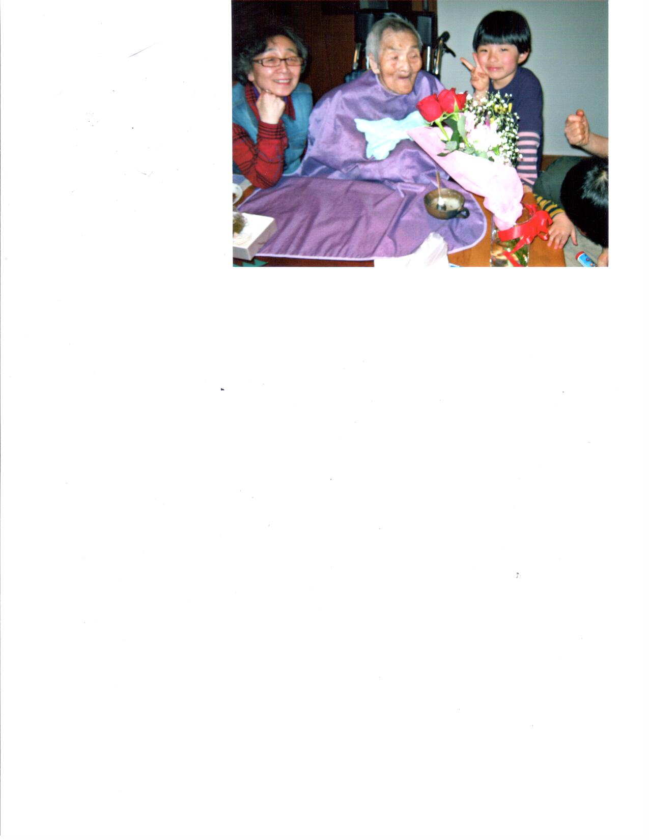
Taken in Tokyo Cho Fu-shi, March 15, 2013 on grandmother's 101st birthday. Sanae Kawasaki, Kane Yamaguchi, Ban Koshige (great-grandson).

Kerr (Surname / family name / 苗字 / 家族名)
Keiko (First name / given name / 名前)
Year of birth / 生年: 1983

Ancestral History? 先代やあなたは日本のどこから来ましたか？
Mother is from Matsuyama. I was born in Vancouver. In 1990 moved to and grew up in Toronto. Moved to Edmonton in 2007.

When and why did you or your family come to Edmonton? いつ、どうしてエドモントンへ来ましたか？
For a job.

What were your major occupations in the past and major employers? あなたの仕事はなんですか？雇用主はどこですか？
Civil engineer work for Aecon.

In what ways has having Japanese heritage affected the course of your life or family history? あなたが日本人または日系人であることは、人生にどのような影響があったと思いますか？
It has shaped the person I have become.

Kikuchi (Surname / family name / 苗字 / 家族名)
Setsuko (First name / given name / 名前)
Year of birth / 生年: 1928

Ancestral History? 先代やあなたは日本のどこから来ましたか？
Setsuko Tomiye's parents were originally from Shigaken, Japan. They settled in the Kelowna area where Setsuko's father worked hard and eventually owned and operated Kelowna Nurseries. Setsuko's parents' names were Sutejiro and Matsu Tomiye. Although Setsuko was born in Kelowna, she spent many of her formative years in Japan. Her father wanted to have some of the Tomiye family live and be educated in Japan, and so Setsuko went to Japan at the age of 8 with her older sister. Two years later, WW II broke out, and plans changed. Setsuko was unable to return to Canada and remained in Japan, living in Fukudo and Hikone with her aunt. She later moved to Kyoto, where she worked at a tailor shop. In 1948, Setsuko returned to Canada where she re-learned English, and immersed herself in Canadian life. In Nov 1952 she married Bill Kikuchi and relocated to Edmonton where she lived with Bill's parents and two younger sisters - no car, no phone, no central heating. Setsuko and Bill had three children, two sons and a daughter. The family resided in a one bedroom house in the Prince Charles area. In 1961 a new house was constructed next door to the original house. Bill and Setsuko live in this house presently. They recently celebrated their 60th anniversary. They are happy grandparents of 5 grandchildren.

When and why did you or your family come to Edmonton? いつ、どうしてエドモントンへ来ましたか？
1952 - marriage to Bill Kikuchi

What were your major occupations in the past and major employers? あなたの仕事はなんですか？雇用主はどこですか？
Seamstress

In what ways has having Japanese heritage affected the course of your life or family history? あなたが日本人または日系人であることは、人生にどのような影響があったと思いますか？
Husband's family (Kikuchi) was evacuated from, west coast and ended up in Edmonton

Additional history? 個人史・家族史
Married to Edmonton resident Bill Kikuchi. We still have close relatives (adopted sister) in Japan. My father also built a house in Fukudo, Japan.

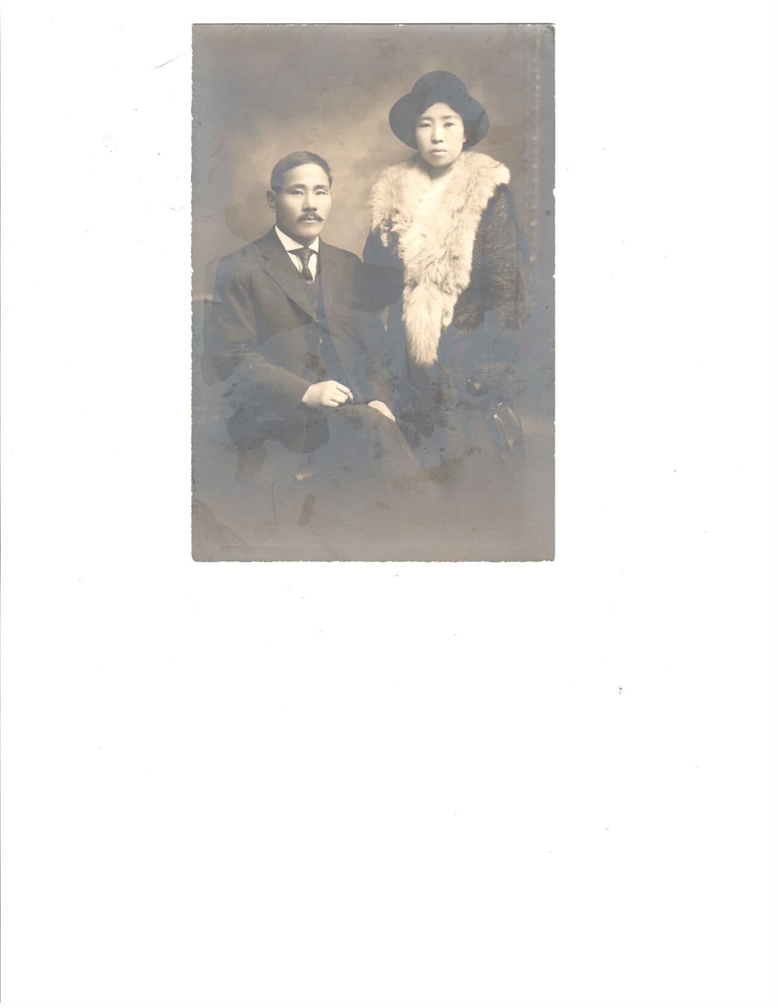 | 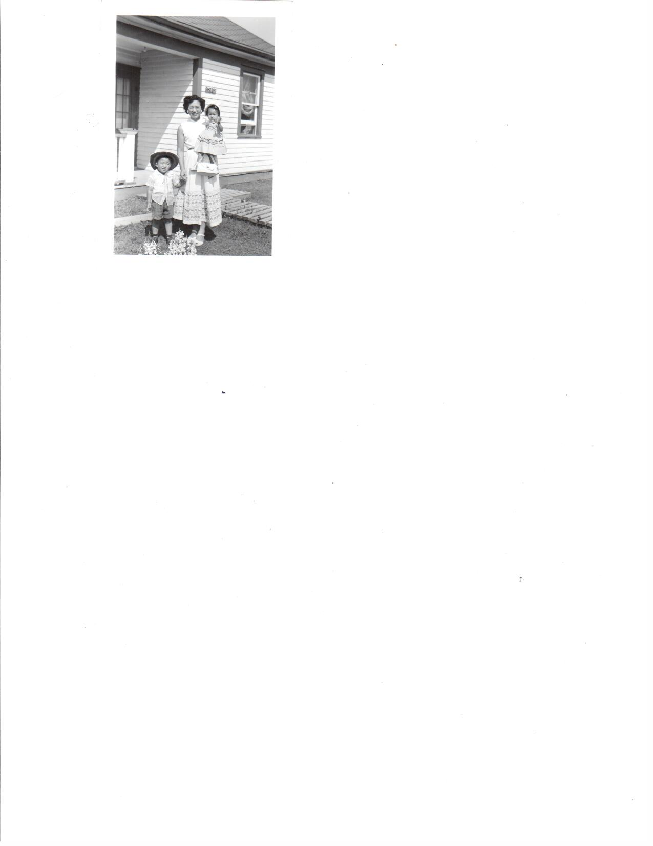
Vancouver 1918. Matao and Kiju Kikuchi. Kiju came to Canada as a picture bride to marry Matao. | Edmonton, July 1956.Taken in front of Kikuchi's old house on the way to the exhibition. Dennis, Setsuko and Amy Kikuchi
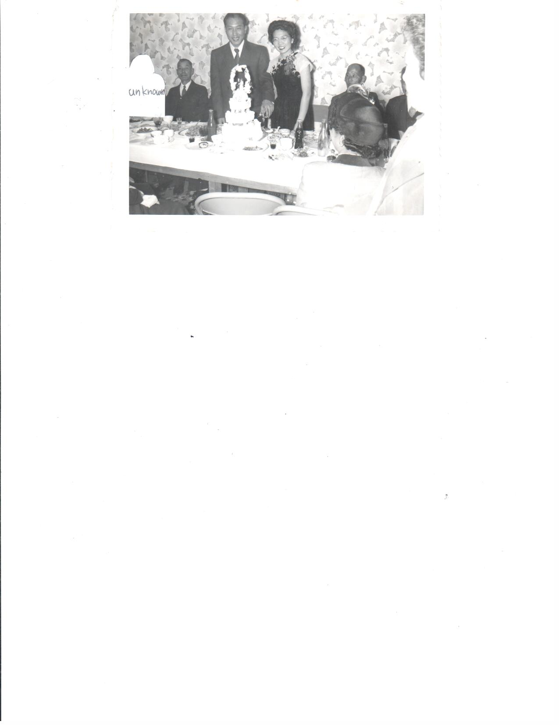 | 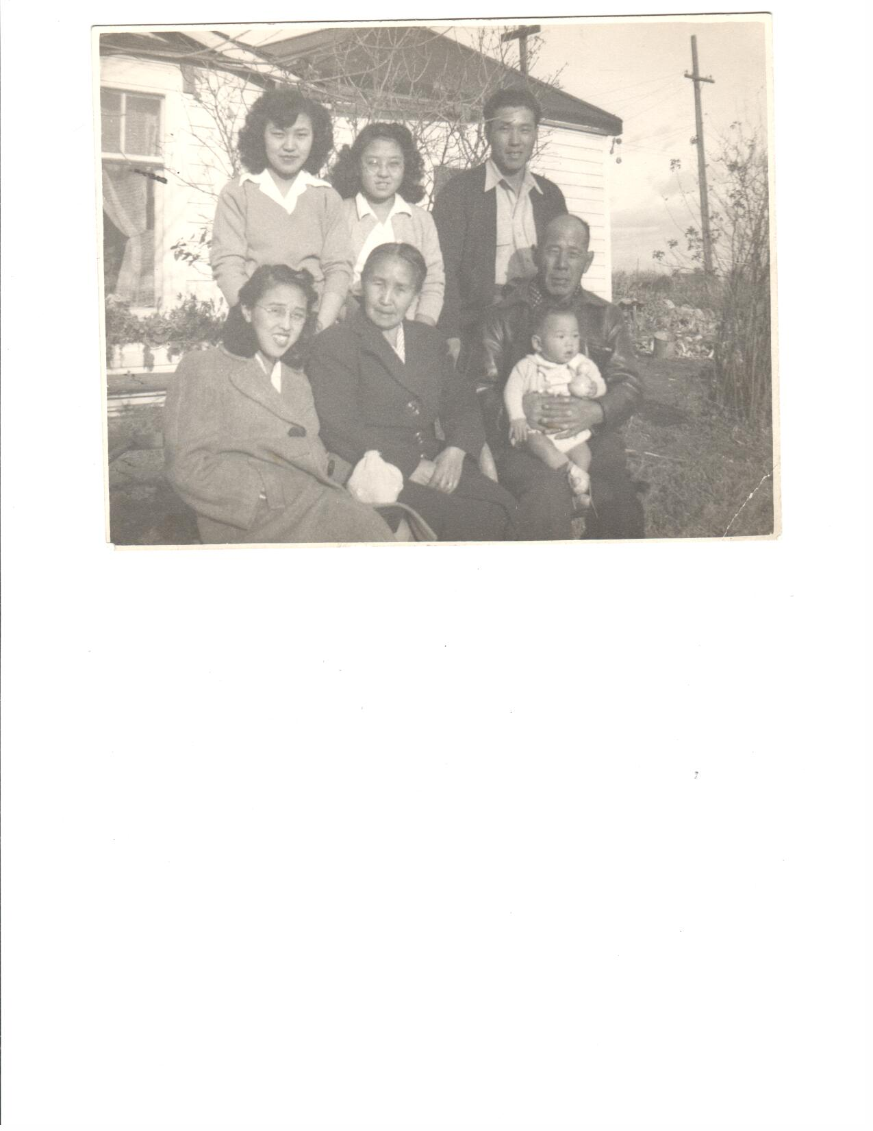
Edmonton, November 1952. Wedding reception at Kikuchi's old house in Edmonton. Mr. Kato, Bill and Setsuko Kikuchi, Matao Kikuchi. | Edmonton 1948 - family picture.  Back: Sueko Kikuchi, Chris Kikuchi, Bill Kikuchi. Middle: Kumiko Yasuda, Kiju Kikuchi, Matao Kikuchi. Front: Richard Yasuda

Kikuchi (Surname / family name / 苗字 / 家族名)
William Hisao (First name / given name / 名前)
Year of birth / 生年: 1919

Ancestral History? 先代やあなたは日本のどこから来ましたか？
The roots of the Kikuchi family originate in Kumamoto ken, Japan. Matao Kikuchi arrived in Canada in the early 1900s and was joined by his wife, Kiju a few years later. They settled in Vancouver, B.C., and here there first son, Bill was born. Six siblings followed; all but Bill were girls. The family moved to New Westminster and remained there for a few years. It was about this tie World War II broke out and evacuation was mandatory. The Kikuchi family was destined for Kaslo, B.C. A house was later allocated to the family in Roseberry, B.C. When the war ended the family headed to Alberta where they spent time in Waterways and Draper. During this time, various family members worked at the fish camps up north, as well as at the sawmills. In the fall of 1946, the family moved to Edmonton to pursue education and employment opportunities. A house was purchased in Edmonton on 127th street and 124 Ave (the present location of Prince Charles School). The total cost of the house was $2800. There was water piped to the house but no sewage or gas. The toilet was outside (outhouse). Coal was used for cooking and heating. After growing up in Edmonton, the girls left for Toronto to seek employment. Only Bill remained in Edmonton. He married Setsuko Tomiye (from Kelowna, BC) in 1952, They had 3 children, and still presently live in Edmonton.

When and why did you or your family come to Edmonton? いつ、どうしてエドモントンへ来ましたか？
Evacuation because of war. Edmonton was a good location because of education and employment.

What were your major occupations in the past and major employers? あなたの仕事はなんですか？雇用主はどこですか？
Worked for the Federal Govt. for 35 years (Revenue Canada Taxation).

In what ways has having Japanese heritage affected the course of your life or family history? あなたが日本人または日系人であることは、人生にどのような影響があったと思いますか？
Because of WW-II evacuation family had to leave West Coast and move inland.
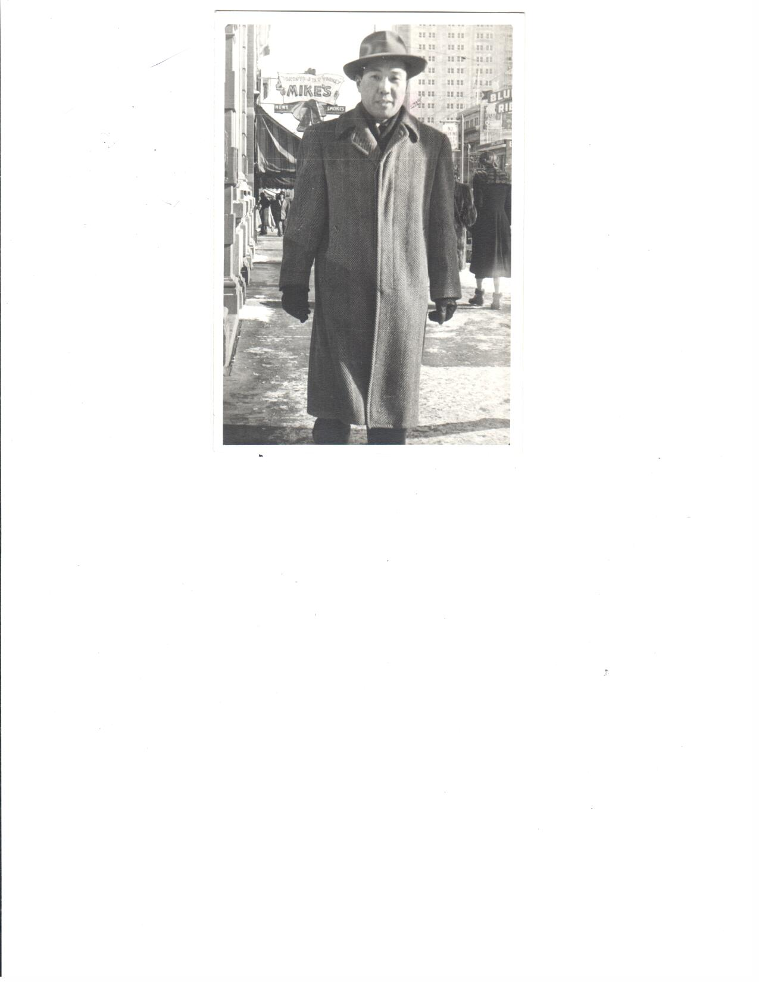Downtown Edmonton, 1952. Going for a walk during lunch break at work. Bill Kikuchi

Kim, 金, キン (Surname / family name / 苗字 / 家族名)
Rika, 里加, リカ (First name / given name / 名前)
Year of birth / 生年: 2002

Ancestral History? 先代やあなたは日本のどこから来ましたか？
奈良. [Translation] Nara-ken,

When and why did you or your family come to Edmonton? いつ、どうしてエドモントンへ来ましたか？
父が仕事の都合で移住していた（1998年）
[Translation] We immigrated in 1998 for my father's job.

Additional history? 個人史・家族史
父の仕事の都合でエドモントンに移住。父母の家族が日本在住にて２～５年に一度短期帰国している。
[Translation] We moved to Edmonton because of my father's job. I go back to Japan once every two to five years to visit my parents' families who still live there.

Kin, 金, キン (Surname / family name / 苗字 / 家族名)
Noriko, 紀子, ノリコ (First name / given name / 名前)
Year of birth / 生年: 0

Ancestral History? 先代やあなたは日本のどこから来ましたか？
奈良. [Translation] Nara-ken

When and why did you or your family come to Edmonton? いつ、どうしてエドモントンへ来ましたか？
主人の仕事の都合で1998年にエドモントンに来ました。
[Translation] We came to Edmonton in 1998 due to my husband's job.

What were your major occupations in the past and major employers? あなたの仕事はなんですか？雇用主はどこですか？
- 看護師 星ヶ丘厚生年金病院
- 看護師 友仁山崎病院
- ランチルームスーパーバイザー エドモントンパブリックスクール
- 教師 エドモントン補習校
- 店員 アマランス
[Translation] 1. Nurse, Hoshigaoka Employees Pension Hospital; 2. Nurse, Yujin Yamazaki Hospital; 3. Lunchroom supervisor, Edmonton Public Schools; 4. Teacher, Metro Edmonton Japanese Community School; 5. Sales clerk, Amaranth [Whole Foods Market]

In what ways has having Japanese heritage affected the course of your life or family history? あなたが日本人または日系人であることは、人生にどのような影響があったと思いますか？
主人の仕事に伴って1998年に移住。
[Translation] I immigrated to Edmonton in 1998 with my husband when he found his employment here.
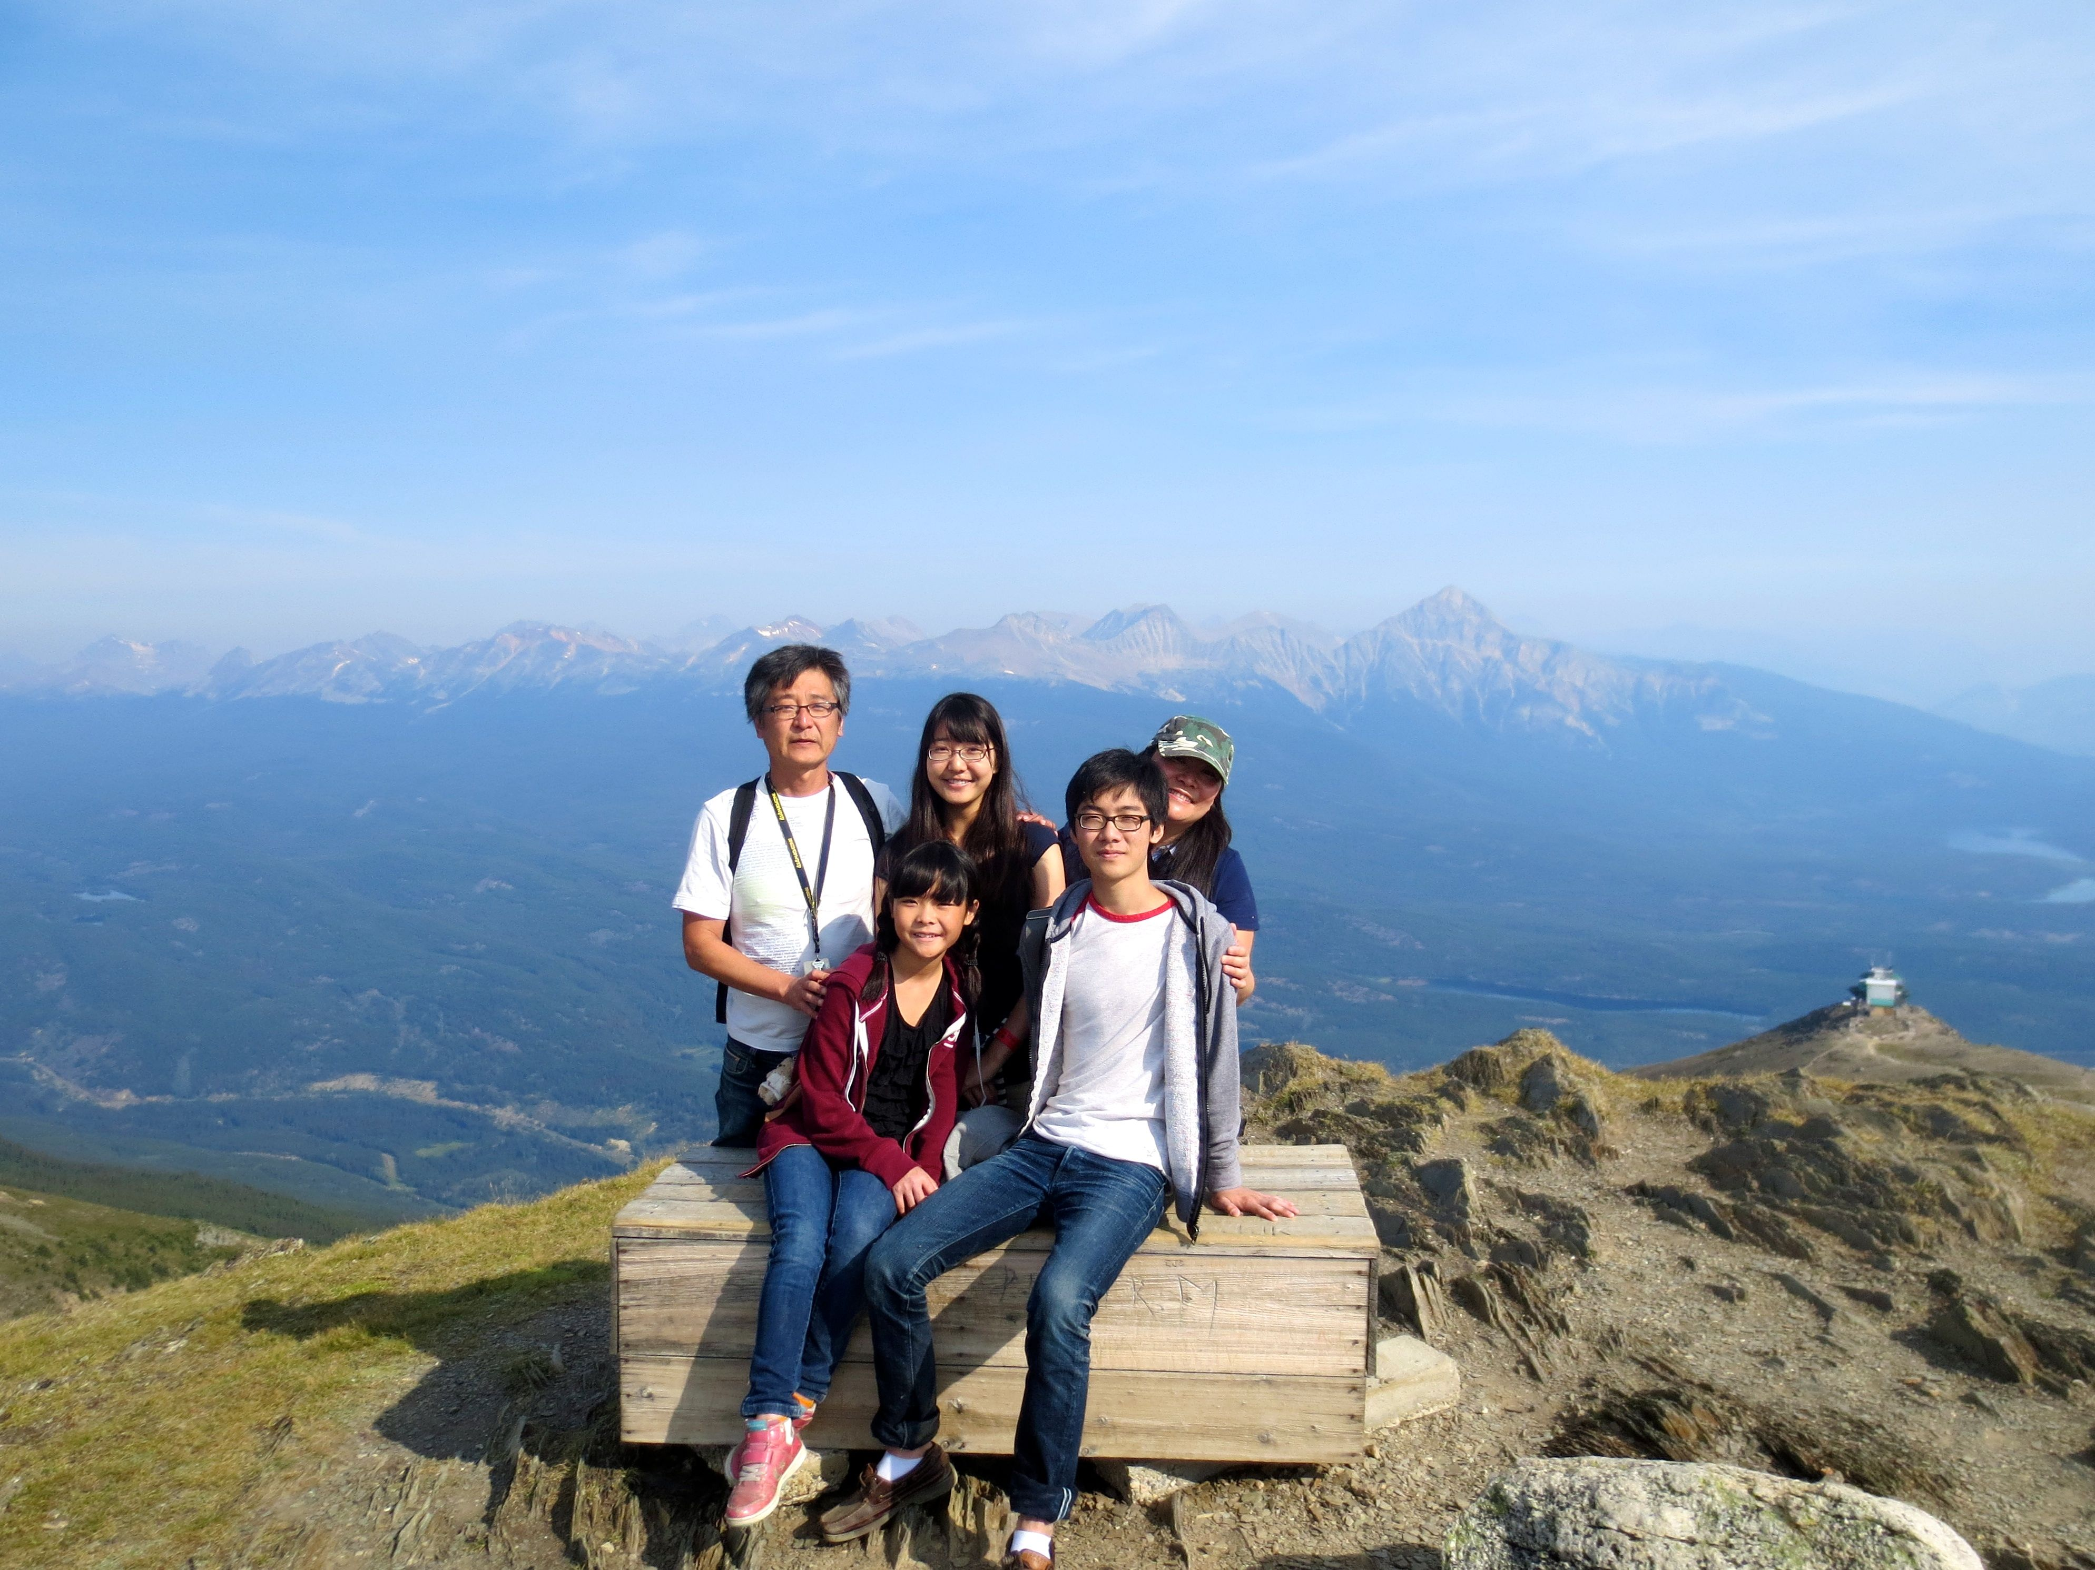
Jasper, Alberta August 2014. (Top) Tatsuya, Kana, Noriko. (Front) Rika, Rikizou

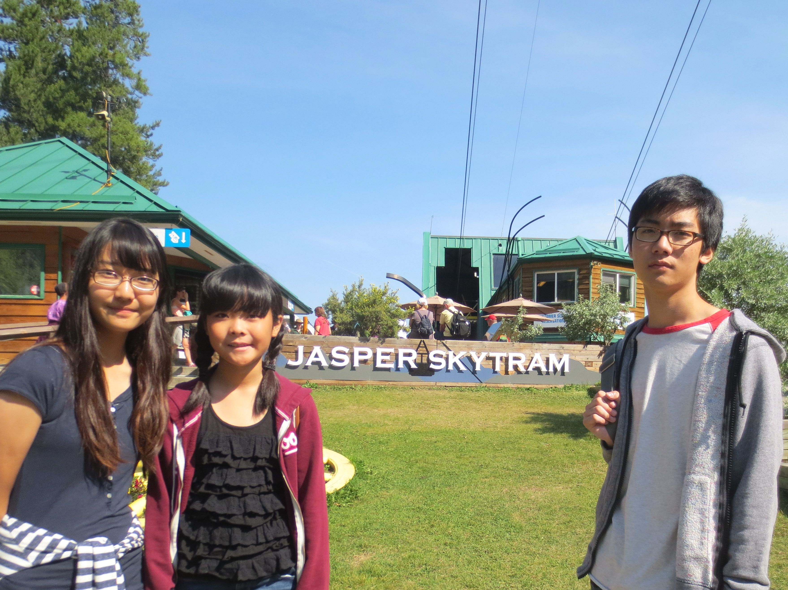
Jasper, Alberta August 2014. Kana, Rika and Rikizou (Kin children)

Kimura (Surname / family name / 苗字 / 家族名)
Chizuko (First name / given name / 名前)
Year of birth / 生年: 1924

Ancestral History? 先代やあなたは日本のどこから来ましたか？
Yamaguchi & Shikoku, Japan; Raymond, AB

When and why did you or your family come to Edmonton? いつ、どうしてエドモントンへ来ましたか？
Married in 1946; came to Redwater/Opal, AB

What were your major occupations in the past and major employers? あなたの仕事はなんですか？雇用主はどこですか？
School teacher; Farmer's wife and assistant

In what ways has having Japanese heritage affected the course of your life or family history? あなたが日本人または日系人であることは、人生にどのような影響があったと思いますか？
Proud to be Japanese. Special recognitions. Being an Albertan - not affected by evacuation.

More detail submitted in addition to survey responses.

I was born on November 28, 1924. I am the oldest child of Haru and Toyoichi Matsuno of Raymond, Alberta. I would like to begin by relating the history of my father who was born in Yamaguchi, Japan.
In the early years of Japan’s history, numerous civil wars occurred. One was in Yamaguchi and the Upper Kyushu area where Lord Mori, the warlord, actively consolidated the foundations of later-day Yamaguchi. Dad’s grandfather, Jukichi, was one of Lord Mori’s samurai warriors. After Mori’s victory, he told his troop that if they would go with him to Edo, he would have honours conferred on them. Grandfather refused, saying he would prefer to live in the familiar area. In lieu, Lord Mori presented him with the surname “Matsuno”. These were the days when nobility had surnames while others were identified only by their first names. This is all well documented in the record book. Grandfather’s name is one of the 300 published names of distinguished people in Yamaguchi. His medal and two swords are kept by his grandson as part of the family treasure.
Dad came to Canada in 1904. He worked as a house-boy at the Japanese Consulate to learn English. He worked at different jobs and managed to buy some property in Vancouver which he later lost due to an inability to pay taxes.
He was among the first Japanese beet workers brought to Raymond by the Knight Sugar Company in 1909. By 1917, he saved enough money to purchase 640 acres of land in the ridge area which the Alberta government was selling at $1.00 per acre in order to get the land cultivated and settled. In time, he was able to buy more land. He was one of the original pioneers.
Father married Haru from Shikoku in 1924 and began his family life, bringing eight children into the world of which I am the oldest. We were all raised on the farm, making our living growing grain. We grew vegetables for our food, kept chickens for eggs, some hogs for market and two or three cows to supply us with milk and butter. The children all took turns and helped at whatever they were capable of doing. The youngest child collected eggs from under the hens. We attended a one-room country school, with one teacher who taught grades one to nine. Some children were in a combined class depending on their capabilities and we all benefited from ‘eavesdropping’ while the teacher was teaching another class.
When I completed grade nine, I attended high-school in a nearby town and did light house-work for a couple who lived close to the school. After high school, I went to Calgary to attend the normal school for teacher training. After completing the term, we were offered a job as a practice teacher at a country school where we “learned by doing”.
One of the fond memories of my senior grade school days was when dad came home from the post office with several issues of the correspondence course from Japan. My brother and I would completed the necessary subjects and send them back to be graded. I wish I had kept some of these books.
Dad was a forward thinking Japanese man of that era, because he wished to ensure that his daughters were sufficiently educated to make it on their own if it was ever necessary when they went out into the world. In spite of the hard times during the depression years, the family managed to make ends meet and the children were encouraged to pursue their education. To that end, Dad was made happy when one became an RN and then an RN with a Masters’ degree, another a veterinary Medicine/Entomology researcher and I, an educator.
In 1946, I married Jim Kimura who farmed with his dad near Redwater, Alberta. We had 3 children, a son and two daughters who attended elementary and high school in Redwater. They graduated from the University of Alberta and worked in their respective professions until their retirement.
While raising the children and helping my husband whenever required, I raised 2000 turkeys from poult (baby) to maturity, for market at the Lilydale Packing Plant. We did not have power in those days, so everything was done in the old fashioned way--carrying feed in large pails. But life was not all work. We joined the Redwater Community Club, visited neighbours to play canasta, helped with the pit-BBQ and the annual chicken supper. We were the only active Japanese family in the club and were treated as one of the group. I enjoyed sewing, gardening and baking for Agricultural Society Fairs in our area and won many prizes for my baking, one of which was a trophy which read “Queen of the Household”. Since I returned to Edmonton, I took up pottery when I was 80 and still enjoy improving my skills. I’ve also learned to surf the web and use email.
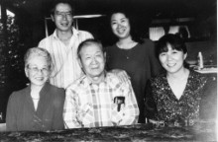
1994 with Kenneth, Patricia, Chizuko, Jim and Joy.

Kin, 金, キン (Surname / family name / 苗字 / 家族名)
Kana, 加奈, カナ (First name / given name / 名前)

Ancestral History? 先代やあなたは日本のどこから来ましたか？
奈良. [Translation] Nara-ken

When and why did you or your family come to Edmonton? いつ、どうしてエドモントンへ来ましたか？
父が仕事の都合で移住(１９９８年). [Translation] Immigrated in 1998 because of my father's job.

Additional history? 個人史・家族史
父の仕事の都合でエドモントンに移住。父母の家族が日本在住のため2~5年に１度は帰国している。
[Translation] I moved to Edmonton because of my father's job. I go back to Japan once every two to five years because my parents' families still live there.

Kinoshita (Surname / family name / 苗字 / 家族名)
Dan (First name / given name / 名前)
Year of birth / 生年: 1954

Ancestral History? 先代やあなたは日本のどこから来ましたか？
Father from Wakayama. Mother born in Opal, Alberta. Her parents are from rural Hiroshima.

When and why did you or your family come to Edmonton? いつ、どうしてエドモントンへ来ましたか？
Grandfather came as a pioneer and worked on a farm. My grandmother came and met him when they got married. Then they eventually cleared land and had a farm.
She also wanted to meet her father who left Japan to make his "fortune", which did not happen as far as I know.
He lived closer than Japan but she had no idea that California was so far. She never met him.
The farm was eventually sold and the family moved near Whyte Ave [Edmonton].

What were your major occupations in the past and major employers? あなたの仕事はなんですか？雇用主はどこですか？
IT [information technology], government

In what ways has having Japanese heritage affected the course of your life or family history? あなたが日本人または日系人であることは、人生にどのような影響があったと思いますか？
Many many ways. In my generation it seems I am the only one in my family that has a very strong attraction to Japan; e.g. I took a unpaid leave in order to move to Japan for a year.
There I worked, made friends and became very close to a cousin. We still see each other every time I go back. And the same is true for one friend.Though I have lost touch with most of the friends I made, it is something that I will always treasure.
I understand so much more of daily life. And keeping in constant touch with family and friends in Japan I understand much more about more than daily life, such as government, policies, pensions, health care, etc. So I can compare to life in Canada.
My way of living and viewing the world is a hybrid of the two cultures though at times they are in conflict.

Kinoshita, キノシタ (Surname / family name / 苗字 / 家族名)
Naomi, 直美 (First name / given name / 名前)
Year of birth / 生年: 1960

Ancestral History? 先代やあなたは日本のどこから来ましたか？
東京都小平市. [Translation] Tokyo-to, Kodaira-shi

When and why did you or your family come to Edmonton? いつ、どうしてエドモントンへ来ましたか？
エドモントン在住の日系カナダ人と結婚したため。
[Translation] I married a Japanese-Canadian who was living in Edmonton.

What were your major occupations in the past and major employers? あなたの仕事はなんですか？雇用主はどこですか？
現在：アルバータ州政府で事務職（Administrative Assistant)
カナダに来る前日本(東京)で：ヨガのインストラクター、外資系保険代理店で営業事務
[Translation] Current job: Administrative Assistant with the Government of Alberta. Before moving to Canada: Yoga instructor in Tokyo and a sales representative for a foreign-affiliated insurance company

In what ways has having Japanese heritage affected the course of your life or family history? あなたが日本人または日系人であることは、人生にどのような影響があったと思いますか？
日本で生まれた日本人なので日本人であることが当たり前でしたから、日本人であることが人生にどんな影響があったかと考えたことありませんでした。
でも、日本人であったからこそ、英語を学校以外でも勉強し、仕事に活かそうとしたのかもしれません。
英語でコミュニケーションがとれたことがカナダ人と付き合うことにつながり、結婚へと発展しました。主人は日系人であったため、カナダ人とはいえ、わかりあえる部分が多かったと思います。
[Translation] Because I am Japanese and was born in Japan everything Japanese seems natural to me so I have’t given any thought to how it has affected my life. However, I perhaps the fact that I am Japanese and studied English outside regular school classes, I was able to shake up my workplaces to some extent. Being able to communicate in English led to a courtship with a Canadian and eventually got married to him. Although Canadian, my husband has Japanese ancestry so there are many things we mutually understand because of background.

Additional history? 個人史・家族史
エドモントン在住のカナダ人と結婚したため、エドモントンに移住しました。日本へは、ほぼ１年に１回里帰りと友人に会い、日本を旅行するため帰ります。両親と姉が日本にいます。主人の日本の親戚も大阪と東京にいます。
[Translation] I immigrated to Canada since I married a Canadian who lived in Edmonton. I go back to Japan approximately once a year to meet friends and travel around the country. My parents and an older sister still live in Japan. My husband's relatives live in Osaka and Tokyo.

Kiyooka (Surname / family name / 苗字 / 家族名)
Irene (First name / given name / 名前)
Year of birth / 生年: 1938

Ancestral History? 先代やあなたは日本のどこから来ましたか？
Lived in Calgary. I presume that when war broke out, we moved to Opal. Was rather young.

Additional history? 個人史・家族史
Parents came early - 1900's
Have cousins in Japan
My brothers know more "History Kiyooka Family" or ask Joyce.

Kobayashi (Surname / family name / 苗字 / 家族名)
Urara (First name / given name / 名前)
Year of birth / 生年: 1968

Ancestral History? 先代やあなたは日本のどこから来ましたか？
Tokyo-to, Setagaya-ku

When and why did you or your family come to Edmonton? いつ、どうしてエドモントンへ来ましたか？
1992, I came to Edmonton because my husband (an Eastern Indian) found an employment here

What were your major occupations in the past and major employers? あなたの仕事はなんですか？雇用主はどこですか？
1. Japanese instructor, University of Alberta, 2. interpreter and translator, self-employed, 3. voice artist, Octavo Production

In what ways has having Japanese heritage affected the course of your life or family history? あなたが日本人または日系人であることは、人生にどのような影響があったと思いますか？
The way I was brought up in Japan, and the education and the experiences I had in Japan all shaped the way I now live. Also the fact that Japan, my home country, is regarded highly in the world gives me pride and confidence. It also encourages me to live up to it.

More detail submitted in addition to survey responses.

I moved to Edmonton in 1992 with my husband who was offered a position at the University of Alberta. He is from India. We met in Oregon, U.S.A., when we were students there. Before moving here, I had never heard of Edmonton. I didn't know much about Canada, either. The first winter was tough - it was dark and cold, my English was shaky, and I didn't know anyone but my husband here. I missed Japan, my family and friends intensely. Seeing my distress, my husband sought out a Japanese colleague, who introduced me to the Metro Edmonton Japanese Community School. I started teaching there within 6 months, and found great comfort in the environment where I could talk to other people who share the similar cultural background in my own language.
From there, I slowly expanded the network of friends and acquaintances. In the next 20 years or so, I got a Bachelor of Education degree (I already had a Bachelor of Art degree from a university in Japan) and a Master of Art degree from the University of Alberta, taught Japanese at public schools and the university, and had two daughters (the eldest born in 1998 and the youngest in 2000). As of now, I am still teaching Japanese at the university and doing occasional translation/interpretation work as freelancer.
My daughters both attended the Metro Edmonton Japanese Community School. The most immediate goal was to get them able to communicate with their Japanese grandmother who doesn’t speak English. But, I also wanted them to be able to understand what I think and how I feel - things that I can only express in my own language. I also wanted them to be able to “feel” their lives in Japanese - the language which I think can deliver nuances and intricate details most beautifully. In short, I wanted to share everything I have experienced and will experience with my daughters in the most intimate way possible. My older daughter just graduated from the school this spring after having attended there for more than 11 years. Although my lofty goal was barely half achieved (they only occasionally read manga and their conversations with me are peppered with English words), I felt very proud.
As much as I miss my home and the comfort that it provided, I also feel fortunate to have this opportunity to live away from Japan. By living abroad, I learned more about Japan. I would have never learned about its history, culture and people as much if I had been living in Japan. By seeing Japan from outside, I now know how exceptional those fine qualities are that the Japanese people possess. Industriousness, hospitality, consideration to others, care for details, aesthetics, respect for orders and harmony - and the list goes on and on. Now that I know these qualities (that I used to take for granted) are hard to find anywhere else, I renewed my respect for the Japanese people who work hard to protect and maintain these qualities. I also feel more proud now to be one of them.
Although my daughters probably wouldn’t identify themselves as Japanese ever (and I don’t mind if they don’t), I would be very happy if they remember and value some of those wonderful things, be it a peaceful onsen ryokan or clean public bathrooms or Harajuku fashion, that they had opportunities to witness firsthand by being born to a Japanese mother. I would be even happier if they consciously or subconsciously decide to incorporate some of these values of the Japanese people into the way they lead their lives as Canadian.

Kobayashi, 小林 (Surname / family name / 苗字 / 家族名)
Miwa, 美和 (First name / given name / 名前)
Year of birth / 生年: 1980

Ancestral History? 先代やあなたは日本のどこから来ましたか？
新潟県上越市. [Translation] Niigata-ken, Jyoetsu-shi

When and why did you or your family come to Edmonton? いつ、どうしてエドモントンへ来ましたか？
ケアーギバーとして働くために来た. [Translation] I came to work as a caregiver.

What were your major occupations in the past and major employers? あなたの仕事はなんですか？雇用主はどこですか？
ケアーギバー、Edmonton. [Translation] Caregiver in Edmonton

In what ways has having Japanese heritage affected the course of your life or family history? あなたが日本人または日系人であることは、人生にどのような影響があったと思いますか？
カナダに来て日本のことが好きになり、ほこりをもてるようになった。
[Translation] Since moving to Canada, I found there are many things I like about Japan and I’ve become proud of being Japanese.

Additional history? 個人史・家族史
海外で働きたいと思い、何度もきたことのあるカナダをえらんだ。
[Translation] I thought I would like to work overseas; I chose Canada that I had visited many times.

Koizumi, 小泉, コイズミ (Surname / family name / 苗字 / 家族名)
Akihiko, 晶彦, アキヒコ (First name / given name / 名前)
Year of birth / 生年: 1982

Ancestral History? 先代やあなたは日本のどこから来ましたか？
神奈川県川崎市. [Translation] Kanagawa-ken, Kamakura-shi

When and why did you or your family come to Edmonton? いつ、どうしてエドモントンへ来ましたか？
研究留学のため. [Translation] To do reaseach abroad.

What were your major occupations in the past and major employers? あなたの仕事はなんですか？雇用主はどこですか？
博士研究員(現在・過去とも)
アルバータ大学化学科
[Translation] Past and present: Doctoral (Ph.D) Research, U of A Department of Chemistry

Koto, 向当、コウトウ (Surname / family name / 苗字 / 家族名)
Mineko, みね子、ミネコ (First name / given name / 名前)
Year of birth / 生年: 1966

Ancestral History? 先代やあなたは日本のどこから来ましたか？
福井県、NS (Halifax), ON (Toronto). [Translation] Fukui-ken

When and why did you or your family come to Edmonton? いつ、どうしてエドモントンへ来ましたか？
2002, 夫の博士号取得のため（U of A)
[Translation] 2002 - for my husband to complete his PhD at the Univ. of Alberta

What were your major occupations in the past and major employers? あなたの仕事はなんですか？雇用主はどこですか？
１．日本語講師 U of A ２．日本語講師 GEOS ３．保育所
[Translation] １．Japanese Instructor, UAlberta; 2. Japanese instructor, GEOS Halifax, 3, Daycare

In what ways has having Japanese heritage affected the course of your life or family history? あなたが日本人または日系人であることは、人生にどのような影響があったと思いますか？
ハリファックスで禅を勉強しているカナダ人にたくさん出会いました。彼らは日本に興味を持ち、とても好意的でした。彼らに出会う前は、日本が大戦時に行った行為に自責の念がありましたが、今では日本人であることを誇りに思っています。
[Translation] I met many Canadians who studied Zen in Halifax, NS. They were interested in Japanese culture and had favourable impressions about Japan. Before I met them, I had a guilty conscience about Japan’s conduct during WWII. But, today, I am proud to be Japanese.

Krembil, クレンビル, クレンビル (Surname / family name / 苗字 / 家族名)
Miyuki, みゆき, ミユキ、 (First name / given name / 名前)
Year of birth / 生年: 1971

Ancestral History? 先代やあなたは日本のどこから来ましたか？
出身：茨城県古河市
住んでいた所： 大阪府東大阪市
[Translation] Ancestral home: Ibaraki-ken, Furukawa-shi. Place I lived: Osaka-fu, Higashi-Osaka-shi

When and why did you or your family come to Edmonton? いつ、どうしてエドモントンへ来ましたか？
2005．永住権がおりたため、（主人がカナダエドモントン出身）
[Translation] 2005, I came to Edmonton when I was granted Landed Immigrant status (my husband is from Edmonton)

What were your major occupations in the past and major employers? あなたの仕事はなんですか？雇用主はどこですか？
主婦 〔現在〕
２００５冬から、２００７春までパートタイムの仕事をしていました。アルバータエデュケーション
[Translation] 1. Homemaker (current) 2. Part-time staff, Alberta Education (winter 2005 to spring 2007)

In what ways has having Japanese heritage affected the course of your life or family history? あなたが日本人または日系人であることは、人生にどのような影響があったと思いますか？
カナダでは影響があったとは思いません。
一度NYで知り合った香港人の方が戦争時に日本人がした事をどう思うか？と泣きながら問われた事はあります。
彼女はおじいさんからの経験話で、心に残る思いが多々あるようでした。それまで以上に、いろんな面で歴史に興味が持てるようになりました。
[Translation] I don't think being Japanese has much influence over the way I live in Canada. Once, in New York, I was asked by a person from Hong Kong what I thought of the atrocities committed by the Japanese during the war. Even as she asked the question, she began to cry. She had heard stories about her grandfather’s experiences that seemed to have affected her deeply. Since then, I have become more interested in various aspects of history.

Additional history? 個人史・家族史
主人がエドモントン出身の為、結婚後移り住みました。仕事上の都合でこの４月にエドモントンより引っ越してしまいましたが、主人の家族がセントアルバートに住んでいるので、時々は訪ねると思います。
こどもを、日本にいる祖父母に会わせるため、日本は何度か長期滞在しています。これからも出来る限り、続けたいと思っています。
[Translation] Because my husband is from Edmonton, we settled down here after we got married. Due my husband’s job, we moved away from Edmonton about 4 months ago. But, because his family lives in St. Albert, we will likely come to visit them from time to time.
I have taken my children to Japan several times for lenghty visits so they can meet their grandparents. I hope to continue these kinds of trips as long as I can.

Kubota, 久保田, クボタ (Surname / family name / 苗字 / 家族名)
Hiroko, 弘子, ヒロコ (First name / given name / 名前)
Year of birth / 生年: 1982

Ancestral History? 先代やあなたは日本のどこから来ましたか？
兵庫県、神戸市. [Translation] Hyogo-ken, Kobe-shi

When and why did you or your family come to Edmonton? いつ、どうしてエドモントンへ来ましたか？
勉学のため. [Translation] To study.

What were your major occupations in the past and major employers? あなたの仕事はなんですか？雇用主はどこですか？
学生（アルバータ大学）
看護師（大阪大学付属病院）
[Translation] Student (University of Alberta). Nurse (Osaka University Hospital)

In what ways has having Japanese heritage affected the course of your life or family history? あなたが日本人または日系人であることは、人生にどのような影響があったと思いますか？
日本人であることが、私自身の物事の見方や捉え方を決定していると思います。生まれてから20年以上ずっと日本の土地・文化・家族の中で育ってきた影響を、海外に来てから感じることが頻繁にあります。集団の中の調和を重んじること、などいろいろと自然に身についたことを感じます。それは日本で育ってきた影響も大きいと思います。日本人で、日本で生まれ育ったので日本人としてのアイデンティティを深く考えたことはカナダに来るまでありませんでした。
[Translation] My way of seeing and thinking about things is determined by the fact that I am Japanese. For the first 20 years of my life, I was brought up in Japan under the influence of my family, Japanese culture and the land itself. I notice Japanese influences since I moved abroad. For example, among other things, I continue to feel the importance on the harmony of the group I belong to. I think this is due in large part to being raised in Japan. Because I was born and raised in Japan, I hadn’t given much thought to my Japanese “identity” until coming to Canada.

Additional history? 個人史・家族史
勉学のためにエドモントンに来ました。両親・兄弟は皆日本に居住しているので、年に1-2回は日本に帰国します。それ以外は日本の家族・友人とはメールや電話で連絡を頻繁にとっています。
[Translation] I came to Edmonton to study as a foreign student. Since my parents and brothers are all in Japan, I go home once or twice a year. In addition, I correspond often with my family and friends in Japan via e-mail and phone.

Kubota, 久保田, クボタ (Surname / family name / 苗字 / 家族名)
Hiroshi, 裕, ヒロシ (First name / given name / 名前)
Year of birth / 生年: 1978

Ancestral History? 先代やあなたは日本のどこから来ましたか？
日本国東京都目黒区. [Translation] Tokyo-to, Meguro-ku [ward].

When and why did you or your family come to Edmonton? いつ、どうしてエドモントンへ来ましたか？
学位習得のため。自分の研究の興味とアルバータ大学の現在の指導教官の研究テーマがあっていたのでエドモントンへ来ました。
[Translation] Came to obtain a degree. I came to Edmonton to work with my current supervisor whose research matches my own interests.

What were your major occupations in the past and major employers? あなたの仕事はなんですか？雇用主はどこですか？
現在、学生 （アルバータ大学）
過去、サラリーマン（登馬商事株式会社）
[Translation] Currently a student (University of Alberta). Used to work as a salaryman for Tobashoji Co., Ltd.

In what ways has having Japanese heritage affected the course of your life or family history? あなたが日本人または日系人であることは、人生にどのような影響があったと思いますか？
物事の捉え方、行動様式が他の国の人々と違う事、そしてそれは日本人として日本で育ち、教育されているからだと感じます。
すなわち、日本人であることは私の人生そのものであると言えます。
[Translation] I think any differences I have in thinking or behaving that is different than people from other countries is due to my being raised and educated in Japan. In other words, I am Japanese.

Additional history? 個人史・家族史
兄弟が両親の近くに住んでいるので両親の心配はあまりしていません。
そのため、頻繁に連絡する事はないですがやはり両親と電話で会話する事で日本とのつながりを感じます。
[Translation] My brothers live close to my parents so I don't have to worry about them too much. Therefore, I don't correspond too often but whenever I talk to my parents on the phone, I feel my bond to Japan.

Kurashina, 倉科, クラシナ (Surname / family name / 苗字 / 家族名)
Akiko, 有希子, アキコ (First name / given name / 名前)
Year of birth / 生年: 1979

Ancestral History? 先代やあなたは日本のどこから来ましたか？
東京都. [Translation] Tokyo-to

When and why did you or your family come to Edmonton? いつ、どうしてエドモントンへ来ましたか？
私はトロントで学生をしている時に主人と知り合い、結婚後主人の仕事の都合によりエドモントンの方へ移り住みました。
[Translation] I met my husband when I was a student in Toronto. After our wedding, we moved to Edmonton because of my husband's job.

What were your major occupations in the past and major employers? あなたの仕事はなんですか？雇用主はどこですか？
Technician/Student Support, セネカカレッジ (Seneca College), Toronto
Waitress, ナミレストラン (Nami Seafood Japanese Restaurant), Toronto
Casher, タローズ フィッシュ (Taro's Fish), Toronto
Teacher, 日加学園 (Nikka Gakuen), Toronto
Waitress, 串焼き屋とんとん (Kushiyaki Tonton), Tokyo, Japan

Kyan, 喜屋武, キャン (Surname / family name / 苗字 / 家族名)
Kumiko, 久美子, クミコ (First name / given name / 名前)
Year of birth / 生年: 1980

Ancestral History? 先代やあなたは日本のどこから来ましたか？
沖縄県. ロイドミンスター. [Translation] Okinawa-ken. Lloydminster [Alberta]

When and why did you or your family come to Edmonton? いつ、どうしてエドモントンへ来ましたか？
からの仕事関係で. [Translation] Partner's job

What were your major occupations in the past and major employers? あなたの仕事はなんですか？雇用主はどこですか？
1. デンソー 検査(愛知県)
2. 県庁 (沖縄県) 事務
3. デイサービス スタッフ
4. 総合事務局(沖縄県) 事務
5. 旅館の配膳 (三重県)
[Translation] 1. Denso Company (Aichi-ken), testing. 2. Okinawa Prefecture Office (Okinawa-ken), office staff. 3. Adult daycare. 4. General Affairs office (Okinawa Prefectural office), office staff. 5. Ryokan [Japanese-style inn] (Mie-ken), server.

In what ways has having Japanese heritage affected the course of your life or family history? あなたが日本人または日系人であることは、人生にどのような影響があったと思いますか？
小さい頃は書道、学生の頃は華道など日本ならではの文化が好きなので、日本人でよかったと思っています。日本食が一番大好きです。
[Translation] I have always liked Japanese culture (e.g. calligraphy when I was a child and flower arrangement when I was a student) so I was pleased to be Japanese. Also, Japanese food is my favourite.

Additional history? 個人史・家族史
彼の仕事の関係で住み、日本へは、１，２年に１度は帰るようにしています。父や母、家族のみんな、友達に会いたいため日本へ行きます。
[Translation] I live in Edmonton because of my partner's job. I visit Japan once every year or two. I enjoy goint to see my parents, family members, and friends.

Lewis, ルイス (Surname / family name / 苗字 / 家族名)
Lucas, ルーカス (First name / given name / 名前)
Year of birth / 生年: 2011

Ancestral History? 先代やあなたは日本のどこから来ましたか？
沖縄県. [Translation] Okinawa-ken

Additional history? 個人史・家族史
父、母が日本(沖縄)で出会い、父の仕事の関係でエドモントンに住み、私が生まれました。
[Translation] My father and mother met in Okinawa and came to Edmonton for my father's job. I was born here.

Mansey, マンゼィー (Surname / family name / 苗字 / 家族名)
Mika, 美香, ミカ (First name / given name / 名前)
Year of birth / 生年: 1963

Ancestral History? 先代やあなたは日本のどこから来ましたか？
長野県長野市. [Translation] Nagano-ken, Nagano-shi

When and why did you or your family come to Edmonton? いつ、どうしてエドモントンへ来ましたか？
主人がカナダ人のため、カナダに住む選択をした
[Translation] Because my husband is Canadian, we chose to live in Canada.

What were your major occupations in the past and major employers? あなたの仕事はなんですか？雇用主はどこですか？
今はなし. 日本にいるときは柔道整復師、スイミングスクールインストラクター
[Translation] Currently unemployed. When I was in Japan, I was a Judo Seifukuji [Judo orthopedic nurse?] and also a swimming school instructor

In what ways has having Japanese heritage affected the course of your life or family history? あなたが日本人または日系人であることは、人生にどのような影響があったと思いますか？
特になし. [Translation] Nothing in particular

Additional history? 個人史・家族史
特になし. [Translation] Nothing in particular

Mansey, マンゼィー (Surname / family name / 苗字 / 家族名)
Kanna, 栞菜, .カンナ (First name / given name / 名前)
Year of birth / 生年: 2003

Ancestral History? 先代やあなたは日本のどこから来ましたか？
長野県長野市. [Translation] Nagano-ken,Nagano-shi

When and why did you or your family come to Edmonton? いつ、どうしてエドモントンへ来ましたか？
父親がカナダ人で移住を決めた. [Translation] My father decided to live in Canada.

What were your major occupations in the past and major employers? あなたの仕事はなんですか？雇用主はどこですか？
学生. [Translation] Student

In what ways has having Japanese heritage affected the course of your life or family history? あなたが日本人または日系人であることは、人生にどのような影響があったと思いますか？
カナダと日本の両方のいい所を知ることができる。
[Translation] Understanding the good parts of Canada and Japan.

Matsuba (Surname / family name / 苗字 / 家族名)
Yeyiko (Eiko) (First name / given name / 名前)
Year of birth / 生年: 1936

Ancestral History? 先代やあなたは日本のどこから来ましたか？
Parents from Fukushima-ken, Japan & resided in Raymond, AB. I resided in Raymond during school years. Lived in Edmonton since 1956.

When and why did you or your family come to Edmonton? いつ、どうしてエドモントンへ来ましたか？
Came to Edmonton from Raymond to attend school of nursing in 1956.

What were your major occupations in the past and major employers? あなたの仕事はなんですか？雇用主はどこですか？
Registered Nurse, worked at Royal Alex. Hospital.

In what ways has having Japanese heritage affected the course of your life or family history? あなたが日本人または日系人であることは、人生にどのような影響があったと思いますか？
I am proud of my heritage. Has not affected any course of my life.

Additional history? 個人史・家族史
My short visit to Japan resulted in meeting my many cousins from my father's and mother's side of family. Was the most memorable part of my life!

Matsumoto, 松本, マツモト (Surname / family name / 苗字 / 家族名)
Enko, 苑子, エンコ (First name / given name / 名前)
Year of birth / 生年: 1957

Ancestral History? 先代やあなたは日本のどこから来ましたか？
横浜市. ハワイ. [Translation] Yokohama-shi. Hawai’i,

When and why did you or your family come to Edmonton? いつ、どうしてエドモントンへ来ましたか？
子供の教育のためと住環境改善のため
（Edmontonianと結婚したので、彼の故郷に戻った）
[Translation] For the education of our child[ren] and to improve our living environment (also I married an Edmontonian, we returned to his hometown).

What were your major occupations in the past and major employers? あなたの仕事はなんですか？雇用主はどこですか？
Home based business の手伝いー会計
USA公認会計士事務所勤務
税理士
[Translation] 1. Consult with home-based business accounting; 2. Worked in a US company as a certified public accountant. 3. Licenced tax accountant.

In what ways has having Japanese heritage affected the course of your life or family history? あなたが日本人または日系人であることは、人生にどのような影響があったと思いますか？
さて？ [Translation] Not sure.

Additional history? 個人史・家族史
両親、兄弟ともにハワイに住んでいるので、日本に行く機会はありません。
2001年にカナダに移って以来、日本は一度も行ってません。とても行きたいけど高すぎ！
[Translation] Because my parents and brothers live in Hawaii, I haven't had an opportunity to go to Japan. I haven’t gone to Japan even once since I moved to Canada in 2001. I want to visit Japan very much but it is too expensive!

Matsune (Surname / family name / 苗字 / 家族名)
Heidi (Hideko) (First name / given name / 名前)
Year of birth / 生年: n/a

Information submitted in lieu of survey responses.
I was born in Raymond, Alberta. My dad came to Canada in approximately 1910 and he first worked in the Vauxhall area. After a few years in Canada, he went back to Japan to marry my mom. My dad’s older brother came to Canada a few years before my dad and my dad eventually bought his brother’s farm about 9 miles south of Raymond.
That is where my sisters, brother and I were raised and attended a one-room country school. As a matter of fact, Chizuko Matsuno (now “Kimura”) taught at our school for about half of a school term. When I think back now, we had no televisions, computers, Apple iPods, Blackberrys etc. but I remember how we kept ourselves entertained and had so much fun going sleigh-riding on the hills around the farm, skating on the pond by our house, spending hours “playing house” outside making mud pies and cakes, going hiking in the pastures and near the creeks, and biking often to visit my friend who lived 3 miles away. In the evenings, we enjoyed listening to the radio to such programs as Lux Theatre, Fiber McGee and Molly, and The Lone Ranger.
I went to the country school for 8 years, then our family built a small house in Raymond and we were able to attend school in town. I left home after finishing Grade 11; but I did get my high school diploma at age 42 when I attended Alberta College and took a number of business and accounting courses, English 30 etc.
At the age of 17, my girl-friend and I decided to move to Calgary to attend the Calgary Business College where I took a one-year Medical Secretarial course. My first job was working in a doctor’s office. Eventually I changed jobs and went to work for 10 years as a shipping clerk at the CIL Explosives plant just south of Calgary where the pay was much better and I was picked up and dropped off right at my door each day.
I married Victor when I was 27 years old and we had 3 sons. My oldest is a professor at a university in Sapporo, my second son taught school for a few years and is now working as a computer technologist for the Chinook’s Edge School Division, and our youngest is a detective with the Edmonton Police Service. We have 4 grandchildren.
In 1971, our family moved from Calgary to Edmonton. After our sons were old enough, I went back to work for Government Temporary Services where I worked in different temporary positions. The last 9 ½ years of my working life were in a permanent position with Alberta Government Vital Statistics, where I started out in the stenographic pool, then eventually worked at data entry and related clerical duties. I retired at the age of 59.
Upon retirement, I started volunteering at the Royal Alex Hospital, cuddling premature babies and babies with birth defects, and also at the General Hospital helping with long-term patients by feeding them and taking them for short walks etc. Then I joined a few seniors’ centres: Edmonton Seniors Centre, Central Lions and Northgate Lions. I did 5-pin bowling, outdoor and indoor lawn-bowling, golfed 2 times a week, joined tap-dancing, clogging and line-dancing classes, as well as different exercise, craft and computer classes, and played Canasta, Whist and Euchre. I volunteer at the Memorial Society, Seniors United Now and at our Edmonton Japanese Community Association.
My husband Victor does not like to travel so I have made a number of trips with my sisters. I enjoy going to Japan and to places in the U.S. like Las Vegas, New York City, Florida and California; and I love to go on cruises.
Recently, Victor and I sold our house and moved to a 2-bedroom apartment at Rosedale, an assisted living facility in downtown Edmonton.

Mehrotra (Surname / family name / 苗字 / 家族名)
Una (First name / given name / 名前)
Year of birth / 生年: 1998

Ancestral History? 先代やあなたは日本のどこから来ましたか？
Tokyo-to, Setagaya-ku

When and why did you or your family come to Edmonton? いつ、どうしてエドモントンへ来ましたか？
1998 - I was born in Edmonton

What were your major occupations in the past and major employers? あなたの仕事はなんですか？雇用主はどこですか？
Student

In what ways has having Japanese heritage affected the course of your life or family history? あなたが日本人または日系人であることは、人生にどのような影響があったと思いますか？
I feel good about being half Japanese because people think highly of Japan. For example, when I take Japanese food (sushi, rice balls etc.) to school for lunch, my friends ask me to trade.

Additional history? 個人史・家族史
I was born to a Japanese mother and an (Eastern) Indian father in 1998 in Edmonton. I speak Japanese to my mother. I speak English to my younger sister and my father. Although I can get by in Japanese, I consider English as my first language and Japanese as the distant second. I lived in Japan twice, in 2005 and 2008, for 6 months each time when my father was invited as a visiting professor in Tokyo. I attended a local elementary school both times. I remember not particularly enjoying school lunch (kyushoku). I, however, enjoyed the short trips that we made, various food that we tried, and shopping while in Japan.

Mehrotra (Surname / family name / 苗字 / 家族名)
Maya (First name / given name / 名前)
Year of birth / 生年: 2000

Ancestral History? 先代やあなたは日本のどこから来ましたか？
Tokyo-to, Setagaya-ku

When and why did you or your family come to Edmonton? いつ、どうしてエドモントンへ来ましたか？
2000 - I was born in Edmonton

What were your major occupations in the past and major employers? あなたの仕事はなんですか？雇用主はどこですか？
Student

In what ways has having Japanese heritage affected the course of your life or family history? あなたが日本人または日系人であることは、人生にどのような影響があったと思いますか？
Being a Japanese-Canadian encouraged me to be polite, considerate to others and organized.

Additional history? 個人史・家族史
I was born to a Japanese mother and an (Eastern) Indian father in 2000 in Edmonton. I speak Japanese to my mother. I speak English to my older sister and my father. Although I can get by in Japanese, I consider English as my first language and Japanese as the distant second. I lived in Japan twice, in 2005 and 2008, for 6 months each time when my father was invited as a visiting professor in Tokyo. I attended a local kindergarten in 2005 and an elementary school in 2008. My mother told me that I didn't speak much Japanese when I was enrolled in the kindergarten in 2005. I, however, quickly picked up and became fairly fluent within 6 months. I enjoyed the kindergarten/school. I made many friends. I remember having fun riding a unicycle with my friends during the school recess.

Millar, ミラー (Surname / family name / 苗字 / 家族名)
Emiko, 恵美子, エミコ (First name / given name / 名前)
Year of birth / 生年: 1947

Ancestral History? 先代やあなたは日本のどこから来ましたか？
埼玉県上尾市. [Translation] Saitama-ken, Ageo-shi

When and why did you or your family come to Edmonton? いつ、どうしてエドモントンへ来ましたか？
1972年9月 移民ビザ
日本で化学関係の仕事をしていたので石油の豊富なアルバータ州エドモントン市に来るようにカナダ国から勧められる。
[Translation] In Septemeber 1972, I came to Edmonton on an immigrant visa. The Canadian government suggested I try oil-rich Alberta and Edmonton because I was working in the chemical industry back in Japan.

What were your major occupations in the past and major employers? あなたの仕事はなんですか？雇用主はどこですか？
過去 EPSB通訳（年に数回）
H&R BLOCK 所得税申告作成
アルバータ大学 化学科ティーチングアシスタント
旭化成 化学研究
[Translation] 1. Formerly as an interpreter for Edmonton Public School Board (several times a year). 2. H&R Block – preparing income tax returns. 3. Teaching assistant, Department of Chemistry, University of Alberta; 4. Asahi Kasei [company in Japan], chemistry research.

In what ways has having Japanese heritage affected the course of your life or family history? あなたが日本人または日系人であることは、人生にどのような影響があったと思いますか？
小さい頃から島国日本で育った私は、外国への憧れがありました。男性優先の会社組織に不満を持ち、外国へ旅するだけでなく、外国に住みたい、仕事をしたいと強く思うようになり、移民ビザを取得しました。北アイルランド出身の夫を持ちながらも、やはり日本食が一番好きですし、カナダに来たころは、日本人社会に染まっていました。日本語が話せる、そして日本人は信用できる。でも染まりすぎ、つらい経験もしました。
カナダに来てみて、もっと日本を外側から見られるようになりました。色々な日本の歴史もこちらに来て学んだことが多いです。今でも世界の情勢に大変興味がありますが、それと同等に日本の情勢にもいつも関心を持っています。初めて会う人からも”あなたは日本人か”と年中聞かれるように、自分は、日本人であるということは、常に自分の心の中にあると思います。
[Translation] Growing up in the island country of Japan, I always longed to go abroad. I was dissatisfied with the male-dominated Japanese society and began thinking seriously about going abroad not just to travel but to work. So, I applied for, and got, a [Canadian] immigration visa. Although I married a man from Northern Ireland, my favorite food is still Japanese food so when I came to Canada, I became cocooned in the Japanese community. I speak Japanese and can trust Japanese people but because I was so cocooned, I had some difficult experiences, too.
Since coming to Canada, I became able to see Japan more objectively. I have learned a lot more about Japanese history since coming here. Although I have been always interested in what is happening in the world, I am now also more interested in what is happing in Japan. When I meet someone for the first time and am asked, “are you Japanese?” I realise myself that the fact I am Japanese will always be in the centre of my heart.

Additional history? 個人史・家族史
人生は一度しかない。それだったら、狭い島国で一生を終えるより、未知の国で住んでみたい。色々な国を旅したい。旭化成でも女性であるが故の不満もありました。無事、移民ビザも取得し、カナダ国の勧めでエドモントンに移住。その後しばらくして、アルバータ大学院修士課程進学、結婚、卒業、子供3人、日本語学校のお世話になりました。
父母が生きているころは、毎年のように日本へ帰国していましたが、最近は3,4年に1回ぐらいになりました。でも最近は友人や親類がカナダに来てくれるようになりました。日本の兄姉や友人とは電話やメールでよく話したり、メールしています。
[Translation] “You live only once.” So, I decided I wanted to live in unknown lands rather than spending all my life in a small island country. I wanted to travel to many countries. Even working in Asahi Kasei company, being a woman, I often felt dissatisfied and unfulfilled. Quite easily, I obtained an immigrant visa, and immigrated to Edmonton upon recommendation from the Canadian government. Eventually, I enrolled in a master's degree program at the University of Alberta, got married, graduated, and had three children (who all went to the Metro Edmonton Japanese Community School). When my parents were still alive, I went back to Japan almost every year but these days I only go back once every 3 or 4 years. However, my friends and relatives now visit me here in Canada. I stay in touch with my siblings and friends in Japan via frequent phone calls and emails.

Minami (Surname / family name / 苗字 / 家族名)
Yoshio (First name / given name / 名前)
Year of birth / 生年: 1972

Ancestral History? 先代やあなたは日本のどこから来ましたか？
My Dad's family are from Kumamoto-ken, Kawachi-machi [town] and my Mom's family are from Fukuoka-ken, Fukuoka-shi. Both families went to Peru for better fortune, and then my parents met.
My sister came [to Canada] in 2002-1; she married a Canadian nisei and has lived here since then.
I arrived in 2009 with my wife.

When and why did you or your family come to Edmonton? いつ、どうしてエドモントンへ来ましたか？
My sister arrived in 2002 and that gave me the chance to apply and request permanent resident status.

What were your major occupations in the past and major employers? あなたの仕事はなんですか？雇用主はどこですか？
Probably when I worked for Unilever in Lima,Peru. I had to manage more than 150 people who were sale representatives.

In what ways has having Japanese heritage affected the course of your life or family history? あなたが日本人または日系人であることは、人生にどのような影響があったと思いますか？
Japanese culture is driving my day-by-day,. So being responsible, fair and reliable is part of my life.

Mitsui (Surname / family name / 苗字 / 家族名)
David (First name / given name / 名前)
Year of birth / 生年: 1954

Ancestral History? 先代やあなたは日本のどこから来ましたか？
Maternal - Hiroshima to Vancouver to Hamilton (1948)
Paternal - Tokyo to Victoria (1908) to Vancouver to Port Coquitlam (1923) to Hamilton (1948)
I moved from Smithville, Ontario to Spruce Grove, AB in August 1978

When and why did you or your family come to Edmonton? いつ、どうしてエドモントンへ来ましたか？
I moved to seek employment.

What were your major occupations in the past and major employers? あなたの仕事はなんですか？雇用主はどこですか？
I graduated from the University of Waterloo in June 1978.
During cooperative education work terms I was employed by the following agencies:
Government of Ontario - recreation therapy student
City of Scarborough - recreation programmer and supervisor
C.M. Hincks Treatment Centre - recreation therapist and outdoor education programmer
Since my arrival in Edmonton area:
Alberta Hospital Edmonton - recreation therapist
Gov’t of Alberta Edmonton Remand Center - recreation supervisor
University of Alberta - Faculty of Phys Ed and Recreation - Instructor and Administrator

In what ways has having Japanese heritage affected the course of your life or family history? あなたが日本人または日系人であることは、人生にどのような影響があったと思いますか？
As a result of my parents being interned during WWII, my brother and I were raised as "Canadian." Growing up, I experienced some discrimination (naming calling and such) but I do not feel it had any affect on me.
Since my grandfather's passing (Masumi Mitsui) in 1987, I have had a greater appreciation of his contribution to the Japanese community. It all started when I received his WWI medals in his will. Since then, I have been the family spokesperson for his many contributions and actions before, during and after WWII.

Additional history? 個人史・家族史
My paternal grandfather, Masumi Mitsui, was rejected by the Japanese Navy so he emigrated to Canada in 1908. He was one of the 222 Japanese Canadians in BC who went to Calgary and enlisted with the Calgary Highlanders in 1916 to fight with the BEF [British Expeditionary Forces] in Europe. He was awarded the MM [military medal] for Bravery during the battle of Hill 70. Upon return to Canada and Vancouver, he became the first President of Canadian Legion Local Branch # 9 that led a contingent of supporters and lobbied the BC government for the right to vote in 1931.

More detail submitted in addition to survey responses.

David Russel Nobuo Mitsui – Family History
My family’s history begins with my grandfather’s story. The legacy of his WWI medals is the beginning my journey into being Japanese Canadian.
While growing up in Hamilton, Ontario, Grandpa never spoke about his previous life in Japan…or immigrating to Canada in 1908…or being a soldier in WWI…or being wounded in action on Apr 28, 1917, …or being awarded the Military Medal for Bravery for his “conspicuous bravery and distinguished conduct in action” on August 16, 1917, …or his family’s experience of having his Port Coquitlam farm being confiscated, …or of being interned during WWII. In fact, he never spoke to his grandchildren about his life at all.
Masumi Mitsui, son of Hachiro and Yoshi (nee Utsugi) Mitsui, was born Oct 7, 1887 in Fukuoka-ken, Japan. At the age of 21 years, Masumi Mitsui, of samurai ancestry, immigrated to Canada in 1908. His father was an Officer in the Japanese Navy. My Dad told me that his father’s enlistment into the Japanese military was rejected for an unknown reason, so he left Japan. He began his new life in Victoria, BC as a dishwasher, waiter and chauffeur.
When WWI commenced, a group of Issei in Vancouver, wanting to show their patriotism to Canada, tried to enlist in the Canadian Expeditionary Forces. However the Government of British Columbia refused to allow them to enlist because of the prejudicial and racist attitudes against Orientals at that time and especially not wanting to give them the franchise or the right to vote.
Undaunted by this discriminatory policy, at least 225 Japanese Canadians from British Columbia travelled to Calgary, Alberta, where they were permitted to enlist. Masumi Mitsui voluntarily enlisted on September 1, 1916 with the 192nd Overseas Battalion, Calgary and was posted with the 9th Reserve Battalion and proceeded to France for active duty with the 10th Battalion, 2nd Infantry Brigade, 1st Canadian Division, on March 5, 1917.
After the Battle of Vimy Ridge (April 1917), Masumi Mitsui was awarded the Military Medal for Bravery on Hill 70 as he “showed marked ability and efficiency in leading 35 Japanese Canadians in the battle…he salvaged the Lewis gun when his gun crew became casualties and then caused the enemy many casualties….and afterwards, he did excellent work in mopping up and assisting the wounded.” He was Honorably Discharged on April 23, 1919.
After the war, the Japanese Canadian community in BC, raised money, constructed, and dedicated the Japanese Canadian War Memorial in Stanley Park, in April1920. It has become the centerpiece for remembrance and commemoration of the Japanese Canadian soldiers who fought for our freedom. The memorial includes a Japanese lantern with an eternal flame at the top the cenotaph. The cenotaph honours soldiers of Japanese ancestry who fought and died in WWI, WWII, the Korean War, and more recently the Afghanistan conflict.
My grandfather married Sugi Kawasaki (father Kiroku Fujino; mother Kei Kudo) on August 2, 1919 at the age of 35 years. They had 2 sons (George and Harry) and 2 daughters (Amy and Lucy). My grandfather’s family owned a 17 acre poultry farm in Port Coquitlam, BC.
In 1931, Masumi Mitsui was President of the newly formed Canadian Legion Local Branch # 9. The contingent including, Corporal Saisonuke Kobuta, Businessman Saburo Shinbone, Naburo Murakami, Rizuko Hoita, Nobuhei Watanabe, and Legion Provincial Secretary Robert Macnicol travelled to Victoria to lobby the BC legislature in an effort to win the right for all persons of Japanese ancestry the franchise. By a single vote, their efforts were partially successful as only the Japanese Canadian veterans of WWI, were given the right to vote in British Columbia.
In 1938, my Dad spent a year in Japan. Dad stayed with family during his time in Japan and was given his great grandfather’s samurai sword (wakizashi), which he brought back with him to Canada.
After the Japanese attack on Pearl Harbor on Dec 7, 1941, the Canadian federal government determined that all persons of Japanese ancestry were enemy aliens and the entire Japanese Canadian community living along coastal BC (about 22,000) was a security risk. Regardless of being an issei (a new immigrant) or nissei (being born in Canada), all were to be sent to an internment camp in interior BC or they had a choice to be put on a boat to Japan, even if they were Canadian-born. Many nissei got on that boat, some never to return to Canada.
My grandfather, a decorated WWI Canadian soldier, was told to report to the Security Commissioner’s Office in Hastings Park. So outraged by the government’s actions he threw down his WWI medals on the floor with disgust and exclaimed, “What good are these?” Fortunately, his daughter Lucy accompanied him to the office and picked up the medals from floor. Prior to being interned, the family was told to put all of their possessions into the basement of their farmhouse (recently rebuilt in 1941 due to a fire) for safe storage. A few weeks after being taken away, a family friend visited the farmhouse only to find it had been ransacked and all valuables stolen. Fortunately my Grandfather and Dad buried some valuable articles in the ground, including my great-great grandfather’s wakizashi, which my Dad recovered after the war ended.
At some point in 1942, the eternal flame in the lantern atop the War Memorial cenotaph in Stanley Park, was extinguished. Some speculated that it was extinguished because of the black-outs due to air raid threats.
The Mitsui family was interned in the Greenwood Internment Camp. Due to his military background, my grandfather was assigned to security at the camp. My Dad moved to southern Alberta and worked as a farmhand with the Canadian Pacific Railway and eventually moved to Toronto in 1943 or 1944. After the war, the Mitsui family re-located to St. Catherine’s, Ontario and eventually settled in Hamilton, Ontario.
My Dad, George Hideyo (born September 25, 1925 in Vancouver) and Mom (Nancy Ryuko Kawamura-born December 1, 1931 in Vancouver) were married in Hamilton in June 1952 and have 2 sons, Victor (January, 1953) and myself (November, 1954). Dad passed away on August 11, 2011. Mom resides in Hamilton and will be 84 years old on December 1, 2015.
My mother’s family, Kawamura, lived in Gastown, Vancouver prior to being interned in New Denver, the current site of the Nikkei Internment Memorial Centre National Historic Site of Canada. From New Denver, the Kawamura family was relocated to Northern Ontario before being settled in Hamilton, Ontario.
Victor and I grew up in Smithville, Ontario and attended College Street Public School and South Lincoln High School. Victor graduated from the University of Toronto (1979) in History and Geography, and I from the University of Waterloo (1978) in Recreation and Leisure Studies. Victor, who now lives in Hamilton after suffering a stroke, lived in Toronto for 45+ years. He worked in the food service industry for most of his adult life and owned his own neighbourhood pub for a period of time.
In August 1978, I drove across Canada and moved to Spruce Grove, Alberta having met my future wife, Marg Barr (University of Alberta – Recreation Administration) during a study abroad course in Europe through the University of Waterloo in May and June 1976. I graduated with a BA (Recreation/Recreation Therapy/Business Administration) from the University of Waterloo. After convocation in June 1978, I had heard that the employment prospects in Alberta were promising and decided to move. With the blessings of my parents and my mom’s car, I headed west.
In October 1978 I was hired as the first recreation therapist at Alberta Hospital Edmonton and in September 1979 as the first Recreation Supervisor at the newly constructed Alberta Solicitor General’s Department Edmonton Remand Centre. During the completion of a Master of Arts Degree in Recreation and Leisure Studies (1983) from the Faculty of Physical Education and Recreation, University of Alberta, I got an appointment at the University of Alberta. From July 1983 until my retirement in June 2014 I was on academic staff as the Professional Practicum Supervisor. I have presented at numerous national and international conferences and have a variety of publications related to the experiences of my former practicum students and promoting recreation to a variety of municipal, provincial, national and international audiences.
Marg Barr (of Scottish Immigrant parents: Dr. James and May Barr) and I were married in Edmonton on July 14, 1979 (we divorced in 1993). There were no concerns from my future in-laws about my ancestry and the same was with my parents that Marg was Scottish. I recall my Mom saying that she did not expect me to marry a woman of Japanese ancestry. Our daughter, Meaghan was born August 5, 1984 in Edmonton. She attended elementary and junior and senior high school in Spruce Grove where she studied Japanese language. She graduated from the University of Alberta with a Bachelor of Physical Education Degree/Certified Athletic Therapist in June 2007. She married Codey Becker on December 29, 2009 in Jamaica (separated June 2014) and lives in Edmonton, Alberta. During my divorce, I moved to Edmonton in 1991. Diane Dunn and I were married on June 22, 1996. Diane was born and raised in Edmonton. Diane has 2 children: Tony/Sharon Dunn live in Allentown, Pennsylvania; and Joanna/Craig Thompson live in Port Coquitlam, BC.
On August 2, 1985, my grandfather (living in Hamilton) at the age of 96 years was invited to relight the flame atop the Japanese Canadian War Memorial Cenotaph in Stanley Park. As one of 2 remaining WWI Japanese Canadian veterans he paid tribute to and honoured his fellow comrades. At the time, regretfully, I did not fully understand the significance of this event. There had not been many books written about the Japanese Canadian veterans and certainly the interment was not widely talked about by my family.
In fall 1990, I was contacted by the Regimental Secretary of the Calgary Highlanders. The Museum of Regiments (recently renamed the War Museum of Calgary) was creating a display to recognize the 10th Battalion, comprised of Nissei volunteers from BC, including my grandfather. My grandfather had passed away in April 1987 and upon the reading of his will, I was to receive his WWI medals. The Regimental Secretary was hoping to include those WWI medals in the display, but having only recently received them, I was not prepared to relinquish them. I consented to having them professionally photographed for the display. In hindsight, those medals were my grandfather’s long arms reaching out and embracing me. At the age of 5 years, he told me that someday I would receive them (according to my Dad). Since receiving those medals, my life has taken an unexpected and incredible journey into my past.
In 1993 I was contacted to unveil the display of the 10th Battalion, Calgary Highlanders, in the Museum of Regiments and provide a few words about my grandfather’s experience. It was on that day that I met Jim Hoyano (representing EJCA) and Yumiko Hoyano (representing NAJC). I had heard about the NAJC, having read earlier copies of The Bulletin while growing up. But I had not heard of the EJCA prior to that day. My most impactful memory of the day was being interviewed by a plethora of print and TV media. Collectively, they wanted to create an interesting story about my grandfather being a WWI decorated soldier and then being interned during WWII. I soon realized that there was much interest in my grandfather’s story and it motivated me to learn more about his life and the interment.
It was about the same time period that I was contacted by an historian with the Canadian War Museum in Ottawa. Plans were underway to build a new war museum and there was interest in including the story of the Japanese Canadians being interned during WWII. They wanted to include the photos and biographies of 5 prominent Nikkei. When the new War Museum was opened there were only 3 prominent Nikkei featured, including my grandfather.
It was in November 1999 that I had my first trip to Japan. Diane and I were chaperones (with the sensei, James Hamilton, and 2 other parents) of 19 junior and senior high school students, including Meaghan, from Spruce Grove Composite High School, who participated in a 2 week homestay program with a school in Obihiro, Japan. Being the only person of the entire group that looked nihon-jin, I anticipated having some challenges explaining that I did not speak or understand Japanese. Upon arrival in the train station in Obihiro, Hokkaido we were greeted by a throng of families with signs indicating to us our host families. My greatest fear came true as they all looked at me assuming that I was the spokesman for the group! Thankfully Sensei Hamilton stepped in very quickly and took control. This was my first real embarrassment of not having the language skills to communicate, even though I looked the part. For the rest of the trip I used simple phrases of greetings and courtesy. However having a pocketful of Canadian flag lapel pins that I showed proudly to indicate that I was Canadian is what really saved me. We spent our days attending class with the Japanese and Canadian students and came to appreciate that kids are kids no matter their ethnicity and parents want their children to be happy and successful.
Our host family, Onodera, were very open and welcoming. Diane and I spent much of our time learning more about their family and the intimacies of their culture, including language lessons every evening…they taught us Japanese and we taught them English. I soon realized that my Mom, Grandma, and my aunts prepared a lot of the same foods that I experienced growing up that Makiko-san prepared for our breakfast, bento lunches and evening meals. Food is a great way to learn about one’s culture, as it was over many meals that we learned to communicate with each other, in spite of our limited use of the others’ language. Onodera-san gave me the greatest compliment when he told me that I “have a Japanese soul”. Mind you, this was after an evening of eating and drinking (did I mention a lot of drinking?) at the meeting of the local Parent Teacher’s Association. Whether Japanese or Canadian of Japanese descent, we had much in common. It was after this experience that I had a desire to learn the Japanese language.
Since my arrival in Alberta in 1978, I have had a career in the recreation field and mainly employed in the Faculty of Physical Education and Recreation, University of Alberta. I have been a member of and volunteer with the Alberta Recreation and Parks Association since 1980 and on its Board of Directors, including President (1990-1991), for 8 years (1988-1996). In 2001, I was awarded the Alberta Recreation and Parks Association Award of Merit for outstanding contribution to furthering the goals of ARPA and recreation, parks, and culture development in Alberta. I continue to volunteer for ARPA on its Professional Development Committee and on the Recreation for Life Foundation Golf Committee.
Nationally, I served as President (1999-2000) of the Canadian Parks and Recreation Association and served on its Board of Directors for 7 years (1994-2001). I Co-chaired the CPRA National Playground Safety Committee from 1995-1998, which launched the Canadian Playground Safety Institute that created the Playground Safety Inspector’s Certification Program in Canada. From 2000-2005 I chaired the CPRA National Initiative to make Recreation and Physical Activity more accessible for Children and Youth Living in Poverty Task Group, which created the National Everybody Gets to Play Initiative. In 2006, I was awarded the Citation of Outstanding Achievement Award in recognition of outstanding achievement in parks and recreation at a national level by the Canadian Parks and Recreation Association.
After my retirement from the University of Alberta, I was awarded the Individual Citation Award from the Alberta Therapeutic Recreation Association for creating extraordinary opportunities in support of recreation therapy in Alberta, in October 2014.
Being the recipient of these provincial and national awards is an honour, especially having been nominated by my peers. Professionally, my Japanese Canadian background has never been an issue and I have never experienced any racist attitudes during my professional career.
In May of 2007, Diane and I returned for a 2 week tour in Japan…Tokyo, Mt. Fuji, Hakone, and Kyoto. Even though I had taken a 12 week beginner Japanese language course though U of A’s Extension Program the previous winter, speaking Japanese was a challenge and understanding the spoken language even more challenging.
It was in the fall of 2009 that I commenced beginner Japanese class at the EJCA centre. It was during this class and after meeting several EJCA board members that I was encouraged to become more involved with EJCA. I have been on the Board of Directors of the Edmonton Japanese Community Association since October 2011 and have served as President since October 2012.
In the fall of 1994, I had heard about the EJCA for the second time. My dad’s sister, Amy and her husband Tak Kuwabara were in Edmonton. They travelled from Hamilton to see their grandson, Ryan Kuwabara, professional hockey player with the Kukudo Bunnies in Japan, as the team was practicing with Head Coach Clare Drake of the University of Alberta Golden Bears Hockey Program. They mentioned a “Grand Opening” of the new Edmonton Japanese Community Centre and Argyll Community Centre. This was my first real exposure to Japanese (Canadian) culture (other than eating in Japanese restaurants) since arriving in Edmonton in 1978. I recall being amazed at the number of Japanese Canadians who were in attendance and had not realized there were so many Japanese Canadians in the Edmonton area. I think I took out a membership for a few years, but did not attend any other events.
Growing up in the 1960’s and 1970’s in Smithville, Ontario, Victor and I were the only kids of Japanese ancestry. The only other Asian family was the Joly family who were Chinese Canadian and typically, they owned the only Chinese Restaurant in this small town of 1200. The 2 Joly sons were several years older than us so we did not associate with them at all. Our community was predominantly WASP. Throughout our upbringing, Victor and I were raised to be Canadian. The only thing that made us different from everyone else growing up was our looks. Our family fitted in, we integrated, and we assimilated. Growing up, I never heard of the term let alone even considered myself to be a “visible minority”…and to this day I do not see myself in that light. I am who I am and for all intents and purposes, I am Canadian.
In hindsight, I see myself as Canadian of Japanese ancestry, and only in recent years have I gained a better understanding and appreciation of my Japanese ancestry. Growing up we had our extended families on both the Mitsui and Kawamura sides, but the annual local Japanese summer picnic and fall bazaar were the only other times that we saw other Japanese families. My paternal and maternal grandparents only spoke Japanese so it was not possible to have a conversation with them. We learned a few common words and phrases and could understand more than we could speak it. Mom and Dad spoke Japanese at home only when they did not want us to understand their conversation. There was no real attempt to teach us Japanese at home, other than Japanese food. I know of other Japanese Canadian families who spoke Japanese at home but I think that was rare. From my experience most sansei do not speak Japanese, or at least are not fluent in the language. Regardless, that is the case with all my immediate cousins. My parents never denied our Japanese ancestry and we always celebrated Japanese New Years because my maternal grandmother insisted on keeping that tradition alive. As a child I had learned a Japanese children’s song that I sang to my grandparents and in grade 8 I wrote a speech about Japan for a public-speaking assignment. But being “Japanese-Canadian” was never celebrated as such, and language skills were not passed. It was being Canadian that mattered.
Not knowing anything else, I was raised to be like all of the other kids. Fortunately, I excelled in sports, and in spite of my small stature (I was the shortest kid in high school at 4 feet 3 inches) I was athletic. I knew that I had to be as good an athlete or better than any other kid in order to make the sports team. Never was my Japanese background part of the equation. The other thing in my favour was the relatively small population of our community. There were only 350 students in my high school, which included grades 9-13. Within the village of Smithville, we only had enough players for one softball team or one hockey team at each age group within our community. Growing up, I did not experience any discrimination due to being of Japanese ancestry. If I did hear any racist comments I either ignored them or just brushed them aside. Since I was a good athlete I was never cut from trying out for a team. In high school, I was recognized as the top athlete in lower school (grades 9 and 10) and again in upper school (grades 11-13). I was a starter on the team roster of every sport in which I played: fastball, hockey, basketball; volleyball; badminton; track and field; table tennis; and even square dancing. I was also elected to Student’s Council each year and Vice-President in grade 13. Based upon academic grades and athletics, I was awarded Best All Round Boy in both Lower School and Upper School. In 1973 I was selected as the MVP All-Star Third Baseman by the Niagara Regional Softball Association for the Juvenile Division and again in 1975 by the Etobicoke Men’s Fastball League in Toronto.
So I have to admit that my overall experience during my high school years (both at school and in the community) and university played a key role in the person I am today. I am especially grateful that I was given many opportunities to grow as an individual, to grow as an athlete, and to grow as a person without having to deal with the challenges of racism or prejudicial attitudes. I also appreciated that my Mom and Dad supported us in our athletic endeavours and especially wanting both of us to excel at school and go to university… something they never did. Both of them finished high school but they wanted more for us and from us. The other significant persons in my life during my high school years were my high school teachers and sport team coaches (mainly community fastball and hockey) and my team mates, some of whom I keep in contact to this very day. My high school friends did not treat me any differently or think that I was different. The bonds created back then are still fresh in my mind and I am thankful and grateful for the type of persons they and their parents were back then. Never were there any racist or prejudicial attitudes from them. There were a few racist comments directed at me, but they were mostly from other sports teams we played, and in one case an on-ice hockey referee.
Upon arrival in Alberta, I continued to play both fastball and recreational hockey. I retired from fastball in 1993 with the decline of the sport and the increase in slow-pitch. I retired from recreational hockey in 2013 due to chronic knee issues. For the past 20 years my main sport has been golf and I hope that I can play for many years to come!
Throughout my life, sports have played a significant role in my life. When I reflect back on my life experiences, perhaps sports is the great equalizer because the focus is on skill, being able to get along with others, and working together for a common goal as a team. For myself, being of Japanese heritage has never been a factor. In fact, during my lifetime, I have been mistaken for an aboriginal, an Inuit, a Chinese, and a Mexican …go figure!
So, how do I describe being a Japanese Canadian? Am I only pseudo-Japanese because I look the part but do not have the language skills and ultimately I see myself as being Canadian? I see my grandfather, Masumi Mitsui, as epitomizing the Issei generation. The Issei wanted to prove they were worthy of being a Canadian citizen, offered their life as a way to prove their honour and above all wanted the franchise as a symbol of their citizenship. My Dad and Mom represent the Nikkei generation….hard-working, wanting more for their family than they had growing up, prioritizing education as a way for their kids to succeed, and helping their kids fit in as Canadian as any other typical Canadian kid. As a sansei, I know that I have Japanese features but there are times that I feel somewhat removed from being Japanese, especially without being fluent in the language. In spite of studying Japanese, it is a challenging and difficult language to learn and I struggle with it. I have deep appreciation for the culture and am truly fascinated by it and want to learn more about it. And I am grateful for the EJCA and being given the opportunity to volunteer. I have learned so much from attending events, meeting the members, sitting on the board, attending NAJC meetings, and even interacting with the Consul-General of Japan. I am learning that being a sansei places us in a unique position to be able to understand what the Issei and Nikkei generation went through and what we hope the yonsei generation can retain and develop in terms of cultural awareness and appreciation of Japanese Canadian culture into the future.
It was in May 2002 that I came to realize the significance of being Japanese Canadian and being proud of my grandfather’s legacy. The Honourable Jason Kenney, Minister of Immigration and Intergovernmental Affairs, requested that I be the keynote speaker for the opening of Asian Heritage Month. It was an honour to tell the story of the Japanese who immigrated to Canada, who fought for Canada in WWI, who were wrongly accused of being enemy aliens during WWII, and who fought for redress. It is a compelling story made personal by recounting my grandfather’s family’s experience.
Perhaps the defining element that keeps me grounded in and proud of my Japanese ancestry is that my grandfather was a decorated WWI veteran and my great-great grandfather was a samurai warrior. His name has been lost to time, memory and history, but possessing his wakizashi is a family heirloom that reinforces my Japanese-ness and my family’s history in Japan. Having my grandfather’s WWI medals is an honour and responsibility that keeps me reminded of his legacy to his family and future generations of Japanese Canadians. Since receiving those medals, my life has been changed and I would never have had the many opportunities to share his story.
One specific opportunity that honours my grandfather’s legacy, is for the past 3 years I have been a member of the Japanese Canadian War Memorial Committee in Vancouver, BC that plans the annual Remembrance Day Service at the Cenotaph in Stanley Park. It is there that I feel most proud to be Japanese Canadian, and being his grandson, I have had the honour of laying the wreath of remembrance on behalf of Canadian Legion Local Branch # 9. As President in 1931, he led a contingent of WWI Japanese Canadian veterans and lobbied the BC Legislature for the right to vote. Being the first group of Asians to get the right to vote in BC and Canada was declared a national historic event. His medals are put on display and there is always interest in his story and his legacy.
If I have any sadness about my “Japanese-ness” (or lack thereof), it is the legacy of the internment. Being born in Canada or being the children of parents born in Canada or even being a decorated Canadian WWI Veteran, was not enough to stem the tide of racism and prejudicial government policies that left the generations to follow with questions about the future of their heritage and wondering, “what if….”.
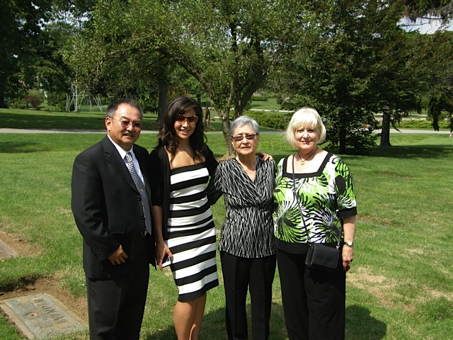
David Mitsui Family

Miyauchi, 宮内, ミヤウチ (Surname / family name / 苗字 / 家族名)
Shohei, 祥平, ショウヘイ (First name / given name / 名前)
Year of birth / 生年: 1982

Ancestral History? 先代やあなたは日本のどこから来ましたか？
広島. [Translation] Hiroshima-ken

When and why did you or your family come to Edmonton? いつ、どうしてエドモントンへ来ましたか？
勉学. [Translation] To study

What were your major occupations in the past and major employers? あなたの仕事はなんですか？雇用主はどこですか？
Athletic Therapist
Edmonton Eskimos Athletic Therapist
Edmonton Eskimos

In what ways has having Japanese heritage affected the course of your life or family history? あなたが日本人または日系人であることは、人生にどのような影響があったと思いますか？
日本人受けがよい. [Translation] Japanese people are popular.

Additional history? 個人史・家族史
勉学のため. [Translation] To study.

Morita, 守田、モリタ (Surname / family name / 苗字 / 家族名)
Sachio, 幸男、サチオ (First name / given name / 名前)
Year of birth / 生年: 1965

Ancestral History? 先代やあなたは日本のどこから来ましたか？
鹿児島県、東京. [Translation] Kagoshima-ken; Tokyo

When and why did you or your family come to Edmonton? いつ、どうしてエドモントンへ来ましたか？
1999年に東京でカナダ人の妻と結婚し、2001年に妻の希望でエドモントンに来ました。
[Translation] I married my Canadian wife in Tokyo in 1999. We came to Edmonton in 2001 because my wife wanted to.

What were your major occupations in the past and major employers? あなたの仕事はなんですか？雇用主はどこですか？
2001年から現在までJapanese Villageで寿司職人をしています。
[Translation] Working as a Sushi specialist at the Japanese Village since 2001.

In what ways has having Japanese heritage affected the course of your life or family history? あなたが日本人または日系人であることは、人生にどのような影響があったと思いますか？
私のプライドです。[Translation] I am proud of my Japanese heritage.

Additional history? 個人史・家族史
1999年にカナダ人と結婚、東京で長男誕生。2001年に家族3人でエドモントンに移住、長女誕生。現在に至ります。
[Translation] I married a Canadian in 1999 and our eldest son was born in Tokyo. Our family of three moved to Edmonton in 2001 where our eldest daughter was born.

Morita, 守田、モリタ (Surname / family name / 苗字 / 家族名)
Luka, 流佳、ルカ (First name / given name / 名前)
Year of birth / 生年: 1999

Ancestral History? 先代やあなたは日本のどこから来ましたか？
鹿児島県、東京. [Translation] Kagoshima-ken; Tokyo

When and why did you or your family come to Edmonton? いつ、どうしてエドモントンへ来ましたか？
家族と一緒に移住。 [Translation] Immigrated to Canada with family

What were your major occupations in the past and major employers? あなたの仕事はなんですか？雇用主はどこですか？
学生. [Translation] Student

Morita, 守田、モリタ (Surname / family name / 苗字 / 家族名)
Eko, 饗子、エコ (First name / given name / 名前)
Year of birth / 生年: 2001

Ancestral History? 先代やあなたは日本のどこから来ましたか？
鹿児島県、エドモントン生まれ。 [Translation] Kagoshima-ken. I was born in Edmonton.

Mullions,マリンズ (Surname / family name / 苗字 / 家族名)
Hiroto, 泰仁、ヒロト (First name / given name / 名前)
Year of birth / 生年: 2005

Ancestral History? 先代やあなたは日本のどこから来ましたか？
母は、福井県越前町出身です。父はハリファックス出身です。僕はエドモントンで生まれ、そだちました。
[Translation] Mother is from Fukui-ken, Echizen-cho [town]. Father is from Halifax. I was born and raised in Edmonton.

What were your major occupations in the past and major employers? あなたの仕事はなんですか？雇用主はどこですか？
学生 [Translation] Student

In what ways has having Japanese heritage affected the course of your life or family history? あなたが日本人または日系人であることは、人生にどのような影響があったと思いますか？
まだ分かりりません。 [Translation] Do not know yet.

Mullions,マリンズ (Surname / family name / 苗字 / 家族名)
Keiji, 圭智、ケイジ (First name / given name / 名前)
Year of birth / 生年: 1998

Ancestral History? 先代やあなたは日本のどこから来ましたか？
母は、福井県越前町出身です。父はハリファックス出身です。私はハリファックスで生まれ、そだちました。
[Translation] Mother is from Fukui-ken, Echizen-cho [town]. Father is from Halifax. I was born and raised in Halifax.

When and why did you or your family come to Edmonton? いつ、どうしてエドモントンへ来ましたか？
2002, 父の博士号取得のため（U of A)
[Translation] 2002 - for my father to complete his PhD at the University of Alberta.

What were your major occupations in the past and major employers? あなたの仕事はなんですか？雇用主はどこですか？
学生. [Translation] Student

In what ways has having Japanese heritage affected the course of your life or family history? あなたが日本人または日系人であることは、人生にどのような影響があったと思いますか？
よい点：アニメや漫画、テレビ・ゲームを通じて共通の趣味を持つ友達に出会えた。悪い点：小学4年の時、中国と韓国から来たクラスメートから”I hate Japan and Japanese"と言われた。So far, I am proud of being a Japanese Canadian.
[Translation] Positive point: I have made friends who have the same interests as I in anime, manga and TV games. Negative point: When I was in grade 4, classmates from China and Korea said to me, “I hate Japan and Japanese.” So far, I am proud of being a Japanese Canadian.

Nagakura, 長倉, ナガクラ (Surname / family name / 苗字 / 家族名)
Yukiko, 由紀子, ユキコ (First name / given name / 名前)

Ancestral History? 先代やあなたは日本のどこから来ましたか？
日本静岡市出身
中国黒龍江省ハルピン市に住んでいました。
[Translation] I am from Japan, Shizuoka-shi and have also lived in Harbin, Heilongjiang, China.

When and why did you or your family come to Edmonton? いつ、どうしてエドモントンへ来ましたか？
1992年、エドモントン出身のカナダ人と知り合いになったので、カナダに来ました。
[Translation] In 1992, I became acquainted with a person from Edmonton and that's why I came to Canada.

What were your major occupations in the past and major employers? あなたの仕事はなんですか？雇用主はどこですか？
フリーランス翻訳（主に Multi-Lingual 社）
日系旅行会社
エドモントン地区日本人コミュニティスクール教師
EJCA日本語クラス
[Translation] Freelance translator (mainly with Multi-Lingual Co.). Japanese travel agent. Metro Edmonton Japanese Community School teacher. Teaching EJCA Japanese language classes.

In what ways has having Japanese heritage affected the course of your life or family history? あなたが日本人または日系人であることは、人生にどのような影響があったと思いますか？
日本で日本人として育ったので、何か特別な「影響」というものはないと思います。
[Translation] Since I grew up Japanese in Japan, I don't think of it as having any special influence.

Additional history? 個人史・家族史
家族はいずれもカナダとはご縁がありません。
1992年、エドモントン出身のカナダ人と知り合いになったので、カナダに来ました。エドモントン在住となったのは、エドモントンで仕事をしているカナダ市民と結婚したためです。
[Translation] None of my family had anything to do with Canada. In 1992, I met a Canadian from Edmonton and came to Edmonton. I live in Edmonton because I married a Canadian who has a job here.

Nagata, 長田, ナガタ (Surname / family name / 苗字 / 家族名)
Mari, 麻里, マリ (First name / given name / 名前)
Year of birth / 生年: 1972

Ancestral History? 先代やあなたは日本のどこから来ましたか？
神奈川県鎌倉市. [Translation] Kanagawa-ken, Kamakura-shi

When and why did you or your family come to Edmonton? いつ、どうしてエドモントンへ来ましたか？
勉学 ＋ 仕事 ＋ 主人の転勤
[Translation] Study + work + husband's job transfer.

What were your major occupations in the past and major employers? あなたの仕事はなんですか？雇用主はどこですか？
1) デイケアティチャー （イエローナイフ チャイルドディベロップメント）
2) フロントデスククラーク （エイローナイフ エクスポローラーホテル）
3) キャビンアテンダント （ジョンストンキャニオン、バンフ）
4)日本食レストラン 〔琴、現在はない〕
5) 幼稚園教諭 〔日本〕
[Translation] 1. Day care teacher, Yellowknife Child Development. 2. Front desk clerk, Yellowknife Explorer Hotel. 3. Cabin attendant, Johnston Canyon, Banff. 4. Koto Japanese restaurant (no longer open). 5. Kindergarten teacher, Japan.

Nagata, 長田, ナガタ (Surname / family name / 苗字 / 家族名)
Sachiko, 幸子, サチコ (First name / given name / 名前)
Year of birth / 生年: 1927

Information submitted in lieu of survey responses.

Stories of Our Seniors Mrs. Sachiko Nagata (submitted by Sanae Ohki)
Mrs. Nagata has been a long-time member of EJCA and had been actively participating in Matsu-no-Kai and other EJCA activities up until a couple of years ago. Since I had seen her for a while at EJCA activities, I dropped in on her at Chartwell Wild Rose Regiment Residence on January 6, 2016. Her room was located just opposite to the dining room and she kept it very cozy. The dining room was clean and nicely decorated like a restaurant. She eats her three meals at this dining room. Her room was cleaned by the residence staff so, as she said, “I spend every day very relaxed.”
I used to know Mr. Nagata as Tak. He was already the EJCA book-keeper in the oldest EJCA document of 1969 and had been in that position for 33 years until 2002. According to Mrs. Nagata, Tak had, in fact, been the book-keeper since 1958. When my husband was an EJCA director, he used to give Tak a ride when for EJCA board meetings. I am glad to see Mr. Nagata enjoys a very relaxed life at a wonderful facility.
I take this opportunity to introduce Mrs. Nagata’s personal story to our readers. This was based on an interview in 2010 in conjunction with the EJCA history project.

I was born in Vancouver in 1927 and went back to Japan in 1934 when I was seven-years old. I came back to Canada in 1958 and it turned out that I was the only one in my family who decided to come back to Canada. While I was in Japan, I was living in Sakei-minato machi, Tottori prefecture. It is a port city that began its trade with Great Britain and the United States in 1899. The city is also famous for its famous Japanese manga writer, Mr. Shigeru Mizuki. Our family went back to Japan to take care of my grandmother who became bedridden by a stroke. I was in Japan during the Second World War and experienced a very tough life.
My mother knew the Nagata family who lived in the south of Taber, Alberta. One of Nagata’s acquaintances happened to visit Japan and introduced me to Mr. Takeo Nagata, my future husband. I came back to Canada to get married with him. I met him for the first time in Canada. He was the eldest son of five sons of the Nagata family. I lived with her mother for a month before we had a wedding ceremony at c church in Taber. Perhaps in October or November of that year, we moved to Edmonton where we have been living since then. I remember that Edmonton used to be colder than now. I also remember that Sakai-minato was pretty cold in winter
My husband worked at several companies as book-keeper. I have not worked for a company partly because I was not good at English. However, I took care of children at a Japanese family for two years. When we moved to Edmonton, there were very few Issei. The Yamamoto’s were the only one we knew. EJCA had meetings at Bissel Church and occasionally a chomen supper. But I do not think many people showed up at these occasions, perhaps less than 20 families. Eventually, I got to know other Japanese-Canadians such as the Tsujikawa’s, Shimizu’s, and Sikaze’s. In Lethbridge and Taber, I used to a lot of Japanese-Canadian families. My husband had been a book-keeper of EJCA since the association started. In those old days, I always enjoyed to visit my mother-in-law at Taber because I could buy Japanese groceries at Nakagama Japanese grocery store in Lethbridge. I bought Japanese groceries such as rice, kamaboko, miso, canned fish and soumen. I used to make sushi using canned eels. It was much later when a store selling Japanese groceries opened in Edmonton.
I visited Japan in 1973 to attend one of my nieces’ wedding. Both my parents and my husband’s parents were born in Sakai-minato. But I do not remember when my parents came to Canada. I remember that once I had a book that described about my parents but have lost it. My husband and I used Japanese and English four our conversations. My husband had never lived in Japan. He passed away in 2006 at the age of 84.

EJCAシニアー会員の物語 長田 幸子さん (大木 早苗)

長田さん（89才）はずっとEJCAの会員で、2年前まで松の会（シニアーの会）を始めいろいろな行事に参加していました。この頃お姿が見えないのでお訪ねしようと思いながら時間がたってしまいました。EJCAの新年会にいらっしゃれるかどうかを考えながら、1月6日にChartwell Wild Rose Retirement Residenceへお訪ねしました。長田さんはここにしばらく前からに住んでいらっしゃいます。ダイニングルームの向かいの部屋をとてもきれいに“Cozy”にしておられます。このダイニングルームはレストランのようにきれいでびっくりしました。食事は3食ともこのダイニングルームに用意され、部屋の掃除や管理はスタッフがしてくれるそうで、「私は一日中のんびりしています」とのこと。この訪問を機会に長田さんをご紹介します。以下は2010年にEJCA の歴史プロジェクトが行なった長田さんのインタビューの記録を長田さんの言葉として要約したものです。

私は1927年にバンクーバーで生まれ、1934年7才の時に日本へ行きました。結局家族の中で私だけが1958年に又カナダへ戻りました。日本にいるときは鳥取県の境港町に住んでいました。（注:境港市は鳥取県日本海側にある町で、名前のとおり1899年にアメリカとイギリスとの貿易港として始まった港町、現在は漁港。最近ではゲゲゲの鬼太郎の作者として有名な水木しげるの出生地としても有名。）バンクーバーから日本へ帰った直接の理由は祖母が中風にかかったから世話のためです。戦争中日本にいましたが生活は大変でした。

私の母がアルバータ州テーバーの南に住んでいた長田家と知り合いで、丁度日本へ戻った知人がたけおさんとの結婚話を伝えてくれ、結婚することになったのでカナダへ戻ったのです。たけおは男だけの5人兄弟の長男で、カナダに来て初めて会いました。1と月程たけおのお母さんの家に住んでから、テーバーの教会で結婚式をしました。それからその年の多分10月か11月にエドモントンへ来て以来ずっとエドモントンに住んでいます。当時のエドモントンは今よりもずっと雪が多くて寒かったのを覚えています。日本も昔はとても寒いでした。

たけおは会計士としていくつかの会社で働きました。私は英語が得意ではなかったこともあり特に仕事はしませんでしたが、日本人の家庭で2年間子供の世話をしました。初めてエドモントンに来た頃知っていた人は山本さんだけでした。その頃は日本から来た日本人は殆どいませんでした。日系クラブではビッセルセンター（Bissell Church）で会合をしたりチャーメン・サパーをしていましたが、そんなに大勢は集まらなかったと思います。20家族ぐらいでしょうか。クリスマスパーティもしていたかも知れませんが、よく知りません。後になってから、何人かの日系人と知り合いになりましたが、大勢の人がもう亡くなりました。辻川さんとも知り合いになりました。それから清水さん、医者の米田さんを知っていました。志風さんも会計士でした。レスブリッジやテーバーには日本人が大勢いました。たけおは日系クラブが始まった時からずっとクラブの会計をしていました。

義母のいるテーバーを時々訪れるのは楽しみで、その時に日本食品を買ったりしました。レスブリッジに中釜日本食品店があったのです。お米、かまぼこ、味噌、魚やウナギの缶詰、そうめんなどを買っていました。ウナギでお寿司を作りました。エドモントンに日本食品店が出来たのはずっと後になってからです。カルガリーにはあったと思います。

1973年に日本を訪問しました。姪の結婚式があったからです。私の両親も長田家の両親も境港出身の1世ですが、何年頃にカナダに来たかは覚えていません。以前、そのようなことを書いた本を持っていたのですが、今はみつかりません。私とたけおは日本語と英語を混ぜて話していました。たけおは日本に住んだことはありません。2006年に84才で亡くなりました。

後書き: ご主人のたけおさんは Tak Nagataと言われ、私が知っているTakはいつもEJCAの会計でした。記録を見ると1969年のEJCAの記録が始まった年から、2002年まで33年間EJCAの会計です。幸子さんのお話によるとその前1958年にエドモントンに来てからも会計をしてくださっていたようです。私の主人が役員をしていた時もいつもTakが会計で役員会の時に車でお迎えに行っていたので、よく知っています。幸子さんはいつも優しくて素敵でした。静かに平安な余生を送られていらっしゃり、嬉しく思いました。
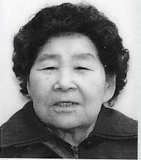Sachiko Nagata [date unknown]

Nakamoto, 中本, ナカモト (Surname / family name / 苗字 / 家族名)
Sinya, 真也, シンヤ (First name / given name / 名前)
Year of birth / 生年: 1979

Ancestral History? 先代やあなたは日本のどこから来ましたか？
大阪. [Translation] Osaka-shi

When and why did you or your family come to Edmonton? いつ、どうしてエドモントンへ来ましたか？
2005年8月に語学習得とPhysiotherapyの資格取得のため
[Translation] I came in August 2005 to learn English and get a physiotherapy qualification.

What were your major occupations in the past and major employers? あなたの仕事はなんですか？雇用主はどこですか？
Physiotherapist
- Capilano Rehab Centre (現/current)
- Edmonton Capitals (2009-2010)
- Edmonton CrackerCats (2008)

In what ways has having Japanese heritage affected the course of your life or family history? あなたが日本人または日系人であることは、人生にどのような影響があったと思いますか？
細かい気遣いがカナダ人よりできるかな、と感じ、その大切さを再確認できた。
[Translation] I feel that perhaps Japanese people are better at showing concern for others in little ways better than Canadians are – and I try to model that behaviour better.

Nakano, 中野、ナカノ (Surname / family name / 苗字 / 家族名)
Yuri, 百合、ユリ (First name / given name / 名前)
Year of birth / 生年: 1970

Ancestral History? 先代やあなたは日本のどこから来ましたか？
Hokkaido; Kanagawa-ken

What were your major occupations in the past and major employers? あなたの仕事はなんですか？雇用主はどこですか？
Missionary - Northern American Baptist Conference, Pastor - Edmonton Japanese Christian Church

In what ways has having Japanese heritage affected the course of your life or family history? あなたが日本人または日系人であることは、人生にどのような影響があったと思いますか？
It is my identity, so it has a big influence on my life.

Additional history? 個人史・家族史
My parents immigrated to Canada and moved to Edmonton from Calgary because my father decided to study at the University of Alberta. My parents enrolled me in the Metro Edmonton Japanese Community School which helped me to read and write Japanese. I am now working in Japan as a missionary so this language learning was very helpful to me.

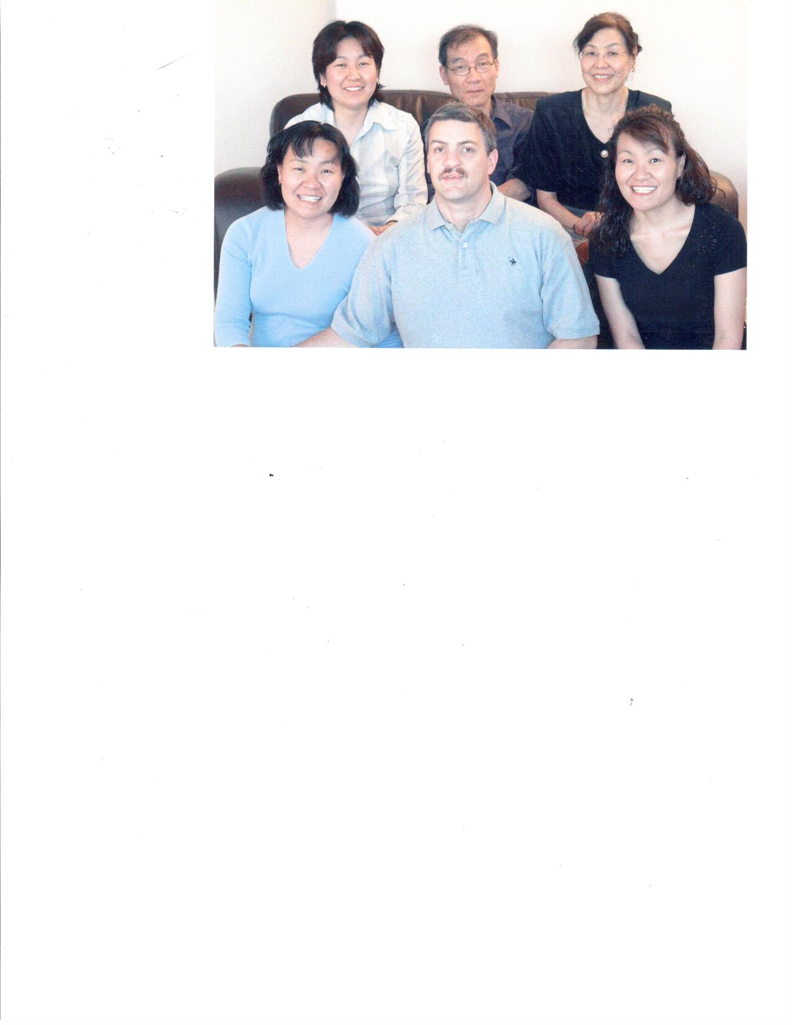

Edmonton, September 2006 Family gathering. (Top) Yuri, Takuo (father), Yuko Nakano (Mother), Miyo (Bottom), Gerald Bly, Kayo Nakano

Nakao, 中尾, ナカオ (Surname / family name / 苗字 / 家族名)
Rui, 塁, ルイ (First name / given name / 名前)
Year of birth / 生年: 1973

Ancestral History? 先代やあなたは日本のどこから来ましたか？
父は岩国で生まれたが、長崎で育ち、母は愛知県で生まれ育った。父が日本の商社の駐在員と初手、オーストラリア、カナダに派遣され、私は日本と海外を転々と引越し、育った。私はトロントで高校を卒業し、日本の大学を経てバンクーバーで収支をしとくし、その後、エドモントンへ仕事のために移った。（２００２年）
[Translation] My father was born in Iwakuni-shi and grew up in Nagasaki. My mother was born and raised in Aichi-ken. My father worked for a Japanese trading company and was dispatched overseas to Australia and Canada, so I moved between Japan and foreign countries as I grew up. I graduated from high school in Toronto, then attended university in Japan. After I got Master degree in Vancouver, I moved to Edmonton for my job in 2002.

When and why did you or your family come to Edmonton? いつ、どうしてエドモントンへ来ましたか？
２００２年にバンクーバーで修士を取得し、学生ビザだったため、当時すでに好景気だったアルバータで仕事を探そうと思った。（学生ビザから就労ビザの切り換えのため、早急に職に付く必要があったため） 妻はエドモントン出身で、彼女とバンクーバーで出会ったが、このため、エドモントンは来やすいところだった。結婚して２，３年で私の妹もいるトロントへ移ろうと思ったが、現在まで至る。
[Translation] After I got my master’s degree in Vancouver in 2002, I thought I would look for work in Alberta where the economy was good (to change from a student visa to a working visa, I had to find work fairly quickly). Although we met in Vancouver, my wife is from Edmonton so it was easy to move here. After about 2 or 3 years of marriage, I thought we should move to Toronto where my sister lives but we’re still here.

What were your major occupations in the past and major employers? あなたの仕事はなんですか？雇用主はどこですか？
1) 建設設計。
2) Ａｒｃｈｉｔｅｃｔｕｒｅ ＡＴＢ
[Translation] 1. Architectural Designer

Additional history? 個人史・家族史
家族構成：つま（日系カナダ人）、子供２人（５歳、３歳） エドモントン生まれ。２０１１年に日本に住んでいた両親を亡くし、日本との絆を失った。アルバータ滞在も１０年を過ぎ、やっとアルバータ州が｢好き｣と宣言できるようになった。このため、アルバータに長く住む事を考えている。
[Translation] My family: wife (Nikkei Canadian), two children (5 and 3 years old) who were born in Edmonton. Since my parents in Japan died in 2011, I have lost my ties to Japan. After living in Alberta for 10 years, I can honestly say I like Alberta. I think I will live in Alberta a long time.

Nakashima (Surname / family name / 苗字 / 家族名)
Tom (First name / given name / 名前)
Year of birth / 生年: 1942

Ancestral History? 先代やあなたは日本のどこから来ましたか？
Kagoshima/California

When and why did you or your family come to Edmonton? いつ、どうしてエドモントンへ来ましたか？
Job

What were your major occupations in the past and major employers? あなたの仕事はなんですか？雇用主はどこですか？
Student/University of Alberta

Nakashima, 中島, ナカシマ (Surname / family name / 苗字 / 家族名)
Tomoko, 朋子, トモコ (First name / given name / 名前)
Year of birth / 生年: 1969

Ancestral History? 先代やあなたは日本のどこから来ましたか？
大阪府箕面市. [Translation] Osaka-fu, Minoho-shi

When and why did you or your family come to Edmonton? いつ、どうしてエドモントンへ来ましたか？
１９９６年、英語の勉強の為、おばの居るエドモントンに留学で来ました。
[Translation] I came to Edmonton in 1996 to study English because my aunt lived here.

What were your major occupations in the past and major employers? あなたの仕事はなんですか？雇用主はどこですか？
看護助手 - ＡＨＳ（Ａｌｂｅｒｔａ Ｈｅａｌｔｈ Ｓｅｒｖｉｃｅｓ）
[Translation] Nurses-aide, Alberta Health Services

In what ways has having Japanese heritage affected the course of your life or family history? あなたが日本人または日系人であることは、人生にどのような影響があったと思いますか？
カナダに来たおかげで日本の奥深い文化をさらに知る事が出来、又、誇りにも思う事ができてよかったです。
[Translation] Because of coming to Canada, I have learned more about Japanese culture and ed to know more about and became more proud of Japanese culture.

Additional history? 個人史・家族史
おばが一世と結婚した為、カナダに居住。私と主人の両親は日本在住のため、孫の顔を見せに、１年に１ヶ月間、日本に帰国しています。
[Translation] I live in Canada because my aunt married an Issei. Both my husband's and my parents live in Japan. I visit Japan for one month every year so that our parents can see their grandchildren.

Nakashima, 中島, ナカシマ (Surname / family name / 苗字 / 家族名)
Ryuichi, 竜一, リュウイチ (First name / given name / 名前)
Year of birth / 生年: 1976

Ancestral History? 先代やあなたは日本のどこから来ましたか？
鳥取県. [Translation] Tottori-ken

When and why did you or your family come to Edmonton? いつ、どうしてエドモントンへ来ましたか？
２００７年に仕事で来ました。[Translation] I came in 2007 for my job.

What were your major occupations in the past and major employers? あなたの仕事はなんですか？雇用主はどこですか？
現在：１）ソーシャルワーカー Ｆａｍｉｌｙ Ｃｅｎｔｒｅ
過去：２）セールスアソシエート Ｈｏｍｅ Ｄｅｐｏｔ
３）フレーマー Ｈｏｒｉｚｏｎ Ｍｏｔｏｒ Ｓｐｏｒｔｓ
[Translation] Current: 1. Social worker, Family Centre.
Past: 2. Sales assistant, Home Depot. 3. Framer, Horizon Motor Sports

In what ways has having Japanese heritage affected the course of your life or family history? あなたが日本人または日系人であることは、人生にどのような影響があったと思いますか？
特に海外に来て、仕事に対する姿勢に関して、まじめにきめ細かく取り組む事は、日本の環境で育ったものである自覚をあらためさせられた。
[Translation] Since moving overseas, I have become more aware of the work attitudes (e.g. seriousness, serious, detail-oriented, collaborative) that I acquired through growing up in a Japanese environment.

Additional history? 個人史・家族史
個人移民. [Translation] I immigrated independently.

Nakashima, 中島, ナカシマ (Surname / family name / 苗字 / 家族名)
Kento, 健仁, ケント (First name / given name / 名前)
Year of birth / 生年: 2009

Ancestral History? 先代やあなたは日本のどこから来ましたか？
大阪府. エドモントンで生まれた。 [Translation] Osaka-fu, though I was born in Edmonton.

Nawata (Surname / family name / 苗字 / 家族名)
Miiko (First name / given name / 名前)
Year of birth / 生年: 1932

Ancestral History? 先代やあなたは日本のどこから来ましたか？
Kagoshima, Japan; Ocean Falls, B.C.; Lethbridge, Alberta

When and why did you or your family come to Edmonton? いつ、どうしてエドモントンへ来ましたか？
1956 - to go to university

What were your major occupations in the past and major employers? あなたの仕事はなんですか？雇用主はどこですか？
Teacher - Edmonton Public School Board

In what ways has having Japanese heritage affected the course of your life or family history? あなたが日本人または日系人であることは、人生にどのような影響があったと思いますか？
Having to move from British Columbia to Alberta.

Nawata (Surname / family name / 苗字 / 家族名)
Akira (First name / given name / 名前)
Year of birth / 生年: 1931

Ancestral History? 先代やあなたは日本のどこから来ましたか？
Fukuoka-ken; Vancouver; Raymond, AB; Calgary, AB

When and why did you or your family come to Edmonton? いつ、どうしてエドモントンへ来ましたか？
1950

What were your major occupations in the past and major employers? あなたの仕事はなんですか？雇用主はどこですか？
Engineer, Consultant, Gov't of AB - Bridge Dept.; Stantec Construction: Nawata Associates, Ltd.

In what ways has having Japanese heritage affected the course of your life or family history? あなたが日本人または日系人であることは、人生にどのような影響があったと思いますか？
Appreciation of Japanese culture & history. Understanding of Japanese culture, language & customs greatly helped me to carry out business with Japanese companies in Japan.

Additional history? 個人史・家族史
Father immigrated to Canada to start a new life & bring up his family. I came to Edmonton to attend University. I made many business trips to Japan - joint ventured with a major Japanese company.

Nishiguchi, 西口, ニシグチ (Surname / family name / 苗字 / 家族名)
Mari, 満理, マリ (First name / given name / 名前)
Year of birth / 生年: 1974

Ancestral History? 先代やあなたは日本のどこから来ましたか？
兵庫県尼崎市. エドモントンに来る前は、バンクーバーに住んでいました。
[Translation] Hyogo-ken, Amagasaki-shi. I lived in Vancouver before coming to Edmonton.

When and why did you or your family come to Edmonton? いつ、どうしてエドモントンへ来ましたか？
夫の家族がエドモントンにいるため。[Translation] Because my husband's family lives in Edmonton

What were your major occupations in the past and major employers? あなたの仕事はなんですか？雇用主はどこですか？
1) Photo Gift World（製本)
2) Day care（保母）
[Translation] 1. Book maker at Photo Gift World. 2. Day Care (nursery school teacher)

In what ways has having Japanese heritage affected the course of your life or family history? あなたが日本人または日系人であることは、人生にどのような影響があったと思いますか？
日本人であるために何か影響があったというのではありませんが、カナダに来て、あらためてわかった事は、日本という国は本当にすばらしい国で、日本人であることがとても誇らしいと思えるようになりました。
[Translation] Although I don’t think being Japanese has had much influence, since coming to Canada I have become more proud to be Japanese and of Japan as a wonderful country.

Additional history? 個人史・家族史
ワーキングホリデービザでカナダに来て、バンクーバーで夫と知り合い、そのまま結婚。夫はもともとエドモントンの人で（パレスチナ人ですが）夫の兄弟もエドモントンにいるので来ました。
[Translation] I came to Canada on a working holiday visa and met my husband in Vancouver where we got married. My husband was originally from Edmonton (he is a Palestinian) and his brothers are here – so that’s why we came to Edmonton.

Nishimura (Surname / family name / 苗字 / 家族名)
Carl (First name / given name / 名前)
Year of birth / 生年: 1941

Ancestral History? 先代やあなたは日本のどこから来ましたか？
Shiga-ken - parents Yosaburo and Maki Nishimura came to Raymond, AB about 1917.
Coaldale from 1947.
Left Coaldale in 1959.
Rimbey, Alberta - 1964 to 1970.
Edmonton, AB since 1970.

When and why did you or your family come to Edmonton? いつ、どうしてエドモントンへ来ましたか？
Study and jobs.

What were your major occupations in the past and major employers? あなたの仕事はなんですか？雇用主はどこですか？
Teacher - 1964 to 1970 - County of Ponoka
Lecturer - 1972 to 1974 - U of A, Faculty of Education, Secondary Education.
Teacher - 1974 to 2000 - Edmonton Public Schools.

In what ways has having Japanese heritage affected the course of your life or family history? あなたが日本人または日系人であることは、人生にどのような影響があったと思いますか？
Who knows where my rather fatalistic and stoic outlook on life came from. However, growing up with home-style Japanese cuisine has given me a continuing interest in many cuisines especially in Japanese cuisine. In the early 2000's, I worked with an elementary teacher to organize and participate in presenting a Japan day for a few years until monies became too tight. Stay in touch with a private English teacher in Japan and lend a native speaker's voice during my very early morning hours to her lessons. Also, spent 5 weeks in Japan visiting my daughter who was working at Riken in Saitama, and 3 weeks of which I explored various regions of Japan, armed with a JR pass and Lonely Planet - Japan. The locals found my spoken Japanese very strange!

Additional history? 個人史・家族史
My father came to Japan [Canada?] to seek employment because, being the youngest in a large family of boys, he had no hope of ever being able to farm on the ancestral land so he had hopes of farming in Canada.
I visited Japan for 5 weeks in 2002 touring as well as trying to connect with some relatives and friends. Our daughter, Tamiko happened to be working at Riken Research in Saitama at the time so it seemed an opportune time to go there.
In the early 1980's, we had a girl from Tokyo stay with us for the year as she volunteered with Edmonton Public Schools as an Intern. We have kept in close contact with her since then.

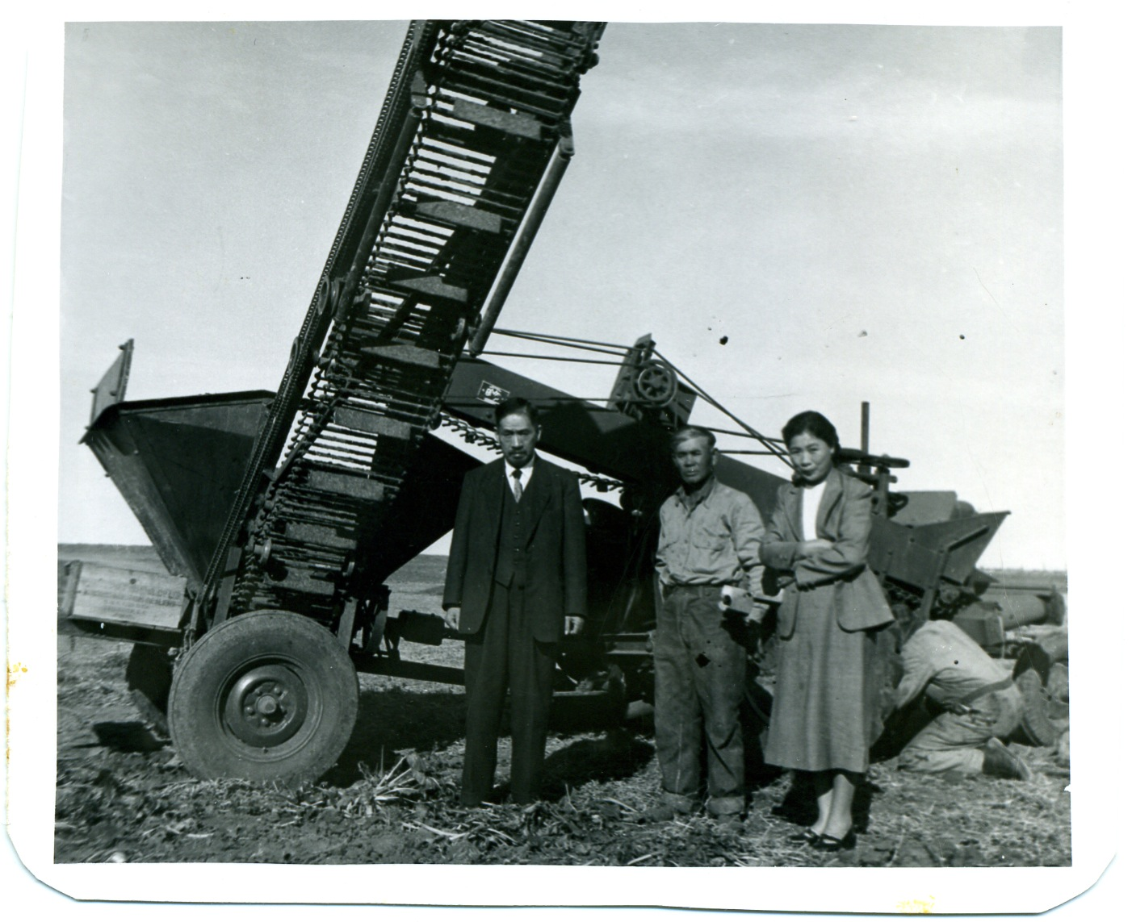
Carl Nishimura Photo 2: Coaldale, Alberta circa 1955. Rev. Nagatomi, Yosaburo Nishimura (my dad ), Mrs. Kawamura taken about 1955 in Coaldale, Alberta on our farm. Reverend Nagatomi was visiting Buddhists in Southern Alberta and Mrs. Kawamura, wife of Reverend Kawamura, senior, was showing him around.

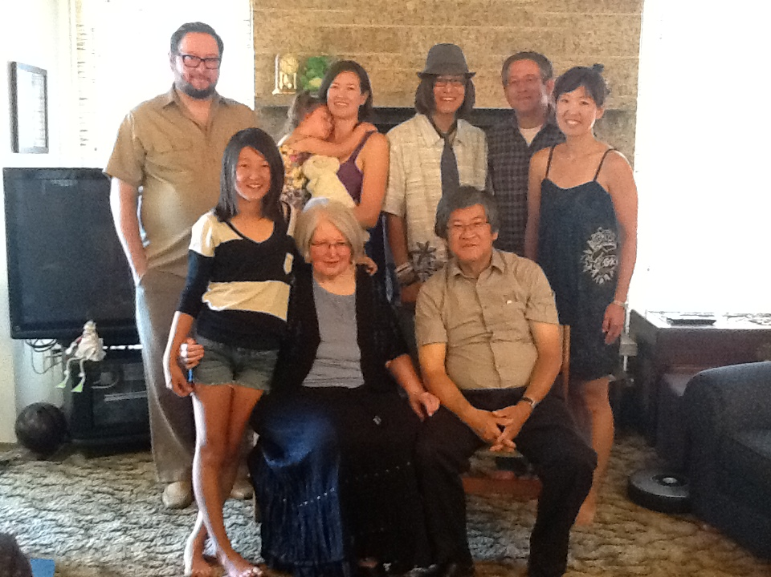
Carl Nishimura Photo 1: Edmonton in March 2012
Back: Kevin, Tamiko holding daughter Aya Trembley, Ethan son of Warren, Tammy
Front: Taylor daughter of Warren and Tammy, Carol, Carl
Family get together in March, 2012. Only Kevin, Carol and Carl are presently living in Edmonton.
Tamiko and Aya live in Montreal, Warren and his family live in Calgary.

Noborio, 登尾、ノボリオ (Surname / family name / 苗字 / 家族名)
Yumiko , 由美子、ユミコ (First name / given name / 名前)
Year of birth / 生年: 1946

Ancestral History? 先代やあなたは日本のどこから来ましたか？
東京 [Translation] Tokyo-to

When and why did you or your family come to Edmonton? いつ、どうしてエドモントンへ来ましたか？
仕事の為. [Translation] Job

What were your major occupations in the past and major employers? あなたの仕事はなんですか？雇用主はどこですか？
日本レストランの会計、ホテルのウェイトレス、領事館公邸の手伝い、日本レストランの経営
[Translation] Accounting for a Japanese restaurant, hotel waitress, helper at the official residence of the Consul-General [Japanese consul to Alberta in Edmonton?], restaurant management.

Noborio, 登尾、ノボリオ (Surname / family name / 苗字 / 家族名)
Toshiyuki, 利行、トシユキ (First name / given name / 名前)
Year of birth / 生年: 1949

Ancestral History? 先代やあなたは日本のどこから来ましたか？
四国、高松. [Translation] Kagawa-ken, Takamatsu-shi

When and why did you or your family come to Edmonton? いつ、どうしてエドモントンへ来ましたか？
仕事の為. [Translation] Job

What were your major occupations in the past and major employers? あなたの仕事はなんですか？雇用主はどこですか？
鉄板焼き、タクシードライバー、領事館公邸の執事、日本レストラン経営
[Translation] Teppan-yaki restaurant, taxi driver, steward at official residence of Consul General [in Edmonton], Japanese restaurant management.

Oba, 大場 (Surname / family name / 苗字 / 家族名)
Maki, 蒔・ まき (First name / given name / 名前)
Year of birth / 生年: 1996

Ancestral History? 先代やあなたは日本のどこから来ましたか？
母ー鳥取県. 父ー大阪府. [Translation] Mother from Tottori-ken; Father from Osaka-fu.

When and why did you or your family come to Edmonton? いつ、どうしてエドモントンへ来ましたか？
父の仕事. [Translation] My father's job.

In what ways has having Japanese heritage affected the course of your life or family history? あなたが日本人または日系人であることは、人生にどのような影響があったと思いますか？
日本語と英語のバイリンガル
日本とアメリカ・カナダのバイカルチャー
[Translation] I am bilingual in Japanese and English and bicultural between Japan and America/Canada.

Oba, 大場 (Surname / family name / 苗字 / 家族名)
Keiko, 恵子 (First name / given name / 名前)
Year of birth / 生年: 1964

Ancestral History? 先代やあなたは日本のどこから来ましたか？
鳥取県. [Translation] Tottori-ken

When and why did you or your family come to Edmonton? いつ、どうしてエドモントンへ来ましたか？
夫の仕事. [Translation] Because of my husband's job.

What were your major occupations in the past and major employers? あなたの仕事はなんですか？雇用主はどこですか？
小学校教師、日本語補習校講師、日本語講師
[Translation] Elementary school teacher, teacher at Metro Edmonton Japanese Community School, Japanese language instructor.

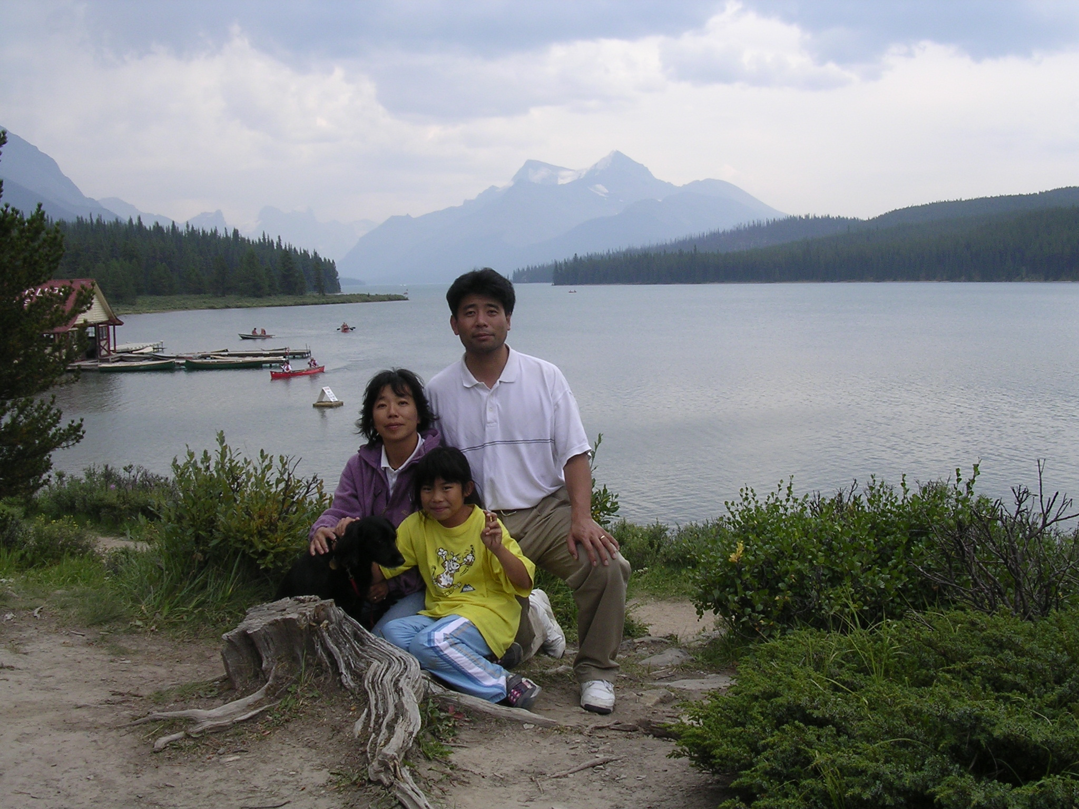
Moraine Lake, Banff 2004, just after arriving in Canada. Keiko Oba, Masahito Oba and daughter Maki

Oba, 大場 (Surname / family name / 苗字 / 家族名)
Masahito, 真人・まさひと (First name / given name / 名前)
Year of birth / 生年: 1969

Ancestral History? 先代やあなたは日本のどこから来ましたか？
大阪府. [Translation] Osaka-fu

When and why did you or your family come to Edmonton? いつ、どうしてエドモントンへ来ましたか？
仕事. [Translation] Job.

What were your major occupations in the past and major employers? あなたの仕事はなんですか？雇用主はどこですか？
大学教授、アルバータ大学. [Translation] University Professor; University of Alberta

Ogata (Surname / family name / 苗字 / 家族名)
Leanne Sayaka (First name / given name / 名前)
Year of birth / 生年: 1987

When and why did you or your family come to Edmonton? いつ、どうしてエドモントンへ来ましたか？
Mother came to Canada on an exchange program. Moved to Canada because she met my father during the exchange program.

What were your major occupations in the past and major employers? あなたの仕事はなんですか？雇用主はどこですか？
EMT - Alberta Paramedical. Pharmacy Tech - Grandin Rx. Admin Assistant - Ford Canada

Ogata (Surname / family name / 苗字 / 家族名)
Laurie Chihiro (First name / given name / 名前)
Year of birth / 生年: 1990

Ancestral History? 先代やあなたは日本のどこから来ましたか？
Mother's side - Fukuyama, Hiroshima

When and why did you or your family come to Edmonton? いつ、どうしてエドモントンへ来ましたか？
Mom came here to learn another language and experience another culture when she was in her 20's.

What were your major occupations in the past and major employers? あなたの仕事はなんですか？雇用主はどこですか？
I am a student at the U of A [Univ. of Alberta].

In what ways has having Japanese heritage affected the course of your life or family history? あなたが日本人または日系人であることは、人生にどのような影響があったと思いますか？
I get to eat the most amazing food, feel a part of another culture, and be proud that I am different from the average person.

Ogata, 緒方, オガタ (Surname / family name / 苗字 / 家族名)
Akiko, 明子, アキコ (First name / given name / 名前)

Ancestral History? 先代やあなたは日本のどこから来ましたか？
広島県福山市田尻（タジリ）町. [Translation] Hiroshima-ken, Fukuyama-shi, Tajiri-cho [town]

When and why did you or your family come to Edmonton? いつ、どうしてエドモントンへ来ましたか？
1981年にセントアルバート市に訪問者として来加した時主人と出会い、1983年に婚約者ビザを取得したあと同年3月に移住してきました。
[Translation] In 1981, I was a visitor to St. Albert where I met my future husband. In 1983, I got a fiance-class visa and moved here in March of that year.

What were your major occupations in the past and major employers? あなたの仕事はなんですか？雇用主はどこですか？
通訳・翻訳者
自営業：OGATA CORP
1978-81：ライオンズクラブ事務局
1983-85：保母
1987-93：グラフィックデザイナー
1994-：通訳・翻訳者
[Translation] [Currently] I am an self-employed interpreter and interpreter, my company is Ogata Corp. 1978-1981: Lions Club Executive Office. 1983-1985: Childcare service provider. 1987-1993: graphic designer. 1994 to present: interpreter and translator.

In what ways has having Japanese heritage affected the course of your life or family history? あなたが日本人または日系人であることは、人生にどのような影響があったと思いますか？
私を受け入れてくらた国で、一人の日本人として恥ずかしくない生き方をしようと努力してきたつもりです。
[Translation] I try to live a life as a an individual Japanese person that I can be proud of in the country that kindly accepted me.

Additional history? 個人史・家族史
結婚のためにセント･アルバート市に移りました。日本の家族とは、電話連絡をとっています。2～3年に一度くらいの頻度で帰国しています。
[Translation] I came to St. Albert because of my marriage. I stay in touch with my family in Japan via phone calls. I go back to Japan once every 2 or 3 years.

More detail submitted in addition to survey responses.

家族構成：夫：Darin Ogata (Polis) 、長女：Leanne 紗矢香（さやか）、次女：Laurie 千裕（ちひろ）

私は、広島県福山市にある、海と山に囲まれた小さな地区、田尻町で育ちました。私が22歳を過ぎる頃には、幼馴染や友人の大部分が、見合い結婚をしていましたし、「男子のいない家庭は、長女が婿養子を迎えて家を継ぐ」というのが仕来りでしたので、私もそろそろ婿養子を迎える時期かなと思っていた頃でした。ただ、母の影響で、小さい頃から外国への憧れと興味はありました。母とよく外国の映画を見たり、翻訳本を読んで感想を話し合ったりしていました。そのため、結婚前に外国生活を是非体験したくて、当時、偶然日本で知り合い、文通していたカナダ人の女子大生、レナータ・ジョリーさんに連絡を取り、彼女のお宅に6ヶ月間の長期滞在をさせてもらう予定で、1981年5月にカナダ・アルバータ州セント・アルバート市にやってきました。
モントリオール・オリンピックをテレビで見ていたので、なんとなく自分なりのカナダを想像していましたが、アルバータ州、ましてや、セント・アルバート市は、まったく未知の場所でした。到着して、初めて見た外国の風景には、ただただ感激でした。ホストファミリーが英語で話しかけてくれても、すべてが、BGMのようで、まるで外国映画の中にいるような感じでした。車は、右側通行、空港からセントアルバート市までの風景は、壮大！そして、外は、寒い！でも、私の心は、カナダに来た嬉しさとこれからの生活への期待でいっぱいでした。
主人は、私のホスト妹、レナータのボーイフレンドの弟でしたので、カナダ到着3日目に会いました。間もなくお付き合いを始めましたが、帰国の日が来て、いったん帰国しました。主人は、すぐ「婚約者呼び寄せ申請」を出してくれ、1983年3月末に再度カナダの地に足を降ろし、5月に結婚しました。私の実家がある地域は、かなり封建的でしたので、町史上初の国際結婚は、町内でのうわさになり、両親には辛い思いをさせてしまいました。これは、とても後悔しています。また、当然ですが、「長女は、婿養子をもらって緒方家の名前を継ぐ」と思っていた両親や親族は、結婚に猛反対でした。でも、主人は、その「長女は、緒方家の名前を継ぐ」ことを大切に考えてくれて、「ボクは、カナダ人で君の両親や親族の意に沿わないかもしれないが、3男なだから、許してもらえるなら名字を緒方に変えたい。」と言ってくれました。日本人の男性でさえ、彼らが女性の苗字になることを躊躇するのですが、カナダ人の主人が自らを犠牲にして提案してくれた時には、驚きと嬉しさで一杯でした。こうして、今の、Mr. Darin Ogataが生まれたのです。また、両親が、その後すぐに、主人を快く受け入れてくれたことには、とても感謝しています。
25歳当時の私の英語力は、簡単な日常会話くらいの程度でしたので、当然、一般の仕事はできず、義母のすすめで保育所で働き、そこで子供の英語を少しずつ学びました。ある日、義兄が、「明子、君は、とても教養のある人なんだろうけど、英語を聞く限りでは、君の教養が感じられない。」と私のために厳しい言葉をかけてくれました。このように、「言いにくいことも、その人のためだから伝える」と言う態度は、正に、カナダ人・西洋人の持つ素晴らしい態度だと思います。日本人の私にとっては、その言葉は、かなりのショックでしたが、カナダで住むためには、正しい英語力が必要性だということに気付きました。エドモントン市内にあり、ESLを提供していたGrant MacEwan Community Collegeで3ヶ月間正式に英語を学びました。その後、同カレッジで2年間グラフィックデザインの勉強をし、やっとカナダでも通用する技術を身につけことができ、自由業の仕事を始めました。
カレッジ卒業と同時に長女、リアン・紗矢香を出産し、その2年半後に次女、ローリー・千裕を授かりました。私の記憶では、日本で出産した母親は、普通、病院に1週間から10日くらい滞在しました。でも、カナダでは、長女の出産の時が2日滞在、次女の時は1日少しの滞在でした。この違いには驚きました。また、白色人種が多かったこの市だからこその、看護師さんとの興味深い会話もありました。長女出産の後、病室で休んでいたら、担当の看護師さんが、大慌てで娘を抱えて病室に入ってくるなり、「ごめんなさいね。でも、貴女の娘のお尻には、あざがあるの。ほら！」といって見せてくれました。私は、「ああ、蒙古斑（Mongolian Spot）ね。3～4年で消えるのよ。」と答えたると、他の看護師さんも、珍しそうに見ていました。「蒙古斑」と呼ばれるので、当然、モンゴル人や日本人などのアジア系の人種にでるはずなのですが、ヨーロッパ系の人種には全く出ないとは、思いもよりませんでした。
このように、私は、日本だから疑問視しないことや習慣、文化、日本語について、カナダに来て再認識したことが沢山ありました。今でも、何かをしている時に「あっ！そうだったんだ！」と気付くことがよくあり、それが面白くてたまりませんし、あまりに基本的なことなので、自身の無知に呆れかえって大笑いしてしまうことが多々あります。
出産直後に病院から帰ってきて、家事と育児を全て1人でするのは、とても心細く感じましたが、母が、3ヶ月ずつ手伝いに来てくれたり、自由業の仕事が入ったときは、主人が100%支援してくれたお陰で、子供達はすくすくと育っていきました。
主人と私は、子供達が幼稚園に入るまでは、日常会話は、英語と日本語で、教育は、英語のみに集中することにしました。私は、娘達に、日本の祖父母と会話ができるくらいの能力を身に付けて欲しかったので、家庭内での私との会話や絵本、ビデオを通して日本語に触れさせるようにしました。お陰で、読み書きは全くできないのですが、会話だけは十分できるようになってくれました。大人になった彼女たちは、日本語の学習に興味を示してくれています。
娘達が学校に通っている間、学校でボランティアの機会があれば、進んで手伝いました。特に、日本の紹介は、セント・アルバート市内だけでなく、近隣地域の色々な小・中学校で行いました。日本紹介をしようと思ったきっかけは、当時何度か体験した、残念で悲しい出来事のためでした。カナダ・デーの日、見ず知らずの若者達に「自分の国に帰れ！」と叫ばれたり、運転中、隣の車から「自分の国に帰れ!」と叫ばれ追跡されたり、老人に罵られたり、私にとっては、どれもがとても悲しい体験でした。でも、それは、日本や日本人をよく理解していないからだということを主人と話し合い、セント・アルバート市の子供たちに少しでも日本と日本人を理解してもらおうと思って始めました。子供達は、無垢ですから、なんでも喜んで吸収してくれました。日本にいた頃は、人種差別という言葉を知っていても無縁のものだと思っていました。実際体験して、人間は、私も含めて誰もが、何らかの形で差別をしていることに気づきました。そして、それを少しでも和らげるために、私にできることから始めようと思いました。
また、過去、この国での日系人の方々による弛みない忍耐と勇気、努力、誠実、そして勤労意欲の積み重ねが、現在、私達のような新日系人にたいして敬意が示され、快く受け入れられるための確かな基盤を作ってくださったのだと実感しました。今までに出会ったカナダ人の多くが、日系人や日本から来た同僚や友人との良い思い出や体験を聞かせてくれました。その時、私も、先人の努力を無駄にせず、将来日本からカナダを訪れる人々が気持ちよく生活できるために努力しようと思いました。
セント・アルバート市は、最近少しづつ変わってきましたが、長い間アジア系などの少数民族があまり住んでいませんでした。特に、長女が通っていたカトリック系の高校では、ヨーロッパ系の人種が多く、長女は、「学校には、少数民族が5.5人いる。」と言い、0.5は彼女だと説明してくれました。日本では、日本人と外国人との子供達は、「ハーフ」と呼ばれますが、この場合、彼女は、自分自身を統計的に表しただけでした。とてもユニークな考え方だと、感心しました。娘達が、日本人のバックグランドを持って生まれてきたことを誇りに思っていると聞いて、本当に嬉しく思います。
子供達が成長するにつれ、学校のスポーツクラブに入って積極的に活動し始めました。また、学校以外のスポーツ活動にも参加するようにもなり、長女は、ソフトボール、次女は、サッカーを選びました。主人と私は、できるだけの支援をしました。アルバータ州以外の州や合衆国の大会にも多く出場しました。これらの試合や練習、遠征での経験そして友情は、彼女達にとって、よい思い出となったことでしょう。娘達のスポーツのおかげで、セントアルバート市やエドモントン市、近隣の地域に住む家族とも出会うことができました。それに、沢山の練習や試合の勝ち負けの嬉しさや悔しさを分かち合った中で生まれた親同士の友情も生まれ、今でも親しくしている家族がたくさんあります。
娘達は、立派に成長し、エドモントン市で、救急医療技師（EMT）と正看護師（RN）として働く傍ら、お気に入りのスポーツも続け健康な生活を維持しています。現在、二人とも、エドモントン市のダウンタウンに住んでいます。
今でも、昔日本にいた頃、私の両親や妹、祖父母との家族全員で近所の神社に初詣やゆったりとした正月の三が日、近所の浜の潮風と波の音などを懐かしく思いますが、カナダに来てあっという間の32年間、素晴らしい家族や友人に恵まれ、ここでの生活は、只々「幸せだった」の一言に尽きます。 (written in July 2015)
I grew up in Tajiri-town which is a small district surrounded by ocean and mountains in Fukuyama-city, Hiroshima Prefecture. By the time I was 22, the majority of my female childhood friends and school friends were married by arrangement. I, too, was thinking of getting married by an arranged marriage since it is an old practice that if there are no sons in the family, the oldest daughter will inherit the household by marring a man who is willing to carry on her family name and live with her family.
However, I still could not let go my childhood longings and interest in traveling abroad. My mother and I often spent time watching western and European movies together and sharing our thoughts and opinions after reading translated English books. I was hoping to visit a foreign country before settling down in my home town. After contacting my pen pal, Renata Joly, I came to St. Albert, Alberta, Canada as a visitor in May, 1981and stayed for 6 months. Everything was so new. I watched the Montreal Olympics on TV when I was in Japan so I had some ideas about Canada, but I had no information on St. Albert or Alberta. My first impression of Canada and St. Albert exceeded my expectation. Conversations amongst my host family members, to me, just sounded like a background music, enhancing my experiences and delight. It felt like I was in a foreign film. Cars drove on the right hand side! The scenery between the airport and St. Albert was grand and… it was really cold! My heart was filled with excitement.
My husband, Darin is a younger brother of my host sister’s then boyfriend, so I met him on my third day in Canada. Before long, we started dating, but I had to go back to Japan. After I went back to Japan, Darin right away applied to bring me back to Canada through the immigration process. At the end of March, 1983, I was able to step onto Canadian soil again, and we were married in May, the same year.
My hometown was, and still is, a very conservative district in Japan. Our marriage was the first interracial marriage in its history and there was a lot of whispering amongst the town’s people. To this day, I still feel sorry that my parents had to endure the unkind words without us. As I mentioned, I needed to fulfill my role as the oldest daughter. Moving to Canada and marrying a Canadian wasn’t an option for my parents so they were adamantly against our marriage. As we were going through tough time with my parents, my husband suggested, “I’m not Japanese so I might not be the perfect solution to this situation. However, I have two older brothers so I would like to take your family name if your family gives me their permission.” Even Japanese men hesitate to change their last name to their wife’s name. I was so impressed and my heart was filled with joy to find out he was totally willing to change his name to mine because he respected my family and family name. This was the birth of “Mr. Darin Ogata.” Thankfully my parents became more accepting of him after that.
When I was still a new landed immigrant, my English was not very good and I was only just able to communicate in daily conversations. Therefore, I couldn’t find a job here in Canada. My mother-in-law found me a job at a daycare and my understanding of English became a bit better, though I sounded like a 3 years old. One day, my brother-in-law came to me and said, “Akiko, you might be a very intelligent person but I can’t see that when you speak English.” It was difficult for me to hear those words but he said it because he cared about my well-being. I believe this is a wonderful attribute of many Canadians and westerners. His words were very shocking, but it instantly made me realize the importance of learning the local language where one decides to live. I studied English in Edmonton for 3 months through an English as a second language course at Grant MacEwan Community College. Then, I enrolled into an Environmental Graphic Design program at Grant MacEwan. Finally, I was able to acquire a skill I could use in Canada and I started a freelance graphic design business.
Just after graduating college, our first daughter, Leanne Sayaka was born and two and a half years later, we were blessed with our second daughter, Laurie Chihiro. I remembered, in Japan, a new mothers would stay 1 week to 10 days after giving birth at the hospital, but here I was discharged from the hospital after only 2 days for our first daughter and just over 1 day for our second daughter. I was so surprised in the difference between Canada and Japan. I remember having an interesting conversation with a nurse as I rested in the hospital just after delivering my first daughter. A nurse rushed into my room with my daughter and said, “I am so sorry to tell you this but your daughter has a large bruise on her buttocks. Look!” I calmly answered, “Oh, that’s called a Mongolian spot. They’ll disappear in a few years. ” My daughter’s “Mongolian spot” drew curious looks from other nurses, too. Of course, I knew that the “Mongolian Spot” would have happened on any Asian race such as Mongolian and Japanese, Koreans, Chinese, but it never crossed my mind that there were races which didn’t get those marks till that moment.
As just described, there are so many things in Japanese customs and culture that I never questioned because they happened in Japan. Only after coming to Canada did I realize the cultural difference. Even now, I still find it so amusing and often find myself laughing at my own ignorance
In the beginning, I felt a bit uneasy taking care of the children and doing household chores alone. However, with my mother coming from Japan to help me for three months and my husband being100% supportive when I had to go to work, our children grew healthy and happy.
My husband and I decided to converse in both English and Japanese at home but concentrate on education in English until our children became kindergarten-age. My wish was for my daughters to communicate in Japanese with my parents so I tried to expose our girls to picture books and videos as well as speaking Japanese with me at home. Thankfully, today, they can converse in Japanese without too much problem, though they cannot read or write Japanese. Recently they have started to show an increased interest in learning to read and write Japanese as well.
Throughout our daughters’ school years, I offered my help as a volunteer as much as I could. In particular, I volunteered to introduce Japan and the Japanese culture, to elementary and junior high school students, not only in St. Albert but surrounding areas as well. One of the reasons I started to help introduce Japan and the Japanese culture was because of some unfortunate and difficult incidents I experienced during the earlier part of my Canadian life. I was yelled at to “Go home” during a Canada Day celebration, and another time a group of young men in a car yelled “Go home!” when they stopped by our car and chased us for a while. I have also been cursed at and called a “Jap” by an old man in a bank. All were sad experiences, but my husband and I talked about it, and reached to the conclusion that the people who do and say such things are not well educated about foreign countries, people and cultures. We wanted children in St. Albert to have a better understanding of Japan and the Japanese. Children are innocent so they happily absorbed everything I could teach them. When I was in Japan, I knew the term “racial discrimination,” but I ignorantly thought it had nothing to do with me. Because of these experiences, I realized everyone including me has discriminated others in some form or other, and I wanted to start something that could mitigate any misunderstandings within our immediate community.
I came to realize, new comers from Japan like me, were benefiting directly from the result of the accumulative actions of the generations of Japanese who came before me. The perseverance, courage, efforts, honesty, and good work ethic shown by our predecessors in Canada, built a concrete foundation for us to enjoy respect and warm acceptance from most Canadians. Many Canadians I’ve met, have told me about friends or colleagues they know from Japan or of Japanese descent and shared their wonderful memories with me. I will put my best effort to keep our predecessors’ effort alive for the people who will come here in the future, so they too can live comfortably.
There weren’t very many ethnic minorities in St. Albert when I came to Canada though that is starting to change. When my older daughter was going to school at St. Albert Catholic High, the majority of the students were of European descent. One day, my daughter came home and mentioned there were 5.5 people of ethnic minorities in whole school. She went on to say the 0.5 represented her. In Japan, children of a Japanese and a foreigner are called “Half”. However, in this case, my daughter saw herself simply as just a part of a statistic. I was impressed with her unique way of thinking. I’m very proud to hear both my girls are proud of their Japanese ancestry.
As our children grew, they participated in many school and extracurricular sports. My husband and I were involved in their activities as much as possible. Our older daughter was mainly involved in fastball over the years and our younger daughter played soccer as her main sport. We hope their experiences through these games, practices, and out of town trips as well as their friendships with their teammates became wonderful memories for them to treasure for a many years to come. Through our daughters’ involvement with sports, my husband and I got the chance to meet many people and families within St. Albert, Edmonton, and surrounding areas. We, parents, even formed strong friendships among us through sharing the joy of winning, the frustration of losing, and watching many practices. We still stay in touch with some of the parents from our daughters’ old teams.
Our daughters are now responsible adults. Leanne works as an emergency medical technician for the city of Edmonton and Laurie works as a RN at a hospital. I’m very happy that they are still involved in many sports activities as part of their healthy lifestyle. Currently, both of them live in downtown Edmonton.
I still miss the New Year's Day visits to the neighbourhood shrine followed by the laid-back first three days of New Year with my family in Japan, and the sea breeze and sound of waves. But, I can sum up my last 32 years with the feeling of being blessed with happiness and a wonderful family and life in Canada.
(written in July 2015)

Ohashi (Surname / family name / 苗字 / 家族名)
Ken (First name / given name / 名前)
Year of birth / 生年: 1937

Ancestral History? 先代やあなたは日本のどこから来ましたか？
Hikone, Shiga-ken. Vancouver, B.C. Raymond, Lethbridge, and Taber, AB.

When and why did you or your family come to Edmonton? いつ、どうしてエドモントンへ来ましたか？
1956 - Study, U of A [University of Alberta], 1966 - Study, U of A, 1967 - Work at Edmonton Public School, 1967 to 2010 - Work at NAIT [Northern Institute of Technology] and Government of Alberta

What were your major occupations in the past and major employers? あなたの仕事はなんですか？雇用主はどこですか？
Motor Mechanic; Teacher/Professor; Technical Instructor; Educational Admin; Program consultant. 1. Edmonton Public School - technical teacher, 2. NAIT - Instructor, Director, Vice President, 3. Government of AB - Advisor to president, Advisor to Minister/Depty minister

In what ways has having Japanese heritage affected the course of your life or family history? あなたが日本人または日系人であることは、人生にどのような影響があったと思いますか？
Having Japanese Heritage was a reason for our relocation to Alberta. Japanese Heritage has enhanced my life

Additional history? 個人史・家族史
Came to Edmonton to study at the U of A [University of Alberta]. I visited Japan often to market 2x4 Homes (Kagoshima. Educational institution linkages (Alberta and Japan Aoyama Technical & NAIT).

Ohba, 大場, オオバ (Surname / family name / 苗字 / 家族名)
Yuki, 有希, ユキ (First name / given name / 名前)
Year of birth / 生年: 1970

Ancestral History? 先代やあなたは日本のどこから来ましたか？
日本 Tokyo. [Translation] Japan

When and why did you or your family come to Edmonton? いつ、どうしてエドモントンへ来ましたか？
Husband’s job

What were your major occupations in the past and major employers? あなたの仕事はなんですか？雇用主はどこですか？
Teaching English in Japan

Ohki (Surname / family name / 苗字 / 家族名)
Yasushi (First name / given name / 名前)
Year of birth / 生年: 1966

Ancestral History? 先代やあなたは日本のどこから来ましたか？
Tokyo to Vancouver to Lethbridge to Edmonton

When and why did you or your family come to Edmonton? いつ、どうしてエドモントンへ来ましたか？
I grew up here, my parents are here, good economic environment

In what ways has having Japanese heritage affected the course of your life or family history? あなたが日本人または日系人であることは、人生にどのような影響があったと思いますか？
My Japanese language ability has enabled me to find work in Japan. My architectural education was enhanced by an interest in Japanese architecture. I understand Japanese and enjoy Japanese food.

Ohki, 大木, オオキ (Surname / family name / 苗字 / 家族名)
Sanae, 早苗, サナエ (First name / given name / 名前)
Year of birth / 生年: 1941

Ancestral History? 先代やあなたは日本のどこから来ましたか？
日本では、主に東京で育ちました。カナダではVancouverで4年、レスブリッジで5年過ごしてからエドモントンへ来ました。
[Translation] In Japan, I grew up mainly in Tokyo. In Canada, I spent 4 years in Vancouver, 5 years in Lethbridge, and then came to Edmonton.

When and why did you or your family come to Edmonton? いつ、どうしてエドモントンへ来ましたか？
主人の仕事. [Translation] Because of my husband's job.

What were your major occupations in the past and major employers? あなたの仕事はなんですか？雇用主はどこですか？
Information Technology関係のSoftwareの開発・管理やプロジェクト・マネージャーをしました。雇い主はアルバータ大学病院、アルバータ医療機構。
Metro Edmonton Japanese Community Schoolで教師と校長をしました。雇い主は役員会。
日本では、数理統計研究所で助手をしました。雇い主は文部省。
[Translation] Developing and managing software related to Information Technology and being project manager. My employers were U of A [University of Alberta] hospital and later Alberta Health Service. Taught at Metro Edmonton Japanese Community School and also served as principal; my employer was the school’s board of trustees. In Japan, I was an assistant researcher at the Institute of Mathematical Statistics, Ministry of Education.

In what ways has having Japanese heritage affected the course of your life or family history? あなたが日本人または日系人であることは、人生にどのような影響があったと思いますか？
日本の戦後の教育を受けたので、皆の意見や考えを重視したり、グループとして行動したりする事を身につけたし、また、大学で女性としても社会に貢献できるような事を重視する環境で学んだので、それらの事が、カナダで生活し仕事をする上で役立ったと思います。
カナダで仕事をする上で、女性である事や日本人である事が、特にマイナスであると感じる事はなかったと思います。
[Translation] I grew up in Japan and received my education in Japan after the war. That was the period when we were trained to value others' opinions and act as a member of a group. I went to a university that offered an environment for female students to contribute to society. This education helped me to live in Canada and have a professional job. Though I was a female and in a minority, I did not experience anything that impacted me negatively.

More detail submitted in addition to survey responses.

私は1941年に日本で生まれました。1965年にカナダに来るまで日本で育ち大学を卒業した後、1年半日本の文部省統計数理研究所で働きました。カナダに来ることにした理由は1年間のつもりで1964年に留学生としてカナダへ来ていた今の主人が1年では帰らないことになったからです。1965年当時日本人がカナダに来るにはカナダ人と結婚しているか、学生（又は研究者）としてくるか、ビジネスで短期間来る方法しかありませんでした。この中で私ができるのは学生としてくる方法しかありませんでしたので、UBC(University of British Columbia at Vancouver)修士課程に入りました。来てすぐに結婚しそれから4年間1969年までバンクーバーで生活しました。1969年から1974年まで南アルバータのレスブリッジ市に住みました。主人はレスブリッジ大学で教え私は子供が2人いましたので家庭の主婦をしていました。その後、主人はエドモントンでアルバータ州政府の仕事をすることになり、1974年に家族でエドモントンへ移りました。

エドモントンに来ると、農業実習生として南アルバータに来ていた人たちでエドモントンに移り住んでいる若い方数人に会いました。この人たちが中心になって1975年に友の会という親睦会を始めました。始めの会員は10人ぐらいでしたがだんだん増えてすぐにオーロラという会報を出すようになりました。このころは日本の新聞が日本から送られて来て読むまでには1ヶ月ぐらいかかりましたし、まだテレビの番組のDVDなどはありませんから会報の中に最近の日本の政治情報とか珍しい話等を入れていたのを覚えています。又みんなが手持ちの本をリストにしてその中から借りたい本を借りられるという図書館も作りました。剣道クラブを始めたり、手作りのうどんパーティをしたり、ピクニックに行ったりと色々な活動をしました。そのうちに日本からお嫁さんが来て結婚をしたり日本へ行ってお嫁さんを連れてきたりする会員も出て、みんなの生活が落ち着いてきました。それに伴ってそれぞれの生活の方向が見えてきて1979年には友の会の役が終り解散になりました。

エドモントンに住んでいる日系の方にもお世話になりました。12月のクリスマス会や6月のピクニックに誘っていただき子供たちもカナダ風の大きなクリスマスパーティーを喜んだり戸外での日本風なピクニックを楽しんだりしました。日本で育った私たちはEJCAが行う大きなクリスマスパーティーでみんなでお食事を分けて食べるような経験がないのでとてもカナダ風な行事だと思いました。子供たちもサンタクロースから直接プレゼントをいただくのは初めての経験でした。私たちもEJCAの会員になり日系の方々と親しくなりました。

1975/6年には日本から来ていた方達と親しくなりました。（1970年代になるとカナダの新しい移民法（１９６７年実施）の下で、カナダで仕事をすることを目的に来る方、日本の会社から出張で来る方、大学や研究機関に来る方などが、家族ぐるみでいらっしゃるようになりました。）多くの家族に学齢期のお子さんがあり子供たちの日本語教育をどうしようかと考えるようになりました。 １９７７年初め、有志3人に私の主人を入れて4人が発起人になって日本語教育をする学校をつくろうということになりました。学校といっても始めは生徒も20人ぐらいしか望めませんでしたから寺子屋方式でもいいから子供たちが日本語をしっかりと学べる学校を作ることにしました。4人がそれぞれ自分の専門分野の知識を生かして活動を行い1977年4月にはエドモントンの公立学校の校舎を借りて毎週金曜日夕方5時45分から8時45分まで主に日本語を教える学校を創立しました。生徒を募集したところ予想の20人より増えて30人ほどが日本語を勉強したいと入学しました。その時から私もこの学校の教師として子供たちに日本語を教えてきました。１９７０年代後半は日本の社会が急成長した時期にも当たり海外へ出る日本人が多くなりました。大学の研究機関やビジネス関係でエドモントンに滞在する日本人も増え生徒も毎年毎年増えて行きました。日本から見ても海外子女教育が重要になってきた頃で、1978年には私たちの学校も「補習校」として認定され日本から教科書の配布を受け、教師の指導も受けられるようになりました。結局私は創立当初から25年間この学校のお世話をしました。教師として教えたり校長として組織作り・学習内容作りに貢献できたと思っています。私たちの子供2人もこの学校で日本語を学びました。2014年9月現在、学校の生徒は120人となり今までで最高の人数です。

エドモントンに移ってから数年すると下の子供も小学生になり、私も自由になる時間ができ、そのうちに何かの役に立つかなぁと思ってアルバータ大学の「コンピューターのビジネスへの応用」というコースを取り始めました。これは卒業すると卒業証書がもらえるコースなのでもし仕事をしたくなったらこの証書がカナダで通用すると思い、又コンピューターのプログラムを作ることに興味もありました。1979年３月にこのコースを終わりほっとしていたらアルバータ大学病院のインフォメーションシステム部から働いてみないかと誘われました。その時は下の子供が小学2年生だったのでまだ気持ちとしては仕事をする準備ができていませんでした。その一方私は英語が得意ではないし自分から仕事を探して面接をしたり書類を提出したりするのは難しいだろうなぁという気持ちもありせっかく誘っていただいたのだから、カナダの職場を見、経験してみるのに良い機会かなと思って大学病院での仕事を始めることにしました。

いつも思うのですが、その時の私は、外国から来た中年（38才でした）のおばさんで英語の発音が悪くてこれで何かいい仕事ができるのだろうかと思われても仕方ない状況だったと思います。でも第1日目、部長さんに挨拶に行くと、「ああきてくれて良かった、これからよろしく頼むよ、さ、みんなに紹介しよう」と、40人程の部員に会わせてくれ、最後に私のチームリーダーのメアリーとこれからの仕事の詳細など話しました。メアリーは20代後半の人で数学の博士号を持っている上に優しく思いやりのある上司でした。結局2010年まで31年間、アルバータ州の医療機構のインフォメーション-システム部で働きましたが、この1日目の第一印象；カナダでは国籍、年齢、性別に差別なく仕事ができるらしい、というのはずっと本当でした。私が仕事をした31年間はコンピューター技術が大きく進歩した時期です。アルバータ大学病院はコンピューターを早くから使っていましたが、私が参加した1979年には経理と人事がコンピューター化されていただけでした。すぐに患者の記録、薬の管理、手術室管理、医療機器管理、食事など病院関係のソフトをどんどん開発していきました。医師、看護士、経理、人事、薬剤師、院長、その他たくさんの職種の人とチームを組んで仕事をする機会に恵まれたのもカナダをよく知る上でとても良かったと思っています。

主人がアルバータ政府で仕事をし、私が大学病院やMetro Edmonton Japanese Community School（日本語学校兼補習校の正式な名前）で働いている間に二人の息子はそれぞれ勉強を終り社会人になり、二人の孫も授かりました。

2006年に日本語学校を退職してからEdmonton Japanese Community Association（EJCA）で副会長として特に日本文化のカナダへの振興や会のいろいろな行事を行う手伝いをしています。Japan Todayという中学生を対象にした日本紹介プログラムの指導、図書の整備、2010年からのエドモントン日系の歴史プロジェクト、Explore Japan という日本語を勉強している高校生を対象にした日本文化経験プログラム、EJCAの会員を対象にした日本語教室の運営、会報の発行、Websiteの世話等々、会員の皆さんと一緒に楽しく活動しています。

日本は1960年代後半から1980年代にかけて経済的に豊かになりました。それと共に日加の交流も盛んになり、特にアルバータ州は北海道との姉妹関係を始めました。そして日本から父母や兄弟がカナダを訪問してくれるようになりました。父母はカナダが大好きになり、度々長期逗留もしてくれました。子供たちも日本旅行を楽しみました。
(written in July 2015)

I was born in 1941 in Japan. I grew up in Japan and worked for one and a half years for the institute of Statistics and Mathematics, at the Ministry of Education, Culture, Sports, Science and Technology after university, until I came to Canada in 1965. I came to Canada because my husband was here as an international student for one year in 1964 but his return to Japan was postponed. In 1965, in order to be allowed to come to Canada, you either had to be married to a Canadian, be an international student or researcher, or be taking a short business trip. I chose to come as an International student and I enrolled in a Master’s program at the University of British Columbia in Vancouver. We got married right after I arrived and lived in Vancouver for four years till 1969. We lived in Lethbridge in southern Alberta from 1969 to 1974. My husband taught at the University of Lethbridge and I stayed home with our two children as a homemaker. Our family moved to Edmonton in 1974 when my husband was hired by the government of Alberta.
In Edmonton, we met several young Japanese who moved to Edmonton after working in Southern Alberta as agricultural apprentices. These people created social gathering called, “Tomo-no-Kai” in 1975. In the beginning, there were around 10 people but it increased in number and even published a newsletter called “Aurora.” In those days, a Japanese newspaper send from Japan took approximately one month to arrive here and there weren’t any DVD tapings of TV programs. I remember we used to include current political information in Japan or interesting stories in our newsletters. Also, we gathered books from homes, made a list of those books, and established a library where you can borrow books you want to read. We started a Kendo club, held homemade udon parties, went on picnics together, and engaged in many activities. Before long, everyone’s lives settled down. Some married women from Japan, some went back to Japan and came back with their brides. As each member of our group started to find direction in their lives, our “Tomo-no-Kai” began to dissolve, and eventually ended.
We also received a lot of support from other Japanese Edmontonians too. We were invited to a Christmas parties in December and picnics in June. Our children were delighted to see a large western-style Christmas tree and enjoyed the Japanese-style outdoor picnic. We thought sharing buffet style foods at EJCA’s big Christmas party was a very Canadian event since both of us grew up in Japan and never had such experiences. It was our children’s first experience to receive gifts from Santa. We joined EJCA and became closer with members.
In 1975/6, we became close with people came from Japan. Since the Canadian government’s new immigration law was implemented in 1967, there was an increase in the number of individuals who came to Canada for work, on business trips, and for schooling and research opportunities at Universities and research institutes in 1970’. These people started to bring their families with them to Canada. There were many school aged children and the parents started to feel concerned about their children’s Japanese education. In early 1977, four individuals: three volunteers and my husband, started a movement to create a school where education in Japanese is provided. They decided to create a school where children could firmly learn Japanese even in the terakoya style (temple school in Edo Era) since we only expected to have around 20 children. Each one of these 4 volunteers used their knowledge and expertise to educate the children. In April of 1977, they established a school where education in Japanese was provided from 5:45 p.m. to 8:45 p.m. every Friday by renting a public school building in Edmonton.
When they recruited students, about 30 students, instead of their anticipated number 20, enrolled into this school. The late 1970’s was the time of rapid economic growth in Japan, and consequently there were many leaving Japan to work abroad. The number of Japanese who come to Edmonton especially to university research institutes or on business trips increased every year. During that time, the Japanese government started see the importance in educating Japanese children living in overseas. Our school was certified as a supplementary school and textbooks from Japan were distributed, and teachers received guidance. I have taught at and took care of this school for 25 years since the time of its establishment. It is my hope that I have contributed to this school by organizing and creating a good quality curriculum as a teacher and a principle. Our two children also studied Japanese at this school. This 2014 school year, we have 120 students and this number is the highest number in the history.
Several years after moving to Edmonton, our younger child became elementary school age and subsequently, I started to have more free time. I took an “Application of computers to business” certification course at the University of Alberta, thinking this might be handy if I chose to work in the future. Also, I was interested in making computer programs then. I was relieved after finishing my course in March 1979, and soon after, I was asked if I would like to work at the Department of Information Systems at the University Hospital. At that time, my youngest child was still in the second grade and I wasn’t mentally prepared to work just yet. On the other hand, I knew if I didn’t take this job, it would be difficult for me to find a job later as English wasn’t my forte. With that in mind, I decided to work at the University hospital because of their kind offer and I thought it would be a good chance for me to see and experience a work place in Canada.
I always felt that I didn't deserve to be treated with much confidence by my colleagues, in regards to my working abilities, because I was a middle-aged woman from foreign country and my English pronunciation wasn’t good. However, when I introduced myself to my director on my first day at work, he said, “Thank you for coming! I look forward to working with you and I shall introduce you to your colleagues”. He introduced me to around 40 members and I talked with Mary who was the team leader, regarding the details of my new job. Mary was in her late 20’s and had a Ph.D. in Mathematics and a very kind and thoughtful boss. After my first day, I found that it is true that, in Canada, people can work without discrimination of one’s nationality, age, and gender. I worked at the Department of Information Systems in Medical Service Agency at the Government of Alberta for 31 years until 2010. During my 30 years at work, computer technology has advanced considerably. The University of Alberta Hospital implemented computers in their system from early on; however, when I started in 1979, accounting and human affairs were the only areas which were computerized. We kept on developing hospital related software such as patients’ records, medicine management, operating room management, medical equipment management, and meals. I’m also glad that I was able to learn more about Canada through many opportunities to work as a team with many different professions such as doctors, nurses, accountants, human affairs personal, pharmacists, the hospital director, and so on.
As my husband worked at an office with the Government of Alberta and I worked at the University Hospital and the Metro Edmonton Japanese Community School, our two sons finished their education and became productive members of our society. We are also blessed with two grandchildren.
Since I retired from the Metro Edmonton Japanese Community School in 2006, I have been helping out as a vice president at the Edmonton Japanese Community Association (EJCA) to promote Japanese culture to Canadians and support coordinating events. I enjoy playing an active role in many projects such as providing direction to “Japan Today,” which introduces Japan to junior high school students. “Explore Japan” is another interactive Japanese cultural program for high school students learning Japanese. I also help with maintaining library books, the history project of Japanese/Japanese descents in Edmonton since 2010, the operating of Japanese classes for EJCA members, publishing of our newsletter, management of the website, and so on, with other EJCA members.
Japan became economically prosperous from the late 1960’s to 1980’s, and with it, interaction between Japan and Canada gained popularity. Especially, with the Hokkaido and Alberta governments starting a sister province relationship. My parents and brothers also started to visit us in Canada. My parents liked Canada so much they often stayed for long periods of time. My children enjoyed traveling in Japan as well. (written in July 2015).
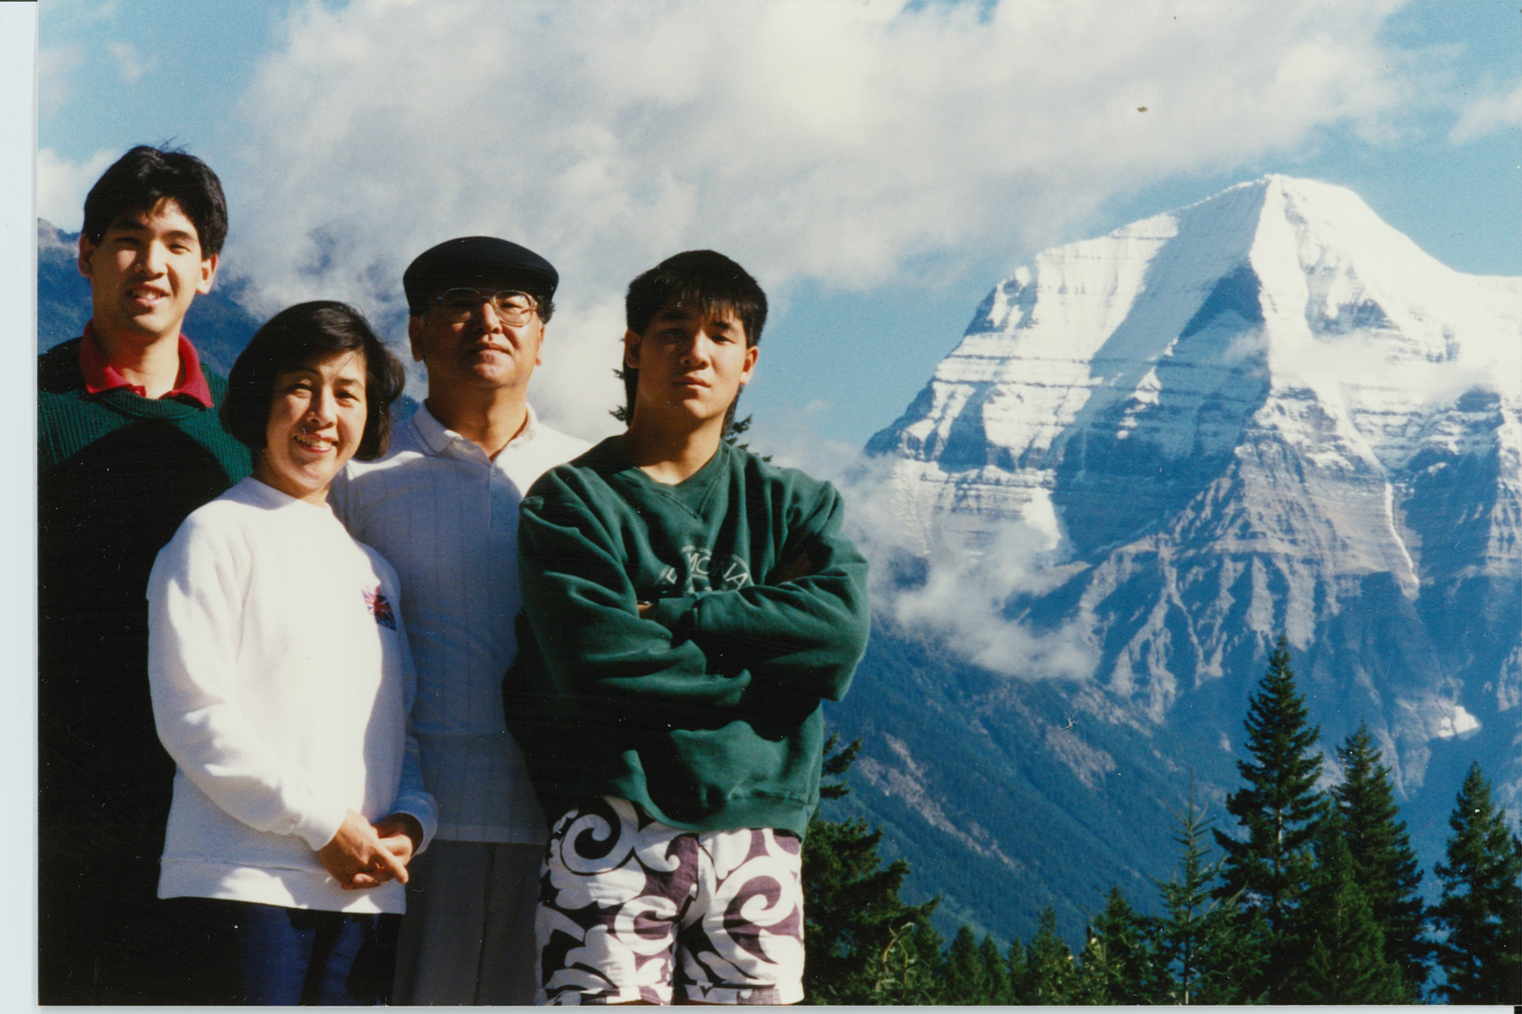
Ohki Family. Mount Robson, British Columbia.
25th wedding anniversary in 1990 From left:Yasushi (John), Sanae, Takashi, Makoto

Ohki, 大木, オオキ (Surname / family name / 苗字 / 家族名)
Takashi, 崇, タカシ (First name / given name / 名前)
Year of birth / 生年: 1941

Ancestral History? 先代やあなたは日本のどこから来ましたか？
Tokyo、Japan

When and why did you or your family come to Edmonton? いつ、どうしてエドモントンへ来ましたか？
1964: Vancouver to attend graduate school at UBC.
1969: Lethbridge to teach at the University of Lethbridge
1974: Edmonton to work at the Government of Alberta

What were your major occupations in the past and major employers? あなたの仕事はなんですか？雇用主はどこですか？
1. University teacher
2. Government employee
3. Economic and business consulting services

In what ways has having Japanese heritage affected the course of your life or family history? あなたが日本人または日系人であることは、人生にどのような影響があったと思いますか？
To realize that I can contribute my Japanese heritage to Canada's multicultural society.

Additional history? 個人史・家族史
Came to Edmonton to work at the Government of Alberta; became active in the local Japanese-Canadian community such as the Metro-Edmonton Japanese Community School and the Edmonton Japanese Community Association; also became treasurer of the National Association of Japanese Canadians.

More detail submitted in addition to survey responses (April 2016)

I was born in Tokyo in 1941. I saw English text for the first time in my English class in junior high school. It was my English textbook and on the first page there were these sentences, “A dog. A big dog. There is a tree. Is there a tree?. There are trees. Are there tree?” Their sentence structures were so different from those of Japanese sentences. I could understand each word in the sentences by looking it up in the dictionary. But when they were put together in the sentence, I could not understand what they meant. This was the beginning of my struggle with English and the way of thinking behind the English language. The mystery of English fascinated me and eventually made it one of my favorite subjects at high school. By the time I finished high school, I was reading novels in paperback and wished that one day I would visit overseas and see lands and people in these English novels.
I chose to go to International Christian University (ICU) in Mitaka, Tokyo. ICU was a small (less than 800 students) and new (opened in 1953) university at that time. But it was unique in Japan because it was a bilingual (Japanese and English) American-style liberal arts university. One third of its faculty were foreigners and students were required to take one-third of their courses in English. I spent the first year just on learning English and in the second year started taking some course in English. In my third year, a few of my classmates and I made a group to seriously study economics for the coming two years.
This group was lucky to be able to take economic courses from great teachers. Professor Akira Takayama was the first graduate from ICU and he just returned from the United States with his Ph. D. in economics. We asked him to give us a special class in the evening after regular classes. He regarded this special course as if it were a graduate class at an American university. It was a tough class but we leaned how to think logically and rigorously in economics. In the fourth year, our group asked Professor Takao Fukuchi to supervise our joint graduating essay. Professor Fukuchi was a pioneer of econometrics (building an economic model on statistics) in Japan. We chose a project of building an econometric model of the Philippines. Professor Fukuchi taught us how to build an econometric model from scratch. At that time, we were one of very few university students who had knowledge and experience in econometrics. These two experiences strongly influenced my professional carrier for the next fifty years.
In my fourth year at ICU (the fall of 1963), I started looking for a job and one day passed by the Ministry of Foreign Affairs on my way home from job interviews in the center of Tokyo. I saw a bulletin posted there that said that the Government of Canada was looking for Japanese students who wanted to study at a Canadian graduate school. I immediately went to the Canadian Embassy in Tokyo and applied for the scholarship. In the mid-1960s, Japan was in the middle of high economic growth but the Japanese government still restricted the use of Japanese currency oversea. Getting a scholarship from a foreign university was one of very few ways going to a foreign school. After an interview at the Canadian Embassy, I was granted admission and a scholarship from the University of British Columbia. In August 1964, I left Yokohama for Vancouver by a freighter for which I received a free ticket from the American Women’s Association in Tokyo. After eleven days on the Pacific Ocean, I arrived at Vancouver. It was a beautiful and quiet city with a view of the bay and mountains. On Sunday, all stores except movie theatres were closed. At the movie theatres, Queen Elizabeth showed up on the screen at the last show and the audience stood up and listened to God Save the Queen.
At UBC, I could manage graduate courses in economics, thanks to my training in economics at ICU. In the spring of 1965, I learned that I could get the Killam Scholarship for my second year in the MA program. In fact I received the Killam Scholarship for three more years until I fished all courses required for my Ph.D. program. In the summer of 1965, I married Sanae Tojo in Vancouver whom I had known in Japan. She managed to come to UBC as a graduate student. We lived in the apartment for married students on the UBC campus. The monthly rent was $40 and we spent $15 on weekly grocery shopping at a Safeway. In the 1960s, Canada was very generous to foreign students and UBC had many foreign students including Japanese students. Most Japanese students were those who came from Japanese companies to study at the graduate school for a year of so. Sanae and I got together with Japanese students and talked about our experiences in Canada. We often talked about the differences between Japanese and Canadian culture. We grew up in Japan where harmony was important for human relationship. In Canada, however, it was taken for granted that people were assertive. We talked about how we could adjust ourselves to this assertive society.
In December 1966, our first son, Yasushi, was born in Vancouver. In the same year, I received a MA in economics and proceeded to a Ph. D. program at UBC. By the fall of 1968, I had completed all course required for writing a Ph.D. thesis and started looking for a job. I decided to get a job in North America, preferably in Canada, partly because I felt obliged to make some contributions to Canada that gave me a chance to come here and supported me with a generous scholarship, and partly because I had few contacts with potential employers in Japan after spending five years in Canada. In the 1960s, baby boomers after the Second World War were going through high schools and post-secondary educational institutes in North America and there was increasing demand for teachers. I applied for 10 Canadian universities and 25 American universities. After a long process of going to interviews at the annual conference of American economics society in Chicago and giving sample lectures at a few universities, I eventually got a position of assistant professor of economics at the University of Lethbridge in Alberta.
In August 1969, our friends gave us a big farewell party and we left Vancouver by our old car for Lethbridge. The car broke down within a few blocks from our apartment. We sneaked back to our friend’s house and left Vancouver on the following morning. We drove over the Canadian Rockies to Calgary and kept driving through the vast and empty Canadian prairie. In the evening of the third day, we saw the lights of the City of Lethbridge on the other side of Old Man River. We settled in the apartment across the street from the Lethbridge Community College, part of which was used to temporally house the University of Lethbridge until a new campus was completed on the west side of the Old Man River in the fall of 1970. The university opened in 1967 and by 1969 had the total enrolment of about 900 students. In September 1969, I started teaching three course in economics: introduction to economics, intermediate economic theory and quantitative economics. I had never taught students before and never leant how to teach. But the students in my course taught me how to teach. In class, I taught students economics. In a bar (Lethbridge was dry and beer tasted so good), students taught me how to teach, telling me which part they could understand and which part they could not understand in my lecture.
There was a large number of Japanese-Canadians living in Lethbridge and its surrounding area. Some of them came here from the Okinawa Islands before the Second World War and the rest came during the war to work on sugar beet farms instead of being sent to camps in the interior of British Columbia and settled in the area after the war. About a month or so after I came to Lethbridge, a Buddhist Church in Lethbridge held a welcome party for me and Dr, Nakamura who also joined the university in September 1969. At the party, I was surprised to see more than one hundred Japanese-Canadians. We got acquainted with many of them while we were in Lethbridge and received many kinds of assistance from them. On the New Year’s Day, they invited us for a special New Year’s dinner. All kinds of special dishes for the New Year’s Day filled a large table and we took a large amount of left-over home. This was a traditional Japanese way of celebrating the New Year’s Day in Japan. We were glad to see this wonderful Japanese tradition surviving in the Japanese-Canadian community.
The City of Lethbridge had only 40,000 people. It was a clean and quiet city, good for us to raise our small children. We enjoyed going to Waterton National Park where we could drive in just over an hour. In December 1971, our second son, Makoto, was born in Lethbridge. During the five years in Lethbridge, we felt that we were more closely integrated into the Canadian way of life than ever before.
In 1973, the number of students started declining at the University of Lethbridge, and so did the amount of government grant. My contract with the university expired in the summer of 1974 and I started looking for a job again. After a couple of months, I decided to accept a job offer from the Alberta Health Care Insurance Commission in Edmonton. My annual salary increased from $16,000 to $20,000. The Commission was in charge of paying medical professionals fees for their services under the Alberta health care insurance system that had started in 1970. I became director of statistics and analysis that produced health care statistics and analysis for the government for their negotiations with the federal government for sharing costs of health care and also for their negotiation with medical services providers in the province for their service fees. The health care insurance system was still in the early stage of development and I had to create and analyze a large number of statistics to monitor the health care insurance system. I worked with the staff of Alberta Associations of Physicians and Surgeons to determine health service fees. I still remember some of these service fee codes: A4 was an initial consultation with a general practitioner and G9 was a comprehensive fee for taking care of a pregnant woman from her initial visit to child birth.
The Alberta Health Care Insurance Commission was part of the Alberta government and must follow its standard regulations for performance appraisal of its employees. I had to supervise the staff of four people and conduct their performance appraisal. That was a new challenge for me because I grew up in Japan and unconsciously adopted the Japanese way of dealing with a human relationship but I was not sure if I could apply the Japanese way to my relationships with my staff. In conclusion, the Japanese way worked well for me and my work place. One day my supervisor told me that I had good human relation skills. I thought he meant that I paid close attention to my staff when I worked with them. Some of my Japanese friends who also supervised their Canadian staff shared the same observation that the Japanese way of managing people worked well in their workplaces.
In 1980, I moved to the Alberta Department of Economic Development and Trade. My job was to conduct scenario analysis in the newly created unit called future research. My colleagues in this unit were one from Scotland (a historian), one from California (a system analyst) and one from Toronto (a lawyer). We identified trends and possible future events in the world that might affect the path of economic development in Alberta in the next twenty years and created several alternative stories of the world and Alberta. The merit of scenario was to prepare the Alberta government and private companies for possible trends and events in the future. We worked with other Alberta government departments, the federal government, municipal governments and private companies. We eventually formed a group called the Futures Compendium that was composed of our unit and a dozen chief executive officers of Alberta-born companies. We met twice a year and discussed our scenarios of the future and their implications for Alberta. This job provided me with new professional experiences that became useful later for my consulting job.
In the 1990s, the economic and political environment surrounding the Alberta government changed and a new leading idea in the government was to privatize government services as much as possible and reduce the role of government in society. In 1993, the Futures Compendium was abolished and I became director of economic policy and coordination with a dozen staff members. On my new job, I was responsible for monitoring economic trends in Alberta and Canada and preparing briefings on economic issues in the province for our senior executives. In 1995, however, the wave of privatization engulfed the Alberta Department of Economic Development and Trade and the number of staff was halved from 800 to 400 (by the year 2000, the department was completely dismantled). In my unit, all of our positions were abolished and we lost our jobs.
When I left the government, two of my colleagues and I set up an economic and management consulting company and started providing our services to the Alberta government, federal government, municipal governments, and private companies. Our contacts at the Futures Compendium helped us to find customers in our initial period of operation. The projects we received from our clients varied from one to another. We examined trends in new technologies for the coming ten years, developed a strategy to sell potatoes to the air force bases in the province, and monitored traffic movements on the provincial highway number two. I worked at this consulting company from 1995 to 2009.
In August 1974 when we moved to Edmonton, we did not have any one we knew in the city. However, we soon got acquainted with Mr. and Mrs. Yasuyuki Hiratsuka. Mr. Hiratsuka was the first graduate from International Christian University and was working at the federal forest research institute in Edmonton. Mr. and Mrs. Satoru Kojima moved to Edmonton in the same year. Mr. Kojima was a graduate student at UBC just about the same time when I was there and started working at the federal forest research institute. In the same year, Mr. and Mrs. Junich Kawashima came to Edmonton. Mr. Kawashima was also a graduate from ICU in 1960 and was a specialist in audio-visual education. Mr. Kojima, Mr. Kawashima, Mr. Shiozawa and I met together on January 12, 1977 and discussed how we could start a school that would teach Japanese to our children. We all had elementary school children who spoke Japanese at home with their parents. But it became hard for our children to develop their Japanese language skills further as they went to local English schools and spent more and more time at school and with friends in the English language environment. All of us might go back to Japan in the future and were concerned that our children might have tough time at Japanese school because of their weakness in the Japanese language abilities.
Canada was a country of immigrants and had many schools and programs where immigrants taught their children their mother tongues. There were more than 50 such schools and programs in Edmonton and they could receive support from the federal, provincial and municipal governments. Mr. Kawashima conducted a survey and found that there were at least 20 children who wanted to study Japanese. We realized that there would be many obstacles we had to overcome before we could open a Japanese language school. But we decided to move forward anyway. We made school bylaws and on March 15, 1977 registered our school with the Alberta government under the Society Act. We approached the Edmonton Public School Board for a school we could rent and on March 25 they told us that we could use classrooms at Sherwood Elementary-Junior High School on Friday evenings free of rent.
The Metro-Edmonton Japanese Community School opened on April 15, 1977 with 30 students in three Japanese language classes for Japanese speaking children and one introduction to Japanese class for non-Japanese speaking children. In September, the school opened another class for Japanese-Canadian adults in response to a request from the Edmonton Japanese Community Association. After trial and error, the school established its teaching principles: First, the school used textbooks that were used in Japan; and second, the students studied in the classes according to their levels of Japanese language abilities and not according to their ages or the length of period they spent at the school. The school has maintained these two principles until now. The teaching principles proved their effectiveness by showing that students from the school could go back to schools in Japan without problem with their Japanese language abilities.
In 1978, the school was approved by the Japanese Overseas Education Fund as an overseas supplementary Japanese school and through the Japanese Ministry of Foreign Affairs received textbooks used in Japan and a subsidy to the honoraria paid to the teaches at the school. The Japanese Overseas Education Fund gave textbooks free to Japanese children staying overseas for a short period of time with their parents. At our school, this kind of Japanese children took up about one-third of the total enrollment and the rest were the children of new immigrants, Japanese-Canadians and Canadians who might not be eligible for free textbooks if the rules were strictly applied. Without free textbooks, our school would have great difficulty in getting textbooks for our students. We could manage to get free textbooks for all of our students, thanks to the generosity of the Japanese Overseas Educational Fund and the Ministry of Foreign Affairs.
From its first year, the school was open to anyone who wanted to study Japanese and set up a special introductory class for non-Japanese speaking children and adults. This was partly because the school wanted to receive financial assistance from the Alberta government, the federal government and the City of Edmonton and partly because the school needed to have a source of students larger than its small source of children of Japanese parents. In the early years of its operation, the school was rather unique among the overseas supplementary Japanese schools in regard to its mix of students. However, by 1990, supplementary Japanese schools similar to ours in Edmonton increased in number worldwide as more and more Japanese lived in foreign countries for a long period of time and as more and more Japanese international marriages between the Japanese and foreigners took place and their children wanted to learn the Japanese language. I have been involved in the school as a member of the board and Sanae as a teacher and principle for a long time. Through our activities at the school, we got to know many people in the Japanese, Japanese-Canadian and Canadian communities in Edmonton. By this year (2016), the school has more than 100 students. From its first year, the school has been publishing its annual report and all back numbers have been digitized and available to the public.
When I came to Edmonton in 1974, I found the Edmonton Japanese Community Association (EJCA). The association held a senior citizens’ day in spring, picnic in summer, annual general meeting at a Chinese restaurant in fall and Christmas party in winter. EJCA welcomed the opening of the school and invited Mr. Kawashima to come and sit on its board of directors. The school participated in the EJCA Christmas party in 1978 and presented skits and singing by its students. In October 1979, I became a member of the EJCA board of directors responsible for public relations. Since then, I have been an active member of EJCA and became a member of the board of directors: treasurer from October 1995 to September 1997 and president from October 1997 to September 1999. My wife became a member of the board of directors in October 2006 and has remained on the board until now.
In Edmonton, the Heritage Festival takes place at Hawrelak Park every year over the Canada Day weekend.. The festival started in 1976 when eleven ethno-cultural organizations, including EJCA, decided to hold a festival celebrating their ethnic cultural backgrounds. Since then, the festival has been expanded to include more than 50 ethno-cultural organizations in the city. For the last several years, the two day and a half festival attracted more than 300 thousand people. The school participated in the festival with EJCA from 1979 to the middle of 1980s. In the first year of its participation, the school built a Japanese pavilion that was a unique Japanese-style structure attached to a large tent. This structure was used over ten years.
When I came to Edmonton in 1974, the number of new immigrants from Japan and the Japanese businessmen sent here by their companies was increasing. Their children came to the Metro- Edmonton Japanese Community School and the Japanese related to the school formed a new Japanese community in Edmonton. I was involved in the activities of both the school and EJCA. I encouraged people at the school to participate in EJCA activities. In September 1994, the Argyll-EJCA Centre opened and provided the Japanese and Japanese-Canadian community with a physical facility for their activities. Many groups interested in Japanese culture started using the centre for their activities. To reflect this trend, EJCA changed its bylaws so that it could allow anyone interested in Japanese culture, regardless their nationalities, could become an EJCA member. In 2015, EJCA changed its name from the Edmonton Japanese-Canadian Association to the Edmonton Japanese Culture Association to widen its scope of activities.
I liked singing songs and when Sanae came to Vancouver in 1965, I asked her to bring me a guitar from Japan. In the second half of 1970s, karaoke appeared in Japan and soon became very popular. People started singing songs along music played by a cassette tape. I brought back about a dozen karaoke cassette tapes from Japan and started a karaoke club with Mrs. Yuko Nakano and Mr. George Tsuruda in the fall of 1989 at the EJCA centre that was a room rented on the second floor of a commercial building in south Edmonton. Gradually the karaoke club increased its membership and we moved to the lounge of a Korean restaurant for our karaoke practice. The lounge was equipped with the latest karaoke system of a laser disk player and projection TV. It was quite exciting for us to sing aloud along the music played by an orchestra watching a movie telling the story of the song on a big projection screen.
We wanted to sing in from of a large number of people and on January 19, 1992 held our first karaoke concert at the Korean restaurant. Ten male and ten female singers participated in the concert. We asked the audience of about 30 people to vote for the team that they thought sang better. This karaoke club concert became an annual event and moved to the EJCA Centre when it opened in September 1994 and lasted until 2012. The club held its regular sing-together twice a month and attracted a wide range of people such as Japanese students, businessmen, diplomats, Japanese school members and EJCA members, and Canadian EJCA members who liked to sing Japanese songs. They practiced hard to for their karaoke concert. Thus, the karaoke club became another focus of the Japanese and Japanese-Canadian community in Edmonton. The karaoke club even had a joint concert with the Denver karaoke club both in Denver and Edmonton, and also with the Calgary karaoke club both in Calgary and Edmonton.
In the 1990s, I participated in several conferences organized by the National Association of Japanese Canadians such as the home-coming conference in Vancouver and the conference of influence of Japanese culture on young Japanese-Canadians in Montreal. During the 1990s, I served on the NAJC Heritage Scholarship Committee for four years. In October 2008, I was elected to the board of directors and in February 2009 became treasurer. I held the position until September 2012. This was the period when NAJC faced financial challenges. NAJC had a fund of about $4.5 million dollars that was transferred from the Japanese-Canadian Heritage Foundation to run the NAJC Heritage Scholarship program and other national programs. NAJC asked two banks, RBC and CIBC, to manage the fund for investment. NAJC used to receive over 200,000 dollars a year from the investment but after the Lehman shock of September 2008, it could receive only $130,000. My job as treasure was to streamline and rationalize the financial status of NAJC so that the fund would be able to support NAJC for a long period of time.
While I was a member of the board of directors of NAJC, I enjoyed meeting many people from Japanese-Canadian communities across Canada and began to understand history and current conditions of these communities. Through this process, I felt more like an issei, the first generation Japanese-Canadian who made Canada his home, than like a new immigrant who was causally passing by the Japanese-Canadian community in Canada.
(written in April 2016)

私は１９４１年６月２０日に東京市豊島区で大木栄一、としの長男として生まれました。中学で初めて英語に接しました。今でも最初の英語の教科書を覚えています。第１ページに “A dog. A big dog. There is a tree. Is there a tree? There are trees. Are there trees?”と書いてありました。私は小学校の時から読書が好きでしたが、日本語の構造とまるで異なる英語の構造に驚きました。思えばこれが私が英語で苦労する始りでした。単語帳を作って朝夕の通学のバスの中で覚えるなどの苦労をしましたが、次第に英語が好きになり、高校を卒業する頃にはペーパーバックの小説を読むようになりました。また英語の本を通して想像する外国の景色と人間を実際に見てみたいと思うようになりました。

大学は東京の三鷹にある国際基督教大学（ＩＣＵ）を選びました。私が１９６０年に入学した時はまだ創立８年目で生徒数は１，０００人以下の小さな大学でしたが、当時日本で唯一の日本語・英語の両国語で授業をする大学でした。教授陣の三分の一が外国人でした。私は良い先生に恵まれて経済学を専攻しました。高山晃教授はＩＵＣ第一期生で私が三年の時に米国の大学で博士号を取って帰ってきました。経済学専攻の友人数人と高山教授の特別なセミナーをお願いしました。教授はまるで私たちがアメリカの大学院の生徒にように厳しく教えてくれました。卒業論文は８人のグループで福地崇生教授の指導で、フィリピン経済の統計モデルを作成しました。福地教授は日本における統計経済学の先駆者でした。当時の日本で実際に経済モデルを作成する経験をした大学生はとても少なかったと思います。ＩＣＵにおける経済学の勉強の経験はその後の私のプロフェッショナルとしての仕事の方向を決めました。
私が就職活動を始めた四年生の秋に、偶然カナダ外務省が日本からの留学生を募集していることを知りました。１９６０年代半ばの日本は経済高度成長期のまっただ中にあり、学生の海外への関心も高まっていましたが、日本政府は外貨の持ちだしを制限をしていて、海外留学はとてとも難しく、会社から研修で派遣されるか、海外の奨学金を貰って留学するしか方法がありませんでした。私は幸いにもカナダ留学生に選ばれ、ＩＣＵを卒業した１９６４年の夏にブリティッシュ・コロンビア州バンクーバーのブリティッシュ・コロンビア大学大学院（ＵＢＣ）の経済学修士課程に留学することになりました。そして、これも偶然が幸いして手に入れた東京アメリカ婦人協会の奨学金で横浜から貨客船に乗り、バンクーバーに八月半ばに到着しました。バンクーバーは静かな港町で日曜日には商店は休みになり、開いているのは映画館だけでした。映画の最終回が終わるとエリザベス女王が出てきてGod Save the Queenの演奏が始り、観客は起立して英国国歌の演奏が終了するのを待ちました。
ＵＢＣの授業は、ＩＣＵでの経済学の訓練のおかげで何とかついていくことが出来ました。そして修士課程二年度のための奨学金を貰うことも出来ました。１９６５年夏に日本で知り合った東條早苗とバンクーバーで結婚しました。早苗もＵＢＣ大学院に入学という形でカナダに来ました。ＵＢＣには既婚学生がたくさんいて、キャンパスの既婚学生寮で生活していました。私たちもこの一つに入りました。家賃は一月４０ドル、一週間のセーフウェイでの買い物が１５ドルでした。当時のカナダは外国人留学生に親切な国でＵＢＣにも日本人留学生が２０名ほどいました。大部分の人は会社から研究・研修のために１，２年派遣されてきた人達でした。私たちは週末にはよく日本人既婚者留学生と一緒に食事をして、日本とカナダ文化の違いを話していました。カナダの個人主義の社会は日本のグループや組織を大切にする社会に育った私たちにとても新鮮に映りました。このような個人主義の社会でどのように生活して行けばよいかなどの議論を交わしました。
１９６６年１２月に長男泰（やすし）が誕生しました。私は１９６８年秋までに博士課程の講義を終了して、博士論文の勉強を開始しました。また同時に就職先を探し始めました。論文の勉強を続けなければならないこと、カナダには長い間奨学金を貰って生活した恩義のあること、日本を離れて五年経ちコンタクトが少なくなったことなどを考慮して北米で仕事を探すことにしました。１９６０年代後半から１９７０年代の北米は戦後のべービーブーマーが高校から大学に進級する時期にあたり、どこでも大学の拡張、新設が盛んで新任教師の需要がありました。私はカナダの大学１０校と米国の大学２５校に願書を送り、数校と面接し、結局アルバータ州レスブリッジ市のレスブリッジ大学に１９６９年９月から就職することになりました。レスブリッジ大学は１９６７年に創立され、私が就職した１９６９年には学生数は９００名余りでした。日本人の先生が二名と日系アメリカ人の先生が二名いました。私は三つの講義を受け持ちました。講義ははじめての経験でしたが、生徒が私の授業を助けてくれました。私が教室で生徒に経済学を教え、生徒がビアホールで私に教え方を教えてくれました。
レスブリッジと周辺の町と村には日系人がたくさん住んでいました。戦前に沖縄から移民してきた人達と戦時中に強制キャンプに入る代わりに甘藷栽培労働者として南アルバータに来て、戦後もここに残った人達です。大学に赴任して一月ぐらいたったときに、レスブリッジの仏教会主催の歓迎会に招待され、１００名ぐらいの日系の方々に初めて会い、その数の大変驚きました。日系の方々にはその後いろいろとお世話になりました。正月のお祝いに招かれ、大きなテーブルに所狭しと並べられたたくさんの正月料理を見て、日本の古き良き習慣がよく保存されていると感心しました。１９７１年１２月に次男誠（まこと）が生まれました。人口４万ほどのレスブリッジはきれいで静かな町でした。市内には日加友好庭園があり、ウオータートン国立公園まで車で一時間余りで行けます。小さな子供を育てるには良い町で、私たちはこの町での生活を楽しみ、カナダ社会で生活していく自信ができました。
しかし、１９７３年に大学の生徒数の減少に伴い大学の予算も減少して、私の契約も１９７４年の８月で終わりになり、また就職口を探すことになりました。アルバータ州健康保険局統計調査課長の仕事が見つかり、１９７４年８月にエドモントンに引っ越しました。新しい職場では部下４人と一緒に仕事をすることになりました。これは私にとって初めての経験でした。仕事は健康保険から医師へ支払う報酬の資料から経済統計を作成しました。この資料はアルバータ政府が連邦政府と医療費の折半を交渉する時に使われました。私はアルバータ政府がアルバータ医師会と医療サービス報酬について交渉をするときに事務局として助けました。当時はまだカナダの国民健康保険制度が始まったばかりで、どのように医師やその他の医療サービス従事者にサービス料金を払ったら良いのか試行錯誤の段階でした。アルバータ医師会の交渉では交渉妥結後の医療報酬点数表の作成を医師会と一緒にしました。私はいまだに点数表のコードを覚えています。Ａ４はホームドクターの初診料、Ｇ９はホームドクターが妊婦を初診から出産まで面倒を見たときのサービスコードです。
健康保険局はアルバータ政府の一部なのでアルバータ州政府の人事規定があり、上司が私を人事考査し、私が部下の人事考査をすることになりました。大学卒業まで日本社会で生活して、日本風な和を大切にする人間関係を身につけている私が、個人主義の社会の人事考査をどのようにしたらよいのか悩みました。しかし、他に知っている方法もなかったので、身についている日本風の価値観、対人関係感覚で人事考査をしました。結果的にはこれが有効でした。ある日、私は上司に「あなたはとても良い人間関係技術 (human skills)を持っている。」と言われたことがあります。きっと、日本人が身につけている気配り、思いやりの気持ちのことを言ったのだと思います。
私は健康保険局で五年間仕事をした後で、アルバータ州経済開発・貿易振興省に移動をして、ここで様々な仕事をしました。特に１９８０年から１０年余り、未来研究ということをしました。これから２０年の将来を見通して、アルバータ経済に影響のあるような世界経済の傾向を想像して、実現可能な未来の物語りを幾通りも作り、アルバータ政府の経済政策に役立てる、という仕事です。専門の違う仲間三人との共同作業でした。当時のアルバータ政府はこのような先端的な仕事にお金を出す余裕がありました。私はその後、経済開発貿易振興省の経済分析；政策調整課長になり、１０名余りの部下とアルバータ経済の現状分析や政府の政策の効果などの仕事をしました。しかし、１９９０年代になるとアルバータの政治・経済状況が変化して、経済は民間に任せる、政府は小さい方が良いということになり、１９９５年には経済開発局は８００人から４００人に削減されました。この時、私の部署は廃止になり、部員は全員が職を失いました（成績不良のために解雇ではなく、部署が廃止になったための失職なので全員が慰謝料をもらいました。）
政府を退職後、アルバータ政府で一緒に仕事をした仲間二人と経済・経営のコンサルタント会社を設立しました。私はこのコンサルタント会社で２００９年まで仕事をしました。州政府、連邦政府、経済団体、市町村、民間の会社からプロジェクトを受注して完成するという仕事です。プロジェクトに公募して仕事を獲得するということが多く、１０のプロジェクトに応募しても受注できるのは二つという打率二割の厳しい仕事でしたが、プロジェクトの内容は毎回違っていて面白い仕事でした。プロジェクトには、これから１０年の産業技術動向、アルバータ空軍基地へのジャガイモの売り込み方法、アルバータ高速道路二号線の使用状況などがありました。
１９７４年８月にレスブリッジからエドモントンに引っ越して来た当初はエドモンに知っている人はいませんでした。しかしすぐにＩＣＵ一期生でエドモントンの連邦政府森林研究所に勤務する平塚保之夫妻にお目にかかりました。そして、同じ研究所に私がＵＢＣにいた時期に同じく大学院にいた小島覚氏が１９７４年夏から勤務を始めたことを知りました。さらに同じ年にＩＣＵ四期生の川島淳一氏とご家族がエドモントンに引っ越してきました。そしてエドモントンの生活も落ち着いてきた１９７７年１月１２日に川島淳一、小島覚、アルバータ大学に勤務していた塩沢千秋、大木崇が集まり、エドモントン地区日本人コミュニティー・スクール設立準備委員会を結成しました。四氏は皆、小学生の子供があり、エドモントンの学校に通っていました。子供は家で日本語を話していましたが、学齢が上がるに従って学校や友達と英語で生活する時間が多くなりました。我々親は子供が家で日本語を話すだけでは日本語能力は伸びないことを痛感しました。また我々は当時まだ日本に帰る可能性もあり、そのときに子供が日本で生活するために十分な日本語能力を身につけているかどうかを心配していました。
移民の国カナダでは移住してきた人達が子供達に母国語を教える塾があり、政府、教育委員会などの公共機関はこのような塾に理解があり支援をしていました。エドモントンにもこのような塾が５０以上ありました。教育専門家の川島氏はすでに、日本語を教える塾の需要があるかどうかの調査を完了していて、エドモントン地区に少なくとも２０名ほどの日本語を学びたい学童が居ることを把握していました。塾の形態、場所、教師、教育方針、経営方法と直面する問題は山積みでしたが、先ずは始めなければ前に進めないという方針を決めました。設立委員会は後援会の会則を作り、１９７７年３月１５日にアルバータ州で社会法人としての登録を行いました。ついで、３月２５日にエドモントン市公立教育委員会からシャーブルック小中学校の校舎を毎週金曜日の夜無料で貸与するという通知を受け取りました。
エドモントン地区日本人コミュニティー・スクールは１９７７年４月１５日に入学式を行い、児童・生徒３０名、日本語による基礎教育科目（日本語、算数）３クラス、日本語を初めて習う生徒（カナダ人、日系人などの児童８名）一クラスで授業を始めました。９月には成人向けの日本語入門コースもエドモントン日系人会からの要請で始めました。教育方針は試行錯誤でしたが、初年度が終了する頃には日本の学校で使われている教科書を使用して授業を行い、児童は日本語能力に従ったクラス分けと進級を行うという基本方針を決めました。この教育基本方針はその後、現在まで受け継がれ、この学校で学んだ生徒の日本語能力の向上に貢献してきました。この学校で学んだ学童が日本に帰国して日本の学校で日本の学童と同様に勉強をすることが出来たという報告がこの基本方針が有効であったことを証明しています。
１９７８年に学校は日本の海外子女教育振興財団から補習校の認可を受けます。これで学校は海外子女教育財団を通して日本から教科書の無料給付と教師の謝礼金の一部を毎年受けることが出来るようになりました。教科書の無料給付は海外に滞在する日本国籍を持つ学齢の児童が対象です。私たちの学校では海外短期滞在の父母の子供は三分の一で、他の生徒は新移住者の子供、日系人とカナダ人です。新移住者の子供は日本国籍を持っていますが、日本国籍を持たない子供います。しかし児童の大部分が日本国籍を持っているということで、全員が教科書の給付を受けられるようになりました。
学校は開校一年目から日本語を勉強したいカナダ人と日系人のためのクラスも作り、エドモントン社会全般に門戸を開いていました。これはカナダ連邦政府、アルバータ政府、そしてエドモントン市からの支持を得るためにに必要な処置でしたが、規模の小さなエドモントンの日本人、日系人コミュニティーだけでは学校の運営は出来ないということを認識した処置でもありました。その後、世界各地の補習校で日本人短期滞在者の児童以外の児童の数が増加してきて、このような児童も補習校児童として日本の教科書の無償配布を受けるようになってきました。いわばエドモントン地区の日本語補習校はこのような傾向の先駆者でありました。学校は創立以来いろいろな試練を乗り越えて教育方針を確立してきました。２０１６年現在、生徒の数は１００名以上になってます。私は長らく役員として、早苗は教師、校長として学校に関係してきました。この仕事を通して、エドモントン地区の日本人、日系人の人達と知り合いになりました。
私がエドモントンに引っ越して来た１９７４年当時、エドモントンには日系人の組織としてエドモントン日系人協会（ＥＪＣＡ）がありました。年中行事として春の敬老会、夏のピクニック、秋の総会、冬のクリスマス・パーティーを行っていました。ＥＪＣＡはエドモントン地区日本人コミュニティー・スクールの創立を歓迎してくれました。そして、学校関係の日本人と日系人協会の会員との交流をはかるために、学校から日系人協会の役員に川島淳一氏を招待しました。１９７８年の日系人会クリスマス・パーティーには学校の生徒が寸劇と歌を披露しました。その後数年、学校の生徒の参加が続きました。１９７９年１０月に私は川島氏の後を継いで、エドモントン日系人協会の役員になり、広報を担当することになりました。以来、２００１年３月までＥＪＣＡの役員としてＥＪＣＡの活動に参加してきました。この間、１９９５年１０月から１９９７年９月までは会計、１９９７年１０月から１９９９年９月までは会長を務めました。なお、早苗は２００６年１０月にＥＪＣＡ役員になり、以来現在（２０１６年４月）も役員として活動しています。
エドモントンには８月はじめのカナダ・デイに市内のホーリロック公園で行うヘリテージ・フェスティバルがあります。１９７６年に市内の１１のボランティア・グループ（エドモントン日系人協会もこの一員でした）が始めた市内に住むいろいろな文化的背景を持つグループがそれぞれの文化遺産を市民に披露する祭りです。２０１５年現在、８月の第一月曜日を含む週末の二日半に３０万人にも上る市民が参加する大きな祭りになりました。このヘリテージ・フェスティバルに学校も日系人協会と一緒に１９７９年から１９８０年代半ばまで参加しました。わたしは学校の役員、そして後には日系人協会の役員として１９７９年から２０００年まで、ヘリテージ・フェスティバルに参加する企画と運営に参加してきました。
私がエドモントンに引っ越して来た１９７０年代に、日本からの新移住者や仕事の関係で来る短期滞在者が増加しました。この人達はエドモントン地区日本人コミュニティー・スクールの創立で、会員同士が頻繁に連絡をとる活発なグループになりました。私はこの二つのグループの会員間の交流を活発にすることをボランティア活動の目的にしました。私と早苗は１９７５年にカナダ市民権をとりました。そしてカナダ人としての視点から、新移住者、短期滞在者に日系人協会の行事に参加するように奨励しました。
エドモントン日系人協会の歴史の大きな出来事は１９９４年９月のアーガイル・エドモントン日系人協会センターの開館です。このセンター開館の経過についてはこの歴史プロジェクトの２０１４年に発行された報告書に記述してあるので割愛しますが、このセンターの開館で日系人会の活動が大きく広がりました。特に日本文化に興味を持つカナダ人のグループがこの会館を利用するようになりました。日系人会は会則を改正して、日本文化に興味を持つ個人、団体なら誰にでも会員になれる組織に拡張しました。これによりエドモントン日系人協会は会員が増加し、活動も拡大しました。ちなみに２０１５年にエドモントン日系人協会は名前をエドモントン日本文化協会に変更して広くカナダ社会における日本文化の理解を推進しています。
私は日本にいたときから歌を歌うのが好きでした。早苗が１９６５年にカナダに来た時には、日本からギターをもって来て貰いました。日本からもって来た楽譜を見ながらギターを弾いて歌を歌っていました。１９７０年代後半、日本でカラオケが流行してきました。この頃のカラオケはカセットテープを使いました。私は日本を訪問した時にこのカラオケテープを１０本ほど購入してきました。私の友人のジョージ・ツルダさんと中野悠子さんが歌が好きだと聞いて、１９８９年の秋から、丁度この年の４月に開館したＥＪＣＡセンター（建物の２階を借りた）に毎月一回三人で集まり、カラオケテープで歌うことにしました。その後、カラオケに興味を持つ人が増え、またエドモントンの韓国レストランで当時のカラオケの先端技術である動画のカラオケセットを備えるところが出て来ました。毎月数回この韓国レストランのラウンジに集まってカラオケを歌うようになりました。
このカラオケ仲間が１９９２年１月１９日に韓国レストランで第一回のカラオケコンサートを開きました。男女１０人ずつが紅白に分かれて歌い、お客さんにどちらが良かったか投票して貰うという形式です。ラウンジに一杯の３０人ぐらいのお客さんが来場しました。このカラオケコンサートは大好評で毎年一月に開き、１９９４年にＥＪＣＡセンターが開館してからはここに場所を移して２０１１年まで続きました。カラオケクラブはＥＪＣＡセンター完成してからはセンターで毎月二回例会を開くようになり、会員も移住者、短期滞在者、カナダ人と増加しました。会員は皆で毎年のコンサートを目指して練習するようになりました。コンサートは歌の練習の他に舞台装置、会場の設定、音響、ビデオといろいろな仕事があり、皆で協力してこのイベントが成功するように頑張りました。カラオケクラブの会員で日本に帰国した人や、カナダの他の町に引っ越した人でもエドモントンに来る時はカラオケクラブに立ち寄りました。私はカラオケコンサートはほとんど歌手として参加しました。早苗もコンサートの司会を何回もしました。２０１２年以降、カラオケクラブの会員は日本に帰国したり、他の町に引っ越したり、年をとったりして少なくなり、コンサートを開くことをやめました。しかし２０１６年現在、クラブの毎月の例会はまだ続けています。
１９９０年代以降、私はカナダ日系人協会（ＮＡＪＣ）の主催したバンクーバーでの「ホームカミング・カンファレンス」、モントリオールで開かれた「カナダ日系人と日本の文化遺産カンファレンス」に出席しました。またカナダ日系人協会リドレス基金の奨学金審査委員を二期四年つとめました。このような縁があり、２００８年１０月にウィニペッグで開かれたカナダ日系人協会年次総会で役員に選出されました。翌２００９年２月に当時の会計が急に辞めることになり、私が会計になりました。それ以降、２０１２年９月の年次総会まで約四年間会計をつとめました。リドレス問題が解決したときにカナダの日系人コミュニティー復興のための基金が出来ましたが、ＮＡＪＣはその一部をその活動とリドレス奨学金のための基金として使っていました。この基金は、私が会計になった２００９年２月現在で約４５０万ドルあり、ＲＢＣとＣＩＢＣに投資の運営を委託していました。しかし、２００８年９月のリーマン・ショックで一年間の投資利益が２０万ドルから１３万ドルまで減少していました。ＮＡＪＣの運営はまだ年間投資利益が２０万ドルだった時の形態を踏襲していました。私の会計としての仕事は、ＮＡＪＣの資金運営、予算作成過程、決算処理、財政報告を合理化、簡素化、顕在化して、ＮＡＪＣの活動を長期にわたり、合理的に効果的に行えるようにすることでした。当時の役員の協力を得て、私の在任中に目的を完了して、次の会計担当役員に引き継ぐごとが出来ました。
私はＮＡＪＣの役員であった四年間に、カナダ各地の日系人コミュニティーを代表して役員会に参加している人達と親しく話す機会があり、各地の日系人コミュニティーの現状を知ることができました。またいろいろな委員会に参加して、カナダ各地の日系人を個人的に知ることも出来ました。このような経験を通して、私は移住者というよそ者感覚の残る立場から次第にカナダ日系人コミュニティーの日系一世という自覚を持つようになりました。２０１６年４月現在、私と早苗はまだＥＪＣＡの活動に積極的に参加しています。
(written in April 2016)

Oikawa (Surname / family name / 苗字 / 家族名)
James (First name / given name / 名前)
Year of birth / 生年: 1978

Ancestral History? 先代やあなたは日本のどこから来ましたか？
As far as I know my paternal grandfather comes from Miyagi-ken in Sendai. He came to Canada and met my grandmother who was born here in BC. They lived at a place called Strawberry Hill. They were moved during WWII to Picture Butte in Alberta. My father has 9 brothers and 1 sister, he is the 7th son. He finished school in Picture Butte and went to the U of A [University of Alberta] to take Pharmacy. He went to Medicine Hat to work and met my mother; they got married and started up their own pharmacy in Redcliff. My brother and I came soon after that. We grew up in Redcliff, went through life and my brother and I came to Edmonton to go the U of A. Later on, in 2011 or so, my parents came to live up here in Edmonton.

When and why did you or your family come to Edmonton? いつ、どうしてエドモントンへ来ましたか？
I came to Edmonton to go to the University of Alberta. My parents came later after they retired and sold their business to be closer to us and my brother who started his own family here.

What were your major occupations in the past and major employers? あなたの仕事はなんですか？雇用主はどこですか？
Syncrude
Degussa
Chenomx
OK Radio Group
Rogers Broadcasting Ltd.

In what ways has having Japanese heritage affected the course of your life or family history? あなたが日本人または日系人であることは、人生にどのような影響があったと思いますか？
I'm not sure having Japanese heritage has adversely affected my life. It helps regarding the interests I have but that's about it.

Additional history? 個人史・家族史
In 1998 I was a student at the U of A until graduation in 2002. I worked for Syncrude, Degussa, and Chenomx before deciding to go NAIT and take the radio and television program in 2005. I volunteered for work at Sonic 102.9 which had just started up as part of the street team, the Intern Army, and became employed by the OK Radio Group soon after. Once I finished NAIT, I did my practicum back in Redcliff for MY96 and CHAT 94.5 which were owned by Pattison. Then I got employed as a creative writer/producer in Grande Prairie by SunFM, owned by OK Radio Group in Oct 2006. Soon after that in Jan 2007 OK Radio Group was bought by Rogers Broadcasting and the station flipped to Rock 97.7. I was moved as part of the creative dept. back down to Edmonton in June 2007 and have been here since then.

Oikawa (Surname / family name / 苗字 / 家族名)
Kiyogi (First name / given name / 名前)
Year of birth / 生年: 1945

Ancestral History? 先代やあなたは日本のどこから来ましたか？
Yonekawa-mura [village], Tome-gun Miyagi-ken. Born in Lethbridge, AB. Grew up in Picture Butte, AB. Lived in Edmonton, Picture Butte, Medicine Hat, Redcliff.

When and why did you or your family come to Edmonton? いつ、どうしてエドモントンへ来ましたか？
July 2010 - Retired & our 2 sons live in Edmonton.

What were your major occupations in the past and major employers? あなたの仕事はなんですか？雇用主はどこですか？
Pharmacist owner for 28 years in Redcliff and worked for 44 years in Picture Butte, Medicine Hat, & Redcliff.

In what ways has having Japanese heritage affected the course of your life or family history? あなたが日本人または日系人であることは、人生にどのような影響があったと思いますか？
Evacuated from BC coast in WWII. Set family back and probably affected the Japanese culture. Tried to be more Canadian.

Additional history? 個人史・家族史
To work & have a better life than what was happening in Japan. Have 9 brothers and one sister. One time six brothers lived in Edmonton (work or school). Have 2 sons and 2 grand children in Edmonton.

Okamoto, 岡本 (Surname / family name / 苗字 / 家族名)
Aya, あや (First name / given name / 名前)
Year of birth / 生年: 1964

Ancestral History? 先代やあなたは日本のどこから来ましたか？
父は京都府生まれ和歌山県育ち
母は栃木県出身
私は鳥取県生まれ沖縄県育ち
家族全員、元沖縄住民
[Translation] Father: Born in Kyoto-fu and raised in Wakayama-ken; Mother: From Tochigi-ken; I was born in Tottori-ken and raised in Okinawa-ken. All my family members are from Okinawa-ken.

When and why did you or your family come to Edmonton? いつ、どうしてエドモントンへ来ましたか？
アルバータ大学入学のため、エドモントンに居住
[Translation] Moved to Edmonton to enter U of A [University of Alberta].

What were your major occupations in the past and major employers? あなたの仕事はなんですか？雇用主はどこですか？
現在：Grant MacEwan大学講師、Edmonton Public Schools 補助教員
その前：日本トランスオーシャン航空（沖縄県）客室乗務員
[Translation] Currently an instructor at Grant MacEwan University; substitute teacher in Edmonton Public Schools. Formerly: flight attendant of Japan Transocean Air (Okinawa-ken).

In what ways has having Japanese heritage affected the course of your life or family history? あなたが日本人または日系人であることは、人生にどのような影響があったと思いますか？
現在のものの考え方、仕事、日本との関係、すべてが影響していると思います。日本人でなければ、今全く別人だったと思います。
[Translation] I think everything including my way of thinking, my work, and my relationship to Japan has been affected. I would have been a completely different person if I were not Japanese.

Additional history? 個人史・家族史
1967年に父、母、私は千葉県から、親戚の店の手伝いのためにトロントに来ました。父はカナダに来る前、航空自衛隊パイロットでした。トロントに住んで2、3年後、父はケベック州モントリオールのNordairという航空会社でパイロットとして仕事を始めました。そこで、妹、弟が生まれました。1972年、一家は日本に戻り、父は沖縄県の南西航空（現在の日本トランスオーシャン航空）でパイロットとして仕事を続けるために沖縄県に二十数年間住んでいました。父が日本トランスオーシャン航空を退職して1996年にアルバータ州に移住し、続いて母が1997年に、妹家族も1997年に、そして私が1998年にまたカナダに戻ってきました。両親はキャンモアに、妹家族はカルガリーに、私はエドモントンに住むようになりました。

[Translation] In 1967, my father, mother, and I went to Toronto from Chiba-ken to help in our relative's shop. Before coming to Canada, my father was a pilot in the Japan Air Self-Defense Force. After 2 or 3 years in Toronto, my father began working as a pilot for Nordair airline company in Montreal, Quebec. My younger sister and brother were born there. In 1972, the family went back to Japan and we lived in Okinawa-ken for more than 20 years while my father worked as a pilot for Southwest Air Lines (currently Japan Transocean Air). After my father retired from Japan Trans Ocean Airline in 1996, he moved to Alberta. My mother followed in 1997; my sister and her family also came in 1997. I came back to Canada in 1998. My parents live in Canmore, my sister and family in Calgary, and I now live in Edmonton.

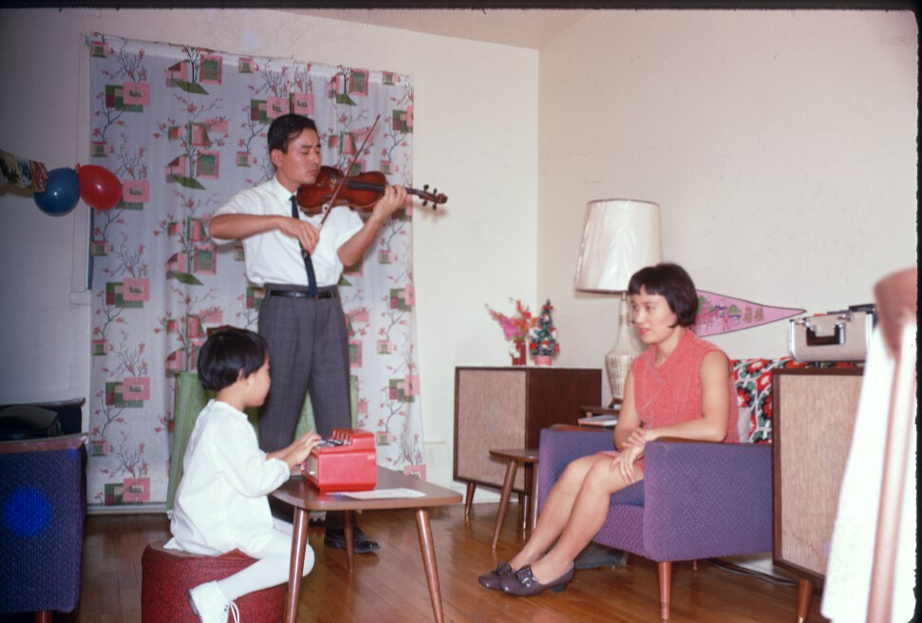
Aya Okamoto Photo 1: Either Montreal or Toronto in the late 1960's. Aya Okamoto, Hiroko-mother, Hisashi-father.

Okamura (Surname / family name / 苗字 / 家族名)
Gordon (First name / given name / 名前)
Year of birth / 生年: 1954

Ancestral History? 先代やあなたは日本のどこから来ましたか？
My parents were born in New Westminster & Steveston, BC. They were relocated to Manitoba during the war [World War Two].

When and why did you or your family come to Edmonton? いつ、どうしてエドモントンへ来ましたか？
I was recruited in Winnipeg and hired to work in Edmonton by Imperial Oil Ltd.

What were your major occupations in the past and major employers? あなたの仕事はなんですか？雇用主はどこですか？
Accountant - Imperial Oil 1976-1979
Auditor - Auditor General 1980-1982
Auditor - Treasury 1983-1986
Financial/Budget Manager 1986-2010

In what ways has having Japanese heritage affected the course of your life or family history? あなたが日本人または日系人であることは、人生にどのような影響があったと思いますか？
From what I have seen of Japan, its culture and lifestyle is much different from Canada. For me, being Japanese makes me interested in how my grand-parents and parents came to or grew up in Canada, and how they gave me a safe and loving lifestyle to grow in. I am aware of how the War caused inequities and hardship and hope that Canada will not repeat that and that we treat each other with dignity and respect.

Additional history? 個人史・家族史
I went to Japan in 2008 and met my mother's cousin and brother (my uncle) for the first time. In July 2013 I went to Tokyo to study judo at the Kodokan [Institute]. This October I am going to Kyoto for the World Kata Championships.

Okura (Surname / family name / 苗字 / 家族名)
Joyce (First name / given name / 名前)
Year of birth / 生年: 1973

Ancestral History? 先代やあなたは日本のどこから来ましたか？
British Columbia

When and why did you or your family come to Edmonton? いつ、どうしてエドモントンへ来ましたか？
Parent’s job promotion

Okura (Surname / family name / 苗字 / 家族名)
Ronald (First name / given name / 名前)
Year of birth / 生年: 1936

Ancestral History? 先代やあなたは日本のどこから来ましたか？
Shiga-ken

When and why did you or your family come to Edmonton? いつ、どうしてエドモントンへ来ましたか？
Job transfer

What were your major occupations in the past and major employers? あなたの仕事はなんですか？雇用主はどこですか？
Design Engineering - telecom

Okura (Surname / family name / 苗字 / 家族名)
Jeffery (First name / given name / 名前)
Year of birth / 生年: 1975

Ancestral History? 先代やあなたは日本のどこから来ましたか？
B.C.

When and why did you or your family come to Edmonton? いつ、どうしてエドモントンへ来ましたか？
Job

What were your major occupations in the past and major employers? あなたの仕事はなんですか？雇用主はどこですか？
UI [unemployment insurance?]

Ono (Surname / family name / 苗字 / 家族名)
Kentaro (First name / given name / 名前)
Year of birth / 生年: 1978

Ancestral History? 先代やあなたは日本のどこから来ましたか？
I was born in Edmonton to my parents who are from Japan. Both parents moved a bit. They met in Utsunomiya, Tochigi.

When and why did you or your family come to Edmonton? いつ、どうしてエドモントンへ来ましたか？
Father attended University of Alberta in Edmonton. After convocation moved to Vulcan, Alberta. Promoted in 1989-ish and moved to St. Albert, where they currently reside.

What were your major occupations in the past and major employers? あなたの仕事はなんですか？雇用主はどこですか？
Engineer - Hitachi
Order Manager - Tenaris
Buyer - Schneider Electric

In what ways has having Japanese heritage affected the course of your life or family history? あなたが日本人または日系人であることは、人生にどのような影響があったと思いますか？
My friends joked that my house was little Japan. We are a very traditional Japanese family, even to Japanese standards. My family keeps close contact with their Japanese friends and family. My family visits Japan, individually, often. We have been involved in the Japanese community in Edmonton extensively. As for myself after convocation I became an Engineer with Hitachi in Kure, Hiroshima.

Ono, 大野, オオノ (Surname / family name / 苗字 / 家族名)
Hiroyuki, ひろゆき, ヒロユキ (First name / given name / 名前)
Year of birth / 生年: 1982

Ancestral History? 先代やあなたは日本のどこから来ましたか？
福島. [Translation] Fukushima-ken

When and why did you or your family come to Edmonton? いつ、どうしてエドモントンへ来ましたか？
２０１３、６月 仕事のため. [Translation] In June 2013 for work.

What were your major occupations in the past and major employers? あなたの仕事はなんですか？雇用主はどこですか？
Ｃｏｏｋ， Ｍｉｋａｄｏ [restaurant]

Ota, 太田, オオタ (Surname / family name / 苗字 / 家族名)
Umeko, 梅子, ウメコ (First name / given name / 名前)
Year of birth / 生年: 1947

Ancestral History? 先代やあなたは日本のどこから来ましたか？
北海道白糠町
1978～1985年まではヴァンクーバー市
1985～1992年まではオタワ市
1992～1995年まではメディスン・ハット市
1995～2000年まではコールドレイク市
[Translation] Hokkaido, Shiranuka-cho [town]. 1978-1985 Vancouver. 1985-1992 Ottawa. 1992-1995 Medicine Hat. 1995-2000 Cold Lake.

When and why did you or your family come to Edmonton? いつ、どうしてエドモントンへ来ましたか？
2000年6月末、夫の仕事のため家族が当市に移動する。
[Translation] The end of June 2000; my family moved to Edmonton for my husband's work.

What were your major occupations in the past and major employers? あなたの仕事はなんですか？雇用主はどこですか？
1. 賦課団体（農業）→賦課団体役員 →の総務、経理
2. レストランの事務→日本人のカナダ人（日系カナダ人）
3. 日本語学校教師（大学の教育科専攻）→日系カナダ人
4. 公共義務教育のボランテア→州教育委員会（校長）
5. 公共義務教育の救急看護士（パート）→州教育委員会（校長）
[Translation] 1. Tax division (agriculture)→ employed by board of directors → general affairs and accounting; 2. Restaurant worker→ employed by a Japanese Canadian; 3. Japanese instructor (employed by Education Department of the university)→Japanese Canadian; 4. Volunteer for public compulsory education→ employed by Board of Education (Principal); 5.Emergency nurse in public school (part-time)→employed by Board of Education (Principal).

In what ways has having Japanese heritage affected the course of your life or family history? あなたが日本人または日系人であることは、人生にどのような影響があったと思いますか？
戦争を知らない私でしたが、第二次大戦前に入国し移民となっていた先人の日系人の努力、実践で差別を平等に、子孫に教育を通し、誇り高き民族として生きることを指し示したものであり、また、自らの子やボランテアの中でその事を無意味（無意義）にしてはならないと自分にいいきかせて今日まで至ってます。
[Translation] Although I have not known war myself, I look to the the Japanese immigrants who immigrated before WWII and, through whose efforts helped transform discrimination into equality. They educated their children and transmitted their pride. I do my best with my own children and through volunteer work to ensure their efforts don’t lose meaning or significance.

Additional history? 個人史・家族史
2000年6月末にエドモントン市に移り住みましたが、アルバーター州には、1992年に住み始めました。西部のヴァンクーバーに一生住むものと思っていたのが不況の波で夫の友人の居るオタワへと移り6年半、言語差別にほとほと呆れ、再び西部カナダへと決意したのと、アルバーター州は夫が育った地でもあったからです。
[Translation] I moved to Edmonton at the end of June in 2000, but I started living in Alberta in 1992. At first I thought I’d live in Vancouver forever but due to a recession we moved to Ottawa where my husband's friend lived and stayed six and half years. Eventually, we became quite fed up with the language discrimination and move back out west – this time to Alberta where my husband was brought up.

Pirie, ピリ (Surname / family name / 苗字 / 家族名)
Ayumi, 愛弓, アユミ (First name / given name / 名前)
Year of birth / 生年: 1972

Ancestral History? 先代やあなたは日本のどこから来ましたか？
愛知県 名古屋. [Translation] Aichi-ken, Nagoya-shi

When and why did you or your family come to Edmonton? いつ、どうしてエドモントンへ来ましたか？
家族の仕事の為. [Translation] Because of family job.

What were your major occupations in the past and major employers? あなたの仕事はなんですか？雇用主はどこですか？
1. Domba Coffee
2. トヨタ自動車（商品企画部）
3. 中央出版
4. 日本通運（シンガポール支店）
5. 竹中工務店
[Translation] 2. Toyota Motor Corporation, Product Planning Division. 3. Chuo Publishing Co. 4. Nippon Express Co. Singapore Branch. 5.Takenaka Corporation

Additional history? 個人史・家族史
主人の仕事上、カナダへ移住する事になりました。
[Translation] Immigrated to Canada because of my husband's work

Pirie, ピリ (Surname / family name / 苗字 / 家族名)
Aika, 愛加, アイカ (First name / given name / 名前)
Year of birth / 生年: 2006

Ancestral History? 先代やあなたは日本のどこから来ましたか？
日本 愛知県 名古屋市. [Translation] Japan, Aichi-ken, Nagoya-shi

When and why did you or your family come to Edmonton? いつ、どうしてエドモントンへ来ましたか？
父親の仕事の為. [Translation] I came to Edmonton because of my father's work

Sakai, 酒井, サカイ (Surname / family name / 苗字 / 家族名)
Kanako, 可奈子 カナコ (First name / given name / 名前)
Year of birth / 生年: 1973

Ancestral History? 先代やあなたは日本のどこから来ましたか？
茨城県. [Translation] Ibaraki-ken

When and why did you or your family come to Edmonton? いつ、どうしてエドモントンへ来ましたか？
子供をカナダの学校に入れたかったのでエドモントンに越してきました
[Translation] Wanted my child/children to be educated in Canada so moved to Edmonton.

Sakata (Surname / family name / 苗字 / 家族名)
Maki (First name / given name / 名前)
Year of birth / 生年: 1972

Ancestral History? 先代やあなたは日本のどこから来ましたか？
Born in Toyama, lived until 2001
Fort St. John, BC, 2001-2002
Prince George, BC, 2002-2006
Edmonton, AB. 2006 - Present

When and why did you or your family come to Edmonton? いつ、どうしてエドモントンへ来ましたか？
To study English - Student Visa. Granted Permanent immigrant – 2007. Canadian citizen - 2010

What were your major occupations in the past and major employers? あなたの仕事はなんですか？雇用主はどこですか？
Family Support Worker
Social Worker
Mental Health Therapist

In what ways has having Japanese heritage affected the course of your life or family history? あなたが日本人または日系人であることは、人生にどのような影響があったと思いますか？
Japanese heritage always affected/influenced of my study and work, writing essay, research study, as well as interested in helping people in Japanese community.

Additional history? 個人史・家族史
I consider myself as the first generation Japanese, since all of my family members are still in Japan. I didn't marry to Canadian, so I am not legally bonded to live in Canada. I can go back to Japan anytime. However, I consider Canada is the place where I am willing to spend all of my life and to be buried when I die. I am not thinking to go back. This is the place I start my family history and become older while watching my family grow, in the same way the Issei (back in late 19th to early 20th Century) felt.

Sando (Surname / family name / 苗字 / 家族名)
Thomas (Tom) (First name / given name / 名前)
Year of birth / 生年: 1922

Ancestral History? 先代やあなたは日本のどこから来ましたか？
My father was born in 1884 in Niigata Prefecture Japan. He immigrated to Canada in 1910 and worked as a salmon fisherman at Skeena River, B.C. until 1941. WWII separated our family completely. During wartime my father lived in Greenwood B.C. After the war, he moved to Vancouver. He was 97 years old when he passed away.

What were your major occupations in the past and major employers? あなたの仕事はなんですか？雇用主はどこですか？
Fisherman at Skeena River B.C. 1938-1941. Western Caisson Ltd. in Winnipeg and Edmonton 1950-1987. Concrete pile specialist. Field supervisor.

More detail submitted in addition to survey responses.
From Stories of Our Seniors 6: Tom Sando by Sanae Ohki
Tom Sando (Tamio Kuwabara) passed away on October 5, 2015 at the age of 93. He was very good at writing and drawing. His book, Wild Daisies in the Sand, 2000, includes his diaries from World War II and his story of Japanese Canadians at Skeena River before the War; the Japanese version of his diaries was published in 1995 as 囚われの身 (In Capture). Both books are in the EJCA library and are highly recommended.
The History project interviewed Tom in 2010. The following is a summary of his interview.

I was born in northern BC by the Skeena River in 1922 [note: the Skeena River runs from the interior of BC to the Prince Rupert area]. My mother passed away when I was four and my brother was two. As my father could not look after us, he took us to Niigata-ken, Japan where we were raised by my aunt with three cousins, a grandmother and an uncle. When I was 16 [in 1938], my father sent me a letter from Canada asking if I wanted to come back or stay in Japan. It was my choice. He said if I decided to stay in Japan, he would let me go to any school; I could be a lawyer, a doctor, or anything. But if I came to Canada, I had to work. At that time, Japan was at war with China and the situation was not very good. As a sixteen-year-old, I had to do military-style training once or twice a week and I had heard many Japanese soldiers died in China. Life was tough for everybody, particularly for farmers. As many men went to the war, all the people remained in the farm needed to do farming. I was already working on the farm which I enjoyed. I liked the countryside but there was no future. So, I decided to come to Canada. My father came to pick my brother and me up in the spring of 1938. I still remembered the name of the ship we took from Yokohama, it was the Princess of Asia.
When I arrived at Canada, we stayed in the Powell Street area of Vancouver; it was a like a Japanese town. I liked the beautiful Vancouver and thought we would live in Vancouver but my father decided to go the Skeena River area to work in a fishing cannery. It took three days and nights by small ferry ship. I had come back to my native place. One day, we went upstream river and visited my mother’s grave. That was very emotional reunion with remains of my mother. Life there was not too difficult because the most of fishermen were Japanese.
In December 1941, the war started and the government took our boats away. So, that was the end of our fishing life. We did not know exactly what was happening and what the government would do with us. Then, in 1942, Japanese Canadian evacuation started. All Japanese-Canadians living within 100 miles of the coast were moved to Hastings Park in Vancouver. Then, most of men from 17 to 45 years old were sent to road camps, making highways and railways. I was 20 years old. My brother and I went to the office of the BC Security Commission to register our names. They told us where and when to go and gave us railway tickets.
While we were waiting for transportation for a few days in the jail-like Hastings Park building, a group from Cumberland came [note: Cumberland is on Vancouver Island]. We were talking with them, asking “Why do we have to obey the government’s order? How about if we decide not to go”? About 19 of us decided that we would not obey the order.
A few days later, the RCMP came to take us to the road camp. “We are not going,” we said and we returned the train tickets. We were loaded into a paddy wagon and taken to the immigration office building in the waterfront in Vancouver harbour. We were under house-arrest for one month in a room with bars. There were soldiers as guides. Then, they decided to ship us to the POW camp – Prisoner of War – in Petawawa, Ontario. Germans and Italians were also in the camp.
There were about 200 Japanese called “trouble makers” in the POW camp. After 2-3 months, they moved us to the Angler German camp. Our life in there was the same as POWs for four years. At 7 am and 7 pm, they counted us. We got special uniforms with a big red circle on the back, stripe on the side, and on a cap. The red circle was an aiming point if we tried to escape. We did not work at the camp.
When the war ended, they gave us a choice of staying in Canada or going to Japan. My father was in Greenwood, BC so I wrote to him for an advice. He said he would go to Japan if I went. But finally he suggested that the situation in Japan was not good and we would stay in Canada. My brother and I signed six month contracts with a pulp mill in northern Manitoba.
After the contract ended, we visited my father who had moved to the Penticton area by that time. My brother decided to stay with my father while I decided to go on my own and got a pulp mill job in the Thunder Bay area. Then, I moved to Winnipeg and met my first Polish girlfriend. I worked there till 1962 as a foreman at a company specialized in building foundation.
In 1962, I broke up with my girlfriend and met my first wife. We decided to move to the West so we loaded whatever we had into my old 1951 Studebaker. When we got to Calgary, the car broke and could not go any farther so I worked in Calgary until the fall of 1963. At that time Edmonton was in an oil boom and there were many jobs available, I heard. So, my wife and I packed everything, and took a bus to Edmonton. Because of my experience as a foreman in building foundations, I got a good job at $350 a month. Until I retired in 1987, I worked for the same company. I divorced my first wife and remarried to a German woman. But she died just before I retired.
Back to the POW camp. As I explained, we went to the POW camp to protest the Government’s unfair treatment against Japanese-Canadians. Before the government realized that they were not doing right thing, the war ended. We sacrificed our four years in camp, but I don’t regret it. I learned how to mingle with other people, do things together with others, and to negotiate. Secondly, I learned how to maintain my mental and physical health. I did lots of reading, writing and joined Judo and Kendo clubs. When I was let out of the camp, I knew how to treat other people and my body was very strong to do heavy work.
When I came back to Canada in 1938, it was not difficult to adjust to the Canadian way of living. As for language, I always had difficulty in pronunciation, especially “L.” Because there is no such pronunciation of L in Japanese, I still get “L” and “R” mixed up. I have never received formal education in Canada. I taught myself English using dictionaries and whatever was available.

Sato, 佐藤、サトウ (Surname / family name / 苗字 / 家族名)
Hitomi, ヒトミ、ヒトミ (First name / given name / 名前)
Year of birth / 生年: 1960

Ancestral History? 先代やあなたは日本のどこから来ましたか？
札幌市. [Translation] Hokkaido, Sapporo-shi

When and why did you or your family come to Edmonton? いつ、どうしてエドモントンへ来ましたか？
2010年、移民目的で、ケアーギバー学校に入学した。
[Translation] 2010, to enroll in a Caregiver Program with the goal of immigrating.

What were your major occupations in the past and major employers? あなたの仕事はなんですか？雇用主はどこですか？
現在：ストーニープレイン エルダリーケアー. 2012：セントアルバート エルダリーケアー. 2011：シャーウッドパーク 障害者ケアー
[Translation] Current: Stony Plain - Elderly Care. 2012: St. Albert - Elderly Care. 2011 Sherwood Park Disabled Persons Care.

In what ways has having Japanese heritage affected the course of your life or family history? あなたが日本人または日系人であることは、人生にどのような影響があったと思いますか？
いろいろな国に行ける日本のパスポートは便利でした。
[Translation] I can go to many other countries with my Japanese passport.

Sato, 佐藤、サトウ (Surname / family name / 苗字 / 家族名)
Sarah, サラ、サラ (First name / given name / 名前)
Year of birth / 生年: 1997

Ancestral History? 先代やあなたは日本のどこから来ましたか？
札幌市. [Translation] Sapporo-shi

When and why did you or your family come to Edmonton? いつ、どうしてエドモントンへ来ましたか？
両親の都合. [Translation] Parents' circumstances

What were your major occupations in the past and major employers? あなたの仕事はなんですか？雇用主はどこですか？
学生. [Translation] Student

In what ways has having Japanese heritage affected the course of your life or family history? あなたが日本人または日系人であることは、人生にどのような影響があったと思いますか？
多いな影響。異人なのに日本人だからいろいろありました。
[Translation] Lot of influence. I’m a foriegner but Japanese at the same time so there are various influences.

Sawada (Surname / family name / 苗字 / 家族名)
Luciana (First name / given name / 名前)
Year of birth / 生年: 2008

Ancestral History? 先代やあなたは日本のどこから来ましたか？
Edmonton

When and why did you or your family come to Edmonton? いつ、どうしてエドモントンへ来ましたか？
1976 - Dad was born here

Sawada (Surname / family name / 苗字 / 家族名)
Daiyo (First name / given name / 名前)
Year of birth / 生年: 1942

Ancestral History? 先代やあなたは日本のどこから来ましたか？
Parents from Shiga-ken. Father came to Edmonton just after WWI with two brothers all of whom were barbers. He moved to Raymond in the mid 1920's and had a daughter. His first wife passed away so he returned to Japan and came back with a new wife - Kane. They moved to Pincher Creek in the late 1920's eventually having a total of 6 kids - 3 girls, 3 boys - with me as the youngest. (I was interviewed by the History Committee so I won't say more here.)

When and why did you or your family come to Edmonton? いつ、どうしてエドモントンへ来ましたか？
I came to Edmonton to attend U of A[lberta] eventually graduating with a Bachelor's degree (1964) and a Masters (1966). If have remained in Edmonton ever since except for a couple years attending Penn State (1969 - 71) for a Ph. D. and then, after retiring from U of A (1998) working for 6 years for Arizona State University, living there as well as commuting from Edmonton.

What were your major occupations in the past and major employers? あなたの仕事はなんですか？雇用主はどこですか？
Pincher Creek School Division (teacher)
University of Alberta (professor)
Arizona State University (researcher)

In what ways has having Japanese heritage affected the course of your life or family history? あなたが日本人または日系人であることは、人生にどのような影響があったと思いますか？
[I talked extensively on this issue during my interview.]

More detail submitted in addition to survey responses.

A Personal Mini-Narrative
As I write this in 2015 I have been here on this planet for 72 years. For the most part things have pretty much “gone my way” despite being born during WW II to Japanese parents in a small “cow-town” community in Southern Alberta called Pincher Creek. I say “despite being born to Japanese parents” because I’m not Japanese because of my parents, never have been and still am not despite being mistook many times for a Chinese or a Korean which might even be worse given that I do look like both. If this sounds confusing, it’s mostly because I have been trained as an “academic” and having practiced being one, somewhat successfully, for over 40 years, I’m pretty good at writing in paragraphs when simple declarative sentences could have done the job.
Come what may, I took early retirement from U of A in 1998 when Premier Ralph Klein, in his wisdom, decimated the university with 22% budgetary cuts necessitating the U of A to offer lucrative retirement packages to encourage the over-the-hill gang to take a hike. Being 55 years of age at the time, I did take the money and run, all the way to Arizona where I worked for another eight years at ASU (Arizona State University). That’s a related story but there’s no use cluttering up this one even more.
Somewhat interestingly, during the years on the ASU payroll, I designed a house to be built in Twin Brooks backing onto Black Mud Ravine just before it merges with White Mud Ravine. This was possible only because I was “triple dipping” – Buy-out package, pension income, plus earnings from ASU – thanks Ralph. I mention the new house because it gave me a chance to design an actual Japanese Zen Garden that would interface the House with Nature – the Blackmud Ravine. The important idea here is neither garden nor house nor nature but rather the notion of an INTERFACE: the Japanese Zen garden interfaces the house, and therefore me, with nature. My hope was that the undertaking of this project would evoke what little “Japanese-ness” was latent within me (just as “zazen” evokes enlightenment). As well, because the lot sloped down to the ravine, I designed the house with a “walk-out” basement where I could design and build a Japanese Tea Room opening onto the Japanese Zen Garden backing onto the Ravine (Nature). Notice the double interface: Tea Room interfacing with the Garden interfacing with Nature. Hip bone connected to the knee bone . . . I refer to such connections as “holonomic”. If living in such holonomically connected space didn’t arouse any Japanese-ness in me, I must be completely Canadian (whatever that might be).
As I write this, I am sitting with my laptop in my “Office/Tea Room” overlooking my Zen Garden gazing into nature. You might have noticed that my writing has become a little simpler. You might even have noticed that my sentences are a bit like bonsai set in a paragraph which in turn is a bit like a garden. And after noticing this, you might infer that the ravine as a back-drop to bonsai and garden, is a bit like this narrative composed of words, sentences, and paragraphs.
And now to be really compact and terse (a little like a haiku poem) allow me to say the above paragraph in one sentence:
sentence / paragraph / narrative ≈ tea room / garden / ravine
or
(sentence is to paragraph is to narrative) AS (tea room is to garden is to ravine)
I call these relationships “holonomic equivalences”. For example, the way a paragraph relates to a narrative is “holonomically equivalent” to the way a garden relates to a ravine.
Doing, building, creating, living and writing about these equivalences is my way of actualizing or recovering what little Japanese-ness might still lie latent within me and simultaneously discovering new connections (e.g., holonomic makoto no kokoro) as well. It is one of my ways of “bringing forth” in my daily living a sense of Japanese-ness I thought was never there. In doing this for the past 20 years or so, I may have discovered or even invented new ways of being Japanese that aren’t part of the history of Japanese-ness even in Japan! (Yeah, dream on Sawada!) Thinking/drifting in this way enables me to carry on with my pedestrian living even as I drift by 72.
For me, “being Japanese in Canada” is as much a creation or an invention as it is a recollection or preservation. I’m so excited by this possibility that I am currently writing a couple books about these possibilities and hoping to write a third. The first of these books has been brewing under the presumptuous title Zen over Troubled Water: A Journey into Consciousness. The second is more focused and scientific: Zen on Ice: Quantum Consciousness in the Game of Curling. The third is a bit more fanciful and “kotodama-like” and thus more wondrous in spirit: The Way Home: Bridging the Mighty Pacific”. And because my name is “Daiyo” (a name made-up by my mother in 1942) the kanji (大洋) has something to do with “bridging the Mighty Pacific” with an “Occidental” emphasis. In doing so, my dream is to realize A Way Home.
All three titles undergo constant revision as I write. In order to see the light of day, the third book may need co-authorship with someone who unlike me is wondrously kami-like. Such a person would keep me from over-indulging in “writer’s prerogative” while ensuring that what we co-create is grounded in authentic holonomic equivalency, and even more so in makoto no kokoro – The Way Home. These three books may see me vanishing into the sunset on my way to JAPAN-eseness: “Bridging the Mighty Pacific” in real time no less. Should this happen, I will be “living’ whatever Japanese-ness there is in these books rather than talking about it, at least for a little while. I can’t think of a better way for me to “become Japanese”. After all, when my mother named me “Daiyo”, she was dreaming about what might happen in the Mighty Pacific. I need to discover/rediscover what such dreams could have been if not for the horrific distortion of Shinto that occurred under the Meiji “Restoration” of 1868 culminating in two horrific explosions over those craggy islands. Despite those two devastating mushroom clouds, the “Restoration” was born anew and rages again onward and upward! Is this surprising? The “new clothes” began saving face once again. The Pale Moon and the Cherry Blossoms seem once again to live only in Haiku.
Nevertheless, it is nice to dream, even as a Japanese Canadian senior, even one born in “cow-town” Pincher Creek to the only Japanese family residing there, before and during and after the devastating journey that culminated in those dreadful atomic flashes. Thank heaven for dedicated public school teachers in Pincher Creek back in the ‘50’s who were fair-minded enough and kind-hearted enough to give children of “enemy aliens” a chance to participate in Canada! My hat is off to them. Without them I could never have written in paragraphs when bonsai would do.
[My apologies to those who believe in the Meiji Restoration or in the renewed militarization of Japan Inc. or in . . .]

Sawada (Surname / family name / 苗字 / 家族名)
Brandon (First name / given name / 名前)
Year of birth / 生年: 1976

Ancestral History? 先代やあなたは日本のどこから来ましたか？
Pincher Creek, Alberta

When and why did you or your family come to Edmonton? いつ、どうしてエドモントンへ来ましたか？
Dad got a job at the University of Alberta.

What were your major occupations in the past and major employers? あなたの仕事はなんですか？雇用主はどこですか？
Systems Analyst - Government of Alberta

In what ways has having Japanese heritage affected the course of your life or family history? あなたが日本人または日系人であることは、人生にどのような影響があったと思いますか？
Pride in being Japanese; regret regarding the atrocities associated with Japanese WWII soldiers.

Sawada (Surname / family name / 苗字 / 家族名)
Andres (First name / given name / 名前)
Year of birth / 生年: 2009

Ancestral History? 先代やあなたは日本のどこから来ましたか？
Edmonton

When and why did you or your family come to Edmonton? いつ、どうしてエドモントンへ来ましたか？
1976 Dad was born here

Schultz (Surname / family name / 苗字 / 家族名)
Toshie (First name / given name / 名前)
Year of birth / 生年: 1962

Ancestral History? 先代やあなたは日本のどこから来ましたか？
Most of my family is still in Shizuoka, Japan. I came to Edmonton alone in 1990.

When and why did you or your family come to Edmonton? いつ、どうしてエドモントンへ来ましたか？
I came to Edmonton in 1990 with Working Holiday Visa. My friend was living in Leduc at the time and found an apartment in Edmonton for me before my arrival. With the visa, I thought I would able to find a job and stay in Edmonton/Canada for at least a year.

What were your major occupations in the past and major employers? あなたの仕事はなんですか？雇用主はどこですか？
Chuo Trust Bank

In what ways has having Japanese heritage affected the course of your life or family history? あなたが日本人または日系人であることは、人生にどのような影響があったと思いますか？
Respect for others, hard working, honesty.

Seto, シート (Surname / family name / 苗字 / 家族名)
Sena, 世那, セナ (First name / given name / 名前)
Year of birth / 生年: 2010

Ancestral History? 先代やあなたは日本のどこから来ましたか？
東京. [Translation] Tokyo

When and why did you or your family come to Edmonton? いつ、どうしてエドモントンへ来ましたか？
家族の引越しに伴い. [Translation] Because my family moved here

Additional history? 個人史・家族史
2010年5月16日, 生後４ヶ月、生まれて初めて飛行機に乗り、バンクーバー経由にてエドモントンに来ました。９ヶ月からEJCAの日本語キッズクラブに通い、たくさんお友達ができました。
[Translation] On May 16th, 2010, at four months of age, I took an airplane ride for the first time and came to Edmonton via Vancouver. I have been attending "Japanese Kids' Club" at EJCA since nine months and have many friends there.

Seto, シート (Surname / family name / 苗字 / 家族名)
Yukie, 幸枝, ユキエ (First name / given name / 名前)
Year of birth / 生年: 1974

Ancestral History? 先代やあなたは日本のどこから来ましたか？
日本（東京）[Translation] Japan (Tokyo)

When and why did you or your family come to Edmonton? いつ、どうしてエドモントンへ来ましたか？
主人の転職をきっかけに、2010年5月、（職場がエドモントンと決定）家族で移ってきました。日本で生活していたのですが、子供が生まれ将来のことを具体的に考えるようになりました。いろいろ考えた末、主人の母国のカナダへ移住する結論に至りました。
[Translation] In May 2010, our family moved to Edmonton because my husband had a new job opportunity. We used to live in Japan but we started to think seriously about the children's future. After careful consideration, we reached the conclusion to immigrate to Canada, which is my husband's home country.
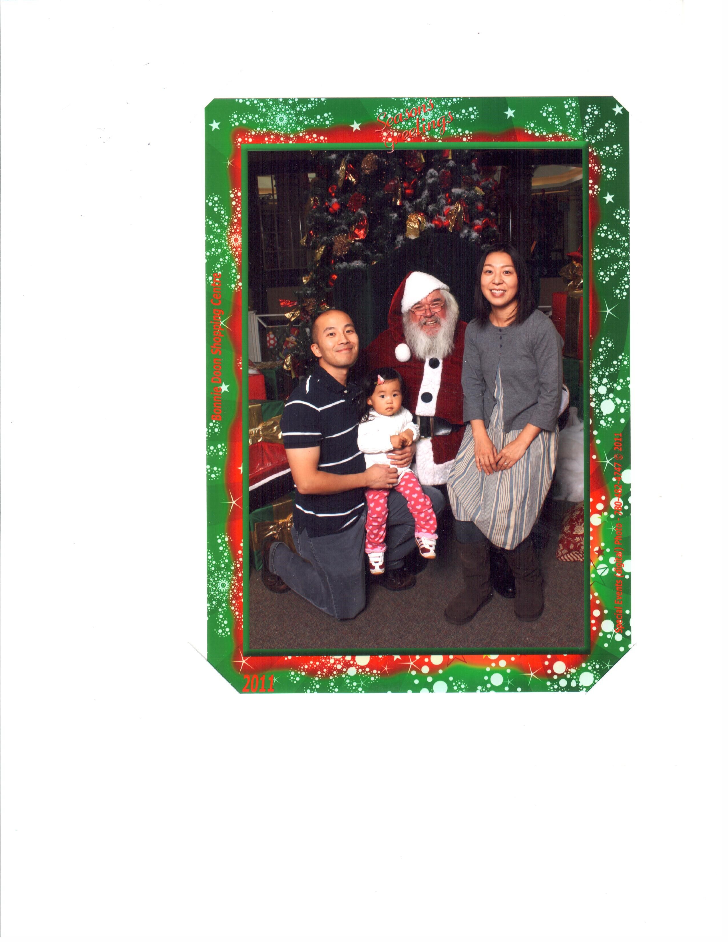
Bonnie Doon Shopping Centre, Edmonton December 2011

Shigamitsu (Surname / family name / 苗字 / 家族名)
Hayato (First name / given name / 名前)
Year of birth / 生年: 1980

Ancestral History? 先代やあなたは日本のどこから来ましたか？
Mother - Nagano Father - Kagoshima

When and why did you or your family come to Edmonton? いつ、どうしてエドモントンへ来ましたか？
For a job

What were your major occupations in the past and major employers? あなたの仕事はなんですか？雇用主はどこですか？
Adecco, Hire-a-student, Old Timers Cabin, Save-On-Foods, NavCanada

In what ways has having Japanese heritage affected the course of your life or family history? あなたが日本人または日系人であることは、人生にどのような影響があったと思いますか？
Continual involvement with Japanese Church, Heritage Days Festival, and visits to Japan

Additional history? 個人史・家族史
I have many relatives and friends in Japan and within Canada. Many are Japanese or of Japanese descent.

Shigehiro (Surname / family name / 苗字 / 家族名)
John (First name / given name / 名前)
Year of birth / 生年: 1962

Ancestral History? 先代やあなたは日本のどこから来ましたか？
Unknown

When and why did you or your family come to Edmonton? いつ、どうしてエドモントンへ来ましたか？
Transferred from Calgary

What were your major occupations in the past and major employers? あなたの仕事はなんですか？雇用主はどこですか？
General Motors Canada

In what ways has having Japanese heritage affected the course of your life or family history? あなたが日本人または日系人であることは、人生にどのような影響があったと思いますか？
The tradition - I want to pass on the heritage to my children and girlfriend.

Additional history? 個人史・家族史
I visited Japan to see where my dad's family came from and follow the steps of his family during the war and then internment camps.

Shigemitsu (Surname / family name / 苗字 / 家族名)
Suzuko (First name / given name / 名前)
Year of birth / 生年: 1978

Ancestral History? 先代やあなたは日本のどこから来ましたか？
My father was from Hayato-cho [town] in Kagoshima, Japan. He came to Tabor, Alberta, where he worked on a farm for a period of time.
My mother was from Kiso-Fukushima in Nagano, Japan. She came to Edmonton and stayed with her aunt's family.
Both of my parents met in Edmonton, where they got married and moved to Calgary, which was where I was born, as well as my brother and sister.

When and why did you or your family come to Edmonton? いつ、どうしてエドモントンへ来ましたか？
Our family moved to Edmonton in September of 1985 as an opportunity for a better life.

What were your major occupations in the past and major employers? あなたの仕事はなんですか？雇用主はどこですか？
From 2002 to 2007, I've worked at Chapters Indigo for 5+ years.
From 2007 to 2009, I went to Yonezawa City in Yamagata prefecture, Japan as a native English teacher at Yonezawa English School.
From 2009 to 2011, I worked with the EJCA History project as a researcher.
From 2011 to 2013, I've taught at Metro Edmonton Japanese Community School as a senior kindergarten teacher for about 1 year and 3 months.

In what ways has having Japanese heritage affected the course of your life or family history? あなたが日本人または日系人であることは、人生にどのような影響があったと思いますか？
I see my Japanese heritage as a blessing (eg., something of a fascination where people approached me out of interest in Japanese culture), but also carries some sad memories (eg., bullied for my background, or mentioned that it was the fault of the Japanese that WWII had started). I have learned to see history from the view point of "the aggressor" (Pearl Harbor) and "the victim" (Internment Camps). I have been taught by my friends that though race may not be important, but the heritage we leave for our descendants could become treasures of history and wisdom.

Additional history? 個人史・家族史
My great grandfather (my father's grandfather) went to the US for an opportunity of a good life. Later my grandmother (my father's mother) was born in Oakland, California. Before WWII, the family returned to Kagoshima, Japan; which was where my father was born.

Shigemitsu, 重満, シゲミツ (Surname / family name / 苗字 / 家族名)
Hitoshi, 仁, ヒトシ (First name / given name / 名前)
Year of birth / 生年: 1949

Ancestral History? 先代やあなたは日本のどこから来ましたか？
鹿児島県. [Translation] Kagoshima-ken

When and why did you or your family come to Edmonton? いつ、どうしてエドモントンへ来ましたか？
神の導きによりエドモントンに参りました。 [Translation] God led me to Edmonton.

What were your major occupations in the past and major employers? あなたの仕事はなんですか？雇用主はどこですか？
Cook, Shogun Japanese Restaurant.
Cook, La Boehme
Cook, Japanese Village
Self Employment

In what ways has having Japanese heritage affected the course of your life or family history? あなたが日本人または日系人であることは、人生にどのような影響があったと思いますか？
日本で生まれ育ったことを誇りと思います。
[Translation] Am proud of being born and raised in Japan.

Additional history? 個人史・家族史
1970年 テーバーに移住
1972年 カルガリーに移住
1985年 エドモントンに移住
2015年 退職予定
[Translation] 1970 - moved to Taber. 1972 - moved to Calgary. 1985 - moved to Edmonton. 2015 - expect to retire.

Shigemitsu, 重満, シゲミツ (Surname / family name / 苗字 / 家族名)
Makiko, 真紀子, マキコ (First name / given name / 名前)
Year of birth / 生年: 1947

Ancestral History? 先代やあなたは日本のどこから来ましたか？
東京都目黒区. [Translation] Tokyo-to, Meguro-ku [ward]

When and why did you or your family come to Edmonton? いつ、どうしてエドモントンへ来ましたか？
1972年 カナダに住みたいと思ってエドモントンに来ました。伯母がエドモントンに住んでいたので、私もエドモントンに住むことにしました。
1977年 カルガリーに主人と移りましたが、
1985年にまたエドモントンに戻ってきました。
[Translation] In 1972, I thought I’d like to live in Canada so I came to Edmonton. Since my aunt lived in Edmonton, I also chose to live in Edmonton.

What were your major occupations in the past and major employers? あなたの仕事はなんですか？雇用主はどこですか？
Coordinator, Alberta Blue Cross, Edmonton; Administrator, Alberta Blue Cross、Edmonton;
Typist, Glenrose Hospital, Edmonton;
Data Entry Clerk, United Farmers of Alberta, Calgary;
Data Entry Clerk, Government of Alberta, Edmonton

In what ways has having Japanese heritage affected the course of your life or family history? あなたが日本人または日系人であることは、人生にどのような影響があったと思いますか？
日本人は勤勉だからという事で雇ってくださったか方おられました。
[Translation] I got a job since the owner thought Japanese were hard workers.

Additional history? 個人史・家族史
伯母がいたのでエドモントンに来ましたが、今は、ここが好きで住んでいます。日本にいる姉や兄たちがまだ健在なうちはできるだけ日本に行きたいと願っています。日本に行って、友人や家族に会うのが楽しみです。
[Translation] Originally, I came to Edmonton because my aunt was here but now I live here because I like it. I hope to visit Japan often while my siblings are still healthy. I njoy visiting friends and family when I go to Japan.

Shikaze (Surname / family name / 苗字 / 家族名)
Kesa (First name / given name / 名前)
Year of birth / 生年: 1976

Ancestral History? 先代やあなたは日本のどこから来ましたか？
My father's family is from Kagoshima, but immigrated to Canada (his grandparents came over) and settled on the West Coast. Most of my family now lives in Vancouver.

When and why did you or your family come to Edmonton? いつ、どうしてエドモントンへ来ましたか？
I came here for school at the University of Alberta.

What were your major occupations in the past and major employers? あなたの仕事はなんですか？雇用主はどこですか？
I've been a manger with the Government of Alberta, doing policy development.

In what ways has having Japanese heritage affected the course of your life or family history? あなたが日本人または日系人であることは、人生にどのような影響があったと思いますか？
Growing up in Vancouver and being half Japanese, I rarely felt out of place as there were many other Japanese people, and people were generally familiar with Japanese culture and particularly food! When I first moved to Edmonton, I noticed that there were fewer Japanese people and that people often mistook me for half Chinese. My family was relocated to Alberta during the war, and my father was born in an internment camp. This experience shaped my whole family significantly, but it's impact on me has been relatively limited.

Shimajiri, 島尻 (Surname / family name / 苗字 / 家族名)
Michiaki, 道秋 (First name / given name / 名前)
Year of birth / 生年: 1973

Ancestral History? 先代やあなたは日本のどこから来ましたか？
北海道. [Translation] Hokkaido

When and why did you or your family come to Edmonton? いつ、どうしてエドモントンへ来ましたか？
日本語教師として日本の文化省より派遣されたため
[Translation] I was dispatched by the Japanese Ministry of Culture as a Japanese language teacher.

What were your major occupations in the past and major employers? あなたの仕事はなんですか？雇用主はどこですか？
日本語教師. [Translation] Japanese Language Teacher

Shimajiri, 島尻 (Surname / family name / 苗字 / 家族名)
Nanako, 菜々子 (First name / given name / 名前)
Year of birth / 生年: 2007

Ancestral History? 先代やあなたは日本のどこから来ましたか？
北海道. [Translation] Hokkaido

When and why did you or your family come to Edmonton? いつ、どうしてエドモントンへ来ましたか？
父の仕事. [Translation] Father's job

Shimajiri, 島尻 (Surname / family name / 苗字 / 家族名)
Hikaru, ヒカル (First name / given name / 名前)
Year of birth / 生年: 2004

Ancestral History? 先代やあなたは日本のどこから来ましたか？
北海道. [Translation] Hokkaido

When and why did you or your family come to Edmonton? いつ、どうしてエドモントンへ来ましたか？
父の仕事. [Translation] Father’s job.

Shimajiri, 島尻 (Surname / family name / 苗字 / 家族名)
Takako, 孝子 (First name / given name / 名前)
Year of birth / 生年: 1976

Ancestral History? 先代やあなたは日本のどこから来ましたか？
北海道. [Translation] Hokkaido

When and why did you or your family come to Edmonton? いつ、どうしてエドモントンへ来ましたか？
夫の仕事（日本語教師） [Translation] My husband's work (Japanese Language Teacher)

Shimizu (Surname / family name / 苗字 / 家族名)
Gregory Hideo (First name / given name / 名前)
Year of birth / 生年: 1964

Ancestral History? 先代やあなたは日本のどこから来ましたか？
Nara [Japan} then Prince Rupert [BC] then New Denver [BC] during the war then Edmonton

When and why did you or your family come to Edmonton? いつ、どうしてエドモントンへ来ましたか？
Grandfather decided that it had a good university.

What were your major occupations in the past and major employers? あなたの仕事はなんですか？雇用主はどこですか？
Worked for 10 years in corporate Marketing focusing on Casino work for Northlands Park and also opened up River Cree Resort and Casino a 180 million dollar project. Last 4 years opened up a restaurant and bar, The Pourhouse Bier Bistro. Last 4 years created Booming Tree Taiko Duo. A professional taiko group.

In what ways has having Japanese heritage affected the course of your life or family history? あなたが日本人または日系人であることは、人生にどのような影響があったと思いますか？
Having Japanese heritage set the seeds to making the path towards Booming Tree Taiko to exist today. In the late 1970's, I saw Ondekoza , the first taiko super group from Japan, my connection to it was I as part Japanese so seeing this show was important. Later my dad brought in a taiko group from Seattle 1986? to showcase taiko at the Heritage festival. They even billeted at our house. From that the EJCA started a taiko group and I played with them for over 20 years. I am actually the longest running member to retire from the group. I went on to create the professional taiko duo Booming Tree. Now because of Booming Tree I travel regularly to Japan to study taiko. I am very active creating connections with all other taiko groups in Alberta. My sister also plays with Midnight taiko in Calgary. We have taught almost all the groups in Alberta. We created the first ever Alberta Taiko Supershow with Alberta Taiko groups and one from Japan. We taught at the North American Taiko Conference and am a delegate to the Taiko Community Alliance group (60 people around North America are in this group, top leaders, performers, administrators etc). Being 1/2 Japanese gave me a starting point in taking up taiko almost 25 years ago. Since then I/ we created Booming Tree and have taken taiko well beyond our dreams in presenting this artform. We have done several TV commercials, toured North America, collaborated with countless musicians and other performers, played while flying in the air. the list of things is very long. Basically we have taken taiko well beyond what anyone could imagine. All of this has made me more connected to Japan in many ways. Things like costumes- by wearing kimono in shows and also full Sumari Armour. We travel more to Japan and have more connections with people in Japan and the rest of the Taiko world in general. Being Japanese gave me the 'in' on starting doing taiko, and now I feel it still gives me credibility with our unique taiko duo. As far as I know we are the only taiko duo in North America and possibly the world, doing what we do. So being Japanese gave me the start into taiko for sure and now with Booming Tree I have a lot more Japanese connections in many ways.

Additional history? 個人史・家族史
An interesting connection is that my partner in Booming Tree is not Japanese but taught English for 2 years in Japan. She speaks Japanese whereas I don't. She has many more friends in Japan since she lived there. We visit Japan not only because of taiko but to see friends we know there. For me mostly through taiko connections for my partner from teaching English in Japan.

Shimoda, 下田 (Surname / family name / 苗字 / 家族名)
Noriko, 規子 (First name / given name / 名前)
Year of birth / 生年: 1934

Ancestral History? 先代やあなたは日本のどこから来ましたか？
熊本県. [Translation] Kumamoto-ken

When and why did you or your family come to Edmonton? いつ、どうしてエドモントンへ来ましたか？
主人の転勤. [Translation] I came to Edmonton because of my husband's job transfer

What were your major occupations in the past and major employers? あなたの仕事はなんですか？雇用主はどこですか？
主婦. [Translation] Homemaker

Additional history? 個人史・家族史
夫のおじいさんがBCに移民。戦後家族で帰日（帰国）。夫高卒後Toronto へ帰加。婚約していた私と1963年にTorontoに住み、２児〔長男James, 次男Albert) 誕生。主人はTorontoでCMA の資格を取り、９年間IBMに勤め、その後、カナダ政府のFinance OfficerとしてTorontoで２－３年、そのご西部地区のコントローラーとして１８２１年に移動。Sherwood Parkの現在に至る。子供たち二人もAlberta、U of Aを卒業し、長男はSh.Pk. 次男はTwin Brooksに住んでいる。

[Translation] My husband's grandfather immigrated to BC. After the war, the family returned to Japan. My husband came back to Toronto after graduating from high school. I was engaged to him so I move to Toronto in 1963 with him. Our sons, James and Albert, were born there. In Toronto, my husband took the Certified Management Accountant licence, worked for IBM for 9 years, and then worked as Finance Officer for the Canadian Government in Toronto for 2-3 years. Ater that, he then moved as a controller for the western region anada in 1821 [?]. We live in Sherwood Park . Our sons both graduated from University of Alberta. The eldest son lives in Sherwood Park, and the youngest in Twin Brooks [Edmonton]

Speors, スピアーズ (Surname / family name / 苗字 / 家族名)
Miki, 美紀 (First name / given name / 名前)

Ancestral History? 先代やあなたは日本のどこから来ましたか？
日本 山口県 生身
4 カルガリー
3 ケイマン諸島
2 アメリカ
1 日本
[Translation] Born in Yamaguchi-ken. 4 Calgary, AB. 3 Cayman Islands. 2. USA. 1. Japan

When and why did you or your family come to Edmonton? いつ、どうしてエドモントンへ来ましたか？
夫の転きんの為. [Translation] My husband's job transfer

What were your major occupations in the past and major employers? あなたの仕事はなんですか？雇用主はどこですか？
エドモントンサン、新聞社、ディストリビューション、マネージャー
FedEX ground
[Translation] 1. Edmonton Sun, newspaper company, distribution manager. FedEX ground

In what ways has having Japanese heritage affected the course of your life or family history? あなたが日本人または日系人であることは、人生にどのような影響があったと思いますか？
ほこりに思っています。 [Translation] I am proud of being a Japanese.

Additional history? 個人史・家族史
日本の祖父、祖母、いとこたちとふれ合う事で日本との関わりを保っています。
[Translation] I keep a relationship with Japan by going to see my grandfather, grandmother, and cousins.

St. Laurent (Surname / family name / 苗字 / 家族名)
Scott (First name / given name / 名前)
Year of birth / 生年: 1994

Ancestral History? 先代やあなたは日本のどこから来ましたか？
Kanagawa prefecture

What were your major occupations in the past and major employers? あなたの仕事はなんですか？雇用主はどこですか？
Student

In what ways has having Japanese heritage affected the course of your life or family history? あなたが日本人または日系人であることは、人生にどのような影響があったと思いますか？
It allowed me to embrace a part of my heritage.

Sugawara, 菅原 (Surname / family name / 苗字 / 家族名)
偉年 (First name / given name / 名前)

Ancestral History? 先代やあなたは日本のどこから来ましたか？
東京. [Translation] Tokyo

When and why did you or your family come to Edmonton? いつ、どうしてエドモントンへ来ましたか？
仕事とそして日本語があったので. [Translation] Job and Japanese

What were your major occupations in the past and major employers? あなたの仕事はなんですか？雇用主はどこですか？
1. 東芝. 2. 米軍. 3. Northern Telecom. 4. Teleradio Co. 5. AGT Ltd [Alberta Government Telephones].
[Translation] 1.Toshiba; 2. US army,

In what ways has having Japanese heritage affected the course of your life or family history? あなたが日本人または日系人であることは、人生にどのような影響があったと思いますか？
日系人の歴史をもつと知る事ができた. [Translation] Knew Nikkei history

Sugiura (Surname / family name / 苗字 / 家族名)
Stuart (First name / given name / 名前)
Year of birth / 生年: 1974

Ancestral History? 先代やあなたは日本のどこから来ましたか？
Gifu, Japan (I think). Vancouver, Kaslo, Calgary, Edmonton

When and why did you or your family come to Edmonton? いつ、どうしてエドモントンへ来ましたか？
Grandparents came in late 1940s. Not sure of the reason, but probably related to a job/work relocation.

What were your major occupations in the past and major employers? あなたの仕事はなんですか？雇用主はどこですか？
Engineer at Cameron Canada and Emerson Process Management

In what ways has having Japanese heritage affected the course of your life or family history? あなたが日本人または日系人であることは、人生にどのような影響があったと思いますか？
Difficult to say. Probably an increased interest in Japanese culture and pride in the heritage.

Sugiyama, 杉山, スギヤマ (Surname / family name / 苗字 / 家族名)
Toshiyuki, 俊之, トシユキ (First name / given name / 名前)
Year of birth / 生年: 1963

Ancestral History? 先代やあなたは日本のどこから来ましたか？
埼玉県 [Translation] Saitama-ken

When and why did you or your family come to Edmonton? いつ、どうしてエドモントンへ来ましたか？
仕事探し [Translation] Look for a job

What were your major occupations in the past and major employers? あなたの仕事はなんですか？雇用主はどこですか？
Emergency Medical Technician, Ambulance, Business person in the past

In what ways has having Japanese heritage affected the course of your life or family history? あなたが日本人または日系人であることは、人生にどのような影響があったと思いますか？
比較的裕福に育ったと思う. [Translation] Grew up in relative affluence

Additional history? 個人史・家族史
仕事探しの過程でアルバータにたどり着いた. [Translation] Arrived in Alberta on a quest to fine work

Suzuki, 鈴木, スズキ (Surname / family name / 苗字 / 家族名)
Yumi, 佑未, ユミ (First name / given name / 名前)
Year of birth / 生年: 1991

Ancestral History? 先代やあなたは日本のどこから来ましたか？
新潟県 [Translation] Niigata-ken

When and why did you or your family come to Edmonton? いつ、どうしてエドモントンへ来ましたか？
留学のため [Translation] Study abroad

Tajino (Surname / family name / 苗字 / 家族名)
Junichi (First name / given name / 名前)
Year of birth / 生年: 1971

Ancestral History? 先代やあなたは日本のどこから来ましたか？
All of my ancestors are from Japan and still live there. They are from Hyogo prefecture or Kyoto prefecture.

When and why did you or your family come to Edmonton? いつ、どうしてエドモントンへ来ましたか？
To study as a graduate student at U of A [Alberta].

What were your major occupations in the past and major employers? あなたの仕事はなんですか？雇用主はどこですか？
Physical Therapist

In what ways has having Japanese heritage affected the course of your life or family history? あなたが日本人または日系人であることは、人生にどのような影響があったと思いますか？
Honestly, I do not know.

Takahashi (Surname / family name / 苗字 / 家族名)
Lucy (First name / given name / 名前)
Year of birth / 生年: 1932

Ancestral History? 先代やあなたは日本のどこから来ましたか？
Hiroshima, Japan

When and why did you or your family come to Edmonton? いつ、どうしてエドモントンへ来ましたか？
So children could attend university

What were your major occupations in the past and major employers? あなたの仕事はなんですか？雇用主はどこですか？
Secretarial work

Takahashi (Surname / family name / 苗字 / 家族名)
Rie (First name / given name / 名前)
Year of birth / 生年: 1978

Ancestral History? 先代やあなたは日本のどこから来ましたか？
Japan

When and why did you or your family come to Edmonton? いつ、どうしてエドモントンへ来ましたか？
I came to Edmonton for school

What were your major occupations in the past and major employers? あなたの仕事はなんですか？雇用主はどこですか？
Cram school teacher. Book keeper. Sales person

Takahashi (Surname / family name / 苗字 / 家族名)
(First name / given name / 名前)
Year of birth / 生年: 1930

Ancestral History? 先代やあなたは日本のどこから来ましたか？
Kanagawa-ken

When and why did you or your family come to Edmonton? いつ、どうしてエドモントンへ来ましたか？
Attend university

What were your major occupations in the past and major employers? あなたの仕事はなんですか？雇用主はどこですか？
Teacher

Takahashi, 高橋 (Surname / family name / 苗字 / 家族名)
Megumi, 恵 (First name / given name / 名前)
Year of birth / 生年: 1973

Ancestral History? 先代やあなたは日本のどこから来ましたか？
去年まで東京に住んでいました。実家は秋田県です。家族は秋田県に住んでいます
[Translation] Lived in Tokyo until last year. My family is from in Akita-ken. My family lives in Akita-ken

When and why did you or your family come to Edmonton? いつ、どうしてエドモントンへ来ましたか？
彼はマニトバ出身で、今年の１月に仕事の関係でエドモントンに引っ越してきました。
[Translation] Husband is from Manitoba and moved to Edmonton this January because of his job.

What were your major occupations in the past and major employers? あなたの仕事はなんですか？雇用主はどこですか？
まだ永住権申請中でSSNをもっておりません。働きたく思っているのですが、今のところ主婦です
[Translation] Don't have SSN [Social Security Number = social insurance number] but have applied for immigrant visa. I'd like to work but at the moment am a home-maker

In what ways has having Japanese heritage affected the course of your life or family history? あなたが日本人または日系人であることは、人生にどのような影響があったと思いますか？
まだカナダに住んで日も浅く、まだ経験もうすい為、今後とても楽しみにしております。
[Translation] Have not lived in Canada very long and do not have much experience. Am looking forward to the future.

Additional history? 個人史・家族史
カナダ人の彼と結婚して、今年からエドモントンに住むようになりました。
[Translation] I got married to a Canadian man and we started to live in Edmonton this year.

Takeda, 武田, タケダ (Surname / family name / 苗字 / 家族名)
Jun, 純, ジュン (First name / given name / 名前)
Year of birth / 生年: 1983

Ancestral History? 先代やあなたは日本のどこから来ましたか？
東京 [Translation] Tokyo-to

When and why did you or your family come to Edmonton? いつ、どうしてエドモントンへ来ましたか？
留学 [Translation] I came to Edmonton to study

What were your major occupations in the past and major employers? あなたの仕事はなんですか？雇用主はどこですか？
医師（産婦人科）順天堂大学. [Translation] Physician in obstetrics and gynecology, Juntendo University

Tanaka (Surname / family name / 苗字 / 家族名)
Ken (First name / given name / 名前)
Year of birth / 生年: 1943

Ancestral History? 先代やあなたは日本のどこから来ましたか？
Shiga-ken

When and why did you or your family come to Edmonton? いつ、どうしてエドモントンへ来ましたか？
Job

What were your major occupations in the past and major employers? あなたの仕事はなんですか？雇用主はどこですか？
Telus; EJCA Manager

In what ways has having Japanese heritage affected the course of your life or family history? あなたが日本人または日系人であることは、人生にどのような影響があったと思いますか？
My parents & grandparents were moved out of BC and moved to work in the beet fields in Alberta.

Additional history? 個人史・家族史
Previously interviewed by EJCA

More detail submitted in addition to survey responses.

My father (Masamoto) was born in Vancouver, B.C. and my mother (Asako) was born in Mie-ken, Japan. They settled in the Maple Ridge area in B.C. where my grandfather and grandmother had started to build their own house out of the trees on their property. My father along with his 2 brothers (Yosh & Harry) and 3 sisters (Kay Oseki, Sue Koyata & Namiko Ebata) helped build their house like the pioneers that settled our country.
There was a reunion of all the people who originally lived in Maple Ridge so my father and mother met a lot of their former friends. From that reunion my father received a letter from the people who presently lived in their former house asking whether my dad was related to the Tanaka’s that built the house. My father had an old picture of their house and it was the same house. So the present owner asked whether he wanted to come see the house so on August, 2002 I took my Dad to see the house that he built. Along the way we picked up my auntie Kay who lives in Richmond, B.C. We toured the house and many fond memories came back. The present owners are trying to preserve as much of the original house and while he was doing that he commented that he found a lot of Japanese newspapers that dad had used to insulate the house. Today there is a plaque outside the house with the inscription “Tanaka House.”
Everyone in the house in Maple Ridge was evacuated to Diamond City, Alberta in 1942. My uncle Harry was so mad about the evacuation that he was going to burn the house down before he left. I am glad he never did because I would have never seen the house my dad built.
I was born in Lethbridge in 1943. I have 2 sisters (Mary Thomas & Amy Yakimchuk) and 1 brother Glen. I married Midori Tsuji originally from Raymond and we had 2 boys (Scott & Brent). Scott married Sally Kim and now we have 2 grandchildren Mirabel (5) and Henry (3).
Starting in Diamond City we moved to Coalhurst starting a greenhouse business while doing sugar beets. Then we moved to Lethbridge so till high school most of my time was spent around Lethbridge. Being on the farm we had little time for sports but I did take a few years in judo taking lessons from the late and well known Yosh Senda. I remember picking beans and thinning beets more than practicing judo. When we moved to Lethbridge I met the Okamura family who ran an asparagus farm just a few hundred yards from our farm. I spent countless hours with Tak, Hiroshi, Mas and Ken playing baseball, football and of course hockey. I have known their family for over 60 years (a life time).
I took 2 years at SAIT after that I joined AGT (now Telus) in 1963 and I retired in in 1994. After 31 years with Telus I was only 51 years of age so I needed another job or hobby. So I got involved with Building Committee for the Argyll/EJCA Centre headed by the late George Tsuruda. Other EJCA members involved were Junichi Hashimoto, Jim Hoyano, Brenda Madsen, Bryan Maruyama, Sanae Ohki and Daiyo Sawada. I got the job of being the treasurer and looking after funds around $500,000.00. I was pretty nervous but with the help of my fellow board members as well as my investment advisor John Yamamoto (RBC Dominion Securities) we managed to stay within budget. The Centre opened on September 24, 1994. In 2014 we celebrated the 20th Anniversary of the Argyll/EJCA Centre with many of the original board members in attendance.
Now I was out of work again so I applied to be the 1st Manager for the Centre. I got the job (probably no one else wanted that job). I worked for over 8 years and retired fully in November, 2002.
Now fully retired I am involved with some of the EJCA functions as well as Matsu no Kai Club (EJCA Seniors). I am on the board for the CVRS (Canadian Vintage Radio Society) who collect and repair old radios. Also much of my time is being a handy man for my friends and relatives. I curl 3 times a week so that takes a lot of my spare time.
(October 2015)

Tellambura (Surname / family name / 苗字 / 家族名)
Hannah, はな, ハナ (First name / given name / 名前)
Year of birth / 生年: 2001

Ancestral History? 先代やあなたは日本のどこから来ましたか？
愛媛県今治市 [Translation] Ehime-ken, Imabari-shi

When and why did you or your family come to Edmonton? いつ、どうしてエドモントンへ来ましたか？
2002 - father's job

What were your major occupations in the past and major employers? あなたの仕事はなんですか？雇用主はどこですか？
Student

Additional history? 個人史・家族史
Moved to Edmonton in 2002 because of father's job. Go to Japan almost every summer.

Tellambura (Surname / family name / 苗字 / 家族名)
Kenta, 健太, ケンタ (First name / given name / 名前)
Year of birth / 生年: 1998

Ancestral History? 先代やあなたは日本のどこから来ましたか？
愛媛県今治市 [Translation] Ehime-ken, Imabari-shi

When and why did you or your family come to Edmonton? いつ、どうしてエドモントンへ来ましたか？
2002 - father's job

What were your major occupations in the past and major employers? あなたの仕事はなんですか？雇用主はどこですか？
Student

Additional history? 個人史・家族史
Moved to Edmonton from Melbourne Australia. Go to Japan almost every summer.

Tobo Gaudreau (Surname / family name / 苗字 / 家族名)
Shelley (First name / given name / 名前)
Year of birth / 生年: 1956

Ancestral History? 先代やあなたは日本のどこから来ましたか？
Lethbridge, AB

When and why did you or your family come to Edmonton? いつ、どうしてエドモントンへ来ましたか？
I came to Edmonton to attend University of Alberta

What were your major occupations in the past and major employers? あなたの仕事はなんですか？雇用主はどこですか？
Human resource management in various leadership capacities with the Alberta government, Celanese Canada, Sobeys, and also self-employed as a consultant.

Tokunaga (Surname / family name / 苗字 / 家族名)
Akio (First name / given name / 名前)
Year of birth / 生年: 1950

Ancestral History? 先代やあなたは日本のどこから来ましたか？
Father: Kagoshima then to Mission,BC then Lethbridge area during WW2, where he passed away. Mother: Born in Whonnock, BC the to Lethbridge during WW2 where she passed away.

When and why did you or your family come to Edmonton? いつ、どうしてエドモントンへ来ましたか？
1976 - better job opportunities

What were your major occupations in the past and major employers? あなたの仕事はなんですか？雇用主はどこですか？
Farming

Torii, 鳥居 (Surname / family name / 苗字 / 家族名)
Sakura, さくら (First name / given name / 名前)
Year of birth / 生年: 2002

Ancestral History? 先代やあなたは日本のどこから来ましたか？
北海道 [Translation] Hokkaido

When and why did you or your family come to Edmonton? いつ、どうしてエドモントンへ来ましたか？
父の仕事 [Translation] Father's job.

Toyoda, 豊田, トヨダ (Surname / family name / 苗字 / 家族名)
Minae, みなえ, ミナエ (First name / given name / 名前)
Year of birth / 生年: 1970

Ancestral History? 先代やあなたは日本のどこから来ましたか？
大阪. Windermere, B.C. [Translation] Osaka.

When and why did you or your family come to Edmonton? いつ、どうしてエドモントンへ来ましたか？
主人の仕事がエドモントンに決まったため
[Translation] My husband was transferred to Edmonton with his job.

What were your major occupations in the past and major employers? あなたの仕事はなんですか？雇用主はどこですか？
現在 主婦
過去 ホテル（最終アシスタントジェネラルマネージャー）
[Translation] Currently - Homemaker. Formerly – assistant general manager at a hotel.

Toyoda, 豊田, トヨダ (Surname / family name / 苗字 / 家族名)
Noah, 望天, ノア (First name / given name / 名前)
Year of birth / 生年: 2003

Ancestral History? 先代やあなたは日本のどこから来ましたか？
大阪 [Translation] Osaka

When and why did you or your family come to Edmonton? いつ、どうしてエドモントンへ来ましたか？
父の仕事 [Translation] Father's job

Toyoda, 豊田, トヨダ (Surname / family name / 苗字 / 家族名)
Mia, ミア (First name / given name / 名前)
Year of birth / 生年: 2011

Ancestral History? 先代やあなたは日本のどこから来ましたか？
大阪 [Translation] Osaka-fu

Toyoda-Gibson, 豊田, トヨダ (Surname / family name / 苗字 / 家族名)
Ria, りあ, リア (First name / given name / 名前)
Year of birth / 生年: 2000

When and why did you or your family come to Edmonton? いつ、どうしてエドモントンへ来ましたか？
父の仕事. [Translation] Father's job

Trusilo, ツルシロ (Surname / family name / 苗字 / 家族名)
Kimie, 喜美江 (First name / given name / 名前)
Year of birth / 生年: 1956

Ancestral History? 先代やあなたは日本のどこから来ましたか？
大阪府堺市. [Translation] Osaka-fu, Sakai-shi,

When and why did you or your family come to Edmonton? いつ、どうしてエドモントンへ来ましたか？
結婚のため [Translation] Got married

What were your major occupations in the past and major employers? あなたの仕事はなんですか？雇用主はどこですか？
印刷屋 [Translation] Printer

Tsuchida, 土田, ツチダ (Surname / family name / 苗字 / 家族名)
Asuka, 飛鳥, アスカ (First name / given name / 名前)
Year of birth / 生年: 1992

Ancestral History? 先代やあなたは日本のどこから来ましたか？
東京 [Translation] Tokyo

When and why did you or your family come to Edmonton? いつ、どうしてエドモントンへ来ましたか？
交換留学のため [Translation] Exchange student

Tsuji (Surname / family name / 苗字 / 家族名)
Wray (First name / given name / 名前)
Year of birth / 生年: 1943

Ancestral History? 先代やあなたは日本のどこから来ましたか？
Father – Notagawa [Japan], Mission BC, New Denver BC, Taber AB
Mother - can't remember [Japan] , Steveston BC, New Denver BC, Taber AB

When and why did you or your family come to Edmonton? いつ、どうしてエドモントンへ来ましたか？
For employment with the federal government

What were your major occupations in the past and major employers? あなたの仕事はなんですか？雇用主はどこですか？
Transportation Safety Board of Canada - Accident Investigator
WT Aviation Services Ltd - Commercial Pilot/Engineer
Lethbridge Air Services Ltd - Commercial Pilot/Engineer
International Jet Air Ltd - Engineer

More detail submitted in addition to survey responses.
Name: Teruo Wray Tsuji
Born July 22, 1943 in Lethbridge, AB
FATHER
Juichi Ted Tsuji. Born Shiga-ken, Echi-gun, Hayemi-mura, Japan
His father was Kamajiro Tsuji, Mother was Sue Minaguro
Farmed near Mission City, BC before the evacuation
MOTHER
Kiyoko Yoshida Tsuji. Born in Steveston, BC
Her father was Yoshigoro Yoshida, Mother was Mitsu Nishi
Fishing family from Steveston BC before the evacuation

- Tsuji & Yoshida families evacuated to New Denver in 1942.
- Tsuji families moved to Noble Farms in Nobleford AB, Yoshida families moved to farms around Barnwell AB.
- After the war we moved to Taber AB in 1946 to work on the Bill Holtman farms. The rest of the Tsuji families moved on to Toronto.
- The Yoshida families moved back to Steveston
- We started renting the Holtman farms in 1952, then bought a farm in Fincastle AB in 1958.
- I grew up in Taber, graduated from Myers High School, trained in Aeronautics at S.A.I.T. in Calgary.
- Worked in Aviation for over 50 years as a Commercial Pilot, Engineer (AME), Operations Manager, & Accident Investigator Owned & operated an aviation Fixed Base Operation (FBO) from the Taber & Lethbridge airports for 20 years, with branches in Medicine Hat, Cardston, Brooks, & Ft McMurray.
- Joined the federal Transportation Safety Board (TSB/C) as an Aviation Accident Investigator in 1992, based out of Edmonton AB. Retired from the TSB in 2013.
- Moved from Edmonton to Airdrie AB in 2014.

We had been semi-active in the Japanese Canadian (JC) community in Taber & Lethbridge for quite a number of years, since I had grown up in Taber & my parents had been very active in the JC communities in southern AB. My cousin Roy & Betty Inouye had been active with the NAJC for a number of years & my uncle Reverend Takashi Tsuji was well-known internationally in the Japanese Buddhist community.
Gayle & I moved to Edmonton in 1992 when I joined the TSB/C [Transportation Safety Board of Canada]. We did not know anyone in the JC community in Edmonton, & had no contact with anyone from the JC community for about 8 or 10 years. Our involvement began when we were invited to join an Envisioning group in 2002 to discuss the future direction of the EJCA. Since then we have been active members, with my serving on the board for a couple of terms. We have both volunteered at a number of events. We have very much enjoyed our involvement with the EJCA & the Edmonton JC community in general, & with all the friends that we have made. We had previously been interested in my Japanese heritage & culture for some time, but in a superficial way since we were so involved in other aspects of our lives.
Since our move to Airdrie we do not have any plans for further connections with Japan or the JC community other than retaining our membership in the EJCA to stay in touch. Unfortunately, Gayle is handicapped & has other serious health problems. She finds it getting more & more difficult to get out to socialize, especially in winter. She is not allowed to fly, & her doctor & cardiologist do not recommend trips too far from home & medical care, especially during the hot summer months. We don’t normally travel unless we can use our travel/camper van or the truck & trailer because we have to take along all her support equipment.
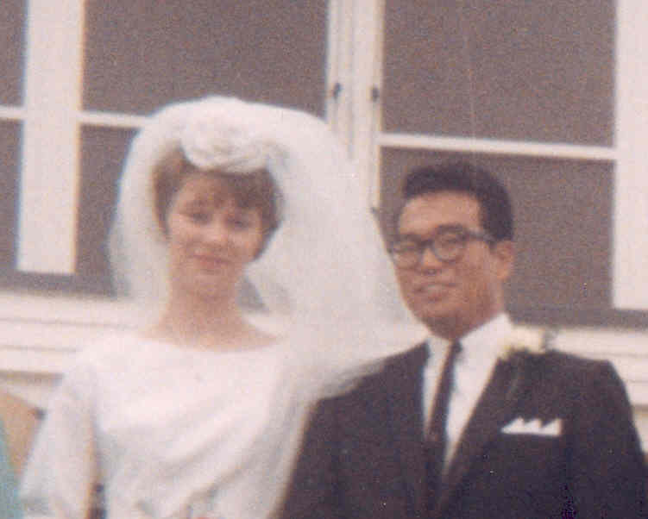
Whitehorse, Yukon in front of the RCAF Protestant Chapel. September 18, 1965. Gayle and Wray Tsuji

Tsujikawa (Surname / family name / 苗字 / 家族名)
Tamiko (Surayama) (First name / given name / 名前)
Year of birth / 生年: 1921

Ancestral History? 先代やあなたは日本のどこから来ましたか？
My parents are from Ehime-ken, Shikoku. Their home was in Lethbridge - visited us here but never resided in Edmonton.

When and why did you or your family come to Edmonton? いつ、どうしてエドモントンへ来ましたか？
Evacuated to Picture Butte, AB to work on a sugar beet farm, but father found employment at Broder's Cannery in Lethbridge; worked there till his retirement.

What were your major occupations in the past and major employers? あなたの仕事はなんですか？雇用主はどこですか？
Helped my husband's chicken hatchery in Athabasca, AB during Jan to March and worked as a fur finisher from April to December in Edmonton where we had our permanent residence.

In what ways has having Japanese heritage affected the course of your life or family history? あなたが日本人または日系人であることは、人生にどのような影響があったと思いますか？
Became prouder of my Japanese heritage and have more compassion and understanding towards other nationalities who are discriminated as we had been.

Additional history? 個人史・家族史
Married George Tsujikawa in Picture Butte. His uncle's family was also working in the sugar beet farm at Picture Butte. My husband was a "chick sexer" in Edmonton. First time we visited Japan was to accompany our son David to Tokyo to his dental convention there & to visit George's relatives in Shiga & my aunt in Osaka.

More detail submitted in addition to survey responses.

I was born in Cumberland on Vancouver Island B.C., on April 14, 1921. I had three siblings. My sister Hideko was born two years later in Cumberland and my two brothers, Masaaki (Mas) in 1925 and Masakazu (Harry) in 1927 were born in a little lumbering village about 50 miles south of Cumberland called Red Gap, Nanoose Bay on Vancouver Island. This is where I was raised for 14 years until I graduated from elementary school. Then I was sent to Vancouver where I had to go to Japanese Language School after high school classes ended for the day.
In 1908, my father, Wataru (Tom) Sarayama, immigrated to Canada when he was 13 years old, sponsored by his parents’ friend who owned a farm near Cumberland. My grandparents (father’s parents) immigrated to Canada much earlier. Perhaps they were one of the earlier immigrants to this area.
My father had to go to school until he was 16 years old, but because he had to start school from Grade 1 at age 13, he hated the fact that his schoolmates were just little kids. He had to live with his sponsor until he turned 18. He helped with the farm chores before going to school in the morning and always told us kids that we were very lucky that all we had to do was go to school and not worry about doing chores around the house. My father resolved to learn English as quickly as he could and became quite adept. However, because he always spoke to us in Japanese, it was many years before we knew that he could speak English. Dad loved cars and cameras, so he bought a motorcycle, then a car; this was very handy because he could drive to work.
Around 1924 or so, the coal mine where he was employed had a disastrous explosion and many miners were fatally injured and died and others suffered injuries but lived. My father was one of the few fortunate ones who escaped injury because he and a friend were working near the entrance of the mine and covering their heads with their shirts, crawled out without a scratch.
My father decided to find work elsewhere because he thought that coal mining was too dangerous for a father of two. He heard about a lumber mill a few miles from Parksville about 100 miles from Cumberland called Straits Lumber Company which was owned by an American. With a vehicle, he pulled finished lumber to the drying sheds. He was very lucky that he was able to speak English and was able to drive so he was spared the heavy labour of carrying lumber on his shoulder and stacking them in the drying sheds as most Japanese hands had to do. He must have had good mechanical skills because on the weekend he would often fix vehicles for the company.
This lumber was sold to domestic and foreign companies whose freight ships sailed into Nanoose bay. The longshoremen who were mostly native Indians stored the lumber in the ships’ holds. Sometimes, ships from Japan came for the lumber. Then the whole Japanese community would take potluck to the boarding house and treat these sailors to gochiso (Japanese treats).
The Japanese boarding house was an ideal place for parties and Japanese movies. The technician would use different voices to match the scenes in the silent movie. He was very good, so we thought at the time. He had lots of different gadgets to coincide with the action of sword fighting (there were many samurai movies), running footsteps, neighing of horses and water running. We had lots of fun!
In the late spring, pods of whales migrated into Nanoose Bay and spent about a week there. We’d know when they arrived because at sundown, we’d hear their whaling noises, maybe communicating with each other. We’d row out near them in our home-made row boats when our parents were absent. We stayed away from the big ones. They watched us with their big eyes but never harmed us. We’d row after the smaller ones when they swam around; they seemed to be playing with us. We were careful not to row too close to them but we were not scared at all. Much later, we learned that the smaller whales were killer whales from Alaska—then we were scared! Then some evening, the waters were quiet. We knew their visit was over and the whales had left us. We felt as though we had lost our good friends.
As children, we were very happy and kept busy. We went berry picking (blackberries, raspberries, wild strawberries) and in the fall we all went to hunt for matsutake (pine mushrooms). We went clam digging and fishing for perch and shiners (small replica of perch). Most of the families grew big gardens and raised chickens, so we had eggs.
For staples, the owner of the Red and White store came for orders each month. For produce, a nice Chinese man would stop with fresh loads of fruits and Chinese vegetables. For Japanese staples, a salesmen from Komura and Furuya, the Vancouver produce stores came to take orders. When the order arrived, we were in seventh heaven. We helped store all the items in the pantry and we looked forward to treats at 10:00 in the morning and 3:00 in the afternoon (my Mom, Misao’s, rule).
When I graduated grade 8, attending high school turned out to be a problem. The nearest high school was in Parksville about two miles away. Dad had decided to buy me a bicycle so that I could bike to school but the superintendent of our school warned my father that the discrimination in the Parksville area was very fierce. He advised Dad that if we had a relative in Vancouver, that I would be much happier there. So Dad asked his brother who owned a grocery store in Vancouver if he would have room for me. In those days most of the grocery store owners lived in the back of the store or upstairs. Most were just large enough for a bed and small kitchen. My parent and relatives decided that I’d dine with them but they would rent a room at the house of one of his friends for me to sleep and study.
King George High was only a block and a half away from my uncle’s store and three and a half blocks from the house where I rented a room. I did my own laundry and dried and ironed them at the store. For the first month or so, I cried in bed every night. I was only 15, still a child. After high school, I dashed to my uncle’s store, grabbed my Japanese schoolbook and rushed to catch the street car so that I would not be late for my Japanese classes. Fortunately, my mother taught us to read and write Japanese and we had to use Japanese at home so I was advanced to the equivalent of high school. These classes started around 6:00 p. m. so I was able to relax and enjoy the lessons.
The following year, my sister joined me. I suppose I was used to my routine by then but having company made a difference. It wasn’t too bad then. I guess for my aunt who was not used to having children around, much less two teenagers, it was getting too much for her to take. My uncle talked to Dad and discussed having Mom move to Vancouver and renting a room. In a few years, my brothers would be ready for high school too. He advised Dad that he would help locate an apartment for us. The apartment they found was on the second floor with a small kitchen, 2 bedrooms and a dining and living room combined. It was also very close to the Japanese language school. So there, Mother, 2 brothers, my sister and I lived until the war started.
After graduating from high school, I wanted to go into nursing but my mother dashed my hopes. She sent me to a sewing school. My sister would be sent to business school and she would save money and rent a storefront where she would start a dry cleaning store with me sewing dresses made-to-order and my sister would look after the expenses. That was my Mother’s plan but the war started and that ended her dream.
My father was ‘batching’ and sometimes dining at the boarding house. I’m sure he did not have it easy at all. During the summer holidays, I wanted to go to help Dad but Mother said that I had to earn some money to help with the upkeep of the apartment. Mother was working too, doing piece-work at a clothing factory. In the summer, I worked in the fish cannery and Japanese convenience store or bakery. In the winter holidays, I helped at the fish and grocery store owned by my future husband’s uncle.
One fall weekend, when the cannery work ended, I worked at a Japanese bakery, helping at the counter and also helping to make and bake some Japanese confections. Mother had taught me how to bake some of these pastries so the work was quite easy.
My father was sent to a road camp at Yellowhead. There, he learned that the whole family would be able to live and work together if we chose to work in the sugar beet fields in Alberta or Manitoba. Dad chose Alberta. On May 17, 1942, we arrived in Picture Butte to work in the beet fields. It was no picnic!
We learned that the Chaki family whose fish market I used to work at during the school holidays was just a farm away. George, their nephew visited them one summer and Mrs. Chaki reasoned that George at 30 was still single and it was about time he married and raised a family. Since she knew me, she and her husband came to ask for my hand for their nephew.
Of course Mom was all for it but Dad hung back. He told me that it’s my life so I should do what I want. That was fine with me. I didn’t want to marry a stranger. I used to see him now and then at his uncle’s store, and that’s all.
But Mom insisted—she told me I’d be a “うれのこり” (“urenokori”-a remnant) and no one would want to marry an old maid. She insisted I marry George. Finally I relented. We were married December 26, 1944 at the Buddhist Church in Picture Butte by Reverend Kawamura.
We came to Edmonton just before George’s chick sexing season was about to start—around the end of January. We raised 2 sons (David and Ron) and when my boys were older, I worked as a fur finisher in a dry cleaning and fur shop on 95th Street.
I’ve been living in Edmonton since 1944 with the exception of 13 years in Athabasca, when George bought a chicken hatchery and started a business of his own. However, we returned to Edmonton each year when the season ended, with the exception of the last few years when he sold the business and bought a mobile home where we lived for several years until George’s health started to deteriorate.
George died in his sleep of an aneurysm in an artery in his heart. For him it was a blessing to die so peacefully.
I carried on until six years ago, when David insisted that taking care of the house and yard was too much for me. In 2007, when I was 86 years old, I sold the house and moved into an adult apartment in Westmount. My pet cat that was my sole companion developed cancer in 2012 and it was a sad day for me when I had to put him down.
I developed AMD (Age-related Macular Degeneration) in the spring of 2014 but I’m being treated every 15 days and that seems to stay the progression of my disease. My sincere hope is that I’ll be gone to my other home before I go blind. In April 2016, I turned 95 but I still cook my own meals and have a small garden to look after on the apartment property. I’ve learned to love my apartment and my fellow tenants who are so good to me. And best of all, my church is within walking distance.
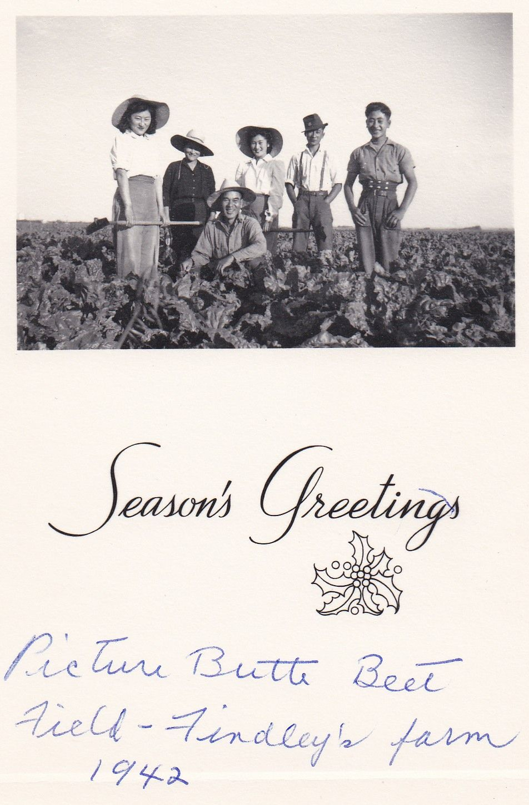
Tami's Family on the Sugar Beet Farm in Picture Butte 1942:
Back: Tami, Mother Hideko, Father Harry
Front: Mas

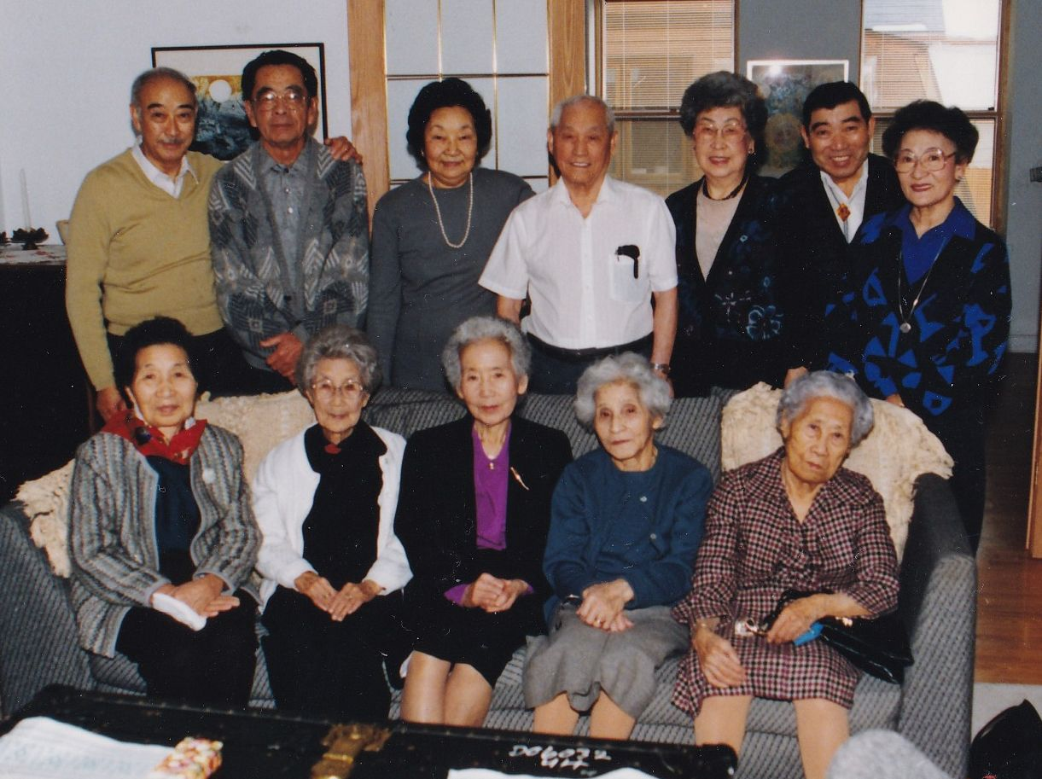
EJCA Seniors at the Murakami House in Nov.1991
Back: Mike Murakami, George Tsujikawa, Aiko Murakami, unknown, Kimiko Shimizu, George Nakamura, Tami Tsujikawa
Front: Mrs. Noborio, Mrs. Kiyooka, Mrs. Matsuba, Mrs. Sugimoto, Mrs. Yamauchi

Tsuruda (Surname / family name / 苗字 / 家族名)
Ruby Ikuto) (First name / given name / 名前)
Year of birth / 生年: 1927

Information submitted in lieu of survey responses.

Stories of Our Seniors 4: Ruby Ikuto Tsuruda (submitted by Cathy Tennant)

Ruby’s story is presented in the first person but has been edited from information provided by Ruby in her interview for the EJCA History Project and from other sources.

My father, Minekichi Kusunoki was from Hiroshima. After finishing high school he read about Canada so came here and became a fisherman. Before leaving Japan, my father who was divorced, sent his son to live with his younger brother. My mother, Kiyo (maiden name, Toyama) was divorced in Japan and had two children but because of the Japanese law in those days, she could not keep them
My parents were introduced to each other and I was born in Ocean Falls, B. C. on October 16,1927. I had two brothers. The brother next to me became sick so he was taken to Japan to see if the doctors there could help him but he died. I know the youngest brother was a baby when he died of pneumonia. My father was upset because he lost two sons. He went to Japan then returned to Canada and I was brought up as an only child.
My mother and I lived in Vancouver because I had to go to school and Wadhams B. C. (where we were) was a fishing village without a school. Around the time the war started, a boat fell on my father and he died due to the injury.
When the war broke out, my mother and I were evacuated to Hastings Park for a short time, then we were sent to Lemon Creek. After the war ended, we went by ship to Japan. We had the choice of going to easter Canada but since we didn’t know anyone there, my mother decided to go to Japan. But she realized it was a mistake. After the war, times were very hard in Japan, people were begging and there were many orphans. I met a Buddhist priest who spoke English and advised me to work for the US Army, so I worked for the Third Battalion until the Korean War started. Then I worked for the International Dairy and ate a quarter cup of ice cream every day for lunch (which was a luxury). I lived in a dormitory so when a group of work colleagues would get together to go to a restaurant for something like sukiyaki, I was hungry so I ate everything even though I missed things like steak and hotdogs.
While in Japan, I met George’s cousin, whom I knew when I was a little kid. She said, “Oh, there is a nice guy…. ”. But I didn’t meet George in Japan. It was not until I visited Montreal at the same time he was visiting his cousin that I got to know him.
In 1952 I left Japan and went to Windsor, Ontario because I had a friend there. My mother stayed in Japan until her death in 1962.
My husband George joined the air force as an aerospace engineer in 1952 and we lived in a number of places after we got married in France. We stayed there for 3 years; we also lived Cold Lake (where he became an officer) and Calgary. In 1972 when a mega station at Camp Iqluit was closed, we were given the choice of transferring to Toronto or Edmonton. We decided that with three children (Lorraine, Terese and Daniel) and Toronto being too big, we would move to Edmonton.
We first got involved with the Edmonton Japanese community after seeing a sign in a store that said “picnic” in Japanese writing. George said “let’s go” so we went and I got to know other Nisei. George became the President of the community association three times and was president when the new community centre (current EJCA centre) was built.
In 1973 I found a job with Canadian Utilities which became Atco Electric and retired from there in 1992. In 1993 George and I went to Japan to visit his brother who he hadn’t seen for 40 years.

Addendum:
Ruby passed away peacefully in her sleep at the age of 87 years old in July, 2015. She actively volunteered for the Catholic Women's League, the Northgate Senior Centre, the Edmonton Japanese Community Association and the EJCA Seniors Club where she generously donated her skills and time. She was a dedicated and hard-working help-mate to her husband George when he carried out his duties on the EJCA Board and with the EJCA activities.
Ruby loved to learn and studied Spanish and German. She took computer courses, clogging and exercise classes. A loving wife, mother, grandmother and friend, Ruby will be missed for her wonderful sense of humour, lovely smile, gentle spirit, grace and style.

シニアー会員の物語 ４： ルビー・イツコ・ツルダ (キャシー・テナント)

ルビー・イツコ・ツルダさんの話は一人称で書いてありますが、これはＥＪＣＡの歴史プロジェクトの一つとしてルビーさんとインタビューした時の記録とその他の資料をキャシー・テナントがまとめた記事です。

私の父、楠峰吉は広島県の出身です。高校を終了してから、カナダのことを読みカナダに来ました。カナダに来てからは漁師として働きました。峰吉は日本で結婚し、子供をもうけましたが、離婚して、この子を弟に預けました。私の母、キヨ（結婚前の姓は富山）も離婚していて子供が二人ありましたが、子供を手元に置いておけませんでした。

峰吉とキヨは結婚して、私はブリティッシュ・コロンビア州のオーシャンフォールズで１９２７年１０月１６日に生まれました。私には二人弟がいましが、直ぐ下の弟は病気になり、父が日本につれて行って医者に見せましたが亡くなりました。またその下の弟はまだ赤ん坊の時に肺炎で亡くなりました。父は大変がっかりして、一度日本に戻りましたが、またカナダに帰ってきました。わたしは両親のただ一人の子供として育ちました。

父が漁師をしていたブリティッシュ・コロンビア州のワドハムは小さな漁師町で学校がありませんでしたので、母は私を連れてバンクーバーに来ました。ちょうどこの頃太平洋戦争が始まりました。父は事故でボートの下敷きになり、これがもとで亡くなりました。戦争が始まるとともに、母と私はヘースティング・パークに収容され、それからレモン・クリークに強制移動させられました。戦争終了とともに母は私を連れて日本に帰ることを選びました。

しかし、日本に戻ると母はこの選択が間違っていたことに気づきます。戦後の日本は貧しく町には物乞いをする人と孤児があふれていました。私は英語が話せるお坊さんから、米国軍隊で働くように勧められました。そして朝鮮戦争が始まるまで米国陸軍第三大隊で働きました。その後は国際乳業という会社で働き、毎日お昼にアイスクリームを食べたのを覚えています。私は会社の寮に住んでいたので、いつもお腹が空いていました。同僚とレストランに行くと出されたものを全部食べました。スキヤキなども食べましたが、カナダで食べたステーキやホットドッグを食べたかったです。

日本で、後で私の夫になるジョージ・ツルダの従姉妹に会いました。彼女は、私がカナダでまだ子供のころに知っていました。彼女は「実はいい人がいるんだけれど」とジョージのことを教えてくれましたが（当時ジョージも日本にいました）、日本ではジョージに会う機会はありませんでした。わたしがモントリオールに旅行したときにたまたまジョージもモントリオールに従姉妹を訪ねに来ていて、私と会いました。

私は１９５２年に日本を離れオンタリオ州ウィンザーに来ました。私の友達がウィンザーにいたからです。母は一人で日本に残り、日本で１９６２年に亡くなりました。ジョージは１９５２年にカナダ空軍にエンジニアーとして入隊しました。私たちはジョージがカナダ空軍のフランスの基地にいるときに結婚し、フランスに三年住みました。ジョージはカナダ空軍基地を移動するので、私たちはアルバータ州コールドレーク、キャルガリーにも住みました。１９７２年ジョージが当時いた基地が閉鎖されるときにトロントかエドモントンに移動する選択がありました。すでに三人子供がいたので、子供を育てるにはトロントは大きすぎると考えて、エドモントンに行くことにしました。

エドモントンの日本レストランでＥＪＣＡのピクニックのポスターを見て、日系二世の人に会いたくなりピクニックに参加したのが私たちとＥＪＣＡの関係の始りです。その後私たちはＥＪＣＡの行事や仕事に積極的に参加するようになり、結局ジョージは三回会長になりました。ＥＪＣＡセンターの建設の時も会長として尽力しました。私は１９７３年にカナディアン・ユーティリティーズ（後にアトコ電力になります）に就職して１９９２年に退職しました。１９９３年に私とジョージは一緒に日本を訪問して、日本に残って生活していたジョージの弟と４０年ぶりに再会しました。

補足

ルビーさんは２０１５年７月に８７才で安らかに永眠いたしました。ルビーさんはボランティア活動に積極的に参加しました。またジョージを助けてＥＪＣＡの活動にたくさん参加しました。いろいろと新しいことを学習することも好きで、スペイン語、ドイツ語、コンピュータ、フィットネスと幅広く学んでいました。ルビーさんのご冥福をお祈りします。

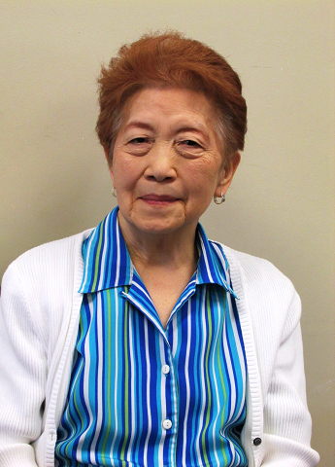
Ruby Tsuruda [date unknown]

Turnbull (Surname / family name / 苗字 / 家族名)
Margene (First name / given name / 名前)
Year of birth / 生年: 1947

Ancestral History? 先代やあなたは日本のどこから来ましたか？
Lethbridge, AB. Mission, BC & Vernon, BC. Fukuoka, Japan. Kumamoto, Japan

When and why did you or your family come to Edmonton? いつ、どうしてエドモントンへ来ましたか？
University

What were your major occupations in the past and major employers? あなたの仕事はなんですか？雇用主はどこですか？
Teaching, Farm wife, Potter

Turnbull (nee Matsunaga) (Surname / family name / 苗字 / 家族名)
Kaoru Kathleen "Kathy" (First name / given name / 名前)
Year of birth / 生年: 1945

Ancestral History? 先代やあなたは日本のどこから来ましたか？
Kuushui Fukuoka ken (mother's family) and Kumamoto-ken (father). B. C. Mother - Mission, BC. Father - Vancouver and area, and Vernon. Picture Butte/Turin area; Lethbridge and Edmonton. Regina and Kingston. Edmonton.

When and why did you or your family come to Edmonton? いつ、どうしてエドモントンへ来ましたか？
1963 (Fall) to study at U of A [Alberta] (Hospital, Pharmacy specialty). 1987 work opportunities for both spouse and myself; educational opportunities for children;; proximity to aging parents in Alberta and other relations

What were your major occupations in the past and major employers? あなたの仕事はなんですか？雇用主はどこですか？
Hospital pharmacist: 1988-2005 Grey Nuns, Edmonton; 1985-87 Regina hospitals; 1984-85 Hospital in Kingston, ON; 1969-84 Regina Hospitals; 1967-69 U of A Hospital.

In what ways has having Japanese heritage affected the course of your life or family history? あなたが日本人または日系人であることは、人生にどのような影響があったと思いますか？
1) Inter-racial marriage - appreciating cultural difference of Japanese-Canadian and English-Canadian heritage. 2) Raising children in inter-racial family environment to appreciate and learn the history of struggles of both Issei and Nisei pre- and post-WWI, depression and pre- and post-WWII as well during both wartimes in C Canada and Japan; i. e. , the lives of parents, grandparents and their family. 3) Incentive to learn the Japanese language to communicate and visit with relatives in Japan. This is ongoing and continues. 4) Incentive to document genealogy of both paternal and maternal families in North America, South America, and Japan for our children and grandchildren. 5) Incentive to continue regular extended family reunions in both Canada and in Japan for our children, and grandchildren re Canadian multicultural heritage.

Additional history? 個人史・家族史
Both paternal grandfather (1907) and father (1927) immigrated to Canada for economic opportunities (and alternative lifestyle from Japan. ) Both maternal grand father (1902) and grandmother (1912) immigrated to Canada for economic opportunities and interned to southern Alberta because of WW II.

Ueda, 上田, ウエダ (Surname / family name / 苗字 / 家族名)
Mayumi, 麻友美, マユミ (First name / given name / 名前)
Year of birth / 生年: 1975

Ancestral History? 先代やあなたは日本のどこから来ましたか？
奈良市内 [Translation] Nara-ken, Nara-shi

When and why did you or your family come to Edmonton? いつ、どうしてエドモントンへ来ましたか？
1996年、父の意向で交換留学生として渡加しました。
1998年にアルバイト先で華僑である主人と出合い結婚し移民として住むようになりました。
[Translation] In 1996, I visited Canada as an exchange student which was my father's idea. In 1998, I met my husband who is a Chinese living in Canada and had a part-time job. I married him and immigrated.

What were your major occupations in the past and major employers? あなたの仕事はなんですか？雇用主はどこですか？
Japanese Village
The ART WORKS
123rd ST Liquor Store
SANKYU Japanese Restaurant
OHGIYA Ltd

Umeda, 梅田 (Surname / family name / 苗字 / 家族名)
Mitsue, 光枝 (First name / given name / 名前)
Year of birth / 生年: 1966

Ancestral History? 先代やあなたは日本のどこから来ましたか？
名古屋出身. カルガリーに一年住んでいた
[Translation] Aichi-ken, Nagoya-shi; lived in Calgary for one year

When and why did you or your family come to Edmonton? いつ、どうしてエドモントンへ来ましたか？
2012年, 夫の仕事にともないエドモントンへ来た
[Translation] 2012, Came to Edmonton because of my husband's job

In what ways has having Japanese heritage affected the course of your life or family history? あなたが日本人または日系人であることは、人生にどのような影響があったと思いますか？
自身のアイデンティティーを形成した
[Translation] Confirmed my own identity.

Additional history? 個人史・家族史
カナダ人である夫と結婚したため。
[Translation] Because I married a Canadian

Umeda, 梅田 (Surname / family name / 苗字 / 家族名)
多敏 (First name / given name / 名前)
Year of birth / 生年: 2004

Ancestral History? 先代やあなたは日本のどこから来ましたか？
名古屋. カルガリー. [Translation] Nagoya [city], Calgary

When and why did you or your family come to Edmonton? いつ、どうしてエドモントンへ来ましたか？
父親の仕事で. [Translation] Father's job

What were your major occupations in the past and major employers? あなたの仕事はなんですか？雇用主はどこですか？
小学生. [Translation] Student

In what ways has having Japanese heritage affected the course of your life or family history? あなたが日本人または日系人であることは、人生にどのような影響があったと思いますか？
まだ小学生だからこれから影響が出てくると思われます。
[Translation] I am still an elementary school student so any influences will be seen in the future.

Umeda, 梅田,ウメダ (Surname / family name / 苗字 / 家族名)
Waka, 和加, ワカ (First name / given name / 名前)
Year of birth / 生年: 2002

Ancestral History? 先代やあなたは日本のどこから来ましたか？
名古屋 [Translation] Nagoya-shi

When and why did you or your family come to Edmonton? いつ、どうしてエドモントンへ来ましたか？
2012年 父の仕事で
[Translation] Came in 2012 for father’s job.

Van, 文, ヴァン (Surname / family name / 苗字 / 家族名)
Ryusei Jadian, 隆誠 ジェイディアン, リュウセイ (First name / given name / 名前)
Year of birth / 生年: 2000

Ancestral History? 先代やあなたは日本のどこから来ましたか？
名古屋、ジャスパー. [Translation] Nagoya-shi, Jasper Alberta

When and why did you or your family come to Edmonton? いつ、どうしてエドモントンへ来ましたか？
父の仕事が変わったため. [Translation] For a change in my father's work

What were your major occupations in the past and major employers? あなたの仕事はなんですか？雇用主はどこですか？
学生 [Translation] student

In what ways has having Japanese heritage affected the course of your life or family history? あなたが日本人または日系人であることは、人生にどのような影響があったと思いますか？
ゲーム、アニメ、電化製品など世界に誇れるものが沢山あるので、自慢できる。
[Translation] I feel proud that Japan makes many world-famous products areas as games, animes, and electronics.

Additional history? 個人史・家族史
日本には、祖母をはじめ、友達もいるので会いに行くのが楽しみ
[Translation] I look forward to going to Japan to see my grandmother and friends

Van, 文, ヴァン (Surname / family name / 苗字 / 家族名)
Yuhi, Jasper, 勇飛・ジャスパー, ユウヒ・ジャスパー (First name / given name / 名前)
Year of birth / 生年: 1998

Ancestral History? 先代やあなたは日本のどこから来ましたか？
名古屋; ジャスパー. [Translation] Nagoya; Jasper Alberta

When and why did you or your family come to Edmonton? いつ、どうしてエドモントンへ来ましたか？
５歳の時 父親の仕事が変わったから. [Translation] When I was 5, my father changed jobs.

In what ways has having Japanese heritage affected the course of your life or family history? あなたが日本人または日系人であることは、人生にどのような影響があったと思いますか？
日本人の国民性に誇りが持てるので、堂々と僕は日系カナダ人ですということができること。
[Translation] I confidently say I am a Japanese-Canadian because I am proud of the Japanese national character.

Additional history? 個人史・家族史
日本には、友達や祖母などが住んでいるので、会いに行きます。
[Translation] I visit Japan to see my grandmother and others who live there.

Van, 文, ヴァン (Surname / family name / 苗字 / 家族名)
Shoui, Jettrams, 翔智 ショウイ, ジェットラムズ (First name / given name / 名前)
Year of birth / 生年: 2004

Ancestral History? 先代やあなたは日本のどこから来ましたか？
名古屋. [Translation] Nagoya

When and why did you or your family come to Edmonton? いつ、どうしてエドモントンへ来ましたか？
父の仕事が変わったため
[Translation] I came to Edmonton because of a change in my father's work.

In what ways has having Japanese heritage affected the course of your life or family history? あなたが日本人または日系人であることは、人生にどのような影響があったと思いますか？
漢字が難しくて覚えられないので、日本語学校に行くのが嫌になるけど、英語の学校の友達に日本語を教えられるので、うれしい。
[Translation] I don’t like going to Japanese school much anymore because kanji is difficult and hard to remember but I am happy that I can teach Japanese to my Canadian school friends.

Additional history? 個人史・家族史
日本の食べ物のは美味しいから日本に行くのが楽しみ
[Translation] I look forward to going to Japan because Japanese food is delicious.

Wagoner (Surname / family name / 苗字 / 家族名)
Christine (First name / given name / 名前)
Year of birth / 生年: 1975

Ancestral History? 先代やあなたは日本のどこから来ましたか？
Whitehorse, Yukon. Great grandparents born in Japan then came to Canada. Grandma born and lived in BC until war then Toronto and then Calgary. My mother was born in Calgary. I was born in Whitehorse.

When and why did you or your family come to Edmonton? いつ、どうしてエドモントンへ来ましたか？
University of Alberta. My mother and sister attended U of A as well.

What were your major occupations in the past and major employers? あなたの仕事はなんですか？雇用主はどこですか？
Alberta Health
Alberta Children's Services
Alberta Cancer Board
Alberta Health Services

In what ways has having Japanese heritage affected the course of your life or family history? あなたが日本人または日系人であることは、人生にどのような影響があったと思いますか？
The war impacted our family as they took away property and family was dispersed. I lived far away from any Japanese relatives and there was no Japanese community where I grew up.

Additional history? 個人史・家族史
I would love to visit Japan one day and learn more about Japanese culture.

Waida, 和井田, ワイダ (Surname / family name / 苗字 / 家族名)
Kyoko, 京子, キョーコ (First name / given name / 名前)
Year of birth / 生年: 1940

Ancestral History? 先代やあなたは日本のどこから来ましたか？
ハリファックス（ノヴァスコーシャ）[Translation] Halifax, Nova Scotia

When and why did you or your family come to Edmonton? いつ、どうしてエドモントンへ来ましたか？
夫が大学（アルバータ）に就職のため
[Translation] My husband got a job at the University of Alberta

What were your major occupations in the past and major employers? あなたの仕事はなんですか？雇用主はどこですか？
教稚園教師、日本語学校教師, 大学エクステンション日本語教師
[Translation] Kindergarten teacher, teacher in a Japanese school, Japanese language instructor in the Faculty of Extension.

Additional history? 個人史・家族史
夫がアルバータ大学に就職のため家族でエドモントンに来ました。
[Translation] My family came to Edmonton because my husband got a job at the Univ. of Alberta.

More detailed response submitted by individual in addition to survey responses

和井田京子 家族史
1967年9月、私は、1才3ヵ月の長女永子とともにアンカレッジ経由の飛行機で、シカゴのオヘア空港に到着いたしました。一年前に、シカゴ大学大学院 Divinity schoolに留学していた夫が、空港に出迎えてくれ、私達のシカゴでの生活が始まりました。
ベビー用品及び家具の一切を夫が整えてくれていたおかげで、私は、何の苦労もせず、学生にしては経済的にも恵まれ、初めての異国の生活をスタートしたのです。ただ、当時シカゴ大学の辺りは、治安が悪く、夕暮れになると外出はできなくなり、理由無くナイフを突きつけられたり、大学キャンパスの中で、学生が殺されるというショッキングなニュースもあり不安でした。

1969年、次女令子が大学病院で生まれました。夫はPhDのキャンディデットになれば、日本の大学に帰る予定で留学していましたが、当時日本の大学は学園紛争が巻き起こり、バリケードだ、機動隊が入ったとかのニュースを頻繁に聞くようになります。夫の大学もまともに授業の行える状態ではありませんでした。今日本に帰っても論文など書ける状況ではないので、当分こちらで就職をして、論文を書き上げては、という神学部長のお勧めもあり、幸い、カナダのハリファックスに仕事が決まり、カナダに移住することになったのです。

1970年、ハリファックスでの生活が始まります。
何が嬉しかったかといって、夜も外を歩くことが出来るということでした。星空を見上げながら、勢いよくはねる公園の噴水を仰ぎ、心の底から深呼吸をした日のことが想い出されます。夫は初めての授業の準備に加えて、博士論文を仕上げることになり、この頃のことを「四つんばいになっての生活だった」と当時をふり返っています。

博士号を修得した後、アメリカのローチェスター大学からの招きで、ビジティング・プロフェッサーとしておもむくことになり、家族４人で雪の多いローチェスター市で過ごしました。
夫はローチェスターに滞在中、突然アルバータ大学比較宗教学部より誘いがありました。最初はお断りしていたものの、大学の図書の冊数が多いということにひかれアルバータ大学に移る決心をしました。

1974年からエドモントンでの生活が始まりました。
子供の教育について、夫は、自分は日本人として子供を育てたい、そのためには日本語を家庭で使用することを主張していました。日本とカナダとそれぞれの良いところを考えて伝えていくなどという器用なことは出来ないからとも言っていました。幸いなことに、エドモントンに有志の方の努力で、1977年に日本語補習校が開校。すぐに二人娘を入学させました。
暫くして、私も日本語学校の教師をするようになり、体力的にも元気であった40代を日本語学校とともに歩みました。
1977年長男益実の誕生
今まで夫は子供の育児には殆どかかわっていませんでしたが、というより、自分の生活が多忙で、かかわるゆとりが無かったというのが本当のところです。しかしこの頃には学究生活にも少しゆとりが出来、益実の育児には、はじめて協力してくれました。

1978年、夫のサバティカルの年、家族5人でイタリアのローマに1年間滞在しました。娘2人は、カナダの通信教育を受け、現地の学校にも通わせました。夫は時間を見つけては、バチカンの図書館に通ったり、ローマ近辺の教会や、遺跡を訪ねてよく外に出かけました。私も、今までとは違った文化にふれ、息子をストローラーに乗せ、よく市バスを利用して、町全体が遺跡のようなところを興味深く廻りました。休日は、（時には娘達の学校を休ませて）頻繁に小旅行をいたしました。
エドモントンに帰ってからは、また日本語学校の教師を続けました。当時は、学校所有のコピー機もありませんでしたので、宿題は手書きで自分で作り、毎週ダウンタウンのコピー屋さんまで車を運転していったことなど懐かしく思い出します。

1995年の5月に、夫は父の葬儀のために日本にいて、「くも膜下出血」で倒れました。日本から連絡があった時は、かなり重症で助からないかも知れないということでしたので、子供達も全員その覚悟で日本へおもむきました。よい救急医療センターに運んでもらったことが幸いして、幾度かの危機も乗り越え、9月には飛行機に乗せて連れて帰ることが出来ました。夫をストレッチャーに寝かせ、幾席もの飛行機の座席を倒し、小児科医の長女永子に付き添ってもらい、無事エドモントンへ帰りました。

その頃アルバータの医療システムは、大きく変わり、多くいの患者にとっては最悪の時で、夫の医療中も様々なことが起こり、日本で順調に回復していたものも、あまりよい方向に向かいませんでした。ベッドから落ちたことで、又、頭の手術をしたり、早朝、看護師がベッドを起こさないまま食事(胃ろう)を与えて、無熱性肺炎を起こし、ICUに運ばれるということもありました。

2000年、夫がなくなるまで、私は5年間介護に専念しました。この5年間は、精神的にも体力的にも厳しいものでしたが、いつも忙しかった夫とゆっくり二人の時間が持てたのもこの時で、私達にとっても大切な時間でした。

エドモントンに住んで40年になります。子供達は、それぞれBC州、ドゥバイ、ダラスに移り住み、皆エドモントンを出てしまいました。
私のとって、ここエドモントンは、第二の故郷（ふるさと）となりました。良き友に恵まれ、この街からは抜け出せそうにありません。

[Translation to English] Kyoko Waida - Family History

In September 1967, I arrived at Chicago O’Hare International Airport via Anchorage with our 15-month-old daughter, Eiko. My husband, who had left from Japan a year ago to study at the University of Chicago Divinity School, welcomed us at the airport and so began our new life in Chicago.
Thanks to my husband preparing living necessities such as baby supplies and furniture, we were able to start our life in a foreign country without much difficulty and lived quite comfortably even considering that my husband was a graduate student. However, at that time, the area around the university was considered to be unsafe and we did not want to risk going out after dusk and being attacked with knife for no reason. It made me uneasy to hear that a student was murdered on campus.
Our second daughter, Reiko, was born at the university hospital in 1969. My husband planned to study here until becoming a PhD candidate and was going to go back to his former university in Japan afterwards. However, back home in Japan, there were many riots occurring on many university campuses. Students where barricading and riot squads were being dispatched. My husband’s university was in the same situation and it would not be possible for him to teach nor write his thesis in Japan. The director at the Chicago Divinity School advised my husband to find a job outside Japan for the time being, and continue working on his thesis. Luckily, he found a job in Halifax, Canada.
Our life in Halifax started in 1970. I was happy to be able to go outside at night and feel safe again. I still reminisce about taking a deep breath as I looked up at the stars and watched the splashing of the water fountain in the park. On the other hand, when my husband thinks back to living in Halifax, he only recalls a very hard and busy life as he prepared for his first classes and finished his thesis.
After acquiring his PhD degree, he was invited to go to the University of Rochester in the U. S. as a visiting professor. While we were all living in the snowy city of Rochester, my husband received an unexpected invitation from the Department of Comparative Religion at the University of Alberta. Initially, he wanted to decline the offer but he was so captivated by the vast number of books in its library that he decided to move to the University of Alberta.

Our life in Edmonton started in 1974.
My husband wished he could raise our children as both Japanese and Canadian, but did not feel he would be able to do so adequately. Therefore, we chose to have our children speak Japanese and practice Japanese culture at home. Luckily, thanks to the efforts of volunteers, the Metro Edmonton Japanese Community School was opened in 1976 and we enrolled our two daughters immediately. Later, I began teaching at the Metro Edmonton Japanese Community School and kept pace with the school in my 40’s.
Up until our first son was born in 1977, my husband was not very involved in child care. Though, to be fair, he had no time to spare because of his work. His academic life eventually started to slow down, and he was able to participate in Masumi’s child care.
During his sabbatical in 1978, our family chose to live in Rome for a year. Our two daughters took distance learning from Canada and attended a local school. My husband often found the time to visit the library in the Vatican, as well as churches and archeological sites around Rome. I, too, ventured around town by using city buses, with my son in his stroller. The whole city looked like an archeological site. We could not miss out on this special life experience, so on holidays and even some school days, we would go on family excursions in and around the area.
When we came back to Edmonton, I continued to work as a teacher at the Metro Edmonton Japanese Community School. I fondly remember the days when we teachers had to write out homework assignment sheets by hand and then drive downtown to photocopy them because we didn’t have a school copying machine.
In May1995, my husband travelled to Japan to attend his father’s funeral. While he was there, he suffered a subarachnoid hemorrhage. I received a phone call and was told that his condition was quite serious and he might not make it. My children and I prepared for the worst and went to Japan. Fortunately, my husband had been taken to a very good emergency treatment centre and was able to overcome several crises. In September, he was allowed to fly home to Edmonton. We had him lay down on the plane by laying many seats flat and our daughter, who was a pediatrician by this time, tended to him during the flight.
Alberta’s health care system underwent a significant change for the worse in the 1990’s and patients, including my husband, were negatively affected. My husband was recovering well in Japan, but upon returning home he did not fare so well in the hospital. First, he had to have a second head operation because he had fallen out of a hospital bed. In another incident, he was sent to the ICU for aspiration pneumonia that was caused by the nurse not raising the head of his bed while he was receiving food through his gastrostomy tube.
I concentrated on taking care of my husband for 5 years until he passed away in 2000. It was very hard for me mentally and physically; but at the same time, I was able to spend time with my husband who used to be so busy. It was very important for both of us.
I have been living in Edmonton for 40 years now and it has become my second home. Though my three children have moved away and are now living in BC, Dubai and Dallas, I am blessed with good friends and I plan to stay here for good.

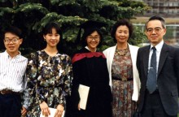Waida family: From left - Masumi (son), Reiko (daughter), Eiko (daughter), Kyoko, Manabu

Watanabe, 渡辺 (Surname / family name / 苗字 / 家族名)
Kyoko, 京子 (First name / given name / 名前)
Year of birth / 生年: 1959

Ancestral History? 先代やあなたは日本のどこから来ましたか？
愛媛 [Translation] Ehime-ken

When and why did you or your family come to Edmonton? いつ、どうしてエドモントンへ来ましたか？
夫の仕事 [Translation] My husband's job.

What were your major occupations in the past and major employers? あなたの仕事はなんですか？雇用主はどこですか？
コンピュータープログラマー [Translation] Computer programmer.

In what ways has having Japanese heritage affected the course of your life or family history? あなたが日本人または日系人であることは、人生にどのような影響があったと思いますか？
よかった [Translation] It has been positive.

Additional history? 個人史・家族史
夫の仕事のため、エドモントンに来ました。日本には両親がおり、毎年、帰ります。
[Translation] Came to Edmonton for my husband's job. Go home to Japan every year because my parents live there.

Wong (Surname / family name / 苗字 / 家族名)
Peter (First name / given name / 名前)
Year of birth / 生年: 1950

Ancestral History? 先代やあなたは日本のどこから来ましたか？
Married Japanese girl from Montreal. Her parents came from Vancouver prior to war-time.

When and why did you or your family come to Edmonton? いつ、どうしてエドモントンへ来ましたか？
We moved from Calgary to Edmonton when I got a transfer to a better job with the Alberta provincial government in 1981.

What were your major occupations in the past and major employers? あなたの仕事はなんですか？雇用主はどこですか？
Assistant manager, Motor Vehicles Branch in Calgary.
Special Projects Coordinator, Solicitor General, MVD in Edmonton.
Research Officer, MVD, Solicitor General (Edmonton)
Operational Development Team, MOVES.
Senior Research Officer, Transportation.
Semi-retirement.

In what ways has having Japanese heritage affected the course of your life or family history? あなたが日本人または日系人であることは、人生にどのような影響があったと思いますか？
Enjoy the food & company at family gatherings. Learn more about my wife's family in my later years.

Additional history? 個人史・家族史
Neither of us nor our three sons have never visited Japan (yet?).

Wong, 黄, ウォン (Surname / family name / 苗字 / 家族名)
Yoko, 庸子, ヨウコ (First name / given name / 名前)
Year of birth / 生年: 1941

Ancestral History? 先代やあなたは日本のどこから来ましたか？
長野県松本市. [Translation] Nagano-ken, Matsumoto-shi

When and why did you or your family come to Edmonton? いつ、どうしてエドモントンへ来ましたか？
1965, I came to Edmonton to teach violin to 40 young children. I was invited by the "Society for Talent Education. "

What were your major occupations in the past and major employers? あなたの仕事はなんですか？雇用主はどこですか？
Violinist

In what ways has having Japanese heritage affected the course of your life or family history? あなたが日本人または日系人であることは、人生にどのような影響があったと思いますか？
日本人であることは大変誇りであるとともに多くの日本に住んだ時代の記憶が今の私を支えてくれています。それらをベースにカナダおよび友人、知人を通して私の一部となった他文化が私の人生を豊かなものにしてくれました。
[Translation] A strong pride in being Japanese as well as many memories of when I lived in Japan have helped form who I am today. With that base, the other cultures I’ve come to know through friends and acquaintances have all enriched my life.

Additional history? 個人史・家族史
1965年７月にSociety for Talent Educationの招きで鈴木慎一氏の才能教育の方法でエドモントンの幼児40人にバイオリンの指導をするためカナダに来ました。
１年間の契約でしたが、始めたばかりの仕事の成果を見届けたく滞在を延期し、家庭を持ったため個人の教室で継続し、合計４０年に渡ってバイオリン教師を続けました。
[Translation] In July 1965, I was invited by the "Society for Talent Education" to teach violin to 40 young children in Edmonton based on the talent-development method of Shinichi Suzuki. Although the contract was for one year, I decided to stay longer to see the results of my teaching. Because I got married and started a family here, I started teaching on my own; 40 years have now passed with me continuing to teach violin.

Wong, 黄, ウォン (Surname / family name / 苗字 / 家族名)
Leo, レオ (First name / given name / 名前)
Year of birth / 生年: 1971

Ancestral History? 先代やあなたは日本のどこから来ましたか？
Mother came to Edmonton from Nagano, Japan. I was born in Edmonton.

When and why did you or your family come to Edmonton? いつ、どうしてエドモントンへ来ましたか？
Born in Edmonton

What were your major occupations in the past and major employers? あなたの仕事はなんですか？雇用主はどこですか？
I have worked as a volunteer for many organizations as office assistant.

In what ways has having Japanese heritage affected the course of your life or family history? あなたが日本人または日系人であることは、人生にどのような影響があったと思いますか？
I like Japanese food and enjoy making dishes with my mother.

Additional history? 個人史・家族史
I was born in Edmonton in 1971. My parents and my sister lived together just as other families, but only difference is that I am a person with Down’s Syndrome. I do need a little more care and assistance than other 42 year olds. However, I do help my aging parents in many ways, as well.

Wong, 黄, オウ (Surname / family name / 苗字 / 家族名)
Ryotaro, 諒太郎, リョウタロウ (First name / given name / 名前)
Year of birth / 生年: 2003

Ancestral History? 先代やあなたは日本のどこから来ましたか？
奈良県奈良市 [Translation] Nara-ken,Nara-shi

When and why did you or your family come to Edmonton? いつ、どうしてエドモントンへ来ましたか？
エドモントン生まれ [Translation] Born in Edmonton

What were your major occupations in the past and major employers? あなたの仕事はなんですか？雇用主はどこですか？
学生 [Translation] Student

Wong, 黄, オウ (Surname / family name / 苗字 / 家族名)
Sachiyo, 咲千代, サチヨ (First name / given name / 名前)
Year of birth / 生年: 2010

Ancestral History? 先代やあなたは日本のどこから来ましたか？
奈良市 [Translation] Nara-shi

When and why did you or your family come to Edmonton? いつ、どうしてエドモントンへ来ましたか？
エドモントン生まれ [Translation] Born in Edmonton

Wong, 黄, オウ (Surname / family name / 苗字 / 家族名)
Genjiro, 源次郎, ゲンジロウ (First name / given name / 名前)
Year of birth / 生年: 2007

Ancestral History? 先代やあなたは日本のどこから来ましたか？
奈良市 [Translation] Nara-shi

When and why did you or your family come to Edmonton? いつ、どうしてエドモントンへ来ましたか？
エドモントン生まれ. [Translation] Born in Edmonton

Yamada (Surname / family name / 苗字 / 家族名)
Hiroshi (First name / given name / 名前)
Year of birth / 生年: 1922

Ancestral History? 先代やあなたは日本のどこから来ましたか？
My family still lives in Hiroshima, Japan. My father homesteaded in Revelstoke, then Mission, BC, then returned to Japan in 1930. I was born in Revelstoke, moved to Hiroshima at age 8, returned to Canada (BC) at 16. Interned during the war in Northern Ontario. Moved to Toronto after the war.
Moved to Edmonton in 1982.

When and why did you or your family come to Edmonton? いつ、どうしてエドモントンへ来ましたか？
Took retirement at age 60 and moved with my wife, Mitsuko, to be with my daughter's family and just-born granddaughter, Chantal. Worked in the family business in Edmonton, La Boehme Restaurant, Bed & Breakfast.

What were your major occupations in the past and major employers? あなたの仕事はなんですか？雇用主はどこですか？
Pattern maker & fabric cutter in Toronto for everything from slippers, bras, ironing board covers, oven mitts, leather goods, etc. I was given a sample and had to make a pattern and figure out how to cut the fabric to make the most use of it. I supervised and trained the women who sewed the goods.
In Edmonton I was the janitor, handyman, jack of all trades for my daughter's restaurant and bed & breakfast, La Boehme.

In what ways has having Japanese heritage affected the course of your life or family history? あなたが日本人または日系人であることは、人生にどのような影響があったと思いますか？
Moving to Edmonton was the first time away from lifetime Japanese-Canadian friends, family and strong community ties in Toronto. My Edmonton life was busy helping my daughter and her business and spending time with my granddaughter. I did participate in some activities offered by EJCA and enjoyed very much the annual karaoke concert.

Yamada (Surname / family name / 苗字 / 家族名)
Mitsuko (First name / given name / 名前)
Year of birth / 生年: 1922

Ancestral History? 先代やあなたは日本のどこから来ましたか？
Shimane-ken. Father's family is from Kuromatsu, Shimane-ken.

When and why did you or your family come to Edmonton? いつ、どうしてエドモントンへ来ましたか？
Please refer to questionnaires from Carole Eder and Hiroshi Yamada for more info. Moved to Edmonton from Toronto in 1982 to be with my daughter, her family and newly born granddaughter.

What were your major occupations in the past and major employers? あなたの仕事はなんですか？雇用主はどこですか？
Bookkeeper for Govt of Ontario, Toronto
Bookkeeper for La Boehme Restaurant, Edmonton

In what ways has having Japanese heritage affected the course of your life or family history? あなたが日本人または日系人であることは、人生にどのような影響があったと思いますか？
Interned during WWII in Lemon Creek, BC. (David Suzuki's family was interned in the same camp). First JC family to move east to Ontario (Leamington, Ont. ). Settled in Toronto and family was one of the original members of JCCC.

Additional history? 個人史・家族史
See entries from Carole Eder and Hiroshi Yamada

Yamamoto (Surname / family name / 苗字 / 家族名)
Toshiko (First name / given name / 名前)
Year of birth / 生年: 1934

Ancestral History? 先代やあなたは日本のどこから来ましたか？
私の先代は静岡県浜松市に住んでいました。
愛知県、名古屋市に住んでいました。
[Translation] My ancestors lived in Shizuoka-ken, Hamamatsu-shi.
[translator note: not clear if it’s I, or her family, or other ancestors who] lived in Aichi-ken, Nagoya-shi.

When and why did you or your family come to Edmonton? いつ、どうしてエドモントンへ来ましたか？
結婚した時に主人が2世でエドモントン在住でしたので
[Translation] When we were married, my husband was a nisei living in Edmonton.

What were your major occupations in the past and major employers? あなたの仕事はなんですか？雇用主はどこですか？
エドモントンへ来てからは専業主婦です。
日本では教会関係の仕事をしていました。
[Translation] Since coming to Edmonton, I’ve been a full-time homemaker. In Japan, was working for a church.

In what ways has having Japanese heritage affected the course of your life or family history? あなたが日本人または日系人であることは、人生にどのような影響があったと思いますか？
日本人であることに誇りを持っています。
言葉が自由でないので、思い通りにいかない点は多くあります。
ここへ来てから日本文化を見なおす事が多くあります。
私が日本人であることは神の導きによる私の運命と思います。
私が日本人に生まれたのを選択したのではありませんから。
[Translation] I am proud to be a Japanese. Since I am not completely fluent in English, I experience various inconveniences. Since coming here, my views on many aspects of Japanese culture have changed. I believe that being Japanese is my destiny decided by God since I didn't choose to be born Japanese.

Additional history? 個人史・家族史
私の主人は帰加二世です。そして彼はエドモントンに住んで居り、教会関係の方の紹介で文通するようになり、結婚してエドモントンへ住むようになりました。日本へ行くのは、兄弟たちに会う目的です。
[Translation] My husband is a second-generation Japanese, who went to Japan but returned to Canada – to Edmonton. After being introduced by someone in our church, we started exchanging letters. When we got married, I moved to Edmonton. I still go to Japan to see my brothers.

More detail submitted in addition to survey responses.
私の夫、山本伊佐男の祖父は1909年に渡加、その後、伊佐男の父、伯母、伯父たちが渡加しました。B. C. 州のMatsqui（1995年にAbbotsfordと合併された）で苺農園を営んでいました。
第2次世界大戦前（1934年）に伊佐男の家族は日本へ帰国、伯父と伯母たちはカナダへ残りました。（伯父の話では、1942年に強制移動が決まって苺を最後に出荷した時は届けた苺だけを取られて代金はくれなかったということです。伯父や伯母達は、レスブリッジやウィニペグ方面へ移動したと聞いています。）伊佐男は戦後1950年にカナダ・ウィニペグへ戻り、1954年にエドモントンに越しました。私との結婚のため1962年に日本へ戻り、それ以来エドモントンに住んでいます。（伊佐男が1950年に日本からカナダに来たときは羽田からカナダへ飛んだCanadian Pacific第1便の飛行機に乗りました。香港から東京経由でカナダへ飛んだ便で、中国人が５０人ほど乗っていて、日本人は伊佐男一人だったそうです。新聞に大きく報道され、送りに来た家族も飛行機の中を見学できたという時代で、片道の飛行機代が当時約1,200ドルだったそうです。現在のドルに換算するといくらぐらいに相当するのでしょうか?）
カナダ在住の親族はB. C. 州、アルバータ州、マニトバ州各地にいましたが、ずっと交流が途絶えていたところ、家族の一人がUBC（University of British Columbia）のArchiveでFamily Treeを調べ上げたのがきっかけで、2000年頃からFamily Reunion をはじめ、次のような要領で続いています。
- 2年おきに2泊3日で行う。
- 責任者が中心になって、日程やホテルを決める。
- 会の目的は旧交を深めること、新しいメンバー（最近生まれた子供や結婚で加わった家族）を紹介し合うこと。
- 会食はバーベキュー、中華料理など。最後の日のブランチの時に次回の責任者と集会場所を決める。
- 出席者には過去のリユニオンの写真集とささやかな記念品を用意する。
- 時々Family treeの図を更新する。

Reunionの時の写真を見ると、日本人らしい顔の人はほんの一握りの年寄りだけで、若い世代はみんな普通のカナダ人の顔です。みんなの結婚相手が普通のカナダ人だとよく分かります。でもみんなお寿司などの日本食は大好きで、日本語が出来なくても食べ物の日本語はよく分かります。息子の一人は、カナダ人のお嫁さんの影響で魚好きになっているのも面白いです。
娘のなおみはカルガリーのACA (Alberta College of Arts) に在学中にFilm Makerの勉強もし、“Harris Road”という15分の映画を作りました。これは伊佐男誕生の地、マックイ地区ハリソンロードの苺農園の話をまとめた物。役場から、先祖の苺農園の地図を得て、その広さがわかったようです。バンクーバーでのリユニオンでみんなで鑑賞しました。私たち家族はReunionの後でこの農園を訪ねてみました。いまはリンゴや木の苗を育て、鯉を繁殖させているのどかな農園で楽しい訪問でした。
私が1962年にエドモントンに来た頃は、日本食材の買える店はなく、お米、醤油、お味噌はGeorge Nakamuraさん夫妻がしていた床屋に注文すると世話係の杉浦さんがバンクーバーから取り寄せてくれるようになっていました。そのうちに床屋で食べ物を扱うのは衛生的によくないとか言われて杉浦さんのガレージに届くようになりました。国宝ローズのお米100ポンドが丈夫な布の袋に入って届くのです。その頃の日本人は殆どが戦前の一世･二世で戦後カナダに来た日本人はあまりいませんでした。誰でも日系人、日本人だとすぐに仲良くなったものです。仏教の人も無宗教の人もキリスト教会の集まりに参加し一緒に楽しみました。町にはアジア系の人も殆どいなかったので、Shopping Centreで子供が見えなくなっても毛が黒いのが私の子供達ですからすぐみつかりました。子供達は英語は簡単に覚えますが、少しは日本語も話すようになったらいいと思い日本語を話すと、「Do not talk like that. That is different from what other people speak」というのです。一番下の なおみの時は日本語学校が出来ていたので通いました。特に日本語が上手になったというわけではありませんが、日本に興味を持つようになったことが今のなおみにプラスになっています。これは言葉を学ぶ以上によい経験でした。
子供は長男のHans ゆずる、次男Mark いさむ、三男Timothy まこと、長女 Joy なおみです。(written in July 2015)
[Translation to English]
My husband’s name is Isao Yamamoto. His grandfather moved to Canada in 1909 and was later followed by his father and aunts and uncles. They ran a strawberry farm in Matsqui, B. C. (which later amalgamated with the city of Abbotsford in 1995).
Before the start of World War II, in 1934, Isao’s immediate family went back to Japan but his aunts and uncles stayed in Canada. When the forced removal of Japanese was decided in 1942, we heard his aunts and uncles moved to the Lethbridge and Winnipeg areas (and didn’t receive the payments for their last shipment of strawberries!). In 1950, after the war, Isao came back to Winnipeg from Japan. In fact, he took the very first flight Canadian Pacific Airlines flew from Haneda Airport to Canada. It had had originated in Hong Kong and carried 50 Chinese passengers but Isao was the only Japanese. Weren’t those the days - the flight appeared in a newspaper, families who came to see him off were allowed to see the inside of the airplane, and at that time, a one-way ticket cost approximately $1,200 (how much would that be converted to current Canadian dollars?). Isao moved to Edmonton in 1954 and, other than going back to Japan to marry me in 1962, has been living here ever since.
Our Yamamoto relatives living in Canada are spread out across B. C. , Alberta, and Manitoba and we have lost contact with them for a while. However, one of our relatives did some research on our family tree at the University of British Columbia archives which sparked a family reunion in 2000. Since then we've had a reunion every 2 years lasting 3 days with ground-rules such as:
- The person in charge decides the schedule and hotels.
- The purpose is to re-establish old ties and introduce new members (such as children who were born recently or new spouses).
- Food will be BBQ, Chinese food, and so on.
- Deciding on the person in charge and location of the next reunion happens at brunch on the last day.
- Photo albums containing past photos as well as small tokens for attendance are created
- The Family Tree chart is updated from time to time

As I look at photos from our reunions, there are only a handful of seniors with Japanese looking faces. The younger generations all have generally Canadian looking faces. It seems their spouses are all Canadians too, but they like Japanese food such as sushi and know Japanese words regarding Japanese foods even if they can’t converse in Japanese. It was interesting to find out that one of my sons started liking fish because he was influenced by his Canadian wife.
My daughter, Naomi, studied film making at Alberta College of Arts and produced a 15 minute movie called “Harris Road. ” It is a short story about the family strawberry farm on Harris Rd in Matsqui and birth place of Isao. When my daughter acquired a map of her ancestral strawberry farm, she realized the vastness of the farm. We watched it at our reunion in Vancouver. Our family visited the farm after our reunion. It was a tranquil place where they were growing apples, cultivating seedlings, breeding koi and we had a nice visit.
When I came to Edmonton in 1962, there were no stores where we could buy Japanese food ingredients. So when we needed rice, soy sauce, and miso, we placed an order through a barbershop operated by Mr. and Mrs. George Nakamura who passed it on to a caretaker named Mr. Sugiura who ordered them from Vancouver. Before very long, he was told it was not hygienic to handle food at a barbershop, so goods were sent to Mr. Sugiura’s garage. For example, 100 lb of Kokuho Rose rice in a heavy-duty bag was shipped.
During that time, the majority of Japanese here in Canada were first- or second-generation from before World War Two and we didn’t have too many Japanese coming to Canada right after. Thus, anyone who was from Japan or had Japanese descent became friends instantly. It didn’t matter if one was a Buddhist or Atheist, we all attended and enjoyed gatherings at the Christian church. There weren’t too many Asians, in general either, so even when I lost sight of my child in the shopping centre, I could find them easily by looking for the black haired one. Naturally, children learned English easily but we wished they would learn Japanese as well so we spoke to them in Japanese. However, they would often reply, “Do not talk like that. That is different from what other people speak. ” Our youngest, Naomi, was able to attend a Japanese school which had been established by then. We can’t say her Japanese became too much better but she started showing an interest in Japan and I believe that was maybe even more important for her than learning the language.
We have four children: our oldest son, Hans Yuzuru; second son, Mark Isamu; third son, Timothy Makoto; and first daughter, Joy Naomi.
(written in July 2015)

Yamamoto (Surname / family name / 苗字 / 家族名)
Isao (First name / given name / 名前)
Year of birth / 生年: 1930

Ancestral History? 先代やあなたは日本のどこから来ましたか？
Shizuoka-ken

When and why did you or your family come to Edmonton? いつ、どうしてエドモントンへ来ましたか？
For a job

What were your major occupations in the past and major employers? あなたの仕事はなんですか？雇用主はどこですか？
Machinist

Yamamoto, 山本 (Surname / family name / 苗字 / 家族名)
Eri, 恵理 (First name / given name / 名前)
Year of birth / 生年: 1983

Ancestral History? 先代やあなたは日本のどこから来ましたか？
兵庫県神戸市 [Translation] Hyogo-ken, Kobe-shi

When and why did you or your family come to Edmonton? いつ、どうしてエドモントンへ来ましたか？
勉学のため [Translation] to study

What were your major occupations in the past and major employers? あなたの仕事はなんですか？雇用主はどこですか？
大学院生, アルバータ大学. [Translation] Graduate student at the University of Alberta.

Yanagawa, 柳川, ヤナガワ (Surname / family name / 苗字 / 家族名)
Hikaru, 光, ヒカル (First name / given name / 名前)
Year of birth / 生年: 1950

Ancestral History? 先代やあなたは日本のどこから来ましたか？
姫路. [Translation] Himeji [Hyogo-ken]

When and why did you or your family come to Edmonton? いつ、どうしてエドモントンへ来ましたか？
家族(妻)のため [Translation] Because of my family (wife).

What were your major occupations in the past and major employers? あなたの仕事はなんですか？雇用主はどこですか？
教師だった. [Translation] Teacher

In what ways has having Japanese heritage affected the course of your life or family history? あなたが日本人または日系人であることは、人生にどのような影響があったと思いますか？
日本人としての誇りを持って生活できる. [Translation] I live my life proud to be Japanese.

Additional history? 個人史・家族史
妻がカナダ人なので、こちらに来ることになりました。
[Translation] I came here because my wife is Canadian.

Yokota, 横田、ヨコタ (Surname / family name / 苗字 / 家族名)
Toshitsugu, 俊次、トシツグ (First name / given name / 名前)
Year of birth / 生年: 1934

Ancestral History? 先代やあなたは日本のどこから来ましたか？
東京、ワシントンD. C. , オタワ、エドモントン、バーナビー、エドモントン
[Translation] Tokyo, Washington D. C. , Ottawa, Edmonton, Burnaby, Edmonton

When and why did you or your family come to Edmonton? いつ、どうしてエドモントンへ来ましたか？
アルバータ大学の化学科主任（後に学長）の招待によって。
[Translation] Offer to be department chair of the chemistry department at the Univeristy of Alberta – later became a Dean.

What were your major occupations in the past and major employers? あなたの仕事はなんですか？雇用主はどこですか？
化学研究職: 東京工業大学、National Research Council (Ottawa), University of Alberta, Simon Fraser University.
[Translation] Research in chemistry: Tokyo Industrial University …

In what ways has having Japanese heritage affected the course of your life or family history? あなたが日本人または日系人であることは、人生にどのような影響があったと思いますか？
大変よかったと思っており日本人であることを誇りに思っている。
[Translation] I am happy to be Japanese and proud of it.

Additional history? 個人史・家族史
個人史、家族史を書く予定にしています。
[Translation] I plan to write a personal and family history.

More detail submitted in addition to survey responses.

私の家系
私の家系は1500年以上の歴史があり、古くは大和（現,奈良県）藤原一族で、鎌倉時代（1192-1333）に鎌倉の山の内に住居したので、山ノ内姓を名乗り、また戦功あって会津4郡（現、福島県の一部）を与がわられ、鷹の巣山頂に中丸城を築き、城主となり、その地を横田と改め、横田姓を名乗り、以来約400年にわたってこの地方を治めました。しかしその頃勢いを増してきた仙台の伊達族とぶつかり、ついに天正18年（1591年）戦いに敗れ、 一族バラバラとなり、城を逃れ、城主流浪の身となり、江戸（現在の東京）に出て、徳川家の世話で甲斐の国（現、山梨県）に居所を与えられ、その後信州（現、長野県）松代の真田伊豆守に客人として迎えられ、承応3年（1655年）に200石の中級武士として取り立てられ、以後祖父一家が東京に移り住むまで松代におりました。松代の邸宅は父・正俊（まさとし）（1962年最高裁判所判事、1966年同長官）が退官後1974年に国に寄付し、今は国の重要文化財になっております。

幼い頃
私は1934年1月15日父・正俊、母、清子（きよこ）の子供7人（4姉妹・3兄弟）の上から4番目、次男として東京都新宿区東中野で生まれました。当時両祖父もまだ健在で父方の祖父秀雄は大審院（旧憲法下で最高の司法裁判所）長を退官し、明治大学の学長をしており、母方の祖父深水貞吉（ていきち）は海軍の主計中将を退官しておりました。その頃祖父秀雄の家は東中野の広大な敷地内にあり、我々の家も同敷地内にありました。祖父秀雄の他界と戦争の危機が迫っていたので、すでに郊外に住んでいた祖父貞吉の勧めもあって、我が家も東京都世田谷区成城町に移りました。

越してきてすぐに私は砧小学校に入り、その年（1941年)の12月8日に太平洋戦争が始まりました。小学校では各家庭環境の違いから土地の悪童たちにさんざんいじめられ苦労しましたが、3年もたつと「朱に交われば赤くなり」で自分もいっぱしの悪童になっており彼らともうまく付き合えるようになりました。 1944年あたりから戦況がどんどん悪化し、1945年には東京に大空襲があり、
その直後、私は他の学童と一緒に北アルプスの麓の長野県北安積郡白馬村へ集団疎開しました。この疎開は家庭環境の違う人々のことをよりよく知ることができ、私にとって大変有益でした。 1945年終戦となり、その年の秋には疎開から東京に戻ってきたのですが、市の中心は焼け野原になっておりました。幸い我が家は戦災から免れましたが、物資不足はひどく、特に食糧事情は悪く毎日の食事に事欠く日々でした。そんな折、かって私をいじめた悪童たちが農家出身だったので、随分助けてくれ、大変ありがたく思いました。

中学、高校、大学生時代
疎開から帰った次の年に成城学園中学校に入り、引き続き高校も同校におりました。この学校は部活動の盛んな学校で、私は山岳部と化学部に入りました。山岳部での活動は中学・高校・大学と10年間にわたり、四季を通じて山に登り心身を鍛えました。化学部では良い先生に恵まれ、研究実験がどんなものかを学び、私が後ほど化学研究を志す基礎を作ってくれました。大学は東京理科大学化学学科に入りました。この時代、我が家は経済的に苦しく、学費と登山の費用を稼ぐためいろいろなアルバイト（短期雇用の仕事）をしており、あまり勉強したとは思いませんが、1958年に無事卒業しました。

卒業後続けて化学研究の仕事をしたいと思っていたところ、東京工業大学の田中郁三（いくぞう）先生（当時東工大の教授、後東工大学長、現、武蔵野大理事）の特別の計らいで、約2年間先生の部屋の研究助手を務めました。その間にアメリカのカソリック大学（The Catholic University of America, Washington D. C. ）で国立研究基金（National Research Foundation）からの全額（学費＋生活費）支給の奨学金を得、1961年に渡米しました。

カソリック大学の最初の1年は、旅費を同大学から借りていたのでその返済と、こちらの生活に慣れるため、同大学の教授（後の論文研究のアドバイザー）の研究助手をし、2年目から大学院生になりました。大学院では講義に出席するのと、研究実験とで毎日とても忙しく、また金銭的にもあまり余裕がなかったので、テレビも買わず、娯楽らしいものはほとんどなく、下宿に帰るのは食事の時と寝る時だけで、朝から晩まで、時には深夜まで学校にいるというような生活で、あっという間に5年が過ぎました。この大学の学位取得審査はなかなか厳格、公正なものでした。努力の甲斐あって各学科試験も通り、150ページにわたる論文を書き上げ、私の専門分野の物理化学と二カ国語の最終筆記試験も無事に通過し、最後の口頭試験に臨みました。

口頭審査委員は化学から教授2人、物理学科から教授１人、大学外からの物理化学の学者1人、大学本部から審査会を取りしているセクレタリーの5人からなります。最初私の論文発表があり、それから審査員からの質問が1時間半ばかりありました。質問の中にはかなり難しいものもあり、冷や汗をかく思いをさせられました。終って、私は部屋を出、外で結果を待っていると、ドアが開き、審査員が1人ずつ出てきて「おめでとう」と言いながら握手を求めてきました。握手の感覚を今でも感慨深く思い出します。カソリック大学で学位を得た後、職探しをする一方、１時帰国し、その間同大学で先輩の助教授と共同研究し論文を一つ書きました。この間にカナダ国立研究所（National Research Council）のポストドクトラール奨学金（Postdoctoral Fellowship）がもらえることになりました。

研究生活時代
1969年の秋にオタワに行きました。オタワでの研究生活は快適で、論文２本を書き、その後の方の論文を 1971年ハリファックス（Halifax）でのカナダ化学会の年会で発表しました。その時私の発表の座長が図らずもドクター・ガンニング（Dr. H. Gunning, 当時化学科・科長、後アルバータ大学・学長）であって発表の後、個人的に挨拶をしたのですが、その時オタワでの研究発表後、よかったらアルバータ大学へ来ないかと誘われ、まだ先の事は何も決まっていなかったので、伺いますからよろしくお願いいたしますと答え、アルバータ大学に行くことになりました。この決定は後で考えると職業上は失敗であったと思いましたが、ロッキーの山々へ登る魅力に惹かれたことも確かでした。

1972年オタワから思いトレーラーを引き、車で四日間かけてはるばるとEdmontonへ来ました。来てすぐにドクター・ガンニングに挨拶に行った時、当大学の化学科の事、ガンニングの教室の事を知りました。化学科は巨大で正教授 40人、助教授2人といった構成で、そのうちでも最大の教室がガンニングの部屋でした。それでこれはとんでもないところに来てしまったなと思いました。それでも研究課題はたくさんあり、すぐに仕事にかかりましたが、これが大学院生の指導でした。学生の質が悪く、手取り足取りをしてやらなければ研究にならないといった状態で論文ができてもこれでは誰の仕事なのか分からないので、ここの学位はあまり信用できないなと思いました。マスター論文の学生の世話をする傍ら、研究論文を1つまとめ、もうここではあまり行き先が良さそうでないので去ることにしました。

ちょうどその頃バーナビー（Burnaby, B. C. ）のサイモン・フレーザー大学（Simon Fraser University）で研究者を探していることを聞き、1977年11月にバンクーバー（Vancouver, Burnabyの隣り）へ移りました。この大学の研究環境はとても良く、早速仕事にかかりました。エドモントンから去って半年も経ってないうちに、新しく化学科にできた石油研究グループに加わってほしいという手紙がきました。あまり気が進まなかったのですが新しい研究分野で仕事をするのも良いと思ったのと、再三の要請だったので、今やっている仕事が終わり次第行くと返事しました。

この間、前にワシントン時代に知り合い、その後もずっと連絡を取り合っていた小林律子の母が癌で余命いくばくもない状態だと言う知らせがあり、突如日本へ帰り律子と結婚しました。律子は彼女の母が他界するまで日本におり、それからバンクーバーに来て私との生活を始めました。サイモン・フレーザー大学で論文を1つまとめた後、 1975年5月にまたエドモントへ戻ってきました。その時ドクター・ガンニングは大学長に転出しており、石油研究グループも発足しておりましたが、まだ組織がきちんと整っておらず、教授たちの間で色々と揉めておりましたが、仕事はあり、すぐに研究に取り掛かりました。

今回はイギリスから来たポストドクトラールの人との共同研究で、新しい分野での初めての論文を物にしました。そんなことをしているうちにかつて私がいた教室を引き継いだ時、ドクター・ガンニングの一番弟子だった教授から、また大学院生の面倒を見てくれと言われ、石油研究グループでの仕事と学部での仕事を掛け持ちことになり、大学院の学生2人の面倒を見ることになってしまい、後にはこの教授の大学院での講義の代行までさせられて、大変忙しくしているうちに、また10年があっという間に過ぎました。この間に4つの論文をまとめました。私が始めから危惧していたように、石油研究グループの運営上の失敗から、資金難に陥り、人員削減をしなければならなくなり、研究員が1人去り、2人去り、私も最後には去らなければならなくなり、1985年をもって、アルバータ大学から去りました。激動の時代の波にさらされながらもひたすら物理化学の基礎研究に携わり、各地で思い通りの研究成果を上げることができ良い半生だったと思っております。

余生
私の趣味は登山、スキー、魚釣り、木工、園芸、料理、クラシック音楽などなど幅広く、研究の仕事を辞めた後もやることに困るような事はなく、妻とともに大いに生活を楽しんできました。また趣味を生かして旅行企画案内の仕事をしたり、日本にいる友達から頼まれて、その人のエドモントンの古家の管理等をしてかなりの収入も得てきました。しかし2008年の妻律子の死は私の一生の上での最大の痛恨事となってしまい、妻には大変申し訳なく思っております。理由はここの医療制度の低迷と医者の質の悪さで、十分な手当てが得られず、私にはどうすることもできなかったからです。歳を重ねいつの間にか80歳を超え、精神の衰えを感じるような今日この頃ですが、この年まで大事なく生きてこられたことに感謝しております。

[Translation to English]
Personal History of Mr. Toshitsugu Yokota

Family Tree

My family tree can be traced back more than 1,500 years to the Fujiwara clan in Yamato (currently Nara Prefecture). During the Kamakura period (1192 to 1333), my ancestors lived in Yamanouchi in Kamakura, calling themselves the Yamanouchi’s. They were awarded a part of Aizu (now Fukushima Prefecture) for their contributions during wars in the period and built Nakamaru Castle at the top of Mt. Takanosu-yama in Aizu. They renamed the area Yokota and used this name as their family name. The Yokota clan ruled this area for over 400 years but in 1591 lost a war against the Date clan that had been increasing their influence over the area. The Yokota clan fell apart and Lord Yokota and his family came to Edo (now Tokyo). The Tokugawa Shogun gave him a residence in Kai (now Yamanashi Prefecture). Then, in 1655, the Yokotas were invited to come to Shinshu (now Nagano Prefecture) by the Sanada clan. The Yokota clan lived in Matsushiro, Shinshu until my grandfather on the father’s side moved to Tokyo.
My father, Masatoshi Yokota, became a judge of the Supreme Court of Japan in 1962 and eventually became chief justice in 1966. After he retired in 1974, he donated his house in Matsushiro to the Japanese Government.

Childhood
I was born on January 15, 1934 at Higashi-Nakano, Shinjuku Ward, Tokyo. My father, Masatoshi and my mother Kiyoko had seven children (four daughters and three sons). I was the fourth child and second son. When I was born, my grandfather on my father’s side, Hideo Yokota, was still alive. He had retired from the position of chief justice of the Supreme Court and was president of Meiji University. My grandfather on my mother’s side, Teikichi Fukamizu, had already retired from the position of lieutenant general of the Japanese Navy in charge of finance. Hideo Yokata had a house in a large acreage at Higashi-Nakano and my parents had their house in the same acreage. When Hideo Yokota died, our family moved to Seijo in Setagaya Ward, Tokyo as Teikichi Fukamizu recommend we move there because it would be safer than Higashi-Nakano were Japan to be dragged into a major war.
In 1941, soon after our family moved to Seijo, I was enrolled at Kinuta Elementary School. The Pacific War started on December 8 of the same year. At school, I was bullied by local kids because my family had a different background from them. But by grade 3, I was accepted by them. The living conditions in Tokyo started getting worse and worse around 1944. In 1945, there were major air raids of Tokyo by the allied forces and the pupils at our school were all evacuated to Shirouma Village, Kita-Azumi-gun, Nagano Prefecture. This evacuation gave me good opportunities to mingle with kids with different family backgrounds. The pupils came back to Tokyo when the war ended in August 1945. Our house in Seijo was spared from the air raids but a majority of Tokyo was devastated and just turned into burned ruins. Everything was in short supply and we could hardly get food each day. But we were luckier than others because my classmates were from farming families and they helped us get food.

High School and University Years
One year after I came back to Tokyo from the school evacuation, I enrolled at Seijo Gakuen Junior and Senior High School. This school had a lot of active extra-curricular activities and I joined the mountain climbing club and the chemistry club. I went hiking and mountain climbing with the members of the club all through my high school days. In the chemistry club, I was fortunate to have a good supervisor and learned the basics of chemistry experiments that would later help me to decide to become a chemistry researcher. I enrolled at the department of chemistry at the Science University of Tokyo. While I was a university student, our family went through financially tough times so I had to pick up all kinds of part-time jobs to earn money for my university tuition and mountain climbing. I don’t remember if I studied particularly hard at university. Nevertheless, I graduated from university.
I wanted to continue to study chemistry and was again fortunate to be invited by Professor Ikuzo Tanaka at the Tokyo Institute of Technology (he became president of the university and is now a member of the board of directors of Musashino University) to his laboratory as a research assistant for two years. While I was working as a research assistant, I received a scholarship from the National Research Foundation of the United States and went to the Catholic University of America in Washington D. C. in 1961.
During the first year at the Catholic University of America, I worked for a professor (later he became my thesis advisor) as a research assistant to get used to life in the United Sates and also to earn money to pay back a loan I had borrowed to cover the costs of travel from Tokyo to Washington D. C. I became a graduate student in the second year. I was so busy attending classes and working as a research assistant, I spent most of my time at the university and just went back to my boarding house for meals and sleep. Financially, I had a tough time and could not afford to buy a TV, not to mention having any money for entertainment.
Five years passed quickly; I finished all the required courses for a Ph. D. , passed a special examination for my specialty of physical chemistry, wrote examinations for two languages, and finished a 150-page Ph. D. thesis. Finally, I went to an oral examination that was attended by two chemistry professors, one physics professor, one physical chemistry professor from outside and one secretary from the Ph. D. examination committee of the university. At the oral examination, I presented my thesis first. Then the examiners asked me questions for one-hour and a half. Some questions were very tough. I finished the oral examination and came out of the room to wait for the judgement. Soon, one examiner came out of the room and told me, “Congratulations,” while shaking my hands. I still remember the feeling of that handshake. After I got the Ph. D. , I wrote a joint paper with an assistant professor of the university, looked for a job and also temporarily went back to Japan. While I was engaged in those things, I received a post-doctoral fellowship from the National Research Council of Canada.

Research Years
I moved to Ottawa in the fall of 1969. I enjoyed life in Ottawa. I wrote two papers, one of which was presented at the annual conference of Canadian Chemical Society in Halifax in 1971. The chairman of the meeting at which I presented my paper was Dr. H. Gunning who was chairman of the department of chemistry at the University of Alberta (later he became president). After the meeting, he invited me to work at the University of Alberta. I accepted the invitation because I had not found any job yet. When I looked it back later, I thought that I made a wrong decision from a view point of my professional career. But at that time I thought it was wonderful because I would have a plenty of time climbing the Rocky Mountains once I moved to Edmonton.
In 1972, I drove for four days from Ottawa to Edmonton pulling a heavy trailer. When I visited Dr. Gunning at his laboratory, I found out what the department of chemistry really was. The department was huge with forty full professors and two assistant professors. I regretted that I joined such a huge department. In the department, Dr. Gunning’s laboratory was the largest. Anyway, there were many research projects in the laboratory. The first job I was asked to do was to supervise graduate students who were not really the brightest and needed my close supervision all the time. Even when they completed their papers, it was not easy to identify who really worked on these papers. I was afraid that the degrees from this department were not quite reliable. I wrote one paper while supervising Master of Arts students but I could not see any professional future in the department. I accepted a position at Simon Fraser University in Burnaby, British Columbia in November 1977.
I liked the research environment at Simon Fraser University and started on my work. After six months at the university, I received a letter from the University of Alberta asking me to join a new group for oil-related research in the department of chemistry. At first I was reluctant but after their persistent requests, I decided to join the group thinking that starting research in a new field might be interesting. I wrote them back saying that I would join the group when I finished my current research at Simon Fraser University.
In the meantime, I learned that the mother of Miss Ritsuko Kobayashi whom I met in Washington D. C. and had kept contact was critically ill with cancer. Immediately I went back to Japan and got married with Miss Kobayashi. I came back to Burnaby but Mitsuko stayed in Japan until her mother passed away. In May, 1975, I came back again to Edmonton. Dr. Gunning had been already president of the University of Alberta but the newly formed group of oil research was still chaotic. Nevertheless, I started a new research with a post-doctorate researcher from the United Kingdom and we succeeded in writing a paper in the new research field. Then a professor in the old Dr. Gunning laboratory asked me to supervise his graduate students. I ended up doing my own research in the oil research group and at the same time supervising two graduate students. Later, I even occasionally taught this professor’s courses.
I was so busy doing all these kinds of things before I realized that ten years had quickly passed. During those ten years, I wrote four papers. But the oil research group had to face financial problems because of its poor management (I was afraid of it when I first joint the group) and had to reduce its size. Eventually, I had to leave the University of Alberta in 1985. Looking back my research life, I feel lucky because I could pursue basic research in physical chemistry and have written papers at several places I worked during those years of rapid changes.

After Retirement
I enjoy a wide range of hobbies such as mountain climbing, skiing, fishing, wood crafting, gardening, cooking and listening to classical music. I truly enjoyed life after retirement with my wife. I could even make use of my hobbies to earn a little money by planning travels for others and taking care of an old house in Edmonton on behalf of my friend in Japan. But I lost my wife in 2008. I regret greatly that I could not give her good health care because the health service system was inadequate and poor the qualities of medical professions were poor in Alberta.
Now I am over 80 years old and no longer as mentally as sharp as before but I appreciate the fact that I have lived to this age without major problems.

Yoshida (Surname / family name / 苗字 / 家族名)
Kazuyo (First name / given name / 名前)
Year of birth / 生年: 1977

Ancestral History? 先代やあなたは日本のどこから来ましたか？
日本の愛知県にすんでいました。祖父母の代から愛知です。[Translation] Used to live in Aichi-ken. My family has been living in Aichi-ken since the time of my grand parents.

When and why did you or your family come to Edmonton? いつ、どうしてエドモントンへ来ましたか？
2006年にワーキングホリデーできました。
その後、移民を考え始めて2011年にカナダにもどりました。
リブインケアギバーとして働き移民したいと考えています。
[Translation] In 2006, I came on a working holiday visa. Later, in 2011, when I started thinking about immigrating, I returned to Canada. when I decided to immigrate2011, came back to Canada hoping to become an immigrant. Now I am hoping to become an immigrant and work as a live-in caregiver.

What were your major occupations in the past and major employers? あなたの仕事はなんですか？雇用主はどこですか？
住み込みでナニーやケアギバーをしていました。これからもする予定です。
[Translation] I was working as a live-in nanny and caregiver. I plan to continue this.

In what ways has having Japanese heritage affected the course of your life or family history? あなたが日本人または日系人であることは、人生にどのような影響があったと思いますか？
日本人としての節度をまもること、自然を大切にすること、日本語という美しい言葉を学べてうれしいです。
[Translation] I am Japanese in that I keep a moderate termperament and respect nature. I am glad I learned such a beautiful language like Japanese.

Additional history? 個人史・家族史
カナダが自分に合っていると思ったので移民を決意しました。日本に家族（父、母、弟二人）は日本にいます。
2011年の地震直後に偶然日本から出たので前回かえったときは2年ぶりで2週間の滞在でした。日本にいるときは友達とあったり免許を更新したり、歯医者さんにいったりしています。
[Translation] I decided to immigrate to Canada because I thought it would suit me. My family (father, mother and 2 younger brothers) are in Japan. Since I left Japan just after the 2011 earthquake, it was unexpectedly 2 years before I went back for 2 weeks. While in Japan, I do things like see my friends, renew my driver's license, visit my dentist, etc.

Zuehlke (Surname / family name / 苗字 / 家族名)
Albert (First name / given name / 名前)
Year of birth / 生年: 1989

Ancestral History? 先代やあなたは日本のどこから来ましたか？
Mother was born in Shiranuka, Hokkaido. I’m not sure of all the details about where she moved around in Japan but she grew up, finished her education, and worked there for several years before moving to Canada. Father was born in Germany and came to Canada at an early age.

When and why did you or your family come to Edmonton? いつ、どうしてエドモントンへ来ましたか？
Father's career, moved here in 2000.

What were your major occupations in the past and major employers? あなたの仕事はなんですか？雇用主はどこですか？
Lab assistant. Kitchen Staff

In what ways has having Japanese heritage affected the course of your life or family history? あなたが日本人または日系人であることは、人生にどのような影響があったと思いますか？
It has gotten me interested in the language (because I grew up speaking English only) so I studied Japanese language in high school and a bit in university. I also enrolled in karate for 6 years out of personal interest. It also drew me into working at Sushi Wasabi because they are a Japanese family-owned business that serves authentic Japanese cuisine. So in these ways it has integrated into my daily life and I feel fairly connected to the culture. Likely this connection will be passed on to the next generation.

Anonymous (Surname / family name / 苗字 / 家族名)
Anonymous (First name / given name / 名前)
Year of birth / 生年: 2001

Ancestral History? 先代やあなたは日本のどこから来ましたか？
茨城 [Translation] Ibaraki

When and why did you or your family come to Edmonton? いつ、どうしてエドモントンへ来ましたか？
父の仕事ため. [Translation] Father's job

Additional history? 個人史・家族史
父が仕事にエドモントンに行くと言った。祖父母に会うため日本へ行く
[Translation] My father said we were going to Edmonton for his job. I go to Japan to see my grandparents.

Anonymous (Surname / family name / 苗字 / 家族名)
Anonymous (First name / given name / 名前)
Year of birth / 生年: 2003

Ancestral History? 先代やあなたは日本のどこから来ましたか？
茨城 [Translation] Ibaraki

When and why did you or your family come to Edmonton? いつ、どうしてエドモントンへ来ましたか？
父の仕事のため. [Translation] Father's job

Additional history? 個人史・家族史
父の仕事がエドモントン地区になった。祖父母に会うため日本へ行く
[Translation] My father’s job ended up in the Edmonton. I go to Japan to see my grandparents.

Anonymous (Surname / family name / 苗字 / 家族名)
Mari, 麻里 (First name / given name / 名前)
Year of birth / 生年: 1979

Ancestral History? 先代やあなたは日本のどこから来ましたか？
千葉県 印西市 [Translation] Chiba-ken, Inzai-shi.

When and why did you or your family come to Edmonton? いつ、どうしてエドモントンへ来ましたか？
結婚のため。主人がカナダ人で彼の兄がたまたまエドモントンに住んでいたため。
[Translation] Because of my marriage. My husband is Canadian and his older brother happens to live in Edmonton.

What were your major occupations in the past and major employers? あなたの仕事はなんですか？雇用主はどこですか？
日本ではIT会社の営業職、今は専業主婦です。
[Translation] In Japan, marketing at an IT company. Now a full-time homemaker.

In what ways has having Japanese heritage affected the course of your life or family history? あなたが日本人または日系人であることは、人生にどのような影響があったと思いますか？
日本人で良かったと改めて思います。
日本の文化や食事は誇れるものですし、美しい自然もたくさんあります。
たくさんの人が日本に興味を持っていて、１度は行ってみたい国だと言ってくれます。
日本の良さが身に染みて解ったような気がします。
[Translation] I particularly think it is good to be Japanese. Japanese culture and food are things to be proud of and there is lots of beautiful nature. Many people are interested in Japan and tell me that they would like to visit Japan once. I understand well the good points of Japan.

Additional history? 個人史・家族史
カナダ人と結婚したために日本で働いていた会社を辞めてカナダへ移住しました。その後、子供をカナダで産んで、専業主婦として子育て中心の毎日を送っています。自分の子供たちに日本語や文化を学んでもらい、ルーツを知ってもらうため、また私の両親が孫との時間を持てるように、出来るだけ日本へ帰国しようと思っていますが、現地校の行事や飛行機代が高いことで、中々思うように帰国できていない状態です。電話では週に１回程度、両親と話し、近況を報告し合っています。
[Translation] When I married a Canadian, I left the company I was working at in Japan and immigrated to Canada. Since our children were born in Canada, I have become a full-time homemaker and spend everyday bringing them up. I would like to go back to Japan as often as possible so my children will learn Japanese language and culture and spend time with my parents. However, I haven’t gone back to to Japan as often as I thought because of many school events and the high cost of travelling. I speak to my parents about once a week by telephone to exchange recent news.

Anonymous (Surname / family name / 苗字 / 家族名)
Anonymous (First name / given name / 名前)
Year of birth / 生年: 1973

Ancestral History? 先代やあなたは日本のどこから来ましたか？
茨城. [Translation] Ibaraki

When and why did you or your family come to Edmonton? いつ、どうしてエドモントンへ来ましたか？
主人の仕事の関係. [Translation] Husband's job

Additional history? 個人史・家族史
日本に家族がいるので日本へ行く. [Translation] I visit Japan because my family members are there.

Anonymous (Surname / family name / 苗字 / 家族名)
Anonymous (First name / given name / 名前)
Year of birth / 生年: 1976

Ancestral History? 先代やあなたは日本のどこから来ましたか？
神奈川県横浜市. [Translation] Kanagawa-ken, Yokohama-shi

When and why did you or your family come to Edmonton? いつ、どうしてエドモントンへ来ましたか？
NZに留学中に出会った人で一生一緒にいようと思った人がエドモントン出身だったから。
[Translation] I met the person I want to spend the rest of my life with while studying in New Zealand and he/she is from Edmonton.

What were your major occupations in the past and major employers? あなたの仕事はなんですか？雇用主はどこですか？
Advanis
Western Translation
Polar Homestay

In what ways has having Japanese heritage affected the course of your life or family history? あなたが日本人または日系人であることは、人生にどのような影響があったと思いますか？
差別されたこともあれば、うらやましがられたこともあります。
[Translation] I have experienced some descrimination by being Japanese but I have also been told by others that they envy me for being Japanese.

Additional history? 個人史・家族史
日本にはほぼ、毎年行っています。日本の家族とはスカイプやeメールで、友達とは、Facebook, eメール、LINEで連絡を取っています。
[Translation] I go to Japan almost every year. I stay in touch with my family in Japan via Skype and email, and with my friends via Facebook, emails and “LINE”.

Anonymous (Surname / family name / 苗字 / 家族名)
Anonymous (First name / given name / 名前)
Year of birth / 生年: 1975

Ancestral History? 先代やあなたは日本のどこから来ましたか？
東京 [Translation] Tokyo

When and why did you or your family come to Edmonton? いつ、どうしてエドモントンへ来ましたか？
国際結婚. 旦那の出身地. [Translation] International marriage. My husband is from Edmonton.

What were your major occupations in the past and major employers? あなたの仕事はなんですか？雇用主はどこですか？
自営業 [Translation] Self-employed.

In what ways has having Japanese heritage affected the course of your life or family history? あなたが日本人または日系人であることは、人生にどのような影響があったと思いますか？
どのような影響があったか分からないが、誇りに思っている
[Translation] I don't know exactly what influence it has had on me but Iam proud to be Japanese.

Anonymous (Surname / family name / 苗字 / 家族名)
Anonymous (First name / given name / 名前)

Ancestral History? 先代やあなたは日本のどこから来ましたか？
北海道 [Translation] Hokkaido

In what ways has having Japanese heritage affected the course of your life or family history? あなたが日本人または日系人であることは、人生にどのような影響があったと思いますか？
まだわからない [Translation] I am not sure at this point yet.

Anonymous (Surname / family name / 苗字 / 家族名)
Anonymous (First name / given name / 名前)

Ancestral History? 先代やあなたは日本のどこから来ましたか？
三重県、静岡県. [Translation] Mie-ken, Shizuoka-ken

When and why did you or your family come to Edmonton? いつ、どうしてエドモントンへ来ましたか？
勉学, 家族のため. [Translation] I came to Edmonton to study and also because of my family

What were your major occupations in the past and major employers? あなたの仕事はなんですか？雇用主はどこですか？
学生. [Translation] student

In what ways has having Japanese heritage affected the course of your life or family history? あなたが日本人または日系人であることは、人生にどのような影響があったと思いますか？
Identity

Anonymous (Surname / family name / 苗字 / 家族名)
Anonymous (First name / given name / 名前)

Ancestral History? 先代やあなたは日本のどこから来ましたか？
北海道. [Translation] Hokkaido

When and why did you or your family come to Edmonton? いつ、どうしてエドモントンへ来ましたか？
結婚した相手（ニュージーランド人）がここで仕事を得たため。
[Translation] I came because my spouse (a New Zealander) found an employment here in Edmonton.

What were your major occupations in the past and major employers? あなたの仕事はなんですか？雇用主はどこですか？
現在：歯科技工士 Bailey's Orthodontics
日本で：看護師 斗南病院
[Translation] Current: Dental technician at Bailey's Orthodontics. In Japan: Nurse at Tonan Hospital.

Anonymous (Surname / family name / 苗字 / 家族名)
Anonymous (First name / given name / 名前)
Year of birth / 生年: 1994

Ancestral History? 先代やあなたは日本のどこから来ましたか？
兵庫県. [Translation] Hyogo-ken

When and why did you or your family come to Edmonton? いつ、どうしてエドモントンへ来ましたか？
アルバータ大学で勉強するため. [Translation] To study at the University of Alberta

What were your major occupations in the past and major employers? あなたの仕事はなんですか？雇用主はどこですか？
学生. [Translation] Student

Anonymous (Surname / family name / 苗字 / 家族名)
Anonymous (First name / given name / 名前)

Ancestral History? 先代やあなたは日本のどこから来ましたか？
東京. 横浜. [Translation] Tokyo. Yokohama.

When and why did you or your family come to Edmonton? いつ、どうしてエドモントンへ来ましたか？
主人の仕事のため. [Translation] I came to Edmonton due to my husband's work.

Anonymous (Surname / family name / 苗字 / 家族名)
Anonymous (First name / given name / 名前)

Ancestral History? 先代やあなたは日本のどこから来ましたか？
東京. リッチモンド、BC
[Translation] Tokyo. Richmond, BC

When and why did you or your family come to Edmonton? いつ、どうしてエドモントンへ来ましたか？
夫の仕事の転勤. [Translation] Husband’s job transfer.

Anonymous (Surname / family name / 苗字 / 家族名)
Anonymous (First name / given name / 名前)

When and why did you or your family come to Edmonton? いつ、どうしてエドモントンへ来ましたか？
カナダ人と結婚したため. [Translation] Married a Canadian.

Appendix A: Survey Instruments
Four versions of this survey were produced to allow responses in English or Japanese to be completed through an online survey form (using google docs forms) or as a hard-copy print form. The English online version was the working version from which the other three were derived. The English text was translated to the Japanese online version, then the print versions were derived from the online versions requiring a few modifications in the formatting and some instructions but not the content. For example, the online version response space expanded automatically so the print version needed ample space built into the format. Also, where the online version could be set to automatically only accept only one response or go to various next questions depending on the previous answer, more explanation was sometimes necessary in the print version. Below are fair representations of the various survey versions: online English, online Japanese, print English, print Japanese.

Online, English survey (google forms)
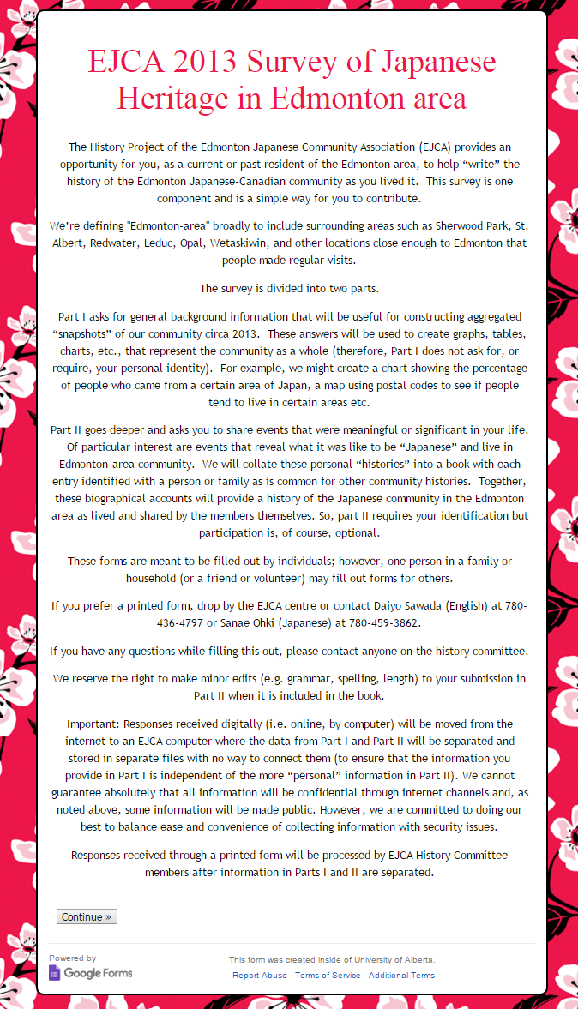

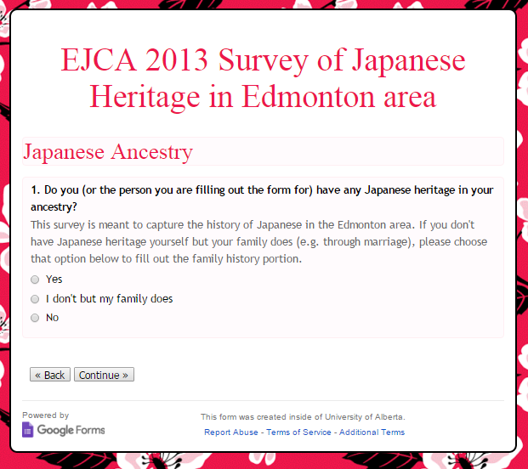
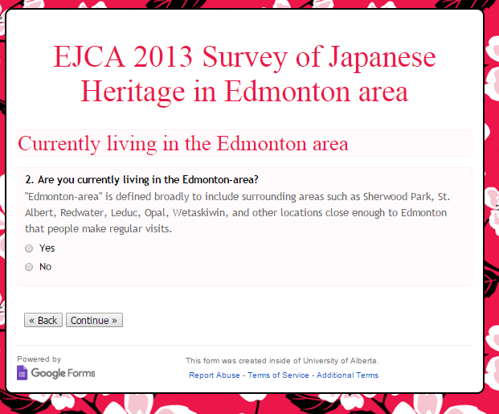
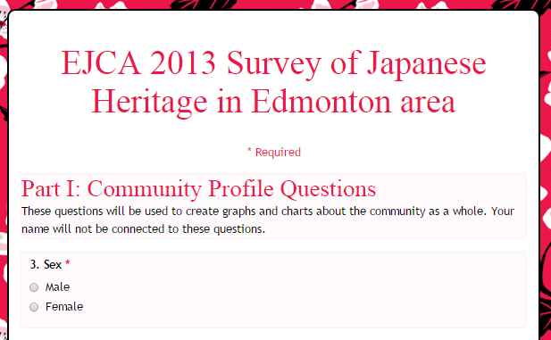
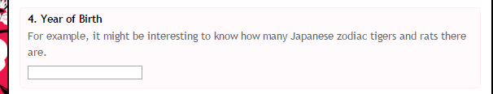
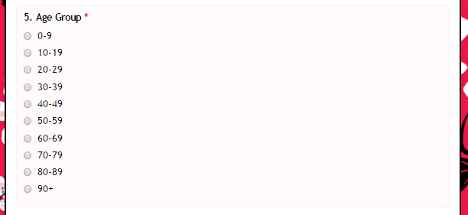
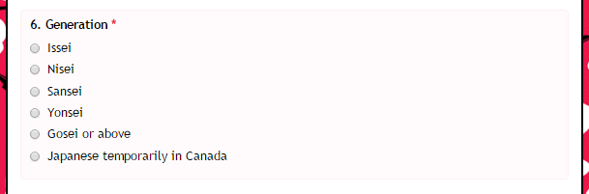
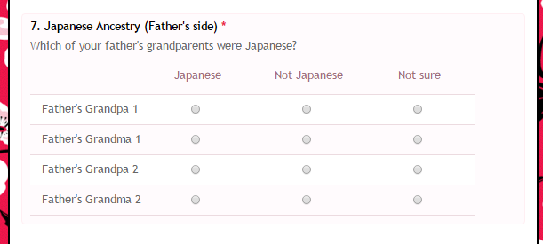
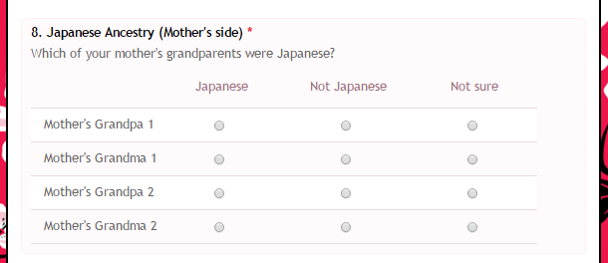
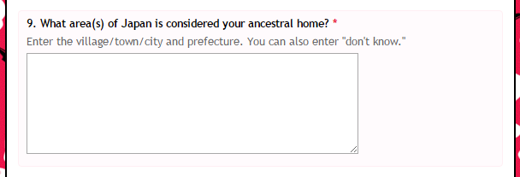
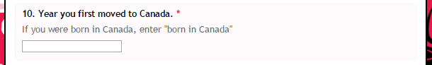
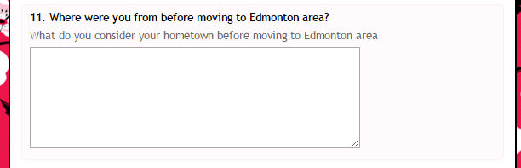
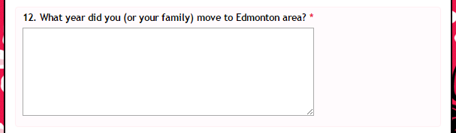
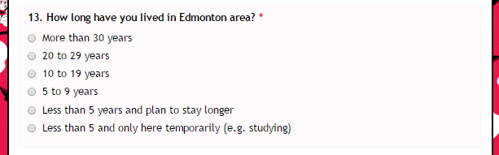
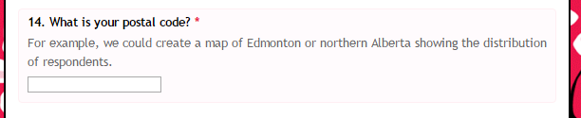
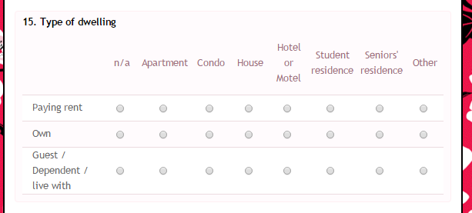
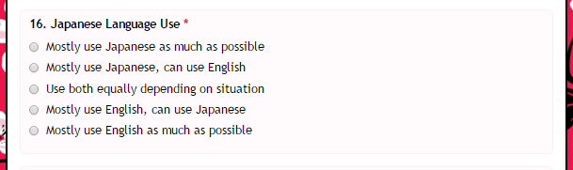
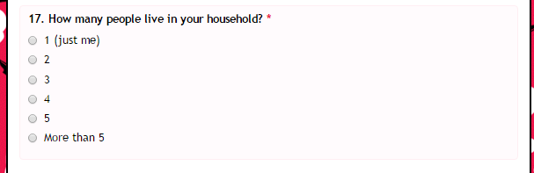
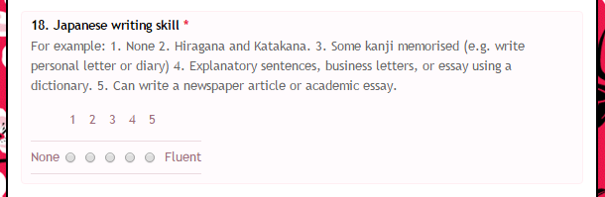
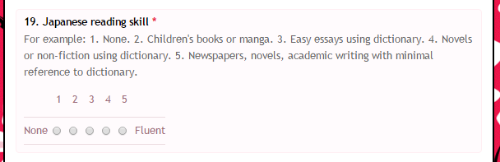
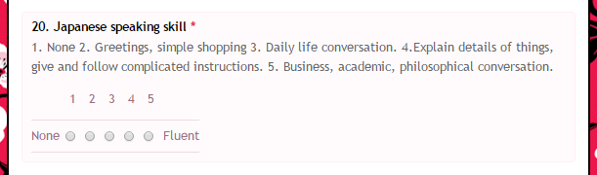
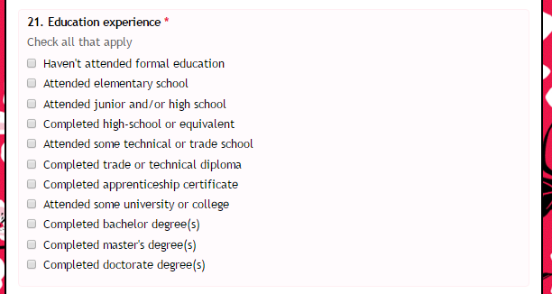
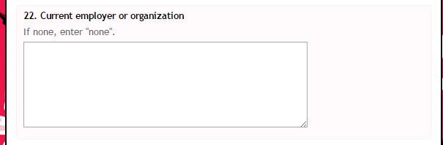
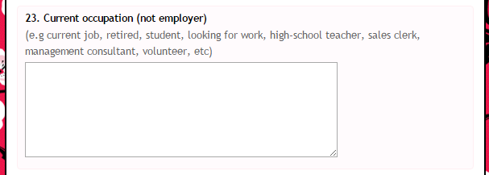
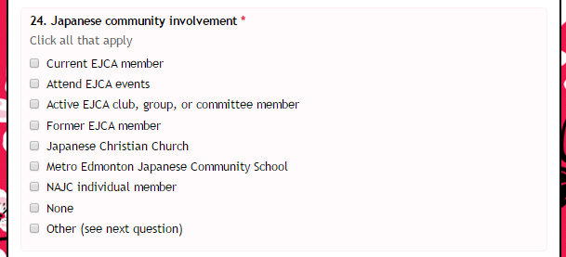
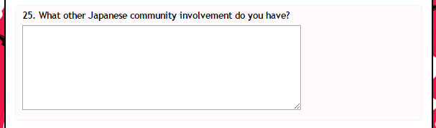
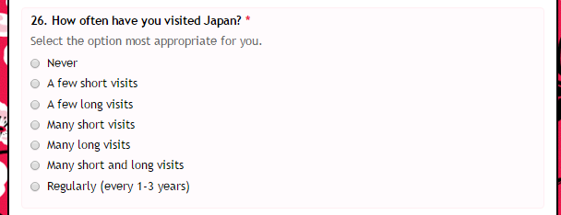
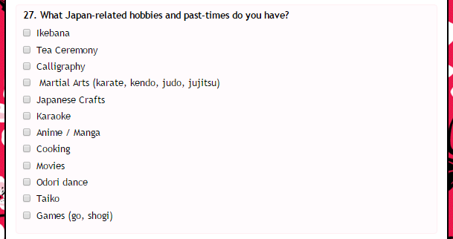
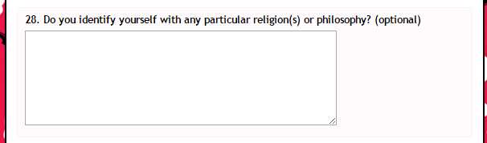
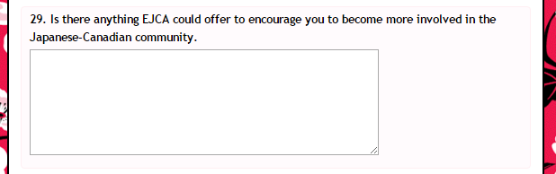
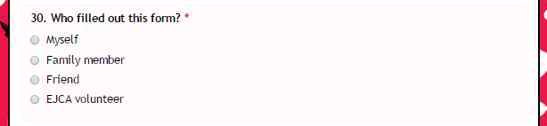
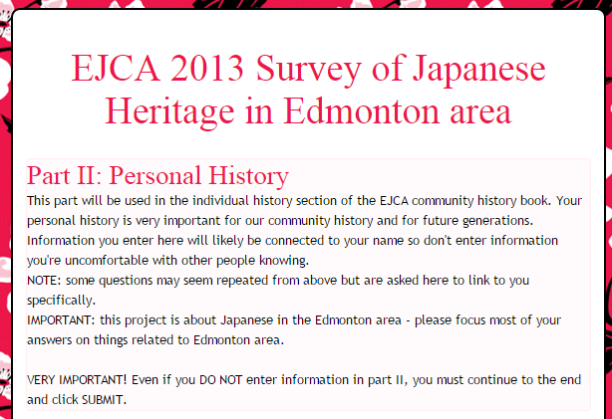
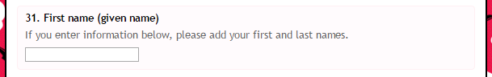
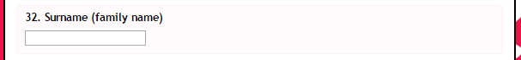
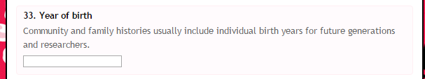
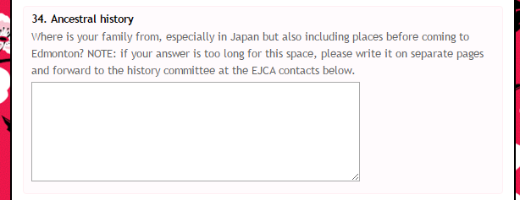
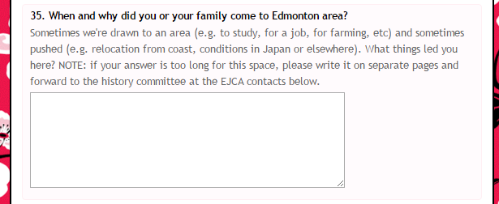
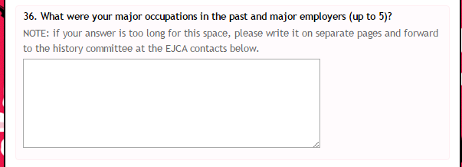
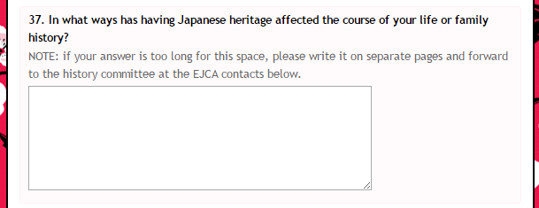
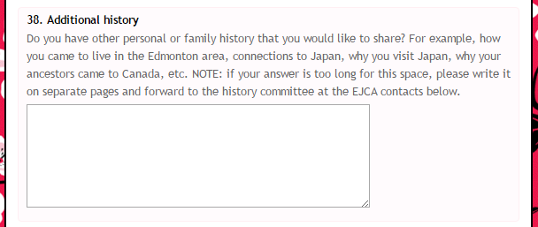
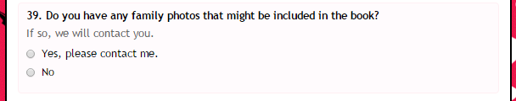
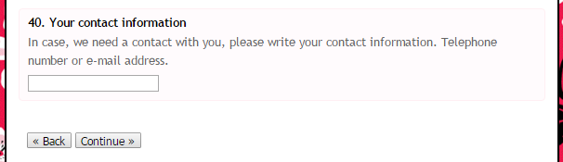
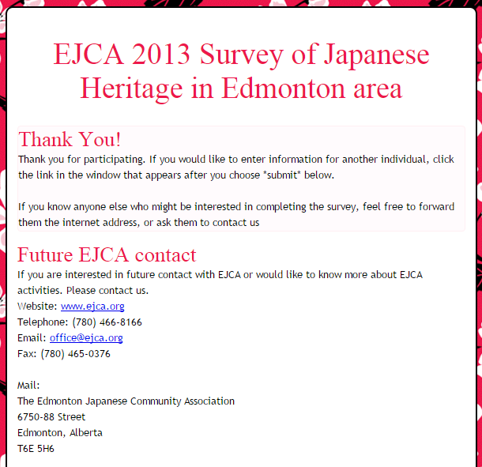

Online, Japanese survey (google forms)
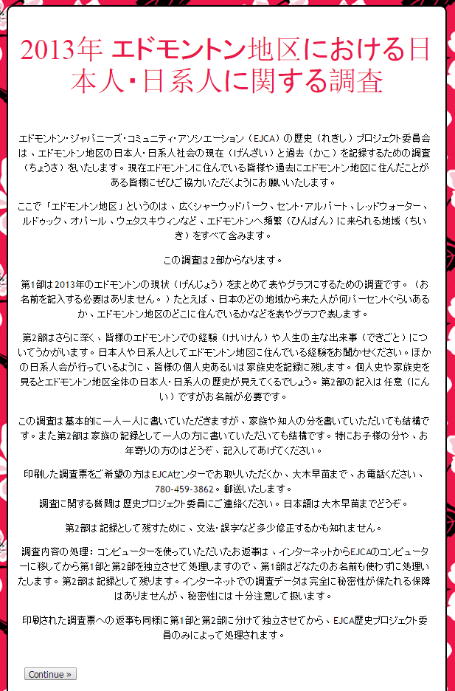
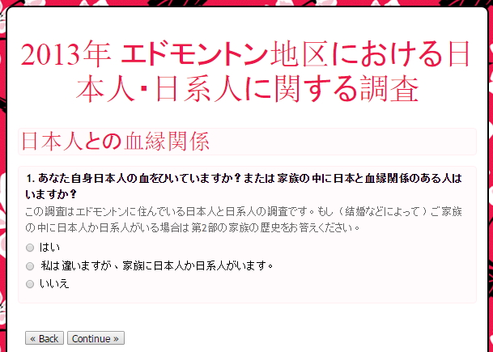
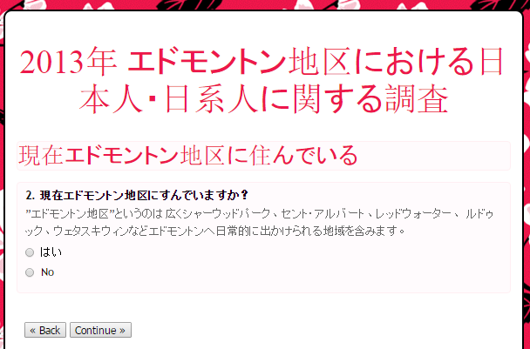
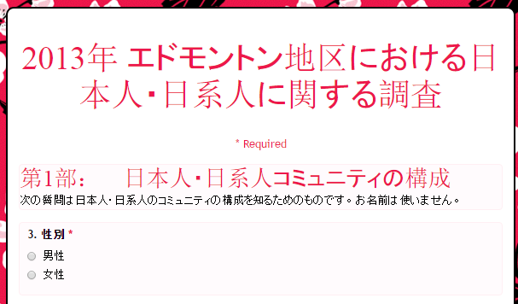
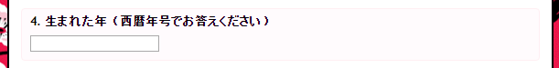
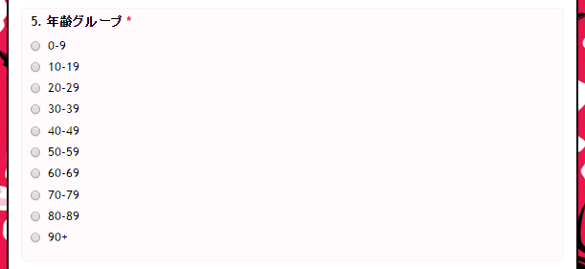
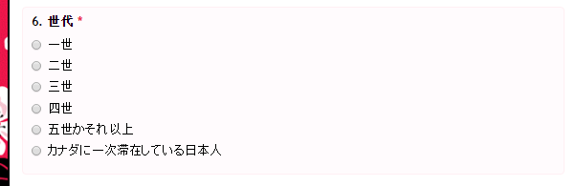
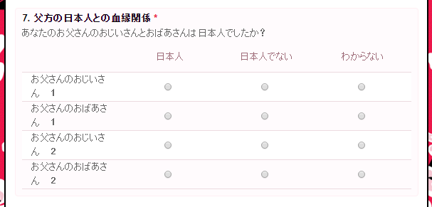
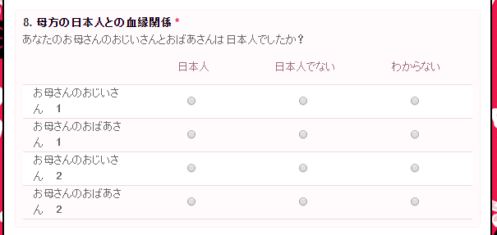
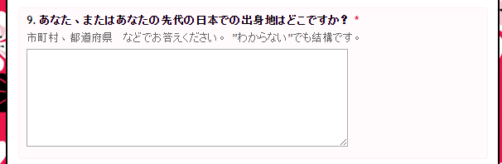
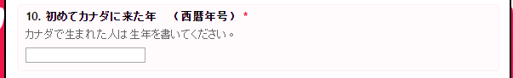
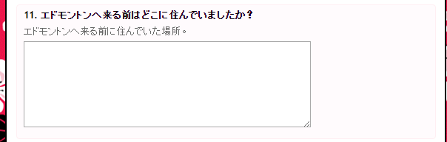
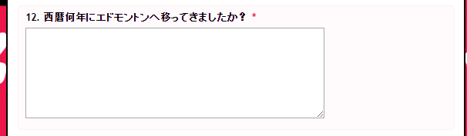
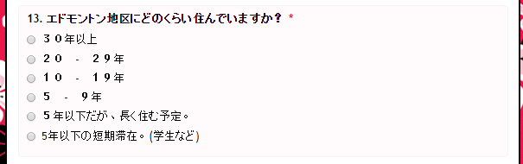
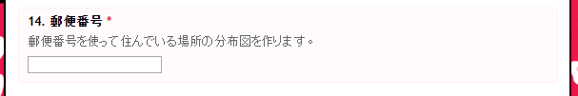
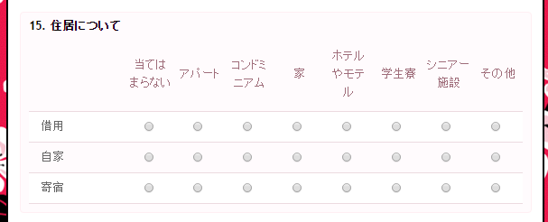
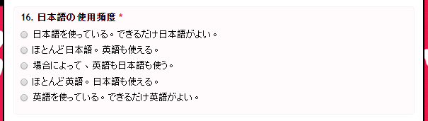
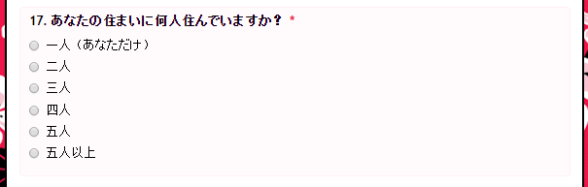
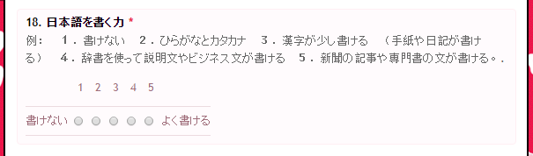
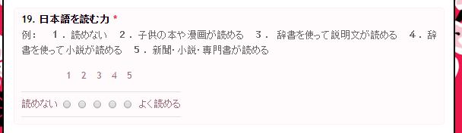
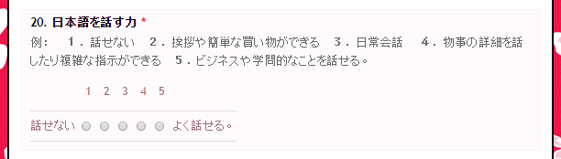
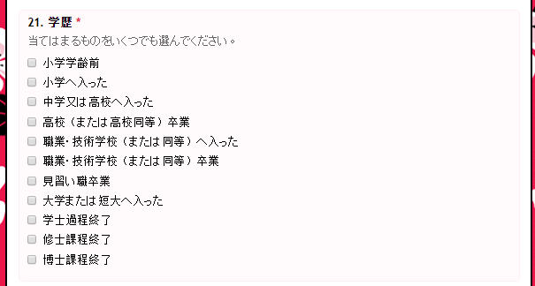
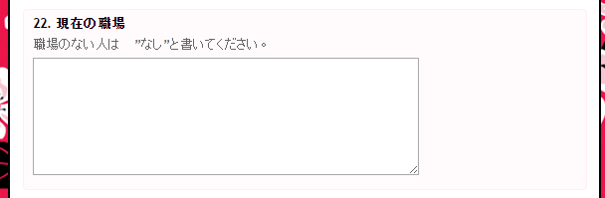
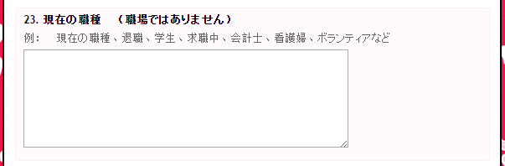
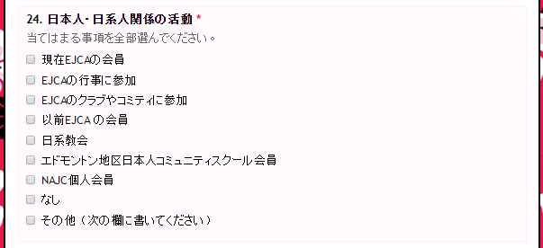
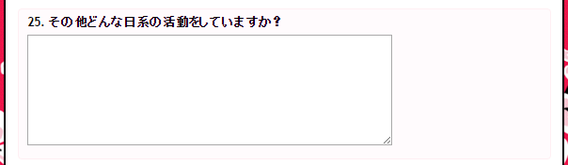
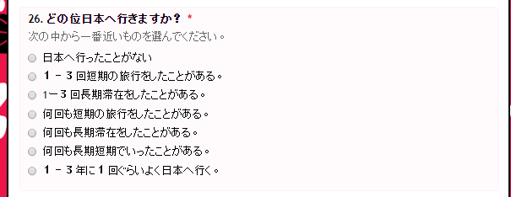
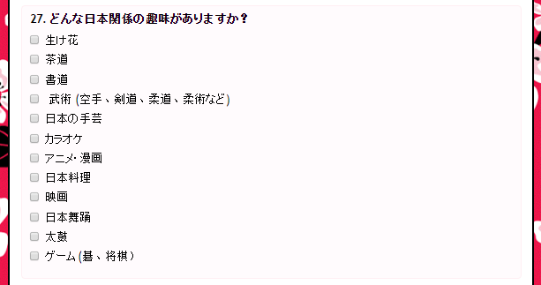
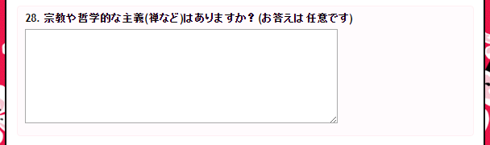
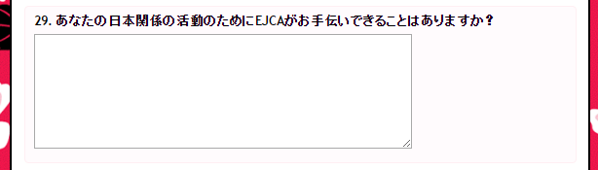
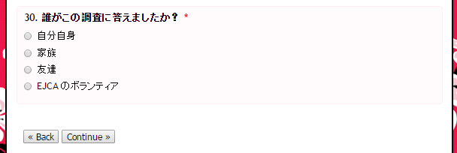
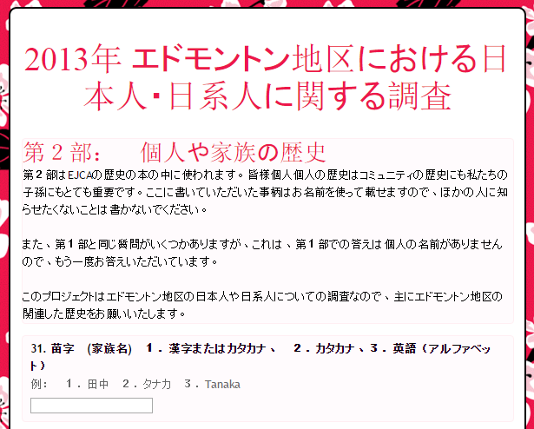
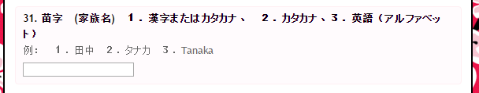
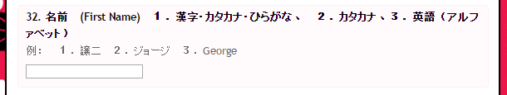
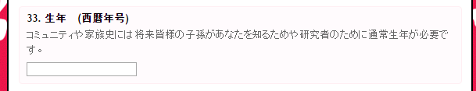
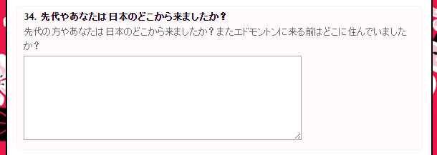
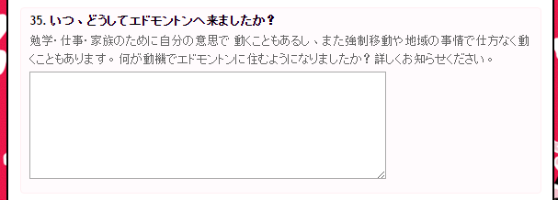
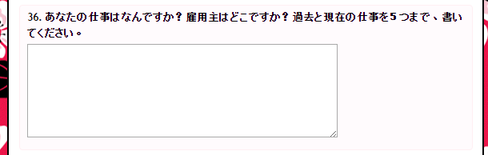
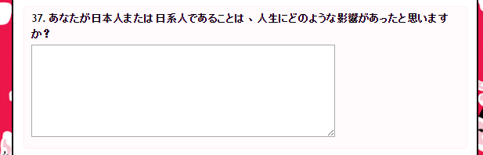
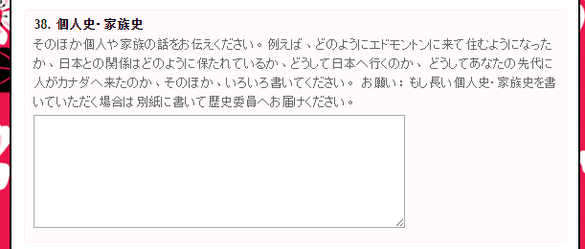
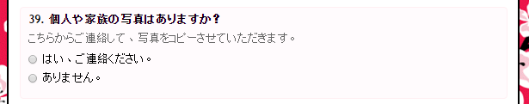
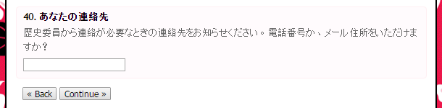
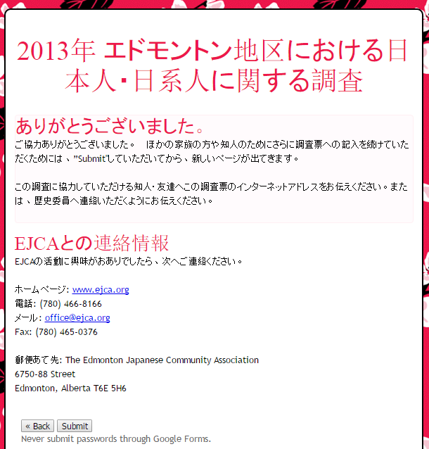

Print Versions
The print versions were derived from the online version so the page formatting was not as efficient as it might have been - 13 pages with some overly larges white spaces and some spaces possible too small for some responses. Respondents could download a PDF from the EJCA website to print on their own or copies were made available through the EJCA office.
Following are screen shots from the PDF – each box appeared on a separate letter-sized page.
Print (hard-copy) English version
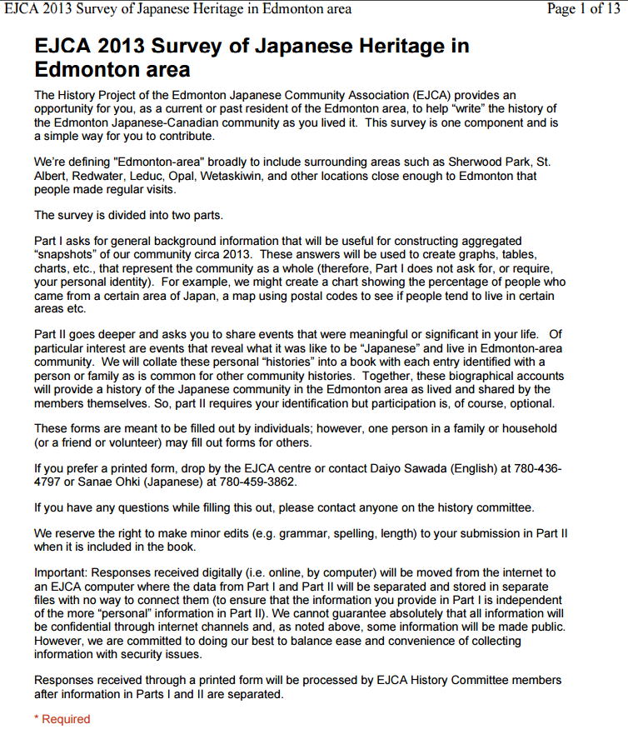
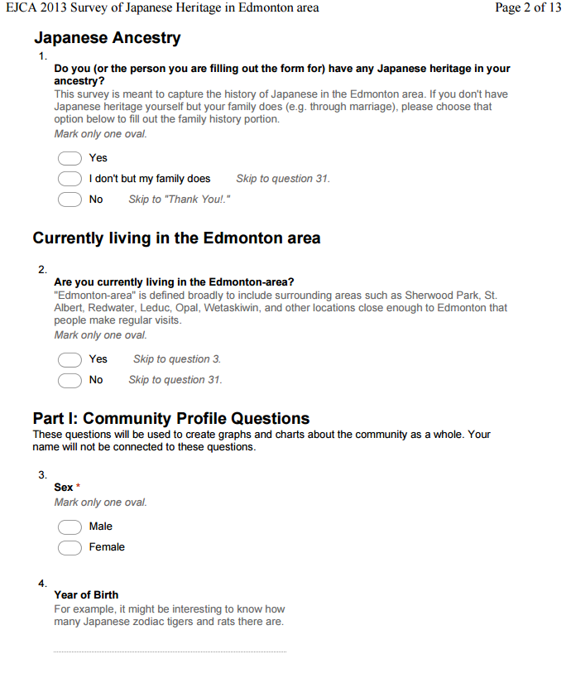
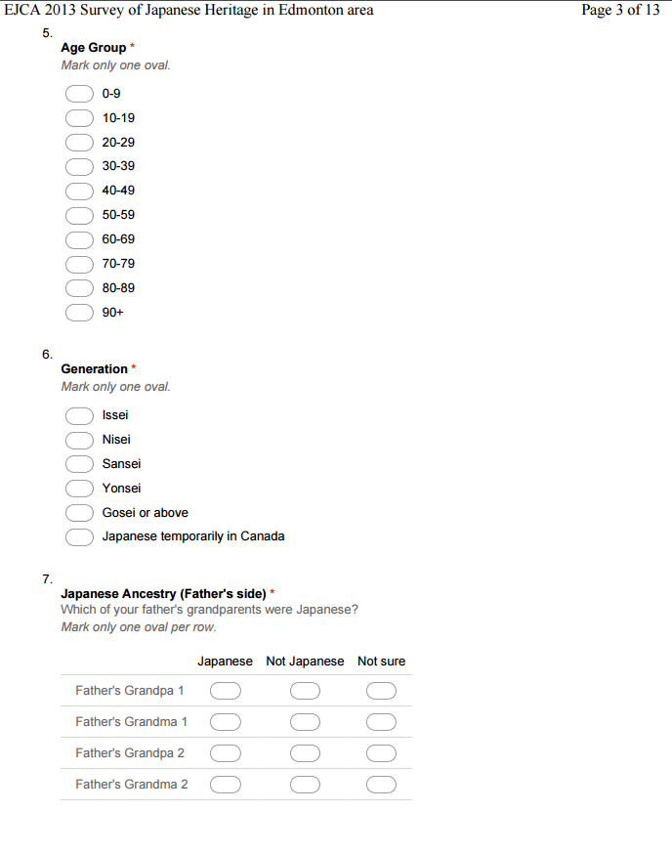
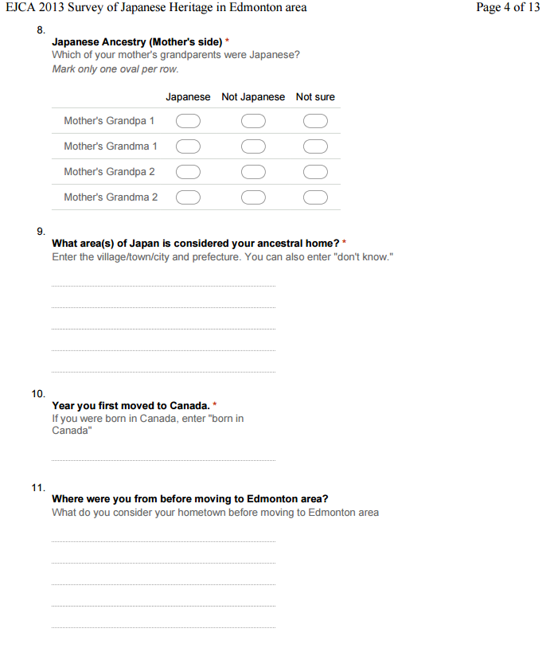
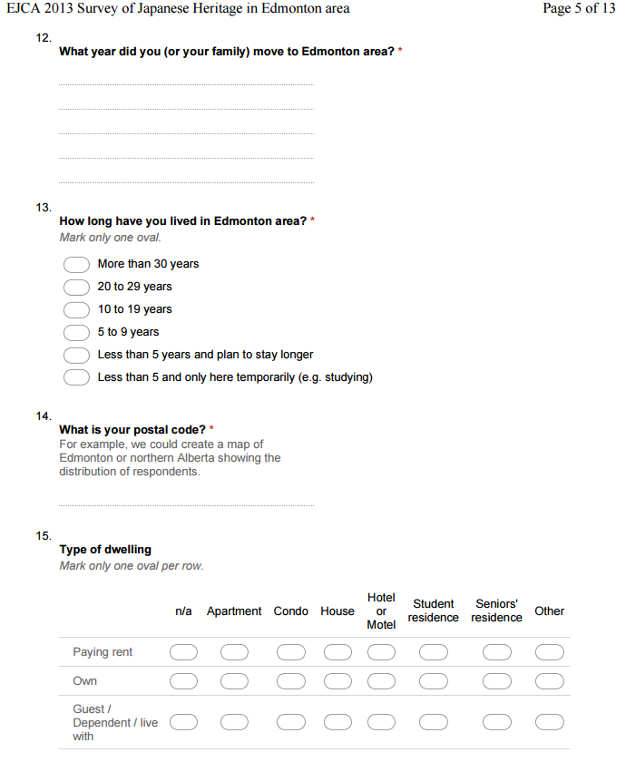
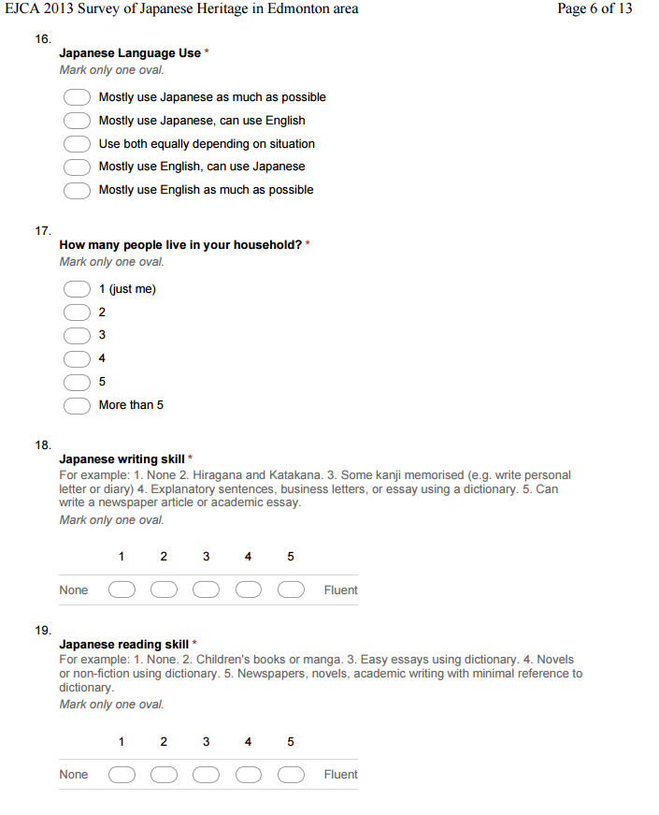
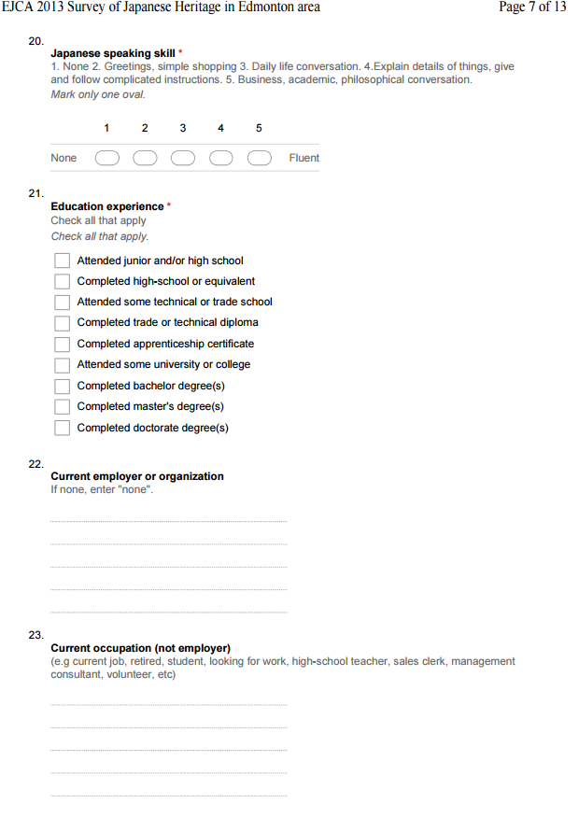
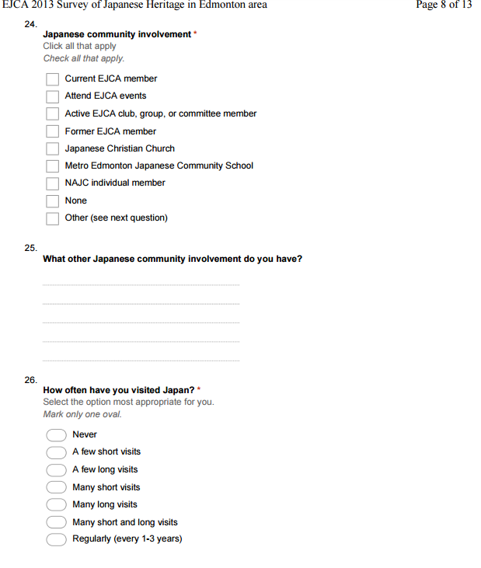
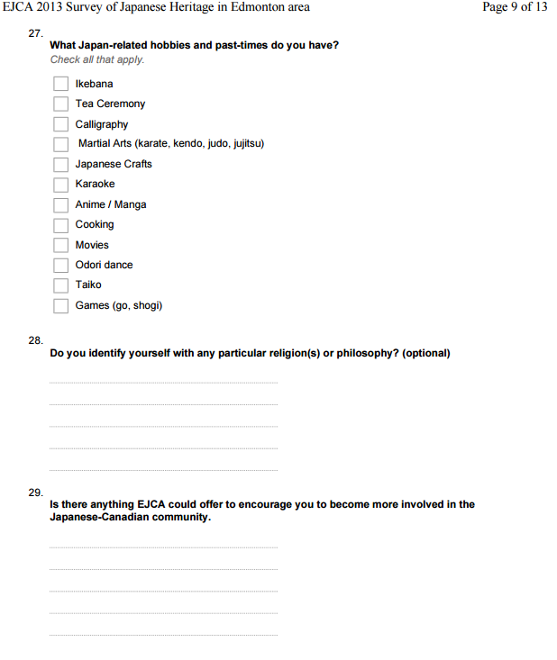
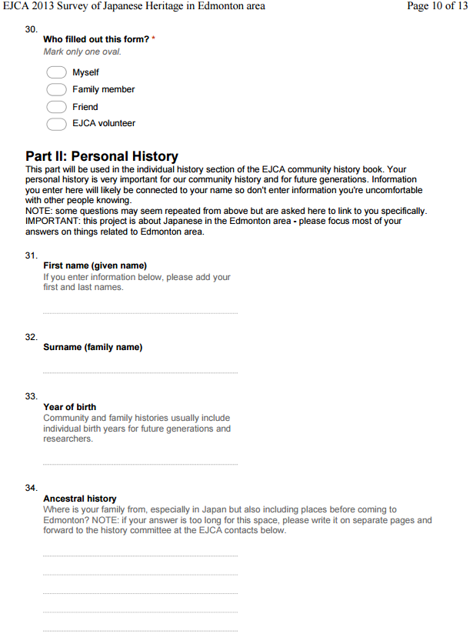
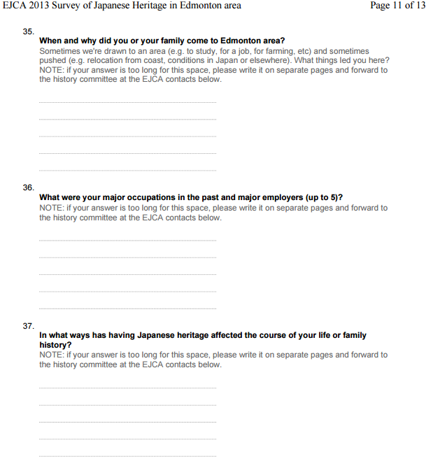
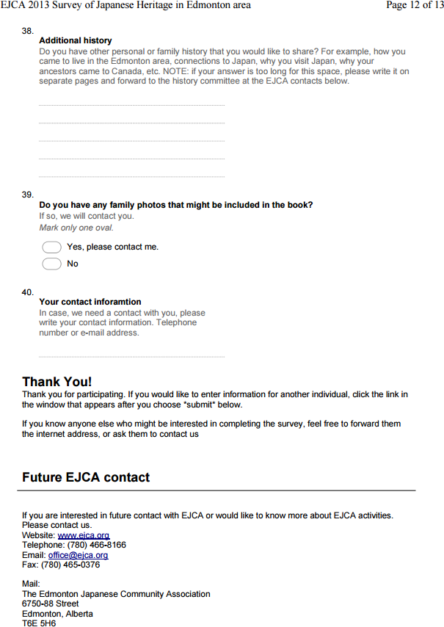

Print (hard-copy) Japanese version
