Breakthrough Performances of Metal-Exchanged Nanotitanate ETS-2 Adsorbents for Room Temperature Desulfurization
Sabereh Rezaei, Maria Ophelia D. Jarligo, Lan Wu, Steven M. Kuznicki
Department of Chemical & Materials Engineering, University of Alberta, Edmonton, Alberta, Canada T6G 2V4

ABSTRACT
Engelhard Titanosilicate-2 (ETS-2) has shown to be a promising substrate to load active sites for deep H₂S removal (to sub-ppm levels) for gas purification applications at room temperature. Because of the high external surface area and the cation exchange capacity of ETS-2, active sites can be highly dispersed and very accessible to H₂S molecules making it a novel support material for metal-oxide H₂S adsorbents. In this paper, we report the room temperature H₂S breakthrough performances of ETS-2 metal exchanged with Ag, Ca, Cu and Zn in comparison to a fully developed commercial H₂S adsorbent (R3-11G, 36 wt% CuO, BASF). The results indicate the following trend for H₂S uptake capacities at room temperature: Cu-ETS-2>Ag-ETS-2>Zn-ETS-2≈R3-11G>Ca-ETS-2≈Na-ETS-2. Cu exchanged ETS-2 displays the highest H₂S capacity of 29.7 mg H₂S/g adsorbent compared to the other investigated materials, making it the most promising metal-exchanged ETS-2 for room temperature desulfurization.
Keywords: room temperature desulphurization; titanosilicate ETS-2; adsorption; cation exchange
1. Introduction
Hydrogen sulfide (H₂S) is one of the major contaminants in various industrial gas streams that cause a number of negative effects such as corrosion of the pipelines, generation of harmful environmental emissions, etc. Its removal is therefore extremely necessary (Yasyerli et al., 2004; Elsayed et al., 2009; Jiang et al., 2010, Hernández et al., 2011). Even at very low concentrations (<1 ppm) H₂S has detrimental effects on many industrial catalysts (such as those used in reforming processes and fuel cells) and ceramic membranes (used in syngas separations) (Monteleone et al., 2011; Rezaei et al., 2012; Bhandari et al., 2013). In addition, during the combustion process of biogas it causes corrosion in thermal or thermo-catalytic conversion devices (Hernández et al., 2011) as well as resulting in other environmental hazards like acid rain (Xue et al., 2003; Jiang et al., 2010).
To improve the separation efficiency and for particular applications (e.g. natural gas sweetening and refining desulfurization of fuel cell system products) there is an increasing requirement for gas purification and H₂S scavenging at low temperatures (<200 °C). In particular, H₂S removal at room temperature for such applications is essential since both reforming and fuel cell catalysts are susceptible to H₂S at levels as low as 0.1-1 ppm (Hernández et al., 2011; Rezaei et al., 2012). Among the currently used methods for H₂S removal, the adsorptive technique is the simplest and the most efficient and cost effective at low concentration and temperature (Velu et al., 2002; Zhou et al., 2004; Hernández et al., 2011; Gholampour and Yeganegi 2014). It is capable of reducing sulfur concentration in the process streams to sub ppm levels (Rezaei et al., 2012).
Adsorption processes using various metal and mixed metal oxides have been studied for room temperature ( Carnes and Klabunde, 2002; Xue et al., 2003) and relatively low temperature (<400 °C) desulfurization (Baird et al., 1999; Babé et al., 2012; Moezzi et al., 2012), focusing more on high surface area pure zinc oxide or mixed with other metal-oxides (Baird et al., 1999; Carnes and Klabunde, 2002; Xue et al., 2003; Jiang et al., 2010; Babé et al., 2012; Moezzi et al., 2012). From the differences in the intrinsic reactivity of metal oxides with H₂S by thermodynamic driving force ZnO, CuO, Ag₂O and CaO have shown favorable sulfidation at room temperature (Carnes and Klabunde, 2002; Xue et al., 2003).
High dispersion of reactive sites can considerably enhance the reaction between metal compounds and H₂S molecules (Jiang et al., 2010). An approach for improving desulfurization capacity at room temperature is to load reactive sites on high surface area supports, which include zeolites (Melo et al., 2006; Crespo et al., 2008; Kumar et al., 2011), carbon sorbents (Nguyen-Thanh and Bandosz, 2005; Li et al., 2014), SBA-15 and other mesoporous material supports (Crespo et al., 2008; Xue and Liu, 2012; Hussain et al., 2012; Wang et al., 2008; Montes et al., 2013). Cu-ZnO/SiO₂ and Cu supported titanosilicate have been studied for adsorptive removal of H₂S at room temperature as well (Dhage et al., 2010; Rezaei et al., 2012).
To further improve the capacity and utilization of supported metal-oxide adsorbents, Engelhard Titanosilicate-2 (ETS-2) is used as a novel substrate material to load active ions for deep H₂S removal (to sub-ppm levels) for gas purification applications at room temperature. ETS-2 has high external surface area and cation exchange capacity, which allow active ions to be highly dispersed and accessible to H₂S molecules (Rezaei et al., 2012).
- In the present investigation we have exchanged Na-ETS-2 (native form) with metal ions Cu⁺², Ag⁺, Zn²⁺, Ca²⁺. Their H₂S adsorption and room temperature H₂S removal capacities were then determined and compared to that of a commercial sample. Different characterization techniques such as X-ray diffraction, scanning electron microscopy with EDX and BET surface area measurements have also been applied to carefully investigate phases and structures of the tested materials.

2. Experimental
2.1 Preparation of the precursor
Na-ETS-2 was hydrothermally synthesized using a commercial source of titanium (Titanium (III) Chloride Solution 20 % stabilized, Fisher Scientific, Canada) with the following formulation: 13.2 g of sodium hydroxide (97wt.%+ NaOH, Fisher Scientific, Canada) and 4.2 g sodium fluoride (99 wt.%+ NaF, Fisher Scientific, Canada) mixed in 10 g of de-ionized water (resistivity >18 MΩ cm). This mixture was then added to 10.4 g of sodium silicate (28.8 % SiO₂, 9.14 % Na₂O, Fisher Scientific, Canada), followed by the addition of 38.1 g of titanium trichloride (20 % w/w solution in 2N hydrochloric acid, Fisher Scientific, Canada). Finally, the reaction mixture was sealed into a 125 mL Teflon-lined autoclave (Parr Instrument Company, Illinois, USA) and reacted at 100 °C for 7 days. The autoclave was quenched to ambient temperature. The precipitate was washed and filtered by de-ionized water, and then dried in a forced-air oven at 80 °C for 24 hours.
In order to prepare the Ag and Cu exchanged forms of ETS-2, high external surface area Na-ETS-2 (253 m²/g) was exchanged with nitrate salts (Fisher Scientific, Canada and Anachemia Chemicals, Canada, respectively). For the Zn and Ca exchanged forms, Na-ETS-2 was exchanged with the chloride salts (Fisher Scientific, Canada). The ion exchange procedure was done by mixing a quantity of as synthesized ETS-2 with the salt dissolved in deionized water (weight proportion 1:2:10). Obtained slurry was kept in an oven at 80 °C for approximately 18 h following by filtering and washing with deionized water and dried at 80 °C overnight. The exchanged powders were pressed into binderless pellets, which were then crushed and sieved to 1.19 mm to 0.595 mm (No. 16 to 30 mesh) fraction for use in the H₂S removal test experiments. The commercial sample R3-11G (BASF, New Jersey, USA) was also sieved to obtain the same particle size.

2.2 Adsorption tests
A sample of 30 mg of each adsorbent was packed between plugs of glass wool in a stainless steel column of 3.8 mm (inner diameter). A certified gas mixture 10 ppm H₂S in He (Praxair, Canada) was passed through the column at a continuous flow of 100 mL/min. The feed flow rate was controlled with a mass flow controller (MFC, Alicat Scientific, Arizona, USA). The outlet concentration of the bed recorded at 7 min intervals was monitored using a gas chromatograph (GC) equipped with MXT-1 column 60 m in length and 0.53 mm inner diameter (Restek, Bellefonte, USA) and a flame photometric detector (FPD, SRI Instruments, Canada). The FPD detector is specified to be able to detect H₂S at 200 ppb.
The H₂S breakthrough capacity of each adsorbent ($q(t))$ was calculated by using the H₂S concentration in the inlet gas ($C_{in})$, the gas flow rates ($F_{in}$ and $F_{out}$, inlet and outlet respectively), bed volume ${(V}_{b})$, column void fraction ${(ε}_{b})$, breakthrough time ($t_{∞})$, mass of adsorbent $(w)$, H₂S molecular weight $(Mw)$ and is reported as (mg H₂S) / (g adsorbent) through the following equation:
$$\frac{Mw}{w}\int_{0}^{t_{∞}}{\left(F_{in}-F_{out}\right)dt}=q(t)+C_{in} V_{b} ε_{b} \frac{Mw}{w} (1)$$

Breakthrough time is defined as the point at which the outlet concentration for H₂S reached 1 ppm. Reproducibility was confirmed by repeating the breakthrough experiments at least twice and the testing system error was considered by averaging the measurements for each sample.

2.3 Microstructure characterization
The X-ray diffraction (XRD) was conducted to observe the material structures of the tested samples using a Rigaku Geigerflex 2173 (Rigaku Corporation, Tokyo, Japan) with a vertical goniometer. The elemental analysis of the adsorbents was performed using a Zeiss EVO MA 15 (Zeiss, Goettingen, Germany) equipped with a Bruker Silicon Drift Detector for Energy Dispersive X-Ray analysis (EDX). The BET specific surface area data was collected by an ASAP 2020 instrument (Micromeritics Instrument Corporation). Scanning electron microscopy was performed using a high resolution Hitachi S-5500 Series SEM (Hitachi, Japan) equipped with EDX.

3. Results
3.1 H₂S breakthrough performance
Figure 1 demonstrates the H₂S breakthrough capacities for all adsorbents using equation 1. Blank correction is neglected due to the prompt H₂S response obtained from the empty column tested with the glass wool. Negligible H₂S removal capacity of the base material Na-ETS-2 confirms that it does not have any role in H₂S removal and has been chosen properly as an inactive substrate to only expose active metal sites toward H₂S molecules. The data also show that among different exchanged forms of ETS-2, Cu exchanged ETS-2 has the highest H₂S removal capacity followed by Ag-ETS-2. The latter’s performance is slightly higher than the commercial R3-11G which has almost the same capacity as Zn-ETS-2. Ca exchanged ETS-2 shows minor H₂S uptake capacity under the current experimental conditions.
Fig. 1. H₂S breakthrough profiles of different tested adsorbents.

3.2 Phase formation and morphology
While the sulfidation of CuO, Ag₂O, ZnO and CaO is thermodynamically favorable at room temperature, it is noticeably different for each oxide (ΔG₂₉₈, -132.35 kJ/mol, -233.02 kJ/mol, -81.96 kJ/mol, -70.40 kJ/mol, HSC thermodynamic software). H₂S removal capacity of the studied samples does not follow the same trend of the metal oxide affinities to reaction with H₂S. This simply indicates that several other factors may influence the H₂S removal capacity of a metal-exchanged form of ETS-2 (see discussion in section 4).
Figure 2 shows the XRD patterns of the native and the different cation metal exchanged forms of ETS-2. The native form is cryptocrystalline as evidenced by low broad peaks in the XRD profile, which are characteristic of nano particles of anatase (Yazdanbakhsh et al., 2014). It can be seen that no significant crystalline peaks are visible for the rest of the samples, indicating that Na-ETS-2 structure is able to accommodate Ag, Ca, Cu and Zn during the ion exchange process without having any significant effect on its nano structure.
Previously we have found that for Cu-ETS-2 at high temperature above 500°C structural changes occur (Rezaei et al., 2012). In the presence of H₂S, structural changes start to occur from 350 °C. However, the removal capacity still shows promising values up to 650 °C after which sintering progresses leading to loss of copper adsorption sites (Yazdanbakhsh et al., 2014).
Fig. 2. XRD patterns for different ion exchanged forms of ETS-2.

The external surface areas of all the tested adsorbents are given in Table 1. Results show that besides Ag-ETS-2, all samples have very high surface area.
Metal content of the samples have been determined through energy dispersive x-ray Spectroscopy (EDX). Results are given in Table 2. From the EDX results it can be seen that Ag-ETS-2 has very high Ag content. The metal loading for Cu and Zn are similar while Ca-ETS-2 has the lowest metal content.

Table 1. External surface area of different ion-exchanged forms of ETS-2 and a commercial sample R3-11G.
Adsorbent | BET surface area (m²/g)
Cu-ETS-2 | 250
Ag-ETS-2 | ‬173
Zn-ETS-2 | ‬297
Ca-ETS-2 | ‬293
R3-11G | ‬264

Table 2. Elemental analysis derived from EDX results for different adsorbents.
Adsorbent | Ion | Norm. wt%
Cu-ETS-2 | Cu | 13.2
Ag-ETS-2 | Ag | 39.0
Zn-ETS-2 | Zn | 14.3
Ca-ETS-2 | Ca | 8.1
R3-11G | Cu | 28.5

Based on the SEM images presented in Figure 3 the copper exchange process seems to enlarge the dendritic structure on the surface of ETS-2 while the particle morphology remains the same. Zn-ETS-2 also shows close morphology to the un-exchanged substrate material ETS-2. The Ag and Ca exchange processes change the physical structure of ETS-2 significantly. The particles have become highly agglomerated.
Figure 4 shows the metal dispersion on Cu-ETS-2, Ag-ETS-2, Zn-ETS-2 and Ca-ETS-2 samples. Metal sites are well dispersed on ETS-2 and exposed to H₂S molecules.
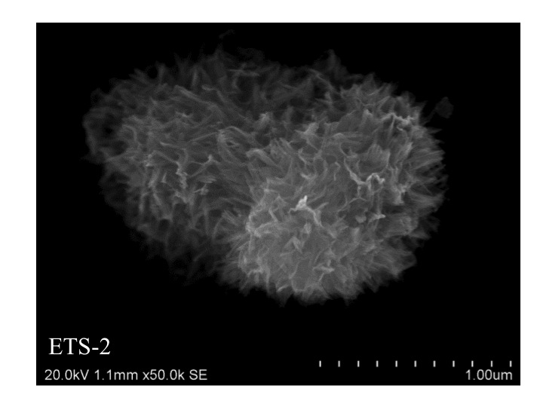
a
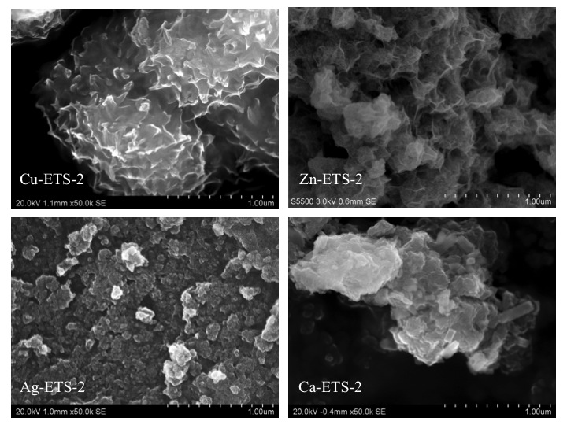
b
Fig. 3. SEM images for: a) Na-ETS-2 and b) Cu, Ag, Zn and Ca-ETS-2.

Fig. 4. Metal dispersion on Cu, Ag, Zn and Ca-ETS-2. L- secondary electron images and R- corresponding elemental maps.

4. Discussion
Several factors may influence the room temperature breakthrough performance of metal-oxide adsorbents. Among them are physical structure, external surface area and both number and affinity of the adsorption sites (Jiang et al., 2010). The high metal content (Table 2) of Ag-ETS-2 but rather low H₂S removal capacity could be attributed to its low surface area (Table 1). In addition, a lot of the Ag molecules are not in their active form for reaction with H₂S. A high resolution SEM image of this sample in Figure 5 clearly shows the presence of inactive sites of metallic silver dots on Ag-ETS-2.
From Figure 4 it can be seen that silver is well dispersed on Ag-ETS-2 as the other metal ions on other samples. Ag-ETS-2 compared to other adsorbents form highly agglomerated particles as shown in Figure 3. This also explains the lower surface area of Ag-ETS-2 compared to the other samples presented in Table 1. Agglomeration changes some physical properties like surface area and the adsorption capacity tends to decrease with increasing agglomeration (Hussain et al., 2012).
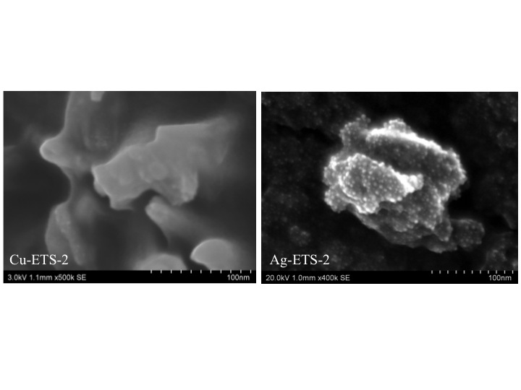
Fig. 5. High-resolution SEM image of Cu-ETS-2 and Ag-ETS-2.

The formation of some tetragonal particles can be observed in the Ca-ETS-2 morphology (Figure 6). Figure 7 shows an EDX line scan through a tetragonal particle indicated by an arrow in Figure 6.

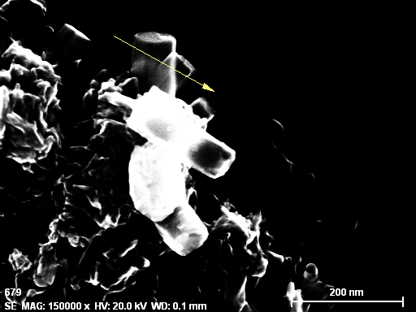
Fig. 6. High-resolution SEM image of Ca-ETS-2.
Fig. 7. EDX line scan through a tetragonal particle on Ca-ETS-2.

It can be seen that these particles are Ti-rich with very low Ca loading. This means that these particles can be considered as inactive sites for the purpose of this study. This observation is in good agreement with the low metal content in Ca-ETS-2 reported in Table 2. The low affinity of CaO for the reaction with H₂S in section 3.2 in addition to low metal loading compared to the other samples could probably cause the negligible H₂S removal capacity of Ca-ETS-2.
Among tested adsorbents, Cu-ETS-2 and Zn-ETS-2 show similar physical structures and amount of metal loading as well as surface area while their H₂S removal capacities are more different. Another factor, which strongly influences their breakthrough performances, is their thermodynamic property at room temperature. CuO is thermodynamically favorable for sulfidation than ZnO as indicated by their previously mentioned ΔGs. Moreover the sulfidation of ZnO requires more rearrangement of the anions than CuO, which results in slower rate of the lattice diffusion of the anions, or exchange of dissociated parts of H₂S with the lattice oxide (Jiang et al., 2010).

Conclusions
High surface area and cation exchange capacity nanotitanate ETS-2 was used as support material and cation-exchanged with Ag, Ca, Cu and Zn for potential adsorbents of sub-ppm levels of H₂S at room temperature. Breakthrough experimental results show that Cu-ETS-2 has the most promising performance as adsorbent material outperforming even the commercial sample. It has a high sulfur adsorption capacity of 29.7 mg H₂S/g adsorbent. Lower H₂S removal capacities for silver, zinc and calcium samples can be attributed to the presence of inactive sites such as metallic silver dots and the rigidity of physical structure of the material which lower thermodynamically favorable sulfidation reactions.

Acknowledgements
We thank Dr. James Sawada, Albana Zeko and Dr.Tetyana Kuznicki for helpful comments and suggestions during the preparation of this manuscript. We are also grateful to Paul Concepcion, Diane Caird, Nathan Gerein and Tong Qiu for help with SEM, XRD, EDX and BET analyses. Financial support from the Helmholtz-Alberta Initiative and the Canada Research Chair in Molecular Sieve Nanomaterials (S.M.K.) is gratefully appreciated.

References
Babé, C., Tayakout-Fayolle, M., Geantet, C., Vrinat, M., Bergeret, G., Huard, T. & Bazer-Bachi, D. 2012, "Crystallite size effect in the sulfidation of ZnO by H2S: Geometric and kinetic modelling of the transformation", Chemical Engineering Science, vol. 82, pp. 73-83.
Baird, T., Campbell, K., Holliman, P., Hoyle, R., Huxam, M., Stirling, D., Williams, B. & Morris, M. 1999, "Cobalt-zinc oxide absorbents for low temperature gas desulfurisation", Journal of Materials Chemistry, vol. 9, no. 2, pp. 599-605.
Bhandari, D.A., Bessho, N. & Koros, W.J. 2013, "Dual layer hollow fiber sorbents for trace H2S removal from gas streams", Chemical Engineering Science, vol. 94, pp. 256-264.
Carnes, C.L. & Klabunde, K.J. 2002, "Unique chemical reactivities of nanocrystalline metal oxides toward hydrogen sulfide", Chemistry of Materials, vol. 14, no. 4, pp. 1806-1811.
Crespo, D., Qi, G., Wang, Y., Yang, F.H. & Yang, R.T. 2008, "Superior sorbent for natural gas desulfurization", Industrial & Engineering Chemistry Research, vol. 47, no. 4, pp. 1238-1244.
Dhage, P., Samokhvalov, A., Repala, D., Duin, E.C., Bowman, M. & Tatarchuk, B.J. 2010, Copper-Promoted ZnO/SiO2 Regenerable Sorbents for the Room Temperature Removal of H2S from Reformate Gas Streams.
Elsayed, Y., Seredych, M., Dallas, A. & Bandosz, T.J. 2009, "Desulfurization of air at high and low H2S concentrations", Chemical Engineering Journal, vol. 155, no. 3, pp. 594-602.
Gholampour, F. & Yeganegi, S. 2014, "Molecular simulation study on the adsorption and separation of acidic gases in a model nanoporous carbon", Chemical Engineering Science, vol. 117, pp. 426-435.
Hernández, S.P., Chiappero, M., Russo, N. & Fino, D. 2011, "A novel ZnO-based adsorbent for biogas purification in H2 production systems", Chemical Engineering Journal, vol. 176–177, no. 0, pp. 272-279.
Hussain, M., Abbas, N., Fino, D. & Russo, N. 2012, "Novel mesoporous silica supported ZnO adsorbents for the desulphurization of biogas at low temperatures", Chemical Engineering Journal, vol. 188, pp. 222-232.
Jiang, D., Su, L., Ma, L., Yao, N., Xu, X., Tang, H. & Li, X. 2010, "Cu-Zn-Al mixed metal oxides derived from hydroxycarbonate precursors for H2S removal at low temperature", Applied Surface Science, vol. 256, no. 10, pp. 3216-3223.
Kumar, P., Sung, C., Muraza, O., Cococcioni, M., Al Hashimi, S., McCormick, A. & Tsapatsis, M. 2011, "H2S adsorption by Ag and Cu ion exchanged faujasites", Microporous and Mesoporous Materials, vol. 146, no. 1-3, pp. 127-133.
Li, F., Wei, J., Yang, Y., Yang, G.H. & Lei, T. 2014, Preparation of Sorbent Loaded with Nano-CuO for Room Temperature to Remove of Hydrogen Sulfide, Durnten-Zurich, Trans Tech.
Melo, D., de Souza, J., Melo, M., Martinelli, A., Cachima, G. & Cunha, J. 2006, "Evaluation of the zinox and zeolite materials as adsorbents to remove H2S from natural gas", Colloids and Surfaces A-Physicochemical and Engineering Aspects, vol. 272, no. 1-2, pp. 32-36.
Moezzi, A., McDonagh, A.M. & Cortie, M.B. 2012, "Zinc oxide particles: Synthesis, properties and applications", Chemical Engineering Journal, vol. 185–186, no. 0, pp. 1-22.
Monteleone, G., De Francesco, M., Galli, S., Marchetti, M. & Naticchioni, V. 2011, "Deep H2S removal from biogas for molten carbonate fuel cell (MCFC) systems", Chemical Engineering Journal, vol. 173, no. 2, pp. 407-414.
Montes, D., Tocuyo, E., Gonzaĺez, E., Rodriǵuez, D., Solano, R., Atencio, R., Ramos, M.A. & Moronta, A. 2013, Reactive H2S chemisorption on mesoporous silica molecular sieve-supported CuO or ZnO.
Nguyen-Thanh, D. & Bandosz, T. 2005, "Activated carbons with metal containing bentonite binders as adsorbents of hydrogen sulfide", Carbon, vol. 43, no. 2, pp. 359-367.
Rezaei, S., Tavana, A., Sawada, J.A., Wu, L., Junaid, A.S.M. & Kuznicki, S.M. 2012, "Novel Copper-Exchanged Titanosilicate Adsorbent for Low Temperature H2S Removal", Industrial & Engineering Chemistry Research, vol. 51, no. 38, pp. 12430-12434.
Velu, S., Ma, X. & Song, C. 2002, "Zeolite-based adsorbents for desulfurization of jet fuel by selective adsorption", ACS Division of Fuel Chemistry, Preprints, pp. 447.
Wang, X., Sun, T., Yang, J., Zhao, L. & Jia, J. 2008, "Low-temperature H(2)S removal from gas streams with SBA-15 supported ZnO nanoparticles", Chemical Engineering Journal, vol. 142, no. 1, pp. 48-55.
Xue, M., Chitrakar, R., Sakane, K. & Ooi, K. 2003, "Screening of adsorbents for removal of H2S at room temperature", Green Chemistry, vol. 5, no. 5, pp. 529-534.
Xue, Q. & Liu, Y. 2012, "Removal of minor concentration of H2S on MDEA-modified SBA-15 for gas purification", Journal of Industrial and Engineering Chemistry, vol. 18, no. 1, pp. 169-173.
Yasyerli, S., Dogu, G., Ar, I. & Dogu, T. 2004, "Dynamic analysis of removal and selective oxidation of H2S to elemental sulfur over Cu-V and Cu-V-Mo mixed oxides in a fixed bed reactor", Chemical Engineering Science, vol. 59, no. 19, pp. 4001-4009.
Yazdanbakhsh, F., Bläsing, M., Sawada, J.A., Rezaei, S., Müller, M., Baumann, S., & Kuznicki, S.M. 2014, "Copper Exchanged Nanotitanate for High Temperature H2S Adsorption", Industrial & Engineering Chemistry Research, vol. 53, no. 29, pp. 11734−11739.
Zhou, L., Yu, M., Zhong, L. & Zhou, Y. 2004, "Feasibility study on pressure swing sorption for removing H2S from natural gas", Chemical Engineering Science, vol. 59, no. 12, pp. 2401-2406.

Corresponding author: Email: steve.kuznicki@ualberta.ca; Telephone: 1.780.492.8819; Facsimile: 1.780.492.8958
MDS provided by BASF

