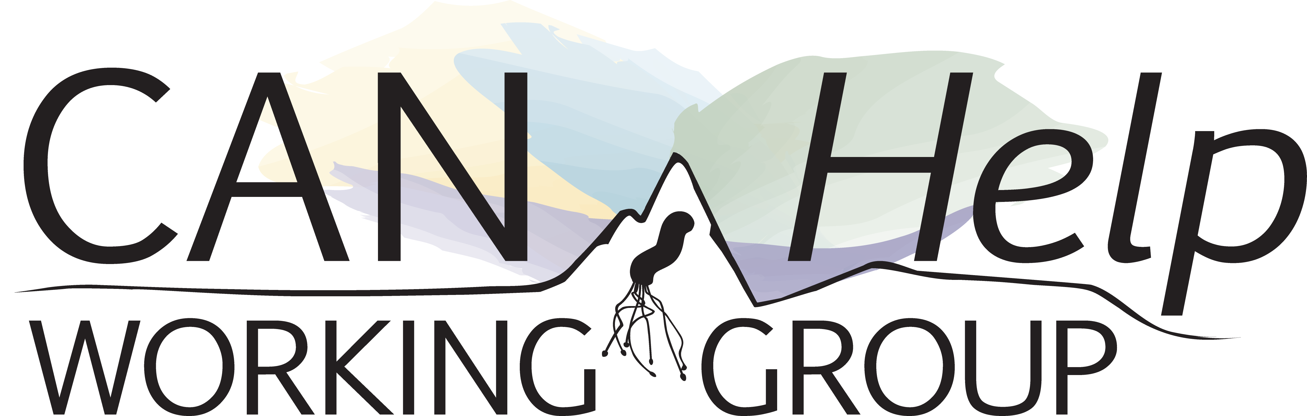

CANHelp Working Group Project Description and Agreement Form

Karen J Goodman^{1,2}, Janis Geary¹, Emily Walker¹, Katharine Fagan-Garcia¹, Laura McAlpine¹, Amy Colquhoun^{2,3}, Hsiu-Ju Chang¹, Ali Assi¹, CANHelp Working Group.

1. Division of Gastroenterology, Department of Medicine, University of Alberta, Edmonton, Alberta
2. School of Public Health, University of Alberta, Edmonton, Alberta
3. Analytics and Performance Reporting Branch, Alberta Health, Alberta Health

Copyright: © 2019 Goodman et al. These are open access materials distributed under the terms of the Creative Commons BY-NC-SA license [https://creativecommons.org/licenses/by-nc-sa/4.0/], which permits modification of this document and requires that users share any materials they create from it under the same license acknowledging the original source

Suggested Citation: Karen J Goodman, Janis Geary, Emily Walker, Katharine Fagan-Garcia, Laura McAlpine, Amy Colquhoun, Hsiu-Ju Chang, Ali Assi, CANHelp Working Group. CANHelp Working Group Project Description and Agreement Form. University of Alberta. https://doi.org/10.7939/r3-ce0e-0m15. 2019.
PROJECT DESCRIPTION AND AGREEMENT FORM
(Read the CANHelp Project Guidelines before completing the form)

Name [Enter your name]
Date submitted [Enter Date}

For students or trainees:

Supervisor [Enter supervisor's name]

Project goal (check all that apply)
Manuscript for Publication
Presentation
Thesis/Dissertation
Paper for Course
Learning Exercise
Other; specify

Date approved
Reviewed by

Working title [Enter a project title]

Collaborators [List all collaborators and indicate their role and project activities in which they will be involved]

Rationale

[Explain your reasons for doing this project and clarify how it furthers the goals of the CANHelp Working Group research program and/or the investigators or trainees who will carry it out]

Synopsis of methods
[Briefly describe the methods to be used]

Information needed for this project (check all that apply)
CANHelp databases*
Urea breath tests
Endoscopy and pathology reports
Microbiological cultures, antibiotic susceptibility tests and genotypes
Surveys
Medical chart reviews
Community kinships
Other; specify
Biological specimens
H. pylori isolates
Gastric tissue samples
Other; specify

Visual contents
Logo drawings
Audio-recorded interviews
Other; specify

Proposed timeline for the project
[Describe the time period during which the project will be carried out and due dates for any products (e.g., abstract, presentation, report) that will result]

I, [Insert name], confirm I have read the CANHelp Investigator Agreement and agree to:
Abide by the Statement on Stewardship and Dissemination of Knowledge Generated Collaboratively in CANHelp Working Group Community Projects, paying particular attention to the Research Project Guidelines, Authorship Guidelines, Acknowledgement Guidelines and Data Dissemination Guidelines
Carry out my project without going beyond the approved project description unless I get written approval from the Managing Director of a modified project description
Notify the Data Dissemination Lead about any abstract, report or presentation I plan to prepare from my work on this project, following the timeline indicated in the Data Dissemination Guidelines
Refrain from presenting, publishing or otherwise reporting any information from my project without written approval from the Research Director
Submit to the Managing Director a summary of my work when I stop working on this project, whether or not I complete it, along with a final copy of any written abstract, report or presentation arising from my project

