Appendix B
Aggregate Responses by Question
One participant does not work at a public library, so they were unable to answer most of the questions and their answers have been omitted beyond Section 1.
Section 1: Demographics
- How old are you?
Summary statistics for 36 respondents:
- Minimum: 24.00
- 1st Quartile:31.75
- Median: 42.00
- Mean: 43.25
- 3rd Quartile: 45.00
- Maximum:66.00
- In what country are you employed?
  - Canada: 17
  - United States of America: 19
- What is your gender?
  - Female: 29
  - Male: 5
  - Other: Genderqueer: 1
  - Prefer not to say: 1
- Are you currently employed at a public library?
  - Yes: 35
  - No: 1
- Are you a librarian?
  - Yes: 30
  - No: 6
- During a typical day of work, how likely are you to interact with public library patrons? This includes in-person interactions, email, phone calls, and other forms of messaging and social media.
  - Always: 18
  - Often: 9
  - Sometimes: 0
  - Occasionally:5
  - Never:4
  - Not applicable: 0

Section 2: Personal Opinions
- Have you ever read an e-book for school or work? Choose the answer that best fits your experience.
  - I have read an entire e-book, or more than one ebook, for school or work: 19
  - I have read portions of one or more ebooks, but not an entire ebook, for school or work: 11
  - I have referenced or searched one or more ebooks, but not read significant portions of it, for school or work: 2
  - I have not read an ebook for school or work: 3
- If you have read an entire e-book for school or work, how did you feel about your experience?
  - Strongly Dislike :0
  - Somewhat Dislike: 3
  - Neutral: 7
  - Somewhat Liked:7
  - Strongly Liked: 10
  - No response: 7
- Would you recommend reading e-books for school or work?
  - Yes: 24
  - No: 3
  - Unsure:7
- Have you ever read an e-book recreationally (not for school or work)? Choose the answer that best fits your experience.
  - I have recreationally read an entire e-book, or more than one ebook: 29
  - I have recreationally read portions of one or more ebooks, but not an entire ebook: 3
  - I have recreationally referenced or searched one or more ebooks, but not read significant portions of it: 1
  - I have not read an ebook recreationally:1
- If you have read an entire e-book recreationally, how did you feel about your experience?
  - Strongly Dislike
  - Somewhat Dislike :2
  - Neutral: 5
  - Somewhat Liked: 7
  - Strongly Liked: 18
  - No response: 2
- Would you recommend reading e-books recreationally?
  - Yes: 30
  - No: 1
  - Unsure: 4
- Do you or does someone you live with own a specialized e-reader (Kindle, Kobo, Nook, etc)?
  - Yes: 24
  - No: 11
- In general, do you prefer e-books or traditional printed paper books for work or school?
  - Strongly prefer printed books: 15
  - Slightly prefer printed books: 6
  - No preference: 3
  - Slightly prefer e-books:8
  - Strongly prefer e-books: 3
- In general, do you prefer e-books or traditional printed paper books for recreational reading?
  - Strongly prefer printed books:11
  - Slightly prefer printed books: 10
  - No preference: 3
  - Slightly prefer e-books: 6
  - Strongly prefer e-books: 5
- Has your opinion on e-books changed in light of the COVID-19 pandemic? If so, please explain how.
32 responses
Code | Frequency | Meaning
No (without elaboration) | 18 | Respondent’s opinion has not changed.
physical access | 13 | Opinion on e-books has improved during pandemic because e-books are accessible in situations where physical books are not.
Safety | 5 | Opinion has changed due to lessened COVID-19 risk associated with e-books.
Cost | 1 | Opinion discusses low cost of e-books.
Overdue | 1 | Respondent notes e-books cannot be overdue.
Table B1: Codes, frequency (number of appearances) and meaning of each code for responses to the question on e-books changed in light of the COVID-19 pandemic. Each answer may be coded in multiple ways
- Please include any additional thoughts on e-books and the reading experience. Remember, all responses will be published.
23 responses
Code | Frequency | Meaning
convenience | 11 | Respondent finds e-books convenient in general.
space | 5 | Respondent finds reduced physical space requirement of e-books over physical books to be beneficial.
DRM | 4 | DRM or other licensing issues factor negatively into the respondent’s opinion of e-books or add additional anonymizing steps to their reading process.
cost | 3 | Respondent mentions additional cost of e-book related licensing, devices and infrastructure as a con.
discomfort | 3 | Respondent mentions physical discomfort associated with reading on a screen for sustained periods.
distraction | 3 | Participant has trouble focusing when reading e-books on an internet-connected device.
accessibility | 2 | Respondent positively mentions adaptive features for marginalized or disabled users.
format-neutral | 2 | Participant reports no strong preference between formats.
reference | 2 | Respondent mentions difficulty referring back to a given page when using e-books instead of printed books.
Table B2: Codes, frequency (number of appearances) and meaning of each code for responses to the free response question about opinions on e-books and the reading experience. Each answer may be coded in multiple ways.
Section 3: E-book Awareness
The following questions deal with copyright and different sources for public domain e-books. If you are unfamiliar with a given term, please do not search for it until after you have submitted your questionnaire.
- Do you think you understand copyright?
  - Yes, I understand it well: 14
  - Yes, I mostly understand it: 17
  - No: 2
  - Not sure: 2
- When it comes to copyright, do you feel confident in your understanding of what is in the public domain in your country?
  - Yes: 31
  - No: 3
  - Not sure: 1
- If given a specific title of a work and time to search for it online, do you think you could identify whether the work is in the public domain?
  - Yes: 32
  - No: 0
  - Not sure: 3
- Which of the following public domain e-book providers have you heard of? (Note that not all books on these websites are in the public domain).
E-book Provider Name | Responses
Google Books (https://books.google.com) | 35
Project Gutenberg (https://www.gutenberg.org/) | 33
U.S. Library of Congress (https://www.loc.gov/) | 30
The Internet Archive (https://archive.org/) | 29
Open Library by the Internet Archive (https://openlibrary.org/) | 27
Library and Archives Canada (https://recherche-collection-search.bac-lac.gc.ca) | 20
Smithsonian Digital Library (https://library.si.edu/digital-library) | 19
Digital Public Library of America (https://dp.la/) | 15
HathiTrust Digital Library (https://www.hathitrust.org/) | 15
LibriVox (specialized in audiobooks) (https://librivox.org/) | 11
Standard Ebooks (https://standardebooks.org/) | 4
Europeana (https://www.europeana.eu/en) | 3
Manybooks (https://manybooks.net/) | 3
British Library https://www.bl.uk/catalogues-and-collections/digital-collections | 1
Get Free Books, Harlequin Romance Books, Feed Books, Duke Classics | 1
ReadMichigan, Free Classic Audios, Baen free, Books should be Free | 1
The Online Books Page (http://onlinebooks.library.upenn.edu/) | 1
Table B3: List of public domain e-book providers that respondents reported having heard of. Additional e-book providers as listed by the respondents are shaded in gray.

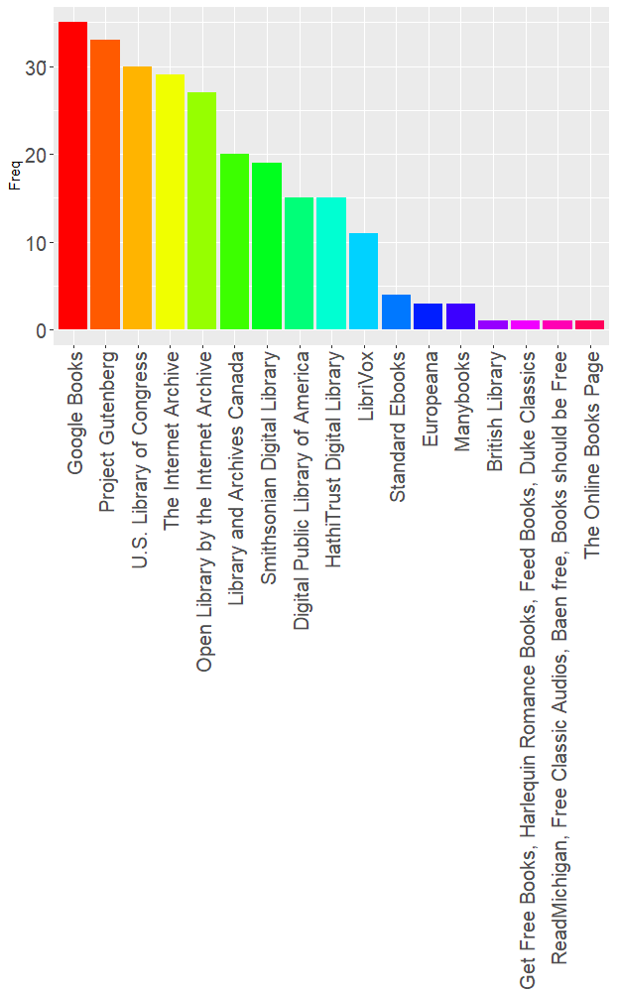
Figure B1: A bar graph of the public domain e-book providers that respondents had heard of, arranged in decreasing order of popularity from left to right.

- Which of the following public domain e-book providers have you used? (Note that not all books on these websites are in the public domain).
E-book Provider Name | Responses
Project Gutenberg (https://www.gutenberg.org/) | 23
Google Books (https://books.google.com) | 22
The Internet Archive (https://archive.org/) | 19
U.S. Library of Congress (https://www.loc.gov/) | 12
HathiTrust Digital Library (https://www.hathitrust.org/) | 8
Open Library by the Internet Archive (https://openlibrary.org/) | 8
Smithsonian Digital Library (https://library.si.edu/digital-library) | 7
Library and Archives Canada (https://recherche-collection-search.bac-lac.gc.ca) | 5
Digital Public Library of America (https://dp.la/) | 2
LibriVox (specialized in audiobooks) (https://librivox.org/) | 2
Standard Ebooks (https://standardebooks.org/) | 2
British Library https://www.bl.uk/catalogues-and-collections/digital-collections | 1
Duke Classics | 1
Manybooks (https://manybooks.net/) | 1
The Online Books Page (http://onlinebooks.library.upenn.edu/) | 1
Table B4: List of public domain e-book providers that respondents reported having used. Additional e-book providers as listed by the respondents are shaded in gray.
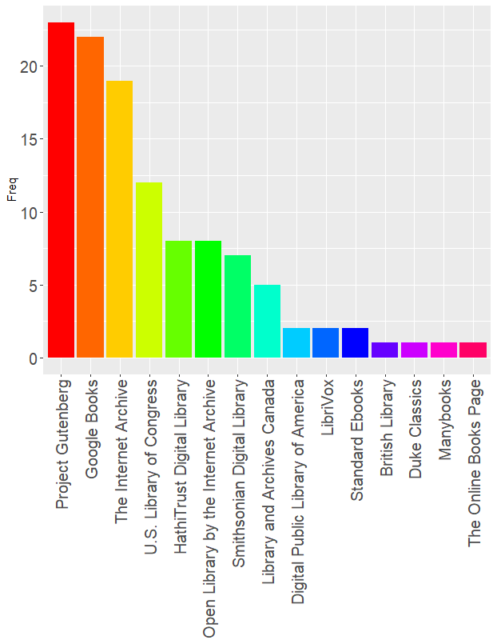
Figure B2: A bar graph of the public domain e-book providers that respondents had personally used, arranged in decreasing order of popularity from left to right.
- During your public library work, which sites featuring public domain e-books have you recommended to public library patrons?
E-book Provider Name | Responses
Project Gutenberg (https://www.gutenberg.org/) | 22
Google Books (https://books.google.com) | 10
The Internet Archive (https://archive.org/) | 10
U.S. Library of Congress (https://www.loc.gov/) | 10
Library and Archives Canada (https://recherche-collection-search.bac-lac.gc.ca) | 6
Smithsonian Digital Library (https://library.si.edu/digital-library) | 6
Digital Public Library of America (https://dp.la/) | 5
Open Library by the Internet Archive (https://openlibrary.org/) | 4
HathiTrust Digital Library (https://www.hathitrust.org/) | 3
Manybooks (https://manybooks.net/) | 2
Get Free Books, Harlequin Romance Books, Feed Books, Duke Classics | 1
LibriVox (specialized in audiobooks) (https://librivox.org/) | 1
ReadMichigan, Free Classic Audio, Baen Free | 1
Not Applicable | 4
Table B5: List of public domain e-book providers that respondents reported having recommended to public library patrons. Additional e-book providers as listed by the respondents are shaded in gray.
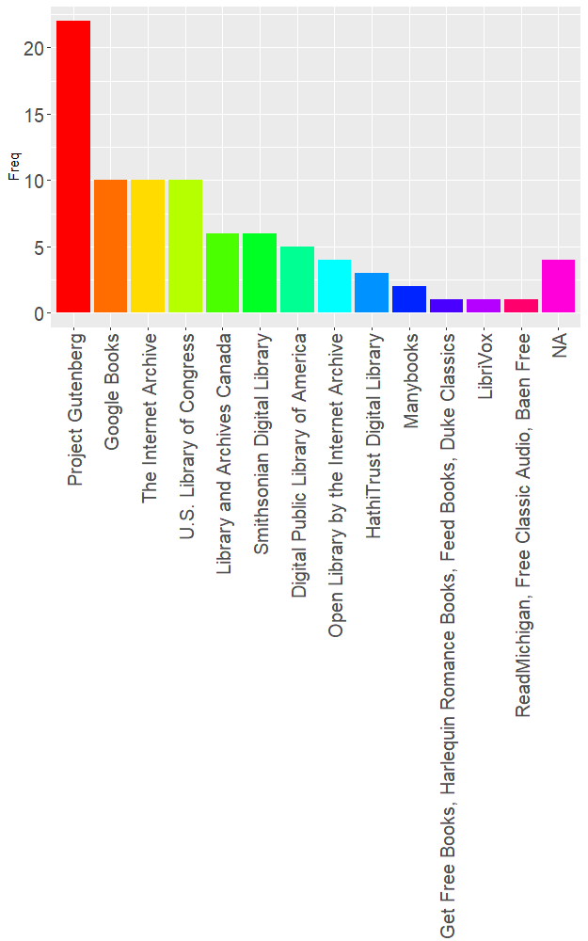
Figure B3: A bar graph of the public domain e-book providers that respondents had recommended to public library patrons, arranged in decreasing order of popularity from left to right.
- Which of the following sites have you recommended to people other than in your public library work?
E-book Provider Name | Responses
Project Gutenberg (https://www.gutenberg.org/) | 21
Google Books (https://books.google.com) | 13
The Internet Archive (https://archive.org/) | 11
U.S. Library of Congress (https://www.loc.gov/) | 8
HathiTrust Digital Library (https://www.hathitrust.org/) | 6
Smithsonian Digital Library (https://library.si.edu/digital-library) | 5
Library and Archives Canada (https://recherche-collection-search.bac-lac.gc.ca) | 4
Open Library by the Internet Archive (https://openlibrary.org/) | 4
LibriVox (specialized in audiobooks) (https://librivox.org/) | 2
British Library | 1
Duke Classics | 1
Manybooks (https://manybooks.net/) | 1
Standard Ebooks (https://standardebooks.org/) | 1
ReadMichigan | 1
Not Applicable | 1
Table B6: List of public domain e-book providers that respondents reported having recommended to people outside of their public library work. Additional e-book providers as listed by the respondents are shaded in gray.
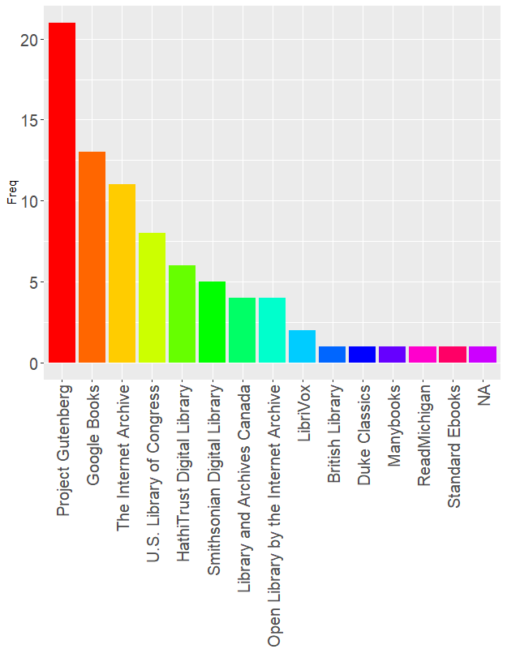
Figure B4: A bar graph of the public domain e-book providers that respondents had recommended to people other than during their public library work, arranged in decreasing order of popularity from left to right.
- In general, how do you feel about availability of e-book versions of public domain works?
  - Strongly Dislike
  - Somewhat Dislike: 3
  - Neutral: 6
  - Somewhat Like: 9
  - Strongly Like: 17
- Please use this space to share any opinions about ebooks and the public domain. Remember, all responses will be published.
13 responses
Code | Frequency | Meaning
Formatting | 6 | Respondent mentioned format and upload problems found in public domain e-books.
Access | 2 | Respondent positively noted that e-books can increase access to public domain works
Vendors | 2 | Respondent noted negative issues arising vendors and online publishers who charge for public domain titles.
author rights | 1 | Respondent noted concern for the author and their rights under copyright. As public domain status is reached 50 to 70 years after the author is deceased, this is likely a non-issue.
Resource | 1 | Respondent was optimistic about the resources list.
unavailable | 1 | Respondent noted that some public domain titles are still not available online.
Table B7: Codes, frequency (number of appearances) and meaning of each code for responses to the free response question about opinions on e-books and the public domain. Each answer may be coded in multiple ways.
Section 4: Hypothetical Scenarios
Scenario A:
Would you recommend that this student use an ebook?
  - Yes: 35
  - No: 0
  - Not sure: 0
- To find the ebook, where online would you start your search?
  - Library ebook catalog (such as OverDrive): 15
  - General search engine (such as Google): 10
  - Subject database or search engine (such as Gale Literature): 2
  - Archive or e-book repository (such as Archive.org): 6
  - Other: https://howelllibrary.org/digital-downloads/ : 1
  - Other: Project Gutenberg: 1
  - Not sure
- Please include any additional details or thoughts on this scenario.
14 responses
Code | Frequency | Meaning
owncatalog | 4 | Respondents would search the public library’s own catalog first, often to boost their library’s checkout statistics.
archive | 3 | Respondents would search a particular archive first, usually Project Gutenberg.
time | 3 | The respondent would use e-books in the situation because e-books can be retrieved faster than traditional ILL.
librarydevice | 2 | Specific devices in the participant’s actual library were referenced in the response.
choice | 1 | The participant would provide information but leave the search method up to the patron’s choice.
format | 1 | Respondents presented several potential usability issues with public domain e-book formats and editions.
physicalsearch | 1 | Respondent’s recommended holds or other search and retrieval methods for physical books.
priorknowledge | 1 | Respondent detailed specific programs or resources that patrons at their actual public library have access to and training in.
Table B8: Codes, frequency (number of appearances) and meaning of each code for responses to the free response question about scenario A. Each answer may be coded in multiple ways.
Scenario B:
- Would you recommend that this patron use an ebook?
  - Yes: 14
  - No: 11
  - Not sure: 10
- To find the ebook, where online would you start your search?
  - Library ebook catalog (such as OverDrive): 18
  - General search engine (such as Google): 6
  - Subject database or search engine (such as Gale Literature): 1
  - Archive or e-book repository (such as Archive.org): 5
  - Other: https://howelllibrary.org/digital-downloads/ : 1
  - Other: “I would not look for the ebook”: 1
  - Not sure
  - No response: 4
- Please include any additional details or thoughts on this scenario.
13 responses
Code | Frequency | Meaning
accessibility | 10 | Respondents noted that e-books have certain beneficial in-built accessibility tools.
choice | 7 | The participant would provide information but leave the search method up to the patron’s choice.
librarydevice | 1 | Specific devices in the participant’s actual library were referenced in the response.
owncatalog | 1 | Respondents would search the public library’s own catalog first, often to boost their library’s checkout statistics.
physicalsearch | 1 | Respondent’s recommended holds or other search and retrieval methods for physical books.
Table B9: Codes, frequency (number of appearances) and meaning of each code for responses to the free response question about scenario B. Each answer may be coded in multiple ways.
Scenario C
- Would you recommend that this patron use an ebook?
  - Yes: 35
  - No: 0
  - Not sure: 0
- To find the ebook, where online would you start your search?
  - Library ebook catalog (such as OverDrive): 21
  - General search engine (such as Google): 5
  - Subject database or search engine (such as Gale Literature): 2
  - Archive or e-book repository (such as Archive.org): 6
  - Other: “I would check to see if they have the Libby App, and start them there, then I would refer them to https://howelllibrary.org/digital-downloads/”: 1
  - Not sure: 0
- Please include any additional details or thoughts on this scenario.
11 responses
Codes | Frequency | Meaning
archive | 4 | Respondents would search a particular archive first, usually Project Gutenberg.
accessibility | 2 | Respondents noted that e-books have certain beneficial in-built accessibility tools.
choice | 2 | The participant would provide information but leave the search method up to the patron’s choice.
priorknowledge | 2 | Respondent detailed specific programs or resources that patrons at their actual public library have access to and training in.
owncatalog | 1 | Respondents would search the public library’s own catalog first, often to boost their library’s checkout statistics.
Table B10: Codes, frequency (number of appearances) and meaning of each code for responses to the free response question about scenario C. Each answer may be coded in multiple ways.
Scenario D
- Would you recommend that this patron use an ebook?
  - Yes: 33
  - No: 0
  - Not sure: 2
- To find the ebook, where online would you start your search?
  - Library ebook catalog (such as OverDrive): 18
  - General search engine (such as Google): 7
  - Subject database or search engine (such as Gale Literature): 3
  - Archive or e-book repository (such as Archive.org): 5
  - Other: “I have recommended No Fear Shakespeare for students in this situation, as I find them to be accessible and understandable for this demographic. They feature a side-by-side layout of the original text and a modern translation.”: 1
  - Other: https://howelllibrary.org/digital-downloads/: 1
  - Not sure: 0
- Please include any additional details or thoughts on this scenario.
13 responses
Code | Frequency | Meaning
archive | 7 | Respondents would search a particular archive first, usually Project Gutenberg.
owncatalog | 3 | Respondents would search the public library’s own catalog first, often to boost their library’s checkout statistics.
format | 2 | Respondents presented several potential usability issues with public domain e-book formats and editions.
physicalsearch | 2 | Respondent’s recommended holds or other search and retrieval methods for physical books.
accessibility | 1 | Respondents noted that e-books have certain beneficial in-built accessibility tools.
copyrightstatus | 1 | The participant noted that the work would be aged out of the public domain.
priorknowledge | 1 | Respondent detailed specific programs or resources that patrons at their actual public library have access to and training in.
supplement | 1 | The respondent mentioned a specific resource other than the public domain work in question that they would recommend in addition to the work.
Table B11: Codes, frequency (number of appearances) and meaning of each code for responses to the free response question about scenario D. Each answer may be coded in multiple ways.
Scenario E
- Would you recommend that this patron use an ebook?
  - Yes: 34
  - No: 0
  - Not sure: 1
- To find the ebook, where online would you start your search?
  - Library ebook catalog (such as OverDrive): 10
  - General search engine (such as Google): 8
  - Subject database or search engine (such as Gale Literature): 5
  - Archive or e-book repository (such as Archive.org): 7
  - Other: “Gutenberg or Open Culture”: 1
  - Other: https://howelllibrary.org/digital-downloads/ : 1
  - Other: “start with something like Project Guttenberg”: 1
  - Not sure: 2
- Please include any additional details or thoughts on this scenario.
6 responses
Codes | Frequency | Meaning
archive | 5 | Respondents would search a particular archive first, usually Project Gutenberg.
owncatalog | 2 | Respondents would search the public library’s own catalog first, often to boost their library’s checkout statistics.
format | 1 | Respondents presented several potential usability issues with public domain e-book formats and editions.
priorknowledge | 1 | Respondent detailed specific programs or resources that patrons at their actual public library have access to and training in.
Table B12: Codes, frequency (number of appearances) and meaning of each code for responses to the free response question about scenario E. Each answer may be coded in multiple ways.
Section 5: Policy Considerations
This section consists of questions about how public domain e-book repositories can be used by public libraries.
- Does your library currently have a policy about recommending websites unaffiliated with the library?
  - Yes: 5
  - No: 26
  - Not Sure: 4
- If your library does have a policy, does it allow you to refer people to public domain e-book repositories?
  - Yes: 5
  - No: 1
  - Not Sure: 1
  - Not Applicable: 27
- Have you recommended public domain e-book repositories at your library in the past, either to colleagues or to patrons?
  - Yes: 23
  - No: 6
  - Can’t remember/Not sure: 6
- Do you foresee recommending public domain e-book repositories to patrons or colleagues in the future?
  - Yes: 30
  - No: 1
  - Not Sure: 3
  - No response: 1
- Do you think libraries should promote or advertise public domain e-book repositories in general?
  - Yes: 26
  - No: 1
  - Not Sure: 8
- Please elaborate on whether you think libraries should promote or advertise public domain e-book repositories.
27 responses
Code | Frequency | Meaning
Yes | 18 | General code for positive answers.
Patron | 13 | Response focused on assisting public library patrons.
Resources | 13 | Participant acknowledges the utility of these repositories as resources.
Situational | 10 | Participant would only implement the public domain e-book provider sites in certain situations.
owncatalog | 2 | Responded highlighted existing sources in their public library system.
Table B13: Codes, frequency (number of appearances) and meaning of each code for responses to the free response question about whether libraries should promote or advertise public domain e-book repositories. Each answer may be coded in multiple ways.
- In general, do you think that there is a place for public domain e-book repositories in the public library?
29 responses
Code | Frequency
yes | 24 | General code for positive answers.
patron | 7 | Responses focused on patron or community needs.
resources | 5 | Participant acknowledges the utility of these repositories as resources.
situational | 5 | Participant believes that public domain e-book repositories should only be used by public libraries in certain specified cases.
Table B14: Codes, frequency (number of appearances) and meaning of each code for responses to the free response question about whether public domain e-book repositories have a place in libraries. Each answer may be coded in multiple ways.
- Do you think the COVID-19 pandemic has effected use or awareness of ebook repositories at your library? Please explain.
25 responses
Code | Frequency
yes | 16 | Positive responses.
unsure | 6 | Neutral and uncertain responses.
no | 5 | Negative response.
Table B15: Codes, frequency (number of appearances) and meaning of each code for responses to the free response question about whether COVID-19 has effected e-book repository use at the participant's library. Each answer may be coded in multiple ways.
- Please place any additional notes on the relationship between public libraries and online e-book repositories here.
6 responses
Code | Frequency | Meaning
helpful | 4 | The respondent noted that the e-book repositories can be useful and beneficial for public libraries.
federal | 1 | Participant suggest federal regulation to help support users and dismantle diffuse and outdated programs.
owncatalog | 1 | Participant listed private websites and existing public library catalogs that may be used instead of e-book repositories.
Table B16: Codes, frequency (number of appearances) and meaning of each code for responses to the free response question for general notes on the relationship between public libraries and online e-book repositories.

