Finding Canadian Polar Indigenous Studies in Medline
By Sandy Campbell¹, Lisa Tjosvold¹, Marlene Dorgan¹, Danièle Behn-Smith²
¹John W. Scott Health Sciences Library, University of Alberta; ²Department of Family Practice, Faculty of Medicine, University of British Columbia
Abstract
The polar library community has made much progress over the past thirty years in the development of bibliographic search tools that allow fast and easy access to publications about the Arctic and Antarctic. Many of us rely heavily on tools such as Arctic and Antarctic Regions to satisfy our need for information organized with a geographic focus. For Circumpolar health researchers, there is now the growing Circumpolar Health Bibliographic Database, a subset of the Arctic Science and Technology Information System (ASTIS), which is improving access to polar health materials. However, when conducting systematic review searches, searchers are required to be as comprehensive as possible, which means that all relevant subject databases must be searched, even if overlap is substantial. As a result, Medline must be searched as part of any systematic review search related to Indigenous health issues in Canada’s Arctic regions. While the MESH Subject Headings and Geographic Headings do supply some controlled vocabulary access, keywords must also be searched to make the search comprehensive. This goal of this project is to create a Medline search filter which will assure comprehensive retrieval of Canadian Indigenous materials

Background
A systematic review is a specialty type of literature review which originated in medical research. Systematic reviews are designed to gather together all of the relevant publications on a specific topic, and evaluate and synthesize the findings of all of the various works into a single plain language summary which describes the state of the evidence. Hemingway and Brereton describe the goals of a systematic review in the following terms:

High quality systematic reviews seek to:
    - Identify all relevant published and unpublished evidence
    - Select studies or reports for inclusion
    - Assess the quality of each study or report
    - Synthesise the findings from individual studies or reports
in an unbiased way
    - Interpret the findings and present a balanced and
impartial summary of the findings with due consideration of
any flaws in the evidence. (Hemingway and Brereton 2009, 1-8)
The systematic review search embodies all of the activities implied by Hemingway and Brereton’s first point “identify all relevant published and unpublished evidence” and extends to the detailed documentation of the search process in the published systematic review. The quality of a systematic review search can be evaluated using the PRESS Checklist (Sampson et al. 2008)
The first step in “identify[ing] all relevant published and unpublished evidence”,
is identifying all of the relevant bibliographic sources to be searched. For any systematic review related to health questions, including those related to Indigenous health in the Canadian Arctic, Medline must be among the databases searched.
Medline is one of the largest health-related databases, containing over 19 million references and indexing more than 5600 biomedical journals. Content coverage is world-wide. Medline employs the MESH Subject Headings and Geographic Headings as a controlled vocabulary. Controlled vocabularies, when applied thoroughly, consistently and accurately can make searching much more efficient. However, when conducting a systematic review search, in which comprehensive recall is the goal, searches necessarily include both controlled vocabulary terms and keywords. Further, in the cases of Canadian Indigenous people and the Canadian Arctic region, there are numerous problems with the MESH headings that make their use less effective.
MESH headings are not applied immediately as the reference is added to the database. So, there are always current references in the database that are not indexed at all (Example 1). There are also references included in Medline, that date pre-date the point at which a journal started being indexed in Medline, so some older materials are not indexed at all.
Example 1
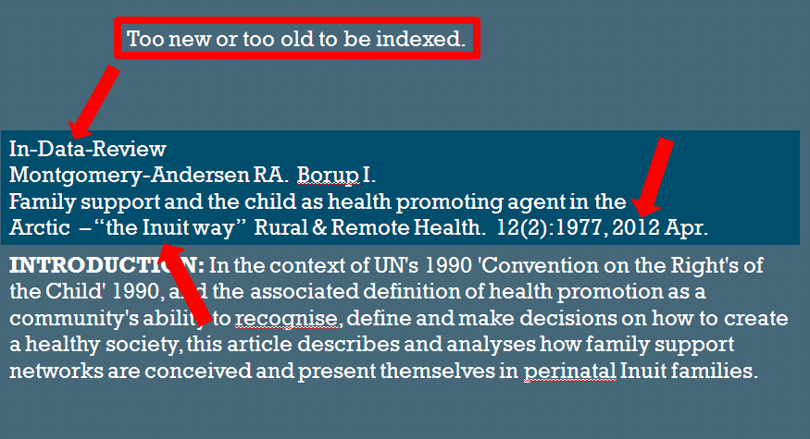

In the indexing of publications related to Canadian Arctic peoples, the MESH Headings do not have the granularity required to separate Canadian subjects from non-Canadian subjects or to separate Canadian Arctic subjects from other Canadian subjects (Example 2).
Example 2 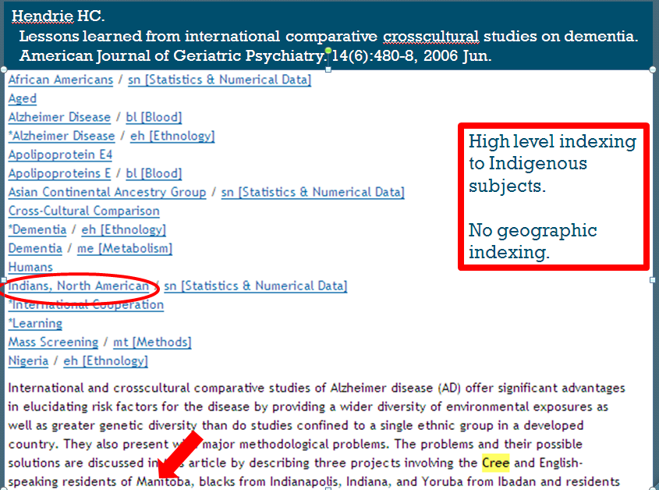

Further, the headings appear to be applied inconsistently, both in terms of the level of the term in the hierarchy and also in whether or not the term is applied at all (Example 3).

Example 3
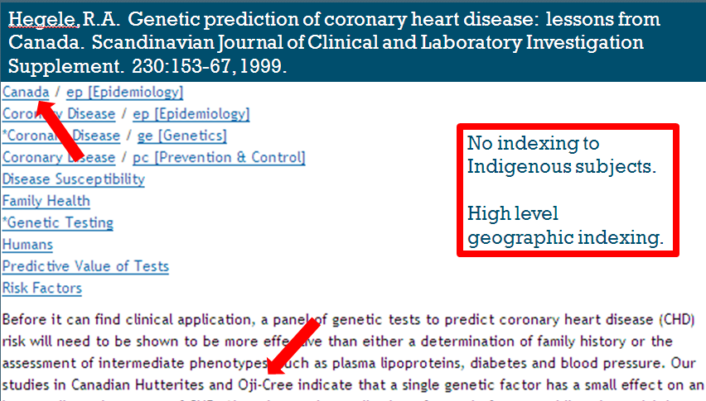

All of these shortcomings with MESH indexing in Medline highlight the need to combine the controlled vocabulary searching with keyword searching to create a strong systematic review search strategy. Keyword searching for both Canadian Arctic geographic terms and Canadian Arctic Indigenous people is complex and difficult. The goal of this project is to create and publish a search filter for Canadian Arctic Indigenous people, that other searchers will be able to apply in their searches.
Building a Canadian Arctic Indigenous Filter for Medline
Search filters (also called hedges) are pre-defined search strategies that have long been recognized as a way to enhance literature searches. In 1994 Klatt observed that “the use of a subject hedge can greatly improve the quality and accuracy of a mediated search on MEDLINE or any other database”.(Klatt 1994, 438-441)
While the creation of the Canadian Arctic Indigenous filter is a part of a larger project to create a Canadian Indigenous filter, it raises most of the challenges inherent in the larger project.

Searching for “Canadian Arctic” Concept
The development of geographic filters for Medline is not new. The most recently, Radut and Sanz-Valero described a filter for the European Union (Radut and Sanz-Valero 2010, 227-234) A broad filter for retrieving health information from PubMed has been developed,(Murray 2012) however, no detailed filter Medline exists for Canada’s North. In defining the part of the filter that will capture the “Canadian Arctic” concept, there are several challenges. The first is the fact that the MESH vocabulary for Canada’s north is restricted to the names of the three territories (Yukon, Northwest Territories and Nunavut) and the term “Arctic Regions”, which can be coordinated with other terms such as “Canada” (Example 4)
Example 4
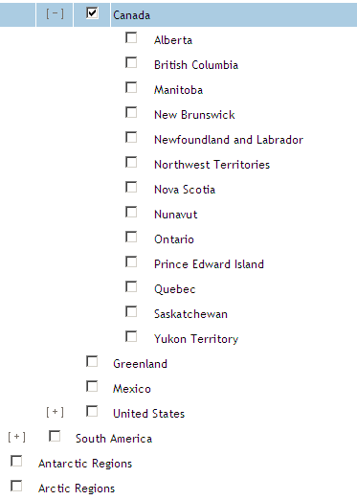
A variety of types of keywords which indicate northern geography must also be searched to increase recall. In creating this list, the following kinds of conceptual synonyms must be considered:
- Keywords that mirror the MESH terms
- Names of regions (eg: “high Arctic”/“western Arctic”/“eastern Arctic” “Arctic islands” - remembering that Arctic, by itself, refers to areas outside Canada - as well /river basins/island names/bodies of water/Keewatin/ Franklin/Ungava/Nunavik)
- Names of cities, towns, villages, settlements, settlement areas and reserves (eg: Yellowknife, Amadjuak, Inuvaluit Settlement Region/Moosehide Creek 2)
- Current and former place names (eg: Eskimo Point/Arviat)
- Names in different languages (eg: Hudson Bay/Kangiqsualuk ilua/baie d’Hudson)
- Spelling variants and common errors in spelling eg: Hudson Bay/ Hudson’s Bay
Searching for the “Canadian Indigenous” Concept
Challenges involved in defining Canadian Arctic Indigenous people are even more complex. The MESH terms for Indigenous people are too high level and do not distinguish people by geography. When the MESH terms for Indigenous people are coordinated with the vocabulary for northern Canada, the results are incomplete. Apart from the “Ancestry Group” Headings, only a single term “Health Services, Indigenous” indexes Indigenous content.
Keyword search strategies designed to retrieve Northern Canadian Indigenous people must include or account for the following concepts:
- Keywords that mirror the MESH terms
- Linguistic group names (eg: Athapascan) coordinated with geographic terms
- Broader and narrower names for groups of people (eg: Dene and Sahtu)
- Names for broad groups of people unique to northern Canada (eg: Dene, Inuvialuit)
- Names for broad groups of people not unique to northern Canada that must be coordinated with geographic terms (eg: Inuit, Cree, Metis)
- Former and current names (eg: Yellowknives/T’atasaot’ine)
- Names in various languages (eg: Innu/Montagnais/Naskapi)
- Variant spellings and common spelling errors (eg: Gwich’in/Kutchin/Gwitch’in)
- Names which have other meanings (eg: Hare/Dogribs)

In addition there are terms which imply the presence of information about Indigenous people:
- Numbered treaties (eg: Treaty 8)
- “off-reserve/on-reserve”
- “traditional use”
- “urban Indian*”
- “Native people*” (“native” retrieves plants, etc.)
- “first nation*”
- “country food*”

Validation and Publication
Once the filter is constructed and tested, it will be validated. Validation is the process of determining the efficiency by comparing a sample of the results (2 to 5 years) against a known set of data, such as a standard bibliography, a set of journals which specialize in the subject of the search. Validation could also be done through scrutiny by an expert who is familiar with the publication patterns of this literature. Devising a validation set for this filter will be complex because polar health literature is scattered widely through an array of general medical and clinical specialty journals, journals dedicated broadly to northern subjects and journals in disciplines such as sociology and anthropology. Further, several journals which cover Canadian Indigenous subjects (eg: Rural and Remote Health, Pimatsiwin and Journal of Aboriginal Health) are not indexed by Medline.
Potential journals to be used in a validation study of this filter include
1. Canadian Medical Association Journal
2. Canadian Family Physician
3. Canadian Journal of Dietetic Practice and Research
4. Canadian Journal of Infectious Diseases
5. Canadian Journal of Nursing Research
6. Canadian Journal of Psychiatry
7. Canadian Journal of Public Health
8. Canadian Journal of Rural Medicine
9. Chronic Diseases in Canada
10. Health Policy
11. Harm Reduction Journal
12. International Journal of Circumpolar Health (prev. Arctic Medical Research)
13. Journal of Ethnopharmacology

Once the filter is validated, it will be published so that anyone may use it to restrict searches to Canadian Arctic Indigenous references.

Conclusion and Future Research

The product of this part of the project will be a validated search filter which will identify Canadian Arctic Indigenous references in Medline. It will improve the ability of searchers to isolate this material in their searches. We predict that the filter will also enable searchers to remove Canadian Arctic Indigenous references from searches focused on other parts of Canada or other Countries. It is part of a larger project that will create a filter for all Canadian Indigenous studies in Medline. Future research could involve constructing individual filters for Canadian Provinces and Territories or Indigenous people in other countries and adapting the filters for other health databases, such as EMBASE or CINAHL.

References

Hemingway, Pippa, and Nic Brereton. 2009. What is a systematic review? Hayward Medical Communications, NPR09/1111.
Klatt, Mary J. 1994. An aid for total quality searching: Developing a hedge book. Bulletin of the Medical Library Association 82 (10): 438-41.
Murray, Kathy. 2012. (A filter to retrieve arctic health pulications from PubMed) e-mail 20 june 2012.
Radut, Dan Silviu, and Javier Sanz-Valero. 2010. Developing and testing of search filters for the new european union member states’ research. Health Information & Libraries Journal 27 (3) (09): 227-34.
Sampson, M., J. McGowan, C. Lefebvre, D. Moher, and Grimshaw J. 2008. PRESS: Peer review of electronic search strategies - appendix G: Press checklist. Ottawa: Canadian Agency for Drugs and Technologies in Health, .

