Chapter 5 Supplement D: Sub-Stratified Quality Improvement Interventions and Numbers Needed to Treat

Contents
This supplement contains additional figures and tables from data analysis, including forest plots for sub-strata of quality improvement interventions and tables showing numbers needed to treat to obtain a single additional vaccination.

Influenza vaccinations – Methods of patient outreach
Figure S5-D1: Influenza vaccinations – Effect of particular patient outreach methods
Figure S5-D2a: Influenza vaccinations – Patient outreach – Brochures handed out at the point of care
Figure S5-D2b: Influenza vaccinations – Patient outreach – Community (mass) media campaigns
Figure S5-D2c: Influenza vaccinations – Patient outreach – Emergency medical technician counseling
Figure S5-D2d: Influenza vaccinations – Patient outreach – Home-visit counseling
Figure S5-D2e: Influenza vaccinations – Patient outreach – Mailed materials
Figure S5-D2f: Influenza vaccinations – Patient outreach – Patient-held preventive care cards
Figure S5-D2g: Influenza vaccinations – Patient outreach – Telephone reminders
Figure S5-D2h: Influenza vaccinations – Patient outreach – Waiting room materials (passive)

Influenza vaccinations – Team change interventions
Figure S5-D3: Influenza vaccinations – Effect of particular team change methods
Figure S5-D4a: Influenza vaccinations – Team change – Emergency medical technician counseling
Figure S5-D4b: Influenza vaccinations – Team change – Pharmacist counseling
Figure S5-D4c: Influenza vaccinations – Team change – Nurse involvement, no autonomous vaccinations
Figure S5-D4d: Influenza vaccinations – Team change – Nurse involvement, autonomous vaccinations
Figure S5-D4e: Influenza vaccinations – Team change – Multidisciplinary team

Pneumococcal vaccinations – Methods of patient outreach
Figure S5-D5: Pneumococcal vaccinations – Effect of particular patient outreach methods
Figure S5-D6a: Pneumococcal vaccinations – Patient outreach – Brochures handed out at the point of care
Figure S5-D6b: Pneumococcal vaccinations – Patient outreach – Community (mass) media campaigns
Figure S5-D6c: Pneumococcal vaccinations – Patient outreach – Emergency medical technician counseling
Figure S5-D6d: Pneumococcal vaccinations – Patient outreach – Home-visit counseling
Figure S5-D6e: Pneumococcal vaccinations – Patient outreach – Mailed materials
Figure S5-D6f: Pneumococcal vaccinations – Patient outreach – Patient-held preventive care cards
Figure S5-D6g: Pneumococcal vaccinations – Patient outreach – Telephone reminders
Figure S5-D6h: Pneumococcal vaccinations – Patient outreach – Waiting room materials (passive)
Figure S5-D7: Pneumococcal vaccinations – Effect of particular team change methods

Pneumococcal vaccinations – Team change interventions
Figure S5-D8a: Pneumococcal vaccinations – Team change – Emergency medical technician counseling
Figure S5-D8b: Pneumococcal vaccinations – Team change – Pharmacist counseling
Figure S5-D8c: Pneumococcal vaccinations – Team change – Nurse involvement, no autonomous vaccinations
Figure S5-D8d: Pneumococcal vaccinations – Team change – Nurse involvement, autonomous vaccinations
Figure S5-D8e: Pneumococcal vaccinations – Team change – Multidisciplinary team

Numbers needed to treat
Table S5-D9: Numbers needed to treat for an additional influenza vaccination
Table S5-D10: Numbers needed to treat for an additional pneumococcal vaccination

Figure S5-D1: Influenza vaccinations – Effect of particular patient outreach methods
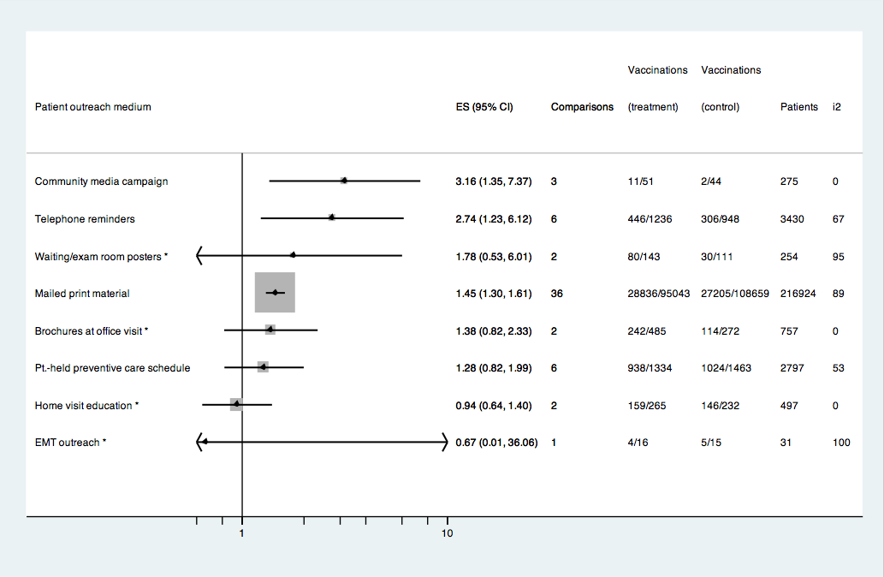
* Pooled odds ratios from fewer than 3 comparisons.
Figure S5-D2a: Influenza vaccinations – Patient outreach – Brochures handed out at the point of care

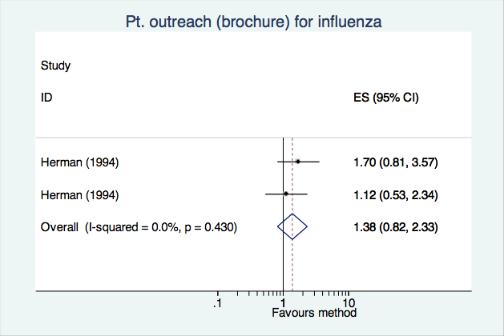

Figure S5-D2b: Influenza vaccinations – Patient outreach – Community (mass) media campaigns

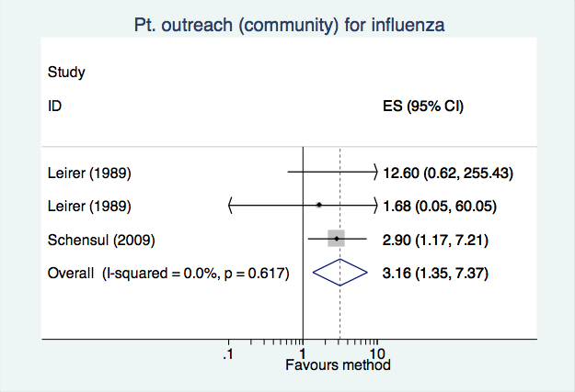

Figure S5-D2c: Influenza vaccinations – Patient outreach – Emergency medical technician counseling

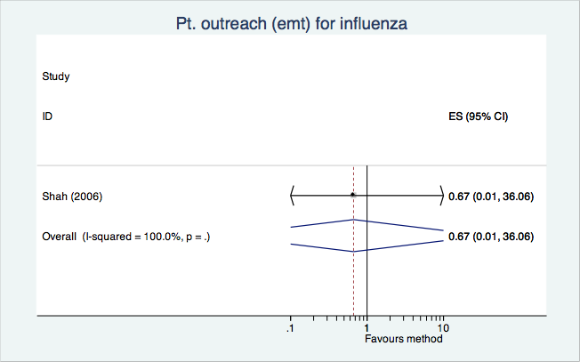

Figure S5-D2d: Influenza vaccinations – Patient outreach – Home-visit counseling

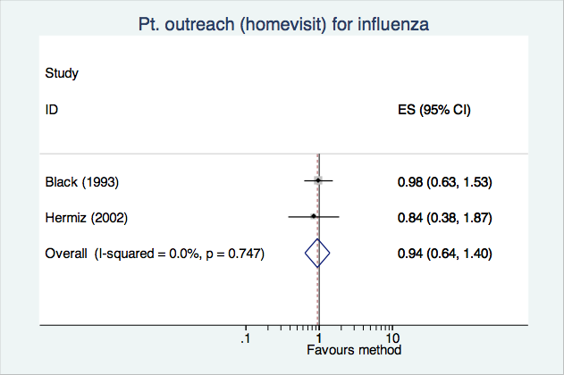

Figure S5-D2e: Influenza vaccinations – Patient outreach – Mailed materials

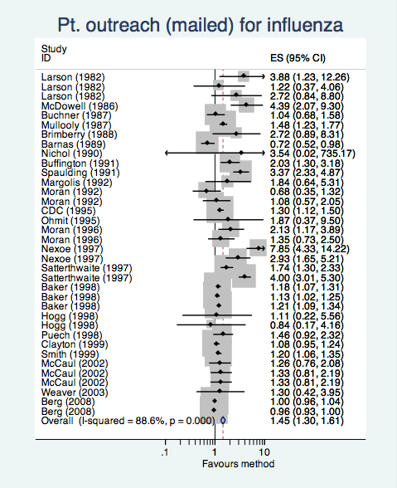

Figure S5-D2f: Influenza vaccinations – Patient outreach – Patient-held preventive care cards

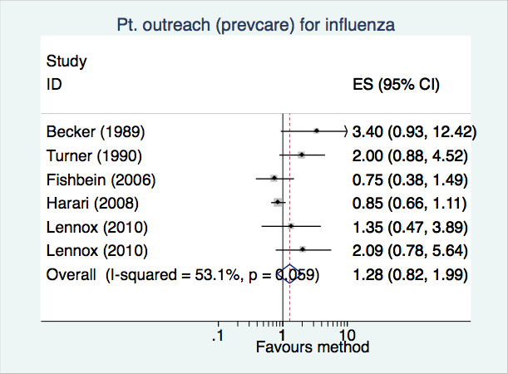

Figure S5-D2g: Influenza vaccinations – Patient outreach – Telephone reminders

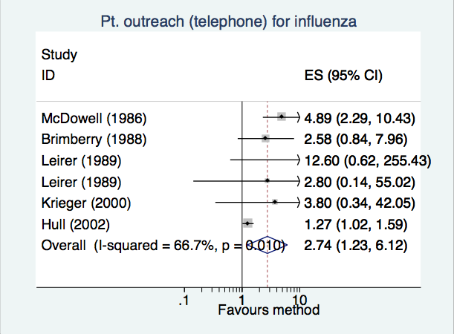

Figure S5-D2h: Influenza vaccinations – Patient outreach – Waiting room materials (passive)

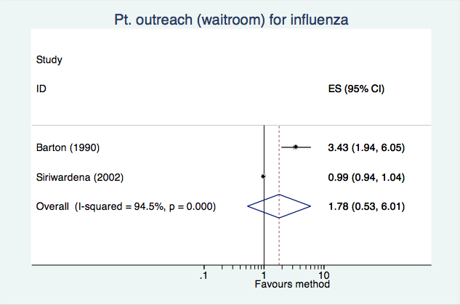

Figure S5-D3: Influenza vaccinations – Effect of particular team change methods
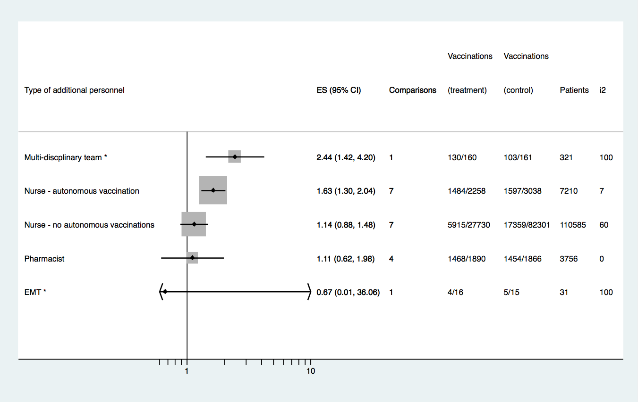
* Pooled odds ratios from fewer than 3 comparisons.
Figure S5-D4a: Influenza vaccinations – Team change – Emergency medical technician counseling

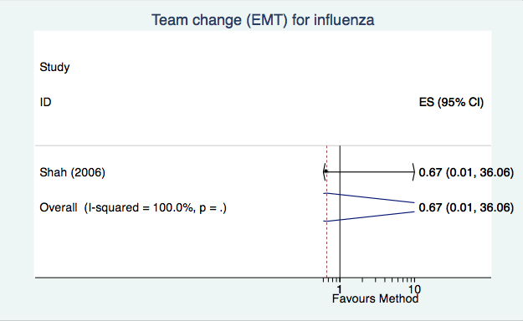

Figure S5-D4b: Influenza vaccinations – Team change – Pharmacist counseling or vaccinations*

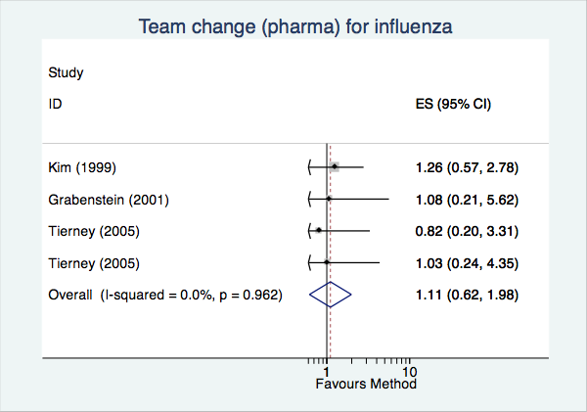

* Commercial pharmacists provided vaccinations only in Grabenstein (2001).

Figure S5-D4c: Influenza vaccinations – Team change – Nurse involvement, no autonomous vaccinations

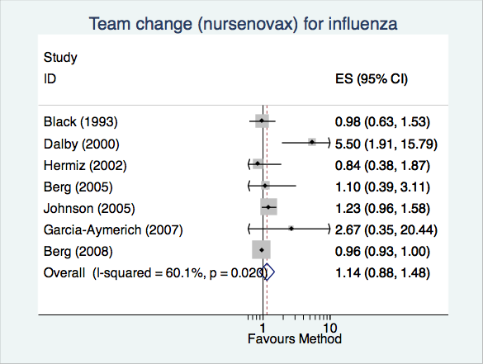

Figure S5-D4d: Influenza vaccinations – Team change – Nurse involvement, autonomous vaccinations

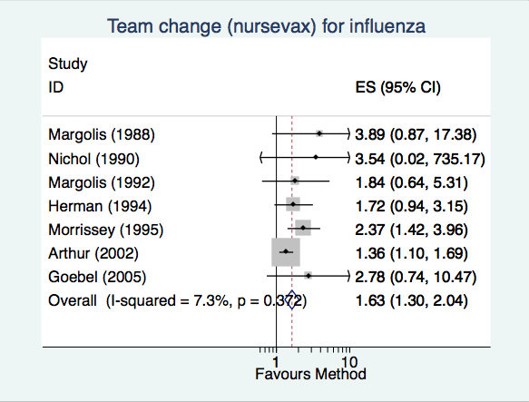
Figure S5-D4e: Influenza vaccinations – Team change – Multidisciplinary team

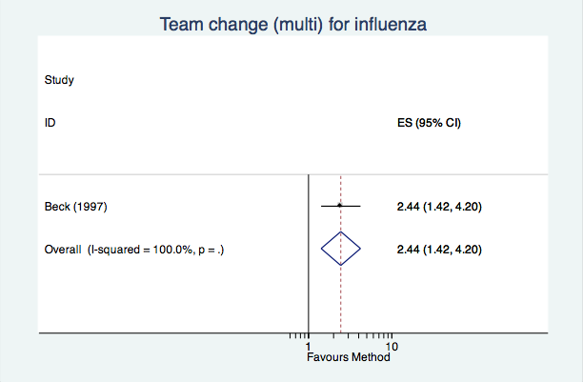

Figure S5-D5: Pneumococcal vaccinations – Effect of particular patient outreach methods
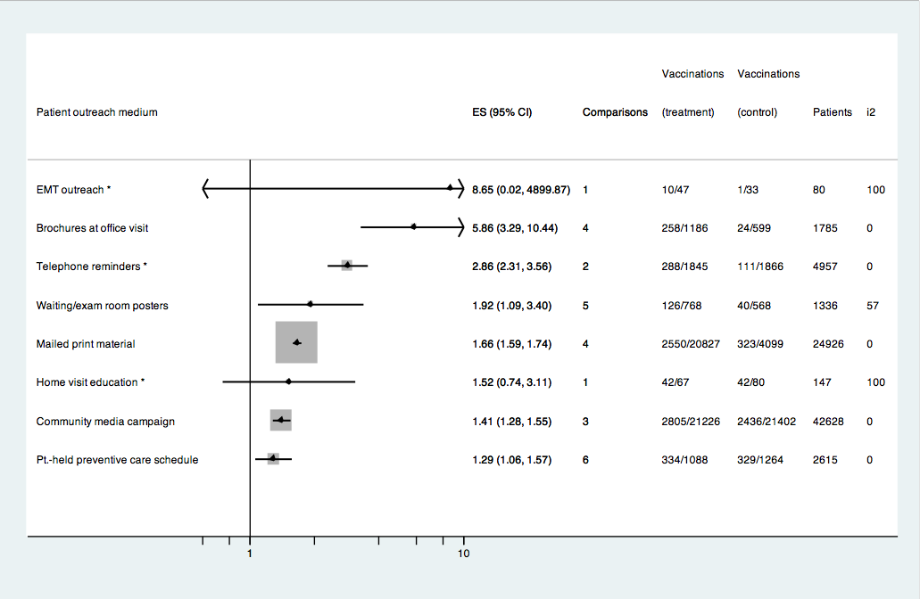
* Pooled odds ratios from fewer than 3 comparisons.
** The pooled odds ratio for waiting/exam room posters is likely over-estimated, since there were few comparisons and the highest performing comparisons combined posters with other effective interventions. Indeed, analysis of comparisons featuring waiting and exam room posters alone (n = 2) showed a pooled OR = 1.17 (95% CI [0.726, 3.566], I² = 0%).
Figure S5-D6a: Pneumococcal vaccinations – Patient outreach – Brochures handed out at the point of care

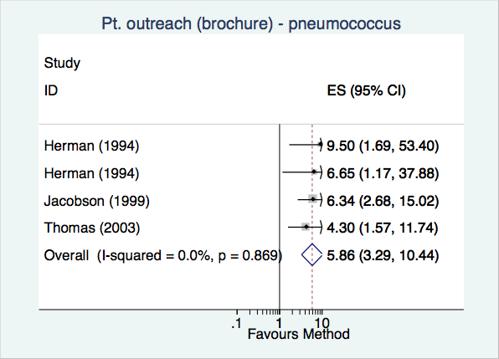

Figure S5-D6b: Pneumococcal vaccinations – Patient outreach – Community (mass) media campaigns

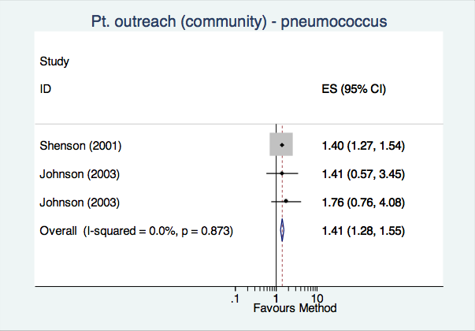

Figure S5-D6c: Pneumococcal vaccinations – Patient outreach – Emergency medical technician counseling

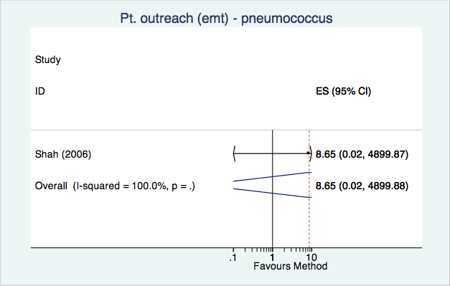

Figure S5-D6d: Pneumococcal vaccinations – Patient outreach – Home-visit counseling

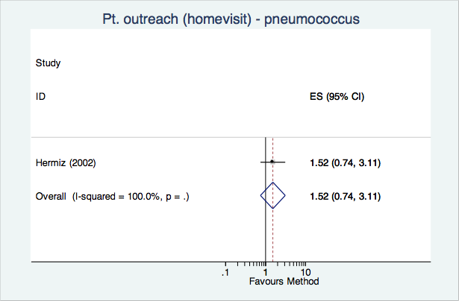

Figure S5-D6e: Pneumococcal vaccinations – Patient outreach – Mailed materials

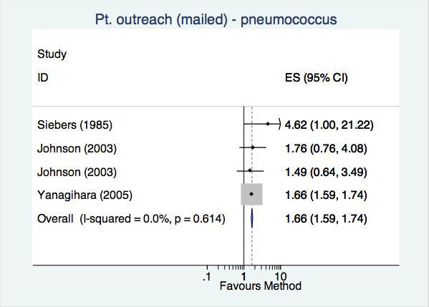

Figure S5-D6f: Pneumococcal vaccinations – Patient outreach – Patient-held preventive care cards

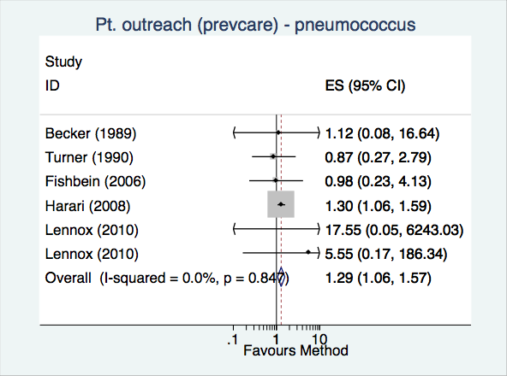

Figure S5-D6g: Pneumococcal vaccinations – Patient outreach – Telephone reminders

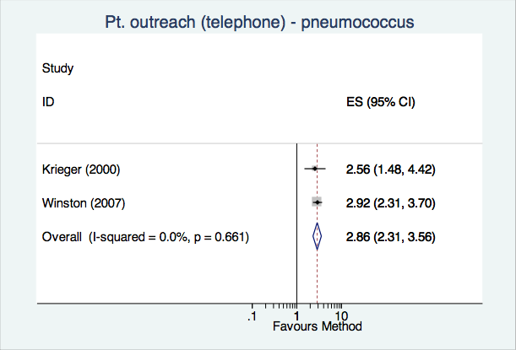

Figure S5-D6h: Pneumococcal vaccinations – Patient outreach – Waiting room materials (passive)

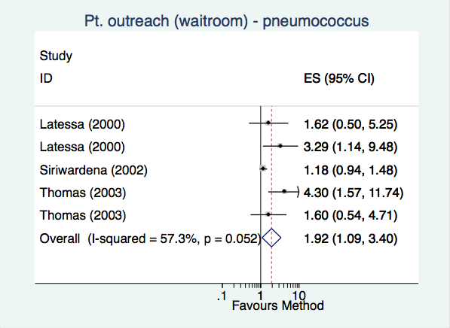
Figure S5-D7: Pneumococcal vaccinations – Effect of particular team change methods
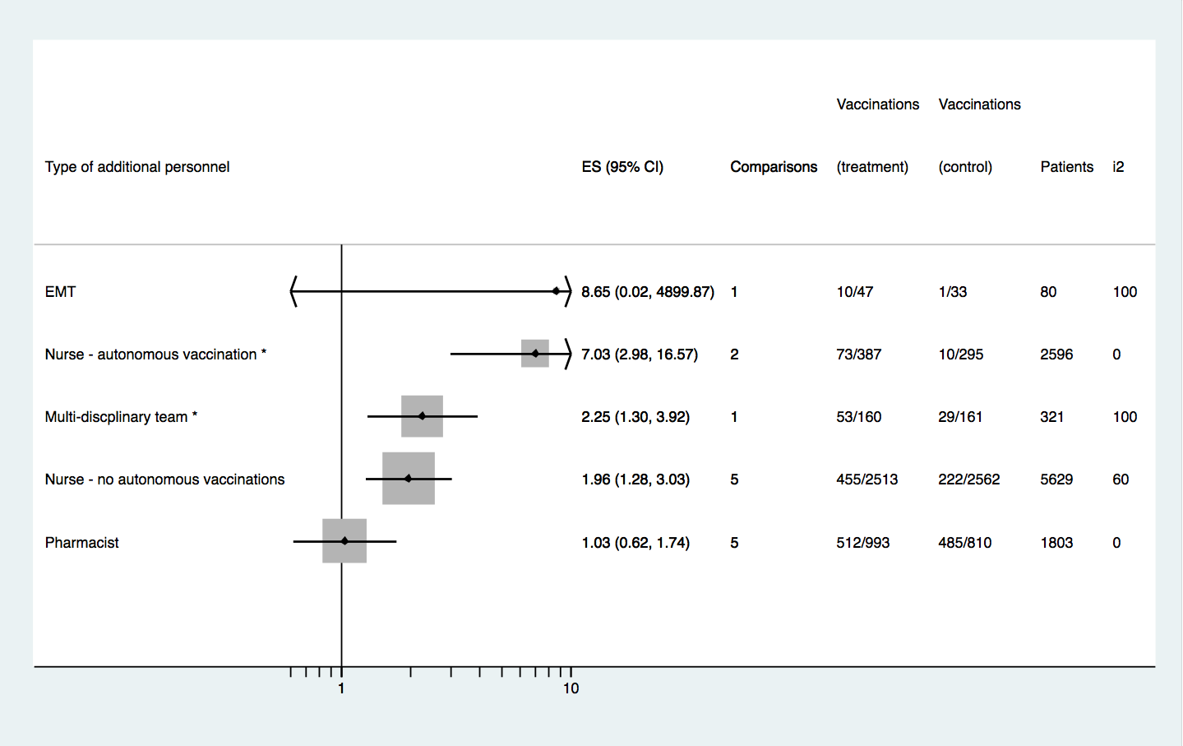
* Pooled odds ratios from fewer than 3 comparisons.
Figure S5-D8a: Pneumococcal vaccinations – Team change – Emergency medical technician counseling

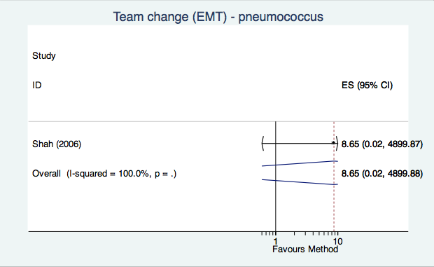

Figure S5-D8b: Pneumococcal vaccinations – Team change – Pharmacist counseling

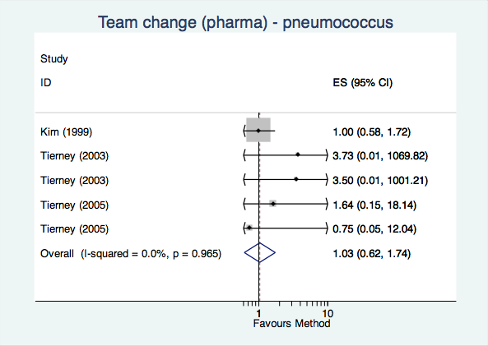

Figure S5-D8c: Pneumococcal vaccinations – Team change – Nurse involvement, no autonomous vaccinations

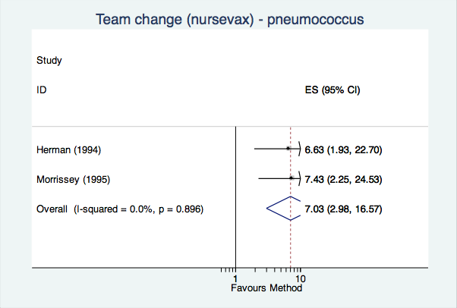

Figure S5-D8d: Pneumococcal vaccinations – Team change – Nurse involvement, autonomous vaccinations

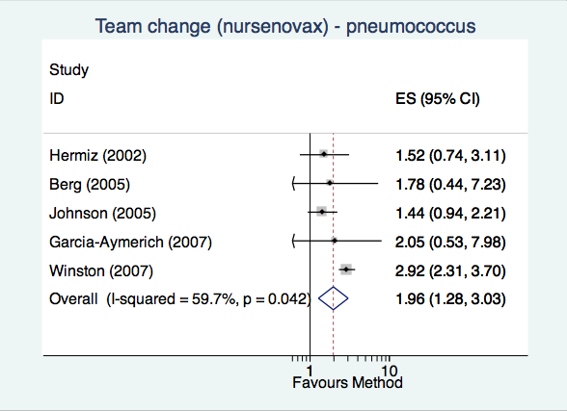

Figure S5-D8e: Pneumococcal vaccinations – Team change – Multidisciplinary team

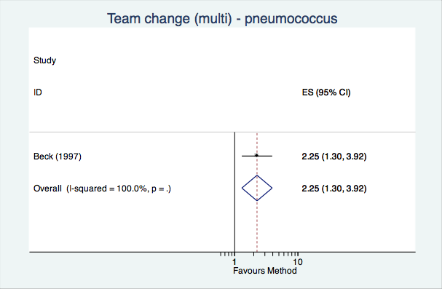

Table S5-D9: Numbers needed to treat for an additional influenza vaccination
Baseline vaccination rate | QI intervention | NNT
0.3 | Patient outreach - community media | 3.6
0.3 | Patient outreach - telephone reminders | 4.2
0.3 | Financial incentives (patient) | 6.3
0.3 | Audit and feedback | 7.2
0.3 | Team change - nurse vaccine administration | 9.0
0.3 | Clinician reminders | 10.4
0.3 | Financial incentives (clinician) | 10.6
0.3 | Patient outreach - mailed print materials | 12.0
0.3 | Team change | 12.3
0.3 | Patient outreach | 12.8
0.3 | Delivery site change | 16.3
0.4 | Patient outreach - community media | 3.6
0.4 | Patient outreach - telephone reminders | 4.1
0.4 | Financial incentives (patient) | 5.9
0.4 | Audit and feedback | 6.7
0.4 | Team change - nurse vaccine administration | 8.3
0.4 | Clinician reminders | 9.5
0.4 | Financial incentives (clinician) | 9.7
0.4 | Patient outreach - mailed print materials | 10.9
0.4 | Team change | 11.1
0.4 | Patient outreach | 11.6
0.4 | Delivery site change | 14.7
0.5 | Patient outreach - community media | 3.9
0.5 | Patient outreach - telephone reminders | 4.3
0.5 | Financial incentives (patient) | 6.1
0.5 | Audit and feedback | 6.8
0.5 | Team change - nurse vaccine administration | 8.3
0.5 | Clinician reminders | 9.5
0.5 | Financial incentives (clinician) | 9.7
0.5 | Patient outreach - mailed print materials | 10.9
0.5 | Team change | 11.1
0.5 | Patient outreach | 11.5
0.5 | Delivery site change | 14.5
0.6 | Patient outreach - community media | 4.4
0.6 | Patient outreach - telephone reminders | 4.9
0.6 | Financial incentives (patient) | 6.8
0.6 | Audit and feedback | 7.5
0.6 | Team change - nurse vaccine administration | 9.1
0.6 | Clinician reminders | 10.4
0.6 | Financial incentives (clinician) | 10.5
0.6 | Patient outreach - mailed print materials | 11.8
0.6 | Team change | 12.0
0.6 | Patient outreach | 12.4
0.6 | Delivery site change | 15.5
0.7 | Patient outreach - community media | 5.5
0.7 | Patient outreach - telephone reminders | 6.1
0.7 | Financial incentives (patient) | 8.2
0.7 | Audit and feedback | 9.1
0.7 | Team change - nurse vaccine administration | 10.9
0.7 | Clinician reminders | 12.3
0.7 | Financial incentives (clinician) | 12.5
0.7 | Patient outreach - mailed print materials | 13.9
0.7 | Team change | 14.2
0.7 | Patient outreach | 14.7
0.7 | Delivery site change | 18.2

Table S5-D10: Numbers needed to treat for an additional pneumococcal vaccination
Baseline vaccination rate | QI intervention | NNT
0.3 | Patient outreach - brochures handed out before appointments | 2.4
0.3 | Clinician reminders | 5.2
0.3 | Team change | 5.8
0.3 | Team change involving nurses without vaccination powers | 6.4
0.3 | Patient outreach - waiting / exam room posters | 6.6
0.3 | Patient outreach | 7.4
0.3 | Patient outreach - mailed print materials | 8.6
0.3 | Clinician education | 10.2
0.3 | Case management | 11.1
0.3 | Patient outreach - community media | 13.0
0.3 | Preventive care checklists | 17.8
0.4 | Patient outreach - brochures handed out before appointments | 2.5
0.4 | Clinician reminders | 4.9
0.4 | Team change | 5.5
0.4 | Team change involving nurses without vaccination powers | 6.0
0.4 | Patient outreach - waiting / exam room posters | 6.2
0.4 | Patient outreach | 6.9
0.4 | Patient outreach - mailed print materials | 8.0
0.4 | Clinician education | 9.4
0.4 | Case management | 10.2
0.4 | Patient outreach - community media | 11.8
0.4 | Preventive care checklists | 16.0
0.5 | Patient outreach - brochures handed out before appointments | 2.8
0.5 | Clinician reminders | 5.1
0.5 | Team change | 5.7
0.5 | Team change involving nurses without vaccination powers | 6.2
0.5 | Patient outreach - waiting / exam room posters | 6.3
0.5 | Patient outreach | 7.0
0.5 | Patient outreach - mailed print materials | 8.1
0.5 | Clinician education | 9.4
0.5 | Case management | 10.2
0.5 | Patient outreach - community media | 11.8
0.5 | Preventive care checklists | 15.8
0.6 | Patient outreach - brochures handed out before appointments | 3.4
0.6 | Clinician reminders | 5.8
0.6 | Team change | 6.3
0.6 | Team change involving nurses without vaccination powers | 6.8
0.6 | Patient outreach - waiting / exam room posters | 7.0
0.6 | Patient outreach | 7.7
0.6 | Patient outreach - mailed print materials | 8.8
0.6 | Clinician education | 10.2
0.6 | Case management | 11.0
0.6 | Patient outreach - community media | 12.7
0.6 | Preventive care checklists | 16.9
0.7 | Patient outreach - brochures handed out before appointments | 4.3
0.7 | Clinician reminders | 7.1
0.7 | Team change | 7.7
0.7 | Team change involving nurses without vaccination powers | 8.3
0.7 | Patient outreach - waiting / exam room posters | 8.5
0.7 | Patient outreach | 9.3
0.7 | Patient outreach - mailed print materials | 10.5
0.7 | Clinician education | 12.2
0.7 | Case management | 13.1
0.7 | Patient outreach - community media | 14.9
0.7 | Preventive care checklists | 19.8

